E
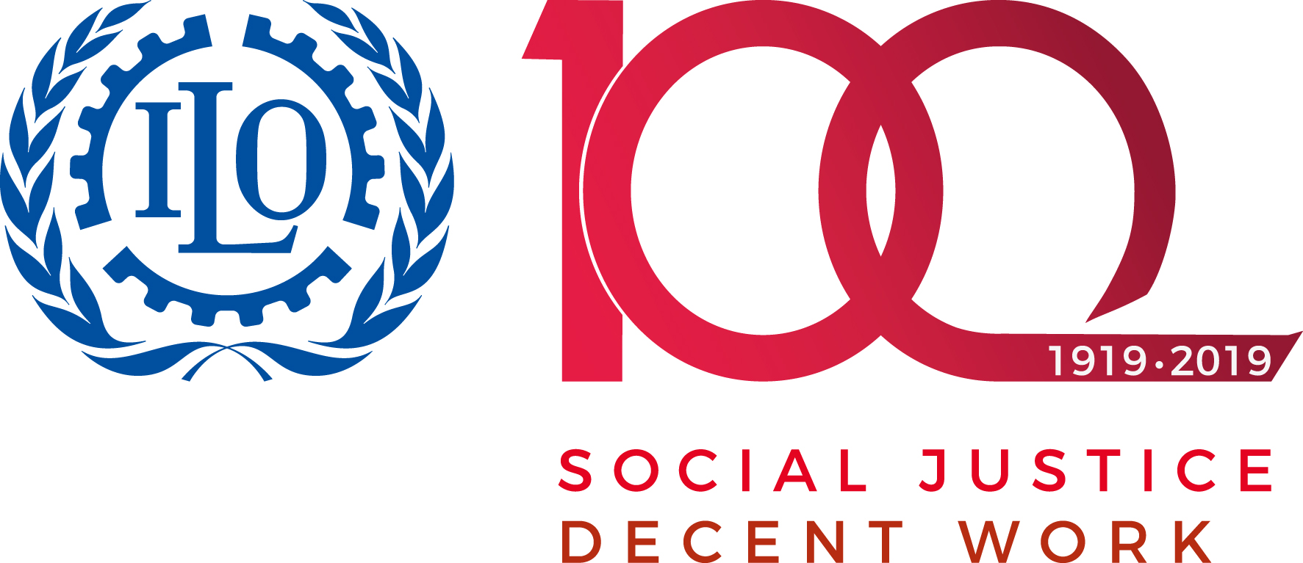 | 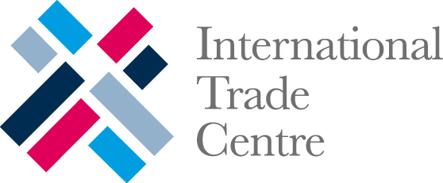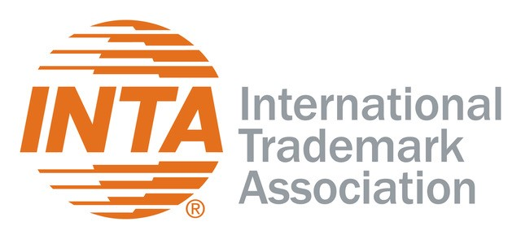 |  | 
WORKSHOP
WIPO/IPTK/GE/19/INF/1
ORIGINAL: ENGLISH
DATE: November 5, 2019

Practical Workshop on Intellectual Property for Women Entrepreneurs from Indigenous Peoples and Local Communities

organized by
the World Intellectual Property Organization (WIPO)

in cooperation with
the International Labour Organization (ILO),

the International Trade Centre (ITC),

and
the International Trademark Association (INTA)

Geneva, Switzerland, November 11 to 15, 2019

PROGRAM

prepared by the International Bureau of WIPO

Background: | This Practical Workshop is offered in the context of the WIPO Project-Based Training and Mentoring Program on Intellectual Property for Women Entrepreneurs from Indigenous Peoples and Local Communities (the Program).  The Program aims to strengthen the capacity of women entrepreneurs from indigenous peoples and local communities (IPLCs) to make strategic and effective use of intellectual property (IP) rights, in support of projects based on traditional knowledge (TK), traditional cultural expressions (TCEs) and genetic resources (GRs).  The Program consists of two phases: a training phase (the Practical Workshop), and a mentoring phase in 2020.
Objectives: | The objectives of the Practical Workshop are to provide the opportunity for participants to:  - Acquire basic knowledge of the main principles, systems and tools of the IP system and how they relate to IPLCs, emphasizing both the potential value that IP could bring in support of TK, TCEs and GRs protection, as well as the challenges;  - Meet amongst themselves and share experiences and ideas with the use of IP tools to protect and promote TK, TCEs and GRs;  - Further develop their projects.

Monday, November 11, 2019

Venue: Room 0.107, WIPO New Building

9.00 – 9.30 Registration

9.30 – 10.00 Introduction

Mr. Wend Wendland, Director, Traditional Knowledge Division, Global Issues Sector, World Intellectual Property Organization (WIPO), Geneva

Indigenous Opening Ceremony

Welcome Address by:

Mr. Minelik Getahun, Assistant Director General, Global Issues Sector, WIPO, Geneva

Remarks by:

Mr. Martin Oelz, Team Leader, Indigenous Peoples and Ethnic Minorities, Gender, Equality and Diversity & ILOAIDS Branch, International Labour Organization (ILO), Geneva

Mr. Juan Hoyos, Adviser, Sustainable and Inclusive Value Chains, Division of Enterprises and Institutions, International Trade Centre (ITC), Geneva

Ms. Marion Heathcote, Representative, International Trademark Association (INTA), Principal, Davies Collison Cave Pty, Sydney, Australia

Message from UN Women:

Ms. Christine Löw, Director, UN Women Liaison Office in Geneva

10.00 – 10.30 Overview of Program and Practical Arrangements

Ms. Daphne Zografos Johnsson, Legal Officer, Traditional Knowledge Division, Global Issues Sector, WIPO, Geneva

Ms. Rebecka Forsgren, WIPO Indigenous Fellow, Traditional Knowledge Division, Global Issues Sector, WIPO, Geneva

10.30 – 11.30 Working Coffee - Getting to Know One Another

Facilitator: Ms. Jennifer Tauli Corpuz, Legal Coordinator, Tebtebba - Indigenous Peoples’ International Center for Policy Research and Education, Baguio City, Philippines
11.30 – 12.30 Introduction to Intellectual Property (IP)

Presentation: Mr. Wend Wendland

Ms. Daphne Zografos Johnsson

Ms. Rebecka Forsgren

Discussion

12.30 – 14.00 Lunch Break

14.00 – 15.00 Introduction to IP (continued)

Discussion

15.00 – 15.45 Project Presentations

Presenters: Ms. Lucia Fernanda Inácio Belfort Sales, Brazil

Ms. Florence Jaukae, Papua New Guinea

Ms. Solveig Ballo, Norway

Discussion

15.45 – 16.15 Coffee Break

16.15 – 16.45 Marketing Cultural Heritage: An Introduction

Presentation: Mr. Diego Rinallo, Associate Professor of Marketing and Consumer Culture, KEDGE Business School, Marseille, France

16.45 – 17.00 Wrap up of the Day

Facilitators: Ms. Jennifer Tauli Corpuz

Ms. Rebecka Forsgren

17.15 Reception

Tuesday, November 12, 2019

Venue: Room 0.107, WIPO New Building

9.00 – 9.10 Overview of the Program for the Day

Ms. Rebecka Forsgren

9.10 – 10.30 Think Cooperation/Think Cooperatives

Presenters/
Facilitators: Ms. Simel Esim, Manager, Cooperatives Unit, ILO, Geneva

Ms. Andrea Dávila, Technical Officer, Cooperatives Unit, ILO, Geneva

Ms. Mina Waki, Technical Officer, Cooperatives Unit, ILO, Geneva

10.30 – 11.00 Coffee Break

11.00 – 11.30 Project Presentations

Presenters: Ms. Lorcia Moore, Belize

Ms. Paula Thomson, South Africa

Discussion

11.30 – 12.30 Think Cooperation/Think Cooperatives (continued)

12.30 – 14.00 Lunch Break

14.00 – 15.30 IP Group Exercises

Facilitators: Ms. Marion Heathcote

Ms. Begoña Venero, Senior Counsellor, Traditional Knowledge Division, Global Issues Sector, WIPO, Geneva

Ms. Fei Jiao, Program Officer, Traditional Knowledge Division, Global Issues Sector, WIPO, Geneva

Ms. Daphne Zografos Johnsson

Ms. Carla Bengoa, Consultant, Traditional Knowledge Division, Global Issues Sector, WIPO, Geneva

15.30 – 16.00 Coffee Break

16.00 – 16.40 Project Presentations

Presenters: Ms. Gulnara Derbisheva, Kyrgyzstan

Ms. Fotima Bairambekova, Tajikistan

Ms. Theresa Secord, United States of America

Discussion

16.40 – 17.30 IP Group Exercises (continued)

17.30– 18.00 Wrap up of the Day

Facilitator: Ms. Jennifer Tauli Corpuz

Wednesday, November 13, 2019

Venue: Room 0.107, WIPO New Building

9.00 – 9.10 Overview of the Program for the Day

Ms. Carla Bengoa

9.10 – 10.00 Introduction to Branding

Presenters/
Facilitators: Ms. Marion Heathcote

Ms. Alexandra Grazioli, Director, Lisbon Registry, Department for Trademarks, Industrial Designs and Geographical Indications, Brands and Designs Sector, WIPO, Geneva

Discussion

10.00 – 10.40 Project Presentations

Presenters: Ms. Laima Abeid Sinare, United Republic of Tanzania

Ms. Lucille Anak Awen Jon, Malaysia

Ms. Nancy Vásquez García, Mexico

Discussion

10.40 – 11.00 Coffee Break

11.00 – 11.10 Group Photo

11.10 – 12.30 Branding Exercises

Facilitators: Ms. Marion Heathcote

Ms. Daphne Zografos Johnsson

12.30 – 14.00 Lunch Break

14.00 – 15.30 Building Respect for IP

Presenters/
Facilitators: Ms. Louise van Greunen, Director, Building Respect for IP Division, Global Issues Sector, WIPO, Geneva

Mr. Thomas Dillon, Legal Counsellor, Building Respect for IP Division, Global Issues Sector, WIPO, Geneva

Ms. Maria Beyeler Sapiente, Legal Officer, Building Respect for IP Division, Global Issues Sector, WIPO, Geneva

15.30 – 16.00 Coffee Break

16.00 – 17.15 Coaching Session

Remarks by: Ms. Cornelia Moussa, Director, Human Resources Management Department, WIPO, Geneva

Presenter/
Facilitator: Ms. Beate Giffo-Schmitt, Human Resources Officer, Performance and Development Section, WIPO, Geneva

17.15 – 17.30 Wrap up of the Day

Facilitator: Ms. Jennifer Tauli Corpuz

Thursday, November 14, 2019

Venue: AB Building, Blue Room

9.00 – 9.10 Overview of Program for the Day

Ms. Rebecka Forsgren

9.10 – 10.30 Parallel Sessions

Patents/TK Based Innovation/GRs
Venue: AB Building, Yellow Room

Facilitators: Mr. Shakeel Bhatti, Counsellor, Traditional Knowledge Division, Global Issues Sector, WIPO, Geneva

Ms. Carla Bengoa

Project Presentations

Presenters: Ms. Loreta Alsa, Philippines

Ms. Celestine Magouo Epse Djallo, Cameroon

Ms. Subama Mapou, New Caledonia (France)

Copyright and Designs
Venue: AB Building, Blue Room

Facilitators: Ms. Fei Jiao

Ms. Marion Heathcote

Project Presentations

Presenters: Ms. Naeema Al Maimani, Oman

Ms. Elham Fekrinejad Tehrani, Iran (Islamic Republic of)

Ms. Sarah Muhammad Fikry, Egypt

Festivals
Venue: AB Building, Orange Room

Facilitators: Ms. Daphne Zografos Johnsson

Ms. Rebecka Forsgren

Project Presentations

Presenters: Ms. Elverina Johnson, Australia
Geographical Indications (TBD)
Venue: AB Building, Green Room

Facilitator: Ms. Alexandra Grazioli

Project Presentations

Presenter: Ms. Lorena Llumiquinga Jiménez, Ecuador

Documentation of TK and TCEs
Venue: AB Building, Baeumer room

Facilitator: Ms. Begoña Venero

Project Presentations

Presenters: Ms. Adi Lua Chung, Fiji

Ms. Aurea Mendoza Capcha, Peru

10.30 – 11.00 Coffee Break

11.00 – 12.30 Collaborations
Venue: AB Building, Blue Room

Presenters/
Facilitators: Mr. Rune Fjellheim, Director General, Sámi Parliament of Norway, Kárášjohka, Norway

Ms. Marion Heathcote

Discussion

12.30 – 14.00 Lunch Break

14.00 – 15.30 SheTrades - Market Access
Venue: AB Building, Blue Room

Presenter/
Facilitator: Mr. Juan Hoyos

Discussion

15.30 – 16.15 Wrap up of the Day

Facilitator: Ms. Jennifer Tauli Corpuz

16.15 – 18.00 Visit to the Musée d’ethnographie de Genève

Friday, November 15, 2019

Venue: Room 0.107, WIPO New Building

9.00 – 9.10 Overview of the Program for the Day

Ms. Carla Bengoa

9.10 – 9.40 Developing your IP Strategy

Presenters/
Facilitators: Ms. Tamara Nanayakkara, Counsellor, Department for Transition and Developed Countries, SMEs and Entrepreneurship Support Division, WIPO, Geneva

Ms. Daphne Zografos Johnsson

9.40 – 10.40 Marketing Cultural Heritage: Part 2

Presenter/
Facilitator: Mr. Diego Rinallo

10.40 – 11.00 Coffee Break

11.00 – 12.00 Marketing Cultural Heritage: Part 2 (continued)

Discussion

12.30 – 14.00 Lunch Break

14.00 – 14.45 Project Presentations

Presenters: Ms. Higinia González Maroto, Costa Rica

Ms. Tia Taurere-Clearsky, Canada

Ms. Elena Variksoo, Russia

14.45 – 15.15 Mentoring and Project Implementation

Presenters: Ms. Daphne Zografos Johnsson

Ms. Rebecka Forsgren

Discussion

15.15 – 15.30 Coffee Break

15.30 – 16.00 Evaluation of Practical Workshop

16.00 – 16.30 Wrap-up of the Workshop and Closing Remarks

Mr. Minelik Getahun

Mr. Wend Wendland

16.30 Closing of the Workshop

[End of document]

