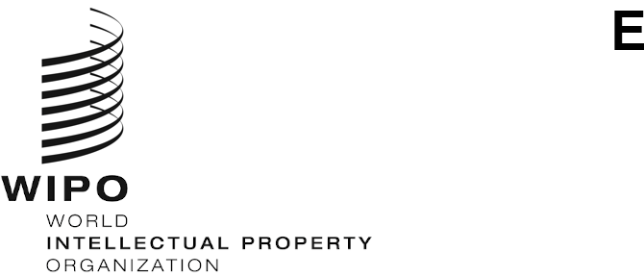
WIPO/GRTKF/IC/46/12
ORIGINAL: English
DATE: January 27, 2023

Intergovernmental Committee on Intellectual Property and Genetic Resources, Traditional Knowledge and Folklore

Forty-Sixth Session

Geneva, February 27 to March 3, 2023
JOINT RECOMMENDATION ON THE USE OF DATABASES FOR THE DEFENSIVE PROTECTION OF GENETIC RESOURCES AND TRADITIONAL KNOWLEDGE ASSOCIATED WITH GENETIC RESOURCES

Document submitted by the Delegations of Japan, the Republic of Korea and the United States of America

- On January 27, 2023, the International Bureau of the World Intellectual Property Organization (WIPO) received a request from the Permanent Mission of the United States of America to International Organizations in Geneva, on behalf of the Delegations of Japan, the Republic of Korea and the United States of America, to resubmit the “Joint Recommendation on the Use of Databases for the Defensive Protection of Genetic Resources and Traditional Knowledge Associated with Genetic Resources”, as contained in document WIPO/GRTKF/IC/45/11, for discussion by the Forty-Sixth Session of the Intergovernmental Committee on Intellectual Property and Genetic Resources, Traditional Knowledge and Folklore (IGC).

- Pursuant to the request above, the Annex to this document contains the proposal
referred to.

- The Committee is invited to take note of and consider the proposal in the Annex to this document.
[Annex follows]
JOINT RECOMMENDATION ON THE USE OF DATABASES FOR THE DEFENSIVE PROTECTION OF GENETIC RESOURCES AND TRADITIONAL KNOWLEDGE ASSOCIATED WITH GENETIC RESOURCES

The Intergovernmental Committee on Intellectual Property and Genetic Resources, Traditional Knowledge and Folklore and the General Assembly of the World Intellectual Property Organization,

Considering the decision of the 55th Session of the WIPO General Assembly to convene a Diplomatic Conference to conclude an International Legal Instrument Relating to Intellectual Property, Genetic Resources and Traditional Knowledge Associated with Genetic Resources, to be based on document WIPO/GRTKF/IC/43/5 in addition to any other contributions by Member States;

Reaffirming the important economic, scientific and commercial value of genetic resources and traditional knowledge associated with genetic resources;

Acknowledging the important contribution of the patent system to scientific research and development, innovation and economic development;

Recognizing the complementarity between the patent system and the Convention on Biological Diversity;

Stressing the need for Member States to prevent the erroneous grant of patents for inventions related to genetic resources and traditional knowledge associated with genetic resources;

Recommend that each Member State and the WIPO International Bureau consider the use of this Recommendation adopted by the Intergovernmental Committee on Intellectual Property and Genetic Resources, Traditional Knowledge and Folklore as guidelines for the establishment, improvement and use of databases for the defensive protection of genetic resources and traditional knowledge associated with genetic resources.

- INTRODUCTION

- The erroneous granting of patents has been identified as an important issue in discussions in the WIPO and the WTO.

- The erroneous granting of patents can be effectively addressed by improving databases for storing genetic resources and non-secret traditional knowledge associated with genetic resources that are used for prior art or reference material searches, as well as through utilizing certain existing institutional systems, such as information provision systems and the invalidation trial system more efficiently.

- A one-click database search system would help examiners conduct searches more efficiently for prior art or reference material concerned with genetic resources and non-secret traditional knowledge associated with genetic resources, while preventing inappropriate access to its contents by third parties.

- STRUCTURE OF THE ONE-CLICK DATABASE SEARCH SYSTEM

- As described in Figure 1 below, searchable databases under the proposed system should be in the possession of, and maintained by, each participating WIPO member state. The database will be composed of a WIPO portal site as well as databases of WIPO member states, which are linked to this portal site.

- Each participating WIPO member state will, as it deems necessary, collect information on genetic resources and non-secret traditional knowledge associated with genetic resources within its territory and store this information in its database/databases (either adapted from an existing database or newly created). Assigning the responsibility of the development of databases to each member state will allow each member state adequately take into account various sensitive issues, such as considerations for customary law, the identification of interested parties concerned and their willingness and condition for providing information, and coordination amongst multiple interested parties who claim entitlement to common genetic resources. In developing national databases, Member States should consult with relevant indigenous stakeholders in the territory prior to putting indigenous traditional knowledge and genetic resources from tribal lands into the databases. With regards to the format of a database, a basic format for registering data to the database should be developed by the WIPO, taking into account that the allowable format of prior art or reference material (e.g. written/oral form) may vary depending on each national patent law and practice. For example, entries to the database would have to include the name and a brief description of the genetic resource, as well as a code number to identify the said genetic resource. For genetic resources that have been referenced in a publication, such as a book or journal, the bibliographic data of the said publication should also be included in the database. Further work of the IGC may include the development of a uniform and interoperable format for information contained in the database.

- A simple text search function should be provided in the databases of each participating WIPO member state. For countries that are not able to develop such search programs, technical assistance can be provided. For example, technical assistance in the form of a common program for conducting searches can be provided by the WIPO.

- The WIPO portal site will be equipped with two basic functions: (i) a function which enables an examiner to directly access the databases of the participating WIPO member states and
(ii) a function which enables an examiner to retrieve data from the accessed databases.

- Simply by accessing the WIPO portal site and entering a search formula, an examiner can instantaneously obtain search results derived from the databases of all participating WIPO member states. (see Figure 2) This search result can be used as prior art or reference material for a patent application, enabling an examiner to determine more easily whether the subject matter of a patent application lacks novelty. As an examiner need only point to the necessary information in the database when rejecting an application under examination, the danger of information leakages would be minimal.

- While the languages used in databases differ, there are some possible solutions to the language barrier problem. For instance, the name and a brief description of each genetic resource in a database could (and should) be translated into English and registered in the database as keywords. The development of a multi-language glossary of technical terms is another possible solution. With a multi-language glossary of technical terms, an examiner is able to have a search keyword entered in certain language translated automatically into multiple languages and, then, using the translated keywords, can conduct a one-click multilingual search of the databases of the participating WIPO member states.

III. PREVENTION OF THIRD PARTY ACCESS

- To prevent third party access, the WIPO portal site will be made accessible only from registered IP (Internet Protocol) addresses. Specifically, an IP (Internet Protocol) Address Authentication System (IPAAS) will be incorporated into the WIPO portal site. Then, access will be provided only to registered IP (Internet Protocol) addresses. (See Figure 1.)

- IP Offices that conduct examinations have specific IP (Internet Protocol) addresses. Therefore, by restricting access to the WIPO portal site to specific IP (Internet Protocol) addresses, we can limit users of the site to those IP Offices that have registered their unique IP (Internet Protocol) addresses with WIPO.

- On the other hand, there is some truth in that stakeholders can contribute to preventing erroneous granting of patents, by conducting a prior art or reference material search for their own or interested patent applications. Given that, the possibility of allowing limited public access to the WIPO portal site should not be entirely excluded before a careful consideration is given to this issue.

IV. REGISTRATION OF CITED/REFERENCE INFORMATION

- When an examiner accesses the WIPO portal site, he might come across a relevant piece of information on genetic resources and/or non-secret traditional knowledge associated with genetic resources that would serve as prior art or reference information for a patent application under examination. In such a case, it would be valuable for the WIPO portal site to have a function enabling an examiner to add any data concerned with such an application
(e.g. the application number) under the code number of a relevant genetic resource and/or
non-secret traditional knowledge associated with genetic resources. In this way, a code number attached to a genetic resource and/or non-secret traditional knowledge associated with genetic resources and a relevant patent application number can be linked. Such data on patent applications linked with genetic resources and/or non-secret traditional knowledge associated with genetic resources could be used by interested parties to explore where patent applications related to the resources in question are filed with specific IP Offices. The interested parties,
(e.g., indigenous people) who provided information on the genetic resources and/or non-secret traditional knowledge associated with genetic resources concerned might be allowed through the examining authority or other competent authority to have access to such data on the relevant patent applications.

- It should be noted, however, that the data in a certain patent application being
cross-referenced with certain genetic resources and/or non-secret traditional knowledge associated with genetic resources in a database has no relevance to whether the invention in the application was made in compliance with CBD or not.

V. APPLICATION

- The establishment, improvement and use of databases will be subject to the availability of resources.

- Member States should provide adequate and effective legal, policy or administrative measures, as appropriate and in accordance with national law, to facilitate the application of this Recommendation. This should include guidance to examiners on the use of the database and the confidentiality of documents contained in it.

VI. FUTURE WORK

- Member states are invited to consider and share their views and experiences on the following key issues:

- Structured data to be stored in databases (e.g. genetic resources and non-secret traditional knowledge associated with genetic resources) with a view to conducting effective prior art search,
- Allowable format of prior art or reference material (e.g. written form and oral form) in accordance with each national law and practice;
- The accessibility to the WIPO portal website (e.g. IP Offices and stakeholders);
- The impact the national database has on genetic resources and non-secret traditional knowledge associated with genetic resources protected under tribal or IP laws
(e.g. third party unlawfully accesses a national database or WIPO portal); and
- The process used to populate a national database (e.g. consulting with indigenous stakeholders).

- The WIPO International Bureau should consider exploring the development of the database without prejudice. The feasibility studies to be conducted by the WIPO International Bureau should include, but are not limited to:

- Study of technical requirement(s) for an effective connection between the WIPO portal site and databases of member states,
- Creating a prototype of the WIPO portal site and a draft guideline on the use and function of DB, and;
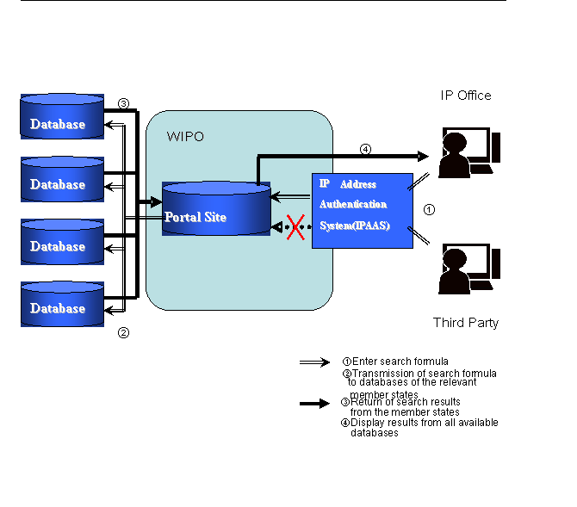
- Consideration of technical assistance to member states on the development of database.
Figure 1: Overview of One-Click Database Search System for individual Databases of WIPO Member States

Figure 2: Image of a retrieval screen

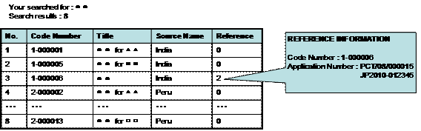

[End of Annex and of document]

Reference material includes information not available to the public which can be used only by an examiner as references for determining patentability.

