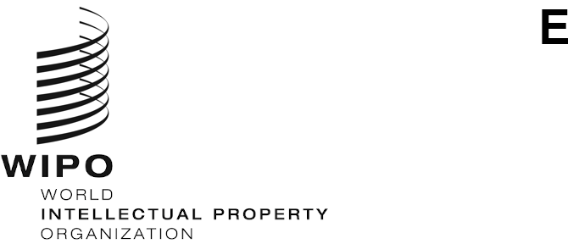
PCT/WG/14/6
ORIGINAL: English
DATE: May 12, 2021

Patent Cooperation Treaty (PCT) Working Group

Fourteenth Session

Geneva, June 14 to 17, 2021

IP5 PCT Collaborative Search and Examination: Status Report
Document prepared by the European Patent Office

Summary
- This document reports on the progress of the third pilot project on collaborative search and examination under the PCT (“CS&E”) among the IP5 Offices (the European Patent Office (EPO), the Japan Patent Office (JPO), the Korean Intellectual Property Office (KIPO), the China National Intellectual Property Administration (CNIPA) and the United States Patent and Trademark Office (USPTO)).

Background
- At its third session in June 2010, the PCT Working Group endorsed a series of recommendations to improve the functioning of the PCT as listed in document PCT/WG/4/3. The recommendation under paragraph 165(b) mentions trials of arrangements whereby examiners in International Authorities with complementary skills work together to establish a report.
- With this aim, KIPO, the USPTO and the EPO launched two pilot projects on collaborative search and examination under the PCT (CS&E) in 2010 and 2012. Both pilots concluded with an overall very positive outcome in terms of quality and efficiency for both the participating Offices and users whose applications were treated under the collaborative scheme (see documents PCT/MIA/18/7, PCT/MIA/20/4 and PCT/MIA/24/3).

Framework
- On June 2, 2016, the IP5 Heads endorsed the “IP5 Cooperation Framework on Collaborative Search and Examination under the PCT”, which is a document setting the underlying principles and main features of the third pilot. The Collaborative Search and Examination Pilot Group (“CS&E Pilot Group”) established on the basis of that document is in charge of developing and monitoring this project.
- The main features of this pilot project are in particular:
- an applicant-driven approach: the applications processed during this pilot are selected by applicants;

- a balanced workload distribution: all collaborating International Authorities contribute to the establishment of each CS&E work product; each Office will process up to 100 international applications in its role as “main International Searching Authority” and up to 400 international applications in its role as “peer International Searching Authority” over two years;

- a common set of quality and operational standards is applied by all collaborating International Authorities when processing PCT applications;

- the use of a “collaborative tool”, i.e. an IT infrastructure allowing exchanges among Offices in a secure environment and automated data collection; and

- the possibility for the collaborating International Authorities to accept, at some point in time during the pilot, also applications filed in a language other than English.
- In this pilot project, the examiner from the Office acting as competent International Searching Authority under PCT Rule 35 for a given international application (“the main examiner”) conducted the search and examination as for any other international application and established a provisional international search report and written opinion. These provisional work products were then transmitted to peer examiners from the other participating Offices in their capacity as International Searching Authorities. Peer examiners provided the main examiner with their contributions, taking into consideration the provisional international search report and written opinion. The final international search report and written opinion were established by the main examiner after consideration of the contributions from the peer examiners.

State of Play
- This pilot project is divided into three phases: a preparatory phase, an operational phase and an evaluation phase.
- The operational phase - dedicated to the processing of applications under the collaborative scheme - ran smoothly from July 1, 2018 to June 30, 2020, in spite of the operational challenges resulting from the need of manual workarounds to process CS&E files and especially peer contributions. The USPTO and KIPO reached the ceiling of 100 applications in January 2020 and the EPO reached it in April 2020. On June 30, 2020, the JPO and CNIPA stopped accepting requests to participate in the pilot. Applications in all six official languages of the participating ISAs have been accepted and successfully processed in the pilot. A total of 468 applications have been accepted into the pilot and the same number of international search reports have been established in collaborative mode. The final operational CS&E results are summarized in the table below:
Accepted applications | CS&E search reports per ISA | Receiving Offices | Languages | Technological fields
468 | CN: 93  JP: 75  KR: 100  US: 100  EP: 100 | CN – 92  EP – 32  IB – 42  JP – 60  KR – 26  US – 216 | de – 13  en – 413  fr – 2  ja – 20  ko – 3  zh – 17 | A – 87  B – 53  C – 62  D – 6  E – 10  F – 14  G – 145  H – 91

- On July 1, 2020, the pilot entered the evaluation phase during which the IP5 Offices are assessing the entry of international applications processed collaboratively into their respective national or regional phases and reporting on the agreed set of quality and operational indicators. In 2021, the International Bureau will survey pilot participants using a questionnaire agreed upon by the IP5 Offices. In addition, the IP5 Offices will consult their interested user groups to obtain further feedback. The Pilot Group is also looking into the various financial scenarios that could sustain the CS&E concept in the PCT framework. This will eventually form part of the final report due to be presented to the IP5 Heads of Office by the end of the pilot.
- Since the IP5 Cooperation Framework on Collaborative Search and Examination under the PCT provides that the period of cooperation was set for a maximum of five years, the evaluation phase had been initially scheduled to end in June 2021. However, at the 13th IP5 Heads of Office meeting held by videoconference on July 21, 2020, it was decided to extend the evaluation phase by an additional year up to June 2022. The information gathered during the evaluation phase will be critical when making the general evaluation of the CS&E concept. More information on the outcome of the pilot could be shared with the PCT Working Group next year.
- The Working Group is invited to take note of the contents of the present document.
[End of document]

