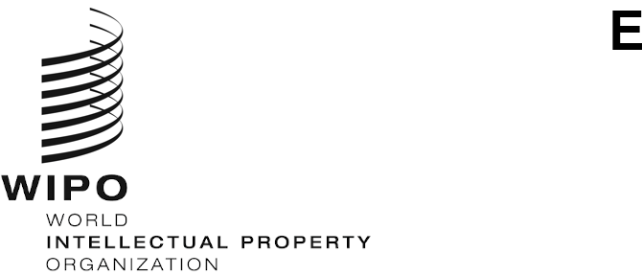
PCT/WG/13/3 Rev.
ORIGINAL: English
DATE: September 8, 2020

Patent Cooperation Treaty (PCT) Working Group

Thirteenth Session
Geneva, October 5 to 8, 2020

International Applications Linked to United Nations Security Council Sanctions
Document prepared by the International Bureau
This document reproduces document PCT/WG/13/3, but with a change to the dates of this session of the Working Group. The reporting of relevant events in paragraph 3 reflects the status at the publication date of this document.

Monitoring of Sanctions
- At the eleventh session of the PCT Working Group, held in June 2018, the International Bureau gave an overview of the measures taken to comply with various sanctions imposed by the United Nations Security Council (see document PCT/WG/11/14 and paragraphs 40 to 43 of document PCT/WG/11/26).
- The Chair concluded, inter alia, that (paragraph 44(c) of document PCT/WG/11/26):
“Delegations supported the subject of UN sanctions remaining on the agenda of the PCT Working Group, with the International Bureau providing a report to Member States of any relevant events at the next session of the Working Group. Such reports should not include details of applications that were not open to public inspection, which would be contrary to PCT Article 30 concerning the confidential nature of an international application before international publication.”
- Since the twelfth session of the PCT Working Group, the monitoring process set up by the International Bureau with respect to all individuals and entities subject to sanctions measures imposed by the Security Council of the United Nations did not reveal that applicants named in PCT international applications implicate any such designated individual or entity.
- The Working Group is invited to note the contents of this document.
[End of document]

