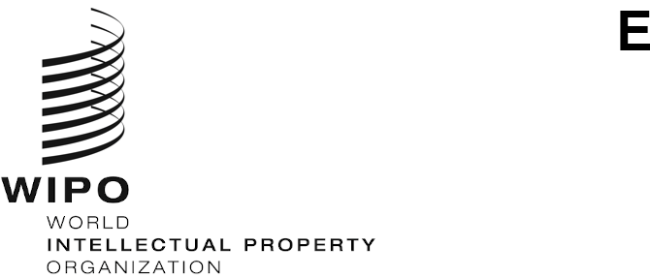
PCT/MIA/28/7
ORIGINAL: English Only
DATE: March 12, 2021

Meeting of International Authorities
under the Patent Cooperation Treaty (PCT)

Twenty-Eighth Session

Geneva, March 24 to 26, 2021

Proposal to Promote the Improvement of the International Search Report and the Written Opinion
Document prepared by the China National Intellectual Property Administration

Summary
- Following the proposal at the twenty-seventh session of the Meeting, International Authorities are invited to comment on the preliminary statistics of the feedback of the survey on the International Search Report (ISR) and the Written Opinion (WOSA) as well as next steps proposed by the China National Intellectual Property Administration (CNIPA).

Background
- At the twenty-sixth session of the Meeting of International Authorities in February 2019, the CNIPA proposed to design a questionnaire and conduct a survey with a view to improving the layout, content and format of the ISR and the WOSA, so as to promote the improvement of the quality of ISR and the WOSA (see document PCT/MIA/26/11). The CNIPA proposed to implement related work in the following three steps: designing a questionnaire; conducting a survey; and completing an analysis report to raise potential areas and/or specific suggestions to aid in future improvement of the ISR and WOSA at the practical level based on the survey results. At the twenty-seventh session of the Meeting in February 2020, the ISAs agreed to discuss the content and methodology of the survey on the Quality Subgroup electronic forum with a view to reaching agreement to conduct the survey (see paragraph 39 of document PCT/MIA/27/16).

Implementation of the Survey
- In the first half of 2020, the CNIPA revised questionnaires and methodology of the survey based on the feedback from the ISAs, and further solicited comments from all ISAs via the Quality Subgroup electronic forum in June 2020. Based on the agreed questionnaires and survey methodology, the International Bureau issued Circulars C. PCT 1607 and C. PCT 1608 to ISAs and PCT users in October 2020, inviting them to participate the survey regarding the improvement of the ISR and WOSA. By the end of January 2021, the International Bureau received 20 responses from PCT ISAs and 33 responses from PCT users, including 7 user organizations and 26 PCT designated Offices (DOs) and elected Offices (EOs).
- In order to respond the Circulars, the CNIPA conducted the survey by distributing the questionnaires to all PCT international phase examiners and PCT DO/EO examiners. In total, 2,837 raw responses were received, 883 of which were from PCT international phase examiners and 1,954 were from PCT DO/EO examiners. The final responses of the CNIPA were established as the summary and aggregation of the raw responses.

Preliminary Statistics of Survey Results
- The questionnaires for PCT ISA examiners and PCT users both consisted of four sections, which are questions for the layout, content, format and other comments. The numbers of substantial comments/suggestions raised by respondents in each section are as follows:
 | Substantial comments/  suggestions from PCT ISA examiners | Substantial comments/  suggestions from PCT users
Comments on the layout | 33 | 34
Comments on the content | 31 | 32
Comments on the format | 17 | 19
Other comments | 31 | 32

- The preliminary statistics above shows the comments/suggestions mainly focus on the modification of specific boxes, wording and writing requirements of forms.

Next Steps
- On the basis of the responses, the CNIPA will lead the analysis of the responses and the establishment of a report on suggestions for the improvement of the ISR and the WOSA with the input from International Authorities. The CNIPA proposes the schedule as follows:
  - By August 2021, the CNIPA will establish the draft report.
  - By September 2021, the CNIPA will solicit comments and suggestions from ISAs on the draft report via the Quality Subgroup electronic forum.
  - By November 2021, the CNIPA will revise the report considering the feedback from ISAs.
  - By December 2021, the CNIPA will collect comments from ISAs regarding the revised report via the Quality Subgroup electronic forum.

  - In early 2022, the CNIPA will report to PCT MIA meeting.
- The Meeting is invited to comment on the proposed schedule contained in paragraph 7 of the document.

[End of document]

