E
pct/mia/22/6
ORIGINAL: English Only
DATE: December 15, 2014

Meeting of International Authorities
under the Patent Cooperation Treaty (PCT)

Twenty-Second Session
Tokyo, February 4 to 6, 2015

Review of the Supplementary International Search System

Document prepared by the International Bureau

- The PCT Assembly (“the Assembly”), at its thirty-sixth session in September/ October 2007, amended the PCT Regulations to introduce a supplementary international search system. These amendments entered into force on January 1, 2009 (document PCT/A/36/13).
- At its forty-third session in October 2012, the Assembly reviewed the supplementary international system. The decision by the Assembly after this review is set out in paragraph 27 of document PCT/A/43/7 as follows:
“27. The Assembly, having reviewed the supplementary international search system three years after the date of entry into force of the system, decided:
(a) to invite the International Bureau to continue to closely monitor the system for a period of another three years, and to continue to report to the Meeting of International Authorities and the Working Group on how the system is developing;
(b) to invite the International Bureau, International Authorities and national Offices and user groups to increase their efforts to raise awareness of and promote the service to users of the PCT system;

(c) to invite the International Authorities which offer supplementary international searches to consider reviewing the scope of their services provided under the system and consequently the levels of fees charged for the services provided, which should be reasonable; and to invite Authorities which currently do not offer the service to reconsider whether to offer the service in the near future;
(d) to review the system again in 2015, taking into account further developments until then, notably in relation to efforts to move towards collaborative search and examination models and in relation to efforts to improve the quality of the “main” international search.”
- To gather information and feedback on the supplementary international search system to prepare the review decided by the Assembly in paragraph 27(d) of document PCT/A/43/7, the International Bureau sent Circular C. PCT 1429, dated October 23, 2014, to Offices in their various capacities (receiving Office, International Searching and Preliminary Examining Authority and/or designated/elected Office), and certain intergovernmental and non-governmental organizations representing users of the PCT system. This Circular, reproduced in the Annex to this document, provides an update on the supplementary international search system and invites comments through a questionnaire by December 19, 2014.

- A preliminary report on the responses received in reply to Circular C. PCT 1429 will be present orally to the Meeting.
- The International Authorities are invited to provide feedback on the issues and questions set out in Circular C. PCT 1429, reproduced in the Annex to this document.

[Annex follows]

REVIEW OF THE SUPPLEMENTARY INTERNATIONAL SEARCH SYSTEM
(reproduced from Circular C. PCT 1429)

C.PCT 1429 | October 23, 2014

Madam,
Sir,

Review of the Supplementary International Search System
- This Circular is addressed to your Office in its capacity as a receiving Office, International Searching and Preliminary Examining Authority and/or designated or elected Office under the Patent Cooperation Treaty (PCT). It is also addressed to certain intergovernmental and non-governmental organizations representing users of the PCT system.
- The PCT Assembly, at its forty-third session in October 2012 reviewed the supplementary international search system. The decision by the Assembly following this review is set out in paragraph 27 of document PCT/A/43/7 as follows:
“27. The Assembly, having reviewed the supplementary international search system three years after the date of entry into force of the system, decided:
(a) to invite the International Bureau to continue to closely monitor the system for a period of another three years, and to continue to report to the Meeting of International Authorities and the Working Group on how the system is developing;
(b) to invite the International Bureau, International Authorities and national Offices and user groups to increase their efforts to raise awareness of and promote the service to users of the PCT system;
(c) to invite the International Authorities which offer supplementary international searches to consider reviewing the scope of their services provided under the system and consequently the levels of fees charged for the services provided, which should be reasonable; and to invite Authorities which currently do not offer the service to reconsider whether to offer the service in the near future;
(d) to review the system again in 2015, taking into account further developments until then, notably in relation to efforts to move towards collaborative search and examination models and in relation to efforts to improve the quality of the “main” international search.”
- In line with the above decision, the International Bureau reported on the development of the supplementary international search system to the Meeting of International Authorities (document PCT/MIA/20/5) and the Working Group (document PCT/WG/6/5) at their sessions in 2013. Discussions at these meetings are detailed in the reports of the sessions, see paragraphs 27 to 33 of document PCT/MIA/20/14, and paragraphs 318 to 335 of document PCT/WG/6/24. An update on the supplementary international search system to take into account developments since the discussions in 2013 is provided in Annex I to this Circular.

/...
- The primary purpose of this Circular is to gather further information and feedback on the functioning of the supplementary international search system to prepare the review of the system decided by the Assembly in paragraph 27(d) of document PCT/A/43/7. The preliminary findings will be presented for further discussion at the next session of the Meeting of International Authorities under the PCT, provisionally scheduled to take place in February 2015. The feedback received in response to the Circular and the results of the deliberations at the Meeting of International Authorities will be used as input to discussions at the next session of the PCT Working Group (to be held in May/June 2015) before the PCT Assembly reviews the supplementary international search system at its session in September/October 2015.
- You are kindly requested to complete the Questionnaire attached in Annex II to this Circular and to return it to the International Bureau, or to submit any other comments you may have on the issues raised in the Questionnaire, by December 19, 2014, preferably by e-mail to my colleague Mr. Claus Matthes, Director, PCT Business Development Division (e-mail: pctbdd@wipo.int; fax: (+41 22) 338 7150). Responses to this Questionnaire may be submitted in any of the six official languages of the United Nations (Arabic, Chinese, English, French, Russian and Spanish).
./.
- In general, any response received in reply to this Circular will be presented in an anonymous fashion in the report to be submitted to the PCT Assembly or documents for the PCT Working Group or Meeting of International Authorities; individual responses from Offices or user organizations will not be attributed without the specific prior permission of the relevant Office or organization.
Yours sincerely,

James Pooley
Deputy Director General

Enclosures: Annex I – Update on the supplementary international search system
Annex II – Questionnaire
Update on the Supplementary International Search System
International Authorities offering supplementary international search

Six International Authorities offer supplementary international searches. The Federal Service for Intellectual Property, Patents and Trademarks of the Russian Federation (ROSPATENT; SISA/RU), the Nordic Patent Institute (SISA/XN) and the Swedish Patent and Registration Office (SISA/SE) have offered supplementary international searches since the entry into force of the system on January 1, 2009. The National Board of Patents and Registration of Finland (SISA/FI) became a Supplementary International Searching Authority on January 1, 2010, followed by the European Patent Office (SISA/EP) and the Austrian Patent Office (SISA/AT), which began offering the service on July 1, 2010, and August 1, 2010, respectively.

Languages accepted for supplementary international search

All six International Authorities which offer supplementary international searches accept international applications which are filed in, or have been translated into, English. Other languages accepted for supplementary international search include: Danish (SISA/SE and SISA/XN); Finnish (SISA/FI); French (SISA/EP and SISA/AT); German (SISA/EP and SISA/AT); Icelandic (SISA/XN); Norwegian (SISA/SE and SISA/XN); Swedish (SISA/SE, SISA/FI and SISA/XN) and Russian (SISA/RU).

Documentation covered by Supplementary International Search

The documentation covered by the supplementary international search varies between International Authorities. For some International Authorities, a supplementary international search can be limited to documentation in specific languages where examiners at the Supplementary International Searching Authority have particular language capabilities and expertise: SISA/RU offers a supplementary international search in patent document collections in Russian from countries of the former Soviet Union; SISA/AT offers a supplementary international search of only the German documentation or of only the European and North American documentation; and SISA/XN offers a supplementary international search of only the documents in Danish, Icelandic, Norwegian and Swedish held in the search collection of the Authority. All three of these Authorities also offer a supplementary international search covering the PCT minimum documentation in certain instances, either by applicant choice according to the level of fee paid (SISA/AT), or else in cases where the “main” International Searching Authority has issued a declaration under PCT Article 17(2)(a) that no international search report will be established (SISA/RU).

All other Supplementary International Searching Authorities always perform a complete new search equivalent to the “main” international search, covering at least the entire PCT minimum documentation as well as whatever further documentation in local or other languages would also usually be searched.

Fees charged for Supplementary International Search

SISA/RU charges two levels of supplementary international search fee, one being specifically for searches related to methods of treatment where a declaration from the International Searching Authority has been made under Article 17(2)(a), which costs 60 per cent more than the standard supplementary search fee; both these supplementary search fees are higher than the “main” search fee for international applications in Russian but lower than “main” search fee for international applications in English. SISA/AT provides three levels of fees between 46 and 92 per cent of the fee it charges for the “main” international search, depending on the documentation covered (German documentation only, European and North American documentation only, PCT minimum documentation). SISA/XN charges a fee of less than 30 per cent of the “main” international search when the search is limited to the documents in Danish, Icelandic, Norwegian and Swedish held in the collections of the Authority; for full searches covering these documents and the PCT minimum documentation, the supplementary search fee is the same as the “main” search fee. All other Authorities, all of which always search (at least) the entire PCT minimum documentation for the supplementary international search, charge the same level of fees for supplementary searches as they do for the “main” international searches.

Requests for Supplementary International Search by International Searching Authority

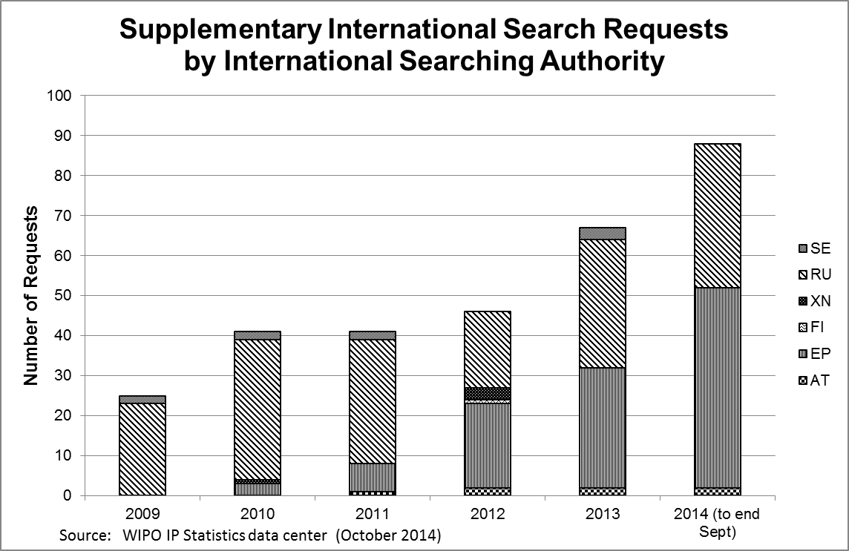
Figure 1: Supplementary International Search Requests by International Searching Authority

Figure 1 shows that since the previous review of the system in 2012, the number of supplementary international search requests received each year has risen; the total so far in 2014 is approximately double that received at the time of previous review. The total does, however, remain very low compared to the number of new international applications filed. More than 90 per cent of all requests have selected either the Federal Service for Intellectual Property, Patents and Trademarks of the Russian Federation (Rospatent) or the European Patent Office (EPO) to perform the supplementary international search. Figure 2 shows the initial International Searching Authority for applications from these two Supplementary International Searching Authorities.

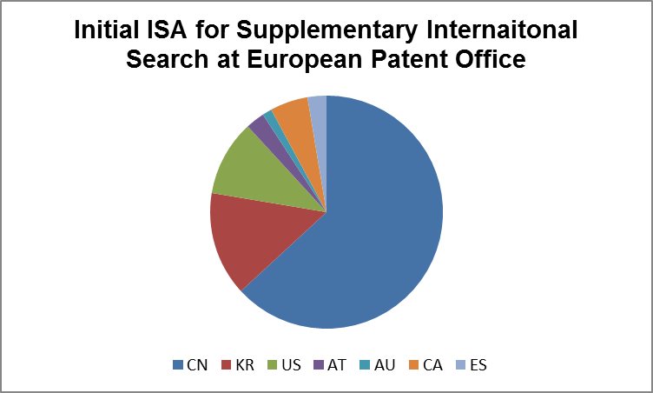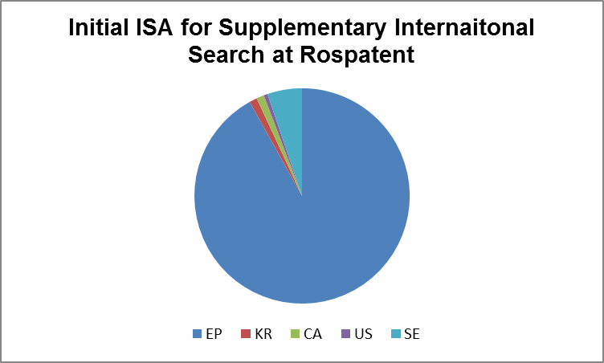
Figure 2: Distribution of Initial International Searching Authority for Supplementary International Search Requests at the European Patent Office and the Federal Service for Intellectual Property, Patents and Trademarks of the Russian Federation

Applicants requesting Supplementary International Search

Since the service began in 2009, about 40 applicants have filed a request for supplementary international search. Based on published international applications, about one quarter of the applicants that have requested supplementary international search have filed two or more requests and more than two thirds of all requests have originated from just two of these applicants. Amongst applicants who have requested more than one supplementary international search, some have used the service for the first time since 2012 when the previous review was conducted, but others have not made a request for supplementary search since 2012.

The top applicant has requested about half of all supplementary international search requests, consistently selecting Rospatent to perform the supplementary search. This indicates that supplementary international search was requested by this applicant to have particular documentation held by this Authority searched by an examiner who would have knowledge of Russian at the level of a native speaker.

Possible Reasons for Requesting Supplementary International Search

Where applications include a supplementary international search, the information on the “main” and supplementary International Searching Authority indicates that one reason for applicants requesting supplementary international search is to have prior art documentation in certain languages searched by an examiner with a strong knowledge of these languages. In some cases, this documentation may not be part of the PCT minimum documentation. The languages understood by examiners could therefore play a role in the combination of the “main” International Searching Authority and supplementary International Searching Authority chosen for an international application.

Other examples of requests for supplementary international search included cases where a finding by the International Searching Authority that the international application lacked unity of invention and the applicant requested the supplementary international search in respect of the inventions not searched during the “main” international search. In some cases, the request for supplementary international search was followed by a demand for international preliminary examination containing amendments of the international application. There has also been at least one supplementary international search request following a declaration by “main” International Searching Authority under Article 17(2)(a) because of subject matter relating to a method of treatment referred to Rule 39.1(iv). Furthermore, supplementary international search may also be requested as it provides an opportunity to obtain a further opinion on the application from a different examiner at another International Searching Authority, particularly at an Authority that is not competent for the applicant’s receiving Office.

Activities by the International Bureau to Raise Awareness of the Supplementary International Search System

The International Bureau continues its efforts to raise awareness of the supplementary international search system by providing information on the service as part of its PCT seminar training program and other user outreach and promotional activities. Information on the supplementary international search system has also been included in PCT Brief, a resource on the Internet which contains a high level overview of recent and future developments in the PCT for managers and attorneys as the main target readership, along with hyperlinks to more in depth information if needed. Moreover, an episode of the “Learn the PCT” video series available on the WIPO web site and on YouTube is dedicated to supplementary international search. Furthermore, as requested at the Meeting of International Authorities in 2013 (see paragraph 30 of document PCT/MIA/20/14), the International Bureau has modified Form PCT/ISA/220 with effect from July 1, 2014 to remind users about the time limit and procedures for requesting supplementary international search.

Developments in Collaborative Search and Examination Models

With regard to the review of the supplementary international search system to be carried out in 2015, the Assembly decided that this review should take into account further developments in relation to efforts to move towards collaborative search and examination models (see paragraph 27(d) of document PCT/A/43/7). At the Meeting of International Authorities in February 2014, the European Patent Office presented an oral update on the Collaborative Search and Examination Pilot project it had carried out with the Korean Intellectual Property Office and the United States Patent and Trademark Office (see paragraphs 60 to 64 of document PCT/MIA/21/22). Having performed two pilot projects, the European Patent Office had been reviewing the methodology of the project with a view to possibly launching a third pilot. This pilot would be applicant-driven so as to assess real the interest of users better and review the impact of the project in the regional and national phases.

QUESTIONNAIRE

THE SUPPLEMENTARY INTERNATIONAL SEARCH SYSTEM

Part A: Questions for International Authorities Offering Supplementary International Searches

A1. If your Office in its capacity as an International Authority offers supplementary international searches, what are your main experiences with the system?

A2. If your Office offers different types of supplementary international searches, in which ones were applicants most interested?

A3. If your Office accepts several languages for supplementary international searches, in which languages were most supplementary international searches carried out?

A4. Were there, in your opinion, specific reasons for applicants to request supplementary international searches at your Office (interest in specific documentation or subject matter, interest in another full search)?

A5. Did your Office carry out supplementary international searches in cases where the “main” International Searching Authority had issued a declaration under PCT Article 17(2)(a) that no international search report will be established? If so, to which subject matter did the international application relate?

A6. When carrying out supplementary international searches, did your Office take the international search report in account? If so, to which extent? If not, why not? Please elaborate.

A7. Were the findings in the supplementary international search reports different from those in the “main” international search reports?

A8. If documents found during the supplementary international searches were different from those found during the “main” international search, please elaborate on possible reasons. For example, were other documents found because the supplementary international search was carried out in documentation in specific languages or in documentation other than the minimum documentation? Or was the supplementary international search essentially the same as the “main” international search, but different parameters were used, such as different classification symbols?

A9. In which cases did your Office find the supplementary international search particularly useful for applicants (in addition to the “main” international search)?

Part B: Questions for International Authorities Currently not Offering Supplementary International Searches

B1. What are the main reasons for your Office not offering supplementary international searches?

B2. Does your Office intend to offer supplementary international search in the near future? If so, please further explain the supplementary international search service your Office intends to offer.

Part C: Questions for all Offices

C1. Does your Office in its capacity as a designated Office have any experiences with international applications entering the national phase in respect of which a supplementary international search report had been established? If so, what are your main experiences with the system?

C2. What, in your view, are the main reasons for the low uptake of supplementary international search system?

C3. Do you have any further suggestions on how the awareness of the supplementary international search service among applicants could be improved?

C4. Do you have any suggestions what should be changed so that the supplementary international search system better meets users’ needs?

C5. Do you have any further suggestions on ways of improving the overall attractiveness of the system for PCT applicants?

Part D: Questions for Users of the PCT System

D1. Are you aware of the supplementary international search system and have you considered using it?

D2. If you have used the supplementary international search system, what are your main experiences with that system?

D3. If you have used the supplementary international search system, would you consider using it again? If so, please specify the circumstances in which you would consider requesting supplementary international search again. If not, please specify the reasons why not.

D4. If you have not yet used the supplementary international search system, what are the main reasons for not doing so?

D5. Would you consider requesting supplementary international searches if specific Offices, which do not yet offer supplementary international search, would offer this service? If so, could you specify why this would make the supplementary international search service more attractive for you?

D6. Are you interested in supplementary international searches being carried out in specific other languages (at present, the International Authorities offering supplementary international search currently offer the service for international application filed in, or translated into, English, French, German, Danish, Finnish, Swedish, Icelandic, Norwegian and Russian)?

D7. Are you interested in supplementary international searches being carried out in specific subject matter? If so, please specify.

D8. What, in your view, are the main reasons for the low uptake of the supplementary international search system (such as lack of awareness, detailed knowledge, costs of the service, documentation covered in the “main” international search report sufficient not to warrant a further search)?

D9. Do you have any suggestions on how the awareness of the supplementary international search service among users could be improved?

D10. Do you have any suggestions what should be changed so that the supplementary international search system better meets users’ needs?

D11. Do you have any suggestions for alternative ways in which the objective of increasing the scope of prior art searched effectively during the international phase could be achieved more effectively?

D12. Do you have any further suggestions on ways of improving the overall attractiveness of the system for PCT applicants?

[End of Annex and of document]

