E
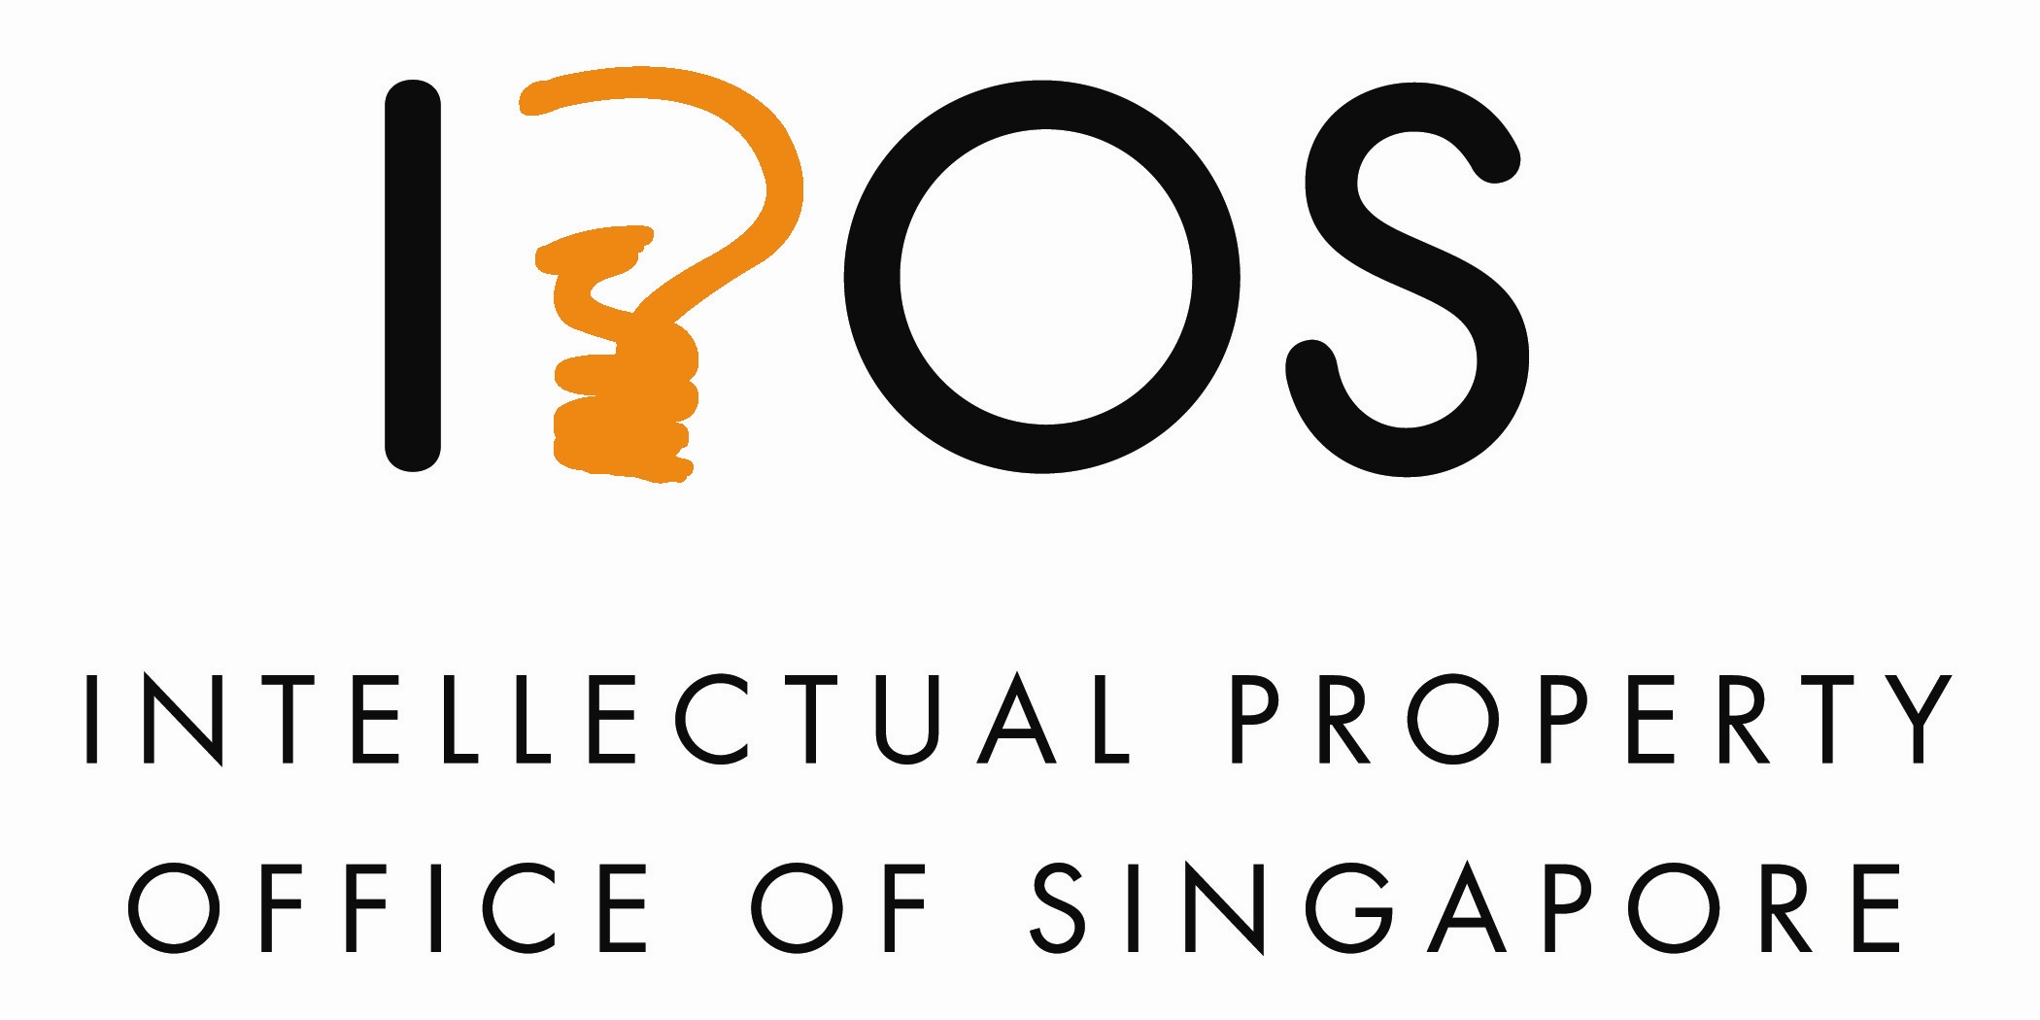 | 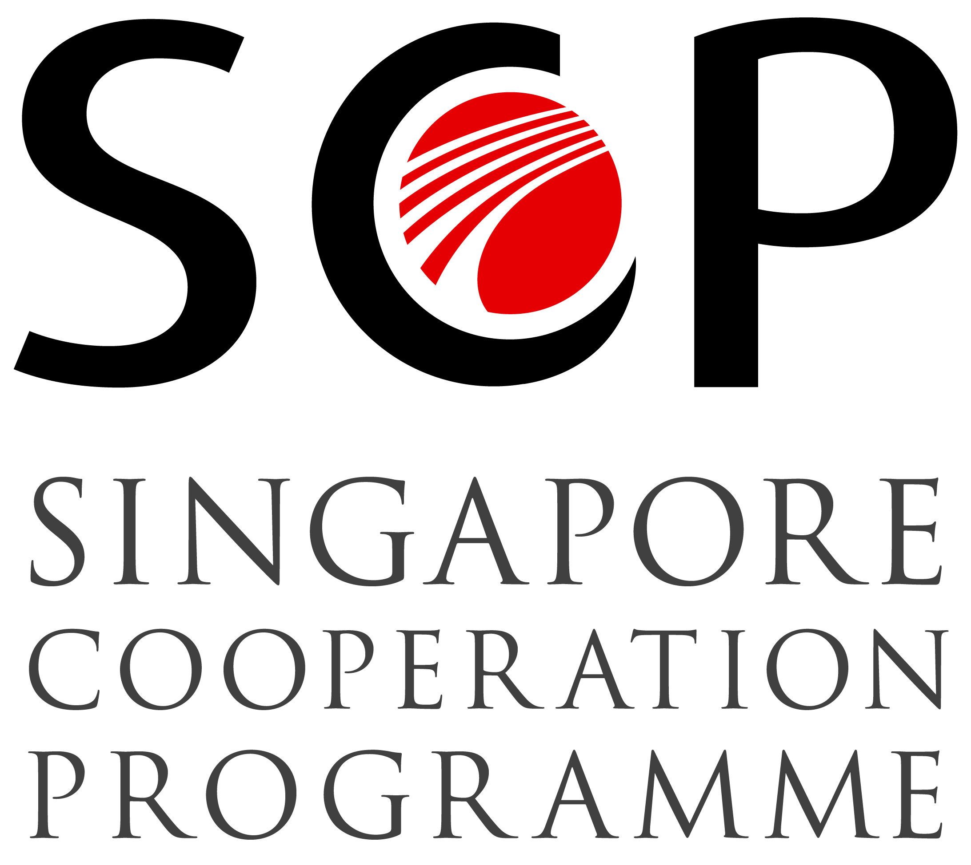 | 
Regional seminar
WIPO/reg/IP/SIN/13/inf/1
ORIGINAL: English
DATE: august 21, 2013

Best Practices in Patent Work Sharing, Examination and Promotion

organized by
the World Intellectual Property Organization (WIPO)

in cooperation with
the Singapore Cooperation Programme of the Singapore Ministry of Foreign Affairs

and with the assistance of
the Intellectual Property Office of Singapore (IPOS)

Singapore, August 26 and 27, 2013

PROVISIONAL Program

prepared by the Secretariat

Monday, August 26, 2013 – Venue: WIPO Singapore Office

9.30 – 10.00 | Registration
10.00 – 10.30 | Opening Ceremony
 | Opening remarks by:
 | Mr. Francis Gurry, Director General, World Intellectual Property Organization
 | BG (NS) Tan Yih San, Chief Executive, Intellectual Property Office of Singapore
 | Ms. Sharon Chan, Deputy Director, Technical Cooperation Directorate, Ministry of Foreign Affairs, Singapore
10.30 – 10.45 | Coffee Break
10.45 – 11.15 | Topic 1: | Global trends in patent filings
 | Speaker: | Mr. Matthew Bryan, Director, Patent Cooperation Treaty (PCT) Legal Division , WIPO, Geneva
11.15 – 12.00 | Topic 2a: | Benefits of patent work sharing arrangements:  - ASEAN - ASPEC  - Patent Prosecution Highways (PPH)
 | Speakers: | - Ms. Sandra Merinda, Senior Assistant Director, Registry of Patents, IPOS
- Mr. Bong Hoon Lee, Deputy Director, Patent Examination and Policy Division, Korean Intellectual Property Office
- Mr. Paolo Trevisan, Attorney-Advisor, Office of Policy and External Affairs, USPTO
- Mr. Zhang Xian Feng, Patent Manager, SIPO
12.00 – 12.45 | Topic 2b: | Benefits of patent work sharing arrangements: the PCT as a work sharing mechanism
 | Speaker: | Mr. Matthew Bryan, WIPO
12.45 – 13.45 | Lunch Break
13.45 – 14.45 | Topic 3: | Establishing best practice on searching and examination techniques:  - sharing of national experiences in searching techniques
 | Speakers: | - Mr. Keith Porter, Policy Officer, International Policy & Cooperation, IP Australia  - Mr. Le Huy Anh, Patent Division No. 2, National Office of Intellectual Property of Vietnam  - Madam Norsita Ismail, Intellectual Property Corporation of Malaysia
14.45 – 15.30 | Topic 4: | Similarities and differences in patent law and practices: spotlight on software patents
 | Speaker: | Mr. Paolo Trevisan, USPTO
15.30 – 15.45 | Coffee Break
15.45 – 16.45 | Topic 5: | PCT International search and examination guidelines: a potential model for best practice search and examination
 | Speaker: | Mr. Matthew Bryan, WIPO
16.45 – 17.30 | Topic 6: | WIPO CASE Update
 | Speakers: | - Mr. Peter Willimott, Senior Program Officer, WIPO Singapore Office  - Mr. Keith Porter, IP Australia  - Mr. William Meredith, Director, IP Office Business Solutions Division, WIPO, Geneva (via video conference)
17.30 | WIPO Reception

Tuesday, August 27, 2013 – Venue: Cassia Room (3306 &3206),_Marina Bay Sands Convention Centre

8.45 - 9.30 |  | Global IP Forum (Marina Bay Sands Convention Centre) Registration, networking and morning coffee
9.30 – 9.45 |  | Welcome Address by Chairman of IP Week@SG 2013
9.45 – 10.00 |  | Opening Address by Guest-of-Honour
10.00 – 11.00 | Keynote Panel Discussion 1 | The Changing Global Innovation Landscape: Whither IP?
11.00 – 11.30 | Coffee Break
11.30 – 13.00 | Keynote Panel Discussion 2 | Global IP Perspectives and Strategies
13.00 – 14.00 | Networking lunch
14.00 – 15.15  (Level 3,  #3306 & 3206 Cassia Room) | Topic 7: | Key considerations for patent filing strategies, benefits of patent work sharing and suggestions for better use – users’ perspectives
 | Moderator: | Ms. Sandra Merinda, IPOS
 | Speakers: | - Mr. Shinji Komai, General Manager/Patent Attorney, Intellectual Property Department, Sumitomo Osaka Cement Co. Ltd.  - Mr. Shun Hara, Patent Attorney/Program Manager, Intellectual Property Group, Hitachi, Ltd.  - Mr. Akimichi Tanabe, President and CEO/Japanese Patent Attorney, felicite IP Consulting Singapore Pte. Ltd.  - Ms. Tan Hui Leng, Patent Agent, Drew & Napier LLC
15.15 – 15.30 | Coffee Break
15.30 – 16.15 | Topic 8: | Promoting the use of patents and PCT – IP Offices’ perspective
 | Moderator: | Mr. Peter Willimott, WIPO
 | Speakers: | Roundtable discussion of national experiences
16.15 – 16.45 | Topic 9: | Wrap-up Session
 | Moderator: | Mr. Matthew Bryan, WIPO
 | Speakers: | All participants and speakers
16.45 | Closing Ceremony

[End of document]

