E
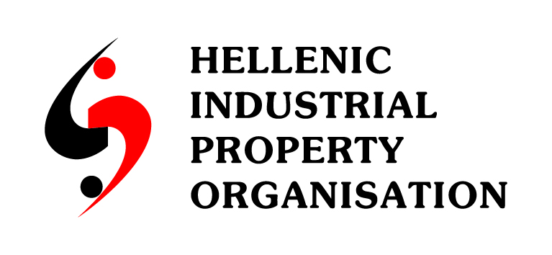 | 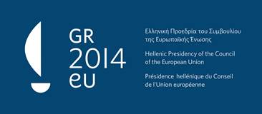
international conference
WIPO/IP/ATH/14/INF/1 Prov.
ORIGINAL: english
DATE: april 2014

Intellectual Property and Health Innovation − Challenges for the Future

organized by
the World Intellectual Property Organization

and
the Hellenic Industrial Property Organization (OBI)

Athens, April 28, 2014

provisional program

8:30 – 9:00 Registration

9:00 – 9:15 OPENING SESSION

Chaired
by: Ms. Lia Athanasiou, Professor, Law School, Kapodistrean, University Athens, Athens

Welcome addresses by:

Μr. Athanasios Skordas, Deputy Minister for Development and Competitiveness, Athens

Professor Constantine Polyzogopoulos, President, Administrative Council, Hellenic Industrial Property Organization (OBI), Athens

9:15 – 9:30 Key note Speech: Intellectual Property, Innovation and Health: The Need for
Equilibrium

Mr. Francis Gurry, Director General, World Intellectual Property Organization (WIPO), Geneva

9.30 – 13.00 SESSION I

Chaired
by: Ms. Lia Athanasiou

9:30 – 10:00 Topic 1: Medical Innovation

Speaker: Mr. Paolo Macchiarini, Professor, Director of Advanced Center for
Regenerative Medicine, Karolinska Institute, Stockholm

10:00 – 10:40 Topic 2: Promoting Access to Medical Technologies and Innovation

Speakers: Dr. Peter Beyer, Senior Advisor, World Health Organization
(WHO), Geneva

Mr. Anthony Taubman, Director, Intellectual Property Division
World Trade Organization (WTO), Geneva

10:40 – 11:00 Topic 3: Exceptions and Limitations to Patent Rights; Patent-related
Flexibilities under TRIPS and Doha Declaration

Speaker: Ms. Catherine Margellou, Director, Legal Support, Industrial
Property Organization (OBI), Athens

11:00 – 11:30 Coffee Break

11:30 – 12:00 Topic 4: Research and Innovation in Drug Discovery and Diagnostics.
Challenges and Problems.

Speaker: Dr. Alexander Pintzas, Director, Institute of Biology, Medicinal
Chemistry and Biotechnology, National Hellenic Research
Foundation, Athens

12:00 – 12:30 Topic 5: Commercializing research into patentable Inventions; Intellectual
Property Strategy

Speaker: Mr. Konstantinos Frouzis, President of the Hellenic Association of
Pharmaceutical Companies (SFEE), Athens

12:30 – 13:00 Topic 6: Open Innovation Collaboration in Pharmaceutical Research

Speaker: Mr. Andrew-Stephen Brown, Head of Intellectual
Property Department, Pharmathen Pharmaceuticals, Athens

13:00 – 14:30 Lunch Break

14.30 – 17.30 SESSION II

Chaired
by: Ms. Aristea Sinanioti-Maroudi, Professor, Commercial
Law, University of Piraeus, Athens, Greece

14:30 – 15:00 Topic 7: The EU Public Health Policy Ensuring Access to Medicines

Speaker: Μr. Sib Hayer, Policy Advisor, Intellectual Property & Public
Procurement Unit, DG Trade, European Commission, Brussels

15:00 – 15:30 Topic 8: New Business Models in Financing Innovation; Public-Private
Partnerships; WIPO Re:Search

Speaker: Mr. Thomas Bombelles, Head, Global Health, WIPO

15:30 – 16:00 Topic 9: Competition Policy; Enforcement Issues

Speaker: Mr. Paul Csiszár, Director of Basic Industries, Manufacturing and
Agriculture, DG Competition, European Commission, Brussels

16:00 – 16:30 Coffee Break

16:30 – 17:30 Topic 10: Panel Discussion: The Role of Patents in Fostering Health
Innovation and Access to Medicines

Moderator: Dr. Nikolaos Lyberis, Managing Partner, Law Firm Vayanos Kostopoulos, Athens

Panelists: Mr. Andrew-Stephen Brown, Head of Intellectual Property
Department, Pharmathen Pharmaceuticals

Mr. Georgios Kourgias, Legal Counsel & Compliance Manager, AbbVie Pharmaceuticals S.A.

Dr. Paschalis Sideras, PhD, Investigator A, Director, Centre of Clinical, Experimental Surgery and Translational Research, Biomedical Research Foundation Academy of Athens (BRFAA)

Mr. Thomas Bombelles

Μr. Sib Hayer

17:30 – 18:00 CLOSING SESSION

