Ellen ’t Hoen is a lawyer and an independent consultant in medicines policy and law. She has particular expertise in the area of access to medicines and intellectual property. Her most recent achievement is the establishment in 2010 of the Medicines Patent Pool to accelerate the availability of low cost HIV treatments in developing countries through patent licensing. She is a visiting fellow at the University of Amsterdam and an advisor to the Medicines Patent Poool.

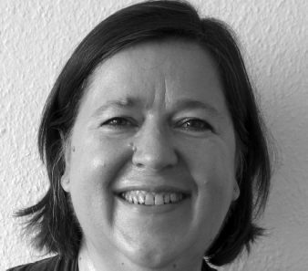

From 1999 until 2009 she was the Director of Policy and Advocacy at Médecins sans Frontières’ (MSF) Campaign for Access to Essential Medicines.

In 2009 she became the Senior Adviser for Intellectual Property and Medicines Patent Pool at WHO/UNITAID, where she set up the Medicines Patent Pool which aims at brokering and making available patent licenses to antiretroviral medicines with the purpose of increasing access to low-cost and better adapted ARVs in developing countries. She was the executive-director of the Medicines Patent Pool until June 2012.

She won several awards for her work on the effects of exposure to the drug (DES) in the 1980s and 1990s, including the prestigious Harriet Freezerring award in 1989. In 2005, 2006, 2010 and 2011 she was listed as one of the 50 most influential people in intellectual property in the world by the journal Managing Intellectual Property. On 10 December 2012 her TEDx talk about bringing medical advances to people in the developing world was posted as ‘Talk of the Day” on TED.COM.

She authored the book "The Global Politics of Pharmaceutical Monopoly Power. Drug patents, access, innovation and the application of the WTO Doha Declaration on TRIPS and Public Health." which was published by ABM Press in 2009.

She is a member of the World Health Organization’s Expert Advisory Panel on Drug Policies and Management, a member of the advisory board of Universities Allied for Essential Medicines (UAEM) and a member of the editorial board of the Journal for Public Health Policy.

Ellen F.M. ‘t Hoen, LLM
e-mail: ellenthoen.ip@gmail.com
Skype: efmthoen
Twitter: @ellenthoen

