Mr. Eduardo Bitran Colodro  Professor, Engineering School, University Adolfo Ibañez, Santiago de Chile  Mr. Eduardo Bitran Colodro has hold academic positions in the Department of Industrial Engineering of the University of Chile and Engineering School of University Adolfo Ibáñez. He was Minister of Public Works of Chile, CEO of CORFO the Chilean Innovation Agency, President of the National Council of Innovation, and CEO of Fundación Chile, an innovation and company builder institution. Currently he is the President of Club de Innovación, the oldest private innovation hub in Chile, as well as the Professor of innovation at University Adolfo Ibáñez. | 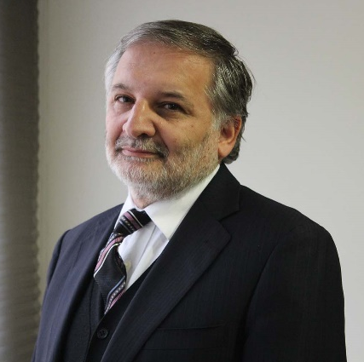
Ms. Pamela Chávez Crooker  Biotech Researcher and Entrepreneur, Founder of Aguamarina and Chief Executive Officer (CEO) of Domolif, Santiago de Chile  Ms. Pamela Chávez Crooker, is an Aquaculture Engineer, she holds a MSc., in Aquatic Microbiology, a Ph.D. in Molecular Microbiology and Biotechnology from Kyoto University, Japan and a Post Doctorate in Cellular Physiology in Heavy Metals from the University of Hawaii, at Manoa, United States of America (U.S.). She holds a diploma in Technologies, Innovation and Business from Adolfo Ibañez University, Executive Business Program ECLA (Competitiveness of Entrepreneurship in Latin America) at Columbia University, Columbia Business School in New York City. She also has a diploma in Female Leadership, IESE Business School, Spain. | 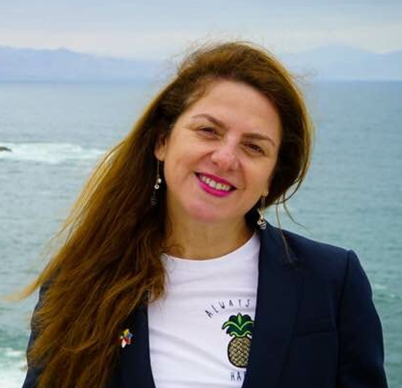

Ms. Joëlle Noailly  Head of Research of the Centre for International Environmental Studies (CIES), Lecturer, International Economics, Graduate Institute of Geneva, and Associate Professor in Environmental Economics at the Vrije Universiteit (VU), Amsterdam  Ms. Joëlle Noailly is Head of Research of the Centre for International Environmental Studies (CIES) and Lecturer in the Department of International Economics at the Graduate Institute. She also holds an appointment as Associate Professor in Environmental Economics at the Vrije Universiteit (VU) Amsterdam. Her research helps inform policymaking on issues of green growth, energy transition, net-zero carbon pathways, financing breakthrough innovation and technology transfers to the developing world. Ms. Joëlle Noailly holds a PhD in environmental and resource economics from the Vrije Universiteit Amsterdam, an M.Phil in economics from the Tinbergen Institute, and a M.Sc in environmental economics from the University of Delaware, U.S. | 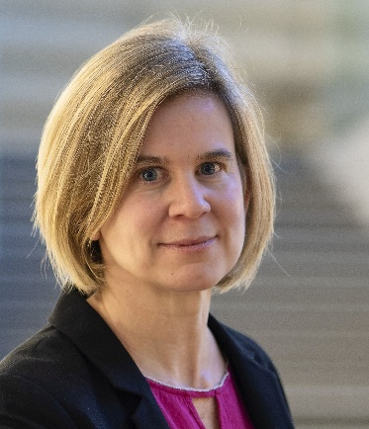
Mr. José Ignacio Noguera Gómez  Vice-President, Corporate Affairs and Sustainability, GCM Mining, Medellín, Colombia  Mr. José Ignacio Noguera Gómez is Vice-President of Corporate Affairs and Sustainability of GCM Mining. He is also President of Gran Colombia Gold Segovia, Sucursal Colombia and President of the Board of the Colombian Mining Association. Mr. Noguera Gómez is a Lawyer who right now is studying a Master in Global Leadership at Yale University. He previously did a Master in Business Administration and a postgraduate in insurance law. He started his career in the mining sector with Prodeco S.A. Glencore Swiss Limited, then at ExxonMobil in different positions such as Lawyer for Colombia, Central America and the Caribbean and later as Manager of Public Affairs and Government. Additionally, he is a university professor in different institutions in the areas of Energy, Geopolitics , Public Affairs and Commercial Law | 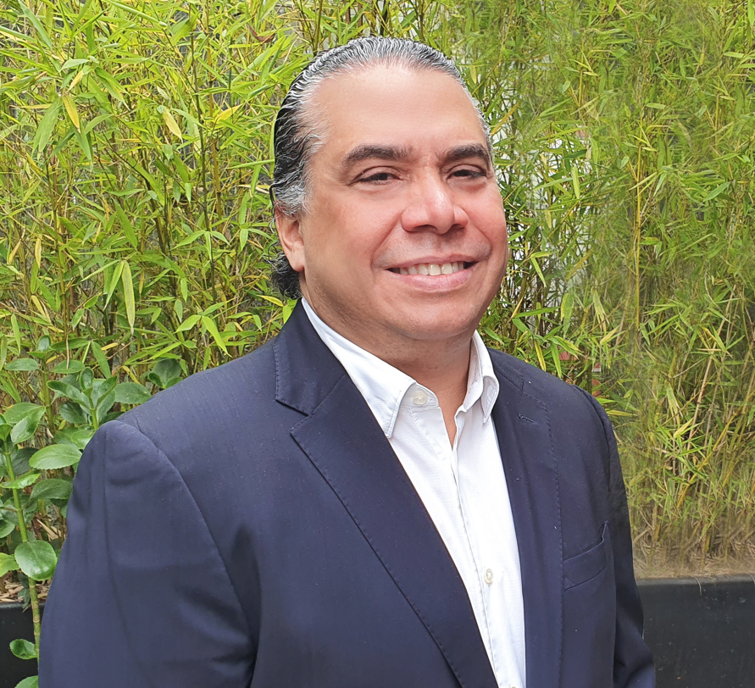

Mr. Carl Weatherell  Executive Director and CEO, Canada Mining Innovation Council (CMIC), Ottawa, Canada  Mr. Carl Weatherell is a natural connector bringing together disparate and seemingly unrelated people, groups, and organizations to transform possibilities into plans and plans into action. Mr. Weatherell focuses on collaboration and building innovation ecosystems to solve complex problems. His experience includes over 30 consortia comprised of more than 500 organizations from businesses, government, and academia, spanning industries from software, microelectronics, cybersecurity, photonics, aerospace and defence, and mining. He has won awards for breakthrough leadership and technology transfer and holds an M.Sc. from Carleton University and a B.Sc. from the University of Waterloo. | 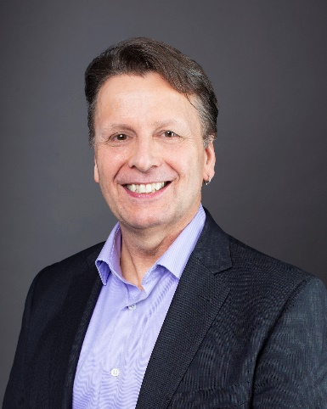
Mr. David Humphreys  Honorary Lecturer, Centre for Energy, Petroleum and Mineral Law and Policy (CEPMLP), University of Dundee, Dundee United Kingdom  Mr. David Humphreys was Chief Economist of the Global Mining Company Rio Tinto to 2004 and of Norilsk Nickel, Russia’s largest miner, until the end of 2008. He has written and lectured extensively on the economics of the mining and metals industries, authoring over two hundred articles and papers and the book, The Remaking of the Mining Industry (2015). He has been a Visiting Scholar at the Colorado School of Mines, the Catholic University of Chile, the Transatlantic Academy in Washington D.C., U.S., and is an Honorary Lecturer at the Centre for Energy, Petroleum and Mineral Law and Policy (CEPMLP) at the University of Dundee. He has a PhD from the University of Wales. | 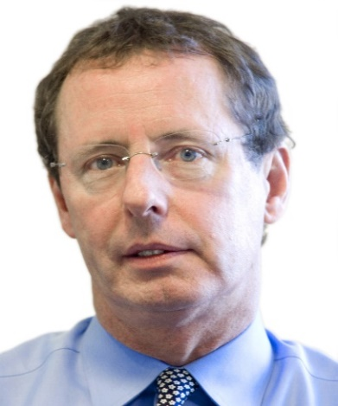
Ms. Giulia Valacchi  WIPO Consultant, Department for Economics and Data Analytics (DEDA), Innovation Ecosystems Sector, WIPO, Geneva  Ms. Giulia Valacchi is an external Consultant and former Research Fellow in the Innovation Economics Section at the Department for Economics and Data Analytics, IP and Innovation Ecosystems Sector of the World Intellectual Property Organization (WIPO), Geneva. Her research interests are in the field of environmental economics. | 