E
WIPO/ACE/9/7
ORIGINAL: eNGLISH
DATE: JANUARY 28, 2014

Advisory Committee on Enforcement
Ninth Session
Geneva, March 3 to 5, 2014

INTELLECTUAL PROPERTY Alternative Dispute Resolution IN THE REPUBLIC OF KOREA

prepared by Ms. Yang Jeonghwa, Deputy Director, Multilateral Affairs Division, Korea Intellectual Property Office (KIPO), Republic of Korea

Overview of Alternative Dispute Resolution in the republic of korea

Alternative Dispute Resolution (ADR) is an umbrella term for procedures, other than judicial determination, in which an impartial person (an ADR practitioner) assists those in a dispute to resolve the issues between them. The main types of ADR are mediation, arbitration and conciliation.

Mediation

Mediation occurs when one or both participants ask a mediator to be fair and independent when assisting the participants in order to resolve the dispute. The dispute is resolved when the mediation results in a workable agreement to which the participants agree. Since mediation is not binding, if the participants do not agree to the result, the procedure comes to an end. Interestingly, Korean laws provide for a Dispute Resolution Committee in almost every government organization. For example, the Industrial Property Right Dispute Mediation Committee is provided under the Invention Promotion Act to the Korea Intellectual Property Office (KIPO). Also, the Construction Dispute Resolution Committee is provided under the Construction Industry Act to the Ministry of Land, Transport and Maritime Affairs. There are many such Dispute Resolution Committees in the Korean government.

Arbitration

Arbitration is a procedure where an arbitrator decides the concerned dispute, not the court. In the Republic of Korea, we have the “Arbitration Law”. The Ministry of Justice is the competent authority for this Law. Most of the arbitration cases, especially the disputes between private parties, go to the Korean Commercial Arbitration Board (KCAB). The KCAB follows the Arbitration Law. It also provides mediation between private parties. Arbitrations may occur under the Arbitration Commissions concerning certain matters under specific laws (e.g., Press Arbitration Commission, Korea Medical Dispute Mediation and Arbitration Agency).
You may find more information about KCAB at http://www.kcab.or.kr/jsp/kcab_eng/index.jsp.

Conciliation

Conciliation occurs when the parties work out the disputed issues and enter into an agreement to conclude the dispute. There are three ways to conciliate: i) disputed parties may conciliate under Rule 731 of the Civil Procedures Code, ii) one of the parties may request for conciliation in the civil court before the lawsuit under Rule 385 of the Civil Procedures Code, iii) even if the lawsuit proceeds, the court may order for conciliation under Rule 225 of the Civil Procedures Code.

Overview of Industrial Property Right Dispute Mediation Committee

Current developments in the industry are calling for different forms of dispute resolution systems. The traditional courts may not be suitable for increasingly complicated matters. This is the reason why the Industrial Property Right Dispute Mediation Committee (IPRDMC) was established under KIPO in 1995. The Vice Commissioner of KIPO is the Chairman of the IPRDMC. The Committee consists of twenty members, including the Chairman. The Committee members are patent attorneys in specific fields (e.g. trademark, design, mechanic, chemical, bio, electronic, etc.), IP lawyers, professors and KIPO examiners. The term lasts three years.

IPRDMC covers disputes concerning industrial property rights (including patent, utility model, industrial design, and trademarks) as well as employee inventions. Since the declaratory judgment of invalidity, non-infringement, and unenforceability are matters referred to the Patent Court, these claims are not subject to mediation. Disputes in relation to copyright, another area of intellectual property, are covered by the Korea Copyright Commission in the Ministry of Culture, Sports and Tourism.

The IPRMDC mediation procedure is as follows:

Step 1) a party to a dispute applies for mediation,
Step 2) IPRDMC appoints three mediators,
Step 3) IPRDMC notifies the request for mediation to the other party,
(respondent may or may not participate),
Step 4) if the respondent agrees to participate, IPRDMC investigates the dispute
and prepares a proposal,
Step 5) IPRDMC communicates the proposal to both parties,
Step 6) if the parties agree to the proposal, IPRDMC writes a conciliation protocol, and
Step 7) if one of the parties does not agree to the proposal or decides not to
participate in mediation (Step3), the procedure is terminated.

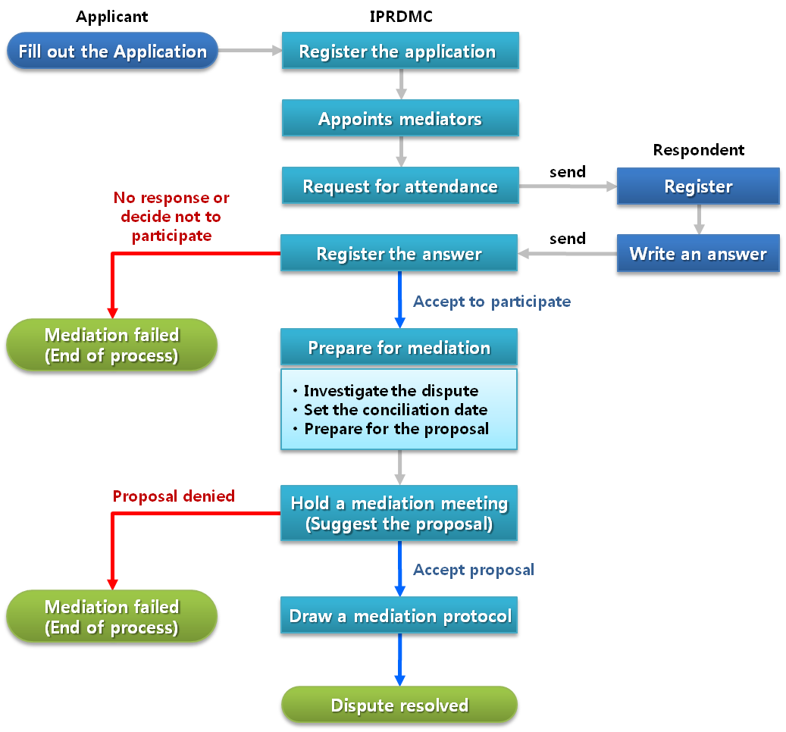

When the mediation is successful, it is binding under Rule 46 of the Invention Promotion Act. It provides the same effect as the court’s conciliation order.

The application process for the mediation of industrial property rights is easy and free of charge. Also, if mediation is successful, the dispute may be resolved in three months. Because it is confidential, there is less likelihood of disclosure of business secrets, including technology. It is also favorable in the sense that the parties can enter into strategic cooperation with each other, such as cross licensing and technology cooperation during the mediation process.

The following chart shows the caseload of the IPRDMC.

(Number of cases and outcome)

Year | Applications | Successful | Failed
’95 | 4 | 2 | 2
’96 | 2 | 0 | 2
’97 | 13 | 7 | 6
’98 | 15 | 4 | 11
’99 | 7 | 3 | 4
’00 | 5 | 0 | 5
’01 | 3 | 0 | 3
’02 | 15 | 2 | 13
’03 | 5 | 1 | 4
’04 | 5 | 1 | 4
’05 | 5 | 0 | 5
’06 | 5 | 1 | 4
’07 | 5 | 1 | 4
’08 | 4 | 0 | 4
’09 | 4 | 1 | 3
’10 | 3 | 0 | 3
’11 | 2 | 0 | 2
’12 | 2 | 2 | 0
’13 | 3 | 2 | 1
Total | 107 | 27 | 80

Mediation by IPRDMC is not so vibrant. Upon mediation applications hitting the 15-case mark in 1998, it gradually declined to a mere two to three cases per year. There have been only 27 cases of finalized mediations in the past 19 years. Therefore, KIPO is keen to invigorate the mediation procedure.

First, mediation is voluntary so it may not proceed if any of the parties refuse to partake in it. Also, the mediation proposal may not be adopted if one party does not agree to it.

Second, it is difficult to prove infringement of the industrial property rights in comparison to other infringements. For example, infringement of copyright is not so difficult to prove since downloading itself is an infringement. Mediation may proceed if the parties agree on the damages. However, if a party has to prove infringement, it is not easy to make the other party admit to the infringement as well as to continue the mediation process.

Third, IPRDMC does not cover disputes concerning invalidity, non-infringement, and unenforceability claims. However, these claims are often contested when there is an infringement lawsuit. Under the Invention Promotion Act, the Patent Court has jurisdiction over these disputes, because they not only concern the disputing parties, but also concern the third party who wishes to sign a license agreement regarding the industrial rights. This is why invalidity, non-infringement, and unenforceability claims cannot be subject to mediation.

Fourth, a court may order a huge sum of damages. If the infringement of industrial property right is proven, the damages may be quite large. In this case, the winning party would not easily agree to the mediation proposal. Damages for copyright infringement, however, are quite low compared to industrial property damages. This is also why the number of mediation is high in copyright.

Plan to invigorate mediation of industrial property right dispute mediation

KIPO wants to invigorate the mediation of industrial property right disputes in order to reduce social costs, including excessive expenditures associated with litigation and to promote independent and smooth dispute resolution among the parties.

To this end, KIPO plans to pursue mediation with IPRDMC and with the courts. Mediation with the courts is a system where, when there are cases appropriate for mediation among cases filed with the court, the court forwards the case to an external dispute mediation body so that mediation can precede a full-fledged litigation. When mediation is successful, the dispute is resolved through mediation, and if mediation is not successful, then the case proceeds to litigation. To invigorate mediation, Korea’s Seoul Central District Court currently conducts mediation in conjunction with more than 10 external dispute mediation bodies, including the Copyright Commission and KCAB.

However, as explained in the foregoing, unlike other areas of mediation, mediation of disputes in industrial property right is not conducive to easy determination of infringement and involves large amounts. In addition, certain cases are simply not suitable for mediation. As a result, the parties prefer dispute resolution through trial. It is therefore necessary to proceed with caution when the mediation option with courts is pursued.

Nevertheless, the parties’ choice has been broadened by expanding the subjects of mediation from disputes related to industrial property rights that are currently registered to pending industrial property and trade secrets.

Additionally, KIPO plans to strengthen the level of expertise in mediation by establishing and operating a secretariat that provides support to dispute mediation, such as dispute-related consultation, dispute investigation, and drafting of mediation proposal.

In addition, by executing business cooperation agreements with corporations and organizations that need mediation, KIPO plans to encourage resolution through industrial property rights dispute mediation prior to litigation, thereby enhancing public accessibility and understanding.

[End of document]

