E
WIPO/ACE/9/17
ORIGINAL: Spanish
DATE: january 20, 2014

Advisory Committee on Enforcement
Ninth Session
Geneva, March 3 to 5, 2014

Report on the Campaigns of the Copyright Directorate – PERU (2013)

prepared by the National Institute for the Defense of Competition and Intellectual Property Protection (INDECOPI), Peru*

Experience acquired in promoting the legal use of software BY SMEs: Rated AS good governance in the 2013 edition of the Good Governance Competition organized by the Ciudadanos al Día organization

Model for the formalization of small and medium enterprises (SMEs) regarding the legal use of software in Peru: the model is based on successive campaigns through which the National Institute for the Defense of Competition and the Protection of Intellectual Property (INDECOPI), via its Copyright Directorate, sends messages (letters) to corporate databases, provided by various software owners, in order to raise awareness and persuade them to use properly licensed software (licensing of software parks), thereby complying with copyright and intellectual property legislation.

It is a unique model designed to achieve greater efficiency in the management of the Copyright Directorate, which is the administrative authority responsible for supervising the use of legal software in Peru.

It allows INDECOPI to generate measurable results in the short term, which gives impetus to the registered hardware, software and services information technology market. It helps INDECOPI to play the role of a promoter of a culture of respect and protection of copyright and intellectual property.

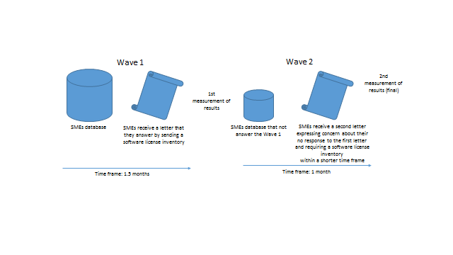
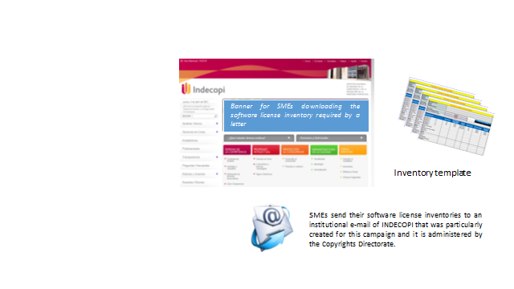
Results for 2012:

In 2012, we conducted three campaigns to promote the use of legal software by sending a total of 4,300 information and prevention letters to SMEs.

Impact:

- 1st Campaign in March and April: 235 companies obtained licenses for their software parks.
- 2nd Campaign June to August: 167 companies obtained licenses for their software parks.
- 3rd Campaign September and October: 305 companies obtained licenses for their software parks.
- 4th Campaign November and December: 123 companies obtained licenses for their software parks.

The rate of licensing was 19%. The response rate was 41%.

Assuming that each SME has an average of 8 PCs, 6,640 workstations were licensed in 2012.

Given that 4,300 SMEs received information and prevention letters and given that 19% of software were regularized (817 companies with an average of 8 PCs each) as a result of the INDECOPI campaigns in 2012, it is estimated that the industry earned an income amounting to some US$3.6 million.

There was a 39% increase in the number of transactions in the licensed software marketing sector. There was a 59% increase in sales in the number of duly registered SMEs marketing licensed software. There was a 15% increase in the number of registered companies selling hardware, software and IT services to SMEs.

Anti-Piracy CRUSADE: Experience of joint action with the private audiovisual sector to conduct campaigns and operations against the illegal sale of films

Together with representatives of the audiovisual industry, the Copyright Directorate led the Anti-Piracy Crusade, a joint private and public effort to combat the mass reproduction and distribution of audiovisual works protected by copyright law.

Its action plan can be summarized as follows:

- It led to the promulgation of a regulation that declares anti-piracy to be a matter of national interest, as with other crimes of high social impact, giving a further boost to anti-piracy efforts through the involvement of a variety of agencies. This initiative came into being through the enactment of Supreme Decree 009-2006-PRODUCE published in the official newspaper El Peruano on May 4, 2006.

- The Anti-Piracy Crusade promoted the enactment of Law No. 28289 to buttress anti-piracy action in the face of increasing piracy, resulting in increased inspections by the Central Command to Combat Piracy and Customs Crimes in copy, printing and sales centers not only in Lima, but in the hinterland of the country, with the assistance of the National Police of Peru being requested for this purpose.

- It involved municipalities in repressive action and education with a view to promoting the consumption of legal products in the various municipalities nationwide. Several municipalities of metropolitan Lima have signed undertakings to combat piracy in their respective jurisdictions.

- The joint efforts continued with La Superintendencia Nacional de Aduanas y de Administración Tributaria (SUNAT) to conduct anti-piracy operations supported by the National Police and the Public Prosecutor’s Office.

- The interventions increased in customs areas with the cooperation of suppliers who can report the existence of illegal goods prior to customs clearance.

- The conducting of training sessions on intellectual property for the police, prosecutors and judges.

- It led to promote the creation of more specialized prosecutor’s offices nationwide.

- In the summer, letters were sent to the various summer resorts, informing them of copyright legislation and the need to create a culture of respect for intellectual property, spreading the message that no copying and/or distribution or public communication outside the legal framework should be permitted.

“Buy Legal, Buy Original” Campaign: Offer of legal products from the various cultural sectors through the Internet and social networks as an alternative to pirated products

The website “Buy Legal, Buy Original” is a technological tool that allows users to access information related to the illegal activities of piracy, counterfeiting and smuggling, the legal mechanisms available for the protection of creations, and information on the registered places or establishments offering legal and original products or services.

This new tool allows all registered businesses that provide services or sell original products in the Peruvian market to register, providing their contact details.

When they visit the “Buy Legal, Buy Original” website, consumers may access a list of registered establishments and choose the best option for purchasing original products, in open opposition to piracy, counterfeiting and smuggling.

“Buy Legal, Buy Original” is an initiative of the National Commission to Combat Customs Fraud and Piracy and INDECOPI, with the support of USAID Project “Facilitating Trade”, a new joint effort to disseminate information useful for all users interested in purchasing original cultural products and licensed services.

Campaign to reduce illegal use of broadcast signals and audiovisual productions and works

INDECOPI has been endeavoring to achieve proper enforcement of intellectual property rights recognized in both national law and the international treaties and in the commitments made by the Peruvian government in signing the various Free Trade Agreements (FTAs).

The Copyright Directorate, pursuant to the legal authority with which it is vested under Article 38 of Legislative Decree No. 1033, is the authority empowered to exercise monitoring and inspection functions in regard to the activities which may give rise to the exercise of the rights enshrined in copyright legislation, and is accordingly empowered to order the necessary measures seeking to verify the circumstances of the use of software installed on computer equipment.

The Copyright Directorate has required the cooperation of the companies providing cable services in an action to monitor compliance with regulations on the use of audiovisual works, as well as of content that is protected by copyright legislation the signals of which are relayed through the cable operator’s network under the control of the cable operator and require licenses from the right holders.

Hence, cable operators have been required to review the status of the contracts signed by the companies owning the rights, by which means they are authorized to distribute content (audiovisual works that they transmit and relay) and send us a detailed description of these contracts and licenses authorizing their sale.

Also, the Copyright Directorate has informed cable operators that the distribution, public communication or making available of works protected by copyright law, such as movies and TV shows, among others, without the permission of the right holders, constitutes an illegal act punishable by a fine of up to 180 ITUs (US$657,000), without prejudice to criminal proceedings being instituted under Articles 217 and 218 of the Peruvian Criminal Code.

Campaign to promote the legal use of music and movies in overland transportation services

Public transport companies providing passenger services are required to comply with copyright law, particularly in cases of public communication of musical and audiovisual works (films and TV in general) during journeys on public vehicles.

Public transport companies are regularly reminded to prohibit the screening of films and/or music protected by copyright laws in any of the vehicles belonging to the business.

Through the Copyright Directorate, INDECOPI has waged intense campaigns seeking, among other things, to instill and promote due respect for copyright and a genuine culture of intellectual property protection, which implies compliance with the regulations set forth in Legislative Decree No. 822 – Copyright Law, in accordance with the guidelines outlined below, indicating that communicating in public a private musical or audiovisual work, whether it is fixed on a CD or DVD, requires the prior authorization of the author or owner of the work or the collecting society that represents it. Also, the public transmission of a work performed in a public setting, such as a transport company, a terminal or bus station and vehicles, must have the prior written consent of the authors of the works or of the collecting society.

The campaigns targeted at public transport companies provide information on the prohibition of the unauthorized use, both at the terminal and on the respective vehicles, of works (music or film) protected by copyright, for which a license can be obtained from the copyright holders represented in the country.

Similarly, the campaign seeks to impress upon the general public that piracy constitutes theft and is a felony, causes enormous damage to the country, eliminates jobs in registered companies and affects our development potential. Thus everyone should work together to create awareness of a culture of respect for intellectual property.

Educational project to establish a culture of respect for intellectual property in schools nationwide: rated good governance PRACTICE in 2012 in THE GOOD GOVERNANCE COMPETITION organized by Ciudadanos al Día (Citizens Daily)

In 2011 and 2012, the project was launched by INDECOPI in cooperation with the USAID Project “Facilitating Trade”, the Regional Centre for Book Development in Latin America and the Caribbean (CERLALC) and the Ministry of Education.

The pilot program has been deployed in schools in Piura, Lima, Iquitos, Arequipa and Chiclayo, reaching 600 teachers and 21,000 students.

In this way, it will be possible to create awareness about the importance and benefits of intellectual property and promote an appreciation of creativity through the development of tools for entertainment and education.

This plan includes the methodological guide “Peru = Genius + Creativity”, cartoons and audiovisual material.

Through this tool, awareness is created to respect intellectual property, so that students value existing creative potential and this is transmuted into internationally recognized new products and services.

The program was recognized as good governance in the educational field by Ciudadanos al Día, an organization that annually honors public entities which implement important projects and contribute to the improvements in a particular area.

“I decide, I respect” educational project on content distribution to promote rejection of piracy and smuggling in schools nationwide

Educational Workshops: Reject Contraband and Recognize Intellectual Property
SCOPE:

Objective:

To promote among young students values and attitudes of respect, and the rejection of unlicensed products and the consumption of pirated, counterfeit and contraband products, as a means to generate a more responsible society in the face of these crimes.

Participating institutions:

INDECOPI and SUNAT as members of the Commission to Combat Piracy and Customs Crimes in the Ministry of Production.

Knowledge and Skills:

The aims of this initiative are as follows:

- Identifying virtuous cycle of taxation and its benefits.

- Recognizing the value of intellectual property: industrial property encourages business development and copyright contributes to the development of cultural industries.

- Identifying the consequences of tax evasion in relation to smuggling, as well as the negative impact of piracy and counterfeiting.

- Rejecting any activity that undermines the country's development, such as smuggling, tax evasion, counterfeiting and piracy.

- Requesting proof of payment.

- Avoiding buying counterfeit goods and contraband.

Material provided:

Students received information leaflets “I Decide, I Respect” the content of which reflects the adverse effects of smuggling and piracy on economic and social development. Furthermore, this activity is complemented by the delivery of advertising bracelets bearing the web address of the “Buy Legal, Buy Original” campaign, which aims to encourage young people to visit the website providing information on the legal mechanisms available for the protection of creations, on places or formal establishments offering legal and original products or services, and on information related to smuggling and piracy.

Scope:

- 15 Regions (including Lima) where the Commission to Combat Customs Crimes and Privacy has a presence.

The “I Decide, I Respect: Rejection of Smuggling and Respect for Intellectual Property” workshop which began on April 22, 2013, has so far reached a total of 3,817 students from colleges, universities and institutes.

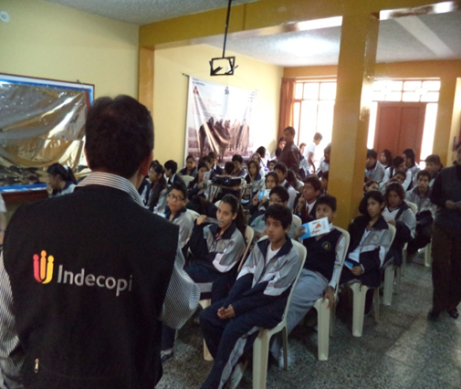

From the past and planned events a total of 7,204 students were trained and made aware from April until about November 2013.

[End of document]

* The views expressed in this document are those of the author and not necessarily those of the Secretariat or of the Member States of WIPO.

