E
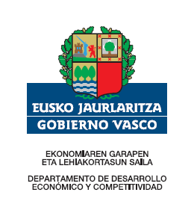 | 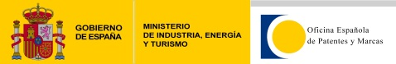
 | Spanish Patent and Trademark Office
national
ompi/pi/es/13
ORIGINAL: ENGLISH
DATE: JULY 2, 2013

Seminar on WIPO Services and Initiatives

organized by
the World Intellectual Property Organization (WIPO)

and
the Spanish Patent and Trademark Office (OEPM)

Bilbao, Spain, July 2, 2013

PROVISIONAL PROGRAM

prepared by the World Intellectual Property Organization (WIPO)

Tuesday, July 2, 2013

09.00 – 09.20 Opening

Welcome addresses by:

Mr. Pedro Rodríguez Díaz, Head of Service of Industrial Administration, Department of Energy, Mines and Industrial Administration of the Basque Government

Ms. Cristina Fernández Ordás, Director of the International Relations and Legal Coordination Department, Spanish Patents & Trademarks Office, Ministry of Industry, Energy & Tourism

Mr. Yo Takagi, Assistant Director General, WIPO Global Infrastructure Sector

09.20 – 09.40 Special Addresses: Local Innovator

09.40 – 10.10 Topic 1 Introduction to WIPO
Development of the International Legal Framework
Major Intellectual Property Economic Studies

Speaker: Mr. Vìctor Vázquez Lopez, Head, Section for Coordination of Developed Countries, WIPO Department for Transition and Developed Countries

10.10 – 10.50 Topic 2 Global Intellectual Property Systems: Patent Cooperation Treaty (PCT)

Speaker: Mr. David Muls, Director, PCT Operations Division, WIPO Innovation and Technology Sector

10.50 – 11.30 Topic 3 Global Intellectual Property Systems:
Madrid System for the International Registration of Marks
The Hague System for the International Registration of Industrial Designs

Speaker: Mr. Diego Carrasco Pradas, Deputy Director
Legal Division, Madrid Registry, WIPO Brands and Designs Sector

11.30. – 12.00 Coffee Break

12.00 – 12.20 Topic 4 Alternative Disputes Resolution: the WIPO Arbitration
and Mediation Center

Speaker: Mr. David Muls

12.20 – 12.50 Topic 5 Relations between the Spanish Patent and Trademark Office (OEPM) and the World Intellectual Property Organization (WIPO)

Speaker: Ms. Cristina Fernández Ordás

12.50 – 13.30 Topic 6 Global databases for Intellectual Property
Platforms and Tools for the Connected Knowledge Economy

Speaker: Mr. Yo Takagi

13.30 - 14.20 Questions and Answers

14.20 – 14.30 Closing of the Event

[End of document]

