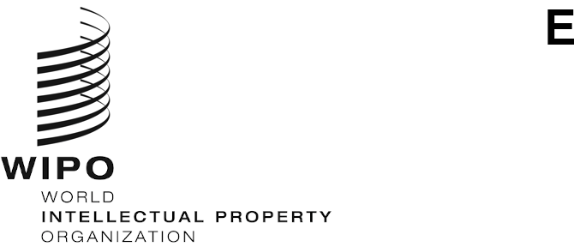
CDIP/30/10
ORIGINAL: ENGLISH
DATE: march 1, 2023

Committee on Development and Intellectual Property (CDIP)

Thirtieth Session
Geneva, April 24 to 28, 2023
EVALUATION REPORT OF THE PROJECT ON INTELLECTUAL PROPERTY AND GASTRONOMIC TOURISM IN PERU AND OTHER DEVELOPING COUNTRIES: PROMOTING THE DEVELOPMENT OF GASTRONOMIC TOURISM THROUGH INTELLECTUAL PROPERTY
prepared by Ms. Carolina Del Campo Vara, Independent Evaluator and Consultant, Madrid
The Annex to this document contains an external independent Evaluation Report of the Development Agenda Project on Intellectual Property and Gastronomic Tourism in Peru and Other Developing Countries: Promoting the Development of Gastronomic Tourism through Intellectual Property, undertaken by Ms. Carolina Del Campo Vara, Independent Evaluator and Consultant, Madrid, Spain.
The CDIP is invited to take note of the information contained in the Annex to this document.
[Annex follows]
Table of contents
Acronyms 2
INTRODUCTION 3
Background and Context 3
Purpose and Structure of the Report 4
SCOPE AND METHODOLOGY 5
Data Collection 6
Constraints 8
FINDINGS 8
Project Design and Management 8
Effectiveness 10
Sustainability 12
Implementation of the Development Agenda Recommendations 13
WIPO Visibility 13
WIPO Added Value 13
MAIN CONCLUSIONS AND LESSONS LEARNED 13
RECOMMENDATIONS 14

Appendixes (Attached separately)
Appendix I: Evaluation Matrix
Appendix II: List of Selected Interviewees
Appendix III: List of Documents Reviewed

Acronyms

CDIP | Committee on Development and Intellectual Property
DA | Development Agenda
DAC | Development Assistance Committee
DACD | Development Agenda Coordination Division
INDECOPI | Peru’s National Institute for the Defense of Competition and Protection of Intellectual Property
IP | Intellectual Property
KII | Key Informants Interviews
OECD | Organisation for European Economic Co-operation
TCE | Traditional Cultural Expressions
TK | Traditional Knowledge
ToR | Terms of Reference
UN | United Nations
WIPO | World Intellectual Property Organization
UNWTO | World Tourism Organization

INTRODUCTION

Background and Context
- The World Intellectual Property Organization’s (WIPO) Development Agenda (DA) ensures that development considerations form an integral part of WIPO’s work. The effective implementation of the DA, including the mainstreaming of its Recommendations into WIPO’s substantive programs, is a key priority. The WIPO DA projects are different from any other WIPO project. DA projects are usually inspired by one or more DA Recommendations. The DA projects should be development-orientated, which means they deliver sustainable results and have an impact in different areas of Intellectual Property (IP). DA projects are designed in a way that they can be implemented in different parts of the world. The Development Agenda Coordination Division (DACD) guides Member States through the process of project development. The DACD has created an infographic, presented in Figure 1, with all the steps to follow in order to get a project proposal approved.
Figure 1 – DA Project Life Cycle Flow Chart (only available in English)
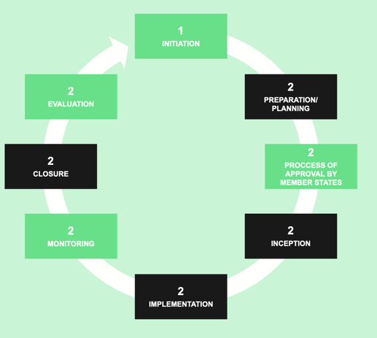 | - Member State(s) develop the concept for a DA project;  - DACD reviews the project concept to assess its feasibility and discuss it with the proponent Member State(s);  - DACD consults with other areas of WIPO and helps Member State(s) to develop the draft proposal further;  - The proposed DA project is considered at the CDIP where comments and inputs are provided;  - Member States address the comments by CDIP;  - CDIP approves the proposal and WIPO appoints a project manager and starts implementing it.
- The DA project on Intellectual Property and Gastronomic Tourism in Peru and Other Developing Countries: Promoting the Development of Gastronomic Tourism through Intellectual Property aimed at promoting the use of IP related to culinary traditions (food and beverages) for use in the tourism sector, as well as enabling the documentation, development, and sustainable use of each beneficiary country’s (Cameroon, Malaysia, Morocco and Peru) culinary tradition. Through its activities and deliverables, the project aimed at analyzing the potential benefits that IP related to culinary traditions could bring to economic activities within the gastronomic tourism sector in beneficiary countries. The project also aimed at raising awareness about this subject.
- The project was articulated in the following phases:
- Preparing a scoping study in each pilot country on the gastronomic tourism sector to provide a mapping of key culinary traditions (food and beverages) within the respective countries.
- Instituting a round table to bring together the main tourism, gastronomy and IP public entities and stakeholders, as well as opinion leaders in the sector of each country to discuss and gather information regarding the existing challenges and coping strategies related to IP in the gastronomic tourism sector.
- Preparing an analysis of the IP-related areas of the value chain of selected culinary traditions in each pilot country, based on the scoping study and the results of the round table.
- Sharing of the analysis of the IP-related areas of the value chain of the selected culinary traditions with the participants of the round table, for their comments and revision before finalizing the document.
- Organizing a seminar in each pilot country to present the recommendations and results of the research activities undertaken in that pilot country.
- Organizing an international seminar to present experiences and results of the studies undertaken in the different pilot countries.
- Preparing a compilation of the main outputs and conclusions reached in the different beneficiary countries, which will contribute to raising awareness on the subject matter across a broader public.

Purpose and Structure of the Report
- The evaluation is in line with the established priorities of WIPO relative to the systematic and timely evaluation of its programs and projects. Further, the evaluation adopts WIPO’s focus on the assessment of achievements, the quality, and the results of interventions in an evolving context, with an emphasis on using evaluation for managing results, learning and accountability, as well as improving the quality and impact of programs and projects.
- This report provides findings related to each of the Evaluation Questions, together with a set of conclusions and recommendations, on the basis of data collection undertaken.
- The evaluation conducted an overall assessment of the performance of the above-mentioned DA project, paying particular attention to its project design framework, project management, including monitoring and reporting tools, as well as measured and reported on the results achieved to date and assessed their likelihood of sustainability. The lessons learned, conclusions and recommendations developed will aim to provide evidence-based evaluative information to support the CDIP’s decision-making process and to improve future interventions. In particular, this evaluation assessed the extent to which the project has been instrumental in:
- Building the capacity of economic operators involved in gastronomic tourism and of national authorities, including IP offices, to use and leverage IP tools and strategies to add value that differentiates their products and services, and to diversify their economic activities while respecting local traditions and culture.
- Raising awareness on the contributions that the use of IP can take to the gastronomic tourism activities.

SCOPE AND METHODOLOGY
- The evaluation scope covers activities and results delivered during the project implementation, starting from May 2019 till December 2022. The evaluation covers project design and management, coordination, coherence, implementation, project activities and results achieved, contribution to Member States’ needs and resources or the means to address those needs. This evaluation covers the four beneficiary countries of the project (Cameroon, Malaysia, Morocco and Peru).
- This evaluation follows the Organization for Economic Co-operation and Development (OECD)/ Development Assistance Committee (DAC) Principles for Evaluation of Development Assistance. The DAC model establishes five criteria to evaluate an intervention in development cooperation, namely, relevance, coherence, effectiveness, efficiency, sustainability, and impact. However, the WIPO DACD indicated a preference for a focus on only three of these evaluation criteria, namely: relevance (project design and management), effectiveness and sustainability. In addition, the Evaluator considered including the criteria of WIPO added value and WIPO visibility in order to assess the extent to which the intervention has brought additional benefits to the Member States participating in this project and generated greater visibility for the work carried out by WIPO.
- During the inception phase and following an initial desk review, the Evaluator constructed and proposed a set of evaluation questions, presented in Table 1.
Table 1 – Evaluation questions
OECD Criteria | Evaluation questions
Project design and management | Does the initial project document serve as a guide for project implementation and assessment of results achieved?
 | Were the project monitoring, self-evaluation and reporting tools useful and adequate to provide the project team and key stakeholders with relevant information for decision-making purposes?
 | To what extent other entities within the WIPO Secretariat have contributed and enabled an effective and efficient project implementation?
 | To what extent the risks identified in the initial project document have been materialized or been mitigated?
Effectiveness | To what extent the outputs of the project have been useful and effective to raise awareness about IP and Gastronomic Tourism?
 | Has the project been able to build the capacity of economic operators involved in the gastronomic tourism and of national authorities, including IP offices, to use and leverage IP tools and strategies to add value that differentiates their product and services, and to diversify their economic activities while respecting local traditions and culture?
 | To what extent the project has raised awareness on the contributions that the use of IP can take to the gastronomic tourism activities?
Sustainability | To what extent has the project been effective in continuing to work on the use of IP systems as a tool to promote culinary traditions and gastronomic tourism?
WIPO Visibility | Did the intervention bring positive WIPO visibility for stakeholders and beneficiary governments, and how?
WIPO Added Value | What is the added value of this project?
Lessons Learned | What lessons learned and best practices can be drawn from this project (with special focus on its design and management)?
Implementation of the DA Recommendations | To what extent have the DA Recommendations 1, 10 and 12 been implemented through this project?
- The above-mentioned evaluation questions functioned as a structured guide to the evaluation process and ensured consistency in questioning throughout all evaluation tools. On this basis, an evaluation matrix was developed with key evaluation tools, data sources and data collection methods. The use of this type of matrix is a useful and valuable instrument to organize and systematize the information needed. The evaluation matrix can be found in Appendix I to this document.

Data Collection
- Data collection was expanded from the Inception Phase to establish a solid evidence base. This was achieved through document review, and upscaling of stakeholders’ consultation, from exchange with WIPO project coordinators and focal points to other relevant stakeholders with reliable knowledge of the intervention. The main data collection activities are presented in Table 2.
Table 2 – Data collection activities
Documentary analysis | For the document review, the Evaluator examined the following types of reports:  - General literature review: this was used to answer questions related to the relevance of WIPO's overall strategic framework and to generalize the findings identified in the evaluation. The review included overarching WIPO policy documents and guidelines to extract relevant findings related to IP and to the support for traditional cultural expressions and traditional knowledge.  Intervention literature review: this was used to answer questions related to the relevance and pertinence of the project under evaluation and to generate conclusions at the thematic and intervention level.
Stakeholder consultations | The primary focus of the Evaluator’s consultations was on stakeholders with direct concern or experience of the intervention under analysis. In the first stages of the Interim Phase, the Evaluator refined, in consultation with the evaluation management team and the project manager, the overall list of stakeholders to be consulted, and prioritized those who were going to be interviewed. All stakeholder consultations informed specific elements of the Evaluation Matrix (judgement criteria and indicators).  The consultations during the Interim Phase aimed to obtain insights into the intervention, based on the elements of the Evaluation Matrix. Semi-structured online interviews were conducted with all targeted stakeholders.  Given the characteristics of the project, the following evaluation methods have been discarded as evaluation methods to be used in this evaluation: i) an online survey; ii) field visits; iii) the use of a contribution analysis as impact is not one of the evaluation criteria to be analyzed; and iv) any method that delves into people’s life experiences, and not into organizational or more structural elements, as this is not the objective of the evaluation either.
- In general, stakeholders that have been interviewed comprised the categories presented in Table 3.
Table 3 – Categories of stakeholders interviewed
WIPO Staff | This includes WIPO representatives who have at any time been relevant to the project, including members of the DACD.
Beneficiary Countries’ Focal Points | This includes national representatives belonging to Ministries, State Secretariats, Divisions and/or departments related to IP and Tourism who have served as focal points in the countries where the project was implemented and who served as liaison with the WIPO Headquarters.
Member States | These includes group coordinators for each of the geographical areas where the project was implemented, namely: Latin America and the Caribbean countries; African countries; Arab countries; and Asia and the Pacific countries.
External Stakeholders | This includes primarily the various consultants who worked on the project and developed project outputs related to the scoping study and the IP Analysis.
- In total, the Evaluator reviewed over 20 documents initially provided by the DACD and WIPO project manager, and others that have been independently sourced, and which are listed in Appendix III. A total of 25 online interviews were conducted through different platforms. 15 of interviewees were women and 10 were men.
- Although the final number of people to be interviewed did not vary from the initial design, it should be noted that there were two people not initially foreseen in the list of interviewees and were included at the suggestion of one of the focal points. Also, there were two other persons pre-selected to conduct the interviews who declined to be interviewed, claiming little knowledge or involvement in the project. The final number of interviewees was the same, however, the role and responsibility that these people played in the implementation of the project changed.

Table 4 – Details of Key Informant Interviews during the interview phase
Key informant interviews (KII) | Women | Men
WIPO Staff | 5 | 4
Focal points for DA Project on IP and Gastronomic Tourism | 6 | 3
External stakeholders (experts and project beneficiaries) | 4 | 1
Permanent Missions | 0 | 2
Total | 15 | 10
 | 25
- All KII were purposively selected based on their experience and level of involvement and participation in the design process of the project, on their work related to project management, project implementation and on their membership in a division or section relevant to the evaluation process. The possibility of considering a bias in the selection of KII was mitigated by asking respondents the same question in different ways and probing the responses to triangulate the consistency of the answers.

Constraints
- The evaluation inception report outlined a set of potential risks and limitations to the evaluation, with associated mitigation strategies. As anticipated, there were some difficulties in conducting interviews with key stakeholders, mainly due to poor internet connectivity. Finally, all of them could be carried out without major problems, except one (after several unsuccessful attempts, the questionnaire had to be sent via email to be answered in writing).
- A key constraint was the timing of interviews, which largely took place in the middle of January 2023, during a holiday season for some of the project countries (Lunar New Year for Malaysia and summer season in Peru). This meant that some interviews had to be scheduled later than expected. The support of the evaluation management team helped considerably to counteract these difficulties.

FINDINGS

Project Design and Management
- Project Design Background: The Government of Peru decided to analyse the potential benefits that IP could have for culinary traditions for two main reasons: (i) to respond to the growing interest in the Peruvian gastronomic tourism; and (ii) to create enabling conditions for economic and social development in communities that have potential tourist areas to attract investment and generate a platform for IP proposals. The project under evaluation was developed following the regulations established for DA projects, under the proposal of the National Institute for the Defense of Competition and Protection of Intellectual Property of Peru (INDECOPI).
- Design process: The 8 steps established by WIPO for the implementation of a DA project were respected. DACD guided the project planning and helped in the preparation of the project budget and timeline. However, the project manager was appointed after the adoption of the project by the CDIP. This caused slight difficulties in the appropriation of the project at the beginning.
- Relevance of the initial project document: Stakeholders defined this project as interesting and challenging. It has raised interest of Member States, and it has been considered a good example of a DA project, since it can support many of the DA objectives (generate value, assist in development, etc.). Support to traditional culinary expressions and knowledge was highly relevant, contributing to promotion of cultural and gastronomic heritage and development of the tourism through IP. The theme of the project (IP and gastronomic tourism) was novel, hence, some reluctance was shown at the beginning about the expected results and how they could be perceived by the beneficiaries. As a result, the broad scope of the project, initially presented to the CDIP, was reduced to a more modest approach in order to monitor, explore and study the relationship between IP and gastronomic tourism.
- In general, the DA Project on IP and Gastronomic Tourism demonstrated to be relevant and complementarity with other initiatives in WIPO.
- Project Management: The management team, for whom this was the first DA project to manage, faced several challenges during the implementation of the project, particularly in the initial phase. The first was related to the identification of the entities in charge of carrying out the implementation of the project in the beneficiary countries. The establishment of national teams in three of the participating countries and the interaction with them was slow in the beginning and took longer than originally anticipated. The second was related to the management of focal points’ expectations and the need to keep those expectations in line with WIPO’s procedures. All of the above was overcome thanks to the close collaboration and good understanding that was forged later among all parties involved in the implementation of the project.
- Three Regional Divisions at WIPO played an active role in forging efficient communication channels between the WIPO management team and the local coordination teams. Notably, Counsellors from those three Regional Divisions were key in the project’s early stages, relaying information to the local coordination teams, as well as motivating and engaging stakeholders in the project. Stakeholders recognized that the interest, ownership, and level of commitment grew as they took over the project and understood the issue better.
- COVID-19 impacted the delivery of the project. Outputs and activities were planned to be carried out physically, with visits to the regions and with the development of reports and studies done face-to-face. However, because of the travel restrictions caused by the pandemic, the approach had to be changed. Far from remaining static in its initial plan, the project management showed a high sensitivity and capacity to understand and adapt to new events and circumstances.
- Project monitoring, self-evaluation, and reporting tools: Project indicators are not considered specific, measurable, achievable, relevant and time-bound (SMART) but are sufficient to show the achievements for each of the project outputs. Country-level project plans were found to be used as main monitoring tool during the implementation of the project. These plans were considered very useful and of the great help to follow-up project activities. Different interviewees reported that the first phase was underestimated and took longer than expected, subsequently, the project management framework was reviewed. DACD provided a template for progress report and self-evaluation. Midterm reviews were well received by Member States and allowed project manager to ask for an extension of the project, due to the challenges faced by the COVID-19 pandemic. Permanent contact with WIPO officials in charge of the project, continuous online exchange meetings, emails, oral consultations were considered by the national focal points and project coordinators as the main monitoring instruments that have helped to advance work and keep track of the project’s progress.
- The initial project document had foreseen general potential risks and mitigation measures, which were considered appropriate. The decision of developing a mapping of stakeholders, as well as a risk and mitigation plan per country, together with the country project plans, was a wise choice that allowed progress in certain areas not initially foreseen. The situation caused by the pandemic led to a forced suspension of the project throughout 2020 and part of 2021, which meant starting the project practically from scratch with the difficulties that this entailed. High turnover of representatives of gastronomic unions and public authorities, changes in governments, political instability in beneficiary countries were among the risks that were added to the project and that were not contemplated at the beginning. All of them were mitigated and the project went ahead without major disruptions.

Effectiveness
- The DA project on IP and Gastronomic Tourism achieved its objectives, despite some adjustments made due to changes during the implementation phase, including, for example, changes caused by periods of political instability or the COVID-19 pandemic. In terms of activity delivery, the majority of respondents considered that the project has demonstrated a strong level of effectiveness, and the expected results were achieved. The methodology and approach used served to identify the potential each country had on the subject of IP and gastronomic tourism.
- Final outputs were considered useful and managed to explore the link between IP and Gastronomic Tourism. For many project beneficiaries, it was the first time to be exposed to IP-related issues. The project raised their awareness and built capacity on the linkages between IP and gastronomic tourism. The evaluation noted that this project has inspired national pride. Those who implemented it reported that the project have made them feel proud of their culinary heritage, their gastronomic traditions and richness and variety of local foods. The project also provided an opportunity to approach new stakeholders working for the tourism and gastronomic sectors to enhance national cuisine. All the results were validated by project participants, thanks to seminars and round tables that had been held.
- Stakeholders considered that the intervention enhanced national, institutional, and professional capacities to promote and protect IP. According to respondents, awareness on the importance of IP was very high. Project beneficiaries realized that proper IP management can add value to their products and were able to understand the relevance of the use and management of these tools not only to protect but also to boost their businesses. Thanks to the round tables and seminars organized within the project framework, project beneficiaries were able to identify the existing tools around IP, which has subsequently given rise to many questions related to collective rights and other types of IP elements. In addition, it was reported that in the context of the project important networking opportunities were generated with interested parties, resulting in a subsequent exchange and generation of positive discussions, leading to a favorable attitude to protect IP rights of gastronomic tourism related products and services. The unexpected opportunities that arose from the different activities carried out with new partners were considered very positive.
- Given the characteristics of the project and that it has recently concluded, all respondents agreed that in this initial phase, it is not yet possible to assess the effectiveness of the created capacity of beneficiaries to use IP tools and strategies to add value that differentiates their products and service and diversifies their economic activities while respecting local traditions and culture.
- The publicity component of the project was considered very good, although it took place a little late. An earlier communication strategy would have resulted in greater awareness of the project and greater participation in the round tables and seminars. The project website was launched in June 2022, in the final stage of the project. Only the stakeholders directly involved in the implementation were aware of it and had visited it on occasion. The website is a faithful reflection of everything that has been done, the products obtained by country and the activities carried out in the context of the project.
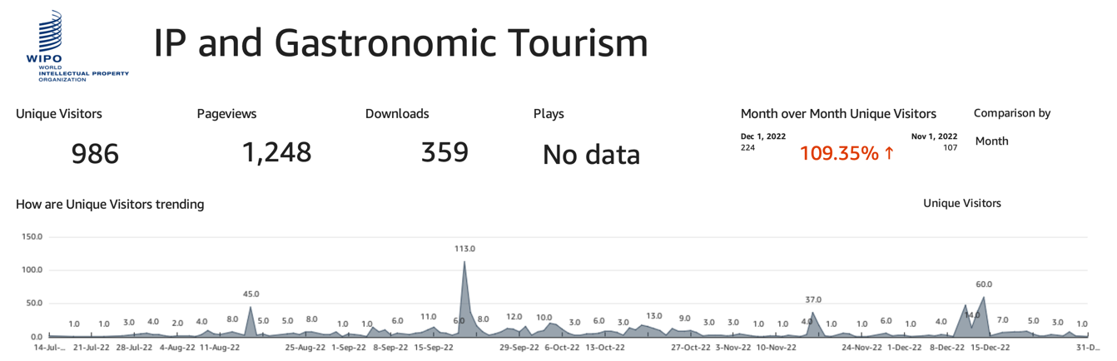
Figure 2 - only available in English
- With a record number of visits on certain days, reaching 113 visitors in a single day, as presented in Figure 2, the reception of the project on the network is considered satisfactory. As shown in Figure 3, surprisingly, the website had a higher number of visits in countries that are not direct beneficiaries of the project, such as China (137), Switzerland (93) and the United States (86). This is followed by Peru (67) and Morocco (47). Visits from Cameroon and Malaysia have been quite minor.
Figure 3 - only available in English
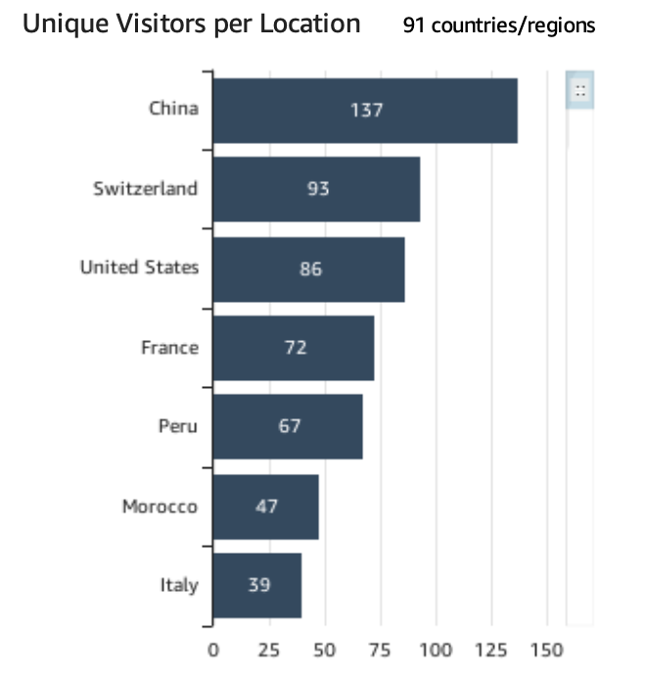
- In all the beneficiary countries, women play a key role in passing on the culinary traditions and typical dishes of each family, area or region. In the business area, women play a less predominant role. The sources reviewed have shown that the project has sought a balance in the participation of both women and men in the project. While the number of female experts in charge of doing the scoping studies and IP analysis has been higher than that of men, the percentage of men in the total number of participants in the roundtables and national seminars has always been higher than that of women, except in the case of Malaysia, where there were more women participating in the national seminars than men (43% male, 57% female). The percentage in the roundtable discussions was very similar (52% male, 48% female).
Table 5 – Roundtable Discussion
Country | Number of Participants | Male | % | Female | %
Peru | 35 | 25 | 71% | 10 | 29%
Cameroon | 100 | 65 | 65% | 35 | 35%
Malaysia | 21 | 11 | 52% | 10 | 48%
Morocco | 14 | 11 | 79% | 3 | 21%
Subtotal | 170 | 112 | 66% | 58 | 34%

Table 6 – National Seminars on IP and Gastronomic Tourism
Country | Number of Participants | Male | % | Female | %
Peru | 204 | 77 | 38% | 127 | 62%
Cameroon | 151 | 101 | 67% | 50 | 33%
Malaysia | 62 | 25 | 40% | 37 | 60%
Morocco | 46 | 33 | 72% | 13 | 28%
Subtotal | 463 | 236 | 51% | 227 | 49%

Table 7 – Total Participation (Round Tables and National Seminars)
Country | Total Participants | Male | % | Female | %
Peru | 239 | 102 | 43% | 137 | 57%
Cameroon | 251 | 166 | 66% | 85 | 34%
Malaysia | 83 | 36 | 43% | 47 | 57%
Morocco | 60 | 44 | 73% | 16 | 27%
Grand Total | 633 | 348 | 55% | 285 | 45%

Sustainability
- Ownership and sustainability were two principles that have been promoted within the project. The project has provided greater visibility to local IP offices, raised awareness of IP work to Ministries of Tourism and provided greater knowledge of WIPO’s mandate and role. A work for change to come has been developed, yet, it is difficult to measure and quantify the lasting results that this project has obtained. Except from Peru, in the other beneficiary countries, there were no connection between IP and food or food and tourism at the beginning of the implementation.
- The evaluation agrees with all respondents on the fact that project sustainability will depend on further work. The development and implementation of this project has been crucial to set up the basis, get some statistics and data regarding a subject of IP and gastronomic tourism that was quite new in the beneficiary’ countries. This project contributed to set the foundations of future work and to raise awareness on the contributions that the use of IP can take to the gastronomic tourism activities.

Implementation of the Development Agenda Recommendations
- All respondents agreed on the fact that the DA Recommendations 1, 10 and 12 were certainly implemented. This project was demand-driven, development-oriented and transparently completed. Despite no infrastructures were developed in the context of this project, it helped Member States to improve national IP capacities and to protect IP.

WIPO Visibility
- This intervention brought positive WIPO visibility for stakeholders and beneficiary governments. Stakeholders considered that project activities highlighted WIPO’s work and its support to IP. In addition, they reported that this project has contributed to public awareness of IP and gastronomy related issues. Documents reviewed and interviews showed that in some countries, WIPO’s work was not previously known, particularly, by representatives of the Ministries of Tourism, cooks and persons belonging to gastronomic guilds. This project provided the opportunity to present IP on a new topic, enhancing WIPO’s visibility in other segment where it was not before and to show that IP can be used in the gastronomic economic activities sector. The interaction in the seminars, round table discussions were very positive and helped to bring a higher visibility to WIPO’s mandate and work.
- The evaluation found that this project also brought new collaboration with relevant authorities and with other UN Agencies (World Tourism Organization (UNWTO)), getting the possibility to join forces and work together in the future on similar projects.

WIPO Added Value
- For all the beneficiary countries, this project has been a turning point. They all agreed that it has helped them to better understand IP as a tool that can benefits tourism, in particular, gastronomic tourism. For the majority of the respondents, the technical assistance, knowledge, training and support that these beneficiary countries have received are the mark of WIPO’s added value. Nevertheless, it will not be until someone files or registers an IP when the added value can be realized.

MAIN CONCLUSIONS AND LESSONS LEARNED
- WIPO’s work was highly appreciated by the stakeholders consulted. The originality of the topic, a first of its kind for the project beneficiaries, and the added value provided by WIPO's expertise and experience in this type of pilot project make it highly relevant. The stakeholders interviewed (focal points in the implementing countries, experts, project coordinators and representatives of Member States) are unanimous in stating how interest in gastronomic tourism and its relationship with IP has increased as the project has developed.
- Project’s design followed the regulations established for DA projects, but had some difficulties at first due to the different realities of each country that soon became lessons learned and from which the following emerged: 1) the importance of project manager’s and coordinators’ involvement from the beginning ; 2) the development of country project plans to help focus and gain ownership; 3) the need to include in the project timeframe a period devoted to selection of the coordination team in each country along with an induction period to talk about the project together and get into it; 4) explanation of WIPO’s operational procedures, requirements and commitments, including sharing of internal procedures and rules (i.e. hierarchies, expected per diems to participate in seminars, workshops, etc.), need to be clear from the beginning to avoid misunderstanding and delays in project’s implementation.
- Flexibility is the word that better defined the management style used in the implementation of the evaluated project. The project’s adaptation to a changing context was agile. It reacted in an accurate and timely manner. Having an interdivisional board was a good practice that allowed the project to move forward when it got stuck due to differences in understanding, comprehension, or expectations of the beneficiary countries. The project proved that linking the public, private, unions and academia sector is key, which created synergies and gave a greater opening and potential to the project.
- Project management was considered impeccable. Attentive to detail, proactive in the face of difficulties and reactive when challenges arise. Project management has been effective in achieving the expected outputs and contributing to the achievement of outcomes. The evaluation found that the project has obtained exceptional results in strengthening capacities and raising awareness of the benefits that the use of IP can bring to gastronomic tourism activities. The different challenges that arose in the implementation of the project (i.e. ignorance of the types of IP tools by key actors; the high level of rotation of the representatives of the unions and associations related to tourism and gastronomy; mobility restrictions caused by the COVID-19 pandemic and their impact on the work to be carried out) did not affect the result.

- Project’s communication and visibility activities were conducted, and various outputs were produced. However, such activities were considered to be carried out late and were only reported as remarkable in Peru. A greater dissemination component at an early stage of the project would have generated more expectations and summoned new strategic allies that were not initially identified. Even so, the intervention’s visibility efforts resulted in increased recognition of WIPO’s support to development, greater awareness of benefits of using IP in the gastrotourism and an increased engagement with national IP offices, unions, private sector and academia.

RECOMMENDATIONS

- Recommendations based on the above conclusions are presented below. In many cases, collaborative efforts across the actors would bring the best results.
  - Maintain support to IP and gastronomic tourism activities in project’s beneficiary countries.
- Consider to expand this project to other countries interested in the subject, bearing in mind the lessons learned and good practices.
  - Strengthen the preparation/planning phase of the project, involving the project manager and coordinators, so that they take ownership of the project from its design and can better contribute to its implementation.
  - Consider giving, at the project inception phase, more time to create a unique approach, learn about the expectations and internal rules and procedures of all stakeholders, set up local project teams, clarify WIPO’s operational procedures, etc.
- Involve delegations from Member States in the set-up of this phase to ease the process between the project design and the establishment of local project teams.
- Develop clear guidelines and a profile for beneficiary countries’ participation.
- Ensure the participation of the interdivisional board and local focal points in this phase to gain knowledge and interest in the activities and results to be obtained, as well as dynamism in the implementation of the project.
- Develop strategies through a mapping of national stakeholders to ensure the widest possible participation, consensus and validation of the project.
  - Create an internal community of practice so that national focal points, project coordinators and the project manager can easily exchange and communicate. This platform will help to jointly resolve obstacles with each country contributing to its own approach. It will also serve as a platform to share information and lessons learned and to build a better teamwork relationship.
- Deepen the understanding of the project at country level through regular meetings, discussions, etc.
- Motivate participation and increase interest of focal points through frequent exchanges and sharing of experiences and best practices.
  - Continue working with the public and private sectors, guilds and academia to have the greatest number of points of view, information and knowledge, while at the same time gaining sustainability through their involvement in the project.
  - Develop a result and monitoring framework with standardized and verifiable indicators applicable across actions to account for results, and which provide guidance on what constitute a successful IP and gastronomic tourism project.
  - Develop a communication strategy to make strategic alliances from the very beginning of the project’s implementation and seek to transcend the project beyond the project’s webpage.
  - Establish new partnership and strengthen the engagement with UNWTO.
[Appendixes are attached separately (in English only)]

The DA Recommendations are available at: www.wipo.int/ip-development/en/agenda/recommendations.html
See document CDIP/22/14 REV., available at: www.wipo.int/meetings/en/doc_details.jsp?doc_id=421371
Namely, 1. project initiation; 2. project preparation/planning; 3. approval process by the EM; 4. project initiation; 5. project implementation; 6. project monitoring; 7/ project closure; and 8. project evaluation.
For example, Entrepreneurs Online Network (EON) initiative, under which a series of webinars were organized in 2022 focused on the agro-food sector.
The website is available at: www.wipo.int/ip-development/en/agenda/projects/ip-and-gastronomic-tourism.html

