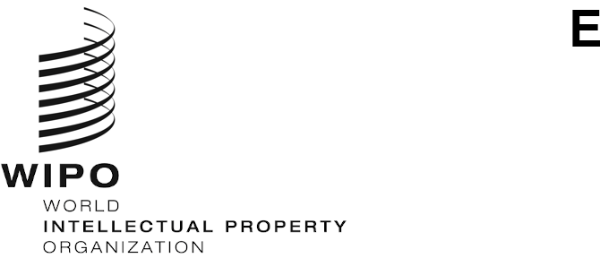
CDIP/27/3
ORIGINAL: ENGLISH
DATE: SEPTEMBER 27, 2021

Committee on Development and Intellectual Property (CDIP)

Twenty-Seventh Session
Geneva, November 22 to 26, 2021

ACCREDITATION OF OBSERVERS
prepared by the Secretariat
- The Rules of Procedure for the Committee on Development and Intellectual Property (CDIP) provide for ad hoc accreditation as observers of intergovernmental and
non-governmental organizations for a period of one year (document CDIP/1/2 Rev.).

- The Annex to this document contains information about one non-governmental organization (NGO), namely, the Global Expert Network on Copyright User Rights, which has requested to be granted ad hoc observer status.

3. The CDIP is invited to take a decision on the request for accreditation of the NGO contained in the Annex to this document as ad hoc observer for a period of one year.

[Annex follows]

ORGANIZATION THAT HAS REQUESTED ACCREDITATION AS OBSERVER IN SESSIONS OF THE COMMITTEE ON DEVELOPMENT AND INTELLECTUAL PROPERTY (CDIP)

Global Expert Network on Copyright User Rights

Description of the Organization:
The Global Expert Network on Copyright User Rights is a network of over 100 copyright scholars and experts from over 30 countries who produce research and public testimony on the value of “user rights” within domestic and international copyright law.

Main aim of the Organization:
The purpose of the Network is to promote research, education, and technical assistance that furthers its Mission.

Main field of IP of the Organization:
Copyright

Country in which the Organization is primarily active:
May 1, 2011, Amsterdam, Netherlands

Full list of Officers:
Secretariat: Program on Information Justice and Intellectual Property, American University Washington College of Law
President and Chair: Sean Michael Fiil-Flynn, American University Washington College of Law
Vice-Chair: Martin Senftleben, IVIR, University of Amsterdam
Steering Committee:
- Michael Carroll, PIJIP
- Peter Jaszi, PIJIP
- Stef Von Gompel, IVIR, University of Amsterdam
- Joao Pedro Quintais, IVIR, University of Amsterdam
- Allan Rocha, Federal University of Rio De Janeiro (UFRJ/PPED - UFRRJ/ITR)
- Dick Kawooya, University of South Carolina
- Arul Scaria, National University Delhi
- Niva Elkin Koren, Tel-Aviv University, Israel
- Carys Craig, University of Toronto, Canada
- Rachael Samberg, University of California, Berkeley
- Caroline Ncube, University of Cape Town, South Africa

- Tobias Schonwetter, University of Cape Town, South Africa

- Matthew Sag, Loyola University School of Law, Chicago

- Lucie Guibault, Halifax University, Canada

- Christophe Geiger, Centre for International Intellectual Property Studies, Strasbourg

- Thomas Margoni, CiTiP, KU Leuven, CREATE

- Ariel Katz, University of Toronto

- Jorge Contreras, University of Utah School of Law

Full contact details of the Organization:
Postal address: American University Washington College of Law
4300 Nebraska Ave NW, Washington, DC 20016

Telephone number: +1-571-417-8589

E-mail address: andres@wcl.american.edu

Website: Andrés Izquierdo - American University Washington College of Law

Name of Organization Representative and Title:

Mr. Andres Izquierdo, Senior Research Analyst
[End of Annex and of document]

