E
CDIP/23/15
ORIGINAL: Spanish
Date: 4 April 2019

Committee on Development and Intellectual Property (CDIP)

Twenty-Third Session
Geneva, May 20 to 24, 2019

Project proposal SUBMITTED BY THE PLURINATIONAL STATE OF bolivia FOR THE REGISTRATION OF THE COLLECTIVE MARKS OF LOCAL ENTERPRISES AS A CROSS-CUTTING ECONOMIC DEVELOPMENT ISSUE

prepared by the Secretariat

- In a note verbale dated March 21, 2019, to the Secretariat, the Permanent Mission of the Plurinational State of Bolivia to the United Nations Office and other International Organizations at Geneva submitted a project proposal for the Registration of the Collective Marks of Local Enterprises as a Cross-Cutting Economic Development Issue for consideration at the twenty-third session of the CDIP.

- The note verbale and project proposal are contained in the Annex hereto.

3. The Committee is invited to consider the Annex hereto.

[Annex follows]

Permanent Mission of the
Plurinational State of Bolivia
Geneva
Ama Suwa, Ama Llulla y Ama Qhilla
“Neither a thief, a liar nor an idler be”

MBNU - 300

The Permanent Mission of the Plurinational State of Bolivia to the United Nations and other International Organizations at Geneva presents its compliments to the Secretariat of the World Intellectual Property Organization (WIPO) and appends hereto Bolivia’s project on collective marks for consideration at the twenty-third session of the Committee on Development and Intellectual Property of the World Intellectual Property Organization that will be held from May 20 to 24, 2019, at Geneva, Switzerland.

The Permanent Mission of the Plurinational State of Bolivia to the United Nations and other International Organizations at Geneva avails itself of this opportunity to renew to the WIPO Secretariat the assurances of its highest consideration.

Geneva, 21 March 2019

To the distinguished:
Secretariat of the World Intellectual Property Organization
Geneva.-

J
CDIP/23/15
Annex, page 2

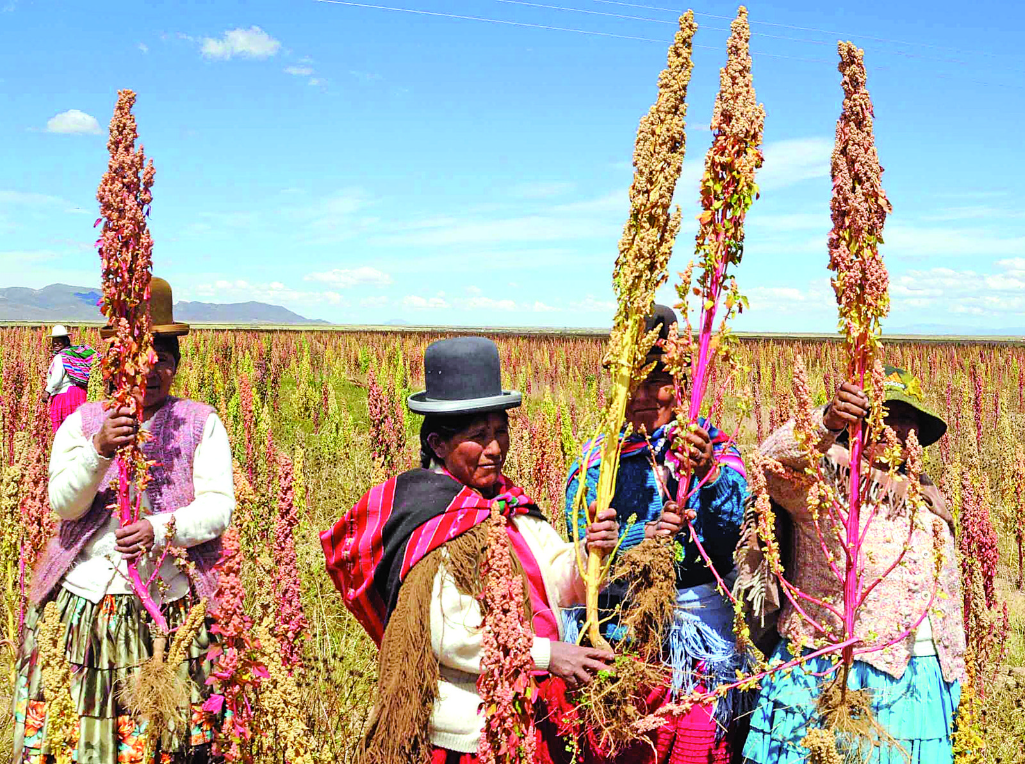 | PROJECT  Registration of the Collective Marks of Local Enterprises as a Cross-Cutting Economic Development Issue  NATIONAL INTELLECTUAL PROPERTY SERVICE - SENAPI  February, 2019

- SUMMARY
TITLE | REGISTRATION OF THE COLLECTIVE MARKS OF LOCAL ENTERPRISES AS A CROSS-CUTTING ECONOMIC DEVELOPMENT ISSUE
DEVELOPMENT AGENDA RECOMMENDATIONS | 4. Place particular emphasis on the needs of small and medium-sized enterprises (SMEs) and institutions dealing with scientific research and cultural industries and assist Member States, at their request, in setting up appropriate national strategies in the field of intellectual property.  13. WIPO’s legislative assistance shall be, inter alia, development-oriented and demand driven, taking into account the priorities and the special needs of developing countries, especially LDCs, as well as the different levels of development of Member States and activities should include time frames for completion.  41. Conduct a review of current WIPO technical assistance activities in the area of cooperation and development.
BRIEF PROJECT DESCRIPTION | The project aims to convert the competent national office (SENAPI, in the case of the Plurinational State of Bolivia, or the relevant office in each beneficiary country) into an entity effecting linkages between collective mark registration and local development by supporting SMEs through the promotion of practices that generate a positive image of their goods, nationwide marketing, links to traditional practices and added value derived from the prioritization of organic and environmentally sustainable products.  The proposal is to establish a “collective mark incubator” involving SENAPI and the relevant private and public bodies (as appropriate in each beneficiary country), which will be tasked with assessing the technical, financial and market viability of the goods and services that they select, providing technical advisory services on trademark protection, drawing up marketing and sales plans and, lastly, if need be, affording access to funding for collective mark registration.  It will thus contribute to the economic growth and development of the regions of the entire Plurinational State of Bolivia (and of another three developing countries) by making the most of the links between social capital, production enterprises and intellectual property.  Technical assistance for the collective mark incubator will be required in three stages. First, pre-incubation, during which guidance will be provided to entrepreneurs on the development of their collective mark. Second, incubation, during which creation of the collective mark will be reviewed and monitored, and action will be taken to collate the requisite documentation for actual registration. Procedures will be debureaucratized and decentralized, and processing will be simplified to permit access to registration and the relevant grant of title.  Third, post-incubation assistance will be provided after the launch of the production enterprise with a view to its continuous improvement.  Expected project result  Organization of a supporting, bolstering and monitoring system to facilitate the registration of the collective marks of local enterprises as a cross-cutting feature of production-based economic development.
IMPLEMENTATING PROGRAM
LINKS TO RELATED PROGRAMS OR DEVELOPMENT AGENDA PROJECTS
LINKS TO EXPECTED COUNTRY RESULTS, BY PROGRAM
PROJECT DURATION | 18 months
PROJECT BUDGET

- PROJECT DESCRIPTION
  - INTRODUCTION
In many countries in the region, SMEs gain comparative advantages from forming groups, traditionally as federations or associations that enhance market access through specialization in the supply of goods or services, by geographical sector or by branch of industry.

In the Plurinational State, special provisions (laws) on the protection of collective marks are still pending because they constitute a genuine representation of community enterprises that makes it possible to distinguish geographical origin, raw materials, manufacturing method or other common features of the goods and services of associations that have still not decided to use the collective mark. This may also hold true for other developing countries.

Most socio-community enterprises identified by SENAPI operate collectively but are unaware of the advantages of using a collective mark, hence the need to publicize widely the scope, benefits and contribution of SMEs, which can have a comparative advantage for, as they are relatively small enterprises, their collective dynamism is all the greater. Small firms operate with few bureaucratic trappings and have much greater flexibility in adapting to market conditions. Another advantage is teamwork, which is conducive to economies of scale and greater recognition of their “branded good” in the same way as in large firms.

  - OBJECTIVES

OVERARCHING OBJECTIVE
Develop a supporting, bolstering and monitoring system to facilitate the registration of the collective marks of local enterprises as a cross-cutting economic development issue.

SPECIFIC OBJECTIVES
> Formulate an awareness-raising, information and dissemination strategy on the advantages, opportunities and benefits of the registration of collective marks as the intellectual property of small community enterprises.
> Develop an institutional structure to incubate holistic production processes based on the identification of potential collective marks.
> Promote mechanisms to protect, safeguard and support small enterprises in recognition of their impact on the national economy.
> Coordinate production sectors identified with collective marks, creating ties with other private and public entities to follow up the enterprise, support, cooperation, and, if need be, links to financing and/or market opportunities arising from the registration obtained.
> Follow up and monitor the “life cycle” of the project or enterprise in order to conduct analysis for continuous improvement.

- SCOPE
4
The project will be implemented in the Plurinational State of Bolivia and another three beneficiary States, taking into account WIPO’s support and lines of joint cooperation.

- CRITERIA FOR THE SELECTION OF BENEFICIARY COUNTRIES
Interested Member States must appoint a coordinator as the country’s institutional representative who must provide preliminary information on the following matters:
> expression of interest by Member States’ intellectual property bodies;
> commitment to and strategy for incorporating project results in his/her country.

- IMPLEMENTATION STRATEGY
To accomplish the proposed objectives and achieve results, SENAPI (or the relevant office in each beneficiary country) will make a substantial investment that shall not be limited to the matters below.

Project implementation will consist of three phases.
- Preparations for the identification of collective marks
> Georeferencing of production areas and opportunities to survey community enterprises.
> Information events, for local authorities, on production-related collective marks.
> Information events, for local entrepreneurs, on production-related collective marks.
> Outreach events, for public and private stakeholders interested in cooperation with these sectors of production.

- Conduct of incubator activities to manage collective marks and support the registration of collective marks
> Information events on production chains linked to the generation of collective marks.
> Workshops on collective identity building and business trademarks.
> Management of and support for collective mark registration.

- Post-incubation and positioning monitoring and evaluation of collective marks
> Monitoring and evaluation from the introduction of the collective mark to the positioning management and promotion of community enterprises’ goods.
> Compilation of lessons learnt and good practices for replication in other State scenarios.

- POTENTIAL RISKS AND MITIGATION MEASURES
Risk  Mitigation  Risk  Mitigation | > Resistance by some producer associations to change when collective mark registration begins.  > Conduct high-impact information and awareness-raising drives on the comparative advantages of using collective marks.  > Possible conflicts within community associations, which could delay action to launch the collective mark incubation process.  > Initiate action to build local authorities’ awareness of the effects of organizational weakness on the formulation of productive ideas by their associates.

3. IMPLEMENTATION SCHEDULE
STAGE | ACTIVITY | TIMING
Preparations for the identification of collective marks | Georeferencing of production areas and opportunities to survey community enterprises. | Sep/19  1st Six-months
 | Information events, for local authorities, on production-related collective marks. | 1st Six-months
 | Information events, for local entrepreneurs, on production-related collective marks. | 1st Six-months
 | Outreach events, for public and private stakeholders interested in cooperation with these sectors of production. | 1st Six-months
Conduct of incubator activities to manage collective marks and support collective mark registration | Information events on production chains linked to the generation of collective marks. |  | Mar/20 2nd Six months
 | Workshops on collective identity building and business trademarks. |  | 2nd Six months
 | Management of and support for collective mark registration. |  | 2nd Six months
Post- incubation and positioning monitoring and evaluation of collective marks | Monitoring and evaluation from the introduction of the collective mark to the positioning management and promotion of community enterprises’ goods. |  |  | Sep/20 3rd Six months
 | Compilation of lessons learnt and good practices for replication in other State scenarios. |  |  | 3rd Six months

[End of Annex and of document]

