 | 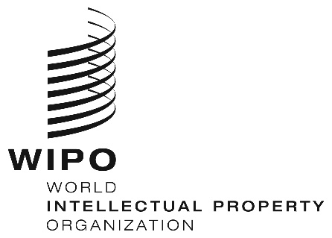 | E
CDIP/22/16 rev.
ORIGINAL: English
DATE: november 21, 2018

Committee on Development and Intellectual Property (CDIP)

Twenty-Second Session
Geneva, November 19 to 23, 2018

PROPOSAL BY MEXICO ON WOMEN AND INTELLECTUAL PROPERTY

prepared by the Secretariat

In a communication dated November 20, 2018, the Permanent Mission of Mexico has submitted to the Secretariat a proposal on Women and Intellectual Property (IP) as its contribution to the discussion on “Women and IP” under the agenda item IP and Development, with the request that the document CDIP/22/16 may be revised.

2. The proposal is contained in the Annex to this document.

3. The CDIP is invited to consider the information contained in this document.

[Annex follows]

REVISED PROPOSAL SUBMITTED BY THE DELEGATION OF MEXICO
Original text in Spanish

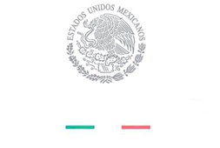

PERMANENT MISSION OF MEXICO

OGE04356

The Permanent Mission of Mexico to the United Nations Office and other International Organizations in Geneva presents its compliments to the World Intellectual Property Organization (WIPO) and has the honor to refer to Note OGE03787, dated October 15, 2018, to transmit herewith the document entitled “Women and Intellectual Property”.
The Permanent Mission requests the kind assistance of WIPO so that the annexed document may be published as a revised version (REV.) of document no. CDIP/22/16. This is in order that it may be considered and approved during the twenty-second session of the Committee on Development and Intellectual Property (CDIP).
The Permanent Mission of Mexico to the United Nations Office and other International Organizations in Geneva avails itself of this opportunity to reiterate to the World Intellectual Property Organization (WIPO) the assurances of its highest consideration.

Geneva, November 20, 2018

To the World Intellectual
Property Organization (WIPO)
Geneva

Original text in English
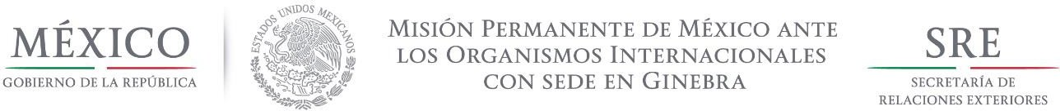

ANNEX

DRAFT PROPOSED BY MEXICO (REVISED)
Women and Intellectual Property

The Committee addressed the issue of “Women and Intellectual Property” under Agenda item “Intellectual Property and Development” and agreed to adopt the following decision:

The Committee aware of the importance of incorporating a gender perspective into the promotion of inclusive economic growth, and the key role that gender-responsive policies can play in achieving sustainable socioeconomic development:

- Considers that gender gaps reflect widespread gender inequality in social and economic life;
- Recognizes that gender equality and the empowerment of women and girls are integral to all dimensions of inclusive and sustainable development, and as such, a critical enabler to progress across the entire 2030 Agenda for Sustainable Development;
- Recalls Goal 5 of the Sustainable Development Goals in the United Nations 2030 Agenda for Sustainable Development, which is to achieve gender equality and empower all women and girls and the importance of mainstreaming gender equality through all the Agenda and Goal 9 “Industry, innovation and infrastructure” and the fact that investment in infrastructure and innovation are crucial drivers of economic growth and development;
- Emphasizes the role of science and technology in finding solutions to tackle some of the major problems humanity faces through innovative solutions;
- Recognizes that innovation and creativity are the engines of human progress;
- Acknowledges that improving women’s access to opportunities and removing barriers to their participation in national and international economies contributes to sustainable economic development;
- Emphasizes on the importance of promoting equal access and use of the Intellectual Property system;
- Agrees that increased participation by women and girls contribute to improve the innovation performance of societies;
- Recognizes that inclusive IP policies can contribute to advancing gender equality and women’s and girls’ empowerment, which has a positive impact on innovation and economic growth;
- Reaffirms that WIPO is the lead agency within the United Nations on issues of IP, technology and innovation;
- Welcomes the determination of WIPO to promote gender equality and the empowerment of women within its mandate and in line with the commitments of the UN as established in WIPO´s Policy on Gender Equality of 2014 and in this context, its commitment to making gender equality a cross-cutting issue which is mainstreamed across all Strategic Goals of WIPO;
- Express its appreciation for the 2018 World Intellectual Property Day campaign –Powering change: Women in innovation and creativity-; and
- Notes that according to WIPO available data more women than ever before are using the international patent system, though there is still a long way to achieve gender parity.

The Committee urges WIPO Member States to:
- Foster a wider and increased participation of women innovators and creators in the IP system.

- Encourage innovation and creativity among women innovators to reduce the gender gap among innovators and creators.

- Work towards the implementation of policies and practices aimed to foster women and girls’ empowerment and their full participation in innovation and creativity.

- Develop actions to promote the inclusion of women and girls on science and technology, as well as, in the innovation decision-taking processes.

- Share experiences relating to policies and practices to enable women and girls’ participation in the field of IP.

- Share best practices on multi-stakeholder initiatives to encourage more girls and women to participate in innovation activities to create valuable intellectual property.

- Share best practices for supporting women inventors and entrepreneurs and empowering women in IP management.

- Share programs to encourage and enable young women and girls to foster their talents in science, technology, engineering and mathematics, (the STEM subjects) and the arts by facilitating their access to quality education and allowing them to develop the skills, information and knowledge necessary to support their labor market entry, in particular in the field of IP.

- Share best practices of an inclusive IP system that can be used by everyone to acquire and own IP rights.

- Work together with WIPO Secretariat on the identification of barriers that limit women’s participation in IP.

To facilitate the implementation of the actions referred in the previous paragraphs, the WIPO Secretariat is requested to:
- Compile comparable and disaggregated international data on the gender of IP rights owners and creators.

- Share methods and procedures for the collection of gender-disaggregated data, the use of indicators, the monitoring and evaluation methodologies, and the economic analysis of gender gaps related to IP.

- Continue gender mainstreaming in WIPO programs and policies, including the implementation of WIPO´s Policy on Gender Equality.

- Continue through WIPO Academy to empower women through its range of IP training and capacity-building programs.

- Assist Member States on the implementation of measures and programs aimed to encourage women and girl´s involvement in IP.

The Committee decides to provide this decision to the General Assembly with the request to take note of its content.

The Committee also decides to revisit the issue “Women and IP” at its 26th session to consider the progress made on implementing its decision and future options for the way forward.

[End of Annex and of document]

As reflected in the Program and Budget for the 2018-2019 biennium

