E
CDIP/19/6
ORIGINAL: English
DATE: March 10, 2017

Committee on Development and Intellectual Property (CDIP)

Nineteenth Session
Geneva, May 15 to 19, 2017

REPORT ON WIPO’S CONTRIBUTION TO THE IMPLEMENTATION OF SDGs AND ITS ASSOCIATED TARGETS

prepared by the Secretariat

At its eighteenth session, the Committee on Development and Intellectual Property (CDIP) requested the Secretariat to present an annual report to the Committee, at its first session of the year, containing information on WIPO’s contribution to the implementation of the Sustainable Development Goals (SDGs) and its associated targets on:

(a) the activities and initiatives undertaken individually by the Organization;
(b) the activities undertaken by the Organization as part of the UN System; and
(c) the assistance provided by WIPO to Member States upon their request.

It is recalled that this document is a continuation of discussions initiated at the fifteenth session of the Committee on how WIPO would support Member States to fulfill the objectives of the post-2015 Development Agenda.

In this context, the Committee considered at its sixteenth, seventeenth and eighteenth sessions, a series of documents on “WIPO and the Post-2015 Development Agenda” (document CDIP/16/8 ), “Mapping of WIPO Activities Related to the SDGs Implementation” (document CDIP/17/8), and the “Compilation of Member State Inputs on SDGs relevant to WIPO’s Work” (document CDIP/18/4), respectively.

WIPO’S CONTRIBUTION TO THE IMPLEMENTATION OF THE SDGS AND ITS ASSOCIATED TARGETS

(a) The activities and initiatives undertaken individually by the Organization

On February 9, 2017, the Director General held a briefing to the Ambassadors and the Permanent Representatives in Geneva on “WIPO and the SDGs”. His presentation is contained in the Annex to this document.

In addition, in order to effectively respond to the Member State needs pertaining to SDGs, the Organization has recruited a Representative of the Director General on the SDGs to coordinate this subject internally and externally. The Representative started his functions in March 2017.

(b) The activities undertaken by the Organization as part of the UN System

As a specialized agency of the United Nations (UN), WIPO participated as an observer organization in all major UN processes supporting the preparation of the UN sustainable development agenda, including the Open Working Group on Sustainable Development Goals (March 2013 to July 2014 (OWG)), the General Assembly Workshops and Structured Dialogues on Technology Facilitation (2013-2014), the intergovernmental negotiations on the Post-2015 Development Agenda, and related processes such as the Third International Conference on Financing for Development, and the Interagency Task Team on the Technology Facilitation Mechanism.

The Secretariat has also contributed to the inter-agency work on SDG issues within the UN Chief Executives Board (CEB) as well as in the work of the UN Task Team on the Post-2015 Development Agenda (UNTT), and the UN Technical Support Team (TST) to the OWG. The role of the WIPO Secretariat included:

- monitoring the negotiations and discussions in these processes as they related to WIPO’s mandate;
- providing factual information on the role of the intellectual property system in relation to broader policy areas, as required by Member States and UN Secretariat; and
- raising awareness of the various WIPO programs, projects and initiatives which may support Member States in implementing the Sustainable Development Goals (SDGs).

A detailed report on WIPO’s engagement on the preparatory processes for 2030 Sustainable Development Agenda was presented by the Secretariat at the sixteenth session of the CDIP (document CDIP/16/8).

United Nations Summit (September 25 to 27, 2015)

At the UN Summit (September 25 to 27, 2015), the UN Member States adopted the Summit Outcome Document: “Transforming our World: the 2030 Agenda for Sustainable Development”. The 2030 Agenda sets the course and establishes a plan for sustainable development for the period up until 2030, and incorporates 17 SDGs and their associated 169 targets. The 2030 Agenda calls for bold and transformative steps to shift the world to a sustainable and resilient path. It seeks to be universal in its application to all countries, and to integrate and balance the three dimensions of sustainable development: economic, environmental and social. It calls upon countries and diverse stakeholders in the public and private sectors to collaborate and develop partnerships to support its implementation. The Summit was the culmination of a number of political processes outlined above that WIPO followed closely.

WIPO attended the Summit and participated in an interactive dialogue on a strengthened global partnership for realizing the Post-2015 Development Agenda. During the dialogue, WIPO presented some of its key partnerships that are relevant to SDGs; mainly WIPO Re:Search, WIPO Green and the Accessible Books Consortium (ABC). The dialogue was co-chaired by the President of Senegal and the Prime Minister of Turkey. WIPO participated also in the launching of the agreement on the establishment of a Technology Facilitation Mechanism. This took place at a high level event organized during the Summit that was co-hosted by the Governments of Brazil and France.

The Technology Facilitation Mechanism

The Technology Facilitation Mechanism (TFM) was established by the Outcome Document of the Third International Financing for Development Conference: the “Addis Ababa Action Agenda” (AAAA) and adopted in the 2030 Agenda. Its purpose is to support the achievement of SDGs through use of science, technology and innovation.

The TFM is composed of a UN Interagency Task Team on Science, Technology and Innovation for the SDGs (IATT), an annual Multi-stakeholder Forum on Science, Technology and Innovation for the SDGs, and an on-line platform to provide a cohesive overview of UN initiatives on science, technology and innovation, and facilitate access to and use of such technology-related initiatives. The aim of the IATT is to promote coordination, coherence, and cooperation within the UN system on STI-related matters with the aim of enhancing synergy and efficiency, in particular to enhance capacity-building initiatives.

WIPO is part of the IATT and also participated in the informal working group on technology facilitation which contributed to the development of the TFM. The other institutions that were part of the informal working group included the UN Department of Economic and Social Affairs (UN DESA), United Nations Environment Programme (UNEP), United Nations Industrial Development Organization (UNIDO), United Nations Educational Scientific and Cultural Organization (UNESCO), United Nations Conference on Trade and Development (UNCTAD), International Telecommunication Union (ITU) and the World Bank.

As a member of the IATT WIPO, through its Coordination Office in New York, is closely involved in this process. WIPO also assisted UN DESA and the 10-member advisory group appointed by the UN Secretary General with the organization of the first annual Multi-stakeholder Forum on Science, Technology and Innovation for the SDGs, convened by the President of ECOSOC, at UN Headquarters New York, on June 6 and 7, 2016, under the theme Realizing the Potential of Science, Technology and innovation for all to achieve the SDGs. In addition, WIPO, in cooperation with UNIDO and the Permanent Missions of Finland and Kenya organized in the margins of the first STI Forum, on June 7, 2016, a side event on the role of Innovation and Technology for Sustainable Development. WIPO is supporting the second annual Multistakeholder Forum on Science, Technology and Innovation for the SDGs that will take place at UN Headquarters New York on May 15 and 16, 2017, under the theme Science, Technology and Innovation for a Changing World – Focus on SDGs 1, 2, 3, 5, 9, and 14.

UN High Level Political Forum (HLPF) on Sustainable Development

The United Nations High-level Political Forum on Sustainable Development (HLPF) met at the United Nations Headquarters in New York from June 26 to July 8, 2015, under the auspices of ECOSOC. The Forum was created at the United Nations Conference on Sustainable Development (RIO+20), held in Rio de Janeiro in June 2012. Its main role is to promote and review the implementation of the sustainable development agenda and to provide political leadership, guidance and recommendations.

The WIPO Director General participated as a lead discussant in a roundtable discussion on “The role of business in implementation: How the private sector will support the implementation of the SDGs, through its activities and through partnerships, and how it will engage in the HLPF’’. The moderated round-table discussion took place at UN Headquarters in New York on June 26, 2015 and included Ministers and senior government officials, UN system and other organizations, as well as major groups of civil society and stakeholders. It was organized under the general theme of the Forum, Strengthening integration, implementation and review-the HLPF after 2015.

WIPO was represented at the HLPF session held in New York from July 11 to 22, 2016, under the auspices of ECOSOC. The theme of the session was “Ensuring that no one is left behind”. The session reviewed the implementation of the Agenda 2030 by 22 countries (LDCs, Middle Income and Developed Countries), through Voluntary National Reports.

Interagency and Expert Group on the SDG Indicator Framework

The Inter-Agency and Expert Group on Sustainable Development Goal Indicators (IAEG-SDGs) was established at the forty-sixth session of the Statistical Commission with the task of developing and implementing the global indicator framework to measure progress in implementing the SDGs. The IAEG-SDGs developed, between
June 2015 and February 2016, the initial set of global indicators through a process involving Member States negotiations. Observers from the UN system provided inputs as required.

WIPO participates as an observer in the IAEG-SDGs and the Statistical Commission meetings and teleconferences. WIPO attended the meetings held in New York in June 2015, in Bangkok in October 2015, in Mexico in March 2016 and in Geneva in November 2016. WIPO made its data sets and data methodologies available, upon request by members, for the measurement of the contribution of innovation systems to achieve SDGs 9 and 17. WIPO also worked closely with other UN agencies, in particular with UNESCO and ITU, in respect of indicator 17.6 for the measurement of innovation and technological development. The IAEG members were informed about WIPO statistical products which may support and inform their work, such as the World Intellectual Property Indicators Report and the Global Innovation Index. Currently no specific indicator is related to intellectual property. The global indicator framework is subject to ongoing periodic review throughout the 2030 Agenda period.

(c) The assistance provided by WIPO to Member States upon their request

At the time of the preparation of this document, the Secretariat has not received any request from Member States seeking assistance related to the attainment of the SDGs.

The CDIP is invited to consider the information contained in this document.

[Annex follows]

WIPO and the

Sustainable Development

Goals (SDGs)

(rfiilifu'\

SUSTAINABLE
DEVELOPMENT
G't1a,\-A\ LS

WIPO
WORLD
INTELLECTUAL PROPERTY ORGANIZATION

Francis Gurry

February 9, 2017

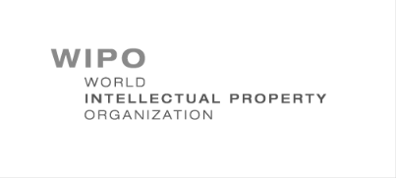
The Sustainable Development Goals (SDGs)

o Adopted UNGA September 25, 2015

o 17 Goals

▪ 169 Targets

o “These are universal goals and targets which involve the entire world, developed and developing countries alike. They are integrated and indivisible and balance the three dimensions of sustainable development.” (Para.5)

o Means of Implementation

▪ “a revitalized Global Partnership”

▪ “bringing together Governments, the private sector, civil society, the United Nations system and other actors and mobilizing all available resources” (Para. 39)

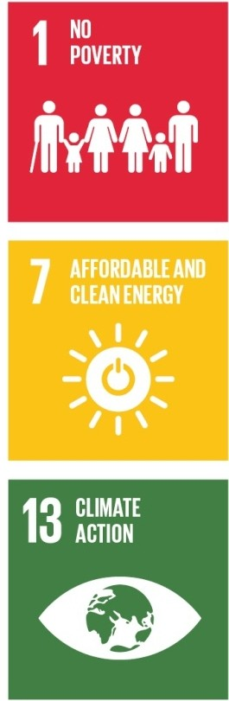

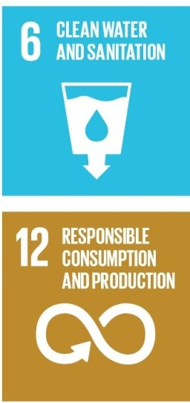
W ORLD
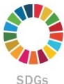
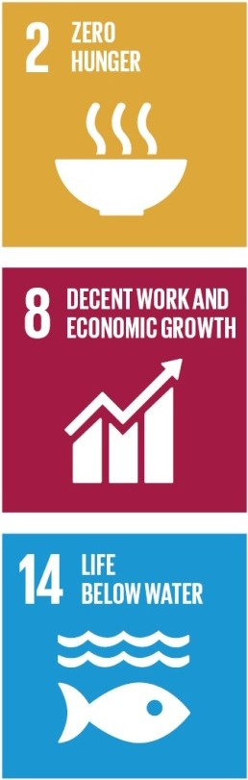
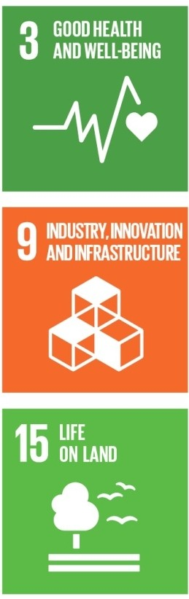
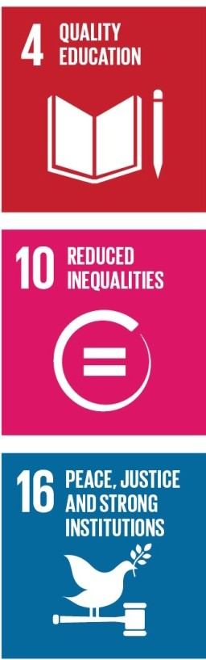
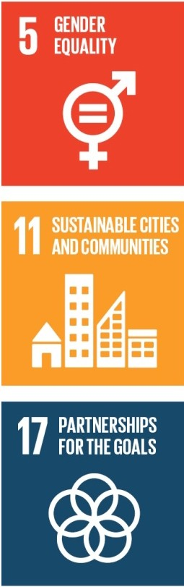
----0 ······
Mi··············· · WIPO

SDG 9: Industry, Innovation and Infrastructure

§ rif-

t lmplemeotatioo

Ideas
Research & Development Commercial Development Commercialization;
Ma<ke
rn loncll

WIPO
Contributions
o Legal Framework ------0 26 multilateral treaties

o Systems ---------o PCT; Madrid; Hague; Lisbon Agreement; WIPO Arbitration and Mediation Center

o Databases & Platforms - - ......o

Patentscope; Global Brands Database; Global Designs Database; WIPO Lex; IP Statistics Data Center; Industrial Property Automation System (IPAS); Centralized Access to Search & Examination (CASE); Digital Access Service
(DAS); Technology and Innovation Support Centers (TISCs)

o Analysis & Statistics -----0 World IP Reports; World IP Indicators; Global Innovation Index

o Partnerships --------o
Access to Research for Development & Innovation (ARDI); Access to
Specialized Patent Information (ASPI); WIPO Re:Search; WIPO Green; Inventor Assistance Program

Academy; National Strategies; Regulatory Framework Advice;
o Capacity Building ------0 Technical Infrastructure Coordination; Appropriate Technology; SMEs; University IP Policies
·················.......................................i............... WI
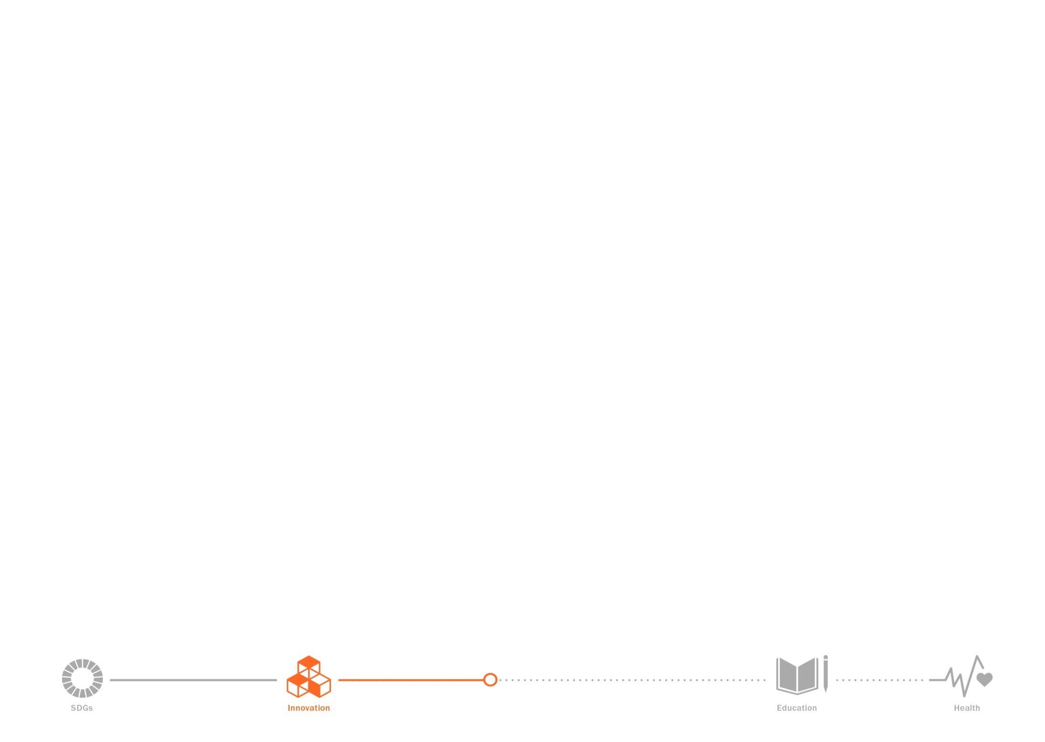
The Innovation Ecosystem

Slide4

How WIPO’s programs contribute

1. Establishing a legal framework for IP as an essential (but not sufficient) component of the innovation ecosystem in the global economy

(- Treaties)

2. Cost-effectiveness, transactional efficiency and simplicity in the operation of the
IP System internationally

(- Treaties; Global IP Systems; Platforms; Databases)

3. Enhancing capacity across the innovation ecosystem

(- Global IP Systems; Platforms and Technical Infrastructure; Partnerships; WIPO Academy; Capacity Building)

4. Economic intelligence

(- Databases; Economic and Statistical Reports)

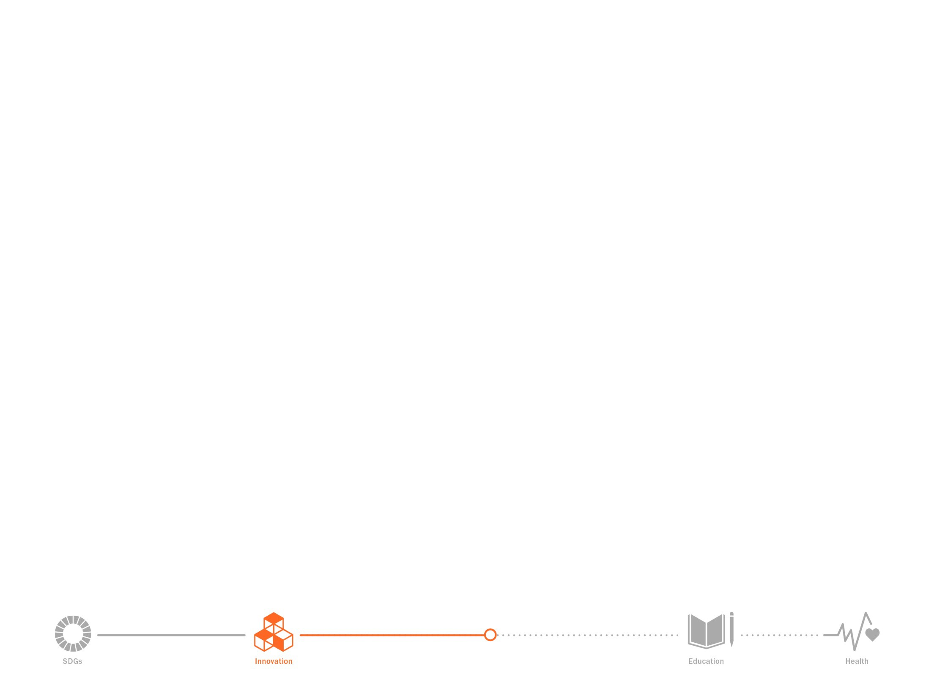
Innovation and the other SDGs

1. Innovation has an impact on a number of other SDGs.

Innovation in practice contributes directly to the achievement of certain SDGs, notably

o SDG 2 – Zero hunger

o SDG 3 – Good health and well-being

o SDG 6 – Clean water and sanitation

o SDG 7 – Affordable and clean energy

o SDG 8 – Decent work and economic growth

o SDG 11 – Sustainable cities and communities

o SDG 13 – Climate action

Innovation as a policy setting can assist in realizing other SDGs, notably

o SDG 1 – No poverty

o SDG 8 – Decent work and economic growth

o SDG 14 – Life below water

o SDG 15 – Life on land

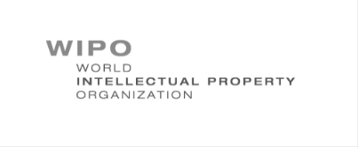
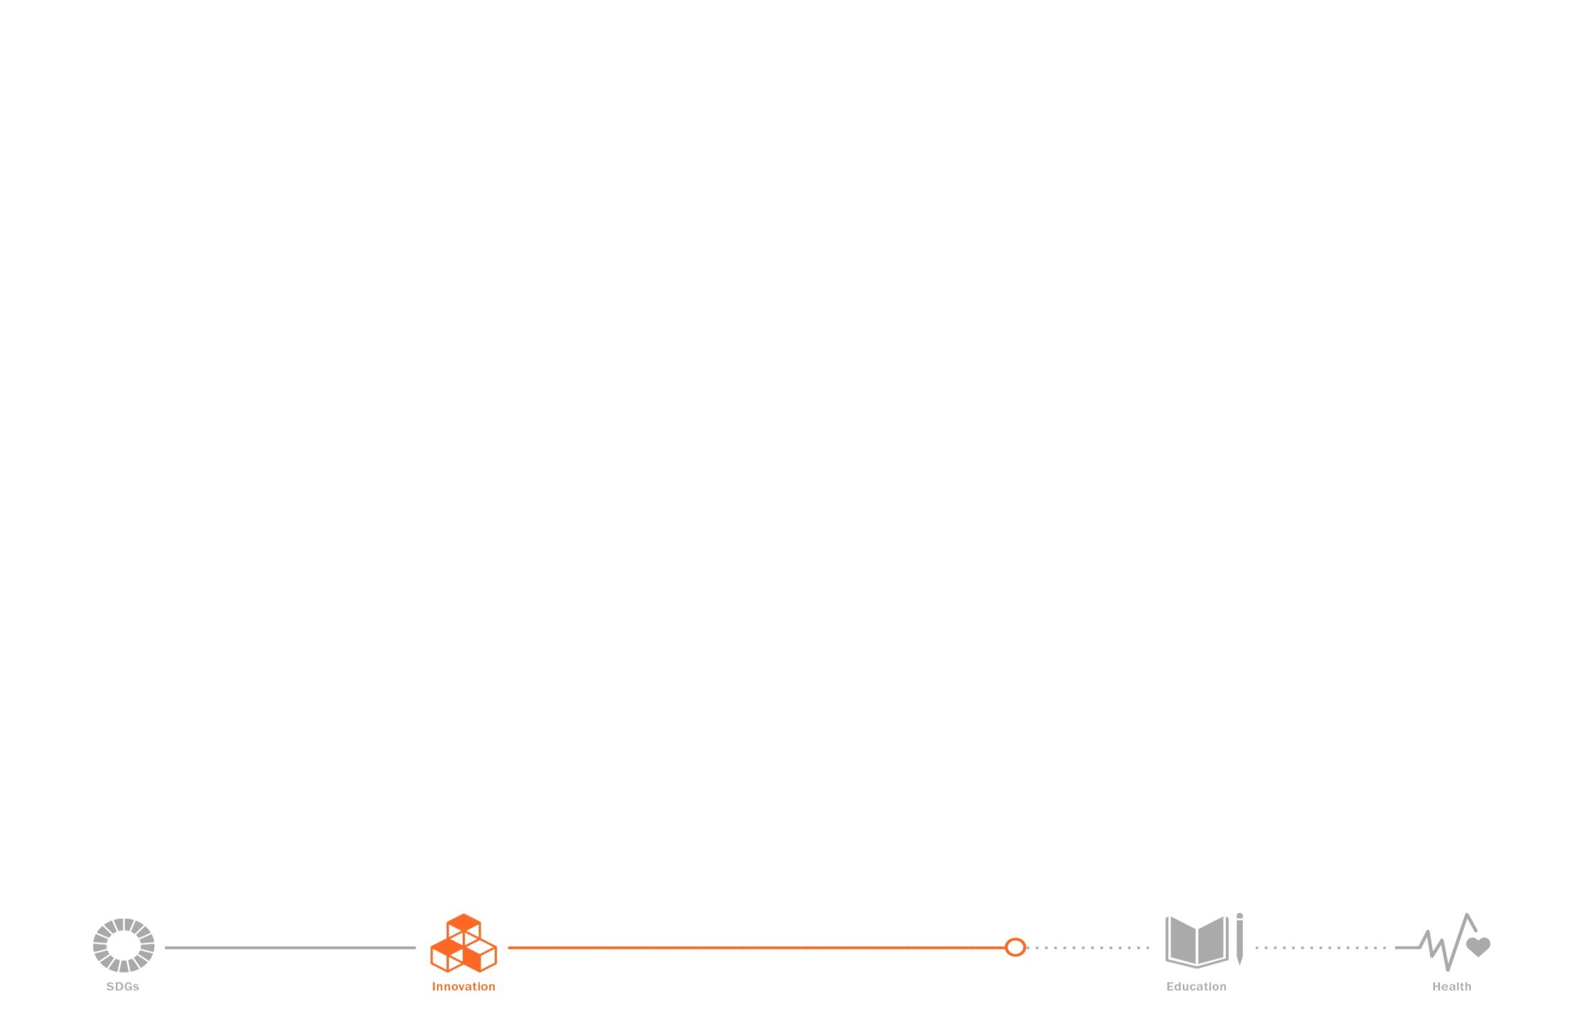
Innovation and the other SDGs

2. Certain SDGs are relevant to the settings of an innovation policy framework

o SDG 5 – Gender equality

o SDG 8 – Decent work and economic growth

o SDG 10 – Reduced inequalities

o SDG 12 – Responsible consumption and production

3. SDG 17 is a modality

o SDG 17 – Partnerships for the goals

SDG 4: Quality Education

1. Copyright as the principal mechanism for financing cultural production
- Legal framework in treaties
- Normative discussions

2. Partnerships
- Accessible Books Consortium (ABC)
- Enhancing publishing capacity

3. Capacity building
- Legal and technical advice
- Collective and individual rights management
- Human resource capacity building

SDG 3: Good Health and Well-Being

Slide 8

xxx

1. Health and innovation
- Standing Committee on the Law of Patents (SCP)
- Trilateral Cooperation (WHO – WIPO – WTO)

2. Upstream (R&D) activities
- WIPO Re:Search (neglected tropical diseases, malaria & tuberculosis)
- Patentscope database

3. Operational (use of IP) activities
- Patentscope database
- Trilateral Cooperation

[End of Annex and of document]

