|  |  |  |
| --- | --- | --- |
|  | WIPO-E | **E** |
| CDIP/16/INF/3 | | |
| ORIGINAL: English | | |
| DATE: september 29, 2015 | | |

**Committee on Development and Intellectual Property (CDIP)**

**Sixteenth Session**

**Geneva, November 9 to 13, 2015**

Guide ON the Strategic Management of Open Innovation Networks

*prepared by Ms. Ellen Enkel, Professor, Zeppelin University, Friedrichshafen, Germany[1]*

1. This document contains a Guide on the Strategic Management of Open Innovation Networks, prepared in the context of the *Project on Innovation and Technology Transfer Support Structure for National Institutions* (CDIP/3/INF/2). The guide has been prepared by Ms. Ellen Enkel, Professor, Zeppelin University, Friedrichshafen, Germany.

*2. The CDIP is invited to take note of the information contained in this document.*

**Content**

1. Executive summary 3

2. When to cooperate? 4

2.1. Importance of collaborative innovation 4

2.2. Open innovation and SMEs 4

2.3. Barriers and risks in collaborative action 4

2.4. Attributes of individuals for successful collaboration 5

2.5. Company´s network embeddedness – make, buy or ally decisions 6

2.6. Corporate strategy determine the balance between make, buy and ally 8

3. With whom to cooperate? 10

3.1. Selection of external sources as impulse for own development 10

3.2. Ally – develop together with a partner 12

4. How to settle a successful cooperation? 13

4.1. Process flow of creating an open innovation network 13

4.2. Understanding the motivation of different partners 16

4.3. Selecting the appropriate organizational form for cooperation 20

4.4. IP methodologies in different collaborative forms 22

4.5. Distribution of rights in collaborative agreements in the preparation phase 23

4.6. Management of IP rights in the practical management phase 25

5. Summary 28

6. References 29

7. About the Author 31

1. Executive summary

This guide aims to introduce and help companies to use bilateral and multilateral cooperation in order to increase their innovativeness as well as their efficiency. Specially SME´s are yet not leveraging the full potential of opening up their innovation management (open innovation) because they fear risk of knowledge loss or are unsure where to invest their limited resources in order to gain maximum benefit from collaborations. This guide aims to target the most important questions like “when to cooperate”, “with whom to cooperate” and “how to settle a successful cooperation agreement”. In order to benchmark the own company with the activities done by other successful large as well as small companies, this guide starts with providing some data on the use of open innovation activities and their related risks. It then gives some framework how to find the appropriate balance between own (make) and cooperative development (ally) and provides help how to set up a network with collaboration partners in order to accelerate innovation and improve efficiency. Additionally, this guide explains why the corporate strategy defines the balance as well as the selection of activity necessary for benefiting from open innovation. Consequently, after knowing how much collaboration activities need to be launched with whom, the last chapter illustrates different collaborative IP agreements and organisational forms with their related advantages and disadvantages.

1. When to cooperate?
   1. Importance of collaborative innovation

The increasing globalization of research, technologies, and innovation, new information and communication technologies, as well as new organizational forms and business models’ potential, reinforce the importance of finding new ways to innovate. Additionally, before the 80s, organizational structure changed into developing independent business units which could take care of their own knowledge demands. These drivers resulted in a huge growth of collaboration activities and the opening up of the innovation process in order to integrate external knowledge.

Cisco is regarded as one of the most innovative companies worldwide. Nevertheless, it does very little research and buys most of its technology. In the last decade stronger global competition has led to the sharing of labor, and cooperation with respect to the innovation process. Agility, flexibility, and concentration on core competencies are now regarded as sources of competitive advantage in most industries. The 'do-it-yourself' mentality has become outdated in technology and R&D management. As the focus shifted from purely internal R&D activities, the academic community started emphasizing that the firm’s boundary should be opened to outside innovation (e.g. Rigby and Zook, 2002; Chesbrough, 2003; Laursen and Salter, 2006).

Nevertheless, emulation requires more than just a few changes in a company’s innovation paradigm. Transforming a company’s solid boundaries into semi-permeable membranes, which will enable innovation to move more easily between the external environment and the company’s internal R&D process, is only one precondition (open innovation). A more important challenge lies in building the organizational capabilities required to use the environment effectively to increase innovation.

* 1. Open innovation and SMEs

Drawing on a database collected from 605 innovative SMEs in the Netherlands, van de Vrande et al. (2009) explored the incidence of and apparent trend towards open innovation. The authors found that the responding SMEs engage in many open innovation practices and have increasingly adopted such practices during the past 7 years. In addition, they found no major differences between manufacturing and services industries, but medium-sized firms are on average more heavily involved in open innovation than their smaller counterparts. Furthermore, they found that SMEs pursue open innovation primarily for market-related motives such as meeting customer demands, or keeping up with competitors. Their most important challenges relate to organizational and cultural issues as a consequence of dealing with increased external contacts.

Our 2011 study on open innovation with 98 European companies comparing innovation activities of big enterprises (46% of the respondents have more than 500 employees) with SMEs (54% of the respondents) shows that open innovation is increasingly important for small and medium sized companies as it helps to overcome resource limitation and increases efficiency and effectiveness (Enkel et al., 2011). At the moment, most of the companies using open innovation intensively are from manufacturing (57%), fewer are from the service industry.

* 1. Barriers and risks in collaborative action

At the same time, companies investing in open innovation activities face risks and barriers which prevent them from profiting from their initiatives. Our study of 107 companies, both European SMEs and large enterprises, undertaken in 2008, show that risks such as loss of knowledge (48%), higher coordination costs (48%), as well as loss of control and higher complexity (both 41%), are mentioned as frequent risks connected to open innovation activities (Enkel et al., 2009). In addition, there are significant internal barriers, such as the difficulty in finding the right partner (43%), imbalance between open innovation activities and daily business (36%), and insufficient time and financial resources for open innovation activities.

Today’s business reality is not based on pure open innovation but on companies that invest simultaneously in closed as well as open innovation activities. Too much openness can negatively impact companies' long-term innovation success, since it could lead to loss of control and core competencies. Moreover, a closed innovation approach does not serve the increasing demands of shorter innovation cycles and reduced time-to-market. The future lies in an appropriate balance of the open innovation approach where the company or institution uses every available tool to create successful products and services faster than their competitors, and at the same time fosters the building of core competencies and protects its intellectual property. This demand creates an increasing urge for identifying the cause-and-effect relationship of open and closed innovation activities and finding the appropriate contributors and integration mechanisms. Recent studies show that the orientation toward the corporate strategy determines the degree of openness or closeness with maximum benefits (see section ‎2.6).

* 1. Attributes of individuals for successful collaboration

Besides the organizational environment for collaboration, individual attributes of the employee and partner within the collaboration play a crucial role. The right degree of individual openness, combined with organizational openness, supports an improvement in company´s innovativeness. Chesbrough (2003) suggests that openness is key to profiting from external influences. An emergent strategy is based on interaction and progressiveness. Not only structures’ openness (the organizational possibility to contribution in collaborative activities), but also the individual's openness (e.g. the lack of a Not-Invented-Here syndrome, open mind set to collaborate with different partner) correlates strongly with the degree with which companies and individuals profit from collaboration. Individual openness includes predictability and the willingness to maintain a good relationship. These factors as well as the complementarity of knowledge in a bilateral (collaboration) or multilateral cooperation (network) influence the value of the engagement. A balance between complementarity and the two trust indicators 'predictability' and 'willingness to maintain a good relationship' enhances individual learning and its application in the individual´s home institution.

Innovation networks are influenced by “innovation platform thinking” as a recipe for establishing successful networks based on the multidimensional benefits that it offers, which not only helps them in developing a large variety of innovative services, but also build an environment for nurturing ideas, knowledge and solutions which feed the innovation networks, connect the network members, their knowledge, activities, resources and capabilities based on an open innovation model (Jazairy, 2012). An open environment that enables every member of a network to contribute is important for profiting from open innovation networks. Network management has to enable all partners to contribute equally and employ fewer hierarchical structures. An egalitarian network structure gives smaller members an opportunity to contribute and provides a positive working atmosphere.

Interaction in open innovation networks has a significant influence on the company’s innovation outcome. A significant positive relationship between profiting from open innovation and the home organization’s improved outcome in terms of reduction of cost, improved products and services can be reported. Thus, organizations that have identified networks as an important source of learning and of gaining access to external knowledge companies, as well as research institutions can begin to address contributing to open innovation networks as a strategy to increase their corporate innovativeness.

* 1. Company´s network embeddedness – make, buy or ally decisions

Successful small and medium sized as well as big enterprises have developed a network of bilateral and multilateral relationships to the external environment in order to gain the knowledge or skills needed or in order to learn from their partners. Multiple innovation partners can be selected along and outside the value chain, as well as on different horizontal levels and from other industries. Those relationships form a network of knowledge streams the company is embedded in and needs to manage successfully in order to increase benefit (see Figure 1).

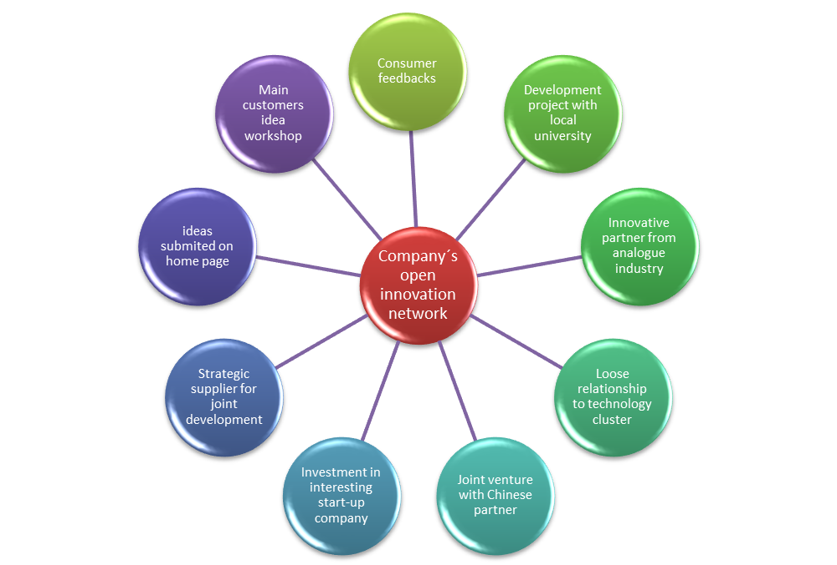

Figure 1: Possible open innovation network with tied and loose relationships with different partners

While open innovation’s core process helps to access or exploit knowledge, technology, and competencies, the innovation modes aid the selection of an appropriate partner and the sourcing of knowledge for a successful innovation. The following figure illustrates the innovation modes found in our data and describes them from a company perspective. As in the case with the processes, companies within our sample do not engage in all modes, but focus on those that are easy to access or add value with regard to knowledge or required competence.



Figure 2: Principle Modes of Innovation (source: Gassmann and Enkel, 2004)

The numbers within figure 2 indicate the mode of cooperation and/or the cooperation partner found in our sample: 1) Customer integration, 2) supplier integration, 3) competitor alliances, 4) customer of customer or end consumer integration, 5) integration of second tier supplier, 6) cross-industry innovation, 7) university-industry cooperation, and 8) globalization of innovation. The numbers do not indicate the frequency of these sources’ use. Customers and suppliers are much more often chosen as partners of one of the open innovation processes than the other modes.

There are many motives for the single cooperative arrangements as risk reduction, achievement of economies of scale and/or rationalization, technology exchange, enabling organizational learning but also coopting or blocking competition, overcoming government mandated trade or investment barriers, as well as facilitating initial international expansion of inexperienced firms, and vertical quasi-integration advantages of linking the complementary contributions of the partners in a value chain. External drivers as well as internal needs require companies to cooperate in many different forms and with a variety of partners. Yet, those demands still offer a wide range of cooperative agreements and forms to be fulfilled, e.g. to integrate existing technologies by licensing from a partner, co-creation of certain products or services with partners, or to learn from other industries and copy their principles. Generally, the make-buy-ally matrix helps to decide when to choose which basic form of knowledge transfer or development, (Figure 3).

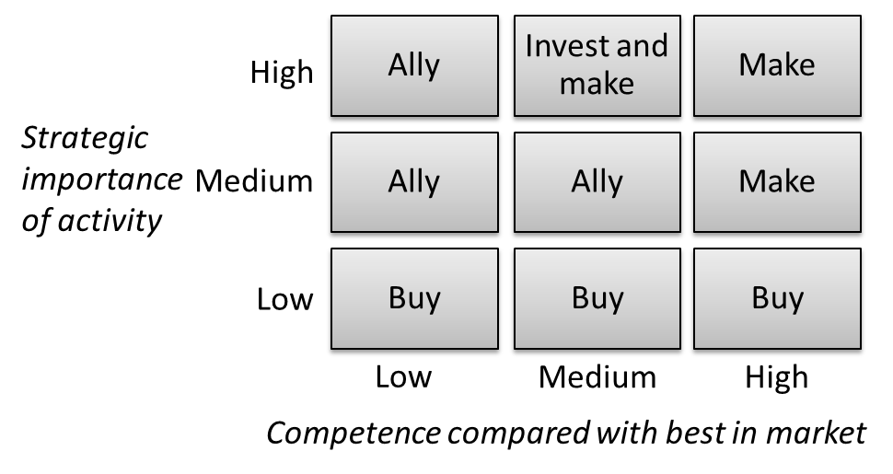

Cooperate

Develop alone

Figure 3: Make-Buy-Ally matrix depending on strategic importance and existing competence

While the make-decision focuses on the exploitation of own competencies often with the impulse from customers, suppliers or universities, the ally- as well as the buy- decision focus on cooperative arrangements where at least one partner or source needs to be selected. Buying knowledge in the form of outsourcing research and development activities to or license technology from an outside partner, mostly suppliers, partners in one´s own or in other industries or research institutions, requires the identification and evaluation of the knowledge asset to be purchased. Internal and external sources’ relative importance is determined by a company’s technological position and varies across different industries. The ally-decision requires a choice about the appropriate partner and form of cooperation as well as the handling of intellectual property in the cooperation and afterwards. Those forms that enable learning from the partner are joint ventures, collaborations, and consortia, while skill-substitution arrangements can be made in virtual corporations and networks. This guideline focuses on the ally- and make-decisions and offers some basic recommendations for companies to quickly find the appropriate partner and organize the knowledge exchange.

* 1. Corporate strategy determine the balance between make, buy and ally

This section is based on the work of Bader and Enkel (2014). Analyzing the motives for opening up the innovation process, yet increasing innovativeness (conquering new markets, increasing market share, growing new products or services) is more important for companies than resource efficiency (increasing efficiency by outsourcing R&D activities, buying external technology or IP, partnering in development and commercialization to share resources).

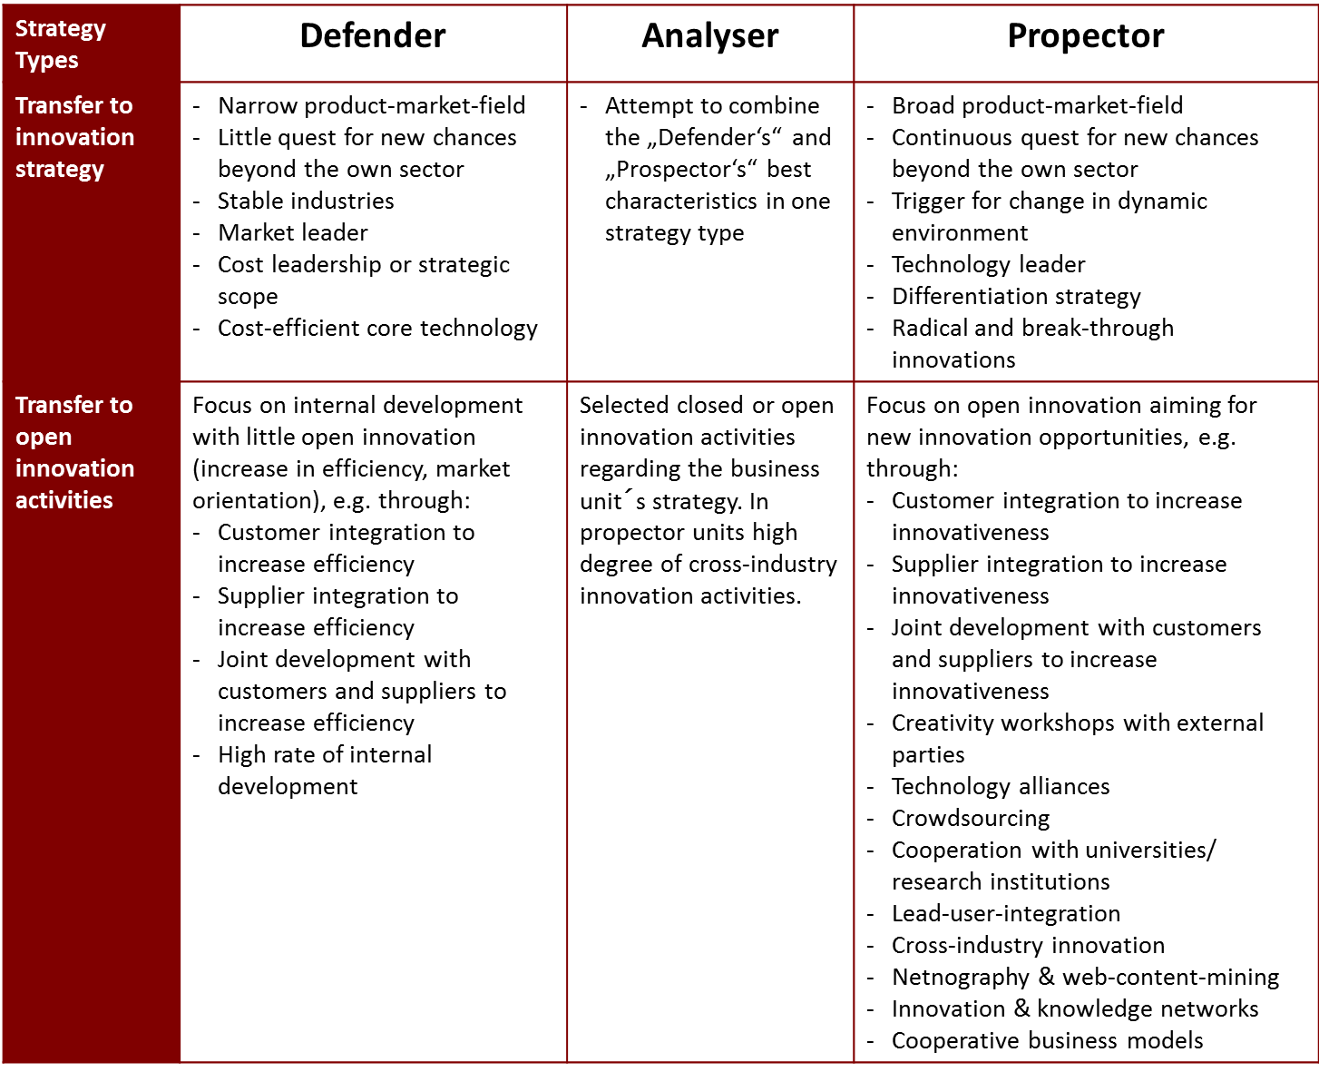

Figure 4: Open innovation activities depending on business strategies (based on Bader and Enkel , 2014)

The study shows that both motives can be followed successfully when selecting the right sources and the right collaborative activities depending on the corporate strategy. Based on the strategic typology of Miles and Snow (1978) we can differentiate between three innovation archetypes and determine the right sources and activities in open innovation.

Prospectors describe firms which continuously search for novel product and market opportunities and ways of reacting to trends in the marketplace. They are prepared to easily operate in a highly dynamic environment and are regarded as initiators of change and uncertainty. Furthermore, prospectors frequently exploit new occasions for value creation in the notion of creative destruction (Schumpeter, 1942). They are able to create future visions and strive to detect new markets. Consequently, they are often recognized as technology leaders in their industries and are likely to focus on radical solutions and technological breakthroughs.

To succeed in tracing novel market chances, and witness environmental shifts, trends, and events presciently, prospectors need to develop and maintain the competence of scanning and scouting a broad market domain. Furthermore, environmental scanning enables the prospectors to act proactively. Since scouting as activity is not limited to a firm's current market domain, prospectors commonly look for new opportunities in several marketplaces and frequently initiate radical changes in their domains. As a result of searching a broad market domain, prospectors tend to strive for diversification and product development and predominantly follow a differentiation strategy (Fiss, 2011; [Porter, 1980](#_ENREF_70" \o "Porter, 1980 #276)).

The strategic orientation of defenders opposes the prospectors’ strategy and reaction towards the environment. Defenders portray companies with tight product-market domains striving for cost leadership via competitive pricing. They constantly aim for internal process optimizations and operating efficiency to reduce costs. Usually, defenders are engineering-oriented firms concentrating on the maintenance of specific market segments in a relatively sheltered domain. They assertively intend to deter competitors from entering their market domain and defend their market shares. By cutting off a fragment of the entire market, defenders try to achieve a high degree of stability and steadiness.

Since defenders target early and late mainstream market segments and approach a selected portion of the total market, they frequently manage to become market-share leaders and are able to roughly serve two thirds of the market demand. Market-share leadership is achieved, since this strategic archetype strongly penetrates the market, and aims at resource efficiency and incremental product, service, and process improvements (Chandy and Tellis, 1998; [DeSarbo et al., 2005](#_ENREF_24" \o "DeSarbo, 2005 #257)). Due to the narrow market domain, defenders hardly need to conduct structure, process, or technology assimilations, but are fully committed to the enhancement of current operations. Their desire for technological efficiency and predictability seems to be reasonably high.

The analyzers represent the third proactive strategy archetype and are positioned between the defenders and prospectors. They are not stuck in the middle, but may be labeled as strategic hybrids. This strategic archetype operates in both a stable and dynamic product-market domain, focusing on exploration and exploitation. On the one hand, analyzers track auspicious novel product or market developments in dynamic domains. In this context, existing products, technologies, and concepts of firms in their own or foreign industries are monitored, and the most promising ones are rapidly imitated and enhanced. On the other hand, analyzers employ a high degree of uniformity and formalization of structures and processes in rather stable domains. In order to benefit from this strategic orientation, analyzers need to successfully meet the challenge of strategic duality and a dual technological core, namely technological flexibility and stability.

Analyzers often outperform prospectors and defenders on distinct performance measures, as they strive for risk minimization and simultaneously intend to exploit chances for higher profitability. By combining the strengths of the pure strategies in this archetype, they frequently achieve superior performance by realizing efficiency and adaptability at the same time. However, this finding is negated by Fiss (2011) evaluating firm performance differently. The pure strategic archetypes achieve higher firm performance than analyzers, as they do not have to cope with the complexity resulting from duality.

1. With whom to cooperate?
   1. Selection of external sources as impulse for own development

Comparing open innovation behavior of enterprises with SMEs It becomes clear that both using sources inside their own value chain, like customers, consumers or suppliers, in more than 50% of all innovation projects (Figure 5). The main reasons for usage are the already existing relationships resulting in trust, knowledge about the internal processes, and understanding of the motives of each other. Whereas the integration of normal customers or consumers mostly leads to incremental innovation, lead user integration often leads to radical innovation. Lead user recognizes demands earlier than other customers, they are able and motivated to engage in product development. Suppliers are already heavily integrated in certain industries like automotive or fast moving consumer goods while other industries don´t cooperate yet.

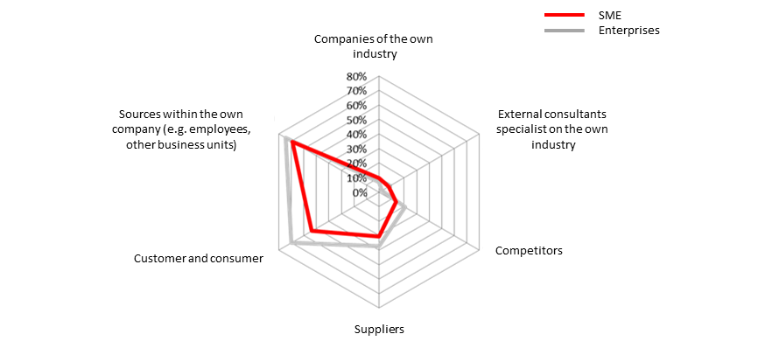

Figure 5: Comparing enterprise´s and SMEs usage of sources inside of the value

chain

A negative side effect of integrating customers or suppliers is their possible integration into the innovation process of major competitors and therefore the likelihood of fewer differentiated products and knowledge loss. Institutionalized sources like public or private research institutions, universities, data bases, newspapers, and journals as well as conferences are as of yet only used by 10-25% of the SMEs and by 10-45% of enterprises (Figure 6). The lack of usage of public or private research institutions and universities can result especially from missing structure, management support, and processes for identifying knowledge from those sources on the one hand, and missing IT infrastructure and expensive database access on the other hand.

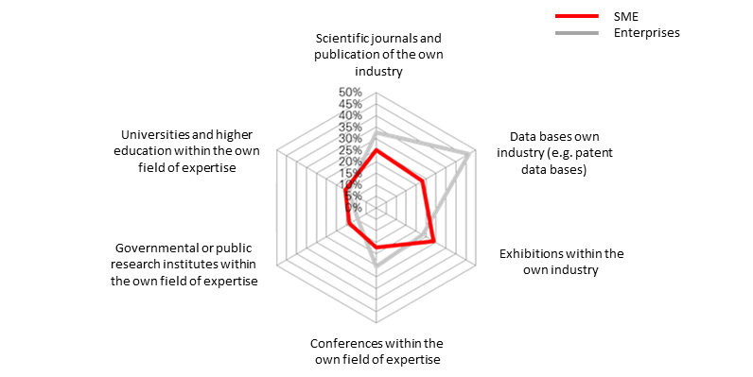

Figure 6: Institutionalized knowledge sources

The less frequently used sources are sources outside of the value chain, although those sources possess the main potential for radical innovation with highest benefits and low risk. While enterprises use companies of other industries, universities and research institutions outside of their main technology area between 2 and 12% of all innovation projects, SMEs relay on these sources even more often (Figure 7). The challenge of integrating existing knowledge or solutions from other industries lies in the identification of analog industries in order to narrow down the possible solution space. Lack of trust and the so called not-invented-here-syndrome (NIH) could hinder companies to use industry foreign solutions.

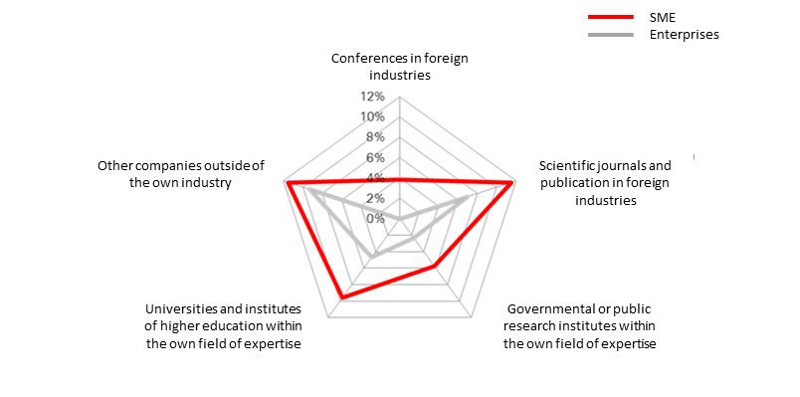

Figure 7: Usage of sources outside the own industry

To study the partnering activities in greater detail, one needs to examine the individual phases of the innovation process. Within the early phase of the innovation process (opportunity identification, development of new businesses etc.), suppliers, clients, competitors, and universities are used as the major sources of innovation (see the make-section of the guideline). Companies in slow and fast industries often steer clear of integration with government and commercial research institutes. Within the idea generation and selection phase, external partners are integrated to a lesser degree than they are in the technology exploration phase. Here, important partners are both clients and competitors. Ideas from clients might come through the sales and service departments, while information on competitors is scanned through marketing. In contrast to idea generation and selection phases, clients only seem to be regarded as a valuable source of knowledge, (e.g., for customizing products) in development projects’ later phases. All other sources are ignored, or only drawn upon in a minor way.

* 1. Ally – develop together with a partner

While the integration of sources or knowledge described above refers to a short term or no personal involvement of the source, the term collaboration or ally expresses a longer time involvement as well as an intensive direct contact between the partners. Laursen and Salter (2006) presented the first quantitative study based on 2707 manufacturing firms in UK which, on the one hand side, proved that open innovation improves the company´s performance. On the other hand side it illustrated, that there is an optimal number of relationships and an optimal distribution of intensity of those relationships which causes a higher impact on corporate performance. It is neither good to have too many relationships with a low intensity of interaction nor is it a successful strategy to focus on only a few with very tied and formal links. The right mixture, depending on the cooperate strategy, is the most successful approach. In order to identify which partner add which value to the cooperate network of loose and tied relationships again corporate strategy gives the answer: while Defenders need a network with customers, suppliers and partners to efficiently produce their goods or services with lower costs, the prospector needs a wide spread network of all kind of different partners in order to quickly identify and leverage new opportunities.

Looking again on the open innovation study (Enkel et al., 2011) might help to benchmark the own collaboration network with other companies and identify gaps where useful partners are not yet integrated. The main partners of the sample companies are customers (45-48%), suppliers (19-27%) as well as universities and research institutions (25-27%). Companies in the same industry (8-12%), from other industries (SMEs only 5%, enterprises 12%) and partners engaging in cooperative business models (SMEs only 3%, enterprises 9%) are still used less, although they are associated with more radical innovation than the sources of the same value chain. In industries like electronic, information, and the communications industry, as well as fast moving consumer goods, cooperation in order to join development with a partner of complimentary knowledge or assets, or to increase efficiency, is core for many years (Gassmann et al. 2010).

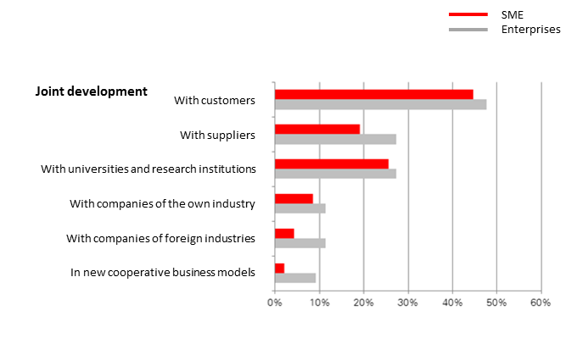

Figure 8: Collaboration partners for enterprises and SMEs

Cooperation with competitors or cooperative business models is still rare. The risk of knowledge loss and the consequent protection of IP seem to be hurdles companies can only manage by systematically applying methodologies of IP protection. SMEs suffer more of these problems than bigger companies as the numbers suggest. This might be the result of missing organizational structures, management support, and processes or tools for cooperation and knowledge protection.

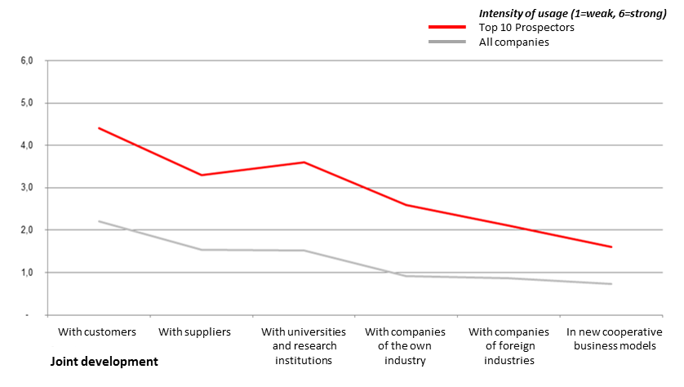

**Figure 9: Comparison of the intensity of external partners between the average company in the sample and the best 10 open innovators aiming for innovativeness**

Looking at the huge differences between the best open innovators compared to innovation performance and the average of the sample it becomes clear that a higher intensity of collaboration is needed for maximum benefit from open innovation. Increasing the intensity means to collaborate with more sources in various degrees of intensity, (from loose short time cooperation to formalized long lasting joint venture).

One major influence factor the study revealed is the corporate culture which builds the nutrient medium for leveraging the value of open innovation. Attributes like the focus on future customers instead of current ones, a risk taking attitude, and focus on non-monetary incentive systems play a significant role in increasing the number of radical innovations and therefore the overall financial performance of the company. Additionally, centrality of decision making of process and product development, which can be found in SME more than in enterprises, is associated with a higher margin of radical innovation. Those attributes are characteristic of the so-called hidden champions: small and medium sized, often family owned, businesses which are world market leader in their niche.

1. How to settle a successful cooperation?
   1. Process flow of creating an open innovation network

From a broader perspective, the company is surrounded by bilateral relationships which embedded it into a more or less dense open innovation network. While companies with a defender strategy will use cooperation mainly to increase efficiency and cost reduction in order to grow market share, they will still have a distinct degree of own development in place. The company with a prospector strategy has a much higher number of collaboration in place which should serve to identify and leverage new opportunities. Because the prospector does not know where an opportunity for technology leadership might arise, he has a wide spread portfolio of dense and loose cooperation in his open innovation portfolio. While the defender focus more on customer and supplier as partners, the prospector has relationships too many different sources (see Figure 10).

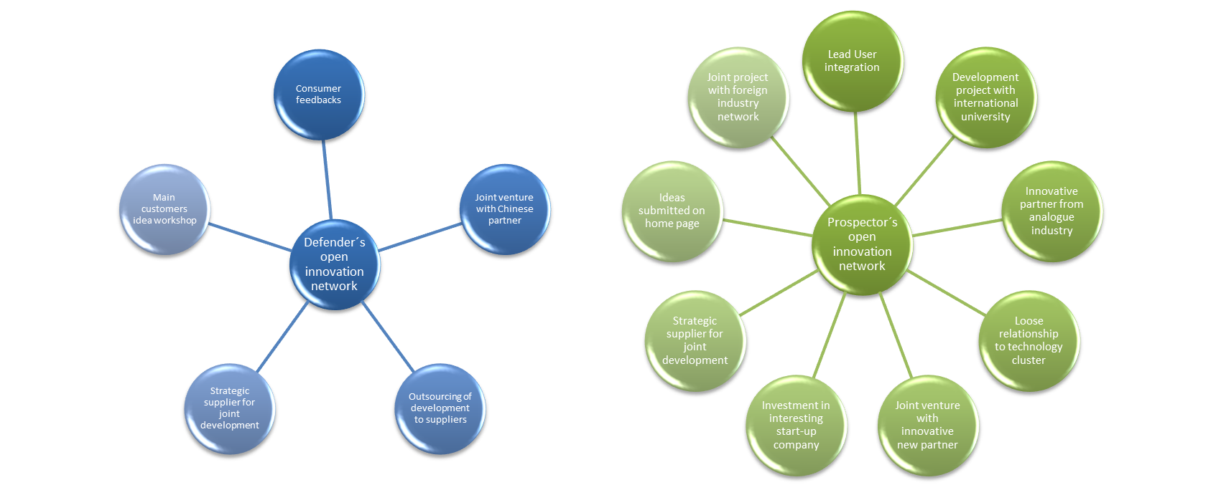

Figure 10: Defender´s and Prospector’s typical open innovation network

Yet, companies do not launch or maintain every relationship equally because different partner and different organisation forms demand different requirements and treatment.

Therefore, in the next chapters the launch and management of a single relationship is explained.

In order to provide a process for launching and maintaining collaboration, different factors need to be taken into account. The collaboration process can be distinguished into the phases start, design, collaboration and end (Figure 11).

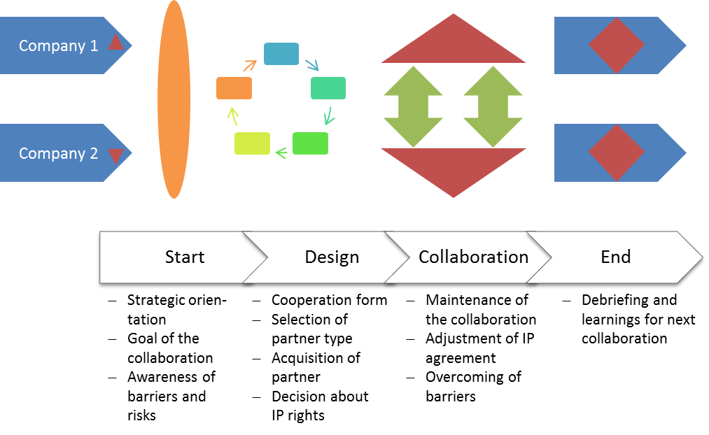

Figure 11: Collaboration process outline

The factors necessary to be understood and decided in the start phase have been already explained in the previous chapters (“When to cooperate?” and “With whom to cooperate?”). The most important factors in the design phase are the selection of the cooperation form, the partner type and the IP agreement form. Besides, the partner needs to be acquired by which the knowledge about the motivation of different partners might help (see next chapter). Within the actual collaboration phase the management of IP rights as well as other legal and procurement process with special collaboration forms, like joint venture, are important and are discussed in the following chapters.

The acquisition of the selected partner is in done in different steps which are described shortly.

I. Analysis and profile development

* Definition of the strategy (open or closed innovation, defender or prospector strategy)
* Comparison of own competencies with state-of-the art in market and in technology
* Draft concept of collaboration goal and partner profile (make, buy or ally decision)
* Project definition and tasks (selection of partner type)
* Development of a cooperation concept including IP management and collaboration form

II. Identification and pre-selection of possible partners

* Overview over potential partner and their motivation to collaborate
* Collection of information about potential partners
* Ranking of partners
* First discussions with 2-3 partners (non-disclosure agreement (NDA), discussion of conflict of interest or resources, first gut feeling)

III. Selection and Acquisition

* Selection of the partner
* Acquisition
* Due diligence (checking the credentials of the other party) and decision of legal form

IV. Negotiation

* Operative management of the cooperation
* Definition of project plan
* Definition of leadership and steering committee
* Definition of cash flow and performance

V. Signing of the contract

* Legal contract formulation and signature

The responsibility for the selection process could lay with different people within a bigger company, e.g. R&D, project leader or university relationship department as well as marketing, business development or product management. Besides the management of the selection process, expert from different areas and business units need to provide information. The analysis and pre-selection can be led by marketing, sales or technical experts, existing contacts can be used as well. In the phase of the contract discussion and signature the legal department and the IP experts are crucial. In small companies project management or head of R&D are taking care of most of the phases, the legal parts often takes over an external patent lawyer.

* 1. Understanding the motivation of different partners

Co-operation refers to the joint development of knowledge through relationships with specific partners. Examples of relationships are with consortia of competitors, suppliers and customers, joint ventures and alliances, as well as with universities and research institutes. Co-operation is usually characterized by a profound interaction between parties over a longer period of time.

The benefits of co-operation are revealed in an improvement in the companies’ competitive position and in risk minimization, but not in a reduction of development time. The objectives of most companies that focus on co-creation are to set standards, or create a dominant design with their products. A recent example of this is the strategic alliance of suppliers, consumer goods companies, and retailers for producing RFID chips. The members of the alliance (e.g., Metro, Unilever and Henkel) aim to set a standard and participate in development because the technology is new and will be relevant for all of them in future.

A crucial precondition for working in cooperative innovation processes is the capacity to integrate foreign knowledge into a company’s own knowledge and technology, and to externalize it in order to enable the partner to learn. Success is based on a company’s ability to find and integrate the right partner that will provide the competencies and/or knowledge needed to gain a competitive advantage in their industry.

A cross case analysis of 12 companies and 22 cases of collaboration revealed strength, weaknesses, and threats, as well as opportunities for collaboration with different partners (Enkel and Conreder, 2007). In the analysis the goals of the different partners as well as their origin is discussed in order to identify patterns for collaboration. Characteristics of five different partner types were identified and discussed below. These are: vertical cooperation with competitors, horizontal cooperation with suppliers and with customers, cooperation with universities and research institutions, and cooperation with start-ups or young companies.

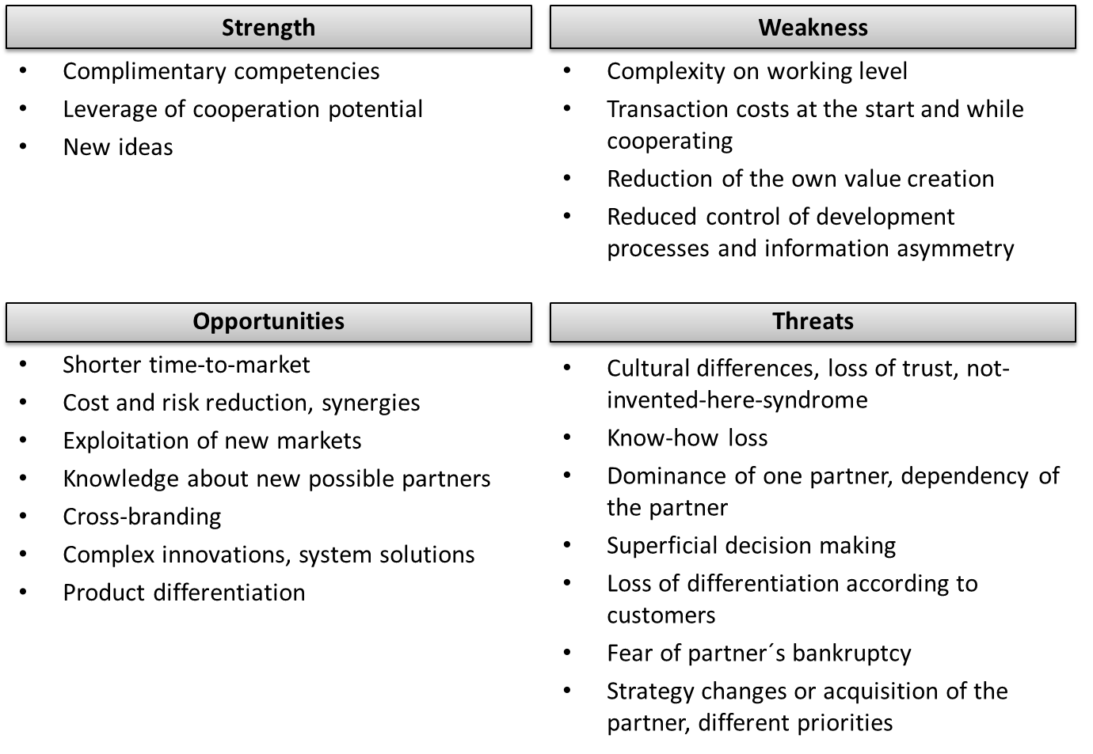

Figure 12: General strength, weakness, opportunities and threats of cooperation

The German MTU Aero Engines and the American engine manufacturer Pratt & Whitney mirror their organizations’ structure in order to facilitate co-operation and communication on each organizational layer. This interaction tends to result in an intensive exchange of knowledge and a process of mutual learning, which in turn yields context-specific and implicit knowledge. The following SWOT analysis shows in an overview the characteristics of cooperation with competitors (Figure 13).

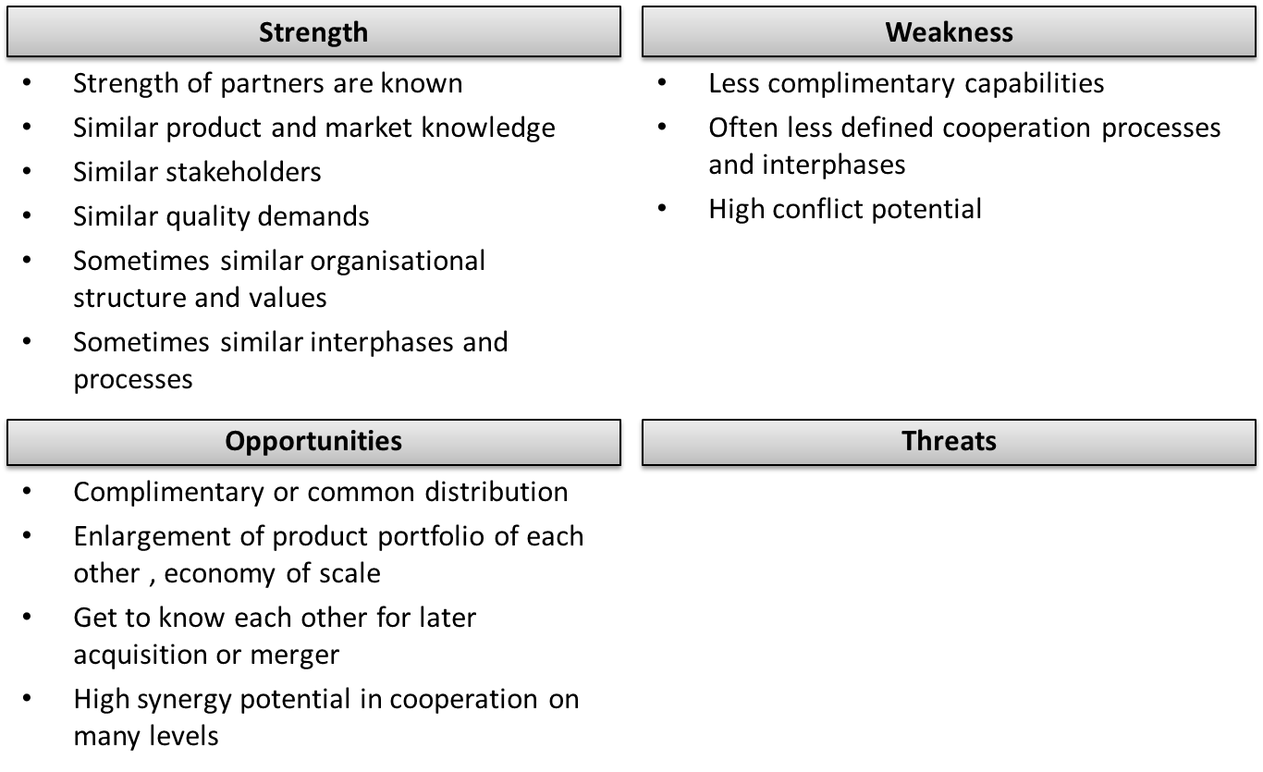

Figure 13: SWOT analysis of cooperation with cooperation with competitors

Companies that can achieve increasing returns by multiplying their exploitation also choose the cooperation process as a core one. An example is the mobile industry in which new technologies like MMS, UMTS, and polyphone ring tones can be established as a standard and lead to high revenues if all or most telecom companies (e.g., Sony, Ericsson, Siemens and Nokia) implement them. The technology provider needs to work with the mobile industry in a strategic alliance in order to ensure that the new technology will be implemented in the new mobile phone generation. See the following figure as summary of the SWOT of cooperating with suppliers (Figure 14).

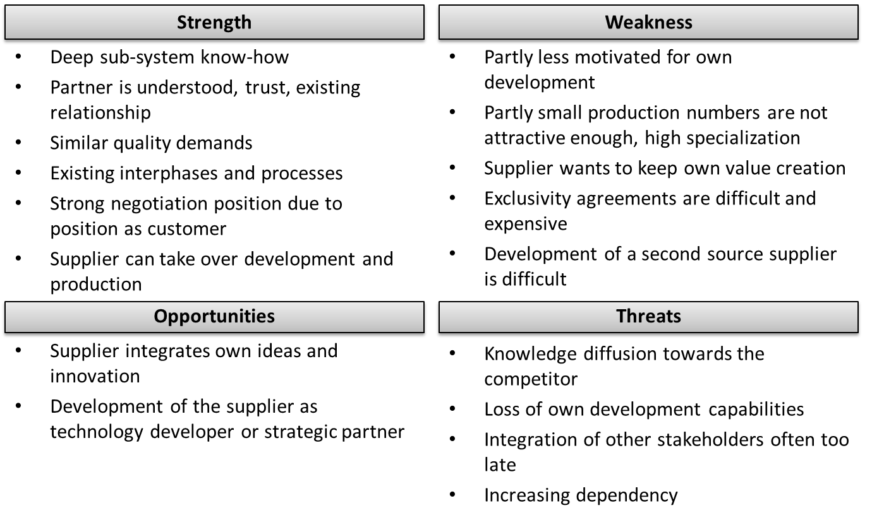

Figure 14: SWOT analysis of cooperation with cooperation with suppliers

As said above, customers are by far the most used collaboration partners in the innovation process. One trigger for customer integration is the high failure rate of innovative products. Customer integration can reduce this rate: customers know what they want and need and thus guarantee that new products developed accordingly will satisfy the market. At the same time, customers constitute a reliable buyer potential. In addition, early customer integration minimizes the risk of a change having to be made later to meet customers’ wishes and accordingly prevents the increase in costs and the reduction of profits that a delayed market introduction causes. The following SWOT analysis shows in an overview the characteristics of cooperation with customers and end-consumers (Figure 15).

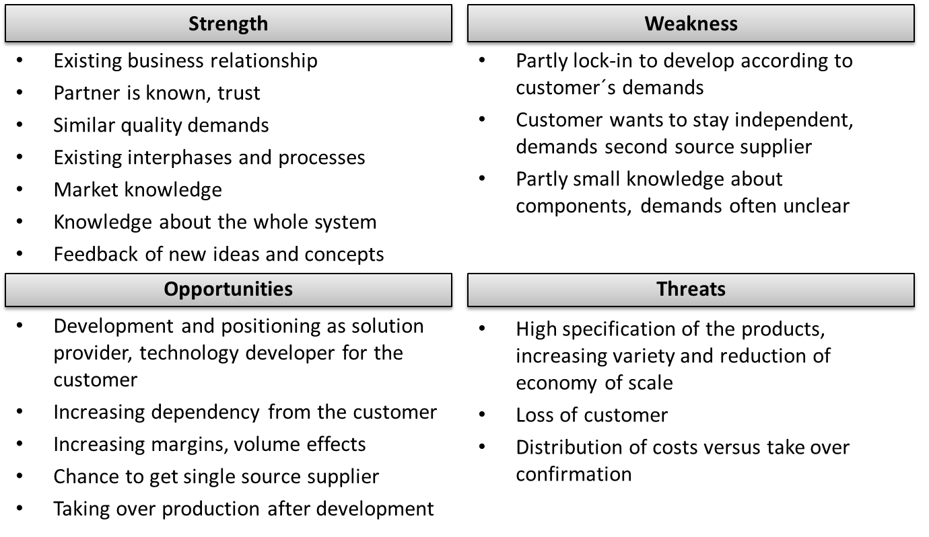

Figure 15: SWOT analysis of cooperation with cooperation with customers

Theoretical and empirical work in innovation economics suggests that industry-science relations positively affect innovation performance through the use of scientific knowledge. The main incentive to engage with universities is the access to know-how. Yet, the amount of cooperation with universities and research institutions is still surprisingly low because it entails several barriers (see Figure 16).

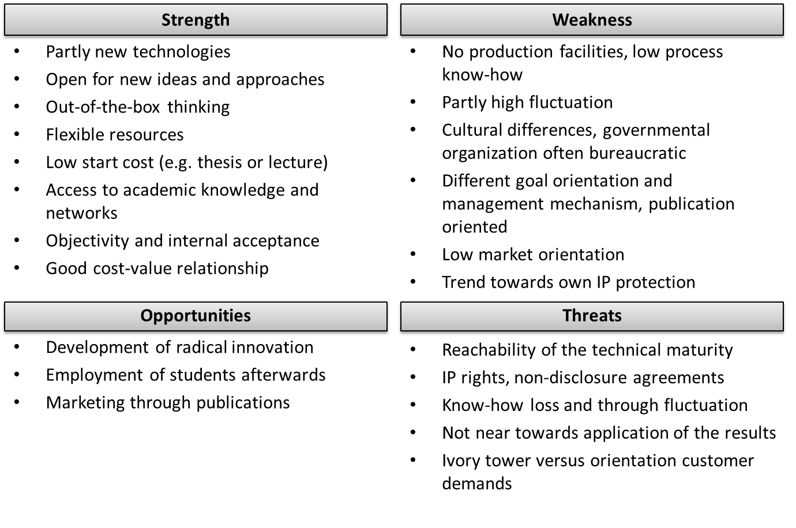

Figure 16: SWOT analysis of cooperation with cooperation with universities and research institutions

Cisco invests in young start-up companies in order to monitor their attractiveness and innovations. Besides evaluating their acquisition potential, Cisco also directs their development towards Cisco standards and Cisco-compatible products.

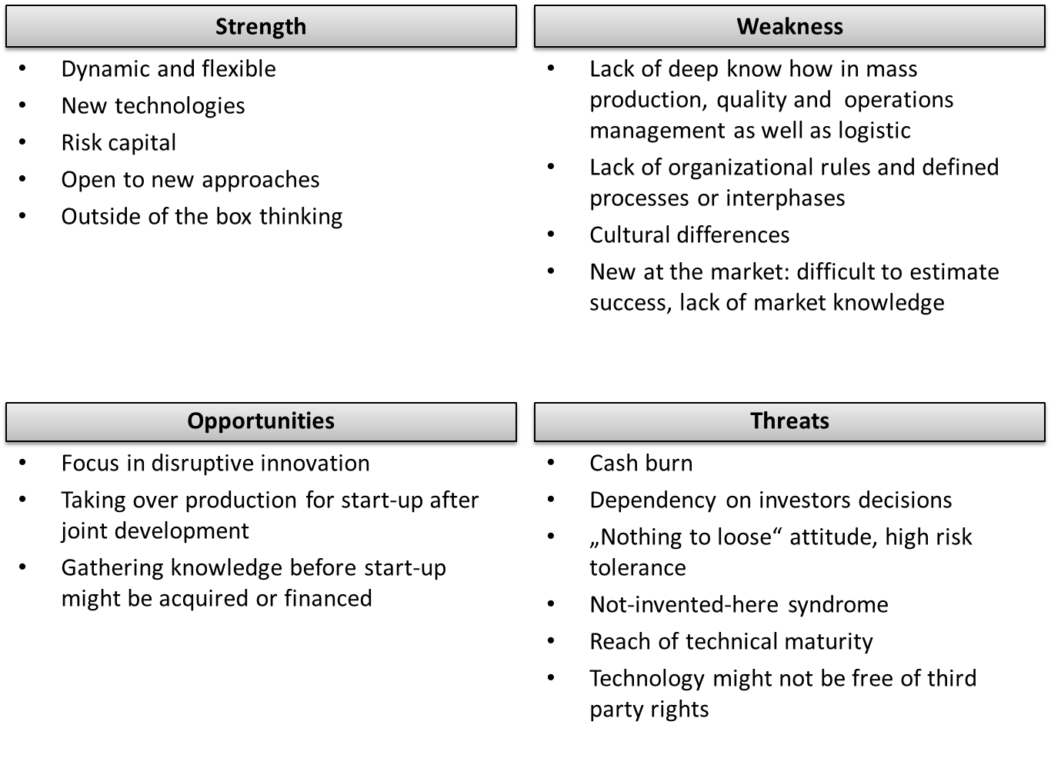

Figure 17: SWOT analysis of cooperation with start-ups and young companies

The selection of the partner is often not an explicit choice but the result of existing contacts. However, it is important to understand the chances and risks related to this partner in order to successfully manage the cooperation. Additionally, already established trust and a clear understanding of each other as well as cultural fit are important factors to increase the success of collaboration. Selecting the right partner requires a deep understanding of the own companies, the strategic goals and the own role in the value chain of the new product.

* 1. Selecting the appropriate organizational form for cooperation

There are many reasons to establish a network of multilateral relationships. They can reduce uncertainty; provide flexibility, capacity, speed, and access to resources and skills not owned by the company itself as well as information. Yet, relationships within a network differ in their closeness. Where partners in a strategic alliance are very close and highly integrated, in virtual corporation or equal partner relationships the partners are more independent.

The *degree of specialization* describes how much both companies will focus on special competencies. With companies that possess identical competencies, e.g. in the case of close competitors, the degree of specialization is low.

The *degree of coordination* describes how close both companies are connected with each other, e.g., in terms of joined and formalized working processes. While an informal information exchange e.g. within a norm committee, requires a low degree of coordination, where a joined co-development of a complex product with equal rights requires a high degree of coordination through an appropriate and comprehensive contract agreement, joined leadership and cooperation on operative as well as strategic level.

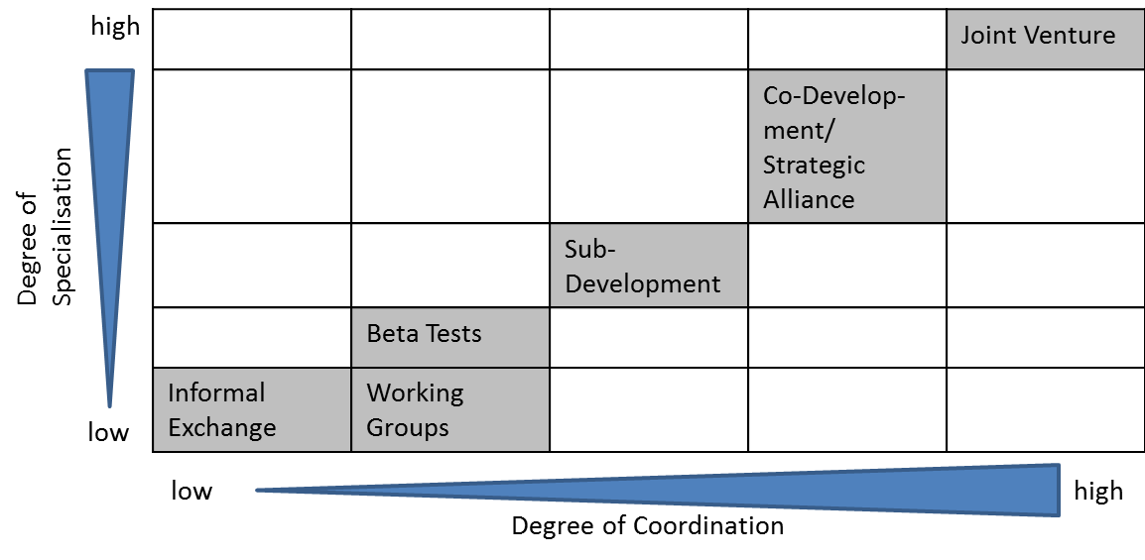

Figure 18: Categorising organizational forms according to the degree of specialisation and coordination

Whereas **informal exchange** relationships, **working groups** and collaboration based on **testing** prototypes or new products require a low degree of specialization and coordination, **sub-development** already involve contract agreements including the decision about IP rights and expected results, budget, time involvement etc. Because the time and resource involvement in the first three forms are generally low, these forma are ideal to getting to know new partners and build up a trustful relationship for a further deeper engagement.

**Co-development, strategic alliances** and **joint ventures** require a higher degree of coordination and specialization. The risk related to these forms are higher because the initiating partner is not in total control and cannot easily withdraw the contractual relationship without major loss of money and development time. Therefore, preparation, partner as well as organizational form selection for the last three collaboration form need to be done very carefully. Those forms are getting explained more in detail below.

A **strategic alliance** is a longer term cooperation based on contracts and has clear objectives. Both partners continue their core business independently, but collaborate on the specific area, product group, or technology agreed upon. Those strategic alliances can be developed with suppliers, customers, or partners inside or outside of the value chain. A strategic alliance can entail two or more partners (consortium) of different or equal skills. If the partners are building a separate legal entity for their collaboration we speak of a joint venture.

A **joint venture** is a business agreement in which parties decide to develop, for a finite time, a new entity and new assets by contributing equity. They exercise control over the enterprise and consequently share revenues, expenses and assets. A joint venture takes place when two parties come together to take on one project. In a joint venture, both parties are equally invested in the project in terms of money, time, and effort to build on the original concept. While joint ventures are generally small projects, major corporations also use this method in order to diversify. A joint venture can ensure the success of smaller projects for those that are just starting in the business world or for established corporations. Since the cost of starting new projects is generally high, a joint venture allows both parties to share the burden of the project, as well as the resulting profits.

Since money is involved in a joint venture, it is necessary to have a strategic plan in place. In short, both parties must be committed to focusing on the future of the partnership, rather than just the immediate returns. Ultimately, short term and long term successes are both important. In order to achieve this success, honesty, integrity, and communication within the joint venture are necessary.

The venture can be for one specific project only - when the joint venture is referred to more correctly as a consortium (as the building of the Channel Tunnel) - or a continuing business relationship (e.g. Sony Ericsson). The consortium joint venture (also known as a cooperative agreement) is formed where one party seeks technological expertise or technical service arrangements, franchise and brand use agreements, management contracts, rental agreements, for one-time contracts. The joint venture is dissolved when that goal is reached.

* 1. IP methodologies in different collaborative forms

This section is based on the empirical work of Gassmann and Bader (2011). The management of intellectual property is regarded as increasingly important as a success factor for R&D cooperation. Therefore, companies try to protect their knowledge before entering the collaboration. Handling knowledge that is developed during the collaboration is challenging for both partners and their strategists. Business plans, legal agreements about the future use of the results, and rules in case of failure of the alliance need to be taken care of.

Still 50-60% of all cooperation fail, therefore the definition of a clear exit strategy at the beginning of the cooperation is important. This strategy provides the answer to the question: who owns what when the collaboration fails? One dilemma in negotiation at the beginning is to forecast final market and competition conditions that are mostly unknown in the early phase. The cake needs to be divided before baking. Various scientific studies show that IP management in the early phase of cooperation is one major success factor (Gassmann and Bader, 2011). But in only 50% of the negotiations the management of trade mark rights can be decided satisfactory.

**Intellectual property in cooperation contracts.** In cooperation agreements the management of the following points needs to be decided:

* Property rights: invention ship and patent-ownership
* Rights of use
* Licencing rights

In the later management phase of the cooperation the enforcement of those rights include:

* process, administration, and distribution of costs
* knowledge regarded as close to the content of the cooperation, like background IP, periphery, or post-cooperative IP

**Property rights: invention and patent-ownership**. The ownership of an invention and the possession of a patent are in most countries two different things. While the ownership of an invention is initially attributed to the inventor, the right of claiming a patent for the invention is governed by the national laws of the different partners. In the US this patent would be owned by the inventor and not with his employer (Dillahunty 2002). Therefore, the cooperation partner should initially decide how they could possess the desired rights depending on legislation. Sometimes it is necessary to integrate the name of the employee in the cooperation contract. Because inventions can be made by one of the partners as well as by both together, the cooperation contract should include the management of cooperative inventions. If the partners do not clarify the patent ownership explicitly, the affiliation with the company of the inventors defines the patent ownership.

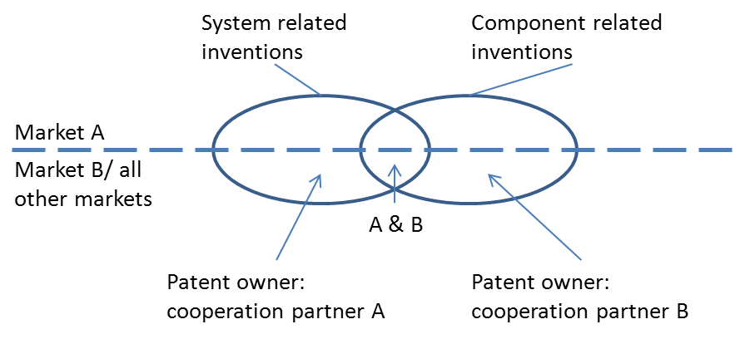

Figure 19: Patent ownership according to the invention (source: Gassmann and Bader, 2011, p. 246)

A potential problem is that, as a result, each of the partners will try to create their own inventions without the other partner, or, one partner will try to take part in a minimal way in the developments of the other partner to increase the number of cooperative patents (Figure 20). Consequently, the partners try to solve interesting and patentable problems alone while spying on each other. Trust is then destroyed.

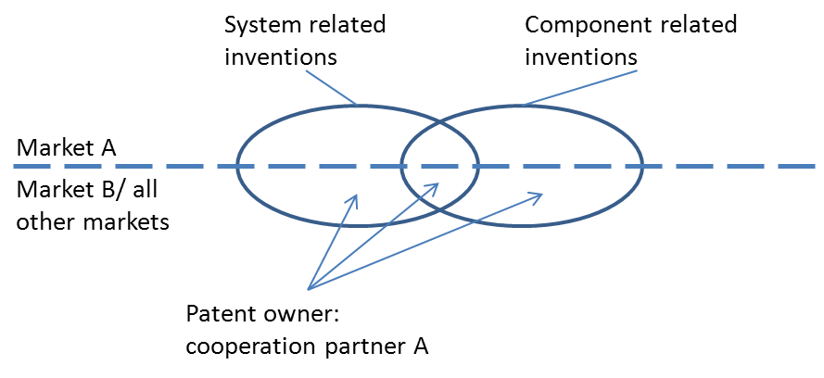

Figure 20: Patent ownership by one of the cooperation partner (source: Gassmann and Bader, 2011, p. 248)

* 1. Distribution of rights in collaborative agreements in the preparation phase

A cooperation agreement should include patent ownership independent of invention, and define the rights of usage, licensing, and enforcement of rights regarding the product, market, and competition situation of the cooperation partners. Distribution of rights could be focused on the invention itself. Is the value creation of one partner the system, while the other offers the components for this system? All inventions regarding the system can be distributed to one partner while the component-related inventions will be owned by the other partner. Inventions that include both can be appointed in cooperative patents (Figure 21).

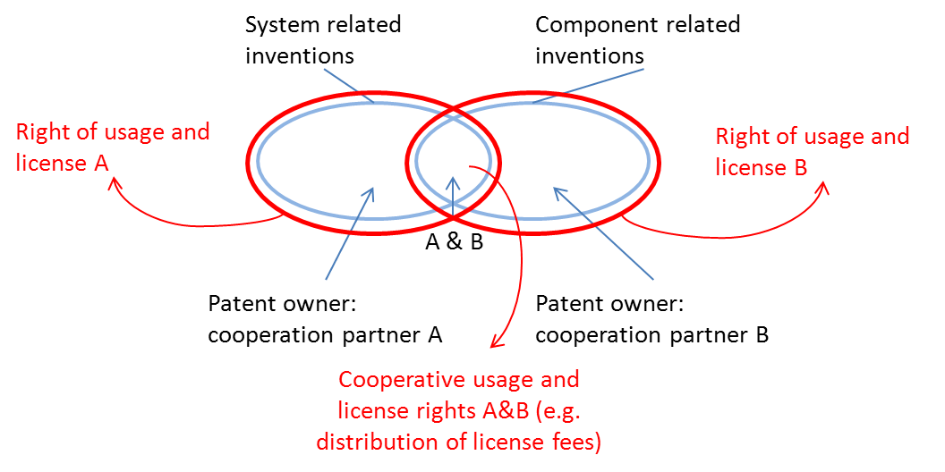

Figure 21: Solution space by cooperative usage and license rights e.g. in semiconductor industry (source: Gassmann and Bader, 2011, p. 249)

A negative side effect of the above mentioned distribution of rights for the invention, (system and component), might be the desire of both partners to engage with other partners in the future, e.g. to buy cheaper components or to sell components to other system providers, in both cases competitors of the initial cooperation partner.

One criterion for distributing interests in cooperation could be according to markets of the partners: market A could be served by partner A (in system and component) while partner B serves market B or all other markets (Figure 22).

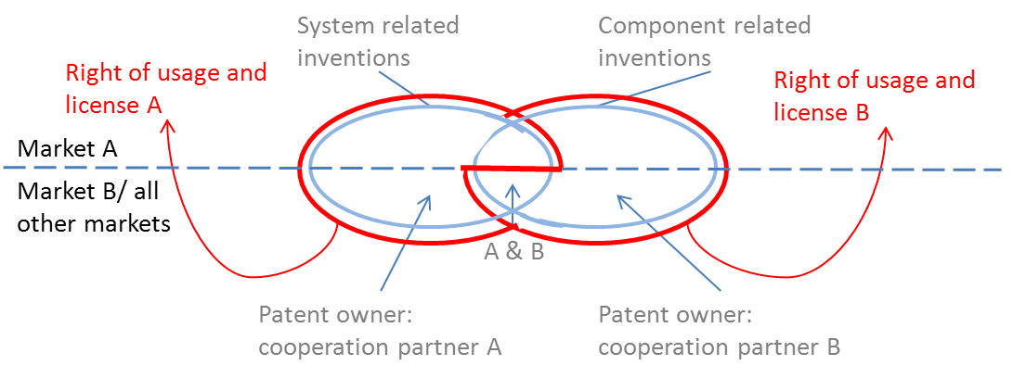

Figure 22: Distribution of rights of usage and license rights according to markets, e.g. Banking (system) and IT (components) industry (source: Gassmann and Bader, 2011, p. 249)

A second possibility of market related distribution of rights in the contract agreement could be the full rights for all individually or cooperatively developed inventions in a specific market for one partner, while the other partner is fully serving the other market with its own cooperative as well as with rights owned by the other partner (Figure 23).

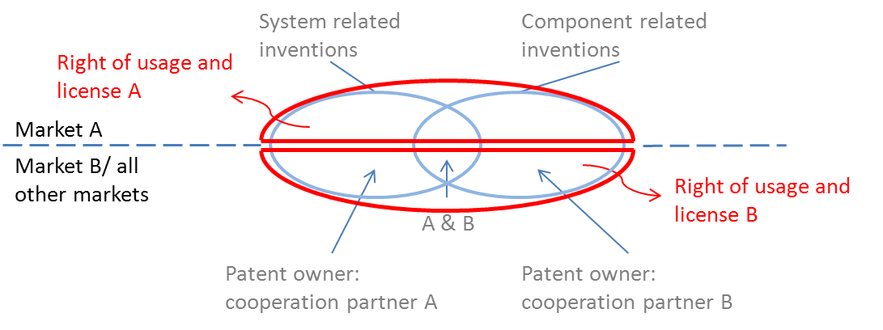

Figure 23: Total distribution of rights according to market e.g. in chemical and pharmaceutical industry (source: Gassmann and Bader, 2011, p. 249)

Other varieties of agreements could be the total distribution of rights to one partner or the total distribution to both partners. This can be beneficial when the patent application procedure can be eased or optimized e.g. to hinder collisions in each other’s state-of-the-art descriptions. In both cases the partners can additionally agree to distribute rights as described above after the closing of the application procedure. This procedure is especially beneficial in cases of cultural differences between the partners, e.g. with Japanese companies (Nakano, 2000).

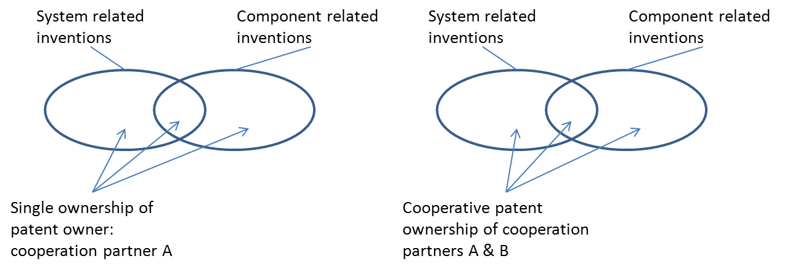

Figure 24: Total patent ownership of one or of both cooperation partners (source: Gassmann and Bader, 2011, p. 248)

* 1. Management of IP rights in the practical management phase

**Rights of usage and license.** The distribution of usage and license rights can only be granted according to the described possibility (see Figure 19). Problems might arise with the use of cooperatively own patents. The national laws foresee different rights of the individual in cooperative goods. In Switzerland and Germany in cooperative ownership only cooperative use is possible, while in the US every patent owner can individually use the cooperative patent without informing the other owners (O´Reilley 2000). Cannibalization effects can occur in the cooperatively owned areas when companies possess different licensing strategies and compete with each other. In countries like the UK, Japan, or Malaysia, a patent co-owner can grant licenses in accordance with his fellow patent owners (Brown 2000). In both cases the patent owners can decide to share the license fees from cooperatively owned patents after discharge of costs (see Figure 21).

One advantage of distributing rights according to system/component (see Figure 21) is that the system provider A can order components from other companies (A1 in Figure 25) and can hereby distribute component licenses for their production, but only in market A. While component provider B can grant licenses of the system to other system providers (A2 Figure 25) in but only in market B or in other markets not related to A.

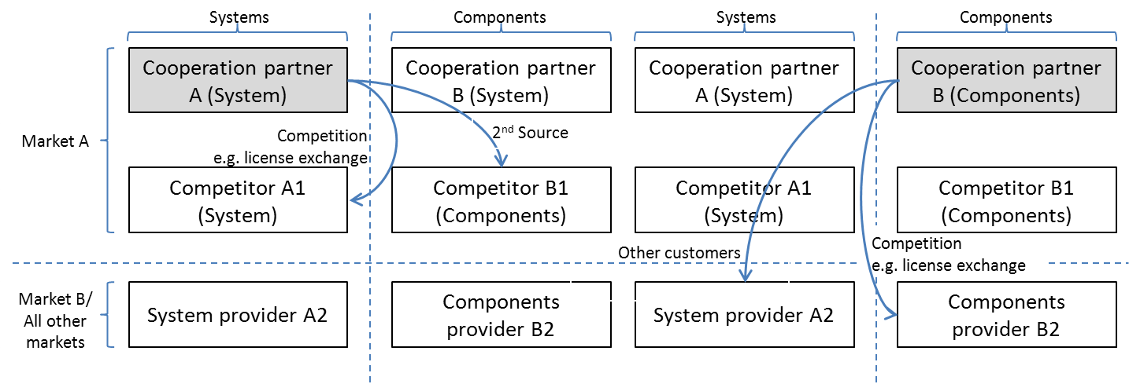

Figure 25: Granting of exclusive rights in the different markets (source: Gassmann and Bader 2011, p. 250)

**Enforcement of rights.** The enforcement of the rights depends on the national law. Here it is of interest how closely a cooperation partner needs to be involved to be summoned by the courts when a suit is filed for a violation of the patent. If the national law stipulates an involvement, it is recommended that this is agreed upon in the initial cooperation contract and in consideration of the rights of usage and licensing.

**Process, administration and distribution of costs.** Important is the early agreement which manages the process, and if this should be done by the internal patent department or an external patent lawyer. Agreements upon process related decisions are important, e.g. the selection of countries by application, or the management of country specific maintenance decisions. Additionally, the distribution of costs which occur in the application procedure of the patent, the process and cost related to an external patent lawyer, translations, or yearly fees, should be agreed upon.

Management of knowledge is regarded as close to the content of the cooperation. To establish a successful cooperation the partners need to evaluate which additional knowledge and protection rights are necessary in order to realize results of the cooperation in a possible solo attempt.

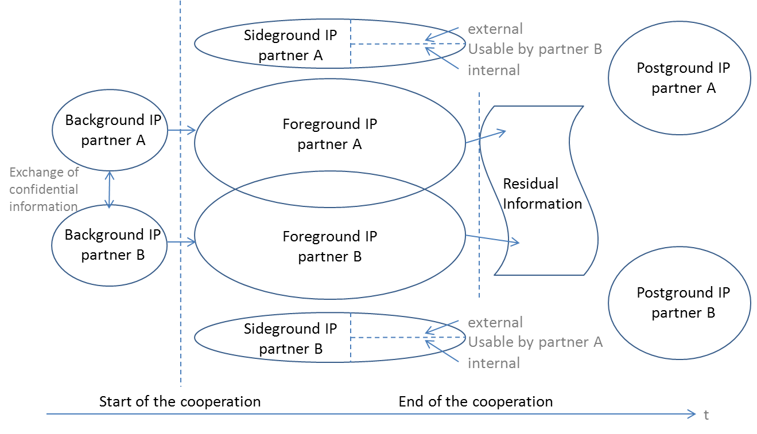

Figure 26: For the realization of the cooperation results it is important who is allowed to use which IP (source: Bader 2006, p. 172)

Besides the knowledge or IP that was created in the cooperation (Foreground IP), the knowledge that the partners are directly transferring into the cooperation (Background IP) is important. If the partners are exchanging knowledge before the start of the cooperation, e.g. in order to test if the selected partner is the right one, a non-disclosure agreement should be agreed upon, to document the exchange and to formalize it. Too many cooperation negotiations and resulting agreements focus only on the foreground IP. Difficulties can occur when activities parallel to the cooperation result in relevant, proprietary IP that can only be used by one of the partners (Sideground IP).

After the cooperation the question comes up as to how best deal with the residual knowledge (Residual Information) and the knowledge created after the cooperation (Postground IP), like improvement of marketing strategies or process improvements. One possible solution which deals with the knowledge close to the cooperation might be temporary supply or purchase rights. These agreements are very common in the automotive and consumer goods industry.

1. Summary

This guide aimed to be a “how-to” toolkit designed particularly for SMEs advising them on some of the most important questions like “when to cooperate”, “with whom to cooperate” and “how to settle a successful cooperation agreement”. This guide started with providing some data on the use of open innovation activities and their related risks. It then gave some framework how to find the appropriate balance between own (make) and cooperative development (ally) and provided help how to set up a network with collaboration partners in order to accelerate innovation and improve efficiency. Additionally, this guide explained why the corporate strategy defines the balance as well as the selection of activity necessary for benefiting from open innovation. Consequently, after knowing how much collaboration activities need to be launched with whom, the guide concluded with the description of different collaborative IP agreements and organisational forms with their related advantages and disadvantages.

1. References

Bader, M. (2006). Intellectual Property Management in R&D Collaborations. The Case of the Service Industry Sector. Physica-Verlag, Heidelberg.

Bader, K. and Enkel, E. (2014): Understanding a firm’s choice for openness: Strategy as determinant. International Journal of Technology Management, 66 (2/3): 156-182.

Brown, J. (2000). Allocations of ownership of inventions in joint development agreements – the united kingdom perspective. Les Nouvelles – Journal of the Licensing Executives Society, Vol. XXXV (4), 173-175.

Chesbrough, H. (2003). Open innovation: The new imperative for creating and profiting from technology. Boston, MA: Harvard Business School Press.

Chandy, R.K. and Tellis, G.J. (1998). Organizing for radical product innovation: The overlooked role of willingness to cannibalize. Journal of Marketing Research, 35(4), 474-487.

DeSarbo, W.S., Benedetto, C.A.D., Song, M. and Sinha, I. (2005). Revisiting the Miles and Snow strategic framework: Uncovering interrelationships between strategic types, capabilities, environmental uncertainty, and firm performance. Strategic Management Journal, 26(1), 47-74.

Dillahunty, G.T. (2002). How to (and how not to) deal with inventorship in joint agreements. Les Nouvelles – Journal of the Licensing Executives Society, Vol. XXXVII (1), 1-6.

Enkel, E. (2011). Open Innovation. Wie machen es die Besten? Zeitschrift für Führung und Organisation, 06 (80. Jg.): 415–421.

Enkel, E. and Conreder, A. (2007) Abschlussbericht Arbeitskreis Innovationskooperationen. Ein Leitfaden zur erfolgreichen Gestaltung und Durchführung von Innovationskooperationen. Institut für Technologiemanagement, Universität St. Gallen.

Enkel, E., Gassmann, O. and Chesbrough, H. (2009). Open R&D and Open Innovation: Exploring the Phenomenon. R&D Management Journal, 39 (4), 311-316.

Fiss, P.C. (2011): Building better casual theories: A fuzzy set approach to typologies in organizational research. Academy of Management Journal, 54(2), 393-420.

Gassmann, O. and Bader, M. (2011). Patentmanagement. Innovationen erfolgreich nutzen und schützen. 3. Ed. Springer Verlag, Heidelberg.

Gassmann, O. and Enkel, E. (2004). Towards a theory of open innovation: Three core process archetypes. Paper presented at the R&D Management Conference (RADMA). Lisabon, Portugal.

Gassmann, O.; Enkel, E. and Chesbrough, H. (2010). The future of open innovation. R&D Management, 40(3), 213–221.

Jazairy, A. (2012). Impact of collaborative innovation on IP and future trends in IP. Les Nouvelles – Journal of the Licensing Executives Society, Vol. XXXXVII (3), 224-229.

Laursen, K. and Salter, A. (2006). Open for innovation: the role of openness in explaining innovation performance among U.K. manufacturing firms. Strategic Management Journal, 27, 131–150.

Miles, R.E. and Snow, C.C. (1978). Organizational strategy, structure, and process. New York: McGraw-Hill.

Porter, M.E. (1980). Competitive strategy: Techniques for analyzing industries and competitors. New York: Free Press.

Rigby, D. and Zook, C. (2002). Open-market innovation. Harvard Business Review, 80(10), 80-89.

Schumpeter, J.A. (1942). Capitalism, socialism, and democracy. New York: Harper.

van de Vrande, V., de Jong, J., Vanhaverbeke, W. and de Rochemont, M. (2009). Open innovation in SMEs: Trends, motives and management challenges. Technovation, 29 (6-7), 423-437.

1. About the Author



**Dr. Ellen Enkel, Professor, Zeppelin University, Friedrichshafen, Germany.**

Prof. Ellen Enkel is the Head of the Dr. Manfred Bischoff Institute for Innovation Management of EADS and the Chair for Innovation Management, Zeppelin University, Friedrichshafen, Lake Constance, Germany.

The fields of research of the Institute encompass open innovation and cross-industry innovation, cooperative innovation processes in networks, business model innovation as well as innovation metrics and culture. The Institute strives for supporting businesses in enhancing their innovation capacity, improving internal and external transfer of knowledge, establishing and leveraging innovation networks within and across industry boundaries, and investigating innovation strategies, culture and organizational capabilities as well as the management of innovation in general.

Prof. Enkel was previously the Head of the ‘Open Innovation’ competence center at the Institute of Technology Management at the University of St. Gallen, Switzerland. She has published numerous books and articles in the area of knowledge and innovation management and has collaborated with Prof. Henry Chesbrough on numerous common articles and projects.

[End of document]

1. Ms. Ellen Enkel, Professor, Zeppelin University, Friedrichshafen, Germany