E
cdip/14/INF/9
ORIGINAL: English
DATE: September 23, 2014

Committee on Development and Intellectual Property (CDIP)

Fourteenth Session
Geneva, November 10 to 14, 2014

CASE STUDIES ON COOPERATION AND EXCHANGE BETWEEN R&D INSTITUTIONS IN DEVELOPED AND DEVELOPING COUNTRIES

commissioned by the Secretariat

- The Annexes to this document contain (i) Case Studies on Cooperation and Exchange Between R&D Institutions in Developed and Developing Countries, undertaken in the context of the Project on Intellectual Property and Technology Transfer: ‘Common Challenges – Building Solutions’ (CDIP/6/4 Rev.), by Dr. Bowman Heiden, Deputy Director, Center for Intellectual Property (CIP), and Dr. Ulf Petrusson, Director, CIP, Chalmers University of Technology, Gothenburg, Sweden, and (ii) a Peer Review of the above Study by Mr. Nikolaus Thumm, European Commission Joint Research Centre, Seville, Spain.
- The CDIP is invited to take note of the information contained in the Annexes to this document.
[Annexes follow]

Note: The views expressed in this study are those of the author and do not necessarily reflect those of the WIPO Secretariat or any of the Organization’s Member States.

EXECUTIVE SUMMARY

Background
- Knowledge is the most valuable resource in the world, and the institutional infrastructure that defines how it is created, owned, transferred, and utilized in society has become the main determinant of the sustainable wealth of nations. In fact, much of what defines the gap between developed and developing countries can be stated in terms of knowledge and the institutions that support its effective and efficient use. Nowadays, the term, knowledge economy, is commonly used to describe how advancements in education, research, and innovation have created a post-industrial society that delivers wealth and welfare beyond the constraints of land, labor, and (physical) capital. However, even in today’s connected world, knowledge is difficult to transfer especially between developed and developing countries based on its tacit and institutional nature. For example, patent databases are full of technical information, but this information does not become actionable knowledge unless it can be absorbed and implemented properly to create value. In other words, the challenge to move from information to knowledge and then, from knowledge to innovation, should not be taken for granted especially in environments that lack strong institutional incentives and capacity to support these processes.
- Some of the most important sets of institutions in the world governing the development and utilization of knowledge are the different intellectual property systems, which includes a number of global institutional frameworks defining specific intellectual property rights and regulations, including patents, trademark rights, design rights, copyrights, plant breeders rights, and trade secrets among others. However, intellectual property (IP) rights and regulations play varied roles in different geographical regions and knowledge areas. For example, the patent system applies differently to pharmaceutical inventions and computer software both in relation to the technical aspects and the scope of protection in different regions, such as among the United States, the European Union, and India for example. Thus, while knowledge transfer is often associated with intellectual property rights (IPRs), the role these IPRs play will depend on the specific technical and socio-economic context, which is made more complex when collaborations comprise both developed and developing countries, involving different languages, cultures, and legal norms. It is with this background in mind that this report explores the challenges of successful collaborations regarding research, development, and innovation (RDI) between developed and developing countries.
- The request for this report originated from the WIPO Member States within the context of the Development Agenda. It was carried out by Center for Intellectual Property (CIP), a joint center between University of Gothenburg and Chalmers University of Technology, as a collaborative effort enlisting primarily the support of graduate students with guidance from technology transfer professionals, and academic researchers. While the scope of the project was more exploratory than academically rigorous, the project resulted in eight cases illustrating several different technical fields and geographical regions, providing an interesting first look at the diverse institutional challenges facing actors in R&D collaboration and technology transfer between developed and developing countries. Below is a summary of each of the cases followed by a conclusion of the results of the studies.

Case Studies

1. Gastric Cancer Research Project
- Gastric cancer is one the deadliest forms of cancer, in particular, for lower income countries. In Nicaragua, the instance of gastric cancer is 100 times greater than in the US, which led to the formation of an international consortium of actors to develop a biobank to discover the underlying causes of gastric cancer and identify biomarkers for diagnosis of early stage gastric cancer development. The consortium, including research institutions from Canada, Sweden, the United States, and Italy, built a collaboration with the Hospital Salud Integral in Nicaragua, where patient tumor samples are collected and sent to the international partners for further research. Knowledge regarding lab practices and data collection processes has been transferred to Nicaragua, which has resulted in preliminary research results in the form of data/databases to support further research. The project is still in an early research phase, but has already experienced several challenges including the loss of its initial lab environment, struggles in the adoption of new knowledge, and organizational difficulties managing an informal, international consortium. This case is an example of an informal international research collaboration operating without an explicit IP policy.

2. Once-a-day HIV Medicine Project
- In 2012 more than 35 million people were living with HIV or AIDS globally. The number of people infected with the virus is significantly higher in developing countries, where the antiviral drugs often are too expensive for the affected population to afford. The Once-a-day HIV Medicine is a project initiated by Gilead through their Access Program to treat HIV patients in developing countries. As part of the project, technology is transferred through local distributors and generic drug manufacturers to spread novel drugs to over 5.4 million HIV patients in 130 countries. The transfer includes IPRs as well as other intellectual assets, mainly consisting of manufacturing know-how and support with regulatory approvals. Licensees have been encouraged to create and take ownership in their own novel solutions based on the licensed technology. This case is an example of the use of IP on a royalty basis to regulate openness and facilitate access on a global scale.

3. Phenolic Extract Project
- The plant, Uncaria Tomentosa (also known as Cat’s Claw), is a vine from the tropical rainforest that is found from Peru to Belize. It has been used medicinally for centuries in South America and is claimed to boost the immune system and to treat illnesses ranging from allergies to cancer based on the phenolic compounds in the plant. A research collaboration between the University of Costa Rica (UCR) and the National Research Council in Spain (CSIC) was formed to develop a new extract and extraction methods that could improve the polyphenol profile in products. The two organizations have entered into a formal collaboration agreement for future RDI, filed a PCT patent, and are now seeking licensees for their technology in different fields of application, such as food additive, cosmetic composition and pharmaceutical products. This case is an example of a successful research and technology transfer collaboration originating from novel research in a developing country focused on commercialization in developed countries.

4. Strawberry Licensing Project
- Research at the University of California at Davis (UC Davis) has enabled California to become the leading producer of strawberries in the world, accounting for over 80% of production in North America. The project uses traditional breeding techniques to develop plants with optimized fruit size, firmness, appearance, flavor, tolerance, ease of harvest, etc. UC Davis created the Strawberry Licensing Program to provide patented cultivars initially to California farmers but eventually opened up the program to farmers all over the world. The program uses master licensees to offer sublicenses to farmers in foreign countries where either patent protection or plant breeder’s rights on novel cultivars is available. Using Turkey as an example,
this case focuses on the use of IP on a royalty basis to regulate openness and facilitate access, and how the International Union for the Protection of New Varieties of Plants (UPOV) can facilitate transfer of novel cultivars in countries with weak patent protection.

5. Late Blight Resistant Potato Project
- Phytophthora infestans, also known as Late Blight, is one of the deadliest plant diseases in the world. In 2007, 70% of India’s potato crops were lost due to this disease and 50% of Bangladesh’s potato production was affected. In 2003, a team of researchers led by the University of Wisconsin isolated a gene and encoded proteins and developed a transgenic potato cultivar with broad resistance to this potentially devastating disease. In 2005, a collaboration was established between University of Wisconsin (UW), Central Potato Research Institute (CPRI), and Bangladesh Agricultural Research Institute (BARI) with the aim to increase the yield of potato farmers in India and Bangladesh while limiting the need for costly and environmentally harmful fungicides to fight Late Blight. The collaboration resulted in a number of successful local transgenic cultivars with high-expected yield and low environmental impact, which are currently in field-testing. This case is an example of a government funded, international R&D collaboration initiated by a pro-bono transfer of genetic technology based primarily on know-how without IPR protection.

6. Rubber Nano Project
- Zinc oxide is today a vital part of the vulcanization process for the production of rubber products such as shoes, tires and belts. In particular, the tire industry consumes over half of the 1.2 million metric tons of zinc oxide production each year. The researchers at Nelson Mandela Metropolitan University, Port Elizabeth, developed a method to produce a nanomaterial activator for the rubber vulcanization process that has the same basic properties as zinc oxide, while at the same time being easier and cheaper to synthesize and free from heavy metals. The research results were spun-off into a startup venture in South Africa, Nano Rubber Products Ltd (NRP), which in turn formed a joint venture with Esseco Srl from Italy to produce the nanotechnology in Europe. This case is an example of a technology transfer collaboration originating from novel research in a developing country focused on commercialization in developed countries.

7. BIOWASTE4SP Project
- Due to its large population, Africa is is in constant need for increased food and energy production to support its economic growth. Paradoxically, African agriculture currently produces a large amount of biowaste with potential for conversion into value-added energy and food products. The purpose of BIOWASTE 4SP project is to find simple and sustainable solutions to convert biowaste into value-added products in five partner countries in Africa – Egypt, Ghana, Morocco, Kenya and South Africa. The project is funded by the European Commission and includes 16 partner organizations in total from Europe and Africa, including research organizations and SMEs. The case is an example of a large formal, R&D consortium involving public and private actors where IP policies are used to manage the different intellectual asset contributions of the partners both during and after the project.

8. Infant Diarrhea Project
- Diarrheal disease is a public health problem worldwide, mostly affecting children in developing countries. In Nicaragua, diarrhea is the second greatest cause of infant mortality. The Infant Diarrhea project was initiated as part of the Infectious Disease Program between UNAN-Leon and Swedish Institute for Infectious Disease Control (SMI) and Karolinska Institute (KI). The project has been running for 30 years as part of a long-term development strategy funded by Swedish International Development Cooperation Agency (Sida) and the Department for Research Cooperation (SAREC). Through scientific investigation of the underlying causes on infant diarrhea, the goal of the project was to reduce the mortality and morbidity of the disease through vaccination and education in the Municipality of Leon in Nicaragua. This case
is an example of long-term, formal R&D collaboration focused on developing local capacity and solutions where IP policies were mainly concerned with utilization of research results through academic publication and creation of public health policy.

Conclusions
- The cases studied represent a diverse set of RDI environments varying by geography, technology, socio-economic base, and project formality and complexity. Thus, it is not surprising that the cases displayed different modes of collaboration regarding knowledge creation and transfer and different roles for IPRs in the various contexts. Table 1 summarizes the key characteristics of the cases. Below are several key reflections regarding the entire set of case studies and links to useful resources.

Value Models and the Role of IPRs
- While eight cases is only a small sample of projects, it is clear that the role of IPRs is dependent on the context and the value models employed by the projects. In particular, the eight projects displayed primarily three different value logics, where knowledge creation and transfer was focused on:
  - Publication of knowledge for utilization in the public sphere (e.g. Infant Diarrhea Project and Gastric Cancer Project)
  - Proprietary control of knowledge to facilitate utilization through commercial markets primarily for humanitarian purposes (e.g. Once-a-Day HIV Medicine Project and Late Blight Resistant Potato Project)
  - Proprietary control of knowledge for the purpose of commercial licensing and venture creation (Rubber Nano Project and Phenolic Extract Project)
- All value models have the potential to create social value, and more than one model can be employed simultaneously. For example, R&D projects can utilize knowledge through both publication and proprietary control of knowledge to facilitate different utilization strategies in developed and developing countries in parallel. The important issue is that IPRs play different roles depending on the utilization context, and thus IPR strategies need to be designed with these different value models in mind.

IPR to Regulate Openness and Facilitate Access
- Several of the projects involve what could be termed “welfare technologies” as they are directly related to delivering basic human needs connected to the Millennium Development Goals. These technologies need to be utilized under different commercial logics in developed and developing countries. This creates a tension that requires creative solutions. The case of the once-a-day HIV medicine is a good example. While the strong patent system in the United States was vital to the creation of the HIV medicine and the commercial success of Gilead, the relatively weaker patent system in India was vital to the creation of generic manufacturing capabilities that could produce a low cost version for developing countries. Thus, the patent system is used to create exclusivity and generate monopolistic pricing in the United States, while at the same time, regulating openness and facilitating access in developing countries, which has resulted in a lowering in the price of HIV medicine in developing countries through increased competition.
- In the eight cases studied, the two cases that represented South-North collaboration (Rubber Nano Project and Phenolic Extract Project) capitalize on the well-functioning IPR systems in high-income developed countries to support their utilization strategies while the six North-South collaborations use IPRs to facilitate openness and access in low-income environments. Again, this shows how IPRs can take on different roles, enabling both exclusivity as well as open access, to support wealth and welfare creation in both developed and developing countries

From IPR to Intellectual Asset Management
- Intellectual property rights (IPRs) are legal tools to control knowledge; they do not encompass all the knowledge required to practically implement a technical solution, which is often broadly termed “know-how”. In many of the cases studied, the transfer and creation of know-how was the most important aspect of the collaboration as the goal was to empower actors in developing countries to be able to internalize and implement the technology autonomously. This requires attention beyond the legal application of IPRs and IPR policies to manage the successful creation and transfer of knowledge. In particular, it emphasizes that knowledge is ultimately carried in the brains of individuals and knowledge transfer often requires interpersonal communication to effectively share knowledge, often requiring the people that developed the knowledge in the first place as exemplified in the cases of the Late Blight Resistant Potato and Rubber Nano.
- In a world where knowledge is the main value creating asset, a focus on IPRs is too simple and the concept of know-how is too vague. Therefore, it is recommended that a broader intellectual asset management (IAM) approach is adopted in RDI projects to better identify, access, manage, and utilize the knowledge transferred and created in collaborations. In particular, by separating knowledge assets (e.g. data, databases, data correlations, instructions, technical inventions and other objectifiable knowledge) from the IPR assets (e.g. patents, patent applications, copyrights, trade secrets, and other legal tools), a more holistic knowledge management process can be implemented that supports both research and utilization processes regardless of the context of the project.

Links to resources
  - IP Handbook of Best Practices: http://www.iphandbook.org
  - Gilead expanded license agreement for HIV medicine in developing countries: http://www.gilead.com/~/media/Files/pdfs/other/ExpandedTermsLicenseAgreement.pdf
  - Medicines Patent Pool (MPP) license agreements: http://www.medicinespatentpool.org/current-licences/

Acknowledgements

There has been a great deal of interest and support towards understanding the process of knowledge transfer between developed and developing countries through this project that we would like to acknowledge. We would first like to thank Karen Hersey for her help in identifying several of the cases and working with our graduate students to better understand the technology transfer issues. The graduate students at Chalmers University of Technology and University of Gothenburg studying Intellectual Capital Management and Entrepreneurship in Life Science have conducted the bulk of the data gathering as part of their annual social entrepreneurship project in parallel to their studies. The students contributing include Agyat Suri, Alda Hanjalic, Alexander Sologub, Annelie Viksten, Carin Nylander, Camilla Gimskog, Carolina Helgesson, Caroline Egeland, Daniel Gustavsson, Hanna Sonning, Dushyant Chauhan, Emma Wikström, Fernando Lopez, Filip Eriksson, Gustav Johansson, Johan Corell, Johanna Bjarsch Follin, Jonathan Holmén, Linn Holmström, Lucie Mecirova, Marika Källman, Mimmi Bjöersdorff, Sofia Arveteg, Therese Matshede, and in particular, Sissela Engqvist, who worked with us at CIP to get the project up and running. Anna Holmberg and Josefin Karlgrund were instrumental in managing the project and structuring the content. Last, but not least, of course, are the contact people within each case that donated their time to inform us about their interesting projects, including Marika Källman, Polly Fields, Lilliana Rojas Guillén, Debora Villaño, Antonio Jiménez Escrig, Michael Carriere, Akshat Medakker, Robert Bosch, Anne Belinda Bjerre, Anders Cai Holm Hansen, Mathias Gustavsson, and Roland Möllby.

Bowman Heiden
Gothenburg, Sweden
August 2014

 |  | 1. Gastric Cancer Research Project | 2. Once-a-Day HIV Medicine Project | 3. Phenolic Extract Project | 4. Strawberry Licensing Program
Developing Country Partner |  | Nicaragua | Southern Africa, South-East Asia, South America | Costa Rica | Turkey
Developed Country Partner |  | Canada, Sweden, US, Italy | US | Spain | US
Project Type |  | R&D | Innovation | R&D | Innovation
Technical Field |  | Medicine | Medicine | Medicine/Functional Food | Agriculture
Knowledge Assets |  | Lab/Sample Collection Techniques, Research Data/Databases | Support with regulatory process, manufacturing process and quality control | Novel extract and method of extraction | Strawberry cultivar with specific genetic traits together with knowledge on breeding, cultivation and commercialization
IPRs |  | Copyright (implicit in research data) | Patent, trade secret | Patent | Patent, Plant Breeder's Right
Role of IPRs |  | No formal contractual role in collaboration | To regulate openness and facilitate access | To facilitate royalty-based licensing | To facilitate royalty-based licensing
 |  | 5. Late Blight Resistant Potato Project | 6. Rubber Nano Project | 7. Biowaste4SP Project | 8. Infant Diarrhea Project
Developing Country Partner |  | India, Bangladesh, Indonesia | South Africa | Turkey, Malaysia, Ghana, South Africa, Egypt, Morocco, Kenya | Nicaragua
Developed Country Partner |  | US | Italy | Sweden, Denmark, Italy, | Sweden
Project Type |  | R&D | Innovation | R&D | R&D
Technical Field |  | Agriculture | Nano-Materials | Biowaste conversion | Medicine
Knowledge Assets | Transformation methods and molecular characterization processes for Rb transgenic potatoes as well as product development and commercialization knowledge for transgenic crops |  | A method to produce silica. Which is used as a substitute for zinc oxide in rubber production resulting in a more environmentally friendly rubber. Knowledge on how to change the rubber production on order to substitute zinc oxide with silica | Sample collection technique, database of samples, technology research data, socio-economic research data, technology enabling conversion of biowaste to valuable end-product. Background technology. | Research methods and laboratory techniques. Research data and database
IPRs |  | None | Patent | Patent, copyright | Copyright (implicit in research data)
Role of IPRs |  | None | To facilitate royalty-based licensing and venture creation | To regulate openness and facilitate access | To facilitate publication

Table 1. Overview of case studies

Case Study 1 - Gastric Cancer Research Project in Nicaragua

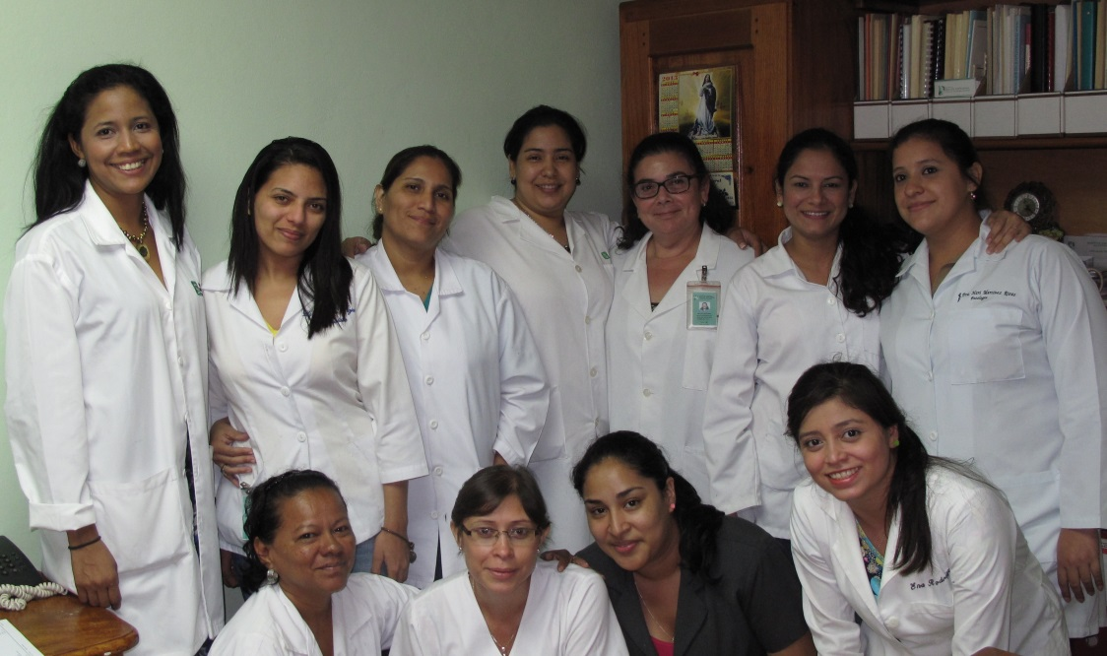
Image 1 The pathology team at Salud Integral

Background
- Gastric cancer is the second most common cause of cancer death in the world and disproportionately affects poorer populations as approximately two-thirds of the 700, 000 yearly deaths occur in low and lower-middle-income countries. The main risk factors for gastric cancer are chronic infection (with the bacterium helicobacter pylori), tobacco smoking and poor dietary habits. Nicaragua is one of the most affected countries. With an instance rate 100 times greater than the United States, gastric cancer was the leading cause of cancer death among men and second among women in Nicaragua in 2008. The complexity of gastric cancer is, to a large extent, related to the symptoms since they are difficult to distinguish from a generic feeling of illness such as dyspepsia, pain, nausea, anemia and early satiety. When people in socio-economically challenged regions suffer from these symptoms they often lack the opportunity of basic health care, which allows the cancer to go undetected, often resulting in death.

The Project
- For Lawrence Paszat, Associate Professor at University of Toronto, what was first meant as a vacation later came to be the start of a multinational collaboration. This happened by chance during a trip to Nicaragua, when Dr. Paszat came in contact with the National Cancer Radio Therapy Center, who informed him of the high incidence of gastric cancer in the country. Dr. Paszat then helped to initiate the necessary foreign support for the development of a research project on gastric cancer in Nicaragua, which began informally in 2008.
- Dr. Paszat expanded the collaboration and gathered the necessary competences by combining people from his personal network into a loose coalition of experienced international actors without dedicated funding and project management. Specifically, he assembled a team comprised of diverse expertise in microbiological and immunological research in order to build a well-characterized biobank of samples that could be used to perform research on the causes and epidemiology of gastric cancer in general and also more specifically in high-risk areas such as Nicaragua. In total, six different institutions were involved worldwide, contributing to the research with their own respective field of research as shown in the figure below.
- In Nicaragua, two public hospitals where involved initially, Hospital Escuela Antonio Lenin Fonseca and Hospital Escuela Roberto Calderon, but due to a change in the leadership, the original lab in the hospital was confiscated and the activity was moved to Hospital Salud Integral, a privately owned hospital in Managua.
- The ultimate ambition of the biobank is to identify a potential biomarker for diagnosis of early stage gastric cancer from a simple blood sample instead of expensive procedures such as gastroscopies and biopsies. Aside from the biobank and biomarker development, the partners had the complementary, yet unofficial, objective to improve medical conditions for the underserved population of Nicaragua and to increase the research capacity in the country. In particular, the latter was done by training Nicaraguan Pathology Residents in conducting cancer research with the hope of inspiring them to continue and create further research projects. The training was mainly managed by the Swedish team with assistance from the Canadian team.
- Currently, the collaboration is still in an early research phase where samples have been collected and stored, but there are still organizational issues to be resolved before the project is up and running continuously. Budgetary issues are the main obstacle at present as funding is required to cover all costs for salary and disposables of the sample collection in Nicaragua. Below the current research phases of the project are illustrated as well as the future development phases that have yet to be implemented.
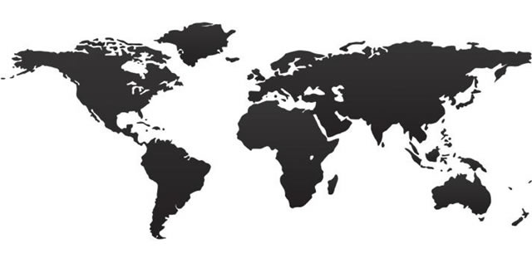

Nicaragua, Hospital Salud Integral
Gastric sample collection and gathering of patient data.

Italy, University of Verona
Detailed histological mapping and categorization of the biopsies of the gastric samples.

Sweden, University of Gothenburg
Research on the development of early stage gastric cancer. Main contributor of knowhow and equipment in the sample collection process.

United States, Washington University School of Medicine
Responsible for culture and storage of strains of the biopsies of the gastric samples.

United States, Baylor
College of Medicine
Provided the expertise in sample collection, processing for histology and culture, storage, transport, culture and identification of helicon-bacter pylori organisms.

Canada, University of Toronto
Project coordination and categorization of biopsies of the gastric samples. Transfer of knowledge and development of how to conduct patient data forms and interviews.
- The involved parties made different contributions to the project in different phases depending on their main field of research. Dr. Paszat initiated the project, and together with a team at Gothenburg University, organized the lab in Managua, bought all equipment, designed patient interview procedures and trained the pathologists to start the sample collection process. University of Verona and Washington University School of Medicine helped with the categorization and historical mapping of the samples as preparations for long-term storage and further research. Baylor College of Medicine provided the expertise in sample collection, processing for histology and culture, storage, transport, culture and identification of the helicobacter pylori organisms. The communication within the collaboration has been built primarily around email contact and has been quite informal, which has led to challenges managing a complex, international research project.

Intellectual Asset Management
- Existing know-how, in the form of instructional material and procedures on research practices and data collection, together with collected research data and processed information, have been informally transferred between the parties as a means to increase the future research capacity. In exchange for the research know-how and required lab equipment the developing country partners have gained access to patient samples of gastric cancer tumors from patients in Nicaragua with information about the patients' medical conditions. The figure below illustrates the knowledge transferred between the involved parties.
Baylor Collage of Medicine
United States
Hospital Salud Integral
Nicaragua
Washington University
School of Medicine
United States
How to handle, trouble shoot and maintain the UBT machine. Method for stool antigen testing and Helicobacter serology.
Knowledge on the resistant effects
of antibiotics. Transferred expertise
knowledge in sample collection,
processing for histology and culture, storage, transport, culture and
identification of the helicobacter
pylori organisms.
University of Gothenburg
Sweden
University of Toronto
Canada
University of Verona
Italy
How to hold an interview. Knowledge on epidemiology, relevant risk factors etc. to include in questionnaire.
Hands on training of the handling of samples, protocols for sample collection and treatment.
Detailed histological mapping of gastritis, atrophy and metaplasia in the biopsies.
Categorization and historical mapping of samples.

= Gastric cancer tumor samples connected with the data of the patients.
- The only intellectual property rights developed through the collaboration due to the early research phase is copyright protection of all research results in the form of data/databases. The informal setup of the project has resulted in no clear ownership rights or contracts stating ownership within the collaboration as the main focus has been on building capacity to conduct basic research and publish the findings. The utilization of the research results to develop diagnostic biomarkers is considered to be rather far into the future at the current stage.

Challenges and Lessons Learned
- Political and bureaucratic obstacles in Nicaragua and organizational difficulties among the consortium of actors were, and continue to be, the main challenges impacting the success of the research collaboration. Below are several specific exemplifications of the problems faced by the project.

Institutional Politics
- Due to a change of governance at the Hospital Escuela Antonio Lenin Fonseca and Hospital Escuela Roberto Calderon where the project was initiated, the main driver of the project doctor Reyna Palacio was replaced as the head pathologist by the new board. This resulted not only in the cancelation of the gastric cancer project, but also the confiscation of key research equipment that had been purchased for the project. A new collaboration was soon set up with Hospital Salud Integral where the samples currently are collected, but new equipment needed to be bought and greater funding is required or operation of the lab, which has delayed the sample collection. Reporting the loss of lab equipment and requesting additional funding to financiers was particularly challenging and required creative solutions. This highlights the difficulty in managing and maintaining ownership of the physical assets necessary to the production of research results (i.e. intellectual assets) in volatile, political environments.

Obstacles to Knowledge Transfer
- In the early phases of the project, the team at Baylor College of Medicine discovered that the antibiotics, for a certain type of bacteria, used by the doctors in Nicaragua were not effective as the bacteria were resistant to the treatment. The study included the identification of which antibiotics were sensitive to the bacteria resulting in the recommendation of new medication. This new knowledge was transferred to doctors in Nicaragua, who ignored this fact and continued to recommend and sell the resistant antibiotics even though it was proven cheaper and more effective.
- This highlights the fact that the transfer of new, superior knowledge is not always easily adopted even in the face of irrefutable evidence due to relationships with pharmaceutical producers, reliance on established norms, and hierarchical structures that support the status quo. These issues need to be taken in consideration when trying to implement new procedures based on new knowledge as knowledge transfer does not necessarily mean that it will be automatically implemented.

Organizational Diversity and Commitment
- The diverse goals of the different researchers and the lack of formal organizational funding and structure are both a strength and weakness within the collaboration. The coalition of actors is held together by personal relationships and aligned research interests, but most importantly, by the personal connection and commitment towards helping the people of Nicaragua. This creates both inefficiency but also flexibility to manage the unforeseen events that characterize research in general and projects involving international actors with different languages and norms, in particular. Complex, multi-year projects between developed and developing countries are likely not to succeed without the existence of a strong, personal connection and commitment necessary to overcome the unexpected challenges.

Reflections
  - The recipient of financial support should be evaluated, in particular, the possibility to provide funding to the innovation projects directly and not go through complex governmental processes nor national development programs. International financiers should consider building in contingency funding for unexpected events (such as the loss of lab equipment) as well as increased project management support as building local research capacity in developing countries can be an entrepreneurial effort.
  - Projects can start informally, but at some point will need a formal budget and organization to be sustainable as research projects can take many years. Projects that have natural synergies with existing research efforts will be more likely to survive the informal period.
  - As the distance between basic and applied research is very short these days, an assessment of potential utilization options in both the developed and developing world could be helpful to govern the research project to facilitate the utilization of the potential research results. In particular, an IP policy and associated contractual agreements specifying IP ownership and use would facilitate not only commercialization but also publication as both are based on contributions of physical and intellectual assets originating from different parties. Different strategies directed towards developed and developing countries should be considered to maximize the utilization opportunities of the potential research results in the future.
Contact Person: Marika Källman

Case Study 2 - Once-A-Day HIV Medicine

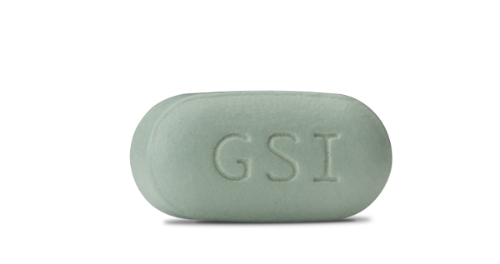

Background
- In 2012 more than 35 million people were living with HIV or AIDS globally. The number of people infected with the virus is significantly higher in developing countries, where the antiviral drugs often are too expensive for the affected population to afford. In the past, it has taken an average of 15 years for a drug to reach the market in developing countries after being launched on the western market. Even in the cases where people can afford the drug there has been an accessibility obstacle. In the past, HIV patients have been forced to take up to 15 pills per day, which puts major strains on logistics as well as the health care system. This means that there is a need for innovative new products and more effective distribution procedures.

The Project
- The pharmaceutical firm, Gilead, has developed a way to combine several drugs into one pill in order to better fight the fast mutating HIV virus. The most successful drugs developed so far are the Once-a-day pills (Atripla® and Truvada®). Combining a number of drugs into one pill simplifies the storage, distribution and transport of the drug to many distant places, as well as impacting the patients’ daily drug regime burden. After developing the novel drug and launching it as a regular treatment in developed countries, the main challenge has been to make it available to the patients in developing countries currently lacking effective treatment.
- To address this issue, Gilead launched an access program with the goal of making HIV treatment drugs available in low- and middle-income countries. In order for the program to be sustainable in the long run it was decided that it would not be a non-profit project, but the primary goal of the project has never been profit. The setup of the program has been gradually developed and fine-tuned with the vision of offering Once-a-day medicine to as many developing countries as possible. The program was launched twice unsuccessfully, but after learning from previous mistakes, a third program was launched in 2006. This third launch has been more successful than previous attempts and the treatment is today reaching more than 5.4 million HIV patients in over 130 countries. In 2001, before launching the first access program, Gilead had roughly 1,100 employees, three products and no geographical presence outside Canada, the United States and Europe. This differed from most companies with a large portfolio, large staff and strong presence outside the United States Therefore; Gilead utilized a different business model than the industry standard in which no manufacturing facilities or local distribution and sales offices were built. Instead, the model was based on collaborations and partnerships with local actors, from R&D (e.g. further drug development) to sales., Nevertheless it should be mentioned that Gilead has continuously worked on enhancing the model, adding new dimensions, and will need to iterate to be able to adapt in order to be sustainable in a changing world.
- The access program is enabled by working with regional distributors of Gilead’s own branded drugs (with local modification of packaging and drug information sheets) in South America, Southern Africa and South East Asia, as well as licensing to generic drug manufacturers, primarily located in India. Close relationships with local actors, such as distributors with connections to, for instance, regulatory agencies and regulatory consultants, was the key factor in a successful launch. The business model allows regional distributors to sell Gilead’s branded drug with a markup of 10 % to 15 % to cover their costs of registering the product in their respective countries, managing local logistics, and cultivating and providing information to the medical network.
- The generic drug manufacturers are at present a group of licensees in India and South Africa. By having a number of licensees for each of their HIV drugs, Gilead makes sure that the production capacity can fulfill the market demands. In order to meet international quality standards, the licensees have to obtain an FDA tentative approval or WHO prequalification, which is eased when Gilead´s branded drugs are already registered. The licensees could establish their own prices but have to pay around 5 % royalty (with differences depending on the drug) on sales to Gilead and are allowed to sell their generic products in local Indian markets and export products to more than 94 low-income countries with high HIV prevalence, including Thailand and African countries through Gilead’s distributors. The license can be offered to any generic drug manufacturer in developing countries, but since collaborations are based on a close working relationship, the partners are chosen based on their resources and capabilities. Most of the partners currently involved in the transfer have contacted Gilead themselves, and a formal contract has been drafted together with each partner. For a geographical overview of the access program see Figure 1.

Figure 1: A geographical overview of the partners in Gilead´s access program. Gilead has many local collaborators and has reached over 130 countries. For a full list of the participating countries and actors see Gilead´s web page “Access Partnerships. *Can also be distributors of the generic drug manufacturers (licensees) versions of Gilead´s drugs.
South East Asia
Local distribution of the branded drug* as well as licensed manufacturing through generic drug manufacturers.
Gilead Science Inc., United States
Invented the combined once a day HIV medicine. Initiators of the Access program and the commercialization of the Once-a-day HIV medicine.
Emory University, United States
Inventor of the drug becoming part of the Once-a-day HIV medicine. Transferred IP and know-how to Gilead and Royalty Pharma for commercialization.
Southern Africa
Local distribution of the branded drug* as well as licensed manufacturing through generic drug manufacturers

Royalty Pharma,
United States
Transferred rights to the technology behind the Once a day HIV medicine, however not part of the Access Program.
Merck and Bristol-Myers Squibb, United States,
Aided in the marketing of the drug in local markets.
South America
Local distribution of the branded drug* as well as licensed manufacturing through generic drug manufacturers

- Polly Fields, Director of Governmental Affairs at Gilead, stressed in an interview that the Indian generic drug manufacturers are considered by Gilead to be at the forefront of the transfer collaborations. They are seen as key partners who are appreciated for their good quality and ability to scale up. Gilead has so far been working a lot with traditional in person-meetings and by telephone communication, stressing the importance of personal contacts and networks that make the project possible. In the end it comes down to the people.
- Fields also points out that the program would not have been possible without collaborative partnerships; what Gilead brings in forms of innovation and regulatory support, the Indian manufacturers bring when it comes to ability to scale up manufacturing quickly to a low cost. Both sides want to keep the partnership, and have benefits for a variety of reasons. The manufacturers are incentivized by the prospect of working with Gilead in other areas than HIV in the future, such as Hepatitis C. One of the other main reasons why many partners keep a loyal collaboration with Gilead is that through the access program the ease of regulatory approval by local regulatory organs (similar to FDA and EMA) and WHO pre-qualifications cuts the time to market access significantly compared to copying the drug and taking it to the market single-handedly. Many developing countries rely heavily on WHO’s guidance in recommending the choice of drugs. In addition, Gilead also fosters the market access for many local distributors of the licensees’ generic drugs to further incentivize the access program and creating a value chain. By helping both the generic drug manufacturers to sell their cost effectively produced drugs and aiding the local distributors to obtain a steady supply of cheaper drugs from the generic companies, more and cheaper drugs will reach patients in need through a win/win scenario.
- For Gilead, collaborations are necessary since they don’t have the production capabilities to meet the need of the large patient population. Gilead emphasizes the fact that they will continue seeking new partnerships in the future. Working with the program is something Gilead takes pride in doing, “it is who we are” says Polly Fields, and it is strongly tied to their corporate brand. Today people consider Gilead to be an HIV-company, and they feel as if they have a responsibility to set a good example for the industry.
- As of today, The Gilead Access program has grown; the number of patients getting medicine due to the program has increased from a few hundred to 5.4 million. However, there are still patients in need and the access program needs to be expanded in order to reach more patients and further decrease the time to market. Gilead recognizes the fact that HIV is not a problem they can solve by themselves, thus their aim is for other big pharmaceutical companies to follow in their footsteps, increasing the generic drugs on the market, lowering the prices even more and expanding the access. For example, Gilead’s decision to join the Medicine Patent Pool (MPP) is a step to spread their program. However, the patent pool needs to be improved and more companies need to join to spread their inventions.
- Further, Gilead is also looking into the possibilities of using the same business model but for Hepatitis C. However, Gilead see new challenges concerning this disease, since state spending on treatment for Hepatitis C is not as prioritized in developing countries as HIV is. Hepatitis C and HIV are linked, in the sense that up to 20-30 % of HIV infected patients have been estimated to be co-infected with Hepatitis C., There is, however, to some extent, a difference in the geographical prevalence of Hepatitis C compared to HIV, which limits the possibility to leverage on the HIV access programs collaborations and distribution channels. Regardless of Gilead’s expansion of the access program, their model can potentially be used by other pharmaceutical companies in order to make other types of treatments more globally accessible. For an overview of the key steps in the access program see Figure 2.

Figure 2: A flowchart of some of the key steps of Gilead´s access program

Technology Transfer
- The generic drug manufacturing partners entering into Gilead Access Program get access to relevant IP, which means a non-exclusive, non-sublicensable, non-transferable license on granted patents and patent applications, in which the terms can vary depending on the relevant drug(s) and the specific territories. Gilead has a number of drugs or combination of drugs for license, namely; TAF, TDF, EVG, COBI, TDF Product, EVG Product, COBI Product and Quad. The license for each of the mentioned drugs/combinations may differ in royalty rates and the extent of its territory.
- The license for a final product (ready drug) is royalty-bearing (3-15%) while the API (Active Pharmaceutical Ingredient) license is royalty-free, with the restriction that it only may be sold to by Gilead licensed product suppliers. The partners also get access to know-how such as knowledge in regard to manufacturing process descriptions, specifications and methods which includes blueprints of the manufacturing process (Data and Instructions) and technical support regarding stability data, analytical method validation and discussion of impurities. The license must fulfill certain criteria such as production capacities and quality requirements, and be obliged to follow Gilead´s and regulatory bodies regulations. They are furthermore not allowed to use Gilead´s trademarks and brands on their products, and Gilead has the right to perform audits on the facilities and to overlook the products (May not contain Gilead´s trademark or brand) and new agreements/collaborators prior to its establishment and use.
- Furthermore, Gilead was one of the first companies to join the Medicine Patent Pool (MPP) that could further help to diffuse the IP from Gilead and other companies. For an overview of the technology transfer see Figure 3. Readers are referred to the publicly available Gilead License agreement and the MPP license agreement for details about the technology transfer.
- Any development of the drug or manufacturing process (including new know-how) made by the collaborators needs to be reported annually and becomes the property of the inventors. Nevertheless Gilead obtains a “nonexclusive, royalty-free, worldwide, sublicensable license to all improvements, methods, modifications and other know-how developed by or on behalf of Licensee and relating to API or a Product”.
- Gilead acknowledges that there is a problem with the IP system in India, and that giving the rights of any enhancement of the IP to the local collaborators will incentivize those actors to push for right to ownership, hence improving the overall IP system. For instance, collaborating partners have worked on new pediatric drugs based on Gilead’s HIV products, making it possible to give the drugs to infants, children and adolescents.
Figure 3: Knowledge flowchart. An overview of the IP transfer from the inventors at Emory University to the markets in developing countries. Royalty Pharma and Gilead Sciences obtained the royalty interest for Emtricitabine (FTC) from Emory. Gilead further developed the technology and created a unique Once-a-day HIV pill containing 2-3 different drug compounds. Merck and Bristol-Myers Squibb aided in the marketing of the drugs. The Medicine Patent Pool acts as an intermediate to help diffuse the IP. The diffusion of the technology to local partners led to lower prices and made HIV treatment possible for over 5.4 million patients in around 130 countries. API (Active Pharmaceutical Ingredient). ,,
Emory University &
Emory Healthcare
Gilead Science Inc.
Local distributors in
developing countries
Merck &
Bristol-Myers Squibb
Generic drug manufacturers in developing countries
MPP
Reaching over 5.4 million patients
in over 130 countries
Invented the Once a day HIV medicine. Initiated the access program. Helping local distributors and generic manufactures with regulatory approvals, WHO listings and medical education, etc.

Patent pool aiding with the diffusion of IP to India and China

The inventors of the drugs behind the Once a day HIV medicine. Transferred the technical solution (patent) as well as data concerning the development of the drug

Local partnerships with distributors (licensed) of the branded drug
Aided in the marketing
of the drug
Are licensees of Gilead’s patents despite that a number of them are not being valid in some local jurisdictions. Manufacturing process data, methods etc. and know-how is transferred as a part of the license by either Gilead or through MPP
Can only sell APIs to certain of Gilead´s licensed partners in different territories but can sell product drugs to any relevant buyer.
Distribution agreement
$$$
Access to products
$$$
IP +
Know-how
IP +
Know-how
$$$,
API supplies, non-excl. worldwide grant back license to improvements
$$$
$$$
$$$
Provide both Gilead branded drugs and other generic drugs from licensees to HIV patients
IP +
Know-how
IP +
Know-how
$$$
Indirect $$$ and access to other IP

- Legally, all of Gilead’s drugs are not patented in India. The royalties for the generic drugs were initially paid as a part of the contract between Gilead and the Indian manufacturers and distributors awaiting the patent applications to be granted. However, in 2009 the applications were rejected. The partnerships have been maintained, including royalties (varying between 3-15% dependent on territory and specific drug), due to the fact that the relevant transfer concerns intellectual assets other than patents, such as know-how of manufacturing processes and regulatory approvals. This implies that the value of the program lies in the collaborations and the transfer of knowledge and experience rather than only the legal right to market the drug. However, the relevance of a functioning IP system as an infrastructure facilitating such collaboration should not be underestimated.

Challenges and lessons learned
- As mentioned, the access program was launched twice unsuccessfully. The first launch was unsuccessful mainly due to the fact that import permits were used instead of registering drugs. By registering, drugs could instead be stored in stock in each country, which enabled a more efficient distribution. Registering products also made it possible for Gilead and local distributors to educate physicians on the benefits of the drug, ultimately leading to the drug being prescribed to a larger extent. To enhance the education Gilead created an online portal, and with information material in many different languages enabled access for many physicians, patients and policy makers. The second launch also failed, this time due to differences in national regulatory demands and, in many cases, due to lack of collaboration with local actors. Gilead had underestimated facts such as the importance of local agents, in-country partnerships, and to register their drugs with WHO, among others.
- As mentioned by both Gregg Alton, Gilead’s Executive Vice President for Corporate and Medical affairs, and Polly Fields, Director of Governmental Affairs, when collaborating with generic drug manufacturers in the developing world, Gilead has faced some challenges when it comes to setting royalty rates. The company uses a formula to calculate the rate based on the GDP of a country and the number of HIV sufferers in the population. Consequently, the royalty rate is the same for every partner within a given country. The challenges have mainly been in relation to countries such as China that have experienced a growth in GDP over the last decade. The country is no longer considered a low-income country and will therefore not be given the lowest rate; a situation that has led to some conflicts. Nevertheless, it would be unreasonable to have identical rates in for instance Lesotho and China. In relation to the problems with royalty rates, Gilead also faced competition by other drugs on local markets (e.g. from the company Cipla), and a number of the partners were questioning the long-term viability of Gilead’s low margin business plan. In addition, Gilead had to be careful when launching the product on markets in which they have licensees and when introducing new HIV drugs from their drug pipeline as this may lead to cannibalization. Gilead is operating in the highly competitive pharmaceutical industry, but by using local manufacturers who can produce the products in a cost-efficient way, they have managed to compete and make a profit in different local markets.
- One challenge mentioned in a previous documented interview with Gregg Alton is the uneven global environment for patents, such as a variation in the assessment of incremental innovations within national patent laws. Gregg Alton stressed the difference between new chemical entities (new drugs) versus small improvements on existing chemical structures. The latter is often easier to develop, much cheaper, and in most cases the most beneficial for the patients, but the IP system encourages the development of new drugs instead, due to the fact that they are easier to patent. Trying to invent new entities instead of maximizing the value of existing drugs may not be most beneficial to people in need and is often considered a waste of resources due to the high cost of development; still the system in many countries is built to suit these types of innovations.
- Furthermore, since the access program is based on the distribution of drugs, Gilead is highly dependent on the regulatory process in each country. This is a process that can vary greatly between countries. Some governments are not motivated by humanitarian concerns and can be less helpful regarding regulatory issues. In addition, various governments may have a different procurement policy, which further undermines the efforts by the access program.
- Another challenge of Gilead’s concerned the Medicines Patent Pool (MPP). The patent pool was established by UNITAID in 2009 with the goal of expanding the access to different medicines by sharing patents amongst the members. Gilead was the first pharmaceutical company to join the pool allowing access to a number of patents in their portfolio for sub-licensing to Indian manufacturers (ISB). The value of the pool is highly dependent on the number of members and its initial growth has been slow. Few other actors joined initially but recently more ventures such as Bristol Myers Squibb, Roche, and ViiV Healthcare have become members, contributing to the network effect and overall value of MPP.
- Finally, it is a time consuming administrational work for Gilead to communicate with a large number of collaborators. Ms. Fields mentioned that they further could improve the communication with various organs in countries and also with all the partners and local actors. Gilead will try to extend their utilization of modern communication tools such as Skype and other video conferencing tools. Ms. Fields explains that transfer of IP and know-how is a very time-consuming process.
- Despite the nature of the project Gilead points out that it is unsustainable to uphold an entirely philanthropic project. In order for collaborations to last and the HIV drugs to reach a bigger and larger part of the market, the initiative has to have a commercial value. It should be stressed though, that Gilead’s official statement is not to make a huge profit on the project and their policy is to reinvest the profit back into the project to keep it sustainable.

Reflections
  - Strengthening the local IP system through incentivizing local actors was key to the success of the access program.
  - Assisting partners with know-how, regulatory approvals, WHO listings, and helping to reach the markets in addition to transferring IP was also a key factor. Education of physicians, patients and policy makers by creating an online portal was also an important step for Gilead to spread the usage of their drugs.
  - In order for a program to be sustainable it may not be enough to keep it philanthropic. An additional financial incentive is often needed to keep the access program viable, but it is important to keep the balance in pricing.
  - Longer term contracts of drugs for each partner and collaborator can be a key to further incentivize partners.
  - Having a long-term goal and being prepared to iterate the model/program until it can manage to fulfill the goals is important. This is very similar to the entrepreneurial endeavors of a startup venture.
  - In conclusion, a functioning system of international intellectual property law is important to manage licensing deals, but may not be the only important factor to facilitate successful tech transfers. Partnerships that incentivize collaboration is a very important aspect.
Contact Person: Polly Fields

References
Amended and Restated License Agreement between MPP and Gilead, available at: http://www.medicinespatentpool.org/wp-content/uploads/mpp-gilead-licence-taf.pdf, date of view: 15.08.14.
Amended and Restated License Agreement between Gilead and licensee, available at: http://www.gilead.com/~/media/Files/pdfs/other/ExpandedTermsLicenseAgreement.pdf, date of view: 15.08.14.
Baker, P C., Donohue, B. Fuller, R. Roberts Henderson, M J. Huff, C. Mastrandrea, A. Perilstein, D. Richter, L. Ritzer Ross, J. and Weiss, S. (2009) AUTM: Innovations from Academic Research That Positively Impact Global Health, THE BETTER WORLD REPORT, pp. 31-33.
Gilead’s “HIV/AIDS” web page: http://www.gilead.com/responsibility/developing-world-access/hiv%20aids, date of view: 15.07.2014.
Gilead´s “Access Partnerships” web page: http://www.gilead.com/responsibility/developing-world-access/access%20partnerships, date of view: 16.07.2014.
Gilead (2013). Increasing Sustainable Access to Medicines and Healthcare. Gilead Treatment Expansion Programs. Gilead Sciences.
Gilead Sciences Programs in Developing Countries (2013). Scaling Up Antiretroviral Treatment Sustainably. Gilead Sciences.
Gupta, P. (2013) Hepatitis C Virus and HIV Type 1 Co-Infection. Infection Dis Rep, vol. 6; 5 (Suppl 1): e7.
Jewell, C. (2012) INNOVATIVE LICENSING expands access to HIV treatment. Communications division - WIPO, vol. 6, pp. 17-21
Polly Fields, Director of Governmental Affairs at Gilead Science Inc., Skype interview, 23.01.2014
Rangan. V. K., and Lee. K. (2011) Gilead science, Inc.: Access Program. Harvard Business School. 9-510-029
Sachan, N., Tatambhotla, A., Nehru, R. and Dhanaraj, C. (2013) COLLABORATIVE COMMERCIALIZATION AT GILEAD SCIENCES: RESOLVING THE INNOVATION VS. ACCESS TRADEOFF. Indian School of Business (ISB). Version: 2013-04-10
World Health Organization (WHO). 2014 HIV/AIDS. World Health Organization, web page: http://www.who.int/hiv/en/, date of view: 04.02.2014.

Case Study 3 - Phenolic Extract Rich in Propelar-gonidins, Procyanidins and Flavalignans

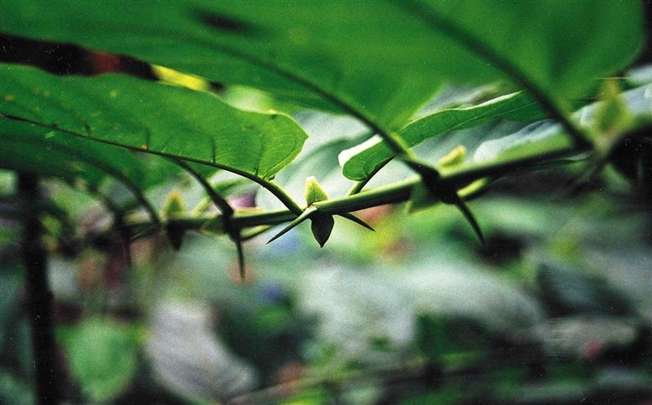
Image 2 Uncaria tomentosa (Cat's claw)

Background
- The collaboration regards an invention on extracting polyphenol extract from the plant Uncaria Tomentosa (in English known as “Cat’s claw”). The Uncaria Tomentosa plant is a vine from tropical rainforest that is found from Peru to Belize. The plant is claimed to have properties such as anti-inflammatory, anti-tumor, immunomodulatory and antioxidant activities. This is due in part to phenolic compounds as procyanidin type, propelargonidins and flavonolignanes.
- There are commercial products derived from Cat's claw in more than 30 countries and most products are found within natural/alternative medicines. The plant has been used medicinally for centuries in South America. It has been claimed to boost the immune system and to treat illnesses ranging from allergies to cancer. Cat's claw has become a popular natural medicine in the United States and Europe. It can be found in for instance capsules and can be made into a tea.
- According to Antonio Jimenez (2014) the existing products do not have the level of characterization and do not contain neither the quantitatively nor qualitatively polyphenol profile reached with the new technology developed by UCR and CSIS.

The Project
- The collaboration between the two research groups started from a network of researchers and interuniversity collaboration between Costa Rica and Spain. Dr. Mirtha Navarro from the Chemical School at University of Costa Rica (UCR), and Dr. María Monagas from the Food Science Research Institute (CIAL) at the National Spanish Research Council (CSIC) situated in Spain were the coordinators of the research activities of this network. The project started when
Mirtha Navarro, from UCR, began researching on her spare time on the properties of Uncaria Tomentosa. In an informal way, Mirtha shared information about the potential of the project with some of her colleagues from CSIC.
- The original information exchanged was informal and started as personal relationship without any expectation of making profit out of it. Once they saw that these properties were potentially valuable, they decide to bring it to the boards of UCR and CSIC to create a research agreement.
National Research Council in Spain (CSIS)
Together with UCR they researched in this new technology. They were the main monetary sponsor’s in the project and this entitles them with 51% of ownership.

Universidad de Costa Rica (UCR)
Initial research started here by one of the university’s tops researchers DR. Mirtha Navarro Hoyos

- A patent was filed at the Spanish Office of Intellectual Right Protection in December 2012. In addition a PCT application was filed in December in 2013, at the same office. The patent application claims several new extraction methods innovated to obtain certain polyphenols from Uncaria Tomentosa, and also the protection of different functional bioactivities tested in vitro.
- During the initial phase of the project UCR and Mirtha ran into issues regarding financing and commercialization experience. UCR does not have a lot of financial strength and did not have the experience needed to commercialize it. Collaborating with CSIC gave UCR an opportunity to learn and grow in this field. In contrast to UCR, CSIC has a technology transfer office, which is in charge of looking for potential customers and licensees for this project. The next step in the collaboration will most possibly include further research to improve the protected technology’s properties, e.g. by testing it on animal model as preclinical studies, and to further on find potential licensees for commercialization.

- The incentive for the collaboration was to commercialize the technology, as both parties saw a big potential to use the invention in the food industry. The aim of the collaboration is to license the technology to a third party and to split royalties in the amount established in the agreement.

Technology Transfer
- The official collaboration between the parties is assigned accordingly: 51% to CSIC and 49% to UCR. The mentioned distribution was split based on the economic and technological resources that the CSIC has in order to keep researching and exploiting the invention. The collaboration implies that all further research costs and benefits will be split according to the above-mentioned percentages. All intellectual property management is handled by the technology transfer office at CSIC due to their experience in the field.
- To date, this project has not been commercialized, therefore technology transfer has not started with third parties. Nevertheless, currently the CSIC technology transfer office is seeking potential customers to license the technology.
- The technology is a method for extraction of phenolic compounds from the Uncaria tomentosa (Cat’s claw). Other extraction processes currently exist in the market, but these are less effective and adapted for other plants than Cat’s claw. The new technology entails a better way of extracting the compounds by enabling the identification, extraction and characterization of the Cat’s claw compounds, which are believed to have health beneficial properties. The health beneficial properties of the plant Cat’s claw has been known before but non-specific substances, such as the phenolics had been extracted from the plant and used for therapeutic or other health related purposes The research teams at the Universidad de Costa Rica (UCR), and CSIS have performed both In vitro and cell culture studies on the extracted substances, indicating both general ant oxidative effect as well as anti-proliferative and cytotoxic activities against tumor cells. Some substances have also shown antimicrobial activity against pathogenic bacteria (S. aureus, E. coli, P. aeruginosa). The patent applications aim to protect the method described above and also to claim the health beneficial aspects of some of the identified substances.
- The two main purposes of the project are the financial potential of the technology and the potential to increase health trough functional food and/or the development of therapeutic products.
National Research council in Spain
(CSIC)
Universidad de Costa Rica
(UCR)
PROINNOVA (Technology transfer office UCR)
IP rights
(Patents)
Original concept of research
Research collaboration, testing in big scale and knowledge expertise
Monetary remuneration
IP expertise
IP rights (Patents)
Technology rights was handle over to the technology transfer office, in order to be the one responsible to negotiate and file a patent application together with CSIC

Challenges and Lessons Learned
- Some of the challenges in the collaboration could be regarding the internal policies of the parties involved, as an example the students at UCR get the rights for their discoveries, and UCR are therefore required to make students sign an agreement to give the rights to the university. In some cases the University share the patent and ownership with the students, which in many cases complicates the process, as it requires getting authorization from the students for every step they give. In many cases this becomes a conflict as the involved parties have different interests and point of views. In this specific collaboration of the Uncaria tomentosa, this problem hasn’t been encounter, but is nevertheless, a fear that this situation could happen.
- According to Lillian de Rojas, UCR does not have a well-functioning IP management. The lack of experience and the mentioned IP policies have complicated their IP management. The model that they have been using in the past consist of 50/50 for the university and the researcher. The extra incentives for UCR to patent inventions is that they can get a tax reduction from the government which does not apply when a patent is filed in collaboration with a second party, such as a researcher.

Reflections
- Based on the experiences from the project, an essential factor in facilitating similar technology transfers would be to increase general knowledge and awareness of technology licensing to multiple licensees, with special focus on division of foreground results and rights for future developments of this technology. A crucial aspect to the project has also been the handling of information and issues of confidentiality. By increasing awareness of the importance of managing confidentiality in such collaborations, further technology transfers could be facilitated.

Contact persons: Lilliana Rojas Guillén, Basic Sciences and engineering Manager (UCR PROINNOVA), Dr. Debora Villaño, Technology transfer manager. (CSIS), Dr. Antonio Jiménez Escrig (Ph.D.), Knownedge transfer manager CSIC.

More information on Cat’s claw
Info on PROINNOVA ( is UCR’s technology transfer office. They are responsible for managing and organizing innovations generated at the University of Costa Rica. )

References
Jimenez Escrig, Antonio, Uncaria Tomentosa commercialization, non-published 2014.
Shahidi Fereidoon and Naczk Marian, Phenolics in Food and Nutraceuticals, CRC Press, 2003.
PHD Antonio Jimenez Escrig, Knowledge transfer manager CSIC, email interview, April 2014.
American cancer society, www.cancer.org, complementary and alternative medicine/“cat’s claw”, 2014-07-15.
Liliana Rojas Guillen, Basic sciences and engineer manager UCR, Skype interview, January 2014.
Technology commercialization brochure, Extractos fenólicos bioactivos de uncaria tomentosa, pamphlet, CSIC.

Case Study 4 - The Strawberry Licensing Project
Image 1 Strawberries grown from UC Davis cultivars

Background
- The United States is the world’s largest producer of strawberries, producing approximately 30% of the world’s total production. The State of California is the primary producer, and accounts for almost 80% of strawberries consumed domestically. The total value of the domestic strawberry production in 2011 was $2.4 billion and is increasing.
- In 2011, Turkey was the second largest strawberry producer in the world and is growing quickly exporting to a value of $21 million, primarily to Russia followed by Iraq, Bulgaria, Germany and Romania. Important developments have occurred during the last years regarding strawberry culture and the strawberry production. The Mediterranean coastal areas have the greatest potential for growing strawberries with a citrus climate and sandy soils, but several other sites are also suitable for production in Turkey.
- Still the United States produce more strawberries than the rest of the top 5 countries together, the knowledge and varieties that UC Davis possessed and used to make California the world largest producer may be beneficial for other producers as well. This may have been the reason why UC Davis in 1999 commercially released four plants outside the State of California. Turkey farmer who saw a growth in the strawberry industry wanted to adapt to better varieties of plant to meet the needs of the market.

The Project
- UC Davis makes use of a master licensee to license the use of the cultivars outside the United States and Canada. The far biggest of these master licensees is Eurosemillas, responsible for licensing the crop to Argentina, Belarus, Brazil, Chile, China, Colombia, Ecuador, Egypt, the European Union, Israel, Japan, Jordan, Mexico, Morocco, Peru, Switzerland, Tunisia, Turkey and Uruguay. Initially, it was Eurosemillas, as a master licensee, who contacted UC Davis approximately fifteen years ago asking if they were allowed to license the cultivars to the Turkish market.
- Eurosemillas has a strong relationship and collaboration with UC Davis and became a master licensee already in 1989. The company licenses many types of crops and has collaboration with several research facilities around the world and has specialized in transferring plant technology to farmers. In the strawberry division most of the varieties that they license are protected by UC Davis as some are no longer protected by plant breeders rights eventhough they were initially developed by UC Davis.
- When the project started, Eurosemillas knew they had farmers in Turkey who could utilize the cultivars but lacked the permission from UC Davis for sub-licensing the varieties to this territory. The challenge was that Turkey was not bound by UPOV, meaning that there was limited ways to control the use of the varieties in the country through patents. Therefore, UC Davis was not able to find a way to allow the plant to be used at this early stage.

The Plant Breeder's Right (PBR)
- If a breeder has discovered a new plant variety that is new, distinct, uniform and stable, the requirements for a plant breeder's right is fulfilled. The application is sent to national offices where the examination will be done ex officio to determine whether the exclusive right should be granted. The plant variety office will have a plant from the variety to determine whether the requirements are fulfilled. If the right is granted, the breeder has the choice to either be exclusive on the market or license the variety further to other breeders within the country of protection. The protection lasts for 20 years, except for wine and trees where the protection is 25 years.
- These requirements are needed to fulfill to have a granted right.
  - Novelty. The plant has not been sold or disposed to others during a specified period of time prior to the application date.
  - Distinctness. The variety needs to differ from all other known varieties by one or more botanical characteristics, such as color, maturity etc.
  - Uniformity. The plant characteristics should be consistent among all plants within the variety.
  - Stability. The characteristics also need to be genetically fixed to create stability from generation to generation, or after a cycle of reproduction if the plant is a hybrid.
Together with these requirements, the breeder needs to give the variety an acceptable "denomination" that will be used by all breeders worldwide. The national office also examines this acceptance before the breeder's right is granted.

The International Union for the Protection of new Varieties of Plants (UPOV)
- As the name suggest, UPOV is an intergovernmental organization with their headquarter in Geneva, Switzerland, focused on the protection of new varieties and plant to make sure that the agricultural market is fair for all parties, both large companies and small breeders. Their mission is to "provide and promote an effective system of plant variety protection, with the aim of encouraging development of new varieties of plants for the benefit of society".. This is done primarily through the UPOV Convention where the breeder's right is an opportunity for the members, as an overlapping complement to the patent system, to protect the plant varieties and be able to build a business around the variety.
- UPOV has become a way for countries without a patent system for plant varieties to have another protection and thereby enable innovation in new areas and create new markets within the industry. A granted breeder's right in one country is under the UPOV Convention treated bilaterally and used with the same filing date in all other countries where the applicant choose to file within one year from the original filing date. This means that the novelty isn't ruined through the application of a breeder's right. In Turkey, the UPOV Convention has enables UC Davis to create the licensing program since the patent system isn't enough developed yet and the process needed to be quicker than to change the law, or the populations thoughts of the law.
- It is a worldwide issue to recognize the intellectual property as having the same status as other property rights where a physical product has usually been the crucial "thing". By having the regulation through UPOV, UC Davis managed to reach the Turkish market and utilize the climate zone appropriate for breeding the strawberry cultivars, but maintain the protection of the varieties at the same time. This creates a win-win situation where the societal benefits in Turkey relate to the knowledge transfer between the countries and the ongoing research and development at UC Davis in California. UPOV is thereby a part of the knowledge shared all over the world that would not have been possible otherwise due to the lack of a credible patent system where the varieties is usually protected in e.g. the United States.
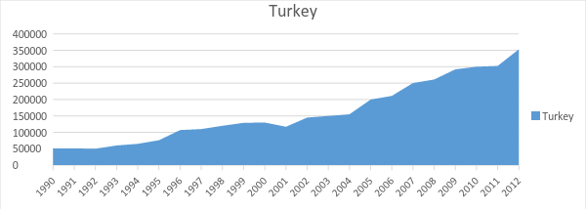
Figure 2 The production of strawberry in turkey between the years of 1990 to 2012 in tons

Product development
- UC Davis provides the master licensee in Turkey, Eurosemillas, with the right to create sublicenses to use the patent protected varieties. The Master Licensee can thereafter sublicense the patent to nurseries that can sell the plants to fruit growers through the licensing agreement with UC Davis. This is a fruitful collaboration for UC Davis and the master licensee as they both benefit from the royalties generated by the license. The system also creates a fast and efficient way of spreading a technology to farmers out on the countryside of faraway countries who hopefully benefit from a better variety with higher yield and quality.

Regulatory phase
- When the project was initiated with Turkey, they did not follow the international conventions UPOV of the Plant Breeders Right (PBR). This became a challenge since Turkey has its own legal system for plant breeder’s rights that was difficult to understand and have confidence in as a foreign breeder.
- In October 2007, Turkey signed the UPOV convention and the licensing could begin. However, the problem party remained, as the plant-based IP was a relatively new phenomenon, the system had not been tested. Lawyers who know about how to prosecute cases in plant protection were few making the process slow and costly. These factors complicate the process of identifying competent, cost-effective way to protect plants in Turkey.

Technology Transfer
- When Turkey implemented UPOV 2007, the master licensee Eurosemillas were allowed to begin licensing the right to propagate from the cultivars in Turkey through the Strawberry Licensing Program. Moreover, Eurosemillas had to produce material to transfer the knowledge necessary for the farmers to take the full advantage of the cultivars. There is a continuous contact between UC Davis and the master licensee so that the farmers can utilize new knowledge from research. Eventhough there is a possibility to use data about growing condition and yield etc. from farmer and transfer it back to the university, this is not used to a large extent today.
- Today, with more and more farmers using the cultivars UC Davis regards Turkey as a successful country when it comes to the introduction of their strawberry cultivars. Turkey had a large growth in strawberries for many years and mainly uses Californian cultivars. This production could probably be increased even more but lack of improved species, cold storage houses, necessary protection laws and government incentives may hold back the development.
- The primarily intellectual assets are the 13 still valid patents as the core of the program. The patents are owned by the university and are used as a way of financing further research through the licensing program. The patents protect different strawberry cultivars developed at UC Davis that were developed based on certain criteria representing the most central qualities for a good strawberry from a California perspective. In addition to the right to propagate from the patented cultivars, UC Davis provides expertise and technologies that help farmers to maximize the yield from the plants. UC Davis has additional patents on genes and gene modification that are not part of the program and not deemed to be important to the master license.

The “Plant Wrap” Construction
- Within the United States and Canada, cultivars are provided through a nonexclusive license directly to the nurseries with the right to propagate plants and sell daughter plants to growers. Outside of the United States and Canada, the UC Davis is managing the program through external contacts as business partners in the receiving country. These are referred to as “Master Licensees” with an exclusive license within a defined territory and the right to sublicense a nonexclusive license to the nurseries within the territory. Eurosemillas is the master licensee for Turkey. Crucial responsibilities for the master licensee are market development, technical support and the transfer of produced expertise. The master licensee will also support IP development and provides access to the local court system.
- When a licensing agreement is signed, a UC strawberry plant is shipped from a California nursery to the receiving party. An electronic shipping system is under development to give the master licensee and UC Davis updated information about the shipping process of the plant. This gives the master licensees a way to accept or reject proposed sales of the plants or sublicensing option and gives both parts better control over the situation where the UC licensing policy is central to follow.
- When the plant is shipped from California to the Turkish breeder through Eurosemillas, a license agreement is signed where the licensee gets the rights to the plants, but not any ownership to the patent. Included in the license is knowledge regarding how to breed the strawberries in an optimal way and instructions for how the sublicenses are supposed to be handled. Included in the license is therefore a right to commercialize the plants further together with expertise from California regarding the sublicense.

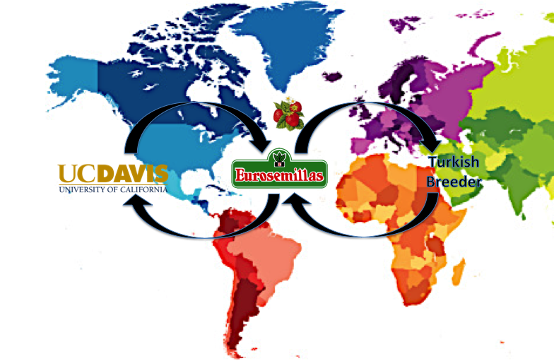

Challenges and Lessons Learned
- Mr. Carrier pointed out since the patent system in Turkey was not developed enough due to the lack of conformity from the population, UC Davis needed to manage this challenge and find a way to use their patented cultivars and expand the program. The solution was to go through UPOV to have a plat breeder's right as a complementary protection to the patent. Even though the cultivars can be patented in Turkey, the breeder's right becomes a way to force the challenge and learn how to manage the situation outside countries with well-developed patent systems. UPOV is a great contact to manage future similar challenges when the program is expanding to new regions worldwide.

Reflections
- The main problem found in this investigation was however you can feel confident in another countries judicial arena. The most obvious way to improve collaboration is to make countries agree upon international conventions. Still an organization as UPOV could take a more active role in countries that have recently adapted their legal system to implement PBR. They could support in the enforcement of the PBR to ensure that the cultivars is protected and the breeder’s rights is not neglected.
- After analyzing the situation, it became clear that the technology transfer would not have happened if there was not a strong protection of the breeders right in Turkey. From a philanthropic perspective, the plants could have been released to the public domain or one could disregard that it could be impossible to protect the plant in the country. However the monetary reward supports the faster transfer of technology as master licensee as Eurosemillas has a strong incentive to spread the varieties. Eurosemillas was an important partner for this technology transfer and it may not have happened without them.
- The royalty also support founding new research in plant breeding which eventually benefit the breeder more. However, as varieties are primarily developed for the California market they could potentially be adapted even more to Turkish condition if that was a goal. It could be suggested that more knowledge should be transferred back from Turkey to UC Davis and that the university use this data to improve its crop.
Contact Person: Michael Carrier, University of California, Davis

Case Study 5 - Late Blight Resistant Potato Project

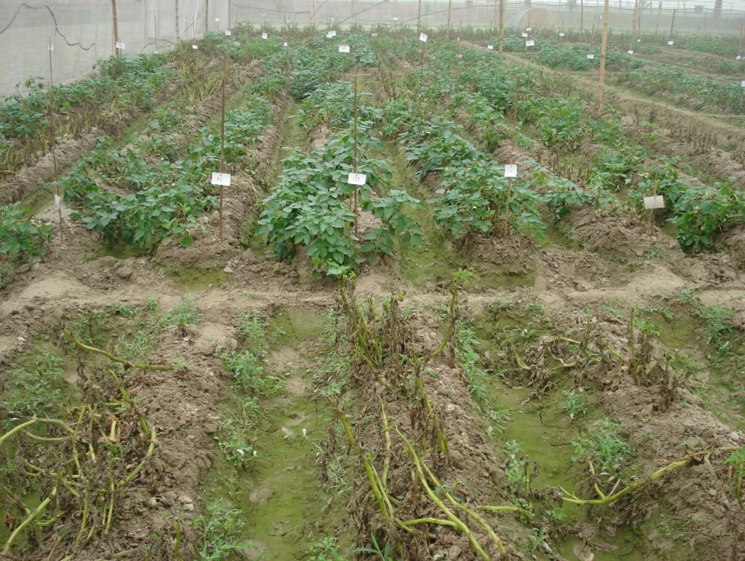

Image 3 Healthy LBR resistant plants with Rb gene in comparison to completely decimated potato plants without Rb gene under high disease pressure

Background
- India is the second largest potato producer in the world (after China), with a cultivation area of over 1.28 million hectares. Due to the fact that potato is a highly remunerative crop, farmers in the Indian subcontinent have become increasingly reliant on this crop. However, potato production is severely threatened by Late Blight, a plant disease caused by fungus (Phytophthora infestans). In 2007, 70% of India’s potato crops were lost due to this disease and 50% of Bangladesh’s potato production was affected. In some Indian states, the yield loss due to late blight is up to 40% even with the use of “resistant” varieties and chemical control. Chemical treatments with fungicides and pesticides not only impose costs on resource-poor farmers and reduce their crop and thereby profit, but also pose serious environmental and health risks and issues.
- All commercial potato cultivars are susceptible to Late blight, but a wild variety of potato, (Solanum bulbocastanum), possesses a Rb gene that makes it resistant to all known strains of Phytophthora infestans. The conventional breeding techniques have been ineffective to introgress this gene into domesticated potato varieties. However, the researchers at University of Wisconsin have isolated and successfully incorporated the Rb gene into a potato cultivar, Katahdin, a transgenic event referred to as SP951. The technology is being used to develop local Late Blight Resistant potato cultivars in India, Bangladesh and Indonesia.

Project Establishment and Parties
- The project started officially in 2005, but the initial contact between the parties was established in 2003 during a priority setting workshop for scientists across the globe. Sathguru Management Consultants, an Indian life sciences innovation advisory firm, under Agricultural Biotechnology Support Project II (ABSPII), organized this workshop. Additionally, as a Regional Coordination Office, Sathguru identified and contacted the collaborating parties, developed a partnership and devised a technology transfer mechanism intended to benefit the farmers. Once the partnership was established, the actual transfer of the technology knowledge and the biomaterial transfer of the Katahdin potato variety with the Rb gene, was between the University of Wisconsin and the Central Potato Research Institute (CPRI) in India, the Bangladesh Agricultural Research Institute (BARI) in Bangladesh and Indonesian Center for Agricultural Biotechnology and Genetic Resources Research and Development (ICABIOGRAD) in Indonesia.
- Cornell University’s College of Agriculture and Life Sciences (CALS) International Programs was awarded a grant from The United States Agency for International Development (USAID) to lead the ABSPII project. Sathguru is the regional coordinator for CALS in South Asia, managing all their international programs in this region and also supporting CALS in the work with various South Asian governments, to pool resources in synergic areas for sustainable development. Cornell University, University of Wisconsin and Sathguru were all involved in all capacity building initiatives that were carried out in the initial years of the project. These initiatives included many aspects of knowledge transfers concerning areas of product development, intellectual property, technology management, regulatory oversight, capacity building as well as communication. Additionally, Cornell University guided the scientists in India and Bangladesh in introgression breeding of local potato cultivars with the Rb gene.
- The project parties’ incentives for participation vary. For Sathguru, Medakker states that the incentive was to help poor farmers acquire new knowledge and technology, and thereby enabling sustainable agriculture. For the University of Wisconsin, the incentives was of philanthropic character, where they were able to share their knowledge on transformation methods and molecular characterization processes with the scientists from the different research institutes. It is however probable that there were additional incentives for the university not mentioned as official incentives, such as recognition, goodwill and reputation. Since a condition for the technology transfer is an obligation to report findings back to University of Wisconsin, it is also possible that the university wants input on results for further research and development.
- Additional important parties in the different regions are presented below. All project partners report to Sathguru on a quarterly basis concerning the progress of the project.
  - Indian Council of Agricultural Research (ICAR), India
  - Indonesian Agency for Agricultural Research and Development (IAARD), Indonesia
  - Indonesian Center for Agricultural Biotechnology and Genetic Resources Research and Development (ICABIOGRAD), Indonesia
  - Indonesian Vegetable Research Institute (IVEGRI), Indonesia
  - International Potato Late Blight Testing Program (PICTIPAPA), Mexico
  - International Potato Research Center (CIP), Peru

- The figure below illustrates an overview of partners, between which the tech transfer was carried out, and their geographical location. These are the key partners for the specific transfers, for information on all partners see full report.

India, CPRI
Central Potato Research Institute. In essence the same function as BARI.
USA, Cornell University College
of Agriculture & Life Sciences
The ABSPII project is led by Cornell University. Dr. K V Raman, a professor at Cornell and Associate Director of the ABSPII project, played a critical role in guiding the scientists in CPRI (India) and BARI (Bangladesh) in introgression breeding of local potato cultivars with SP951 (product development). Furthermore, other aspects of project management including regulatory oversight, capacity building and communication was/and is being carried out by Cornell University.
USA, USAID
The founder of the ABSPII project.
Bangladesh, BARI
Bangladesh Agricultural Research Centre. Recipient of the technology transfer. Including training in fields such as product development, conducting field test, environmental risk assess-ments, applying for regulatory approval and commercialization.

USA, University of Wisconsin
The RB gene from Solanum bulbocastanum was originally transformed into Katahdin (potato variety) by University of Wisconsin. This event was transferred to CPRI through a MTA (“bio” material transfer agreement). Additionally, the university contributed with transformation methods, molecular characterization processes for the Rb transgenic potatoes and training sessions with the scientists from CPRI

India, Sathguru Management Consultants
Project coordinator and initiator. Sathguru, under ABSPII, organized the project. Sathguru did contact the collaborating parties in its strength as a Regional Coordination Office in South Asia for Cornell. They created the consortium by identifying partners, developed partnerships and devised a tech transfer mechanism for public good.

Project phases
- The Late Blight Resistant Potato project comprises of the following four phases:

- Technology Transfer – The technology concerning the Rb gene was made available to a global consortium under ABSPII, so that the institutions in India Bangladesh and Indonesia could use the knowledge efficiently. Projects partners from these countries were trained in fields such as product development, conducting field test, environmental risk assessments, applying for regulatory approval, commercialization. The University of Wisconsin also trained the scientists from CPRI on transformation methods and molecular characterization processes for Rb transgenic potatoes.
- Product Development – Each participating country introgressed the Rb gene into local potato varieties and these hybrids are the end products. In India, the Central Potato Research Institute (CPRI) owns the Kufri Jyoti variety, BARI in Bangladesh owns the Diamant variety and ICABIOGRAD in Indonesia owns the Atlantic variety. These hybrids promise high degree of resistance to late blight with good agronomic traits and are ready for field evaluation.
- Regulatory Phase - The project is in 2014 under the regulatory phase where various steps have been taken for capacity building. A thorough study conducted by the Socio Economists in India found that although seed cost of transgenic potato will increase by 20%, the yield would be 25% higher. Additionally, there would be a reduction of labor cost by 11% due to reduced use of fungicides. Thus, the adoption of transgenic potato would substantially increase the income of farmers.
- Deregulation & Commercialization - The product will be distributed at cost to the farmers along with instructive written material addressing safety issues and benefits of adopting the new technology. Eventhough the project is currently active in India, Bangladesh and Indonesia, the project consortium expects that there might be some interest from the private sectors when the product is ready for commercialization. According to CPRI the phase is expected to reach commercialization in September 2014.

Intellectual Property
- The intellectual property transferred in this project was the know-how and a technology disclosed in a patent application for the previously mentioned Rb gene, developed by researchers at the University of Wisconsin. The United States patent application was published in 2005, the same year as the project was officially initiated. The University of Wisconsin donated the knowledge, a transfer regulated through a biomaterial transfer agreement between the parties. In return, the university stated conditions in the transfer agreement, such as mandatory and constant monitoring of the project to avoid negative environmental impact. Annual project progress reports are sent to USAID, who are monitoring the progress of the project.
- In addition to the technology described in the patent application, associated technology knowledge was transferred between the involved parties during workshops at the initial stages of the project. The technology know-how, as mentioned earlier, consisted of potato transformation, the sequence of development and commercialization of transgenic crops, intellectual property management and project coordination. Although the technology disclosed in the patent application itself is of importance, the knowledge of how the gene is used was the key transfer. The technology in the patent application was primarily utilized from a molecular perspective since it mainly embodied information about the Rb gene on a molecular level.
- Regarding any future developments and improvements, the project partners who have developed the assets will also be the owner of the assets. The new potato varieties that each country has developed through the introgression of the Rb gene will also be owned by the party who developed it, e.g. CPRI owns the Kufri Jyoti variety, BARI owns the Diamant variety and ICABIOGRAD owns the Atlantic variety. If a new inventions leads to a patent, then the patent will belong to the party responsible for the development. However, if the patent is on an improvement over an existing patent or technology then it will either be jointly owned between the developing partner and previous patent owner, or there would be further discussions between both parties on the ownership and/or benefit sharing.
Reports all progress and findings (all IA) back on a quarterly basis. This also goes back to University of Wisconsin and USAID (annual progress reports) who are monitoring the progress of the project.
USAID
Cornell University College of Agriculture & Life sciences
University of Wisconsin
Sathguru Management
Consultants
CPRI
BARI
The RB gene from Solanum bulbocastanum was originally transformed into Katahdin (potato variety) by University of Wisconsin. This event was transferred to CPRI through a MTA. Additionally, the University trained scientists from CPRI on transformation (methods) and molecular characterization processes for RB transgenic potatoes (Instructions).

Guiding the scientists in CPRI (India) and BARI (Bangladesh) in introgression breeding of local potato cultivars with SP951 (product development, instructions). Furthermore, other aspects of project management including regulatory oversight, capacity building and communication was/and is being carried out by Cornell University.

Organized the project under ABSPII. Acts as coordinator and initiated the project in connection to having introduced the parties. Also contributes with knowhow on market and commercialization aspects.

Challenges
- Although the genetically-modified potato will improve agricultural production as well as environmental and economic factors in farming, there are widespread concerns regarding genetically-modified organisms in general (GMO). Medakker explains that the basis for these concerns is a limited understanding of GMO and its attached ethical issues. The challenge remains for companies and researchers to address various safety, socioeconomic, ethical and environmental concerns for GMOs in general. Anti-GMO activists have shown continuous resistance, which has compelled judicial system to slow down the political process of approval. The goal is to enhance the understanding of the scientific community, policymakers, and farmers on issues behind the use of genetically engineered products, which will allow them to make well-informed decisions.
- The main challenge identified is the number of activists that are against gene-manipulated crops. The consortium anticipates that there might be even more resistance from similar organizations the closer the project gets to the commercialization phase. The parties’ goal is to communicate as much as possible about this gene and its benefits to be able to commercialize it successfully. The project consortium is optimistic, despite the possibility of resistance in society, mainly since the Rb gene is isolated from another potato, not artificially created, and also because the injected gene will not be active in the harvested potato.
- The project is currently in its regulatory phase, and it is predicted based on the socio economic studies that this new product could potentially save farmers up to $200 million in input costs alone. The project is optimistic on the success of the product which will benefit and improve the circumstances for the farmers of these countries.
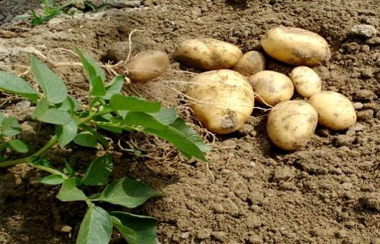
Image 4 Healty potato tubers from a LBR resistant plant with Rb genes

Reflections
- Events and workshops, such as the one organized in this project, where researchers and other organizations can meet and discuss research and potential collaborations, offers opportunity for initiating technology transfers. An intermediate with the purpose of locating and introducing parties with common interests and complementing assets, could be effective in order to increase market transparency and efficiency for technological intellectual assets.
- Finally, since the project is still ongoing, it is difficult to determine which specific actions, collaboration structures, etc. that will be proven successful and which could be improved in the future.

Contact person: Akshat Medakker, Senior Technology Manager at Sathguru
Acknowledgements to: K. Vijayaraghavan, Regional Coordinator ABSPII South Asia.

Case Study 6 - Rubber Nano Project

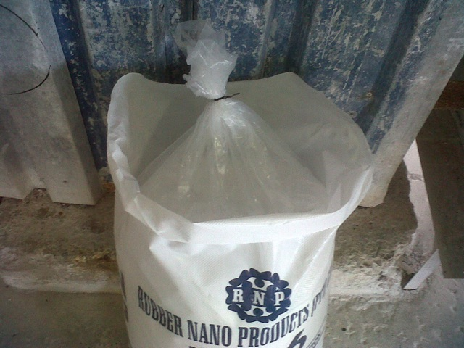

Background
- Zinc oxide is an inorganic compound with the formula ZnO. It is a white powder that is insoluble in water, and is widely used as an additive in numerous materials and products. It occurs naturally as the mineral Zincite, but most zinc oxide is produced synthetically. Zinc oxide is a widely used compound in the rubber industry due to the excellent properties that shows as activator for sulphur vulcanization. The tire industry remains the largest single market for ZnO, consuming more than half of the total worldwide demand of 1,200,000 metric tons. Traditionally, ZnO is used in rubber formulations in concentrations of 3–8 parts per hundred rubber (phr).
- The rubber industry has tried to lower the levels of zinc in order to minimize the production costs. Today there are few viable replacement options to zinc oxide in the rubber vulcanization process. The rubber industry has to conform to national and/or international environment and security standards while at the same time delivering a high quality product to a price sensitive market. A suitable replacement to Zinc oxide needs to be both high performing and cost equivalent to the current solutions. The researchers at Nelson Mandela Metropolitan University, Port Elizabeth have found a method to produce a type of sulfide particles that has the similar basic properties as zinc oxide, while at the same time being easier and cheaper to synthesize. It is claimed to both economic and environmental benefits compared to zinc oxide.

The Project
- The foundation for the technology of the company started during doctorate research at the Nelson Mandela Metropolitan University, Port Elizabeth. Looking at the kinetic properties of nano zinc oxide in rubber products the researchers came across a method to synthesize it in a chemical way. In order to commercialize the innovation it was patented and the university funded research company (Rubber Nano Products, RNP) the Nelson Mandela Metropolitan University, Port Elizabeth. Research continued to be conducted in relation to RNP and the technology developed. They also identified a sulfide particle that works in vulcanization in similar ways that zinc oxide does. This is now the core of the RNPs technology and the aim is to eliminate the use of Zinc Oxide in rubber production worldwide by substituting it for a less costly alternative. The venture was initially founded with the researchers themselves and the University as shareholders. Some of the researchers later sold their shares to industry representatives. The university transferred all relevant IP to the company itself and they now hold all patents concerning the innovation.
- The main market for the innovation is the rubber tire manufacturing industry in South Africa, but the company is simultaneously expanding into Europe where they have active co-operations with a company manufacturing sulfur-based products, Esseco (Italy). The contact between RNP and Esseco was established by Hans Strydom (Marketing Director, RNP) while RNP actively was searching for suitable collaboration partners in Europe. In order for this collaboration to work smoothly a satellite company has been registered in Europe. The ownership of the patent portfolio remains in the original South Africa based company and a license scheme has been set up for satellite companies and other actors. The licensees will eventually been responsible for production and the South Africa based company will mainly become a holding company. As of now all commercial production of the silica is handled by RNP in South Africa and sold as a product. The collaboration with Esseco has not reached commercialization yet, but is in an early production development stage. It has, however, reached a manufacture capability at a rate of 30 tons/month. The strategy is to get other industry representatives involved in the development process and test RNPs process within their own research departments in order to implement the technology into their current manufacturing lines. RNP are planning on eventually establishing satellite companies in America and Asia as well
Esseco Ltd, Italy
For the transfer a European joint venture company, Rubber Nano Products EU, was created and acts as a licensee to the patents owned by Rubber Nano Products South Africa Ltd.

Rubber Nano Products Ltd, South Africa
RNP Ltd is the company that was started up to facilitate the commercialization of the rubber nano technology. They are currently the sole holder of all the worldwide patents and acts as licensor for all the international commercialization efforts.

- The current focus is sheet rubber and mining rubber applications and for applications within the shoe industry. Future possible collaborators are tire manufacturer Bridgestone who are in the process of getting a product integrated with the Rubber Nano technology approved.

Technology Transfer
- The license between RNP and Esseco is exclusive for the geographical area in question and a license fee of 13,5% of sales are transferred back to RNP South Africa. The patent in question is a product patent for the component that replaces zinc oxide in the rubber vulcanization process. The most important part of the transfer, apart from the patents themselves is the transfer of knowledge on how to alter the productions process to implement the sulfide particle to replace zinc oxide. It is a radical new technology that changes the work process in the factories which will require training as part of the implementation process. This means that a great part of the value of the transferred technology depends on the possibility for RNP South Africa to be able to transfer the knowledge related to production to engineers at each production facility.

Rubber Nano Products Ltd. South Africa
Esseco Ltd. Italy
Nelson Mandela Metropolitan University
Rubber Nano Products Ltd. Europe
South African
Industry Collaborators
Nelson Mandela University is the origin o f the technology. They supplied the IP for Rubber Nano Products South Africa and owns a minor share of the company together with the original inventor.

Supplies production facilities, market and research data and contact network in exchange for the potential economic and environmental benefits the technology.
Esseco owns part of Rubber Nano Europe, as it is a joint venture between Rubber Nano South Africa and Esseco. Esseco supplies an available product line, contact network and production and research facilities to act as a springboard into the European market
The European subsidiary receives a license for the technology from the South African company in exchange for license fees and access to improvements and data about possible applications.

Challenges and Lessons Learned
- The main obstacles going forward for RNP is that their technology is quite a radical innovation. They are basically trying to change a hundred years of chemistry and the biggest threat is the lack of know-how in the potential customer companies. They are trying to solve this by having representatives from Nano Rubber Products physically involved in the adaptation process at the customer companies’ location. Rubber Nano Products is, however, a fairly small company with a small number of employees and this is a time consuming process.
- Further development of international technical standards and manuals would be very useful when it comes to trying to transfer the more intangible parts of the intellectual assets inside the company. Since the technological language can be very different in between different countries it is often a challenge to communicate knowledge regarding production and the implementation of the technology itself.
Contact Person: Mr. Robert Bosch

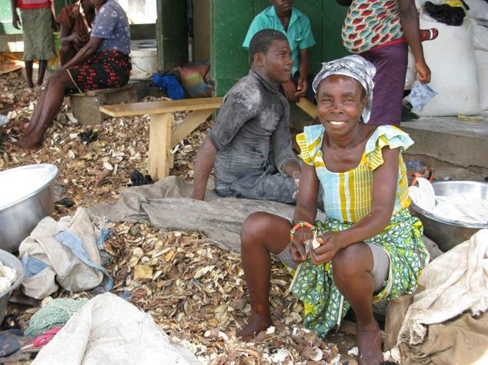
Case Study 7 - Biowaste 4 Sustainable Products

Background
- The idea for this project was first initiated by the Danish Technological Institute and was aimed for Europe. Unfortunately, this project was not approved, but a new opportunity for a similar project in the African region was recognized by the European Commission.
- When food is produced in Africa, a large amount of biological waste is generated from mainly food and agricultural waste. Typically around 20-30% of the feedstock is left in the fields after harvest, partly because of the climate but also due to poor methods. This means that millions of tons of fruit and vegetables are wasted which could be converted to better use both in terms of energy sources and bio-fertilisers for the African soil.
- The purpose of BIOWASTE 4SP project is to improve the management of bio waste in developing countries and therefore reduce the potential adverse impacts on human and animal health, the environment and the economy. In order to achieve this, the Biowaste4SP project focuses on identifying suitable biological waste in five countries in Africa: Egypt, Ghana, Morocco, Kenya and South Africa. It is also about identifying and using the right technology to turn biological waste into value-added products such as bioethanol, biogas and bio fertilizer in an environmentally appropriate and socio-economical sustainable way. An example of this is processing banana peels into biogas. With the use of enzymes, the sugar in banana peels are converted into smaller kind of sugar molecules, which can be fermented to produce biogas which can be extracted.

The Project Structure and Management
- The project stretches over three years and was initiated in September 2012. It is funded by the European Commission and there are 16 different partner organizations involved. They are all bringing different technologies and knowhow into the project but they work together towards the overall goal of identifying waste and applying suitable technology in order to create value (e.g. biogas) with a commercial potential.

Table 1: Partners in Biowaste4SP
Partner organization | Short name | Organization | Country
1. Danish Technological Institute | DTI | Research | Denmark
2. Swedish Environmental Research Institute | IVL | Research | Sweden
3. TÜBİTAK Marmara Research Centre | TUBITAK | Research | Turkey
4. SIRIM Berhad | SIRIM | Research | Malaysia
5. Council for Scientific and Industrial Research – Institute of Industrial Research – CSIR-IIR | CSIR-GH | Research | Ghana
6. Council for Scientific and Industrial Research | CSIR-ZA | Research | South Africa
7. Agricultural Research Centre | ARC | Research | Egypt
8. University of Siena | UNISI | University | Italy
9. Hassan II Institute of Agronomy and Veterinary Medicine Morocco | IAV | Research | Morocco
10. The Technical University of Denmark | DTU | University | Denmark
11. Ethekwini Municipality | ETM | Public | South Africa
12. Myagri Group of Companies | MYAGR | SME | Malaysia
13. BioVelop AB | BV | SME | Denmark or Sweden
14. Moroccan Association Of Solid Waste | AMADES | NGO | Morocco
15. African Institute for Capacity Development | AICAD | Research | Kenya
16. World Association of Industrial and Technological Research Organizations | WAITRO | NGO | Malaysia

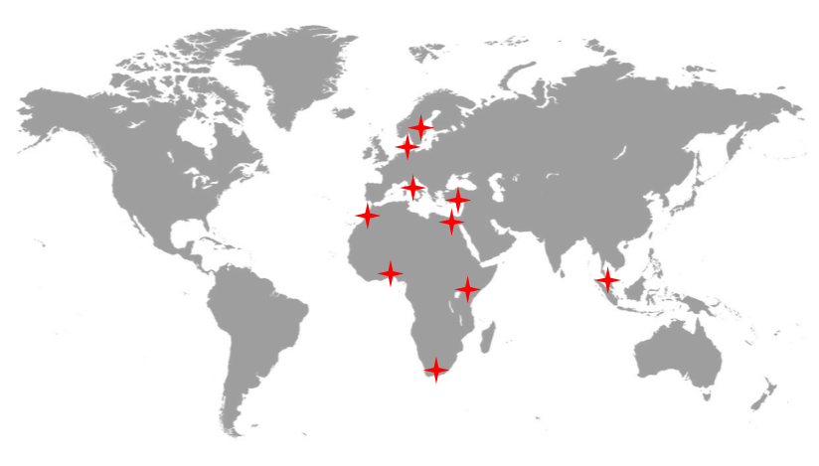
Figure 2: Countries involved in the Biowaste 4SP project
- This project is managed by Dr Anne-Belinda Bjerre, a senior research scientist from the Danish Technology Institute (DTI). The whole project is divided into 9 different “work packages” (see table 2). The working packages all have different task addressing the overall challenge. Some of the work packages are focusing on finding suitable biowaste in African countries and some are focusing on the technological aspects of converting waste into useful end products. Other working packages have coordinating roles and aim to manage the consortium and perform research focusing on environmental sustainability. In order to verify that milestones are met and to facilitate a more efficient collaboration between the project partners frequent meetings are held and routines for reporting progress has been set up. Documented monthly or bi-monthly meetings over video link are examples of these routines.

Table 2: Working packages of the Biowste4SP
Work Package | Title
WP1 | Identification and characterization of biowaste from food industry and agricultural sources
WP2 | Identification and characterization of biowaste from municipal sources and manure
WP3 | Pre-treatment and development of a sugar-based platform
WP4 | Bio-conversion for the production of bioethanol, lactic acid and amino acids
WP5 | Biogas production
WP6 | Bio-fertilizer production
WP7 | Sustainability studies
WP8 | Knowledge-sharing, dissemination, and capacity building
WP9 | Scientific and Technical Project Management
WP10 | Project Coordination and Consortium Management

- The project stretches over three years and has 246 deliverables. Each deliverable is connected to one or several work packages (see figure 3 for an overview of the project structure). The European Commission is not only funding the project, but also closely monitoring its progress, which means that the project is using templates, protocols and notification systems in meetings and in other communication activities.

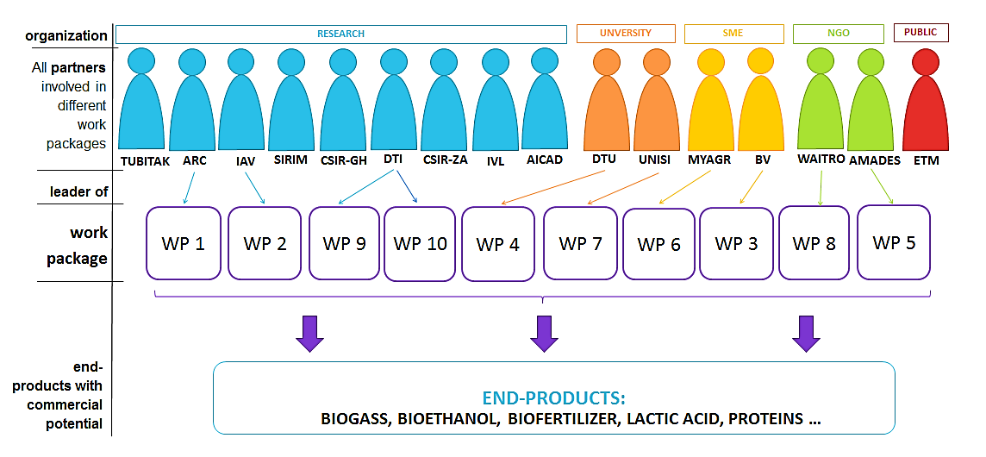
Figure 3: Overview of the project participants and the work packages

Workpackage 4
- In order to assess how knowledge has been transferred, it is valuable to focus on only one workpackage at a time. Workpackage 4 is focusing on bio-conversion for the production of bioethanol, lactic acid and amino acids. More specifically one of the two tasks within the workpackage is addressing co-production of ethanol and amino acids from two certain sugar molecules. This task is a collaboration between DTI in Denmark and CSIR-GH in Ghana.

Legal Framework

Agreement
- Before the partners started the project, they all signed a consortium agreement written by the project leader Dr Bjerre and Mr Moses Mengu both from DTI. This agreement stated the framework for the management of the project and stresses the issue of respecting each partner’s integrity according to Dr Bjerre. It also states certain obligations, such as payments and how to treat the potential findings of the research. In order to protect novelty and enable potential commercialization of new inventions all involved partners have a chance to express interest in patent filing prior to publication of research conducted within the scope of the project.

Technology Transfer and Intellectual Property
- In some cases, the project utilizes technological solutions protected by intellectual property right such as patents, mainly brought by the private actors. But according to Dr Bjerre, the most important intellectual asset in this project is the knowhow, which all the parties has brought into the project to some extent. The knowhow is being shared in different ways through the work packages. There are often meetings and symposiums and seminars organized by the management of the project. The researchers from developed countries are training the researchers in the developing countries and vice versa. Students from Africa are offered to study in e.g. Danish universities as the project also comprise a training program, where the students are gaining experience and knowhow, which they can leverage in this project back in Africa.
- While some of the partners are involved on social or scientific grounds, others have commercial interests in the project. According to Dr Bjerre, this rather strengthens the collaboration and the motivation to work towards the common goal of all the parties: to commercialize final products. This will require more intellectual property management, for example patenting or creating licensing agreements. The project is now in a phase, where the IP is being investigated further by the Kenyan actor (AICAD). This is made to clarify the ownership issues connected to background IP (IP brought to the project) and foreground IP (IP outcomes of the project). The intellectual assets created during the project could be patentable inventions, but could also be useful knowledge and experience.

Desired Outcomes of Biowaste4SP
  - Develop a biotechnological process for utilizing biological waste which will be environmentally and socio economically sustainable in selected African countries
  - Develop technologies that will rely on simple and locally available resources
  - Manage biological waste in developing countries in order to reduce the impact on human and animal health, the environment and the economy
  - Give opportunity to researchers and students from both developed and developing countries to create networks, share knowledge, experience and best practises
  - Create inventions and technological solutions with commercial value and with positive impact on the living standards in Africa
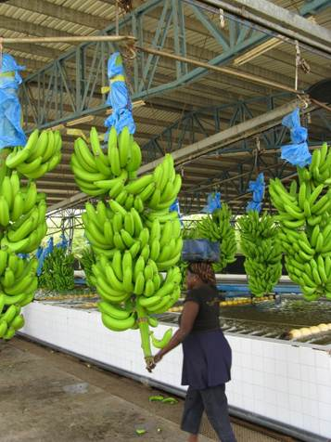
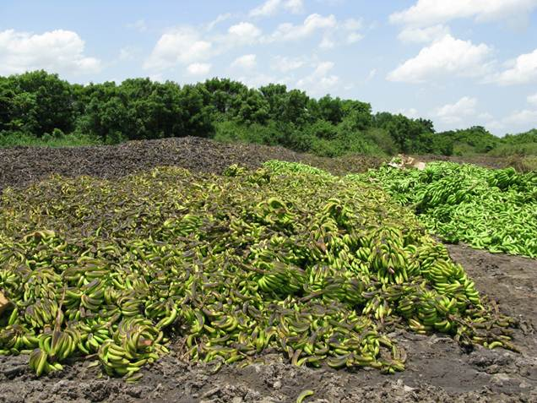
  - Involve small and medium sized enterprises to expose the European companies to new markets and new products (from biowaste transformation) and also help the African companies to capture value from the limited local resources
Image 5 From banana plants to banana waste

Progress
- In the latest newsletter released by the project the publication of a catalogue categorizing feed stocks that have been identified in the partner countries and what their characteristics are in the different five countries. They also raise some concerns regarding the sustainability of the use of the feed stocks and how this will be handled in a special work package.

Challenges and Lessons Learned
- Well-functioning project: The overall impression from the interview and research is that this project is a very good example of collaborative initiative in the technology research and development. It is creating value for academia, public and also private companies in both developing and developed countries.
- Limitation of the consortium agreement: The most important agreement regulating this project was written by two people. There is no doubt that the agreement is well written (the project is functioning very well) but there might be limitations that could be complemented by involving more people, for example an IP law expert.
- The IP management issue: While interviewing Dr Bjerre she states that all the partners are bringing some kind of technology or knowledge but it does not seem to be clear who is the owner of the foreground IP (IP created in the project). She also expressed that this issue has not been solved yet. Moreover, there are probably IAs hidden in different parts of the projects (the templates for monitoring etc.) that needs to be identified.
- Exploiting biowaste: There might be some ethical issue of exploiting biowaste that already has an area of use. In different countries, there are different main sources of biowaste. Exploiting one of them (for example banana biowaste) might cause no harm in one country, but might have an impact in another country, if for example the banana waste is as feeding stuff or in any other way. Identifying other areas of use is therefore important and making recommendations on how to manage it could solve the problem of disrupting an existing use of the biowaste.

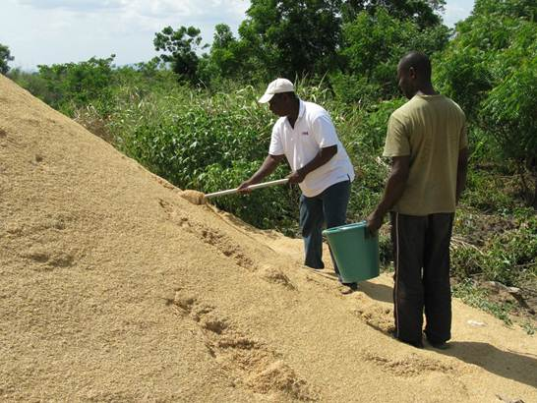
- Transporting biowaste: shipping biowaste from one country to another is currently not allowed so therefore each country will have to make its own solutions. This could be solved by creating a strategy for each country or an overall licensing agreement.

Reflections
- The project work has generated reflections on the necessity of establishing and reifying common terms between parties in an international collaboration. The different languages and cultural backgrounds offer a wide-ranging experience and perceptions, which can create nuances in definitions of terms. It is therefore important for the collaborating parties to establish a common understanding of definitions and in this process documentation, such as contractual agreements defining terms and scope of the collaborations, can play an essential role.
Contact Person: Dr Anne Belinda Bjerre
Photos by Mathias Gustavsson, IVL Swedish Environmental Research Institute

Case Study 8 - Infant Diarrhea Project

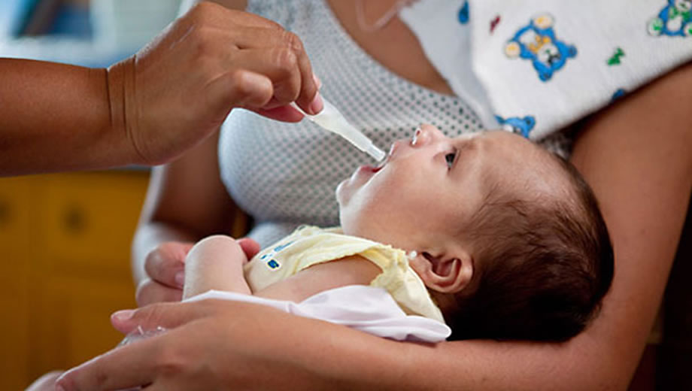
Image 1 Infant receiving vaccine

Background
- Diarrheal disease is one of the leading causes of child mortality and morbidity in the world. The disease is caused by bacterial, viral, or parasitic infection and is especially prevalent in developing countries where food and water sources are contaminated through lack of proper sanitation. Rotavirus and Escherichia coli are the two most common etiological agents of diarrhea in developing countries. In Nicaragua, in particular, diarrhea is the second greatest cause of infant mortality. However, Nicaragua faces very poor funding and laboratory facilities from which to conduct research on issues of national importance, which prevents a proper characterization of the program and formulation of appropriate solutions.
Nicaragua, UNAN-Leon
Analysis of patient samples and search for a genetic marker. Continuous education and strive towards increasing the research capacity within the university.

Nicaragua, Leon Central Hospital
Patient sample collection and gathering of patient data

Sweden, Karolinska Institute
Project coordination and educational support for master studies and PhD dissertations. Analysis of patient samples and search for a genetic marker.

Swedish Institute for Infectious Disease Control
Analysis of patient samples and search for a genetic marker.

SIDA
Coordination and financial support during 1982-2011

The Project
- In the early 1980s Swedish International Development Cooperation Agency (Sida) and the Department for Research Cooperation (SAREC) funded a number of programs to support the development of scientific research within the system of Public Universities of Nicaragua. In particular, an Infectious Disease Program was initiated with a specific project focused on infant diarrhea. The collaboration included participation by the Autonomous National University of Leon Nicaragua (UNAN-Leon), León Central Hospital (HEODRA), Swedish Institute for Infectious Disease Control (SMI) and Karolinska Institute (KI). The goal of the project was to reduce the mortality and morbidity of infant diarrhea through vaccination and education in the Municipality of Leon in Nicaragua. To achieve this goal a number of Nicaraguan investigators where trained at the Master and PhD level in Sweden, while conducting scientific research in Nicaragua together with Swedish colleagues.
- The thirty-year Infectious Disease Program generated a total of eight master degrees and nine PhD dissertations, 63 academic publications, and the creation of a Master of Science in Microbiology at UNAN-Leon focused on the challenges facing Nicaragua and specifically the Municipality of Leon. Through the education and research activities, the Nicaraguan actors evolved from sample collectors to capable research scientists. Sophisticated diagnostic and laboratory practices unique to Nicaragua where developed resulting in the development of diagnostic services offered to private enterprises. In 2006, Nicaragua became the first developing country to implement universal infant immunization with the pentavalent rotavirus vaccine. Current research is looking for genetic markers from which to create a better vaccine as the initial vaccine was not effective for all children.
- In 2011, Sida decided to close the Nicaragua program in favour of new investments in Africa, but the group at Karolinska continues to support the project as much as they can, even though they now have far from the same budget to work with. Through the educational program and exchanges with Sweden, the project is successfully progressing and research is still being done at UNAN-Leon with hopes of developing a better vaccine for infant diarrhea.
- As the initial project was a part of KIRT (Karolinska Institute Research Program), the network of participants for all projects worldwide still are connected, which provides a platform and a forum for encouragement for further development of scientific capacity. Below are the phases of the project, where research is still conducted and in the future a new vaccine hopefully can be developed.

Intellectual Asset Management and Knowledge Transfer
- Due to the formal approach of governmental institutions involved in the program, the collaboration is built upon a contractual structure when it comes to the research. As the program has been active during such a long time there is a lot of data, which is protected by copyright for its database. There has been an extensive exchange of knowledge due to the focus on both providing resources for a fully equipped and functioning laboratory and also the support for education. The aim has been to provide Nicaragua with their own tools to conduct research and create the database, which have been done continuously even though Sida left the collaboration.
- The following intellectual assets can be identified:
  - Data: Collection of patient samples and patient information regarding the samples.
  - Database: Database containing the research data on characteristics of infant diarrhea.
  - Data Correlation: Characteristics of certain genetic markers that are resistant towards the current diarrhea vaccine.
  - Theoretical Framework: Causes and characteristics of infant diarrhea based upon the research of the samples.
  - Instructions: How to collect, store and analyse samples
- The knowledge transferred to Nicaragua contributes of educational material that are essential for conduction research and laboratorial work, which also the knowledge about the methodology of the research. As there has been an interexchange of Swedish researchers traveling to Nicaragua and PhD aspirants coming to Sweden for their PhD, an understanding of the local circumstances has been provided. This has helped during the project as such knowledge is valuable to the progress of the project. In return for the knowledge provided by the Swedish group, research material and laboratory tests has been transferred back to Sweden.
- Below, the knowledge transfer of the project is mapped out.

- Regarding Intellectual Property rights, material transfer agreements are signed by the involved parties of the project. The agreements say that if a lab does research on a sample from León, the León team needs access to the results. The León team also needs to be included in every paper that is based upon the sample collection and research results developed in Nicaragua. The university has a policy for that in order for a professor to get a salary, contracts and agreements should be signed when going in to the collaboration. This solves the issue of the university being used for only sample collection as they now have the ownership rights of
Karolinska Institute
Sweden

Swedish Institute for
Infectious Disease Control

Sida, Sweden
Leon Central Hospital,
Nicaragua
UANA, Leon,
Nicaragua
KIRP
Research on samples

Financial and organizational support

Patient sample collection and gathering of patient data

Exchange of knowledge on challenges and success factors in north south partnerships that can be used as support for all members within the network.

Hands on training of the handling of samples, protocols for sample collection and laboratory work. Research methodology training and educational material.

the samples to take into negotiation. HR and knowledge can be negotiated in exchange for samples and the participation in research projects for the university to further develop its research capacity.

Success Factors within the Collaboration
- For a north south partnership, this particular collaboration has some key points, listed below, which makes it successful in its goals and the transfer and exchange of knowledge.

Quality Control
- Within the collaboration, the team in León stresses the need of controlling the research process in the whole value chain. Everyone in the collaboration is involved in meetings so they know that what they contribute with is important. This applies for both the Swedish and the Nicaraguan part. They have learned by experience the need for control within their work. In one previous project a nurse who controlling children’s results in a field study did sloppy work so one year of studies needed to be thrown away. Therefore, control in the whole process is essential to ensure quality.
- SIDA had also a person employed during the project just to keep track of the finances and so that all money where used for the right purpose. After a few years the financial procedures were improved and no such employee was needed anymore. The money was given directly to the project from SIDA, which decreased the chance of money disappearing trough other institutional complexities.

Communication and Personal Meetings
- Communication is important within the León collaboration and they have regularly weekly, monthly and yearly meetings both internally and with the Swedish team. It is important for all parties to be included in the progress, challenges and issues regarding the project for everyone to be one the same page. The meetings are both in person, but also by Skype or conference setup. During the years there have also been a number of personal meetings where the Swedish group have travelled to Nicaragua and the students at Leon have travelled to Sweden for their PhD. This has contributed to a mutual understanding of the local circumstances, which has helped a lot in the progress of the collaboration.

Sustainable Results
- The collaboration is still going, even after 30 years and a limited amount of funds coming from Sweden. Looking at the development of the project, initially the research was brought back to Sweden and was done at the Karolinska Institute. However, now the lab is fully equipped to do research and analysis in Leon where all studies are currently done.

Free Rotavirus Vaccine
- The vaccine for rotavirus got a backlash with side effects in America and the team at UNAN-Leon got the opportunity of doing a study of 35 000 children, which as a large study for their team. They performed the study by themselves and thanks to that all children in Nicaragua received the vaccine free for five years.

Challenges within the Collaboration
- The collaboration has faced various challenges during the years, even though nowadays the most common cultural barriers have been overcome. Listed below are some of the challenges that the collaboration has faced.

Lack of Funding
- The infrastructure within the collaboration is hard, as Sida wants to support research but not buy the required equipment. Therefore there are basic problems in communication if computers are lacking and the university cannot afford to acquire new ones. Often the universities want to invest in research but they cannot do to financial disabilities.
- It is difficult in the developed countries and especially hard in developing countries to obtain funding for research. This is especially true in Nicaragua, where the newly graduated PhDs found it hard to find post-doctoral research funding. The risk is therefore that PhDs will only teach and not conduct any research.

Loss of Human Resources
- Knowledge tied to human resources has been lost during the project. This is always a risk in cases where knowledge, especially tacit knowledge, is contained in the form of human resources, and not formalized. One of the disputants sadly passed away shortly after her disputation, which lead to a substantial loss of knowledge and experience that otherwise could have been spread to fellow researchers. Another example is the loss of a competent project leader of a sister demography project, also funded by Sida. A rule exists that states if you participate at the university election for principle and are not selected, you are not allowed to continue to work at the university. The project leader ran for principal, but failed and was not allowed to continue to work on the project, which impacted the whole capacity of project failed. For people to climb within the university there is a need to manoeuvre the politics and it is therefore hard for researchers at the university to develop both professionally and as a researcher at the same time without giving up one of the options.

Reflections
- Building scientific capacity is an effort requiring long-term commitment and funding to build resources that have a critical mass to create sustainability. Without foreign support it is hard to continue such projects as this one. In this case, it was really unfortunate that the project ended before there was a PhD examination established at UNAN-Leon, which could have allowed for more rapid development of research capacity and a greater scientific self-sufficiency.
- Even research collaborations focused primarily on developing on scientific publications and public policy can benefit from clear contracts defining the ownership and use of intellectual assets and property. In this case, the material transfer agreements provided a good foundation to respect and manage the contributions of all actors involved in the project in support of developing knowledge for the public domain and the public welfare.
Contact Person: Marika Källman
Acknowledgements to: Roland Möllby, KI, and Filemon Bucardo-Rivera, UNAN-Leon

[Annex II follows]

Review of Study (c): Bowman Heiden, “Case Studies on Cooperation and Exchange between R&D Institutions in Developed and Developing Countries”

Reviewer: Dr. Nikolaus Thumm, European Commission Joint Research Centre, Seville, Spain

Structure
The case studies provide a difficult lecture in their current format. They are all of different nature, which is what was demanded. Though, added value could be provided by presenting them in a common general framework/structure (e.g. nature of the problem, IP right used, why? How? special IP challenge, solution provided, lessons learned etc.).

Main IPR contribution
IPRs are fairly unspecified in most of the case studies. Sometimes the use of IPR is confusing and going from one IPR to another without further explanation (e.g. from plant variety rights to patents). Be precise with which IPR is at stake and in case of patents which is the scope of the patent (a whole technology/product can typically not be covered by a single patent).

Elements missing
Two case studies are missing. There is no synthesis of the combined case studies provided. Turkey is not a developed country. A more IP specific focus in the analysis would increase the added value of the analysis considerably. Move away from general case studies to IPR specific case studies (Which specific IPR is used? Why? How? Where? Patent application is not equal to a grant. Geographical relevance of the IPR? What is the specific role of the IPR in the specific case? How did it facilitate a solution/technology transfer? etc).

IPR guidance for policymakers
Lessons to be learnt should be more IPR specific and should be presented in a summary together.

Overall assessment/recommendation
I would recommend a revision of the cases with a focus on coherent structure/framework analysis and elaboration of specific role/feature of IPR in the case studies.

[End of Annex II and of document]

Lundin, S. Procarcinogenic mechanisms of Helicobacter pylori-induced atrophic gastritis in a population of high gastric cancer risk. Private Publication.
Project website - http://gastriccancerresearch.wordpress.com/2013/09/21/nicaragua-why-are-we-here/
World Health Organization (WHO). 2014 HIV/AIDS web page, date of view: 04.02.2014
Jewell, C. (2012) INNOVATIVE LICENSING expands access to HIV treatment. Communications division - WIPO, vol. 6, pp. 17-21
Baker, et al. (2009) AUTM: Innovations from Academic Research That Positively Impact Global Health, THE BETTER WORLD REPORT, pp. 31-33.
Rangan and Lee, Gilead science, Inc.: Access Program
Gilead (2014) HIV/AIDS web page, date of view: 15.07.2014
Rangan and Lee, Gilead science, Inc.: Access Program
Rangan and Lee, Gilead science, Inc.: Access Program
Sachan, N., Tatambhotla, A., Nehru, R. and Dhanaraj, C. (2013) COLLABORATIVE COMMERCIALIZATION AT GILEAD SCIENCES: RESOLVING THE INNOVATION VS. ACCESS TRADEOFF. Indian School of Business (ISB). Version: 2013-04-10
Rangan and Lee, Gilead science, Inc.: Access Program
Rangan and Lee, Gilead science, Inc.: Access Program
Gilead´s “Access Partnerships” web page, date of view: 16.07.2014.
Polly Fields, Skype interview
ibid.
Rangan and Lee, Gilead science, Inc.: Access Program
Polly Fields, Skype interview
Gilead (2013). Scaling Up Antiretroviral Treatment Sustainability, date of view: 16.07.14
Rangan and Lee, Gilead science, Inc.: Access Program
Gupta, P. (2013) Hepatitis C Virus and HIV Type 1 Co-Infection. Infection Dis Rep, vol. 6; 5 (Suppl 1): e7
Amended and Restated License Agreement between MPP and Gilead, date of view: 15.08.14, Amended and Restated License Agreement between Gilead and licensee, date of view: 15.08.14
ibid.
Polly Fields, Skype interview
Rangan and Lee, Gilead science, Inc.: Access Program
Baker et al., AUTM: Innovations from Academic Research That Positively Impact Global Health
Jewell, INNOVATIVE LICENSING expands access to HIV treatment
Rangan and Lee, Gilead science, Inc.: Access Program
Rangan and Lee, Gilead science, Inc.: Access Program
Jewell, INNOVATIVE LICENSING expands access to HIV treatment
Polly Fields, Skype interview
Rangan and Lee, Gilead science, Inc.: Access Program
Rangan and Lee, Gilead science, Inc.: Access Program
Baker et al., AUTM: Innovations from Academic Research That Positively Impact Global Health
Gilead (2013). Increasing Sustainable Access to Medicines and Healthcare., date of view: 16.07.14
Polly Fields, Skype interview
Jimenez Escrig , 2014
Shahidi and Naczk, 2003
Jimenez Escrig, 2014
American Cancer Association
Rojas Guillen, 2014
Rojas Guillen, 2014
http://research.ucdavis.edu/strawberry/bp
http://www.agmrc.org/commodities__products/fruits/strawberries/commodity-strawberry-profile/
http://faostat.fao.org/site/339/default.aspx
http://www.hurriyetdailynews.com/default.aspx?pageid=438&n=turkeys-agricultural-exports-on-the-rise-2010-06-20
http://www.eurosemillas.com/?ids=369
http://www.eurosemillas.com/?ids=552
http://www.eurosemillas.com/?ids=528
(http://www.upov.int/overview/en/upov.html
http://www.upov.int/export/sites/upov/news/en/pressroom/pdf/pr74.pdf
http://www.actahort.org/books/439/439_63.htm
http://www.hurriyetdailynews.com/default.aspx?pageid=438&n=turkeys-agricultural-exports-on-the-rise-2010-06-20
http://worldwide.espacenet.com/searchResults?compact=false&AB=strawberry&ST=advanced&locale=en_EP&DB=EPODOC&PA=University+of+California
http://www.google.com.br/patents/US5929303
P andey S.K., Singh J.P. and Gopal J. Potato varieties and cropping systems in India. Potato journal, 3 (p. 103-110), 2008
AUTM, The Better World Report, 2009. Available online: http://www.autm.net/AM/Template.cfm?Section=Past_Reports&Template=/CM/ContentDisplay.cfm&ContentID=7451
Song, J., Bradeen, J.M., Naess, K.S., Raasch, J.A., Wielgus, S.M., . Haberlach, G.T., Liu,J., Kuang, H., Austin-Phillips, S., Buell, C.R., Helgeson, J.P. and Jiang, J. Gene RB cloned from Solanum bulbocastanum confers broad spectrum resistance to potato late blight. PNAS (100:16)(p.9128-9133), 2003
CPRI webpage, “Externally funded projects - Project Nr 11”, 2014-08-08, http://cpri.ernet.in/?q=node/265
Ramasamy, C., Selvaraj, K.N., Norton, G.W. and Vijayaraghavan, K., Economic and environmental Benefits and Costs of Transgenic crops: Ex-Ante assessment, TNAU, India, p. 52-55, 2007
CPRI webpage, “Externally funded projects - Project Nr 11”, 2014-08-08, http://cpri.ernet.in/?q=node/265
Newell, P. Biotech firms, biotech politics: negotiating GMOs in India. IDS working paper 201, 2003
Guzmán M, Agullo N, Borrós S, “Reducing zinc oxide in rubber industry use through the development of mixed metal oxide nanoparticles” http://www.tntconf.org/2010/abstracts_TNT2010/TNT2010_Guzman.pdf
ibid.
Source
WHO - http://www.who.int/mediacentre/factsheets/fs330/en/
Sida Report
Sida/SAREC 30 Year Project Accompliments
See Becker-Dreps (2012)
Project Leader, National Autonomous University of Nicaragua-Leon, 2014
Project Leader, National Autonomous University of Nicaragua-Leon, 2014

