|  |  |  |
| --- | --- | --- |
|  | WIPO-E | **E** |
| CDIP/14/INF/6 | | |
| ORIGINAL: english | | |
| DATE:  September 17, 2014 | | |

**Committee on Development and Intellectual Property (CDIP)**

**Fourteenth Session**

**Geneva, November 10 to 14, 2014**

Report on IP use in Brazil (2000-2011)

*prepared by Mr. Sergio Paulino de Carvalho, Instituto Nacional da Propriedade Industrial (INPI), Brazil, Ms. Marina Filgueiras Jorge, INPI, Brazil, Ms. Vera Pinheiro, INPI, Brazil, Mr. Felipe Lopes, INPI, Brazil, Mr. Celso Sampaio, INPI, Brazil, and Mr. Leonardo Ribeiro, Instituto Nacional de Metrologia, Qualidade e Tecnologia (INMETRO), Brazil  
in cooperation with the Secretariat.*

1. The Annex to this document contains a Study on the Use of Intellectual Property in Brazil prepared under the Project on Intellectual Property and Socio-Economic Development (CDIP/5/7 Rev.)

*2. The CDIP is invited to take note of the information contained in the Annex to this document.*

[Annex follows]

REPORT ON IP USE IN BRAZIL

# EXECUTIVE SUMMARY

Brazil has made a remarkable effort in order to align its policies and structure to promote innovation in relation to developed countries. The last twenty years were characterized by effective improvements of governance and increased efficiency of the integration between policies, instruments and agencies. In this sense, the legal framework of the system to protect intellectual property in Brazil was changed to incorporate the Final Act of the Uruguay Round of Multilateral Trade Negotiations of the General Agreement on Tariffs and Trade (GATT), including the Agreement on Trade-Related Aspects of Intellectual Property Rights (TRIPS Agreement). The most significant changes were related to the scope of the protection, which was expanded to all areas of knowledge. As a result of TRIPS (Article 27), the new Industrial Property Law (Law No. 9.279/96) recognized the patenting of “substances, materials or products obtained by chemical means or processes, and alimentary or chemical-pharmaceutical substances, materials, mixtures or products, and medications of any kind, as well as the respective processes for obtaining or modifying them”; however it was opted for sui generis protection for plant varieties and species of microorganisms.

The data presented in this report provides evidences that Brazil is becoming a more mature innovation system. The smooth fall of utility model applications from 2000 to 2011 (7%) and the rapid growth of patent applications underline such trend. In this period, patent applications increased 63%, totaling more than 28,000 in 2011. Moreover, the patent applications filed by residents (99% directly with INPI), have grown 46%, from around 3,200 per year in 2000 to around 4,700 in 2011. It is also of notice the increase of PCT applications from residents since 2009, the year INPI started to operate as ISA-IPEA. The data regarding patent applications by country of origin shows that the United States represents around 30% of the patents, followed by Brazil (16%), Germany (10%) and Japan (9%). Applications from France and Switzerland are also relevant, with around 5% each. In the period, Japan and China stand out as countries that showed a significant growth of patent applications.

Regarding the distribution among technological sectors, there were no relevant changes during the period, which continues to be majorly constituted by non-resident applications. The chemistry sector accounted for the highest share of total applications (over 40%), followed by mechanical engineering (more than 20%), electrical engineering (14%), instruments (11%) and other fields (7%). The analysis by technological fields of the patent applications filed in 2011 varies according to the origin of applicants and indicates the contrast between the internal technological capabilities and the areas under strong prominence and protection of non-residents. Furthermore, when comparing the distribution of applications between resident and non-residents, the sectors of technology follow the same order of importance. In the chemistry sector, residents accounts for a smaller share of the applications, around 30%, while representing 43% of total applications. In the mechanical engineering sector and “other fields”, residents account for bigger shares.

The data also shows that individuals represented more than 70% of total patent applications in 2000 (2,286 applications), with companies accounting for 26.8% (861 applications) and the universities with a small participation of 2.0%. During the period, it is of note the significant increase in the number of patent applications from universities and companies. The latter almost duplicated (1,619) reaching 34.2% of total applications in 2011, while the former showed an increase of 13.8% in 2011, totaling 652 applications. Individual patent applications also increased by 7.5% (2,459 applications) but their participation in the total number of applications dropped to 52%. The statistics on the distribution of applicants have thus been changing. This could be attributed to the several incentives given by recent industrial and innovation policies and also to the internal changes at INPI-Brazil, who became more active in their initiatives to disseminate information on intellectual property among universities and companies.

With regard to the analysis of patent applications by economic sectors, the report points out the large participation of universities and government research institutes that are classified in the following divisions: “education”, “public administration, defense and social security” (a division that includes Government Research Institutes and the Institutes of Technological Research from the Army and the Air Force) and “Scientific research and development” (which also includes private and public foundations funding research). These sectors as a whole represented 19% of total resident applications in 2006 and reached 31% in 2011. The industrial sector also has a significant share of resident applications. The electrical equipment sector more than doubled the number of patent applications in the period considered, increasing its relative share from 4.4% to 8.5%. The machinery and equipment sector, although reducing its share in the period 2006-11, continues as one of the most important sectors in 2011 (6.2%).

Over the period 2000-11, Brazil's INPI granted more than 38,000 patents. Out of this total, 34,291 were granted to non-resident and 3,985 to residents. Considering the distribution along the years, INPI granted 6,006 patents in 2000, falling to a level of 2,100 grants in 2004, reaching 3,437 grants in 2011. In the period analyzed, the main foreign countries of which residents were granted patents are the United States, with 34% of the total, Germany, with 14%, France, with 7% and Japan, with 5%.

Concerning utility model (UM) applications, despite the decrease of almost 7% observed in the period, it is interesting to note that it was not continuous. At the beginning of the decade, between 2000 and 2004, UM applications had an upward trend, when applications increased from 3,300 to 3,600. Since then, the total number of UM applications filed in Brazil fell sharply between 2004 and 2007 (-15%), followed by a recovery in 2008-2009 (11%) and then, in 2010-2011, declining again (-11%) to a lower level when compared to the beginning of the period. Considering the origin of non-resident applicants, more than 50% of non-resident applications originated in Taiwan, Province of China (21%), Argentina, United States and China (11% each). Regarding UM applications by technological sector, the mechanical engineering sector and other fields accounted for the highest share in total applications, with almost 75%. The data shows that the sectors in which residents predominate in patents are different from those in UM applications. In other words, the form of protection is specific to each sector. For example, the chemistry sector has a relevant participation in patent applications, with 30%, but it represents only 7% of UM applications. Individually, the five most important sectors were “furniture, games”, “handling”, “other consumer goods”, “civil engineering” and “transport”. Considering UM applications by economic sectors, those with the largest participation were “machinery and equipment production”, “metal products” and “rubber and plastics products”. In the period of 2000-11, Brazil granted 4,007 Utility Models, of which 3,799 were for residents and 208 for non-residents.

The report also shows that the total number of industrial design applications filed in Brazil between 2000 and 2011 increased 89%, from around 3,610 to 6,835. The 6,835 applications filed in 2011 consisted of 4,364 resident and 2,471 non-resident applications. Compared to 2000, the number of non-resident applications in 2011 showed a strong increase and almost tripled (175%), while resident applications also grew but by a more modest rate (62%). Thus, there was an increased participation of non-resident applicants in their share of total industrial design applications during the period. In 2000, the applications consisted of 25% from non-residents and 75% from residents, while, in 2011, this share increased to 36% and 64%, respectively. Residents from the United States accounted for the most substantial growth of non-resident applications (27%), but lost its relative importance. Japan accounted for 19% of growth of total non-resident applications and presented a strong increase of 574%. In the case of resident applications, the state of São Paulo had the largest share of all Brazilian states during the period, but presented a small loss on it: from 1,344 applications in 2000 (49.7%) to 2,129 in 2011 (48.8%). The same occurred with applications from Rio Grande do Sul, which grew from 355 applications in 2000 (13.1%) to 547 applications in 2011 (12.5%), and from Paraná, where applications grew from 303 applications in 2000 (11.2%) to 427 applications in 2011 (9.8%). Applications from the Northeast Region accounted for just 5% of total resident applications, with the North and Central West regions represented 1% each. In 2000, individual applicants accounted for 2,479 applications (68.8% of total applications), while, in 2011, they filed 5,176 industrial design applications (75.7%). Concerning only resident companies, the largest sector was “manufacture of leather and related products”, accounting for 23.1% in 2011 (compared to 10.3% in 2006). It was followed by “manufacture of electrical equipment” (8.9%), “manufacture of motor vehicles, trailers and semi-trailers” (8.8%) and “manufacture of rubber and plastics products” (8.2%). It is interesting to note that “manufacture of fabricated metal products, except machinery and equipment”, which accounted for 9.3% of applications from resident companies in 2006, lost its importance (relative and absolute). The number of resident registrations increased from 1,934 in 2000 to 3,348 in 2011, while non-resident registrations increased from 840 in 2000 to 1,298 in 2011. This means that, despite its largest increase in absolute terms, the share of residents in total registrations granted fluctuated around 70% each year.

In the case of trademarks, applications increased about 40% between 2000 and 2012, from 108,231 to 151,711. Regarding their nature, trademarks of product and service accounted for most of the applications, with a balanced distribution between them. However, trademark applications for products predominated until 2006, when trademark service applications started to represent the majority of trademarks applications. Concerning the type, most of the applications are of combined trademarks, or signals composed of both word and figurative elements. Most applicants, 83%, are residents, of which about 40% are micro or small companies. Over the period, non-residents accounted for only 18% of trademarks deposits, with a decrease between 2001 and 2004 and an upward trend from 2005 onwards. The most representative non-resident applicants are from the following countries: United States (5%), Germany (2%), France and Switzerland (both with 1%). With regard to resident applicants, between 2000 and 2012 the states of São Paulo (SP), Minas Gerais (MG) and Rio de Janeiro (RJ) represented 60% of applications; the states of Paraná (PR), Rio Grande do Sul (RS) and Santa Catarina (SC) represented 20% of the applications. Concerning the main activity of applicants, the financial services industry and real estate, business management and advertising had, on average, a share of about 21 percent of applications in the same period, while the education, training and leisure sectors represented 16%. The granting of trademarks increased in the period in question, from an annual average of 16.300, over the period 2000-2005, to 60.900 over the period 2008-2012.

With regard to technological contracts, between 2000 and 2012 the total number of new contracts registered in INPI increased by 2%, from 1,212 to 1,238. Contracts for the provision of technical assistance services accounted for the largest portion of the total, although its share has declined over the period (from 74% in 2000 to 65% in 2012). The large share of services in the contracts registered by the INPI may be credited to the importance of the sector of machinery and equipment in the modernization of industry. Among the other types of contracts, Trademark Licensing and Franchising contracts showed increased participation over the period, from 12% of total registrations in 2000 to 22% in 2012, while contracts for the supply of technology ("Know-How Agreements"), contracts for licensing patents and industrial designs and contracts with more than one modality maintained their share stable, with around 15%. Between 2001 and 2005, the value of the contracts as a percentage of total foreign payments was very small, ranging between 1 and 3%, as calculated by the Central Bank of Brazil. In 2006, however, the pattern of such disbursements changed, reaching almost 50% of the total in that year, or US$ 716.5 million. In 2012, contract payments reached 44% of total payments, or US$ 1.37 billion. The changing pattern of payments related to royalties and provision of technical assistance in 2006 and the growth of these revenues in the period of 2006-2012 is mainly explained by the efforts of Brazilian companies to integrate into the global economy, promoted by Brazilian industrial policy. In this context, it is worth highlighting the financing programs carried out by the National Bank of Economic and Social Development (BNDES) since 2005.

Applications of geographical indication are still incipient in Brazil, although the interest of nationals for this protection has increased. Between 2000 and 2012, there were 67 applications, predominantly by residents (49), of which the states of Minas Gerais and Rio Grande do Sul were the most representative, with 10 and 9 applications, respectively. Concerning their type, most applications are of indication of origin (40) and, regarding the nature, the majority is related to products (63). Over this period, 39 applications were granted. There was an increase in registrations in 2012, when 21 were granted, as compared with 18 between 2000 and 2011.

Lastly, software applications almost doubled between 2000 and 2011, from 663 to 1,279 applications. Applications with only one applicant predominate, with only 10% of such applications having multiple applicants. In 2011, for example, the 1,279 applications had approximately 1,400 applicants, of which around 60% were legal entities. Software producers are not required to register at INPI in order to enjoy the protection granted under Brazilian law.

REPORT ON IP USE IN BRAZIL

# 1 Introduction

The past decades have seen profound changes in the use of the intellectual property (IP) system worldwide. There is a great interest in improving the understanding of the effects of IP protection in less developed countries, regarding both the specific aspects of social and economic performance and the process of economic development more broadly. At the same time, national policymakers in developing countries lack credible empirical guidance in order to tailor their IP systems to their national capacities and needs. This is in contrast to developed countries, where national IP offices, other branches of government and academic economists have produced insightful evidence on the economic implications of the different aspects of IP protection.

The resulting changes in the IP landscape have raised numerous new questions on the role that the IP system plays in the innovation process. Currently, the economic literature focuses mainly high-income countries and does not provide much evidence on the role of IP in middle-income economies such as Brazil. There appears to be two underlying reasons. First, in absolute terms, high-income countries are the largest users of IP protection and, consequently, questions regarding IP protection have raised considerable public interest. Second, efforts by IP offices and academic researchers of such countries have led to the creation of micro-level IP databases – mostly on patent data – that enabled a wide range of empirical investigations.

The Project on Intellectual Property and Socio-Economic Development under the Committee on Development and Intellectual Property (CDIP) of the World Intellectual Property Organization (WIPO) consists of a series of economic studies seeking to narrow the knowledge gap that policymakers in developing countries face.[1] One critical constraint for such research has been the lack of an IP data infrastructure.[2] Therefore, exploiting the full potential of IP data requires investments on the development of new databases.

In this context, the Brazilian IP Office – *Instituto Nacional da Propriedade Industrial* (INPI) – created the Economic Advisory Area (AECON) with the mission of conducting economic studies on the impact of Intellectual Property (IP) and to contribute to INPI’s actions on policies for economic development.[3] When executing such activities, AECON faced serious limitations in terms of data availability, mainly on the use of statistical and analytical tools.

The report presents the outcome of a joint effort by INPI and WIPO to build a comprehensive database on the use of IP in Brazil. This Intellectual Property Statistical Database (BADEPI) contains all IP records available in Brazil: in the case of patent, utility model, industrial design and software data, it covers the period of 2000 to 2011, while for trademarks, geographical indications and technological contracts, it covers the period of 2000 to 2012. One key aspect contributing to the creation of the BADEPI was the establishment of a dynamic process for production of data.

This new database enables new investigations that can deepen the understanding of the role that IP plays in Brazil’s innovation system. As part of the CDIP/5/7 *Country Study Brazil*, this report also attempts to provide a first descriptive statistical overview of the use of IP in Brazil. Using the detailed and novel data on IP filings, this report describes how IP is being used, by whom and for which technological sectors.

# 2 Industrial Policy and Intellectual Property System in Brazil

## Macroeconomic Outlook (2000-2012)

The last 20 years have seen profound changes in both national and international economic backgrounds, as a result of the changes in the productive structure of each country. During the 90s, Brazil experienced a rapid transformation due to a process of trade liberalization and economic stability achieved through a set of appropriate economic policies, such as the adoption of an inflation target, a floating exchange rate and fiscal austerity, which have created favorable conditions for economic growth. However, throughout the decade, the macroeconomic environment was characterized by constant turmoil due to economic external crises.[4]

Between 2000 and 2012, the Gross Domestic Product (GDP) had an average annual growth of 3.41% per year (Figure 2.1), higher than the observed in the previous decade, of 1.64% per year. The highest performance of the economy occurred between 2004 and 2008, when GDP grew on average by 4.82% per year. It is worth mentioning that the effects of the subprime crisis on GDP were relatively small, with a drop of only 0.3% in 2009 and a rapid recovery in 2010, when GPD grew by 7.53%. In 2011 and 2012, there was a more modest growth, reflecting the adverse external environment.

Figure 2.1: Annual GDP Growth, 1999-2012



Source: Prepared by INPI, data from the Brazilian Institute of Geography and Statistics (IBGE)

This behavior may be partly credited to the strength of the domestic market and to factors such as the strong expansion of domestic credit. The credit-to-GDP ratio until 2006 was less than 30%, reaching 50% in 2012 (Figure 2.2). In particular, the expansion of credit to individuals was relevant, growing from 6% of the GDP in 2001 to 16% in 2012.

Figure 2.2: Credit Operations relative to GDP (%), 2001-2013

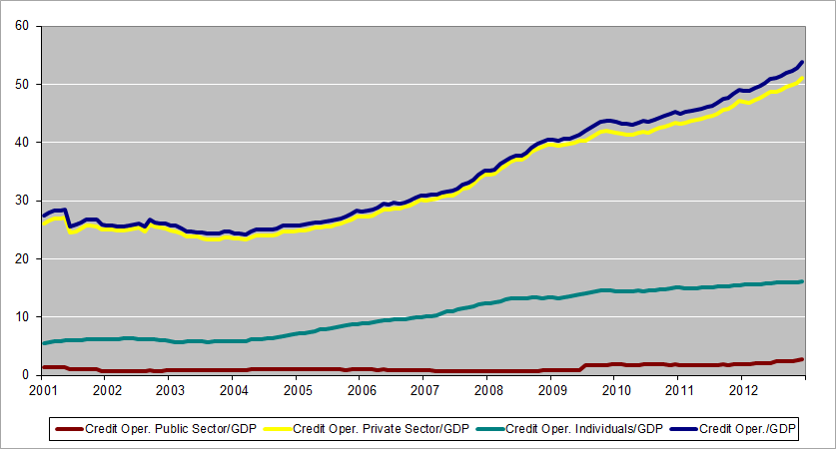

Source: Prepared by INPI, data from the Central Bank of Brazil (BCB)

The expansion of investment in the different sectors of the economy was also a relevant factor in the period. Their performance is related to domestic and international markets as well as to public policies and structural reforms. Between 2006 and September 2008, Brazil experienced an important investment cycle. There was a strong increase in the investment rate, from 15.9% of GDP in 2005 to 19.1% of GDP in 2008, maintaining this level until 2012.

Regarding the external sector, the consolidation of China as an economic power provided a growing demand for commodities and increased the exportation of mineral and energetic resources from Brazil. This change in the international economic structure impacted the dynamism of emerging and developed countries. In this sense, the Brazil's balance of trade reversed the trend of deficits observed during the 90s, with an annual average surplus of US$ 24 billion in the 2000s. The Brazilian exports jumped from around US$55 billion in 2000 to US$242 billion in 2012, while imports grew from US$56 billion to US$223 billion. This balance of trade improvement had different contributions in terms of intermediary products than of capital goods (Table 2.1). In the first case, the agricultural sector and those intensive in natural resources were greatly influenced by the increase of the market prices of agricultural and mineral commodities. In the second case, the trade deficit in the sector was explained by companies relying heavily on engineering and technological products.

Another relevant aspect of the Brazilian economy in the period refers to the flow of Foreign Direct Investment (FDI). In 2012, with a flow of US$ 65 billion, the country was the fourth country in the world as FDI destination. Although this volume is 2% lower than in 2011, these values are a result of the measures undertaken by the Government in industry, technology and foreign trade policies adopted by the government in the last decade.

Table 2.1: Balance of Trade by Type of Good, 2000-2012

Source: Prepared by INPI, data from the Central Bank of Brazil (BCB)

From a social perspective, government policies of readjustments of the minimum wage and transfer income provided a substantial improvement in the income and quality of life of the poorest households. The unemployment rate had an almost continuous fall, and , reached the lowest value in the last 10 years (4.6%) in late 2012.

Despite recent improvements in macroeconomic indicators between 2000 and 2012, an economic, social and environmentally sustainable development is necessary to continue the social advances and increase the competitiveness of the Brazilian economy. In the process, investments in infrastructure, increased R&D spending and better qualification of the workforce are key factors. With that in mind, the next section highlights the changes in the regulatory framework and the main policies implemented.

## Brazilian National System of Innovation and Industrial Development

In Brazil, public policies for scientific and technological development begun in the 1950s. In that decade, the Brazilian Government created its first science and technology (S&T) programs. Later on, with the goal of raising incentives for innovation and scientific and technological research and to boost the competitiveness and economic growth of the economy, the Ministry of Science and Technology (MCT) was created in 1985.

Until the 90s, S&T policy consisted in a set of actions aimed at building an infrastructure for scientific research, and then applying it to the production system. Under the new macroeconomic scenario – economic stabilization and trade liberalization –, the prevailing view at that point in time was that industrial policies should cover all sectors, without distinguishing among specific priorities. With the goal of integrating it to the industrial policy of the 90s, the S&T policy was duly adapted. Other relevant aspects of the period are the changes in the intellectual property regime with the adoption of the Agreement on Trade-Related Aspects of Intellectual Property Rights (TRIPS) and the emergence of innovation as one of the objectives of S&T policies[5]. On this last point, the role of sectorial funds is an important advance, since they provide a significant part of the R&D funding.

In the case of innovation-based industrial policy, a general framework was created by the Industrial, Technological and Foreign Trade Policy (PITCE). Despite emphasizing the importance of interactions between the productive and the academic sectors, this policy brought two important advances: The Innovation Law (2004) and the "Lei do Bem" (2005). The first provided the institutional basis for strategic partnerships between universities and industries and also established rules for the sharing of infrastructure and of the economic benefits associated with innovations. To boost the efficiency of the Innovation Law, the “Lei do Bem” expanded the incentives for investments in innovative activities by authorizing the use of tax benefits for companies that invest in R&D.

In 2008, the PICTE was replaced by the Productive Development Policy (PDP), increasing the number of benefited sectors and the programs for stimulating investments. It also aimed at bolstering the process of economic growth, increase the investment and the economic growth rates. One of the main objectives for 2010 was to increase R&D expenditures to 0.65% of Gross Domestic Product (GDP).

Jointly with the targets of industrial policy, the Plan of Action for Science, Technology and Innovation (PACTI) was launched in 2007 with activities to be carried out and objectives to be reached in the period of 2007 to 2010. The main objective of PACTI was to define a wider range of initiatives, actions and programs that could improve the role of science, technology and innovation (S,T&I) as a basis for the sustainable development. To achieve this goal, several of the initiatives were aimed at stimulating companies to incorporate the activities of research, development and innovation (R,D&I) in their production process. All areas of knowledge were included in the programs, but with greater stimulus for engineering and strategic areas for the economic development. The plan forecast an investment of R$36 billion in S,T&I and the articulation of five policies and programs (Program of Accelerating Growth, PITCE, Policy for the Development of Agriculture, Plan of Health Development and Educational Development Plan). The PACTI priorities are directly related to four strategic pillars that guide the current National Policy on S,T& I: i) using ST&I as a tool for social development through the stimulation and dissemination of S&T in the society, with improvements in education and in the use of technology; ii) bolstering the number of active researchers working at the private sector; iii) increasing in the number of scholarships and fellowships for undergraduates, master’s and PhD students, postdoctoral students and senior researchers; and, iv) raising the proportion of innovative companies that benefit from governmental support.

Launched in 2011, the Greater Brazil Plan (PBM) consists of a set of initiatives to support the productive sector, especially the industry, with a wider scope than its predecessors. The PBM brings together two sets of integrated actions to improve the competitiveness of the productive sector. The first set has ten macro goals related to investments in R&D, industrial production, the qualification of the labor force in the industry and to the use of clean energy, among other. The second set includes instruments aiming at improving the competitiveness, such as: the expansion of BNDES' financing, the reduction of indirect federal taxes and the use of tax benefits. This plan is articulated with the National Strategy on Science, Technology and Innovation (ENCTI) with the objectives to be reached between 2012 and 2015. The ENCTI is under the responsibility of the Ministry of Science, Technology and Innovation (MCTI). Its main goals consist of: i) reducing the scientific and technological gap in relation to developed countries; ii) training and raising the qualification of human resources; iii) expansion of the bases for environmental sustainability and, iv) poverty and social inequalities reduction.

In light of the above, it is clear that Brazil has made a remarkable effort in order to align its policies and structure for promoting innovation. There was an effective improvement of governance and an increased efficiency by the integration of policies, instruments and agencies. Among recent advances, there is a consistent increase on scientific indicators, such as training of postgraduates. However, despite the growth observed in the period, innovation indicators such as the number of patent applications are still much lower than desirable. This may be partly credited to institutional factors that undermine the effectiveness of the instruments and to the difficulties of reaching the target of the programs.

## The Intellectual Property System in Brazil

The legal framework of intellectual property in Brazil has undergone important changes in order to incorporate the results of the Final Act of the Uruguay Round of Multilateral Trade Negotiations of the General Agreement on Tariffs and Trade (GATT) in the form of the Agreement on Trade Related Aspects of Intellectual Property Rights - TRIPS Agreement). As a result, Brazil adopted new industrial property law (Law No. 9.279/1996) and copyright (Law No. 9.610/1998), as well as specific laws to protect software (Law No. 9.609/1998) and plant varieties (Law No. 9.456/1997).

In this context, the most significant changes were related to the scope of patent protection, which recognizes patentable subject-matter from all technological sectors. As a result of TRIPS (Article 27), the new Industrial Property Law (Law No. 9.279/96) recognized the patenting of “substances, materials or products obtained by chemical means or processes, and alimentary or chemical-pharmaceutical substances, materials, mixtures or products, and medications of any kind, as well as the respective processes for obtaining or modifying them”; however it was opted for sui generis protection for plant varieties and species of microorganisms(Barbosa, 1999[6]; Carvalho, 1997).[7]

Another important initiative arising from the negotiations on the Uruguay Round of intellectual property is related to the establishment of a new institutional framework to address the needs of coordinating governmental action. In 2001, created the Interministerial Group of Intellectual Property (GIPI)[8] was created. It is under the Foreign Trade Chamber - CAMEX, with the function of proposing governmental actions to harmonize internal and external policies regarding IP-related goods and services. The GIPI, coordinated by the Ministry of Development, Industry and Foreign Trade (MDIC), defines government positions related to intellectual property and provide support for the international negotiations (involving direct or indirect issues), whereas the negotiations themselves are conducted by the Ministry of External Relations.

The institutional structure of intellectual property protection was also regulated by decrees which establish the functioning of the several institutions responsible for the implementation of the specific laws.

The protection of industrial property assets is regulated and managed by the National Institute of Industrial Property (INPI)[9], an institution under the Ministry of Development, Industry and Foreign Trade. The INPI has the following responsibilities: the examination of patent, trademarks, industrial designs and geographical indications applications and also the registration of contracts of technology transfer and franchising. The INPI is also responsible for the registration of software (which enjoy copyright protection) and integrated circuit topographies (a sui generis protection). Besides registry services, INPI is responsible for disseminating technological information contained in patent documents and for promoting IP system.

Regarding copyright law, the protection of the rights is independent of the registration. Nevertheless, authors may register their work in a public institution according to the type of the work:

1. Literary, scientific and artistic works are registered in the National Library Foundation from the Ministry of Culture[10].
2. Musical compositions are registered in School Music of the Federal University of Rio de Janeiro[11].
3. Works of drawing, painting, sculpture, lithography and kinetic arts are registered at the School of Fine Arts of the Federal University of Rio de Janeiro[12].
4. Architectural plans and projects are registered at the Regional Council of Engineering, Architecture and Agronomy (CREA)[13].
5. Cinematographic works are registered at the National Film Agency (ANCINE)[14].

Concerning the analysis of requests for new varieties of plants, it is under the responsibility of the National Service for Plant Variety Protection (SNPC) from the Ministry of Agriculture, Livestock and Food Supply.[15]

The following subsections offer a brief description of the different forms of protection that are under the responsibility of INPI and which are object of the analysis of this report. At the end of this section, a summary box is presented with the main information of the intellectual property system in Brazil.

### Patents (of invention and utility models)

As an introduction of the characteristics of invention patents and utility models in Brazil, it is important to clarify that, according to the Law No. 9.279/96, which regulates industrial property in Brazil, both inventions and utility models are protected as patents, albeit with different terms of protection and substantive criteria. It means that both are under the same regulations.

The following are not considered to be inventions or utility models: (i) discoveries, scientific theories, and mathematical methods; (ii) purely abstract conceptions; (iii) commercial, accounting, financial, educational, advertising, raffling, and inspection schemes, plans, principles or methods; (iv) literary, architectural, artistic and scientific works, or any aesthetic creation; (v) computer programs per se; (vi) presentation of information; (vii) rules of games; (viii) surgical techniques and methods, as well as therapeutic or diagnostic methods, for application to human or animal body; and (ix) all or part of natural living beings and biological materials found in nature, even if isolated therefrom, including the genome or germoplasm of any natural living being, and the natural biological processes.

In order to facilitate international comparisons, patents should be understood as referring only to invention patents, while utility model will be presented separately.

#### Patents

Patent refers to an invention that satisfies the requirements of novelty, inventive step and industrial application. An invention can be defined as a new solution to a specific technical problem, within a given technological field.

In Brazil, the process of filing and granting a patent application undergo the following main steps:

1. Once the application has been submitted, it will undergo a formal preliminary examination and, if found to be properly documented, the date of submission (protocol or entrance at INPI) will be considered as the date of filing.
2. A patent application will be kept secret for 18 (eighteen) months from the date of filing or of the oldest priority, if any, after which it is published. The publication of the application may be anticipated at the request of the applicant; however, it does not accelerate the technical examination. After publication of the application and up to the end of the examination, interested parties may submit documents and data to assist the examination.
3. The examination of a patent application must be requested by the applicant or by other interested party within a period of 36 (thirty six) months from the date of filing. If the examination of the application is not requested, the application is dismissed. The technical examination contains a report of search and an opinion with respect to: the patentability of the application; the appropriateness of the application given the nature claimed (Patents of Invention or Utility Model); the need to reformulate or divide the application; and the technical requirements.
4. The examination can either approve or reject the patent application. In the case of approval, the applicant has 60 days to pay for the expedition of the letter patent.

Once granted, a patent remains in force for a period of 20 (twenty) years from the date of filing and the term shall not be less than 10 (ten) years counting from the date of granting.

Regarding international treaties on patents, it is worth noting that Brazil is part of:

* The Patent Cooperation Treaty (PCT), since April/1978. Since August/2009, INPI commenced its operation as an International Searching Authority (ISA) and International Preliminary Examination Authority (IPEA).
* The Strasbourg Agreement, since October 1975, which established the International Patent Classification (IPC). The IPC provides a hierarchical system of symbols for the classification according to the different technological areas to which they belong.

Judicial proceedings for the nullification of a patent may be proposed at any time during the term of the patent (either by the INPI or by any person with a legitimate interest) and are filed at the Federal Court forum. When not being the plaintiff, the INPI is part of such proceedings.

#### Utility models

A Utility Model refers to an object of practical use or part thereof that can be patented as a utility model if it is capable of industrial application, has a new form or arrangement, and involves an inventive act that results in a functional improvement in its use or manufacture.

Utility models are very similar to patents in terms of process of filing and granting, but differ in a few issues:

1. Utility models refer only to products, not processes.
2. Instead of the inventive step requirement of patents, utility models require an inventive act, which is less complex.
3. Fees for filing patents and utility models are the same, but examination and annuity fees are cheaper for utility models than for patents.
4. Once granted, a utility model remains in force for a period of 15 (fifteen) years from the date of filing and the term shall not be less than 7 (seven) years beginning on the date of granting.

As a patent, a utility model is also a type of protection available via the PCT System and the classification of the invention also follows the International Patent Classification (IPC).

### Industrial designs

In Brazil, the Industrial Property Law (No. 9.279, 14/05/1996) established[16] that industrial design registration protects the ornamental external form of an object or the set of lines and colors applied to a product, provided that they make a new and original result and are capable of industrial production. Such registration does not protect functionalities, dimensions, materials or manufacturing processes of an object. The Brazilian law determines that the application for industrial design registration refers to a single object, of which a plurality of variations is permitted, provided that they are intended for the same purpose and all retain the same preponderant distinctive characteristic, with each application limited to a maximum of 20 (twenty) variations.

The main feature with respect to the filing and granting of the application for registration of the industrial design process is the lack of substantive examination, except if requested by the applicant. This means that, after the filing of an industrial design registration with the INPI, if it is considered properly documented, it will automatically be published and the registration will be simultaneously granted, being issued the respective certificate.

The industrial design registration is valid for 10 years with the possibility of consecutive renewal for up to three (3) periods of five years, totaling a maximum of 25 years. The registration of Industrial Design guarantees to the owner temporary ownership of the industrial design and the right to exclude others from manufacturing, selling or importing products incorporating the object without their permission in the country.

Regarding international treaties on industrial design, Brazil's current status are:

* Brazil is not a member of Locarno Agreement, which establishes the International Classification of industrial designs, but uses its classification to indicate the goods incorporating the designs belong.
* Brazil is not a signatory to the Hague System for the international registration of industrial designs.

### Trademarks

In Brazil, according to the Industrial Property Law (Law No. 9.279/96), the trademark registration protects visually distinctive and perceivable signs, not prohibited by law. Marks can be differentiated by their nature, according to its use on the market in four distinct categories:

1. Product trademarks: used to distinguish a product from another that is identical, similar, or alike, but of different origin.
2. Service marks: used to distinguish a service from another that is identical, similar, or alike, but of different origin.
3. Certification marks: used to attest the conformity of a product or service with certain technical standards or specifications, particularly regarding its quality, nature, material used and methodology employed; and
4. Collective marks: used to identify products or services provided by members of a certain entity.

A trademark can also be classified according to its presentation in four distinct categories:

1. Nominative marks: protect words, abbreviations, neologisms or any combination of letters, and/or numbers, provided they are not misleading.
2. Figurative marks: protect only signs with pictures, image symbols or drawings.
3. Mixed marks: protect both word and figurative signs, and three-dimensional marks consisting of three-dimensional features such as the shape and packaging of goods without a functional or technical effect.

In Brazil, the process of an application for trademark registration has the following main steps:

1. The Brazilian law provides that the application for registration should be in only one class of the good or service that the trademark intends to distinguish. Where applicants wish protection in different classes, they should submit separate applications for each class. It is not necessary to submit proof of use of the mark when filing the register.
2. After filing in the INPI, the application is subject to a formal preliminary examination and, if properly documented, the application is published in the Industrial Property Gazette (RPI).
3. After the application is published in the RPI, interested parties have 60 days to submit information to INPI if they wish to oppose the application.
4. After the opposition period, the application is submitted to the substantive examination.
5. If the trademark application complies with the substantive criteria and the applicant duly pays the corresponding fees, the registration certificate will be granted to the applicant.

Once granted, a trademark remains in force for a period of 10 (ten) years from the date of grant and this period may be extended for equal and successive periods by paying renewal fees. Under Brazilian law, the certificate of registration of a trademark ensures to the titleholder its exclusive use throughout the national territory, as well as the right to authorize others to use your trademark and to prevent other people from using it to signal products or services which are identical, similar or related.

A trademark can also be cancelled post-grant. Administrative nullity proceedings may be request by any person having a legitimate interest within 180 days from grant. Judicial nullity proceedings may be proposed either by INPI or by any person having a legitimate interest within five years after it was registered.

Regarding international treaties on trademarks, it is worth noting that:

* Brazil is not a member of the Nice Agreement ("Nice Agreement Concerning the International Classification of Goods and Services for the Purposes of the Registration of Marks"). INPI, however, uses Nice's International Classification of Goods and Services.
* Brazil is not a member of the Vienna Agreement ("Vienna Agreement Establishing an International Classification of the Figurative Elements of Marks"), but uses the Classification of the Figurative Elements established by it.
* Brazil is not a member of the Madrid Protocol (“Protocol Relating to the Madrid Agreement Concerning the International Registration of Marks”). The Agreement is an international system of record that enables obtaining protection for trademarks in several States and/or intergovernmental organizations through a single international application to be filed with the International Bureau of the World Intellectual Property Organization (WIPO)

### Technology and franchising Contracts

According to the Industrial Property Law (No. 9.279/96), INPI is responsible for the registration of contracts that involves transfer of technology, franchise agreements and alike in order that such contracts take effect for third parties. Under Brazilian law, technology contracts are agreements whose object involves industrial property rights or an expectation of rights, which may include pending applications for the registration of IPRs.

Agreements whose object involves the transmission of knowledge, which may not be registered as industrial property rights, are also required to be registered at INPI. This is the case of contracts involving know-how and trade secrets as well as contracts for the provision of technical assistance services, related to the preparation of studies, projects and technical support needed for the absorption of technology.

The franchise contracts are regulated by Law No. 8.955/94, which defines them as "the mechanism by which the franchisor grants the franchisee the right to use the trademark or patent, associated with the right of exclusive or semi-exclusive distribution of products or services, and, eventually, the right to use the technology of deployment and management of the business or the operating system developed or held by the franchisor, by direct or indirect remuneration, without, however, characterizing any employment relationship" (art. 2 Law No. 8.955/94).

According to these rules and regulations, technology and franchise contracts should be registered at the INPI:

1. to have effect for third parties (Law 9.279/96);
2. to legitimize and enable the remittance of royalties and services involving technology transfer (Law No. 4.131/62 and Resolution No. 3.844/2010 of the Central Bank of Brazil); and,
3. to allow the tax deduction of technology and technical assistance expenses (Decree Nº. 3.000, 26/03/1999, relating to the Income Tax Regulations).

### Geographical indications

In Brazil, according to the Law 9279/96, the registration of geographical indications protects an indication of origin (or indication of source) or an appellation of origin (or denomination of origin). INPI is the institution responsible for establishing the registration procedure.

An indication of source is the geographic name of a country, city, region or locality in a territory which has become known as a center of extraction, production or manufacture of a given product or of provision of a given service. A denomination of origin is the geographical name of a country, city, region or locality in its territory that designates a product or service whose qualities or characteristics are exclusively or essentially attributable to the geographical environment, including natural and human factors.

Once a geographic name has fallen into the common use as designating a product or service, it cannot be registered as a geographical indication.

The use of the geographical indication is restricted to those producers and service providers who are established in that locality, and it is also demanded, concerning denominations of origin, that the quality requirements are satisfied.

Regarding international treaties on geographical indications, it is worth noting that Brazil is not part of the Lisbon Agreement (“Lisbon Agreement for the Protection of Appellations of Origin and their International Registration”).

### Software

In Brazil, in addition to copyright law (Law No. 9.610/1998) in which the computer program is protected as a literary work, the intellectual property protection of computer programs is the subject of specific legislation: the Law 9.609/98, also known as Software Law.

In the case of works protected by copyright, the protection of rights in the computer program comes with its creation, independent of registration. To enjoy the rights granted by the ownership of the software, the owner must have of proof of authorship, either by the publication or by other evidence. Thus, to provide legal certainty for business and ensure its ownership, computer programs may be registered at INPI. The validity of the rights for those who develops software is fifty years from January 1st of the year following that of its publication or, failing that, of their creation.

In the case of foreign programs, once coming from countries that grant reciprocity to Brazilian authors, they are not required to be registered in Brazil (except in cases of transfer of rights).

Box 2.1: Summary of IP system in Brazil

|  |  |  |  |  |
| --- | --- | --- | --- | --- |
| **Institution** | **Type of IP** | **Period in force** | **National IP Laws** | **International Agreements Status** |
| Brazilian IP  Office (INPI),  Ministry of  Development,  Industry and  Foreign  Trade | Patents | 20 years from the date of filing, shall not be less than 10 years beginning on the date of granting. | Law No. 9.279 May 14, 1996 Industrial  Property Law | - Paris Convention since July/1884  - Strasbourg Agreement (for International Patent Classification - IPC) since October/1975  - PCT since April/1978  - ISA/IPEA since August/2009  - Brazil is not a member of the Budapest Treaty (international recognition of the deposit of microorganisms for the purposes of patent procedure) |
| Utility Models | 15 years from the date of filing, shall not be less than 7 years beginning on the date of granting. |
| Trademarks | 10 years from the date of granting of the registration, renewable. | - Paris Convention since July/1884  - Madrid Agreement (Repression of False or Deceptive Indications of Source on Goods) since October/1896  - Nairobi Treaty (Protection of the Olympic Symbol) since August/1984  - Brazil is not a member of the Madrid Protocol (for International Registration of Marks)  - Brazil is not a member of the Nice Agreement but uses its classification of goods and services for registration of marks.  - Brazil is not a member of the Vienna Agreement (for figurative elements of marks) but uses its classification |
| Industrial Designs | 10 years from the date of filing, being extendable for 3 successive periods of 5 years each. | - Paris Convention since July/1884  - Brazil is not a member of the Hague System (for the International Registration of Industrial Designs)  - Brazil is not a member of Locarno Agreement (for International Classification of industrial designs) but uses its classification. |
| Geographical  Indications | Not determined. | - Paris Convention since July/1884  - Brazil is not a member of the Lisbon System (a global protection system for protection of appellations of origin and their international registration). |
| Contracts of licensing  of industrial property,  technology transfer  and franchising | - Licensing of industrial property: duration of the validity of the industrial property rights involved;  - Know-how and trade secrets contracts: period of 5 years, renewable for equal periods of 5 years;  - Technical assistance services: period of provision of the services. | Law No. 4.131/1962 (Foreign Capital Law); Law No. 8.884/1994 (Antitrust Law);  Law No. 8.955/1994 (Franchising Law);  Law No. 9.279/1996 (Industrial Property Law);  Decree No. 3.000/1999 (Income Tax Regulations);  Ordinance of the Ministry of Finance No. 436/1958. |  |
| Software | 50 years, counting from January 1 of the year following its publication. | [Law No. 9.609, February 19, 1998](http://www.wipo.int/wipolex/en/details.jsp?id=513) |  |
| Integrated Circuit  Topographies |  | [Law No. 11.484, May 31, 2007](http://www.wipo.int/wipolex/en/details.jsp?id=8307) |  |
| Ministry of  Culture  and  Ministry of  Education | Copyright and  Neighboring Rights |  | Law No. 9.610, February 19, 1998 | - Berne Convention (Protection of Literary and Artistic Works) since Feb/1922  - Phonograms Convention (Convention for the Protection of Producers of Phonograms Against Unauthorized Duplication of Their Phonograms) since Nov/1975  - Rome Convention (Protection of Performers, Producers of Phonograms and Broadcasting Organizations) since Sep/1965 |
| National  Service  for Plant  Variety | National Service for  Plant Variety Protection  / Ministry of Agriculture | 15 years for most of varieties; | Law No. 9.456, April 28, 1997 | - UPOV Convention since May/1999[17] |

# 3 Brazil in the Global context (Overall trends)

Brazil is the seventh largest economy of the world and the second largest middle-income economy.[18] Brazil is the largest economy among the Latin American and Caribbean (LAC) countries. Its GDP represented 42% of the LAC region’s GDP in 2011. That same year, it had a GDP of 2,477 billion USD which is more than twice the one of Mexico (1,160 billion constant USD), the second largest economy in the LAC region.

Brazil ranked first among LAC countries in registration of patents, utility models, industrial designs and trademarks. Similar to its GDP share, the share of patent filings originating from Brazilian applicants was of 40% of all LAC patent filings in 2011. With almost 6,400 patents filed worldwide, however, applications by Brazilian residents accounted for less than 0.5% of total world filings. By comparison, Chinese and Indian residents filed respectively about 436.000 and 16.000 patent applications worldwide in 2011.[19]

INPI-Brazil received 28,547 patent applications in 2011 (figure 3.1), which represents roughly half of the filings in LAC but only 1.3% in the world. Between 2002 and 2011, the number of patents filed at INPI Brazil grew rapidly. By contrast, the offices of Argentina and Mexico received higher volumes of filings in 2006 than in 2011. Over the ten years’ period, all offices from upper-middle income countries combined have experienced a 16.8% annual growth on average, mainly due to the sharp growth seen at SIPO[20] (23.2%). Nonetheless, with a 6.1% annual growth rate in the same period, INPI Brazil has seen an increase of patent filings by 1.6 percentage points above the world’s rate (4.5%).

Figure 3.1: Trends in patent filings

|  |  |
| --- | --- |
|  |  |

Note: 2011 data for Argentina, Upper-middle income data, LAC data and World data are WIPO estimates. Geometric mean was used to determine the average annual growth. Source: WIPO Statistical Database, January 2014

Similar to patent filings, industrial design filings at INPI Brazil experienced a sharp increase from 2002 to 2011, with the filing of 6,835 industrial design applications in 2011 (figure 3.2). This represents 46.5% of the industrial design filings in LAC, but less than 1% of the world total. Unlike patent filings, however, its 5.3% annual growth is lower than those observed at the offices of Argentina (7.4%) and Mexico (8.6%) as well as slightly below LAC average (5.5%). In any case, all three offices experienced a substantial increase in the number of industrial design applications received since 2002. The INPI Brazil growth rate is also lower than the one observed for the world’s average as well as the one for the upper-middle income countries. These rates are largely due to filings at SIPO, which experienced an average growth of 23.3% since 2002 and accounted for 68% of the world's total industrial design filings in 2011.

Figure 3.2: Trends in industrial design filings

|  |  |
| --- | --- |
|  |  |

Note: 2006 and 2011 data for Argentina, Upper-middle income data, LAC data and World data are WIPO estimates. Geometric mean was used to determine the average annual growth. Source: WIPO Statistical Database, January 2014

With 152,699 filings received in 2011, INPI Brazil accounts for 27.6% of the trademark filings in LAC and 3.7% of the world. Brazil experienced a sharp increase in trademark filings since 2002 and especially since 2009 (figure 3.3). This growth represents, in absolute terms, an increase of about 58,400 filings over the past decade, the highest increase in absolute terms among LAC countries. However, in relative terms, Brazil (5.5%) experienced a slightly lower average annual growth since 2002 than Argentina (6.6%) and Mexico (6.6%). If filings at INPI Brazil grew, on average, faster than LAC average (4.9%), it was below the upper-middle income (10.8%) and world average (6.4%).

Figure 3.3: Trends in trademark filings

|  |  |
| --- | --- |
|  |  |

Note: 2011 data for Argentina, Upper-middle income data, LAC data and World data are WIPO estimates. Geometric mean was used to determine the average annual growth. Source: WIPO Statistical Database, January 2014

Even though Brazilian residents represent a small share of world total, the IP filing activity in Brazil markedly increased over time. Among LAC offices, INPI Brazil is not only the largest office in terms of filing activity but is also among the fastest growing offices in terms of filings.

# 4 Patents and Utility Models

Over the period from 2000 to 2011, a number of policies and regulations were put in place in Brazil. Innovation was emphasized as playing an important role in the economic and industrial development. In light of that, improvements regarding intellectual property rights were undertaken through the restructuring of the INPI, investing in its infrastructure and human resources. The first subsection provides an overview of the filing trend for patents and utility models for INPI, the second subsection describes in details the patenting behavior of inventions and the third subsection presents specific aspects of the use of utility model protection.

## Trend of total applications received by Brazilian IP Office (INPI)

Figure 4.1 presents the trend of total applications received by the INPI, classified by patents and utility models, residents and non-residents, and also distinguishing the ones via the PCT route from those directly filed with INPI.

The main findings are: (i) growth in patent applications from non-residents using the PCT route, was the main contributor to total growth of applications, (ii) residents also increased the number of patent applications, but far below from those from non-residents, (iii) the share of non-resident in total applications (patents and utility models) increased during the period, (iv) the participation of PCT applications in total applications increased, particularly from non-residents, (v) the share of utility models decreased, if considered only resident or total applications, and (vi) resident applications via PCT and non-resident UM applications were not representative.

Figure 4.1: **Patent and Utility model applications, 2000-2011**

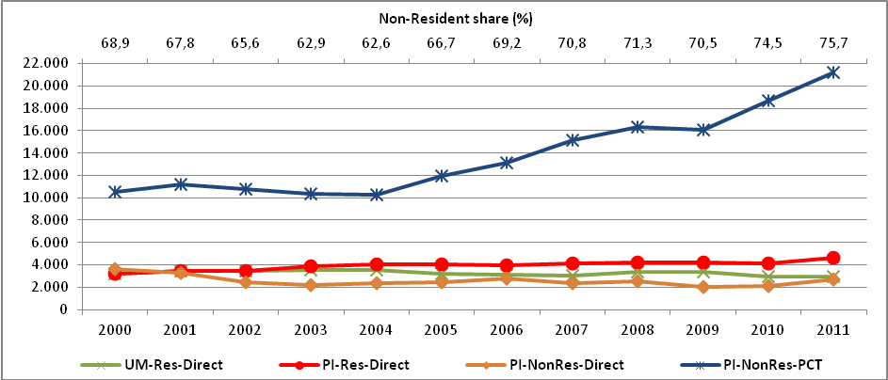

Source: INPI’s Statistical database (BADEPI)

The 20,773 applications filed in 2000 consisted of 14,319 non-resident and 6,449 resident applications. In 2011, with 31,652 applications filed, the number of non-resident applications grew sharply and reached 23,975 (67%), while resident applications also grew but by a more modest rate (19%), resulting in 7,677 applications. As a consequence, the resident share decreased from 31% to 24% of total applications filed at the Brazilian IP Office.

The number of patent applications was stable until 2004, when they started to experience fast yearly growth. Patent applications grew more than 60%, from 17,443 per year in 2000 to 28,547 in 2011. It contrasts with the trend for utility model applications in the same period, which registered a smooth fall of 6% less applications from 2000 to 2011. In 2000, 3,330 utility model applications were filed and, in 2011, approximately 3,100 applications. Consequently, the share of utility model dropped from 16% of total applications to only 10%. If we only take into consideration resident applications, UM filings have dropped from 50% to 39% of total patent and UM applications.

The applications through Patent Cooperation Treaty (PCT) have shown to be of great and growing importance to INPI. Between 2000 and 2011 the PCT patent applications more than doubled, from approximately 10,600 to 21,244 applications, while the trend of direct filings (patents and utility models) had a small and not continuous growth over this period. In 2011, PCT applications represented almost 75% of patent applications and 67% of total applications (patents and utility models).

It is important to point that the increased use of PCT is combined with a general increase in applications of patents by non-residents, whether PCT or Paris Convention applications, and with the fact that the INPI was indicated as an International Searching Authority (ISA) and International Preliminary Examination Authority (IPEA) under the PCT in September 2007. In August 2009, the Institute began operating as ISA-IPEA. This new condition affected the number of PCT applications for utility models. In 2009, there were 12 such applications. In 2010, these applications numbered 15 and, in 2011, 30 applications. Although in absolute terms they represent a small share of total applications, they experienced a significant growth (100%).

When considering countries’ origin for patent and utility model together, the share of Brazilian residents (30%) is superior to U.S. residents (27%). This highlights the significant use of utility model protection by Brazilian residents.

Figure 4.2: Patent and Utility model applications by country, 2000-2011

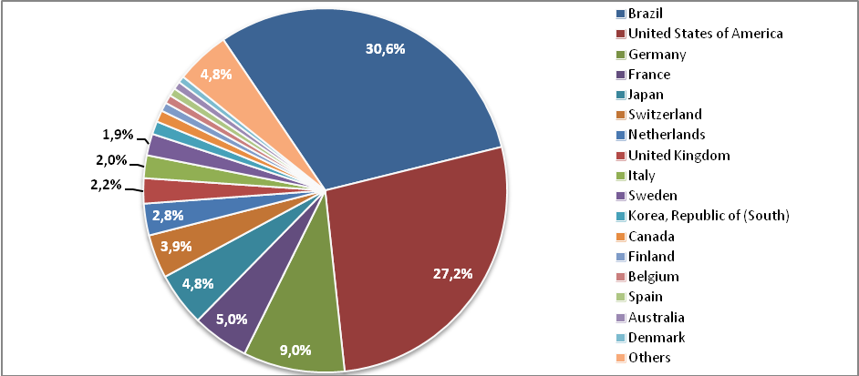

Source: INPI, BADEPI

The distribution of patent applications by Brazilian residents according to their state is highly concentrated in São Paulo. In the period 2000-2011, it represented more than 40% of the total. Rio Grande do Sul (9.5%), Paraná (8.9%) and Minas Gerais (8.7%) follow. Rio de Janeiro and Santa Catarina have around 8% each.

Figure 4.3: Patent and Utility model applications by states (UFs), 2000-2011

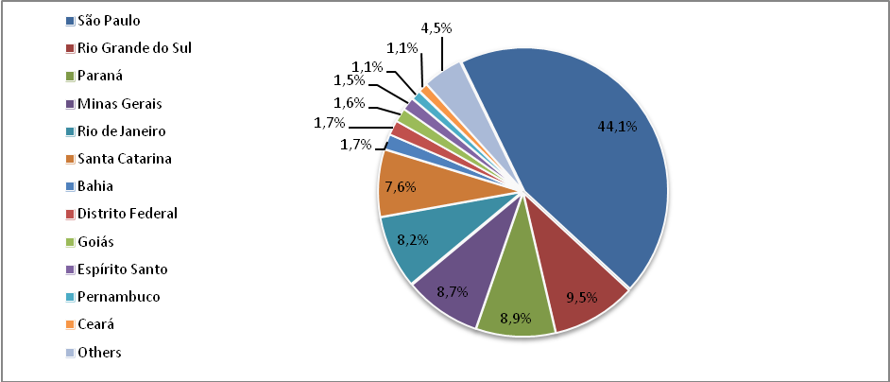

Source: INPI’s Statistical database (BADEPI)

## Patent applications

Figure 4.4 presents the trend for patents application, by residents and non-residents, using the PCT route or directly filed with INPI. It shows that: (i) growth in non-resident (using PCT route) applications was the main contributor to total growth, (ii) continuation of the share of non-resident applications by around 80% during the period, and (iii) non-resident applicants represent 99% of all PCT applications.

Figure 4.4: Patents, PCT route or direct filings, by residents and non-residents, 2000-2011

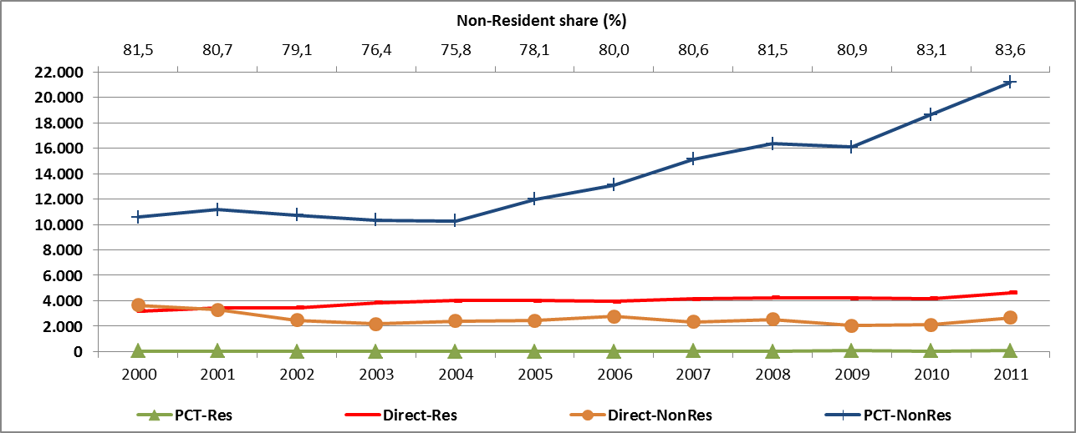

Source: INPI’s statistical database (BADEPI)

PCT applications from non-resident were at a relatively low level until 2004, when it started growing consistently until 2011 (except in 2009). On the other hand, the number of non-resident applications filed directly with INPI followed a downward trend, falling almost 30% from 2000 to 2011.

Resident patent applications (99% filed directly with INPI), have grown over 40%, from 3,181 per year in 2000 to 4,627 in 2011. It should be noted that since 2009, when INPI started to operate as ISA-IPEA, PCT applications from residents also increased, from 29 applications in 2008, to more than 60 applications per year in the period 2009-2011.

## Patents applications by origin

As in WIPO statistical reporting, we use the residence of the first-named applicant to determine the country of origin, which facilitates international comparisons.[21] This is also justified due to the fact that 98% of all patents filed in Brazil were by applicants from the same country of origin. This means that only 2% of total patent applications were filed jointly by applicants from different countries, and, among them, only a very small number of patents were filed jointly by residents and non-residents.

Figure 4.5 shows that few countries were responsible for most of the applications. The United States represented around 30% of the patents in 2011, followed by Brazil and Germany, with 16.4% and 10%, respectively. At a level below are Japan, with 9%, France (6%), Switzerland (4.4%) and Netherlands (4%).

Figure 4.5: Patents by country of origin, 2000/2011

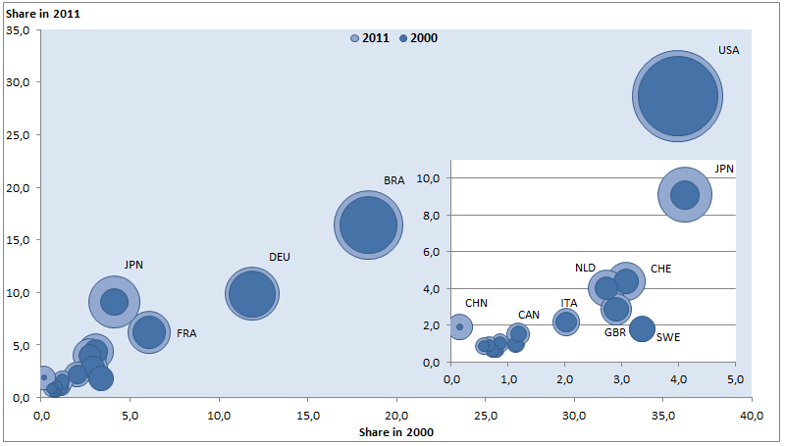

Source: INPI’s statistical database (BADEPI)

The evolution of the main countries of origin of patent applications is shown by the growth bubbles between 2000 and 2011. Applications from the USA grew by 31%: it had around 6,200 applications in 2000 and more than 8,200 in 2011. Brazil had a higher growth rate of 46% – from 3,200 to 4,700 applications – while Germany grew by 36% – from 2,000 to 2,800 applications.

In relation to countries that showed significant growth in the period, Japan jumped from 700 applications in 2000 to 2,600 in 2011, surpassing France. China also experienced strong growth, although from a much lower level. In 2000, it had filed 25 applications, while in 2011 it rose to almost 550, surpassing countries such as Sweden, Canada, Korea and Spain, that respectively filed 513, 438, 285 and 261 applications in that same year.

## Patents applications by technological fields

Figure 4.6 provides an overview of patent applications, from residents and non-residents, by technological sectors[22]. It is interesting to note that the distribution didn’t experience relevant changes in the period of 2000-2011. The chemistry sector accounted for the highest share in total applications (over 40%). It was followed by mechanical engineering, which accounted for more than 20% of total applications, electrical engineering (14%), instruments (11%) and other fields (7%). This distribution is largely determined by technological fields with a major participation of non-residents, as they were responsible for 80% of applications.

Figure 4.6: Patents by technological sectors, 2000-2011

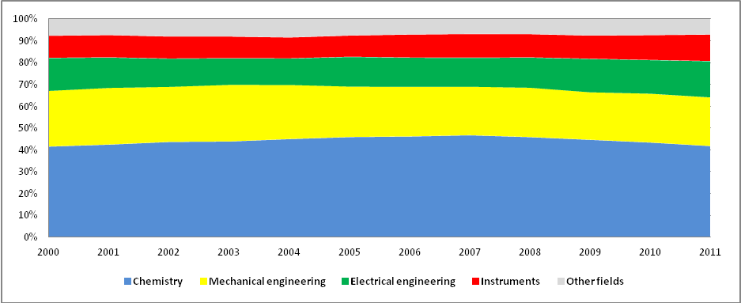

Source: INPI’s Statistical database (BADEPI)

As the distribution didn’t experience relevant changes over the period 2000-2011, Figure 4.7 shows how the technological fields differ according to the origin of applicants. It indicates the contrast between the internal technological capabilities and the areas under protection by non-residents applications. Comparing the distribution of applications from residents and non-residents, chemistry appears as the largest sector in both cases, but it accounts for a smaller share for the residents as compared to non-residents (around 30% against 43%, respectively). The mechanical engineering sector and “other fields” account for bigger shares (around 28% and 15%) for residents than non-residents (21% and 6% respectively).

In the analysis of the top-10 sectors of patent applications, non-resident applications clearly concentrate in the chemistry sector: pharmaceuticals (9%), organic fine chemistry (7%), basic materials chemistry (6%), medical technology (5%) and biotechnology (5%). Resident applications, on the other hand, are concentrated in other sectors, such as: civil engineering (7%), other special machines (7%), medical technology (5%), transport (5%) and basic materials chemistry (5%). It is interesting to note that sectors associated with the most dynamic technologies (Information and Communication Technologies - ICT) are relevant to both residents and non-residents.

Figure 4.7: Patents by technological sectors and applicant origin, 2011

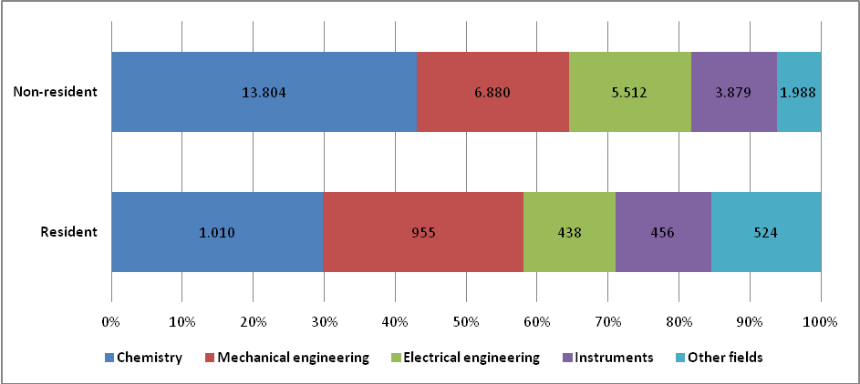

Source: INPI’s Statistical database (BADEPI)

Table 4.1 shows patent applications classified by the top 10 non-resident applicants, while Table 4.2 shows patent applications classified by the top 10 resident applicants. In the case of non-resident applicants, the top 10 applicants accounted for 8.5% of all patent applications from non-residents during the period of 2000 to 2011, suggesting a relatively low concentration of applicants. If resident applications are also included, the top 10 non-resident applicants account for only 6.7% of all patent applications. Among non-resident applicants, other relevant companies are from the sectors pf consumer goods, information and communications technology (ICT), chemicals and pharmaceuticals, most of which are multinationals with subsidiaries in Brazil.

Table 4.1: Top 10 non-resident applicants - Patents, 2000-2011

|  |  |  |  |  |
| --- | --- | --- | --- | --- |
| Rank | Name | Sector | Number of  applications | Share  of Total |
| 1 | Qualcomm Incorporated | information and communications technology (ICT) | 3,092 | 1.38% |
| 2 | BASF aktiengesellschaft | Chemicals | 2,894 | 1.29% |
| 3 | The Procter & Gamble Company | Consumer goods | 2,359 | 1.05% |
| 4 | Unilever | Consumer goods | 1,753 | 0.78% |
| 5 | 3M Innovative Properties Company | Several sectors | 1,656 | 0.74% |
| 6 | Novartis | Pharmaceutical | 1,585 | 0.71% |
| 7 | Koninklijke Philips Electronics | information and communications technology (ICT) | 1,493 | 0.67% |
| 8 | Microsoft Corporation | information and communications technology (ICT) | 1,469 | 0.66% |
| 9 | E, I, du Pont de Nemours and Company | Chemicals | 1,386 | 0.62% |
| 10 | Kimberly Clark Worldwide Inc, | Cleaning and personal hygiene products | 1,356 | 0.61% |
| Top 10 total | | | 19,043 | 8.50% |
| Total non-resident applications | | | 224,037 | 100% |
| Total applications (including residents) | | | 282,820 |  |

Table 4.2 shows patent applications distributed according to the top 10 resident applicants, with only two companies appearing in the list: Petrobras and Whirpool S.A., with 696 and 652 applications respectively. It is important to highlight that Whirpool S.A. and Multibras are associated companies. Whirpool S.A. was established in 2006 with the reorganization of Multibrás SA and Empresa Brasileira Compressor SA – Embraco. Table 4.2 also shows the strong presence of universities and public foundations, particularly those from São Paulo and Minas Gerais. Such institutions have the mission of fostering research and the scientific and technological development of the states.

Table 4.2: Top 10 resident applicants - Patents, 2000-2011

|  |  |  |  |
| --- | --- | --- | --- |
| Rank | Name | Number of  applications | Share  Total |
| 1 | Petróleo Brasileiro S.A. – Petrobras | 696 | 1,18% |
| 2 | Universidade Estadual de Campinas – Unicamp | 595 | 1,01% |
| 3 | Universidade de São Paulo – USP | 534 | 0,91% |
| 4 | Whirlpool S.A. | 492 | 0,84% |
| 5 | Universidade Federal de Minas Gerais – UFMG | 385 | 0,65% |
| 6 | Fundação de Amparo à Pesquisa do Estado de São Paulo – FAPESP | 342 | 0,58% |
| 7 | Universidade Federal do Rio de Janeiro – UFRJ | 279 | 0,47% |
| 8 | Fundação de Amparo à Pesquisa do Estado de Minas Gerais – FAPEMIG | 169 | 0,29% |
| 9 | Universidade Federal do Rio Grande do Sul – UFRGS | 162 | 0,28% |
| 10 | Multibrás S.A. Eletrodomésticos | 160 | 0,27% |
| Top 10 total | | 3.814 | 6,49% |
| Total resident applications | | 58.783 | 100,00% |
| Total applications (including non-residents) | | 282,820 |  |

## Patents applications by residents

Brazilian resident applications can be classified in three types of applicants: companies, universities and individuals[23]. Figure 4.8 shows that individuals are the main applicants but companies and universities also increased their participation during the period.

In 2000, individuals concentrated more than 70% of total patent applications (2,286 applications), while companies accounted for 26.8% (861 applications) and universities had a very small participation of 2.0%. During the period, the number of patent applications from universities had a relevant increase, with 13.8% of total applications in 2011 (or 652 applications), while the number of patent applications from companies almost duplicated and reached 34.2% of total applications in 2011 (1,619). Individuals also increased (7.5%) their number of patent applications (to 2,459 applications in 2011) but their participation dropped to 52%.

It is necessary to further investigate the reasons behind the fact that the majority of patent applications are from individuals and identify whether they are inventors and applicants at the same time or if the owners of companies prefer to have patents in their names. In addition to that, Figure 4.8 shows that the composition of applicants has changed. This could be a result of the several incentives implement by recent industrial and innovation policies or a result of internal changes at INPI-Brazil, who became more active in its efforts for the national dissemination of the use of intellectual property at universities and companies.

Figure 4.8: Patent from residents, by type of applicant, 2000-2011

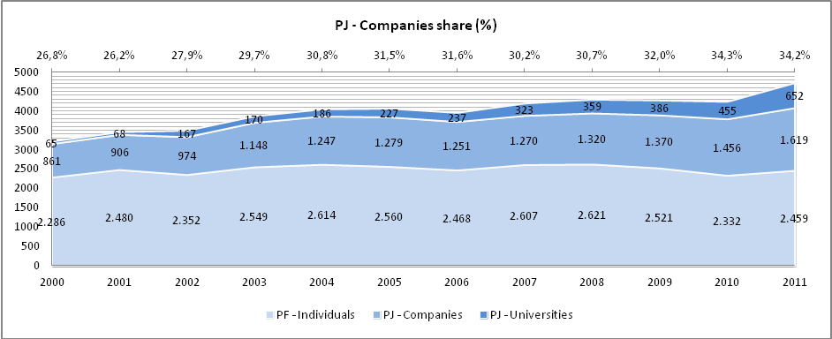

Source: INPI’s Statistical database (BADEPI)

## Resident patents applications by economic sector

With regard only to resident companies, applications can be broken down by economic sectors, which refers to the 87 activities (from agriculture, industry and services) of the "National Classification of Economic Activities" (CNAE). The CNAE follows the same methodology of the International Standard Industrial Classification of all Economic Activities (ISIC Rev.4). In this report, references to an economic sector use the CNAE classification (2-digits level). Data, however, are not available for all resident companies[24].

Table 4.3: Patent applications by economic sectors (ISIC Rev.4), 2006/2011

|  |  |  |  |  |
| --- | --- | --- | --- | --- |
|  | 2006 | 2006 | 2011 | 2011 |
| Total | 1.488 | 100,0% | 2.274 | 100,0% |
| Education | 207 | 13,9% | 499 | 21,9% |
| Manufacture of electrical equipment | 66 | 4,4% | 194 | 8,5% |
| Manufacture of machinery and equipment n.e.c. | 108 | 7,3% | 140 | 6,2% |
| Public administration and defense; compulsory social security | 46 | 3,1% | 121 | 5,3% |
| Manufacture of chemicals and chemical products | 81 | 5,4% | 88 | 3,9% |
| Scientific research and development | 27 | 1,8% | 81 | 3,6% |
| Manufacture of computer, electronic and optical products | 51 | 3,4% | 64 | 2,8% |
| Wholesale trade, except motor vehicles and motorcycles | 44 | 3,0% | 62 | 2,7% |
| Manufacture of motor vehicles, trailers and semi-trailers | 35 | 2,4% | 43 | 1,9% |
| Manufacture of fabricated metal products, except machinery and equipment | 35 | 2,4% | 40 | 1,8% |

Source: INPI’s Statistical database (BADEPI)

For the companies with available data, Table 4.3 shows a strong participation of universities and government research institutes that are classified in the following sectors: “education”, “public administration, defense and social security” (which includes Government research institutes and the Institutes of Technological Research from the Army and the Air Force) and “Scientific research and development” (which includes private and public foundations that fund research). Jointly they represented 19% in 2006 and reached 31% of the total applications of resident legal entities in 2011.

Industrial activities have a significant share of resident patent applications in Brazil. The manufacture of electrical equipment more than doubled the number of patent applications in the period under consideration, increasing its relative share from 4.4% to 8.5%. The manufacture of machinery and equipment, although it has lost relative importance in the period 2006-11, continues as one of the most important sectors in 2011 (6.2%).

The remaining sectors – manufacture of chemicals and chemical products, manufacture of computer, electronic and optical products, wholesale trade, except motor vehicles and motorcycles, and manufacture of computer, electronic and optical products – despite of an increased number of applications, have experienced a relative decline.

## Patent Grants

In the period 2000-2011, Brazil granted over 38,000 patents. Out of this total, 34,291 were granted to non-resident and 3,985 to residents. Considering the distribution by year, INPI granted 6,006 patents in 2000, falling to a level of 2,100 grants in 2004, when it begins a process of recovery that reaches 3,437 grants in 2011.

Among the main foreign countries that received a patent in the period are: the United States of America with 34% of the non-resident total, Germany with 14%, France with 7% and Japan with 5%.

Table 4.4: Patent Grants, 2000-2011

|  |  |  |  |
| --- | --- | --- | --- |
| Year | Resident | Non-Resident | Total |
| 2000 | 651 | 5,355 | 6,006 |
| 2001 | 383 | 2,865 | 3,248 |
| 2002 | 338 | 3,958 | 4,296 |
| 2003 | 400 | 3,689 | 4,089 |
| 2004 | 270 | 1,896 | 2,166 |
| 2005 | 246 | 2,182 | 2,428 |
| 2006 | 231 | 2,226 | 2,457 |
| 2007 | 197 | 1,434 | 1,631 |
| 2008 | 234 | 2,276 | 2,510 |
| 2009 | 342 | 2,428 | 2,770 |
| 2010 | 313 | 2,925 | 3,238 |
| 2011 | 380 | 3,057 | 3,437 |

Source: INPI’s Statistical database (BADEPI)

## Utility Model applications

Over the period 2000-2011, the number of utility model applications in Brazil had a decrease of almost 7%, albeit not continuously. Between 2000 and 2004, UM applications followed an upward trend, when applications increased from 3,300 to 3,600. Since then, the total number of UM applications filed in Brazil fell between 2004 and 2007 (-15%) followed by a recovery in 2008-2009 (11%) and then, in 2010-2011, declined yet again (-11%), reaching a lower level when compared to the beginning of the period. This was mainly due to resident applications, which accounted for around 98% of total UM applications. Unlike patents, utility models are a type of protection typically used by residents, considering that (the subsidiary of a multinational corporation is considered resident. In this scenario, such companies are able to implement adjustments to their products in order to adapt them to the Brazilian market. If complying with the substantive criteria, such products are protectable as UMs and are considered resident applications.

Non-resident participation increased in 2010 and 2011, even though the reasons for this growth are not clear. Considering the origin of the non-resident applications, more than 50% of them originated in Taiwan (Province of China) (21%), Argentina, United States and China (11% each).

Figure 4.9: Utility models by origin of applicants, 2000-2011

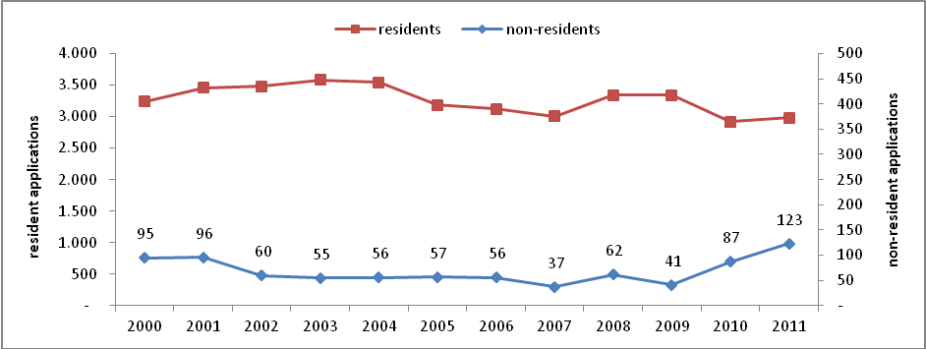

Source: INPI’s Statistical database (BADEPI)

## Utility Model applications by technological fields

Figure 4.10 shows total utility model applications, during the period of 2000-2011, broken down by technological sectors[25]. It shows that, together, the sectors of mechanical engineering and of other fields accounted for the highest shares in total applications, with almost 75%. The areas in which residents predominate in patents differ from areas in which utility models are more expressive. In other words, the form of protection is specific to the characteristics of the sector. For example, the chemistry sector has an important concentration in patents (30% of the total), while in terms of utility models it represents only 6%.

When looking at the fields separately, the five most important fields were “furniture, games”, “handling”, “other consumer goods”, “civil engineering” and “transport”.

Figure 4.10: Utility models by technological sectors, 2000-2011

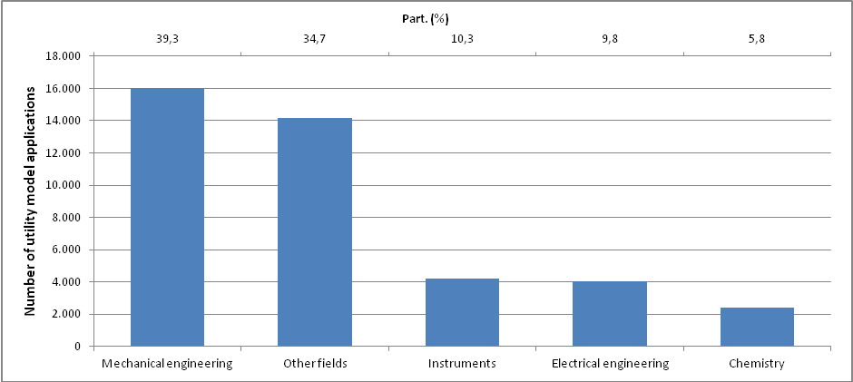

Source: INPI’s Statistical database (BADEPI)

## Utility Model applications by applicants' type

Figure 4.11 presents Brazilian applications classified according to the type of applicant: companies, universities and individuals[26]. It shows that individuals play an important role in UM applications; companies, however, have increased their participation during the period. Since utility models are used primarily as an instrument to protect adjustments made ​​into products to adapt them to the Brazilian market, universities are not representative. However, individuals account for larger shares than in patent applications as showed before. This may be an indicative of the fact that UM applications, comparing to patent applications, are more used by micro, small and medium enterprises, the owners of which usually prefer to register the UM in their own name.

Figure 4.10: Utility models by type of applicant, 2000-2011

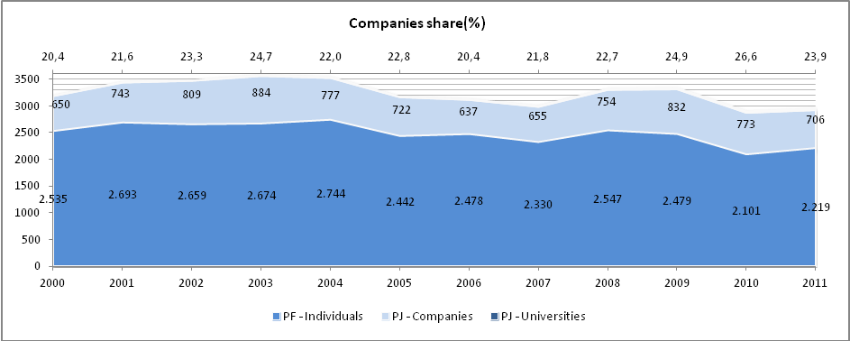

Source: INPI’s Statistical database (BADEPI)

## Resident utility model applications by economic sector

Concerning only resident companies, utility model applications can be broken down by economic sectors according to version 2.0 of the National Classification of Economic Activities (CNAE), which follows the same methodology as International Standard Industrial Classification of all Economic Activities (ISIC Rev.4). Data, however, are not available for all resident companies[27].

Table 4.5 shows that most of the utility model applications are related to industrial sectors, such as: “manufacture of machinery and equipment”, “manufacture of fabricated metal products”, “manufacture of rubber and plastics products”, “manufacture of electrical equipment” and “manufacture of motor vehicles, trailers and semi-trailers”.

Table 4.5: Utility model applications by economic sector (ISIC Rev.4) , 2006/2011

|  |  |  |  |  |
| --- | --- | --- | --- | --- |
| **Economic sector** | **2006** | **%** | **2011** | **%** |
| **Total** | 650 | 100,0% | 737 | 100,0% |
| Manufacture of machinery and equipment n.e.c. | 71 | 10,9% | 94 | 12,8% |
| Manufacture of fabricated metal products, except machinery and equipment | 66 | 10,2% | 42 | 5,7% |
| Manufacture of rubber and plastics products | 45 | 6,9% | 40 | 5,4% |
| Manufacture of electrical equipment | 37 | 5,7% | 34 | 4,6% |
| Manufacture of motor vehicles, trailers and semi-trailers | 26 | 4,0% | 31 | 4,2% |
| Wholesale trade, except of motor vehicles and motorcycles | 29 | 4,5% | 28 | 3,8% |
| Other manufacturing | 45 | 6,9% | 26 | 3,5% |
| Education | 10 | 1,5% | 25 | 3,4% |
| Manufacture of furniture | 17 | 2,6% | 17 | 2,3% |
| Retail trade, except of motor vehicles and motorcycles | 27 | 4,2% | 14 | 1,9% |

Source: INPI, BADEPI

## Utility Model Grants

Brazil granted, in the period 2000-2011, 4,007 Utility Models, of which 3,799 for residents and 208 for non-residents. Their distribution in the period decreased from 427 grants in 2000 to 355 in 2002, recovering in 2003 with 465 grants. It oscillated until 2007, with 197 grants. Thereafter, grants rose to around 350 to 360 per year between 2008 and 2011. It is noteworthy that in this period resident applicants had a share of 95% of all granted utility models.

Table 4.6: Utility Model Grants, 2000-2011

|  |  |  |  |
| --- | --- | --- | --- |
| Year | Resident | Non-Resident | Total |
| 2000 | 403 | 24 | 427 |
| 2001 | 310 | 12 | 322 |
| 2002 | 336 | 19 | 355 |
| 2003 | 437 | 28 | 465 |
| 2004 | 246 | 12 | 258 |
| 2005 | 339 | 21 | 360 |
| 2006 | 256 | 14 | 270 |
| 2007 | 185 | 12 | 197 |
| 2008 | 277 | 10 | 287 |
| 2009 | 335 | 21 | 356 |
| 2010 | 343 | 18 | 361 |
| 2011 | 332 | 17 | 349 |

Source: INPI’s Statistical database (BADEPI)

# 5 - Industrial designs

Data reported in this section refer to industrial design applications and registrations in Brazil. As an industrial design can have multiple applicants and multiple authors, data reported here take into consideration only the first applicant in order to determine the origin of the application.

Figure 5.1 shows the total number of industrial design applications filed in Brazil from 2000 to 2011. The long-term trend shows a significant growth in industrial design applications over this period. The number of applications increased 89%, from around 3,610 in 2000 to 6,835 in 2011.

However it is interesting to note that the growth was not continuous. The total number of industrial design applications filed in Brazil grew strongly between 2000 and 2003 (38.4%) than in the period between 2004 and 2007, when the increase was smaller (20%). It was followed by a strong recovery in 2008 (11.7%). In 2009, applications declined 10.8% and then, following a worldwide trend, rebounded strongly in 2010 (13.7%) and 2011 (13%).

Figure 5.1: Industrial design applications, 2000-2011

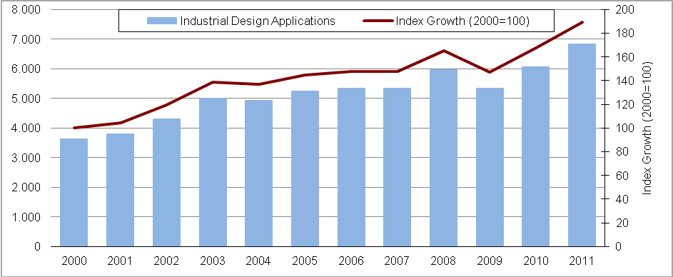

Source: INPI’s Statistical database (BADEPI)

## Industrial designs by origin

Figure 5.2 provides a breakdown of industrial design applications in Brazil by origin of the applicant. A resident application is defined here as an application filed at INPI by an applicant residing in Brazil when he is listed as the first applicant.

The 6,835 applications filed in 2011 consisted of 4,364 resident and 2,471 non-resident applications. Compared to 2000, the number of non-resident applications grew strongly and almost tripled in 2011 (175%), while resident applications also grew but by a more modest rate (62%).

Figure 5.2: Industrial design applications by origin, 2000-2011

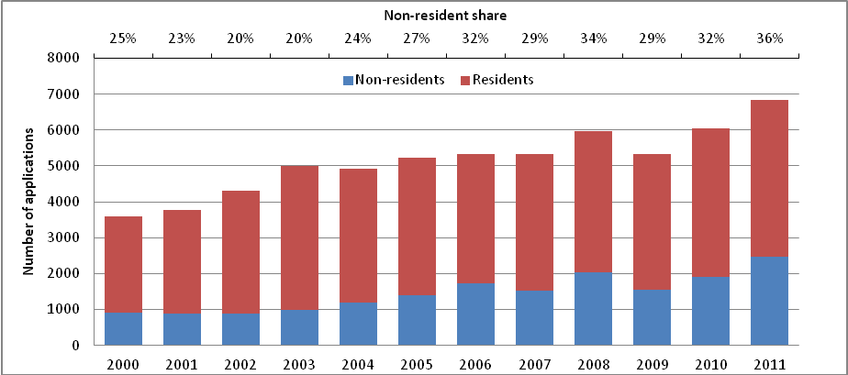

Source: INPI’s Statistical database (BADEPI)

Figure 5.2 also shows that industrial design applications in Brazil had an increase of the non-resident's share during the period. The applications filed in 2000 consisted of 25% non-resident and 75% resident applications, while, in 2011, they consisted of 36% non-resident and 64% resident applications. Comparing to World Intellectual Property Indicators 2012[28], the share of applications for non-residents in Brazil in 2011 was above the world average of 10.9%, and below that occurred in offices such as Australia, Mexico and Russia, where non-resident applications accounted for the majority of industrial designs.

Figure 5.3: Industrial design applications by country of origin, 2000/2011

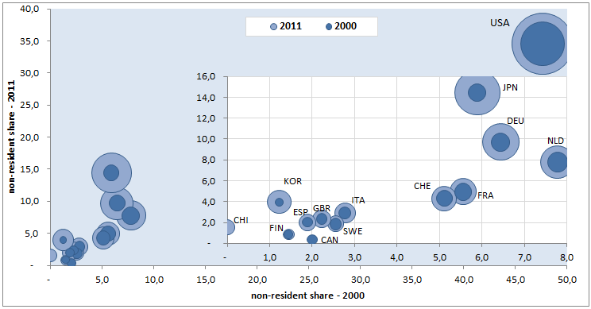

Source: INPI’s Statistical database (BADEPI)

## Industrial designs by non-residents

Concerning non-resident applications in Brazil broken down by country of origin of the first applicant, a relatively small number of countries explain the substantial growth of applications between 2000 and 2011. Applicants from the United States accounted for the most substantial growth of non-resident applications (27%), but lost its relative importance. In 2000, with 433 applications, they accounted for 47.8% in total non-resident applications; in 2011, with 854 applications, the number of applications grew by 99% but reduced its share (34.5%).

Residents from Japan accounted for 19% of the growth of non-resident applications and had a strong increase of 574% between 2000 and 2011. In 2000, residents from Japan filed 53 (5.9% of total non-residents) and in 2011 filed 357 industrial design applications (14.4%).

Table 5.1 Industrial design applications by state of origin of residents, 2000/2011

|  |  |  |  |  |  |  |
| --- | --- | --- | --- | --- | --- | --- |
| **Region** | **State** | **2000** | **Share(%)** | **2011** | **Share(%)** | **Var.Abs.** |
| Southeast | Espírito Santo | 4 | 0.1 | 45 | 1.0 | 41 |
| Minas Gerais | 159 | 5.8 | 342 | 7.8 | 184 |
| Rio de Janeiro | 141 | 5.2 | 133 | 3.0 | -8 |
| São Paulo | 1.349 | 49.7 | 2.129 | 48.8 | 785 |
| South | Paraná | 304 | 11.2 | 427 | 9.8 | 124 |
| Rio Grande do Sul | 357 | 13.1 | 547 | 12.5 | 192 |
| Santa Catarina | 181 | 7.0 | 316 | 7.2 | 126 |
| Northeast | Alagoas | 0 | 0.0 | 11 | 0.3 | 11 |
| Bahia | 20 | 0.7 | 40 | 0.9 | 20 |
| Ceará | 106 | 3.9 | 227 | 5.2 | 122 |
| Maranhão | 3 | 0.1 | 2 | 0.0 | -1 |
| Paraíba | 1 | 0.0 | 16 | 0.4 | 15 |
| Pernambuco | 9 | 0.3 | 32 | 0.7 | 23 |
| Piaui | 0 | 0.0 | 0 | 0.0 | 0 |
| Rio Grande do Norte | 7 | 0.3 | 4 | 0.1 | -3 |
| Sergipe | 2 | 0.1 | 2 | 0.0 | 0 |
| North | Acre | 0 | 0.0 | 0 | 0.0 | 0 |
| Amazonas | 5 | 0.2 | 43 | 1.0 | 38 |
| Amapá | 0 | 0.0 | 0 | 0.0 | 0 |
| Pará | 2 | 0.1 | 3 | 0.1 | 1 |
| Rondônia | 8 | 0.3 | 6 | 0.1 | -2 |
| Roraima | 0 | 0.0 | 0 | 0.0 | 0 |
| Tocantins | 0 | 0.0 | 0 | 0.0 | 0 |
| Central West | Distrito Federal | 12 | 0.4 | 17 | 0.4 | 5 |
| Goiás | 14 | 0.5 | 15 | 0.3 | 1 |
| Mato Grosso do Sul | 4 | 0.1 | 4 | 0.1 | 0 |
| Mato Grosso | 3 | 0.1 | 3 | 0.1 | 1 |
| Not identified | |  | 13 | 0.5 | 0 | 0.0 |
| Total | | 2.704 | 100 | 4.364 | 100 |  |

Source: INPI’s Statistical database (BADEPI)

Germany also had an important contribution to the growth of total applications by non-residents (11.6%) and had a strongly increase of 314% in the period. In 2000, residents from Germany filed 58 applications (6.4% of total non-residents), while in 2011 they filed 240 applications (9.7%).

Other countries that had a relevant share of industrial design applications in Brazil are Netherlands, France, Switzerland and Republic of Korea.

## Industrial designs by Brazilian states

Concerning resident applications in Brazil broken down by state of origin of the first applicant, states from Southeast and South Regions represented 90% of resident applications during the period of 2000 to 2011. Almost all of them showed an increase in the number of applications (the only exception was Rio de Janeiro). Applicants from the Northeast Region accounted for just 5% of total resident applications and North and Central West region for 1% each.

Applicants from São Paulo were the most representative during the period and accounted for nearly all the growth of resident applications, however presented a small loss of its share: from 1,344 applications in 2000 (49.7%) to 2,129 in 2011 (48.8%). The same occurred with applications from Rio Grande do Sul, which grew from 355 applications in 2000 (13.1%) to 547 applications in 2011 (12.5%), and from Paraná, where applications grew from 303 applications in 2000 (11.2%) to 427 applications in 2011 (9.8%).

## Industrial designs by type of applicant

Concerning all applications (from residents and non-residents), applicants can be divided in two types: companies and individuals. Figure 5.4 shows that individuals are the main applicants and that their participation grew during the period. In 2000, individuals accounted for 2,479 applications (68.8% of total applications), while in 2011 individuals filed 5,176 industrial design applications (75.7%).

Concerning only resident companies, applications can be broken down by economic sector according to the 87 activities (from agriculture, industry and services) of version 2.0 of the National Classification of Economic Activities (CNAE), which follows the same methodology of the International Standard Industrial Classification of all Economic Activities (ISIC Rev.4). Data, however, are not available for all resident companies[29].

For the companies for which data are available, “manufacture of leather and related products” was the largest sector, accounting for 23.1% in 2011 (compared to 10.3% in 2006), followed by the sectors of “manufacture of electrical equipment” (8.9%), “manufacture of motor vehicles, trailers and semi-trailers” (8.8%) and “manufacture of rubber and plastics products” (8.2%). It is interesting to note that “manufacture of fabricated metal products, except machinery and equipment”, which accounted for 9.3% of applications from resident companies in 2006, lost its importance (relative and absolute).

Figure 5.4: Industrial design applications by type of applicant, 2000-2011

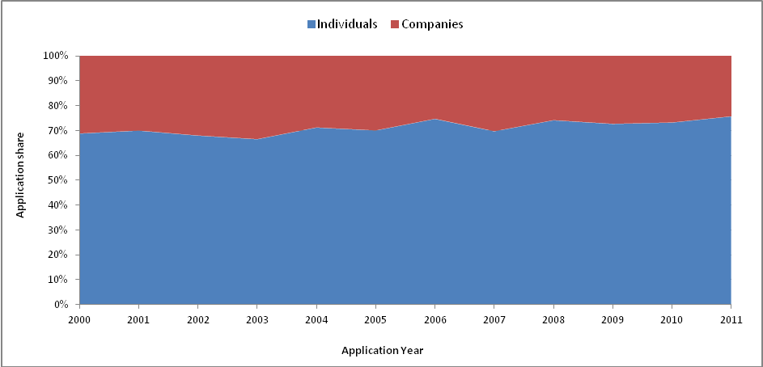

Source: INPI’s Statistical database (BADEPI)

Table 5.2: Industrial design applications by economic sectors (ISIC Rev.4), 2006/2011

|  |  |  |  |  |  |
| --- | --- | --- | --- | --- | --- |
| **Economic Activities** | | **2006** | **%** | **2011** | **%** |
| **Total** | | 1,353 | 100% | 1,565 | 100% |
| 15 | Manufacture of leather and related products | 140 | 10.3% | 362 | 23.1% |
| 27 | Manufacture of electrical equipment | 67 | 5.0% | 139 | 8.9% |
| 29 | Manufacture of motor vehicles, trailers and semi-trailers | 94 | 6.9% | 138 | 8.8% |
| 22 | Manufacture of rubber and plastics products | 113 | 8.4% | 129 | 8.2% |
| 32 | Other manufacturing | 86 | 6.4% | 119 | 7.6% |
| 46 | Wholesale trade, except of motor vehicles and motorcycles | 74 | 5.5% | 98 | 6.3% |
| 47 | Retail trade, except of motor vehicles and motorcycles | 62 | 4.6% | 89 | 5.7% |
| 28 | Manufacture of machinery and equipment | 71 | 5.2% | 86 | 5.5% |
| 31 | Manufacture of furniture | 93 | 6.9% | 72 | 4.6% |
| 25 | Manufacture of fabricated metal products, except machinery and equipment | 126 | 9.3% | 58 | 3.7% |
| 20 | Manufacture of chemicals and chemical products | 35 | 2.6% | 38 | 2.4% |

Source**:** INPI’s Statistical database (BADEPI)

## Industrial design registrations

Figure 5.5 shows the number of industrial design registered at INPI-Brazil from 2000 to 2011. Similar to applications, the number of registrations issued each year shows a strong, but not continuous, growth over this period. The number of applications grew rapidly, from 2,815 in 2000 to 5,451 in 2003 (93.6), then had a sharp decline until 2007. Since then, it oscillated without recovering the number of registrations reached in 2003.

The number of resident registrations increased from 1,934 in 2000 to 3,348 in 2011, while non-resident registrations increased from 840 in 2000 to 1,298 in 2011. This means that, despite its largest increase in absolute terms, the share of residents in total registrations issued fluctuated slightly around 70% each year.

Figure 5.5: Industrial design registrations, 2000-2011

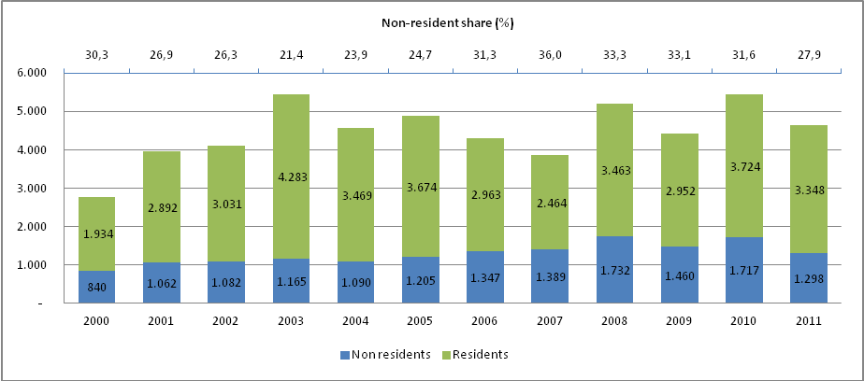

Source: INPI’s Statistical database (BADEPI)

# 6 Trademarks

## Trademark applications

In the last thirteen years, the demand for protection of trademarks in Brazil had a significant growth, expressed by an upward trend in the number of applications. Comparing the years 2000 and 2012, Figure 6.1 shows that trademark applications increased about 40%, suggesting a growing interest of firms and individuals in enjoying the protection granted by the registration of their trademarks against unauthorized third parties. Between 2000 and 2004, the number of trademark applications declined 13%, from 108,231 to 94,040. After that, the number of applications returned its growth, reaching 151,711 applications in 2012.

Figure 6.1: Trademark applications, index (2000=100), 2000-2012

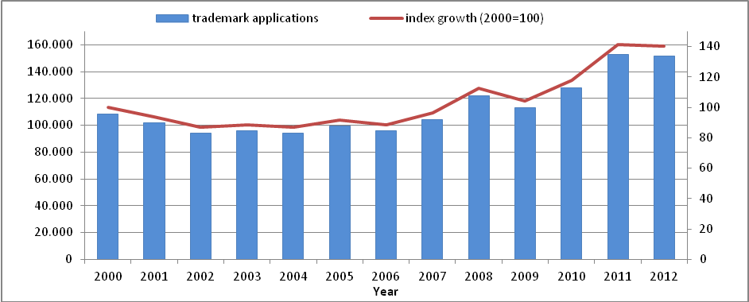

Source: INPI’s Statistical database (BADEPI, April 2013)

This growth may be partially explained by the implementation of the "e-Marcas" system in 2007, which offers the option of applying for a trademark through a fully on-line platform.

Figure 6.1 shows the change in the curve of applications since 2007, when the number of trademark applications was over 100,000.

Figure 6.1 also shows that the demand for trademark protection was cyclical between 2005 and 2012, with peaks of growth in 2005 (5.6%), 2007 (8.7%), 2008 (17.0%) and 2011 (19.6%). This behavior of the trademark applications' curve illustrates an intensification of the demand in the second half of the period.

## Trademarks by nature

Trademark applications for goods and services accounted for almost all of the deposits. Collective and certification marks were not representative. Until 2003, trademarks for products represented the majority of the requests. Afterwards, the demand for services trademarks changed the pattern of application (see Figure 6.2), with services trademarks growing faster than trademarks for goods. In the period of 2000 to 2012, applications for services trademarks grew 62,2%, while for products the growth was of 18,7%, .

Figure 6.2: Trademark applications by nature, 2000-2012

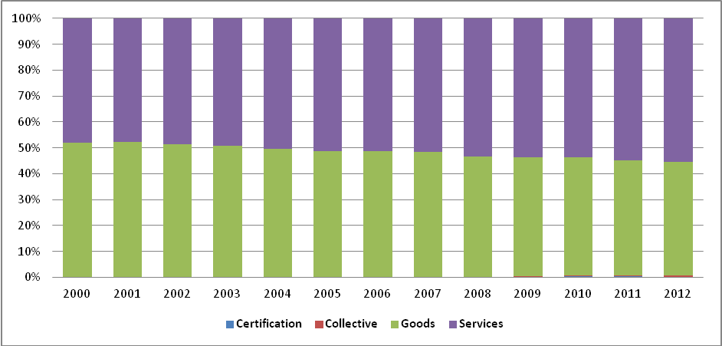

Source: INPI’s Statistical database (BADEPI, April 2013)

## Trademarks by type

Concerning the type, most of the applications filled consisted of mixed trademarks, that is, signals composed of both word and figurative elements, as illustrated by Figure 6.3. Their relative share increased from 51%, in 2000, to 63%, in 2012. Nominative marks also occupy an important position, despite the decline of their participation: from 46%, in 2000, to 34%, in 2012. The share of other types – figurative and three-dimensional trademarks – is not representative, accounting for less than 5% of applications.

Figure 6.3: Trademark applications by type, 2000-2012

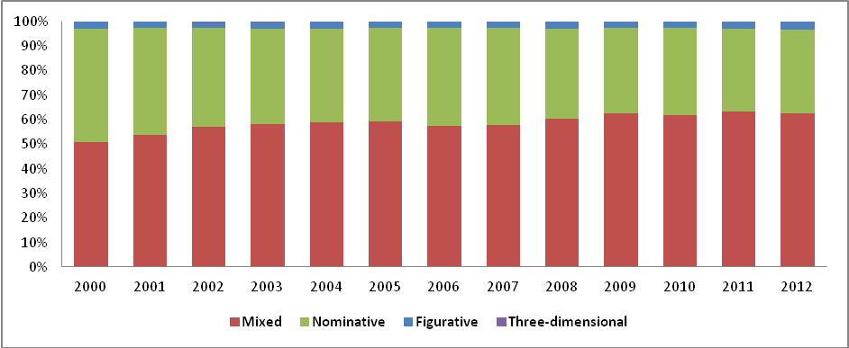

Source: INPI’s Statistical database (BADEPI, April 2013)

## Trademarks by origin

Throughout the period, most applications were from residents (83%), as illustrated by Figure 6.4. The participation of non-residents declined between 2000 (20%) and 2004 (15%), increased again in 2005 and following since then an upward trajectory. Their share of total applications therefore grew, reaching 21% in 2012, surpassing the level of 2000, with an increase also in the number of applications in absolute terms.

Figure 6.4: Trademark applications by origin, 2000-2012

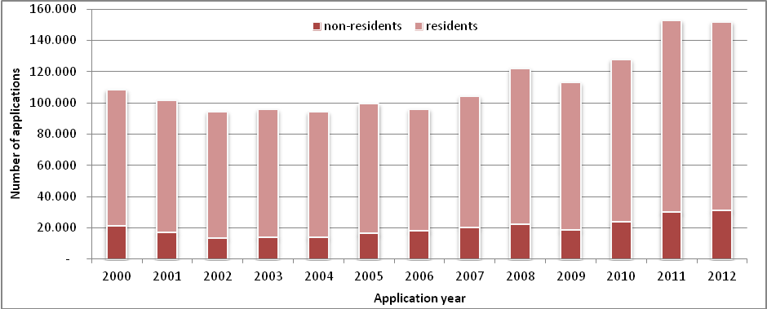

Source: INPI’s Statistical database (BADEPI, April 2013**)**

Table 6.1: Trademark applications by resident companies, micro and small-companies' share, 2000-2012

|  |  |  |  |  |  |  |
| --- | --- | --- | --- | --- | --- | --- |
| Year | Size of the companies | | | | |  |
| Micro | Small | Other classification | Not classified | Total | Part. micro and small |
| 2000 | 16,244 | 10,881 | 47,186 | 8,519 | 82,830 | 32,75% |
| 2001 | 17,077 | 11,308 | 45,871 | 6,164 | 80,420 | 35,30% |
| 2002 | 17,644 | 11,107 | 43,372 | 4,327 | 76,450 | 37,61% |
| 2003 | 19,151 | 11,410 | 43,735 | 2,881 | 77,177 | 39,60% |
| 2004 | 19,739 | 10,984 | 43,104 | 1,556 | 75,393 | 40,75% |
| 2005 | 20,906 | 11,221 | 45,368 | 900 | 78,395 | 40,98% |
| 2006 | 19,614 | 10,100 | 42,361 | 740 | 72,815 | 40,81% |
| 2007 | 21,318 | 10,629 | 44,120 | 857 | 76,924 | 41,53% |
| 2008 | 26,291 | 12,532 | 52,049 | 739 | 91,611 | 42,38% |
| 2009 | 27,331 | 11,372 | 45,802 | 934 | 85,439 | 45,30% |
| 2010 | 29,795 | 12,091 | 50,295 | 1,891 | 94,072 | 44,52% |
| 2011 | 36,567 | 13,733 | 55,494 | 3,859 | 109,653 | 45,87% |
| 2012 | 32,094 | 11,436 | 46,946 | 14,420 | 104,896 | 41,50% |

Source: INPI’s Statistical database (BADEPI, April 2013**)**

Resident applicants may be divided in individuals and companies. Table 6.1 shows that since 2003, about 40% or more of the companies applying for registration are micro or small enterprises, according to the classification of the Brazilian Institute of Geography and Statistics-IBGE[30].

Figure 6.5: Trademark applications by country, 2000-2012

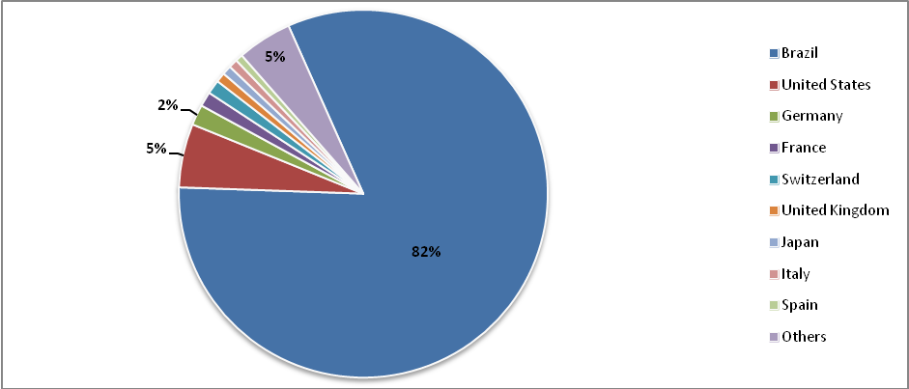

Source: INPI’s Statistical database (BADEPI, April 2013)

## Trademarks by country of origin

Concerning applications broken down by country of origin, non-residents applications accounted for 18% during the period. Figure 6.5 presents the share of applications from the countries that were the most representative: United States (5%), Germany (2%) and France, Switzerland, United Kingdom, Japan, Italy and Spain (1% each).

## Trademarks by Brazilian states

Figure 6.6 shows that, between 2000 and 2012, the distribution of applications by state was concentrated in two groups: the first is composed by the states of São Paulo (SP), Minas Gerais (MG) and Rio de Janeiro (RJ), all located in the southeastern region, with approximately 60% of applications; in the second group come the States of Paraná (PR), Rio Grande do Sul (RS) and Santa Catarina (SC), from the south region, representing 20% of applications. The similarity between the regional profile of trademark and the distribution of wealth in the country can be observed when comparing the participation of these States in Brazil's GDP in 2012, according to data from the Brazilian Institute of Geography and Statistics-IBGE. São Paulo (SP), Rio de Janeiro (RJ) and Minas Gerais (MG) generated, together, around 50% of Brazil's GDP, while Paraná (PR), Rio Grande do Sul (RS) and Santa Catarina (SC) participated with approximately 16%.

Figure 6.6: Trademark applications by state of origin, 2000-2012

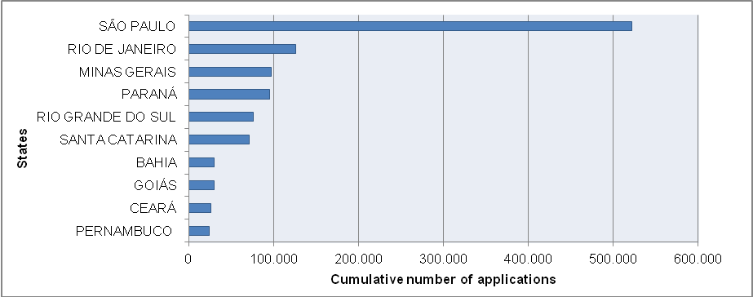Source: INPI’s Statistical database (BADEPI, April 2013)

## Trademarks by products and services classification

The analysis of the applications by classes of products and services, established by the Nice Classification, allows the establishment of a sectorial pattern of the applications. Figure 6.7 shows the distribution by sector of accumulated applications between 2000 and 2012. In the case of trademarks for products, the following classes may be highlighted: class 3 (cleaning products, cosmetics, perfumes, etc.), class 5 (medicines, pharmaceutical and veterinary products, dietetic food, products for medicinal or veterinary use, etc.), class 9 (computers, computer programs, apparatus for recording, transmitting or reproducing sound and images, telephone devices, etc.), class 16 (paper, printed material, stationery, etc.), class 25 (clothing) and class 30 (staple foods).

In the case of service marks, there is a concentration of applications in class 35, which includes marks of services related to the trade of goods, as well as trademarks of advertising and business management services. Class 41 appears as the second most demanded, used mainly in the areas of education, entertainment and sporting and cultural activities. Class 42 follows as the third most demanded, which includes technological and scientific services, scientific research and software development services.

In fact, the distribution of applications of marks to distinguish products and services appears relatively balanced, since, between 2000 and 2012, the marks for products represented about 48% of applications, while marks for services represented around 52%.

However, the distribution of applications by product or service has changed, from a predominance of the classes of products, in 2004, to a balanced distribution among trademark for products and for services. From 2005 onwards, the demand for service marks had an upward trend, as illustrated by Figure 6.8.

The ranking of the ten most demanded classes between 2000 and 2012 ratifies the trend regarding service marks, as provided in Table 6.2.

Additionally, using a methodology developed by WIPO, it is possible to identify the main sectors of economic activity in which trademarks are applied for in Brazil. By this method, the Nice classes are associated with different economic activities, with the following configuration: Food products and services – classes 29, 30, 31, 32, 33, 43; Chemicals – classes 1, 2, 4; Construction, infrastructure – classes 6, 17, 19, 37, 40; Household equipment – classes 8, 141, 20, 21; Education, training and leisure -classes 13, 15, 16, 28, 41; Financial services and real estate, business management, advertising - class 35; Health products and services; Cosmetics; Veterinary products – classes 3, 5, 10, 44; Information technology and scientific research – classes 9, 38, 42, 45; Textiles, apparel and clothing accessories – classes 14, 18, 22, 23, 24, 25, 26, 27, 34; Transport and logistics – classes 7, 12, 39.

Figure 6.7: Trademark applications by Nice Classes, 2000-2012

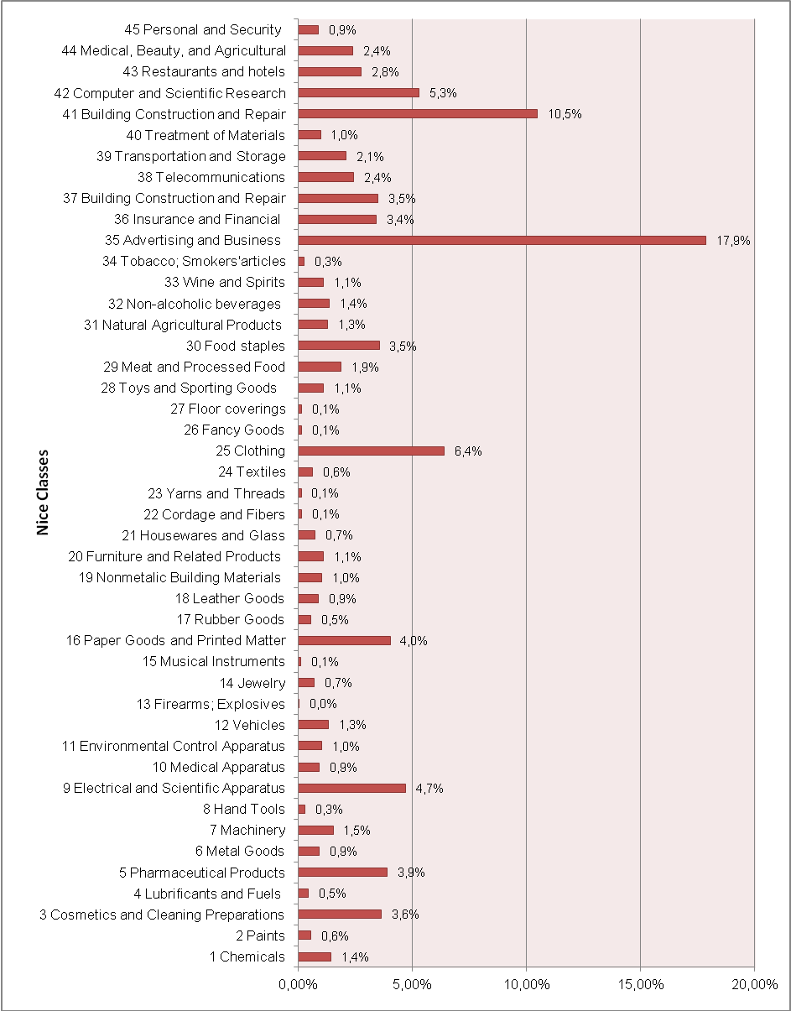

Source: INPI’s Statistical database (BADEPI, April 2013)

Figure 6.8: Trademark applications by products and services classes, 2000-2012

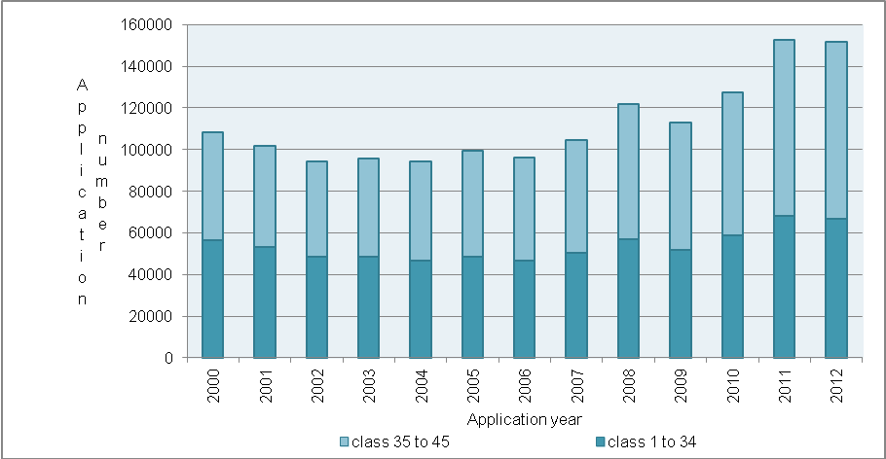

Source: INPI’s Statistical database (BADEPI, April 2013)

Table 6.2: Top 10 Nice classes – Trademarks, 2000-2012

|  |  |  |  |
| --- | --- | --- | --- |
| Rank | Nice class | Number of applications | Share |
| 1 | 35 – Advertising and Business | 260.645 | 17,86% |
| 2 | 41- Education; Entertainment | 152.866 | 10,47% |
| 3 | 25 - Clothing | 93.516 | 6,41% |
| 4 | 42 – Computer and Scientific Research | 77.102 | 5,28% |
| 5 | 9 – Eletrical and Scientific Apparatus | 68.739 | 4,71% |
| 6 | 16 – Paper Goods and Printed Matter | 58.715 | 4,02% |
| 7 | 5 – Pharmaceutical Products | 56.837 | 3,89% |
| 8 | 3 – Cosmetics and Cleaning Preparations | 53.051 | 3,64% |
| 9 | 30 – Food Staples | 51.772 | 3,55% |
| 10 | 37 – Building Construction and Repair | 51.046 | 3,50% |
| Total | | 924.289 | 63,33% |

Source: INPI’s Statistical database (BADEPI, April 2013)

Figure 6.9 provides a division of the main sectors of activities that applied for trademarks in the period of 2000 to 2012.

As shown in Figure 6.9, the most important group of activities in terms of volume of applications belongs to the service sector. The financial services industry and real estate, business management and advertising represented, on average, about 21 percent of the deposits in the period under analysis.

In the case of Brazil, it is necessary to take into account the fact that class 35 includes trademarks designed to services that act in the trade of goods. This segment comprises not only large retail companies that have physical and/or virtual stores, but also hypermarkets, supermarkets and smaller companies, many of which produce their own brands as a way to differentiate their services in a competitive sector.

Figure 6.9: Trademark applications by economic activities, 2000-2012

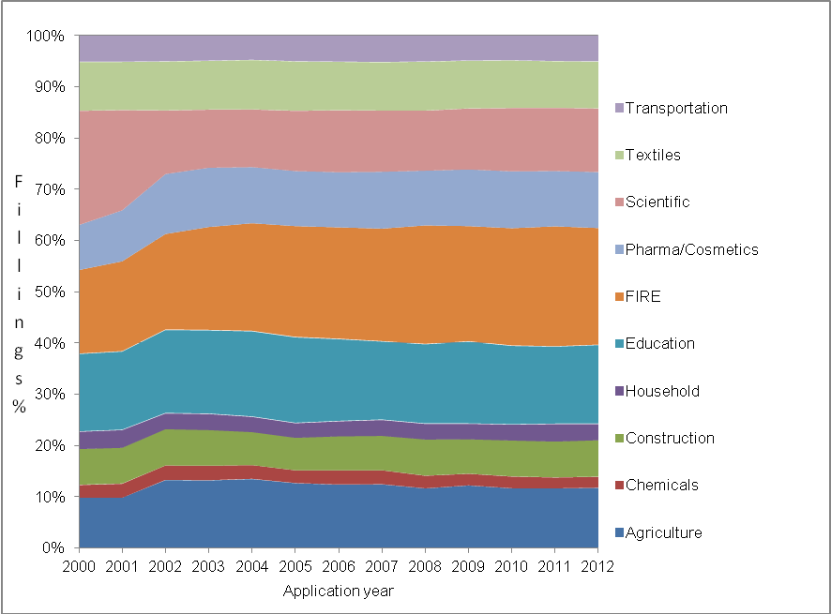

Source: INPI’s Statistical database (BADEPI, April 2013), Notes: FIRE = Finance, insurance, and real state.

Table 6.3: Top 10 applicants - Trademarks, 2012

|  |  |  |  |  |
| --- | --- | --- | --- | --- |
| Rank | Name | Number of applications | Main Activity | Origin |
| 1 | Disney Enterprises, Inc. | 403 | Education; training; culture; leisure | US |
| 2 | Comité International Olympique | 348 | Sports activities; trade in products and services related to the Olympic Games | FR |
| 3 | Fast Shop Comercial Importadora e Exportadora Ltda. | 347 | Trade in home appliances, housewares, computer equipment, telephony | BR/SP |
| 4 | Maxmix – Produtos de Beleza Ltda. | 342 | Trade in cosmetics and Perfumery | BR/SP |
| 5 | Globosat Programadora Ltda. | 273 | Entertainment; information; leisure; cable TV | BR/RJ |
| 6 | Federation of passenger transport undertakings of the State of Rio de Janeiro-Fetranspor | 204 | Transports | BR/RJ |
| 7 | Fédération Internationale de Football Association (FIFA) | 199 | Sports activities; trade in products and services related to Football | CH |
| 8 | Minvest S.A. | 197 | Financial services; import and export of products and services in the field of vehicles and machinery, | CL |
| 9 | TVSBT 4 Channel of São Paulo S/A | 178 | Telecommunications; broadcasting; pay TV | BR/SP |
| 10 | Send – Empreendimentos e Participações Ltda. | 168 | Real estate | BR/SP |
|  | **Total**  **Residents**  **Non-Residents** | **2,659**  **1,512**  **1,147** |  |  |

Source: INPI’s Statistical database (BADEPI, April 2013)

The sectors of education, training and leisure (classes 16 and 41) represent on average 16% of the deposits. In this segment, companies seeking trademark protection include not only educational institutions such as universities and educational institutes, but also those dedicated to cultural activities, such as theaters, television and book publishing.

The sector of IT and scientific research appears as the third with most applicants. In this case, it includes classes of products and services related to information technology, scientific research and protection services to individuals and to the patrimony.

Additionally, it is possible to identify the main resident and non-resident applicants. This ranking is led by Disney, a traditional American company dedicated to entertainment segment, the 14th most valuable brand in the world, according to research “Interbrand – Best Global Brands 2013”. Other important non-resident applicants are those organizations linked to sporting activities, since Brazil was the host of several international events such as the 2007 Pan American Games and the 2013 Confederations' Cup, as well as the 2014 World Cup and the 2016 Rio Olympic Games.

It is important to mention that three of the Top 10 applicants operate with the trade of goods. In this group, the fourth position is occupied by Maxmix – Produtos de Beleza Ltda., a Brazilian company from the cosmetic and perfumery sector, a very dynamic activity in Brazil.

## Trademark registrations

Figure 6.10 shows that the number of trademark registrations has tripled in the period in question. Administrative efforts undertaken by INPI explain the good performance in 2006, when the granting of marks doubled, with an increase of 598% in relation to the previous year.

After this atypical time, the number of trademark registrations passed from an annual average of 16.300, in the period 2000-2005, to 60.900 in the period 2008-2012. For applicants, this was an important administrative improvement, considering that the time for obtaining protection of a trademark is minimized.

Figure 6.10: Trademark registrations, index (2000=100), 2000-2012

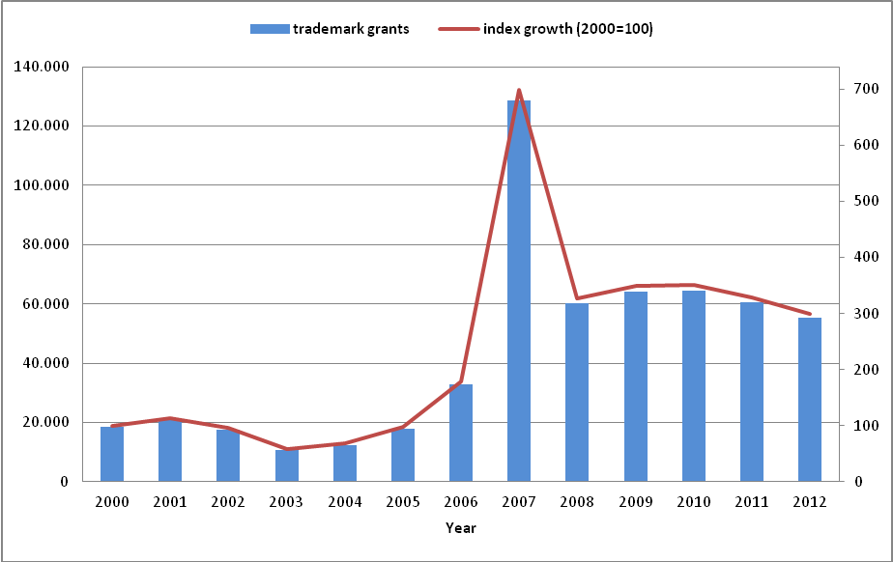

Source: INPI’s Statistical database (BADEPI, April 2013)

Finally, it is important to highlight that a mark is an important component of business value, as part of the intangible assets of a company. The data presented here show that, in Brazil, trademarks are the form of IPR more intensively used, mainly among resident applicants. On the other hand, the Top 10 Nice Classes reveals that trademarks have been widely used across many different sectors of the economy.

# 7 Technology Contracts

The number of contracts submitted for registration in INPI depends on the behavior of another variables such as, for example, foreign technology acquisitions by resident companies, investment projects for expansion and modernization of production capacity in Brazil, and the flow of foreign direct investment to the country. The number of registered contracts is also influenced by changes in the relationship and the business models of resident and international companies that involve new contracts.

Between 2000 and 2012, the total number of new contracts registered in INPI increased by 2%, from 1,212 to 1,238. This small increase occurred after a year-on-year fluctuation. The beginning of the period was marked by more substantial fluctuations: a growth of 12% in registration in the first year was followed by a drop of 27% in the next two years. Since 2004, the number of registered new contracts had smaller changes, fluctuating around 1,000 per year. In the last two years, the number of new contracts increased (25%) and recovered its level when compared to 2000.

Figure 7.1: Number of Contracts Registered in INPI

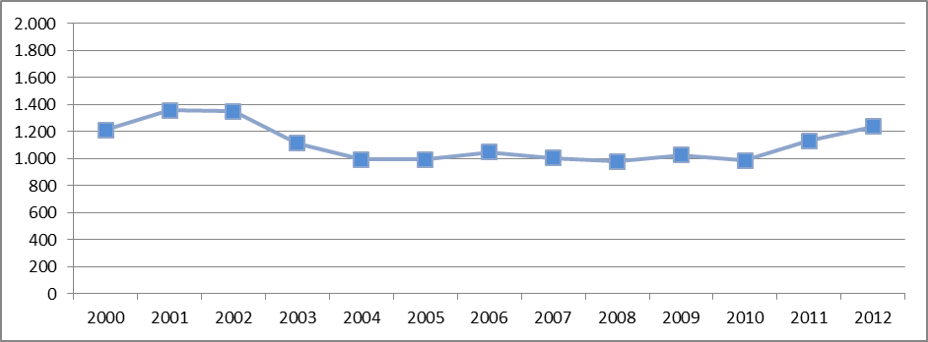

Source: INPI, Directory of Contracts, Geographical Indications and Registers, Coordinator-General for Technology Contracts.

Table 7.1: Number of Contracts Registered by Type, 2000-2012

|  |  |  |  |  |  |
| --- | --- | --- | --- | --- | --- |
| Registered Year | Between  non-residents | Between  residents | Export | Import | Total |
| 2000 | 11 | 79 |  | 1.122 | 1.212 |
| 2001 | 11 | 63 | 1 | 1.284 | 1.359 |
| 2002 | 12 | 56 | 1 | 1.282 | 1.351 |
| 2003 | 21 | 50 | 2 | 1.039 | 1.112 |
| 2004 | 7 | 47 | 1 | 937 | 992 |
| 2005 | 11 | 52 | 2 | 930 | 995 |
| 2006 | 8 | 77 |  | 964 | 1.049 |
| 2007 | 13 | 63 | 1 | 928 | 1.005 |
| 2008 | 11 | 85 | 1 | 882 | 979 |
| 2009 | 13 | 57 | 1 | 955 | 1.026 |
| 2010 | 12 | 76 | 3 | 896 | 987 |
| 2011 | 14 | 100 |  | 1.017 | 1.131 |
| 2012 | 4 | 92 | 3 | 1.139 | 1.238 |

Source: INPI, Directory of Contracts, Geographical Indications and Registers, Coordinator-General for Technology Contracts.

## Technological contracts by business type

Contracts related to foreign technology or IPR accounted, on average, for 90% of the total, while internal contracts (between residents) accounted for an average of 6%. External contracts (between non-residents) and contracts for technology exports were not significant.

It is important to clarify that the data organized by the INPI should be considered representative for international business only when they are signed between residents and companies domiciled abroad and they intend to "import" technology. The INPI data, however, are not representative for international business when they are signed by residents and non-residents for the "exportation" of technology, or they are between residents.

The information provided by INPI does not involve all the business with intangible assets and franchises in the country, because the registration of technology and franchise contracts among Brazilian companies is not mandatory. Registration of the contract is required in order to have valid effects on third parties, to allow the enforceability of its effects beyond the agreement between the parties and to allow tax deduction of net income duties. Thus, the fact that most contracts refer to imported technology is due both to the mandatory registration in INPI of contracts involving the payment of royalties and to the non-mandatory registration of contracts between residents.

Figure 7.2: Number of Contracts by contractual arrangements, 2000-2012



Source: INPI, Directory of Contracts, Geographical Indications and Registers, Coordinator-General for Technology Contracts.

## Technological contracts by contractual arrangement

It is observed that, among contracts for technology imports, the provision of technical assistance services accounted for the largest portion of the total contract endorsed, although its share has declined over the period (from 74% in 2000 to 65% in 2012). The large share of services in the contracts registered by the INPI is explained by the importance of the sector of machinery and equipment for the innovative activities in Brazil, as proposed by the Technological Innovation Survey (PINTEC).

Among the other types of contracts, Trademark Licensing and Franchising contracts increased their participation over the period, from 12% of total registrations in 2000 to 22% in 2012, while contracts for the supply of technology (Know-How Agreements), contracts for the exploitation of patents and industrial designs and combined modality contracts maintained their share stable, close to 15%.

## Technological contracts by type of royalty

The value of payments made abroad by type of royalties depends on the number of contracts for the licensing of industrial property rights, technology transfer and franchising between resident companies with non-residents. The value of the payments also depends on the terms of these agreements, for example, compensation for the use of intangible assets (that is, the value itself of contract) or payment linked to the performance of the economic exploitation of these assets (e.g., payment of a percentage of net sales). However, it is important to clarify that the payments can be done in different periods, not necessarily at the year of the registration of the contract.

Between 2001 and 2012, the value of foreign payments for royalties and technical assistance, provided by the Central Bank of Brazil, has grown at an average annual rate of 10.5%, which increased the value of payments from about US$ 1 billion in 2001 to US$ 3 billion in 2012. The highest growth rates were recorded in 2007 (49.6%) and 2005 (39.7%).

Considering the payments by contractual arrangement, the highest average growth rates of payments between 2001 and 2012 were related to franchising contracts (32.1%) and licensing of trademarks (28.2%). Payments relating to contracts of exploitation of patents and industrial designs and know-how agreements registered an average growth 15.2% and 10.2% per year, respectively, while the lowest average growth rate was for technical assistance services contracts (3.8%).

The differences in the growth rates of payments made abroad observed also explain the changes in the composition of the payments in the period 2001-2012. The share of trademarks-related payments in total payments increased from 3% to 14%, while franchising contracts increased their share from 1% to 7% and the share of technical assistance fell from 41% to 21%. Lastly, patents contracts increased from 7% in 2001 to 11% in 2002 and Know-How Agreements remained with about 50% of all payments.

Whereas the number of contracts registered at INPI did not change substantively in the period, the growth in the value of payments can be associated mainly to the increase in the value of contracts. We also highlight the continued growth of the Brazilian economy in the period, which influences the payment of performance-related royalties when they are linked to the net sales.

The receipt of royalties and fees for the provision of technical assistance, as well as payments abroad, are related to the number of contracts signed between resident and non-resident companies. This amount is also dependent on the characteristics of the agreements and the results of operations of these intangible assets abroad, as mentioned above.

Between 2001 and 2005, the value of the receipts, calculated by the Central Bank, was very small, ranging between 1% and 3% of the value of foreign payments in the same period. From 2006 onwards, however, the pattern of receipts changed, reaching US$ 716.5 million (about 50% of the value of payments in 2006), and increasing thereafter. Thus, in 2012, total revenues reached US$ 1.37 billion (or 44% of payments).

Figure 7.3: Payments in thousand dollars, 2001-2012

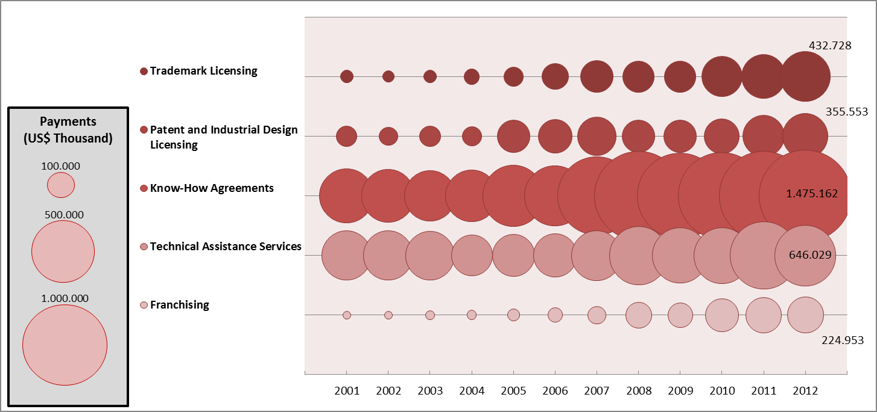

Source: INPI, Directory of Contracts, Geographical Indications and Registers, Coordinator-General for Technology Contracts.

Figure 7.4: Receipts in thousand dollars, 2001-2012

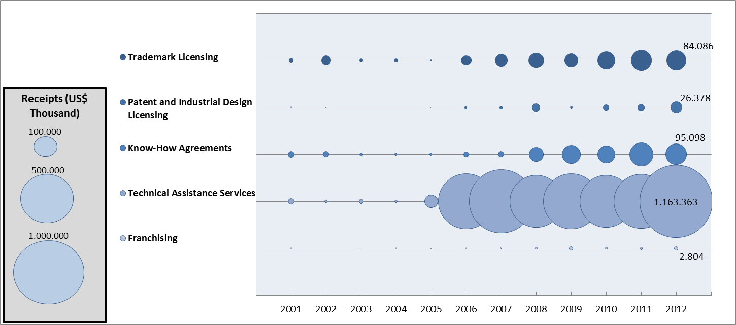

Source: INPI, Directory of Contracts, Geographical Indications and Registers, Coordinator-General for Technology Contracts.

The changing pattern of inflows related to royalties and provision of technical assistance in 2006 and growth of these revenues in the period 2006 to 2012 may be explained mainly by the actions of large international companies, promoted by Brazilian industrial policy. In this context, the credit lines offering special financing created by the National Bank of Economic and Social Development (BNDES) in 2005 for organizing subsidiaries, acquisition of established companies and joint ventures abroad were very relevant.

Another important initiative was the support provided to the internationalization of Brazilian franchise systems promoted by the Brazilian Export Promotion Agency (APEX Brazil), the Brazilian Franchising Association (ABF) and the Ministry of Development, Industry and Foreign Trade (MDIC). The average annual growth of income of royalties related to franchises and trademark licensing between 2006 and 2012 was respectively 45% and 24.5%.

# 8 - Geographical indications

When certain quality and/or traditions of a particular product or service can be attributed to its “place of origin”, a Geographical Indication (GI) may be the key factor to guarantee their protection and market differentiation. In fact, since the adoption of the TRIPS Agreement, which contains a section on GIs, this form of industrial property has attracted increasing attention across the world.[31] This may be attributed to the fact that a Geographical Indication delimits the area of production, restricting its use to the producers of the region and keeping local standards, and also prevents others from using the name of the region in products or services without authorization.

Following the global trend, Brazil has made important advances in stimulating the use of GIs, mainly as an option for valorization of rural activities. Despite of the increasing national interest for this type of protection, GI applications are still incipient compared to some European countries which are more engaged in the use of this protection.[32] In the period 2000-2012, there were 67 applications, with an substantial growth between 2009 and 2012 in relation to the previous years (Figure 8.1).

Figure 8.1: Geographical indication applications, 2000-2012

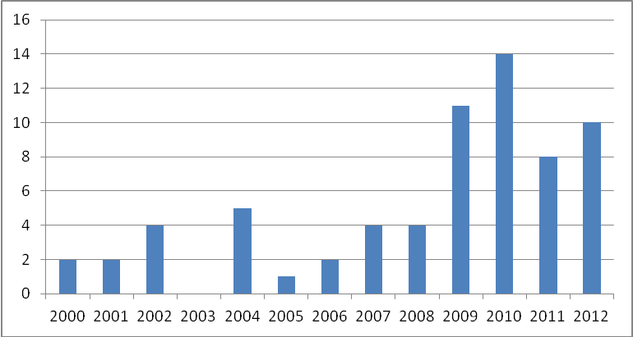

Source: INPI, BADEPI

## Geographical indications by country of origin

The graph below provides a breakdown of geographical indication applications in Brazil by origin of the applicant. Out of the 67 applications filed in the period 2000-2012, 49 are from resident and 18 from non-residents. The growth of applications after 2009 is mainly a result of the increase of resident applications.

When applications are broken down by country, it’s possible to classify the distribution of non-resident applications. From 2000 to 2012, Italy stands out as the country with highest number of applications (8 applications), followed by Portugal (3) and France (2).

Figure 8.2: Geographical indication applications by country, 2000-2012

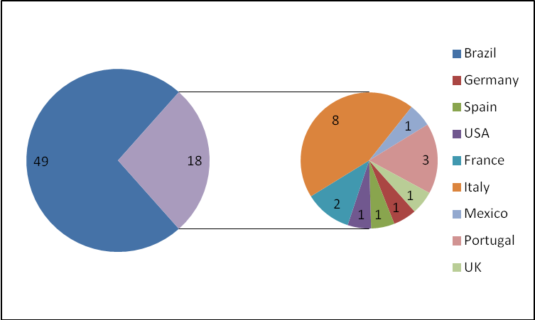

Source: INPI, BADEPI

## Geographical indications by Brazilian states

Concerning resident applications, there are 49 applications, 10 of which come from the producers located in the state of Minas Gerais, while 9 applications from Rio Grande do Sul, the most representative states. Figure 8.3 provides a graph with applications from other states.

Figure 8.3: Geographical indication applications by Brazilian states, 2000-2012

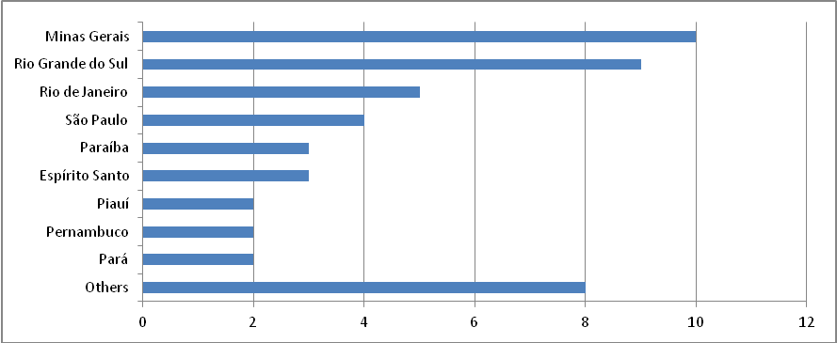

Source: INPI, BADEPI

## Geographical indications by type

GIs can be protected by a wide variety of approaches which are related to the concept of geographical indications. In Brazil, geographical indications can be divided into two types: (i) appellation of origin, which refers to the name of a place that identify products or services, where a given qualities or characteristics are essentially or exclusively attributable to its geographical origin; and (ii) indication of origin, which refers to the name of a place that has become known to produce, extract or manufacture a product or to provide a service.

In the period 2000-2012, the 40 applications concerned indication of origin, whereas 27 applied for the protection of appellations of origin. It’s noteworthy the relevance of appellations of origin for non-residents and of indications of origin for residents (figure 8.4).

Figure 8.4: Geographical indication applications by type, 2000-2012

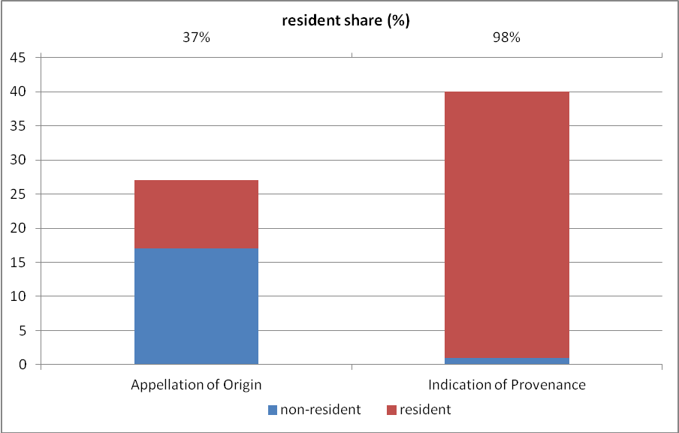

Source: INPI, BADEPI

Figure 8.5: Geographical indication applications by presentation, 2000-2012

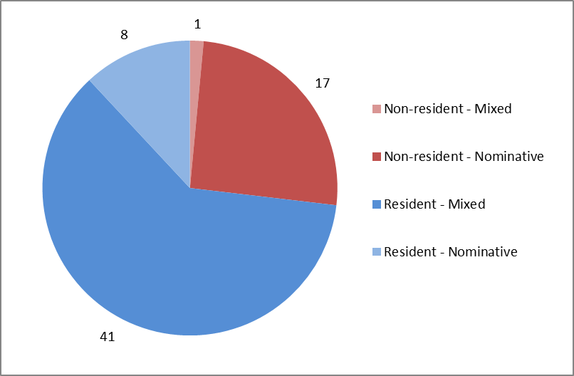

Source: INPI, BADEPI

## Geographical indications by presentation

Another way to differentiate geographical indications is by the presentation, which can be nominative, figurative or mixed. While the nominative presentation is more relevant to non-residents, the mixed is most used by residents. In the case of Brazilian applicants, they may only choose between a nominative or mixed signal. The figure below shows the distribution by presentation.

## Geographical indications by nature

Over the years, some cities or regions have become famous due to their products or services, but the regional characteristics of GI vary from country to country. In the Brazilian case, as well as in India, China and some African countries, the GI system has been characterized by a much wider variety of goods, ranging from handicraft products to services.[33]

In this sense, as seen in the Figure 8.6 below, when it comes to the nature of the GI, there is a great predominance in products, for both residents and non-residents, with the total of 63 applications out of 67.

Figure 8.6: Geographical indication applications by nature, 2000-2012

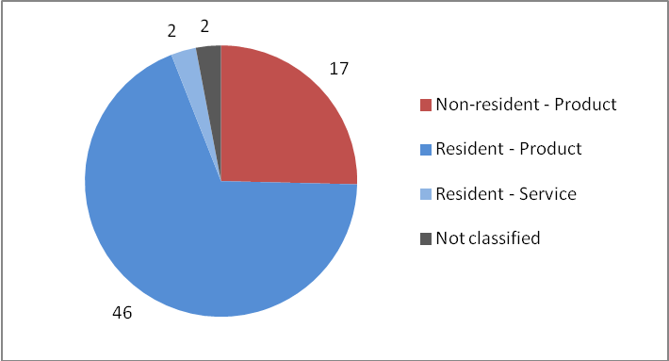

Source: INPI, BADEPI

## Geographical indications by product classification

Since their qualities are influenced by specific local and geographical factors, it is not surprising that the majority of GIs throughout the world are related to agricultural products, foodstuffs, wine and spirits. The use of GIs is not limited to these products, for there are also products whose specific qualities are due to human factors in its origin, such as special manufacturing skills and traditions. That is the case, for instance, of the handicrafts, which are generally made with the use of local natural resources and usually incorporated to the traditions of the local community.[34]

The Figure 8.7 summarizes the main specialties by product classification for GIs applications, highlighting the relevance of wine/spirit drinks and agricultural products for both non-residents and residents. For the latter, there are IGs applications for wines and sugarcane spirit (a typical Brazilian drink), with 6 and 3 applications in the period, respectively. The classification by agricultural products is also relevant, with 19 applications in the period (about 33% of total resident applications), with “coffee” representing 47% of these products. The remaining classes, handicraft and minerals, appear as less relevant for residents, with respectively 10% and 18% of the total applications requested by residents between 2000 and 2012.

Figure 8.7: Geographical indication applications by specialty, 2000-2012

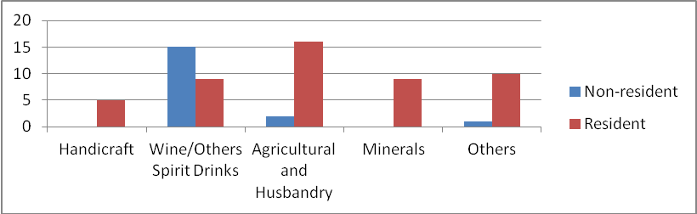

Source: INPI, BADEPI

## Geographical indication registrations

In the period 2000-2012, there was an increase in registrations, with a total of 39 registrations. Figure 8.8 shows the registrations in the period, with 2012 particularly standing out, when there were 21 registrations against the 18 registrations accumulated during the period 2000-2011.

Figure 8.8: Geographical indication registrations, 2000-2012

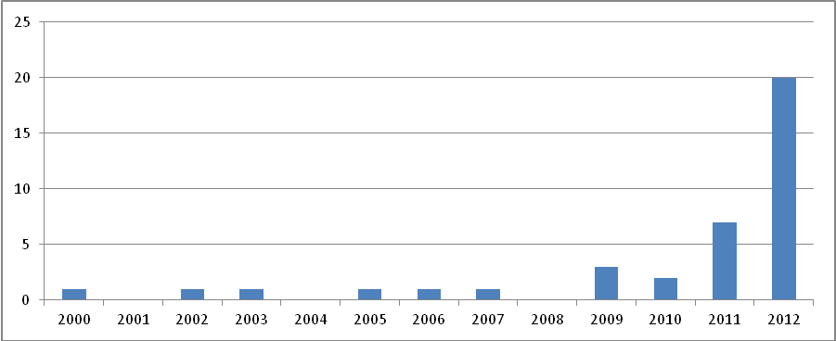

Source: INPI, BADEPI

# 9 Software

## Software applications

Between 2000 and 2011, the total number of software applications at INPI-Brazil increased from 663 to 1,279. At the beginning of the period (2000-2004), the total number of applications increased by 20%. In 2005, the number of applications dropped 13% (to 686) and maintained this level for three years. Since 2007, the applications have shown a continuous trend of growth, having increased by 86% until 2011 (to 1,279).

Figure 9.1: Total number of software applications, 2000-2011

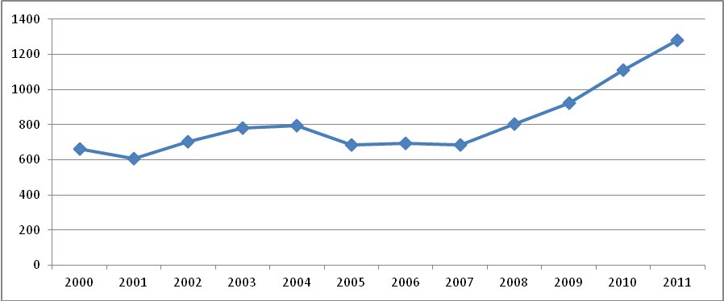

Source: INPI’s Statistical database (BADEPI, April 2013)

An important point is the number of applicants by application. It is predominant the presence of a single applicant, while just 10% of applications have multiple applicants. Between 2000 and 2011, however, this proportion has remained constant with a slight drop in 2011, when it fell to 5%.

Figure 9.3 shows that around 60% of these applicants are legal entities. This trend continued up to 2011, when there was an increase of applications by individuals to 71%. Likewise to legal entities, individuals usually file alone, though the percentage is much lower than the observed for legal entities.

The ranking of the largest applicants presents “*Fundação CPQD - Centro de Pesquisa e Desenvolvimento em Telecomunicações*” as the largest one, representing 5% of the total of 11,034 applications in the period 2000-2011. This company is from the "Scientific research and development" sector, having “software creation” as its secondary activity. Furthermore, it is worth noting that, among the ten largest applicants, seven are not related to the software industry and four of these are universities. Only two of them – Tecnet Teleinformática Ltda. and Ismael Felicio de Toledo – are applicants from “Manufacture of computer, electronic and optical products” sector. Although Ismael Felicio de Toledo is an individual, he owns Dura-Lex Sistemas de Gestão Pública Ltda, which is from the “Manufacture of computer, electronic and optical products” sector. Another important consideration is that the largest applicants usually file alone; only universities periodically request joint applications.

Figure 9.2: Software applications by number of applicants, 2000-2011

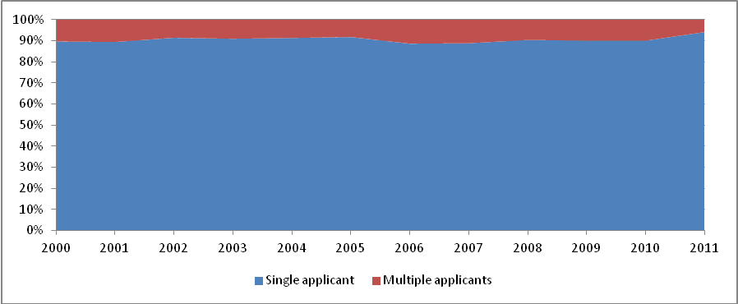

Source: INPI’s Statistical database (BADEPI, April 2013)

Figure 9.3: Software applications by type of applicant and strategy, 2000-2011

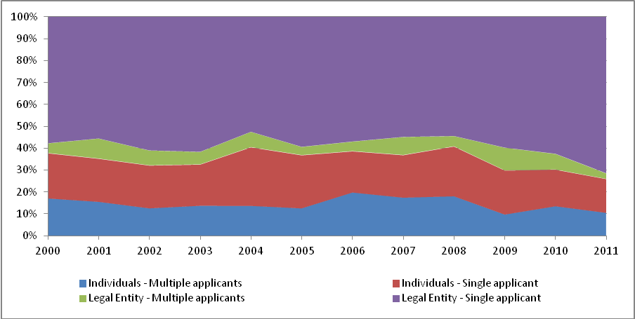

Source: INPI’s Statistical database (BADEPI, April 2013)

The economic sectors listed were obtained from the website of *Receita Federal do Brasil* ([*www.receita.fazenda.gov.br/pessoajuridica/cnpj/cnpjreva/cnpjreva_solicitacao.asp*](http://www.receita.fazenda.gov.br/pessoajuridica/cnpj/cnpjreva/cnpjreva_solicitacao.asp)). The search was conducted by the company CNPJ informed when the application was filed.

Table 9.1: Top 10 Software applicants, 2000-2011

|  |  |  |  |  |
| --- | --- | --- | --- | --- |
| Name | Number of Applications | % | Joint Application | Economic Sector |
| Fundação CPQD - Centro de Pesquisa e Desenvolvimento em Telecomunicações | 592 | 5.37% | 1 | Scientific research and development |
| Universidade Estadual de Campinas - UNICAMP | 90 | 0.82% | 4 | Education |
| Energisa S.A. | 83 | 0.75% |  | Financial service activities, except insurance and pension funding |
| Petróleo Brasileiro S.A. - Petrobras | 62 | 0.56% |  | Manufacture of coke and refined petroleum products |
| Universidade Federal de Santa Catarina - UFSC | 42 | 0.38% | 1 | Education |
| Tecnet Teleinformática Ltda. | 40 | 0.36% |  | Manufacture of computer, electronic and optical products |
| Universidade Estadual Paulista Júlio de Mesquita Filho - UNESP | 40 | 0.36% | 8 | Education |
| Universidade de São Paulo - USP | 38 | 0.34% | 8 | Education |
| Ismael Felicio de Toledo | 37 | 0.34% |  | Manufacture of computer, electronic and optical products |
| Empresa Brasileira de Pesquisa Agropecuária - EMBRAPA | 33 | 0.30% | 3 | Scientific research and development |
| Top 10 - Total | 1,057 | 9.58% | 25 | - |
| Total | 11,034 | 100.00% | - | - |

Source: INPI’s Statistical database (BADEPI, April 2013)

# 10 Conclusions

The findings in this report point to a future agenda for the development of BADEPI and of studies to explore the available statistics.

Since the conceptual model initially developed ­– which accessed the information directly from the database – does not allow that updates be made without losing the corrections on the data format, a new conceptual model was conceived. It involves the creation of an intermediate base from the production base of the INPI, facilitating the update of the data. In this new model, the future updates of the Annual statistical report will be improved and will maintain the corrections of the inconsistencies detected in the raw data.

Better understanding the use of the intellectual property system in Brazil is important both to the INPI and to the various economic agents and policymakers. Thus, BADEPI provides relevant developments, such as:

* creation of a unique applicant identifier that facilitates the visualization of market strategies that involve the combined use of different IP rights, also known as "IP bundle”,
* creation of national or world maps with the geographic distribution of users of the IP system to study the spatial organization of production and innovation systems,
* creation of new IP statistics related to applications by size and by sector of the Brazilian companies,
* identification of the origin of the capital from applicant companies, in order to understand the relationship between the protection strategies of firms and their internationalization.

It will be important to further explore the agenda of studies, examining both the sectorial dimension as well as the technological fields in order to compare patent applications of residents and non-residents. For example, while the sector of chemical technology experiences a concentration of applications by non-residents, the mechanical engineering sector has a more significant participation of residents. This analysis can help to understand their impact on the national industrial base and to subsidize industrial, innovation and foreign trade policies.

In some sectors, the various forms of protection used together may indicate a strategy of appropriation that cannot be identified by isolated analyses. Similarly, some sectors, if singled out, may represent a small share of intellectual property protection, but the chain of production that they integrate may indicate otherwise. From this point of view, for example, agribusiness deserves special mention because it is a sector that connects with many others, such as: fine chemical, pharmaceutical, mechanical engineering, machinery and equipment, food processing, transportation, and wholesale and retail distribution. Understanding the form of innovation and protection of intangible assets in agribusiness is relevant due to the importance of this sector for the Brazilian economy, not only in terms of the national capital, but also in terms of the impact of technologies linked to foreign capital in Brazil.

Finally, collaboration between institutions that formulate public policies, institutions that produce indicators of science, technology and innovation and the research community will be the most fruitful way for further develop knowledge regarding the use of IP in Brazil.

# Methodological Annex

In the World Intellectual Property Organization (WIPO) Development Agenda, Recommendation 35 indicates the need for member countries to develop studies on the economic, cultural and social impacts of the use of the IP system. In this sense, WIPO established its Economics and Statistics Division to develop such studies on the international IP system, as well as comparative reports between IP offices. Brazil was chosen as one of the countries where the project would be developed for economic studies regarding the relationship between intellectual property protection and economic development. In this context, INPI created the Economic Advisory Area (AECON), by Decree No. 7,356 on November 12, 2010, with the mission to conduct economic studies on the impact of intellectual property and the Institute's role in national development.

INPI-Brazil, with the support of WIPO, executed the Project "CREATION OF A DATABASE ON INTELLECTUAL PROPERTY FOR STATISTICAL PURPOSES - BADEPI" with the goal of creating a structured database focused on statistical purposes that may serve as a tool to develop studies regarding the use of the IP system and its economic, social and cultural impacts.

This methodological appendix aims at explaining the methodologies used to transform the raw data from the production database into the tables and graphs presented in this report.

## About INPI’s Statistical Database - BADEPI

BADEPI was created from administrative records on IP, stored in INPI’s Production Databases (BP-INPI) developed in the platform Informix.[35] These administrative records shall be referred to as BP-INPI's raw data.

The first version of BADEPI, which was named BADEPI_v1.0, was developed by a group of consultants that created a static database of a given period of time (2000-2011 for patents, utility models, industrial designs and computer programs, and 2000-2012 for other forms of protection) through the extraction of selected fields from BP-INPI.

BP-INPI's data are dynamic, as they are subject to the introduction of new records and to the modification of existing records. BADEPI, therefore, was created in order to function as a "photo" of BP-INPI at a given point in time. It means that, on different dates, some information may differ from BADEPI, when compared with the BP-INPI.

As shown in Box A.1, from BADEPI v1.0 INPI created a preliminary version of its Statistical Yearbook on Intellectual Property (with charts and graphs). Additionally, a copy of BADEPI_v1.0_patentes was distributed to a network of users qualified in the handling of intellectual property databases, formed by experts in research and analysis using intellectual property databases, particularly regarding the resolution of inconsistencies (missing data and invalid information). Firstly, under a confidentiality agreement, the database was distributed to UFMG - CEDEPLAR, UFJF - Institute of Economics, Inter-American Development Bank, World Intellectual Property Organization - Economics and Statistics Division, Institute of Applied Economic Research - IPEA, INMETRO - National Institute of Metrology and Institute of Public Goods and Policies of the Superior Council of Scientific Research in Madrid. The members of this network will be able to provide their support by: sharing new data with INPI; improving some existing variables; and contributing to the correction of errors identified by them.

**Box A.1: INPI’s Statistical Database**

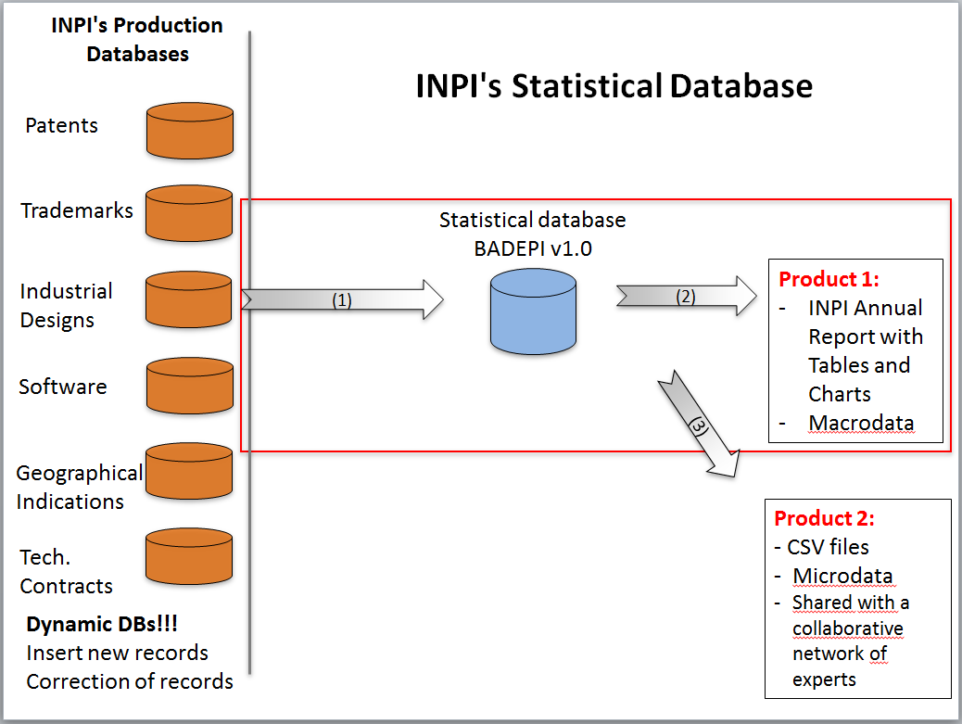

## BADEPI’s conceptual models

The BADEPI_v1.0 contains bibliographic information and the classification of the data about applications filed at INPI-BR in the selected period.

The BADEPI_v1.0 also incorporated some information from IBGE about the size and the economic sector of the applicants. However, information regarding size and sector are not complete and could not be used for all forms of protection, since the raw data had many records without the CNPJ (a unique firms’ identification number).

To the information about technology contracts data from the Central Bank of Brazil about the annual flow of payments and receipts of royalties were added, by contract category. At this data level, it is not possible to link the amounts paid to each specific process.

Box A.2: Conceptual Model: BADEPI_v1.0_Patents and Utility Models

Box A.3: Conceptual Model: BADEPI_v1.0_Trademarks

Box A.4: Conceptual Model: BADEPI_v1.0_Industrial designs

Box A.5: Conceptual Model: BADEPI_v1.0_Softwares

Box A.6: Conceptual Model: BADEPI_v1.0_Contracts

Box A.7: Conceptual Model: BADEPI_v1.0_Geographical Indications

## Methodology for processing BADEPI’s data

The methodology used to handle data from BADEPI_v1.0 to generate the tables and graphs in this report is presented as follows. This section explains how the main variables were treated and also how the inconsistencies found were dealt with.

### Patents and utility models

The raw data from patents and utility models[36] are provided in one unique database and they are identified by the variable called “type”. As the data have the same structure and faced similar challenges, they were similarly treated and will be presented together in the following items.

#### Type

The nature of the application is informed by the applicant in the application form and can be filed as "PI", "MU" or "PP". Applications starting with "PP", which means that it is a "pipeline" patent, are also considered as patent (PI). At the time of the technical examination, the examiner can consider the need to readjust the nature of the application and, through a dispatch, can change the nature of the application and therefore the numbering of the application as well.

The variable "type" should always be compatible with the "number of application", because it represents the first two characters of the number of application. However, in some applications the variable "type" did not correspond to the characters that appear in the variable "number of application".

As a result, the original variable “type” was not considered and a new one was devised, using the first two characters of the number of application.

#### Application date

The production database contains two variables that can cause confusion about the application date: “data_deposito” and “data_protocolo_no_inpi” (INPI protocol date).

For the construction of application tables, the variable that has been considered is "data_protocolo_no_inpi" that means: (i) date of filing in case of applications filed directly with INPI-Brazil and (ii) entrance at the national phase in case of PCT applications. The "data_protocolo_no_inpi" is the date on which the application is filed in INPI.

The variable “data_deposito” is used to define the term of protection.

#### PCT and Direct Application

To determine whether the application was filed via PCT or directly, when the variable "NO_DO_PCT" is not null, the application filing is defined as PCT, otherwise it is a direct application.

#### Applicant order

A patent application may contain “n” applicants. In the filing form, these applicants are informed in a certain order, at their option. For the elaboration of the tables, the name of the first applicant was used. However, it was detected that some applications had problems in this field, such as:

* applications without a first applicant;
* applications with more than one first applicant;
* applications with wrong numbering.

In these applications, the variable "applicant order" was redefined.

This criterion was used because 98% of total patents were filed by applicants from the same country of origin. This means that only 2% of total patent applications were filed jointly by applicants from different countries and among them only a very small number of patents were protected by residents and non-residents together.

#### Residents' identification number: “CNPJ or CPF”

The applicant ID (CNPJ or CPF) is informed in the application form by the applicant. In principle the processing of such information should be easy, facilitanting the identification of applicants and also whether they are legal entities (CNPJ) or individuals (CPF).

In raw patent data, however, there are a significant number of resident applicants without its ID. For the period 2000-2011, the patent and utility model database had 15% of resident applicant records with missing “cpf_cnpj” variable.

#### Identification of resident applicants by type

To classify the type of resident applicants in the period 2000-2011, the following methodology was developed: 1) for applicants with information about “cpf_cnpj”, the classification was based on the length of this information: those who had 14 characters would be classified as a legal entity and those who had 11 characters as individuals; 2) among applicants already classified as legal entities and applicants with missing “cpf_cnpj” field, the classification was based on a search of keywords in order to distinguish universities from companies: “S.A.”, “Ltda.” and “EPP” were classified as companies and “Universidade”, “Faculdade” and “Educação” as universities; 3) manually, it was checked if there were any company or university not classified in the previous steps; and 4) finally, non-classified applicants were defined as individuals.

Box A.8: Identification of resident applicants by type

|  |
| --- |
| Individuals – 11 characters |
| Legal entities – 14 characters  Universities and Companies |
| Missing – 15%  Individuals + Legal entities not classified |

#### Identification of top 10 applicants (residents and non-residents)

To create the applicant ranking, some procedures to standardize applicant names were applied: (1) blanks and special characters (such as accent marks, quotes, bars, numeral operators, *and* other symbols) were removed; (2) similar applicant names were aggregated and (3) spelling mistakes and abbreviated company names were corrected.

#### Economic sector

In order to define from which economic sector comes the patent applicant, the National Classification of Economic Activities (CNAE) was used, corresponding to the classification of ISIC Rev.4. However, only applications that had the applicant's CNPJ available in BADEPI_v1.0 were classified.

#### Technological Sectors

Patent applications were mapped according to their technological field by using a table to link IPC symbols to the corresponding fields of technology as developed by WIPO's methodology (see www.wipo.int/ipstats/en). When a patent application was related to multiple fields of technology, it was counted in each field. When a patent application had multiple IPC symbols related to the same field of technology, it was counted just once.

### Industrial Designs

Raw data from industrial designs were available in the same database containing patent data. As the data have the same structure and faced similar challenges, they were treated very similarly with regard to the following variables: “type”, “applicant order”, “top 10 applicants” and “economic sector”.

#### Applicant order

An industrial design application may contain “n” applicants. In the filing form, these applicants are informed in a certain order, at their option. The first named applicant was used in order to determine the application’s origin. As this variable presented a low level of inconsistency, concentrated in the years 2000-2002, the same treatment used for patents was executed. In these applications, the variable "applicant order" was redefined.

#### Type of applicant

In industrial design data, a variable that identifies if the applicant is an individual or a legal entity was used, independent if the applicant was resident or non-resident.

#### Resident's ID number: Variable “CNPJ or CPF”:

The applicant's ID number (CNPJ or CPF) is informed in the application form by the applicant and in principle it should facilitate the identification of applicants and also if they are legal entities (CNPJ) or individuals (CPF). In raw industrial design data, however, there are a significant number of resident applicants without their ID. For the period 2000-2011, the industrial design database had 7% of resident applicant records in which the “cpf_cnpj” variable is missing.

### Softwares

#### Identification of applicants by type

A new variable "natureza_jurídica" was created to distinguish individuals from legal entities using the variable "CPF_CNPJ". The raw software data presented complete information for this variable. Only 74 applications, out of a total of 9,728, had no information of applicants. In a total of 11,034 records of applicants, it was not possible to classify the variable "CPF_CNPJ" in 167 records.

#### Identification of top 10 applicants

The software database presented complete and standardized raw data for the variable "applicant_ name" This allowed INPI to create the ranking of applicants by grouping them by name.

The economic sectors informed in Top 10 applicants table were obtained by Receita Federal do Brasil's website ([*www.receita.fazenda.gov.br/pessoajuridica/cnpj/cnpjreva/ cnpjreva_solicitacao.asp*](http://www.receita.fazenda.gov.br/pessoajuridica/cnpj/cnpjreva/%20cnpjreva_solicitacao.asp)). The search was conducted by the company's CNPJ informed in the application.

### Trademarks

Before BAPEPI was developed, INPI carried out a correction of the inconsistencies at BP-INPI as a preparatory step to its migration to the Industrial Property Automation System – IPAS, provided by WIPO to automate the processing of trademarks. In this respect, INPI corrected the data of processes and applicants (individuals or companies). BADEPI-Trademarks, therefore, incorporated the data with a very low level of inconsistencies.

Out of the 1,5 million applications filed between 2000 and 2012, the inconsistencies, as of April, 2013, were the following: 403 missing data regarding the state of origin of resident trademark applicants, 287 missing data regarding the country of origin of applicants (both residents and non-residents) and 4,352 missing data of “applicants' ID” (CPF or CNPJ) of resident applicants.

## Data improvements and future updates

According to the original conceptual model of the development of BADEPI_v1.0, the process of updating the data in the future would demand a new copy of the selected fields from BP-INPI, in which past records, with eventual changes, and the errors and missing data already identified and corrected, would be replaced.[37] It means that updating the data, in this conception, would tend to generate retroactive dynamism, by the very nature of BP.

Aiming at overcoming this difficulty, a new model was designed and will be implemented in future updates, including in the completion of 2012 data where necessary. This new model involves the creation of a copy of the tables that contain the records of Patents, Utility Models, Industrial Designs, Trademarks, Contracts, Program and Geographical Indication from INPI’s production database that will act as an intermediate database for the construction of new versions of BADEPI. The relevance of an intermediate database with raw data is that it is a static database and articulates with the interruption of "retroactive dynamism". This version of BADEPI extracted from the intermediate database will be called BADEPI v1.1, replacing BADEPI v1.0. The diagram below summarizes the new conceptual model proposed herein.

Box A.9: Future updates of INPI’s Statistical Database

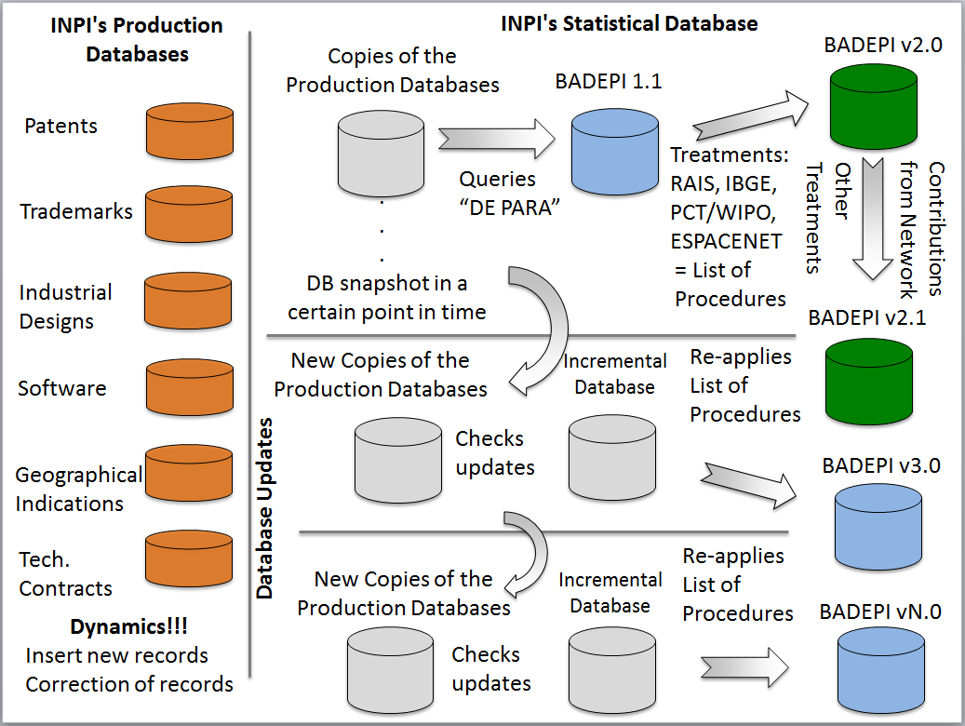

From the BADEPI v1.1 a series of procedures will be applied for identifying and correcting inconsistencies, resulting in the creation of BADEPI v2.0. This version, in turn, will be the basis of INPI’s Statistical Yearbook of Intellectual Property on the internet (web interface) and shared with a larger network of qualified specialists.[38]

The process will be repeated annually, incorporating only data from each subsequent year. It will also repeat the list of procedures for dealing with inconsistencies and other improvements suggested by the network of qualified specialists. As a result, past data that has already been treated in BADEPI will no longer be replaced with each new extraction of BP-INPI, preserving the process of cleaning the database of inconsistencies as done previously.

## New procedures for identification and correction of inconsistencies

As presented above, the raw data have missing values or invalid information that have been already identified and quantified for the production of this report. Some of them were already treated and now need to be automated, while others need to receive new treatments for cleaning and harmonization.

The processing and the integration with external databases (databases from either INPI or other institutions) will allow the reduction of the number of records with missing values, the correction of invalid information and thus the improvement of BADEPI’s quality.

The main variables that need new treatment are:

### Variable “CNPJ or CPF”: applicant ID for residents

INPI will use the PAG database (INPI’s database that contains the records of fee payments for INPI's services) to find, through the application number, the applicant's ID number (CNPJ for legal entities or CPF for individuals), where this information remains missing, and associate it with the name of the applicant.

INPI will search, for every type of protection and between the different types, records of homonymous legal entities when in at least one of them information of its CNPJ is available and in another such information is missing. The information of the available CNPJ will be attributed to other homonyms records without this information.

INPI will also use the database of Annual Social Information Registry (RAIS) of the Ministry of Labor and Employment (MTE) to search through the name of the applicants that are legal entities and remain with missing CNPJ. The CNPJ located in RAIS database will be attributed to these missing records.

With these procedures, the number of records with missing data will significantly reduce.

### Identification of resident applicants by type

Resident applicants will be classified by their legal nature according to the field’s length: 14 characters for a legal entity and 11 characters for individuals. For those records with missing ID numbers, they will be classified by a keyword search.

### Name of applicants, inventor and authors

Procedures to standardize applicant names to remove blanks and special characters (such as accent marks, quotes, bars, numeral operators, *underline*) will be applied.

### City of origin of resident applicants

The 3 errors identified for classifying by city of origin are: i) missing names, ii) invalid names different from the IBGE list of cities, or iii) the name of the city does not correspond to the state informed.

The procedure that will be adopted in order to identify the municipality associated with the applicant in BADEPI includes the use of the CNPJ number to search in the RAIS database the correct information.

# Statistical Annex

## Patents

Table A.1: Patent applications by route, 2000-2011

|  |  |  |  |
| --- | --- | --- | --- |
| Application Year | Direct | Via PCT | Total |
| 2000 | 6,848 | 10,595 | 17,443 |
| 2001 | 6,721 | 11,188 | 17,909 |
| 2002 | 5,937 | 10,751 | 16,688 |
| 2003 | 6,036 | 10,379 | 16,415 |
| 2004 | 6,418 | 10,292 | 16,710 |
| 2005 | 6,473 | 12,014 | 18,487 |
| 2006 | 6,710 | 13,135 | 19,845 |
| 2007 | 6,488 | 15,167 | 21,655 |
| 2008 | 6,787 | 16,363 | 23,150 |
| 2009 | 6,250 | 16,151 | 22,401 |
| 2010 | 6,277 | 18,705 | 24,982 |
| 2011 | 7,303 | 21,244 | 28,547 |

Table A.2: Patent applications by origin, 2000-2011

|  |  |  |  |  |
| --- | --- | --- | --- | --- |
| Application Year | Non-Resident | Resident | Not Available | Total |
| 2000 | 14,224 | 3,214 | 5 | 17,443 |
| 2001 | 14,457 | 3,451 | 1 | 17,909 |
| 2002 | 13,203 | 3,485 |  | 16,688 |
| 2003 | 12,545 | 3,867 | 3 | 16,415 |
| 2004 | 12,666 | 4,044 |  | 16,710 |
| 2005 | 14,432 | 4,054 | 1 | 18,487 |
| 2006 | 15,883 | 3,956 | 6 | 19,845 |
| 2007 | 17,461 | 4,194 |  | 21,655 |
| 2008 | 18,870 | 4,280 |  | 23,150 |
| 2009 | 18,129 | 4,272 |  | 22,401 |
| 2010 | 20,754 | 4,228 |  | 24,982 |
| 2011 | 23,852 | 4,695 |  | 28,547 |

Table A.3: Patent applications by route and origin, 2000-2011

|  |  |  |  |  |  |  |  |  |  |
| --- | --- | --- | --- | --- | --- | --- | --- | --- | --- |
| Year | Non-Resident | | | Resident | | | Not Available | | |
| Direct | Via PCT | Total | Direct | Via PCT | Total | Direct | Via PCT | Total |
| 2000 | 3,662 | 10,562 | 14,224 | 3,181 | 33 | 3,214 | 5 |  | 17,443 |
| 2001 | 3,300 | 11,157 | 14,457 | 3,420 | 31 | 3,451 | 1 |  | 17,909 |
| 2002 | 2,469 | 10,734 | 13,203 | 3,468 | 17 | 3,485 |  |  | 16,688 |
| 2003 | 2,184 | 10,361 | 12,545 | 3,850 | 17 | 3,867 | 2 | 1 | 16,415 |
| 2004 | 2,393 | 10,273 | 12,666 | 4,025 | 19 | 4,044 |  |  | 16,710 |
| 2005 | 2,441 | 11,991 | 14,432 | 4,031 | 23 | 4,054 | 1 |  | 18,487 |
| 2006 | 2,773 | 13,110 | 15,883 | 3,936 | 20 | 3,956 | 1 | 5 | 19,845 |
| 2007 | 2,330 | 15,131 | 17,461 | 4,158 | 36 | 4,194 |  |  | 21,655 |
| 2008 | 2,536 | 16,334 | 18,870 | 4,251 | 29 | 4,280 |  |  | 23,150 |
| 2009 | 2,047 | 16,082 | 18,129 | 4,203 | 69 | 4,272 |  |  | 22,401 |
| 2010 | 2,111 | 18,643 | 20,754 | 4,166 | 62 | 4,228 |  |  | 24,982 |
| 2011 | 2,676 | 21,176 | 23,852 | 4,627 | 68 | 4,695 |  |  | 28,547 |
| Total | 30,922 | 165,554 | 196,476 | 47,316 | 424 | 47,740 | 10 | 6 | 244,232 |

Table A.4: Patent applications by countries or regions, 2000-2011

|  |  |  |  |  |  |  |  |  |  |  |  |  |
| --- | --- | --- | --- | --- | --- | --- | --- | --- | --- | --- | --- | --- |
| Country | 2000 | 2001 | 2002 | 2003 | 2004 | 2005 | 2006 | 2007 | 2008 | 2009 | 2010 | 2011 |
| Total | 17,443 | 17,909 | 16,688 | 16,415 | 16,710 | 18,487 | 19,845 | 21,655 | 23,150 | 22,401 | 24,982 | 28,547 |
| United States of America | 6,249 | 6,089 | 5,433 | 4,946 | 5,415 | 6,153 | 6,337 | 6,856 | 6,990 | 6,869 | 7,561 | 8,194 |
| Brazil | 3,214 | 3,451 | 3,485 | 3,867 | 4,044 | 4,054 | 3,956 | 4,194 | 4,280 | 4,272 | 4,228 | 4,695 |
| Germany | 2,071 | 2,248 | 1,944 | 1,837 | 1,719 | 1,765 | 2,034 | 2,093 | 2,444 | 2,133 | 2,477 | 2,818 |
| Japan | 718 | 876 | 755 | 714 | 629 | 745 | 902 | 1,042 | 1,226 | 1,477 | 1,923 | 2,599 |
| France | 1,059 | 961 | 931 | 922 | 820 | 1,063 | 1,131 | 1,193 | 1,337 | 1,422 | 1,675 | 1,780 |
| Switzerland | 537 | 548 | 593 | 731 | 717 | 873 | 965 | 1,157 | 1,289 | 1,154 | 1,216 | 1,251 |
| Netherlands | 476 | 539 | 601 | 495 | 547 | 570 | 590 | 693 | 789 | 739 | 845 | 1,148 |
| United Kingdom | 506 | 486 | 433 | 464 | 402 | 436 | 490 | 518 | 592 | 556 | 667 | 821 |
| Italy | 353 | 371 | 389 | 461 | 390 | 445 | 479 | 543 | 578 | 503 | 579 | 623 |
| China | 25 | 14 | 36 | 29 | 39 | 55 | 91 | 127 | 121 | 182 | 233 | 547 |
| Sweden | 585 | 492 | 353 | 275 | 337 | 378 | 434 | 454 | 641 | 493 | 510 | 513 |
| Canada | 206 | 224 | 212 | 196 | 188 | 215 | 229 | 251 | 238 | 230 | 310 | 438 |
| Belgium | 149 | 131 | 89 | 95 | 110 | 125 | 200 | 243 | 236 | 235 | 221 | 295 |
| Republic of Korea | 197 | 214 | 207 | 167 | 170 | 330 | 389 | 397 | 340 | 331 | 252 | 285 |
| Spain | 116 | 98 | 130 | 110 | 118 | 129 | 175 | 196 | 182 | 164 | 256 | 261 |
| Denmark | 100 | 109 | 82 | 68 | 95 | 110 | 138 | 150 | 187 | 179 | 212 | 247 |
| Norway | 69 | 88 | 82 | 79 | 77 | 69 | 81 | 113 | 134 | 141 | 176 | 225 |
| Austria | 74 | 88 | 82 | 67 | 76 | 75 | 64 | 112 | 115 | 98 | 158 | 208 |
| Finland | 138 | 180 | 226 | 200 | 120 | 142 | 176 | 230 | 224 | 154 | 227 | 184 |
| Australia | 127 | 184 | 144 | 145 | 138 | 140 | 189 | 206 | 184 | 148 | 185 | 183 |
| Israel | 90 | 69 | 64 | 66 | 73 | 67 | 87 | 136 | 168 | 119 | 143 | 170 |
| India | 16 | 37 | 48 | 61 | 85 | 74 | 97 | 89 | 133 | 91 | 146 | 146 |
| Virgin Islands (British) | 29 | 20 | 24 | 30 | 13 | 20 | 37 | 23 | 24 | 85 | 90 | 113 |
| Taiwan, Province of China | 13 | 22 | 14 | 28 | 31 | 48 | 48 | 54 | 52 | 50 | 60 | 78 |
| Luxembourg | 36 | 28 | 20 | 14 | 18 | 30 | 32 | 29 | 26 | 32 | 43 | 67 |
| Ireland | 16 | 26 | 23 | 24 | 29 | 23 | 50 | 78 | 60 | 63 | 37 | 57 |
| Mexico | 28 | 25 | 17 | 16 | 20 | 18 | 28 | 31 | 38 | 36 | 64 | 55 |
| South Africa | 29 | 26 | 26 | 29 | 31 | 49 | 43 | 40 | 57 | 48 | 41 | 43 |
| New Zealand | 23 | 37 | 33 | 22 | 20 | 28 | 37 | 25 | 22 | 31 | 42 | 40 |
| Singapore | 6 | 8 | 13 | 7 | 8 | 11 | 25 | 22 | 31 | 19 | 27 | 40 |
| Argentina | 46 | 55 | 30 | 59 | 42 | 36 | 45 | 40 | 36 | 48 | 40 | 32 |
| Russian Federation | 12 | 8 | 16 | 9 | 11 | 10 | 13 | 12 | 23 | 15 | 22 | 30 |
| Portugal | 5 | 9 | 4 | 11 | 6 | 12 | 20 | 21 | 22 | 34 | 29 | 28 |
| Chile | 6 | 3 | 5 | 7 | 11 | 6 | 17 | 13 | 18 | 11 | 18 | 21 |
| Malaysia |  | 4 | 5 |  | 6 | 1 | 5 | 2 | 7 | 3 | 6 | 20 |
| Turkey | 1 | 1 | 1 | 1 | 1 | 2 | 4 | 12 | 10 | 5 | 12 | 18 |
| Hungary | 12 | 12 | 7 | 5 | 13 | 16 | 9 | 9 | 15 | 15 | 9 | 17 |
| Liechtenstein | 8 | 5 | 2 | 7 | 4 | 5 | 5 | 6 | 3 | 8 | 5 | 17 |
| Barbados | 3 | 2 | 2 | 5 | 7 | 2 | 1 | 11 | 9 | 2 | 8 | 16 |
| Colombia | 1 | 2 | 1 | 4 | 5 | 4 | 2 | 4 | 8 | 11 | 12 | 16 |

Note: Only first 40 reported.

Table A.5: Patent applications by Brazilian states, 2000-2011

|  |  |  |  |  |  |  |  |  |  |  |  |  |  |
| --- | --- | --- | --- | --- | --- | --- | --- | --- | --- | --- | --- | --- | --- |
| Brazilian States | 2000 | 2001 | 2002 | 2003 | 2004 | 2005 | 2006 | 2007 | 2008 | 2009 | 2010 | 2011 | Total |
| Total | 3,214 | 3,451 | 3,485 | 3,867 | 4,044 | 4,054 | 3,956 | 4,194 | 4,280 | 4,272 | 4,228 | 4,695 | 47,740 |
| São Paulo | 1,524 | 1,585 | 1,620 | 1,790 | 1,830 | 1,801 | 1,731 | 1,857 | 1,848 | 1,844 | 1,800 | 1,992 | 21,222 |
| Minas Gerais | 269 | 347 | 339 | 395 | 363 | 378 | 400 | 489 | 396 | 427 | 471 | 471 | 4,745 |
| Rio de Janeiro | 298 | 291 | 332 | 322 | 412 | 394 | 378 | 384 | 388 | 373 | 334 | 359 | 4,265 |
| Rio Grande do Sul | 239 | 240 | 260 | 296 | 341 | 330 | 346 | 334 | 377 | 339 | 327 | 419 | 3,848 |
| Paraná | 209 | 203 | 233 | 288 | 326 | 331 | 332 | 374 | 392 | 414 | 340 | 370 | 3,812 |
| Santa Catarina | 158 | 217 | 190 | 256 | 256 | 268 | 247 | 233 | 310 | 269 | 320 | 288 | 3,012 |
| Distrito Federal | 73 | 57 | 75 | 80 | 91 | 76 | 87 | 52 | 66 | 63 | 82 | 95 | 897 |
| Bahia | 45 | 48 | 39 | 59 | 53 | 62 | 63 | 71 | 91 | 93 | 112 | 131 | 867 |
| Espírito Santo | 55 | 59 | 55 | 70 | 53 | 59 | 63 | 69 | 73 | 70 | 78 | 63 | 767 |
| Goiás | 49 | 48 | 43 | 77 | 63 | 75 | 46 | 65 | 60 | 54 | 52 | 82 | 714 |
| Ceará | 37 | 51 | 36 | 44 | 53 | 50 | 38 | 49 | 57 | 67 | 72 | 74 | 628 |
| Pernambuco | 47 | 49 | 58 | 39 | 42 | 60 | 49 | 40 | 53 | 52 | 46 | 76 | 611 |
| Amazonas | 9 | 18 | 15 | 21 | 39 | 26 | 24 | 26 | 42 | 47 | 35 | 44 | 346 |
| Paraíba | 13 | 21 | 25 | 12 | 15 | 18 | 30 | 18 | 24 | 21 | 29 | 33 | 259 |
| Rio Grande do Norte | 19 | 10 | 2 | 22 | 18 | 30 | 20 | 24 | 15 | 28 | 22 | 24 | 234 |
| Mato Grosso | 18 | 15 | 18 | 13 | 12 | 15 | 32 | 37 | 22 | 12 | 11 | 25 | 230 |
| Pará | 9 | 15 | 16 | 9 | 16 | 23 | 12 | 19 | 21 | 11 | 24 | 26 | 201 |
| Mato Grosso do Sul | 10 | 17 | 10 | 11 | 19 | 20 | 17 | 18 | 11 | 19 | 21 | 20 | 193 |
| Sergipe | 8 | 8 | 6 | 6 | 10 | 13 | 11 | 9 | 5 | 17 | 9 | 33 | 135 |
| Maranhão | 9 | 6 | 5 | 8 | 5 | 7 | 5 | 1 | 8 | 19 | 15 | 18 | 106 |
| Alagoas | 4 | 8 | 3 | 9 | 5 | 6 | 5 | 7 | 5 | 12 | 14 | 11 | 89 |
| Rondônia | 6 | 5 | 7 | 8 | 5 | 4 | 4 | 7 | 6 | 6 | 1 | 14 | 73 |
| Piauí | 8 | 4 | 2 |  | 2 | 3 | 3 | 4 | 5 | 7 | 6 | 20 | 64 |
| Tocantins | 3 | 2 | 8 | 4 | 3 | 1 | 4 | 1 | 3 | 4 | 4 | 3 | 40 |
| Acre |  | 1 | 1 | 5 | 1 | 1 | 5 | 2 | 2 | 1 |  | 1 | 20 |
| Amapá | 2 | 1 | 2 | 1 | 4 | 2 |  |  |  | 2 | 2 | 1 | 17 |
| Roraima | 2 |  | 1 | 2 |  | 1 | 4 | 4 |  | 1 | 1 | 1 | 17 |
| Others | 91 | 125 | 84 | 20 | 7 |  |  |  |  |  |  | 1 | 1 |

Table A.6: Patent applications by type of Brazilian applicants, 2000-2011

|  |  |  |  |  |
| --- | --- | --- | --- | --- |
| Year | Individual | Legal Entity | | Total |
| University | Company |
| 2000 | 2,286 | 65 | 861 | 3,212 |
| 2001 | 2,480 | 68 | 906 | 3,454 |
| 2002 | 2,352 | 167 | 974 | 3,493 |
| 2003 | 2,549 | 170 | 1,148 | 3,867 |
| 2004 | 2,614 | 186 | 1,247 | 4,047 |
| 2005 | 2,560 | 227 | 1,279 | 4,066 |
| 2006 | 2,468 | 237 | 1,251 | 3,956 |
| 2007 | 2,607 | 323 | 1,270 | 4,200 |
| 2008 | 2,621 | 359 | 1,320 | 4,300 |
| 2009 | 2,521 | 386 | 1,370 | 4,277 |
| 2010 | 2,332 | 455 | 1,456 | 4,243 |
| 2011 | 2,459 | 652 | 1,619 | 4,730 |

Table A.7: Patent applications by technological sector, 2000-2011

|  |  |  |  |  |  |  |  |  |  |  |  |  |  |  |  |
| --- | --- | --- | --- | --- | --- | --- | --- | --- | --- | --- | --- | --- | --- | --- | --- |
|  | Field | TEC | 2000 | 2001 | 2002 | 2003 | 2004 | 2005 | 2006 | 2007 | 2008 | 2009 | 2010 | 2011 | Total |
| Electrical engineering | Electrical machinery, apparatus, energy | 1 | 822 | 807 | 724 | 600 | 572 | 634 | 789 | 851 | 962 | 934 | 1,134 | 1,345 | 10,174 |
| Audio-visual technology | 2 | 475 | 461 | 409 | 390 | 415 | 571 | 541 | 505 | 575 | 624 | 689 | 865 | 6,520 |
| Telecommunications | 3 | 1,066 | 909 | 664 | 570 | 553 | 757 | 797 | 801 | 781 | 744 | 652 | 784 | 9,078 |
| Digital communication | 4 | 296 | 285 | 252 | 299 | 343 | 423 | 536 | 645 | 726 | 970 | 1,151 | 1,219 | 7,145 |
| Basic communication processes | 5 | 136 | 97 | 66 | 80 | 69 | 61 | 67 | 75 | 83 | 76 | 77 | 100 | 987 |
| Computer technology | 6 | 480 | 529 | 520 | 534 | 585 | 710 | 642 | 801 | 909 | 862 | 934 | 1,108 | 8,614 |
| IT methods for management | 7 | 16 | 16 | 13 | 8 | 24 | 31 | 103 | 162 | 215 | 226 | 268 | 277 | 1,359 |
| Semiconductors | 8 | 38 | 51 | 47 | 39 | 36 | 38 | 66 | 87 | 107 | 168 | 180 | 252 | 1,109 |
| Instruments | Optics | 9 | 293 | 297 | 254 | 175 | 197 | 242 | 266 | 295 | 307 | 277 | 361 | 595 | 3,559 |
| Measurement | 10 | 638 | 699 | 547 | 578 | 574 | 603 | 783 | 981 | 1,091 | 1,045 | 1,331 | 1,373 | 10,243 |
| Analysis of biological materials | 11 |  |  |  |  |  |  |  |  |  |  |  |  | 0 |
| Control | 12 | 356 | 347 | 345 | 301 | 279 | 320 | 285 | 396 | 418 | 368 | 428 | 441 | 4,284 |
| Medical technology | 13 | 930 | 943 | 945 | 980 | 982 | 1,125 | 1,429 | 1,515 | 1,520 | 1,475 | 1,596 | 1,926 | 15,366 |
| Chemistry | Organic fine chemistry | 14 | 1,603 | 1,690 | 1,697 | 1,653 | 1,860 | 2,183 | 2,506 | 2,839 | 2,795 | 2,562 | 2,489 | 2,401 | 26,278 |
| Biotechnology | 15 | 826 | 763 | 728 | 682 | 686 | 815 | 971 | 1,169 | 1,289 | 1,321 | 1,549 | 1,632 | 12,431 |
| Pharmaceuticals | 16 | 1,858 | 2,058 | 1,945 | 2,088 | 2,439 | 2,800 | 3,032 | 3,248 | 3,411 | 2,978 | 3,013 | 2,927 | 31,797 |
| Macromolecular chemistry, polymers | 17 | 1,017 | 961 | 923 | 863 | 689 | 784 | 852 | 1,008 | 1,029 | 889 | 1,032 | 1,177 | 11,224 |
| Food chemistry | 18 | 496 | 504 | 451 | 472 | 515 | 605 | 647 | 753 | 829 | 855 | 820 | 827 | 7,774 |
| Basic materials chemistry | 19 | 1,201 | 1,316 | 1,272 | 1,169 | 1,337 | 1,280 | 1,572 | 1,710 | 1,820 | 1,753 | 1,886 | 2,150 | 18,466 |
| Materials, metallurgy | 20 | 607 | 604 | 543 | 567 | 546 | 620 | 698 | 780 | 895 | 735 | 875 | 1,008 | 8,478 |
| Surface technology, coating | 21 | 401 | 479 | 427 | 450 | 423 | 508 | 457 | 607 | 569 | 528 | 574 | 674 | 6,097 |
| Micro-structural and nano-technology | 22 | 1 | 3 | 2 | 4 | 9 | 74 | 11 | 28 | 23 | 20 | 37 | 42 | 254 |
| Chemical engineering | 23 | 776 | 823 | 778 | 761 | 741 | 835 | 990 | 1,128 | 1,135 | 1,140 | 1,328 | 1,388 | 11,823 |
| Environmental technology | 24 | 279 | 294 | 257 | 271 | 283 | 263 | 334 | 418 | 501 | 492 | 556 | 593 | 4,541 |
| Mechanical engineering | Handling | 25 | 817 | 886 | 821 | 797 | 869 | 925 | 921 | 1,068 | 1,050 | 878 | 992 | 1,041 | 11,065 |
| Machine tools | 26 | 478 | 481 | 410 | 466 | 479 | 500 | 602 | 654 | 651 | 599 | 672 | 728 | 6,720 |
| Engines, pumps, turbines | 27 | 539 | 596 | 489 | 532 | 513 | 472 | 548 | 637 | 712 | 674 | 846 | 909 | 7,467 |
| Textile and paper machines | 28 | 638 | 613 | 549 | 584 | 560 | 611 | 678 | 663 | 627 | 585 | 643 | 627 | 7,378 |
| Other special machines | 29 | 984 | 979 | 966 | 1,007 | 941 | 1,056 | 1,067 | 1,149 | 1,303 | 1,197 | 1,301 | 1,309 | 13,259 |
| Thermal processes and apparatus | 30 | 257 | 385 | 239 | 263 | 285 | 276 | 340 | 370 | 379 | 338 | 453 | 521 | 4,106 |
| Mechanical elements | 31 | 792 | 806 | 748 | 766 | 771 | 705 | 771 | 847 | 944 | 910 | 968 | 1,125 | 10,153 |
| Transport | 32 | 1,029 | 1,029 | 965 | 875 | 811 | 860 | 990 | 1,093 | 1,351 | 1,243 | 1,366 | 1,579 | 13,191 |
| Other fields | Furniture, games | 33 | 442 | 388 | 477 | 445 | 534 | 474 | 504 | 567 | 523 | 498 | 492 | 492 | 5,836 |
| Other consumer goods | 34 | 511 | 513 | 448 | 469 | 529 | 598 | 561 | 632 | 669 | 662 | 656 | 710 | 6,958 |
| Civil engineering | 35 | 715 | 745 | 732 | 728 | 725 | 701 | 789 | 810 | 960 | 1,094 | 1,259 | 1,312 | 10,570 |

Table A.8: Patent applications by technological sector and origin, 2011

|  |  |  |  |  |  |  |
| --- | --- | --- | --- | --- | --- | --- |
|  | Field | Sector | 2011 | | | Total |
| Non-Residents | Residents | N.A. |
| 1 | Electrical machinery, apparatus, energy | Electrical engineering | 1,206 | 139 |  | 1,345 |
| 2 | Audio-visual technology | Electrical engineering | 802 | 63 |  | 865 |
| 3 | Telecommunications | Electrical engineering | 728 | 56 |  | 784 |
| 4 | Digital communication | Electrical engineering | 1,178 | 41 |  | 1,219 |
| 5 | Basic communication processes | Electrical engineering | 93 | 7 |  | 100 |
| 6 | Computer technology | Electrical engineering | 1,019 | 89 |  | 1,108 |
| 7 | IT methods for management | Electrical engineering | 240 | 37 |  | 277 |
| 8 | Semiconductors | Electrical engineering | 246 | 6 |  | 252 |
| 9 | Optics | Instruments | 572 | 23 |  | 595 |
| 10 | Measurement | Instruments | 1,227 | 146 |  | 1,373 |
| 11 | Analysis of biological materials | Instruments |  |  |  | 0 |
| 12 | Control | Instruments | 340 | 101 |  | 441 |
| 13 | Medical technology | Instruments | 1,740 | 186 |  | 1,926 |
| 14 | Organic fine chemistry | Chemistry | 2,297 | 104 |  | 2,401 |
| 15 | Biotechnology | Chemistry | 1,555 | 76 | 1 | 1,632 |
| 16 | Pharmaceuticals | Chemistry | 2,778 | 148 | 1 | 2,927 |
| 17 | Macromolecular chemistry, polymers | Chemistry | 1,117 | 60 |  | 1,177 |
| 18 | Food chemistry | Chemistry | 732 | 95 |  | 827 |
| 19 | Basic materials chemistry | Chemistry | 1,987 | 163 |  | 2,150 |
| 20 | Materials, metallurgy | Chemistry | 910 | 97 | 1 | 1,008 |
| 21 | Surface technology, coating | Chemistry | 627 | 46 | 1 | 674 |
| 22 | Micro-structural and nano-technology | Chemistry | 19 | 23 |  | 42 |
| 23 | Chemical engineering | Chemistry | 1,254 | 134 |  | 1,388 |
| 24 | Environmental technology | Chemistry | 528 | 64 | 1 | 593 |
| 25 | Handling | Mechanical engineering | 897 | 144 |  | 1,041 |
| 26 | Machine tools | Mechanical engineering | 671 | 57 |  | 728 |
| 27 | Engines, pumps, turbines | Mechanical engineering | 820 | 88 | 1 | 909 |
| 28 | Textile and paper machines | Mechanical engineering | 567 | 59 | 1 | 627 |
| 29 | Other special machines | Mechanical engineering | 1,083 | 225 | 1 | 1,309 |
| 30 | Thermal processes and apparatus | Mechanical engineering | 435 | 86 |  | 521 |
| 31 | Mechanical elements | Mechanical engineering | 1,011 | 114 |  | 1,125 |
| 32 | Transport | Mechanical engineering | 1,396 | 182 | 1 | 1,579 |
| 33 | Furniture, games | Other fields | 359 | 133 |  | 492 |
| 34 | Other consumer goods | Other fields | 556 | 154 |  | 710 |
| 35 | Civil engineering | Other fields | 1,073 | 237 | 2 | 1,312 |

Table A.9: Patent applications by economic sector, 2006-2011

|  |  |  |  |  |  |  |  |
| --- | --- | --- | --- | --- | --- | --- | --- |
| Economic Sector  (2 digits level of ISIC Rev.4) | 2006 | 2007 | 2008 | 2009 | 2010 | 2011 | Total |
| Total | 650 | 671 | 776 | 858 | 801 | 737 | 4,493 |
| N.A. | 99 | 86 | 108 | 101 | 107 | 240 | 741 |
| Manufacture of machinery and equipment n,e,c, | 71 | 84 | 106 | 125 | 137 | 94 | 617 |
| Manufacture of rubber and plastics products | 45 | 64 | 56 | 74 | 63 | 40 | 342 |
| Manufacture of fabricated metal products, except machinery and equipment | 66 | 38 | 56 | 66 | 54 | 42 | 322 |
| Manufacture of electrical equipment | 37 | 42 | 54 | 53 | 29 | 34 | 249 |
| Manufacture of motor vehicles, trailers and semi-trailers | 26 | 37 | 45 | 54 | 45 | 31 | 238 |
| Other manufacturing | 45 | 27 | 30 | 41 | 36 | 26 | 205 |
| Wholesale trade, except of motor vehicles and motorcycles | 29 | 25 | 30 | 37 | 35 | 28 | 184 |
| Manufacture of furniture | 17 | 25 | 31 | 41 | 18 | 17 | 149 |
| Retail trade, except of motor vehicles and motorcycles | 27 | 23 | 22 | 24 | 35 | 14 | 145 |
| Education | 10 | 20 | 19 | 26 | 34 | 25 | 134 |
| Manufacture of computer, electronic and optical products | 15 | 32 | 21 | 23 | 29 | 13 | 133 |
| Manufacture of paper and paper products | 13 | 17 | 23 | 18 | 20 | 13 | 104 |
| Manufacture of leather and related products | 13 | 15 | 10 | 37 | 17 | 10 | 102 |
| Manufacture of chemicals and chemical products | 13 | 7 | 14 | 7 | 11 | 6 | 58 |
| Manufacture of basic metals | 6 | 8 | 15 | 8 | 8 | 9 | 54 |
| Manufacture of textiles | 3 | 14 | 13 | 3 | 8 | 5 | 46 |
| Manufacture of other transport equipment | 12 | 7 | 10 | 4 | 6 | 5 | 44 |
| Manufacture of other non-metallic mineral products | 5 | 10 | 10 | 3 | 8 | 7 | 43 |
| Rental and leasing activities | 4 | 1 | 3 | 12 | 9 | 6 | 35 |
| Manufacture of wearing apparel | 1 | 10 | 9 | 3 | 5 | 4 | 32 |
| Manufacture of wood and of products of wood and cork, except furniture; manufacture of articles of straw and plaiting materials | 9 | 7 | 7 | 4 | 2 | 3 | 32 |
| Repair and installation of machinery and equipment | 2 | 2 | 17 | 2 | 3 | 4 | 30 |
| Wholesale and retail trade and repair of motor vehicles and motorcycles | 6 | 7 | 2 | 8 | 4 | 2 | 29 |
| Manufacture of food products | 6 | 6 | 4 | 3 | 7 | 2 | 28 |
| Public administration and defence; compulsory social security | 3 | 3 | 1 | 11 | 2 | 5 | 25 |
| Architectural and engineering activities; technical testing and analysis | 2 | 4 | 2 | 4 | 8 | 4 | 24 |
| Scientific research and development | 3 | 5 | 2 | 2 | 6 | 3 | 21 |
| Computer programming, consultancy and related activities | 2 | 3 | 2 | 4 | 4 | 5 | 20 |
| Civil engineering | 8 | 2 | 1 | 2 | 2 | 3 | 18 |
| Advertising and market research | 5 | 3 | 1 | 5 | 2 | 2 | 18 |
| Human health activities | 6 | 3 | 2 | 1 | 1 | 5 | 18 |
| Printing and reproduction of recorded media | 1 | 1 | 4 | 5 |  | 6 | 17 |
| Financial service activities, except insurance and pension funding | 1 | 3 | 2 | 3 | 2 | 5 | 16 |
| Other professional, scientific and technical activities | 2 | 2 | 4 | 4 | 1 | 2 | 15 |

Economic sector data are not available for all resident companies, because part of them had missing information for CNPJ and thus could not be classified. Only first 35 sectors reported.

Table A.10: Patent grants by origin, 2000-2011

|  |  |  |  |
| --- | --- | --- | --- |
| Year | Residents | Non-Residents | Total |
| 2000 | 651 | 5,355 | 6,006 |
| 2001 | 383 | 2,865 | 3,248 |
| 2002 | 338 | 3,958 | 4,296 |
| 2003 | 400 | 3,689 | 4,089 |
| 2004 | 270 | 1,896 | 2,166 |
| 2005 | 246 | 2,182 | 2,428 |
| 2006 | 231 | 2,226 | 2,457 |
| 2007 | 197 | 1,434 | 1,631 |
| 2008 | 234 | 2,276 | 2,510 |
| 2009 | 342 | 2,428 | 2,770 |
| 2010 | 313 | 2,925 | 3,238 |
| 2011 | 380 | 3,057 | 3,437 |
| Total | 3,985 | 34,291 | 38,276 |

# Utility Models

Table A.10: Utility Model applications by route, 2000-2011

|  |  |  |  |  |
| --- | --- | --- | --- | --- |
| Year | Non-resident | Resident | Not Available | Total |
| 2000 | 95 | 3,235 |  | 3,330 |
| 2001 | 96 | 3,459 | 1 | 3,556 |
| 2002 | 60 | 3,482 |  | 3,542 |
| 2003 | 55 | 3,579 | 1 | 3,635 |
| 2004 | 56 | 3,542 |  | 3,598 |
| 2005 | 57 | 3,185 |  | 3,242 |
| 2006 | 56 | 3,125 |  | 3,181 |
| 2007 | 37 | 3,007 |  | 3,044 |
| 2008 | 62 | 3,340 |  | 3,402 |
| 2009 | 41 | 3,343 |  | 3,384 |
| 2010 | 87 | 2,917 |  | 3,004 |
| 2011 | 123 | 2,982 |  | 3,105 |
| Total | 825 | 39,196 | 2 | 40,023 |

Table A.11: Utility Model applications by origin, 2000-2011

|  |  |  |  |  |
| --- | --- | --- | --- | --- |
| Year | Non-resident | Resident | Not Available | Total |
| 2000 | 95 | 3,235 |  | 3,330 |
| 2001 | 96 | 3,459 | 1 | 3,556 |
| 2002 | 60 | 3,482 |  | 3,542 |
| 2003 | 55 | 3,579 | 1 | 3,635 |
| 2004 | 56 | 3,542 |  | 3,598 |
| 2005 | 57 | 3,185 |  | 3,242 |
| 2006 | 56 | 3,125 |  | 3,181 |
| 2007 | 37 | 3,007 |  | 3,044 |
| 2008 | 62 | 3,340 |  | 3,402 |
| 2009 | 41 | 3,343 |  | 3,384 |
| 2010 | 87 | 2,917 |  | 3,004 |
| 2011 | 123 | 2,982 |  | 3,105 |
| Total | 825 | 39,196 | 2 | 40,023 |

Table A.12: Utility Model applications by origin and route, 2000-2011

|  |  |  |  |  |  |  |  |  |  |
| --- | --- | --- | --- | --- | --- | --- | --- | --- | --- |
| Year | Non-Resident | | | Resident | | | Not Available | | |
| Direct | Via PCT | Total | Direct | Via PCT | Total | Direct | Via PCT | Total |
| 2000 | 84 | 11 | 95 | 3,235 |  | 3,235 |  |  | 0 |
| 2001 | 91 | 5 | 96 | 3,459 |  | 3,459 | 1 |  | 1 |
| 2002 | 51 | 9 | 60 | 3,482 |  | 3,482 |  |  | 0 |
| 2003 | 47 | 8 | 55 | 3,579 |  | 3,579 | 1 |  | 1 |
| 2004 | 47 | 9 | 56 | 3,542 |  | 3,542 |  |  | 0 |
| 2005 | 51 | 6 | 57 | 3,184 | 1 | 3,185 |  |  | 0 |
| 2006 | 53 | 3 | 56 | 3,124 | 1 | 3,125 |  |  | 0 |
| 2007 | 35 | 2 | 37 | 3,007 |  | 3,007 |  |  | 0 |
| 2008 | 55 | 7 | 62 | 3,340 |  | 3,340 |  |  | 0 |
| 2009 | 29 | 12 | 41 | 3,343 |  | 3,343 |  |  | 0 |
| 2010 | 72 | 15 | 87 | 2,917 |  | 2,917 |  |  | 0 |
| 2011 | 95 | 28 | 123 | 2,980 | 2 | 2,982 |  |  | 0 |
| Total | 710 | 115 | 825 | 39,192 | 4 | 39,196 | 2 | 0 | 2 |

Table A.13: Utility Model applications by countries or region, 2000-2011

|  |  |  |  |  |  |  |  |  |  |  |  |  |
| --- | --- | --- | --- | --- | --- | --- | --- | --- | --- | --- | --- | --- |
| **Country** | **2000** | **2001** | **2002** | **2003** | **2004** | **2005** | **2006** | **2007** | **2008** | **2009** | **2010** | **2011** |
| Total | 3330 | 3556 | 3542 | 3635 | 3598 | 3242 | 3181 | 3044 | 3402 | 3384 | 3004 | 3105 |
| Brazil | 3235 | 3459 | 3482 | 3579 | 3542 | 3185 | 3125 | 3007 | 3340 | 3343 | 2917 | 2982 |
| Italy | 9 | 5 | 5 | 1 | 4 |  | 2 | 1 | 3 | 2 | 8 | 19 |
| Spain | 10 | 19 | 6 | 3 | 5 | 12 | 6 | 1 | 6 | 1 | 6 | 16 |
| China | 11 | 3 | 10 | 5 | 5 | 2 | 2 | 1 | 4 | 2 | 9 | 12 |
| Taiwan, Province of China | 13 | 19 | 6 | 18 | 16 | 16 | 14 | 15 | 14 | 9 | 18 | 12 |
| United States of America | 12 | 9 | 5 | 9 | 1 | 3 | 6 | 3 | 6 | 9 | 14 | 12 |
| Sweden |  | 1 |  |  |  | 1 |  | 1 | 1 |  | 3 | 9 |
| Germany | 4 | 2 | 7 | 5 |  | 1 |  | 3 | 3 |  | 1 | 8 |
| Argentina | 19 | 20 | 9 | 1 | 4 | 10 | 9 | 1 | 8 | 2 | 6 | 4 |
| Japan | 1 | 1 | 1 |  |  |  | 1 |  |  |  | 2 | 4 |
| Others | 0 | 1 | 0 | 1 | 0 | 1 | 1 | 0 | 3 | 0 | 0 | 4 |
| Australia |  |  | 1 |  |  |  |  |  |  |  | 1 | 2 |
| Austria | 4 |  |  |  | 1 |  | 1 |  |  | 1 |  | 2 |
| Mexico | 3 |  |  | 1 |  | 1 |  |  | 1 | 3 | 2 | 2 |
| Netherlands | 1 | 1 | 2 |  | 1 |  | 1 |  | 1 |  | 1 | 2 |
| Serbia |  |  |  |  |  |  |  |  |  |  |  | 2 |
| Turkey |  |  |  |  |  |  | 1 |  | 1 |  | 1 | 2 |
| Virgin Islands (British) |  |  |  |  |  |  |  |  |  |  |  | 2 |
| Finland | 1 | 1 |  |  |  |  | 1 |  |  | 2 | 1 | 1 |
| France | 1 | 2 | 1 |  | 3 |  |  |  |  | 1 | 2 | 1 |
| Madagascar |  |  |  |  |  |  |  |  |  |  |  | 1 |
| Republic of Korea |  |  |  |  |  | 2 | 1 | 1 |  |  | 1 | 1 |
| Russian Federation |  |  |  |  | 1 |  |  | 1 | 1 | 1 | 2 | 1 |
| Saudi Arabia |  |  |  |  |  |  |  |  |  |  |  | 1 |
| Switzerland | 1 | 2 |  |  | 2 | 1 |  |  | 1 | 1 | 2 | 1 |
| United Kingdom |  | 2 |  |  |  |  |  |  | 1 |  | 1 | 1 |
| Uruguay | 1 | 3 | 5 | 2 | 4 | 5 | 2 | 2 | 2 |  | 2 | 1 |

Only countries with filings in 2011 reported.

Table A.14: Utility Model applications by Brazilian states, 2000-2011

|  |  |  |  |  |  |  |  |  |  |  |  |  |
| --- | --- | --- | --- | --- | --- | --- | --- | --- | --- | --- | --- | --- |
| **Brazilian States** | **2000** | **2001** | **2002** | **2003** | **2004** | **2005** | **2006** | **2007** | **2008** | **2009** | **2010** | **2011** |
| Total | 3235 | 3459 | 3482 | 3579 | 3542 | 3185 | 3125 | 3007 | 3340 | 3343 | 2917 | 2982 |
| São Paulo | 1449 | 1534 | 1574 | 1579 | 1619 | 1391 | 1350 | 1314 | 1492 | 1400 | 1134 | 1258 |
| Rio Grande do Sul | 335 | 360 | 406 | 462 | 388 | 350 | 312 | 308 | 370 | 372 | 384 | 362 |
| Santa Catarina | 236 | 258 | 303 | 318 | 310 | 309 | 321 | 253 | 291 | 347 | 331 | 293 |
| Paraná | 335 | 368 | 337 | 375 | 383 | 324 | 311 | 296 | 334 | 320 | 304 | 281 |
| Rio de Janeiro | 256 | 287 | 238 | 238 | 236 | 254 | 239 | 250 | 243 | 230 | 183 | 214 |
| Minas Gerais | 234 | 224 | 229 | 243 | 252 | 232 | 219 | 239 | 253 | 232 | 225 | 208 |
| Goiás | 54 | 41 | 40 | 49 | 63 | 36 | 70 | 54 | 64 | 55 | 55 | 64 |
| Bahia | 47 | 33 | 47 | 73 | 44 | 61 | 46 | 46 | 49 | 62 | 58 | 63 |
| Distrito Federal | 45 | 57 | 51 | 32 | 33 | 44 | 44 | 36 | 38 | 92 | 34 | 45 |
| Espírito Santo | 36 | 31 | 34 | 34 | 43 | 34 | 47 | 58 | 56 | 65 | 36 | 35 |
| Pernambuco | 29 | 35 | 27 | 33 | 26 | 34 | 23 | 14 | 23 | 19 | 21 | 33 |
| Ceará | 22 | 24 | 24 | 31 | 23 | 31 | 26 | 25 | 17 | 24 | 31 | 19 |
| Pará | 4 | 11 | 16 | 11 | 19 | 15 | 21 | 10 | 12 | 14 | 8 | 15 |
| Paraíba | 9 | 21 | 12 | 11 | 20 | 9 | 12 | 17 | 9 | 11 | 18 | 14 |
| Alagoas | 7 | 7 | 9 | 17 | 7 | 6 | 12 | 18 | 11 | 9 | 15 | 12 |
| Amazonas | 6 | 2 | 10 | 5 | 5 | 4 | 6 | 11 | 13 | 16 | 15 | 11 |
| Mato Grosso do Sul | 8 | 12 | 9 | 10 | 15 | 12 | 17 | 14 | 11 | 24 | 20 | 9 |
| Mato Grosso | 25 | 21 | 12 | 17 | 14 | 16 | 15 | 17 | 31 | 17 | 17 | 8 |
| Rondônia | 2 | 2 | 8 | 6 | 2 | 2 | 6 | 7 | 4 | 7 | 3 | 8 |
| Rio Grande do Norte | 5 | 5 | 6 | 5 | 9 | 7 | 9 | 7 | 2 | 1 | 2 | 7 |
| Maranhão | 10 | 3 | 6 | 2 | 7 | 4 | 3 | 3 | 2 | 5 | 7 | 5 |
| Piauí | 3 | 2 | 1 | 4 | 4 | 6 | 6 | 4 | 3 | 6 | 7 | 5 |
| Roraima | 1 |  | 3 | 3 | 2 | 2 | 1 | 2 | 2 |  |  | 4 |
| Tocantins | 1 | 2 |  | 1 | 2 |  | 1 | 1 | 4 | 4 | 5 | 4 |
| Acre |  |  | 1 | 1 | 1 |  | 2 |  |  | 2 | 2 | 3 |
| Sergipe | 5 | 2 | 1 | 4 | 7 | 2 | 6 | 2 | 5 | 8 | 2 | 1 |
| Amapá |  |  | 1 |  |  |  |  | 1 | 1 | 1 |  |  |

Table A.15: Utility Model applications by type of Brazilian applicants, 2000-2011

|  |  |  |  |  |
| --- | --- | --- | --- | --- |
| Year | Individual | University | Company | Total |
| 2000 | 2,535 | 4 | 650 | 3,189 |
| 2001 | 2,693 | 10 | 743 | 3,446 |
| 2002 | 2,659 | 8 | 809 | 3,476 |
| 2003 | 2,674 | 20 | 884 | 3,578 |
| 2004 | 2,744 | 18 | 777 | 3,539 |
| 2005 | 2,442 | 9 | 722 | 3,173 |
| 2006 | 2,478 | 11 | 637 | 3,126 |
| 2007 | 2,330 | 16 | 655 | 3,001 |
| 2008 | 2,547 | 19 | 754 | 3,320 |
| 2009 | 2,479 | 26 | 832 | 3,337 |
| 2010 | 2,101 | 28 | 773 | 2,902 |
| 2011 | 2,219 | 31 | 706 | 2,956 |
| Total | 29,901 | 200 | 8,942 | 39,043 |

Table A.16: Utility Model applications by technological sector, 2000-2011

|  |  |  |  |
| --- | --- | --- | --- |
|  | **Field** | **Sector** | **2000-2011** |
| 1 | Electrical machinery, apparatus, energy | Electrical engineering | 1,671 |
| 2 | Audio-visual technology | Electrical engineering | 1,309 |
| 3 | Telecommunications | Electrical engineering | 474 |
| 4 | Digital communication | Electrical engineering | 82 |
| 5 | Basic communication processes | Electrical engineering | 34 |
| 6 | Computer technology | Electrical engineering | 327 |
| 7 | IT methods for management | Electrical engineering | 78 |
| 8 | Semiconductors | Electrical engineering | 34 |
| 9 | Optics | Instruments | 217 |
| 10 | Measurement | Instruments | 766 |
| 11 | Analysis of biological materials | Instruments | 0 |
| 12 | Control | Instruments | 806 |
| 13 | Medical technology | Instruments | 2,414 |
| 14 | Organic fine chemistry | Chemistry | 17 |
| 15 | Biotechnology | Chemistry | 13 |
| 16 | Pharmaceuticals | Chemistry | 31 |
| 17 | Macromolecular chemistry, polymers | Chemistry | 28 |
| 18 | Food chemistry | Chemistry | 191 |
| 19 | Basic materials chemistry | Chemistry | 157 |
| 20 | Materials, metallurgy | Chemistry | 124 |
| 21 | Surface technology, coating | Chemistry | 195 |
| 22 | Micro-structural and nano-technology | Chemistry | 2 |
| 23 | Chemical engineering | Chemistry | 969 |
| 24 | Environmental technology | Chemistry | 657 |
| 25 | Handling | Mechanical engineering | 4,366 |
| 26 | Machine tools | Mechanical engineering | 1,113 |
| 27 | Engines, pumps, turbines | Mechanical engineering | 617 |
| 28 | Textile and paper machines | Mechanical engineering | 554 |
| 29 | Other special machines | Mechanical engineering | 3,244 |
| 30 | Thermal processes and apparatus | Mechanical engineering | 1,051 |
| 31 | Mechanical elements | Mechanical engineering | 1,662 |
| 32 | Transport | Mechanical engineering | 3,432 |
| 33 | Furniture, games | Other fields | 5,946 |
| 34 | Other consumer goods | Other fields | 4,117 |
| 35 | Civil engineering | Other fields | 4,092 |

Table A.17: Utility Model applications by economic sector, 2006-2011

|  |  |  |  |  |  |  |
| --- | --- | --- | --- | --- | --- | --- |
| Economic Sector  (2 digits level of ISIC Rev,4) | **2006** | **2007** | **2008** | **2009** | **2010** | **2011** |
| Total | 650 | 671 | 776 | 858 | 801 | 737 |
| Manufacture of machinery and equipment n,e,c, | 71 | 84 | 106 | 125 | 137 | 94 |
| Manufacture of fabricated metal products, except machinery and equipment | 66 | 38 | 56 | 66 | 54 | 42 |
| Manufacture of rubber and plastics products | 45 | 64 | 56 | 74 | 63 | 40 |
| Manufacture of electrical equipment | 37 | 42 | 54 | 53 | 29 | 34 |
| Manufacture of motor vehicles, trailers and semi-trailers | 26 | 37 | 45 | 54 | 45 | 31 |
| Wholesale trade, except of motor vehicles and motorcycles | 29 | 25 | 30 | 37 | 35 | 28 |
| Other manufacturing | 45 | 27 | 30 | 41 | 36 | 26 |
| Education | 10 | 20 | 19 | 26 | 34 | 25 |
| Manufacture of furniture | 17 | 25 | 31 | 41 | 18 | 17 |
| Retail trade, except of motor vehicles and motorcycles | 27 | 23 | 22 | 24 | 35 | 14 |
| Manufacture of paper and paper products | 13 | 17 | 23 | 18 | 20 | 13 |
| Manufacture of computer, electronic and optical products | 15 | 32 | 21 | 23 | 29 | 13 |
| Manufacture of leather and related products | 13 | 15 | 10 | 37 | 17 | 10 |
| Manufacture of basic metals | 6 | 8 | 15 | 8 | 8 | 9 |
| Manufacture of other non-metallic mineral products | 5 | 10 | 10 | 3 | 8 | 7 |
| Printing and reproduction of recorded media | 1 | 1 | 4 | 5 |  | 6 |
| Manufacture of chemicals and chemical products | 13 | 7 | 14 | 7 | 11 | 6 |
| Rental and leasing activities | 4 | 1 | 3 | 12 | 9 | 6 |
| Manufacture of textiles | 3 | 14 | 13 | 3 | 8 | 5 |
| Manufacture of other transport equipment | 12 | 7 | 10 | 4 | 6 | 5 |
| Computer programming, consultancy and related activities | 2 | 3 | 2 | 4 | 4 | 5 |
| Financial service activities, except insurance and pension funding | 1 | 3 | 2 | 3 | 2 | 5 |
| Public administration and defence; compulsory social security | 3 | 3 | 1 | 11 | 2 | 5 |
| Human health activities | 6 | 3 | 2 | 1 | 1 | 5 |
| Manufacture of wearing apparel | 1 | 10 | 9 | 3 | 5 | 4 |
| Repair and installation of machinery and equipment | 2 | 2 | 17 | 2 | 3 | 4 |
| Architectural and engineering activities; technical testing and analysis | 2 | 4 | 2 | 4 | 8 | 4 |
| Manufacture of wood and of products of wood and cork, except furniture; manufacture of articles of straw and plaiting materials | 9 | 7 | 7 | 4 | 2 | 3 |
| Civil engineering | 8 | 2 | 1 | 2 | 2 | 3 |
| Information service activities | 1 |  | 1 |  |  | 3 |
| Scientific research and development | 3 | 5 | 2 | 2 | 6 | 3 |
| Manufacture of food products | 6 | 6 | 4 | 3 | 7 | 2 |
| Wholesale and retail trade and repair of motor vehicles and motorcycles | 6 | 7 | 2 | 8 | 4 | 2 |
| Land transport and transport via pipelines | 5 | 2 |  | 1 |  | 2 |
| Activities of head offices; management consultancy activities |  |  | 1 | 2 | 2 | 2 |
| Advertising and market research | 5 | 3 | 1 | 5 | 2 | 2 |
| Other professional, scientific and technical activities | 2 | 2 | 4 | 4 | 1 | 2 |

Economic sector data are not available for all resident companies, because part of them had missing information for CNPJ and thus could not be classified. Only first 35 sectors reported.

Table A.18: Utility Model grants by origin, 2000-2011

|  |  |  |  |
| --- | --- | --- | --- |
| Year | Residents | Non-residents | Total |
| 2000 | 403 | 24 | 427 |
| 2001 | 310 | 12 | 322 |
| 2002 | 336 | 19 | 355 |
| 2003 | 437 | 28 | 465 |
| 2004 | 246 | 12 | 258 |
| 2005 | 339 | 21 | 360 |
| 2006 | 256 | 14 | 270 |
| 2007 | 185 | 12 | 197 |
| 2008 | 277 | 10 | 287 |
| 2009 | 335 | 21 | 356 |
| 2010 | 343 | 18 | 361 |
| 2011 | 332 | 17 | 349 |

# Industrial Designs

Table A.19: Industrial Design applications by origin, 2000-2011

|  |  |  |  |
| --- | --- | --- | --- |
| Application Year | Non-Resident | Resident | Total |
| 2000 | 906 | 2,704 | 3,610 |
| 2001 | 881 | 2,897 | 3,778 |
| 2002 | 882 | 3,419 | 4,301 |
| 2003 | 989 | 4,009 | 4,998 |
| 2004 | 1,194 | 3,738 | 4,932 |
| 2005 | 1,395 | 3,837 | 5,232 |
| 2006 | 1,727 | 3,602 | 5,329 |
| 2007 | 1,525 | 3,810 | 5,335 |
| 2008 | 2,032 | 3,929 | 5,961 |
| 2009 | 1,560 | 3,760 | 5,320 |
| 2010 | 1,916 | 4,134 | 6,050 |
| 2011 | 2,471 | 4,364 | 6,835 |
| Total | 17,478 | 44,203 | 61,681 |

Table A.20: Industrial Design applications by type of applicant, 2000-2011

|  |  |  |  |
| --- | --- | --- | --- |
| Application Year | Individual | Legal Entity | Total |
| 2000 | 2,479 | 1,123 | 3,602 |
| 2001 | 2,640 | 1,131 | 3,771 |
| 2002 | 2,923 | 1,374 | 4,297 |
| 2003 | 3,326 | 1,672 | 4,998 |
| 2004 | 3,514 | 1,418 | 4,932 |
| 2005 | 3,666 | 1,566 | 5,232 |
| 2006 | 3,982 | 1,347 | 5,329 |
| 2007 | 3,721 | 1,614 | 5,335 |
| 2008 | 4,421 | 1,540 | 5,961 |
| 2009 | 3,868 | 1,452 | 5,320 |
| 2010 | 4,432 | 1,618 | 6,050 |
| 2011 | 5,176 | 1,659 | 6,835 |
| Total | 44,148 | 17,514 | 61,662 |

Table A.21: Industrial Design applications by countries or regions, 2000-2011

|  |  |  |  |  |  |  |  |  |  |  |  |  |
| --- | --- | --- | --- | --- | --- | --- | --- | --- | --- | --- | --- | --- |
| Country | 2000 | 2001 | 2002 | 2003 | 2004 | 2005 | 2006 | 2007 | 2008 | 2009 | 2010 | 2011 |
| Total | 3,610 | 3,778 | 4,301 | 4,998 | 4,932 | 5,232 | 5,329 | 5,335 | 5,961 | 5,320 | 6,050 | 6,835 |
| Brazil | 2,704 | 2,897 | 3,419 | 4,009 | 3,738 | 3,837 | 3,602 | 3,810 | 3,929 | 3,760 | 4,134 | 4,364 |
| United States of America | 433 | 383 | 382 | 434 | 390 | 563 | 760 | 487 | 699 | 537 | 605 | 854 |
| Japan | 53 | 92 | 89 | 104 | 168 | 157 | 118 | 150 | 271 | 187 | 202 | 357 |
| Germany | 59 | 26 | 53 | 62 | 85 | 106 | 107 | 97 | 132 | 107 | 185 | 240 |
| Netherlands | 70 | 38 | 41 | 46 | 60 | 58 | 69 | 95 | 122 | 98 | 176 | 192 |
| France | 50 | 38 | 28 | 46 | 93 | 114 | 126 | 115 | 141 | 96 | 129 | 122 |
| Switzerland | 45 | 15 | 31 | 22 | 48 | 46 | 64 | 61 | 51 | 56 | 60 | 106 |
| Italy | 25 | 71 | 32 | 70 | 74 | 70 | 134 | 110 | 51 | 94 | 97 | 72 |
| United Kingdom | 20 | 26 | 59 | 52 | 54 | 56 | 43 | 69 | 73 | 31 | 53 | 58 |
| Spain | 17 | 25 | 8 | 15 | 40 | 62 | 64 | 26 | 19 | 28 | 36 | 50 |
| Sweden | 24 | 19 | 16 | 16 | 42 | 13 | 43 | 38 | 78 | 63 | 46 | 46 |
| China |  | 5 | 3 | 2 | 3 | 1 | 2 | 21 | 32 | 32 | 38 | 38 |
| Denmark | 2 | 2 | 2 |  | 1 | 2 | 1 | 2 | 4 | 28 | 11 | 32 |
| Israel | 5 | 1 |  | 1 |  | 1 |  | 4 | 6 | 8 | 3 | 24 |
| Austria | 6 | 3 | 3 | 5 | 3 | 6 | 4 | 8 | 10 | 17 | 12 | 23 |
| Finland | 13 | 43 | 60 | 50 | 25 | 21 | 32 | 62 | 156 | 39 | 23 | 21 |
| Mexico | 5 | 5 | 6 | 6 | 2 | 4 | 7 | 3 | 2 | 1 | 2 | 17 |
| Portugal | 1 | 4 | 2 |  | 4 | 4 | 2 | 3 | 1 | 1 | 4 | 13 |
| Argentina | 11 | 21 | 4 | 10 | 6 | 13 | 11 | 15 | 29 | 8 | 9 | 9 |
| Australia | 11 | 5 | 3 | 1 | 13 | 2 | 4 | 7 | 14 | 23 | 8 | 9 |
| Canada | 18 | 1 | 1 | 1 | 7 | 6 | 4 | 3 | 10 | 11 | 15 | 9 |
| Norway | 4 | 2 | 7 | 7 | 4 | 3 | 3 | 4 | 3 | 8 | 15 | 8 |
| Cyprus |  |  |  |  |  |  |  |  |  | 1 | 5 | 7 |
| India |  |  |  | 6 | 4 | 2 | 6 | 18 |  | 2 | 10 | 7 |
| Luxembourg | 1 | 3 |  | 1 |  |  | 1 |  |  |  | 5 | 7 |
| Belgium | 3 |  | 2 | 2 | 6 | 7 | 9 | 16 | 8 | 11 | 11 | 6 |
| Poland |  |  |  | 1 |  |  |  |  |  |  |  | 6 |
| Singapore |  | 4 | 2 |  |  | 1 |  | 6 |  |  |  | 6 |
| Taiwan, Province of China | 6 | 3 | 4 | 2 | 1 | 6 | 5 | 7 | 2 | 11 | 1 | 6 |
| The Hong Kong Special Administrative Region of the People’s Republic of China |  | 1 |  | 2 | 5 | 3 | 1 | 3 |  |  | 6 | 4 |
| Turkey |  |  | 1 | 5 |  |  |  | 5 |  | 4 |  | 4 |
| Ireland | 1 |  |  |  | 2 |  | 4 |  | 1 | 2 |  | 2 |
| South Africa | 4 |  | 2 |  | 3 | 2 | 7 | 3 | 9 | 3 | 3 | 2 |
| Angola |  |  |  |  |  |  |  |  |  |  |  | 1 |
| Chile | 1 |  | 1 | 1 | 1 |  |  |  | 2 |  | 6 | 1 |
| Dominican Republic |  |  |  |  |  |  |  |  |  |  | 1 | 1 |
| Estonia | 1 |  |  |  |  |  |  |  |  |  |  | 1 |
| Indonesia |  |  |  |  |  |  |  |  |  |  |  | 1 |
| Russian Federation |  |  |  |  |  |  | 1 |  |  | 1 |  | 1 |
| Turks and Caicos Islands |  |  |  |  |  |  |  |  |  |  |  | 1 |
| Uruguay |  | 2 |  |  | 2 | 2 | 8 |  |  |  | 1 | 1 |
| Viet Nam |  |  |  |  |  |  |  |  |  |  |  | 1 |
| Virgin Islands (British) |  |  | 1 | 1 | 1 | 1 | 2 | 2 |  | 1 | 1 | 1 |

Only countries with at least one filing in 2011 reported

Table A.22: Industrial Design applications by Brazilian states, 2000-2011

|  |  |  |  |  |  |  |  |  |  |  |  |  |
| --- | --- | --- | --- | --- | --- | --- | --- | --- | --- | --- | --- | --- |
| Brazilian States | 2000 | 2001 | 2002 | 2003 | 2004 | 2005 | 2006 | 2007 | 2008 | 2009 | 2010 | 2011 |
| Total | 2,704 | 2,897 | 3,419 | 4,009 | 3,738 | 3,837 | 3,602 | 3,810 | 3,929 | 3,760 | 4,134 | 4,364 |
| São Paulo | 1,349 | 1,470 | 1,544 | 1,828 | 1,844 | 1,947 | 1,773 | 1,945 | 1,879 | 1,554 | 1,979 | 2,129 |
| Rio Grande do Sul | 357 | 412 | 564 | 657 | 544 | 468 | 453 | 534 | 593 | 496 | 536 | 547 |
| Paraná | 304 | 297 | 353 | 431 | 408 | 378 | 362 | 416 | 442 | 480 | 371 | 427 |
| Minas Gerais | 159 | 169 | 232 | 277 | 291 | 321 | 327 | 265 | 253 | 280 | 316 | 342 |
| Santa Catarina | 181 | 214 | 283 | 272 | 246 | 280 | 285 | 289 | 348 | 294 | 384 | 316 |
| Ceará | 106 | 56 | 57 | 113 | 108 | 109 | 94 | 74 | 55 | 247 | 225 | 227 |
| Rio de Janeiro | 141 | 127 | 144 | 172 | 147 | 138 | 150 | 131 | 167 | 201 | 178 | 133 |
| Espírito Santo | 4 | 30 | 32 | 39 | 17 | 80 | 34 | 27 | 23 | 25 | 13 | 45 |
| Amazonas | 5 | 5 | 14 | 51 | 19 | 33 | 21 | 29 | 38 | 36 | 15 | 43 |
| Bahia | 20 | 17 | 24 | 52 | 32 | 11 | 19 | 28 | 52 | 54 | 35 | 40 |
| Pernambuco | 9 | 8 | 20 | 16 | 15 | 16 | 14 | 26 | 19 | 26 | 17 | 32 |
| Distrito Federal | 12 | 17 | 63 | 32 | 19 | 22 | 21 | 12 | 11 | 14 | 17 | 17 |
| Paraíba | 1 | 2 | 1 | 3 | 3 | 1 | 1 | 3 | 7 | 1 | 7 | 16 |
| Goiás | 14 | 15 | 19 | 20 | 16 | 11 | 33 | 16 | 23 | 20 | 19 | 15 |
| Alagoas |  |  | 2 | 2 |  | 5 | 1 | 3 | 2 | 8 | 1 | 11 |
| Rondônia | 8 | 2 | 3 |  |  | 2 |  | 2 |  | 1 |  | 6 |
| Mato Grosso do Sul | 4 |  | 3 | 1 | 2 |  |  |  | 2 |  | 4 | 4 |
| Rio Grande do Norte | 7 | 7 | 3 | 16 | 5 | 1 | 2 | 4 | 3 | 9 | 2 | 4 |
| Mato Grosso | 3 |  | 5 | 1 | 1 | 4 | 3 | 3 | 4 | 4 | 5 | 3 |
| Pará | 2 | 9 | 20 | 3 | 2 | 6 | 2 |  | 2 | 5 | 4 | 3 |
| Maranhão | 3 | 1 |  | 1 | 2 | 2 | 1 | 2 | 1 | 1 |  | 2 |
| Sergipe | 2 | 1 | 3 | 3 | 9 | 2 | 4 |  | 2 | 1 | 6 | 2 |
| Acre |  |  |  |  | 1 |  |  |  | 1 |  |  |  |
| Amapá |  |  |  |  |  |  |  |  |  |  |  |  |
| Piauí |  |  |  |  | 1 |  |  | 1 |  | 1 |  |  |
| Roraima |  |  |  |  |  |  |  |  |  |  |  |  |
| Tocantins |  |  |  | 2 | 3 |  | 2 |  | 2 | 2 |  |  |
| Others | 13 | 38 | 30 | 17 | 3 |  |  |  |  |  |  |  |

Table A.23: Industrial Design registrations by origin, 2000-2011

|  |  |  |  |
| --- | --- | --- | --- |
| Application Year | Non-Resident | Resident | Total |
| 2000 | 840 | 1,934 | 2,774 |
| 2001 | 1,062 | 2,892 | 3,954 |
| 2002 | 1,082 | 3,031 | 4,113 |
| 2003 | 1,165 | 4,283 | 5,448 |
| 2004 | 1,090 | 3,469 | 4,559 |
| 2005 | 1,205 | 3,674 | 4,879 |
| 2006 | 1,347 | 2,963 | 4,310 |
| 2007 | 1,389 | 2,464 | 3,853 |
| 2008 | 1,732 | 3,463 | 5,195 |
| 2009 | 1,460 | 2,952 | 4,412 |
| 2010 | 1,717 | 3,724 | 5,441 |
| 2011 | 1,298 | 3,348 | 4,646 |
| Total | 15,387 | 38,197 | 53,584 |

# Trademarks

Table A.24: Trademark applications by nature, 2000-2012

|  |  |  |  |  |  |  |  |
| --- | --- | --- | --- | --- | --- | --- | --- |
| Year | Certification | Collective | Goods | Services | Generic | Advertising | Total |
| 2000 | 35 | 48 | 56,220 | 51,927 | 1 | - | 108,231 |
| 2001 | 21 | 57 | 52,967 | 48,572 | - | - | 101,617 |
| 2002 | 29 | 30 | 48,302 | 45,953 | 1 | - | 94,315 |
| 2003 | 28 | 43 | 48,465 | 47,044 | - | - | 95,580 |
| 2004 | 29 | 25 | 46,590 | 47,396 | - | - | 94,040 |
| 2005 | 31 | 36 | 48,217 | 51,035 | - | - | 99,319 |
| 2006 | 30 | 42 | 46,644 | 49,144 | - | - | 95,860 |
| 2007 | 61 | 79 | 50,296 | 53,783 | - | - | 104,219 |
| 2008 | 96 | 215 | 56,644 | 64,957 | - | - | 121,912 |
| 2009 | 217 | 307 | 51,598 | 60,689 | - | - | 112,811 |
| 2010 | 360 | 640 | 58,287 | 68,404 | - | 1 | 127,692 |
| 2011 | 496 | 663 | 67,817 | 83,723 | - | - | 152,699 |
| 2012 | 237 | 794 | 66,583 | 84,096 | - | 1 | 151,711 |
| Total | 1,670 | 2,979 | 698,630 | 756,723 | 2 | 2 | 1,460,006 |

Table A.25: Trademark applications by presentation, 2000-2012

|  |  |  |  |  |  |
| --- | --- | --- | --- | --- | --- |
| Year | Figurative | Mixed | Nominative | 3D | Total |
| 2000 | 2,962 | 55,227 | 49,836 | 206 | 108,231 |
| 2001 | 2,411 | 54,818 | 44,190 | 198 | 101,617 |
| 2002 | 2,249 | 53,764 | 38,041 | 261 | 94,315 |
| 2003 | 2,613 | 55,517 | 37,220 | 230 | 95,580 |
| 2004 | 2,748 | 55,413 | 35,739 | 140 | 94,040 |
| 2005 | 2,251 | 58,810 | 38,099 | 159 | 99,319 |
| 2006 | 2,521 | 55,097 | 38,109 | 133 | 95,860 |
| 2007 | 2,723 | 60,283 | 41,073 | 140 | 104,219 |
| 2008 | 3,384 | 73,537 | 44,873 | 118 | 121,912 |
| 2009 | 2,744 | 70,447 | 39,517 | 103 | 112,811 |
| 2010 | 3,148 | 79,016 | 45,374 | 154 | 127,692 |
| 2011 | 4,276 | 96,692 | 51,562 | 169 | 152,699 |
| 2012 | 4,756 | 94,827 | 51,927 | 201 | 151,711 |
| Total | 38,786 | 863,448 | 555,560 | 2,212 | 1,460,006 |

Table A.26: Trademark applications by origin, 2000-2012

|  |  |  |  |  |
| --- | --- | --- | --- | --- |
| Year | Non-residents | Residents | Not Available | Total |
| 2000 | 21,269 | 86,960 | 2 | 108,231 |
| 2001 | 16,972 | 84,643 | 2 | 101,617 |
| 2002 | 13,529 | 80,782 | 4 | 94,315 |
| 2003 | 13,748 | 81,832 |  | 95,580 |
| 2004 | 13,871 | 80,169 |  | 94,040 |
| 2005 | 16,219 | 83,099 | 1 | 99,319 |
| 2006 | 18,197 | 77,645 | 18 | 95,860 |
| 2007 | 20,267 | 83,944 | 8 | 104,219 |
| 2008 | 22,342 | 99,569 | 1 | 121,912 |
| 2009 | 18,449 | 94,361 | 1 | 112,811 |
| 2010 | 23,526 | 104,166 |  | 127,692 |
| 2011 | 30,023 | 122,671 | 5 | 152,699 |
| 2012 | 31,175 | 120,528 | 8 | 151,711 |
| Total | 259,587 | 1,200,369 | 50 | 1,460,006 |

Table A.27: Trademark applications by countries, 2000-2012

|  |  |
| --- | --- |
| **Country** | **Number of  applications** |
| Total | 1,460,006 |
| Brazil | 1,200,369 |
| United States of America | 81,614 |
| Germany | 26,256 |
| France | 18,890 |
| Switzerland | 17,934 |
| United Kingdom | 12,312 |
| Japan | 11,714 |
| Italy | 11,453 |
| Spain | 9,468 |
| Netherlands | 7,926 |
| Argentina | 5,459 |
| China | 4,888 |
| Mexico | 3,558 |
| Portugal | 3,498 |
| Sweden | 3,129 |
| Republic of Korea | 2,988 |
| Chile | 2,683 |
| Canada | 2,640 |
| Australia | 1,920 |
| Denmark | 1,901 |
| Austria | 1,740 |
| Luxembourg | 1,740 |
| Uruguay | 1,631 |
| Belgium | 1,604 |
| Taiwan, Province of China | 1,468 |
| Finland | 1,444 |
| Virgin Islands (British) | 1,148 |
| Norway | 1,137 |
| Colombia | 1,131 |
| Ireland | 1,091 |
| Singapore | 971 |
| The Hong Kong Special Administrative Region of the People’s Republic of China | 919 |
| Panama | 781 |
| Others | 738 |
| India | 703 |
| Israel | 676 |
| South Africa | 676 |
| Bermuda | 669 |
| Cayman Islands | 666 |
| Paraguay | 641 |

|  |  |
| --- | --- |
| **Country** | **Number of  applications** |
| Liechtenstein | 548 |
| Monaco | 469 |
| Peru | 461 |
| Bahamas | 434 |
| Venezuela, Bolivarian Republic of | 421 |
| Turkey | 393 |
| Cyprus | 386 |
| Russian Federation | 377 |
| United Arab Emirates | 371 |
| New Zealand | 336 |
| Czech Republic | 244 |
| Hungary | 234 |
| Poland | 210 |
| Malaysia | 189 |
| Indonesia | 166 |
| Barbados | 164 |
| Malta | 147 |
| Cuba | 114 |
| Greece | 110 |
| Saudi Arabia | 110 |
| Bulgaria | 105 |
| Thailand | 105 |
| Iceland | 86 |
| Morocco | 78 |
| Isle of Man | 75 |
| Ukraine | 67 |
| Gibraltar | 63 |
| Bolivia, Plurinational State of | 61 |
| Ecuador | 60 |
| Kuwait | 59 |
| Mauritius | 58 |
| Slovenia | 56 |
| Andorra | 51 |
| Guatemala | 49 |
| Costa Rica | 48 |
| Angola | 46 |
| Croatia | 44 |
| Guinea-Bissau | 42 |
| Slovakia | 42 |
| Philippines | 39 |
| Qatar | 37 |
| Romania | 35 |

## 

Table A.28: Trademark applications by Brazilian states, 2000-2012

|  |  |
| --- | --- |
| **Brazilian States** | **2000-2012** |
| Total | 1,200,369 |
| São Paulo | 521,437 |
| Rio de Janeiro | 126,321 |
| Minas Gerais | 97,128 |
| Paraná | 95,028 |
| Rio Grande do Sul | 76,101 |
| Santa Catarina | 71,206 |
| Bahia | 30,112 |
| Goiás | 29,412 |
| Ceará | 26,199 |
| Pernambuco | 23,671 |
| Distrito Federal | 22,207 |
| Espírito Santo | 16,259 |
| Mato Grosso | 9,042 |
| Mato Grosso do Sul | 8,048 |
| Amazonas | 8,038 |
| Rio Grande do Norte | 8,027 |
| Pará | 6,928 |
| Paraíba | 6,359 |
| Alagoas | 4,348 |
| Sergipe | 3,185 |
| Maranhão | 3,057 |
| Rondônia | 2,484 |
| Tocantins | 1,982 |
| Piauí | 1,937 |
| Acre | 592 |
| Roraima | 433 |
| Amapá | 425 |
| Not Classiflied | 403 |

Table A.29: Trademark applications by company size, 2000-2012

|  |  |  |  |  |  |
| --- | --- | --- | --- | --- | --- |
| Year | Micro | Small | Other classification | Not classified | Total |
| 2000 | 16,244 | 10,881 | 47,186 | 8,519 | 82,830 |
| 2001 | 17,077 | 11,308 | 45,871 | 6,164 | 80,420 |
| 2002 | 17,644 | 11,107 | 43,372 | 4,327 | 76,450 |
| 2003 | 19,151 | 11,410 | 43,735 | 2,881 | 77,177 |
| 2004 | 19,739 | 10,984 | 43,104 | 1,556 | 75,393 |
| 2005 | 20,906 | 11,221 | 45,368 | 900 | 78,395 |
| 2006 | 19,614 | 10,100 | 42,361 | 740 | 72,815 |
| 2007 | 21,318 | 10,629 | 44,120 | 857 | 76,924 |
| 2008 | 26,291 | 12,532 | 52,049 | 739 | 91,611 |
| 2009 | 27,331 | 11,372 | 45,802 | 934 | 85,439 |
| 2010 | 29,795 | 12,091 | 50,295 | 1,891 | 94,072 |
| 2011 | 36,567 | 13,733 | 55,494 | 3,859 | 109,653 |
| 2012 | 32,094 | 11,436 | 46,946 | 14,420 | 104,896 |
| Total | 303,771 | 148,804 | 605,703 | 47,787 | 1,106,075 |

Table A.30: Trademark applications by Nice Class, 2000-2012

|  |  |  |  |  |  |  |  |  |  |  |  |  |  |  |
| --- | --- | --- | --- | --- | --- | --- | --- | --- | --- | --- | --- | --- | --- | --- |
|  | Nice Classification | 2000 | 2001 | 2002 | 2003 | 2004 | 2005 | 2006 | 2007 | 2008 | 2009 | 2010 | 2011 | 2012 |
| 01 | Chemicals | 1,389 | 1,464 | 1,422 | 1,484 | 1,444 | 1,474 | 1,563 | 1,620 | 1,725 | 1,518 | 1,789 | 1,926 | 2,047 |
| 02 | Paints | 659 | 697 | 646 | 671 | 591 | 556 | 569 | 623 | 651 | 534 | 597 | 633 | 613 |
| 03 | Cosmetics & Cleaning Prep. | 3,604 | 3,412 | 3,507 | 3,920 | 3,687 | 3,660 | 3,611 | 4,045 | 4,083 | 4,047 | 4,711 | 5,327 | 5,437 |
| 04 | Lubrificants and Fuels | 605 | 557 | 533 | 485 | 441 | 380 | 470 | 545 | 560 | 451 | 465 | 600 | 500 |
| 05 | Pharmaceutical Products | 5,070 | 5,811 | 4,167 | 3,709 | 3,331 | 3,664 | 3,428 | 3,830 | 4,531 | 4,170 | 4,591 | 5,361 | 5,174 |
| 06 | Metal Goods | 1,026 | 1,010 | 904 | 921 | 800 | 971 | 912 | 953 | 1,165 | 939 | 1,159 | 1,340 | 1,341 |
| 07 | Machinery | 1,647 | 1,631 | 1,462 | 1,482 | 1,410 | 1,512 | 1,481 | 1,676 | 1,938 | 1,619 | 1,952 | 2,245 | 2,233 |
| 08 | Hand Tools | 357 | 339 | 245 | 266 | 272 | 310 | 265 | 327 | 372 | 315 | 367 | 547 | 513 |
| 09 | Electrical and Scientific Apparatus | 6,401 | 5,223 | 4,595 | 4,309 | 4,153 | 4,600 | 4,750 | 4,966 | 5,439 | 5,010 | 5,788 | 6,692 | 6,813 |
| 10 | Medical Apparatus | 864 | 927 | 769 | 809 | 767 | 853 | 889 | 977 | 1,196 | 1,058 | 1,321 | 1,318 | 1,483 |
| 11 | Environmental Control Apparatus | 1,125 | 1,123 | 849 | 859 | 790 | 789 | 883 | 1,123 | 1,244 | 1,150 | 1,450 | 1,808 | 1,601 |
| 12 | Vehicles | 1,448 | 1,346 | 1,240 | 1,236 | 1,110 | 1,361 | 1,377 | 1,420 | 1,614 | 1,469 | 1,694 | 2,061 | 2,046 |
| 13 | Firearms; Explosives | 75 | 61 | 33 | 20 | 62 | 34 | 32 | 44 | 79 | 27 | 67 | 65 | 96 |
| 14 | Jewelry | 731 | 623 | 609 | 660 | 675 | 641 | 707 | 643 | 848 | 665 | 894 | 1,092 | 1,212 |
| 15 | Musical Instruments | 101 | 102 | 90 | 77 | 78 | 80 | 88 | 88 | 115 | 93 | 130 | 187 | 178 |
| 16 | Paper Goods and Printed Matter | 5,516 | 4,857 | 4,543 | 4,400 | 4,364 | 4,413 | 4,059 | 3,941 | 4,745 | 4,136 | 4,448 | 4,964 | 4,329 |
| 17 | Rubber Goods | 641 | 519 | 576 | 502 | 482 | 546 | 627 | 603 | 672 | 544 | 728 | 810 | 702 |
| 18 | Leather Goods | 795 | 690 | 692 | 786 | 780 | 821 | 822 | 963 | 1,185 | 965 | 1,229 | 1,583 | 1,519 |
| 19 | Nonmetalic Building Materials | 1,353 | 1,251 | 1,143 | 1,168 | 946 | 860 | 886 | 1,005 | 1,142 | 1,010 | 1,263 | 1,465 | 1,395 |
| 20 | Furniture and Related Products | 1,432 | 1,330 | 1,136 | 1,158 | 1,099 | 1,067 | 988 | 1,052 | 1,282 | 1,186 | 1,281 | 1,709 | 1,563 |
| 21 | Housewares and Glass | 780 | 773 | 696 | 748 | 666 | 701 | 708 | 765 | 877 | 792 | 900 | 1,181 | 1,175 |
| 22 | Cordage and Fibers | 134 | 118 | 107 | 140 | 143 | 135 | 96 | 140 | 177 | 171 | 188 | 206 | 189 |
| 23 | Yarns and Threads | 165 | 196 | 141 | 120 | 107 | 162 | 135 | 173 | 145 | 134 | 143 | 134 | 116 |
| 24 | Textiles | 804 | 767 | 684 | 640 | 522 | 613 | 564 | 657 | 790 | 609 | 661 | 901 | 771 |
| 25 | Clothing | 7,095 | 6,538 | 6,329 | 6,228 | 6,351 | 6,676 | 6,252 | 6,706 | 7,865 | 7,375 | 7,891 | 8,966 | 9,244 |
| 26 | Fancy Goods | 159 | 203 | 131 | 144 | 128 | 131 | 100 | 125 | 166 | 120 | 179 | 236 | 209 |
| 27 | Floor coverings | 183 | 159 | 116 | 160 | 110 | 114 | 123 | 154 | 148 | 152 | 235 | 290 | 222 |
| 28 | Toys and Sporting Goods | 1,237 | 1,025 | 1,020 | 1,207 | 1,216 | 1,114 | 986 | 1,219 | 1,372 | 1,240 | 1,267 | 1,549 | 1,577 |
| 29 | Meat and Processed Food | 2,299 | 2,064 | 2,028 | 2,046 | 1,955 | 1,954 | 1,869 | 2,017 | 2,161 | 2,025 | 2,034 | 2,433 | 2,456 |
| 30 | Food staples | 4,208 | 4,021 | 3,816 | 3,896 | 3,827 | 3,793 | 3,406 | 3,445 | 3,798 | 3,981 | 4,156 | 4,605 | 4,820 |
| 31 | Natural Agricultural Products | 1,499 | 1,419 | 1,499 | 1,523 | 1,473 | 1,433 | 1,245 | 1,289 | 1,441 | 1,260 | 1,528 | 1,648 | 1,501 |
| 32 | Non-alcoholic beverages | 1,513 | 1,334 | 1,277 | 1,290 | 1,310 | 1,272 | 1,372 | 1,584 | 1,593 | 1,562 | 1,655 | 2,009 | 1,958 |
| 33 | Wine and Spirits | 1,080 | 1,140 | 1,111 | 1,189 | 1,261 | 1,254 | 1,144 | 1,345 | 1,277 | 1,089 | 1,317 | 1,594 | 1,436 |
| 34 | Tobacco; Smokers'articles | 271 | 265 | 197 | 233 | 248 | 292 | 262 | 288 | 345 | 332 | 426 | 455 | 376 |
| 35 | Advertising and Business | 13,411 | 14,759 | 14,869 | 16,155 | 16,803 | 18,464 | 17,724 | 19,195 | 23,415 | 21,690 | 24,531 | 30,138 | 29,491 |
| 36 | Insurance and Financial | 4,254 | 3,083 | 2,734 | 3,061 | 2,963 | 3,037 | 3,139 | 3,718 | 4,803 | 3,696 | 4,697 | 5,541 | 5,073 |
| 37 | Building Construction and Repair | 3,828 | 3,678 | 3,365 | 3,291 | 3,021 | 3,099 | 3,037 | 3,360 | 4,340 | 3,994 | 4,581 | 5,568 | 5,884 |
| 38 | Telecommunications | 5,609 | 3,574 | 2,515 | 2,185 | 2,204 | 2,284 | 2,226 | 2,412 | 2,437 | 2,164 | 2,286 | 2,771 | 2,872 |
| 39 | Transportation and Storage | 2,395 | 2,169 | 2,002 | 1,927 | 1,904 | 2,067 | 1,990 | 2,258 | 2,563 | 2,358 | 2,454 | 3,219 | 3,304 |
| 40 | Treatment of Materials | 767 | 695 | 810 | 884 | 915 | 914 | 978 | 1,173 | 1,385 | 1,189 | 1,323 | 1,606 | 1,601 |
| 41 | Building Construction and Repair | 9,521 | 9,530 | 9,674 | 9,902 | 9,989 | 11,014 | 10,211 | 10,657 | 12,623 | 12,594 | 13,700 | 16,255 | 17,196 |
| 42 | Computer and Scientific Research | 12,173 | 11,128 | 4,028 | 3,816 | 3,629 | 4,106 | 4,030 | 4,074 | 5,113 | 4,925 | 5,952 | 7,141 | 6,987 |
| 43 | Restaurants and hotels | 6 | 1 | 2,767 | 2,667 | 2,823 | 2,855 | 2,820 | 3,259 | 3,899 | 3,843 | 4,164 | 5,409 | 5,646 |
| 44 | Medical, Beauty, and Agricultural | 0 | 1 | 2,628 | 2,655 | 2,562 | 2,530 | 2,431 | 2,753 | 3,273 | 3,238 | 3,587 | 4,511 | 4,527 |
| 45 | Personal and Security | 1 | 4 | 610 | 551 | 628 | 713 | 605 | 1,008 | 1,313 | 1,369 | 1,771 | 2,210 | 2,236 |
|  | Total | 108,231 | 101,617 | 94,315 | 95,580 | 94,040 | 99,319 | 95,860 | 104,219 | 121,912 | 112,811 | 127,692 | 152,699 | 151,711 |

Table A.31: Trademark registrations, 2000-2012

|  |  |
| --- | --- |
| Year | Number of Registrations |
| 2000 | 18,412 |
| 2001 | 20,857 |
| 2002 | 17,682 |
| 2003 | 10,857 |
| 2004 | 12,492 |
| 2005 | 18,032 |
| 2006 | 32,803 |
| 2007 | 128,545 |
| 2008 | 60,305 |
| 2009 | 64,186 |
| 2010 | 64,537 |
| 2011 | 60,485 |
| 2012 | 55,230 |
| Total | 564,423 |

# Softwares

Table A.32: Software applications, 2000-2011

|  |  |
| --- | --- |
| Year | Number of applications |
| 2000 | 663 |
| 2001 | 608 |
| 2002 | 703 |
| 2003 | 781 |
| 2004 | 794 |
| 2005 | 686 |
| 2006 | 693 |
| 2007 | 686 |
| 2008 | 802 |
| 2009 | 922 |
| 2010 | 1111 |
| 2011 | 1279 |
| Total | 9728 |

Table A.33: Software applications by type and number of applicants, 2000-2011

|  |  |  |  |  |  |  |  |  |
| --- | --- | --- | --- | --- | --- | --- | --- | --- |
| Year | Individuals | | |  | Legal Entities | | | Total |
| Multiple applicants | Single applicant | Total |  | Multiple applicants | Single applicant | Total |
| 2000 | 125 | 151 | 276 |  | 32 | 422 | 454 | 730 |
| 2001 | 108 | 137 | 245 |  | 63 | 386 | 449 | 694 |
| 2002 | 99 | 154 | 253 |  | 53 | 480 | 533 | 786 |
| 2003 | 117 | 160 | 277 |  | 48 | 524 | 572 | 849 |
| 2004 | 123 | 240 | 363 |  | 62 | 471 | 533 | 896 |
| 2005 | 92 | 178 | 270 |  | 27 | 435 | 462 | 732 |
| 2006 | 157 | 149 | 306 |  | 34 | 451 | 485 | 791 |
| 2007 | 141 | 157 | 298 |  | 66 | 443 | 509 | 807 |
| 2008 | 168 | 211 | 379 |  | 43 | 505 | 548 | 927 |
| 2009 | 100 | 207 | 307 |  | 106 | 614 | 720 | 1,027 |
| 2010 | 170 | 210 | 380 |  | 89 | 786 | 875 | 1,255 |
| 2011 | 145 | 213 | 358 |  | 34 | 985 | 1,019 | 1,377 |
| Total | 1,545 | 2,167 | 3,712 |  | 657 | 6,502 | 7,159 | 10,871 |

# Geographical Indications

Table A.34: Geographical Indication applications, 2000-2012

|  |  |
| --- | --- |
| Year | Number of applications |
| 2000 | 2 |
| 2001 | 2 |
| 2002 | 4 |
| 2003 | 0 |
| 2004 | 5 |
| 2005 | 1 |
| 2006 | 2 |
| 2007 | 4 |
| 2008 | 4 |
| 2009 | 11 |
| 2010 | 14 |
| 2011 | 8 |
| 2012 | 10 |
| Total | 67 |

Table A.35: Geographical Indication applications by countries, 2000-2012

|  |  |
| --- | --- |
| Country | Number of applications |
| Brazil | 49 |
| Germany | 1 |
| Spain | 1 |
| USA | 1 |
| France | 2 |
| Italy | 8 |
| Mexico | 1 |
| Portugal | 3 |
| UK | 1 |
| Total | 67 |

Table A.36: Geographical Indication applications by Brazilian states, 2000-2012

|  |  |
| --- | --- |
| Brazilian States | Number of Applications |
| Espírito Santo | 3 |
| Minas Gerais | 10 |
| Pará | 2 |
| Paraíba | 3 |
| Pernambuco | 2 |
| Piauí | 2 |
| Rio de Janeiro | 5 |
| Rio Grande do Sul | 9 |
| São Paulo | 4 |
| Others | 9 |
| Total | 49 |

Table A.37: Geographical Indication applications by specialty, 2000-2012

|  |  |  |  |
| --- | --- | --- | --- |
| Specialty | Non-resident | Resident | Total |
| Handicraft |  | 5 | 5 |
| Wine/Others Spirit Drinks | 15 | 9 | 24 |
| Agricultural and Husbandry | 2 | 16 | 18 |
| Minerals |  | 9 | 9 |
| Others | 1 | 10 | 11 |
| Total | 18 | 49 | 67 |

Table A.38: Geographical Indication registrations, 2000-2012

|  |  |
| --- | --- |
| Year | Number of Registrations |
| 2000 | 1 |
| 2001 | 0 |
| 2002 | 1 |
| 2003 | 1 |
| 2004 | 0 |
| 2005 | 1 |
| 2006 | 1 |
| 2007 | 1 |
| 2008 | 0 |
| 2009 | 3 |
| 2010 | 2 |
| 2011 | 7 |
| 2012 | 20 |
| Total | 38 |

# Contracts

Table A.39: Technological contract registrations, 2000-2012

|  |  |
| --- | --- |
| Year | Number of Registrations |
| 2000 | 1,212 |
| 2001 | 1,359 |
| 2002 | 1,351 |
| 2003 | 1,112 |
| 2004 | 992 |
| 2005 | 995 |
| 2006 | 1,049 |
| 2007 | 1,005 |
| 2008 | 979 |
| 2009 | 1,026 |
| 2010 | 987 |
| 2011 | 1,131 |
| 2012 | 1,238 |

Table A.40: Technological contract registrations by type of business, 2000-2012

|  |  |  |  |  |  |
| --- | --- | --- | --- | --- | --- |
| Year | Between  non-residents | Between residents | Export | Import | Total |
| 2000 | 11 | 79 |  | 1,122 | 1,212 |
| 2001 | 11 | 63 | 1 | 1,284 | 1,359 |
| 2002 | 12 | 56 | 1 | 1,282 | 1,351 |
| 2003 | 21 | 50 | 2 | 1,039 | 1,112 |
| 2004 | 7 | 47 | 1 | 937 | 992 |
| 2005 | 11 | 52 | 2 | 930 | 995 |
| 2006 | 8 | 77 |  | 964 | 1,049 |
| 2007 | 13 | 63 | 1 | 928 | 1,005 |
| 2008 | 11 | 85 | 1 | 882 | 979 |
| 2009 | 13 | 57 | 1 | 955 | 1,026 |
| 2010 | 12 | 76 | 3 | 896 | 987 |
| 2011 | 14 | 100 |  | 1,017 | 1,131 |
| 2012 | 4 | 92 | 3 | 1,139 | 1,238 |

Table A.41: Technological contract registrations by type, 2000-2012

|  |  |  |  |  |  |  |  |
| --- | --- | --- | --- | --- | --- | --- | --- |
| Year | Patent and  Industrial Design Licensing | Franchising | Know-How Agreements | Mixed | Technical Assistance Services | Trademark Licensing | Total |
| 2000 | 7 | 12 | 131 | 22 | 895 | 55 | 1,122 |
| 2001 | 13 | 21 | 151 | 23 | 999 | 77 | 1,284 |
| 2002 | 17 | 26 | 116 | 27 | 1037 | 59 | 1,282 |
| 2003 | 9 | 14 | 91 | 23 | 854 | 48 | 1,039 |
| 2004 | 16 | 3 | 105 | 16 | 730 | 67 | 937 |
| 2005 | 19 | 32 | 103 | 35 | 670 | 71 | 930 |
| 2006 | 12 | 33 | 71 | 19 | 773 | 56 | 964 |
| 2007 | 12 | 23 | 95 | 16 | 711 | 71 | 928 |
| 2008 | 14 | 28 | 77 | 29 | 664 | 70 | 882 |
| 2009 | 15 | 46 | 101 | 39 | 670 | 84 | 955 |
| 2010 | 9 | 50 | 107 | 33 | 629 | 68 | 896 |
| 2011 | 15 | 55 | 117 | 33 | 717 | 80 | 1,017 |
| 2012 | 13 | 94 | 99 | 27 | 798 | 108 | 1,139 |

Considered only contracts for technology imports.

Table A.42: Royalty Payments by type, 2000-2012 (US$ Thousand)

|  |  |  |  |  |  |  |
| --- | --- | --- | --- | --- | --- | --- |
| Year | Trademark Licensing | Patent and Industrial Design Licensing | Know-How Agreements | Technical Assistance Services | Franchising | Total |
| 2001 | 28,134 | 75,069 | 505,126 | 429,314 | 10,550 | 1,048,193 |
| 2002 | 22,163 | 59,102 | 485,436 | 423,009 | 10,008 | 999,718 |
| 2003 | 26,680 | 75,076 | 453,737 | 416,225 | 13,901 | 985,619 |
| 2004 | 41,552 | 64,475 | 469,975 | 291,923 | 15,828 | 883,753 |
| 2005 | 65,287 | 182,975 | 646,272 | 306,016 | 25,143 | 1,225,693 |
| 2006 | 119,701 | 198,242 | 640,945 | 327,425 | 35,212 | 1,321,525 |
| 2007 | 179,550 | 253,993 | 1,055,070 | 434,961 | 53,649 | 1,977,223 |
| 2008 | 169,820 | 186,817 | 1,363,258 | 592,174 | 115,769 | 2,427,838 |
| 2009 | 172,717 | 184,249 | 1,277,263 | 536,348 | 105,217 | 2,275,794 |
| 2010 | 282,659 | 211,725 | 1,310,292 | 546,881 | 192,544 | 2,544,101 |
| 2011 | 340,188 | 298,167 | 1,378,264 | 790,727 | 219,176 | 3,026,522 |
| 2012 | 432,728 | 355,553 | 1,475,162 | 646,029 | 224,953 | 3,134,425 |

## Table A.43: Royalty Receipts by type, 2001-2012 (US$ Thousand)

|  |  |  |  |  |  |  |
| --- | --- | --- | --- | --- | --- | --- |
| Year | Trademark Licensing | Patent and Industrial Design Licensing | Know-How Agreements | Technical Assistance Services | Franchising | Total |
| 2001 | 4,192 | 136 | 9,103 | 7,874 | 142 | 21,447 |
| 2002 | 18,681 | 60 | 6,617 | 1,565 | 0 | 26,923 |
| 2003 | 2,109 | 0 | 2,354 | 4,187 | 23 | 8,673 |
| 2004 | 3,249 | 2 | 1,555 | 1,784 | 135 | 6,725 |
| 2005 | 758 | 34 | 1,543 | 38,062 | 103 | 40,500 |
| 2006 | 22,482 | 1,574 | 6,172 | 685,993 | 301 | 716,522 |
| 2007 | 33,525 | 1,552 | 6,757 | 901,342 | 572 | 943,748 |
| 2008 | 49,301 | 12,813 | 46,548 | 610,973 | 706 | 720,341 |
| 2009 | 39,524 | 1150 | 74,616 | 689,643 | 2,766 | 807,699 |
| 2010 | 66,587 | 6,891 | 63,835 | 605,161 | 821 | 743,295 |
| 2011 | 94,101 | 9,734 | 122,029 | 653,077 | 1,212 | 880,153 |
| 2012 | 84,086 | 26,378 | 95,098 | 1,163,363 | 2,804 | 1,371,729 |

[End of Annex and of document]

1. See Document CDIP/5/7, available at http://www.wipo.int/meetings/en/doc_details.jsp?doc_id=131717.
2. The EPO’s Patstat database offers comprehensive patent data for a large number of middle-income countries, including Brazil. However, it only covers patents and utility models.
3. See Decree No. 7356 of 12 November 2010.
4. The main external crises in the last decade were: In 2001, the energy crisis, the "contagion" of the Argentine crisis and the terrorist attacks of September 11; In 2002, the lack of international liquidity; In 2007, the subprime crisis and, starting at the end of 2009, the public debt crisis in the euro zone.
5. VIOTTI, E. Brasil**:** from S&T to innovation policy? The evolution and the challenges facing Brazilian policies for science, technology and innovation. Paper presented on Globelics Conference, Mexico City, September 22-24, 2008.
6. BARBOSA, A. L. F. Sobre a propriedade do trabalho intelectual: uma perspectiva crítica. Rio de Janeiro: Editora UFRJ, 1999.
7. CARVALHO, S. M. P. Proteção de cultivares e apropriabilidade econômica no mercado de sementes no Brasil. **Cadernos de Difusão de Tecnologia**. Brasília: v.14, no 3, 1997, p. 365-409.
8. For more information, see: http://www.mdic.gov.br//sitio/interna/interna.php?area=3&menu=1779
9. For more information, see: <http://www.inpi.gov.br>
10. For more information, see: <http://www.bn.br>
11. For more information, see: [http://www.musica.ufrj.br](http://www.musica.ufrj.br/)
12. For more information, see: <http://www.eba.ufrj.br>
13. For more information, see: [http://www.confea.org.br](http://www.confea.org.br/)
14. For more information, see: [www.ancine.gov.br](http://www.ancine.gov.br)
15. For more information, see: <http://www.agricultura.gov.br/vegetal/registros-autorizacoes/protecao-cultivares>
16. Before the Industrial Property Law (No. 9.279, 14/05/1996) industrial designs were protected by patents as an industrial model.
17. For more information, see: http://www.upov.org
18. Source: <http://data.worldbank.org/country/brazil>
19. Source: WIPO Statistical Database. 2011 data for Argentina are estimated
20. State Intellectual Property Office of China
21. For more information, see: <http://www.wipo.int/export/sites/www/ipstats/en/wipi/2013/pdf/wipo_pub_941_2013_annex.pdf>
22. For more information, see methodological annex.
23. For more information, see methodological annex.
24. Part of them had missing information for CNPJ and could not be classified by CNAE / IBGE.
25. For more information, see methodological annex.
26. For more information, see methodological annex.
27. Part of them had missing information regarding the CNPJ and thus could not be classified by CNAE / IBGE.
28. For more information, see: www.wipo.int/ipstats/en
29. Part of them had missing information regarding their CNPJ and thus could not be classified by CNAE / IBGE.
30. This classification is available only for trademarks, for which the level of missing information for CNPJ is low comparatively to total of applications.
31. For more information, see: Section 3, articles 22-24 of TRIPS Agreement
32. See, for instance: Portugal, France and Italy
33. For instance, in the European Community the legislation protects wines, spirits drinks and agricultural products.
34. For more information, see: http://www.wipo.int/export/sites/www/freepublications/en/geographical/952/wipo_pub_952.pdf
35. Informix® Dynamic Server (IDS) from IBM.
36. The database also contains industrial designs (DI) data.
37. The inconsistencies identified in BP-INPI can be corrected only by their own Directors (Patents, Trademarks, Contracts and Other Records), then the corrections made in BADEPI not necessarily reflect the raw data.
38. The collaborative network will be expanded with the incorporation of other institutions and researchers, such as Unicamp (Institute of Economics), UFF (Institute of Economics), UFRJ (Institute of Economics), Ministry of Science Technology and Innovation (Coordination Indicators C, T & I), Central Bank of Brazil, the Brazilian Institute of Geography and Statistics - IBGE (Central Register of Enterprises and Survey of Technological Innovation - PINTEC), MDIC - Brazilian Agency for Industrial Development (ABDI - Research Survey of Innovation), Financier of Studies and Projects - FINEP, European Patent Office - EPO (PATSTAT - Vienna), Organization for Economic Cooperation and Development (OECD).