|  |  |  |
| --- | --- | --- |
|  | WIPO-E | **E** |
| WO/PBC/26/2 | | |
| ORIGINAL: ENGLISH | | |
| DATE: May 15, 2017 | | |

**Program and Budget Committee**

**Twenty-Sixth Session**

**Geneva, July 10 to 14, 2017**

Program Performance Report for 2016

*presented by the Director General*

1. The Program Performance Report (PPR) for 2016 has been prepared in accordance with WIPO’s results-based management framework. The present report is based on the performance criteria established in the 2016/17 Program and Budget, as approved by the Assemblies of the Member States of WIPO in October 2015 (publication No. 360E/PB1617). The Report provides an assessment of progress made in 2016 towards achieving the expected results for the biennium 2016/17.

2. The following decision paragraph is proposed.

*2.* *The Program and Budget Committee (PBC), having reviewed the Program Performance Report (PPR) for 2016 (document WO/PBC/26/2), and recognizing its nature as a self‑assessment of the Secretariat, recommended that the Assemblies of WIPO acknowledge Programs’ progress made in 2016 towards achieving the expected results.*

[Program Performance Report for 2016 follows]

**PROGRAM PERFORMANCE REPORT FOR 2016**

TABLE OF CONTENTS

I. INTRODUCTION 3

II. EXECUTIVE SUMMARY - HIGHLIGHTS OF 2016 4

III. REPORT ON THE IMPLEMENTATION OF COST EFFICIENCY MEASURES  IN 2016 20

IV. OVERVIEW OF PROGRESS IN 2016 BY STRATEGIC GOAL 24

STRATEGIC GOAL I 24

PROGRAM 1 PATENT LAW 26

PROGRAM 2 TRADEMARKS, INDUSTRIAL DESIGNS AND GEOGRAPHICAL INDICATIONS 29

PROGRAM 3 COPYRIGHT AND RELATED RIGHTS 32

PROGRAM 4 TRADITIONAL KNOWLEDGE, TRADITIONAL CULTURAL EXPRESSIONS AND GENETIC RESOURCES 37

STRATEGIC GOAL II 39

PROGRAM 5 THE PCT SYSTEM 42

Program 5 Annex: Indicators of PCT Operations 46

PROGRAM 6 THE MADRID SYSTEM 56

Program 6 Annex: Indicators of Madrid Operations 61

PROGRAM 31 THE HAGUE SYSTEM 75

Program 31 Annex: Indicators of the Hague System Operations 79

PROGRAM 32 LISBON SYSTEM 86

PROGRAM 7 WIPO ARBITRATION AND MEDIATION CENTER 89

STRATEGIC GOAL III 92

PROGRAM 8 DEVELOPMENT AGENDA COORDINATION 95

PROGRAM 9 AFRICA, ARAB, ASIA AND THE PACIFIC, LATIN AMERICA AND THE CARIBBEAN COUNTRIES, LEAST DEVELOPED COUNTRIES 97

PROGRAM 10 TRANSITION AND DEVELOPED COUNTRIES 106

PROGRAM 11 THE WIPO ACADEMY 111

PROGRAM 30 SMALL AND MEDIUM-SIZED ENTERPRISES (SMES) AND ENTREPRENEURSHIP SUPPORT 114

STRATEGIC GOAL IV 118

PROGRAM 12 INTERNATIONAL CLASSIFICATIONS AND STANDARDS 121

PROGRAM 13 GLOBAL DATABASES SERVICE 124

PROGRAM 14 SERVICES FOR ACCESS TO INFORMATION AND KNOWLEDGE 127

PROGRAM 15 BUSINESS SOLUTIONS FOR IP OFFICES 130

STRATEGIC GOAL V 132

PROGRAM 16 ECONOMICS AND STATISTICS 133

STRATEGIC GOAL VI 136

PROGRAM 17 BUILDING RESPECT FOR IP 137

STRATEGIC GOAL VII 140

PROGRAM 18 IP AND GLOBAL CHALLENGES 141

STRATEGIC GOAL VIII 145

PROGRAM 19 COMMUNICATIONS 147

PROGRAM 20 EXTERNAL RELATIONS, PARTNERSHIPS AND EXTERNAL OFFICES 151

STRATEGIC GOAL IX 159

PROGRAM 21 EXECUTIVE MANAGEMENT 163

PROGRAM 22 PROGRAM AND RESOURCE MANAGEMENT 167

PROGRAM 23 HUMAN RESOURCES MANAGEMENT AND DEVELOPMENT 172

PROGRAM 24 GENERAL SUPPORT SERVICES 176

PROGRAM 25 INFORMATION AND COMMUNICATION TECHNOLOGY 180

PROGRAM 26 INTERNAL OVERSIGHT 183

PROGRAM 27 CONFERENCE AND LANGUAGE SERVICES 186

PROGRAM 28 INFORMATION ASSURANCE, SAFETY AND SECURITY 189

V. APPENDICES 193

APPENDIX I BREAKDOWN OF THE PERFORMANCE ASSESSMENTS BY PROGRAM 193

APPENDIX II IMPLEMENTATION OF FUNDS-IN-TRUST 2016 195

APPENDIX III CAPITAL MASTER PLAN (CMP) PROGRESS REPORT 2016 223

PROJECT 1 SECURITY ENHANCEMENT: DATA ENCRYPTION AND USER MANAGEMENT (CMP 1) 224

PROJECT 2 ENTERPRISE CONTENT MANAGEMENT (ECM) IMPLEMENTATION (CMP 2) 227

PROJECT 3 RENOVATION OF THE FACADES AND COOLING/HEATING INSTALLATION IN PCT BUILDING (CMP 3) 233

PROJECT 4 DEPLOYMENT OF GENEVA LAKE WATER (“GLN”) COOLING SYSTEM TO AB AND PCT BUILDINGS (CMP 4) 237

PROJECT 5 ARPAD BOGSCH BUILDING - PHASE 1 OF BASEMENT RENOVATION (RESIZING OF DATA CENTER AND RENOVATION OF THE PRINTSHOP) (CMP 5) 240

PROJECT 6 ARPAD BOGSCH BUILDING - REPLACEMENT OF CERTAIN WINDOWS (CMP 6) 243

PROJECT 7 SAFETY AND FIRE PROTECTION MEASURES (CMP 7) 246

APPENDIX IV ACRONYMS AND ABBREVIATIONS USED IN THE PRESENT DOCUMENT 250

# INTRODUCTION

1. The Program Performance Report (PPR) is the principal accountability tool for reporting on organizational performance to Member States and an integral part of WIPO’s Results Based Management (RBM) framework. The Report also serves as an important learning tool ensuring that lessons from past performance are learned and duly incorporated into the future implementation of WIPO’s activities. The PPR is a self-assessment by Program Managers based on the results framework approved by Member States in the Program and Budget 2016/17. To strengthen the validity of the information in the PPR, the Internal Oversight Division (IOD) carries out a validation of the performance data on a biennial basis. The next validation exercise will be conducted for the PPR 2016/17.
2. A new, simplified format is being introduced for the PPR 2016 to better distinguish between the PPRs for the first year (reporting on progress) and the second year (reporting on achievements) of the biennium. The design, planning and implementation of WIPO’s activities continued to be guided by the relevant Development Agenda (DA) Recommendations in 2016. A detailed reporting on the implementation of the DA will be provided in the PPR 2016/17.
3. The PPR 2016 is a mid-biennium report, focusing on the progress made towards achieving the Expected Results (as opposed to the end-biennium report which focuses on the extent to which Expected Results were achieved), measured by the Performance Indicators and with the resources approved in the Program and Budget 2016/17. A performance indicator could be measured by more than one target. In such cases, the rating for each target is provided, resulting in multiple ratings. The following assessment criteria have been used for the PPR 2016:
4. Key to Traffic Light System (TLS):

* **On track** is applied when progress towards achievement of the target is 40 per cent or more;
* **Not on track** is applied when progress towards achievement of the target is less than 40 per cent*;*
* **N/A 2016** is applied when performance data are not available for 2016 but are expected to be available at the end of the biennium;
* **Not assessable**[1]is applied when assessment of the performance is not feasible due to target data not having been adequately defined, when a baseline is not available or when the performance data is insufficient to determine the TLS, and;
* **Discontinued** is applied when a performance indicator is no longer used to measure the performance of the Program.

1. Of a total of 455 performance indicator ratings in the Program and Budget 2016/17, 329, or 72 per cent, have been assessed as **On track**. Performance on a total of 82 indicator ratings, or about 18 per cent, were assessed to be **Not on track**, and 20 indicator ratings, or 4.4 per cent, were assessed to be **N/A 2016**. Some 18 indicator ratings, or 4 per cent, were **Not assessable**, and 6 indicator ratings, or 1.3 per cent, were **Discontinued**.

**Overall view of progress towards the Expected Results in 2016**

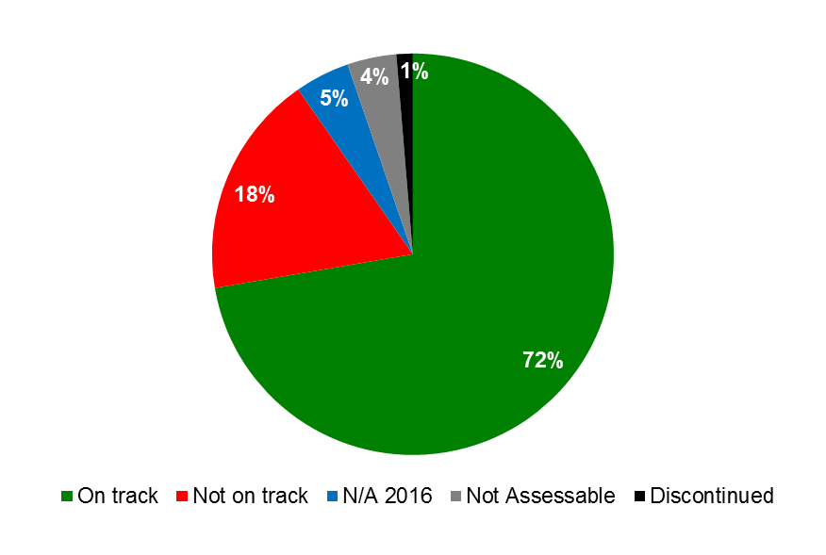

# EXECUTIVE SUMMARY - HIGHLIGHTS OF 2016

1. The PPR 2016 includes Performance Dashboards for each of the nine Strategic Goals (SGs), providing a graphic summary of the progress in 2016 as measured by the Performance Indicators under the Programs contributing to the respective Goals. In assessing performance, the impact of the risks identified in the Program and Budget 2016/17 was duly taken into consideration. The risk reporting for the biennium, including a more in-depth risk analysis and impact on the delivery of the Expected Results, will be provided in the PPR 2016/17.
2. Highlights of achievements in 2016 towards the nine Strategic Goals are summarized below.

**Consolidated view of progress towards the Expected Results in 2016 by Strategic Goal**

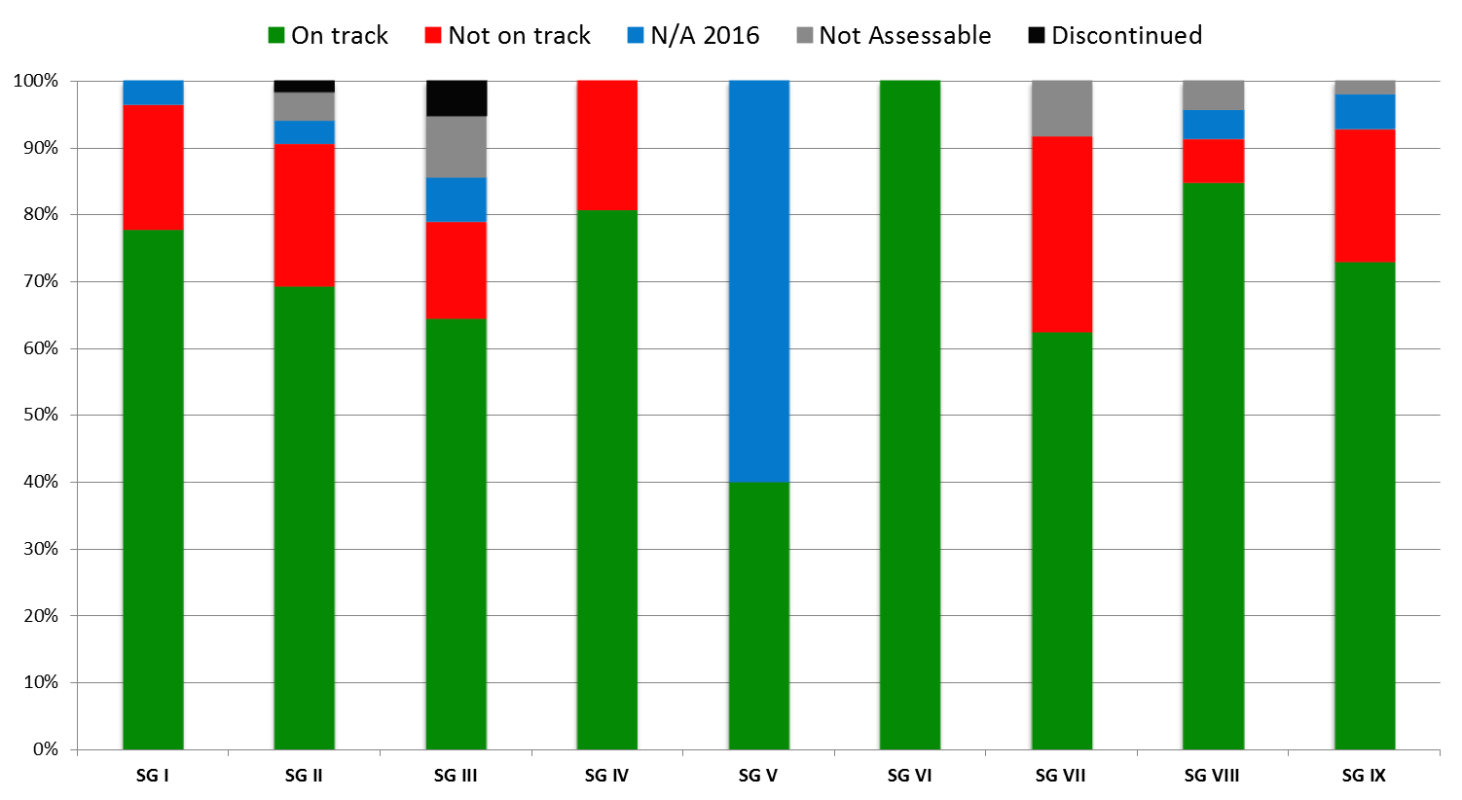

**Strategic Goal I: Balanced Evolution of the International Normative Framework for IP**

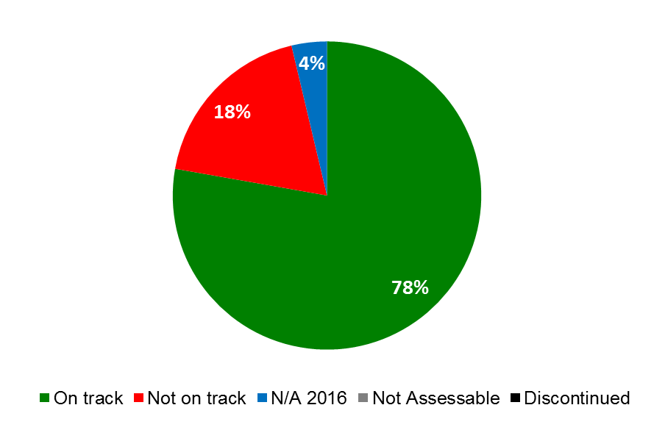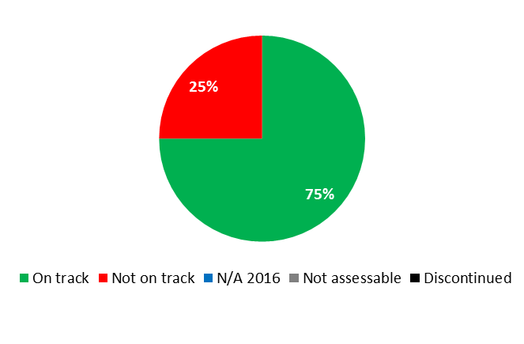

1. Progress continued to be made in 2016 under this Strategic Goal, albeit at a slightly slower pace than anticipated. By the end of 2016, several outstanding issues still remained in the Standing Committees.

* A major highlight of 2016 was the entering into force of the Marrakesh Treaty on September 30, 2016, with a total 25 members. The first meeting of the Marrakesh Treaty took place during the 2016 Assemblies. Overall, WIPO copyright treaties gained 22 new memberships in 2016, including 12 additional ratifications to the Marrakesh Treaty (Botswana, Canada, Chile, Democratic People’s Republic of Korea, Ecuador, Guatemala, Israel, Liberia, Peru, Saint Vincent and the Grenadines, Sri Lanka, Tunisia) and five additional ratifications to the Beijing Treaty (Democratic People’s Republic of Korea, El Salvador, Gabon, Saint Vincent and the Grenadines, Tunisia), bringing the cumulative number to 15 by the end of the year. In addition, some 17 Member States or regional organizations requested and received copyright legislative assistance from WIPO on 18 matters, including many related to the process of updating legislation for the digital era or incorporating new provisions in order to join WIPO copyright treaties.
* The Standing Committee on Copyright and Related Rights (SCCR) held productive discussions on a single text for the protection for broadcasting organizations and principles for limitations and exceptions; received the results of a comprehensive study on education; and started work on two additional matters regarding copyright in the digital environment and the resale royalty right.
* In view of enhancing cooperation among Member States on further developing balanced policy and normative frameworks for the international patent system, at its twenty-fourth and twenty-fifth sessions, which were held in June and December 2016, respectively, the Standing Committee on the Law of Patents (SCP) advanced discussions on the following five agenda topics, namely: (i) exceptions and limitations to patent rights; (ii) quality of patents, including opposition systems; (iii) patents and health; (iv) confidentiality of communications between clients and their patent advisors; and (v) transfer of technology.
* With respect to WIPO’s administered treaties in the field of patents, 2016 saw the accessions of Cambodia, Djibouti and Kuwait to the Patent Cooperation Treaty, of Belarus, Japan and Liberia to the Patent Law Treaty, and of Colombia to the Budapest Treaty.
* Furthermore, the Secretariat continued to contribute towards the promotion of greater awareness of the legal principles and practices of the patent system, through the provision of relevant information to inter-governmental organizations, United Nations bodies, non-governmental organizations and other parties. In this regard, for the first time since the adoption of the Budapest Treaty in 1979, the Secretariat and the International Depositary Authorities (IDAs) met in 2016 to discuss the very diverse practical aspects of their practices in carrying out tasks in the framework of the Treaty.
* In October 2016, the Inventor Assistance Program (IAP) was officially launched. The IAP is now operational in three countries, namely Colombia, Morocco and the Philippines, and is open for progressive expansion to other WIPO Member States. The program now accounts for over 50 patent attorneys, working on a pro bono basis and providing high-quality advice to inventors from the beneficiary countries. By the end of 2016, more than 30 inventors had received free legal and technical advice through the program.
* The thirty-fifth and thirty-sixth sessions of the Standing Committee on the Law of Trademarks, Industrial Designs and Geographical Indications (SCT) were held in April and October, 2016. It is recalled that the WIPO General Assembly, at its forty-seventh (22nd ordinary) session held in October 2015, had decided “to convene a diplomatic conference for the adoption of a Design Law Treaty at the end of the first half of 2017, only if the discussions on technical assistance and disclosure have been completed during the thirty-fourth and thirty-fifth sessions of the SCT.” As the discussions were not completed during the two SCT sessions in question, the matter reverted to the WIPO General Assembly, which, decided, at its forty-eighth (26th extraordinary) session held in October 2016, that “at its next session in October 2017, it will continue considering the convening of a diplomatic conference on the Design Law Treaty, to take place at the end of the first half of 2018.” At the thirty-sixth session of the SCT, the Chair of the SCT concluded that “while the [Design Law Treaty] would remain on its Agenda, the SCT should abide by the decision of the General Assembly.”
* Seven new Contracting Parties ratified or acceded to the Singapore Treaty on the Law of Trademarks (Benin, Democratic People’s Republic of Korea, Ireland, Japan, Mali, Republic of Korea and the *Organisation Africaine de la Propriété* *Intellectuelle (*OAPI)), bringing the total number of Contracting Parties to 45 at the end of 2016.
* After having not met in 2015, the WIPO Intergovernmental Committee on Intellectual Property and Genetic Resources, Traditional Knowledge and Folklore (the IGC) resumed meeting in 2016 and made further progress in its text-based negotiations under its new mandate for the biennium as established by the WIPO General Assembly in 2015. During four sessions in 2016 (IGCs 29, 30, 31 and 32), the IGC’s texts on genetic resources (GRs) and traditional knowledge (TK) were further streamlined and delegations’ positions further clarified. Two seminars organized by the Secretariat contributed to building regional and cross-regional knowledge and to the progress made in the IGC. The number of indigenous and local community participants in the IGC process did not increase partly due to the continued depletion of the Voluntary Fund for Accredited Indigenous and Local Communities, but the Secretariat continued to facilitate their participation in the process to the extent possible. The IGC will address traditional cultural expressions (TCEs) in 2017. The WIPO General Assembly will take stock of the progress made by the IGC in 2016 and 2017 when it meets again in October 2017.

**Strategic Goal II: Provision of Premier Global IP Services**

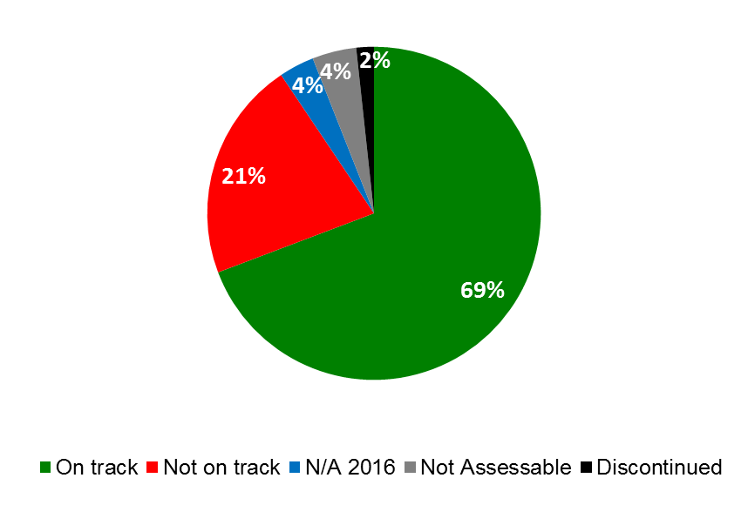

1. The year 2016 represented another record year for WIPO’s international registration systems, demonstrating considerable growth for the seventh consecutive year.

* The PCT International Bureau (IB) received approximately 233,000 record copies in 2016, representing an increase of 7.4 per cent compared to 2015. Three telecom giants from China and the United States of America continued to lead the international patent filing activity. The share of fully electronic filings continued to increase, representing 96 per cent of total filings in 2016. While English accounted for the largest proportion of filings in 2016, with 45 per cent, the share of Asian languages continued to increase. The combined share of the PCT applications filed in Japanese, Chinese and Korean rose from 29.5 per cent in 2010 to 42 per cent in 2016.
* At its ninth session held in 2016, the PCT Working Group continued its discussions aimed at furthering the aims of the Treaty, for the benefit of all stakeholders, in line with the PCT roadmap recommendations endorsed by Member States, which include recommendations as to how the future development of the PCT can be matched with applicable DA Recommendations – notably from Clusters A and C. *Inter alia*, the Working Group considered issues such as IT-based services now offering new openings in collaboration between Offices, more efficient ways of working together and better sharing of information; a proposal for PCT fee reductions for universities and public research institutes; the coordination of technical assistance provided under the PCT; and improved coordination of patent examiner training between Offices.
* Use of the ePCT system increased significantly in 2016. By the end of 2016, 45 receiving Offices had, with the assistance of the IB, begun to accept applications filed via ePCT filing, up from 29 at the end of 2015. International applications filed using ePCT were up 50 per cent, from 7,229 to 10,843. Some 45 receiving Offices and 13 International Searching Authorities (ISAs) (up from 34 and eight, respectively) allowed for submission of post-filing documents via ePCT. Moreover, a new service, eSearchCopy, begun as a trial in 2014, where the IB prepares and transmits search copies to the International Searching Authority (ISA) on behalf of the receiving Office to improve timeliness and efficiencies in international search, expanded from 28 pairs of Offices at the end of 2015, including six ISAs and 15 receiving Offices, to 65 pairs, including 13 ISAs and 45 receiving Offices.
* The year 2016 was a record year for the Madrid System with a total number of 52,550 international applications filed, amounting to a 7.2 per cent increase of filings over 2015. By the end of the year, the Madrid Register contained a total of 641,587 international registrations, equivalent to 5.71 million national or regional trademark registrations.
* The Madrid Working Group made good progress in 2016 and adopted a number of Rule changes which were approved by the Madrid Union Assembly. Moreover, the Working Group agreed on a Road Map for work on specific topics in the short-, medium- and long-term.
* The Hague System received an all-time record number of applications in 2016 (5,562), representing a 35 per cent growth rate over 2015. With a 14 per cent increase over 2015, the number of designs also grew, but at a slower pace, confirming a downward trend in the average number of designs per application due to additional examining jurisdictions resulting from the expansion of the Hague System.
* Membership of the 1999 Act of the Hague System increased to 52 countries following accessions by the Democratic People’s Republic of Korea and Cambodia. The Democratic People’s Republic of Korea’s accession also meant that the number of countries bound exclusively by the 1960 Act (outside the EU and OAPI memberships) was reduced to three. The 1934 Act was effectively terminated on October 18, 2016, following the receipt of the last missing consent to termination.
* As decided by the Assembly of the Lisbon Union in 2015, the first session of the Working Group for the Preparation of Common Regulations under the Lisbon Agreement and the Geneva Act of the Lisbon Agreement was held in June 2016. In addition to reviewing the draft Common Regulations, the Working Group considered the financial situation of the Lisbon Union in the current biennium and its long-term financial sustainability. The Lisbon Registry received 25 new applications for the registration of appellations of origin, 8 statements of grant of protection and 54 refusal declarations, amounting to a total of 89 transactions. The total number of registrations in force increased from 931 in 2015 to 1020 in 2016. Of these, 95 originated from developing countries or LDCs (14 from the Arab region, 38 from Asia and the Pacific, and 43 from Latin America and the Caribbean).
* The International Bureau collected approximately 390,000 Swiss francs from Lisbon Union members in the form of subventions under Article 11(3)(iii) of the Lisbon Agreement, as part of the measures decided by the Assembly of the Lisbon Union, in 2016, towards eliminating the projected biennial deficit of the Lisbon Union.
* The WIPO Arbitration and Mediation Center (the WIPO Center) continued to work to optimize the potential of its procedures to meet the needs of IP right holders and users. In 2016, trademark owners filed an all-time record 3,036 cases under the Uniform Domain Name Dispute Resolution Policy (UDRP) with the WIPO Center, an increase of 10 per cent over the previous year. WIPO UDRP cases involved parties from 109 countries and were administered in 15 different languages. With over 1,200 new generic Top-Level Domains (New gTLDs) now operational, 16 per cent of WIPO’s caseload concerned registrations in new gTLDs. Since the WIPO Arbitration and Mediation Center administered the first UDRP case in 1999, total WIPO case filings passed the 36,000 mark in 2016, encompassing over 66,000 domain names.
* Sixty mediation and arbitration cases were received by the WIPO Center. Patent-related disputes (34 per cent) were most common, followed by ICT (20.5 per cent), copyright (13.6 per cent), and trademark (13.6 per cent) disputes, as well as others arising from distribution and franchising agreements, industrial design, and art and cultural heritage.
* Respondents with experience in IP disputes named the WIPO Center as their second-most used institution in a survey on the use of arbitration for Technology, Media and Telecom disputes by the School of International Arbitration, Queen Mary University of London. Where respondents expressed a preference for an institution in these dispute areas, the WIPO Center ranked first.[2]

**Strategic Goal III: Facilitating the Use of IP for Development**

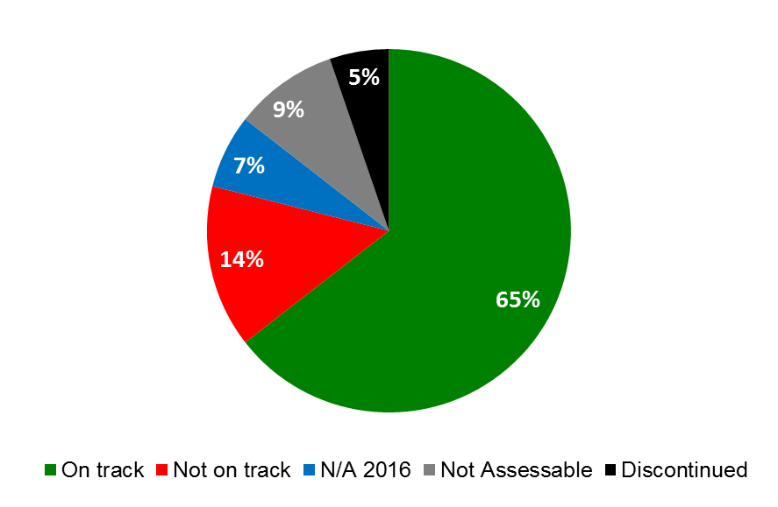



1. Facilitating the use of IP for development and empowering developing countries, LDCs and countries in transition, to harness IP for enhancing national innovation potential and capacities remained a priority in 2016.

* WIPO continued to assist developing countries and LDCs in the design, development and implementation of national IP strategies that are both consistent with their overall development plans and that have the ability to foster innovation and creativity. The application of the standardized, yet flexible, methodology and set of practical tools for the formulation of national IP strategies and plans, developed as part of the DA project on Improvement of National, Sub-regional and Regional IP Institutional and User Capacity in 2012, continued to guide the process. As a result, 11 additional countries (three in Africa, two in the Arab region, two in Asia and the Pacific and four in Latin America and the Caribbean) initiated the process of formulating national IP strategies/development plans. By the end of 2016, national IP strategies/development plans had been adopted in 42 countries (25 in Africa, two in the Arab region, seven in Asia and the Pacific and eight in Latin America and the Caribbean) and were under implementation in a total of 43 countries (27 in Africa, two in the Arab region, nine in Asia and the Pacific, and five in Latin America and the Caribbean) of which 20 in LDCs.
* Promotion of the importance of national IP strategies also remained a priority in transition countries in 2016. One country adopted an IP related national strategy, three additional countries were in the process of formulating or reformulating their IP strategies, and two countries were finalizing their IP strategies at the end of 2016.
* In line with the cooperation plans and national IP strategies and, following WIPO assistance, including promotional activities, the following seven countries amended their national IP legislation in 2016: Albania, Kazakhstan, Latvia, Montenegro, Republic of Moldova and the Russian Federation.
* With regard to the Professional Development Program (PDP), some 20 training courses were offered jointly with 23 partner institutions. Of the 301 government officials who benefited from the programs, 51 per cent were female. The Distance Learning Program (DL) continued to attract participants from a broad group of stakeholders. In 2016, some 54,596 participants (44,423 under its general courses and 10,173 under its advanced courses), a 25 per cent increase over 2015, benefited from the enhanced e-learning Centre (WeLC). Of particular note, 2016 saw the launch of the DL General Course on IP (DL-101) for persons who are print disabled in seven languages. The launch took part as part of the World IP Day 2016 festivities, and since its launch, over 500 participants globally have taken the course.

|  |  |
| --- | --- |
| *Gender Breakdown of PDP Participants in 2016* | *Gender Breakdown of DL Participants in 2016* |

* In 2016, the implementation of the DA Project on Cooperation on Development and Intellectual Property Rights Education and Professional Training with Judicial Training Institutions in Developing and Least Developed Countries was launched in the four pilot countries (Costa Rica, Lebanon, Nepal and Nigeria), representing different regions, including LDCs, with diverse judicial traditions and backgrounds. The objective of the project is to provide technical and professional assistance to judicial training institutions to enhance capacity and skills of magistrates, judges and prosecutors to efficiently and effectively adjudicate IPR disputes in such a way as to ensure coherence with the identified developmental needs and priorities of the concerned country,
* Enhancing human resource capabilities to deal with the broad range of requirements for the effective use of IP for development and fostering innovation and creativity remained a priority in 2016. Focused capacity building and skills development programs were delivered to specific target groups such as government officials, policy-makers, IP professionals, enforcement officials, researchers and academics, entrepreneurs and industrialists, as well as SMEs, at the national, sub-regional and regional levels. Some 17 programs on effective IP asset management by SMEs, including a regional seminar on IP for SMEs organized by the WIPO Singapore Office (WSO), and an International Workshop for Women Inventors and Entrepreneurs organized by WIPO, the Korean Intellectual Property Office (KIPO) and the Korea Women Inventors Association (KWIA), benefitting over 1,000 participants from 125 countries, were organized, aiming at creating a critical mass of trainers in specific countries with knowledge, skills and experience to provide basic assistance to SMEs on IP asset management.
* WIPO continued to strengthen its cooperation with LDCs for the development of a framework for national policies on innovation; assessing technical skills needs; facilitating access to global scientific and technological information platforms; establishing innovation support infrastructure; and supporting inventories and capacity building in traditional knowledge. Good progress was made in 2016 on the implementation in three LDCs (Ethiopia, Rwanda, and United Republic of Tanzania) as part of Phase II of the DA Project on Capacity Building in the Use of Appropriate Technology (AT) Specific Technical and Scientific Information as a Solution for Identified Development Challenges. In beneficiary countries from Phase I of the Project, by the end of 2016, three ATs had been commercialized[3] in LDCs (one in Nepal and two in Zambia), and three ATs were under consideration for commercialization at the government level.
* By the end of 2016, implementation of the DA Project on Intellectual Property, Tourism and Culture: Supporting Development Objectives and Promoting Cultural Heritage in Egypt and Other Developing Countries, which aims at analyzing, supporting and promoting awareness of the role of the IP system in tourism-related economic activity, including activity related to the promotion of national and/or local knowledge, traditions, and culture, had been launched in the four pilot countries (Egypt, Ecuador, Namibia and Sri Lanka).
* In 2016, the Committee on Development and Intellectual Property (CDIP) considered and discussed various documents and studies, including a document on Mapping of WIPO Activities Related to the Sustainable Development Goals (SDGs) and a document containing compilation of Member States Inputs on SDGs relevant to WIPO’s work and decided that the Secretariat will present an annual report to the Committee, at its first session of the year, containing information on WIPO’s contribution to the implementation of the SDGs and their associated targets.
* The 18th session of the CDIP discussed and noted the Independent Review of the DA[4] and requested the Secretariat to prepare a document containing its response to recommendations addressed to it, including inputs provided by Member States.
* Finally, the Committee also approved second phases of one completed and evaluated project and two new projects on the “Use of Information in the Public Domain for Economic Development” and on “Cooperation on Intellectual Property Rights Education and Professional Training with Judicial Training Institutes in Developing and Least Developed Countries”.

**Strategic Goal IV: Coordination and Development of Global IP Infrastructure**

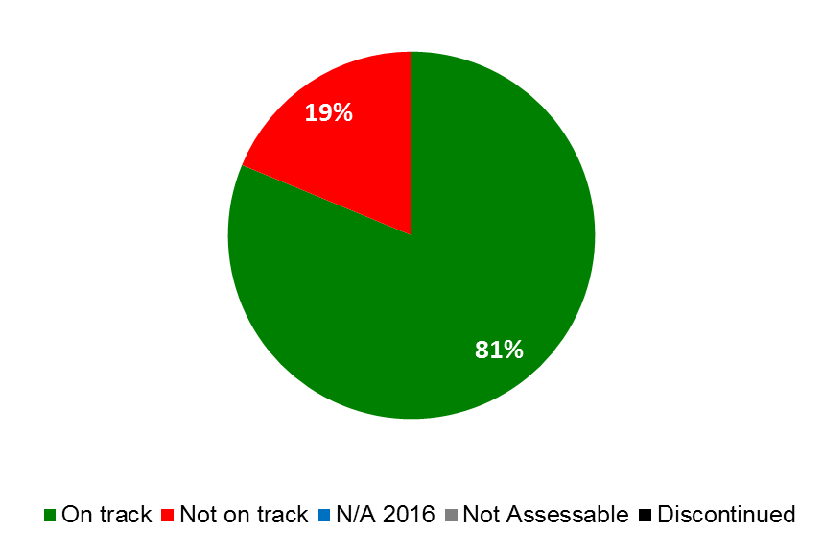

1. With a focus on enhancing the global IP infrastructure to help meet the growing global demand on the IP system and facilitating the participation of developing countries and LDCs in the system, good progress was made in the areas of global IP databases, classifications, IP office modernization, and TISCs in 2016.

* A new, cutting-edge Artificial Intelligence (AI)-based neural machine translation tool for translating patent documents was launched for three language pairs (English-Chinese, English-Japanese and English-Korean), providing innovators worldwide more easily accessible information on patents and new technologies.
* Global Databases continued to meet strong public demands, show a stable user base and experience a steady increase in coverage throughout 2016. In addition, the Global Database family was expanded in 2016 to include WIPO Lex, for which a thorough operational review was carried out and a complete overhaul initiated. The search capability in PATENTSCOPE was further enhanced to include a specialized search function for chemical compounds by both International Non-Proprietary Names (INNs) and chemical formula.
* Use of PATENTSCOPE remained stable with over 245,000 unique visitors per quarter in 2016. The Global Brands Database (GBD) saw a 48 percent increase in the number of unique visitors per quarter to more than 119,000. By the end of 2016, its second year in service, the Global Design Database (GDD) had seen a six per cent increase in its number of design documents, bringing the total to 1.6 million documents. The graphs below illustrate the growth in the number of records contained in the databases from 2014 to 2016 for PATENTSCOPE and GBD and from 2015 to 2016 for GDD.

PATENTSCOPE Records 2014-2016

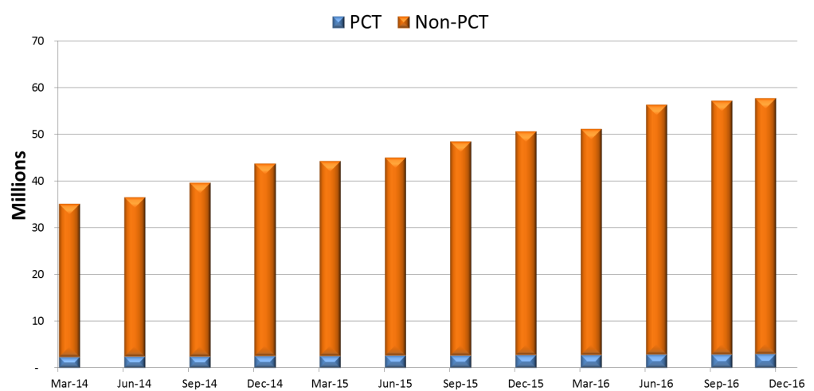

Global Brand Database Records 2014-2016

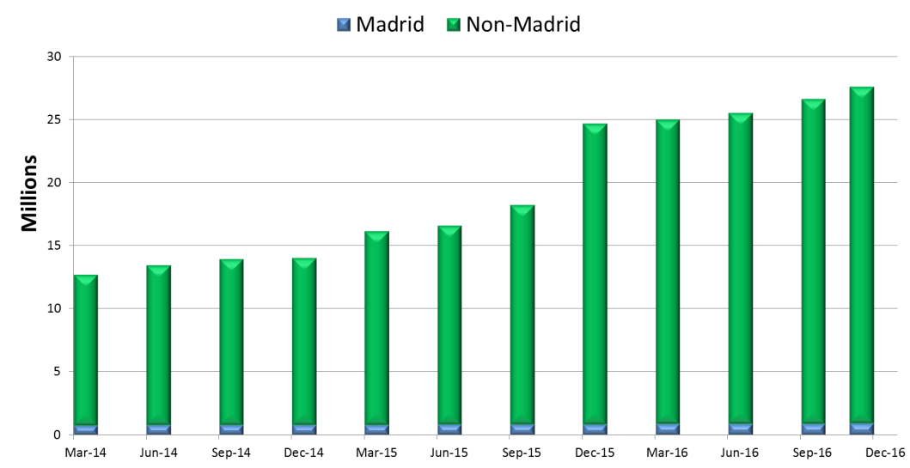

Global Design Database Records 2015-2016

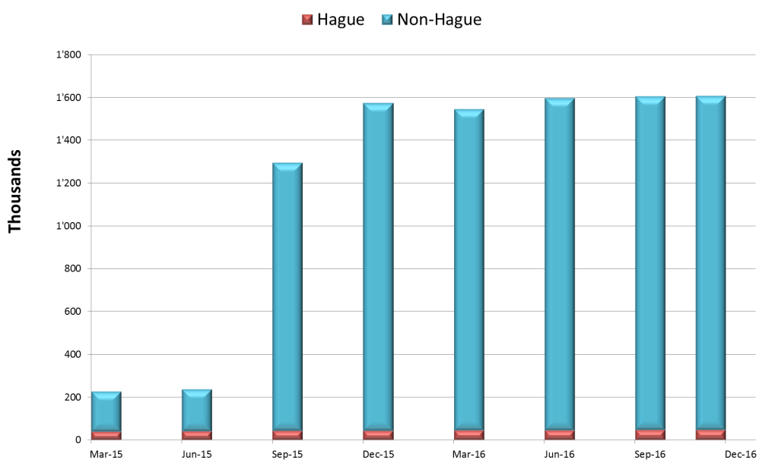

* As regards International Classifications and WIPO IP Standards, the year 2016 saw good progress. The situation as regards WIPO Standards recovered in 2016, following no formal results in 2015, with the formal adoption of two new Standards and revision of three Standards. As regards the Nice Classification, a total of 1,213 amendments (as compared to 920 in 2015) and 30 new information files (as compared to 5 in 2015) were introduced and 148 information files revised (as compared to 4 in 2015).
* A total of 28 Technology and Innovation Support Centers (TISCs) met the criteria to reach one of the three maturity levels of sustainability in 2016. In this regard, six TISCs were offering patent analytical services (Maturity Level 3) by the end of 2016.
* TISC Clinic services in conjunction with the Inventor Assistance Program (IAP) continued to be further developed in Colombia, Morocco and the Philippines with a total of 35 requests received in 2016, representing a significantly higher number than initially foreseen.
* The graph below provides an overview of the steady increase in usage of the WIPO IP Office Systems over the past seven years. At the end of 2016, some 81 IP Offices were using the WIPO IP Office Systems.

**WIPO IP Office Business Systems- Usage by Region[5]**

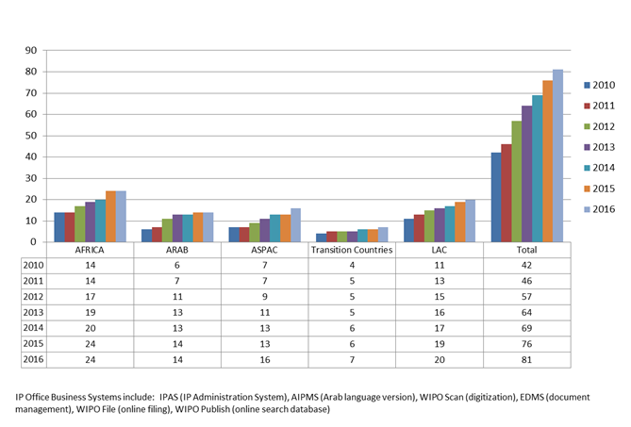

* In 2016, the WIPO Centralized Access to Search and Examination (WIPO CASE) was fully linked with the One Portal Dossier of the European Patent Offices, Japan Patent Office, Korean Intellectual Property Office, State Intellectual Property Office of China and United States Patent and Trademark Office. The number of Offices using WIPO Publish, software used, *inter alia*, to support internal search and examination processes or provide online search for external users, increased to 25 Offices in 2016. In addition, six additional Offices began using WIPO infrastructure platforms.
* The Accessible Books Consortium (ABC) saw excellent results in 2016, with 10 new libraries for the blind joining the ABC Book Service, an international catalogue of accessible books. Over 100,000 loans of ABC titles downloaded through the Service were made to print disabled individuals through participating ABC libraries, representing a 76 per cent increase over 2015. In addition, ABC released the “ABC Starter Kit for Accessible Publishing in Developing and Least Developed Countries” as well as the “ABC Accessibility Guidelines for Self-Publishing Authors”.

**Strategic Goal V: World Reference Source for IP Information and Analysis**

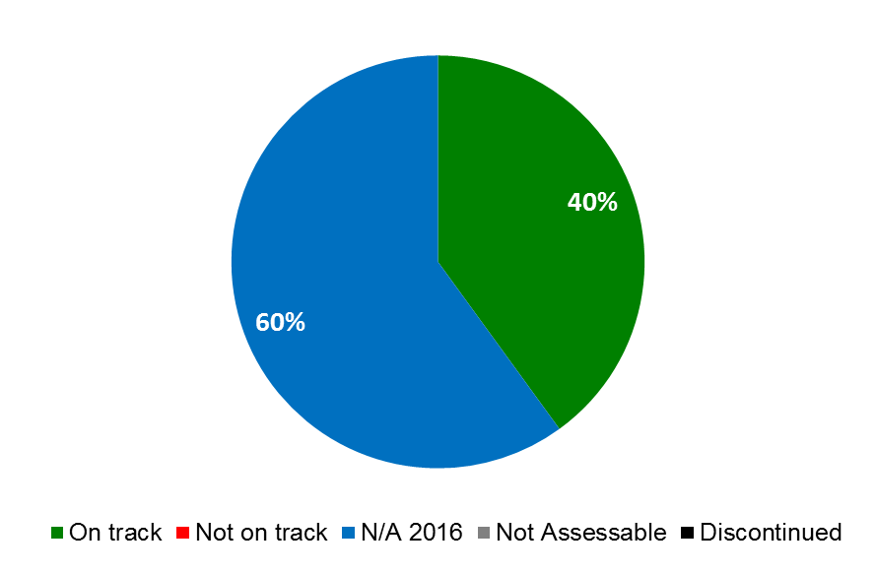

* WIPO’s economic analysis work continued to make significant progress in 2016 towards its objective of promoting high quality analysis addressing economic challenges in the international IP system and assessing the economic effects of IP policy choices. The release of the 2016 Global Innovation Index (GII) continued to reach new levels of and garner wider coverage in the news and social media compared to previous years. Co-published with Cornell University and INSEAD, the GII has become an established reference source for innovation stakeholders worldwide, as evidenced by citations, data inquiries, and requests for advisory services.
* The year 2016 saw the coverage of WIPO’s annual statistical survey expand to 131 national and regional IP Offices, exceeding the average of 127 offices in the 2014/15 biennium. As in previous years, statistical collections were made available through a variety of publications and web tools – notably the annual World IP Indicators and IP Facts and Figures reports; the annual PCT, Madrid, and the Hague Yearly Reviews, the IP Statistics Data Center, and the IP Statistical Country Profiles.
* Substantial progress was also made in the implementation of economic studies, with most studies aimed for completion in 2017.

**Strategic Goal VI: International Cooperation on Building Respect for IP**

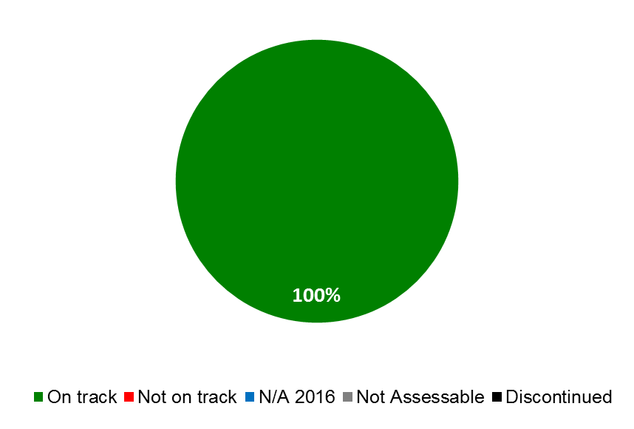

* With a view to achieving progress in the international policy dialogue among WIPO Member States on building respect for IP, the eleventh session of the Advisory Committee on Enforcement (ACE) (September 5 to 7, 2016) served as a forum for Member States to exchange information on awareness building activities and strategic campaigns; institutional arrangements concerning IP enforcement; and WIPO’s legislative assistance and capacity building activities. The expert presentations and panel discussions resulted in a rich and productive dialogue. The eleventh session was accompanied by an audiovisual exhibition on respect for IP and tourism.
* The International Conference on Building Respect for Intellectual Property, organized by WIPO and the Shanghai Municipal People’s Government (SMPG), with the support of the State Intellectual Property Office of China (SIPO), brought together senior representatives from government and the private sector, giving participants the opportunity to share experiences on the role of IP in stimulating innovation and driving development and growth. The Conference, which took place in Shanghai, China, on November 17 and 18, 2016, affirmed a shared commitment to further the work of building respect for IP by sharing information on public awareness-raising strategies and emerging issues in IP adjudication and jurisprudence.
* Finally, WIPO’s work in developing a balanced concept of building respect for IP, in line with Development Agenda Recommendation 45, its diverse activities in capacity-building, technical assistance and knowledge-sharing, and the increasing relevance of WIPO’s ACE were recognized through the award to WIPO of the 2016 Global Anti-Counterfeiting (GAC) International Public Body Award.

**Strategic Goal VII: Addressing IP in Relation to Global IP Policy Issues**

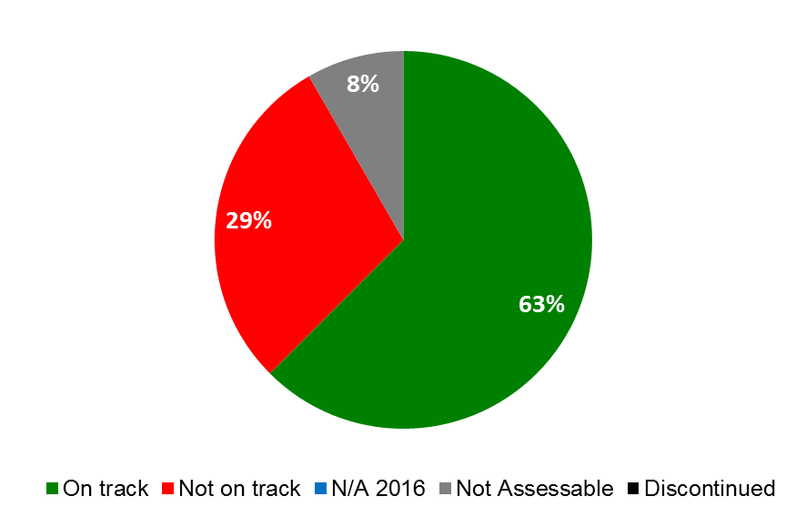



1. At the intersection of pressing global and interconnected issues, in particular global health, climate change and food security, substantive progress continued to be made in supporting an enhanced understanding among policy makers on the interface between global challenges and innovation and IP.

* WIPO Re:Search – Sharing Innovation in the Fight Against Neglected Tropical Diseases (NTDs) – gained in recognition as a platform to support innovation, knowledge and technology transfer and capacity building related to research for NTDs, tuberculosis and malaria, reaching the twin milestones of 108 Members and 108 collaborations by the end of 2016. The accomplishments were highlighted in May 2016 during a side event at the World Health Assembly, opened by the Minister of Health of Ethiopia.
* WIPO GREEN – The Marketplace for Sustainable Technology– also continued to successfully grow its network, adding nine additional Partners and 318 additional users in 2016, bringing the cumulative numbers to 74 Partners and 808 users. By the end of the year, the WIPO GREEN database comprised more than 2,600 technologies available for license, sale or collaboration and 150 needs (largely from developing countries), a 20 per cent increase as compared to 2015. In addition, WIPO GREEN facilitated 127 connections through the database, a matchmaking event in East Africa, an exhibition of innovative SMEs at COP22, and other matchmaking activities.
* Providing fora for participants to share ideas, expertise and information relating to the three core areas, the *Global Challenges Brief- Patents and the WHO Model List of Essential Medicines (18th Edition): Clarifying the Debate on IP and Access* was presented at a Global Challenges Seminar in April 2016. The Brief summarizes the technical report, which guides global health actors on those medicines which should be available in health systems as a minimum, for policy makers. The authors’ presentation of the analysis was well attended and informed a lively debate on patent information in the field of medicines.
* The year 2016 saw the launch of the WHO, WIPO and WTO executive Distance Learning (DL) course entitled *Promoting Access to Medical Technologies and Innovation*. The course aims to address the intersections among public health, IP and trade and was developed under the trilateral cooperation agreement between WHO, WIPO and the WTO in collaboration with the WIPO Academy. The course was launched at the WHO, WIPO and WTO Joint Technical Symposium on Antimicrobial Resistance: How to Foster Innovation, Access and Appropriate Use of Antibiotics?, attracting some 300 participants who followed an intensive exchange on the importance of global cooperation on innovation of, and access to, antimicrobial medicines as well as the appropriate use of antibiotics.

**Strategic Goal VIII: A Responsive Communications Interface between WIPO, its Member States and All Stakeholders**

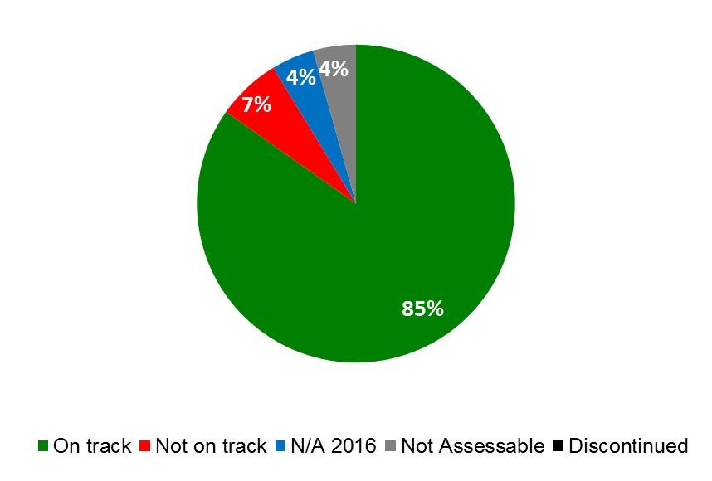

1. Priorities under this goal included a continued focus on creating and delivering relevant, high quality content, on increasing the visibility and public understanding of WIPO’s work, and on strengthening the culture of service within the Organization.

* *Strong brand identity.* The three-minute “What is WIPO?” video, released in October 2016, drew positive feedback and proved an engaging asset to support brand communication. The WIPO Wire e-newsletter (in six languages) reached 12,750 subscribers and established itself as a primary channel for WIPO-watchers. The biennial Stakeholders Perception Survey canvassed a cross-section of 7,680 stakeholders, with 74 per cent of respondents recognizing WIPO as the global forum for IP and 84 per cent considering WIPO to have a good reputation.
* *Reach and visibility.* Major WIPO products and events, identified as strategic communications priorities, achieved greater impact and reach as a result of targeted media outreach and integrated multi-channel communications. The 2016 launches of the Global Innovation Index (GII) and World Intellectual Property Indicators (WIPI) both attained their highest-ever level of international press coverage[6], strengthening public recognition of WIPO as the global reference source for IP information. High impact media coverage was also achieved for the ground-breaking WIPO Translate technology, including over 50 press reports with a potential reach of 62.6 million readers, as well as 7,200 views of promotional web content.
* *Stakeholder engagement.* Multi-platform digital campaigns were rolled out to support all major events including the Global Digital Content Market Conference, (67,200 views of the most popular #GDCM tweet), and the Marrakesh Treaty entry-into-force (more than 103,100 views of the top tweet). The World IP Day campaign, supported by the External Offices, attracted its widest participation yet with 450 events reported in 122 countries and a global fan-base on Facebook, headed respectively by India, United States of America, Mexico, Egypt and Brazil, with a daily organic reach of more than 363,800 people. On Twitter, the rate of positive interactions with WIPO content (some 19,700 retweets) in relation to number of followers (40,000 plus) demonstrated strong community engagement.
* *Wider access to, and geographical availability of, publications.* The Open Access Policy was launched to facilitate free re-use and translations of WIPO’s publications: 81 publications were re-issued under the most open Creative Commons (CC BY) license. Four more Member States were supplied with WIPO Depository Libraries, for a total of 109. Following WIPO’s commitment to the Accessible Publishing Charter, the first 17 publications were published in accessible formats for visually impaired readers.
* *Service orientation.* The new Customer Service Board, chaired by the Director General, began standardizing customer inquiry-handling across the Global IP Systems and other services, including in External Offices.
* With regard to External Relations, the implementation of several intergovernmental and UN processes of relevance to WIPO’s mandate commenced in the course of 2016, including  *inter alia*, the 2030 Agenda on Sustainable Development, the Third Conference on Financing for Development (FFD3), the Paris Agreement under the framework of the UN Framework Convention on Climate Change (UNFCCC), and the United Nations Conference on Trade and Development (UNCTAD) 14. As a specialized agency of the UN, and in line with its mandate and WIPO DA Recommendations 30 and 40, WIPO continued to play its role in supporting these processes through its strategic engagement and the provision of balanced and evidence-based information, as well as in timely responses to specific requests for contributions and cooperation.
* As a member of the UN Interagency Task Team on Science, Technology and Innovation for the SDGs (IATT), WIPO assisted in the organization of the first annual Multi-Stakeholder Forum on Science, Technology and Innovation (STI) for the SDGs. The Forum was convened by the President of ECOSOC on the theme “Realizing the Potential of STI for all to Achieve SDGs”. WIPO also supported, as an observer, the work of the Inter-agency and Expert Group on Sustainable Development Goal Indicators (IAEG-SDGs) and the Statistical Commission, and made available its data sets and data methodologies upon request by Member States.
* WIPO’s network of External Offices continued to form an integral part of the Organization, bringing WIPO’s services and cooperation closer to Member States, stakeholders and partners, thereby enhancing efficiency and effectiveness of program delivery, as well as responding to the specific needs and priorities of the countries and/or regions they serve. In 2016, the Offices focused efforts on promotion of WIPO’s international registration systems, platforms and IP Office systems, as well as strengthening relationships with variety of stakeholders.

**Strategic Goal IX: Efficient Administrative and Financial Support Structure to Enable WIPO to Deliver its Programs**

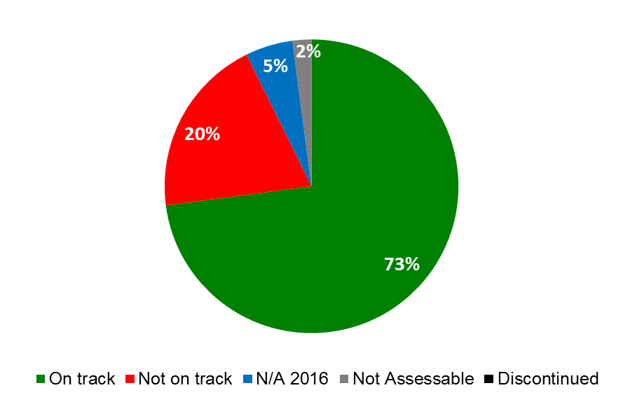

1. WIPO’s program and financial management continued to be strengthened in 2016 in order to utilize resources more effectively as well as to establish best practice in an area of administration, which deals with planning, performance management, facilitation and support for various operational activities across the Organization.

* WIPO closed the year with a positive overall result of 32 million Swiss francs on an IPSAS basis. Income before IPSAS adjustments in 2016 reached 384.7 million Swiss francs, 11.4 million Swiss francs above the linear target of 373.3 million Swiss francs. Total budgetary expenditure amounted to 92.6 per cent of its corresponding linear target (322.2 million Swiss francs as compared to the linear target of 347.9 million Swiss francs in 2016).
* Annual workplanning processes were further enhanced in 2016, with the introduction of a more systematic review of workplan implementation, including both mid-year and end-year organization-wide reviews.
* Progress was made on several ERP projects including talent management, contacts management, time management and self-service. A comprehensive review of the payment architecture was carried out as part of the Revenue Management project. The Revised ICSC Compensation package was successfully implemented and PCT forecasting and budgeting for translation was improved through the use of WIPO’s planning tool. Recruitment lead times were reduced to 18.81 weeks in 2016, as compared to 26.32 weeks in 2015, as the Recruitment tool Taleo stabilized through 2016
* Risk reporting was strengthened to provide a quarterly report with a high-level overview of the risk portfolio, accompanied by reporting on external factors, which influence the Organization’s operating and risk environment.
* Significant progress was made in strengthening WIPO’s internal controls, with a systematic self-assessment applied to 39 entity-level controls (ELCs) to assess control effectiveness and maturity. This served as the basis for evidence-based sign-off by senior officials of Management Representation Letters (MLRs) as part of the annual financial closure.
* To provide more flexibility and better serve clients, in 2016: (i) a Dynamic Currency Converter (DCC) was implemented, reducing the credit card margin from 2.2 per cent down to 1.4 per cent, lowering charges and providing more choice for clients; (ii) the e-Pay platform was expanded to cover the WIPO Arbitration and Mediation Center; and (iii) the current account system was improved to provide clients with easier settlement options and easier to open and maintain accounts.
* The loan prepayment to *Banque Cantonal de Genève* was initiated using core cash balances, resulting in a saving of 0.3 million Swiss francs in interest expense reduction. Increased safety and risk diversification for operational cash balances by expanding the available investment counterparties by 33 per cent in 2016 to include additional banks (Barclays Bank PLC, *Credit Mutuel* and Raiffeisen) that meet WIPO’s credit rating criteria.
* Following the implementation of the new investment policy in late 2015, the Request for Proposal (RFP) for investment fund management was completed in 2016, and a new RFP was launched for a global custodian.
* Other treasury-related initiatives included: (i) increased operational capacity and pricing efficiency to transact in forwards and swaps from Credit Suisse to include UBS, *Société Générale* and Bank of America; (ii) implementation of WIPO’s daily cash positioning and 3-month rolling cash forecast to manage the Organization’s liquidity position, negative interest rate charges and to ensure that, at all times, the organization has access to sufficient cash resources to meet its financial obligations; and (iii) ensuring pricing efficiency and increasing the competition for foreign exchange (FX) spot transactions with the expansion of FX liquidity providers to include *Société Générale* and Bank of America.
* Considerable work was done in 2016 with a view to forging new and strengthening existing relationships with banking institutions in External Office host countries, in order to facilitate the daily operations of the Offices and strengthen the overall financial management.
* Workforce planning was further strengthened in 2016 through a more strategically-oriented, high- level and proactive workforce planning process aimed at analyzing Sector/Program gaps/risks for a three to five year timeframe to better inform biennial planning.
* WIPO’s commitment to mainstreaming gender in WIPO activities and its time-specific goal for achieving gender balance at all staffing levels continued in 2016. To this end, gender markers was integrated into planning processes. While the percentage of women at the P4 level (45.6 per cent) saw a one percentage point decrease as compared to 2015, women at P5 and D1 levels saw increases of 4.3 and 13.2 percentage points respectively. Women at the D2 level continued to see a downward trend, decreasing by 5.5 percentage points as compared to 2015.

*Percentage of Professional and Higher Category Staff by Gender 2013-2016*

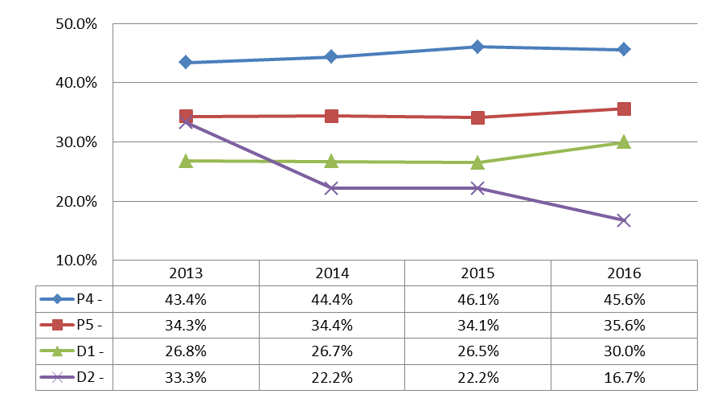

* With regard to geographical diversity, the percentage of staff members from the Africa, Asia and the Pacific, Eastern and Central Europe and Central Asia and the Middle East regions saw increases in 2016, while the percentage of staff coming from the Latin America and the Caribbean and North America regions both saw slight decreases. The percentage of staff coming from Western Europe saw a more significant decrease of 3.6 percentage points.

*Percentage of Professional and Higher Category Staff by Region 2012-2016*

* Procurement initiatives were launched in 2016 with a view to optimizing the cost of WIPO procured goods and services and streamlining its processes resulting in overall savings of 1.8 million Swiss francs. As regards travel expenditure, the Online Booking Tool (OBT) yielded further decreases in the service fee (from 95 Swiss francs to 92 Swiss francs) and the global average ticket fare (from 1,481 Swiss francs to 1,315 Swiss francs). The percentage of locally sourced goods and services for development activities increased to 60.3 per cent in 2016, a three percentage point increase over 2015.
* WIPO received the “Green Good Design Award 2016” for the WIPO Conference Hall (based on the wood structure and extensive utilization of wood for the interior and exterior finishings), awarded by The Chicago Athenaeum Museum of Architecture and Design. WIPO also received a certificate from the electricity provider recognizing the 100% Swiss hydraulic energy provision, chosen by WIPO, for the years 2015 to 2017, thereby contributing to the development of renewable energy.
* As regards ICT enhancements, specific accomplishments in 2016 included: Cost savings totaling 300,000 Swiss francs following the implementation of a new backup policy at the end of 2015, which reduced the volume of data storage needed; a reduction of over 30 per cent in the number of ICT service incidents with medium or high impact; enhancements to the ICT infrastructure resilience and service continuity to include remaining key services such as the external Identity and Access Management system and network File and Print services; the deployment of a new Disaster Recovery platform for the email system; and the roll out of the Global Office Architecture (GOA) solution for WIPO’s External Offices to two additional External Offices (WOC, WBO).
* The revised Internal Oversight Charter was approved by the General Assembly in October 2016. The main changes included: (i) detailed provisions concerning investigations into alleged misconduct by the Director General, Deputy and Assistant Directors General as well as the Director IOD; (ii) improving and clarifying the definition of IOD’s independence at both operational and functional levels; and (iii) enabling Member States to have access to full versions of redacted/withheld audit, evaluation and management implications reports.
* The WIPO Language Policy continued to be effectively implemented by extending the six language coverage to Working Groups in a phased and cost-effective approach. According to the timeline set by Member States, coverage was extended in 2016 to: (i) the Working Group for the Preparation of Common Regulations under the Lisbon Agreement and the Geneva Act of the Lisbon Agreement; and (ii) the IPC Union - Committee of Experts.
* Total mailing costs decreased by nine per cent in 2016 resulting from a combination of cost-efficiency measures, better staff awareness, and reduced numbers of items mailed.
* In the field of information assurance, as part of the continuous improvement process promoted by the ISO 27001 Standard, in October 2016, the PCT, Madrid and Hague operations were recertified to the international standard, with AMC added to the certification scope. No major or minor non-conformities were noted.
* Information security awareness initiatives were implemented to increase user awareness of information security threats and to train ICT staff on information security topics. A new mandatory Computer Based Training (CBT) course was launched in October covering basic information security hygiene with over 70 per cent of staff and contractors completing the course in 2016. The ISAEP also promoted four simulated phishing campaigns that continued to raise user awareness of information security threats, as evidenced by a marked increase in the number of staff who reported phishing emails (46 per cent average for 2016, up from 25 per cent in 2015).
* The safety and security context within which WIPO operated in 2016 remained globally complex, but also broadly stable in the countries where WIPO has a presence. International travel safety of WIPO staff members remained a critical area of focus in 2016, as various regions visited by staff were impacted by instability and security-related events. Additional safety and security measures were implemented in 2016, including the strengthening of the Organization’s collaboration with the Host Government.

# 

# REPORT ON THE IMPLEMENTATION OF COST EFFICIENCY MEASURES  IN 2016

COST EFFICIENCIES REALIZED IN 2016

(Amounts in Swiss francs)

| **Area** | **Total savings 2015 \*** | **Total savings  2016 \*\*** | **Unit cost savings  2015** | **Unit cost savings  2016 \*\*\*** | **Comments** |
| --- | --- | --- | --- | --- | --- |
| **1. Registrations systems** | | | | | |
| Unit cost for processing PCT applications |  |  | An increase of 73 CHF (+11%) from 662 CHF in 2014 to 735 CHF in 2015 | A decrease of 50 CHF (-6.8%) from 735 CHF in 2015 to 685 CHF in 2016 | Lower overall costs for processing PCT applications resulting from a decrease of 2.3% in the total cost of production, combined with an increase of 4.7% in the number of applications. |
| Unit cost for processing Madrid System transactions |  |  | A decrease of 94 CHF (-11.2%) from 837 CHF in 2014 to 743 CHF in 2015 | A slight increase of 3 CHF (+0.4%) from 743 CHF in 2015 to 746 CHF in 2016 | Lower cost of processing a new international registration / renewals under the Madrid System. |
| Unit cost for processing the Hague System transactions |  |  | A reduction of 29 CHF (-8%) from 366 CHF in 2014 to 337 CHF in 2015.  A reduction of 330 CHF  (-22.3%) per recorded document from 1,483 CHF in 2014 to 1,153 CHF in 2015. | An increase of 106 CHF (+31%) from 337 CHF in 2015 to 443 CHF in 2016.  An increase of 19 CHF (+2%) per recorded document from 1,153 CHF in 2015 to 1,172 CHF in 2016. | The increase in unit costs is explained by the improvements in the unit cost calculation methodology, which resulted in a better repartitioning of costs between the Madrid and the Hague registry systems (for more information, please refer to the Annex on the Hague Indicators). |
| **2. Travel** | | | | | |
| Home leave travel cost | 267,000 | 1,091,811 |  |  | After the transitional period of 2014/15, 2016 benefited from the full implementation of the new home leave policy, leading to significant savings between the economic fare and the former business fare. |
| Mission travel costs (global average ticket fare) |  |  | A reduction of 7.3% to 1,481 CHF in 2015 | A reduction of 11.2% to 1,315 CHF in 2016 | The decrease in 2016 was driven by the implementation of new technology travel tools (OBT) and training to promote advance purchasing of tickets. The lower amount of travel by both staff and non-staff in 2016 (7.9% less compared to 2015) also contributed to an overall reduction of travel costs. |
| Travel agent fee |  |  | 95 CHF | 92 CHF | Decrease in the transaction fee paid to both UNDP and the travel management company (TMC) is primarily driven by the increased adoption rate of OBT (69% of all tickets were purchased through OBT). |
| **3. Premises** | | | | | |
| Energy consumption cost | 75,000 | 33,800 |  |  | The reduction in electricity consumption was due to the installation in 2015 of the Geneva Lake water cooling system, which doesn't require additional systems to decrease water temperature. Savings for the PCT Building represented 33,800 CHF in 2016. |
| Lighting consumption cost | 45,000 | 25,610 |  |  | Savings resulted from the implementation of light presence detectors, energy-efficient light bulbs, light timing in parking and more efficient electric closets. |
| Water consumption cost | 125,500 | 2,500 |  |  | Reduction in water consumption resulted from the use of lake water instead of city water. No substantial savings in 2016, as the decrease in consumption was offset by the slight increase in water tariffs. |
| Electricity consumption cost | 164,000 | - |  |  | No additional savings in 2016 as compared to 2015. However, costs in 2016 are based on lower tariffs, which were contracted in January 2015 for a three-year period. Savings in 2016 when compared to prior tariffs as a baseline would be 155,000 CHF. |
| Storage areas cost (termination of leases) | 54,150 | - |  |  | No additional savings in 2016 since none of the remaining leases of storage areas were planned for termination in 2016. |
| Parking cost ("Parking des Nations") | 123,492 | 25,280 |  |  | The amount for 2015 represented savings following the termination of 52 subscriptions in Parking des Nations in 2015. The amount for 2016 represented savings following the termination of 35 additional subscriptions in Parking des Nations in 2016. |
| Parking cost (CAM building) | 8,340 | 29,190 |  |  | The amount for 2015 represented savings following the termination of 5 subscriptions in the CAM Building Parking in 2015. The amount for 2016 represented savings following the termination of 30 additional subscriptions in the CAM Building Parking in 2016. |
| Office supplies cost | 9,269 | - |  |  | No savings in 2016. The use of office supplies has remained stable in 2016, as compared to 2015. |
| **4. ICT** | | | | | |
| Mobile communication cost | 227,540 | 45,253 | A reduction of the average monthly mobile subscription cost from 177 in 2013 to 115 in 2015 (35% decrease) | A reduction of the average monthly mobile subscription cost from 115 CHF in 2015 to 108 CHF in 2016 (6% decrease) | 2015: total expenditure was 522,276 CHF (378 subscriptions on average during the year). 2016: total expenditure was 477,023 CHF (370 subscriptions on average during the year). |
| Email management cost | 70,000 **** | 38,675 |  |  | Savings were due to the reduction in number of mailboxes, from an average of 3,300 in 2015 to an average of 2,650 in 2016 (policy implemented in Q4 2015). Total mailbox management cost went up from 288,182 CHF to 291,258 CHF in 2016. This increase was driven by added services such as journaling and advance search. |
| Data backup cost | N/A | 300,000 |  |  | The implementation of a new backup policy in Q3 2015 resulted in a reduction of data volume to be stored. The lower amount of data represents 25,000 CHF of cost reduction per month. A linear pattern of savings per month is assumed for 2016. The reported 300,000 CHF (25,000 x 12) represents the annualized savings. |
| **5. Other areas** | | | | | |
| Translation cost | 601,084 | 313,587 | Cost per word reduced by 0.02 CHF from 0.59 CHF in 2014 to 0.57 CHF in 2015 | Cost per word further reduced by 0.02 CHF from 0.57 CHF in 2015 to 0.55 CHF in 2016 | Cost savings are driven by renegotiated contracts with external translators, new tenders for Arabic, Chinese and Russian translations, and use of Computer-Assisted Translation and Terminological (CATT) tools. |
| Printing cost | 399,000 | 26,947 | Same cost per page of 0.153 CHF in 2015 as in 2014 | Increase in cost per page to 0.161 CHF in 2016 (+5% compared to 2015) | Although total costs of the printing plant decreased in 2016 (2.4 million CHF in 2016 vs. 2.58 million CHF in 2015), the number of printed copies was lower by a higher margin (14.9 million copies in 2016 vs. 16.9 million copies in 2015), resulting in a higher cost per page in 2016. |
| Mailing cost | 189,367 | 135,477 |  |  | Decrease of mailing costs by 9% in 2016 (1,381,137 CHF) as compared to 2015 (1,516,614 CHF). |
| Security guards cost | 708,739 | (160,163) |  |  | Base contract values went down from 3.13 million CHF in 2015 to 3.07 million CHF in 2016, whereas surge capacity cost went up from 143,352 CHF to 359,807 CHF. This resulted in an overall cost increase of 160,163 CHF for 2016. |
| Professional Accident Insurance (PAI) for Employees | 200,000 | (55,000) |  |  | Increase in costs in 2016 compared to 2015 is explained by the change of insurer in 2016 and associated improvements in the quality and scope of services as compared to 2015. |
| Procurement of goods and services | 3,826,361 | 1,801,919 |  |  | Total savings was a combination of savings generated by CPAG amounting to 760,901 CHF and by negotiated discounts on contracts amounting to 1,062,892 CHF. Savings are calculated by taking the negotiated discount over the original / list price and annualizing it to capture 12 months of savings. |

|  |
| --- |
| *\* Information on cost efficiencies achieved in 2015 can be found in the PPR for 2014/15, section V.* |
| *\*\* Annual savings in 2016 compared to 2015.* |
| *\*\*\* Unit cost decreases in 2016 compared to 2015.* |
| *\*\*\*\* Represents the estimated annualized savings (12 months) based on the extrapolation of monthly savings observed in Q4 2015.* |

# OVERVIEW OF PROGRESS IN 2016 BY STRATEGIC GOAL

## STRATEGIC GOAL I

**BALANCED EVOLUTION OF THE INTERNATIONAL**

**NORMATIVE FRAMEWORK FOR IP**

**Mid-term Performance Dashboard (2016)**

The dashboard below provides a summary of the progress towards the achievement of the Results in the 2016 as measured by the indicators under the Programs contributing to this Strategic Goal.

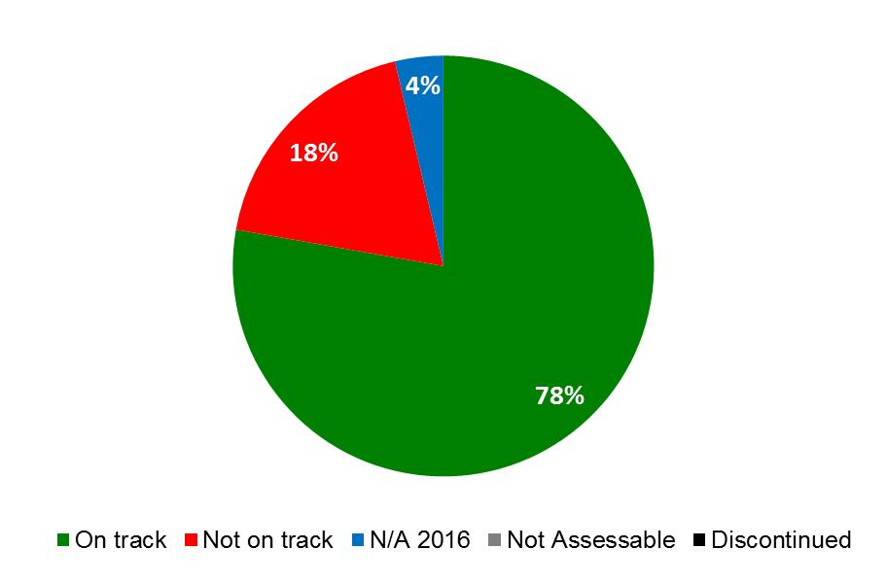

| **Expected Results** | **Performance Indicators** | **Responsible Program(s)** | **TLS** |
| --- | --- | --- | --- |
| I.1 Enhanced cooperation among Member States on development of balanced international normative frameworks for IP | Level of satisfaction of participants in targeted workshops/seminars held on specific patent related topics | Program 1 | ⚫ |
| Level of satisfaction of participants in the Inventor Assistant Program (IAP) | Program 1 | ⚫ |
| Progress on the implementation of agreed work according to SCP Agenda | Program 1 | ⚫ |
| No. of ratifications/accessions to the Singapore Treaty | Program 2  Program 20 | ⚫  ⚫ |
| Progress towards agreement on current issues on the SCT Agenda | Program 2 | ⚫ |
| Progress in the implementation of agreed work according to the SCCR agenda | Program 3 | ⚫ |
| Progress towards implementation of normative activities on IP and GRs, TK and TCEs as agreed by Member States | Program 4 | ⚫ |
| No. of ratifications and/or accessions to the Beijing Treaty | Program 20 | ⚫ |
| No. of ratifications and/or accessions to the Internet Treaties | Program 20 | ⚫ |
| No. of ratifications and/or accessions to the Marrakesh Treaty | Program 20 | ⚫ |
| I.2 Tailored and balanced IP legislative, regulatory and policy frameworks | % of recipients which found information concerning legal principles and practices of the patent, utility model and integrated circuit systems, including the flexibilities, useful | Program 1 | ⚫ |
|  | No. and % of Member States satisfied with the legislative and policy advice provided | Program 1 | ⚫ |
|  | No. and % of Member States/regional organizations providing positive feedback on the legislative advice offered in the area of trademarks, industrial designs and geographical indications | Program 2 | ⚫ |
|  | % of countries that have provided positive feedback about WIPO’s legislative advice | Program 3 | ⚫ |
|  | No. of countries that have ratified or acceded to the Beijing Treaty | Program 3 | ⚫ |
|  | No. of countries that have ratified or acceded to the Marrakesh Treaty | Program 3 | ⚫ |
|  | No. of ratifications or accessions to the copyright treaties in force including the Berne Convention, Rome Convention, and Internet Treaties | Program 3 | ⚫ |
|  | No. and/or % of countries providing positive feedback on WIPO’s legislative and policy advice | Program 9 | ⚫ |
|  | No. of ratifications to WIPO administered treaties | Program 10 | ⚫ |
|  | No. of transition countries with updated national laws and regulations | Program 10 | ⚫ |
|  | No. of countries that have adopted and/or implemented a national strategy on Building Respect for IP, or are in the process of doing so, with WIPO assistance | Program 17 | ⚫ |
|  | No. of countries/regional organizations having adopted or amended relevant frameworks towards effective IP enforcement in the light of Part III of the TRIPS Agreement and DA Recommendation 45, or being in the process of doing so, further to WIPO assistance | Program 17 | ⚫ |
|  | No. and diversity of stakeholders (IP Offices, competition and authorities, relevant IGOs and NGOs) engaged in dialogue with WIPO | Program 18 | ⚫ |
|  | No. of countries requesting WIPO’s specific contribution on IP in relation to competition policy-related issues | Program 18 | ⚫ |
| I.3 Increased protection of State emblems and names and emblems of International Intergovernmental Organizations | No. of signs contained in the Article 6*ter* database | Program 2 | ⚫ |
| I.4 Growing interest in WIPO as a forum for analysis of issues in relation to the international protection of utility models, layout designs (topographies) of integrated circuits and confidential information | % of recipients which found information concerning legal principles and practices on the protection of utility models, layout designs (topographies) of integrated circuits and confidential information, useful | Program 1 | ⚫ |

### PROGRAM 1 PATENT LAW

**Program Manager Mr. J. Sandage**

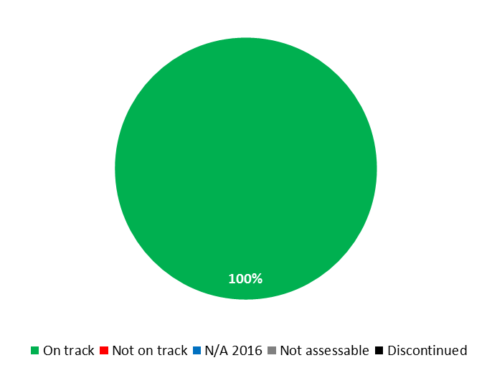

|  |  |  |  |  |
| --- | --- | --- | --- | --- |
| **Expected Result:** I.1Enhanced cooperation among Member States on development of balanced international normative frameworks for IP | | | | |
| **Performance Indicators** | **Baselines** | **Targets** | **Performance Data** | **TLS** |
| Progress on the implementation of agreed work according to SCP Agenda | *Updated Baseline end 2015:*  The SCP concentrated its efforts on the progress of the five topics on its agenda, and advanced its discussions through, for example, preparing studies, collecting information on national laws and practices and exchanging national experiences among Member States. Discussions were based on Delegations’ proposals (12) and documents prepared by the Secretariat (27) during the biennium  *Original Baseline P&B 2016/17:*  Current state of work in the Committee as documented by SCP/21 Report | SCP agreed outcomes | The SCP held 2 sessions in 2016 (SCP 24 and 25). The agreed outcome of the previous sessions (SCP/23 Summary by the Chair[7], paragraphs 20 and 21 and SCP/24 Summary by the Chair[8] Paragraph 17) were fully covered at the next sessions (SCP/24[9] and SCP/25[10]) | **On track** |
| Level of satisfaction of participants in targeted workshops/seminars held on specific patent related topics | *Updated Baseline end 2015:*  96.85%  *Original Baseline  P&B 2016/17:*  92.75% - 2014 survey | 90% | 89% based on 276 responses from participants in 11 seminars (Africa 1; Arab Region 1; Asia and the Pacific 4; Latin America and the Caribbean 4; Other 1) | **On track** |
| Level of satisfaction of participants in the Inventor Assistant Program (IAP) | *Updated Baseline end 2015:*  90% satisfaction based on a survey to Steering Committee Members  *Original Baseline P&B 2016/17:*  n/a | 90% | 84% based on 4 responses from inventors and 7 from other participants | **On track** |
| **Expected Result:** I.2 Tailored and balanced IP legislative, regulatory and policy frameworks | | | | |
| **Performance Indicators** | **Baselines** | **Targets** | **Performance Data** | **TLS** |
| % of recipients which found information concerning legal principles and practices of the patent, utility model and integrated circuit systems, including the flexibilities, useful | *Updated Baseline end 2015:*  95.24% based on 24 responses  *Original Baseline P&B 2016/17:*  7 countries/participants (85.7%) - 2014 survey | 90% | 100% based on 24 responses from participants in 2 training activities (Belarus and the Philippines) | **On track** |
| No. and % of Member States satisfied with the legislative and policy advice provided | *Updated Baseline end 2015:*  In 2014/15, 9 respondents reported on average a 94% satisfaction rate  (Africa-3; Arab-1; Asia and the Pacific-2; Certain Countries in Europe and Asia-2; Latin America and the Caribbean-1)  *Original Baseline P&B 2016/17:*  8 Member States (90%) - 2014 survey | 90% | 92% satisfaction rate based on 7 respondents (Africa 1; Arab Region 1; Asia and the Pacific 2; Latin America and the  Caribbean 3) | **On track** |
| **Expected Result:** I.4 Growing interest in WIPO as a forum for analysis of issues in relation to the international protection of patents, utility models, layout designs (topographies) of integrated circuits and confidential information | | | | |
| **Performance Indicators** | **Baselines** | **Targets** | **Performance Data** | **TLS** |
| % of recipients which found information concerning legal principles and practices on the protection of utility models, layout designs (topographies) of integrated circuits and confidential information, useful | n/a | 90% | 81% based on 18 responses | **On track** |

|  |
| --- |
| **Resource Utilization for Program 1** |

Budget and Actual Expenditure (by result)

*(thousands of Swiss francs)*

|  |  |  |  |  |
| --- | --- | --- | --- | --- |
| **Expected Result No. and Description** | | **2016/17 Approved Budget** | **2016/17 Budget after Transfers** | **2016 Expenditure\*** |
| I.1 | Enhanced cooperation among Member States on development of balanced international normative frameworks for IP | 2,239 | 2,721 | 1,267 |
| I.2 | Tailored and balanced IP legislative, regulatory and policy frameworks | 2,559 | 2,130 | 1,150 |
| I.4 | Growing interest in WIPO as a forum for analysis of issues in relation to the international protection of confidential information | 494 | 368 | 164 |
|  | **Total** | 5,291 | 5,219 | 2,581 |
| *\*2016 Expenditure numbers are preliminary, subject to audit by External auditors* | | | |  |

Budget and Actual Expenditure (personnel and non-personnel)

*(thousands of Swiss francs)*

|  |  |  |  |  |
| --- | --- | --- | --- | --- |
|  | **2016/17 Approved Budget** | **2016/17 Budget after Transfers** | **2016 Expenditure\*** | **Utilization rate (%)** |
| Personnel Resources | 3,953 | 3,888 | 1,928 | 50% |
| Non-personnel Resources | 1,339 | 1,331 | 653 | 49% |
| **Total** | **5,291** | **5,219** | **2,581** | **49%** |
| *\*2016 Expenditure numbers are preliminary, subject to audit by External auditors* | | | | |

*NOTE: The 2016/17 Budget after Transfers reflects transfers as of March 8, 2017 to address needs during the 2016/17 biennium in line with Financial Regulation 5.5.*

A. 2016/17 Budget after Transfers

1. The slight net decrease in personnel resources compared to the 2016/17 Approved Budget resulted, on the one hand, from: (i) the temporary transfer of a Senior Legal Counsellor to Program 3 (Copyright and Related Rights), reflected under Expected Result I.2 (Legislative advice); (ii) redeployment of accrued personnel savings in the Program to other organizational priorities and, on the other hand, from additional funds allocated to the Program for regularization of a continuing function, reflected under Expected Result I.1 (Enhanced cooperation among Member States). The decrease in non-personnel resources was due to the transfer of resources for internships to HRMD (Program 23), which centrally manages interns.

B. 2016/17 Budget Utilization

1. Budget utilization was within the expected range of 40-60 per cent for the first year of the biennium.

### PROGRAM 2 TRADEMARKS, INDUSTRIAL DESIGNS AND GEOGRAPHICAL INDICATIONS

**Program Manager Ms. B. Wang**



|  |  |  |  |  |
| --- | --- | --- | --- | --- |
| **Expected Result:** I.1Enhanced cooperation among Member States on development of balanced international normative frameworks for IP | | | | |
| **Performance Indicators** | **Baselines** | **Targets** | **Performance Data** | **TLS** |
| Progress towards agreement on current issues on the SCT Agenda | *Updated Baseline*  *end 2015:*  State of advancement of SCT work at the end of 2015 as per document SCT/34/7  *Original Baseline*  *P&B 2016/17:*  State of advancement of SCT work at the end of 2015 as per relevant working documents | SCT agreed outcomes | The 2016 WIPO General Assembly decided that “at its next session in October 2017, it will continue considering the convening of a diplomatic conference on the Design Law Treaty, to take place at the end of the first half of 2018.” (Document A/56/16 ADD.4[11])  At the thirty-sixth session of the SCT:   * considered a compilation of replies to a questionnaire on graphical user interface (GUI), Icon and Typeface/ Type Font Designs (Document SCT/36/2 REV[12]); * considered possible areas of convergence regarding the protection of country names against registration and use as trademarks (Document SCT/35/4[13]); and * decided that an information session on geographical indications will take place at its 37th session, following which further discussions will be held regarding its work program in this connection (Document SCT/36/5[14], paragraph 15). | **Not on track** |
| No. of ratifications / accessions to the Singapore Treaty | *Updated Baseline*  *end 2015:*  A total of 38 Contracting Parties  *Original Baseline*  *P&B 2016/17:*  Seven new Contracting Parties in 2014: Belarus, Belgium, Benelux Organization for Intellectual Property (BOIP), Iraq, Luxembourg, Netherlands and Tajikistan, which brings the total number of Contracting Parties to 38 at the end of 2014. | Eight new ratifications/  accessions | 7 new Contracting Parties: Benin, Democratic People’s Republic of Korea, Ireland, Japan, Mali, Republic of Korea and the African Intellectual Property Organization (OAPI)  A total of 45 Contracting Parties at the end of 2016 | **On track** |
| **Expected Result:** I.2 Tailored and balanced IP legislative, regulatory and policy frameworks | | | | |
| **Performance Indicators** | **Baselines** | **Targets** | **Performance Data** | **TLS** |
| No. and % of Member States/regional organizations providing positive feedback on the legislative advice offered in the area of trademarks, industrial designs and geographical indications | *Updated Baseline*  *end 2015:*  Feedback was received from 10 respondents, all of whom (100%) reported satisfaction with the advice offered  *Original Baseline*  *P&B 2016/17:*  2014: Advice was provided to 20 Member States/Regional Organizations. Feedback was received from seven respondents, all of whom (100%) reported satisfaction with the advice offered | 90% of respondents satisfied with the advice offered | Advice was provided to 12 Member States. Feedback was received from 2 respondents, who (100%) reported satisfaction with the advice offered | **On track** |
| **Expected Result:** I.3 Increased protection of State emblems and names and emblems of International Intergovernmental Organizations | | | | |
| **Performance Indicators** | **Baselines** | **Targets** | **Performance Data** | **TLS** | |
| No. of signs contained in the Article 6*ter* database | *Updated Baseline*  *end 2015:*  Number of signs contained in the Article 6*ter* database at the end of 2015: 3,157  *Original Baseline*  *P&B 2016/17:*  3,103 (as at April 15, 2015) | 120 new signs published during the biennium | 137 new signs published  A total of 3,294 signs were contained in the Article 6*ter* Express Database at the end of 2016 | **On track** | |

|  |
| --- |
| **Resource Utilization for Program 2** |

Budget and Actual Expenditure (by result)

*(thousands of Swiss francs)*

|  |  |  |  |  |
| --- | --- | --- | --- | --- |
| **Expected Result No. and Description** | | **2016/17 Approved Budget** | **2016/17 Budget after Transfers** | **2016 Expenditure\*** |
| I.1 | Enhanced cooperation among Member States on development of balanced international normative frameworks for IP | 3,210 | 3,439 | 1,472 |
| I.2 | Tailored and balanced IP legislative, regulatory and policy frameworks | 1,100 | 939 | 440 |
| I.3 | Increased protection of State emblems and names and emblems of International Intergovernmental Organizations | 544 | 560 | 287 |
| III.4 | Strengthened cooperation mechanisms and programs tailored to the needs of developing countries and LDCs | 0 | 109 | 93 |
|  | **Total** | 4,854 | 5,047 | 2,293 |
| *\*2016 Expenditure numbers are preliminary, subject to audit by External auditors* | | | |  |

Budget and Actual Expenditure (personnel and non-personnel)

*(thousands of Swiss francs)*

|  |  |  |  |  |
| --- | --- | --- | --- | --- |
|  | **2016/17 Approved Budget** | **2016/17 Budget after Transfers** | **2016 Expenditure\*** | **Utilization rate (%)** |
| Personnel Resources | 4,089 | 3,752 | 1,863 | 50% |
| Non-personnel Resources | 765 | 1,295 | 431 | 33% |
| **Total** | **4,854** | **5,047** | **2,293** | **45%** |
| *\*2016 Expenditure numbers are preliminary, subject to audit by External auditors* | | | | |

*NOTE: The 2016/17 Budget after Transfers reflects transfers as of March 8, 2017 to address needs during the 2016/17 biennium in line with Financial Regulation 5.5.*

A. 2016/17 Budget after Transfers

1. The increase in non-personnel resources reflected the transfer of additional resources: (i) for the holding of the second session of the SCT in 2017, reflected under Expected Result I.1 (Enhanced cooperation among Member States) and; (ii) to cover additional costs for the Worldwide Symposium on GIs held in China; and (iii) to more efficiently support the increased demand for legislative advice.
2. The decrease in personnel resources as compared to the 2016/17 Approved Budget reflected the transfer of accrued savings in the Program to other organizational priorities.
3. The slight decrease in resources under Expected Result I.2 (Legislative advice) reflected the redistribution of personnel resources to Expected Result I.1, to support the second session of the SCT in 2017, and to Expected Result I.3 (Increased protection of State emblems).
4. The resources allocated to Expected Result III.4 (Strengthened cooperation mechanisms) reflected the resources for the DA project IP and Design Creation.

B. 2016/17 Budget Utilization

1. Budget utilization was within the expected range of 40-60 per cent for the first year of the biennium.

### PROGRAM 3 COPYRIGHT AND RELATED RIGHTS

**Program Manager Ms. S. Forbin**

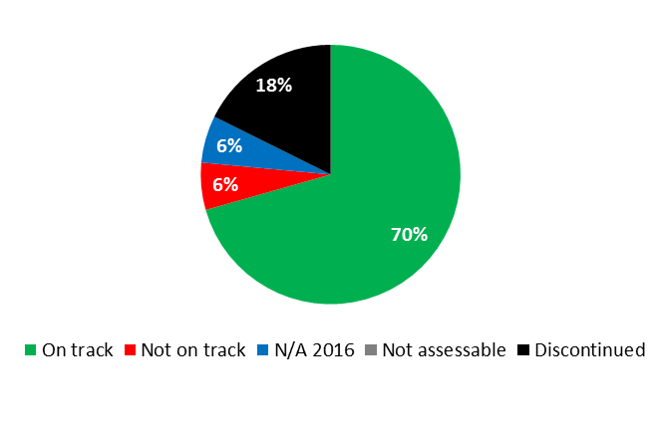

|  |  |  |  |  |
| --- | --- | --- | --- | --- |
| **Expected Result:** I.1Enhanced cooperation among Member States on development of balanced international normative frameworks for IP | | | | |
| **Performance Indicators** | **Baselines** | **Targets** | **Performance Data** | **TLS** |
| Progress on the implementation of agreed work according to SCCR Agenda | *Updated Baseline end 2015:*  The SCCR and the WIPO General Assembly did not reach agreement on steps toward the convening of a diplomatic conference for a treaty on the protection of broadcasting organizations.  Progress as captured by the Summary by the Chair[15]  *Original Baseline P&B 2016/17:*  The SCCR and the 2014 WIPO General Assembly did not reach agreement on steps toward the convening of a diplomatic conference for a treaty on the protection of broadcasting organizations (2014 PPR) | SCCR agreed outcomes | The SCCR made progress on various substantive agenda items as reflected in the Summaries by the Chair (SCCR/32[16] and SCCR/33[17]), and the 2016 WIPO General Assembly directed the SCCR to continue its work | **On track** |
| **Expected Result:** I.2 Tailored and balanced IP legislative, regulatory and policy frameworks | | | | |
| **Performance Indicators** | **Baselines** | **Targets** | **Performance Data** | **TLS** |
| No. of countries that have ratified or acceded to the Beijing Treaty | *Updated Baseline end 2015:*  10 countries in total: (Botswana, Chile, China, Japan, Qatar, Republic of Moldova, Russian Federation, Slovakia, Syrian Arab Republic, United Arab Emirates)  *Original Baseline  P&B 2016/17:*  6 (end 2014) | 30 (cumulative) | 5 additional countries:  (Democratic People’s Republic of Korea, El Salvador, Gabon, Saint Vincent and the Grenadines, Tunisia)  (15 cumulative as at end 2016) | **Not on track** |
| No. of countries that have ratified or acceded to the Marrakesh Treaty | *Updated Baseline end 2015:*  13 countries in total: (Argentina, Australia, Brazil, El Salvador, India, Mali, Mexico, Mongolia, Paraguay, Republic of Korea, Singapore, United Arab Emirates, Uruguay)  *Original Baseline P&B 2016/17:*  5 (end 2014) | 20 (cumulative) | 12 additional countries:  (Botswana, Canada, Chile, Democratic People’s Republic of Korea, Ecuador, Guatemala, Israel, Liberia, Peru, Saint Vincent and the Grenadines, Sri Lanka, Tunisia)  (25 cumulative) | **On track** |
| No. of ratifications or accessions to the copyright treaties in force including the Berne Convention, Rome Convention, and Internet Treaties | *Updated Baseline end 2015:*  5 new ratifications in 2014/15  *Original Baseline P&B 2016/17:*  n/a (revised indicator) | 10 new for all treaties | 5 new ratifications:  Berne Convention: 3 (171 cumulative)  Internet Treaties: 1 (189 cumulative)  Phonograms Convention: 1 (79 cumulative) | **On track** |
| % of countries that have provided positive feedback about WIPO’s legislative advice | *Updated Baseline end 2015:*  25 countries received legislative advice in 2014/15. (Africa 9; Arab 3; Asia and the Pacific 5; Latin America and the Caribbean 6; Other 2).  100% of the survey responses provided positive feedback (5 or 6 on a scale of 1-6) about WIPO’s copyright legislative advice service.  *Original Baseline  P&B 2016/17:*  n/a in 2014 (biennial survey to be conducted in 2015) | *Updated Target:*  80%  *Original Target  P&B 2016/17:*  70% of respondents satisfied with advice offered | 17 countries or regional groups received legislative advice in 2016 (Africa 2; Asia and the Pacific 7; Latin America and the Caribbean 4; Transition Countries 4)  100% of the survey responses provided positive feedback (5 or 6 on a scale of 1-6) about WIPO’s copyright legislative advice service | **On track** |
| **Expected Result:** III.2 Enhanced human resource capacities able to deal with the broad range of requirements for the effective use of IP for development in developing countries, LDCs and countries with economies in transition | | | | |
| **Performance Indicators** | **Baselines** | **Targets** | **Performance Data** | **TLS** |
| No. of national Copyright Offices actively engaged in the TAG consultative process | *Updated Baseline end 2015:*  0  *Original Baseline  P&B 2016/17:*  n/a | 25 national Copyright Offices | More than 90 Copyright Offices throughout 2016  At the end of 2016, a decision was taken not to proceed with the TAG project in its current form | **Dis-continued** |
| No. of CMOs applying for TAG accreditation | *Updated Baseline end 2015:*  0  *Original Baseline  P&B 2016/17:*  0 (end 2014) | 0 (2016)  2 CMOs applying for accreditation (2017) | In June 2016, the TAG Consortium endorsed a decision to focus more efforts on the TAG Compendium and the TAG Educational Program only  At the end of 2016, a decision was taken not to proceed with the TAG project in its current form | **Dis-continued** |
| % of participants that report positively on the collective management capacity building programs | *Updated Baseline end 2015:* 60%  *Original Baseline  P&B 2016/17:*  0 (end 2014) | 70% of surveyed participants approve or strongly approve | More than 80% of the surveyed participants approve or strongly approve | **On track** |
| No. of visits to the Portal on Copyright Infrastructure | *Updated Baseline end 2015:*  52,000    *Original Baseline  P&B 2016/17:*  0 (end 2014) | *Updated Target*:  57,000 visits to the portal  *Original Target P&B 2016/17:*  500 visits to the portal | Development of the Portal on Copyright Infrastructure was postponed | **N/A 2016** |
| No. of publishers signing ABC Charter for Accessible Publishing (“Charter”) | *Updated Baseline end 2015:*  12 publishers signed ABC Charter  *Original Baseline  P&B 2016/17:*  Nine publishers signed ABC Charter | 15 publishers sign (cumulative) | A decision was taken at the beginning of 2016 by the ABC Board, including the International Publishers Association, not to promote the ABC Charter with commercial publishers | **Dis-continued** |
| No. of books in accessible formats loaned to persons who are print-disabled | *Updated Baseline end 2015:*  Over 58,000 loans of accessible books to persons with print disabilities (cumulative)  *Original Baseline  P&B 2016/17:*  16,000 loans to print disabled | *Updated Target:*  130,000 loans (cumulative)  *Original Target  P&B 2016/17:*  20,000 loans (cumulative) | Over 42,000 loans of accessible books to persons with print disabilities  (100,000 loans cumulative) | **On track** |
| % of participants' positive rating of the usefulness of copyright and related rights capacity building meetings and workshops | *Updated Baseline end 2015:*  Over 80% of the participants agree or strongly agree  *Original Baseline  P&B 2016/17:*  70% | *Updated Target:*  80% of the participants agree or strongly agree  *Original Target  P&B 2016/17:*  70 % of the participants agree or strongly agree | Over 80% of the participants agree or strongly agree that copyright and related rights capacity building meetings and workshops were useful | **On track** |
| % of participants in copyright related capacity building workshops reporting practical use of knowledge nine months after the workshop | *Updated Baseline end 2015:*  Over 80% of the participants agree or strongly agree  *Original Baseline  P&B 2016/17:*  About 70% | About 80% of the participants | Over 80% of participants reported practical use of knowledge 9 months after the workshop | **On track** |
| % of participants with improved knowledge and skills in conducting training activities in their respective countries | n/a (new indicator) | 70% of participants that received training | 70% of the participants reported improvements in knowledge and skills in conducting training activities in their respective countries | **On track** |
| **Expected Result:** IV.2 Enhanced access to, and use of, IP information by IP institutions and the public to promote innovation and creativity | | | | |
| **Performance Indicators** | **Baselines** | **Targets** | **Performance Data** | **TLS** |
| No. of ABC constituent members | *Updated Baseline end 2015:*  15 ABC constituent members  *Original Baseline  P&B 2016/17:*  10 ABC constituent members | *Updated Target:*  28 ABC constituent members registered (cumulative)  *Original Target  P&B 2016/17:*  15 ABC constituent members registered (cumulative) | 10 additional ABC constituent members  (25 cumulative) | **On track** |
| No. of donors | Two donors contributing funding:  - Australia  - Republic of Korea | Four donors contribute funding (cumulative) | 2 additional donors contributing:  - Skoll Foundation  - United Nations Fund for International Partnerships  (4 cumulative) | **On track** |
| No. of legal instruments, guidelines, statements of principles other than binding instruments with the participation of the stakeholders concerned in areas such as new copyright treaties and Copyright in the Digital Environment | *Updated Baseline end 2015:*  Two:   * WIPO Review of Contractual Considerations in the Audiovisual Sector * The WIPO Draft Guidelines on Assessing the Economic, Social and Cultural Impact of Copyright on the Economy (ESCIA Guidelines)[18]   *Original Baseline  P&B 2016/17:*  One (IP and Sports Guidelines)[19] | One (additional) | IP and Sports Guidelines currently in the process of being drafted  ABC released the “ABC Starter Kit for Accessible Publishing in Developing and Least Developed Countries” as well as the “ABC Accessibility Guidelines for Self-Publishing Authors” | **On track** |

|  |
| --- |
| **Resource Utilization for Program 3** |

Budget and Actual Expenditure (by result)

*(thousands of Swiss francs)*

|  |  |  |  |  |
| --- | --- | --- | --- | --- |
| **Expected Result No. and Description** | | **2016/17 Approved Budget** | **2016/17 Budget after Transfers** | **2016 Expenditure\*** |
| I.1 | Enhanced cooperation among Member States on development of balanced international normative frameworks for IP | 3,339 | 3,623 | 1,273 |
| I.2 | Tailored and balanced IP legislative, regulatory and policy frameworks | 2,325 | 2,620 | 1,284 |
| III.2 | Enhanced human resource capacities able to deal with the broad range of requirements for the effective use of IP for development in developing countries, LDCs and countries with economies in transition | 8,409 | 8,563 | 3,668 |
| IV.2 | Enhanced access to, and use of, IP information by IP institutions and the public to promote innovation and creativity | 2,640 | 2,615 | 1,123 |
| VIII.1 | More effective communication to a broad public about intellectual property and WIPO’s role | 20 | 0 | 0 |
|  | **Total** | 16,733 | 17,421 | 7,348 |
| *\*2016 Expenditure numbers are preliminary, subject to audit by External auditors* | | | |  |

Budget and Actual Expenditure (personnel and non-personnel)

*(thousands of Swiss francs)*

|  |  |  |  |  |
| --- | --- | --- | --- | --- |
|  | **2016/17 Approved Budget** | **2016/17 Budget after Transfers** | **2016 Expenditure\*** | **Utilization rate (%)** |
| Personnel Resources | 9,919 | 9,468 | 4,448 | 47% |
| Non-personnel Resources | 6,815 | 7,953 | 2,901 | 36% |
| **Total** | **16,733** | **17,421** | **7,348** | **42%** |
| *\*2016 Expenditure numbers are preliminary, subject to audit by External auditors* | | | | |

*NOTE: The 2016/17 Budget after Transfers reflects transfers as of March 8, 2017 to address needs during the 2016/17 biennium in line with Financial Regulation 5.5.*

A. 2016/17 Budget after Transfers

1. The increase in the 2016/17 Budget after Transfers as compared to the 2016/17 Approved Budget was mainly due to additional non-personnel resources for: (i) the WIPO International Conference on the Global Digital Content Market in 2016 and 2017, reflected under Expected Result IV.2 (Enhanced access to IP information); (ii) promotion of the Marrakesh and the Beijing Treaties, reflected under Expected Result I.2 (Legislative advice); and (iii) collective management projects in the Arab region, reflected under Expected Result III.2 (Enhanced human resource capacities). The increases in non-personnel resources were partly offset by a decrease in personnel resources, mainly in the area of Copyright Infrastructure as a result of internal restructuring.

B. 2016/17 Budget Utilization

1. Personnel budget utilization was within the expected range of 40-60 per cent for the first year of the biennium. Non-personnel expenditure for the Program as a whole was below target primarily due to the slower than expected implementation of the DA-related project on Strengthening and Development of the Audiovisual Sector in Burkina Faso and Certain African Countries and DA activities related to using copyright to promote access to information and creative content, as well as postponement of certain copyright infrastructure-related activities (Transparency, Accountability and Governance (TAG) and Accessible Books Consortium (ABC)).

### PROGRAM 4 TRADITIONAL KNOWLEDGE, TRADITIONAL CULTURAL EXPRESSIONS AND GENETIC RESOURCES

**Program Manager Mr. M. A. Getahun**

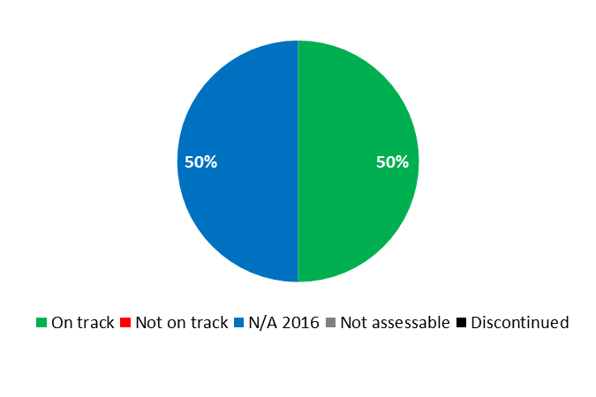

|  |  |  |  |  |  |  |  |  |
| --- | --- | --- | --- | --- | --- | --- | --- | --- |
| **Expected Result:** I.1Enhanced cooperation among Member States on development of balanced international normative frameworks for IP | | | | | | | | |
| **Performance Indicators** | **Baselines** | **Targets** | | **Performance Data** | | **TLS** | |
| Progress towards implementation of normative activities on IP and GRs, TK and TCEs as agreed by Member States | *Updated Baseline end 2015:*  The WIPO General Assembly in October 2014 did not agree on a work program for the Intergovernmental Committee on Intellectual Property and Genetic Resources, Traditional Knowledge and Folklore (IGC) in 2015 and the IGC, therefore, did not meet in 2015. The WIPO General Assembly in October 2015 agreed upon a renewed mandate and work program for the IGC for the 2016/17 biennium.  *Original Baseline P&B 2016/17:*  Current stage of negotiations among Member States on IP and GRs, TK and TCEs, as reflected in documents WIPO/GRTKF/IC/28/4, WIPO/GRTKF/IC/28/5 and WIPO/GRTKF/IC/28/6, respectively | Agreed outcomes of normative activities | | The WIPO General Assembly will only take stock of the progress made by the IGC in its work in October 2017 | | **N/A 2016** | |
| **Expected Result:** III.2 Enhanced human resource capacities able to deal with the broad range of requirements for the effective use of IP for development in developing countries, LDCs and countries with economies in transition | | | | | | | | |
| **Performance Indicators** | **Baselines** | | **Targets** | | **Performance Data** | | **TLS** |
| % of participants in WIPO activities who report enhanced capacity to understand and use IP principles, systems and tools for the protection of TK and TCEs and for addressing the interface between IP and GRs. | *Updated Baseline end 2015:*  92% (370 out of 398) of participants reported positively (feedback questionnaire used in fifteen activities organized by the TK Division in 2014/15)  *Original Baseline P&B 2016/17:* 91% (163 out of 179) participants reported positively (feedback questionnaire used in nine activities organized by the TK Division in 2014) | | *Updated Target:*  90%  *Original Target P&B 2016/17:*  80% | | 92% of participants (46 out of 50 in 4 activities) reported positively | | **On track** |

|  |
| --- |
| **Resource Utilization for Program 4** |

Budget and Actual Expenditure (by result)

*(thousands of Swiss francs)*

|  |  |  |  |  |
| --- | --- | --- | --- | --- |
| **Expected Result No. and Description** | | **2016/17 Approved Budget** | **2016/17 Budget after Transfers** | **2016 Expenditure\*** |
| I.1 | Enhanced cooperation among Member States on development of balanced international normative frameworks for IP | 4,116 | 4,052 | 2,147 |
| III.2 | Enhanced human resource capacities able to deal with the broad range of requirements for the effective use of IP for development in developing countries, LDCs and countries with economies in transition | 1,999 | 2,635 | 898 |
|  | **Total** | 6,115 | 6,686 | 3,045 |
| *\*2016 Expenditure numbers are preliminary, subject to audit by External auditors* | | | |  |

Budget and Actual Expenditure (personnel and non-personnel)

*(thousands of Swiss francs)*

|  |  |  |  |  |
| --- | --- | --- | --- | --- |
|  | **2016/17 Approved Budget** | **2016/17 Budget after Transfers** | **2016 Expenditure\*** | **Utilization rate (%)** |
| Personnel Resources | 3,581 | 4,160 | 1,730 | 42% |
| Non-personnel Resources | 2,534 | 2,526 | 1,315 | 52% |
| **Total** | **6,115** | **6,686** | **3,045** | **46%** |
| *\*2016 Expenditure numbers are preliminary, subject to audit by External auditors* | | | | |

*NOTE: The 2016/17 Budget after Transfers reflects transfers as of March 8, 2017 to address needs during the 2016/17 biennium in line with Financial Regulation 5.5.*

A. 2016/17 Budget after Transfers

1. The increase in personnel resources reflected the transfer of two staff members from IP and Global Challenges (Program 18) and Executive Management (Program 21) to the Department of Traditional Knowledge and Global Challenges, as reflected under Expected Result III.2 (Enhanced human resource capacities).

B. 2016/17 Budget Utilization

1. Budget utilization was within the expected range of 40-60 per cent for the first year of the biennium.

## STRATEGIC GOAL II

**PROVISION OF PREMIER GLOBAL IP SERVICES**

**Mid-term Performance Dashboard (2016)**

The dashboard below provides a summary of the progress towards the achievement of the Results in the 2016 as measured by the indicators under the Programs contributing to this Strategic Goal.



| **Expected Results** | **Performance Indicators** | **Responsible Program(s)** | **TLS** |
| --- | --- | --- | --- |
| II.1 Wider and more effective use of the PCT system for filing international patent applications | Further development of the PCT system, notably implementation of the PCT roadmap recommendations endorsed by PCT Member States | Program 5 | ⚫ |
| Level of satisfaction of PCT users with PCT-specific legal advice, information, training and customer service | Program 5 | ⚫ |
| Satisfaction of Offices and International Authorities with PCT cooperative activities | Program 5 | ⚫ |
| Improved electronic services for applicants, third parties, Offices and Authorities | Program 5 | ⚫⚫⚫ |
| No. of PCT applications originating from developing countries, transition and developed countries. | Program 9  Program 10  Program 20 | ⚫⚫⚫⚫  ⚫  ⚫⚫⚫⚫⚫ |
| % of survey respondents showing increased use of WIPO services within 6 months of attending Roving Seminars on WIPO Services and Initiatives | Program 10 | ⚫ |
| % of policy makers, government officials, and IP Practitioners and participants in targeted workshops with enhanced understanding of the PCT and related topics | Program 20 | ⚫⚫⚫ |
| II.3 Improved productivity and service quality of PCT operations | Aggregate quality of formalities examination (including timeliness) | Program 5 | ⚫ |
| Application unit cost | Program 5 | ⚫ |
| Information systems service levels | Program 5 | ⚫ |
| Quality of software development (QSD) | Program 5 | ⚫ |
| Quality of Translation | Program 5 | ⚫ |
|  | Timeliness of Report Translation | Program 5 | ⚫ |
| II.4 Wider and more effective use of the Hague system, including by developing countries and LDCs | No. of Hague applications originating from developing, transition and developed countries | Program 9  Program 10  Program 20 | ⚫⚫⚫  ⚫  ⚫ |
| % of policy makers, government officials, and IP Practitioners and participants in targeted workshops with enhanced understanding of the Hague System | Program 20 | ⚫⚫⚫ |
|  | Membership of the Geneva (1999) Act | Program 20  Program 31 | ⚫  ⚫ |
|  | Hague filings and renewals | Program 31 | ⚫⚫⚫ |
|  | Share of Offices concerned providing information on the Hague System to their users | Program 31 | ⚫ |
| II.5 Improved productivity and service quality of the Hague operations | 3 deployed versions of DIRIS and 3 deployed versions of Hague e-Filing | Program 31 | ⚫⚫ |
| Flexibility of data recorded in the International Register | Program 31 | ⚫ |
| Improved operation of the Hague Registry, including electronic processes and procedures | Program 31 | ⚫ |
| Predominance of the Geneva (1999) Act in the Hague System | Program 31 | ⚫ |
|  | Processes and procedures adapted to geographical and legal evolution of the system | Program 31 | ⚫ |
|  | Progress towards the enhancement of the legal framework | Program 31 | ⚫ |
|  | Stable provision of evolving the Hague back office IT services | Program 31 | ⚫⚫ |
| II.6 Wider and more effective use of the Madrid System, including by developing countries and LDCs | Filing rate (Madrid) | Program 6 | ⚫ |
| Functional improvements to the Madrid System | Program 6 | ⚫ |
| Irregularity rate (Article 12 and 13) (Madrid) | Program 6 | ⚫⚫ |
| Market share (i.e., national route versus Madrid route) (Madrid) | Program 6 | ⚫ |
| Registrations (Madrid) | Program 6 | ⚫ |
|  | Renewals (Madrid) | Program 6 | ⚫ |
|  | Total Membership of the Madrid System | Program 6 | ⚫ |
|  | Total no. of designations (Madrid) | Program 6 | ⚫ |
|  | Total no. of registrations (Madrid) | Program 6 | ⚫ |
|  | No. of Madrid System applications originating from developing, transition and developed countries | Program 9  Program 10  Program 20 | ⚫⚫⚫⚫  ⚫  ⚫⚫⚫⚫⚫ |
|  | % of policy makers, government officials, IP practitioners and participants in targeted workshops with enhanced understanding of the Madrid System | Program 20 | ⚫ |
|  | Total Membership of the Madrid System | Program 20 | ⚫ |
| II.7 Improved productivity and service quality of Madrid operations | 3 deployed versions of M-IRIS and 3 deployed versions of Madrid eFiling (IRPI) | Program 6 | ⚫⚫⚫ |
| Client satisfaction (Madrid) | Program 6 | ⚫ |
| Improved operation of the Madrid Registry, including electronic processes and procedures | Program 6 | ⚫⚫⚫⚫  ⚫⚫⚫ |
|  | Quality (Madrid) | Program 6 | ⚫⚫⚫⚫  ⚫⚫⚫⚫ |
|  | Stable provision of evolving Madrid back office IT services | Program 6 | ⚫⚫ |
|  | Timeliness of transactions (days) (Madrid) | Program 6 | ⚫ |
|  | Unit cost (Madrid) | Program 6 | ⚫⚫ |
| II.8 International and domestic intellectual property disputes are increasingly prevented or resolved through WIPO mediation, arbitration and other alternative dispute resolution methods | Increased use of alternative dispute resolution services and clauses in intellectual property transactions and registrations, including through WIPO procedures | Program 7 | ⚫⚫⚫⚫⚫ |
| Alternative dispute resolution policies to which the Center has contributed in respect of their development and implementation | Program 7 | ⚫ |
|  | No. of IP disputes originating from transition and developed countries prevented/resolved by WIPO mediation, arbitration and other alternative dispute resolution methods | Program 10 | ⚫ |
| II.9 Effective intellectual property protection in the gTLDs and the ccTLDs | Dispute resolution policies in the Domain Name System to which the Center has contributed in respect of their development and implementation | Program 7 | ⚫⚫ |
| No. of UDRP based gTLD and ccTLD cases administered by the Center | Program 7 | ⚫⚫ |
| II.10 Wider and more effective use of the Lisbon System, including by developing countries and LDCs | No. of international registrations from developing countries and LDCs in force under the Lisbon System (in relation to the total no.) | Program 9  Program 32 | ⚫  ⚫ |
| No. of Lisbon System international registrations for transition and developed countries in force | Program 10 | ⚫ |
|  | % of participants in Lisbon System events satisfied and reporting enhanced awareness post an event | Program 32 | ⚫ |
|  | Expansion of the geographical coverage of the Lisbon System | Program 32 | ⚫ |
|  | No. of international applications and other transactions (Lisbon) | Program 32 | ⚫⚫ |
| II.11 Improved productivity and service quality of Lisbon operations | Adoption of provisions streamlining the Lisbon System legal framework | Program 32 | ⚫ |
| Improved electronic services for the Lisbon Registry | Program 32 | ⚫ |
|  | Increased use of electronic means for filing and processing international applications and other transactions (Lisbon) | Program 32 | ⚫⚫ |

### PROGRAM 5 THE PCT SYSTEM

**Program Manager Mr. J. Sandage**

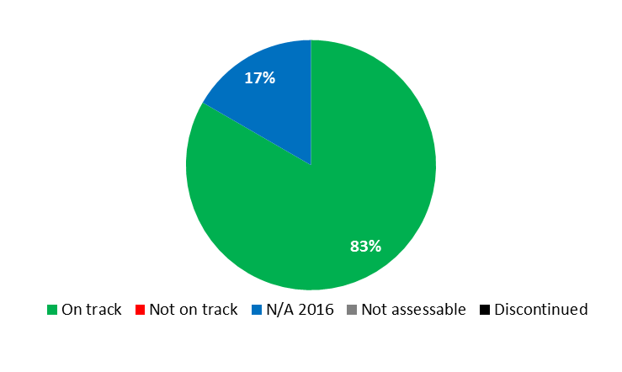



|  |  |  |  |  |
| --- | --- | --- | --- | --- |
| **Expected Result:** II.1 Wider and more effective use of the PCT system for filing international patent applications | | | | |
| **Performance Indicators** | **Baselines** | **Targets** | **Performance Data** | **TLS** |
| Level of satisfaction of PCT users with PCT-specific legal advice, information, training and customer service | *Updated Baseline end 2015:*  Overall PCT user satisfaction with WIPO-provided PCT services increased 11% since 2009 to 89%  *Original Baseline P&B 2016/17:*  Results of 2009 and 2015 Surveys | Increase, or at least maintain, the level of satisfaction of PCT users | The satisfaction survey is conducted once every biennium; the next survey will be carried out in 2017 | **N/A 2016** |
| Satisfaction of Offices and International Authorities with PCT cooperative activities | *Updated Baseline end 2015:*  96% (58 out of 60 beneficiaries of PCT cooperative activities);  95% (58 out of 61 survey respondents) (2016 survey)  *Original Baseline P&B 2016/17:*  56 (95% out of 59 beneficiaries of PCT cooperative activities; 85% out of the 66 survey respondents) (2012 survey). The satisfaction survey is conducted once every biennium | Maintain the 2015 level of satisfaction of Offices and International Authorities | The satisfaction survey is conducted once every biennium; the next survey will be carried out in 2017 | **N/A 2016** |
| Further development of the PCT system, notably implementation of the PCT roadmap recommendations endorsed by PCT Member States | *Updated Baseline end 2015:*  In 2014/5, progress towards furthering the aims of the Treaty, for the benefit of all stakeholders, in line with the PCT roadmap recommendations endorsed by Member States, was made in the following respects:  (a) Agreement by Member States on eligibility criteria for fee reductions;  (b) Agreement by Member States on a revised procedure for appointment of International Searching and Preliminary Examining Authorities;  (c) Agreement by Member States on sharing of results of search work on earlier applications to improve quality and timeliness of PCT work products;  (d) Implementation of a new eSearchCopy service for quicker and more efficient transmission of applications for international search;  (e) Agreement for Offices to send timely data to the IB on applications in the national phase to improve patent status information  *Original Baseline P&B 2016/17:*  Decisions by appropriate PCT bodies up to the end of 2014 (Document PCT/A/46/6) | Decisions by appropriate PCT bodies up to the end of 2017 | In 2016, the PCT Working Group continued its discussions aimed at furthering the aims of the Treaty, for the benefit of all stakeholders, in line with the PCT roadmap recommendations endorsed by Member States. *Inter alia*, the Working Group considered issues such as:   1. IT-based services now offering new openings in collaboration between Offices, 2. more efficient ways of working together and better sharing of information; 3. a proposal for PCT fee reductions for universities and public research institutes; 4. the coordination of technical assistance provided under the PCT; and 5. improved coordination of patent examiner training between Offices. | **On track** |
| Improved electronic services for applicants, third parties, Offices and Authorities | *Updated Baseline end 2015:*  29 Offices accepting e-filing from ePCT  34 Receiving Offices (ROs) and  8 International Authorities accepting documents transmitted by applicants  7,229 filings using ePCT in 2015  *Original Baseline P&B 2016/17:*  At the end of 2014, compared to the end of 2013:  +32% applicants public;  +100% applicants private;  +25% third party observers; +329% Receiving Offices;  -73% International Authorities (largest user Office moved to next level of automation) | Increased number of:  Offices accepting e-filing from ePCT;  Offices using ePCT or accepting documents transmitted by applicants using ePCT;  applications filed using ePCT | At end of 2016:  45 Offices accepting e-filing from ePCT (+55% as compared to 2015)  45 ROs (+32% as compared to 2015) and  13 International Authorities (+63% as compared to 2015) accepting documents transmitted by applicants  10,843 filings using ePCT (+50% as compared to 2015) | **On track**  **On track**  **On track** |
| **Expected Result:** II.3 Improved productivity and service quality of PCT operations | | | | |
| **Performance Indicators** | **Baselines** | **Targets** | **Performance Data** | **TLS** |
| Application Unit Cost | *Updated Baseline end 2015:*  662 Swiss francs (2014)  735 Swiss francs(2015)  *Original Baseline P&B 2016/17:*  662 Swiss francs (2014) | *Updated Target:*  10% biennial reduction in the unit cost  *Original Target P&B 2016/17:*  Maintain unit cost despite foreseen investments to enhance PCT resilience and security levels | 685 CHF  (-6.8%) as compared to 2015 | **On track** |
| Aggregate quality of formalities examination (including timeliness) | *Updated Baseline end 2015:*  92.7%  *Original Baseline P&B 2016/17:*  93.1% (2014) | *Updated Target:*  95% (+/-2%)  *Original Target P&B 2016/17:*  Higher quality | 95.1% | **On track** |
| Timeliness of Report Translation | *Updated Baseline end 2015:*  90.0% on time  *Original Baseline P&B 2016/17:*  82.5% (2014) | *Updated Target:*  91% (+/-2%)  *Original Target P&B 2016/17:*  Improvement | 89.1% | **On track** |
| Quality of Translation | *Updated Baseline end 2015:*  87.6%  *Original Baseline P&B 2016/17:*  86% (2014) | *Updated Target:*  88% (+/-2%)[20]  *Original Target P&B 2016/17:*  Higher quality | 86% | **On track** |
| Quality of software development (QSD) | *Updated Baseline end 2015:*  91.9% (2015)  94.5% (2014)[21]  *Original Baseline P&B 2016/17:*  94.3% (2014) | *Updated Target:*  95% (+/-2%)  *Original Target P&B 2016/17:*  Higher QSD | 93.3% | **On track** |
| Information systems service levels | *Updated Baseline end 2015:*  96.5% (2015)  95.1% (2014)[22]  *Original Baseline P&B 2016/17:*  95.3% (2014) | *Updated Target:*  97% (+/-2%)  *Original Target P&B 2016/17:*  Higher information systems service levels | 97.1% | **On track** |

|  |
| --- |
| **Resource Utilization for Program 5** |

Budget and Actual Expenditure (by result)

*(thousands of Swiss francs)*

|  |  |  |  |  |
| --- | --- | --- | --- | --- |
| **Expected Result No. and Description** | | **2016/17 Approved Budget** | **2016/17 Budget after Transfers** | **2016 Expenditure\*** |
| II.1 | Wider and more effective use of the PCT system for filing international patent applications | 27,129 | 26,074 | 11,973 |
| II.3 | Improved productivity and service quality of PCT operations | 181,080 | 177,330 | 81,888 |
|  | **Total** | 208,209 | 203,404 | 93,861 |
| *\*2016 Expenditure numbers are preliminary, subject to audit by External auditors* | | | |  |

Budget and Actual Expenditure (personnel and non-personnel)

*(thousands of Swiss francs)*

|  |  |  |  |  |
| --- | --- | --- | --- | --- |
|  | **2016/17 Approved Budget** | **2016/17 Budget after Transfers** | **2016 Expenditure\*** | **Utilization rate (%)** |
| Personnel Resources | 133,970 | 129,909 | 59,294 | 46% |
| Non-personnel Resources | 74,239 | 73,495 | 34,567 | 47% |
| **Total** | **208,209** | **203,404** | **93,861** | **46%** |
| *\*2016 Expenditure numbers are preliminary, subject to audit by External auditors* | | | | |

*NOTE: The 2016/17 Budget after Transfers reflects transfers as of March 8, 2017 to address needs during the 2016/17 biennium in line with Financial Regulation 5.5.*

A. 2016/17 Budget after Transfers

1. The overall decrease in the Budget after Transfers as compared to the 2016/17 Approved Budget reflects the longer-term continuing trend of increased productivity in PCT operations. It consisted largely of a reduction under personnel, which is the net result of, on the hand one, transfers, reclassifications and completed regularizations of continuing functions and, on the other hand, the redeployment of accrued personnel savings (realized from vacancies and part time work arrangements) from the Program to other organizational priorities. The reduction in non-personnel resources was primarily due to the downward adjustment of the budget allocation for PCT Translation services in anticipation of projected savings in translation costs.

B. 2016/17 Budget Utilization

1. Budget utilization was within the expected range of 40-60 per cent for the first year of the biennium.

#### Program 5 Annex: Indicators of PCT Operations

PERFORMANCE INDICATORS FOR THE EXPECTED RESULT

“IMPROVED PRODUCTIVITY AND SERVICE QUALITY OF PCT OPERATIONS”

**General**

1. As background for the performance indicators for the expected result “improved productivity and service quality of PCT operations”, the evolution of the following factors need to be considered:

* The PCT workloads;
* The language distribution of those workloads;
* The number of staff assigned to process those workloads; and
* The level of automation.

*Workloads*

1. The workloads are tracked on the basis of the yearly number of record copies received by the International Bureau (IB).[23]

**Evolution of Record Copies by Medium of Filing**

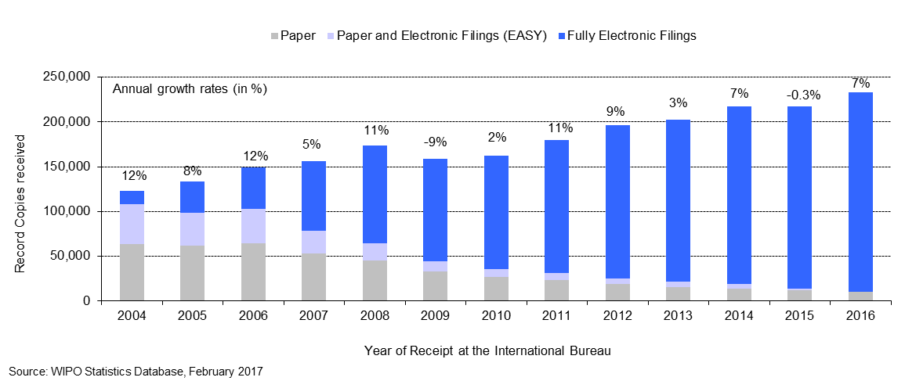

* The IB received about 233,000 record copies in 2016, representing an increase of 7.4 per cent compared to 2015.
* The share of fully electronic filing methods continued to increase in 2016 and now represents 95 per cent of total filings.

*Language distribution*

1. One fundamental development driving change in the IB is the increasing language diversity of filings, resulting, in particular, from continued increased usage of the PCT System in East Asian countries.

**Languages of Filing** *(all languages)*

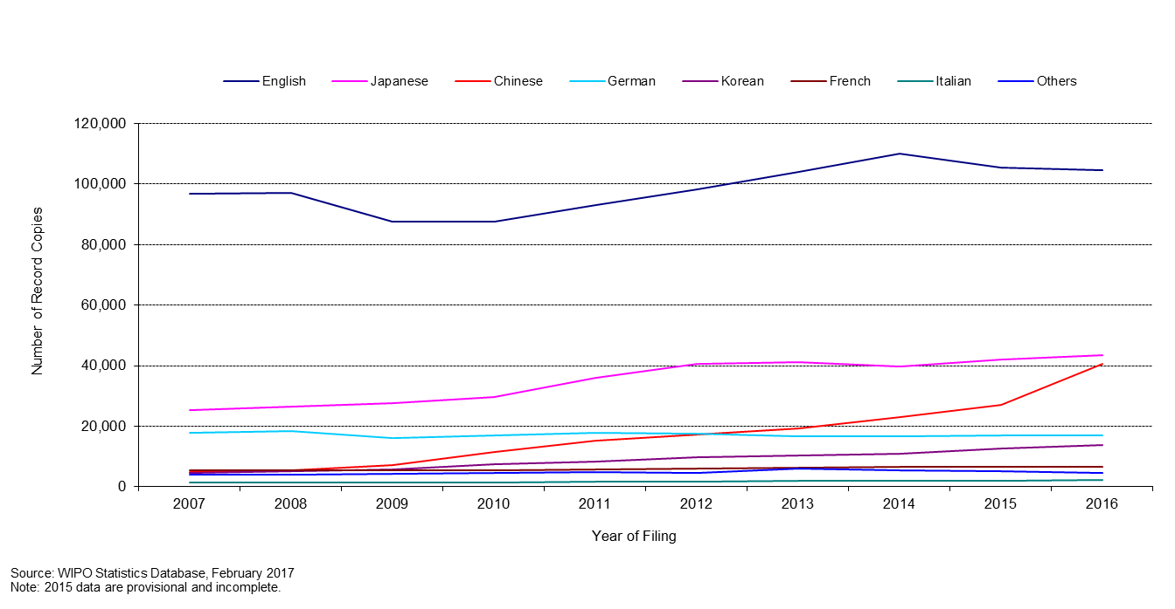

1. As can be observed, while English accounts for the largest proportion of filings, with 45 per cent of filings in 2016, the shares of Asian languages have increased over the past decade. The combined share of the PCT applications filed in Japanese, Chinese and Korean increased from 29.5 per cent in 2010 to 42 per cent in 2016. Zooming in on languages other than English provides the following picture:

**Languages of Filing** (all languages except English)

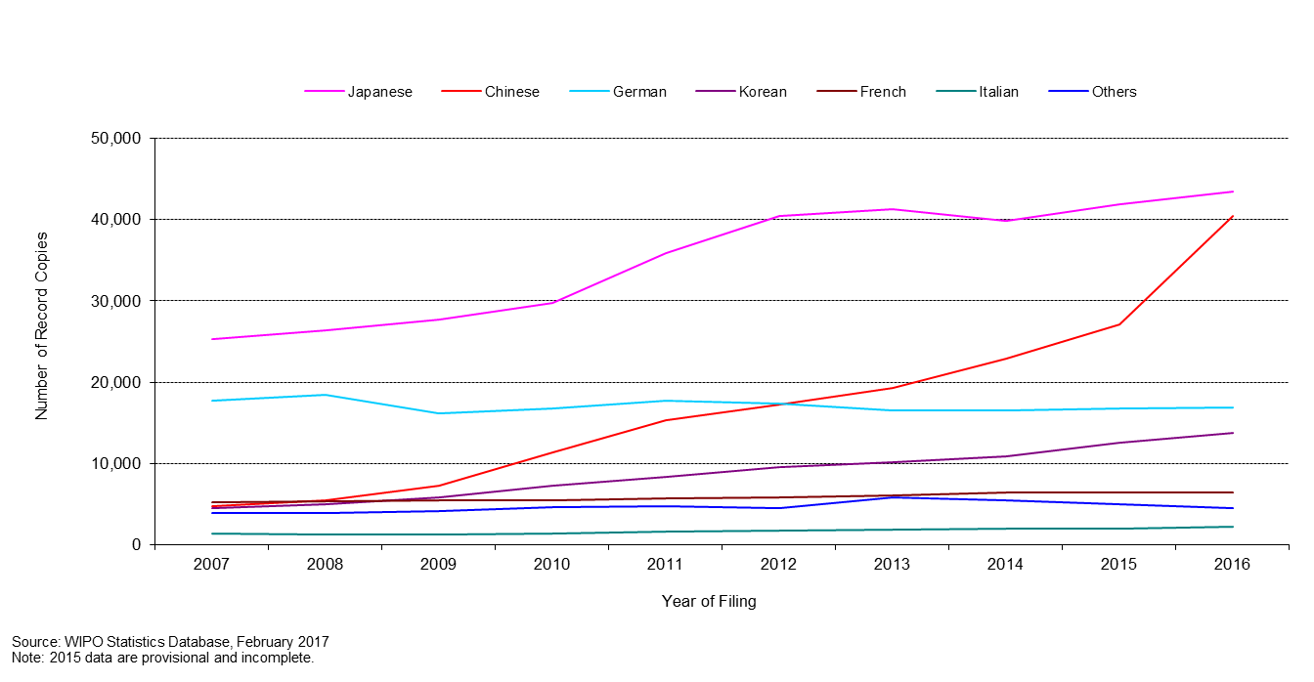

1. The sharp increase of applications filed in Asian languages in the recent years put a considerable strain on the IB due to the limited number of staff resources able to work in these languages. Mitigation of this issue is automation of certain tasks and recruitment of staff able to work in these languages.

*Staff*

1. The chart below shows the number of PCT Operations staff since 2001, in Full Time Staff Equivalent (FTSE ‑ total number of full-time staff plus the full-time equivalent of part-time staff).

**Number of Personnel in PCT Operations**

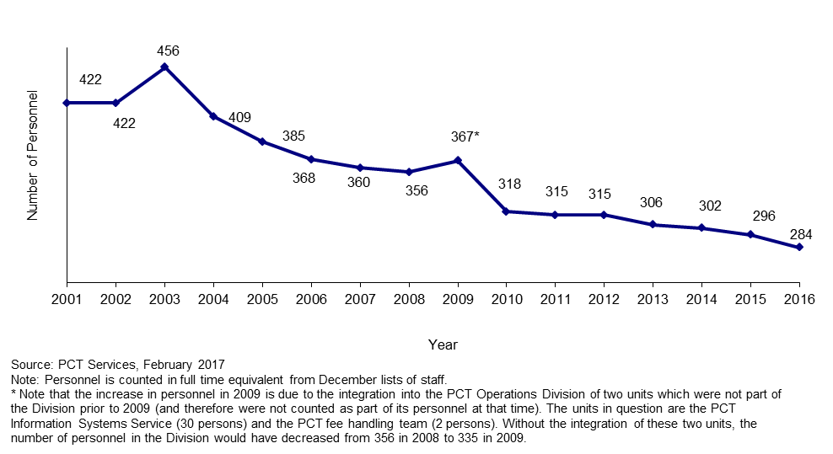

* The number of personnel in PCT Operations further decreased in 2016.

*Unit cost of processing an application*

1. The IB’s efficiency in processing PCT applications can be measured by the unit cost, defined as the average cost of producing one unit of output. The total cost of production comprises expenditure relating exclusively to the PCT System and expenditure of activities supporting the System.
2. The expenditure relating exclusively to the PCT System includes those of Program 5 (the PCT System).
3. Expenditure of activities supporting the PCT System comprises the expenditure of the following services: conference and language services, construction, executive management, finance and budget, general support services, human resources management, internal oversight, IT and safety and security. A small proportion of these expenses (cost of server hosting at UNICC, estimated cost of the authentic publication source of PCT applications (PATENTSCOPE) and share of cost of the Income Section in Finance) are directly attributed to the PCT System whereas the remaining of such expenses attributable to the PCT System are calculated based on headcount (including fixed term staff, temporary staff and fellows).

10. The methodology to compute the unit cost was revised in 2013 in order to align it with other WIPO unit cost calculations and to better capture a fast changing environment. For example, the old method, which was designed in 2007, included a cost of storage (over 30 years) in warehouses, whereas paper filings (including PCT EASY filings) accounted for less than 10 per cent of filings in 2013. The 2012 PCT unit cost has been calculated using both methods. The 2012 unit cost amounted to 680 Swiss francs using the old method and to 712 Swiss francs using the new method. The 32 Swiss francs difference is due to the new method for allocating indirect costs.

1. Formally, unit cost is defined as:



1. The graphs below depict the evolution of the unit cost of processing from 2004 to 2012 using the old method and from 2012 to 2016 using the new method, including a breakdown of the contribution of direct and indirect costs.

**Unit Cost of Processing a Published PCT Application**

|  |
| --- |
| **Old method**    **New method** |

* The average cost of processing a published PCT application was 685 Swiss francs in 2016, representing a decrease of 6.8 per cent compared to 2015. This decrease was due to a decrease of the total cost of production in spite of an increase in the total number of published PCT applications. This was the lowest average cost of the period 2012-16, after the exceptionally low unit cost of 2014.

*Productivity of formalities examination*

1. The definition of staff productivity is output (i.e. the number of PCT publications) divided by the number of staff for formalities examination.

**Productivity of Formality Examination**

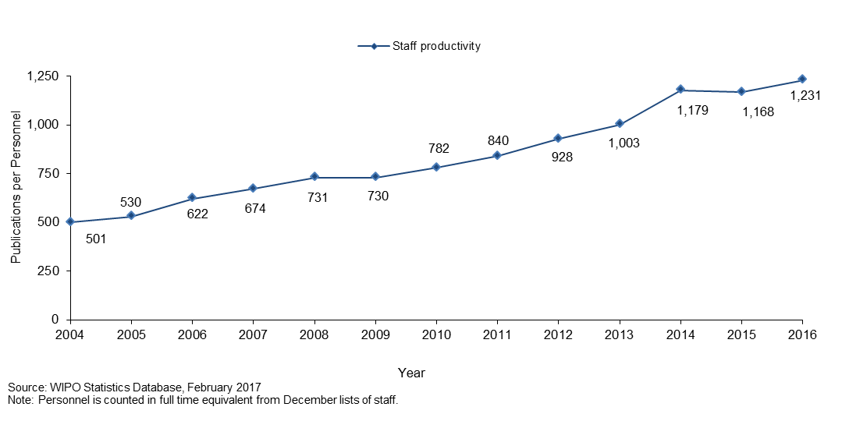

* Productivity of formalities examination increases over time, mainly due to automation, which permits the processing of much larger workloads with less or equal staff.
* In 2016, the productivity of formalities examination increased by 5.4 per cent compared to 2015.

*Aggregate quality of formalities examination*

1. In order to measure the quality of the work performed by the IB in a simple and comprehensive manner, the IB has developed an aggregate quality index, calculated as the average of four lead quality indicators. Three of these indicators are based on the timeliness of key transactions: acknowledgement of receipt of the PCT application, publication and republication. The fourth indicator reflects errors made during the processing of PCT applications.

**Quality Index of Formalities Examination**

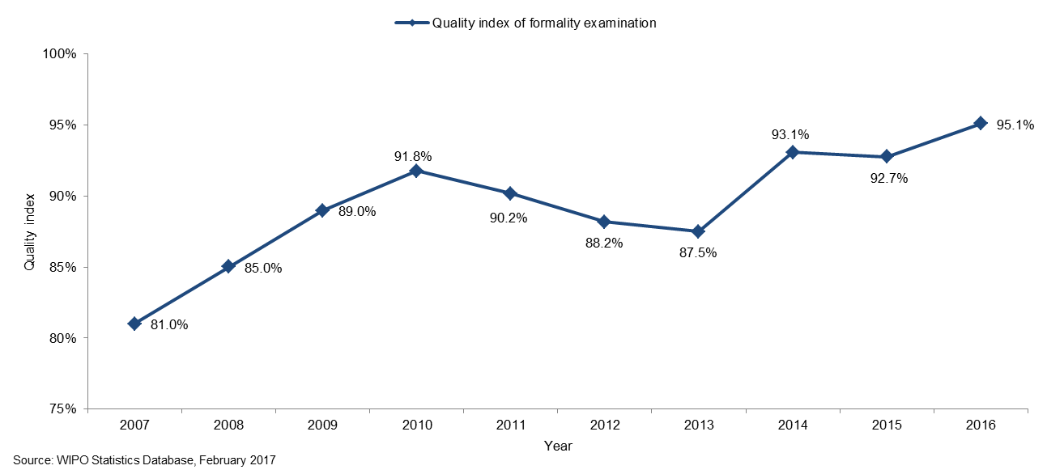

* The overall quality, as measured by the aggregate index, improved markedly from an average of 81 per cent in 2007 to 95.1 per cent in 2016.

*Timeliness of formalities examination*

1. This indicator reflects in more detail one of the components of the aggregate quality indicator, namely the time required by the IB to issue Form 301. This form is issued after the formality examination of the application has been completed. Applicants appreciate receiving this form as soon as possible because it acknowledges receipt of the application at the IB and allows them to know whether their application has any formal defects.

**Timeliness of Formality Examination**

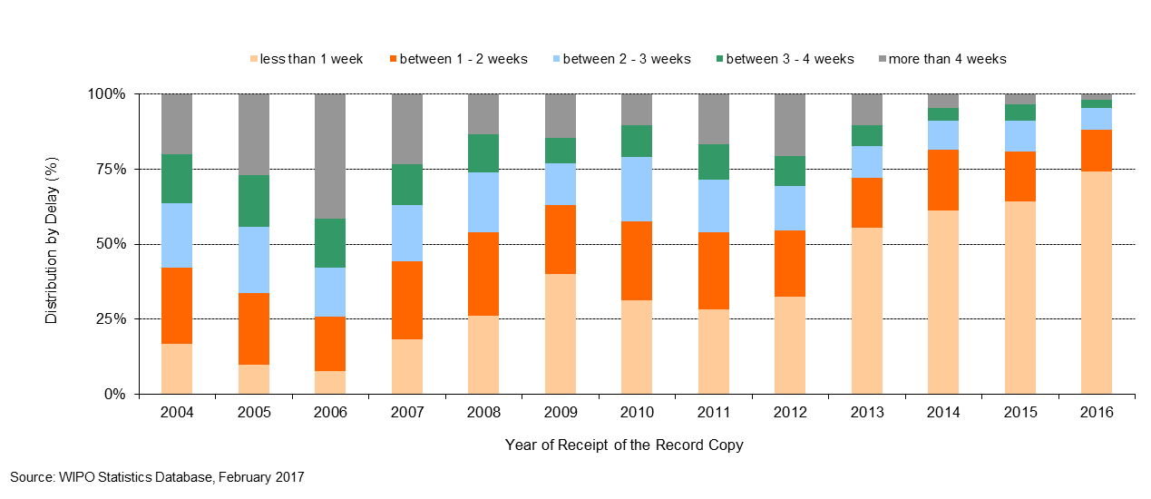

*Timeliness of publication*

1. This indicator reflects in more detail one of the components of the aggregate quality indicator, namely, the time required by the IB to publish the application. Article 21 (2) (a) of the PCT states that the “… international publication of the international application shall be effected promptly after the expiration of 18 months from the priority date of that application.”

**Timeliness of Publication**

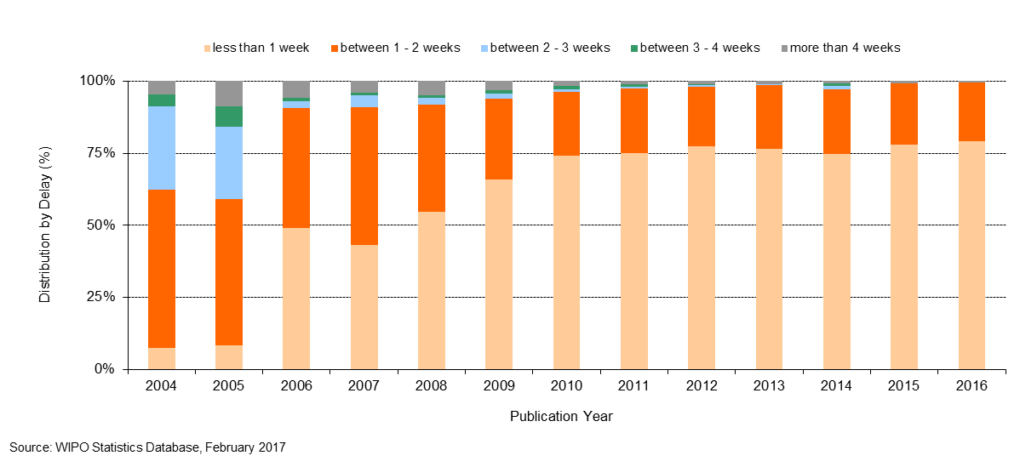

*Timeliness of republication*

1. This indicator reflects in more detail one of the components of the aggregate quality indicator, namely the time required by the IB to republish the application with the ISR. Due to delays in the communication of ISRs by International Searching Authorities (ISAs), a number of international applications are published without the ISR. When the ISR becomes available, the international application needs to be republished with the ISR as soon as possible, so as to complete the international publication.

**Timeliness of Republication**

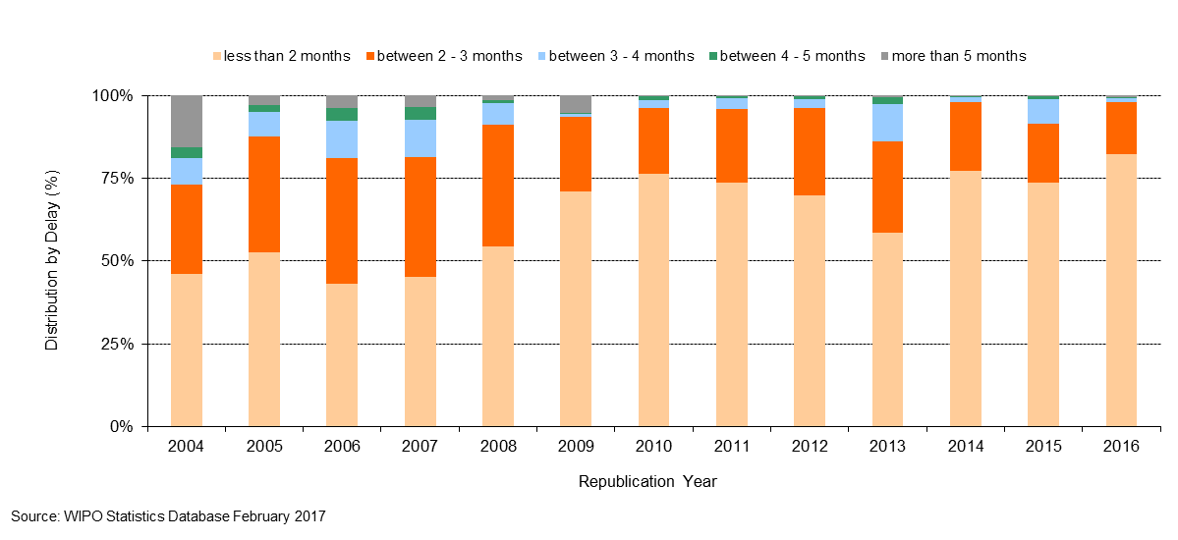

*Quality of translation*

1. Statistically calculated numbers of documents are selected at random from translations of abstracts and patentability reports prepared under the responsibility of the IB for quality control. The evaluation determines whether a translation is “acceptable” or “not acceptable”. This indicator aggregates the results of such quality control performed by the IB across all language combinations and document types. Relationships with any agencies that consistently have less than 80 per cent of their translations deemed “acceptable” are discontinued. A slight drop in quality to 86 per cent resulted from efforts to reduce costs via post-editing.

**Quality of PCT Translation**

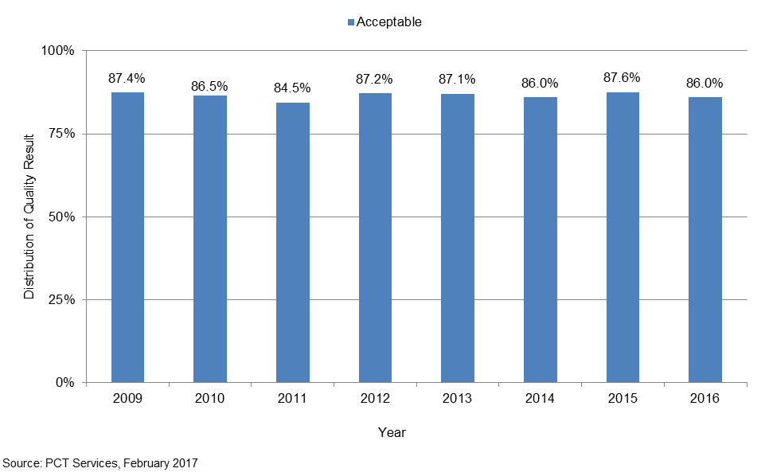

*Timeliness of report translation*

1. This indicator provides information on the timeliness with which patentability report translations are made available by the IB to applicants and Offices. The share of patentability report translations delivered at 30 months from the priority date of the international application has steadily increased between 2010 and 2015, and has stabilized since 2015. In 2016, 89 per cent of patentability report translations were delivered at 30 months, with 99 per cent were delivered by 31 months.

**Timeliness of Report Translation**

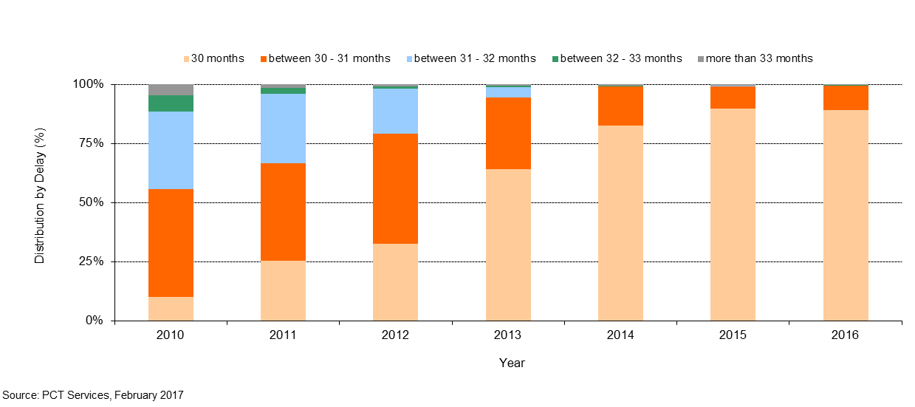

*Quality of software development*

1. The quality of software development (QSD) indicator provides a measure of the quality of major software releases for eDossier and ePCT projects. The QSD reflects the share of the time spent delivering new functionality in the release (i.e. work) out of the total time spent (i.e. work + rework). Rework is the time spent correcting defective work that was detected in the production environment.
2. Under this approach, development outputs that contain low levels of rework are deemed high quality as it reflects the extent of value added to the product through the delivery of new features.
3. The QSD is defined as:

**Quality of Software Development**

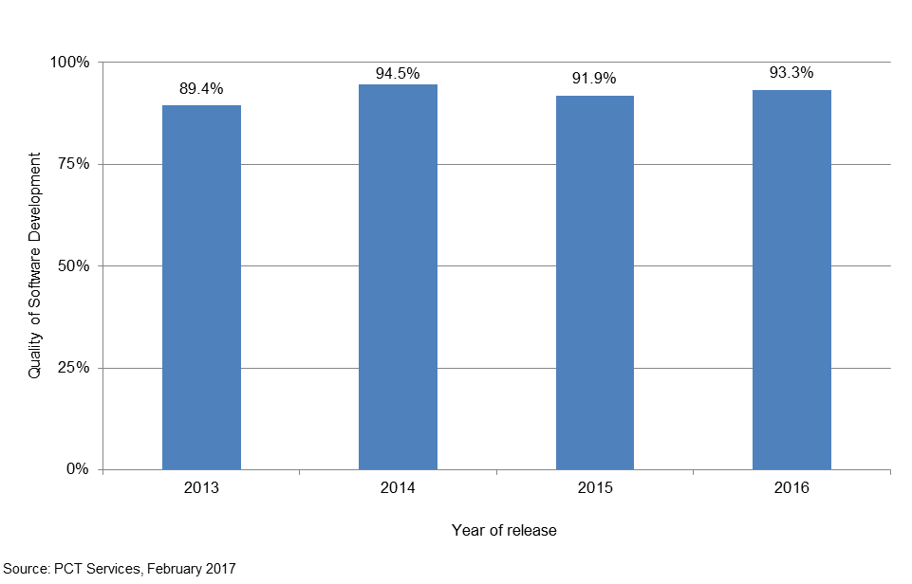

*Information systems service levels*

1. The “information systems service levels (ISSL)” performance indicator reflects the performance of the service provided by the PCT information systems service to users, based on its ability to meet agreed targets.
2. This composite indicator is calculated using the weighted average of five target-based performance indicators[24]. Each indicator is expressed as the percentage of the target actually attained.

1. In 2016, the overall service level improved for the third consecutive year to reach the level of   
   97.1 per cent.

**Information Systems Service Levels**



**Receiving Office at the International Bureau (RO/IB)**

*Filings*

1. This table presents PCT filings by the top 10 receiving Offices over the past five years to 2016. In principle, a PCT application is filed at the national patent office of the applicant’s home country or at a regional patent office acting for the applicant’s home jurisdiction. The IB is a competent receiving Office (RO/IB) for applicants from all PCT contracting States. The evolution of the filings at the RO/IB, its ranking in terms of the number of filings among other receiving Offices, as well as its market share can be observed in this table.

**PCT applications received by the top 10 receiving Offices**



*Timeliness of notification of international filing date*

1. This indicator reflects the time required by the RO/IB to issue Form 105. This form is issued after the international filing date has been accorded. Applicants appreciate receiving this form as soon as possible, because an international application has the effect of a regular national application in each designated State as of the international filing date, which date shall be considered to be the actual filing date in each designated State.

**Timeliness of Notification of International Filing Date**

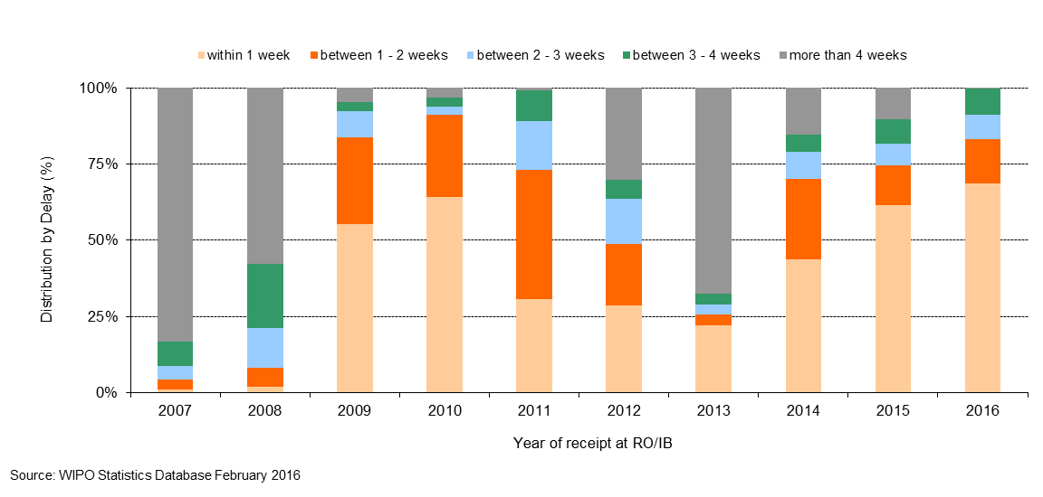

*Timeliness of transmittal of search copy*

1. This indicator reflects the time required by the RO/IB to transmit the search copies to the ISAs. The search copy is to be transmitted promptly after payment of the search fee, so that the ISA can establish the ISR within the deadlines stipulated by the PCT regulatory framework. Delays in paying the fee will delay the transmission of the search copies to the ISAs and therefore negatively impact upon the ability of ISAs to meet these deadlines.

**Timeliness of Transmittal of Search Copy**

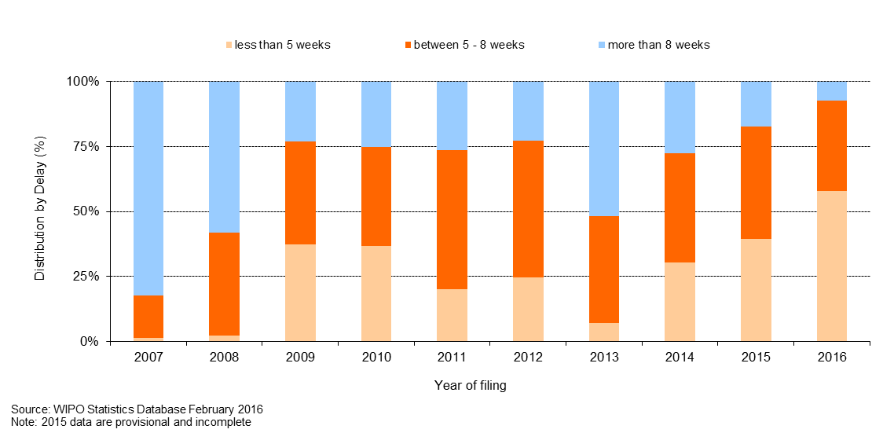

[End of Annex]

### PROGRAM 6 THE MADRID SYSTEM

**Program Manager Ms. B. Wang**

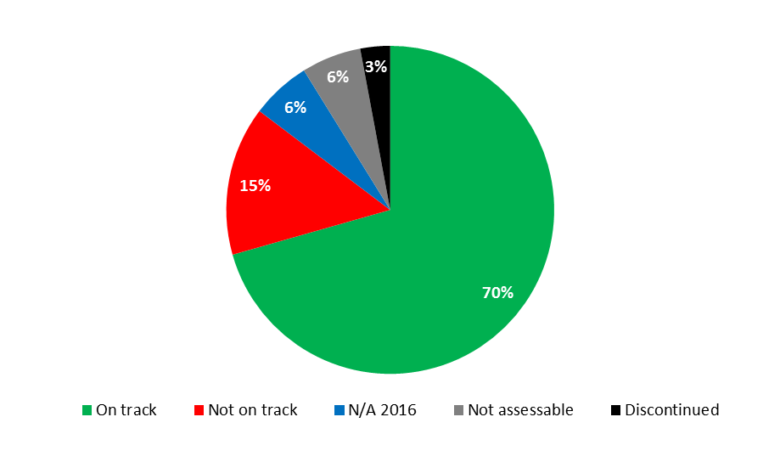



|  |  |  |  |  |  |  |
| --- | --- | --- | --- | --- | --- | --- |
| **Expected Result:** II.6 Wider and more effective use of the Madrid System, including by developing countries and LDCs | | | | | | |
| **Performance Indicators** | **Baselines** | **Targets** | **Performance Data** | **TLS** | | |
| Total Membership of the Madrid System | *Updated Baseline end 2015:*  96 Contracting Parties by end of 2015 covering 112 countries[25]  *Original Baseline  P&B 2016/17:*  95 members (as at April 15, 2015) | 103 | 97 Contracting Parties covering 113 countries | **Not on track** | | |
| Market share  (i.e., national route versus Madrid route) (Madrid) | *Updated Baseline end 2015:*  62.6% market share (2015)  65.3% market share (2014)[26]  *Original Baseline  P&B 2016/17:*  63.4% market share (as of December 31, 2012) | Increase of market share | The data for 2016 will be available only at the end of 2017 | **N/A 2016** | | |
| Filing rate (Madrid) | *Updated Baseline end 2015:*  49,013 applications  +1% filing rate  (as compared to 49,013 application in 2014)[27]  *Original Baseline  P&B 2016/17:*  47,885 applications  +2.3% filing rate (as of Dec 31, 2014) as compared to 2013 | 2016:  + 4.6% Filing rate  2017:  + 2.3% Filing rate | 52,550 applications  + 7.2% filing rate as compared to 2015) | **On track** | | |
| Registrations (Madrid) | *Updated Baseline end 2015:*  51,938 (2015)  *Original Baseline  P&B 2016/17:*  42,430 (2014) | *Updated Target:*  > 47,500 (2016)  > 52,000 (2017)  *Original Target  P&B 2016/17:*  47,387 (2016)  48,652 (2017) | 44,726 registrations | **On track** | |
| Renewals (Madrid) | *Updated Baseline end 2015:*  28,384 renewals  *Original Baseline  P&B 2016/17:*  25,729 (2014) | 29,850 (2016)  31,020 (2017) | 30,103 renewals | **On track** | |
| Total no. of registrations (Madrid) | *Updated Baseline end 2015:*  625,765 active registrations  (as of Dec 31, 2015)[28]  *Original Baseline  P&B 2016/17:*  594,477 registrations  (as of Dec 31, 2014) | 2016: 630,000 registrations 2017: 650,000 registrations | 641,587 registrations | **On track** | |
| Total no. of designations (Madrid) | *Updated Baseline end 2015:*  5.66 million active designations  (as of Dec 31, 2015)  *Original Baseline  P&B 2016/17:*  5.61 million designations  (as of Dec 31, 2014) | 2016:  5.68 million designations  2017:  5.7 million designations | 5.69 million designations | **On track** | |
| Irregularity rate (Article 12 and 13) (Madrid) | *Updated Baseline end 2015:*   * 2015: 39% or 19,216 irregular applications * 2014: 34%[29] or 16,281 irregular applications   Acceptable terms in MGS (in English) 76,300  (as of Dec 31, 2015)  *Original Baseline  P&B 2016/17:*  36% Irregularity rate  (as of Dec 31,2014)  Acceptable terms in Madrid Goods and Services Database (MGS) (in English) 67,050 (May 2015) | Decrease  *Updated Target:*  2016: 80,000  2017: 90,000  *Original Target  P&B 2016/17:*  80,000 | 38% irregularity rate  86,400 terms in English | **On track**  **On track** | |
| Functional improvements to the Madrid System | *Updated Baseline end 2015:*  Common Regulations and Administrative Instructions in force at December 31, 2015[30]  *Original Baseline  P&B 2016/17:*  Common Regulations and Administrative Instructions in force at December 31, 2014 | Amendments to the Common Regulations and Administrative Instructions | Common Regulations and Administrative Instructions in force on December 31, 2016[31]  Amendments adopted by the Madrid Union Assembly in October 2016 (Rules 3, 12, 18*ter*, 22, 23*bis*, 25 to 27, 27*bis*, 27*ter*, 32, 40 and Schedule of fees[32] | **On track** | | |
| **Expected Result:** II.7 Improved productivity and service quality of Madrid operations | | | | |
| **Performance Indicators** | **Baselines** | **Targets** | **Performance Data** | **TLS** | | |
| Client satisfaction (Madrid) | *Updated Baseline end 2015:*  No Survey was held in 2015  *Original Baseline  P&B 2016/17:*  Service Orientation Index in 2014 (39) | Improvement in Index | No survey conducted in 2016 | **N/A 2016** | | |
| Unit cost (Madrid) | *Updated Baseline end 2015:*  Registration/renewal Cost:  743 CHF (2015)  837 CHF (2014)  Inscription Unit Cost:  323 CHF (2015)  322 CHF (2014)  *Original Baseline  P&B 2016/17:*  Registration/renewal Cost:  837 CHF Inscription Unit Cost: 320 CHF | Reduction in both unit cost categories | Registration/renewal Cost: 746 CHF[33]  Inscription Unit Cost: 318 CHF[34] | **Not assessable**  **Not assessable** | | |
| Timeliness of transactions  (days) (Madrid) | *Updated Baseline end 2015:*   * Applications: 57 * Renewals: 56 * Subsequent Designations: 32 * Decisions: 11 * Modifications: 56 * Corrections: 123   *Original Baseline  P&B 2016/17:*  Applications: 70  Renewals: 63  Subsequent Designations: 56 Decisions:12 Modifications:79 Corrections 232 (as at December 31, 2014) | Improvement across all transactions | * Applications: 64 * Renewals: 65 * Subsequent Designations: 42 * Decisions: 24 * Modifications: 62 * Corrections: 140 | **Not on track** | | |
| Quality (Madrid) | *Updated Baseline end 2015:*   * Nice: 89% * Formalities Examinations: 95% * Decisions: 99% * Modifications: 95% * Renewals: 92% * Client Records: 100% * Customer Service: 79% * Translation: EN: 100%   FR: 98%  ES: 96%  *Original Baseline  P&B 2016/17:*  tbd | *Defined Target:*  AQL Nice: 90%  AQL Formalities AQL Examinations: 95%  AQL Decisions: 97%  AQL Modifications: 95%  AQL Renewals: 95%  AQL Client Records: 99%  AQL Customer Service: 90%  AQL Translation: 95%  *Original Target  P&B 2016/17:*  tbd | Nice: 91%  Formalities Examinations: 94%  Decisions: 96%  Modifications: 95%  Renewals: 96%  Client Records: 100%  Customer Service: 83%  Translation: EN 99%  FR 99%  ES 97% | **On track**  **On track**  **On track**  **On track**  **On track**  **On track**  **Not on track**  **On track** | | |
| Improved operation of the Madrid Registry, including electronic processes and procedures (Madrid) | *Updated Baseline end 2015:*   * 79% of documents received electronically * 325,000 email notifications * 2,752 MPM Clients * 27 Offices sending XML * 1 Intelligent web form * 690,000 documents inbound * 1,750,000 documents outbound   *Original Baseline  P&B 2016/17:*  70% of documents received electronically - 220,000 email notifications - 1800 MPM Clients - 17 Offices sending XML - 1 Intelligent web form - 690,000 documents inbound - 1,750,000 documents outbound | *Updated Target:*   * > 79% of documents received electronically (annual) * > 325,000 email notifications (annual) * > 2,752 MPM Clients (biennial) * > 27 Offices sending XML (biennial) * 6 Intelligent web forms (biennial) * 750,000 documents inbound (annual) * 2,000,000 documents outbound (annual)   *Original Target  P&B 2016/17:*   * 75% of documents received electronically * 250,000 email notifications * 2000 MPM Clients * 20 Offices sending XML * 6 Intelligent web forms * 750,000 documents inbound * 2,000,000 documents outbound | 81% of documents received electronically  376,000 email notifications  3,912 MPM clients  30 Offices sending XML  2 intelligent web forms  725,000 documents inbound  1,575,000 documents outbound (reduction due to decisions backlog) | **On track**  **On track**  **On track**  **On track**  **Not on track**  **On track**  **On track** | | |
| Stable provision of evolving Madrid back office IT services | *Updated Baseline end 2015:*  Prototype of Madrid Monitor presented.  *Original Baseline  P&B 2016/17:*  No service interruption  (no. of ICT incidents)  Enhancements delivered and deployed on time | No service interruption (no. of ICT incidents)  Enhancements delivered and deployed on time | 9 ICT incidents  Specified enhancements delivered and deployed on time in accordance with requirements | **Not on track**  **On track** | | |
| 3 deployed versions of M-IRIS and 3 deployed versions of Madrid eFiling (IRPI) | M-IRIS deployed Madrid eFiling deployed | 3 new versions of M-IRIS  3 new versions of D-IRIS  new versions of Madrid eFiling | Specified enhancements to M-IRIS delivered on time and in accordance with requirements  Work began at the end of 2016 on the Hague IT Platform, replacing D-IRIS  1 major eFiling release deployed in 2016 | **On track**  **Dis-continued**  **On track** | | |

|  |
| --- |
| **Resource Utilization for Program 6** |

Budget and Actual Expenditure (by result)

*(thousands of Swiss francs)*

|  |  |  |  |  |
| --- | --- | --- | --- | --- |
| **Expected Result No. and Description** | | **2016/17 Approved Budget** | **2016/17 Budget after Transfers** | **2016 Expenditure\*** |
| II.6 | Wider and more effective use of the Madrid system, including by developing countries and LDCs | 15,755 | 16,326 | 7,664 |
| II.7 | Improved productivity and service quality of Madrid operations | 42,253 | 41,736 | 19,075 |
| II.11 | Improved productivity and service quality of Lisbon operations | 99 | - | - |
|  | **Total** | 58,106 | 58,062 | 26,739 |
| *\*2016 Expenditure numbers are preliminary, subject to audit by External auditors* | | | |  |

Budget and Actual Expenditure (personnel and non-personnel)

*(thousands of Swiss francs)*

|  |  |  |  |  |
| --- | --- | --- | --- | --- |
|  | **2016/17 Approved Budget** | **2016/17 Budget after Transfers** | **2016 Expenditure\*** | **Utilization rate (%)** |
| Personnel Resources | 43,948 | 41,050 | 19,769 | 48% |
| Non-personnel Resources | 14,159 | 17,012 | 6,970 | 41% |
| **Total** | **58,106** | **58,062** | **26,739** | **46%** |
| *\*2016 Expenditure numbers are preliminary, subject to audit by External auditors* | | | | |

*NOTE: The 2016/17 Budget after Transfers reflects transfers as of March 8, 2017 to address needs during the 2016/17 biennium in line with Financial Regulation 5.5.*

A. 2016/17 Budget after Transfers

1. The Budget after Transfers primarily reflected a redistribution of resources from personnel to non-personnel to accommodate more flexible and agile resourcing of Madrid Operations as part of the Madrid Reform Initiative, including the expansion of the Madrid Fellowship Program, as reflected under Expected Result II.6 (Wider and more effective use of the Madrid System).

B. 2016/17 Budget Utilization

1. Budget utilization was within the expected range of 40-60 per cent for the first year of the biennium.

#### Program 6 Annex: Indicators of Madrid Operations

PERFORMANCE INDICATORS FOR THE EXPECTED RESULT

“IMPROVED PRODUCTIVITY AND SERVICE QUALITY OF MADRID OPERATIONS”

**General**

1. In March 2016, the IT legacy system (MAPS) used by Madrid Operations was replaced by a new IT System (MIRIS). Some of the following indicators, such as processed workload, pendency and some quality indicators were impacted by an initial system instability following the deployment of MIRIS.
2. When assessing performance indicators to determine the expected result “improved productivity and service quality of Madrid operations”, the following factors should be considered:

* Madrid workload;
* Composition of the workload;
* Number of staff assigned to process the workload;
* Level of automation; and,
* Total cost of production.

1. **Incoming documents**
2. The International Bureau (IB) receives six different categories of documents, namely international applications, renewals, subsequent designations, modifications, decisions and corrections. The latest trend for the number of documents received by the IB in relation to each of these categories is presented below. With respect to international applications, additional information, such as the average number of classes and average length of the application, is also provided. For technical reasons, some indicators show data based on processed documents rather than on incoming documents. Backlogs in processing may therefore affect some indicators. Moreover, in 2016, the IB changed its methodology for determining the date of receipt of international applications, by using the filing date of an international application at the Office of origin rather than the date of receipt of an international application by the IB.

International applications

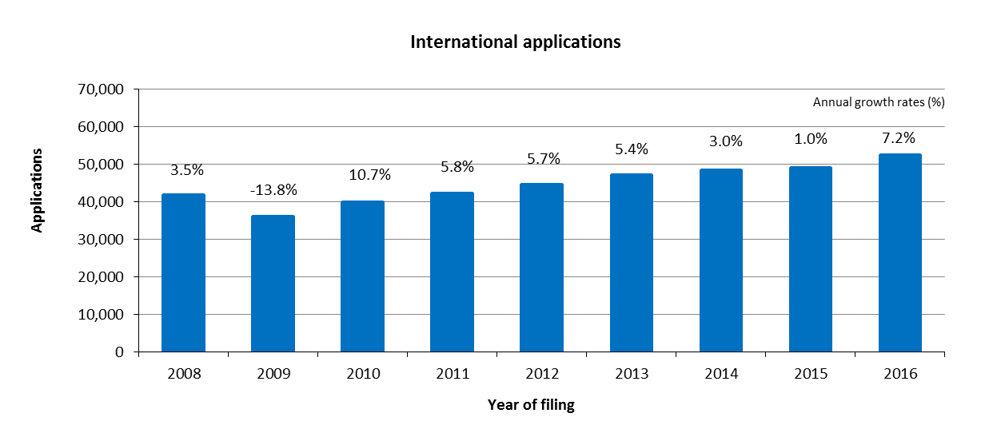

* The IB received 52,550 applications filed in 2016, representing an increase of 7.2 per cent compared to 2015.[35]
* The numbers of applications received have increased continuously since 2010.

*Distribution of applications by language of filing*

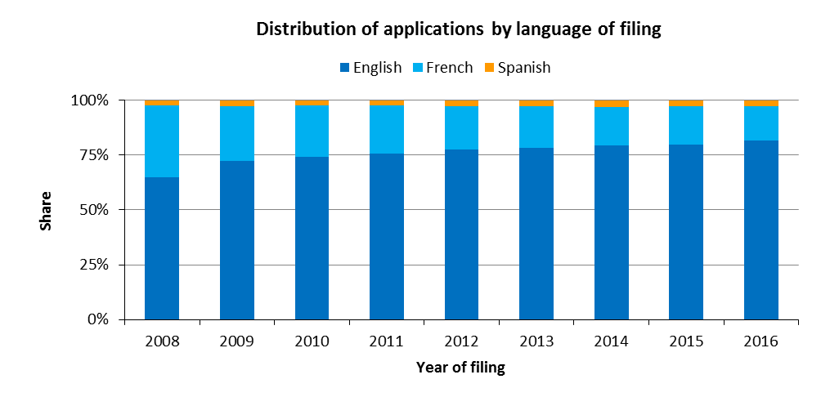

* In 2016, 82 per cent of all applications were filed in English. This share grew by 17 percentage points since 2008, when English applications comprised 65 per cent of all applications filed.

*Average number of designations per registration*

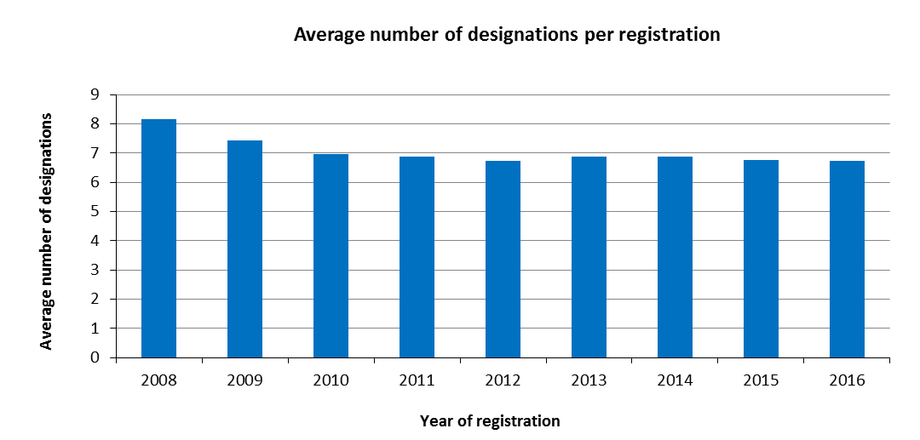

* An average 6.7 designations were made in applications registered in 2016.[36]

*Average number of classes per registration*

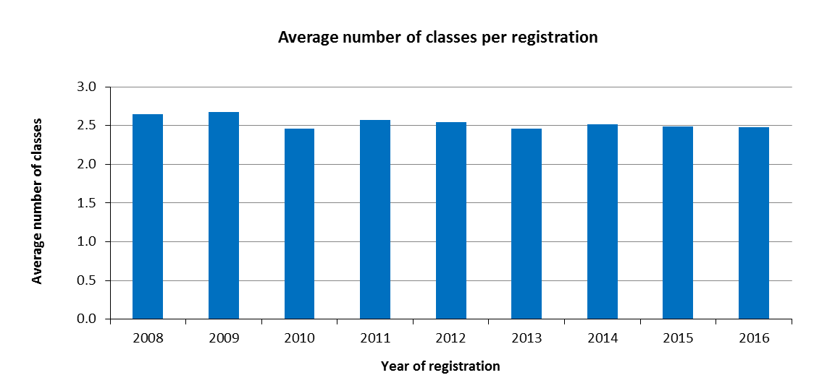

* On average, 2.5 classes were specified in applications registered in 2016, the same as in 2014 and 2015.

*Average length of applications*

1. The length of an application is determined by the total number of words used by applicants in (a) the description of the mark, (b) the list of goods and services and (c) any accompanying limitations. To make the application available in all three Madrid System languages, these three elements are translated by the IB into English, French or Spanish, depending on the original language of the application.

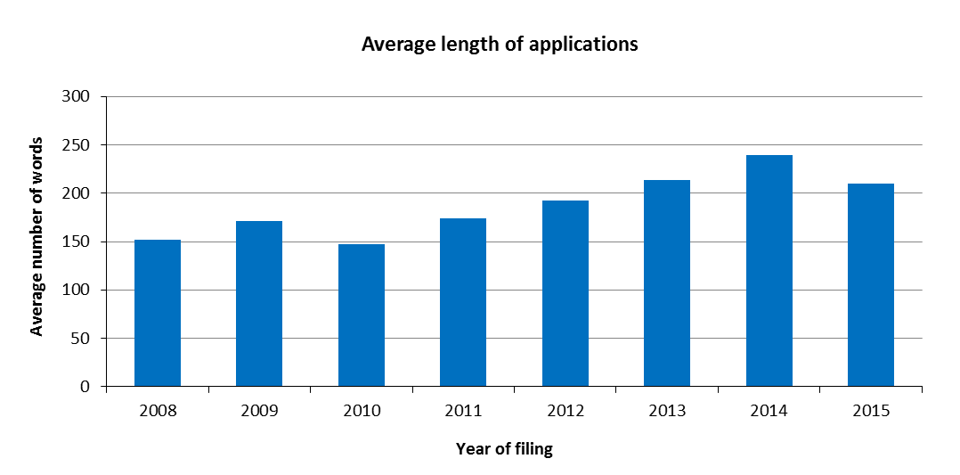

* Due to the IT system migration, data for 2016 were not available at the time of the release of the report.

*Distribution of regular and irregular applications*

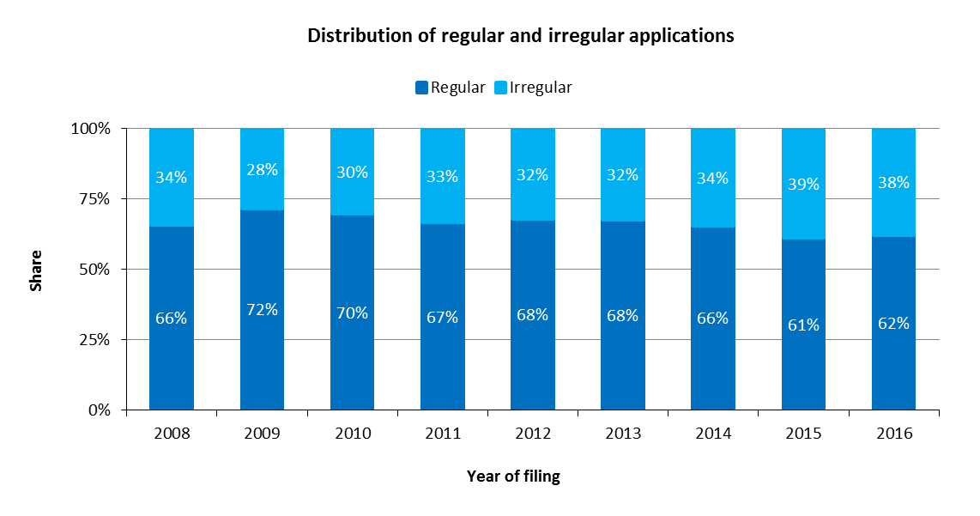

* The share of regular applications remained relatively stable in 2016 compared to 2015, with an increase of 1 percentage point.

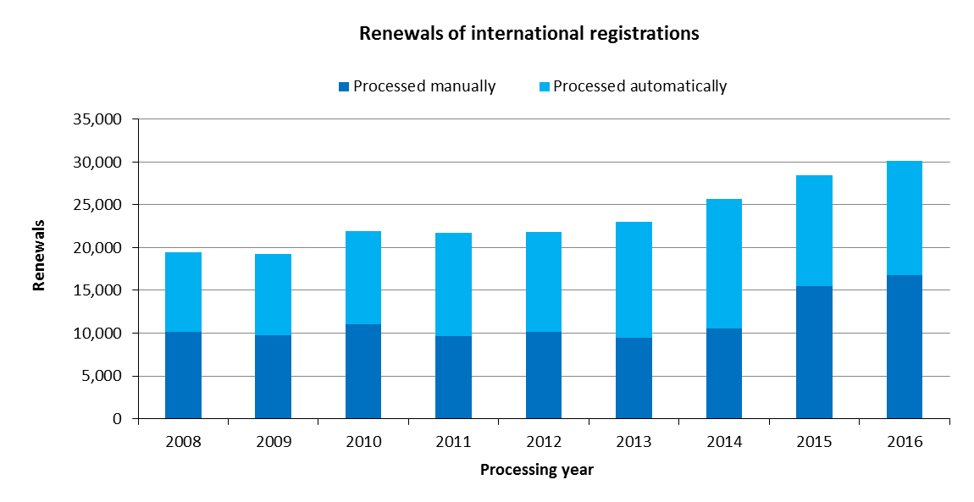Renewals

* In 2016, the IB recorded 30,103 renewals, up 6 per cent from 2015.

Subsequent Designations

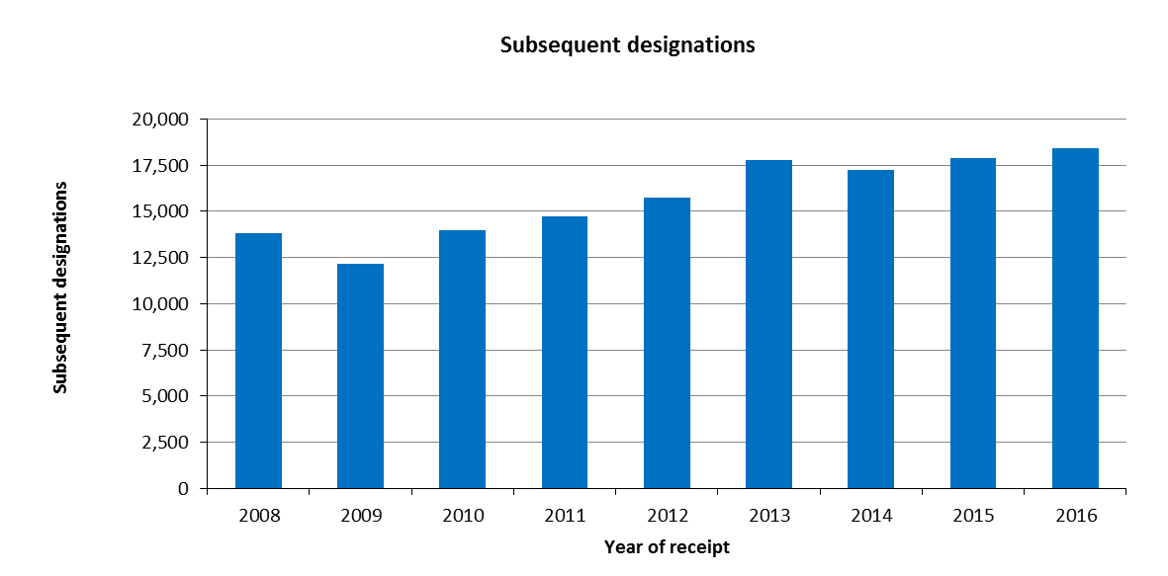

* In 2016, the IB received 18,398 subsequent designations, up 2.9 per cent from 2015.

Modifications

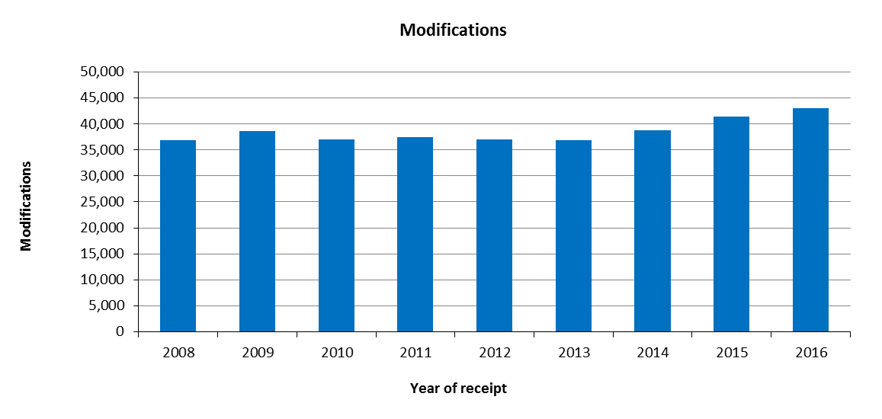

* In 2016, the IB received 43,026 requests for modification, up 4 per cent from 2015.

Decisions

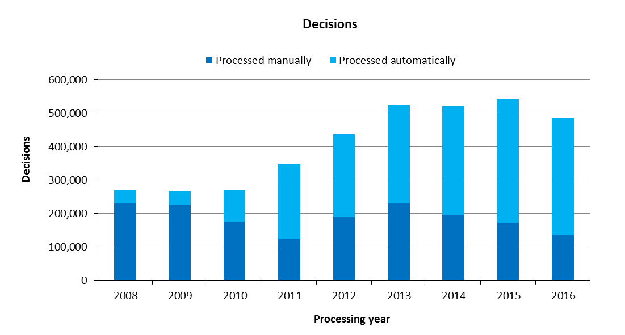

* In 2016, the number of decisions processed by the IB decreased by 10 per cent compared to 2015, totaling 486,295. Between 2010 and 2013, the number of decisions processed sharply increased.
* In 2016, 72 per cent of decisions were processed automatically, a proportion which has consistently increased since 2011.

Corrections

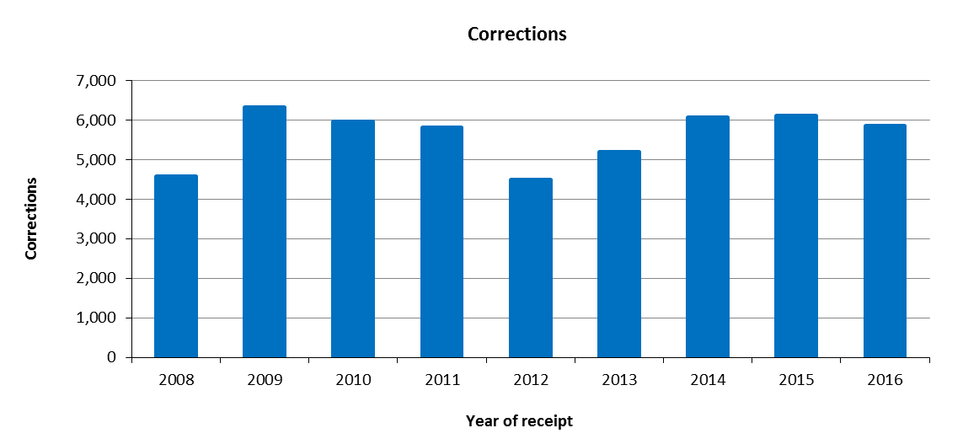

* In 2016, the IB received 5,860 requests for corrections, representing a decrease of 4.4 per cent compared to 2015.

1. **Total processed workload**
2. The total processed workload represents the weighted total number of documents processed by the IB. All six categories of documents are included (applications, renewals, subsequent designations, modifications, decisions and corrections).
3. As the processing of these types of documents do not require an equal amount of resources, they are each weighted differently. According to the current weighting, during the time required to process one international application, a full time equivalent (FTE) examiner can process 1.6 renewals, 1.8 subsequent designations, 1.8 modifications or 10 decisions. Similarly, for documents processed automatically, a FTE in IT systems support is deemed to process 17 documents.

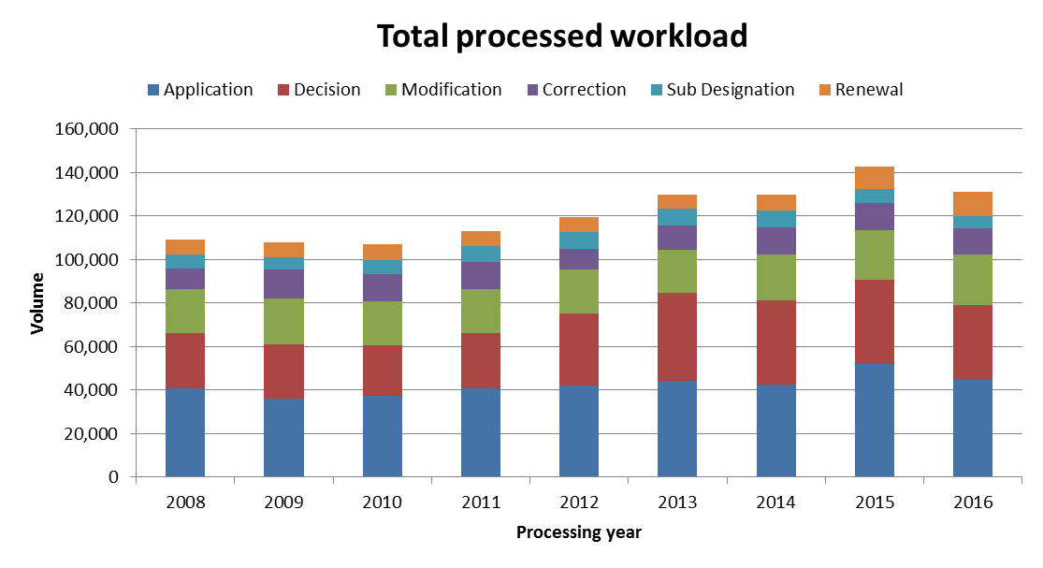

* In 2016, the total processed workload decreased by 8 per cent compared to 2015. Applications, decisions and modifications represented nearly 78 per cent of the total processed workload.
* The overall decrease observed in 2016 included decreases in the number of subsequent designations, applications and decisions processed, with respective reductions of 15, 14 and 12 per cent compared to 2015. This was primarily attributable to the initial instability of the new IT system (MIRIS), which resulted in a backlog of pending documents.

1. **Medium of Transmission of Incoming Documents**

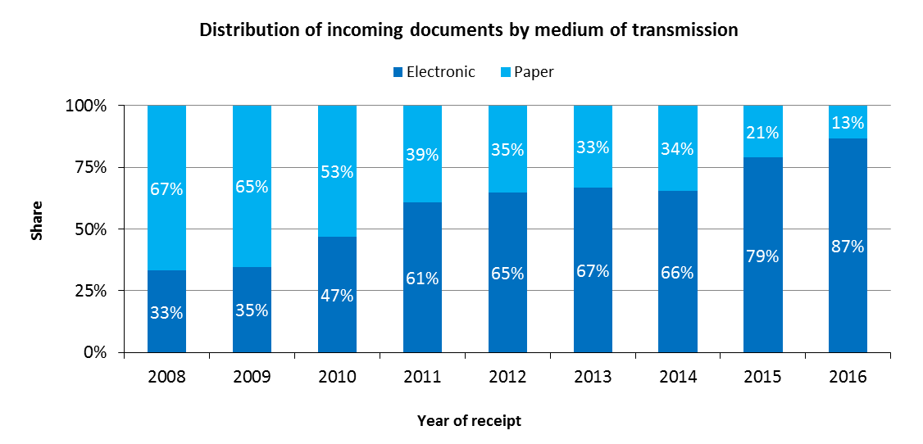

* In 2016, 87 per cent of all incoming documents were transmitted electronically to the IB, which represented an 8 percentage points increase compared to 2015.
* The share of incoming documents transmitted electronically has consistently increased since 2008, except in 2014 where it decreased by 1 percentage point.

1. **Processing**

Total cost of production

1. The total cost of production comprises expenditure relating exclusively to the Madrid System and expenditure of activities supporting the System.
2. For data prior to 2016, the expenditure relating exclusively to the Madrid System represented about 96 per cent of the expenditures of Program 6. From 2016, expenditures of the Madrid System that relate to supporting the Hague and Lisbon Systems are excluded from the calculation. Before the 2016/17 biennium, the expenditure for translation and IT developments in relation to the Hague and Lisbon Systems could not be distinguished from the overall expenditure of Program 6. Because of this refinement in the calculation, 2016 data is not comparable with previous years and is therefore presented in a different graphical view.
3. Expenditure of activities supporting the Madrid System comprises the expenditure of the following general services: conference and language services, construction, executive management, finance and budget, general support services, human resources management, internal oversight, IT and safety and security. A small proportion of these expenses (cost of server hosting at UNICC and share of cost of the Income Section in Finance) are directly attributed to the Madrid System whereas the remaining such expenses attributable to the Madrid System are calculated based on headcount (including fixed term staff, temporary staff and fellows).

|  |  |
| --- | --- |
|  |  |

* The total cost of production is estimated at 41.8 million Swiss francs in 2016.
* In 2016, the direct costs accounted for 61 per cent of total costs.

Unit cost

1. The IB’s efficiency in processing transactions can be measured by the unit cost, defined as the average cost of producing one unit of output.
2. As the IB registers new applications and maintains existing registrations, it is relevant to have a unit of output which includes a set of transactions. Two unit cost indicators are presented below using two different units of output.
3. As part of the IB’s efforts to continuously refine its approach to calculating unit costs, the methodology has been revised in 2016 to reflect more accurately the cost of processing Madrid workloads at the IB:

* The methodology for calculating direct and indirect Madrid costs has been aligned with the methodologies for calculating PCT and the Hague unit costs.
* The weighted system described in Section II, was introduced to better approximate the actual work required to process the six categories of documents, taking into account that some of these documents are more labor-intensive than others.[37]
* The unit cost per new/renewed international registration was redefined to include only new international registrations and renewals. The rationale for removing subsequent designations as a component of this unit cost is a sharper focus on the core Madrid outputs, namely the international registration and its renewal. All other Madrid transactions (subsequent designations, modifications, decisions and corrections) can be considered secondary to these two core transactions. Furthermore, it is difficult to justify including one of these secondary transactions as a component of this unit cost, while excluding the others.
* The second unit cost is based strictly on the number of documents inscribed in the register, irrespective of the varying levels of resources required to process them.

*Unit cost per new/renewed international registration*

1. New international registrations consist of applications that are registered within a given year, and renewed international registrations consist of existing registrations that are renewed within a given year. Combined, these two types of transactions reflect the core business of the IB.
2. As processing these two types of transactions do not require equal resources, they are each weighted differently.[38] The unit cost is calculated by dividing the total cost of production by the number of new/renewed international registrations.

|  |  |
| --- | --- |
|  |  |

* The average cost of processing a new/renewed international registration was 746 Swiss francs in 2016.

*Unit cost per document inscribed in the register*

1. The documents inscribed in the register correspond to the total volume of workload (see “Total volume of workload” above).

|  |  |
| --- | --- |
|  |  |

* The average cost of inscribing a document was 318 Swiss francs in 2016.

1. **Productivity of examination**
2. The definition of examination productivity is the number of new/renewed international registrations processed by examiners, divided by the number of personnel involved in examination. The number of personnel includes fellows, interns and external contractors.

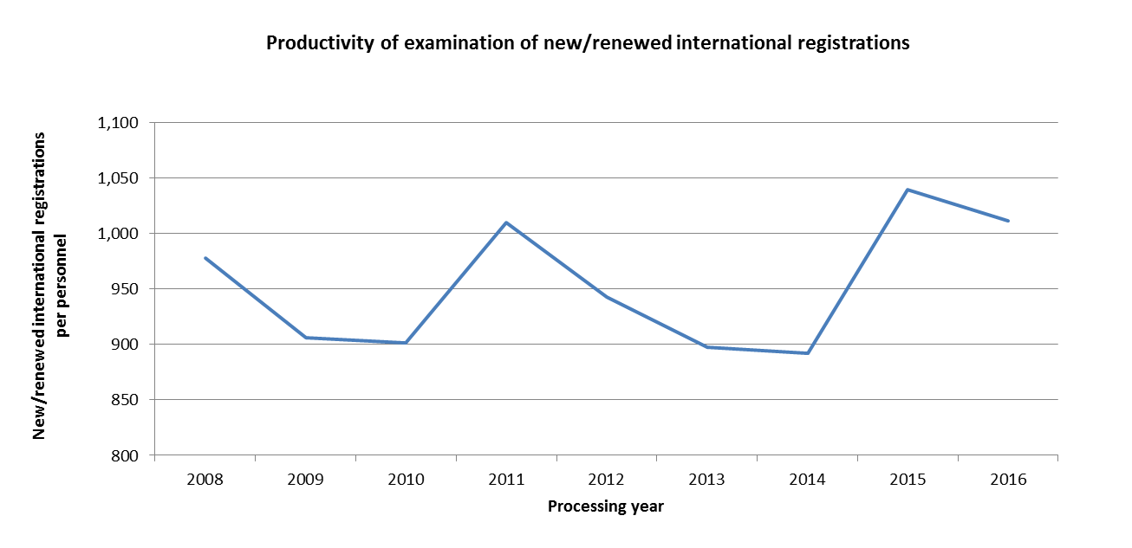

* In 2016, the productivity of examination decreased by 3 per cent compared to 2015. The 1,011 new and renewed international registrations per personnel in 2016 was the second highest during the period 2008-2016.

1. **Personnel**

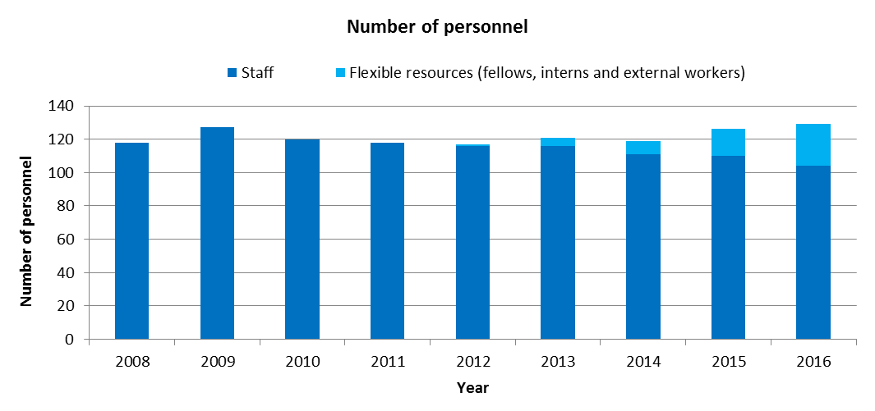

Note: The ability to distinguish the personnel of the Lisbon Registry was only feasible beginning with the 2014/15 biennium. For the years prior to 2014, the personnel of the Lisbon System are included in the overall number of personnel of the Madrid System. Agency workers not working on WIPO premises are not included in this indicator. External workers at the Document Processing Unit are not covered by the current methodology.

* The number of staff decreased from 110 in 2015 to 104 in 2016, while the number of flexible resources increased from 16 in 2015 to 25 in 2016.

1. **Pendency**
2. The average pendency for each of the six transactions performed by the IB is shown below. The pendency is calculated from the date a document is received to the date it is inscribed.

|  |  |
| --- | --- |
|  |  |
|  |  |
|  |  |

* Compared to 2015, the average pendency in 2016 increased for the six transactions performed by the IB. The most important increases were recorded for corrections, decisions and subsequent designations.

1. **Quality of examination**
2. The following key indicators on the overall quality of trademark examination produced by the IB are the result of the quality control undertaken following the implementation of the Madrid Registry Quality Management Framework (QMF) in 2015, in compliance with ISO 9001:2015 and ISO 2859 guidance.[39]
3. Two sources of information on the quality of the examination work produced by the IB are presented:
   1. The results of the internal review of examination transaction samples; and
   2. Errors confirmed to have been made by the IB following the receipt of correction requests under Rule 28 of the Common Regulations.

*Review of examination transaction samples*

1. Quality control was carried out based on the size of the following samples for the manually processed transactions in 2016.

* 1,444 applications for Nice Classification
* 1,499 applications for formalities examination (APEX)
* 540 decisions
* 1,188 requests for modification
* 310 requests for renewal

1. An Acceptable Quality Level (AQL) is set for each transaction and is the criteria against which quality of trademark examination is measured.

* The overall quality performance in 2016 was one percentage point above the acceptable quality level.
* The overall quality performance was one percentage point below the acceptable quality level for 2016 primarily due to the incorrect recording of applicants’ and representatives’ details.
* The overall quality performance for the processing of decisions was one percentage point below the target for 2016.

* The overall quality performance met the target quality level of 95 per cent. However, the same issue as for formalities examination was observed.
* The overall quality performance for the processing of renewals was one percentage point above the target for 2016.

*Errors made by the IB*

1. The distribution of errors presented in the charts below is based on analyses of the following samples of 2016 transactions.[40].

* 371 classifications
* 250 formalities examinations (APEX)
* 276 renewals
* 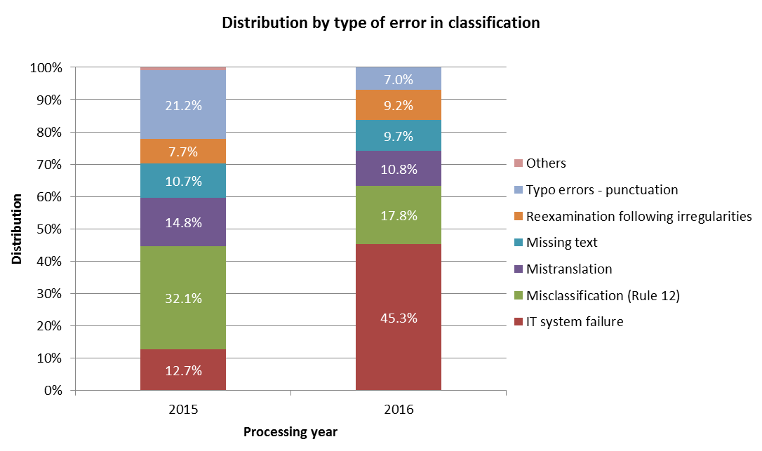293 modifications
* 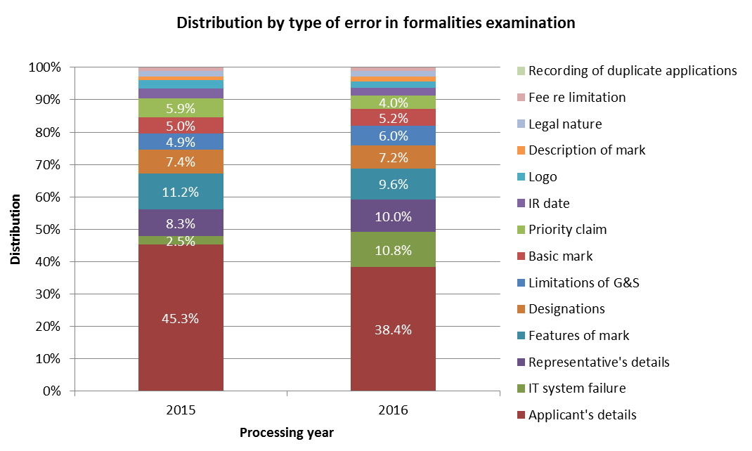IT system (MIRIS) failure accounted for 45.3 per cent of errors in classification in 2016, representing a 32.6 percentage point increase over 2015.
* In 2016, the majority of the corrections in formalities examination were due to errors in entering the details of applicants’ (38.4 per cent) and IT system failure (10.8 per cent).

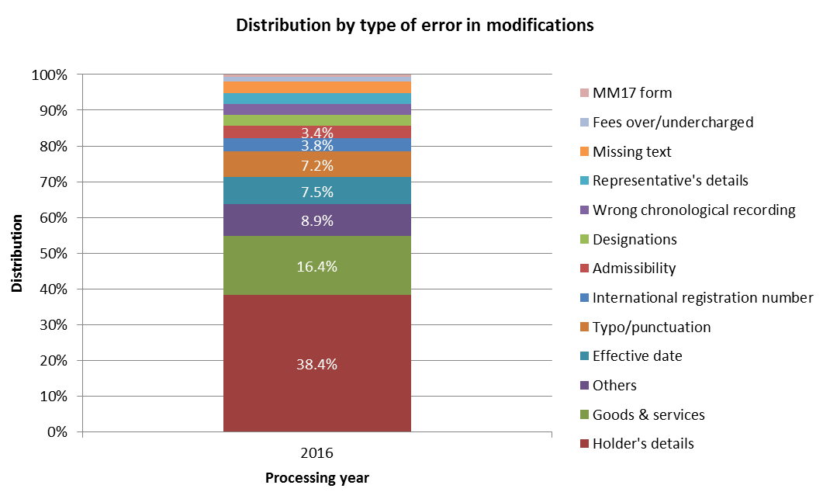

* In 2015, the analysis of errors regarding modifications was presented by type of modification rather than type of errors. It was changed in 2016 to conform to the analysis of the other transactions. Data for 2015 by type of error are not available.
* In 2016, about 42.2 per cent of the corrections in modifications were due to errors in entering the details of holders’ (38.4 per cent) and representatives’ (3.8 per cent). Errors made in relation to goods and services accounted for 16.4 per cent.

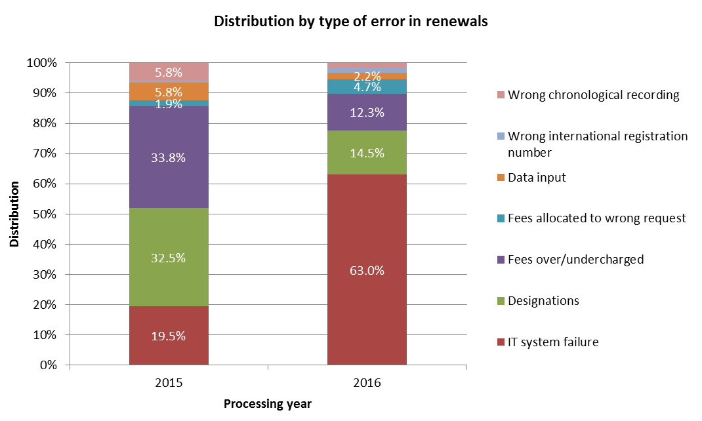

* The increase of the share of errors due to IT system failure was mainly due to the deployment of the new IT system in 2016.

[End of Annex]

### PROGRAM 31 THE HAGUE SYSTEM

**Program Manager Ms. B. Wang**

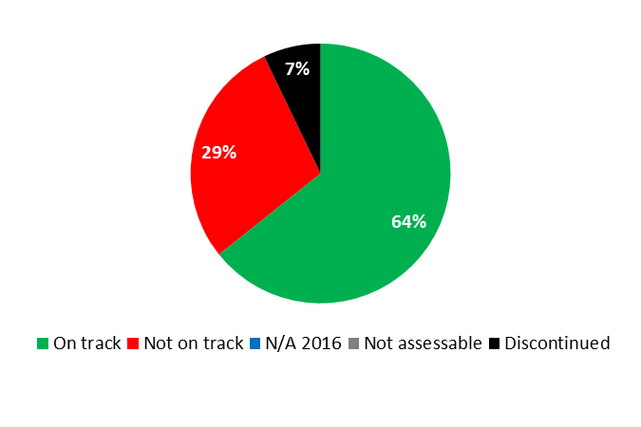

|  |  |  |  |  |
| --- | --- | --- | --- | --- |
| **Expected Result:** II.4 Wider and more effective use of the Hague system, including by developing countries and LDCs | | | | |
| **Performance Indicators** | **Baselines** | **Targets** | **Performance Data** | **TLS** | |
| Membership of the Geneva (1999) Act | *Updated Baseline end 2015:*  50 Contracting Parties  *Original Baseline  P&B 2016/17:*  49 Contracting Parties as of February 13, 2015. | 60 Contracting Parties | 52 Contracting Parties | **Not on track** | |
| Share of Offices concerned providing information on the  Hague System to their users. | *Updated Baseline end 2015:*  47 national or regional Offices were providing information on the Hague System. Ten Offices had no website.  *Original Baseline  P&B 2016/17:* 38 national or regional Offices were providing information on the Hague System. Ten Offices have no web site (end 2014) | Increased share of Offices providing information on the Hague System. | At the end of 2016, 48 national or regional Offices were providing information on the Hague System. Ten Offices had no website. | **On track** | |
| Hague filings and renewals | *Updated Baseline end 2015:*  Applications: 4,111 Designs contained: 16,435 Renewals: 3,194  *Original Baseline  P&B 2016/17:*  Applications 2,924 Designs contained: 14,441 Renewals: 2,703 (2014) | 2016 Applications: 4,940 Designs contained: 22,730 Renewals: 2,830 (−1.0%)  2017 Applications: 5,710 Designs contained: 26,140 Renewals: 2,940 (+3.9%) | 2016:  Applications: 5,562  Designs contained:  18,716  Renewals: 3,150 | **On track**  **Not on track**  **On track** | |
| **Expected Result:** II.5 Improved productivity and service quality of Hague operations | | | | |
| **Performance Indicators** | **Baselines** | **Targets** | **Performance Data** | **TLS** | |
| Predominance of the Geneva (1999) Act in the Hague System | *Updated Baseline end 2015:*  11 consents received with two more consents still required for the termination of the 1934 Act, and four Contracting Parties outside the EU and OAPI still bound only by the 1960 Act.  *Original Baseline  P&B 2016/17:*  10 consents to termination of the 1934 Act received (3 still missing). 4 Contracting Parties bound only by the 1960 Act (which are not members of an intergovernmental organization party to the 1999 Act). | All (13) consents to termination received. All CPs to be bound by the 1999 Act (or members of an intergovernmental organization party to the 1999 Act). | The 1934 Act was terminated on October 18, 2016 | **On track** | |
| Processes and procedures adapted to geographical and legal evolution of the system | Processes and procedures adapted | Processes and procedures adapted | Amendments to the Common Regulations as approved by the Hague Union Assembly in 2016 will come into effect at a date to be decided by the International Bureau once the IT environment is ready | **On track** | |
| Progress towards the enhancement of the legal framework | *Updated Baseline end 2015:*  Amendments to the Common Regulations, among others, introducing a “feedback mechanism”, came into force on January 1, 2015. Amendments to the Administrative Instructions, among others, relaxing certain requirements concerning reproductions and representations, came into force on July 1, 2014.  *Original Baseline  P&B 2016/17:*  Amendments to the Common Regulations (into force on 1.1.2015) and the Administrative Instructions (into force on 1.7.2014) to adapt the Hague System to its geographical expansion to new and prospective CPs with examination systems. | Updating the Hague legal framework to keep pace with the evolvement in the design field worldwide. | Amendments to the Common Regulations (into force on January 1.2017). The purpose of the amendments to Rule 5 is to provide a safeguard against non-delivery of an electronic communication, as it is likely that the majority of future communications with the IB will be in electronic format. | **On track** | |
| Improved operation of  the Hague Registry, including electronic processes and procedures | *Updated Baseline end 2015:*  2 additional automated processes in 2014/15 (Statement of Grant of Protection from OHIM in 2014 and the reception and handling of indirect filings by KIPO)  (4 cumulative)  *Original Baseline  P&B 2016/17:*  2 electronic Hague interfaces | 6 electronic additional Hague interfaces | In 2016, automation of the handling of replies to irregularities (sent through the E-Filing)  (5 cumulative) | **Not on track** | |
| Stable provision of evolving the Hague  back office IT services | No service interruption Enhancements delivered and deployed on time | No service interruption  Enhancements delivered and deployed on time | In 2016, there were no service interruptions  Specified enhancements were delivered and deployed on time in accordance with the specified requirements | **On track**  **On track** | |
| Flexibility of data recorded in the International Register | *Updated Baseline end 2015:*  Progress made on the design choices, yet the implementation was scheduled for after the conversion of the main IT system, an event that did not occur during the biennium: DIRIS.  *Original Baseline  P&B 2016/17:*  Following amendments to the legal framework of the Hague System, more flexibility concerning optional contents of an international application may be indicated and recorded in the International Register.  Inability to record granular design information | Flexibility of data recorded in the International Register and possible specification of further optional contents to be recorded in the International Register.  Ability to record granular design information | Inability to record, retrieve and communicate design-centric data and data in characters other than Latin | **Not on track** | |
| 3 deployed versions of DIRIS and 3 deployed versions of Hague  E-Filing | DIRIS not deployed, E-Filing HPM in production, current database design does not reflect the newly required granularity, E-Filing does not enable the electronic reply to irregularity letters | 3 deployed new versions of DIRIS  3 deployed updated versions of Hague E-Filing, electronic irregularity response enabled and a revised logical database design | Work began at the end of 2016 on the Hague IT Platform, replacing D-IRIS.  In 2016:   * E-Filing enabled the electronic reply to irregularity letters (April 2016); * 5 updated versions of Hague E-Filing were deployed. | **Dis-continued**  **On track** | |

|  |
| --- |
| **Resource Utilization for Program 31** |

Budget and Actual Expenditure (by result)

*(thousands of Swiss francs)*

|  |  |  |  |  |
| --- | --- | --- | --- | --- |
| **Expected Result No. and Description** | | **2016/17 Approved Budget** | **2016/17 Budget after Transfers** | **2016 Expenditure\*** |
| II.4 | Wider and more effective use of the Hague system, including by developing countries and LDCs | 5,337 | 5,865 | 2,688 |
| II.5 | Improved productivity and service quality of the Hague operations | 2,234 | 3,506 | 1,318 |
|  | **Total** | 7,572 | 9,371 | 4,006 |
| *\*2016 Expenditure numbers are preliminary, subject to audit by External auditors* | | | |  |

Budget and Actual Expenditure (personnel and non-personnel)

*(thousands of Swiss francs)*

|  |  |  |  |  |
| --- | --- | --- | --- | --- |
|  | **2016/17 Approved Budget** | **2016/17 Budget after Transfers** | **2016 Expenditure\*** | **Utilization rate (%)** |
| Personnel Resources | 6,226 | 7,524 | 3,428 | 46% |
| Non-personnel Resources | 1,346 | 1,847 | 578 | 31% |
| **Total** | **7,572** | **9,371** | **4,006** | **43%** |
| *\*2016 Expenditure numbers are preliminary, subject to audit by External auditors* | | | | |

*NOTE: The 2016/17 Budget after Transfers reflects transfers as of March 8, 2017 to address needs during the 2016/17 biennium in line with Financial Regulation 5.5.*

A. 2016/17 Budget after Transfers

1. The Budget after Transfers reflected an upward adjustment primarily due to: (i) the transfer of additional non-personnel resources to implement the initial phases the Hague IT Platform Project; (ii) the temporary transfer of a staff member from Business Solutions for IP Offices (Program 15) to support the implementation of the project, as reflected under Expected Result II.5 (Improved productivity and service quality of the Hague operations); and (iii) the transfer of three temporary positions to support the additional examination demands following the accessions of Japan and the United States of America and in anticipation of the accession of the Russian Federation, as reflected under Expected Result II.4 (Wider and better use of the Hague System).

B. 2016/17 Budget Utilization

1. The under-utilization of non-personnel resources was primarily due to the postponement of IT-related work as a result of the ongoing stabilization work on MIRIS.

#### Program 31 Annex: Indicators of the Hague System Operations

PERFORMANCE INDICATORS FOR THE EXPECTED RESULT

“IMPROVED PRODUCTIVITY AND SERVICE QUALITY OF THE HAGUE OPERATIONS”

1. As background for the performance indicators for the expected result “improved productivity and service quality of the Hague System Operations”, the evolution of the following factors needs to be considered:

* The Hague System workloads;
* The composition of those workloads;
* The level of automation; and,
* The resources assigned to cope with the workload.

1. The International Bureau (IB) receives four main types of documents, namely international applications, renewals, changes and decisions. The latest trend for each of these documents is presented below. Additional information on the applications received, such as their average number of designs, is also provided. For technical reasons, the indicator on the irregularities issued shows data based on processed rather than incoming documents.

**I. Incoming Documents**

Applications received

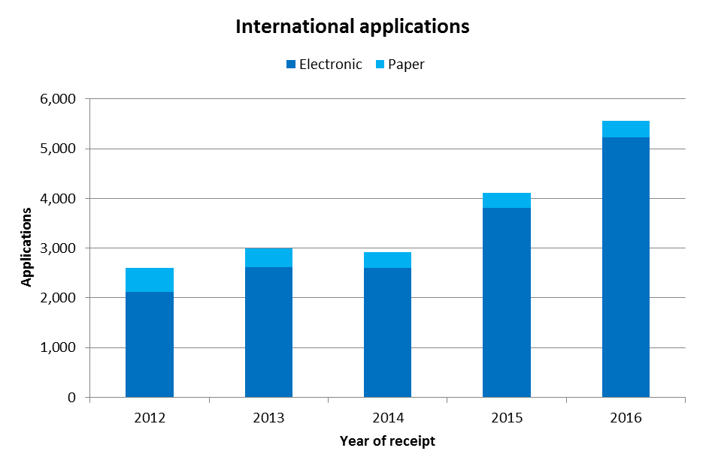

* In 2016, the IB received 5,562 international applications, up 35 per cent from 2015. In addition to applications from the European Union (+186 applications), those from the Republic of Korea (+747 applications), Japan (+220 applications) and the United States of America (+211 applications), all of which joined the Hague System in 2014/15, also contributed to this increase.
* In 2016, 94 per cent of applications were filed electronically, a thirteen percentage points increase over 2012.

*Average number of designs per application*

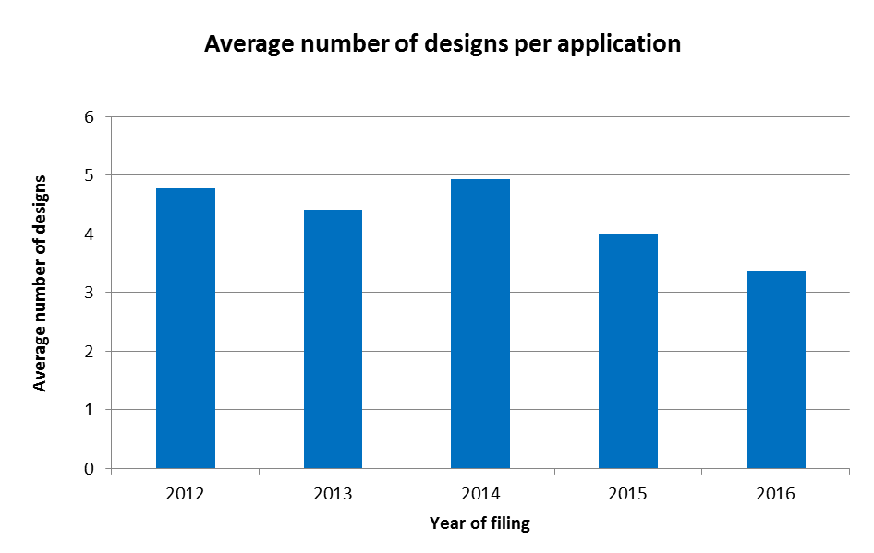

* In 2016, an application contained, on average, 3.4 designs, confirming a downward trend.

*Average number of designations per application*

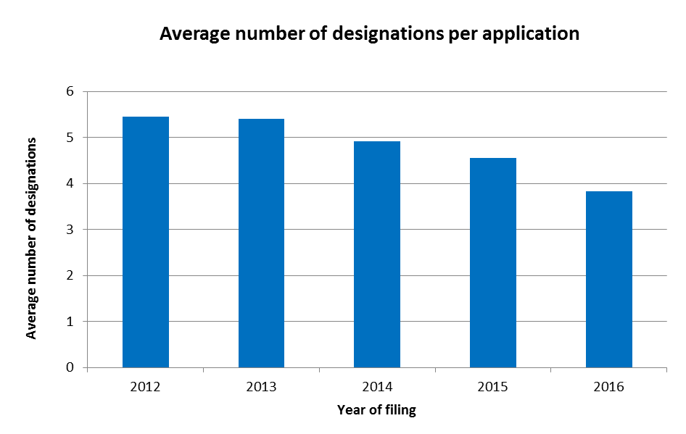

* In 2016, an application contained on average 3.8 designations. Since 2012, the average number of designations per application has decreased continuously.

*Trend of irregularities in applications*

1. Irregularities notified are grouped among the ten categories shown below.

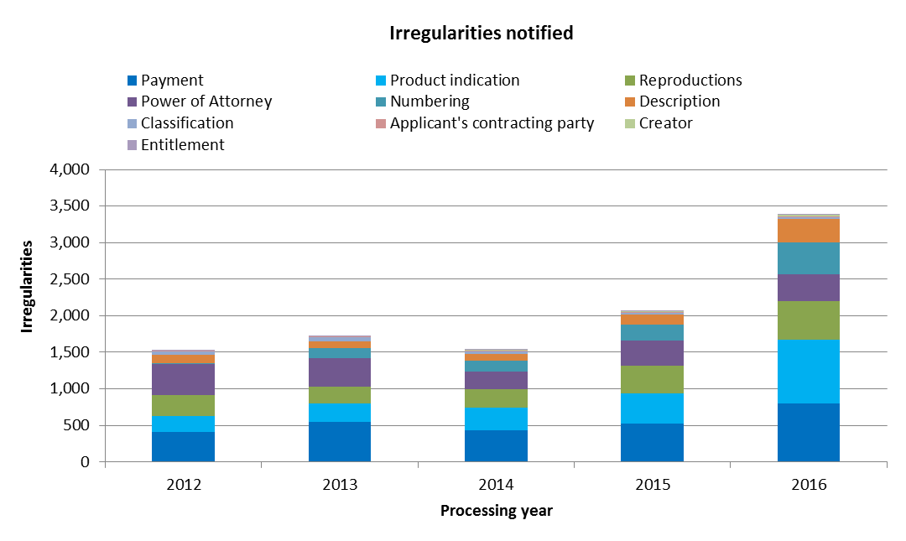

* In 2016, the IB notified 3,383 irregularities in respect of applications.
* Irregularities relating to product indications, descriptions and the numbering of reproductions were those experiencing the sharpest relative increase in 2016.
* Overall, irregularities notified in 2016 increased 64 per cent compared to 2015,[41] which is an increase in excess of the growth in terms of applications.

1. The evolution of the share of applications containing one or more irregularities and/or substantive observations is shown below.[42]

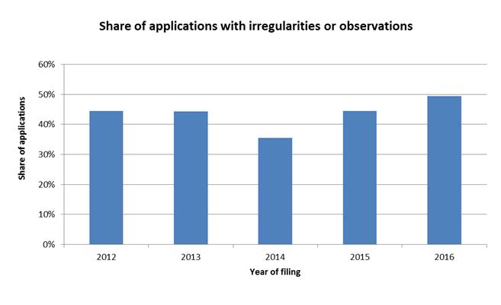

* In 2016, some 49 per cent of applications registered contained at least one irregularity or substantive observation. This represented an increase of about 5 percentage points compared to 2015.

Renewals

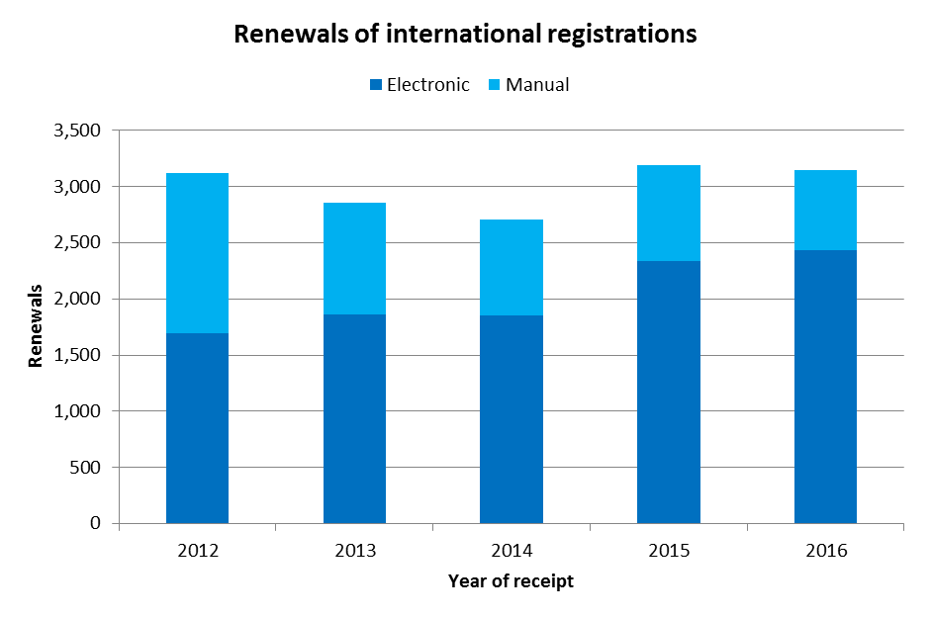

* In 2016, the number of renewals decreased by 1.4 per cent compared to 2015, to a total of 3,150 renewals.
* Since 2012, the majority of renewals have been processed electronically, accounting for 77 per cent of total renewals in 2016 compared to 73 per cent in 2015, an increase of about 4 percentage points.

Changes

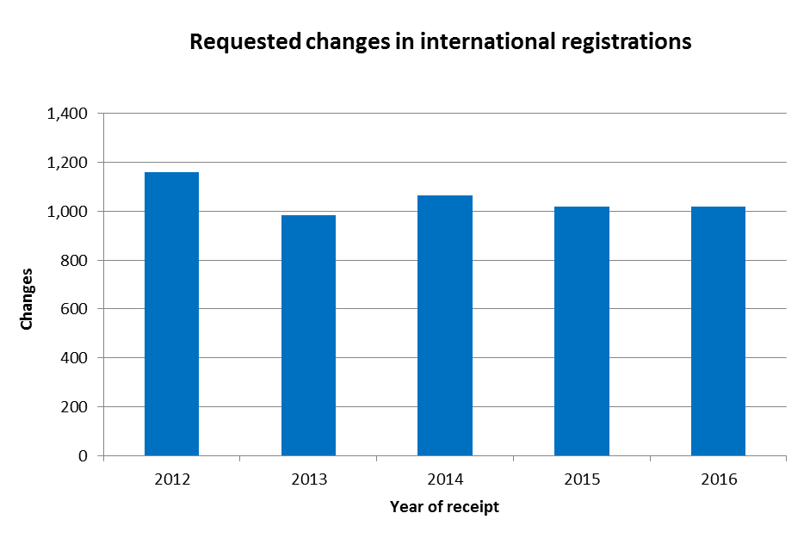

* Applicants requested 1,020 changes in international registrations in 2016, up 0.2 per cent from 2015.

Decisions

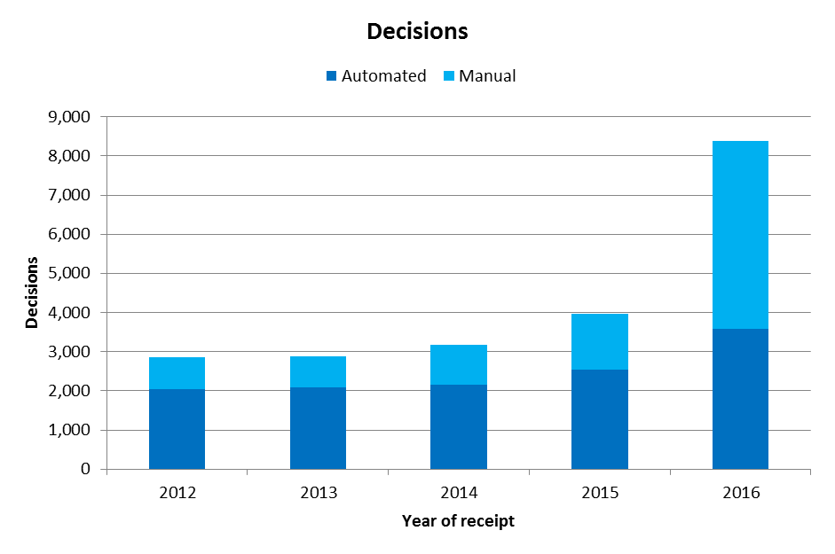

* The number of decisions received in 2016 increased by 112 per cent as compared to 2015, to 8,386 decisions, reflecting the impact on the Hague operations of the System’s recent expansion to substantive examination jurisdictions.
* The share of decisions processed automatically in 2016 (42 per cent) was the lowest since 2012.

**II. Total Workload**

1. The total workload represents the weighted total number of documents received at the IB. All four categories of documents are included (applications, renewals, changes and decisions).
2. As the processing of these types of documents do not require the equal amount of resources, they are each weighted differently. According to the current weighting, during the time required to process one international application, an examiner can process eight renewals, four changes or four decisions (a 1:8:4:4 workload ratio). Since 2014/15, due to an increasing level of complexity of other documents, in particular decisions by Offices, the overall examination of international applications has also become more complex. This, however, has not affected the workload ratio.

* 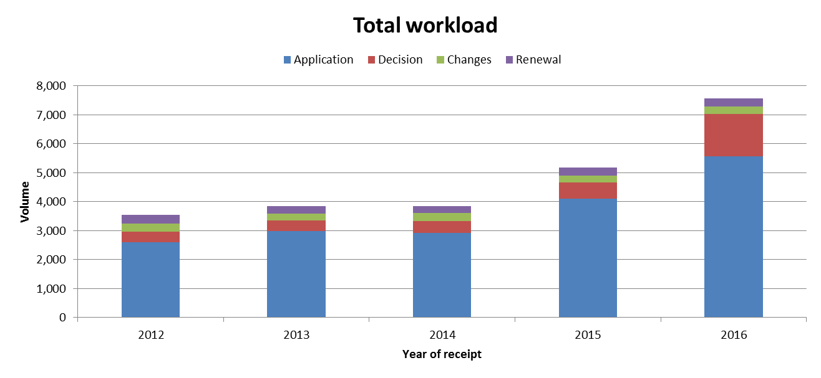In 2016, the total workload increased by 46 per cent compared to 2015. Between 2012 and 2016, the increase in workload was mainly due to the increase in the number of applications received although decisions are becoming an increasingly significant part of that workload.

**III. Cost of Processing**

Total cost of production

1. The total cost of production comprises expenditure relating exclusively to the Hague System and expenditure of activities supporting the System.
2. For data prior to 2016, the expenditure relating exclusively to the Hague System includes those of Program 31 (the Hague System) and about eight per cent of the expenditure of the Office of the Deputy Director General of the Brands and Designs Sector (Program 6 – Madrid System). The 2016 expenditures of the Madrid System that relate to supporting the Hague System – translation and IT expenditures – are included in the calculation. Before the 2016/17 biennium, the expenditure associated with these services could not be distinguished from the overall expenditure in relation to translation and IT developments in Program 6 (Madrid System), and were therefore not included in the calculation. Because of this refinement in the calculation, the 2016 result is not comparable with previous year’s results. For this reason, the data for the period 2012-15 and for 2016 are shown in two different graphical views.
3. 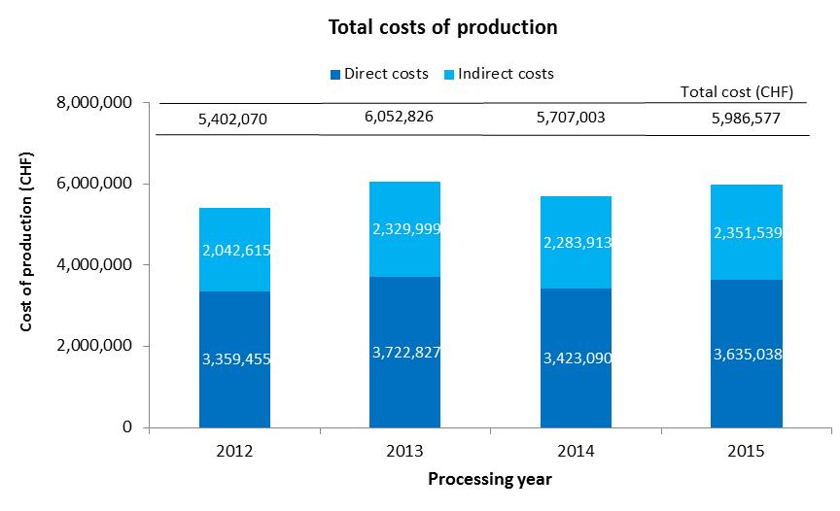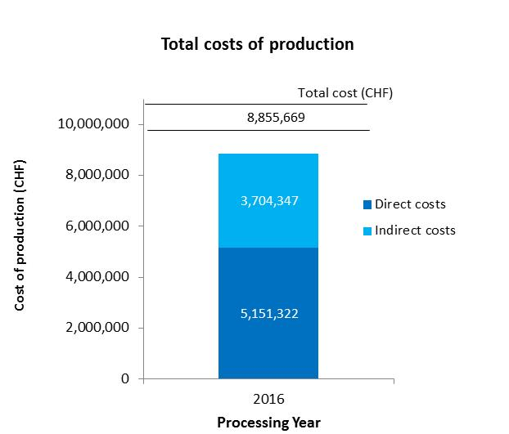Expenditure of activities supporting the Hague System comprises the expenditure of the following general services: conference and language services, construction, executive management, finance and budget, general support services, human resources management, internal oversight, IT and safety and security. A small proportion of these expenses (cost of server hosting at UNICC and share of cost of the Income Section in Finance) are directly attributed to the Hague System whereas the remaining of such expenses attributable to the Hague System are calculated based on headcount (including fixed term staff, temporary staff and fellows).

* The total expenditure related to the processing of the Hague System is estimated at 8.86 million Swiss francs in 2016.
* In 2016, the direct costs accounted for 58 per cent of total expenditures.

Unit cost

1. The IB’s efficiency in processing transactions can be measured by the unit cost, defined as the average cost of producing one unit of output.
2. As the IB registers new applications and maintains existing registrations, it is relevant to have a unit of output, which includes a set of transactions. Two unit cost indicators are presented below using two different units of output.
3. As part of the IB’s efforts to continuously refine the methodology for calculating unit costs, the methodology has been revised in the Program and Budget 2016/17 to reflect more accurately the cost of processing the Hague workloads at the IB.[43]

*Unit cost per new/renewed design*

1. New designs consist of designs in international applications that are registered within a given year. Renewed designs consist of existing designs in international registrations that are renewed within a given year. Combined, designs contained in these two types of transactions reflect the core business of the IB.
2. 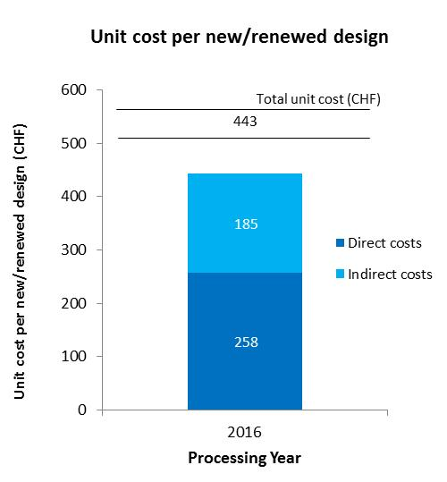As processing designs contained in these two types of documents do not require equal resources, they are each weighted differently.[44] The unit cost is calculated by dividing the total cost of production by the number of new/renewed designs.

* 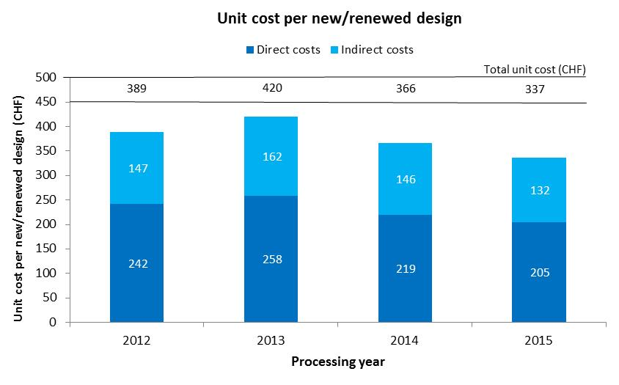The average cost of processing a new/renewed design is estimated at 443 Swiss francs in 2016. For the reasons mentioned above (see total cost of production indicator), the results for 2016 cannot be compared with previous years.

*Unit cost per document recorded in the register*

1. The documents recorded in the Register correspond to the total workload (see “Total Workload” above).

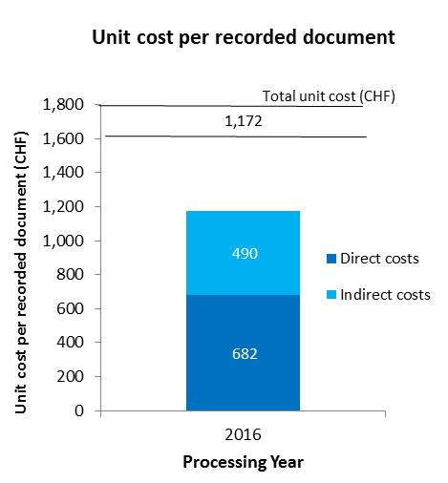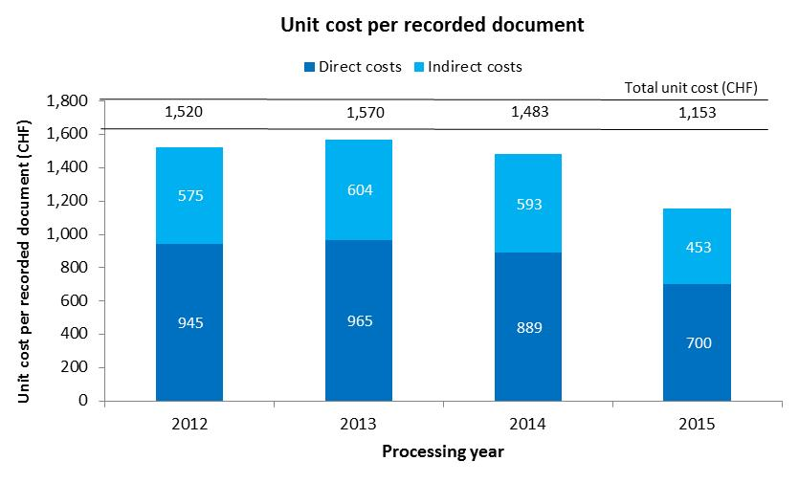

* The average cost of recording a document in the Register is estimated at 1,172 Swiss francs in 2016. For the reasons mentioned above (see total cost of production indicator), the results for 2016 cannot be compared with previous years.

**IV. Timeliness to Process International Applications**

1. This indicator reflects the time required by the IB to process regular applications. The timeliness is calculated between the time elapsed between the date of receipt of an application and the date it was registered.

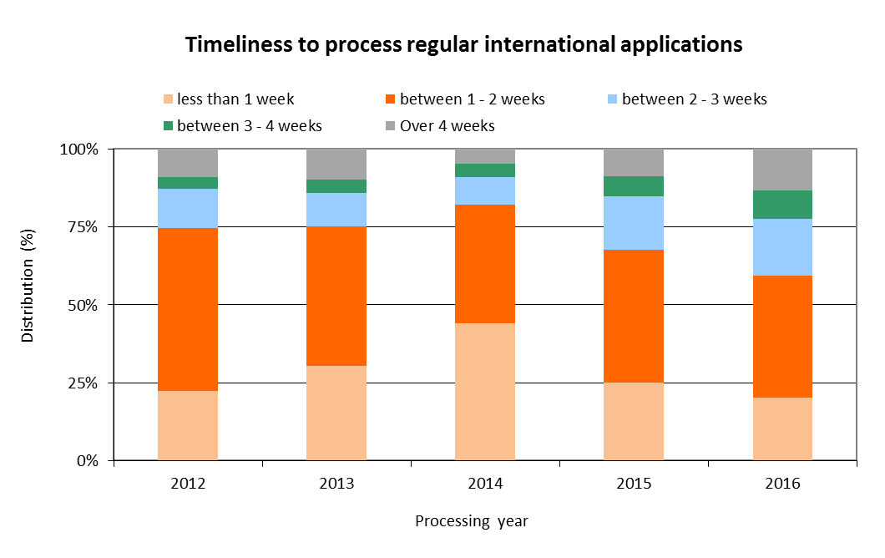

* In 2016, the share of regular applications processed within less than one week decreased to 20 per cent, as compared to 45 per cent in 2014, reflecting the increase in complexity referred to in Section II above.
* In 2016, 78 per cent of applications were processed within three weeks from the date of receipt at the IB.

[End of Annex]

### PROGRAM 32 LISBON SYSTEM

**Program Manager Ms. B. Wang**

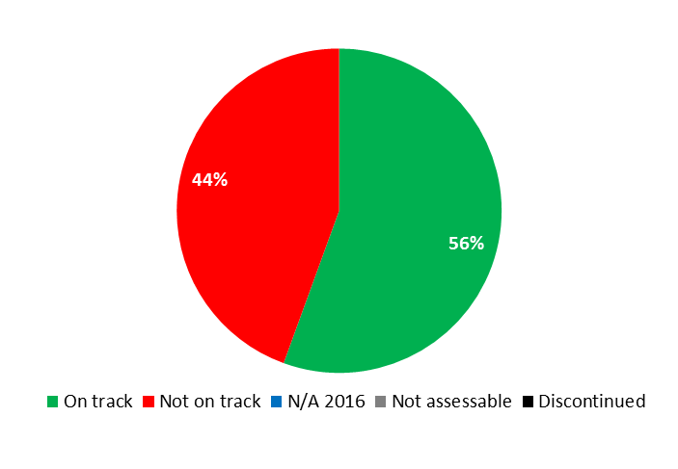



|  |  |  |  |  |
| --- | --- | --- | --- | --- |
| **Expected Result:** II.10 Wider and more effective use of the Lisbon System, including by developing countries and LDCs | | | | |
| **Performance Indicators** | **Baselines** | **Targets** | **Performance Data** | **TLS** |
| Expansion of the geographical coverage of the Lisbon System | *Updated Baseline end 2015:*  No new Contracting Parties (0)  *Original Baseline  P&B 2016/17:*  No. of Contracting Parties to the Geneva Act at the end of 2015 | Up to 5 Contracting parties to the Geneva Act by the end of 2017 | No new Contracting Parties | **Not  on track** |
| % of participants in Lisbon System events satisfied and reporting enhanced awareness post an event | *Updated Baseline end 2015:*  7 information and promotion events with a specific focus on the Lisbon System, including its revision, in all regions with 84% of participants satisfied  *Original Baseline  P&B 2016/17:*  84% of participants satisfied (2014) in 5 events | 85% of participants satisfied | 12 events with a specific focus on the Lisbon System, including its recent developments, with 86% of participants satisfied (survey in one event) | **On track** |
| No. of international applications and other transactions (Lisbon) | *Updated Baseline end 2015:*  259 transactions in 2014/15:  - 115 international applications - 105 statements of grant protection - 39 refusal declarations  *Original Baseline  P&B 2016/17:*  121 transactions in 2014: - 80 international applications - 26 statements of grant protection - 15 refusal declarations | *Updated Target:*  120 transactions in 2016/17 - 20 new international applications (per annum) - 60 statements of grant of protection - 20 refusal declarations  *Original Target P&B 2016/17:* 100 transactions in 2016/17 - 20 new international applications (per annum) - 60 statements of grant protection - 20 refusal declarations | 89 transactions in 2016:   * 25 international applications   Other transactions:   * 8 statements of grant of protection * 54 refusal declarations * 2 withdrawals of refusal | **On track**  **On track** |
| No. of international registrations from developing countries and LDCs in force under the Lisbon System (in relation to the total no.) | *Updated Baseline end 2015:*  95 (out of 931):   * Arab (14) * Asia and the Pacific (38) * Latin America and the Caribbean (43)   *Original Baseline  P&B 2016/17:*  78 (out of 896) (March 2015) | *Updated Target:*  100 (out of 971 )  *Original Target P&B 2016/17:*  90 (out of 950) | 95 (out of 1,020):   * Arab Region (14) * Asia and the Pacific (38) * Latin America and the Caribbean (43) | **Not  on track** |
| Expected Result: II.11 Improved productivity and service quality of Lisbon operations | | | | | |
| **Performance Indicators** | **Baselines** | **Targets** | **Performance Data** | **TLS** |
| Adoption of provisions streamlining the Lisbon System legal framework | *Updated Baseline end 2015:*  Geneva Act of the Lisbon Agreement on Appellations of Origin and Geographical Indications adopted in May 2015  *Original Baseline  P&B 2016/17:*  Current legal framework and legal framework of the Geneva Act of May 2015 | Adoption of Common Regulations under Lisbon Agreement and Geneva Act | The first session of the Lisbon Working Group for the Preparation of Common Regulations under the Lisbon Agreement and the Geneva Act of the Lisbon Agreement, in June 2016, reviewed a first draft of the Common Regulations | **On track** |
| Increased use of electronic means for filing and processing international applications and other transactions (Lisbon) | *Updated Baseline end 2015:*  Streamlined procedure for notifications implemented via the WIPO Inquiry Notification System (WINS)  *Original Baseline  P&B 2016/17:*  Current data entry tool  Current Bulletin and database | Improved data entry tool  Integration of the Bulletin into the Lisbon Express database | Business input provided in order to further enhance current IT tools to generate electronic notifications to Competent Authorities, including related certificates and official communications  The integration of the Lisbon Bulletin into the Lisbon Express database was postponed | **On track**  **Not  on track** |
| Improved electronic services for the Lisbon Registry | *Updated Baseline end 2015:*  Electronic interface linking the International Register and Lisbon Express database on the WIPO website was completed and deployed in 2014  *Original Baseline  P&B 2016/17:*  Simple implementation of an electronic register | Electronic filing web forms | At the end of 2016, the development of electronic filing forms was still in an exploratory phase | **Not  on track** |

|  |
| --- |
| **Resource Utilization for Program 32** |

Budget and Actual Expenditure (by result)

*(thousands of Swiss francs)*

|  |  |  |  |  |
| --- | --- | --- | --- | --- |
| **Expected Result No. and Description** | | **2016/17 Approved Budget** | **2016/17 Budget after Transfers** | **2016 Expenditure\*** |
| II.10 | Wider and more effective use of the Lisbon System, including by developing countries and LDCs | 785 | 996 | 374 |
| II.11 | Improved productivity and service quality of Lisbon operations | 550 | 588 | 262 |
|  | **Total** | 1,335 | 1,584 | 636 |
| *\*2016 Expenditure numbers are preliminary, subject to audit by External auditors* | | | |  |

Budget and Actual Expenditure (personnel and non-personnel)

*(thousands of Swiss francs)*

|  |  |  |  |  |
| --- | --- | --- | --- | --- |
|  | **2016/17 Approved Budget** | **2016/17 Budget after Transfers** | **2016 Expenditure\*** | **Utilization rate (%)** |
| Personnel Resources | 1,124 | 1,373 | 554 | 40% |
| Non-personnel Resources | 211 | 211 | 82 | 39% |
| **Total** | **1,335** | **1,584** | **636** | **40%** |
| *\*2016 Expenditure numbers are preliminary, subject to audit by External auditors* | | | | |

*NOTE: The 2016/17 Budget after Transfers reflects transfers as of March 8, 2017 to address needs during the 2016/17 biennium in line with Financial Regulation 5.5.*

A. 2016/17 Budget after Transfers

1. The increase in personnel resources and across the Expected Results reflected the transfer into the Program of the new Director of the Lisbon Registry in December 2015 as part of the succession plan in anticipation of the retirement of the Head in February 2016 (temporary overlap of resources).

B. 2016/17 Budget Utilization

1. The slight under-utilization of non-personnel resources was primarily due to the postponement of certain activities such as seminars and advisory missions reflected under Expected Result II.10.

### PROGRAM 7 WIPO ARBITRATION AND MEDIATION CENTER

**Program Manager Mr. J. Sandage**

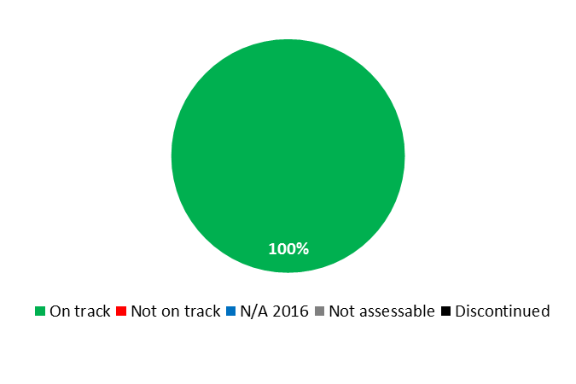

|  |  |  |  |  |  |
| --- | --- | --- | --- | --- | --- |
| **Expected Result:** II.8 International and domestic intellectual property disputes are increasingly prevented or resolved through WIPO mediation, arbitration and other alternative dispute resolution methods | | | | | |
| **Performance Indicators** | **Baselines** | **Targets** | **Performance Data** | **TLS** | |
| Increased use of alternative dispute resolution services and clauses in intellectual property transactions and registrations, including through WIPO procedures | *Updated Baseline end 2015:*  422 disputes and 202 bons offices (cumulative per end 2015)  *Original Baseline  P&B 2016/17:*  393 disputes and 148 bons offices (cumulative per end 2014) | *Updated Target:*  150 additional disputes and bons offices  *Original Target  P&B 2016/17:*  40 additional disputes and bons offices | 60 additional disputes and 54 additional bons offices  482 disputes and 256 bons offices (cumulative at the end of 2016) | **On track** | |
|  | *Updated Baseline end 2015:*  7,500 additional queries (2014/15)  *Original Baseline  P&B 2016/17:*  4,000 incoming queries (2012/13) | *Updated Target:*  7,500 additional queries  *Original Target  P&B 2016/17:*  4,000 additional queries | 3,865 additional queries | **On track** | |
|  | *Updated Baseline end 2015:*  3.1 million additional visits (2014/15)  *Original Baseline  P&B 2016/17:*  1.553 million Web visits (2014) | *Updated Target:*  3.1 million additional visits  *Original Target  P&B 2016/17:*  1.5 million additional Web visits | 1.495 million additional visits | **On track** | |
|  | *Updated Baseline end 2015:*  262 participants at Center events (2014/15)  *Original Baseline  P&B 2016/17:*  408 participants at Center events (2012/13) | *Updated Target:*  400 participants at Center events  *Original Target  P&B 2016/17:*  250 participants at Center events | 859 participants at Center events | **On track** | |
|  | *Updated Baseline end 2015:*  9,670 participants at events involving Center representation (2014/15)  *Original Baseline  P&B 2016/17:*  4,000 participants at events involving Center representation (2012/13) | *Updated Target:*  9,670 participants at events involving Center representation  *Original Target  P&B 2016/17:*  6,000 participants at events involving Center representation | 5,302 participants at events involving Center representation | **On track** | |
| Alternative dispute resolution policies to which the Center has contributed in respect of their development and implementation | *Updated Baseline end 2015:*  23 schemes adopted (ABF, AEF, AGICOA, DESCA, DGIPR, DNDA, EGEDA, ETSI, Film & Media, German R&D, ICOM, IEEE, IMPI, INPI-BR, IPAG, IPOPHL, IPOS(M)/IPOS(ED), KCC, KOCCA, ITPGRFA, Palexpo, SFA, USPTO) (cumulative per end 2015)[45]  *Original Baseline  P&B 2016/17:*  15 schemes adopted (AEF, AGICOA, DGIPR, DNDA, EGEDA, ETSI, Film and Media, ICOM, IMPI, INPI-BR, IPAG, IPOPHL, IPOS(M), IPOS(ED), ITPGRFA) (cumulative per end 2014) | *Updated Target:*  4 to 6 additional schemes  *Original Target  P&B 2016/17:*  1 to 3 additional schemes | 5 additional schemes adopted: (i) National Center of Registries (CNR) (El Salvador); (ii) [National Directorate of Intellectual Property](http://www.dinapi.gov.py/) (DINAPI) (Paraguay); (iii) [Spanish Patent and Trademark Office](http://www.oepm.es/es/index.html) (OEPM) (R&D); (iv) Small & Medium Business Administration (SMBA) (Korea); (v) Technology Innovation Support Centers (TISCs)  (28 cumulative)  3 schemes supported: (i) Mexican Institute of Industrial Property (IMPI) ; (ii) Intellectual Property Office of Singapore (IPOS) ; (iii) United States Patent and Trademark Office (USPTO) | **On track** | |
| **Expected Result:** II.9 Effective intellectual property protection in the gTLDs and the ccTLDs | | | | |
| **Performance Indicators** | **Baselines** | **Targets** | **Performance Data** | **TLS** | |
| No. of UDRP based gTLD and ccTLD cases administered by the Center | *Updated Baseline end 2015:*  29,567 gTLD cases administered by the Center (cumulative per end 2015)  *Original Baseline  P&B 2016/17:*  27,189 gTLD cases administered by the Center  (cumulative per end 2014) | *Updated Target:*  4,000 additional gTLD cases  *Original Target  P&B 2016/17:*  3,000 additional gTLD cases | 2,653 additional gTLD cases  32,220 cumulative (end 2016) | **On track** | |
| *Updated Baseline end 2015:*  3,520 ccTLD-only cases administered by the Center (cumulative per end 2015)  *Original Baseline  P&B 2016/17:*  3,144 ccTLD-only cases administered by the Center (cumulative per end 2014) | *Updated Target:*  450 additional ccTLD-only cases  *Original Target  P&B 2016/17:*  350 additional ccTLD-only cases | 383 additional ccTLD-only cases  3,903 cumulative (end 2016) | **On track** | |
| Dispute resolution policies in the Domain Name System to which the Center has contributed in respect of their development and implementation | *Updated Baseline end 2015:*  UDRP, Updated UDRP Rules for new Registrar Lock provisions, ICANN Pre-Delegation Dispute Resolution Policy, ICANN Trademark Post-Delegation Dispute Resolution Procedure (cumulative per end 2015);  *Original Baseline P&B 2016/17:*  UDRP, Pre-Delegation Dispute Resolution Policy, Trademark Post-Delegation Dispute Resolution Procedure (cumulative per end 2014) | Implementation in the Domain Name System of WIPO policy and process recommendations | UDRP, Updated UDRP Rules for new Registrar Lock provisions, ICANN Pre-Delegation Dispute Resolution Policy, ICANN Trademark Post-Delegation Dispute Resolution Procedure (cumulative end 2016). No additional policies or recommendations to be implemented | **On track** | |
|  | *Updated Baseline end 2015:*  71 cumulative ccTLD administrators (cumulative per end 2015)  *Original Baseline  P&B 2016/17:*  72 ccTLD administrators (cumulative per end 2014) | 2 to 4 new ccTLD administrators | 4 additional  ccTLD administrators (.PM, .TF, .WF, .YT)  (74 cumulative end 2016 following 1 discontinuation)  4 ccTLD policies supported (.BH, .FR, .NI and .RE) | **On track** | |

|  |
| --- |
| **Resource Utilization for Program 7** |

Budget and Actual Expenditure (by result)

*(thousands of Swiss francs)*

|  |  |  |  |  |
| --- | --- | --- | --- | --- |
| **Expected Result No. and Description** | | **2016/17 Approved Budget** | **2016/17 Budget after Transfers** | **2016 Expenditure\*** |
| II.8 | International and domestic intellectual property disputes are increasingly prevented or resolved through WIPO mediation, arbitration and other alternative dispute resolution methods | 4,459 | 4,139 | 1,908 |
| II.9 | Effective intellectual property protection in the gTLDs and the ccTLDs | 6,899 | 7,199 | 3,169 |
|  | **Total** | 11,358 | 11,338 | 5,077 |
| *\*2016 Expenditure numbers are preliminary, subject to audit by External auditors* | | | |  |

Budget and Actual Expenditure (personnel and non-personnel)

*(thousands of Swiss francs)*

|  |  |  |  |  |
| --- | --- | --- | --- | --- |
|  | **2016/17 Approved Budget** | **2016/17 Budget after Transfers** | **2016 Expenditure\*** | **Utilization rate (%)** |
| Personnel Resources | 8,357 | 8,400 | 3,914 | 47% |
| Non-personnel Resources | 3,002 | 2,939 | 1,163 | 40% |
| **Total** | **11,358** | **11,338** | **5,077** | **45%** |
| *\*2016 Expenditure numbers are preliminary, subject to audit by External auditors* | | | | |

*NOTE: The 2016/17 Budget after Transfers reflects transfers as of March 8, 2017 to address needs during the 2016/17 biennium in line with Financial Regulation 5.5.*

A. 2016/17 Budget after Transfers

1. The slight net increase in personnel resources as compared to the 2016/17 Approved Budget was mainly due to, on the one hand, the regularization of two continuing functions and, on the other hand, the redeployment of accrued personnel savings from the Program to other organizational priorities. The small reduction under non-personnel resulted from the transfer of resources for interns to HRMD (Program 23), which centrally manages interns, and to the PCT System (Program 5) for an exceptional purchase of furniture and equipment.

B. 2016/17 Budget Utilization

1. Budget utilization was within the expected range of 40-60 per cent for the first year of the biennium.

## STRATEGIC GOAL III

**FACILITATING THE USE OF IP FOR DEVELOPMENT**

**Mid-term Performance Dashboard (2016)**

The dashboard below provides a summary of the progress towards the achievement of the Results in the 2016 as measured by the indicators under the Programs contributing to this Strategic Goal.



| **Expected Results** | **Performance Indicators** | **Responsible Program(s)** | **TLS** |
| --- | --- | --- | --- |
| III.1 National innovation and IP strategies and plans consistent with national development objectives | No. of countries which are in the process of formulating national IP strategies | Program 9  Program 10 | ⚫⚫⚫⚫  ⚫ |
| No. of countries which are in the process of implementing national innovation and IP strategies and IP development plans | Program 9 | ⚫⚫⚫⚫ |
| No. of countries which have adopted national innovation and IP strategies | Program 9 | ⚫⚫⚫⚫ |
| No. of countries having developed national IP strategies or IP plans, dovetailed with national development goals | Program 10 | ⚫ |
| No. of national IP strategies that address the promotion of creativity including innovation | Program 30 | ⚫ |
| III.2 Enhanced human resource capacities able to deal with the broad range of requirements for the effective use of IP for development in developing countries, LDCs and countries with economies in transition | % of participants in copyright related capacity building workshops reporting practical use of knowledge nine months after the workshop | Program 3 | ⚫ |
| % of participants' positive rating of the usefulness of copyright and related rights capacity building meetings and workshops | Program 3 | ⚫ |
| % of participants that report positively on the collective management capacity building programs | Program 3 | ⚫ |
| % of participants with improved knowledge and skills in conducting training activities in their respective countries | Program 3 | ⚫ |
| No. of books in accessible formats loaned to persons who are print-disabled | Program 3 | ⚫ |
| No. of CMOs applying for TAG accreditation | Program 3 | ⚫ |
| No. of national Copyright Offices actively engaged in the TAG consultative process | Program 3 | ⚫ |
| No. of publishers signing ABC Charter for Accessible Publishing (“Charter”) | Program 3 | ⚫ |
| No. of visits to the Portal on Copyright Infrastructure. | Program 3 | ⚫ |
| % of participants in WIPO activities who report enhanced capacity to understand and use IP principles, systems and tools for the protection of TK and TCEs and for addressing the interface between IP and GRs | Program 4 | ⚫ |
| % of national and regional IP experts used as resource persons in WIPO events | Program 9 | ⚫⚫⚫⚫⚫ |
| % of participants in WIPO events who express satisfaction with the content and organization of these events | Program 9 | ⚫⚫⚫⚫⚫ |
| % of participants in WIPO workshops who apply the skills learned in their work/enterprise | Program 9 | ⚫⚫⚫⚫⚫ |
| % of trained IP professionals and IP Officials using upgraded skills in their work | Program 10 | ⚫ |
| No. of countries in transition having established annual IP training programs and/or courses for IP Professionals | Program 10 | ⚫ |
| % of increase in the no. of participants following the Academy’s distance learning (DL) courses | Program 11 | ⚫ |
| % of participants using enhanced knowledge and skills in various IP areas | Program 11 | ⚫ |
| % of trainees and supervisors who are satisfied with the training programs developed based on training needs assessment exercises | Program 11 | ⚫ |
| Enhanced balance in geographical distribution of summer schools | Program 11 | ⚫ |
| New and improved IP courses and curricula in teaching institutions | Program 11 | ⚫ |
| No. of cooperation agreements and partnerships established in line with the Academy’s new vision | Program 11 | ⚫ |
| No. of DL courses that have been reviewed and updated | Program 11 | ⚫ |
| No. of national start-up academies created under the project which have become sustainable | Program 11 | ⚫ |
| % of trained participants reporting satisfaction with the usefulness and relevance of the training provided for the exercising of their professional duties | Program 17 | ⚫ |
| % of participants of the IP and Health DL module who affirm use of IP for development through transfer of knowledge and creation of skills | Program 18 | ⚫ |
| No. of hosting arrangements for developing country scientists | Program 18 | ⚫ |
| % of policy makers, governments officials, IP practitioners and other targeted groups, including universities, CMOs, journalists, with enhanced understanding of IP policies, and how to effectively use IP development | Program 20 | ⚫⚫⚫ |
| % of trained IP professionals using upgraded skills in their work | Program 30 | ⚫ |
| III.3 Mainstreaming of the DA recommendations in the work of WIPO | Development principles included in the DA recommendations effectively integrated in the work of WIPO programs | Program 8 | ⚫ |
| Effective follow up to the implementation of the recommendations of the Independent Review of the DA | Program 8 | ⚫ |
| Improved mechanism for the development, implementation, monitoring, evaluation of and reporting on, new DA projects and activities | Program 8 | ⚫ |
| III.4 Strengthened cooperation mechanisms and programs tailored to the needs of developing countries, LDCs and countries with economies in transition | No. of national, sub regional and regional/ interregional cooperation agreements, projects, programs, and partnerships to promote the effective use of the IP systems through sharing of best practices. | Program 9 | ⚫⚫⚫⚫⚫ |
| No. of established partnerships | Program 10 | ⚫ |
| III.5 Enhanced understanding of the DA by Member States, IGOs, civil society and other stakeholders | % of satisfied participants in events on the WIPO Development Agenda targeting Member States, Civil Society, IGOs and stakeholders | Program 8 | ⚫ |
| Technical assistance activities undertaken by WIPO reflect the Development Agenda dimension and outcomes of DA projects | Program 8 | ⚫ |
| III.6 Increased capacity of SMEs to successfully use IP to support innovation | % of participants in training programs targeting SME support institutions using enhanced knowledge and upgraded skills in their work | Program 30 | ⚫ |
| % of participants in training programs targeting SME support institutions who express satisfaction with the content and organization of these events | Program 30 | ⚫ |
| % of trained SMEs support institutions who provide information and advisory services on IP asset management | Program 30 | ⚫ |
| No. of countries having established or improved IP training programs for SMEs | Program 30 | ⚫ |
| No. of countries in which IP policies were developed or adopted for SMEs | Program 30 | ⚫ |
| No. of downloads of topical SME material and guidelines | Program 30 | ⚫⚫ |
| No. of subscriptions to the SME Newsletter | Program 30 | ⚫ |

### PROGRAM 8 DEVELOPMENT AGENDA COORDINATION

**Program Manager Mr. M. Matus**

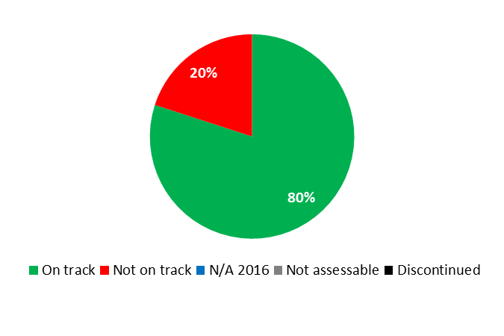

|  |  |  |  |  |
| --- | --- | --- | --- | --- |
| **Expected Result:** III.3 Mainstreaming of the DA recommendations in the work of WIPO | | | | |
| **Performance Indicators** | **Baselines** | **Targets** | **Performance Data** | **TLS** |
| Development principles included in the DA recommendations effectively integrated in the work of WIPO programs | *Updated Baseline end 2015:*  23 Programs contained in the Program and Budget 2014/15 reflected the mainstreaming of DA activities.  *Original Baseline P&B 2016/17:*  n/a (new PI) | Enhanced mainstreaming of principles included in the 45 DA recommendations into WIPO's programs | - 12 Programs were involved in implementing CDIP approved activities;  - 23 Programs reflected mainstreaming of DA in their work | **On track** |
| Effective follow up to the implementation of the recommendations of the Independent Review of the DA | *Updated Baseline end 2015:*  At the end of 2015, the Independent Review of the DA was still ongoing.  *Original Baseline P&B 2016/17:*  n/a (new PI) | WIPO has in place an effective system to monitor the implementation of the recommendations emanating from the review | The 18th session of the CDIP discussed and noted the Independent Review of the DA[46] and requested the Secretariat to prepare a document containing its response to recommendations addressed to it, including inputs provided by Member States | **On track** |
| Improved mechanism for the development, implementation, monitoring, evaluation of and reporting on, new DA projects and activities | *Updated Baseline end 2015:*  All relevant Programs had in place an effective planning, monitoring and evaluation system on the implementation of DA recommendations.  *Original Baseline P&B 2016/17:*  n/a (new PI) | New mechanism that takes into account recommendations emanating from the evaluations of DA Projects discussed during the 12th, 13th, 14th and 15th sessions of the CDIP | All relevant Programs had in place a new planning, monitoring and evaluation system on the implementation of DA recommendations that take into account recommendations emanating from the evaluations of DA Projects discussed until the 18th session of the CDIP | **On track** |
| **Expected Result:** III.5 Enhanced understanding of the DA by Member States, IGOs, civil society and other stakeholders | | | | |
| **Performance Indicators** | **Baselines** | **Targets** | **Performance Data** | **TLS** |
| Technical assistance activities undertaken by WIPO reflect the Development Agenda dimension and outcomes of DA projects. | *Updated Baseline end 2015:*  No system in place  *Original Baseline P&B 2016/17:*  n/a (new PI) | System developed to ensure that all technical assistance activities undertaken are in compliance with the DA principles | No system in place | **Not on track** |
| % of satisfied participants in events on the WIPO Development Agenda targeting Member States, Civil Society, IGOs and stakeholders | *Updated Baseline end 2015:*  78.57%  *Original Baseline P&B 2016/17:*  n/a in 2014 (per PPR 2014) | 80% | 86.6% | **On track** |

|  |
| --- |
| **Resource Utilization for Program 8** |

Budget and Actual Expenditure (by result)

*(thousands of Swiss francs)*

|  |  |  |  |  |
| --- | --- | --- | --- | --- |
| **Expected Result No. and Description** | | **2016/17 Approved Budget** | **2016/17 Budget after Transfers** | **2016 Expenditure\*** |
| III.3 | Mainstreaming of the DA recommendations in the work of WIPO | 2,278 | 2,363 | 1,008 |
| III.5 | Enhanced understanding of the DA by Member States, IGOs, civil society and other stakeholders | 1,393 | 1,224 | 636 |
|  | **Total** | 3,671 | 3,587 | 1,645 |
| *\*2016 Expenditure numbers are preliminary, subject to audit by External auditors* | | | |  |

Budget and Actual Expenditure (personnel and non-personnel)

*(thousands of Swiss francs)*

|  |  |  |  |  |
| --- | --- | --- | --- | --- |
|  | **2016/17 Approved Budget** | **2016/17 Budget after Transfers** | **2016 Expenditure\*** | **Utilization rate (%)** |
| Personnel Resources | 2,462 | 2,401 | 992 | 41% |
| Non-personnel Resources | 1,209 | 1,186 | 652 | 55% |
| **Total** | **3,671** | **3,587** | **1,645** | **46%** |
| *\*2016 Expenditure numbers are preliminary, subject to audit by External auditors* | | | | |

*NOTE: The 2016/17 Budget after Transfers reflects transfers as of March 8, 2017 to address needs during the 2016/17 biennium in line with Financial Regulation 5.5.*

A. 2016/17 Budget after Transfers

1. The slight decrease in personnel resources compared to the 2016/17 Approved Budget was due to the transfer of resources (non-personnel) to Web Communications for the migration of the Database on Flexibilities in the IP System. The slight decrease in non-personnel resources was due to the transfer of resources for interns to HRMD (Program 23), which centrally manages interns. The slight increase in resources under Expected Result III.3 (Mainstreaming of the DA recommendations) reflected internal reshuffling of resources for CDIP-related events and activities.

B. 2016/17 Budget Utilization

1. Personnel expenditure for the Program was slightly below its target due to the backfilling of two vacant posts. Non-personnel expenditure was within the expected range of 40-60 per cent for the first year of the biennium.

### PROGRAM 9 AFRICA, ARAB, ASIA AND THE PACIFIC, LATIN AMERICA AND THE CARIBBEAN COUNTRIES, LEAST DEVELOPED COUNTRIES

**Program Manager Mr. M. Matus**

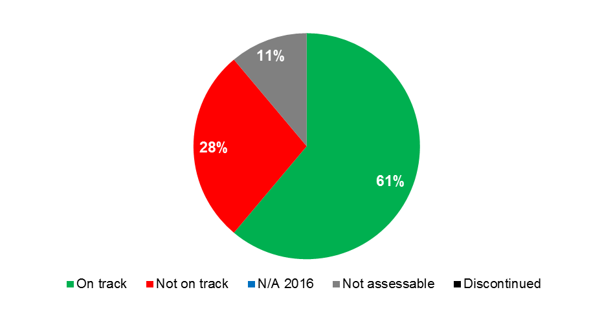



|  |  |  |  |  |  |  |  |  |  |
| --- | --- | --- | --- | --- | --- | --- | --- | --- | --- |
| **Expected Result:** I.2 Tailored and balanced IP legislative, regulatory and policy frameworks | | | | | | | | | |
| **Performance Indicators** | **Baselines** | | **Targets** | | | **Performance Data** | | **TLS** | |
| No. and/or % of countries providing positive feedback on WIPO’s legislative and policy advice | *Updated Baseline end 2015:*  In 2014/15:   * 7 respondents reported a 94% satisfaction rate with the advice offered (Africa-3; Arab-1; Asia and the Pacific-2; Latin America and the Caribbean-1) (Program 1) * 10 respondents from 8 countries reported 100% satisfaction with the advice offered (Africa-1; Asia and the Pacific-7; Latin America and the Caribbean-2 ) (Program 2) * 13 respondents reported 100% satisfaction with the advice offered (Africa-3; Arab-3; Asia and the Pacific-4; Latin America and the Caribbean-3 ) (Program 3)   *Original Baseline  P&B 2016/17:*  Regional breakdowns to be determined in cooperation with Programs 1, 2, 3 and 4 | | *Updated Target:*  90%  *Original Target  P&B 2016/17:*   * Africa (90%) * Arab (90%) * Asia and the Pacific (90%) * Latin America and the Caribbean (90%) | | | - 7 respondents reported a 100% satisfaction rate with the advice offered (Africa-1; Arab-1; Asia and the Pacific-2; Latin America and the Caribbean-3) (Program 1)  - 2 respondents reported 100% satisfaction with the advice offered (Africa-1; Latin America and the Caribbean-1) (Program 2)  - 13 respondents reported 100% satisfaction with the advice offered (Africa-2; Asia and the Pacific-7; Latin America and the Caribbean-4) (Program 3) | | **On track** | |
| **Expected Result: Expected Result:** II.1 Wider and more effective use of the PCT System for filing international patent applications | | | | | | | | | |
| **Performance Indicators** | **Baselines** | | | **Targets** | | | **Performance Data** | | **TLS** |
| No. of PCT applications originating from developing countries and LDCs | *Updated Baseline end 2015:*  49,524 (2015)   * Africa (374) * Arab (507) * Asia and the Pacific (47,284) * Latin America and the Caribbean (1,359) | | | * Africa (maintain) * Arab (2% annual) * Asia and the Pacific (2.5% annual) * Latin America and the Caribbean (1.5% annual) | | | 63,957 applications   * Africa (327) * Arab (517) * Asia and the Pacific (61,629) * Latin America and the Caribbean (1,484) | | **Not on track**  **On track**  **On track**  **On track** |
|  | *Original Baseline  P&B 2016/17:*  43,972 (2014)   * Africa (352) * Arab (616) * Asia and the Pacific (41,569)   Latin America and the Caribbean (1,412) | | |  | | |  | |  |
| **Expected Result: Expected Result:** II.4 Wider and more effective use of the Hague System, including by developing countries and LDCs | | | | | | | | | |
| **Performance Indicators** | **Baselines** | | | **Targets** | | | **Performance Data** | | **TLS** |
| No. of Hague applications originating from developing countries and LDCs | *Updated Baseline end 2015:*  604 (2015)   * Africa (4) * Arab (8)   Asia and the Pacific (590)  *Original Baseline  P&B 2016/17:*  105 (2014)   * Africa (5) * Arab (6) * Asia and the Pacific (94) | | | * Africa (maintain) * Arab (maintain) * Asia and the Pacific (10% annual) | | | 1,362 applications   * Africa (5) * Arab (6) * Asia and the Pacific (1,351) | | **On track**  **Not on track**  **On track** |
| **Expected Result: Expected Result:** II.6 Wider and more effective use of the Madrid System, including by developing countries and LDCs | | | | | | | | | |
| **Performance Indicators** | **Baselines** | | | **Targets** | | | **Performance Data** | | **TLS** |
| No. of Madrid System applications originating from developing countries and LDCs | *Updated Baseline end 2015:*  4,130 (2015)   * Africa (52) * Arab (191) * Asia and the Pacific (3,668)   Latin America and the Caribbean (219)  *Original Baseline  P&B 2016/17:*  3,629 (2014)   * Africa (18) * Arab (122) * Asia and the Pacific (3,338) * Latin America and the Caribbean (151) | | | * Africa (maintain) * Arab (maintain) * Asia and the Pacific (5% annual) * Latin America and the Caribbean (10% annual) | | | 5,479 applications   * Africa (38) * Arab (178) * Asia and the Pacific (5,075) * Latin America and the Caribbean (188) | | **Not on track**  **Not on track**  **On track**  **Not on track** |
| **Expected Result: Expected Result:** II.10 Wider and more effective use of the Lisbon System, including by developing countries and LDCs | | | | | | | | | |
| No. of international registrations from developing countries and LDCs in force under the Lisbon System (in relation to the total no.) | *Updated Baseline end 2015:*  95 out of 931:   * Arab (14) Asia and the Pacific (38) Latin America and the Caribbean (43)   *Original Baseline  P&B 2016/17:*  78 out of 896:   * Arab (14) * Asia and the Pacific (22) * Latin America and the Caribbean (42)   (March 2015) | | | *Updated Target:*  100 (out of 971 )  *Original Target P&B 2016/17:*  90 (out of 950) | | | 95 (out of 1,020):   * Arab (14) * Asia and the Pacific (38) * Latin America and the Caribbean (43) | | **Not on track** |
| **Expected Result: Expected Result:** III.1 National innovation and IP strategies and plans consistent with national development objectives | | | | | | | | | |
| **Performance Indicators** | **Baselines** | | | **Targets** | | | **Performance Data** | | **TLS** |
| No. of countries which are in the process of formulating national IP strategies | *Updated Baseline end 2015:*  Africa: 8  Arab: 2  Asia and the Pacific: 10  Latin America and the Caribbean: 7  *Original Baseline  P&B 2016/17:*   * Africa (24 cumulative) * Arab (4 in 2014) * Asia and Pacific (14 cumulative) * Latin America and Caribbean (12 cumulative) | | | * Africa (additional 3) * Arab (additional 4) * Asia and the Pacific (additional 4) * Latin America and the Caribbean (additional 5) | | | Africa (3 additional): Guinea, Guinea Bissau, Namibia  Arab (2 additional): Djibouti, Jordan  Asia and the Pacific (2 additional): Indonesia, Lao People's Democratic Republic    Latin America and the Caribbean (4 additional): Belize, Dominica, Jamaica, Paraguay | | **On track**  **On track**  **On track**  **On track** |
| No. of countries which have adopted national innovation and IP strategies | *Updated Baseline end 2015:*  Africa (21 cumulative)  Arab (2 cumulative)  Asia and the Pacific (7 cumulative)[47]  Latin America and the Caribbean (7 cumulative)  *Original Baseline  P&B 2016/17:*   * Africa (21 cumulative) * Arab (2 cumulative) * Asia and Pacific (8 cumulative) * Latin America and the Caribbean (6 cumulative) | | | * Africa (additional 8) * Arab (additional 2) * Asia and the Pacific (additional 7) * Latin America and the Caribbean (additional 2) | | | Africa (4 additional): the Gambia, Guinea, Namibia, Sierra Leone  (25 cumulative)  Arab (no additional)  (2 cumulative)    Asia and the Pacific (no additional)  (7 cumulative)  Latin America and the Caribbean (1 additional): Chile  (8 cumulative)  20 LDCs included in the above regional breakdown | | **On track**  **Not on track**  **Not on track**  **On track** |
| No. of countries which are in the process of implementing national innovation and IP strategies and IP development plans | *Updated Baseline end 2015:*  Africa: 21 (cumulative)  Arab 2 (cumulative)  Asia and Pacific: 5 (cumulative)  Latin America and the Caribbean: 5 (cumulative)  *Original Baseline  P&B 2016/17:*   * Africa (21 cumulative) * Arab (2 cumulative) * Asia and Pacific (4 cumulative) * Latin America and the Caribbean (6 cumulative) | | | * Africa (additional 8) * Arab (additional 2) * Asia and the Pacific (additional 7) * Latin America and the Caribbean (additional 2) | | | Africa (6 additional):  Benin, Congo, Madagascar, Malawi, Swaziland, Zimbabwe  (27 cumulative)  Arab (no additional)  (2 cumulative)  Asia and the Pacific (4 additional: Brunei Darussalam, Cambodia, Fiji, Mongolia)  (9 cumulative)  Latin America and the Caribbean (Saint Kitts and Nevis)  (6 cumulative)  20 LDCs included in the above regional breakdown | | **On track**  **Not on track**  **On track**  **On track** |
| **Expected Result: Expected Result:** III.2 Enhanced human resource capacities able to deal with the broad range of requirements for the effective use of IP for development in developing countries, LDCs and countries with economies in transition | | | | | | | | | |
| **Performance Indicators** | **Baselines** | | | **Targets** | | | **Performance Data** | | **TLS** |
| % of participants in WIPO events who express satisfaction with the content and organization of these events | *Updated Baseline end 2015:*  Africa (75%)  Arab (90%)  Asia and the Pacific (95%)  Latin America and the Caribbean (80%)  LDCs (85%)  *Original Baseline  P&B 2016/17:*   * Africa (70%) * Arab   (not available in 2014; system to be implemented in 2015)   * Asia and Pacific (92%) Latin America and the Caribbean   (not available in 2014; system to be implemented in 2015)   * LDCs (90%) | | | *Updated Target:*   * Africa (75%) * Arab (90%) * Asia and Pacific (95%) * Latin America and the Caribbean (85%) * LDCs (85%)   *Original Target  P&B 2016/17:*   * Africa (70%) * Arab (70%) * Asia and Pacific (70%) * Latin America and the Caribbean (85%) * LDCs (70%) | | | Africa (data only partially available)  Arab (data only partially available)  Asia and the Pacific (99%)  Latin America and the Caribbean (data only partially available)  LDCs (95%) | | **Not assessable**  **Not assessable**  **On track**  **Not assessable**  **On track** |
| % of participants in WIPO workshops who apply the skills learned in their work/enterprise | *Updated Baseline end 2015:*  Africa (70%)  Arab: Not available**[48]**  Asia and the Pacific: (91%)  Latin America and the Caribbean (90%)  LDCs (90%)  *Original Baseline  P&B 2016/17:*   * Africa (70%) * Arab (not available in 2014; system to be implemented in 2015) * Asia and Pacific (89%) Latin America and the Caribbean   (not available in 2014; system to be implemented in 2015)   * LDCs (95%) | | | *Updated Target:*   * Africa (70%) * Arab (50%) * Asia and Pacific (91%) * Latin America and the Caribbean (90%) * LDCs (90%)   *Original Target  P&B 2016/17:*   * Africa (70%) * Arab (50%) * Asia and Pacific (70%) * Latin America and the Caribbean (45%) * LDCs (50%) | | | Africa (data only partially available)  Arab (data only partially available)  Asia and the Pacific (96%)  Latin American and the Caribbean (data only partially available)  LDCs (85%) | | **Not assessable**  **Not assessable**  **On track**  **Not assessable**  **Not on track** |
| % of national and regional IP experts used as resource persons in WIPO events | *Updated Baseline end 2015:*  Africa (75%)  Arab (55%)  Asia and the Pacific (66%)  Latin America and the Caribbean (80%)  LDCs (85%)  *Original Baseline  P&B 2016/17:*   * Africa (80%) * Arab (35%) * Asia and Pacific (71%) * Latin America & the Caribbean (80%) * LDCs (95%) | | | *Updated Target:*   * Africa (85%) * Arab (55%) * Asia and Pacific (66%) * Latin America and the Caribbean (80%) * LDCs (85%)   *Original Target  P&B 2016/17:*   * Africa (85%) * Arab (55%) * Asia and Pacific (40%) * Latin America & the Caribbean (80%) * LDCs (70%) | | | Africa (85%)  Arab (55%)  Asia and the Pacific (29%)  Latin American and the Caribbean (85%)  LDCs (75%) | | **On track**  **On track**  **Not on track**  **On track**  **Not on track** |
| **Expected Result: Expected Result:** III.4 Strengthened cooperation mechanisms and programs tailored to the needs of developing countries, LDCs and countries with economies in transition | | | | | | | | | |
| **Performance Indicators** | **Baselines** | **Targets** | | | **Performance Data** | | | | **TLS** |
| No. of national, sub- regional and regional/ interregional cooperation agreements, projects, programs, and partnerships to promote the effective use of the IP systems through sharing of best practices. | *Updated Baseline end 2015:*  Africa (2)  Arab (1)  Asia and the Pacific (1)  Latin America and the Caribbean: (9) ongoing projects  *Original Baseline  P&B 2016/17:*   * Africa (1 in 2014) * Arab (1 in 2014) * Asia and Pacific (2 in 2014) * Latin America & the Caribbean (6 in 2014) * LDCs: 1 regional/sub regional program, 4 national programs (2014) | * Africa (additional 2) * Arab (additional 2) * Asia and the Pacific (additional 1) * Latin America & the Caribbean (additional 4)   LDCs:   * 3 regional /sub-regional programs, * 8 national programs | | | Africa: Progress on the establishment of 2 new MoUs expected to be finalized in 2017:   * New Partnership for Africa's Development (NEPAD) * Economic Community of West African States (ECOWAS)   (2 cumulative)  Arab: 3 new MoUs   * Central Organization for Standardization and Quality Control (COSCQ) * Moroccan Office of Industrial and Commercial Property (OMPIC) * Public Authorities for Craft Industries (PACI)   (4 cumulative)  Asia and the Pacific (10)   * Initiation of a pilot project on the Development of Country Plans (Thailand) * Initiation of 3 projects on IP Office Diagnostics (Philippines, Sri Lanka, Thailand) * Initiation of 4 projects on Enabling IP Environment (Technology Transfer) (Malaysia, Philippines, Sri Lanka, Thailand) * 2 Heads of Intellectual Property Office Conferences (HIPOCs) (1 for ASEAN and SAARC countries; 1 for Pacific Island Countries (PICs))   (11 cumulative)  Latin America and the Caribbean: 2 new projects initiated   * Development of a global database (WIPO-JURIS) on leading judicial decisions on IP (pilot project in Latin American countries) * Development of a manual on Trademark Procedures and Examination (Caribbean Community)   7 ongoing projects[49]  (11 projects cumulative)  LDCs: 8 programs   * 4 joint WIPO-Sida (Swedish International Development Cooperation Agency) training and advisory programs for LDCs * 1 joint WIPO-UNESCO program for LDCs * 2 national programs (Technological Capacity Building for the Honey Sector (Zambia); National Consultation on Building IP Capacity in Institutions (Nepal) * 1 joint WIPO-UN ESCAP program for LDCs in Asia and the Pacific | | | | **On track**  **On track**  **On track**  **On track**  **On track** |
| **Expected Result: Expected Result:** IV.2 Enhanced access to, and use of, IP information by IP institutions and the public to promote innovation and creativity | | | | | | | | | |
| **Performance Indicators** | **Baselines** | | | **Targets** | | | **Performance Data** | | **TLS** |
| No. of sustainable[50] national TISC networks (numbers cumulative) | *Updated Baseline end 2015:*  23 sustainable national networks out of 50 formally established  Maturity Level 1:  Africa (8 of which 6 LDCs)  Arab (1)  Asia and the Pacific (3)  Latin America and the Caribbean (5)  (17 Total)  Maturity Level 2:  Africa (2 of which 1 LDC)  Arab (0)  Asia and the Pacific (0)  Latin America and the Caribbean (2)  (4 Total)  Maturity Level 3, including the provision of value-added services[51]:  Africa (0)  Arab (1)  Asia and the Pacific (1)  Latin America and the Caribbean (0)  (2 Total)  *Original Baseline  P&B 2016/17:*   * Africa (9) * Arab (2) * Asia and the Pacific (3) * Latin America and the Caribbean (5) | | | * Africa (11) * Arab (4) * Asia and Pacific (5) * Latin America and the Caribbean (8) | | | 27 sustainable national networks (cumulative as at end 2016)  Maturity Level 1:  Africa (3 of which 1 LDC )  Asia and the Pacific (2)  Latin America and the Caribbean (2)  (7 Total)  Maturity Level 2:  Africa (8 of which 6 LDCs)  Arab (1)  Asia and the Pacific (2)  Latin America and the Caribbean (4)  (15 Total)  Maturity Level 3, including the provision of value-added services[52]:  Africa (1)  Arab (1)  Asia and the Pacific (1)  Latin America and the Caribbean (2)  (5 Total) | | **On track** |
| No. of organizations, communities, individuals that applied and used the Appropriate Technology as a solution to identified development challenges in LDCs | *Updated Baseline end 2015:*  6 Organizations in LDCs  *Original Baseline  P&B 2016/17:*  Organizations in 6 LDCs (2014) | | | Organizations in 3 additional LDCs | | | 4 organizations working on Appropriate Technology in 3 LDCs  Ethiopia (1):  Ministry of Science and Technology  Rwanda (1):  National Industrial Research and Development Agency (NIRDA)  United Republic of Tanzania (2):  - Tanzania Commission for Science and Technology (COSTECH);  - University of Zanzibar  (10 organizations in 6 LDCs cumulative) | | **On track** |
| Use of Appropriate Technology for development through patent searches and reports, technology landscapes, business plans (Number of experts, National Expert Groups (NEGs) in LDCs) | 6 in LDCs | | | Additional 3 in LDCs | | | 9 additional experts/NEGs:   * 3 National Experts appointed (Ethiopia, Rwanda, United Republic of Tanzania); * 3 International Experts appointed (Ethiopia, Rwanda, United Republic of Tanzania) * 3 NEGs established (Ethiopia, Rwanda, United Republic of Tanzania)   (6 NEGs in 6 LDCs cumulative) | | **On track** |
| Identified Appropriate Technology commercialized in LDCs | *Updated Baseline end 2015:*  6 ATs were being considered for commercialization at the government level  *Original Baseline P&B 2016/17:*  6 ATs | | | At least 3 additional ATs | | | 3 ATs commercialized   * Nepal (1) * Zambia (2)   3 ATs were under consideration for commercialization at the government level | | **On track** |
| Projects replicated in other areas in LDCs | n/a | | | 1 LDC | | | None | | **Not on track** |
| Institutions established to continue working on Appropriate Technology in LDCs | Updated baseline end 2015:   * 3 NEGS in 3 LDCs * 3 Multi-stakeholder groups in 3 LDCS   *Original Baseline P&B 2016/17:*  3 institutions | | | Additional 3 Institutions | | | 3 NEGs established (Ethiopia, Rwanda, United Republic of Tanzania)  (6 NEGS in 6 LDCs cumulative) | | **On track** |
| Continuation and expansion of national technological capacity building programs on Appropriate Technology in LDCs | 7 programs | | | Additional 6 programs | | | 4 national technological capacity building programs on Appropriate Technology were carried out in the 3 LDCs:  Ethiopia (1)  Rwanda (1)  United Republic of Tanzania (2)  (11 cumulative) | | **On track** |
| Utilization of Appropriate Technology for economic development included in the national innovation and IP policies and strategies in LDCs | n/a | | | 1 LDC | | | None | | **Not on track** |
| **Expected Result: Expected Result:** IV.4 Enhanced technical and knowledge infrastructure for IP Offices and other IP institutions leading to better services (cheaper, faster, higher quality) to their stakeholders and better outcome of IP Administration | | | | | | | | | |
| **Performance Indicators** | **Baselines** | | | **Targets** | | | **Performance Data** | | **TLS** |
| Average Service Level of IP Offices assisted (ranging from 1 to 5) | *Updated Baseline end 2015:*  Overall average: 2.9   * Africa: 2.9 * Arab: 2.8 * Asia and the Pacific: 2.7 * Latin America and the Caribbean: 3   *Original Baseline  P&B 2016/17:*  Average service level as per the 2014 PPR: 2.9 | | | Average of 3.0 (by end of 2017) | | | Overall average: 2.8   * Africa: 3.0 * Arab: 2.9 * Asia and the Pacific: 3.4 * Latin America and the Caribbean: 3.2 | | **Not on track** |

|  |
| --- |
| **Resource Utilization for Program 9** |

Budget and Actual Expenditure (by result)

*(thousands of Swiss francs)*

|  |  |  |  |  |
| --- | --- | --- | --- | --- |
| **Expected Result No. and Description** | | **2016/17 Approved Budget** | **2016/17 Budget after Transfers** | **2016 Expenditure\*** |
| I.2 | Tailored and balanced IP legislative, regulatory and policy frameworks | 792 | 604 | 265 |
| III.1 | National innovation and IP strategies and plans consistent with national development objectives | 8,440 | 8,992 | 4,065 |
| III.2 | Enhanced human resource capacities able to deal with the broad range of requirements for the effective use of IP for development in developing countries, LDCs and countries with economies in transition | 11,174 | 9,855 | 4,574 |
| III.3 | Mainstreaming of the DA recommendations in the work of WIPO | 214 | 201 | 96 |
| III.4 | Strengthened cooperation mechanisms and programs tailored to the needs of developing countries and LDCs | 5,383 | 6,347 | 3,063 |
| IV.2 | Enhanced access to, and use of, IP information by IP institutions and the public to promote innovation and creativity | 4,564 | 3,844 | 1,816 |
| IV.4 | Enhanced technical and knowledge infrastructure for IP Offices and other IP institutions leading to better services (cheaper, faster, higher quality) to their stakeholders and better outcome of IP Administration | 1,339 | 1,120 | 281 |
|  | **Total** | 31,907 | 30,962 | 14,160 |
| *\*2016 Expenditure numbers are preliminary, subject to audit by External auditors* | | | |  |

Budget and Actual Expenditure (personnel and non-personnel)

*(thousands of Swiss francs)*

|  |  |  |  |  |
| --- | --- | --- | --- | --- |
|  | **2016/17 Approved Budget** | **2016/17 Budget after Transfers** | **2016 Expenditure\*** | **Utilization rate (%)** |
| Personnel Resources | 22,993 | 22,088 | 10,968 | 50% |
| Non-personnel Resources | 8,913 | 8,874 | 3,192 | 36% |
| **Total** | **31,907** | **30,962** | **14,160** | **46%** |
| *\*2016 Expenditure numbers are preliminary, subject to audit by External auditors* | | | | |

*NOTE: The 2016/17 Budget after Transfers reflects transfers as of March 8, 2017 to address needs during the 2016/17 biennium in line with Financial Regulation 5.5.*

A. 2016/17 Budget after Transfers

1. The slight decrease in non-personnel resources was due to the transfer of resources from the Program to HRMD (Program 23) for the participation of two staff members in training courses. Changes across Expected Results reflected the re-allocation of both personnel and non-personnel resources in line with the 2016 workplans.

B. 2016/17 Budget Utilization

1. Personnel resource utilization was on target. Non-personnel expenditure was below target due to the postponement and/or cancellation of several activities in the African and Arab regions, including in LDCs. In addition, the DA project on IP and Tourism had a lower than anticipated utilization rate due to the postponement of some activities to 2017.

### PROGRAM 10 TRANSITION AND DEVELOPED COUNTRIES

**Program Manager Director General**

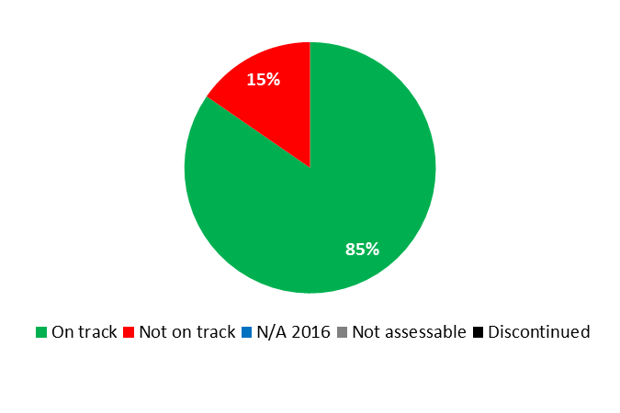

|  |  |  |  |  |
| --- | --- | --- | --- | --- |
| **Expected Result:**  I.2 Tailored and balanced IP legislative, regulatory and policy frameworks | | | | |
| **Performance Indicators** | **Baselines** | **Targets** | **Performance Data** | **TLS** |
| No. of transition countries with updated national laws and regulations | *Updated Baseline*  *end 2015:*  9 (Kazakhstan, Kyrgyzstan, Latvia, Lithuania, Montenegro, Republic of Moldova, Russian Federation, Tajikistan, Turkmenistan)  *Original Baseline*  *P&B 2016/17:*  6 countries (2014) | 6 additional countries | 6 countries (Albania, Kazakhstan, Latvia, Montenegro, Republic of Moldova and Russian Federation) | **On track** |
| No of ratifications to WIPO administered treaties | *Updated Baseline*  *end 2015:*  10  *Original Baseline*  *P&B 2016/17:*  n/a | *Updated Target:*  12 additional countries  *Original Target P&B 2016/17:*  4 additional countries | 7 ratifications (Australia, Belarus, Canada, Finland, Israel, Japan and Turkmenistan) | **On track** |
| **Expected Result:**  II.1 Wider and more effective use of the PCT System for filing international patent applications | | | | |
| **Performance Indicators** | **Baselines** | **Targets** | **Performance Data** | **TLS** |
| No. of PCT applications originating from transition and developed countries. | *Updated Baseline*  *end 2015:*  170,177 (2014) (+2.15%)  168,207 (2015) (-1.17%)  +3.5% (biennium)  *Original Baseline*  *P&B 2016/17:*  170,317 (2014) | 1.5% increase (annual) | 168,832  +0.4% | **Not on track** |
| % of survey respondents showing increased use of WIPO services within 6 months of attending Roving Seminars on WIPO Services and Initiatives | *Updated Baseline*  *end 2015:*  35%  *Original Baseline*  *P&B 2016/17:*  18% | *Updated Target:*  25% of survey respondents showing increased use of WIPO services  *Original Target  P&B 2016/17:*  20% of survey respondents showing increased use of WIPO services | 20% of respondents reported increased use of WIPO services | **On track** |
| **Expected Result:**  II.4 Wider and more effective use of the Hague System, including by developing countries and LDCs | | | | |
| **Performance Indicators** | **Baselines** | **Targets** | **Performance Data** | **TLS** |
| No. of Hague applications originating from transition and developed countries | *Updated Baseline*  *end 2015:*  3,448 (2015) +24%  *Original Baseline*  *P&B 2016/17:*  2,776 (2014) | *Updated Target:*  10% increase (annual)  *Original Target  P&B 2016/17:*  1.5% increase (annual) | 4,132  +19.8% | **On track** |
| **Expected Result:**  II.6 Wider and more effective use of the Madrid System, including by developing countries and LDCs | | | | |
| **Performance Indicators** | **Baselines** | **Targets** | **Performance Data** | **TLS** |
| No. of Madrid System applications originating from transition and developed countries | *Updated Baseline end 2015:*  44,570 (2015) +1.8%  43,748 (2014)  *Original Baseline P&B 2016/17:*  43,748 (2014 estimate) | 2% increase (annual) | 47,094  +5.7% | **On track** |
| **Expected Result:** II.8 International and domestic intellectual property disputes are increasingly prevented or resolved through WIPO mediation, arbitration and other alternative dispute resolution methods | | | | |
| **Performance Indicators** | **Baselines** | **Targets** | **Performance Data** | **TLS** |
| No. of IP disputes originating from transition and developed countries prevented/resolved by WIPO mediation, arbitration and other alternative dispute resolution methods | *Updated Baseline*  *end 2015:*  412 disputes and 160 bons offices involving parties from transition and developed countries (cumulative per end 2015)[53]  *Original Baseline*  *P&B 2016/17:*  18 additional disputes and 25 additional bons offices involving parties from transition and developed countries (2014)  377 disputes and 76 bons offices (cumulative) | 33 additional disputes and bons offices involving parties from transition and developed countries | 57 additional disputes and 46 additional bons offices involving parties from transition and developed countries  469 disputes and 206 bons offices involving parties from transition and developed countries (cumulative) | **On track** |
| **Expected Result:**  II.10 Wider and more effective use of the Lisbon System, including by developing countries and LDCs | | | | |
| **Performance Indicators** | **Baselines** | **Targets** | **Performance Data** | **TLS** |
| No. of Lisbon System international registrations for transition and developed countries in force | *Updated Baseline*  *end 2015:*  836 out of 931 registrations in force from transition and developed countries at the end of 2014/15  (+11.6% over 2012/13)  *Original Baseline*  *P&B 2016/17:*  818 out of 896 registrations in force (2014) | 2% increase (biennial) | 861 out of 956 registrations in force from transition and developed countries (+10.6% over 2015) | **On track** |
| **Expected Result:**  III.1 National innovation and IP strategies and plans consistent with national development objectives | | | | |
| **Performance Indicators** | **Baselines** | **Targets** | **Performance Data** | **TLS** |
| No. of countries which are in the process of formulating national IP strategies | *Updated Baseline*  *end 2015:*  4 countries: Albania, Georgia, Latvia and Poland  *Original Baseline*  *P&B 2016/17:*  4 countries in 2014  (21 cumulative) | 7 additional countries | 3 additional countries in the process of formulating or reformulating their IP strategies: Kyrgyzstan, Slovakia and Ukraine  2 countries (Georgia, Latvia) were finalizing their IP strategies at the end of 2016 | **On track** |
| No. of countries having developed national IP strategies or IP plans, dovetailed with national development goals | *Updated Baseline*  *end 2015:*  6 countries developed IP strategies in 2014/15: Bulgaria, Slovenia, Tajikistan, Turkey, Turkmenistan and Ukraine  (20 cumulative)  *Original Baseline*  *P&B 2016/17:*  3 countries in 2014  (17 cumulative) | 7 additional countries | 1 additional country developed an IP strategy: Albania  21 countries (cumulative) | **Not on track** |
| **Expected Result:** III.2 Enhanced human resource capacities able to deal with the broad range of requirements for the effective use of IP for development in developing countries, LDCs and countries with economies in transition | | | | |
| **Performance Indicators** | **Baselines** | **Targets** | **Performance Data** | **TLS** |
| No. of countries in transition having established annual IP training programs and/or courses for IP Professionals | *Updated Baseline*  *end 2015:*  *9 (Bulgaria, Croatia, Czech Republic, Georgia, Kazakhstan, Poland, Romania, Slovakia, Turkey)*  *Original Baseline*  *P&B 2016/17:*  6 countries (2014) | 8 countries | 4 additional countries established annual IP training programs/courses: Azerbaijan, Latvia, Republic of Moldova and Russian Federation  2 baseline countries established additional IP training programs/courses: Georgia, Poland  15 programs/courses in 13 countries (cumulative) | **On track** |
| % of trained IP professionals and IP Officials using upgraded skills in their work. | *Updated Baseline*  *end 2015:*  82.7%  *Original Baseline*  *P&B 2016/17:*  80% | *Updated Target:*  80%  *Original Target P&B 2016/17:*  70% | 83% | **On track** |
| **Expected Result:** III.4 Strengthened cooperation mechanisms and programs tailored to the needs of developing countries, LDCs and countries with economies in transition | | | | |
| **Performance Indicators** | **Baselines** | **Targets** | **Performance Data** | **TLS** |
| No. of established partnerships | *Updated Baseline*  *end 2015:*   * 5 new MoUs (Denmark, France, Germany, Israel, Spain) * 1 collaboration (USPTO-WIPO) on promotion of the IP Development Matchmaking Database   *Original Baseline*  *P&B 2016/17:*  4 MoUs signed (2014) | 6 IP partnerships established | 6 IP partnerships:   * 2 MoUs between l*’Institut National de la Propriété Industrielle* (INPI) (France) and WIPO * 1 MoU between the National Institute of IP of Kazakhstan and the United States Patent and Trademark Office (USPTO) * Agreement between WIPO and the Hellenistic IP Organization (OBI) Concerning the Translation into Greek and Printing of a WIPO Publication (Patents) * 10th WIPO Advanced Intellectual Property Research Forum (Israel) * 2016 Ono Academic College (ONO) (Israel)/ WIPO Seminar | **On track** |

|  |
| --- |
| **Resource Utilization for Program 10** |

Budget and Actual Expenditure (by result)

*(thousands of Swiss francs)*

|  |  |  |  |  |
| --- | --- | --- | --- | --- |
| **Expected Result No. and Description** | | **2016/17 Approved Budget** | **2016/17 Budget after Transfers** | **2016 Expenditure\*** |
| I.2 | Tailored and balanced IP legislative, regulatory and policy frameworks | 833 | 752 | 339 |
| II.1 | Wider and more effective use of the PCT system for filing international patent applications | 1,170 | 1,295 | 602 |
| II.4 | Wider and more effective use of the Hague system, including by developing countries and LDCs | 550 | 528 | 241 |
| II.6 | Wider and more effective use of the Madrid system, including by developing countries and LDCs | 526 | 555 | 245 |
| II.8 | International and domestic intellectual property disputes are increasingly prevented or resolved through WIPO mediation, arbitration and other alternative dispute resolution methods | 343 | 352 | 152 |
| II.10 | Wider and more effective use of the Lisbon System, including by developing countries and LDCs | 111 | 128 | 66 |
| III.1 | National innovation and IP strategies and plans consistent with national development objectives | 1,497 | 1,791 | 777 |
| III.2 | Enhanced human resource capacities able to deal with the broad range of requirements for the effective use of IP for development in developing countries, LDCs and countries with economies in transition | 1,999 | 2,000 | 871 |
| III.4 | Strengthened cooperation mechanisms and programs tailored to the needs of developing countries and LDCs | 890 | 911 | 397 |
|  | **Total** | 7,919 | 8,313 | 3,690 |
| *\*2016 Expenditure numbers are preliminary, subject to audit by External auditors* | | | |  |

Budget and Actual Expenditure (personnel and non-personnel)

*(thousands of Swiss francs)*

|  |  |  |  |  |
| --- | --- | --- | --- | --- |
|  | **2016/17 Approved Budget** | **2016/17 Budget after Transfers** | **2016 Expenditure\*** | **Utilization rate (%)** |
| Personnel Resources | 6,021 | 6,447 | 2,864 | 44% |
| Non-personnel Resources | 1,898 | 1,866 | 825 | 44% |
| **Total** | **7,919** | **8,313** | **3,690** | **44%** |
| *\*2016 Expenditure numbers are preliminary, subject to audit by External auditors* | | | | |

*NOTE: The 2016/17 Budget after Transfers reflects transfers as of March 8, 2017 to address needs during the 2016/17 biennium in line with Financial Regulation 5.5.*

A. 2016/17 Budget after Transfers

1. The overall increase in the 2016/17 Budget After Transfers as compared to the 2016/17 Approved Budget resulted from an increase in personnel resources due to: (i) the reclassifications of two posts; (ii) the regularization of a continuing function to support the Roving Seminars in developed and transition countries; and (iii) the transfer of an Assistant Program Officer into the Program to strengthen the work in Caucasian, Central Asian and Eastern European countries, mainly reflected under Expected Result III.1 (National innovation and IP strategies). The slight decrease in non-personnel resources resulted from the transfer of resources for interns to HRMD (Program 23), which centrally manages interns.

B. 2016/17 Budget Utilization

1. Budget utilization was within the expected range of 40-60 per cent for the first year of the biennium.

### PROGRAM 11 THE WIPO ACADEMY

**Program Manager Mr. M. Matus**

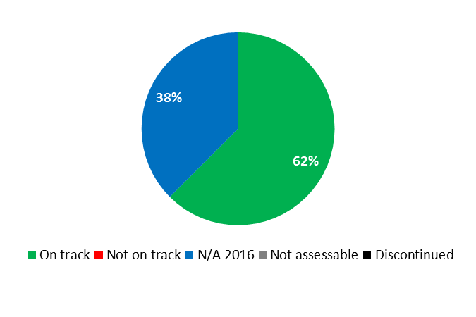

|  |  |  |  |  |
| --- | --- | --- | --- | --- |
| **Expected Result:** III.2 Enhanced human resource capacities able to deal with the broad range of requirements for the effective use of IP for development in developing countries, LDCs and countries with economies in transition | | | | |
| **Performance Indicators** | **Baselines** | **Targets** | **Performance Data** | **TLS** |
| % of trainees and supervisors who are satisfied with the training programs developed based on training needs assessment exercises | No data available | 70% of respondents | Data to be collected in 2017 | **N/A 2016** |
| % of participants using enhanced knowledge and skills in various IP areas | No data available | 60% of respondents | Data to be collected in 2017 | **N/A 2016** |
| No. of cooperation agreements and partnerships established in line with the Academy’s new vision | *Updated Baseline*  *end 2015:*  0  *Original Baseline  P&B 2016/17:*  Not available | 5 | In 2016, 6 cooperation agreements/partnerships involving China (2), France, Malaysia, Morocco, Nicaragua and Turkey were established in line with the Academy’s new vision. | **On track** |
| % of increase in the no. of participants following the Academy’s distance learning (DL) courses | *Updated Baseline end 2015:*  78,551:  2015 (43,616)  2014 (34,935)  *Original Baseline  P&B 2016/17:*  35,000 (2014)[54] | 10% | 25% (54,596) increase as compared to 2015 | **On track** |
| No. of DL courses that have been reviewed and updated | *Updated Baseline*  *end 2015:*  2  *Original Baseline*  *P&B 2016/17:*  0 | 4 | 2 additional courses in 2016:   * DL318: Patent Information Searches * DL320: Basics of Patent Drafting   (4 courses cumulative) | **On track** |
| No. of national start-up academies created under the project which have become sustainable[55] | 0 | 4 | Data to be collected in 2017 | **N/A 2016** |
| New and improved IP courses and curricula in teaching institutions | *Updated Baseline*  *end 2015:*  3 new teaching programs  5 universities enhanced existing IP programs (in 2014/15)  *Original Baseline  P&B 2016/17:*  5 | 20% increase | 3 universities established new teaching programs:   * Ankara University with the Turkish Patent and Trademark Office (Turkey) * Tongji University (China) * University of the West Indies, Mona Campus (Jamaica)   2 universities enhanced existing teaching programs:   * Nicaraguan Council of Science and Technology (CONICYT) and the Martin Luther University (Nicaragua) * University of the West Indies, Cave Hill (Barbados)   (2016) | **On track** |
| Enhanced balance in geographical distribution of summer schools | *Updated Baseline*  *end 2015:* 7 regions:  Africa, Asia, China, Central and Eastern Europe, Western Europe, Latin America, North America  *Original Baseline  P&B 2016/17:* 6 regions | *Updated Target:*  Maintain 7 regions  *Original Target P&B 2016/17:*  7 regions | 7 regions maintained | **On track** |

|  |
| --- |
| **Resource Utilization for Program 11** |

Budget and Actual Expenditure (by result)

*(thousands of Swiss francs)*

|  |  |  |  |  |
| --- | --- | --- | --- | --- |
| **Expected Result No. and Description** | | **2016/17 Approved Budget** | **2016/17 Budget after Transfers** | **2016 Expenditure\*** |
| III.2 | Enhanced human resource capacities able to deal with the broad range of requirements for the effective use of IP for development in developing countries, LDCs and countries with economies in transition | 13,083 | 13,333 | 5,765 |
|  | **Total** | 13,083 | 13,333 | 5,765 |
| *\*2016 Expenditure numbers are preliminary, subject to audit by External auditors* | | | |  |

Budget and Actual Expenditure (personnel and non-personnel)

*(thousands of Swiss francs)*

|  |  |  |  |  |
| --- | --- | --- | --- | --- |
|  | **2016/17 Approved Budget** | **2016/17 Budget after Transfers** | **2016 Expenditure\*** | **Utilization rate (%)** |
| Personnel Resources | 7,779 | 7,939 | 3,639 | 46% |
| Non-personnel Resources | 5,304 | 5,394 | 2,126 | 39% |
| **Total** | **13,083** | **13,333** | **5,765** | **43%** |
| *\*2016 Expenditure numbers are preliminary, subject to audit by External auditors* | | | | |

*NOTE: The 2016/17 Budget after Transfers reflects transfers as of March 8, 2017 to address needs during the 2016/17 biennium in line with Financial Regulation 5.5.*

A. 2016/17 Budget after Transfers

1. The slight increase in non-personnel resources as compared to the 2016/17 Approved Budget was due to the transfer of the responsibility for the management of the Advanced International Certificate Course on IP from Program 30 (SMEs and Entrepreneurship Support) to the WIPO Academy.

B. 2016/17 Budget Utilization

1. Personnel budget utilization was within the expected range of 40-60 per cent for the first year of the biennium. The 39 per cent non-personnel resource utilization rate was mainly due to slower than anticipated implementation of the DA project on Cooperation with Judicial Training Institutes in Developing and Least Developed Countries.

### PROGRAM 30 SMALL AND MEDIUM-SIZED ENTERPRISES (SMES) AND ENTREPRENEURSHIP SUPPORT

**Program Manager DIRECTOR GENERAL**

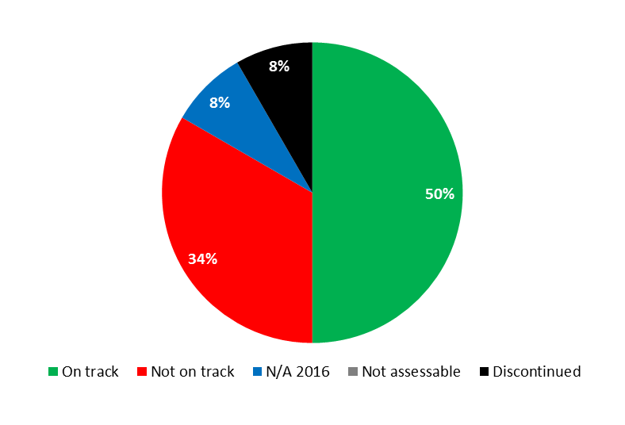



|  |  |  |  |  |
| --- | --- | --- | --- | --- |
| **Expected Result:** III.1 National innovation and IP strategies and plans consistent with national development objectives | | | | |
| **Performance Indicators** | **Baselines** | **Targets** | **Performance Data** | **TLS** |
| No. of national IP strategies that address the promotion of creativity including innovation | *Updated Baseline end 2015:*  Initiated in 6 countries (Cameroon, Jamaica, Rwanda, Serbia, Sri Lanka, Trinidad & Tobago)  *Original Baseline  P&B 2016/17:*  4 initiated (2014) | 5 countries | 1 national IP strategy developed addressing the promotion of creativity including innovation (Albania)  National IP Strategies initiated in 3 additional countries (Georgia, Latvia, Slovakia) | **Not on track** |
| **Expected Result:** III.2 Enhanced human resource capacities able to deal with the broad range of requirements for the effective use of IP for development in developing countries, LDCs and countries with economies in transition | | | | |
| **Performance Indicators** | **Baselines** | **Targets** | **Performance Data** | **TLS** |
| % of trained IP professionals using upgraded skills in their work | *Updated Baseline end 2015:*  77%  *Original Baseline  P&B 2016/17:*  >60% | *Updated Target:*  70%  *Original Target P&B 2016/17:*  50% | 63% | **On track** |
| **Expected Result:** III.6 Increased capacity of SMEs to successfully use IP to support innovation | | | | |
| **Performance Indicators** | **Baselines** | **Targets** | **Performance Data** | **TLS** |
| No. of subscriptions to the SME Newsletter | *Updated Baseline end 2015:*  6,657 (2015)[56]  *Original Baseline  P&B 2016/17:*  40,510 (2014) | 10% | The SME newsletter was discontinued in June 2015, following the issuance of the e‑newsletter platform | **Dis-continued** |
| No. of downloads of topical SME material and guidelines | *Updated Baseline end 2015:*  2015:  - No. of downloads: 71,867  - No. of page views of the SME web page: 960,196  *Original Baseline  P&B 2016/17:*  2014:  No. of downloads: 70,559  No. of page views of the SME web page: 821,150 | 10%  10% | - No. of downloads: 58,733[57]  (-18% as compared to 2015)  - No. of page views of the SME web page: 1,144,629 (+19% as compared to 2015) | **Not on track**  **On track** |
| % of participants in training programs targeting SME support institutions who express satisfaction with the content and organization of these events | *Updated Baseline end 2015:*  100% (46% very satisfied; 54% satisfied)  *Original Baseline  P&B 2016/17:*  100% | 90% | 90% (42% very satisfied; 48% satisfied) | **On track** |
| % of trained SMEs support institutions who provide information and advisory services on IP asset management | *Updated Baseline end 2015:*  100%:  very often (48%); often (32%); sometimes (20%)  *Original Baseline  P&B 2016/17:*  100% | 80% | 100%  Very often (80%); often (20%) | **On track** |
| % of participants in training programs targeting SME support institutions using enhanced knowledge and upgraded skills in their work | n/a | 50% | No data available | **N/A 2016** |
| No. of countries having established or improved IP training programs for SMEs | *Updated Baseline end 2015:*  18 countries/regional organizations (cumulative)  *Original Baseline  P&B 2016/17:*  13 | 10 additional | Institutions in 4 countries (Republic of Iran, Russian Federation, Seychelles, South Africa) indicated having established and/or improved training programs and assistance to SMEs | **On track** |
| No. of countries in which IP policies were developed or adopted for SMEs | n/a | 5 countries | None | **Not on track** |
| **Expected Result:** IV.2 Enhanced access to, and use of, IP information by IP institutions and the public to promote innovation and creativity | | | | |
| **Performance Indicators** | **Baselines** | **Targets** | **Performance Data** | **TLS** |
| No. of Technology Transfer Offices (TTOs) that were established or strengthened in Universities or R&D institutions under the WIPO University Initiative Program | *Updated Baseline end 2015:*  10 in 2014/15: Tunisia (4); Philippines (6)  *Original Baseline  P&B 2016/17:*  tbd | *Updated Target:*  6 additional TTOs (16 cumulative)  *Original Target P&B 2016/17:*  6 TTOs | 1 TTO established at the Ministry of Science of Montenegro  Progress continued to be made towards strengthening 4 TTOs in Tunisia to be operationally independent and sustainable in 2016:   * *Centre Technique de la Chimie* (CTC) * Technopark El Ghazala * Packtec Technical Center for Packaging * Technopark of Sidi Thabet (TST) | **Not on track** |
| No. of universities and/or research institutions having developed and/or improved their IP policies | *Updated Baseline end 2015:*  436 universities:   * Poland (434) * Russian Federation (1) * Uzbekistan (1)   *Original Baseline  P&B 2016/17:*  150 universities in transition countries (2014) | 10 additional universities | 3 universities and/or research institutions developed IP policies:   * Botswana University of Agriculture and Natural Resources (BUAN) (Botswana) * *Instituto Superior de Ciências e Tecnologia de Moçambique* (ISCTEM) (Mozambique) * *Universidade Eduardo Mondlane, Centro de Estudos sobre Direito de Integração Regional da SADC-CEDIR* (Mozambique); and   4 universities/research institutions strengthened IP policies:   * Ilia State University, (Georgia) * *Pavol Jozef Šafárik University* University (Slovakia) * Jagiellonian University (Poland) * Ministry of Science of Montenegro (Montenegro)   (444 universities and/or research institutions cumulative) | **On track** |

|  |
| --- |
| **Resource Utilization for Program 30** |

Budget and Actual Expenditure (by result)

*(thousands of Swiss francs)*

|  |  |  |  |  |
| --- | --- | --- | --- | --- |
| **Expected Result No. and Description** | | **2016/17 Approved Budget** | **2016/17 Budget after Transfers** | **2016 Expenditure\*** |
| III.1 | National innovation and IP strategies and plans consistent with national development objectives | 1,020 | 895 | 402 |
| III.2 | Enhanced human resource capacities able to deal with the broad range of requirements for the effective use of IP for development in developing countries, LDCs and countries with economies in transition | 962 | 746 | 458 |
| III.6 | Increased capacity of SMEs to successfully use IP to support innovation | 3,125 | 3,100 | 1,369 |
| IV.2 | Enhanced access to, and use of, IP information by IP institutions and the public to promote innovation and creativity | 976 | 1,521 | 629 |
|  | **Total** | 6,083 | 6,262 | 2,857 |
| *\*2016 Expenditure numbers are preliminary, subject to audit by External auditors* | | | |  |

Budget and Actual Expenditure (personnel and non-personnel)

*(thousands of Swiss francs)*

|  |  |  |  |  |
| --- | --- | --- | --- | --- |
|  | **2016/17 Approved Budget** | **2016/17 Budget after Transfers** | **2016 Expenditure\*** | **Utilization rate (%)** |
| Personnel Resources | 4,522 | 4,908 | 2,338 | 48% |
| Non-personnel Resources | 1,561 | 1,354 | 520 | 38% |
| **Total** | **6,083** | **6,262** | **2,857** | **46%** |
| *\*2016 Expenditure numbers are preliminary, subject to audit by External auditors* | | | | |

*NOTE: The 2016/17 Budget after Transfers reflects transfers as of March 8, 2017 to address needs during the 2016/17 biennium in line with Financial Regulation 5.5.*

A. 2016/17 Budget after Transfers

1. The net increase in personnel resources compared to the 2016/17 Approved Budget resulted mainly from, on the one hand: (i) the transfer of two positions (one post and one temporary position) into the Program from Copyright and Related Rights (Program 3) and Information Assurance, Safety and Security (Program 28) to strengthen the capacity of the SMEs Division, and (ii) reclassifications within the Program; and, on the other hand, the transfer of a post to the WIPO Academy (Program 11) to support management, strategic planning and coordination.
2. The decrease in non-personnel resources resulted from the transfer of resources from the Program to: (i) The WIPO Academy (Program 11) for the collaboration with institutions in support of advanced international certificate courses; (ii) to IP and Global Challenges (Program 18) to support work on IP and competition policy; and (iii) HRMD (Program 23) to cover for the costs of interns. Part of unspent balances in 2016 was also reallocated to other Organizational priorities.

B. 2016/17 Budget Utilization

1. Personnel budget utilization was within the expected range of 40-60 per cent for the first year of the biennium. Non-personnel expenditure for 2016 was lower than the target due to delays in the implementation of activities on: (i) outreach and capacity building efforts to support innovative enterprises and institutions; (ii) IP Commercialization; and (iii) outreach and capacity building efforts/ advisory services for SMEs.

## STRATEGIC GOAL IV

**COORDINATION AND DEVELOPMENT OF GLOBAL IP INFRASTRUCTURE**

**Mid-term Performance Dashboard (2016)**

The dashboard below provides a summary of the progress towards the achievement of the Results in the 2016 as measured by the indicators under the Programs contributing to this Strategic Goal.

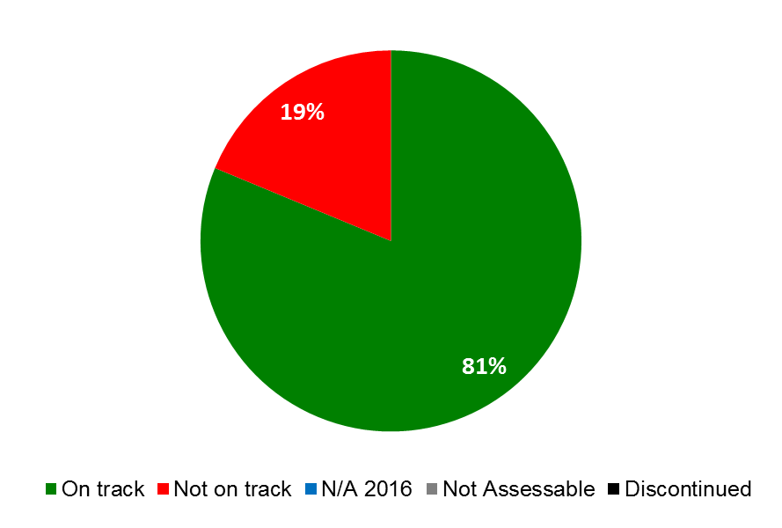

| **Expected Results** | **Performance Indicators** | **Responsible**  **Program(s)** | **TLS** |
| --- | --- | --- | --- |
| IV.1 Updated and globally accepted system of international classifications and WIPO standards to facilitate access, use and dissemination of IP information among stakeholders in the world | No. of amendments and information files introduced into the Nice Classification | Program 12 | ⚫⚫⚫ |
| No. of new subdivisions introduced into the IPC per year | Program 12 | ⚫ |
| No. of amended and new standards adopted | Program 12 | ⚫ |
| No. of users accessing the Internet publications of international classifications and standards, in particular from developing countries | Program 12 | ⚫⚫⚫⚫  ⚫⚫⚫ |
| IV.2 Enhanced access to, and use of, IP information by IP institutions and the public to promote innovation and creativity | No. of ABC constituent members | Program 3 | ⚫ |
| No. of donors | Program 3 | ⚫ |
| No. of legal instruments, guidelines, statements of principles other than binding instruments with the participation of the stakeholders concerned in areas such as new copyright treaties and Copyright in the Digital Environment | Program 3 | ⚫ |
|  | No. of sustainable[58] national TISC networks (numbers cumulative) | Program 9  Program 14  Program 20 | ⚫  ⚫  ⚫ |
|  | No. of organizations, communities, individuals that applied and used the Appropriate Technology as a solution to identified development challenges in LDCs | Program 9 | ⚫ |
|  | Use of Appropriate Technology for development through patent searches and reports, technology landscapes, business plans (Number of experts, National Expert Groups (NEGs) in LDCs) | Program 9 | ⚫ |
|  | Identified Appropriate Technology commercialized in LDCs | Program 9 | ⚫ |
|  | Projects replicated in other areas in LDCs | Program 9 | ⚫ |
|  | Institutions established to continue working on Appropriate Technology in LDCs | Program 9 | ⚫ |
|  | Continuation and expansion of national technological capacity building programs on Appropriate Technology in LDCs | Program 9 | ⚫ |
|  | Utilization of Appropriate Technology for economic development included in the national innovation and IP policies and strategies in LDCs | Program 9 | ⚫ |
|  | No. of different users per quarter in all Global Database systems | Program 13 | ⚫ |
|  | No. of languages in which cross-lingual search is available | Program 13 | ⚫ |
|  | No. of language pairs available for translation of descriptions and claims | Program 13 | ⚫ |
|  | No. of records contained in PATENTSCOPE | Program 13 | ⚫ |
|  | Timeliness of data uploading (the average delay in days between the publication date of the records in their official register and availability in Global Databases for a representative subset of national collections) | Program 13 | ⚫ |
|  | Average no. of users serviced by TISCs per annum | Program 14 | ⚫ |
|  | No. of Member States in the respective regions collaborating with Global Databases | Program 14 | ⚫ |
|  | No. of active registered users of ARDI and ASPI | Program 14 | ⚫ |
|  | No. of TISC Clinic requests submitted to TISCs | Program 14 | ⚫ |
|  | No. of TISCs offering patent analytical services | Program 14 | ⚫ |
|  | No. of users of WIPO’s global Databases, PATENTSCOPE, Global Brands Database, and Global Designs Database | Program 20 | ⚫⚫⚫⚫⚫  ⚫⚫⚫⚫⚫  ⚫⚫⚫⚫⚫ |
|  | Increase in the no. of WIPO Lex users | Program 21 | ⚫ |
|  | No. of Technology Transfer Offices (TTOs) that were established or strengthened in Universities or R&D institutions under the WIPO University Initiative Program | Program 30 | ⚫ |
|  | No. of universities and/or research institutions having developed and/or improved their IP policies | Program 30 | ⚫ |
| IV.3 Broad geographical coverage of the content and use of WIPO Global IP Databases | No. of records contained in Global Brands Database  No. of records contained in Global Designs Database | Program 13  Program 13 | ⚫  ⚫ |
|  | No. of National Collections in PATENTSCOPE | Program 13 | ⚫ |
|  | No. of National Collections in Global Brands Database | Program 13 | ⚫ |
| IV.4 Enhanced technical and knowledge infrastructure for IP Offices and other IP institutions leading to better services (cheaper, faster, higher quality) to their stakeholders and better outcome of IP Administration | No. of Offices using WIPO Infrastructure Platforms | Program 15  Program 20 | ⚫  ⚫ |
| Average Service Level of IP Offices assisted (ranging from 1 to 5 | Program 9  Program 15 | ⚫  ⚫ |
| No. of Collective Management Organizations (CMOs) in developing countries and LDCs participating in regional and global networks facilitated by WIPO ) | Program 15 | ⚫ |

### PROGRAM 12 INTERNATIONAL CLASSIFICATIONS AND STANDARDS

**Program Manager Mr. Y. Takagi**

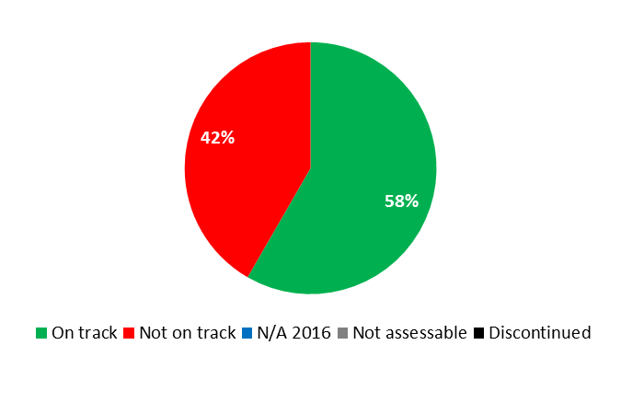

| **Expected Result:** IV.1 Updated and globally accepted system of international classifications and WIPO standards to facilitate access, use and dissemination of IP information among stakeholders in the world | | | | |
| --- | --- | --- | --- | --- |
| **Performance Indicators** | **Baselines** | **Targets** | **Performance Data** | **TLS** |
| No. of amendments and information files introduced into the Nice Classification | *Updated Baseline*  *end 2015:*  1,480 amendments in the biennium:  560 amendments in 2014[59]   * 274 in English * 286 in French   920 amendments in 2015   * 496 in English * 424 in French   43 information files revised   * 39 (2014) * 4 (2015)   25 new information files introduced   * 20 (2014) * 5 (2015)   *Original Baseline  P&B 2016/17:*  570 amendments in English and French, 50 new or amended info files (2014) | Increase compared to baseline | 1,213 amendments   * 651 in English * 562 in French   148 information files revised  30 new information files introduced | **On track**  **On track**  **On track** |
| No. of new subdivisions introduced into the IPC per year | *Updated Baseline end 2015:*  2015: 1,031 new groups were introduced in the 2016.01 version of the IPC  2014: 337 new groups were introduced in the 2015.01 version of the IPC  *Original Baseline*  *P&B 2016/17:*  2014: 337 new groups were introduced in the 2015.01 version of the IPC | Increase compared to baseline | 684 new groups were introduced in the 2017.01 version of the IPC | **On track** |
| No. of amended and new standards adopted | *Updated Baseline*  *end 2015:*  1 new Standard informally adopted and 1 revised (2014)  No formal adoption of new Standards. 2 Standards revised (2015)  *Original Baseline*  *P&B 2016/17:*  2 new standards(2014) | *Updated Target:*  Increase compared to baseline (Adoption of new standard(s))  *Original Target*  *P&B 2016/17:*  Increase compared to baseline | 2 new Standards adopted and 3 Standards revised | **On track** |
| No. of users accessing the Internet publications of international classifications and standards, in particular from developing countries | *Updated Baseline*  *end 2015:*  IPC home: 361,378 (48.1 % of visits from developing countries)  IPC Pub: 1,389,644 (36.3 % of visits from developing countries)  NICE home: 532,493 (47.8 % of visits from developing countries)    NICE Pub: 2,721,537 (49.1 % of visits from developing countries)  LOCARNO home: 51,075 (33.5 % of visits from developing countries)  VIENNA home: 34,830 (38.8 % of visits from developing countries)  WIPO Standards (Handbook): 69,288 (33.6 % of visits from developing countries)  *Original Baseline  P&B 2016/17:*  NicePub: 2,587,788 Locarno Home: 44,557 Vienna Home: 29,596 IPCPub: 1,170,000 WIPO Standards (Handbook): 66,399 | 5% increase compared to baseline | |  | | --- | | IPC  home:  324,981 visits (−10.4%) of which  114,068 (−34.4%) from developing countries | | IPC Pub:  1,386,029 visits (−0.3%) of which  539,165 (+6.9%) from developing countries | | NICE home:  529,804 visits (−0.5%) of which  247,418 (−2.8%) from developing countries | | NICE Pub:  3,767,636 visits (+38.4%) of which 1,936,565 (+45%) from developing countries | | LOCARNO home:  46,719 visits (8.5%) of which  16,123 (−5.8%) from developing countries | | VIENNA home:  36,902 visits (+6.0%) of which  19,078 (+41.2%) from developing countries | | WIPO Standards (Handbook):  70,115 visits (+1.2%) of which  28,467 (+22.3%) from developing countries | | **Not on track**  **Not on track**  **Not on track**  **On track**  **Not on track**  **On track**  **Not on track** |

|  |
| --- |
| **Resource Utilization for Program 12** |

Budget and Actual Expenditure (by result)

*(thousands of Swiss francs)*

|  |  |  |  |  |
| --- | --- | --- | --- | --- |
| **Expected Result No. and Description** | | **2016/17 Approved Budget** | **2016/17 Budget after Transfers** | **2016 Expenditure\*** |
| IV.1 | Updated and globally accepted system of international classifications and WIPO standards to facilitate access, use and dissemination of IP information among stakeholders in the world | 7,070 | 7,250 | 3,118 |
|  | **Total** | 7,070 | 7,250 | 3,118 |
| *\*2016 Expenditure numbers are preliminary, subject to audit by External auditors* | | | |  |

Budget and Actual Expenditure (personnel and non-personnel)

*(thousands of Swiss francs)*

|  |  |  |  |  |
| --- | --- | --- | --- | --- |
|  | **2016/17 Approved Budget** | **2016/17 Budget after Transfers** | **2016 Expenditure\*** | **Utilization rate (%)** |
| Personnel Resources | 5,675 | 5,823 | 2,653 | 46% |
| Non-personnel Resources | 1,395 | 1,427 | 466 | 33% |
| **Total** | **7,070** | **7,250** | **3,118** | **43%** |
| *\*2016 Expenditure numbers are preliminary, subject to audit by External auditors* | | | | |

*NOTE: The 2016/17 Budget after Transfers reflects transfers as of March 8, 2017 to address needs during the 2016/17 biennium in line with Financial Regulation 5.5.*

A. 2016/17 Budget after Transfers

1. The increase in personnel resources as compared to the 2016/17 Approved Budget reflected the regularization of a continuing function and the reclassifications of two posts. The slight decrease in non-personnel resources was due to the transfer of non-personnel resources for internships to HRMD (Program 23), which centrally manages interns.

B. 2016/17 Budget Utilization

1. The 34 per cent budget utilization rate for non-personnel resources was primarily due to the postponement of some activities to 2017, including: (i) a feasibility study for the development of a distance learning IPC course; (ii) work on the Vienna publication platform (prioritization of Nice and Locarno publication platforms in 2016); and (iii) specific work on IT infrastructure and tools (migration of the Master Classification database and the NVL revision management).

### PROGRAM 13 GLOBAL DATABASES SERVICE

**Program Manager Mr. Y. Takagi**

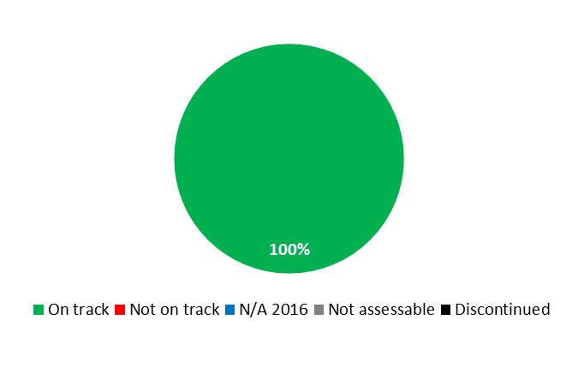

|  |  |  |  |  |
| --- | --- | --- | --- | --- |
| **Expected Result:** IV.2 Enhanced access to, and use of, IP information by IP institutions and the public to promote innovation and creativity | | | | |
| **Performance Indicators** | **Baselines** | **Targets** | **Performance Data** | **TLS** | |
| No. of different users per quarter in all Global Database systems | *Updated Baseline end 2015:*  PATENTSCOPE:  221,981  Global Brand Database:  80,490  Global Design Database:  13,946  *Original Baseline  P&B 2016/17:*  Unique visitors (Q4 2014) PATENTSCOPE: 592,000;  GBD: 49,000;  GDD: N/A | *Updated Target:*  PATENTSCOPE: 250,000  GBD: 75,000  GDD: 15,000  *Original Target P&B 2016/17:*  PATENTSCOPE: 650,000  GBD: 70,000  GDD: 15,000 | PATENTSCOPE 246,516  GBD: 119,208  GDD: 16,868  (Q4 2016) | **On track** | |
| No. of languages in which cross-lingual search is available | *Updated Baseline end 2015:*  14: Chinese, Danish, Dutch, English, French, German, Italian, Japanese, Korean, Polish, Portuguese, Russian, Spanish, Swedish  *Original Baseline  P&B 2016/17:*  12 (end 2014) | 14 | No additional languages added in 2016.  14 languages cumulative | **On track** | |
| No. of language pairs available for translation of descriptions and claims. | 1 (end 2015)  English - Chinese | 4 | 2 additional  English – French  English – Japanese  (3 cumulative end 2016) | **On track** | |
| No. of records contained in PATENTSCOPE | *Updated Baseline end 2015:*  50,000,000  (cumulative)  *Original Baseline  P&B 2016/17:*  43,000,000 (end 2014) | *Updated Target:*  55,000,000 (cumulative)    *Original Target P&B 2016/17:*  50,000,000 | 57,820,000 (cumulative) | **On track** | |
| Timeliness of data uploading (the average delay in days between the publication date of the records in their official register and availability in Global Databases for a representative subset of national collections) | n/a (new PI) | 45 days | 5.6 days (2016) | **On track** | |
| **Expected Result:** IV.3 Broad geographical coverage of the content and use of WIPO Global IP Databases | | | | |
| **Performance Indicators** | **Baselines** | **Targets** | **Performance Data** | **TLS** | |
| No. of records contained in Global Brand Database | *Updated Baseline end 2015:*  24,500,000 (cumulative)  *Original Baseline  P&B 2016/17:*  15,800,000 (end 2014) | *Updated Target:*  30,000,000  *Original Target P&B 2016/17:*  25,000,000 | 27,760,000 (cumulative) | **On track** | |
| No. of records contained in Global Design Database | *Updated Baseline end 2015:*  Total records: 1.53 million  National collections: 5  *Original Baseline  P&B 2016/17:*  n/a | *Updated Target:*  2,000,000  *Original Target* *P&B 2016/17:*  1,000,000 | 1,600,000 (cumulative) | **On track** | |
| No. of National Collections in PATENTSCOPE | *Updated Baseline end 2015:*  43 (cumulative)  *Original Baseline  P&B 2016/17:*  40 (end 2014) | 50 | 43 (cumulative) | **On track** | |
| No. of National Collections in Global Brands Database | *Updated Baseline end 2015:*  26 (cumulative)  *Original Baseline  P&B 2016/17:*  18 (end 2014) | 32 | 32 (cumulative) | **On track** | |

|  |
| --- |
| **Resource Utilization for Program 13** |

Budget and Actual Expenditure (by result)

*(thousands of Swiss francs)*

|  |  |  |  |  |
| --- | --- | --- | --- | --- |
| **Expected Result No. and Description** | | **2016/17 Approved Budget** | **2016/17 Budget after Transfers** | **2016 Expenditure\*** |
| IV.2 | Enhanced access to, and use of, IP information by IP institutions and the public to promote innovation and creativity | 3,803 | 5,578 | 2,305 |
| IV.3 | Broad geographical coverage of the content and use of WIPO Global IP Databases | 1,956 | 2,196 | 851 |
|  | **Total** | 5,758 | 7,774 | 3,156 |
| *\*2016 Expenditure numbers are preliminary, subject to audit by External auditors* | | | |  |

Budget and Actual Expenditure (personnel and non-personnel)

*(thousands of Swiss francs)*

|  |  |  |  |  |
| --- | --- | --- | --- | --- |
|  | **2016/17 Approved Budget** | **2016/17 Budget after Transfers** | **2016 Expenditure\*** | **Utilization rate (%)** |
| Personnel Resources | 4,551 | 5,742 | 2,309 | 40% |
| Non-personnel Resources | 1,208 | 2,032 | 847 | 42% |
| **Total** | **5,758** | **7,774** | **3,156** | **41%** |
| *\*2016 Expenditure numbers are preliminary, subject to audit by External auditors* | | | | |

*NOTE: The 2016/17 Budget after Transfers reflects transfers as of March 8, 2017 to address needs during the 2016/17 biennium in line with Financial Regulation 5.5.*

A. 2016/17 Budget after Transfers

1. The increase in personnel resources as compared to the 2016/17 Approved Budget were due to: (i) the transfer into the Program of WIPO Lex from Executive Management (Program 21), reflected under Expected Result IV.2 (Enhanced access to, and use of IP information), (ii) the transfer of two posts to support the increased workload related to the upload of national collections into PATENTSCOPE and the operation of the WIPO Lex database and (iii) the reclassification of one post.
2. The non-personnel resources reflected an upwards adjustment resulting primarily from: (i) the transfer into the Program of WIPO Lex from Executive Management (Program 21); (ii) the transfer into the Program of the responsibility for the technical assistance special projects (LATIPAT and ARABPAT) from Services for Access to Information and Knowledge (Program 14); and (iii) the additional costs for the outsourcing of national collections’ uploads to an external service provider.

B. 2016/17 Budget Utilization

1. Budget utilization was within the expected range of 40-60 per cent for the first year of the biennium.

### PROGRAM 14 SERVICES FOR ACCESS TO INFORMATION AND KNOWLEDGE

**Program Manager Mr. Y. Takagi**

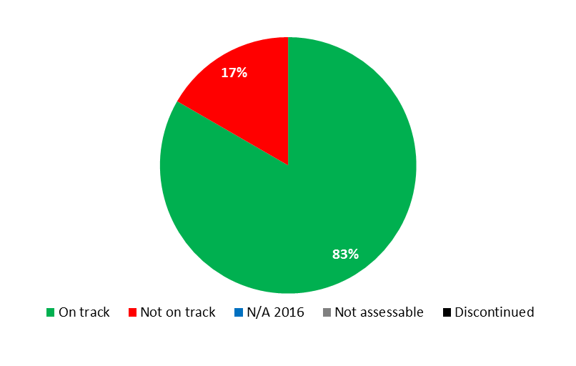

|  |  |  |  |  |
| --- | --- | --- | --- | --- |
| **Expected Result:** IV.2 Enhanced access to, and use of, IP information by IP institutions and the public to promote innovation and creativity | | | | |
| **Performance Indicators** | **Baselines** | **Targets** | **Performance Data** | **TLS** |
| No. of sustainable[60] national TISCs networks  (numbers cumulative) | *Updated Baseline end 2015:*  24 sustainable national networks out of 50 formally established  Maturity Level 1:  Africa: (8 of which 7 LDC)  Arab: (1)  Asia and the Pacific: (3)  Latin America and Caribbean: (5)  (17 total)  Maturity Level 2:  Africa: (2 of which 1 LDC)  Latin America and Caribbean: (2)  (4 total)  Maturity Level 3, including the provision of value-added services[61]:  Arab: (1)  Asia and the Pacific: (1)  Transition: (1)  (3 total)  *Original Baseline  P&B 2016/17:*  20 sustainable national TISC networks out of 45 established (cumulative): Africa (9 of which 6 LDCs); Arab region (2); Asia and Pacific (3 of which 1 LDC); Latin America and the Caribbean (5); Certain Countries in Europe and Asia (1) | *Updated Target:*  30 national TISC networks (cumulative):  Africa: (13 of which 9 LDCs);  Arab: (2);  Asia and the Pacific: (5 of which 2 LDCs);  Latin America and the Caribbean: (9)  Transition: (1)  *Original Target P&B 2016/17:*  30 national TISC networks (cumulative): Africa region (11 of which 8 LDCs);  Arab region (4);  Asia and the Pacific region (5 of which 2 LDCs);  Latin America and the Caribbean region (7);  Certain Countries in Europe and Asia (3) | 28 sustainable national networks (cumulative as at end 2016)  Maturity Level 1:  Africa (3 of which 1 LDC )  Asia and the Pacific (2)  Latin America and the Caribbean (2 )  (7 total)  Maturity Level 2:  Africa (8 of which 6 LDCs)  Arab (1)  Asia and the Pacific (2)  Latin America and the Caribbean (4)  (15 total)  Maturity Level 3, including the provision of value-added services[62]:  Africa (1)  Arab (1)  Asia and the Pacific (1)  Latin America and the Caribbean (2)  Transition Countries (1)  (6 total) | **On track** |
| Average no. of users serviced by TISCs per annum | *Updated Baseline end 2015:*  874 (min.) – 2,631 (max.) = 1,730 average  *Original Baseline  P&B 2016/17:*  548 (min) to 1,625 (max) | *Updated Target:*  *3,500*  *Original Target:*  *1,100* | 1,750 users serviced by TISCs in 2016 | **On track** |
| No. of Member States in the respective regions collaborating with Global Databases. | *Updated Baseline end 2015:*  PATENTSCOPE (19):   * ARABPAT (4) * LATIPAT (15)   GBD (4):   * ARABPAT (3) * LATIPAT (1)   GDD (0):   * ARABPAT (0) * LATIPAT (0)   *Original Baseline  P&B 2016/17:*  15 PATENTSCOPE,  1 GBD, 0 GDD LATIPAT  3 PATENTSCOPE, 1 GBD, 0 GDD ARABPAT  (Feb 2015) | PATENTSCOPE (+2)  GBD (+4)  GDD (+2)  overall | PATENTSCOPE:  No additional Member States  GBD:  No additional Member States  GDD:  No additional Member States | **Not on track** |
| No. of active registered users of ARDI and ASPI | *Updated Baseline end 2015:*  ARDI 623  ASPI 42  *Original Baseline  P&B 2016/17:*  ARDI 411 active users  ASPI (35 active users)  (end 2014) | *Updated Target:*  ARDI - 900 ASPI - 55  *Original Target P&B 2016/17:*  ARDI - 600 ASPI - 60 | ARDI - 800 ASPI - 55 | **On track** |
| No. of TISC Clinic requests submitted to TISCs | *Updated Baseline end 2015:*  0 (zero): No TISC Clinics established before 2016  *Original Baseline  P&B 2016/17:*  n/a (new) | *Updated Target:*  40  *Original Target P&B 2016/17:*  10 | 35 requests submitted in 2016 | **On track** |
| No. of TISCs offering patent analytical services | *Updated Baseline end 2015:*  0 (zero): No TISCs offered patent analytical services before 2016  *Original Baseline  P&B 2016/17:*  n/a (new) | *Updated Target:*  *7*  *Original Target:*  *5* | 6 (see Maturity Level 3 above) | **On track** |

|  |
| --- |
| **Resource Utilization for Program 14** |

Budget and Actual Expenditure (by result)

*(thousands of Swiss francs)*

|  |  |  |  |  |
| --- | --- | --- | --- | --- |
| **Expected Result No. and Description** | | **2016/17 Approved Budget** | **2016/17 Budget after Transfers** | **2016 Expenditure\*** |
| IV.2 | Enhanced access to, and use of, IP information by IP institutions and the public to promote innovation and creativity | 6,990 | 7,235 | 3,169 |
|  | **Total** | 6,990 | 7,235 | 3,169 |
| *\*2016 Expenditure numbers are preliminary, subject to audit by External auditors* | | | |  |

Budget and Actual Expenditure (personnel and non-personnel)

*(thousands of Swiss francs)*

|  |  |  |  |  |
| --- | --- | --- | --- | --- |
|  | **2016/17 Approved Budget** | **2016/17 Budget after Transfers** | **2016 Expenditure\*** | **Utilization rate (%)** |
| Personnel Resources | 5,764 | 6,060 | 2,862 | 47% |
| Non-personnel Resources | 1,225 | 1,174 | 307 | 26% |
| **TOTAL** | **6,990** | **7,235** | **3,169** | **44%** |
| *\*2016 Expenditure numbers are preliminary, subject to audit by External auditors* | | | | |

*NOTE: The 2016/17 Budget after Transfers reflects transfers as of March 8, 2017 to address needs during the 2016/17 biennium in line with Financial Regulation 5.5.*

A. 2016/17 Budget after Transfers

1. The increase in personnel resources as compared to the 2016/17 Approved Budget was primarily due to the regularization of continuing functions.
2. The slight decrease in non-personnel resources resulted primarily from the transfer of responsibility for the technical assistance special projects (LATIPAT and ARABPAT) from the Program to Global Databases (Program 13) and the transfer of non-personnel resources for internships to HRMD (Program 23), which centrally manages interns.

B. 2016/17 Budget Utilization

1. The 26 per cent non-personnel budget utilization rate primarily reflected less than planned expenditure on staff missions.

### PROGRAM 15 BUSINESS SOLUTIONS FOR IP OFFICES

**Program Manager Mr. Y. Takagi**

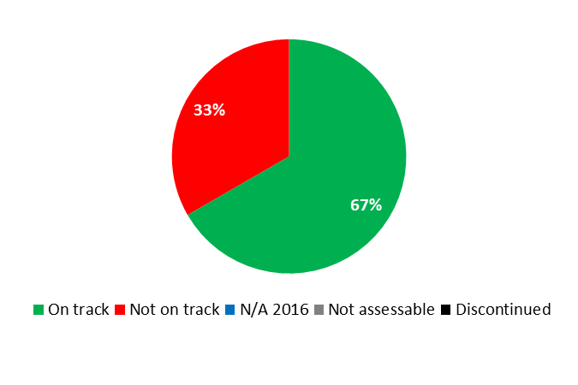

|  |  |  |  |  |
| --- | --- | --- | --- | --- |
| **Expected Result:** IV.4 Enhanced technical and knowledge infrastructure for IP Offices and other IP institutions leading to better services (cheaper, faster, higher quality) to their stakeholders and better outcome of IP Administration | | | | |
| **Performance Indicators** | **Baselines** | **Targets** | **Performance Data** | **TLS** |
| No. of Offices using WIPO Infrastructure Platforms | *Updated Baseline*  *end 2015:*   * Asia and the Pacific: 12 * Latin America and the Caribbean: 1 * Other: 12[63]   (25 Offices cumulative)  *Original Baseline*  *P&B 2016/17:*  22 Offices as of March 2015  Asia and the Pacific: 12  Transition countries: 1  Developed countries: 9 | 29 Offices end 2017 | 6 additional Offices in 2016:   * Asia and the Pacific 2: Cambodia, Papua New Guinea (14 cumulative). * No additional Offices in Latin America and the Caribbean (1 cumulative) * Other 3: European Patent Office, Eurasian Patent Office, Portugal (15 cumulative) * Transition countries 1: Azerbaijan (1 cumulative)   31 Offices (cumulative) | **On track** |
| Average Service Level of IP Offices assisted (ranging from 1 to 5) | *Updated Baseline*  *end 2015:*  Overall average: 2.9   * Africa: 2.9 * Arab: 2.8 * Asia and the Pacific: 2.7 * Certain Countries in Europe and Asia: 3.3 * Latin America and the Caribbean: 3 * Other: 2.5   *Original Baseline  P&B 2016/17:*  2.9 end 2015 | 3 end 2017 | Overall average: 3.1   * Africa: 3.0 * Arab: 2.9 * Asia and the Pacific: 3.4 * Latin America and the Caribbean: 3.2 * Other: 2.6 * Transition Countries: 3.5 | **On track** |
| No. of Collective Management Organizations (CMOs) in developing countries and LDCs participating in regional and global networks facilitated by WIPO | *Updated Baseline*  *end 2015:*  The WIPO Connect system was in the final development phase at the end of 2014/15 and will be deployed in 2 pilot CMOs in developing countries and LDCs at the end of 2016.  *Original Baseline  P&B 2016/17:*  Zero CMOs end 2015 | 7 CMOs end 2017 | Zero CMOs | **Not on Track** |

|  |
| --- |
| **Resource Utilization for Program 15** |

Budget and Actual Expenditure (by result)

*(thousands of Swiss francs)*

|  |  |  |  |  |
| --- | --- | --- | --- | --- |
| **Expected Result No. and Description** | | **2016/17 Approved Budget** | **2016/17 Budget after Transfers** | **2016 Expenditure\*** |
| IV.4 | Enhanced technical and knowledge infrastructure for IP Offices and other IP institutions leading to better services (cheaper, faster, higher quality) to their stakeholders and better outcome of IP Administration | 13,806 | 14,016 | 6,449 |
| VII.2 | IP-based platforms and tools for knowledge transfer, technology adaptation and diffusion from developed to developing countries, particularly least developed countries, to address global challenges | 0 | 355 | 309 |
|  | **Total** | 13,806 | 14,371 | 6,758 |
| *\*2016 Expenditure numbers are preliminary, subject to audit by External auditors* | | | |  |

Budget and Actual Expenditure (personnel and non-personnel)

*(thousands of Swiss francs)*

|  |  |  |  |  |
| --- | --- | --- | --- | --- |
|  | **2016/17 Approved Budget** | **2016/17 Budget after Transfers** | **2016 Expenditure\*** | **Utilization rate (%)** |
| Personnel Resources | 7,756 | 7,931 | 3,841 | 48% |
| Non-personnel Resources | 6,050 | 6,440 | 2,916 | 45% |
| **Total** | **13,806** | **14,371** | **6,758** | **47%** |
| *\*2016 Expenditure numbers are preliminary, subject to audit by External auditors* | | | | |

*NOTE: The 2016/17 Budget after Transfers reflects transfers as of March 8, 2017 to address needs during the 2016/17 biennium in line with Financial Regulation 5.5.*

A. 2016/17 Budget after Transfers

1. The overall increase in personnel resources as compared to the 2016/17 Approved Budget was primarily the net result of, on the one hand, the reclassification of three posts and, on the other hand, the transfer of a post from Business Solutions for IP Offices (Program 15) to the WIPO Singapore Office (Program 20) for strengthening IPAS-related support to national IP Offices in the region.
2. The non-personnel resources reflected an upwards adjustment due to the transfer of additional resources to support the creation of a Patent Family Database and to cover increased operational costs for WIPO Connect. In addition, there was a shift within the Program from personnel to non-personnel resources to support the creation of a pilot Fellowship program.

B. 2016/17 Budget Utilization

1. Budget utilization was within the expected range of 40-60 per cent for the first year of the biennium.

## STRATEGIC GOAL V

**WORLD REFERENCE SOURCE FOR IP INFORMATION AND ANALYSIS**

**Mid-term Performance Dashboard (2016)**

The dashboard below provides a summary of the progress towards the achievement of the Results in the 2016 as measured by the indicators under the Programs contributing to this Strategic Goal.

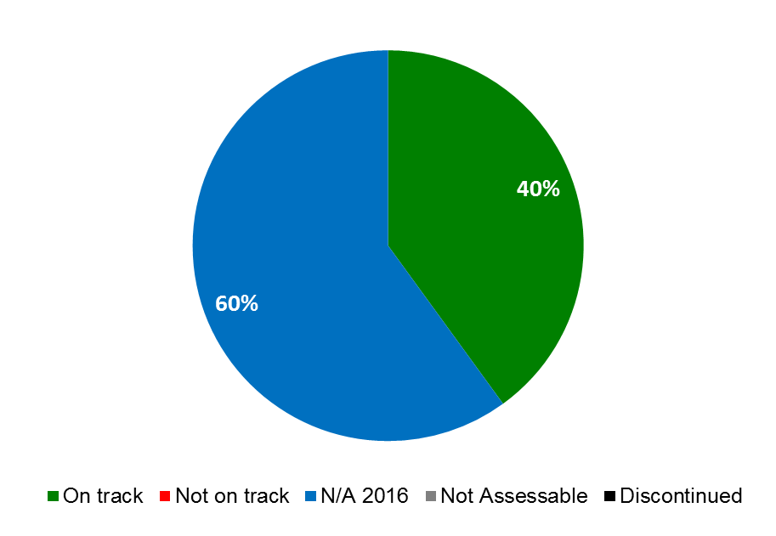

|  |  |  |  |
| --- | --- | --- | --- |
| **Expected Results** | **Performance Indicators** | **Responsible Program(s)** | **TLS** |
| V.1 Wider and better use of WIPO IP statistical information | Difference between January forecasts and actual numbers of PCT, Madrid, and Hague filings are within threshold ranges | Program 16 | ⚫ |
| No. of downloads of annual statistics reports within 6 months of their publication | Program 16 | ⚫ |
| No. of searches on IP Statistics Data Center | Program 16 | ⚫ |
| V.2 Wider and better use of WIPO economic analysis in policy formulation | Annual number of visitors to Global Innovation Index websites | Program 16 | ⚫ |
| No. of downloads of World IP Report within 6 months of publication | Program 16 | ⚫ |

### PROGRAM 16 ECONOMICS AND STATISTICS

**Program Manager Director General**

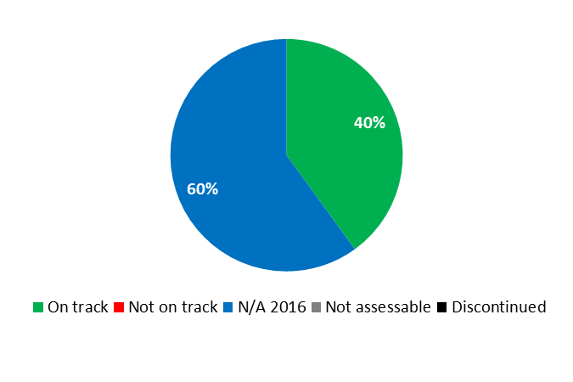

|  |  |  |  |  |
| --- | --- | --- | --- | --- |
| **Expected Result:** V.1 Wider and better use of WIPO IP statistical information | | | | |
| **Performance Indicators** | **Baselines** | **Targets** | **Performance Data** | **TLS** | |
| No. of searches on IP Statistics Data Center | *Updated Baseline end 2015*[64]*:*  68,692  *Original Baseline  P&B 2016/17:*  tbd end 2015 | *Defined Target:*  10% increase  *Original Target:*  Tbd | The enhanced web-analytics tool was implemented during the course of 2016, resulting in the inability to track data for 2016 | **N/A 2016** | |
| No. of downloads of annual statistics reports within 6 months of their publication | *Updated Baseline end 2015*[65]*:*  World IP Indicators: 26,710  PCT Yearly Review: 11,949  Madrid Yearly Review: 4,733  Hague Yearly Review: 3,662  *Original Baseline  P&B 2016/17:*  tbd[66] | *Defined Target:*  World IP Indicators:  10% increase  PCT Yearly Review:  5% increase[67]  Madrid Yearly Review:  5% increase  Hague Yearly Review:  5% increase  *Original Target:*  Tbd | The enhanced web-analytics tool was implemented during the course of 2016, resulting in the inability to track data for 2016 | **N/A 2016** | |
| Difference between January forecasts and actual numbers of PCT, Madrid, and Hague filings are within threshold ranges | *Updated Baseline end 2015:*  January 2015 filing forecasts; and 2015 actuals:  - PCT 216,100; actual 217,230  - Madrid 51,090; actual 49,273  - Hague 3,940; actual 4,111  *Original Baseline  P&B 2016/17:*  tbd in early 2016 | Forecasts within 80 % confidence interval | Forecast vs. Actual   * PCT: 225,400 vs. 233,000 (103%) * Madrid: 52,030 vs. 52,900 (102%) * Hague: 5,560 vs. 5,562 (100%) | **On track** | |
| **Expected Result:** V.2 Wider and better use of WIPO economic analysis in policy formulation | | | | |
| **Performance Indicators** | **Baselines** | **Targets** | **Performance Data** | **TLS** | |
| Annual no. of visitors to Global Innovation Index websites | *Updated Baseline end 2015:*  WIPO Global Innovation Index (GII) webpage[68]:  29,556 (2015)  48,190[69] (2014/15)  GII-dedicated website[70]:  170,417 (2015)  317,690 (2014/15)[71]  *Original Baseline  P&B 2016/17:*  tbd end 2015 | *Defined Target:*  WIPO GII:  10% increase  GII-dedicated: 10% increase  *Original Target:*  Tbd | WIPO GII: 44,244 (+50%)  GII-dedicated: 214,122 (+25.6%) | **On track** | |
| No. of downloads of World IP Report[72] within 6 months of publication | *Updated Baseline:*  World IP Report 2015:  30,017  *Original Baseline  P&B 2016/17:*  tbd[73] | *Defined Target:*  10% increase  *Original Target:*  Tbd | The World IP Report is a biennial publication, with the next edition expected in late 2017 | **N/A 2016** | |

|  |
| --- |
| **Resource Utilization for Program 16** |

Budget and Actual Expenditure (by result)

*(thousands of Swiss francs)*

|  |  |  |  |  |
| --- | --- | --- | --- | --- |
| **Expected Result No. and Description** | | **2016/17 Approved Budget** | **2016/17 Budget after Transfers** | **2016 Expenditure\*** |
| V.1 | Wider and better use of WIPO IP statistical information | 2,677 | 2,447 | 1,172 |
| V.2 | Wider and better use of WIPO economic analysis in policy formulation | 3,395 | 3,874 | 1,569 |
|  | **Total** | 6,072 | 6,322 | 2,741 |
| *\*2016 Expenditure numbers are preliminary, subject to audit by External auditors* | | | |  |

Budget and Actual Expenditure (personnel and non-personnel)

*(thousands of Swiss francs)*

|  |  |  |  |  |
| --- | --- | --- | --- | --- |
|  | **2016/17 Approved Budget** | **2016/17 Budget after Transfers** | **2016 Expenditure\*** | **Utilization rate (%)** |
| Personnel Resources | 4,997 | 5,021 | 2,326 | 46% |
| Non-personnel Resources | 1,075 | 1,300 | 415 | 32% |
| **Total** | **6,072** | **6,322** | **2,741** | **43%** |
| *\*2016 Expenditure numbers are preliminary, subject to audit by External auditors* | | | | |

*NOTE: The 2016/17 Budget after Transfers reflects transfers as of March 8, 2017 to address needs during the 2016/17 biennium in line with Financial Regulation 5.5.*

A. 2016/17 Budget after Transfers

1. The increase in personnel resources as compared to the 2016/17 Approved Budget was primarily due to the reclassification of one post.
2. The increase in non-personnel resources, reflected under Expected Result V.2 (Wider and Better use of WIPO Economic Analysis), resulted from the allocation of unspent 2015 budget under the DA project on Intellectual Property (IP) and Socio-Economic Development (Phase II) and the need for additional resources for: (i) the development of the Global Innovation Index; (ii) specific research projects in relation to the 2017 World IP Report; and (iii) research related to the creative economy.
3. The decrease in resources under Expected Result V.1 (Wider and Better use of WIPO IP statistical information), reflected a shift of resources for the establishment of a new line of research on policy and performance in the creative economy under Expected Result V.2 (Wider and Better use of WIPO Economic Analysis).

B. Budget utilization 2016/17

1. The 32 per cent budget utilization rate for non-personnel resources is primarily due to the disbursement schedules associated with the 2017 World IP Report and the studies under the DA project.

## STRATEGIC GOAL VI

**INTERNATIONAL COOPERATION ON BUILDING RESPECT FOR IP**

**Mid-term Performance Dashboard (2016)**

The dashboard below provides a summary of the progress towards the achievement of the Results in the 2016 as measured by the indicators under the Programs contributing to this Strategic Goal.

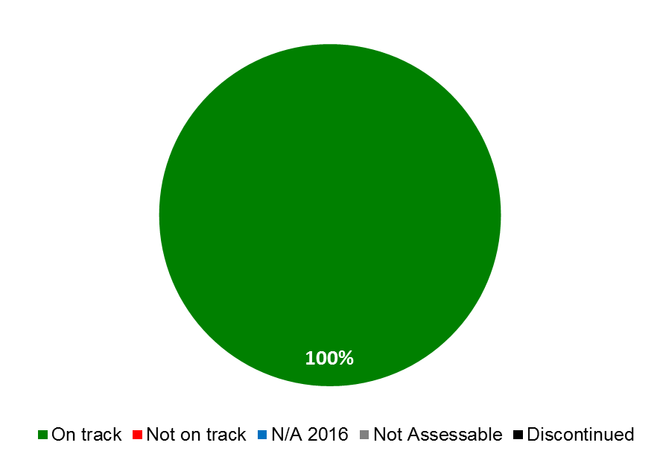

|  |  |  |  |
| --- | --- | --- | --- |
| **Expected Results** | **Performance Indicators** | **Responsible Program(s)** | **TLS** |
| VI.1 Progress in the international policy dialogue among WIPO Member States on building respect for IP, guided by Recommendation 45 of the WIPO Development Agenda | Continued agreement by Member States on the substantive work of the WIPO Advisory Committee on Enforcement (ACE), incorporating development-oriented concerns | Program 17 | ⚫ |
| VI.2 Systematic, effective and transparent cooperation and coordination between the work of WIPO and other international organizations in the field of building respect for IP | No. of strategic collaborations or other joint activities with partner organizations on building respect for IP | Program 17 | ⚫ |

### PROGRAM 17 BUILDING RESPECT FOR IP

**Program Manager Mr. M.A. Getahun**

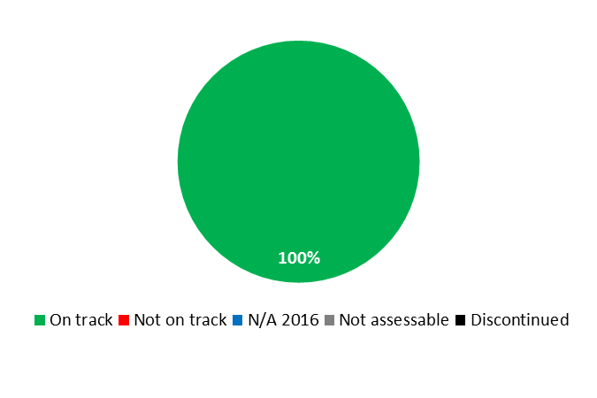

|  |  |  |  |  |
| --- | --- | --- | --- | --- |
| **Expected Result:** I.2 Tailored and balanced IP legislative, regulatory and policy frameworks | | | | |
| **Performance Indicators** | **Baselines** | **Targets** | **Performance Data** | **TLS** |
| No. of countries/regional organizations having adopted or amended relevant frameworks towards effective IP enforcement in the light of Part III of the TRIPS Agreement and DA Recommendation 45, or being in the process of doing so, further to WIPO assistance | *Updated Baseline end 2015:*  21 countries/organizations (cumulative) were in the process of amending and/or adopting relevant frameworks towards effective IP enforcement: Africa (8); Asia and the Pacific (8); Latin America and the Caribbean (5)  *Original Baseline  P&B 2016/17:*  13 countries in the process of amending and/or adopting relevant frameworks towards effective IP enforcement (as at February 15, 2015) | 1 country/ regional organization having adopted and/or amended relevant frameworks towards effective IP enforcement | 31 countries/organizations (cumulative) were in the process of amending and/or adopting relevant frameworks towards effective IP enforcement: Africa (12); Arab Region (2): Asia and the Pacific (10); Latin America and the Caribbean (6); Transition Countries (1) | **On track** |
| No. of countries that have adopted and/or implemented a national strategy on Building Respect for IP, or are in the process of doing so, with WIPO assistance | 2 countries in the process of adopting such a strategy | *Updated Target:*  2 countries have adopted such strategy in the biennium  *Original Target P&B 2016/17:*  2 countries have adopted such strategy | * 1 country (Latvia) was in the late stages of adoption of a Building Respect for IP (BRIP) strategy; * 1 country (Namibia) was implementing a BRIP strategy; * 1 country (Kiribati) was provided assistance in the drafting of a BRIP strategy | **On track** |
| **Expected Result:** III.2 Enhanced human resource capacities able to deal with the broad range of requirements for the effective use of IP for development in developing countries, LDCs and countries with economies in transition | | | | |
| **Performance Indicators** | **Baselines** | **Targets** | **Performance Data** | **TLS** |
| % of trained participants reporting satisfaction with the usefulness and relevance of the training provided for the exercising of their professional duties | *Updated Baseline end 2015:*  Average rate of usefulness: 93%  Average rate of satisfaction: 92%  *Original Baseline P&B 2016/17:*  Relevance : 90% Usefulness: 90%  (as at February 15, 2015) | Relevance: >85% Usefulness: >85% | Relevance: 92%  Usefulness: 92% | **On track** |
| **Expected Result:** VI.1 Progress in the international policy dialogue among WIPO Member States on building respect for IP, guided by Recommendation 45 of the WIPO Development Agenda | | | | |
| **Performance Indicators** | **Baselines** | **Targets** | **Performance Data** | **TLS** |
| Continued agreement by Member States on the substantive work of the WIPO Advisory Committee on Enforcement (ACE), incorporating development-oriented concerns | *Updated Baseline end 2015:*  Agreement on the work program was reached during the ninth and tenth sessions of the ACE  WIPO/ACE/9/29 para 44 and WIPO/ACE/10/26 PROV. para 40  *Original Baseline P&B 2016/17:*  Agreement on the work program for the 10th session of the ACE | Agreement on the work program for the next ACE session | Agreement on the work program of the twelfth session of the ACE was achieved (WIPO/ACE/11/11 para 39) | **On track** |
| **Expected Result:** VI.2 Systematic, effective and transparent cooperation and coordination between the work of WIPO and other international organizations in the field of building respect for IP | | | | |
| **Performance Indicators** | **Baselines** | **Targets** | **Performance Data** | **TLS** |
| No. of strategic collaborations or other joint activities with partner organizations on building respect for IP | *Updated Baseline end 2015:*  In 2014/15, a total of 7 strategic collaborations[74] (cumulative) and 55 activities jointly held with partner organizations and stakeholders and/or in which Program 17 participated  *Original Baseline P&B 2016/17:*  6 strategic collaborations; 24 other joint activities (as at February 15, 2015) | *Updated Target:*  7 strategic collaborations; 50 joint activities in the biennium  *Original Target P&B 2016/17:*  6 strategic collaborations;  25 other joint activities | 7 on-going strategic collaborations and 20 activities jointly held with partner organizations and stakeholders and/or in which Program 17 participated | **On track** |
| **Expected Result:** VIII.1 More effective communication to a broad public about intellectual property and WIPO’s role | | | | |
| **Performance Indicators** | **Baselines** | **Targets** | **Performance Data** | **TLS** |
| No. of Member States participating in the WIPO Awards Program | *Updated Baseline end 2015:*  In 2014/15, a total of 54 different countries participated in the WIPO Awards Program  *Original Baseline P&B 2016/17:*  38 (in 2014) | *Updated Target:*  54  *Original Target* *P&B 2016/17:*  45 in 2016/17 | In 2016, a total of 45 different countries participated in the WIPO Awards Program | **On track** |

|  |
| --- |
| **Resource Utilization for Program 17** |

Budget and Actual Expenditure (by result)

*(thousands of Swiss francs)*

|  |  |  |  |  |
| --- | --- | --- | --- | --- |
| **Expected Result No. and Description** | | **2016/17 Approved Budget** | **2016/17 Budget after Transfers** | **2016 Expenditure\*** |
| I.2 | Tailored and balanced IP legislative, regulatory and policy frameworks | 639 | 659 | 316 |
| III.2 | Enhanced human resource capacities able to deal with the broad range of requirements for the effective use of IP for development in developing countries, LDCs and countries with economies in transition | 1,105 | 1,114 | 519 |
| VI.1 | Progress in the international policy dialogue among WIPO Member States on building respect for IP, guided by Recommendation 45 of the WIPO Development Agenda | 569 | 823 | 383 |
| VI.2 | Systematic, effective and transparent cooperation and coordination between the work of WIPO and other international organizations in the field of building respect for IP | 1,111 | 1,278 | 684 |
| VIII.1 | More effective communication to a broad public about intellectual property and WIPO’s role | 327 | 0 | 2 |
|  | **Total** | 3,752 | 3,874 | 1,905 |
| *\*2016 Expenditure numbers are preliminary, subject to audit by External auditors* | | | |  |

Budget and Actual Expenditure (personnel and non-personnel)

*(thousands of Swiss francs)*

|  |  |  |  |  |
| --- | --- | --- | --- | --- |
|  | **2016/17 Approved Budget** | **2016/17 Budget after Transfers** | **2016 Expenditure\*** | **Utilization rate (%)** |
| Personnel Resources | 3,073 | 3,073 | 1,567 | 51% |
| Non-personnel Resources | 679 | 801 | 338 | 42% |
| **Total** | **3,752** | **3,874** | **1,905** | **49%** |
| *\*2016 Expenditure numbers are preliminary, subject to audit by External auditors* | | | | |

*NOTE: The 2016/17 Budget after Transfers reflects transfers as of March 8, 2017 to address needs during the 2016/17 biennium in line with Financial Regulation 5.5.*

A. 2016/17 Budget after Transfers

1. The Budget after Transfers reflected the transfer into the Program of additional non-personnel resources under Expected Result VI.1 (Progress in the international policy dialogue among WIPO Member States on building respect for IP) to fund: (i) the 12th session of the ACE; and (ii) the preparation of two studies and the future work agreed upon by the Member States during the 11th session of the ACE.

B. 2016/17 Budget Utilization

1. Budget utilization was within the expected range of 40-60 per cent for the first year of the biennium.
2. The expenditure under Expected Result VIII.1 (More effective communication to a broad public) was related to the WIPO Awards Program, which was transferred to Executive Management (Program 21).

## STRATEGIC GOAL VII

**ADDRESSING IP IN RELATION TO GLOBAL POLICY ISSUES**

**Mid-term Performance Dashboard (2016)**

The dashboard below provides a summary of the progress towards the achievement of the Results in the 2016 as measured by the indicators under the Programs contributing to this Strategic Goal.

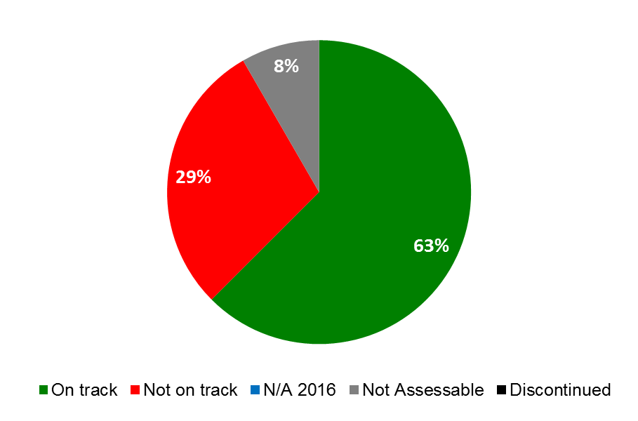

| **Expected Results** | **Performance Indicators** | **Responsible Program(s)** | **TLS** |
| --- | --- | --- | --- |
| VII.2 IP-based platforms and tools are used for knowledge transfer, technology adaptation and diffusion from developed to developing countries, particularly least developed countries, to address global challenges | Increased membership in WIPO Re:Search, including from developing countries and LDCs | Program 18 | ⚫ |
| No. of records in the WIPO Re:Search database | Program 18 | ⚫ |
| Increased no. of agreements under WIPO Re:Search which lead to new or accelerated R&D in NTDs, Malaria and TB" | Program 18 | ⚫⚫ |
| No. of WIPO GREEN Members | Program 18 | ⚫ |
| No. of records in the WIPO GREEN database | Program 18 | ⚫ |
|  | No. of agreements catalyzed by WIPO GREEN facilitating knowledge transfer, technology adaptation, transfer and/or diffusion | Program 18 | ⚫ |
|  | Progress towards an international collaborative framework for effective contribution of IP to food security through consultative process | Program 18 | ⚫ |
|  | No. of visits to the Global Challenges website | Program 18 | ⚫⚫⚫  ⚫⚫⚫ |
|  | Participation of stakeholders in WIPO's platform such as WIPO GREEN and WIPO Re:Search | Program 20 | ⚫⚫⚫⚫⚫⚫⚫⚫⚫⚫ |

### PROGRAM 18 IP AND GLOBAL CHALLENGES

**Program Manager Mr. M. A. Getahun**

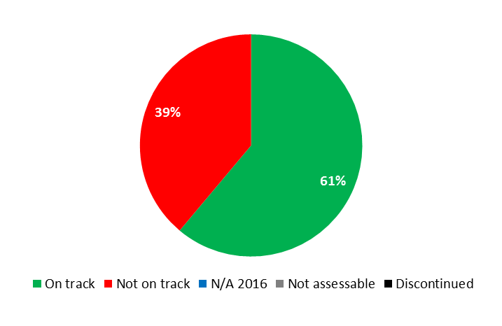

|  |  |  |  |  |
| --- | --- | --- | --- | --- |
| **Expected Result:** I.2 Tailored and balanced IP legislative, regulatory and policy frameworks | | | | |
| **Performance Indicators** | **Baselines** | **Targets** | **Performance Data** | **TLS** |
| No. of countries requesting WIPO’s specific contribution on IP in relation to competition policy-related issues | *Updated Baseline end 2015:*  16 countries (2014/15)  *Original Baseline P&B 2016/17:*  12 countries (2014) | 12 countries in 2016/17 | 2 countries (Peru and the Philippines)  (18 cumulative) | **Not on track** |
| No. and diversity of stakeholders (IP offices, competition authorities, relevant IGOs and NGOs) engaged in dialogue with WIPO | *Updated Baseline end 2015:*  77 national IP/Competition authorities and 5 IGOs/NGOs  (cumulative)  *Original Baseline P&B 2016/17:*  64 national IP/Competition authorities and 5 IGO's/NGO's (cumulative) | 26 additional national IP/ Competition authorities and 5 IGO's/NGO's | 23 Additional Authorities (100 cumulative) and  5 IGOs/NGOs (CUTS, ICN, OECD, UNCTAD, WTO) | **On track** |
| **Expected Result: III.2 Enhanced human resource capacities able to deal with the broad range of requirements for the effective use of IP for development in developing countries, LDCs and countries with economies in transition** | | | | |
| **Performance Indicators** | **Baselines** | **Targets** | **Performance Data** | **TLS** |
| No. of hosting arrangements for developing country scientists | *Updated Baseline end 2015:*  6 hosting agreements  (cumulative)  *Original Baseline P&B 2016/17:*  5 | 2 additional hosting arrangements | No additional hosting arrangements | **Not on track** |
| % of participants of the IP and Health DL module who affirm use of IP for development through transfer of knowledge and creation of skills | n/a | At least 70% of respondents | 67% | **On track** |
| **Expected Result: VII.2 IP-based platforms and tools for knowledge transfer, technology adaptation and diffusion from developed to developing countries, particularly least developed countries, to address global challenges** | | | | |
| **Performance Indicators** | **Baselines** | **Targets** | **Performance Data** | **TLS** |
| Increased membership in WIPO Re:Search, including from developing countries and LDCs | *Updated Baseline end 2015:*  100 total Members (of which 36[75] from developing countries/LDCs)  *Original Baseline P&B 2016/17:*  96 Members; 27 from developing countries  (as at end December 2014) | 8 new Members;  7 from developing countries | 8 new Members; 5 from developing countries  (108 Members cumulative, of which 41 from developing countries/LDCs) | **On track** |
| No. of records in the WIPO Re:Search database | *Updated Baseline end 2015:*  193 database records  *Original Baseline P&B 2016/17:*  186 database records  (as at April 24, 2015) | 300 database records in total | No additional records  (193 database records cumulative) | **Not on track** |
| Increased no. of agreements under WIPO Re:Search which lead to new or accelerated R&D in NTDs, Malaria and TB | *Updated Baseline end 2015:*  96 total agreements  *Original Baseline P&B 2016/17:*  90 agreements  (as at April 9, 2015) | 30 new agreements of which 20 are follow-on agreements | 12 new agreements  (108 agreements cumulative)  1 follow-on agreement | **On track**  **Not on track** |
| No. of WIPO GREEN Members | *Updated Baseline end 2015:*   * 65 total Partners * 490 total users   *Original Baseline P&B 2016/17:*  57 Partners; 430 users  (as at April 24, 2015) | 14 additional Partners;  200 additional users | * 9 additional Partners * 318 additional users   (74 Partners cumulative; 808 total users) | **On track** |
| No. of records in the WIPO GREEN database | *Updated Baseline end 2015:*  2,181 total  *Original Baseline P&B 2016/17:*  2,050 records  (as at April 24, 2015) | 1,200 additional records | 440 additional records  (2,621 records cumulative) | **Not on track** |
| No. of agreements catalyzed by WIPO GREEN facilitating knowledge transfer, technology adaptation, transfer and/or diffusion | *Updated Baseline end 2015:*  7 agreements (AUTM, DKPTO, EACIN, Eco-patent commons, KOTEC, Technologie Allianz, UNOSSC) (cumulative)  *Original Baseline P&B 2016/17:*  7 agreements (AUTM, DKPTO, EACIN, Eco-patent commons, KOTEC, Technologies Allianz, UNOSSC)  (as at April 24, 2015) | 10 agreements (cumulative) | 2 new data sharing agreements: Ministry of Economy of Israel, FLC)  (9 agreements cumulative) | **On track** |
| Progress towards an international collaborative framework for effective contribution of IP to food security through consultative process | n/a - No draft framework | A comprehensive draft framework developed | Discussion document developed | **On track** |
| No. of visits to the Global Challenges website | *Updated Baseline end 2015:*  No. of page views in 2014/15:   * GCD: 2,693 * Global Health and IP: 9,233[76] * Climate Change and IP: 4,952 * WIPO Re: Search: 62,118 * WIPO GREEN: 207,716 * Downloads of pdf files: 45,253   *Original Baseline P&B 2016/17:*  No. of page views:  - GCD: 1,353  - Global Health and IP: 4,778  - Climate Change and IP: 2,462  - WIPO Re:Search: 38,852  - WIPO GREEN: 77,752 | 10% increase | No. of page views:  GCD: 742  Global Health and IP: 4,566  Climate Change and IP: 2,709  WIPO Re:Search: 18,345  WIPO GREEN: 117,176  Downloads of pdf files: 37,868[77] | **Not on track**  **On track**  **On track**  **Not on track**  **On track**  **On track** |

|  |
| --- |
| **Resource Utilization for Program 18** |

Budget and Actual Expenditure (by result)

*(thousands of Swiss francs)*

|  |  |  |  |  |
| --- | --- | --- | --- | --- |
| **Expected Result No. and Description** | | **2016/17 Approved Budget** | **2016/17 Budget after Transfers** | **2016 Expenditure\*** |
| I.1 | Enhanced cooperation among Member States on development of balanced international normative frameworks for IP | 387 | 389 | 181 |
| I.2 | Tailored and balanced IP legislative, regulatory and policy frameworks | 1,500 | 202 | 142 |
| III.2 | Enhanced human resource capacities able to deal with the broad range of requirements for the effective use of IP for development in developing countries, LDCs and countries with economies in transition | 145 | 436 | 218 |
| VI.1 | Progress in the international policy dialogue among WIPO Member States on building respect for IP, guided by Recommendation 45 of the WIPO Development Agenda | 187 | 375 | 180 |
| VI.2 | Systematic, effective and transparent cooperation and coordination between the work of WIPO and other international organizations in the field of building respect for IP | 197 | 216 | 105 |
| VII.2 | IP-based platforms and tools for knowledge transfer, technology adaptation and diffusion from developed to developing countries, particularly least developed countries, to address global challenges | 3,497 | 4,005 | 1,845 |
| VIII.5 | WIPO effectively interacts and partners with UN and other IGO processes and negotiations | 410 | 400 | 200 |
|  | **Total** | 6,323 | 6,023 | 2,871 |
| *\*2016 Expenditure numbers are preliminary, subject to audit by External auditors* | | | |  |

Budget and Actual Expenditure (personnel and non-personnel)

*(thousands of Swiss francs)*

|  |  |  |  |  |
| --- | --- | --- | --- | --- |
|  | **2016/17 Approved Budget** | **2016/17 Budget after Transfers** | **2016 Expenditure\*** | **Utilization rate (%)** |
| Personnel Resources | 5,545 | 5,076 | 2,505 | 49% |
| Non-personnel Resources | 778 | 947 | 366 | 39% |
| **Total** | **6,323** | **6,023** | **2,871** | **48%** |
| *\*2016 Expenditure numbers are preliminary, subject to audit by External auditors* | | | | |

*NOTE: The 2016/17 Budget after Transfers reflects transfers as of March 8, 2017 to address needs during the 2016/17 biennium in line with Financial Regulation 5.5.*

A. 2016/17 Budget after Transfers

1. The increase in non-personnel resources was primarily due to the transfer of funds to support: (i) the enhancement of the WIPO Re:Search and WIPO GREEN platforms under Expected Result VII.2 (IP-based platforms and tools); (ii) work on IP and competition policy, reflected under Expected Result I.2 (Legislative advice); and (iii) the finalization of the second edition of the publication Introduction to IP, Theory and Practice, reflected under Expected Result VIII.5 (WIPO effectively interacts and partners with UN and other IGO processes and negotiations).
2. The decrease in personnel resources reflected under Expected Result I.2 (Legislative advice) was due to: (i) the transfer of one staff member to the Department of Traditional Knowledge and Global Challenges (Program 4) to enhance the overall coordination and management of the two areas; and (ii) the transfer of a post to support priorities in Copyright and Creative Industries (Program 3).

B. 2016/17 Budget Utilization

1. The slight under-utilization of non-personnel resources (38 per cent) was primarily due to the postponement of certain activities related to WIPO Re:Search pending the update of the WHO, WIPO, WTO Trilateral Study.

## STRATEGIC GOAL VIII

**A RESPONSIVE COMMUNICATIONS INTERFACE BETWEEN WIPO, ITS MEMBERS AND ALL STAKEHOLDERS**

**Mid-term Performance Dashboard (2016)**

The dashboard below provides a summary of the progress towards the achievement of the Results in the 2016 as measured by the indicators under the Programs contributing to this Strategic Goal.

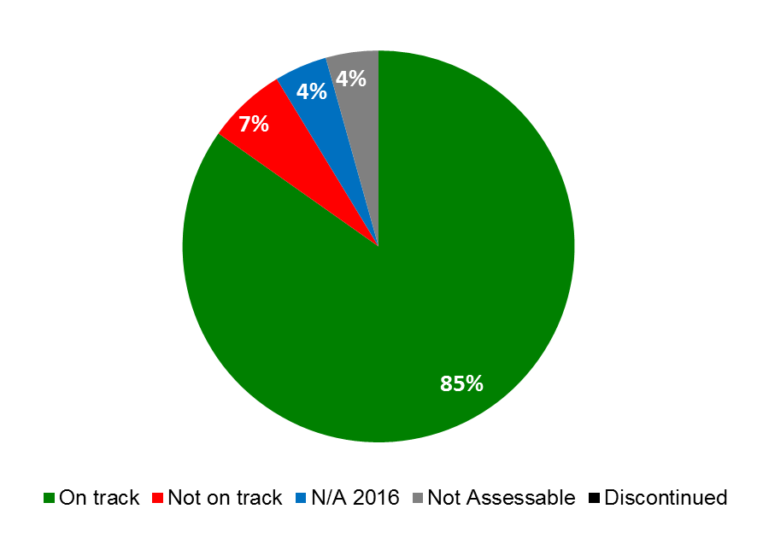

| **Expected Results** | **Performance Indicators** | **Responsible Program(s)** | **TLS** |
| --- | --- | --- | --- |
| VIII.1 More effective communication to a broad public about intellectual property and WIPO’s role | No. of Member States participating in the WIPO Awards Program | Program 17 | ⚫ |
| Stakeholders with a positive perception of WIPO's reputation; and increased brand recognition of WIPO | Program 19 | ⚫⚫ |
| No. of people who view content about major WIPO events, achievements, activities | Program 19 | ⚫ |
|  | Global participation in World IP Day campaign | Program 19 | ⚫ |
|  | Online traffic to the WIPO Publications site and WIPO Magazine site | Program 19 | ⚫⚫ |
|  | Views of WIPO press, video and photographic content | Program 19 | ⚫⚫⚫ |
|  | Fewer users who leave the WIPO website directly from the portal and key gateway pages | Program 19 | ⚫⚫⚫⚫  ⚫⚫⚫ |
|  | WIPO influence and stakeholder engagement on social media | Program 19 | ⚫⚫ |
|  | Increased traffic to the website of WIPO External Offices | Program 20 | ⚫⚫⚫⚫⚫ |
| VIII.2 Improved service orientation and responsiveness to inquiries | User satisfaction with Library services | Program 19 | ⚫ |
| Customer/stakeholder satisfaction rate | Program 19 | ⚫⚫ |
|  | Service Standards for the WIPO Customer Service Center | Program 19 | ⚫⚫ |
|  | Processing time of inquiries | Program 20 | ⚫⚫⚫⚫⚫ |
| VIII.3 Effective engagement with Member States | % of Committee meetings for which pre-Committee information meetings for Member States are held | Program 21 | ⚫ |
|  | % of adherence and other WIPO Treaty-related actions by Member States processed in a timely manner | Program 21 | ⚫ |
|  | Timeliness of publication of Assemblies documents | Program 21 | ⚫ |
|  | Satisfaction rate of Member States and stakeholders with the organization of events | Program 21 | ⚫ |
|  | Delegates’ satisfaction levels with the organization of the Assemblies | Program 21 | ⚫ |
| VIII.4 Open, transparent and responsive interaction with non-governmental stakeholders | No. of permanent observer NGOs engaging in WIPO’s work and vice versa | Program 21 | ⚫ |
| VIII.5 WIPO effectively interacts and partners with UN and other IGO processes and negotiations | WIPO's contributions reflected in UN and IGO reports, resolutions and documents from relevant, targeted processes | Program 20 | ⚫ |
|  | No. of WIPO-led initiatives in partnership with UN and other IGOs to implement the SDGs | Program 20 | ⚫ |
|  | No. of joint activities with ASEAN Secretariat, ECAP/OHIM, Asia/Europe Foundation, AANZFTA | Program 20 | ⚫ |
|  | New joint initiatives with other UN agencies/IGOs | Program 21 | ⚫ |
|  | % of locally sourced goods and services compared to total amount procured for development activity | Program 24 | ⚫ |
|  | % of spend subject to UN leverage (either common tender or piggy-backing) | Program 24 | ⚫ |

### PROGRAM 19 COMMUNICATIONS

**Program Manager Ms. S. Forbin**

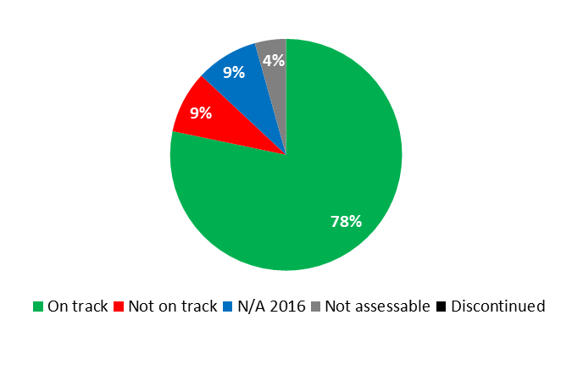



|  |  |  |  |  |
| --- | --- | --- | --- | --- |
| **Expected Result:** VIII.1 More effective communication to a broad public about intellectual property and WIPO’s role | | | | |
| **Performance Indicators** | **Baselines** | **Targets** | **Performance Data** | **TLS** |
| Stakeholders with a positive perception of WIPO's reputation; and increased brand recognition of WIPO | 85.3% of survey respondents agree/strongly agree that WIPO has a good overall reputation. 70.2% of respondents perceived WIPO as the global forum for IP (WIPO Stakeholders Perception Survey, June 2014) | 85% have a positive perception of WIPO's reputation  75% recognize WIPO as the global forum for IP | 84% agree/strongly agree that WIPO has a good overall reputation (2016 WIPO Stakeholders Perception Survey)  74% of survey respondents perceived WIPO as the global forum for IP (2016 WIPO Stakeholders Perception Survey) | **On track**  **On track** |
| No. of people who view content about major WIPO events, achievements, activities | *Updated Baseline end 2015:*  Average open rate in 2015: 33.1%  *Original Baseline P&B 2016/17:* tbd | ≥ 23%[78] of recipients of the WIPO Wire newsletter open it to view content | 26.4% of recipients of the WIPO Wire newsletter opened it to view content | **On track** |
| Global participation in World IP Day campaign | *Updated Baseline end 2015:*  Events in 105 countries were published on the 2015 World IP Day Events Map  *Original Baseline P&B 2016/17:*  Events in 110 countries were published on the 2014 World IP Day Events Map | *Updated Target:*  Events in ≥ 105 countries published on the World IP Day Events Map  *Original Target  P&B 2016/17:*  Events in ≥ 100 countries published on the World IP Day Events Map | 450 events reported in 122 countries | **On track** |
| Online traffic to the WIPO Publications site and WIPO Magazine site | *Updated Baseline end 2015:*  (i)217,600 unique views of WIPO Publications site in 2014/15  (ii) 1,024,790 unique views of the WIPO Magazine site over 2014/15  *Original Baseline  P&B 2016/17:*  (i) 97,804 unique page views of the publications site;  (ii) 432,342 unique views of the WIPO Magazine site in 2014 | (i) 20% increase in unique page views of the publications site;  (ii) 10% increase in unique page views of the Magazine site | (i) 139,011 unique page views of the publications site  (ii) 735,200 unique page-views of the WIPO Magazine site | **On track**  **On track** |
| Views of WIPO press, video and photographic content | *Updated Baseline end 2015:*  (i) 503,120 unique page views of Media Center web content (all languages) in 2014/15  (ii) 473,360 views on WIPO YouTube channel in 2014/15 (excluding pre-school)  (iii) 2,54 million photo views on Flickr in 2014/15 (3,44 lifetime views at end 2015)  *Original Baseline  P&B 2016/17:*  (i) 250,000 unique page views of Media Center web content (all languages) in 2014  (ii) 467,180 views on WIPO YouTube channel in 2013/14 (excl. pre-school) (iii) 1.44 million additional photo views on Flickr in 2014 (Lifetime views end 2014: 2.41 million) | (i) 10% increase in unique page views of Media Center web content  (ii) 10% increase in total videos views on the WIPO YouTube channel (excl. pre-school)  (iii) 2.5 million photo views on Flickr in 2016/17 (i.e. 5.94 million lifetime views by end 2017) | (i) 309,959 unique page views of Media Center web content (all languages)  (ii) 238,734 views on the WIPO YouTube channel (excluding pre-school)  (iii) 1,284,855 photo views on Flickr (4,646,055 lifetime views at end 2016) | **On track**  **On track**  **On track** |
| Fewer users who leave the WIPO website directly from the portal and key gateway pages. | *Updated Baseline end 2015:*  (i) Portal bounce rate 29.8%  (ii) Exit rates from “gateway” pages (EN):  - Services: 16.6%  - Policy: 27.2%  - Cooperation: 20.1%  - Reference: 29.1%  - About IP: 59.9%  - Inside WIPO: 26.1%  *Original Baseline  P&B 2016/17:*  (i) Portal bounce rate 25.1%  (ii) Exit rates from “gateway”  pages:  Services: 13%;  Policy: 16.9%;  Cooperation: 15.3%; Reference: 19.1%;  About IP: 55.1%;  Inside WIPO: 23.5% | (i) stable bounce rate from the portal;  (ii) stable exit rate from the "gateway" page for each of the 6 main areas of the website (IP Services, Policy, Cooperation, Reference, About IP, Inside WIPO) | (i) Portal bounce rate: 29.1% (EN)  (ii) Exit rate from main gateway pages:  - Services: 14.9%  - Policy: 18.4%  - Cooperation: 17.8%  - Reference: 15.6%  - About IP: 64%  - Inside WIPO: 32.8% | **On track**  **On track**  **On track**  **On track**  **On track**  **Not on track**  **Not on track** |
| WIPO influence and stakeholder engagement on social media | *Updated Baseline end 2015:*  (i) number of favorites in 2015: 6,420 (2014 = 5,121)  Yearly average 2014/15 = 5,770  (ii) total retweets in 2015: 14,820 (2014 = 11,920)  Yearly average for 2014/15 = 13,370  *Original Baseline P&B 2016/17:*  (i) number of favorites  (2014 = 5,121) (ii) total retweets  (2014 = 11,920) | (i) 25% increase in yearly number of "favorited" WIPO tweets  (ii) 15% increase in total yearly number of retweets | (i) 13,289 “likes”[79]  (107% increase as compared to 2015)  (ii) 19,715 retweets  (33% increase as compared to 2015) | **On track**  **On track** |

|  |  |  |  |  |
| --- | --- | --- | --- | --- |
| **Expected Result:** VIII.2 Improved service orientation and responsiveness to inquiries | | | | |
| **Performance Indicators** | **Baselines** | **Targets** | **Performance Data** | **TLS** |
| User satisfaction with Library services | *Updated Baseline end 2015:*  70% of respondents to a feedback questionnaire of Library users were highly satisfied with the services. (100% satisfied or highly satisfied)  *Original Baseline P&B 2016/17:*  72.2% of respondents to a feedback questionnaire to users of Library services in 2014 were highly satisfied | ≥ 70 % highly satisfied visitors and online customers | 70% of clients were highly satisfied (“excellent”) | **On track** |
| Customer/stakeholder satisfaction rate | *Updated Baseline end 2015:*  Overall, 85% of PCT and Madrid customers were satisfied or highly satisfied:  PCT= 89%  Madrid= 81%  Hague customers’ satisfaction was not evaluated in 2014/15  *Original Baseline P&B 2016/17:*  86% of Madrid and Hague customers satisfied or highly satisfied (2013 survey) | ≥ 90% satisfied or highly satisfied | Madrid and Hague customer surveys expected in 2017  Overall WIPO Customer Satisfaction Index: 51% | **N/A 2016**  **Not assessable**[80] |
| Service Standards for the WIPO Customer Service Center | *Updated Baseline end 2015:*  (i) 92% of tickets processed within 1 day  (ii) 100% of complaints processed within 8 working hours  *Original Baseline P&B 2016/17:*  92% of tickets processed within 1 day;  100% of complaints processed within 8 working hours | *Updated Target:*  (i) 92% of tickets processed within 1 day  (ii) 100% of complaints processed within 8 working hours  *Original Target  P&B 2016/17:*  90% of tickets processed within 1 day; 90% of complaints processed within 8 working hours | (i) An improved tracking mechanism was developed during the course of 2016 and launched only at the end of 2016  (ii) 100% of complaints processed within 8 working hours | **N/A 2016**  **On track** |

|  |
| --- |
| **Resource Utilization for Program 19** |

Budget and Actual Expenditure (by result)

*(thousands of Swiss francs)*

|  |  |  |  |  |
| --- | --- | --- | --- | --- |
| **Expected Result No. and Description** | | **2016/17 Approved Budget** | **2016/17 Budget after Transfers** | **2016 Expenditure\*** |
| VIII.1 | More effective communication to a broad public about intellectual property and WIPO’s role | 10,808 | 11,336 | 5,078 |
| VIII.2 | Improved service orientation and responsiveness to inquiries | 5,674 | 5,653 | 2,609 |
|  | **Total** | 16,483 | 16,989 | 7,687 |
| *\*2016 Expenditure numbers are preliminary, subject to audit by External auditors* | | | |  |

Budget and Actual Expenditure (personnel and non-personnel)

*(thousands of Swiss francs)*

|  |  |  |  |  |
| --- | --- | --- | --- | --- |
|  | **2016/17 Approved Budget** | **2016/17 Budget after Transfers** | **2016 Expenditure\*** | **Utilization rate (%)** |
| Personnel Resources | 13,996 | 13,991 | 6,500 | 46% |
| Non-personnel Resources | 2,487 | 2,998 | 1,187 | 40% |
| **Total** | **16,483** | **16,989** | **7,687** | **45%** |
| *\*2016 Expenditure numbers are preliminary, subject to audit by External auditors* | | | | |

*NOTE: The 2016/17 Budget after Transfers reflects transfers as of March 8, 2017 to address needs during the 2016/17 biennium in line with Financial Regulation 5.5.*

A. 2016/17 Budget after Transfers

1. The increase in non-personnel resources as compared to the 2016/17 Approved Budget was mainly due to the transfer into the Program of additional resources for the migration of the Database on Flexibilities in the IP System, and for strengthening web analytics and video productions, reflected under Expected Result VIII.1 (More effective communication).

B. 2016/17 Budget Utilization

1. The 40 per cent non-personnel resource utilization rate in the first year of the biennium can be explained by an increase in the 2016/17 Budget after Transfers for web analytics and video productions, which are planned in the second year of the biennium only.

### PROGRAM 20 EXTERNAL RELATIONS, PARTNERSHIPS AND EXTERNAL OFFICES

**Program Managers Director General**

**Mr. M. A. Getahun**

**Mr. Y. Takagi**

**Ms. B. Wang**

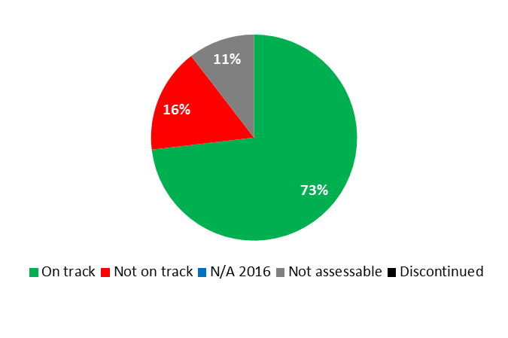

EXTERNAL RELATIONS, PARTNERSHIPS

|  |  |  |  |  |
| --- | --- | --- | --- | --- |
| **Expected Result:** VIII.5 WIPO effectively interacts and partners with UN and other IGO processes and negotiations | | | | |
| **Performance Indicators** | **Baselines** | **Targets** | **Performance Data** | **TLS** |
| WIPO's contributions reflected in UN and IGO reports, resolutions and documents from relevant, targeted processes | *Updated Baseline*  *end 2015:*  33 submissions in 2014/15, all of which were satisfactorily reflected.  *Original Baseline*  *P&B 2016/17:*  2012/13 – 38 out of 38;  2014 12 out of 15, 3 on-going | 80% | 80% of WIPO's contributions (26 out of 33 submissions) were reflected (end 2016) | **On track** |
| No. of WIPO-led initiatives in partnership with UN and other IGOs related to implementation of the SDGs | None | 5 | 3 initiatives | **On track** |

EXTERNAL OFFICES

|  |  |  |  |  |  |  |  |  |  |  |  |
| --- | --- | --- | --- | --- | --- | --- | --- | --- | --- | --- | --- |
| **Expected Result:** I.1 Enhanced cooperation among Member States on development of balanced international normative frameworks for IP | | | | | | | | | | | |
| **Performance Indicators** | **Baselines** | | **Targets** | | | **Performance Data** | | | **TLS** | | | |
| No. of ratifications and/or accessions to Marrakesh Treaty | *Updated Baseline end 2015:*  1 (WBO)  0 (WOC)  0 (WJO)  0 (WRO)  1 (WSO) (Singapore)  *Original Baseline P&B 2016/17:*  0 (all EOs) | | *Updated Target:*  1 WOC  1 WJO  1 WRO  2 additional WSO  *Original Target P&B 2016/17:* 1 (WBO, WOC, WJO, WRO),  2 (WSO) | | | 0 (WOC)  0 (WJO)  0 (WRO)  No additional (WSO) | | | **Not on track** | | | |
| No. of ratifications and/or accessions to Beijing Treaty | | *Updated Baseline end 2015:*  0 (WSO) 1 (WRO)  *Original Baseline P&B 2016/17:*  0 (WSO), 0 (WRO) | | *Updated Target:*  2 (WSO)  *Original Target P&B 2016/17:*  2 (WSO), 1 (WRO) | | | 0 (WSO) | | | **Not on track** | | |
| No. of ratifications and/or accessions to Singapore Treaty | | 0 (WJO)  1 (WSO) | | 1 (WJO)  1 additional (WSO) | | | 1 (WJO)  Progress made towards possible accessions (WSO) | | | **On track** | | |
| No. of ratifications and/or accessions to the Internet Treaties | | WIPO Copyright Treaty: 4 (WSO) WIPO Performances and Phonograms Treaty: 4 (WSO) | | 1 additional (WSO)  1 additional (WSO) | | | Progress made towards possible accessions (WSO) | | | **On track** | | |
| **Expected Result:** II.1 Wider and more effective use of the PCT system for filing international patent applications | | | | | | | | | | | | |
| **Performance Indicators** | | **Baselines** | | **Targets** | | | **Performance Data** | | | **TLS** | | |
| No. of PCT applications | | *Updated Baseline end 2015[81]:*   |  |  | | --- | --- | | * 2015: 548 | (WBO) | | * 2014: 580 |  |  |  | | --- | --- | | * 2015: 29,838 | (WOC) | | * 2014: 25,548 |  |  |  | | --- | --- | | * 2015: 44,053 | (WJO) | | * 2014: 42,381 |  |  |  | | --- | --- | | * 2015: 876 | (WRO) | | * 2014: 948 |  |  |  | | --- | --- | | * 2015: 1,369 | (WSO) | | * 2014: 1,382 |   *Original Baseline P&B 2016/17:*  1,387 (in 2014) (WSO) 581 (in 2014) (WBO) 42,459 (in 2014) (WJO)890 (in 2014) (WRO)25,539 (in 2014) (WOC) | | Annual increase of 2% (all Offices) | | | |  |  |  | | --- | --- | --- | | WBO: | 568 | (+3.7%) | | WOC: | 43,128 | (+45%) | | WJO: | 45,220 | (+2.7%) | | WRO: | 805 | (-8.1%) | | WSO: | 1,285 | (-6.1%) | | | | |  | | --- | | **On track** | | **On track** | | **On track** | | **Not on track** | | **Not on track** | | | |
| % of policy makers, government officials, and IP practitioners and participants in targeted workshops with enhanced understanding of PCT and related topics | | *Updated Baseline end 2015:*  75% (WBO)  91% (WJO)  95% (WSO)  *Original Baseline P&B 2016/17:*  93% (WSO)  75% (WBO)  94% (WJO) | | 75% (all Offices) | | | No data available (WBO)  81% (WJO)  94% (WSO) | | | **Not assessable**  **On track**  **On track** | | |
| **Expected Result:** II.4 Wider and more effective use of the Hague system, including by developing countries and LDCs | | | | | | | | | | | | |
| **Performance Indicators** | | **Baselines** | | **Targets** | | | **Performance Data** | | | **TLS** | | |
| Membership of the Geneva (1999) Act | | 2 (WSO) 0 (WRO) | | 3 additional (WSO)  1 (WRO) | | | 0 (WSO)  0 (WRO) | | | **Not on track** | | |
| No. of Hague applications | | *Updated Baseline end 2015:*  34 (WSO) (2015) (-3%) 128 (WJO) (2015)  *Original Baseline P&B 2016/17:*  50 (WSO) (2014) 0 (WJO) (2014) | | 2% annual growth | | | 348 (WJO) (+172%)  50 (WSO) (+4.7%) | | | **On track** | | |
| % of policy makers, government officials, and IP practitioners and participants in targeted workshops with enhanced understanding of the Hague System | | *Updated Baseline end 2015:*  75% (WBO)  94% (WJO)  88% (WSO)  *Original Baseline P&B 2016/17:*  85% (WSO)  75% (WBO)  94% (WJO) | | | *Updated Target:*  85%  *Original Target P&B 2016/17:*  75% | | | No data available (WBO)  62% (WJO)  86% (WSO) | | | **Not assessable**  **Not on track**  **On track** | |
| **Expected Result:** II.6 Wider and more effective use of the Madrid System, including by developing countries and LDCs | | | | | | | | | | | | |
| **Performance Indicators** | | **Baselines** | | **Targets** | | | **Performance Data** | | | **TLS** | | |
| Total Membership of the Madrid System | | *Updated Baseline end 2015:*  Cambodia, Lao Democratic People’s Republic[82], Philippines, Singapore, Viet Nam (WSO)  (5 cumulative)  *Original Baseline P&B 2016/17:*  4 (WSO) | | 5 additional (WSO) | | | No additional (WSO) | | | **Not on track** | | |
| No. of Madrid applications | | *Updated Baseline end 2015:*  0 (WBO) 2,321 (WOC) (+8%)  2,167 (WJO) (+6.6%) 1,059 (WRO) (-31%) 509 (WSO) (+45%)  *Original Baseline P&B 2016/17:*  351 (WSO) 0 (WBO) 2,033 (WJO) 1,543 (WRO)  2,140 (WOC) | | 2% annual growth (all Offices) | | | |  |  |  | | --- | --- | --- | | 0 | WBO |  | | 3,014 | WOC | +31% | | 2,281 | WJO | +5.3% | | 1,255 | WRO | +18.5% | | 614 | WSO | +20% | | | | **Not assessable**   |  | | --- | | **On track** | | **On track** | | **On track** | | **On track** | | | |
| % of policy makers, government officials, IP practitioners and participants in targeted workshops with enhanced understanding of the Madrid System | | *Updated Baseline end 2015:*  90% (WSO)  *Original Baseline P&B 2016/17:*  89% based on feedback from participants (WSO) | | *Updated Target:*  85%  *Original Target P&B 2016/17:*  75% | | | 86% (WSO) | | | **On track** | | |
| **Expected Result:** III.2 Enhanced human resource capacities able to deal with the broad range of requirements for the  effective use of IP for development in developing countries, LDCs and countries with economies in transition | | | | | | | | | | | | |
| **Performance Indicators** | **Baselines** | | **Targets** | | | **Performance Data** | | | **TLS** | | | |
| % of policy makers, governments officials, IP practitioners and other targeted groups, including universities, CMOs, journalists, with enhanced understanding of IP policies, and how to effectively use IP development | *Updated Baseline end 2015:*  75% (WBO)  100% (WJO)  100% (WSO)  *Original Baseline P&B 2016/17:*  100% of participants agreed that the skills and knowledge gained from the seminar added value to their organization (WSO) 75% (WBO) N/A (in 2014 WJO did not organize seminars) (WJO) | | *Updated Target:*  85%  *Original Target P&B 2016/17:*  75% | | | Data not available (WBO)  100% (WJO)  87% (WSO) | | | **Not assessable**  **On track**  **On track** | | | |
| **Expected Result:** IV.2 Enhanced access to, and use of, IP information by IP institutions and the public to promote innovation and creativity | | | | | | | | | | | | |
| **Performance Indicators** | **Baselines** | | **Targets** | | | **Performance Data** | | | **TLS** | | | |
| No. of users of WIPO’s Global Databases: PATENTSCOPE,  Global Brands Database, Global Designs Database | *Updated Baseline end 2015:*  2014/15:  PATENTSCOPE:   * WBO (8,533) * WOC (27,454) (2015 only) * WJO (30,743) * WRO (6,292) (2015 only) * WSO (15,525)   GBD:   * WBO (1,036) * WOC (3,181) (2015 only) * WJO (6,883) * WRO (2,475) (2015 only) * WSO (24,947)   GDD: (2015 only)   * WBO (107) * WOC (420) * WJO (1,736) * WRO (516) * WSO (437)   *Original Baseline P&B 2016/17:*   |  |  | | --- | --- | | PATENTSCOPE: | GBD: | | 8,054 (WSO) | 9,162 (WSO) | | 4,688 (WBO) | 596 (WBO) | | 14,711 (WJO) | 2,871 (WJO) | | 6,257 (WRO) | 2,352 (WRO) | | 56,355 (WOC) | 3,398 (WOC) |   Designs Database: n/a | | 5% increase (biennial)  5% increase  (biennial)  5% increase  (biennial) | | | |  |  | | --- | --- | | PATENTSCOPE: | | | 4,531 | (WBO) | | | 29,122 | (WOC) | | | 23,226 | (WJO) | | | 8,152 | (WRO) | | | 8,912 | (WSO) | | | GBD: | | | 647 | (WBO) | | | 8,061 | (WOC) | | | 5,964 | (WJO) | | | 3,914 | (WRO) | | | 34,217 | (WSO) | | | GDD: | | | 221 | (WBO) | | | 1,531 | (WOC) | | | 1,754 | (WJO) | | | 1,010 | (WRO) | | | 576 | (WSO) | | | | | **On track**  **On track**  **On track**  **On track**  **On track**  **On track**  **On track**  **On track**  **On track**  **On track**  **On track**  **On track**  **Not on track**  **On track**  **On track** | | | |
| No. of sustainable[83] national TISCs network(s) | *Updated Baseline end 2015:*  WOC: 0  WSO: 2  - 1 Maturity Level 1  - 1 Maturity Level 3  *Original Baseline P&B 2016/17:*  2 (WSO) 0 (WOC) | | 1 (WOC)  2 additional (WSO) | | | 0 (WOC)  3 (WSO):  - 1 Maturity Level 1  - 1 Maturity Level 2  - 1 Maturity Level 3 | | | **On track** | | | |
| **Expected Result:** IV.4 Enhanced technical and knowledge infrastructure for IP Offices and other IP institutions leading to better services (cheaper, faster, higher quality) to their stakeholders and better outcome of IP Administration | | | | | | | | | | | | |
| **Performance Indicators** | **Baselines** | | **Targets** | | | **Performance Data** | | | **TLS** | | | |
| No. of offices using WIPO Infrastructure Platforms | *Updated Baseline end 2015:*  0 (WBO)  8 (WSO) (Brunei Darussalam, Indonesia, Lao People’s Democratic Republic, Malaysia, Philippines, Singapore, Thailand, Viet Nam  *Original Baseline P&B 2016/17:*  7 (WSO)  0 (WBO) | | *Defined Target:*  1 (WBO)  1 additional (WSO)  *Original Target  P&B 2016/17:*  Tbd (WSO)  1 (WBO) | | | 0 (WBO)  1 additional (Cambodia) (WSO) (9 cumulative) | | | **On track** | | | |
| **Expected Result:** VII.2 IP-based platforms and tools for knowledge transfer, technology adaptation and diffusion from developed to developing countries, particularly least developed countries, to address global challenges | | | | | | | | | | | | |
| **Performance Indicators** | **Baselines** | | **Targets** | | | **Performance Data** | | | **TLS** | | | |
| Participation of stakeholders in WIPO's platforms such as WIPO GREEN and WIPO Re: Search | *Updated Baseline end 2015:*  WIPO Re:Search:  2 for the LAC region (WBO)  2 (WOC)  2 (WJO)  0 (WRO)  3 (WSO)  Total 9  WIPO GREEN*:*  16 for the LAC region (WBO)  26 (WOC)  54 (WJO)  0 (WRO)  32 (WSO)  Total 128  *Original Baseline P&B 2016/17:*  WIPO GREEN  21 (WSO)  48 for the LAC region (WBO)  45 (WJO)  1 (WRO)  29 (WOC)  WIPO Re:Search: n/a | | 20% increase both WIPO GREEN and Re:Search  (all Offices) | | | WIPO Re:Search:  7 for LAC region (WBO)  2 (WOC)  2 (WJO)  0 (WRO)  6 (WSO)  Total 16  WIPO GREEN*:*  78 for LAC region (WBO)  34 (WOC)  70 (WJO)  0 (WRO)  43 (WSO)  Total 225 | | | **On track**  **Not on track**  **Not on track**  **Not assessable**  **On track**  **On track**  **On track**  **On track**  **Not assessable**  **On track** | | | |
| **Expected Result:** VIII.1 More effective communication to a broad public about intellectual property and WIPO’s role | | | | | | | | | | | | |
| **Performance Indicators** | **Baselines** | | **Targets** | | | **Performance Data** | | | **TLS** | | | |
| Increased traffic to the website of WIPO External Offices | *Updated Baseline end 2015:*  1,966 (WBO)  4,204 (WOC)  7,027 (WJO)  4,327 (WRO)  10,042 (WSO)  *Original Baseline P&B 2016/17:*  9,882 (WSO)  WBO & WJO: tbd  0 (WRO)  0 (WOC) | | 5% increase all Offices | | | 2,932 (WBO) (+49%)  4,722 (WOC) (+12%)  7,724 (WJO) (+10%)  5,894 (WRO) (+36%)  7,752 (WSO) (-23%) | | | **On track**  **On track**  **On track**  **On track**  **Not on track** | | | |
| **Expected Result:** VIII.2 Improved service orientation and responsiveness to inquiries | | | | | | | | | | | |
| **Performance Indicators** | **Baselines** | | **Targets** | | | **Performance Data** | | | **TLS** | | |
| Processing time of inquiries | *Updated Baseline end 2015:*   * Data not available (WBO) * Data not available (WOC) * Response prepared within 3 working days in 99% of cases (WJO) * Data not available (WRO) * Responses prepared within 3 working days in 95% of cases (WSO)   *Original Baseline P&B 2016/17:*  48h (all Offices) | | 36h (all Offices) | | | Responses prepared within:   * Data not available (WBO) * 90% within 24h (WOC) * 100% within 24h (WJO) * 100% within 24h (WRO) * 100% within 24h (WSO) | | | **Not assessable**  **On track**  **On track**  **On track**  **On track** | | |
| **Expected Result:** VIII.5 WIPO effectively interacts and partners with UN and other IGO processes and negotiations | | | | | | | | | | | |
| **Performance Indicators** | | **Baselines** | | **Targets** | | | **Performance Data** | | | **TLS** | | |
| No. of joint activities with ASEAN Secretariat, ECAP/OHIM, Asia/Europe Foundation, AANZFTA | | 11 (WSO) | | 8 additional | | | 4 additional joint activities:   * ASEAN-USPTO Workshop on Using IP to Protect and Promote Traditional Arts and Crafts, Bangkok, September 6-8 * 1st Session of the UNESCAP Committee on Information and Communications Technology, Science, Technology and Innovation,  Bangkok,   October 5-7   * 7th Informal Meeting of IP Technical Assistance Providers (IPTAP) to the ASEAN countries, Bangkok, November 17 * Regional Seminar on Geographical Indications, organized by ECAP III, Manila, November 28-29,   (15 cumulative) | | | **On track** | | |

|  |
| --- |
| **Resource Utilization for Program 20** |

Budget and Actual Expenditure (by result)

*(thousands of Swiss francs)*

|  |  |  |  |  |
| --- | --- | --- | --- | --- |
| **Expected Result No. and Description** | | **2016/17 Approved Budget** | **2016/17 Budget after Transfers** | **2016 Expenditure\*** |
| I.1 | Enhanced cooperation among Member States on development of balanced international normative frameworks for IP | 685 | 679 | 372 |
| II.1 | Wider and more effective use of the PCT system for filing international patent applications | 857 | 904 | 398 |
| II.4 | Wider and more effective use of the Hague system, including by developing countries and LDCs | 729 | 535 | 213 |
| II.6 | Wider and more effective use of the Madrid & Lisbon Systems, including by developing countries and LDCs | 789 | 526 | 229 |
| III.2 | Enhanced human resource capacities able to deal with the broad range of requirements for the effective use of IP for development in developing countries, LDCs and countries with economies in transition | 858 | 1,516 | 582 |
| IV.2 | Enhanced access to, and use of, IP information by IP institutions and the public to promote innovation and creativity | 1,209 | 1,075 | 433 |
| IV.4 | Enhanced technical and knowledge infrastructure for IP Offices and other IP institutions leading to better services (cheaper, faster, higher quality) to their stakeholders and better outcome of IP Administration | 264 | 43 | 32 |
| VII.2 | IP-based platforms and tools for knowledge transfer, technology adaptation and diffusion from developed to developing countries, particularly least developed countries, to address global challenges | 452 | 456 | 207 |
| VIII.1 | More effective communication to a broad public about intellectual property and WIPO’s role | 878 | 1,521 | 535 |
| VIII.2 | Improved service orientation and responsiveness to inquiries | 544 | 486 | 190 |
| VIII.4 | Open, transparent and responsive interaction with non-governmental stakeholders | 666 | 207 | 87 |
| VIII.5 | WIPO effectively interacts and partners with UN and other IGO processes and negotiations | 4,152 | 4,098 | 1,862 |
| IX.1 | Effective, efficient, quality and customer-oriented support services both to internal clients and to external stakeholders | 311 | 132 | 38 |
|  | **Total** | 12,395 | 12,178 | 5,177 |
| *\*2016 Expenditure numbers are preliminary, subject to audit by External auditors* | | | |  |

Budget and Actual Expenditure (personnel and non-personnel)

*(thousands of Swiss francs)*

|  |  |  |  |  |
| --- | --- | --- | --- | --- |
|  | **2016/17 Approved Budget** | **2016/17 Budget after Transfers** | **2016 Expenditure\*** | **Utilization rate (%)** |
| Personnel Resources | 9,525 | 9,102 | 3,895 | 43% |
| Non-personnel Resources | 2,869 | 3,077 | 1,282 | 42% |
| **Total** | **12,395** | **12,178** | **5,177** | **43%** |
| *\*2016 Expenditure numbers are preliminary, subject to audit by External auditors* | | | | |

*NOTE: The 2016/17 Budget after Transfers reflects transfers as of March 8, 2017 to address needs during the 2016/17 biennium in line with Financial Regulation 5.5.*

A. 2016/17 Budget after Transfers

1. The increase in non-personnel resources was due to: (i) the allocation of additional funds to cover the operational needs of the WIPO Coordination Office in New York in 2017 reflected under Expected Results VIII.5 (WIPO effectively interacts with and partners with UN and other IGO processes and negotiations); and (ii) the transfer of funds to the WIPO Office in China (WOC) for the high-level Conference on Building Respect for IP, Shanghai, November 2016.
2. The net decrease in personnel resources as compared to the 2016/17 Approved Budget primarily reflected, on the one hand, the transfer into the Program of additional staff to strengthen the work of the External Offices, including the Director of the WIPO Office in the Russian Federation (WRO) and two National Professional Officers in the WOC; and on the other hand, the transfer out of personnel resources, including: (i) the temporary transfer of one post to support priorities in Communications (Program 19), reflected under Expected Result VIII.4 (Open, transparent and responsive interaction with non-governmental stakeholders); (ii) the transfer of a temporary position to support the prioritization of the work on the Technology Innovation Support Centers (Program 14); (iii) the temporary transfer of one post to support the Madrid Reform Initiative (Program 6); and (iv) the transfer of accrued savings to accommodate other organizational priorities. The impact of the latter two is reflected across the Expected Results.
3. The increase in resources allocated to: (i) Expected Result III.2 (Enhanced human resource capacities) reflected an increased focus among the External Offices on capacity building; and (ii) Expected Result VIII.1 (More effective communication to a broad public) reflected a greater focus among the External Offices on awareness raising on and promotion of WIPO.

B. 2016/17 Budget Utilization

1. Budget utilization was within the expected range of 40-60 per cent for the first year of the biennium.

## STRATEGIC GOAL IX

**EFFICIENT ADMINISTRATIVE AND FINANCIAL SUPPORT**

**Mid-term Performance Dashboard (2016)**

The dashboard below provides a summary of the progress towards the achievement of the Results in the 2016 as measured by the indicators under the Programs contributing to this Strategic Goal.

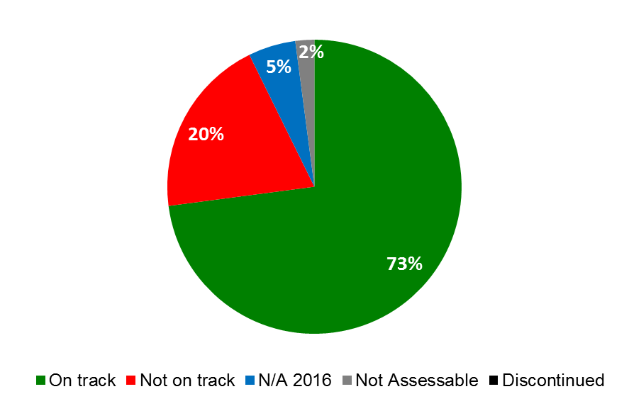



| **Expected Results** | **Performance Indicators** | **Responsible Program(s)** | **TLS** |
| --- | --- | --- | --- |
| IX.1 Effective, efficient, quality and customer-oriented support services both to internal clients and to external stakeholders | % of queries for legal advice and services which receive prompt responses from OLC | Program 21 | ⚫ |
| Provision of financial and management reports and analysis required by senior management, Program Managers and Member States in accordance with agreed deadlines | Program 22 | ⚫ |
| No. of PBC documents submitted on time to the Member States | Program 22 | ⚫ |
|  | WIPO’s ERP system (AIMS) is operating efficiently according to business needs and in line with best practices | Program 22 | ⚫⚫⚫ |
|  | ERP projects are delivered according to plan and within the budget of the portfolio | Program 22 | ⚫ |
|  | % of staff satisfied with human resource services | Program 23 | ⚫ |
|  | Increase in automated versus currently manually-processed actions | Program 23 | ⚫ |
|  | % of queries processed within 5 working days | Program 23 | ⚫ |
|  | Optimized insurance coverage | Program 23 | ⚫ |
|  | Cost savings for goods and services procured by WIPO (derived from RFPs or direct negotiations) | Program 24 | ⚫ |
|  | Processing time ER | Program 24 | ⚫ |
|  | Processing time ETA | Program 24 | ⚫ |
|  | Processing time Visa | Program 24 | ⚫ |
|  | TMC average ticket fare | Program 24 | ⚫ |
|  | Global average ticket fare | Program 24 | ⚫ |
|  | Average service fee | Program 24 | ⚫ |
|  | WIPO premises and installations remain fit for purpose | Program 24 | ⚫ |
|  | Optimum use and occupation of WIPO premises and all types of space | Program 24 | ⚫ |
|  | % of high value items (e.g >5,000 Swiss francs) inventoried | Program 24 | ⚫ |
|  | % of value items 1,000-5,000 Swiss francs, works of arts and attractive items | Program 24 | ⚫⚫ |
|  | ICT Platforms are cost-effectively hosted and managed in line with business demands | Program 25 | ⚫⚫⚫⚫  ⚫ |
|  | Application development activities adhere to the WIPO reference and master data standards | Program 25 | ⚫ |
|  | % of customers that are satisfied with the Service Desk services | Program 25 | ⚫ |
|  | ICT Projects in WIPO are managed in accordance with the WIPO Project Management Guidelines and WIPO Service Transition Guidelines | Program 25 | ⚫⚫ |
|  | % of internal and external participants satisfied with WIPO Conference Services | Program 27 | ⚫ |
|  | Effective implementation of WIPO Language Policy | Program 27 | ⚫⚫ |
|  | Reduction in printing costs (per page) | Program 27 | ⚫ |
|  | Timely publication of documents for Committees and Working Groups | Program 27 | ⚫ |
|  | Cost per word of translation | Program 27 | ⚫ |
|  | IA governance defined and enforced | Program 28 | ⚫ |
|  | No. of staff aware of their information security responsibilities, security policies and best practices | Program 28 | ⚫ |
| IX.2 An agile and smooth functioning Secretariat with a well-managed and appropriately skilled workforce which is effectively delivering results | Establishment of a new Organizational Resilience and Business Continuity framework and associated documentation | Program 21 | ⚫ |
| Satisfactory financial report from the External Auditors confirms the conformity of financial operations to the provisions of the applicable WIPO conventions and treaties, the WIPO Financial Regulations and Rules and IPSAS | Program 22 | ⚫ |
|  | Enhanced maturity of managing for results (RBM) | Program 22 | ⚫ |
|  | Return on invested funds in line with benchmarks established by the Investment Advisory Committee (IAC) | Program 22 | ⚫ |
|  | Effective management of expenditure and reserves | Program 22 | ⚫ |
|  | Payments (including Madrid and Hague fees) made on time | Program 22 | ⚫⚫⚫ |
|  | % of women in professional and higher positions | Program 23 | ⚫⚫⚫⚫ |
|  | Recruitment lead time | Program 23 | ⚫ |
|  | % of staff whose performance is evaluated against their individual objectives and competencies | Program 23 | ⚫ |
|  | No. of days to: (i) notify staff of decisions on RfR/grievances,( ii) notify staff of decisions on rebuttals/disciplinary cases and (iii) provide responses to requests for advice | Program 23 | ⚫⚫⚫ |
|  | Geographical diversity:% of Staff per region | Program 23 | ⚫ |
|  | No. of applications received from unrepresented Member States as a % of total | Program 23 | ⚫ |
|  | Enhanced maturity of HR Planning | Program 23 | ⚫ |
|  | % of trainings needs fulfilled of which: (i) critical collective training needs and (ii) individual training needs | Program 23 | ⚫⚫ |
| IX.3 An enabling working environment supported by an effective regulatory framework and appropriate channels to address staff concerns | % of WIPO staff aware of services available from Ombuds-Office and informal conflict resolution mechanism | Program 21 | ⚫ |
| % of WIPO staff being aware of WIPO ethics principles and policies | Program 21 | ⚫ |
|  | Financial Regulations and Rules and relevant Office Instructions (OIs) up to date | Program 22 | ⚫ |
|  | Increase in maturity of Risk Management and Internal controls, in accordance with the Roadmap | Program 22 | ⚫⚫ |
|  | Effective follow-up of oversight recommendations | Program 22 | ⚫⚫⚫ |
| IX.4 An environmentally and socially responsible Organization in which WIPO staff, delegates, visitors and information and physical assets are safe and secure | Reduced impact of WIPO activities on the environment | Program 24 | ⚫⚫⚫⚫⚫ |
| Improved physical access to the WIPO campus | Program 24 | ⚫⚫ |
| ICT service continuity of critical systems | Program 25 | ⚫ |
|  | % of information risks, including third party risks, reported and managed consistently within WIPO's risk tolerances | Program 28 | ⚫⚫ |
|  | Proactive identification and timely remediation of vulnerabilities within agreed service levels | Program 28 | ⚫ |
|  | Increased compliance to IA policies and standards | Program 28 | ⚫ |
|  | Widely adopted information classification and handling policy to ensure confidentiality of information | Program 28 | ⚫ |
|  | Reduced duplication of information security technical capabilities through reusable security architecture patterns | Program 28 | ⚫ |
|  | Enhanced capability to detect and respond to information security threats much faster ensuring minimal business disruption | Program 28 | ⚫ |
|  | % of WIPO staff, delegates and visitors reporting a work related injury or incident | Program 28 | ⚫ |
|  | % of Conference and Events supported by security inside and outside Geneva[84] | Program 28 | ⚫ |
| IX.8 Improved accountability, organizational learning, value for money, stewardship, internal control and corporate governance through assistance from effective and independent oversight | INDEPENDENCE - No interference and perceived independence by key stakeholders | Program 26 | ⚫ |
| EFFECTIVENESS - % of work that covers high risk, relevant areas aligned with the Organization’s Strategy | Program 26 | ⚫ |
| EFFICIENCY - IOD's reports are issued timely with SMART recommendations | Program 26 | ⚫⚫⚫ |
|  | ORGANIZATIONAL LEARNING - Uptake of Lessons and Recommendations from Oversight Processes | Program 26 | ⚫⚫ |
|  | RELEVANCE, ADDED VALUE & STEWARDSHIP- Tangible cost savings or improvements made in business processes and systems | Program 26 | ⚫⚫ |

### PROGRAM 21 EXECUTIVE MANAGEMENT

**Program Manager Director General**

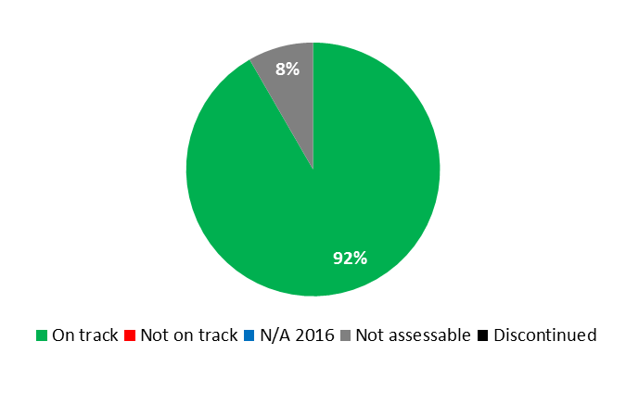

|  |  |  |  |  |
| --- | --- | --- | --- | --- |
| **Expected Result:** IV.2Enhanced access to, and use of, IP information by IP institutions and the public to promote innovation and creativity | | | | |
| **Performance Indicators** | **Baselines** | **Targets** | **Performance Data** | **TLS** |
| Increase in the no. of WIPO Lex users | *Updated Baseline end 2015:*  3,350,643 (2014/15)   * 1,844,135 (2015) * 1,506,508 (2014)   *Original Baseline  P&B 2016/17:*  2,236,486 (2012/13)  1,506,508 (2014) | *Updated Target:*  20% biennial increase  *Original Target  P&B 2016/17:*  20% increase | 2,044,648 (+10.9% as compared to 2015) | **On track** |
| **Expected Result:** VIII.3 Effective engagement with Member States | | | | |
| **Performance Indicators** | **Baselines** | **Targets** | **Performance Data** | **TLS** |
| % of Committee meetings for which pre-Committee information meetings for Member States are held | *Updated Baseline end 2015:*  97% from a survey of secretaries of committees  *Original Baseline  P&B 2016/17:*  93% (end 2014) | 90% | 100% from a survey of secretaries of committees | **On track** |
| % of adherence and other WIPO Treaty-related actions by Member States processed in a timely manner | *Updated Baseline end 2015:*  90% of notifications of adherence and other treaty related actions processed within three days  *Original Baseline  P&B 2016/17:*  95% processed within three days (end 2014) | 95% processed within three days | 91% (39 out of 43) of all treaty actions processed within 3 days | **On track** |
| Timeliness of publication of Assemblies documents | *Updated Baseline end 2015:*  In 2014/15, 97% of all relevant documents were published two months before the Assemblies  *Original Baseline  P&B 2016/17:*  In 2014, 95% of all relevant documents were published two months before the Assemblies | 95% of all relevant documents published two months before the Assemblies | 93.5% of all relevant documents published two months before the Assemblies | **On track** |
| Satisfaction rate of Member States and stakeholders with the organization of events | *Updated Baseline end 2015:*  91% Member States satisfaction with events  (2015 WIPO Assemblies Survey)  *Original Baseline  P&B 2016/17:*  2014 survey results: 82% | *Updated Target:*  90% satisfied with events  *Original Target  P&B 2016/17:*  85% | 87% Member States satisfaction with events (2016 WIPO Assemblies Survey) | **On track** |
| Delegates’ satisfaction levels with the organization of the Assemblies | *Updated Baseline end 2015:*  90% satisfied with arrangements (2015 WIPO Assemblies Survey)  *Original Baseline  P&B 2016/17:*  87% satisfied with arrangements (2014 WIPO Assemblies Survey) | 80% satisfied with arrangements | 94% satisfied with arrangements (2016 WIPO Assemblies Survey) | **On track** |
| **Expected Result:** VIII.4 Open, transparent and responsive interaction with non-governmental stakeholders | | | | |
| **Performance Indicators** | **Baselines** | **Targets** | **Performance Data** | **TLS** |
| No. of permanent observer NGOs engaging in WIPO's work and vice versa | *Updated Baseline end 2015:*  In 2014/15, 488 representatives of permanently accredited NGOs attended WIPO committee meetings  *Original Baseline  P&B 2016/17:*  tbd | Maintain or increase engagement | 259 permanently accredited NGOs attended WIPO committee meetings, representing 53% of the total number of NGOs attending such meetings in the 2014/15 biennium | **On track** |
| **Expected Result:** VIII.5 WIPO effectively interacts and partners with UN and other IGO processes and negotiations | | | | |
| **Performance Indicators** | **Baselines** | **Targets** | **Performance Data** | **TLS** |
| New joint initiatives with other UN agencies/IGOs | *Updated Baseline end 2015:*  Two new initiatives undertaken by the Director General:   * Application for Observer Status to the International Organization for Migration (IOM) in 2014; * Membership in 2015 of the United Nations Interagency Working Group on a Technology Facilitation Mechanism (IAWG) (established by the Addis Ababa Action Agenda)   *Original Baseline  P&B 2016/17:*  One (2014) | Two | WIPO, WHO, WTO Joint Technical Symposium on Antimicrobial Resistance (AMR): How to Foster Innovation, Access and Appropriate Use of Antibiotics, hosted by WIPO, Geneva, October 26, 2016 (1 joint initiative chaired by the Director General) | **On track** |
| **Expected Result:** IX.1 Effective, efficient, quality and customer-oriented support services both to internal clients and to external stakeholders | | | | |
| **Performance Indicators** | **Baselines** | **Targets** | **Performance Data** | **TLS** |
| % of queries for legal advice and services which receive prompt responses from OLC | *Updated Baseline end 2015:*  95% in 2014/15  *Original Baseline  P&B 2016/17:*  95% | 95% | 95% of queries received prompt responses from OLC | **On track** |
| **Expected Result:** IX.2 An agile and smooth functioning Secretariat with a well-managed and appropriately skilled workforce which is effectively delivering results | | | | |
| **Performance Indicators** | **Baselines** | **Targets** | **Performance Data** | **TLS** |
| Establishment of a new  Organizational Resilience and Business Continuity  framework and associated  documentation | Current framework is not  comprehensive and needs  to be replaced | Organizational Resilience and Business Continuity strategies and plans drawn up for the core areas of the Organization | - 1 Pandemic Plan was developed and published  - 15 Business Impact Analyses were carried out for the Organization’s critical business functions, supporting functions and critical data/systems functions | **On track** |
| **Expected Result:** IX.3 An enabling working environment supported by an effective regulatory framework and appropriate channels to address staff concerns | | | | |
| **Performance Indicators** | **Baselines** | **Targets** | **Performance Data** | **TLS** |
| % of WIPO staff aware of  services available from Ombuds-Office and informal conflict resolution mechanism | *Updated Baseline end 2015:*  The Staff feedback survey planned for 2015 was not conducted  *Original Baseline  P&B 2016/17:*  2013 Survey: 63% fully aware. Another survey is planned in 2015. | 70% | No survey conducted in 2016 | **Not assessable** |
| % of WIPO staff being aware of WIPO ethics principles and policies | *Updated Baseline end 2015:*  The Staff survey planned for the biennium was not conducted  *Original Baseline  P&B 2016/17:*  98% from the SRP Core Values Survey (conducted in 2013). Another survey is planned in 2015. | 95% of staff awareness | 86% (2016 Ethics Office Survey) | **On track** |

|  |
| --- |
| **Resource Utilization for Program 21** |

Budget and Actual Expenditure (personnel and non-personnel)

*(thousands of Swiss francs)*

|  |  |  |  |  |
| --- | --- | --- | --- | --- |
|  | **2016/17 Approved Budget** | **2016/17 Budget after Transfers** | **2016 Expenditure\*** | **Utilization rate (%)** |
| Personnel Resources | 18,130 | 16,254 | 7,988 | 49% |
| Non-personnel Resources | 2,545 | 3,185 | 1,441 | 45% |
| **Total** | **20,675** | **19,439** | **9,429** | **49%** |
| *\*2016 Expenditure numbers are preliminary, subject to audit by External auditors* | | | | |

*NOTE: The 2016/17 Budget after Transfers reflects transfers as of March 8, 2017 to address needs during the 2016/17 biennium in line with Financial Regulation 5.5.*

Budget and Actual Expenditure (by result)

*(thousands of Swiss francs)*

|  |  |  |  |  |
| --- | --- | --- | --- | --- |
| **Expected Result No. and Description** | | **2016/17 Approved Budget** | **2016/17 Budget after Transfers** | **2016 Expenditure\*** |
| IV.2 | Enhanced access to, and use of, IP information by IP institutions and the public to promote innovation and creativity | 2,357 | 265 | 271 |
| VIII.1 | More effective communication to a broad public about intellectual property and WIPO’s role | 0 | 109 | 15 |
| VIII.3 | Effective engagement with Member States | 7,099 | 7,040 | 3,459 |
| VIII.4 | Open, transparent and responsive interaction with non-governmental stakeholders | 462 | 374 | 188 |
| VIII.5 | WIPO effectively interacts and partners with UN and other IGO processes and negotiations | 157 | 132 | 61 |
| IX.1 | Effective, efficient, quality and customer-oriented support services both to internal clients and to external stakeholders | 3,694 | 3,649 | 1,736 |
| IX.2 | An agile and smooth functioning Secretariat with a well managed and appropriately skilled workforce which is effectively delivering results | 5,992 | 6,961 | 3,231 |
| IX.3 | An enabling working environment supported by an effective regulatory framework and appropriate channels to address staff concerns | 914 | 909 | 468 |
|  | **Total** | 20,675 | 19,439 | 9,429 |
| *\*2016 Expenditure numbers are preliminary, subject to audit by External auditors* | | | |  |

A. 2016/17 Budget after Transfers

1. The reduction in personnel resources as compared to the 2016/17 Approved Budget was mainly due to the transfer of WIPO Lex to Global Databases Service (Program 13). This is reflected by a decrease in resources under Expected Result IV.2 (Enhanced access to IP information).
2. The increase in non-personnel resources was primarily due to the transfer of additional resources to the Program for: (i) the organization of the WIPO International Conference on the Global Digital Content Market; (ii) the organization of various events on WIPO premises; and (iii) protocol-related activities, all reflected under Expected Result VIII.3 (Effective engagement with Member States); and (iv) hospitality costs related to the WIPO Assemblies, reflected under Expected Result IX.3 (An enabling working environment). In addition, some resources were re-shuffled between Expected Results VIII.3 and IX.2 (An agile and smooth functioning Secretariat) in line with the 2016 workplans.

B. 2016/17 Budget Utilization

1. Budget utilization was within the expected range of 40-60 per cent for the first year of the biennium.

### PROGRAM 22 PROGRAM AND RESOURCE MANAGEMENT

**Program Manager Mr. A. Sundaram**

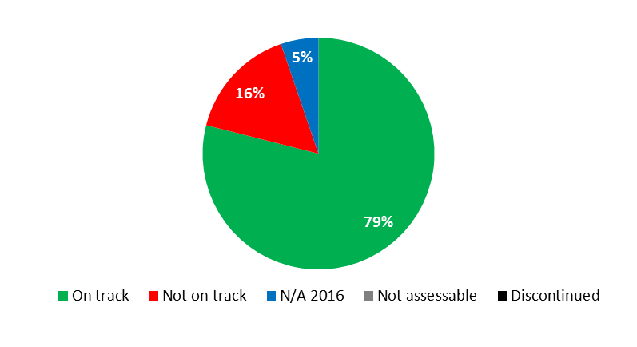

|  |  |  |  |  |
| --- | --- | --- | --- | --- |
| **Expected Result:**  IX.1 Effective, efficient, quality and customer-oriented support services both to internal clients and to external stakeholders | | | | |
| **Performance Indicators** | **Baselines** | **Targets** | **Performance Data** | **TLS** |
| Provision of financial and management reports and analysis required by senior management, Program Managers and Member States in accordance with agreed deadlines | *Updated Baseline end 2015:*  - Monthly closure on the 10th working day or earlier for 10 months. Exceptions were January and October, as a result of the system upgrade.  *Original Baseline P&B 2016/17:*  Monthly closure to be completed 10 working days after month end (except January where monthly close is determined by progress of annual close) | Same as baseline | Monthly closure on the 10th working day or earlier for 8 months. Exceptions were January (as per baseline), December (closed in accordance with the closure planning as per baseline), February (because of problems caused by the AIMS upgrade and late closure of December 2015) and April (because of delays in MIRIS processing, which created issues with the Madrid monthly distribution). | **Not on track** |
| No. of PBC documents submitted on time to the Member States | *Updated Baseline end 2015:*  18% (on the basis of 8 week deadline)  *Original Baseline P&B 2016/17:*  12% (2014 on the basis of 8 week deadline) | *Updated Target:*  20% (on the basis of 8 week deadline)  *Original Target P&B 2016/17:* 15% (on the basis of 8 week deadline) | 50% (on the basis of 8 week deadline) | **On track** |
| WIPO’s ERP system (AIMS) is operating efficiently according to business needs and in line with best practices | *Updated Baseline end 2015:*  In 2015, uptime of AIMS was 99.93%. The highest number of high priority Incidents open at any one time was 31  *Original Baseline P&B 2016/17:*  In 2014, uptime of AIMS was 99.80%. The highest number of high priority Incidents open at any one time was 25 | Uptime of AIMS is greater than 99.90%  No more than 20 high priority incidents are open at any one time  High priority Incidents are not open longer than 8 days | Uptime of AIMS was 100% in 2016.  The maximum number of high priority incidents open at any one time in 2016 was 16.  High priority incidents were open on average 25 days in 2016. | **On track**  **On track**  **Not on track** |
| ERP projects are delivered according to plan and within the budget of the portfolio | Updated Plan as communicated to Member States in 2015. Budget as approved by Member States in 2010 | In accordance with plan | ERP projects delivered to-date were within the budget of the portfolio.  Not all projects were delivered according to the plan communicated to Member States in 2015. In addition, certain projects were removed from the scope, following review and project board approval. For additional details, please refer to the Final Progress Report on the Implementation of a Comprehensive Integrated Enterprise Resource Planning (ERP) System, which will be presented to Member States at the 27th session of the PBC. | **Not on track** |
| **Expected Result:** IX.2 An agile and smooth functioning Secretariat with a well-managed and appropriately skilled workforce which is effectively delivering results | | | | |
| **Performance Indicators** | **Baselines** | **Targets** | **Performance Data** | **TLS** |
| Satisfactory financial report from the External Auditors confirms the conformity of financial operations to the provisions of the applicable WIPO conventions and treaties, the WIPO Financial Regulations and Rules and IPSAS | *Updated Baseline end 2015:*  Clean audit reports received for 2014 and 2015.  At the time of publication, the results of the 2015 audit had yet to be released.  Answers provided to all audit recommendations received during 2014 and 2015.  *Original Baseline  P&B 2016/17:*  Clean audit report received for 2014 and 2015 and answers provided to all audit recommendations | Clean audit report for both years of the biennium | Clean audit report received for 2015.  At the time of publication, the results of the 2016 audit had yet to be received.  Answers provided to all audit recommendations received during 2016. | **On track** |
| Enhanced maturity of managing for results (RBM) | *Updated Baseline end 2015:*  Average rating*[85]*: 3.6  Components: (1-5 scale)   |  |  | | --- | --- | | - RBM Strategy | 3 | | - Accountability Framework | 4 | | - Change Management Framework | 2 | | - Corporate Strategic Results Framework | 5 | | - Results Frameworks Programs &  Projects | 4 | | - Results Measurement System | 4 | | - Results-based Budgeting | 4 | | - HR Management | 3 | | - Performance Monitoring & Results  Tracking | 4 | | - Results Reporting and Communication of results | 4 | | - Evaluation | 3 | | - Management Information Systems | 4 | | - Internalization | 4 | | - Leadership | 4 | | - Use of Results & commitment to learn | 3 |   *Original Baseline P&B 2016/17:*  Maturity level 2 | *Updated Target:*  Maturity level 4  *Original Target P&B 2016/17:*  Maturity level 3 | Assessment conducted on a biennial basis. | **N/A 2016** |
| Return on invested funds in line with benchmarks established by the Investment Advisory Committee (IAC) | *Updated Baseline end 2015:*  Investments continued to be with Swiss authorities, in line with the benchmark established in 2014/15. From mid‑October, 2015, the benchmarks changed with the introduction of a new investment policy  *Original Baseline  P&B 2016/17:*  Investments continue to be with Swiss authorities, in line with the  benchmark established by IAC in 2014/15 | *Updated Target :*  Return on invested funds in line with the benchmark established in the new investment policy [86]  *Original Target P&B 2016/17:*  Return on invested funds in line with the benchmark established by the IAC in 2016/17 | Return on invested funds in Swiss francs consistently exceeded the benchmark throughout the year. Improved cash visibility and forecasting enabled the investment of Euros intra-month, and the returns generated exceeded the benchmark since such investments began (August 2016). Cash balances in Swiss francs largely avoided negative rate charges in spite of the Organization’s strong cash generation and a very challenging interest rate environment for investments in Swiss francs. | **On track** |
| Effective management of expenditure and reserves | *Updated Baseline end 2015:*   |  | | --- | | Approved Budget (millions) | | 673,993 Swiss francs | |  | | Actual expenditure (millions) | | 642,597 Swiss francs  *(before IPSAS adjustments)* |   Actual expenditure 2014/15:  642,597 Swiss francs  (before IPSAS Adjustments)  as compared to:  Approved Budget 2014/15:  673,993 Swiss francs  *Original Baseline P&B 2016/17:*  Expenditure outlook 2014/15 (budgetary before IPSAS adjustments): 659.9 million Swiss francs (as at April 2015) | Expenditure managed within the overall budgetary envelope but Expenditure not to exceed income (should income be exceptionally foreseen to drop below planned expenditure levels) | |  | | --- | | Approved Budget 2016/17 (millions) | | 707,036 CHF | |  | | Actual expenditure end 2016 (millions) | | 322,178 CHF  *(before IPSAS adjustments)* | | **On track** |
| Payments (including Madrid and Hague fees) made on time | *Updated Baseline end 2015:*  All invoices were paid in accordance with baselines except for ex-post facto invoices or where there was no requisition in the system.  Monthly distributions were paid/credited to a current account/applied against contributions in the following month as required by Regulations.  *Original Baseline P&B 2016/17:*  90% of payments made within seven days of payment terms or receipt date (in case of late receipting) for those without other workflow issues (e.g. PO not dispatched, etc.) | *Updated target:*  90% of payments to be made in accordance with the terms of the suppliers  *Original Target P&B 2016/17:* 90% of payments to be made within three days of receipt of invoice | Net 30-day payments   * 94% were paid on time based on the invoice date indicated by the supplier; * 3% were paid within 7 days of late receipting; and * 3% were paid later (ex-post facto invoices or where there was no requisition in the system)   Immediate payments   * 94% were paid within 1 week of the receipt date; and * 6% were paid later (ex-post facto invoices or where there was no requisition in the system)   Monthly distributions were paid/credited to a current account/applied against contributions in the following month as required by Regulations. | **On track**  **On track**  **On track** |
| **Expected Result:**  IX.3 An enabling working environment supported by an effective regulatory framework and appropriate channels to address staff concerns | | | | |
| **Performance Indicators** | **Baselines** | **Targets** | **Performance Data** | **TLS** |
| Financial Regulations and Rules and relevant Office Instructions (OIs) up to date | *Updated Baseline end 2015:*  OIs issued in 2014 and 2015. FRR amended in 2014 and 2015 as deemed necessary  *Original Baseline P&B 2016/17:*  OIs issued in 2014 and 2015. FRR amended in 2014 as deemed necessary | Review and revision of regulatory framework if/as appropriate | Formalized procedures for the content, review and clearance of Office Instructions and Information Circulars were put in place.  Ongoing review and/or issuance of OIs, including those dealing with: WIPO’s Risk Management Group- Terms of Reference and Membership;  * Review of procurement framework.   Property Management Manual issued. | **On track** |
| Increase in maturity of Risk Management and Internal controls, in accordance with the Roadmap | *Updated Baseline end 2015:*  80% progress on Roadmap for Risk Management; 30% progress on Roadmap for Internal Controls  *Original Baseline  P&B 2016/17:*  75% progress on Roadmap for Risk Management; 25% progress on Roadmap for Internal Controls | 100% progress on Roadmap for Risk Management;  80% progress on Roadmap for Internal Controls | 100% progress on Roadmap for Risk Management, including:   * completion of the Roadmap activities for 2014/15 with performance reporting on risks to Member States addressed through the biennial PPR; and * Activities for 2016/17, following the internal audit on ERM conducted end 2016.   40% progress on the draft Roadmap for Internal Controls, including progress made on:   * mapping key administrative processes and internal controls; * control assessment methodology in place; * the assessment of entity-level controls (ELCs) to support Management Representation Letter (MRL) sign-offs | **On track**  **On track** |
| Effective follow-up of oversight recommendations | *Updated Baseline end 2015:*  EA = 62% of rec’s closed in 2015 of those outstanding at end 2013 (whole organization)  IOD = 82% of rec’s closed in 2015 of those outstanding at end 2013 (Program 22)  JIU = 87% of rec’s closed in 2015 of those outstanding at end 2013 (starting with 2010)  *Original Baseline  P&B 2016/17:*  EA = 47% rec's closed in 2014 of those outstanding at end 2013 (whole organization) IOD = 64 % rec’s closed in 2014 of those outstanding at end 2013 (Program 22) JIU = 61% rec's closed in 2014 of those outstanding at end 2013 (starting with 2010) | *Updated Target:*  EA = 65% for rec's closed in 2016/17 out of those outstanding at end 2015  IOD = 85% for rec's closed in 2016/17 out of those outstanding at end 2015  JIU = 70% of rec's closed in 2016/17 out of those outstanding at end 2015 (starting with 2010)  *Original Target P&B 2016/17:*  3EA = 55% for rec's closed in 2016/17 out of those outstanding at end 2015  IOD = 70% for rec's closed in 2016/17 out of those outstanding at end 2015 JIU = 70% for rec's closed in 2016/17 out of those outstanding at end 2015 (starting with 2010) | EA = 48% of rec's closed in 2016/17 out of those outstanding at end 2015 (organization-wide)  IOD = 71% of rec's closed in 2016/17 out of those outstanding at end 2015  (Program 22)  JIU = 58 % of rec’s closed as at end 2016 out of those outstanding at end 2015  (starting with 2010) | **On track**  **On track**  **On track** |

|  |
| --- |
| **Resource Utilization for Program 22** |

Budget and Actual Expenditure (by result)

*(thousands of Swiss francs)*

|  |  |  |  |  |
| --- | --- | --- | --- | --- |
| **Expected Result No. and Description** | | **2016/17 Approved Budget** | **2016/17 Budget after Transfers** | **2016 Expenditure\*** |
| IX.1 | Effective, efficient, quality and customer-oriented support services both to internal clients and to external stakeholders | 13,229 | 13,311 | 5,908 |
| IX.2 | An agile and smooth functioning Secretariat with a well managed and appropriately skilled workforce which is effectively delivering results | 16,744 | 15,948 | 6,902 |
| IX.3 | An enabling working environment supported by an effective regulatory framework and appropriate channels to address staff concerns | 1,626 | 2,188 | 973 |
| IX.8 | Improved accountability, organizational learning, value for money, stewardship, internal control and corporate governance through assistance from effective and independent oversight | 1,677 | 1,593 | 727 |
|  | **Total** | **33,276** | **33,040** | **14,511** |
| *\*2016 Expenditure numbers are preliminary, subject to audit by External auditors* | | | |  |

Budget and Actual Expenditure (personnel and non-personnel)

*(thousands of Swiss francs)*

|  |  |  |  |  |
| --- | --- | --- | --- | --- |
|  | **2016/17 Approved Budget** | **2016/17 Budget after Transfers** | **2016 Expenditure\*** | **Utilization rate (%)** |
| Personnel Resources | 23,453 | 23,458 | 10,351 | 44% |
| Non-personnel Resources | 9,822 | 9,582 | 4,159 | 43% |
| **Total** | **33,276** | **33,040** | **14,511** | **44%** |
| *\*2016 Expenditure numbers are preliminary, subject to audit by External auditors* | | | | |

*NOTE: The 2016/17 Budget after Transfers reflects transfers as of March 8, 2017 to address needs during the 2016/17 biennium in line with Financial Regulation 5.5.*

A. 2016/17 Budget after Transfers

1. The decrease in non-personnel resources as compared to the 2016/17 Approved Budget reflected a downward adjustment mainly due to the avoidance of negative interest rate payments. This was partially offset by the allocation of funds to support the treasury function and the operation and enhancement of the Administrative Integrated Management System (AIMS).
2. The slight increase in personnel resources was primarily the result of reclassifications and completed regularizations of continuing functions and the redeployment of one temporary position and one post into the Program to support Risk Management and Financial Reporting, respectively. This was offset by the redistribution of personnel resources to non-personnel resources to cover the: (i) implementation of the ICSC compensation package project and; (ii) treasury management.

B. 2016/17 Budget Utilization

1. The slight under-utilization of personnel resources was primarily due to ongoing recruitment processes and staff members on part-time working arrangements.

### PROGRAM 23 HUMAN RESOURCES MANAGEMENT AND DEVELOPMENT

**Program Manager Director General**

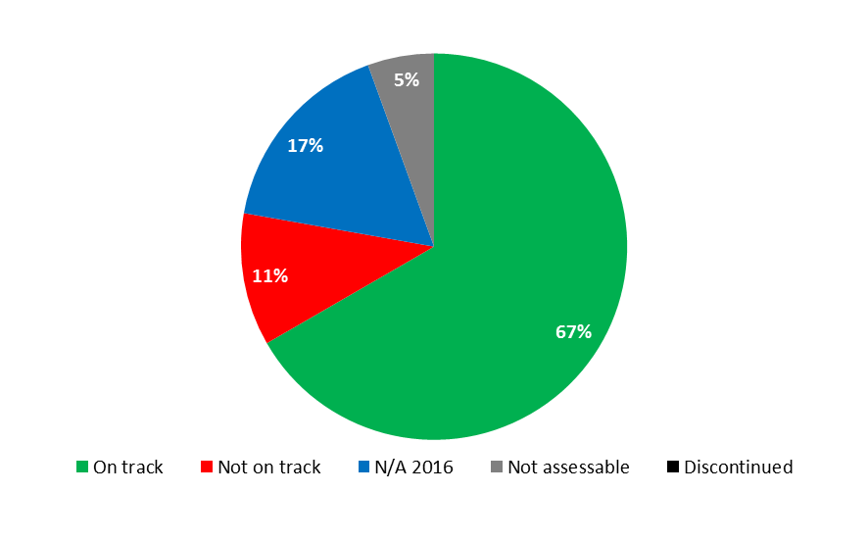

|  |  |  |  |  |
| --- | --- | --- | --- | --- |
| **Expected Result:**  IX.1 Effective, efficient, quality and customer-oriented support services both to internal clients and to external stakeholders | | | | |
| **Performance Indicators** | **Baselines** | **Targets** | **Performance Data** | **TLS** |
| % of staff satisfied with human resource services | *Updated Baseline end 2015:*  No survey was conducted in 2014/15  *Original Baseline  P&B 2016/17:*  Highly satisfied: 30.8% Satisfied: 49.1% Dissatisfied: 17.6% Highly dissatisfied: 2.5% | 85% highly satisfied or satisfied | Survey to be conducted at the end of the biennium | **N/A 2016** |
| Increase in automated versus currently manually-processed actions | *Updated Baseline end 2015:*  3 out of 18 processes (17%) are automated:   * Calculation of promotions * Self-service submission and calculation of education grant * New child dependent   *Original Baseline  P&B 2016/17:*  0% | 67% | 5 additional processes were automated in 2016:   * Submission of dependency documents (phase 1) * Calculation of rental subsidy * Self-service address input and change * GPAFI loss of earnings insurance premium deduction from salary * Leaves and absences * ASHI deduction from pension   8 out of 18 (44%) (cumulative) | **On track** |
| % of queries processed within 5 working days | *Updated Baseline end 2015:*  94.7%[87] of queries registered in the WINS ticketing system were responded to in five working days  *Original Baseline  P&B 2016/17:*  *Tbd end 2015* | *Updated Target:*  95%  *Original Target P&B 2016/17*:  90% | Statistics are unavailable for 2016 as the ticketing tool (WINS) was left for Outlook to improve client service. | **N/A 2016** |
| Optimized insurance coverage | *Updated Baseline end 2015:*  Collective medical insurance protection rate: 87.7%  *Original Baseline  P&B 2016/17:*  tbd end 2015 | *Defined Target:*  Maintain level  *Original Target P&B 2016/17:*  tbd end 2015 | 87.8% | **On track** |
| **Expected Result:** IX.2 An agile and smooth functioning Secretariat with a well-managed and appropriately skilled workforce which is effectively delivering results | | | | |
| **Performance Indicators** | **Baselines** | **Targets** | **Performance Data** | **TLS** |
| % of women in professional and higher positions | *Updated Baseline:*  P4 – 46.1%  P5 – 34.1%  D1 – 26.5%  D2 – 22.2%  (end 2015)  *Original Baseline  P&B 2016/17:*  P4 – 44.4%  P5 – 34.4%  D1 – 26.7%  D2 – 22.2%  (Dec 2014) | *Updated Target:*  P4 – 47%  P5 – 35%  D1 – 30%  D2 – 30%  *Original Target  P&B 2016/17:*  P4 – 46%  P5 – 35%  D1 – 30%  D2 – 30% | P4 – 45.6%  P5 – 35.6%  D1 – 30.0%  D2 – 16.7% | **Not on track**  **On track**  **On track**  **Not on track** |
| Recruitment lead time | *Updated Baseline end 2015:*  Biennium Average: 19.77  2014: 17.28 weeks (includes 29 LSTEs)  2015: 26.32 weeks (no LSTEs in 2015)  *Original Baseline P&B 2016/17:*  14.7 weeks (with LSTE) 19.07 weeks (without LSTE) | 19 weeks | 18.81 weeks (15 competitions from 2016 still ongoing as at March 15, 2017) | **On track** |
| % of staff whose performance is evaluated against their individual objectives and competencies | *Updated Baseline end 2015:*  2014: 93.1%  2015: 94.7%[88]  (as of April 30 in every following year)  *Original Baseline  P&B 2016/17:*  82.9% (2014) | *Updated Target:*  95%  *Original Target  P&B 2016/17:*  90% | 92.7% (as of April 30 in every following year) | **On track** |
| No. of days to: (i) notify staff of decisions on RfR/grievances, (ii) notify staff of decisions on rebuttals/disciplinary cases and (iii) provide responses to requests for advice | *Updated Baseline end 2015:*  (i) 60 days from receipt of RfR/response to grievance  (ii) 30 days from receipt of rebuttal; 35 days from response to charge letter and  (iii) 1 working day from receipt of request | *Updated Target:*  (i) 60 days from receipt of RfR/response to grievance  (ii) 30 days from receipt of response to rebuttal / response to charge letter and  (iii) 5 working days from receipt of request | (i) 60 days from receipt of RfR/response to grievance;  (ii) 30 days from receipt of response to rebuttal/ 30 days from receipt of response to charge letter; and  (iii) Out of 450 requests for advice received in 2016, a response was provided within 1 day in 89.3% of cases, within 2 to 4 days in 9.3% of cases, and within 5 working days or more in 1.3% of the cases. | **On track**  **On track**  **On track** |
|  | *Original Baseline  P&B 2016/17:*  n/a | *Original Target P&B 2016/17:*  (i) 60 days from receipt of RfR/response to grievance  (ii) 30 days from receipt of rebuttal / response to charge letter and  (iii) 10 working days from receipt of request |  |  |
| Geographical diversity: % of staff[89] per region | *Updated Baseline end 2015:*  Africa: 10.7%  Asia & the Pacific: 14.3%  Eastern & Central Europe & Central Asia: 6.9%  Latin America & the Caribbean: 8.4%  Middle East: 1.1%  North America: 9.0%  Western Europe: 49.5%  Original Baseline  P&B 2016/17:  Africa - 10.8%  Asia and the Pacific - 13.5%  Eastern and Central Europe & central Asia - 6.7%  Latin America and the Caribbean - 8.2%  Middle East - 1.2%  North America - 8.4%  Western Europe - 51.2%  (Dec. 2014) | *Updated target:*  Agreement among Member States on WIPO’s policy on geographical distribution  *Original Target P&B 2016/17:*  WIPO’s policy on geographical distribution requires consideration by Member States | Africa: 11.3%  Asia and the Pacific: 17.3%  Eastern and Central Europe and Central Asia: 7.8%  Latin America and the Caribbean: 8.0%  Middle East: 1.3%  North America: 8.4%  Western Europe: 45.8% | **Not assessable** |
| No. of applications received from unrepresented Member States as a % of total | *Updated Baseline end 2015:*  7.1%  *Original Baseline  P&B 2016/17:*  tbd end 2015 | *Defined Target:*  8%  *Original Target P&B 2016/17:*  tbd end 2015 (based on % increase between 2014-2015) | 7.9% (Based on all 2016 applications to positions in Professional categories and above) | **On track** |
| Enhanced maturity of HR Planning | *Updated Baseline[90] end 2015:*  Stage 2  *Original Baseline  P&B 2016/17:*  tbd | Defined Target:  Stage 3  *Original Target P&B 2016/17:*  tbd | Assessment to be conducted at the end of the biennium | **N/A 2016** |
| % of trainings needs fulfilled of which: (i) critical collective training needs and (ii) individual training needs | *Updated Baseline end 2015:*  (i) 2014/15: 81%  (ii) 2015: 62%  *Original Baseline  P&B 2016/17:*  (i) 81.04%  (ii) 60.94% | *Updated Target:*  (i) 80% of the needs in the biennium are addressed by a training program  (ii) 65% of individual training needs are fulfilled  *Original Target P&B 2016/17:*  (i) 60% of the needs are addressed by a training program (ii) 55% of individual training needs are fulfilled | (i) 40.4%  (ii) 60.4% | **On track**  **On track** |

|  |
| --- |
| **Resource Utilization for Program 23** |

Budget and Actual Expenditure (by result)

*(thousands of Swiss francs)*

|  |  |  |  |  |
| --- | --- | --- | --- | --- |
| **Expected Result No. and Description** | | **2016/17 Approved Budget** | **2016/17 Budget after Transfers** | **2016 Expenditure\*** |
| IX.1 | Effective, efficient, quality and customer-oriented support services both to internal clients and to external stakeholders | 12,096 | 12,426 | 5,802 |
| IX.2 | An agile and smooth functioning Secretariat with a well managed and appropriately skilled workforce which is effectively delivering results | 12,521 | 13,233 | 12,070 |
|  | **Total** | 24,617 | 25,659 | 17,873 |
| *\*2016 Expenditure numbers are preliminary, subject to audit by External auditors* | | | |  |

Budget and Actual Expenditure (personnel and non-personnel)

*(thousands of Swiss francs)*

|  |  |  |  |  |
| --- | --- | --- | --- | --- |
|  | **2016/17 Approved Budget** | **2016/17 Budget after Transfers** | **2016 Expenditure\*** | **Utilization rate (%)** |
| Personnel Resources | 18,835 | 18,968 | 14,901 | 79% |
| Non-personnel Resources | 5,782 | 6,691 | 2,972 | 44% |
| **Total** | **24,617** | **25,659** | **17,873** | **70%** |
| *\*2016 Expenditure numbers are preliminary, subject to audit by External auditors* | | | | |

*NOTE: The 2016/17 Budget after Transfers reflects transfers as of March 8, 2017 to address needs during the 2016/17 biennium in line with Financial Regulation 5.5.*

A. 2016/17 Budget after Transfers

1. The increase in personnel resources as compared to the 2016/17 Approved Budget was primarily due to the regularization of a continuing function and the reclassification of one post.
2. The increase in non-personnel resources as compared to the 2016/17 Approved Budget was primarily due to the funding of: (i) the hosting of the 83rd session of the ICSC; (ii) the organization of a Gender workshop for WIPO Delegates and the “Women and IP” lunch-time side-event at the Assemblies; (iii) data collection in the context of gender mainstreaming at WIPO; (iv) a survey on time management; (v) the WIPO Appeal Board; (vi) the processing of Education Grants, collection of receivables for ASHI premiums, implementation of the new ICSC compensation package and the provision of on-site medical services; (vii) Occupational Safety and Health Assessments; and (viii) increased costs of UN shared activities.

B. 2016/17 Budget Utilization

1. Personnel budget utilization rate amounted to 79 per cent and reflected the charging of a provision for litigation costs totaling 6.2 million Swiss francs.
2. Budget utilization for non-personnel resources was within the expected range of 40-60 per cent for the first year of the biennium.

### PROGRAM 24 GENERAL SUPPORT SERVICES

**Program Manager Mr. A. Sundaram**

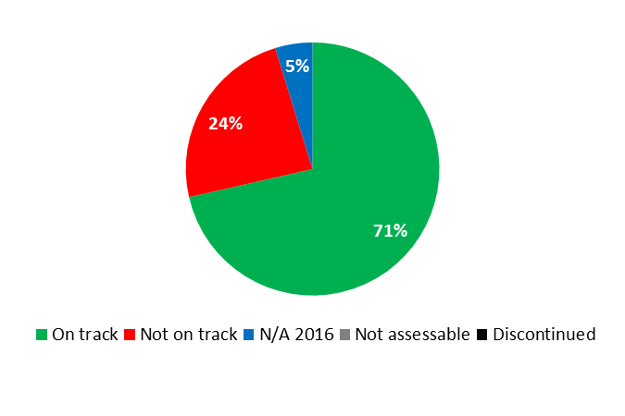

|  |  |  |  |  |
| --- | --- | --- | --- | --- |
| **Expected Result:**  VIII.5 WIPO effectively interacts and partners with UN and other IGO processes and negotiations | | | | |
| **Performance Indicators** | **Baselines** | **Targets** | **Performance Data** | **TLS** |
| % of locally sourced goods and services compared to total amount procured for development activity | *Updated Baseline*  *end 2015:*  2015: 57%  *Original Baseline  P&B 2016/17:*  45% (end 2014) | *Updated Target:*  At least 50%  *Original Target  P&B 2016/17:*  Equal or higher than 2014 result | 60.3% | **On track** |
| % of spend subject to UN leverage (either common tender or piggy-backing) | *Updated Baseline*  *end 2015:*  2015: 5.8%  *Original Baseline  P&B 2016/17:*  4.15% (end 2014) | *Updated Target:*  Equal or higher than 2015 result  *Original Target  P&B 2016/17:*  Equal or higher than 2014 result | 6.7% | **On track** |
| **Expected Result:** IX.1 Effective, efficient, quality and customer-oriented support services both to internal clients and to external stakeholders | | | | |
| **Performance Indicators** | **Baselines** | **Targets** | **Performance Data** | **TLS** |
| Cost savings for goods and services procured by WIPO (derived from RFPs or direct negotiations) | *Updated Baseline end 2015:*  3,826,361 CHF  *Original Baseline  P&B 2016/17:*  2.6 million CHF (end 2014) | Equal or higher than 2014 result[91] | 1,801,919 CHF | **Not on track** |
| Processing time ER | *Updated Baseline*  *end 2015:*  ER = <1 hour  *Original Baseline  P&B 2016/17:*  1/2 day (2014) | Less than 1/2 day | Less than 1/2 day | **On track** |
| Processing time ETA | *Updated Baseline*  *end 2015:*  eTA = 1/2 day  *Original Baseline  P&B 2016/17:*  1/2 day (2014) | Less than 1/2 day | Less than 1/2 day | **On track** |
| Processing time Visa | *Updated Baseline*  *end 2015:*  Visas < 1 day  *Original Baseline  P&B 2016/17:*  less than 1 day (2014) | Less than 1 day | Less than 1 day | **On track** |
| TMC[92] average ticket fare | *Updated Baseline*  *end 2015:*  1,606 CHF  *Original Baseline*  *P&B 2016/17:* 1,850 CHF (Dec 2014) | *Updated Target:*  ≤ 1,606 CHF  *Original Target  P&B 2016/17:*  ≤ 1,850 CHF | 1,374 CHF | **On track** |
| Global average ticket fare | *Updated Baseline*  *end 2015:*  1,481 CHF  *Original Baseline  P&B 2016/17:*  1,600 CHF (Dec 2014) | *Updated Target:*  ≤ 1,481 CHF  *Original Target  P&B 2016/17:*  ≤ 1,600 CHF | 1,315 CHF | **On track** |
| Average service fee | *Updated Baseline end 2015:*  95 CHF  *Original Baseline  P&B 2016/17:*  118 CHF (end 2014) | < 100 CHF | 92 CHF | **On track** |
| WIPO premises and installations remain fit for purpose | Maximum of 1 working day per year with breakdown of a technical installation (electricity, water, heating, cooling, ventilation) affecting WIPO core activities. | Maintain maximum of 1 working day per year with breakdown of a technical installation (electricity, water, heating, cooling, ventilation) affecting WIPO core activities. | Zero working days with a breakdown of a technical installation affecting WIPO core activities | **On track** |
| Optimum use and occupation of WIPO premises and all types of space | 80 rented workplaces, 5 offsite storage/archiving areas | *Updated Target:*  Maintain 80 rented workplaces, reduce to 4 off-site storage/archiving areas  *Original Target  P&B 2016/17:*  Maintain 80 rented workplaces, 5 off-site storage/archiving areas | Maintained 80 rented workplaces; 4 offsite storage/archiving areas (1 less than at the end of 2015) | **On track** |
| % of high value items (e.g >5,000 Swiss francs) inventoried[93] | 95% | Maintain 95% | 95% inventoried | **On track** |
| % of value items 1,000-5,000 Swiss francs, works of arts and attractive items | n/a | 90% | 99% of works of art inventoried[94]  Inventory on value items 1,000-5,000 CHF to be carried out in 2017[95] | **On track**  **N/A 2016** |
| **Expected Result:** IX.4 An environmentally and socially responsible Organization in which WIPO staff, delegates, visitors and information and physical assets are safe and secure | | | | |
| **Performance Indicators** | **Baselines** | **Targets** | **Performance Data** | **TLS** |
| Reduced impact of WIPO activities on the environment | *Updated Baseline end 2015:*  Greenhouse gas emissions: 7,730 ton CO2 (5.2 tons per employee accounted for) in 2015,[96]  In addition, in 2015, WIPO offset 6,248 ton CO2 through redeeming certificates (CERs) noting that the offsetting for natural gas was done directly by the provider, and that the offsetting done under this program also covers travel.  2015 energy consumption for all HQ buildings and rented buildings in Geneva (excluding WIPO External Offices)   * electricity (8,176,493 KwH), * water (41,647 m3), * natural gas (7,201,417 KwH), * heating oil (5,050 li).   (mainly for generators)  *Original Baseline  P&B 2016/17:*  A. Commitment to UN Climate Neutral Framework announced by the United Nations Secretary General in September 2014  B. Commitment to Host Country and local regulations for energy consumption  C. Energy consumption levels as at end-2015 | A. Maintain carbon emissions and greenhouse gases at end-2015 levels[97]  B. Implementation of measures by end-2017 to maintain energy consumption at end-2015 levels and at comparable weather conditions (for electricity, water, gas and heating oil) | Carbon emissions and greenhouse gases are expected to remain comparable to the 2015 levels based on 2016 raw data[98]  2016 energy consumption for all HQ buildings and rented buildings in Geneva (as compared to 2015):   * Electricity: 7,758,000 KwH, (5.1% decrease) mainly due to the installation of presence detectors and energy efficient light fixtures; * Water: 40,654 m3, (2.4% decrease) due to reduced consumption; * Natural gas: 7,550,012 KwH, (4.8% increase) mainly due to the colder winter in 2016; * Heating oil: (5,500 li) (9% increase), mainly due to the decision to carry out longer-duration periodic tests of emergency generators. | **On track**  **On track**  **On track**  **Not on track**  **Not on track** |
| Improved physical access to the WIPO campus | *Updated Baseline end 2015:*  Number of badge readers to be lowered:  AB (6)  GBI and GBII (4)  NB (32)  PCT (0)  WIPO Conference Hall (0)  Number of guard rails to be installed:  AB (4)  GBI passage to GBII (5)  NB (4)  PCT (0)  WIPO Conference Hall (0)  *Original Baseline  P&B 2016/17:*  Recommendations contained in 2012 Physical Accessibility Audit | Implementation of following measures by end-2017:  1. badge readers at required level for persons with disabilities  2. guard rails where required | No. of badge readers lowered:  AB (2 out of 6)  GBI and GBII (2 out of 4)    No. of hand rails installed:  GBI passage to GBII (5 out of 5) | **Not on track**  **Not on track** |

|  |
| --- |
| **Resource Utilization for Program 24** |

Budget and Actual Expenditure (by result)

*(thousands of Swiss francs)*

|  |  |  |  |  |
| --- | --- | --- | --- | --- |
| **Expected Result No. and Description** | | **2016/17 Approved Budget** | **2016/17 Budget after Transfers** | **2016 Expenditure\*** |
| VIII.5 | WIPO effectively interacts and partners with UN and other IGO processes and negotiations | 1,476 | 1,559 | 694 |
| IX.1 | Effective, efficient, quality and customer-oriented support services both to internal clients and to external stakeholders | 44,433 | 49,797 | 19,354 |
| IX.4 | An environmentally and socially responsible Organization in which WIPO staff, delegates, visitors and information and physical assets are safe and secure | 1,308 | 1,216 | 537 |
|  | **Total** | 47,216 | 52,572 | 20,584 |
| *\*2016 Expenditure numbers are preliminary, subject to audit by External auditors* | | | |  |

Budget and Actual Expenditure (personnel and non-personnel)

*(thousands of Swiss francs)*

|  |  |  |  |  |
| --- | --- | --- | --- | --- |
|  | **2016/17 Approved Budget** | **2016/17 Budget after Transfers** | **2016 Expenditure\*** | **Utilization rate (%)** |
| Personnel Resources | 19,287 | 17,165 | 8,032 | 47% |
| Non-personnel Resources | 27,930 | 35,408 | 12,552 | 35% |
| **Total** | **47,216** | **52,572** | **20,584** | **39%** |
| *\*2016 Expenditure numbers are preliminary, subject to audit by External auditors* | | | | |

*NOTE: The 2016/17 Budget after Transfers reflects transfers as of March 8, 2017 to address needs during the 2016/17 biennium in line with Financial Regulation 5.5.*

A. 2016/17 Budget after Transfers

1. The Budget after Transfers reflected a net increase in non-personnel resources primarily due to the: (i) additional allocation of resources to cover the prepaid interest in connection with the repayment of the loan for the New Building; and (ii) a shift from personnel resources to non-personnel resources in support of IT Procurement activities and the preparation of the Assemblies. This was partially offset by the transfer out of the: (i) Messenger Driver Group from Program 24 to Program 27 (Conference and Language Services), reflected under Expected Results IX.1 (Effective, efficient, quality and custom-oriented support) and IX.4 (An environmentally and socially responsible Organization); and (ii) 2016 underspend on maintenance, servicing and renovations of WIPO premises and installations, reflected under Expected Result IX.1, to other organizational priorities.
2. The overall decrease in personnel resources as compared to the 2016/17 Approved Budget is the net result of, on the one hand, reclassifications and completed regularizations of continuing functions, and on the other hand, the redeployment of the Messenger Driver Group to Program 27, as referenced above.

B. 2016/17 Budget Utilization

1. Budget utilization was within the expected range of 40-60 per cent for the first year of the biennium. The slightly lower utilization of personnel resources was mainly due to vacancies, backfills and staff members on part-time working arrangements.

### PROGRAM 25 INFORMATION AND COMMUNICATION TECHNOLOGY

**Program Manager Mr. A. Sundaram**

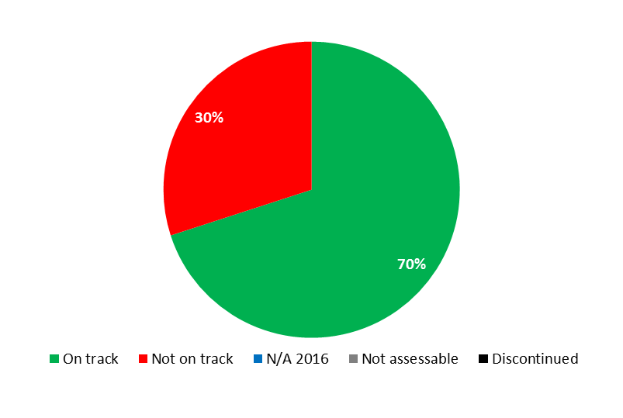



|  |  |  |  |  |
| --- | --- | --- | --- | --- |
| **Expected Result:** IX.1 Effective, efficient, quality and customer-oriented support services both to internal clients and to external stakeholders | | | | |
| **Performance Indicators** | **Baselines** | **Targets** | **Performance Data** | **TLS** |
| ICT Platforms are cost-effectively hosted and managed in line with business demands | *Updated Baseline end 2015:*  26 SDAs  *Original Baseline  P&B 2016/17:* n/a | New SDAs are created and agreed with largest consumers of ICT Platform services | 6 new SDAs (Information Security, WIPO DAS, WIPO CASE, WIPO WebMums (Madrid Union Members) Service, WIPO Connect, Enterprise Content Management) were signed with the United Nations International Computing Centre (UNICC) | **On track** |
|  | *Updated Baseline end 2015[99]:*   * Average monthly unit cost of Servers: 414 CHF * Average monthly unit cost per TB of storage: 234 CHF * Average monthly unit cost of backup per TB storage: 252 CHF   Number of service incidents with medium or high impact: 1.75 per month  *Original Baseline  P&B 2016/17:*  Unit cost Servers: 448 CHF /month;  Unit cost per TB storage: 299 CHF /month;  Unit cost of backup per TB storage: 370 CHF/month (end 2014);  Number of service incidents with medium or high impact: 1.75 per month | Unit costs decrease by at least 5% per year;  No increase in service incidents of medium or high impact | Average monthly unit cost of Servers: 418 CHF  Average monthly unit cost per TB of storage: 233 CHF  Average monthly unit cost of backup per TB storage: 232 CHF  1.17 service incidents with medium or high impact per month | **Not on track**  **Not on track**  **On track**  **On track** |
| Application development activities adhere to the WIPO reference and master data standards. | *Updated Baseline end 2015:*  None  *Original Baseline  P&B 2016/17:*  n/a | The WIPO reference and master data strategy and repository used by at least one application development team | The WIPO reference and master data standards, including the governance processes, were still under development at the end of 2016, as a result of repositioning the initiative. | **Not on track** |
| % of customers that are satisfied with the Service Desk services | *Updated Baseline end 2015:*  97% satisfied with Service Desk services   * 64%[100] completely satisfied * 33% satisfied   *Original Baseline  P&B 2016/17:*  97% satisfied or very satisfied with the Service Desk | Maintain similar high-level of user satisfaction | 97.4% satisfied with Service Desk services   * 66.7% completely satisfied * 30.7% satisfied | **On track** |
| ICT Projects in WIPO are managed in accordance with the WIPO Project Management Guidelines and the WIPO Service Transition Guidelines | *Updated Baseline end 2015:* n/a (new)  WIPO Service Transition Guidelines defined  *Original Baseline  P&B 2016/17:*  n/a (new)  Transition Guidelines not defined | More than 70% of projects are managed in accordance with the WIPO Project Management Guidelines  70% of delivered new projects comply with the WIPO Service Transition Guidelines | 100% of ICTD projects were managed in accordance with the WIPO Project Management Guidelines (3 out of 3)  66% of the delivered ICTD projects complied with the WIPO Service Transition Guidelines (2 out of 3) | **On track**  **On track** |
| **Expected Result: Expected Result:** IX.4 An environmentally and socially responsible Organization in which WIPO staff, delegates, visitors and physical assets are safe and secure | | | | |
| **Performance Indicators** | **Baselines** | **Targets** | **Performance Data** | **TLS** |
| ICT service continuity of critical systems | *Updated Baseline end 2015:*  Server, Storage, Backup and Network Infrastructure extended for core ICT services. In 2014/15, 12 additional core ICT services were assessed and suitable measures implemented for service continuity.  ICT Service Continuity capability validated in 2015 through successful 1-day Disaster Recovery (DR) test; PCT Failover exercise was completed in 30 minutes  *Original Baseline P&B 2016/17:* Critical systems can be recovered in a timely manner without data loss in the event of localized major disruptions | Progress made on a ICT platform to allow critical systems to continue operating in the event of a major regional disruption | 2 additional core ICT Services were enhanced for ensuring service continuity  ICT Service Continuity capability validated in 2016 through a successful 1-day Disaster Recovery (DR) test | **On track** |

|  |
| --- |
| **Resource Utilization for Program 25** |

Budget and Actual Expenditure (by result)

*(thousands of Swiss francs)*

|  |  |  |  |  |
| --- | --- | --- | --- | --- |
| **Expected Result No. and Description** | | **2016/17 Approved Budget** | **2016/17 Budget after Transfers** | **2016 Expenditure\*** |
| IX.1 | Effective, efficient, quality and customer-oriented support services both to internal clients and to external stakeholders | 51,480 | 48,326 | 21,629 |
| IX.4 | An environmentally and socially responsible Organization in which WIPO staff, delegates, visitors and information and physical assets are safe and secure | 552 | 486 | 240 |
|  | **Total** | **52,032** | **48,812** | **21,869** |
| *\*2016 Expenditure numbers are preliminary, subject to audit by External auditors* | | | |  |

Budget and Actual Expenditure (personnel and non-personnel)

*(thousands of Swiss francs)*

|  |  |  |  |  |
| --- | --- | --- | --- | --- |
|  | **2016/17 Approved Budget** | **2016/17 Budget after Transfers** | **2016 Expenditure\*** | **Utilization rate (%)** |
| Personnel Resources | 14,178 | 13,289 | 6,503 | 49% |
| Non-personnel Resources | 37,853 | 35,523 | 15,366 | 43% |
| **Total** | **52,032** | **48,812** | **21,869** | **45%** |
| *\*2016 Expenditure numbers are preliminary, subject to audit by External auditors* | | | | |

*NOTE: The 2016/17 Budget after Transfers reflects transfers as of March 8, 2017 to address needs during the 2016/17 biennium in line with Financial Regulation 5.5.*

A. 2016/17 Budget after Transfers

1. The slight decrease in personnel resources as compared to the 2016/17 Approved Budget was primarily driven by the: (i) redeployment of one post and one temporary position from the Program to support business needs in Executive Management (Program 21) and Safety and Security (Program 28); and (ii) the shift of resources to non-personnel to enable the hiring of database administration (DBA) consulting services. This decrease was compensated by the reclassification upwards of one post.
2. The overall decrease in non-personnel resources as compared to the 2016/17 Approved Budget is the net result of, on the one hand, the additional allocation of resources to cover: (i) the purchasing of additional laptops and related equipment in support of the Business Continuity initiative; and (ii) the hiring of DBA consulting services, as referenced above, and on the other hand, the redeployment of the 2016 underspend in the IT Technical Division to accommodate other organizational priorities in 2017, reflected under Expected Result IX.1 (Effective, efficient, quality and custom-oriented support).

B. 2016/17 Budget Utilization

1. Non-personnel budget utilization was lower than expected due to less than planned expenditure on: (i) UNICC related costs; (ii) training; and (iii) managing ICT services and customer relations.

### PROGRAM 26 INTERNAL OVERSIGHT

**Program Manager Mr. R. Singh**

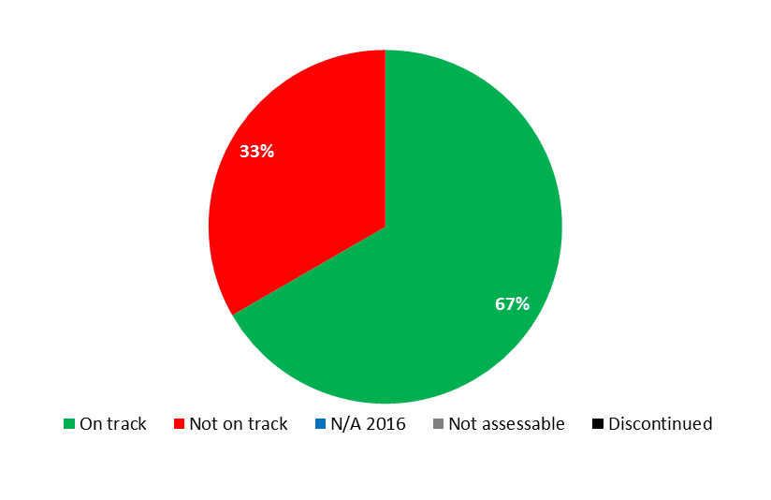



|  |  |  |  |  |
| --- | --- | --- | --- | --- |
| **Expected Result:** IX.8 Improved accountability, organizational learning, value for money, stewardship, internal control and corporate governance through assistance from effective and independent oversight | | | | |
| **Performance Indicators** | **Baselines** | **Targets** | **Performance Data** | **TLS** |
| INDEPENDENCE - No interference and perceived independence by key stakeholders | *Updated Baseline end 2015:*  No interference in IOD's work, as reflected in the annual reports WO/PBC/22/4 and WO/PBC/24/6  The Director of IOD met regularly with the Director General, IAOC and as and when required with Member State Representatives  Cases of perceived impaired independence were referred to the IAOC in accordance with paragraph 18 of the Charter  *Original Baseline  P&B 2016/17:*  No interference in IOD's work | No interference in IOD's work | No interference in IOD's work, as reflected in the annual reports WO/PBC/24/6[101] and WO/PBC/25/5[102]  The Acting Director of IOD met regularly with the Director General, IAOC and, as and when required, with Member States Representatives  Cases of perceived impaired independence were referred to the IAOC in accordance with paragraph 18 of the Charter | **On track** |
| EFFECTIVENESS - % of work that covers high risk, relevant areas aligned with the Organization's Strategy | *Updated Baseline end 2015:*  All work (100%) covered high risk/high relevance areas  *Original Baseline  P&B 2016/17:*  100% high risk/ high relevance areas | 100% work in high risk/ high relevance areas and in alignment with WIPO's Strategic Goals | All work (100%) covered high risk/high relevance areas | **On track** |
| EFFICIENCY - IOD's reports are issued timely with SMART recommendations | *Updated Baseline end 2015:*  24% of audit and evaluation reports issued in less than 4 months  58% of investigation reports issued by Investigation Policy deadline  88% of managers perceived that IOD recommendations were SMART  *Original Baseline  P&B 2016/17:*  75% of audit and evaluation reports issued in less than 4 months;  All investigation activities reports issued in accordance with Investigation Policy;  75 % of recommendations are SMART | *Updated Target:*  85% of audit and evaluation reports issued in less than 4 months  All investigation reports issued by Investigation Policy deadline  100% of managers perceive that IOD recommendations are SMART  *Original Target*  85% of audit and evaluation reports issued in less than 4 months  All investigation reports issued by Investigation Policy deadline  100% of recommendations SMART | (a) 50% of audit and evaluation reports issued in less than 4 months  (b) 53% of investigation reports issued by Investigation Policy deadline  (c) 81% of managers perceived that IOD recommendations were SMART | **Not on track**  **Not on track**  **On track** |
| RELEVANCE, ADDED VALUE & STEWARDSHIP- Tangible cost savings or improvements made in business processes and systems | *Updated Baseline end 2015:*  69% of managers perceived that IOD recommendations had led to efficiency gains  28% of annual cost savings could be linked to IOD recommendations  *Original Baseline  P&B 2016/17:*  n/a (to be provided end 2015) | *Updated Target:*  50% of managers perceive that IOD recommendations led to efficiency gains  50% of annual cost savings could be linked to IOD recommendations  *Original Target*  *P&B 2016/17:*  50% of recommendations lead to efficiency gains | 71% of managers perceived that IOD recommendations had ledto efficiency gains  30% of annual cost savings could be linked to IOD recommendations | **On track**  **Not on track** |
| ORGANIZATIONAL LEARNING-Uptake of Lessons and Recommendations from Oversight Processes | *Updated Baseline end 2015:*  More than 95% of recommendations accepted  40% implemented within 2 years.  *Original Baseline  P&B 2016/17:*  90% of recommendations accepted; 90% of recommendations implemented in 2 years’ time | 90% of recommendations accepted  90% of recommendations implemented in 2 years’ time | 95% of recommendations accepted  59% implemented within 2 years | **On track**  **On track** |

|  |
| --- |
| **Resource Utilization for Program 26** |

Budget and Actual Expenditure (by result)

*(thousands of Swiss francs)*

|  |  |  |  |  |
| --- | --- | --- | --- | --- |
| **Expected Result No. and Description** | | **2016/17 Approved Budget** | **2016/17 Budget after Transfers** | **2016 Expenditure\*** |
| IX.8 | Improved accountability, organizational learning, value for money, stewardship, internal control and corporate governance through assistance from effective and independent oversight | 5,358 | 5,450 | 2,049 |
|  | **Total** | 5,358 | 5,450 | 2,049 |
| *\*2016 Expenditure numbers are preliminary, subject to audit by External auditors* | | | |  |

Budget and Actual Expenditure (personnel and non-personnel)

*(thousands of Swiss francs)*

|  |  |  |  |  |
| --- | --- | --- | --- | --- |
|  | **2016/17 Approved Budget** | **2016/17**  **Budget after Transfers** | **2016 Expenditure\*** | **Utilization rate (%)** |
| Personnel Resources | 4,658 | 4,790 | 1,847 | 39% |
| Non-personnel Resources | 700 | 659 | 202 | 31% |
| **Total** | **5,358** | **5,450** | **2,049** | **38%** |
| *\*2016 Expenditure numbers are preliminary, subject to audit by External auditors* | | | | |

*NOTE: The 2016/17 Budget after Transfers reflects transfers as of March 8, 2017 to address needs during the 2016/17 biennium in line with Financial Regulation 5.5.*

A. 2016/17 Budget after Transfers

1. The overall increase in the 2016/17 Budget after Transfers as compared to the 2016/17 Approved Budget resulted mainly from the increase in personnel resources allocated to the Program to cover the need for a short-term investigator to enhance the quality and timeliness of the work conducted by IOD’s investigation section. The slight decrease under non-personnel resources was due to the transfer of resources for internships to HRMD (Program 23), which centrally manages interns.

B. 2016/17 Budget Utilization

1. Personnel resource budget utilization was lower than expected due to two vacancies and some part-time working arrangements observed during most of the year. Non-personnel expenditure was also lower than planned on audits, evaluation, and investigation-related activities.

### PROGRAM 27 CONFERENCE AND LANGUAGE SERVICES

**Program Manager Mr. A. Sundaram**



|  |  |  |  |  |
| --- | --- | --- | --- | --- |
| **Expected Result:** IX.1 Effective, efficient, quality and customer-oriented support services both to internal clients and to external stakeholders | | | | |
| **Performance Indicators** | **Baselines** | **Targets** | **Performance Data** | **TLS** |
| % of internal and external participants satisfied with WIPO Conference Services | *Updated Baseline end 2015:*  97% of users in 2014/15 considered the overall quality of WIPO’s conference services either excellent or good:  - 2014: excellent (48%) or good (49%);  - 2015: excellent (60%) or good (37%).  *Original Baseline  P&B 2016/17:*  97% of participants satisfied with services (end of 2014) | *Updated Target:*  Maintain rate at end of 2015  *Original Target P&B 2016/17:*  Maintain rate at end of 2014 | 96% of users considered the overall quality of WIPO’s conference services either excellent (56%) or good (40%) | **On track** |
| Effective implementation of WIPO Language Policy | *Updated Baseline end 2015:*  In addition to all Committees/Main Bodies, the 6 language coverage was extended in 2014/15 to four Working Groups:  (i) the PCT Working Group; (ii) the Working Group on the Legal Development of the Hague System for the International Registration of Industrial Designs;  (iii) the Working Group on the Legal Development of the Madrid System for the International Registration of Marks; and  (iv) the IPC Revision Working Group.  Around 87% of the documents received for translation (3,489 out of a total of 4,030 documents) were kept under 3,300 words. The rest that went beyond this word limit mainly concerned publications, verbatim reports or other annual reports, documents containing compilation of practices in Member States, and those prepared in response to specific requests by Member States, which are not subject to such limitation on document length.  *Original Baseline  P&B 2016/17:*  Language coverage extended to documents for all Committees/Main Bodies and some Working Groups | Language coverage extended to documents for all Committees/ Main Bodies/ Working Groups  with lengths maintained as per provisions of Language Policy | The 6 language coverage was extended to 2 additional Working Groups: (i) the Working Group for the Preparation of Common Regulations under the Lisbon Agreement and the Geneva Act of the Lisbon Agreement; and (ii) the IPC Union - Committee of Experts.  (All Committees/Main Bodies and 6 Working Groups, cumulative)  81% (542 out of 666) of meeting documents received for translation were kept under the word limit of 10 UN standard pages or 3,300 words. The remaining documents beyond this limit mostly concerned verbatim reports or other annual reports, proposals from Member States, and documents specifically requested by Member States to be made available in 6 languages in their entirety. | **On track**  **On track** |
| Reduction in printing costs (per page) | *Updated Baseline end 2015:*  0.15 CHF average cost per page in both 2014 and 2015 (25% reduction).  *Original Baseline  P&B 2016/17:*  0.14 CHF per page | Maintain the rate of 0.15 CHF average cost per page | 0.161 CHF average cost per page | **Not on track** |
| Timely publication of documents for Committees and Working Groups | *Updated Baseline end 2015:*  In 2014/15, 52.6% of all documents for major committees were published in all languages 2 months before the relevant meetings  - 2014: 41%  - 2015: 69%  *Original Baseline  P&B 2016/17:*  21% of documents published in all languages 2 months before the relevant meetings | 65% of documents published in all languages 2 months before the relevant meetings | 51% of all documents in all languages published 2 months before the relevant meetings | **Not on track** |
| Cost per word of translation | *Updated Baseline end 2015:*  The translation cost per word was:  - 0.59 Swiss francs in 2014 (6.3% decrease as compared to 2013)  - 0.57 Swiss francs in 2015 (3.4% decrease as compared to 2014).  A total of 15.03 million words (45,537 UN standard pages) were translated in 2014, and 15.32 million words (46,420 pages) in 2015.  *Original Baseline  P&B 2016/17:*  0.59 Swiss francs per word | Maintain cost | The cost per word of translation was further reduced to 0.55 CHF (-3.5% as compared to 2015)  A total of 15.69 million words (47,554 UN standard pages) were translated (+2.6% as compared to 2015) | **On track** |

|  |
| --- |
| **Resource Utilization for Program 27** |

Budget and Actual Expenditure (by result)

*(thousands of Swiss francs)*

|  |  |  |  |  |
| --- | --- | --- | --- | --- |
| **Expected Result No. and Description** | | **2016/17 Approved Budget** | **2016/17 Budget after Transfers** | **2016 Expenditure\*** |
| IX.1 | Effective, efficient, quality and customer-oriented support services both to internal clients and to external stakeholders | 38,925 | 38,622 | 17,609 |
| IX.4 | An environmentally and socially responsible Organization in which WIPO staff, delegates, visitors and information and physical assets are safe and secure | 0 | 39 | 0 |
|  | **Total** | 38,925 | 38,661 | 17,609 |
| *\*2016 Expenditure numbers are preliminary, subject to audit by External auditors* | | | |  |

Budget and Actual Expenditure (personnel and non-personnel)

*(thousands of Swiss francs)*

|  |  |  |  |  |
| --- | --- | --- | --- | --- |
|  | **2016/17 Approved Budget** | **2016/17 Budget after Transfers** | **2016 Expenditure\*** | **Utilization rate (%)** |
| Personnel Resources | 29,571 | 28,834 | 13,024 | 45% |
| Non-personnel Resources | 9,354 | 9,826 | 4,585 | 47% |
| **Total** | **38,925** | **38,661** | **17,609** | **46%** |
| *\*2016 Expenditure numbers are preliminary, subject to audit by External auditors* | | | | |

*NOTE: The 2016/17 Budget after Transfers reflects transfers as of March 8, 2017 to address needs during the 2016/17 biennium in line with Financial Regulation 5.5.*

A. 2016/17 Budget after Transfers

1. The increase in the 2016/17 Budget after Transfers (non-personnel) resulted primarily from: (i) the transfer of the Messenger Driver Group into the Program (initially budgeted in General Support Services (Program 24)), reflected under Expected Results IX.1(Effective, efficient, quality and custom-oriented support) and IX.4 (An environmentally and socially responsible Organization); and (ii) the redistribution of personnel resources to non-personnel for the hiring of temporary assistance for conference and printing services.
2. The net decrease in the 2016/17 Budget after Transfers (personnel) reflected, on the one hand, reclassifications and the transfer of the Messenger Driver Group and, on the other hand, the transfer of resources from the Program to support other business needs within the Administration and Management Sector (Programs 22, 24 and 28).

B. 2016/17 Budget Utilization

1. Personnel Budget utilization was slightly lower than expected, resulting primarily from vacancies, notably within the Language Division and the Conference and General Services Division. The under-utilization of non-personnel resources resulted primarily from lower than expected expenditure on activities related to translation and IT and CAT Tools integration.

### PROGRAM 28 INFORMATION ASSURANCE, SAFETY AND SECURITY

**Program Manager Mr. A. Sundaram**

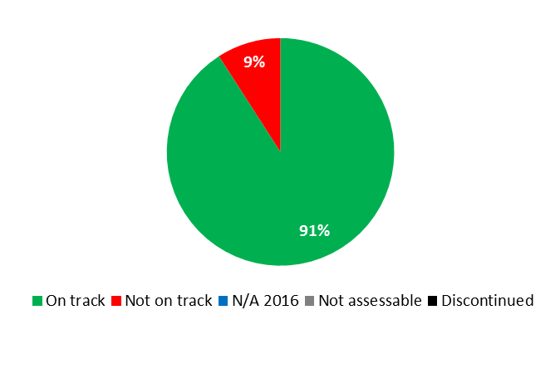

|  |  |  |  |  |
| --- | --- | --- | --- | --- |
| **Expected Result:** IX.1 Effective, efficient, quality and customer-oriented support services both to internal clients and to external stakeholders | | | | |
| **Performance Indicators** | **Baselines** | **Targets** | **Performance Data** | **TLS** |
| IA governance defined and enforced. | Limited governance of IA. Limited capacity to execute the IA strategy. | Approved IA governance framework enactment | Office Instruction (OI/04/2016) detailing the terms of reference for the new Security and Information Assurance (SIA) Governance framework was issued in January 2016. During the course of 2016, the SIA Board met once, the SIA Steering Committee met 3 times and the Business Security Contacts met twice to discuss, approve and direct various SIA projects. | **On track** |
| No. of staff aware of their information security responsibilities, security policies and best practices. | *Updated Baseline end 2015:*  7% in 2015  17% in 2014  *Original Baseline  P&B 2016/17:*  12% of staff have fallen for phishing campaigns (average based on 2 simulation campaigns conducted in 2014 and the first half of 2015) | Less than 5% staff falls for phishing campaigns | 13% of staff fell for phishing campaigns[103] | **Not on track** |
| **Expected Result:** IX.4 An environmentally and socially responsible Organization in which WIPO staff, delegates, visitors and information and physical assets are safe and secure | | | | |
| **Performance Indicators** | **Baselines** | **Targets** | **Performance Data** | **TLS** |
| % of information risks, including third party risks, reported and managed consistently within WIPO's risk tolerances. | Information risks reported on an ad-hoc basis.  Third party information risks not consistently identified and managed. | Quarterly reporting of enterprise information risks to internal IA governance bodies  Active management of third party information risks (<10% High) | All (100%) information risks, including third party risks, were reported to the SIA Steering Committee, which met 3 times in 2016  3 external service providers were assessed under the Service Provider Security Policy requirements in 2016; no high information risks were identified. | **On track**  **On track** |
| Proactive identification and timely remediation of vulnerabilities within agreed service levels. | Limited information security vulnerabilities identified and remediated. | Information security vulnerabilities identified and remediated on 90% of sensitive information assets | In 2016, 2 external penetration tests and 3 enterprise-wide internal tests were carried out. The external tests identified 5 Critical and High vulnerabilities, which were all remediated (100%); the internal tests identified 14 Critical and High vulnerabilities in the first quarter, with 97% remediation by the end of 2016, and 4 Critical and High vulnerabilities in the fourth quarter, with 50% remediation completion and 50% in progress by end 2016. | **On track** |
| Increased compliance to IA policies and standards | *Updated Baseline end 2015:*  PCT Certification successfully transitioned to version ISO 27001:2013.  Certification was renewed in October 2015, and the certification scope was extended to include Madrid and Hague October 2015.  *Original Baseline P&B 2016/17:*  Compliance and certification to ISO 27001 standards limited to PCT applications | Compliance and certification to ISO 27001 standards extended to the Hague, Madrid and HR applications | PCT, the Hague, Madrid and AMC were all ISO 27001 certified in 2016 | **On track** |
| Widely adopted information classification and handling policy to ensure confidentiality of information | Limited adoption of information classification and handling policy | Adoption of information classification and handling increased by 40% | At the end of 2016, a draft information classification and handling policy was undergoing review by business stakeholders | **On track** |
| Reduced duplication of information security technical capabilities through reusable security architecture patterns | Disparate and limited deployment of security capabilities reducing reusability and flexibility | A security reference architecture adopted to increase reusability and flexibility of security capabilities by 30% | Security reference architectures were developed for the External Offices’ Global Office Architecture (GOA) and Identity Access Management and Encryption. These reference architectures were being used to guide the design of new applications and systems. | **On track** |
| Enhanced capability to detect and respond to information security threats much faster ensuring minimal business disruption | *Updated Baseline end 2015:*  A Security Event and Information Management system (SEIM) was installed to provide a means to correlate all security events from other systems and then generate alarms, giving increased visibility and enabling quicker response and more detailed forensic capabilities  *Original Baseline P&B 2016/17:*  Basic security operations cyber threat intelligence and incident response capabilities exist | Implementation of a Cyber Security Operations Center (CSOC) improving the capability to monitor, detect and respond to information security incidents by 30% | In 2016, the current capabilities were assessed, and the development of the CSOC and Vulnerability Management (VM) strategy/roadmap, which will inform the sourcing model for WIPO’s future CSOC for implementation in 2017, was initiated. In the interim, the capability to monitor, analyze and respond to information security incidents was improved through the implementation of endpoint security controls on workstations and servers. | **On track** |
| % of WIPO staff, delegates and visitors reporting a work related injury or incident | *Updated Baseline end 2015:*  The total percentage of safety related incidents with injuries in 2014/15 amounted to 1.1%:   * 2 safety related incidents (2014) * 5 safety related incidents (2015)   *Original Baseline P&B 2016/17:*  2 % or less of total stakeholders/clients reporting a work related injury or incident | 2% or less | A total of 523 requests for safety and security assistance were received, 4 (0.8%) of which were injury-related incidents and 32 (6%) of which were medical-related incidents | **On track** |
| % of Conference and Events supported by security inside and outside Geneva[104] | *Updated Baseline end 2015:*  90% or more  *Original Baseline P&B 2016/17:*  90 % or more of total stakeholders/clients requesting timely safety & security assistance for conferences or events held in or outside Geneva | 90% or more | Support was provided to 115 meetings and conferences and 97 events, representing 100% of requests being supported | **On track** |

|  |
| --- |
| **Resource Utilization for Program 28** |

Budget and Actual Expenditure (by result)

*(thousands of Swiss francs)*

|  |  |  |  |  |
| --- | --- | --- | --- | --- |
| **Expected Result No. and Description** | | **2016/17 Approved Budget** | **2016/17 Budget after Transfers** | **2016 Expenditure\*** |
| IX.1 | Effective, efficient, quality and customer-oriented support services both to internal clients and to external stakeholders | 1,189 | 2,733 | 1,161 |
| IX.4 | An environmentally and socially responsible Organization in which WIPO staff, delegates, visitors and information and physical assets are safe and secure | 16,544 | 16,644 | 6,805 |
|  | **Total** | 17,733 | 19,377 | 7,967 |
| *\*2016 Expenditure numbers are preliminary, subject to audit by External auditors* | | | |  |

Budget and Actual Expenditure (personnel and non-personnel)

*(thousands of Swiss francs)*

|  |  |  |  |  |
| --- | --- | --- | --- | --- |
|  | **2016/17 Approved Budget** | **2016/17 Budget after Transfers** | **2016 Expenditure\*** | **Utilization rate (%)** |
| Personnel Resources | 4,311 | 4,806 | 2,189 | 46% |
| Non-personnel Resources | 13,422 | 14,571 | 5,778 | 40% |
| **Total** | **17,733** | **19,377** | **7,967** | **41%** |
| *\*2016 Expenditure numbers are preliminary, subject to audit by External auditors* | | | | |

*NOTE: The 2016/17 Budget after Transfers reflects transfers as of March 8, 2017 to address needs during the 2016/17 biennium in line with Financial Regulation 5.5.*

A. 2016/17 Budget after Transfers

1. The net increase in the 2016/17 Budget after Transfers (personnel resources) reflected: (i) the transfer into the Program of two temporary positions to support risk and information security program management in support of the implementation of the Information Assurance Strategy; and (ii) the reclassification of one post. This was slightly compensated by the shift of resources to non-personnel to strengthen the information security architect function and to support the implementation of the Security Risk Management Project and Mainstreaming.
2. The net increase in the 2016/17 Budget after Transfers (non-personnel resources) reflected the transfer of additional resources to the Program to support: (i) the implementation of the Security Risk Management Project and Mainstreaming, including the presence of armed guards; (ii) installation of a surveillance CCTV and supervisor system to equip the CAM facility for Business Continuity purposes and; (iii) increased operational needs for security guards in relation to the organization of events. This was partially offset by the redeployment of the 2016 underspend in relation to information security to accommodate other organizational priorities in 2017.

B. 2016/17 Budget Utilization

1. Budget utilization was lower than anticipated primarily due to recruitment delays and the resulting delays in the implementation of the project.

# APPENDICES

APPENDIX I   
BREAKDOWN OF THE PERFORMANCE ASSESSMENTS BY PROGRAM

A new, simplified format is being introduced for the PPR 2016 to better distinguish between the PPRs for the first year (reporting on progress) and the second year (reporting on achievements) of the biennium.

The performance assessments for individual Programs in the PPR 2016 comprise:

*Section I: Performance Data*

The table in this section contains the Expected Results to which the Program contributes and the Performance Indicators, which measure the Program’s contribution to the Results as approved by Member States in the Program and Budget 2016/17. In order to strengthen reporting in 2016/17, the Baseline and Target Update/Definition exercise was further enhanced to allow Programs to update targets in cases where the target had already been met by the end of 2015.[105]

In addition to the Expected Results and the Performance Indicators, the performance data tables reflect the following:

* *Original Baseline P&B 2016/17*: the original baselines as approved in the Program and Budget 2016/17;
* *Updated Baseline[106]*: updated baselines, where appropriate, reflecting the situation at the end of 2015;
* *Original Target P&B 2016/*17: the original targets as defined in the Program and Budget 2016/17;
* *Defined/Updated Target[107]*: (i) targets originally approved as “tbd” in the Program and Budget 2016/17 defined using the year-end 2015 data as the basis[108]; or (ii) updated targets, as appropriate, where the original target had already been met by the end of 2015;
* *Performance Data*: the performance data for 2016 in relation to each indicator. As a general rule, where performance data are measured by percentage changes (increases or decreases), unless otherwise indicated, the percentage changes are in comparison to the previous year, e.g. the percentage change in 2016 as compared to 2015; and
* *TLS*: an assessment of performance using the “traffic light system”.

*Section II: Resource Utilization for 2016*

This section provides information on the 2016/17 Approved Budget, the 2016/17 Budget after Transfers, and actual expenditure and budget utilization in 2016. The reporting in this section includes two tables:

* The *Budget and Actual Expenditure (by result)* provides information on the 2016/17 Approved Budget, the 2016/17 Budget after Transfers, and 2016 Expenditure by Result; and
* The *Budget and Actual Expenditure (personnel and non-personnel resources)* provides information on the 2016/17 Approved Budget, the 2016/17 Budget after Transfers 2016/17, 2016 Expenditure 2016 (personnel and non-personnel), and the Utilization Rate.

Explanations are provided for the differences between the Approved Budget and Budget after Transfers, as well as for budget utilization, taking into account both a Results view and a view of type of expenditure (personnel and non-personnel).

[Appendix II follows]

APPENDIX II   
IMPLEMENTATION OF FUNDS-IN-TRUST 2016

As part of the efforts to enhance the integration of all activities under the results-based management framework of the Organization, irrespective of the source of funds, this Appendix provides an overview of activities implemented under the WIPO Funds-in-Trust (FITs). At the same time, this report responds to a request by donors for a more comprehensive report on all FITs, including both programmatic and financial information. In order to streamline reporting, the FIT report is an integral part of the Program Performance Report, providing an annual view of activities implemented in 2016. The next annual FIT report will be included in the PPR for 2016/17. This Appendix reports on the FITs listed in the table below and excludes the FITs for Junior Professional Officers (JPOs).

|  |  |
| --- | --- |
| **FUND-IN-TRUST** | **IMPLEMENTING SECTOR** |
| Australia I | Office of the Director General |
| Australia II | Office of the Director General |
| Brazil South | Office of the Director General |
| China State Intellectual Property Office (SIPO) | Brands and Designs Sector |
| Finland Copyright | Culture and Creative Industries Sector |
| France Industrial Property | Development Sector |
| Ibero-American Program for Industrial Property | Development Sector |
| Italy | Development Sector |
| Japan Copyright | Culture and Creative Industries Sector |
| Japan Industrial Property | Development Sector |
| Japan Industrial Property /Africa | Development Sector |
| Republic of Korea Building Respect for IP | Global Issues Sector |
| Republic of Korea Copyright | Culture and Creative Industries Sector |
| Republic of Korea Education | Development Sector |
| Republic of Korea Industrial Property | Development Sector |
| Mexico | Development Sector |
| Spain | Development Sector |
| United Nations Fund for International Partnerships - Ending the Book Famine for People with Disabilities | Culture and Creative Industries Sector |
| Uruguay | Development Sector |
| United States Of America/ Creative Industries | Culture and Creative Industries Sector |

**AUSTRALIA I**

|  |  |  |  |
| --- | --- | --- | --- |
| **RESULT**: VII.2. IP-based platforms and tools are used for knowledge transfer, technology adaptation and diffusion from developed to developing countries, particularly least developed countries, to address global challenges | | | |
| **Activity** | **Date** | **Host Country/ Recipients** | **Purpose(s)/Description(s)** |
| Continuation of Hosting Arrangements for African Biomedical Scientists in research facilities outside Africa | January to March, 2016 | University of California San Diego, United States of America/ Dr. Christian Agyare and Ms. Kyere-Davies. | To promote: (i) the effective use of IP to address a global health challenge (neglected tropical diseases (NTDs), which affect many LDCs; and (ii) knowledge transfer for scientists, particularly from LDCs.  Customized research programs were developed to ensure that participants upgrade research skills and are able to make a significant contribution in their home countries on NTDs. During her sabbatical at UCSD, Ms. Kyere-Davies carried forward the work initiated by her supervisor Dr. Christian Agyare during his time as a WIPO Re:Search fellow with the same laboratory. This not only demonstrated the sustainability of capacity building activities undertaken through WIPO Re:Search fellowships, but also their direct contribution to increasing institutional knowledge in the fellow’s home institute. |
| Preparation of a Global Challenges Report on ‘*Sharing Innovation and Building Capacity to Fight Neglected Tropical Diseases: A Selection of WIPO Re:Search Fellowship Stories’* | January to July, 2016 | All | By featuring the stories and experiences of the six scientists who participated in the WIPO Re:Search fellowship/sabbatical program under the first Australian FIT, the publication demonstrated the importance of partnerships as an investment in human and institutional capacity building and as a strategic tool for catalyzing sustainable research and development into NTDs in disease-prevalent regions. The publication also underscored the high value of the commitment shown by a donor (the Government of Australia) in nurturing and sustaining such programs that have the potential for exponential impact. |

**AUSTRALIA I Donor Contributions and Expenditure in 2016**

|  |  |  |  |  |
| --- | --- | --- | --- | --- |
| **Balance as of December 31, 2015** | **Income 2016** | **Expenditure 2016** | **Reimbursements** | **Balance as of December 31, 2016** |
| 110,219 | 40 | 10,775 | 99,484 | - |

**AUSTRALIA II**

| **RESULT:** III.1. National innovation and IP strategies and plans consistent with national development objectives | | | |
| --- | --- | --- | --- |
| **Activity** | **Date** | **Host Country/ Recipients** | **Purpose(s)/Description(s)** |
| Final National Stakeholders’ Consultations Meetings to Finalize the IP Strategy for Kiribati | June 20 to 23, 2016 | Kiribati | To validate the draft IP Policy submitted to the Government of Kiribati for consideration through final consultations with the national stakeholders, with a view to making any changes required before submitting the final IP Policy document. These changes were further reviewed internally by several WIPO Divisions  Once the revised draft of the National IP Strategy was finalized following another round of internal consultations in WIPO, it was sent by the Director General of WIPO to Kiribati’s Minister for Commerce, Industry and Cooperatives for consideration and follow-up action at the national level on September 9, 2016. A note was subsequently prepared by Kiribati for consideration by its Cabinet in late November 2016. |
| First Assessment Mission for the Development of a National IP Strategy for Lao People’s Democratic Republic | April 26 to 28, 2016 | Lao People’s Democratic Republic | To: (i) enhance awareness about the role of a national IP strategy and its linkages to other public policies as well as to sensitize about the methodology and tools for formulating such a strategy; (ii) provide training for the national experts on the methodology and use of the tools; (iii) hold consultation meetings and courtesy calls to the Director General of DIP as well as senior officials of the Ministry of Science and Technology and other relevant ministries to discuss the time lines, the next steps and to secure their political will for the process ahead |
| Desk research and baseline survey undertaken by the project team (consisting of one international consultant, two national experts and a dedicated team from the Department of IP, Ministry of Science and Technology) for the development of a National IP Strategy for Lao People’s Democratic Republic | May to July 2016 | Lao People’s Democratic Republic | To: (i) review existing policy documents in order to draw a comprehensive picture of the country’s national development objectives, strategies and policies, and identify how to align and integrate the national IP strategy with the country’s national development priorities; (ii) obtain a clear picture of the current IP situation in the country (through an IP audit or baseline survey), its weaknesses, strengths and potential as well as to assess, based on the data collected, what needs to be considered during the formulation of a national IP strategy |
| National Consultation Meetings for the Development of a National IP Strategy | August 1 to 5, 2016 | Lao People’s Democratic Republic | To share the results/initial findings of the data collection process (desk research and survey) and engage in discussions with the national authorities concerned and relevant stakeholder groups in validating the audit results/initial findings and in gathering additional information, insights and data as necessary |
| Development of the first draft National IP Strategy | September to December 2016 | Lao People’s Democratic Republic | To formulate a the first draft of the national IP strategy and action plan, incorporating the suggestions, opinions and recommendations generated from the national consultations and identifying key strategic IP objectives and priorities by sector and for the country as a whole. During the drafting process, there were a lot of interactions among the members of the project team and WIPO in revising and refining the draft Strategy, as well as in collecting additional documents and information. |
| National Workshop on Copyright and Related Rights for Stakeholders, and Consultation Meetings | October 24 to 26, 2016 | Tonga | Improve capacity and increase awareness among government officials and stakeholders on the relevance and importance of copyright in promoting cultural and economic development |

**AUSTRALIA II Donor Contributions and Expenditure in 2016**

|  |  |  |  |  |
| --- | --- | --- | --- | --- |
| **Balance as of December 31, 2015** | **Income 2016** | **Expenditure 2016** | **Reimbursements** | **Balance as of December 31, 2016** |
| - | 1,301,725 | 138,023 | - | 1,163,701 |

**BRAZIL SOUTH**

|  |  |  |  |
| --- | --- | --- | --- |
| **RESULT**: III.2. Enhanced human resource capacities able to deal with the broad range of requirements for the effective use of IP for development in developing countries, LDCs and countries with economies in transition | | | |
| **Activity** | **Date** | **Host Country/ Recipients** | **Purpose(s)/Description(s)** |
| XV Seminar Regional on Intellectual Property For Latin American Judges And Public Prosecutors | May 23 to 25, 2016 | Brazil/ 30 participants from Chile, Colombia,Costa Rica,Cuba,Dominican Republic,Ecuador, El Salvador,Guatemal, Honduras, Mexico, Nicaragua,Panama, Paraguay, Peru | To: (i) promote exchange of experiences between representatives of judicial institutions and public prosecutors’ offices in Latin America; (ii) to facilitate agreements on the creation of sectoral networks to ensure the continuity of inter-institutional working relations in the judiciary sector. |
| XXXIV Regional Workshop for Industrial Property Offices of Latin America | July 4 to 8, 2016 | Brazil/ 20 participants from Argentina, Brazil, Chile, Costa Rica, Cuba, Dominican Republic, Ecuador, El Salvador, Honduras, Mexico, Nicaragua, Panama, Paraguay, Peru, Uruguay | To promote the exchange of experiences among officials of national IP Offices on selected topics, focusing in particular on International cooperation in IP. This edition was focused on the establishment of mechanisms of collaboration among IP Offices in relation to the management of the examination process of trademarks and designations of origin |
| III International Seminar on Geographical Indications (GIs) and Collective Trademarks | August 31 to September 2, 2016 | Brazil/ 200 participants from Honduras, Mexico, Peru | To promote a debate about the economic and social gains that GIs and Collective Trademarks could bring to national development as a whole |
| IV Regional Workshop on Intellectual Property and Technology Transfer | September 7 to 9, 2016 | El Salvador/ 40 participants from Colombia, Costa Rica, Ecuador, Guatemala, Mexico | To: (i) promote the establishment of technology transfer agreements and partnerships between academic institutions and the industry sector; and (ii) present practical aspects and experiences related to the negotiation and drafting of technology agreements |
| IX ENAPID - Academic Meeting on IP, Innovation and Development and the International Symposium of the Academies of Intellectual Property from Latin American and the Caribbean Countries | November 23 to 25, 2016 | Brazil/ 250 participants from Argentina, Chile, Colombia, Costa Rica, Cuba, Ecuador, Dominican Republic, El Salvador, Guatemala, Mexico, Nicaragua, Paraguay, Peru, Uruguay, Venezuela | To provide a forum for research institutions, industry and government to analyze open innovation, including such issues as R&D, provision of services and licensing from IP rights, and technology transfer. The last day included a discussion between the Latin America countries on the challenges and opportunities for IP Academies in the region. |

**BRAZIL SOUTH Donor Contributions and Expenditure in 2016**

|  |  |  |  |  |
| --- | --- | --- | --- | --- |
| **Balance as of December 31, 2015** | **Income 2016** | **Expenditure 2016** | **Reimbursements** | **Balance as of December 31, 2016** |
| 238,315 | - | 128,072 | - | 110,242 |

**CHINA SIPO**

|  |  |  |  |
| --- | --- | --- | --- |
| **RESULT**: I.1. Enhanced cooperation among Member States on development of balanced international normative frameworks for IP | | | |
| **Activity** | **Date** | **Host Country/ Recipients** | **Purpose(s)/Description(s)** |
| Organization of the High Level Conference on Intellectual Property for Countries Along the “Belt and Road” | July 21 to 22, 2016 | China/ (over 50 international participants) | To provide a high-level dialogue forum for policy makers, representatives from private sector and academia to seek new opportunities for promoting innovation, economic and social development through regional IP cooperation. |

**CHINA SIPO Donor Contributions and Expenditure in 2016**

|  |  |  |  |  |
| --- | --- | --- | --- | --- |
| **Balance as of December 31, 2015** | **Income 2016** | **Expenditure 2016** | **Reimbursements** | **Balance as of December 31, 2016** |
| - | 327,817 | 226,481 | - | 101,336 |

**FINLAND/ COPYRIGHT**

|  |  |  |  |
| --- | --- | --- | --- |
| **RESULT:** III.2. Enhanced human resource capacities able to deal with the broad range of requirements for the effective use of IP for development in developing countries, LDCs and countries with economies in transition | | | |
| **Activity** | **Date** | **Host Country/ Recipients** | **Purpose(s)/Description(s)** |
| Preparation of guidelines on assessing the economic, social and cultural impact of copyright in the creative industries | March 2016 | Finland | Expert submission for the pilot phase of the project on assessing the economic, social and cultural impact of copyright on the creative industries in Finland to test the implementation of the WIPO guidelines in Finland |

**FINLAND/ COPYRIGHT Donor Contributions and Expenditure in 2016**

|  |  |  |  |  |
| --- | --- | --- | --- | --- |
| **Balance as of December 31, 2015** | **Income 2016** | **Expenditure 2016** | **Reimbursements** | **Balance as of December 31, 2016** |
| 14,360 | - | 11,345 | - | 3,015 |

**FRANCE/ INDUSTRIAL PROPERTY**

|  |  |  |  |
| --- | --- | --- | --- |
| **RESULT:** III.2. Enhanced human resource capacities able to deal with the broad range of requirements for the effective use of IP for development in developing countries, LDCs and countries with economies in transition | | | |
| **Activity** | **Date** | **Host Country/ Recipients** | **Purpose(s)/Description(s)** |
| CAPI (*Certificat d’animateur propriété intellectuelle*) Training Program with the *Institut national de la propriété industrielle* (INPI) France and the *Office Marocain de la Propriété Industrielle et Commerciale* (OMPIC) | January 1 to May 12, 2016[109] | Morocco/ 10 participants from Algeria, Cameroon, Côte d’Ivoire, Senegal, Tunisia, | A certified training program aimed at meeting the needs of businesses and professionals who wish to: (i) develop expertise in the management of Industrial Property rights; (ii) understand the challenges of Industrial Property; (iii) improve efficiency in the management and valuation of intangible assets; and (iv) master the use of protection and search tools |
| Regional seminar on Collaborative Innovation and Intellectual Property:  “Developing Partnerships between Universities and Enterprises” | January 13 and 14, 2016 | Chili/ 100 national participants and representatives from Bolivia, Colombia, Mexico and Peru | To: (i) present various models that help in establishing a conducive environment for innovation and IP rights protection; (ii) develop innovation capacities through an efficient use of the IP system; (iii) address the topics of collaborative innovation and open innovation; and (iv) share experiences in building close cooperation between universities, R&D Institutes and the private sector |
| Side Events at the  22nd session of the Conference of Parties to the United Nations Framework Convention on Climate Change (COP 22) | November 10 to 12, 2016 | Morocco/ 12 Small and Medium Enterprises (SMEs) from Africa and the Arab region, 10 SMEs from France | To: (i) give the opportunity to exhibit innovative climate change solutions to French and international SMEs to interested in the African market; (ii) provide a forum to discuss innovations in renewable energy, the consolidated economy, agricultural and water sectors, and the WIPO GREEN |
| Regional workshop on Copyright Protection and Enforcement for Judges | May 2 and 3, 2016 | United Arab Emirates/ 36 Magistrates from Algeria, Bahrain, Egypt, Jordan, Kuwait, Lebanon, Morocco, Qatar, Palestine, Saudi Arabia, United Arab Emirates | To: (i) understand the economic importance of IP and the economic and social impact of piracy; (ii) master the national and international rules and concepts of Copyright protection and enforcement in light of the Agreement on Trade-Related Aspects of Intellectual Property Rights (TRIPS Agreement); (iii) be able to identify protectable works and know what the authorship criteria are; (iv) analyze Copyright Infringement cases, and work on concrete civil and criminal cases; (v) identify, evaluate and compensate the economic loss for right holders of Copyright Infringement on the internet; and (vi) acquire knowledge of the Broadcasting protection rules |
| Regional for Workshop on Building Respect for Intellectual Property for SMEs and Small and Medium Institutions (SMIs) competitiveness and job creation | May 31 to June 2, 2016 | Côte d’Ivoire/ 39 SMEs | To: (i) sensitize SMEs/SMIs on the importance of protecting their IP assets and the importance of economic intelligence as a strategic tool for decision making and their development; and (ii) present the Technology and Innovation Support Center (TISC) platform and its use as a tool to support innovation |
| Regional Workshop on Building Respect for Intellectual Property for Judges  Regional Workshop on Building Respect for Intellectual Property for Customs Officials and Police Officers | May 31 to June 2, 2016 | Côte d’Ivoire/ 65 judges  Côte d’Ivoire/ 38 Customs Officials and Police Officers | To: (i) develop and strengthen the capacities of the judiciary and customs officials of the invited countries in the enforcement of intellectual property rights and building respect for IP; (ii) strengthen national and sub-regional collaboration between judicial and customs administrations to better fight against IP rights infringements; (iii) provide an opportunity for each participating group to exchange experiences and discuss the challenges in the implementation of legal and regulatory provisions on enforcement of IP rights; and (iv) encourage the establishment or development of national and regional anti-counterfeiting and piracy committees |
| Symposium on Geographical Indications | September 7, 2016 | Cameroon | To: (i) build capacity in IP Offices and of IP rights owners for strategic use of IP assets for competitiveness and job creation; and (ii) raise awareness of the regulations governing the use of the logo of Protected Geographical Indications and Repression of Fraud |
| International Fair of Products whose quality is linked to their Geographical Origin | September 8 to 10, 2016 |  |
| Working visit to Casablanca, Morocco  Working session with Moroccan Office of Industrial and Commercial Property (OMPIC) to discuss the follow-up to the CAPI Program | March 4 and 5, 2016  March 7 and 8, 2016 | Morocco | To explore ways and means for the sustainability of the CAPI Program |
| Development of an IP policy and innovation strategy in universities and research and public development institutions intended to facilitate the transfer of technology to the industrial "Creating a virtuous circle" of innovation | May 1 to 16, 2016 | Morocco/ 46 participants from Algeria, Benin, Botswana, Cameroon, Congo, Côte d’Ivoire, Democratic Rep of Congo, Egypt, Ethiopia, Gabon, Ghana, Guinea, Kenya, Mali, Mauritius, Mozambique, Niger, Nigeria, Rwanda, Senegal South Africa, Sudan Tunisia, Uganda, African Intellectual Property Organization (OAPI) and the African Regional Industrial Property Organization (ARIPO) | To: (i) discuss the role of universities and research institutions in an economy that is increasingly based on knowledge and innovation; (ii) explore how policies and strategies for IP and innovation might contribute to knowledge production with a view to transferring technology to the industrial sector; (iii) create a virtuous cycle of innovation that would both foster research and promote the offer of innovative solutions necessary for SMEs and SMIs to be more competitive and drive growth in the countries involved African economies; and (iv) explore ways to facilitate the participation of African countries in the global digital and knowledge-based economy |
| Training Course on Trademarks | July 11-22, 2016 | Morocco/ 20 participants | To: (i) enhance skills and knowledge of trademark officials from IP Offices or relevant Ministries from developing countries through discussions on trademarks issues and procedures; and (ii) familiarize participating trademark officials with current and important issues in the field of trademark and related areas |
| Regional Workshop on Building Respect for Intellectual Property for Judges | November 29 and 30, 2016 | Madagascar/ 40 judges from Madagascar and 9 judges from Comoros | To develop and strengthen the respective capacities of the judiciary and customs of Madagascar and Comoros in the enforcement of intellectual property rights and building respect for intellectual property |
| Sub-Regional Workshop on Building Respect for IP for Law Enforcement Officers (Police and Customs) | December 1, 2016 | Madagascar/ 38 Customs and Police Officers from Madagascar,  18 Police and Customs Officers from Comoros | To: (i) improve the knowledge and skills of participants in respect of legal proceedings and management of IP litigation and the application of customs measures, in order to help them better use the procedures as described under of Part III of the TRIPS Agreement; (ii) provide an opportunity for each participating group to exchange experiences and discuss the challenges they face in the implementation of legal and regulatory provisions on enforcement of IP rights; and (iii) familiarize the judges with the jurisprudence tools developed respectively by WIPO and OAPI |

**FRANCE/ INDUSTRIAL PROPERTY Donor Contributions and Expenditure in 2016**

|  |  |  |  |  |
| --- | --- | --- | --- | --- |
| **Balance as of December 31, 2015** | **Income 2016** | **Expenditure 2016** | **Reimbursements** | **Balance as of December 31, 2016** |
| 960,497 | 289,323 | 545,186 | - | 704,634 |

**IBERO AMERICAN PROGRAM FOR INDUSTRIAL PROPERTY**

|  |  |  |  |
| --- | --- | --- | --- |
| **RESULT:** III.2. Enhanced human resource capacities able to deal with the broad range of requirements for the effective use of IP for development in developing countries, LDCs and countries with economies in transition | | | |
| **Activity** | **Date** | **Host Country/ Recipients** | **Purpose(s)/Description(s)** |
| Platform on IP services and contents for the Ibero-American entrepreneurial sector with special focus on SMEs (CIBEPYME). | January to December, 16  (ongoing) | All Ibero-American countries | To strengthen the generation and management of IP assets by the business sector in Ibero-American countries |
| **RESULT:** III.4. Strengthened cooperation mechanisms and programs tailored to the needs of developing countries, LDCs and countries with economies in transition | | | |
| **Activity** | **Date** | **Host Country/ Recipients** | **Purpose(s)/Description(s)** |
| Ibero-American Cooperation System for the provision of Information and Technological Services (INFOTEC Program) | January to December 2016  (ongoing) | All Ibero-American countries | In 2016, the Technological Information Committee of IBEPI, formed by Argentina, Brazil, Colombia, Costa Rica, Dominican Republic, Ecuador, Mexico Paraguay, Peru, Portugal, Spain and Uruguay, launched the INFOTEC Program to: (i) expand the capacity of Ibero-American countries to manage and use technological information; and (ii) promote horizontal cooperation among IP Offices to reduce asymmetries between Offices in relation to quality of management of information technology and on the design of training programs |
| Encouraging cooperation through a Platform of Latin American IP Offices (IPOs) to promote the exchange of experiences and good practices between Offices. | January to December, 2016  (ongoing) | All Ibero-American countries | To promote the virtual exchange of best practices among IPOs of Ibero-America on issues such as: (i) quality management; (ii) organization of online registration services and information; (iii) provision of IP databases; (iv) examination of patents, designs and trademarks; (v) offer of services based on the use of technological and commercial information; (vi) organization of capacity building programs; and (vii) the provision of mediation or arbitration services |
| Annual meeting of the Inter-Governmental Committee of the Ibero-American Program on Industrial Property and Development Promotion (IBEPI) | May 19 to 20, 2016 | Portugal/ All Ibero-American countries | To review the on-going activities and projects as well as the planning of new initiatives for the following year |

**IBERO–AMERICAN PROGRAM FOR INDUSTRIAL PROPERTY Donor Contributions and Expenditure in 2016**

|  |  |  |  |  |
| --- | --- | --- | --- | --- |
| **Balance as of December 31,2015** | **Income 2016** | **Expenditure 2016** | **Reimbursements** | **Balance as of December 31,2016** |
| 239,955 | 56,510 | 59,219 | - | 237,245 |

**ITALY**

|  |  |  |  |
| --- | --- | --- | --- |
| **RESULT:** IV.2. Enhanced access to, and use of, IP information by IP institutions and the public to promote innovation and creativity | | | |
| **Activity** | **Date** | **Host Country/ Recipients** | **Purpose(s)/Description(s)** |
| Creation of an online national patent database at the Italian Patent and Trademark Office (DGLC-UIBM) | June 2013 – May 2016 | Italy | To: (i) facilitate Italy’s participation in existing multilateral arrangements for sharing patent information and documents; (ii) set the basis for the participation of Italy in PATENTSCOPE and in other global or international patent databases (e.g. Espacenet); and (iii) contribute to increased dissemination of digitized patent collections for the benefit of all WIPO Member States, including developing countries  Initiated in 2013, the project was successfully concluded with the online publication of the entire collection of paper-based patent filings since 2008. Fully operational since May 2016, the database contributes to increased dissemination of digitized patent collections, for the benefit of all WIPO Member States, including Developing countries |

**ITALY Donor Contributions and Expenditure in 2016**

|  |  |  |  |  |
| --- | --- | --- | --- | --- |
| **Balance as of December 31, 2015** | **Income 2016** | **Expenditure 2016** | **Reimbursements** | **Balance as of December 31, 2016** |
| 796,598 | - | 81,503 | - | 715,095 |

**JAPAN/COPYRIGHT**

|  |  |  |  |
| --- | --- | --- | --- |
| **RESULT:** III.2. Enhanced human resource capacities able to deal with the broad range of requirements for the effective use of IP for development in developing countries, LDCs and countries with economies in transition | | | |
| **Activity** | **Date** | **Host Country/ Recipients** | **Purpose(s)/Description(s)** |
| National Workshop on Awareness Building on Copyright and Related Rights | January 18 to 19, 2016 | Sri Lanka/ over 60 local participants | To: (i) enhance understanding on the importance of a balanced copyright system for economic and cultural development in the country; and (ii) discuss the methods and approaches of promoting better awareness among government officials and stakeholders |
| Sub-Regional Workshop on Copyright and Related Rights in the South Pacific for Decision Makers | February 24 to 26, 2016 | Australia/ 15 participants from Cook Islands, Fiji, Kiribati, Nauru, Niue, Papua New Guinea, Republic of Marshall Islands, Samoa, Solomon Islands, Tonga, Vanuatu | To: (i) exchange information on issues, challenges and new developments relating to copyright and related rights; (ii) exchange views and experiences in establishing and strengthening the copyright systems and capacities for policy formulation, including those related to cultural and economic development; and (iii) explore possible new areas of cooperation in the region |
| National Workshop on Awareness Building on Copyright and Related Rights | May 12 to 13, 2016 | Lao People’s Democratic Republic/ about 50 local participants | To: (i) increase awareness of copyright and related rights; and (ii) promote better understanding on the role of copyright in enhancing cultural and economic development and encouraging creativity |
| Sub-Regional Workshop on Copyright Awareness and Capacity Building for ASEAN Countries | September 6 to 8, 2016 | Malaysia/ 10 participants from Brunei Darussalam, Cambodia, Indonesia, Lao People’s Democratic Republic, Myanmar, Philippines, Singapore, Thailand, Viet Nam, and several local participants from the host country | To: (i) exchange views and information on issues and challenges relating to awareness raising and capacity building in the field of copyright and related rights; and (ii) explore possible new areas of cooperation among copyright Offices to meet the capacity building needs and challenges in the sub-region |
| **RESULT:** IV.4. Enhanced technical and knowledge infrastructure for IP Offices and other IP institutions leading to better services (cheaper, faster, higher quality) to their stakeholders and better outcome of IP administration | | | |
| **Activity** | **Date** | **Host Country/ Recipients** | **Purpose(s)/Description(s)** |
| Workshop on the Protection of Copyright and Related Rights | October 17 to 28, 2016 | Japan/ 8 participants from China, Pakistan, Philippines, Viet Nam | To: (i) inform the officials from the copyright offices and other related institutions in the Asia Pacific region of the importance of protection of copyright and related rights; and (ii) exchange experiences with Japanese colleagues. |
| Study Visit to Copyright Management Organizations (CMOs) | October 24 to 28, 2016 | Japan/ 8 participants from Cambodia, Cook Islands, Lao People’s Democratic Republic, Maldives, Myanmar | To: (i) deepen knowledge and understanding of the participants on copyright management issues; (ii) facilitate cooperation and coordination among copyright Offices and CMOs; and (iii) learn from the Japanese practices and experiences in the field of copyright and related rights |

**JAPAN/COPYRIGHT Donor Contributions and Expenditure in 2016**

|  |  |  |  |  |
| --- | --- | --- | --- | --- |
| **Balance as of December 31, 2015** | **Income 2016** | **Expenditure 2016** | **Reimbursements** | **Balance as of December 31, 2016** |
| 344,935 | 468,973 | 530,717 | - | 283,190 |

**JAPAN/ INDUSTRIAL PROPERTY**

|  |  |  |  |
| --- | --- | --- | --- |
| **RESULT**: II.1. Wider and more effective use of the PCT System for filing international patent applications | | | |
| **Activity** | **Date** | **Host Country/ Recipients** | **Purpose(s)/Description(s)** |
| National Workshop on the PCT system | November 28 to 29, 2016 | India/ 50 local participants | To: (i) enhance knowledge of issues relating to International Searching Authorities (ISAs) and International Preliminary Examining Authorities (IPEA) related work (*inter alia* International Search Report (ISR)/International Preliminary Report on. Patentability (IPRP) Chapter II); (ii) increase skills of the examiners relating to ISA/IPEA related work (*inter alia* ISR/IPRP Chapter II); and (iii) apply acquired knowledge and skills in the workplace |
| **RESULT**: II.4. Wider and more effective use of the Hague System, including by developing countries and LDCs | | | |
| **Activity** | **Date** | **Host Country/ Recipients** | **Purpose(s)/Description(s)** |
| Expert Advisory Mission | March 4, 2016 | Viet Nam/ 30 local participants | To enhance capacity in the area of IT-related communications across the Office, the International Bureau and the right holders in the Hague System. |
| Study Visit Prior to Acceding to the Hague System | November 29 to 30, 2016 | Japan/ 6 participants Viet Nam | To: (i) build capacity on the Hague System regulations and the processing of international registrations; (ii) familiarize participants with the applications, forms, and documents related to international applications; and (iii) initiate the preparatory work for the receiving, administration and examination of international applications |
| **RESULT**: II.6. Wider and more effective use of the Madrid System, including by developing countries and LDCs | | | |
| **Activity** | **Date** | **Host Country/ Recipients** | **Purpose(s)/Description(s)** |
| Sub-regional Meeting of IPO officials responsible for operating Madrid System | December 13 to 14, 2016 | Japan/ 17 participants from Bhutan, Cambodia, India, Indonesia, Lao People’s Democratic Republic, Malaysia Myanmar, Pakistan, Philippines, Singapore, Sri Lanka, Thailand, Viet Nam | To: (i) enhance knowledge of the Madrid System; (ii) increase skills related to the practical implementation of the Madrid System; (iii) share understanding and experiences of the Madrid System by contracting parties with non-contracting parties; (iv) apply acquired knowledge and skills in the workplace ; and (v) provide participants with the opportunity to consider the future operational developments of the Madrid System |
| **RESULT**: III.2. Enhanced human resource capacities able to deal with the broad range of requirements for the effective use of IP for development in developing countries, LDCs and countries with economies in transition | | | |
| **Activity** | **Date** | **Host Country/ Recipients** | **Purpose(s)/Description(s)** |
| Six Short-term Practicum/internships | January to December, 2016 | Japan/ 6 participants from India, Malaysia, Mongolia, Pakistan, Sri Lanka, Thailand | To provide Intellectual Property graduates with knowledge, skills and insights of the real world of IP through classroom learning, complemented with hands-on training and actual work experience |
| National Workshop for the Effective Utilization of the Madrid System for Trademark Agents and Specialists | January 20 to 21, 2016 | Cambodia/ 60 local participants | To: (i) enhance the trademark agents’ and specialists’ knowledge of the Madrid System; (ii) increase skills in the actual use of the Madrid System; (iii) share understanding of the Madrid System and experiences in Japan; and (iv) facilitate participants’ post-workshop application of acquired knowledge and skills in the workplace |
| Training Course on the Industrial Property Examination – Basic Program (Patent and Trademark) | January 18 to 29, 2016 | Japan/ 20 participants from Afghanistan, Cambodia, Chile, Indonesia, Kenya, Lao People’s Democratic Republic, Malaysia, Morocco, Myanmar, Nigeria, Pakistan, Sri Lanka, Turkey, Viet Nam, ARIPO, Gulf Cooperation Council (GCC), OAPI | To: (i) enhance important basic knowledge of the laws and substantive procedures to carry out patent and trademark examinations; (ii) build capacity to use search tools; and (iii) improve understanding of patent and trademark infringement cases through the use of case studies. |
| Training Course on IP Management and the Formulation and Implementation of Results-Based IP Office Plans | February 16 to 23, 2016 | Japan/ 20 participants from Brazil, Cambodia, Chile, China, Egypt, India, Indonesia, Lao People’s Democratic Republic, Malaysia, Mexico, Myanmar, Nigeria, Peru, Philippines, Senegal, Thailand, Uganda, Viet Nam | To: (i) increase the knowledge of participants of modern IP management practices including a manner of making policies, strategies and plans concerning human resources development, capacity building for examiners, operational office management, IP support for small to medium-sized enterprises (SMEs) and quality management of examinations; and (ii) enhance the capacity of participants to formulate, implement and evaluate IP Office plans that are time-bound, result-oriented, and have a measurable impact |
| Training Course on Case-studies on Patent Examinations | February 24 to March 1, 2016 | Japan/ 8 participants from Chile, China, Malaysia, Philippines, Thailand, Viet Nam | To provide participants who have completed the Intermediate/Advanced Program with further training through case studies on patent examinations in a specific area |
| National Workshop on Design Examination and the Hague System for the International Registration of Industrial Designs | March 3 to 4, 2016 | Viet Nam/ 30 local participants | To: (i) enhance knowledge of the Hague System; (ii) increase skills in the actual implementation of the Hague System; (iii) share understanding of the Hague System and experiences in Japan; and (iv) apply acquired knowledge and skills in the workplace |
| Sub-regional Workshop on Patent Examination Quality Management System | April 19 to 20, 2016 | Malaysia/ 20 participants from India, Indonesia, Malaysia, Philippines, Singapore, Thailand, Viet Nam | To: (i) enhance knowledge necessary to carry out quality management; (ii) increase skills in actual management of patent examination quality; (iii) share understanding of the quality management system in each participant’s country and experience in ISAs; and (iv) apply acquired knowledge and skills in the workplace |
| Long-term fellowship | July to September, 2016 | The Osaka Institute of Technology (OIT) in Osaka, Japan/1 participant from Philippines | To increase the pool of IP experts in the region who can undertake teaching and research assignments on IP issues |
| National Workshop on Three-Dimensional Marks | August 2, 2016 | Indonesia/ 50 local participants | To: (i) enhance knowledge of three-dimensional marks; (ii) share experiences in Japan; and (iii) apply acquired knowledge and skills in the workplace |
| Provision of IP Reference Resource Persons for Training | August 29 to September 2, 2016 | Japan | To: enhance (i) understanding of the international IP framework by participants of the Japan Association of Universities for Intellectual Property Education and Research seminar; and (ii) understanding of the international IP framework by participants of the OIT Summer Intellectual Property Incentive Course 2016 |
| Regional Workshop on Use of PCT products | September 13 to 14, 2016 | Japan/ 19 participants from Costa Rica, Indonesia, Lao People’s Democratic Republic, Malaysia, Mexico, Philippines, Peru, Thailand, Viet Nam | To strengthen and improve patent examination capacities in IP Offices in developing and emerging countries which are not appointed as ISAs under the PCT  To: (i) enhance knowledge necessary to carry out timely and efficient patent examination with the use of PCT products; (ii) utilize hands-on technical training to increase skills in efficiently accessing databases to obtain PCT products such as ISRs and International Preliminary Examination Reports (IPERs); and (iii) disseminate knowledge gained in each participant’s IP Office |
| **RESULT**: III.6. Increased capacity of SMEs to successfully use IP to support innovation | | | |
| **Activity** | **Date** | **Host Country/ Recipients** | **Purpose(s)/Description(s)** |
| IP Advantage Initiatives | January to December 2016 | WJO and WIPO HQ/ All countries | Four new case studies were added in the IP Advantage database by WIPO Japan Office (WJO), and four video clips were created by the Communications Division and WJO in order to promote better understanding of the use of the IP system for innovation |
| **RESULT**: IV.2. Enhanced access to, and use of, IP information by IP institutions and the public to promote innovation and creativity | | | |
| **Activity** | **Date** | **Host Country/ Recipients** | **Purpose(s)/Description(s)** |
| Creating an Enabling Intellectual Property Environment (EIE) to Increase the Capacity for Innovation and Creativity | February to December 2016 | Malaysia, Philippines, Thailand, Sri Lanka | To: (i) increase understanding of the existing capacity and potential of institutions in the Philippines and Thailand to embark on technology scouting, absorption, adaptation, innovation and commercialization; (ii) identify institutions in the beneficially countries, which could form part of the EIE for technology development and other related endeavors; (iii) heighten interest among participants to form networked communities for technology development and other related endeavors; and (iv) discuss an appropriate strategy and possible path forward with in-country stakeholders to establish an EIE given the existing structures, systems and overall environment in the country |
| Provision of IP Reference Material | March 3 to 4, 2016 | Philippines/ Philippines, Viet Nam, Thailand | Twenty-five IP handbook sets were provided to the participants of the Regional Workshop on IP Management around WIPO Re:Search and WIPO GREEN to reinforce the learning on IP management and provide participants with pertinent IP reference material that can be used after the training. |
| Study Visit to the Intellectual Property Office of the Philippines and certain Innovation and Technology Support Offices in Manila | July 25 to 29, 2016 | Philippines/ Bangladesh, Bhutan, India, Nepal, Mongolia, Pakistan, Sri Lanka | To contribute to effective innovation support services, in particular, the use and exploitation of technology databases by developing staff experience in promoting and running TISCs |
| Capacity Building in Patent Drafting Skills for Effective Innovation Support | August 22 to 26, 2016  November 21 to 25, 2016 | Thailand  Philippines | To increase patent drafting skills of the staff of selected institutions in Thailand and Philippines. |
| Regional Patent Analytics workshop | September 27 to 29, 2016 | Malaysia/ 11 participants from Indonesia, Malaysia, Philippines, Singapore, Thailand, Viet Nam | To be able to effectively use the WIPO Guidelines for Drafting Patent Landscape Reports and the WIPO Manual on Using Open Source and Free of Charge Tools for Drafting Patent Landscape Report. |
| Regional Workshop on Dissemination and Effective Utilization of Patent Information | December 6 and 7, 2016 | Japan/ 14 participants from Brazil, India Indonesia, Philippines, Malaysia, Thailand, Viet Nam | To: (i) increase patent information/data disseminated by IP Offices both at home and abroad; and (ii) to exchange digitized patent information between more IP Offices. |
| **RESULT**: IV.4. Enhanced technical and knowledge infrastructure for IP Offices and other IP institutions leading to better services (cheaper, faster, higher quality) to their stakeholders and better outcome of IP administration | | | |
| **Activity** | **Date** | **Host Country/ Recipients** | **Purpose(s)/Description(s)** |
| IP Office Diagnostics | May to December, 2016 | Thailand | To assess in a comprehensive manner the legal environment, resource infrastructure, business processes, organizational competency and work efficiency of the patent, trademark and design (IP) registration systems administered by the IPO for the purpose of identifying gaps and areas for improvement to achieve world-class efficiency and effectiveness in delivering IP registration services to the local and global user community |
| Project on Strengthening the Infrastructure of ASEAN IP Offices to Support Regional Cooperation in Patent Work Sharing | January to December 2016[110]  (ongoing) | WIPO HQ and WIPO Singapore Office (WSO)/ASEAN Member States | To: (i) expand and improve ASEAN IP Offices’ sharing of dossier information, including patent search and examination results, with other IP Offices through the WIPO CASE network; (ii) develop regional-level information systems effectively utilizing a software platform; and (iii) provide necessary technical assistance to ASEAN IP Offices to support the sharing of dossier information and other IP information through the upgrade of IP management systems. |
| Digitization, Data Management and Workflow Optimization | January to December 2016 | Brunei Darussalam, Indonesia, Lao People’s Democratic Republic, Mongolia, Philippines, Thailand | Digitization, data cleaning and workflow optimization projects for ASEAN countries in order to maximize the access to and use of IP Offices’ data |
| WIPO Work Sharing Seminar – Workshop on the Improvement of Patent Examination and Granting Practices through Exploitation of WIPO CASE, ASPEC Task Force Meeting and the Community of Practice Meeting for patent examiners | February 29 to March 4, 2016 | Singapore/ ASEAN Member States | To: (i) facilitate regional patent work-sharing initiatives in ASEAN through exploitation of WIPO CASE for easier access to foreign examination works; (ii) review current ASEAN examination and granting practices in order to improve the quality of patent systems; (iii) to promote the use of WIPO CASE and update the technical infrastructure development to enable increased participation of ASEAN member Offices; (iv) exchange information on quality of patents and patent examination practices in different IP Offices in order to identify ways in which IP Offices can improve patent granting practices; and (iv) provide recommendations, including specific action items, for enhancement and improved efficiencies of patent granting practices in ASEAN |
| In-depth Training on the Management and Support of WIPO Business Solutions | April 4 to 8, 2016 | WIPO HQ/ Philippines | In-depth training on the management and support of WIPO business solutions for two officials from the Intellectual Property Office of the Philippines (IPOPHL) |
| WIPO CASE National workshop | April 18 and 19, 2016 | Philippines/ 100 IPOPHL officials, mainly patent examiners and formality examiners | To: (i) build up capacity and technical skills of IPOPHL patent examiners and administrative staff on the utilization of WIPO CASE system; (ii) share the experiences of the patent examiners from current CASE users on how to facilitate the work sharing; (iii) provide the hands-on training of the CASE system and necessary knowledge transfer; and (iv) introduce new CASE Modules and future development plans, and seek inputs from IPOPHL on future priorities |
| WIPO CASE National workshop | April 21 and 22, 2016 | Thailand/ 150 Department of Intellectual Property (DIP) of Thailand officials, mainly patent examiners and formality examiners | To: (i) build up capacity and technical skills of DIP patent examiners and administrative staff on the utilization of WIPO CASE system; (ii) share the experiences of the patent examiners from current CASE users on how to facilitate the work sharing; (iii) provide the hands-on training of the CASE system and necessary knowledge transfer; and (iv) introduce new CASE Modules and future development plans, and seek inputs from DIP on future priorities |
| Sub-regional Information Technology (IT) Training workshop on IT Driven Business Services | November 14 to 18, 2016 | Philippines/ Brunei, Cambodia, Darussalam, Indonesia, Lao Peoples’ Democratic Republic, Malaysia, Mongolia, Myanmar, Papua New Guinea, Philippines, Sri Lanka, Singapore, Thailand, Viet Nam | To provide ASEAN members and some selected countries in Asia-Pacific region with hands-on training and extensive knowledge transfer from WIPO development team on the use of the Industrial Property Administration System (IPAS) and related products, in particular to: (i) provide updates on the newest technical development of WIPO products and services; (ii) build capacity and technical skills on WIPO IP Business Solutions and related products; (iii) deepen the understanding of WIPO solution’s capability to enable and provide support for business operations and service enhancement; and (iv) share knowledge about WIPO’s new products on the support of online services, in particular, WIPO Publish and WIPO File |
| WIPO CASE National Training for New Patent Examiners on Global Patent Examination and Searching | November 21 to 25, 2016 | Thailand/ 34 newly hired DIP patent examiners | To: (i) build capacity and technical skills of the new DIP patent examiners on the utilization of technical platform, in particular WIPO CASE system; (ii) share experiences of patent examiners from current CASE users on how to access foreign dossier information and utilize the outcome of the patent examination work; (iii) provide hands-on training on the CASE system and relevant knowledge transfer; and (iv) enhance understanding of patent documents and patent information as well as search techniques |
| **RESULT**: VIII.1. More effective communication to a broad public about intellectual property and WIPO’s role | | | |
| **Activity** | **Date** | **Host Country/ Recipients** | **Purpose(s)/Description(s)** |
| Translation/Printing of WIPO publications and reference materials | 2016 | WJO and WIPO HQ/ASEAN countries and Cambodia | Translation and printing of the Honmono Manga into ASEAN languages was completed.    Translation and printing of the following WIPO publications into Khmer were completed: (i) *Guide to the International Registration of Marks under the Madrid Agreement and the Madrid Protoco*l (WIPO Publication No. 455), (ii) *Madrid Agreement Concerning the International Registration of Marks* (WIPO Publication No. 204) |

**JAPAN/ INDUSTRIAL PROPERTY Donor Contributions and Expenditure in 2016**

|  |  |  |  |  |
| --- | --- | --- | --- | --- |
| **Balance as of December 31, 2015** | **Income 2016** | **Expenditure 2016** | **Reimbursements** | **Balance as of December 31, 2016** |
| 4,969,999 | 3,830,310 | 3,920,117 | - | 4,880,193 |

**JAPAN/IP/AFRICA-LDCs**

|  |  |  |  |  |  |  |
| --- | --- | --- | --- | --- | --- | --- |
| **RESULT**: III.1. National innovation and IP strategies and plans consistent with national development objectives | | | | | | |
| **Activity** | **Date** | | **Host Country/ Recipients** | | **Purpose(s)/Description(s)** | |
| Study Program on Innovation and Transfer of Technology | | March 8 to 10, 2016 | | Japan/ 6 participants from Egypt, Kenya, Ghana, Nigeria, Morocco, South Africa | | To deepen understanding on the experience in relevant Japanese institutions on their IP management and on successful cases of the promotion of technology transfer and commercialization. | |
| Study Visit: Intellectual Property Focal Persons of the African Regional Economic Communities and Executive Bodies of the African Union | May 17 to 19, 2016 | | Geneva/ COMESA, ECCAS, ECOWAS, SADC, UEMOA | | To: (i) enhance WIPO cooperation with the African Union and Regional Economic Communities; (ii) establish contact with officially designated IP focal persons; and (iii) promote WIPO’s visibility and activity in the African region | |
| **RESULT**: III.2. Enhanced human resource capacities able to deal with the broad range of requirements for the effective use of IP for development in developing countries, LDCs and countries with economies in transition | | | | | | |
| **Activity** | **Date** | | **Host Country/ Recipients** | | **Purpose(s)/Description(s)** | |
| Planning Meeting and the First Training Workshop for a Branding Project using Intellectual Property (IP) for “Taita Basket” | February 15 to 19, 2016 | | Kenya/ 30 local participants | | To: (i) discuss and agree on the implementation strategy of the branding project; (ii) equip the basket weavers with knowledge of IP; and (iii) sensitize them to the importance of standards and quality control. | |
| Patent Examiner Training Workshop on Patent Information, Prior Art Search Methodologies and Utilization of External Examination Work Products | March 14 to 18, 2016 | | South Africa/ 17 participants from Companies and Intellectual Property Commission (CIPC) | | To deliver a five-day introductory workshop on patent information and the utilization of external patent examination work products for the newly recruited 17 staff members of CIPC. | |
| IP Policies in Universities and Research Institutes – Sub-regional Conference | May 11 to 12, 2016 | | Morocco/ 50 participants from Algeria, Benin, Botswana, Burkina Faso, Cameroon, Congo, Egypt, Ethiopia, Gabon, Ghana, Guinea, Kenya, Mali, Mozambique, Niger, Nigeria, Senegal, Uganda, ARIPO, OAPI | | To: (i) present a model IP policy prepared by WIPO for academic institutions to selected universities, research institutes and ministries in charge of science and higher education in African countries; (ii) enrich the model with the experiences of the countries; (iii) select universities and research institutes to introduce the IP policy as a pilot project; and (iv) start the implementation of the pilot project. | |
| Sub-Regional Intellectual Property Workshop for Young Innovators: From Idea to the Market Place | June 22 to 23, 2016 | | Botswana/ 50 participants from Algeria, Botswana, Ethiopia, Ghana, Kenya, Morocco, Niger, Nigeria, Rwanda, Togo, Uganda, Zambia, Zimbabwe | | To: (i) provide a platform for young African innovators/inventors to exchange views and experiences; (ii) teach participants about the IP system and using IP to protect, develop and commercialize innovations; (ii) learn more about the benefits and costs of using the IP system from national, regional, and international perspectives; and (iii) provide a forum for knowledge sharing through an interactive session with innovation enablers in the innovation ecosystem | |
| WIPO-JPO-OMPIC Interregional Workshop on Intellectual Property Enforcement for Customs Officials | May 17 to 19, 2016 | | Morocco/ 21 participants from Egypt, Gabon, Ghana, Guinea, Kenya, Mauritania, Nigeria, Senegal, South Africa, Tunisia | | To: (i) enhance knowledge of IP enforcement at the borders and its challenges; (ii) increase the effectiveness of the implementation of border measures in line with Part III of the TRIPS Agreement in the interest of development and consumer protection; and (iii) exchange experiences and information, including perspectives from Japan | |
| Master’s Degree in Intellectual Property (MIP) program offered jointly by WIPO, OAPI and University of Yaoundé II | January to June 2016  (Ongoing) | | Cameroon/ 10 scholarships to selected trainees from Benin, Burkina Faso, Cameroon, Comoros, Gabon, Guinea, Niger, Senegal, Togo, Rwanda | | To: (i) provide general and specialized IP training for government officials and IP professionals; and (ii) provide opportunities for human resource development and capacity building through IP training and teaching for persons engaged in teaching and research on IP at universities and other institutions | |
| Master’s Degree in Intellectual Property (MIP) program offered jointly by WIPO, ARIPO and Africa University | May to December 2016  (Ongoing) | | Zimbabwe/ 10 scholarships to selected trainees from Botswana, Burundi, Ghana, Kenya, Liberia, Malawi, Mozambique, Nigeria, Uganda, Zimbabwe | | To: (i) provide general and specialized IP training for government officials and IP professionals; and (ii) provide opportunities for human resource development and capacity building through IP training and teaching for persons engaged in teaching and research on IP at universities and other institutions | |
| WIPO-South Africa Advanced Summer School on Intellectual Property (IP) and Transfer of Technology (TOT) | December 5 to 15, 2016 | | South Africa/ 10 scholarships to selected trainees from Botswana, Cameroon, Ghana, Kenya, Malawi, Namibia, Nigeria, Swaziland, Uganda, Zimbabwe | | To provide an opportunity for senior students (graduates and post-graduates) and young professionals to: (i) acquire deep knowledge on the interface between IP and transfer of technology; and (ii) to discuss IP issues pertaining to licensing negotiations through case studies and simulation exercises | |
| **RESULT:** IV.2. Enhanced access to, and use of, IP information by IP institutions and the public to promote innovation and creativity | | | | | | |
| **Activity** | **Date** | | **Host Country/ Recipients** | | **Purpose(s)/Description(s)** | |
| Training of Trainers Workshop on the Effective Use of Technical and Scientific Information and Evaluation of the National TISC Project | April 5 to 7, 2016 | | Nigeria/ approximately 50 local participants | | To reinforce the local TISC network by providing training on the effective use of patent information and scientific publications | |
| TISC Workshops on the Effective Use of Technical and Scientific Information and Evaluation of the National TISC Project | May 2 to 6, 2016 | | Tanzania/ approximately 80 local participants | | To reinforce the local TISC network by giving training on using effectively patent information and scientific publications. | |
| Workshop on Patent Search Strategies and Techniques and on Establishing Technology and Innovation Support Centers (TISCs) | March 10 to 11, 2016 | | Botswana/ approximately 50 local participants | | To: (i) train the staff of TISCs as well as other stakeholders on patent and scientific publications databases; and (ii) assess the fulfillment of the TISC first degree sustainability requirements. | |
| **RESULT:** IV.4. Enhanced technical and knowledge infrastructure for IP Offices and other IP institutions leading to better services (cheaper, faster, higher quality) to their stakeholders | | | | | | |
| **Activity** | **Date** | | **Host Country/ Recipients** | | **Purpose(s)/Description(s)** | |
| Data capture project at the Nigerian Register of Trademarks, Patents and Designs | January to December 2016  (Ongoing) | | Nigeria | | To assist the office with the capture of its bibliographic data corresponding to registered/active trademarks, patents and designs files from paper into digital format with the assistance of a local specialized provider | |
| Digitization of IP Files at OAPI | January to December 2016  (Ongoing) | | OAPI | | To: (i) reduce the burden for, and to optimize performance of, the data entry procedures of IP-related documentation, namely application forms, descriptions, and cited documents; and (ii) efficiently and effectively deal with the backlog that should have been digitized | |
| Digitization of IP Documents for ARIPO | January to December 2016  (Ongoing) | | ARIPO | | To: (i) ease procedures for examination and processing of applications/registrations; (ii) secure and preserve IP files by having them available in both physical and digital form; (iii) facilitate the exchange of IP data both nationally and internationally; and (iv) improve IP process governance, transparency, and accountability | |
| Digitization of IP Documents for the Kenya Industrial Property Institute (KIPI) | January to December 2016  (Ongoing) | | Kenya | | To: (i) ease procedures for examination and processing of applications/registrations; (ii) secure and preserve IP files by having them available in both physical and digital formats; (iii) facilitate the exchange of IP data both nationally and internationally; and (iv) improve IP process governance, transparency, and accountability | |
| Digitization of Patents and Trademarks Project for the Zimbabwe Intellectual Property Office (ZIPO) | January to June 2016 | | Zimbabwe | | To: (i) create electronic dossiers for all patents and trademark files; (ii) accelerate the administrative/examination processes in the IP Office; (iii) improve accessibility to IP information; and (iv) improve IP process governance, transparency, and accountability by making all file info easily accessible and available in digital format. | |
| Deployment of the IPAS Electronic Document Management System (EDMS) in Uganda | October 24 to November 4, 2016 | | Uganda | | To: (i) create logical infrastructure for the storage and management of scanned images (e-dossiers); (ii) transfer skills and build capacity for the capture and digitization of front-files; and (iii) open the door for online services for IPO in Uganda | |
| WIPO Regional Training Workshop on the Industrial Property Administration System (IPAS) – Data Quality Management, Exchange and Online Services | July 11 to 15, 2016 | | Mozambique/ 33 participants from Botswana, Ethiopia, the Gambia, Ghana, Kenya, Lesotho, Madagascar, Malawi, Mauritius, Mozambique, Namibia, Seychelles, Swaziland, Tanzania, Uganda, Zambia, Zimbabwe, ARIPO, OAPI | | To: (i) introduce participants to WIPO Standards and best practices on IP Data Quality Management; (ii) transfer knowledge on WIPO’s automation tools available for data validation and verification; and (iii) build capacity on functions and tools for IP data quality supervision, new modules for online services and data exchange | |
| **RESULT:** V.1. Wider and better use of WIPO IP statistical information | | | | | | |
| **Activity** | **Date** | | **Host Country/ Recipients** | | **Purpose(s)/Description(s)** | |
| WIPO Sub-regional Workshop on Development and Effective Use of Intellectual Property Statistics for ARIPO Member States | September 14 to 16, 2016 | | Zimbabwe/ 25 participants from Botswana, Gambia, Ghana, Kenya, Malawi, Mozambique, Namibia, Rwanda, Tanzania, Uganda, Zambia and Zimbabwe | | To: (i) raise awareness of the importance of IP statistics; (ii) share information, such as, inter *alia*, best practices and the identification of common problems and solutions, among IP Offices in Africa; (iii) help IP Offices develop statistical infrastructure (i.e., capacity building); and (iv) raise awareness of the usefulness of using a website as a platform to provide information, including statistics, with IP system users | |
| **RESULT:** VII.2.IP-based platforms and tools are used for knowledge transfer, technology adaptation and diffusion from developed to developing countries, particularly least developed countries, to address global challenge. | | | | | | |
| **Activity** | **Date** | | **Host Country/ Recipients** | | **Purpose(s)/Description(s)** | |
| Case Study on Water/Agricultural Technology Needs and Opportunities to Demonstrate Proof of Concept under WIPO GREEN | April 5 to 8, 2016 | | Kenya/ approximately 250 local participants | | To: (i) identify the specific needs of selected countries on water and agriculture technologies; (ii) describe and formulate the needs for uploading onto WIPO GREEN; and (iii) identify collaboration opportunities around the identified needs with particular emphasis on national absorptive capacity | |
| Making of Film to Showcase Success Story - WIPO Re:Search | August to December 2016  (Ongoing) | | Ghana | | To feature the elements of WIPO Re:Search and people who are engaging in the project | |

**JAPAN/IP/AFRICA-LDCs Donor Contributions and Expenditure in 2016**

|  |  |  |  |  |
| --- | --- | --- | --- | --- |
| **Balance as of December 31, 2015** | **Income 2016** | **Expenditure 2016** | **Reimbursements** | **Balance as of December 31, 2016** |
| 1,651,640 | 1,599,634 | 1,688,605 | - | 1,562,669 |

**MEXICO**

|  |  |  |  |
| --- | --- | --- | --- |
| **RESULT:** III.1. National innovation and IP strategies and plans consistent with national development objectives | | | |
| **Activity** | **Date** | **Host Country/ Recipients** | **Purpose(s)/Description(s)** |
| Financing of a lecturer for the WIPO Summer School on Intellectual Property (IP) organized by the WIPO Academy in cooperation with the Mexican Institute of Industrial Property (IMPI) and the *Instituto Tecnológico Autónomo de México* (ITAM) | May 30 to June 10, 2016 | Mexico | Financed the participation of one speaker (Chief of the IP Crimes Unit, National Police of Madrid, Spain) to lecture at the WIPO Summer School |
| Regional Seminar to promote the use of industrial property by SMEs: Training future/potential entrepreneurs, organized by the Spanish Patent and Trademark Office (OEPM) and the Mexican Institute of Industrial Property (IMPI), with WIPO’s support | October  19 to 20, 2016 | Mexico/ All Latin American countries | To support IP Offices in their efforts to create services and programs to assist SMEs. |
| *Open Day to Sensitization* with the Chamber of Commerce of Spain in Mexico, co-organized by the Spanish Patent and Trademark Office (OEPM) and the Mexican Institute of Industrial Property (IMPI), with WIPO’s support | October 21, 2016 | Mexico/ All Latin American countries | To address the relevance of IP protection and IP management for industrial competitiveness in the private sector |
| IMPI Side Event in the context of WIPO General Assemblies | October,7, 2016 | Geneva/ All Latin American countries | To present Mexico’s initiative CADOPAT[111] horizontal cooperation initiative for patent examination |

**MEXICO Donor Contributions and Expenditure in 2016**

|  |  |  |  |  |
| --- | --- | --- | --- | --- |
| **Balance as of December 31, 2015** | **Income 2016** | **Expenditure 2016** | **Reimbursements** | **Balance as of December 31, 2016** |
| 144,426 | 98,765 | 27,752 | - | 215,439 |

**REPUBLIC OF KOREA/ BUILDING RESPECT FOR INTELLECTUAL PROPERTY**

|  |  |  |  |
| --- | --- | --- | --- |
| **RESULT:** III.2. Enhanced human resource capacities able to deal with the broad range of requirements for the effective use of IP for development in developing countries, LDCs and countries with economies in transition | | | |
| **Activity** | **Date** | **Host Country/ Recipients** | **Purpose(s)/Description(s)** |
| WIPO-MCST-KCC Interregional Workshop on Copyright Enforcement | December 5 to 9, 2016 | Republic of Korea/ 20 foreign participants from 10 countries | To: (i) consider the value of copyright and related rights (CR) protection and enforcement to the social, economic and cultural development of the participating countries; (ii) provide basic training on remedies and CR enforcement measures, with a particular focus on the digital environment; (iii) discuss topical issues in the area of building respect for CR; and (iv) envisage national and transnational strategies for effective cooperation to build respect for CR |
| Adaptation and translation of the WIPO –Ministry of Culture, Sports and Tourism (MCST) Teaching Materials on Respect for Copyright | June 23 to December 31, 2016  (Ongoing) | All WIPO Member States | Adaptation to French, Spanish and Arabic of existing English (EN)-language CR educational materials, with a view to fostering respect for CR in French, Spanish and Arabic-speaking countries by promoting improved appreciation by the general public, in particular young people, of the CR system and CR enforcement |
| Development of a set of survey tools for the assessment of consumer attitudes | September 7 to December 22, 2016 | All WIPO Member States | To assist IP Offices and others undertaking awareness‑raising activities on respect for IP to obtain objective criteria for the planning and evaluation of communications strategies for building respect |

**REPUBLIC OF KOREA/BUILDING RESPECT FOR INTELLECTUAL PROPERTY Donor Contributions and Expenditure in 2016**

|  |  |  |  |  |
| --- | --- | --- | --- | --- |
| **Balance as of December 31, 2015** | **Income 2016** | **Expenditure 2016** | **Reimbursements** | **Balance as of December 31, 2016** |
| 50,475 | 126,336 | 118,462 | - | 58,349 |

**REPUBLIC OF KOREA/COPYRIGHT**

|  |  |  |  |
| --- | --- | --- | --- |
| **RESULT:** III.2. Enhanced human resource capacities able to deal with the broad range of requirements for the effective use of IP for development in developing countries, LDCs and countries with economies in transition | | | |
| **Activity** | **Date** | **Host Country/ Recipients** | **Purpose(s)/Description(s)** |
| National Workshop on Copyright and Related Rights | December 13 and 15, 2016 | Viet Nam / 200 (about 100 local participants per workshop) | To raise awareness among policy makers and key stakeholders on the importance of copyright and related rights |
| Country Project for Enhancing Awareness on Copyright and Related Rights | May to December, 2016  (Ongoing) | Malawi | To assist Malawi in its endeavors to establish a viable copyright infrastructure and strengthen the national capacity to undertake public awareness-building programs in the area of copyright and related rights |
| Country Project for Enhancing Awareness on Copyright and Related Rights | March to December, 2016  (Ongoing) | Botswana / 5 education institutions (4 secondary schools and 1 youth institution) | To support Botswana in undertaking a copyright education project designed for youth to raise awareness of copyright and establish an environment that is conducive for the effective use and protection of copyright and related rights |
| Country Project for Enhancing Awareness on Copyright and Related Rights | December, 2016  (Ongoing) | Kenya / 77 participants in a training in Mombasa; 92 participants in a training in Bomet | To enhance Kenya’s capacity to undertake systematic public outreach programs, with a view to establishing an environment that is conducive for the effective use and protection of copyright and related rights |
| Accessible Books Consortium (ABC) Project | June to December, 2016  (Ongoing) | India | To: (i) end the book famine of high-school students with print disabilities in Uttar Pradesh, Punjab and Rajasthan, India, by assisting in the production of books in accessible formats; (ii) support students’ access to digitally accessible books by providing reading devices and training students in their use; and (iii) build capacity among government publishers of textbooks so that future books can be born accessible |
| **RESULT:** IV.4 Enhanced technical and knowledge infrastructure for IP Offices and other IP institutions leading to better services (cheaper, faster, higher quality) to their stakeholders and better outcome of IP Administration | | | |
| **Activity** | **Date** | **Host Country/ Recipients** | **Purpose(s)/Description(s)** |
| Inter-Regional Workshop on Copyright Capacity Building | March 21 to 24, 2016 | Republic of Korea/ 15 participants from Angola, Argentina, China, Dominica, Ecuador, Egypt, Guatemala, Indonesia, India, Myanmar, Nepal, Nigeria, Russian Federation, Sri Lanka, Uganda | To update knowledge, share experience in copyright capacity building, exchange views on and methodologies of various copyright capacity building programs, and discuss how to enhance those programs at national, regional and international levels. |
| Regional Workshop on Emerging Issues in Copyright and Related Rights | May 23 to 25, 2016 | China/ 14 participants from Bangladesh, Bhutan, Cambodia, China, Indonesia, Malaysia, Mongolia, Nepal, Pakistan, Philippines, Sri Lanka, Viet Nam and 70 local participants | To: (i) provide copyright officials in the Asia and the Pacific with an opportunity to share information on issues, challenges and new developments in the area of copyright and related rights at national and international levels, update their knowledge; (ii) exchange views on issues and challenges; and (iii) discuss how to further enhance the copyright system at national levels |
| Sub-Regional Workshop on Cooperation in Copyright and Related Rights | June 28 to 30, 2016 | Russian Federation/ 11 participants from China, Mongolia, Republic of Korea, and several local participants | To: (i) share information and experience among participating countries regarding the development of the copyright system; and (ii) explore further opportunities to enhance cooperation among those countries in the area of copyright and related rights |
| Study Visit to the Korea Copyright Commission | October 17 to 20, 2016 | Republic of Korea/ 10 participants from Bhutan, Colombia, Indonesia, Iran (Islamic Republic of), Maldives, Nicaragua, Palestine, Saint Lucia,Thailand, United Republic of Tanzania | To: (i) share Korean practices and experiences in the administration of copyright and related rights; (ii) strengthen their capacity to formulate copyright policies; (iii) modernize legislative and administrative frameworks; and (iv) improve the functioning of the copyright organizations in their respective countries |

**REPUBLIC OF KOREA/COPYRIGHT Donor Contributions and Expenditure in 2016**

|  |  |  |  |  |
| --- | --- | --- | --- | --- |
| **Balance as of December 31, 2015** | **Income 2016** | **Expenditure 2016** | **Reimbursements** | **Balance as of December 31, 2016** |
| 529,652 | 336,852 | 362,837 | - | 503,667 |

**REPUBLIC OF KOREA (EDUCATION) - Scholarships on IP (Academy)**

|  |  |  |  |
| --- | --- | --- | --- |
| **RESULT:** III.2. Enhanced human resource capacities able to deal with the broad range of requirements for the effective use of IP for development in developing countries, LDCs and countries with economies in transition | | | |
| **Activity** | **Date** | **Host Country/ Recipients** | **Purpose(s)/Description(s)** |
| Participation in the WIPO-Queensland University of Technology (QUT) LL.M Program | February 29 to October 28, 2016 | Australia/ Bhutan, Cambodia, Fiji, Republic of Korea | To provide higher education for IP experts, including government officials, to enhance their capacity for administering IP rights, as well as to increase their use of IP for innovation promotion, through the WIPO-QUT Master of Laws in IP Program. |
| Participation in the WIPO-Seoul National University (SNU) MIP Program | March 2 to December 16, 2016 | Republic of Korea/  India, Pakistan | To provide higher education for IP experts, including government officials, to enhance their capacity for administering IP rights, as well as to increase their use of IP for innovation promotion, through the WIPO-SNU MIP Program. |
| Participation in the WIPO-Korea Summer School Program | July 11 to 22, 2016 | Republic of Korea/ Brazil, Cameroon, India, Indonesia, Lesotho, Malawi, Poland | To provide senior students and young professionals with deeper knowledge on each field of IP and the role and function of the IP system through lectures, case studies, exercises and group discussions. |

**REPUBLIC OF KOREA (EDUCATION) - Scholarships on IP (Academy) Donor Contributions and Expenditure in 2016**

|  |  |  |  |  |
| --- | --- | --- | --- | --- |
| **Balance as of December 31, 2015** | **Income 2016** | **Expenditure 2016** | **Reimbursements** | **Balance as of December 31, 2016** |
| 317,318 | 334,567 | 148,105 | - | 503,781 |

**REPUBLIC OF KOREA/ INDUSTRIAL PROPERTY**

|  |  |  |  |
| --- | --- | --- | --- |
| **RESULT:** III.1. National innovation and IP strategies and plans consistent with national development objectives | | | |
| **Activity** | **Date** | **Host Country/ Recipients** | **Purpose(s)/Description(s)** |
| Study Visit of a Delegation from the Dominican Republic to Seoul and Daejeon (Republic of Korea) | November 1 to 4, 2016 | Republic of Korea/ 8 participants from Dominican Republic | To (i) to increase the understanding of policy-makers from the public and private sectors who are involved in the crafting of a national IP strategy to more effectively plan and implement its IP strategy; (ii) enhance their knowledge to promote the domestic innovation through better access to patent literature; and (iii) provide first-hand knowledge and observe how Korea’s economy, through its key industries, has become IP-intensive |
| **RESULT:** III.2. Enhanced human resource capacities able to deal with the broad range of requirements for the effective use of IP for development in developing countries, LDCs and countries with economies in transition | | | |
| **Activity** | **Date** | **Host Country/ Recipients** | **Purpose(s)/Description(s)** |
| Workshops on Patent Law & Examination and On-the-Job Training Pilot Program | March 23 to April 1, 2016  April 4 to 8, 2016 | Republic of Korea/ 19 participants from Bangladesh, Colombia, Egypt, Kazakhstan, Kenya, Mongolia *(both programs)*, Myanmar, Pakistan, Peru, Uzbekistan, Viet Nam, ARIPO | The workshops had (i) a focus on enhancing the knowledge and skills of patent examiners on examination procedures; (ii) practical sessions on access to, and use of, foreign examination results, and understanding of notifications communicated; (iii) a special session for participants to share views and discover the differences and commonalities in practice on patent substantive examination among the national patent Offices; and (iv) sessions on patent quality control for enhancing patent examination credibility |
| Workshops on Trademark Law & Examination and On-the-Job Training Pilot Program | May 10 to 17, 2016  May 18 to 20, 2016 | Republic of Korea/ 20 participants from Kazakhstan, Kyrgyzstan, Mozambique, Papua New Guinea, Paraguay, Sri Lanka, Thailand, Uzbekistan *(both programs)*, Viet Nam | To: (i) enhance the knowledge of trademark examiners of the principles of trademark law and trademark examination procedures; (ii) increase their skills in actual examination of trademark applications; (iii) provide an opportunity to exchange views on national trademark systems and challenges in trademark examination; and (iv) increase the understanding and utilization of the Madrid System |
| Seminar on Alternative Dispute Resolution of IP and Technology Disputes | March 11, 2016 | Republic of Korea/ about 170 participants from Korea | To: (i) provide a better understanding of Alternative Dispute Resolution (ADR) procedures in IP disputes; (ii) share the WIPO Center’s experience in ADR with national ADR authorities; and (iii) encourage the developing countries to develop and implement appropriate procedures of ADR |
| Seminar of Industrial Property on Mediation and Arbitration of Intellectual Property | November 17 to 22, 2016 | Cuba, El Salvador and Mexico/ about 50 participants from Cuba, 136 participants from El Salvador, 100 participants from Mexico | To: (i) provide a better understanding of Alternative Dispute Resolution (ADR) procedures in IP disputes; (ii) share the WIPO Center’s experience in ADR with national ADR authorities; and (iii) encourage developing countries to develop and implement appropriate procedures of ADR |
| The Seed Project: International Education Program on Ideas, Invention, Innovation and IP | May 16 to 20, 2016 | Republic of Korea/ 15 participants from Malaysia, Mongolia, Philippines, Turkey, Viet Nam | The objectives of the project are to: (i) increase participants’ knowledge on the inventing process, protection of inventions and management of IPRs; (ii) pass on the know-how of a teaching method that the Republic of Korea has gained through various projects and educational programs in order to enable participants to further disseminate the knowledge and skills at the national level |
| Production of “Pororo” Animation DVD and Guide (in English, French and Spanish) | January to December 2016 | Republic of Korea | To: (i) provide user-friendly IP materials to non-IP experts; (ii) enhance the interest of the public on IP issues; (iii) assist schools and other educational institutions in accessing creativity enhancing curricula; and (iv) provide IP users with enhanced accessibility to IP material in local languages |
| Production of Dubbed Version of Pororo Animation DVD (CD) and Guide (Workbook) in Arabic language | January to December 2016 | Republic of Korea | To: (i) provide user-friendly IP materials to non-IP experts; (ii) enhance the interest of the public on IP issues; (iii) assist schools and other educational institutions in accessing creativity-enhancing curricula; and (iv) provide IP users with enhanced accessibility to IP material in local languages |
| Production of a New Subject (“Industrial Design”) of Pororo Animation Material | December 2016~ | Republic of Korea | To: (i) provide user-friendly IP materials to non-IP experts; (ii) enhance the interest of the public on IP issues; (iii) assist schools and other educational institutions in accessing creativity-enhancing curricula; and (iv) provide IP users with enhanced accessibility to IP material in local languages |
| Production of Game-based learning PC Toolkit (CD and Workbook) | July 2016 | Republic of Korea | To: (i) inspire public interest, particularly in young people, in IP-related issues in an easier and more entertaining way; (ii) effectively promote long term IP awareness among WIPO Member States; and (iii) provide a proper method of learning IP for those who are familiar with digital devices (digital native) |
| **RESULT:** IV.2. Enhanced access to, and use of, IP information by IP institutions and the public to promote innovation and creativity | | | |
| **Activity** | **Date** | **Host Country/ Recipients** | **Purpose(s)/Description(s)** |
| Project on Use of Intellectual Property for Development and Utilization of Appropriate Technologies: Final Contest & Award Ceremony and Final Workshop | April 20 to 22, 2016 | Dominican Republic/ about 200 participants from Dominican Republic | The objectives of the Competition were to encourage and reward excellence in the invention of AT in the agricultural field that could be easily and economically utilized by local communities to meet their needs and that would contribute to creating sustainable development of local communities. The effective utilization of patent information for devising solutions was a key element of the Competition. |
| Project on Use of Intellectual Property for Development and Utilization of Appropriate Technologies:  (1) Consultation Meetings  (2) Orientation Workshop - Further Advanced Patent Search Workshop  (3) Final Contest & Award Ceremony and Final Workshop | (1) February 8 to 10, 2016  (2) September 7 and 8, 2016  (3) November 9 and 10, 2016 | Thailand  Thailand/ about 80 participants from Thailand  Thailand/ about 250 participants from Thailand | The objectives of the Competition were to encourage and reward excellence in the invention of AT in the agricultural field that could be easily and economically utilized by local communities to meet their needs, and that would contribute to creating sustainable development of local communities. The effective utilization of patent information for devising solutions was a key element of the Competition. |
| Project on Use of Intellectual Property for Development and Utilization of Appropriate Technologies:  (1) Consultation Meetings  (2) Orientation Workshop | (1) March 30 and 31, 2016  (2) November 29 and 30, 2016 | Mongolia  Mongolia/ about 75 participants from Mongolia | The objectives of the Competition were to encourage and reward excellence in the invention of AT in the agricultural field that could be easily and economically utilized by local communities to meet their needs, and that would contribute to creating sustainable development of local communities. The effective utilization of patent information for devising solutions was a key element of the Competition. |
| Study & Evaluation of AT Competitions | March to December, 2016 | Republic of Korea | To: (i) create enabling structures and mechanisms for AT Competition; (ii) develop AT Competition into a sustainable long-term initiative; and (iii) explore new methodologies in order to maximize benefits and reduce the risk of not achieving the desired outcome. |

**REPUBLIC OF KOREA/ INDUSTRIAL PROPERTY Donor Contributions and Expenditure in 2016**

|  |  |  |  |  |
| --- | --- | --- | --- | --- |
| **Balance as of December 31, 2015** | **Income 2016** | **Expenditure 2016** | **Reimbursements** | **Balance as of December 31, 2016** |
| 1,053,391 | 710,526 | 563,464 | - | 1,200,454 |

**SPAIN**

|  |  |  |  |  |
| --- | --- | --- | --- | --- |
| **RESULT:** III.2. Enhanced human resource capacities able to deal with the broad range of requirements for the effective use of IP for development in developing countries, LDCs and countries with economies in transition | | | | |
| **Activity** | **Date** | | **Host Country/ Recipients** | **Purpose(s)/Description** |
| Participation of the Director of the Spanish Office of Patents and Trademarks (OEPM) in the XIX Work Sessions and Administrative Council of the Inter-American Association of Intellectual Property (ASIPI) | December  4 to 7, 2016 | Argentina/ All Latin American countries | | To present the PCT and its latest developments, including a round table on the use of PCT and on the Patent Prosecution Highway (PPH) project. The Spanish and Trademarks Offices (OEPM) participated in the round table in order to share experiences and contribute to technical discussions |
| WIPO/OEPM/AECID.  IV Regional Seminar  on Trademarks and Industrial Designs as Innovation Factors and Enterprise Assets: Design as a Strategic Business Tool and as a Differentiating Factor | March 7 to 10, 2016 | Colombia/ All Latin-American countries | | To: (i) encourage the strategic use of Industrial Designs (ID) as a driver for economic development; (ii) provide a forum for the exchange of ideas related to design protection and the practices and tendencies at the national and international levels |
| Regional Seminar on PCT and the Budapest Treaty | September  5 to 7, 2016 | Cuba/ All Latin American countries | | To facilitate the exchange of ideas and best practices on the use of the international IP system for applicants and national Offices |
| Regional Seminar to promote the use of industrial property by SMEs: (Training future/potential entrepreneurs) | October  19 and 20, 2016 | Mexico/ All Latin American countries | | To support IP Offices in their efforts to create services and programs to assist SMEs to use the IP system |
| *Open Day to Sensitization* with the Chamber of Commerce of Spain in Mexico, co-organized by the Spanish Patent and Trademark Office (OEPM) and the Mexican Institute of Industrial Property (IMPI), with WIPO’s support | October 21, 2016 | Mexico/ All Latin American countries | | To address the relevance of IP protection and IP management for industrial competitiveness in the private sector |
| XV WIPO/AECID/OEPM Regional Seminar on IP for Judges and Prosecutors from  Latin American countries | May 16 to 20, 2016 | Brazil/ *Tribunal de Justicia de la Comunidad Andina* (TJCA)/ All Latin American countries | | To: (i) strengthen the knowledge of Latin American judges and prosecutors of the IP system; (ii) facilitate the identification of common interests in order to allow the presentation of ideas and proposals; and (iii) improve the quality of judicial decisions and legal interpretations |
| Participation of a Spanish Expert in the Regional Seminar on  the Singapore Treaty  on the Law of Trademarks (STLT) | September  6 and 7, 2016 | Chile/ All Latin American countries | | To share experiences and ideas on the use and implementation of the STLT in Spain. |
| Awareness raising Project | March 2016  (ongoing) | All Ibero-American countries | | Production of a video game educational program to raise awareness of IP among teenagers |
| WIPO/OEPM/OEPM/ AECID Regional Workshop for Training  of Trainers on Patent Drafting | April 11 to 15,  2016  (ongoing) | Colombia/ All Latin American countries | | To establish competencies for the organization of future capacity building programs at a national level  throughout the Region |
| **RESULT:** III.4. Strengthened cooperation mechanisms and programs tailored to the needs of developing countries, LDCs and countries with economies in transition | | | | |
| **Activity** | **Date** | | **Host Country/ Recipients** | **Purpose(s)/Description** |
| Participation of the Director of the OEPM  in the WIPO Regional Meeting of Directors of Industrial Property Offices of Latin American Countries | September  15 and 16, 2016 | | Colombia/ All Latin American countries | To enable sharing of ideas and best practices with Latin American countries |
| Participation of the Director of the OEPM  in the WIPO Regional Meeting of Directors of Industrial Property Offices and Export Promotion Offices of Latin American Countries | September  14 and 15, 2016 | | Colombia/ All Latin American countries | To facilitate the sharing of information on strategies to support the use of the IP system by Exporters |
| **RESULT:** IV.4. Enhanced technical and knowledge infrastructure for IP Offices and other IP institutions leading to better services (cheaper, faster, higher quality) to their stakeholders and better outcome of IP administration | | | | |
| **Activity** | **Date** | | **Host Country/ Recipients** | **Purpose(s)/Description(s)** |
| LATIPAT PROJECT  XII Regional Meeting WIPO/OEPM/EPO of  IT Specialist and Management of  Patent Information of Industrial Property Offices in Latin America | November 29 to December 2, 2016 | | Cuba/ All Latin American countries | The LATIPAT Project was created to develop and provide a database with patent information from all Latin American countries. Currently, the LATIPAT Project is an example, not only for the Latin American countries, but also for the different international fora related to patent information, commitment, perseverance and teamwork. Over a period of more than 15 years, the database has amassed more than 2 million documents and receives an average of 14,000 hits per month.  Member States from Latin America and Spain meet annually to discuss the management of the Project and the adoption of new features. |

**SPAIN Donor Contributions and Expenditure in 2016**

|  |  |  |  |  |
| --- | --- | --- | --- | --- |
| **Balance as of December 31, 2015** | **Income 2016** | **Expenditure 2016** | **Reimbursements** | **Balance as of December 31,2016** |
| 107,221 | 165,276 | 180,441 | - | 92,056 |

**UNITED NATIONS FUND for INTERNATIONAL PARTNERSHIPS - Ending the Book Famine for People with Disabilities**

|  |  |  |  |
| --- | --- | --- | --- |
| **RESULT**: III.2. Enhanced human resource capacities able to deal with the broad range of requirements for the effective use of IP for development in developing countries, LDCs and countries with economies in transition | | | |
| **Activity** | **Date** | **Host Country/ Recipients** | **Purpose(s)/Description(s)** |
| Training and technical assistance through a Memorandum of Understanding with the DAISY Consortium, an ABC implementing partner. | July 1, 2016 to December 31, 2016  (ongoing) | India | To (i) increase awareness of accessibility issues for people who are print disabled with key stakeholders; and (ii) provide training in the production of digitally accessible e-books to textbook publishers in the Indian states of Haryana, Chhattisgarh, Maharashtra, Karnataka, Tamil Nadu, Andhra Pradesh and Gujarat so that they are able to:   * convert existing textbooks to the accessible EPUB format using Unicode font for secondary education classes; and * ensure that future books will be prepared using a Unicode-based font and that EPUB files of these books will be made available to individuals with print disabilities or to the organizations providing services to them.   In addition, the project seeks to increase the availability of braille books by:   * providing training to braille presses in the production of hardcopy braille from existing online digital files; and * creating a training manual describing the workflow for production of hardcopy braille from existing online e-text resources. |

**UNITED NATIONS FUND for INTERNATIONAL PARTNERSHIPS - Ending the Book Famine for People with Disabilities Donor Contributions and Expenditure in 2016**

|  |  |  |  |  |
| --- | --- | --- | --- | --- |
| **Balance as of December 31, 2015** | **Income 2016** | **Expenditure 2016** | **Reimbursements** | **Balance as of December 31, 2016** |
| - | 49,200 | 4,016 | - | 45,184 |

**URUGUAY**

| **RESULT:** IV.4. Enhanced technical and knowledge infrastructure for IP Offices and other IP institutions leading to better services (cheaper, faster, higher quality) to their stakeholders and better outcome of IP administration | | | |
| --- | --- | --- | --- |
| **Activity** | **Date** | **Host Country/ Recipients** | **Purpose(s)/Description** |
| Renewal of the Thomson-Reuters Database | Jan- to December, 2016 (ongoing since 2013) | All Latin-American countries | To increase the coverage range and quality of information contained in the databases of the National Directorate for Industrial Property (DNPI) to further support patent examination processes |
| Hiring of an individual contractor (Consultant) to assist in the modernization of the IT systems of the IP Office | May 2016 to December 31, 2016  (Ongoing) | DNPI Official | To enhance DNPI’s IT systems, including, *inter alia*: (i) a public access website to patent and trademark databases; (ii) the design and installation of information technology systems; (iii) the development of interfaces for publishing information; and (iv) the development and implementation of on-line platforms for patent and trademark filing |

**URUGUAY Donor Contributions and Expenditure in 2016**

|  |  |  |  |  |
| --- | --- | --- | --- | --- |
| **Balance as of December 31, 2015** | **Income 2016** | **Expenditure 2016** | **Reimbursements** | **Balance as of December 31, 2016** |
| 148,624 | (119) | 20,555 | - | 127,950 |

**UNITED STATES OF AMERICA/ CREATIVE INDUSTRIES**

|  |  |  |  |
| --- | --- | --- | --- |
| **RESULT:** III.2. Enhanced human resource capacities able to deal with the broad range of requirements for the effective use of IP for development in developing countries, LDCs and countries with economies in transition | | | |
| **Activity** | **Date** | **Host Country/ Recipients** | **Purpose(s)/Description** |
| National workshop on making a living from music | November 21 to 22, 2016 | Argentina | To provide practical insights on copyright income streams to artists and performers with a focus on the digital environment and individual rights management |
| Consultations on individual rights management | November 11, 2016 | All | To review options for WIPO activities on individual rights management |
| International survey on the law and practice of private copying levies | September 1 to December 31, 2016 | All | To provide information on legal developments, collections and distributions of remuneration from private copying levies |
| International survey on the law and practice of text and image levies | September 1 to December 31, 2016  (ongoing) | All | To provide information on the legal developments, collections and distribution of remuneration from text and image levies |

**UNITED STATES OF AMERICA/ CREATIVE INDUSTRIES Donor Contributions and Expenditure in 2016**

|  |  |  |  |  |
| --- | --- | --- | --- | --- |
| **Balance as of December 31, 2015** | **Income 2016** | **Expenditure 2016** | **Reimbursements** | **Balance as of December 31, 2016** |
| - | 98,314 | 35,518 | - | 62,796 |

[Appendix III follows]

APPENDIX III   
CAPITAL MASTER PLAN (CMP) PROGRESS REPORT 2016

**I. INTRODUCTION**

The fifty-first session of the Assemblies of the Member States of WIPO in September 2013 endorsed the principles under which projects are included in the Organization’s Capital Master Plan (CMP), and approved funding for a total estimated amount of 11.2 million Swiss francs from available reserves for seven projects (document A/51/16[112]).

As part of efforts to streamline reporting across the Organization, the Capital Master Plan (CMP) Progress Report 2016 is included as an annex to the PPR 2016. This report is the fourth progress report submitted to the PBC, providing Member States with an overview of progress, milestones reached and resource utilization during the period January to December 2016 under the following projects:

* 1. ICT-Related Projects
     1. Security Enhancement: Data Encryption and User Management (CMP 1)
     2. Enterprise Content Management (ECM) Implementation (CMP 2)
  2. Buildings-Related Projects
     1. Renovation of the facades and cooling/heating installation of the PCT building (CMP 3)
     2. Deployment of Geneva Lake water ("GLN") cooling system to AB and PCT Buildings (CMP 4)
     3. Arpad Bogsch Building – phase 1 of basement renovation (resizing of data center and renovation of the printshop) (CMP 5)
     4. Arpad Bogsch Building – replacement of certain windows (CMP 6)
  3. Safety/Security-Related Projects
     1. Safety and Fire Protection Measures (CMP 7)

**II. APPROVED GOVERNANCE STRUCTURE**

In line with industry best practice for project management, a governance framework for the CMP was implemented in 2014 to: (i) define the structures and processes for the management and monitoring of the activities of the projects towards the achievement of objectives, and (ii) ensure that responsibility and accountability are clearly delineated and communicated.

The PBC, at the twenty-second session in September 2014, took note of the governance structure set up to manage, oversee and report on the implementation of the portfolio of CMP projects, as recorded in document WO/PBC/22/21[113].

**ICT-RELATED PROJECTS**

PROJECT 1 SECURITY ENHANCEMENT: DATA ENCRYPTION AND USER MANAGEMENT (CMP 1)

**Project Manager Mr. R. LANE**

EXPECTED RESULT

*IX.1 Effective, efficient, quality and customer-oriented support services both to internal clients and to external stakeholders*

OBJECTIVES, SCOPE AND APPROACH – BACKGROUND

1. This project serves three primary objectives – protecting the essential data, enabling more cost-effective sourcing options, and holistically managing user access rights.
2. WIPO has already taken multifaceted approaches in protecting confidential information. These approaches include traditional perimeter defense mechanisms, security information and event management systems, and intrusion detection and prevention, among others. However, in response to increasingly sophisticated security threats, information security best practices have now also put emphasis on protecting the source directly.
3. In addition, having cost-effective sourcing options available is a necessity in today's world of information technology management, which expects diversified and rapidly changing competencies on the one hand and the ability to quickly mobilize the workforce in response to changing business priorities on the other. However, the increase of sourcing options also brings the increase of information security exposures.
4. Enterprise data encryption technologies can provide effective solutions in response to these two challenges. Such solutions complement other information security measures by encrypting the data source. They also allow more flexibility in choosing cost-effective service providers by keeping the encryption under tight control while enabling the service providers to perform their support functions.
5. Effective access rights management further complements the investments in enterprise data encryption solutions. Traditionally, access rights management is focused on systems. That is, given a system, it should be clear who has access to what. This mechanism can be effective when number of users and software applications are relatively small.
6. However, it is expected that, as WIPO continues to enhance its online services, the number of users will steadily increase in the coming years. Investments are needed for solutions that focus the access rights management on users. That is, given a user, it should be clear what access rights the user has across the entire spectrum of the systems.
7. In the future, technologies may become even more mature to manage access rights according to users’ roles within and across complex systems, such as ERP. At present, it is difficult to forecast where and how such technologies will evolve. Therefore this has not been included as part of the scope of this project.

OVERVIEW OF PROGRESS IN 2016 (KEY MILESTONES)

1. In 2016, the following progress was made:

* Following a Request for Proposal (RFP) process, an independent firm was contracted in the fourth quarter of 2015 to deliver a current-state assessment of WIPO’s Identity and Access Management Encryption (IAME) and develop: (i) IAME reference architecture/blueprints; (ii) the IAME Strategy; and (iii) a detailed, phased implementation roadmap. The reports were delivered in 2016, and the IAME Strategy and roadmap were approved by the Security and Information Assurance Steering Committee in July, 2016.
* In line with the implementation roadmap, a number of quick-win projects were delivered including an independent assessment of WIPO’s new external Identity and Access Management Platform (OpenAM) and the enforcement of strong password policies on WIPO’s email accounts. In addition, work began in late 2016 to map the authorization models of two key business applications in line with the IAME reference architecture. The mapping will serve as a blueprint for other areas of the business, as well as enable a “train-the-trainer” approach in order to build internal capacity.

BENEFITS REALIZATION

| **Expected Benefits 2017** |
| --- |
| The implementation of the architectural, process and technical solutions to enhance IAME will result in:   1. the standardization and reuse of Encryption and IAM reference security architectures across critical WIPO systems and applications; and 2. the enhanced protection of sensitive information assets from unauthorized access and/or disclosure. |

RESOURCE UTILIZATION**[114]**

**Project Budget Utilization**

*(in Swiss francs, as at December 31, 2016)*

|  |  |  |  |  |
| --- | --- | --- | --- | --- |
| **Project Name** | **Project Budget** | **Actual Expenditure to Date** | **Actual Budget Utilization** | **Implementation Progress Rate of the Project** |
| Security enhancement: data encryption and user management | 700,000 | 129,400 | 18.5% | 20% |

**Project Budget Utilization (by Milestone)**

*(in Swiss francs, as at December 31, 2016)*

|  |  |  |  |  |
| --- | --- | --- | --- | --- |
| **Key Milestone** | **Project Budget** | **Actual Expenditure to Date** | **Actual Budget Utilization** | **Implementation Progress Rate by Milestone** |
| Current state assessment and development of IAME reference architectures, strategy and implementation roadmap | 130,000 | 129,400 | 99.5% | 100% |
| Map the authorization models of 2 key business applications in line with the IAME reference architectures | 95,000 | - | - | - |
| Purchase and integrate Access Governance solution | 375,000 | - | - | - |
| Internal Public Key Infrastructure (PKI) solution | 100,000 | - | - | - |
| **Total** | **700,000** | **129,400** | **18.5%** |  |

**Project Budget Utilization (by Cost Category)**

*(in Swiss francs, as at December 31, 2016)*

|  |  |  |  |
| --- | --- | --- | --- |
| **Cost Category** | **Project Budget** | **Actual Expenditure to Date** | **Actual Budget Utilization** |
| Individual Contractual Services | 225,000 | 129,400 | 57.51% |
| Access Management and Encryption solution, hardware and support | 325,000 | - | - |
| Contractual Services | 150,000 | - | - |
| **Total** | **700,000** | **129,400** | **18.5%** |

RISK AND MITIGATION STRATEGIES

| **Risk/ Risk Description** | **Risk Mitigation** | **Comment** |
| --- | --- | --- |
| Lack of adequate budget needed to implement the IAM and Encryption roadmap. | Prioritization of the roadmap, with a focus on remediating areas of high risk first. | The IAME roadmap identified a prioritized implementation plan in 3 waves, over 3 years (2017-2020) in order to ensure that the key elements of the project scope are covered. |

PROJECT TIMELINE BY MILESTONE

|  | **2015** | | | | **2016** | | | | **2017** | | | | | **2018** | | | |
| --- | --- | --- | --- | --- | --- | --- | --- | --- | --- | --- | --- | --- | --- | --- | --- | --- | --- |
| **Key Milestone** | **Q1** | **Q2** | **Q3** | **Q4** | **Q1** | **Q2** | **Q3** | **Q4** | **Q1** | **Q2** | **Q3** | **Q4** | **Q1** | | **Q2** | **Q3** | **Q4** |
| Current state assessment and reference architecture and implementation roadmap |  |  |  | X | X | X | X |  |  |  |  |  |  | |  |  |  |
| Map the authorization models of 2 key business applications in line with the IAME reference architectures |  |  |  |  |  |  |  | X | X |  |  |  |  | |  |  |  |
| Purchase and integrate Access Governance solution |  |  |  |  |  |  |  |  |  | X | X | X | X | |  |  |  |
| Internal PKI Solution |  |  |  |  |  |  |  |  |  |  | X | X | X | | X | X |  |

**ICT-RELATED PROJECTS**

PROJECT 2 ENTERPRISE CONTENT MANAGEMENT (ECM) IMPLEMENTATION (CMP 2)

**Project Manager Mr. G. Beaver**

EXPECTED RESULT

*IX.2 An agile and smooth functioning Secretariat with a well-managed and appropriately skilled workforce which is effectively delivering results*

OBJECTIVES, SCOPE AND APPROACH- BACKGROUND

1. The project is to introduce a central enterprise repository to store documents. This will enable users to work together (collaborate) on document creation, to search and access information more easily, and will allow documents to be linked to transactions in the ERP system as required.
2. During the planning phase of the implementation of the ECM project, changes to the approach and scope were proposed whilst maintaining the original objectives.  These changes to approach and scope serve to further increase the probability of successful delivery of both the organizational changes and technical implementation elements of ECM.  The revised approach is based upon a phased implementation with a number of ‘early wins’ (detailed below), where business benefits will be realized by specific business sectors, through the automation of a number of their document- centric processes, prior to the corporate level deployment of ECM.
3. The objectives of the ECM project are:

* The implementation of an organizational wide system for the storage, retrieval and management of WIPO documents, records and archives (the ECM application);
* The implementation of process-specific configurations of the ECM Processes within the ECM Application to support content rich business processes. These processes may be sector specific or organizational wide;
* Integration where required, with the sub components of the ERP, to allow the linkage of supporting content (held in ECM) to transactional records (held in ERP) where the business processes implemented in ERP require;
* The ECM application and supporting infrastructure will be hosted and managed in a manner to meet the service availability and security objectives of such a system based upon its business criticality;
* The implementation of the records and archives components of the ECM application and supporting processes will be compliant with the WIPO Records Management and Archiving Policy (OI 15/2013);
* End users will be trained in the use of the system, as well as the processes and procedures to ensure ongoing operational compliance with WIPO OI 15/2013 (ECM processes);
* The system will implement sufficient security controls to maintain compliance with the WIPO Security policies; and
* The ECM Application design, license procurement, implementation, base configuration, individual ‘early win’ project specific configurations, full organizational wide base ECM capability, user training and transition top live operation will be delivered within the budget allocated to the project under the Capital Master Plan (see WO/PBC/21/18, July 31,2013).

1. The project will be broken down into a number of phases/sub-projects, each delivering a set of business benefits to one or more business areas. Each sub-project will include:

* business analysis required to specify the business process which the ECM solution will support;
* the identification and documentation of the interfaces to existing systems, including the ERP system where required;
* the design of the ECM configuration based upon the business process;
* the implementation of the ECM system configuration to support the business process;
* the system testing and user acceptance testing of the ECM system configuration to support the business process; and
* the training for the end-users on the business process specific ECM configuration.

1. The currently identified sub-projects in order of implementation[115] are:

**Corporate Records and Archives** – a sub-project to increase the functionality of the records and archive service, including the enhancement/replacement of their document scanning processes, as well as the implementation of an incoming and outgoing mail scanning and tracking process (scan and workflow), and the implementation of section level archiving based upon the WIPO records management policy (records & archive management).

**Translation request** – the automation of a document based workflow with tracking and reporting, for the allocation of documents to be translated by the Languages Division.

**Mission Reports** – the management of the creation of mission reports (document management), the processes of review and publication of the mission report (work flow), and the searching of previous mission reports (search) based upon categorization (locations, personnel, topic and organizations visited).

**Vendor and Contract Management System** – an ‘early win sub-project’ to implement a solution/processes to manage contract information, allowing for creation of contract documents (document management), the storage of documents related to a contract (case management), the reporting and alerting of events during the contract lifecycle (workflow and case management), and the searching against the contracts (search).

**ODG Incoming Mail** – the scanning and document workflow of Incoming Mail for the Office of the Director General, with the links to the resulting response, with monitoring of progress to ensure that the response is completed and sent within the appropriate time frames.

**Human Resources (Staff eFile)** – the creation of secure HR folders (cases) for each employee, to contain the electronic documents and records for that employee, with the inclusion of electronic scans of the existing paper records (imaging & scanning). HRMD staff will have the ability to search across the eFiles to identify and retrieve any required files (search).

**Organizational wide ECM Capability** – the integration of ECM into the standard WIPO Corporate Desktop so allowing all WIPO users to perform Document Management (storage, categorization, search & retrieval, and version control) on user, unit and organizational created content. The content will include user desktop created content such as word processing files (e.g. Microsoft Word and PDF documents), Spreadsheets (e.g. Microsoft Excel), presentations (e.g. Microsoft PowerPoint), diagrams (e.g. Microsoft visio), project plans (e.g. Microsoft Project) emails.

OVERVIEW OF PROGRESS IN 2016 (KEY MILESTONES)

1. In 2016 the following progress was made:

* Completed the procurement activities related to the Request for Proposal (RFP) for the appointment of a vendor for the provision of design, configuration, implementation and support services. The RFP was issued in the first quarter of 2016, and the contract awarded to the successful vendor in July 2016;
* Selected and appointed the ECM Project Manager in March 2016;
* Completed the detailed planning for the specification, design and implementation of the ECM system with the appointed vendor, resulting in a slight re-prioritization of ‘early win projects’;
* Delivered the specification and design of the Acceptance and Production environments in October 2016 and started the ICT ECM infrastructure build in November 2016.

1. The selection and appointment of the vendor took longer than expected, resulting in a delay in the project schedule. The benefits realization schedule and project timeline were updated accordingly.

BENEFITS REALIZATION

| **Expected Benefits**  **2017** | **Expected Benefits**  **2018** |
| --- | --- |
| ***Following the enhancement of the Corporate Records and Archives:***  An ‘early win’ benefit will be more efficient document scanning processes including for incoming mail scanning, resulting in a reduction in staff time required.  The longer-term benefits will be realized following the operational deployment of the Organizational wide ECM configuration in 2018. | ***Following the operational deployment of the electronic HR staff record ECM system configuration***  The HR Management Department will have a single repository for the storage of documents relating to staff, covering both historical documents, which will be scanned, as well as the capture of newly created documents. This will result in:   * The continued capture, management and preservation of key HR files and related documents. The single repository of information will reduce the time and HR staff effort required to identify and extract relevant documents in support of key organizational processes; * The latest version of each HR document relating to WIPO staff will be clearly identifiable thereby reducing the time and effort required in identifying the latest version of documents, and reducing the level of re-work. |
| ***Following the operational deployment of the Translation workflow and status ECM configuration:***  The creation of Document translation work flow and status tracking system for the Language Division will result in:   * a reduction in the staff effort required to report on the status of the translation requests, as the system will produce automated reporting; * the ability to ensure the translation service levels are achieved through active monitoring and reporting of the status of each translation request | ***Following the operational deployment of the Organizational wide ECM configuration:***  The implementation of Enterprise Content Management to the wider WIPO organization when in support of the knowledge sharing and information management culture changes within WIPO, in addition to the ‘early win’ sub-project will result in:   * The ability to search across the complete WIPO knowledge base, reducing the amount of duplicate knowledge creation and recording through information sharing; * The ability to expand the compliance with the WIPO Records Management and Archiving Policy (OI 15/2013).to a wider number of business units; * An ability to reduce the ongoing cost for physical archiving of documents as these documents become electronic; * An ability to reduce the cost of electronic storage of documents, as the ability to search across the complete Organizational knowledge base should reduce the level of rework and duplication of the recording of knowledge. |
| ***Following the operational deployment of the Contract & vendor management ECM system configuration:***  The Procurement Section will have a single searchable source of information relating to ongoing and concluded procurement tenders, this will result in:   * Reduction in the time taken to identify and retrieve current information; * Reduction in error and re-work by ensuring that the latest version of each document can be clearly identified.   The Procurement Section will have a single dashboard showing the progress of active tenders as well as information on when existing contracts will need to be re-tendered, this will result in:   * Greater staff utilization of productive task through better forward planning of procurement activities. |  |
| ***Following the operational deployment of the Mission Reports ECM system configuration***  The contents of Mission reports, as well as information relating to planned missions, will be searchable across the Organization. This will result in;   * The number of missions being potentially reduced if overlapping trips and agenda items are identified, thereby reducing costs; * Missions will become more productive as WIPO staff will have access to greater amounts of information relating to previous missions to a particular country or organization. This will enable staff to better prepare for follow-up missions by being able to respond to outstanding questions, which may have been asked during a previous mission. |  |
| ***Following operational deployment of the eCourier ECM system configuration***  The ODG and the Senior Management Team will have a single system for the distribution and tracking of the creation of responses to external correspondence, this will result in:   * The time taken to complete responses to external correspondence being reduced as the correspondence and responses will not need to be physically distributed around the WIPO campus, thereby assisting in the achievement of the response time objectives;   The status and progress of each response to an external correspondence will be known via a management dashboard, thereby reducing the staff effort required in tracking the status of responses to ensure compliance with objectives. This will release administrative staff to focus on other activities. |  |

RESOURCE UTILIZATION[116]

**Project Budget Utilization**

*(in Swiss francs, as at December 31, 2016)*

|  |  |  |  |  |
| --- | --- | --- | --- | --- |
| **Project Name** | **Project Budget** | **Actual Expenditure to Date** | **Actual Budget Utilization** | **Implementation Progress Rate of the Project** |
| ECM Implementation Project | 2,068,000 | 524,491 | 25.4% | 25% |

**Project Budget Utilization (by Milestone)**

*(in Swiss francs, as at December 31, 2016)*

|  |  |  |  |  |
| --- | --- | --- | --- | --- |
| **Key Milestone** | **Project Budget** | **Actual Expenditure to Date** | **Actual Budget Utilization** | **Implementation Progress Rate by Milestone** |
| Study & development of approach, including the selection of the ECM technology | 36,000 | 36,000 | 100% | 100% |
| Re-platforming and version upgrade of the existing Corporate Records and Archives | 42,000 | 42,000 | 100% | 100% |
| Award of contract for Client side Project Manager and ECM Specialist | 400,000 | 100,336 | 25.1% | 25% |
| ECM hosting and maintenance fees | 978,000 | 294,766 | 30.1% | 30% |
| Installation & Base configuration | 205,000 | 51,388 | 25.1% | 25% |
| Project 1: Translation request management | 58,000 | - | - | - |
| Project 2: ODG Incoming Mail | 80,000 | - | - | - |
| Project 3: Vendor & Contract management | 46,000 | - | - | - |
| Project 4: Mission Reports | 37,000 | - | - | - |
| Project 5: HR Staff Case Files | 140,000 | - | - | - |
| Project 6: Organizational wide ECM Capability | 46,000 | - | - | - |
| **Total** | **2,068,000** | **524,491** | **25.4%** |  |

**Project Budget Utilization (by Cost Category)**

*(in Swiss francs, as at December 31, 2016)*

|  |  |  |  |
| --- | --- | --- | --- |
| **Cost Category** | **Project Budget** | **Actual Expenditure to Date** | **Actual Budget Utilization** |
| Individual Contractual Services | 400,000 | 100,336 | 25.1% |
| Contractual Services | 690,000 | 123,649 | 17.9% |
| OpenText Software Support (Maintenance Fees) | 514,000 | 280,077 | 54.5% |
| Hosting (UNICC) | 144,000 | 14,689 | 10.2% |
| Miscellaneous and unforeseen | 320,000 | 5,739 | 1.8% |
| **Total** | **2,068,000** | **524,491** | **25.4%** |

RISK AND MITIGATION STRATEGIES

| **Risk/ Risk Description** | **Risk Mitigation** | **Comment** |
| --- | --- | --- |
| The implementation of the individual sub-projects under ECM may not consider sufficiently the related Organization-wide needs and strategies, resulting in duplication and cost inefficiencies. | Ensure that the implementation of all ECM sub-projects is guided by and aligned with the relevant Organization-wide strategies. | As part of the mitigation actions, strategies in respect of records and archives management and information assurance are in the process of being developed. Other relevant strategies will continue to be developed. |

PROJECT TIMELINE BY MILESTONE

|  | **2014** | | | | | **2015** | | | | | **2016** | | | | **2017** | | | | | **2018** | |
| --- | --- | --- | --- | --- | --- | --- | --- | --- | --- | --- | --- | --- | --- | --- | --- | --- | --- | --- | --- | --- | --- |
| **Key Milestone** | **Q1** | **Q2** | **Q3** | **Q4** | **Q1** | | **Q2** | **Q3** | **Q4** | **Q1** | | **Q2** | **Q3** | **Q4** | | **Q1** | **Q2** | **Q3** | **Q4** | **Q1** | **Q2** |
| Study and development of approach |  |  |  | X |  | |  |  |  |  | |  |  |  | |  |  |  |  |  |  |
| ECM Technology selected |  |  |  |  |  | |  | X |  |  | |  |  |  | |  |  |  |  |  |  |
| Re-platforming and version upgrade of the existing Corporate Records and Archives |  |  |  |  |  | |  |  | X |  | |  |  |  | |  |  |  |  |  |  |
| Implementation partner tender completed |  |  |  |  |  | |  |  |  |  | |  | X |  | |  |  |  |  |  |  |
| Base ECM Configuration accepted |  |  |  |  |  | |  |  |  |  | |  |  |  | | X |  |  |  |  |  |
| Enhanced Records & Archives configuration accepted |  |  |  |  |  | |  |  |  |  | |  |  |  | | X |  |  |  |  |  |
| Translation workflow and status tracking ECM configuration operational |  |  |  |  |  | |  |  |  |  | |  |  |  | |  | X |  |  |  |  |
| Vendor & Contract management ECM configuration operational |  |  |  |  |  | |  |  |  |  | |  |  |  | |  | X |  |  |  |  |
| Mission Reports ECM configuration operational |  |  |  |  |  | |  |  |  |  | |  |  |  | |  |  | X |  |  |  |
| OGD Incoming Mail ECM configuration operational |  |  |  |  |  | |  |  |  |  | |  |  |  | |  |  |  | X |  |  |
| HR Staff eFile ECM configuration operational |  |  |  |  |  | |  |  |  |  | |  |  |  | |  |  |  |  | X |  |
| Organizational wide ECM Capability configuration operational |  |  |  |  |  | |  |  |  |  | |  |  |  | |  |  |  |  |  | X |

**BUILDINGS-RELATED PROJECTS**

PROJECT 3 RENOVATION OF THE FACADES AND COOLING/HEATING INSTALLATION IN PCT BUILDING (CMP 3)

**Project Manager Mr. A. FAVERO**

EXPECTED RESULT

*IX.1 Effective, efficient, quality and customer-oriented support services both to internal clients and to external stakeholders*

OBJECTIVES, SCOPE AND APPROACH- BACKGROUND

1. The project objectives are twofold: (i) a complete replacement of the false ceiling installation for the cooling and heating system in the upper floors of the PCT Building, and (ii) a major renovation of structural elements of all the facades of that Building (in other words, the windows per se are generally not implicated). It has been determined in recent years that the minor low-scale reactive repairs – for such as breakdowns and uncontrollable excessively high or low temperature inside the offices – which have been ongoing for about 10 years, were no longer sustainable. Furthermore, a number of components of the current cooling/heating installation are no longer available on the market and spare parts can no longer be purchased, which would in the short-term put at risk the viability of the whole cooling and heating installation in the Building. The wasted energy consumption caused by the defective systems and installations and by the defective structural elements of the facades is significant and will only continue to increase year after year. A technical audit of the cooling and heating installation was carried out in 2011; a technical audit of the facades was carried out during the first semester of 2013.
2. The expected results of the renovation are fully operational and reliable cooling and heating installations and facades, and significant energy consumption reduction by eliminating current waste.
3. The objectives of the project are to: (i) reduce energy loss (facades); (ii) reduce energy consumption (thermal false ceilings and facades); (iii) improve technical facilities to reduce the need for maintenance (thermal false ceilings and facades); (iv) improve the comfort of occupants; (v) use new, more environmentally-friendly technology; and (vi) modernize for longer life-cycles (thermal false ceilings).

OVERVIEW OF PROGRESS IN 2016 (KEY MILESTONES)

1. In 2016, the following progress was made:

* Completed the technical terms of reference and launched the calls for tenders with regard to the HVAC engineers, facade engineers and electrician-fire safety engineers under the leadership of the pilot/architect. Although it had initially been foreseen to complete and launch the tenders independently of contracting the pilot/architect, the approach was revised in order to better reflect the role and responsibilities of the pilot/architect mandate. The project timeline was amended accordingly;
* Awarded contracts to the HVAC engineers, facade engineers and electrician-fire safety engineers;
* A comprehensive study on various technical options was jointly produced by all engineers (taking into account their respective pre-existing commitments) under the leadership of the pilot/architect firm and WIPO’s in-house building-related and safety and security-related staff;
* The preferred technical solutions for the HVAC and facade aspects were chosen by the Secretariat before the end of 2016.

BENEFITS REALIZATION

| **Expected Benefits 2017** | **Expected Benefits 2018** | **Expected Benefits 2019** |
| --- | --- | --- |
| Partial improvements in technical HVAC facilities. | Continued improvements in HVAC and technical facilities. | Full improvement in technical facilities. |
|  | Partial improvement in the comfort of occupants. | Full improvement in the comfort of occupants. |
|  |  | Partial reduction in energy loss due to improved facades. |
|  |  | Partial reduction in energy consumption due to new thermal false ceilings. |
|  |  | Increased life-cycle of new thermal false ceilings. |
|  |  | Reduced cost in corrective maintenance due to new thermal false ceilings. |

RESOURCE UTILIZATION[117]

**Project Budget Utilization**

*(in Swiss francs, as at December 31, 2016)*

|  |  |  |  |  |
| --- | --- | --- | --- | --- |
| **Project Name** | **Project Budget** | **Actual Expenditure to Date** | **Actual Budget Utilization** | **Implementation Progress Rate of the Project** |
| Renovation of the facades and cooling/heating installation of the  PCT Building (CMP3) | 6,000,000 | 436,922 | 7.3% | 20% |

**Project Budget Utilization (by Milestone)**

*(in Swiss francs, as at December 31, 2016)*

|  |  |  |  |  |
| --- | --- | --- | --- | --- |
| **Key Milestone** | **Project Budget** | **Actual Expenditure to Date** | **Actual Budget Utilization** | **Implementation Progress Rate by Milestone** |
| Award of contract to the pilot/architect | 124,000 | 124,000 | 100% | 100 % |
| Award of contracts to agents | 900,000 | 97,490 | 10.8% | 100 % |
| Internal and external resource commitment | 867,000 | 211,634 | 24.4% | 40% |
| Work and commissioning | 4,109,000 | 3,798 | 0.1% | 1% |
| **Total** | **6,000,000** | **436,922** | **7.3%** |  |

**Project Budget Utilization (by Cost Category)**

*(in Swiss francs, as at December 31, 2016)*

|  |  |  |  |
| --- | --- | --- | --- |
| **Cost Category** | **Project Budget** | **Actual Expenditure to Date** | **Actual Budget Utilization** |
| Construction-related costs | 3,569,000 | - | - |
| Honoraria | 1,024,000 | 221,490 | 21.6% |
| Internal/external resources | 867,000 | 211,634 | 24.4% |
| Fees | 120,000 | 3,798 | 3.2% |
| Miscellaneous and unforeseen | 420,000 | - | - |
| **Total** | **6,000,000** | **436,922** | **7.3%** |

RISK AND MITIGATION STRATEGIES

| **Risk / Risk Description** | **Risk Mitigation** | **Comment** |
| --- | --- | --- |
| Delay in starting the works, as this will depend on the time needed to choose the technical solution. | Shift the works timetable. | Due to the final closure of the New Conference Hall Project taking longer than anticipated, the project timeline was further delayed, with the start of works scheduled to begin in the third quarter of 2017 as compared to the first quarter of 2017, as previously reported. There was no material impact to the project deliverables.  *This risk has been closed.* |
| Delay in commissioning the renovation as a result of the technical solution selected and/or the internal logistics for office relocations. | * Appraisal of the choice of technical solution. * Appraisal with a view to shortening the schedule. * Planning with PCT, IT, SSCS. | The current detailed implementation timetable includes about 15 repetitive series composed of: (i) moving staff out of their areas into a specifically equipped swing space; (ii) carrying out the interior replacement of the false ceiling works; (iii) moving staff back in their renovated area. This resulted from a complex and tight examination of the balance needed between an optimum worksite deployment in line with the selected technical solutions and the priorities of the business units located in the building. The works on the facades will be carried out without interfering with the internal occupation of the building, noting that the access around the building will be at times modified or reduced. |
| Financial risk due to unknown cost of the technical solution to be chosen. The cost of the project may also be higher than the approved budget as a result of the construction market situation during the call for tenders from firms in 2016. | Review of the choice of technical solution, and monitor construction market situation – include mitigating clauses in contracts as appropriate. | RFP has not yet been launched. Risk remains valid. |
| Inability to start works before end of 2017 due to unavailability of firms within the project schedule. | * Review the timetable, the contractual provisions; * Assess the extent of delay on the implementation milestones and potential additional cost. | The current construction situation in the Geneva Canton is saturated, in particular with major construction sites for other UN agencies or other large IGOs, as well as large worksites for public and private buildings and housing. |
| Unforeseen difficulties discovered when opening the construction site or when dismantling existing equipment, installations or ducting. | * Assess the need for and extent of interruption to the work; * Assess the potential repairs/replacement works needed; * Carry out any relevant repairs/replacement; * Update the timetable where necessary. |  |

PROJECT TIMELINE BY MILESTONE

|  | **2014** | | | | **2015** | | | | **2016** | | | | **2017** | | | | **2018** | | | | **2019** | |
| --- | --- | --- | --- | --- | --- | --- | --- | --- | --- | --- | --- | --- | --- | --- | --- | --- | --- | --- | --- | --- | --- | --- |
| **Key Milestone** | **Q1** | **Q2** | **Q3** | **Q4** | **Q1** | **Q2** | **Q3** | **Q4** | **Q1** | **Q2** | **Q3** | **Q4** | **Q1** | **Q2** | **Q3** | **Q4** | **Q1** | **Q2** | **Q3** | **Q4** | **Q1** | **Q2** |
| Call for expressions of interest pilot/architect |  |  |  | X |  |  |  |  |  |  |  |  |  |  |  |  |  |  |  |  |  |  |
| Call for tenders and selection of pilot/architect and engineers |  |  |  |  |  |  | X[118] | X | X[119] | X | X |  |  |  |  |  |  |  |  |  |  |  |
| Comprehensive study on implementation |  |  |  |  |  |  |  |  |  | X | X | X |  |  |  |  |  |  |  |  |  |  |
| Choice of technical solution |  |  |  |  |  |  |  |  |  |  |  | X |  |  |  |  |  |  |  |  |  |  |
| Call for tenders from firms |  |  |  |  |  |  |  |  |  |  |  |  | X | X | X |  |  |  |  |  |  |  |
| Works |  |  |  |  |  |  |  |  |  |  |  |  |  |  |  | X | X | X | X | X | X | X |
| Commissioning |  |  |  |  |  |  |  |  |  |  |  |  |  |  |  |  |  |  |  |  |  | X |

**BUILDINGS-RELATED PROJECTS**

PROJECT 4 DEPLOYMENT OF GENEVA LAKE WATER (“GLN”) COOLING SYSTEM TO AB AND PCT BUILDINGS (CMP 4)

**Project Manager Mr. A. FAVERO**

EXPECTED RESULT

*IX.1 Effective, efficient, quality and customer-oriented support services both to internal clients and to external stakeholders*

OBJECTIVES, SCOPE AND APPROACH- BACKGROUND

1. The Geneva Lake Water (“GLN”) cooling system – which is a system created a few years ago, managed by and made operational by the local energy provider (Services Industriels de Genève (SIG)) through which cool water is drawn from the deep waters of the Lake Geneva and brought to the northern bank of the City of Geneva to be used for producing the cooling capacity for a variety of administrative buildings in the area of Place des Nations. WIPO has been, since a few years ago, one of the first clients amongst the UN Agencies to enter into an agreement with the SIG to reserve the capacity required for all its buildings (including the then-construction projects). By the end of 2013, the following buildings of the WIPO Campus were fully connected to the GLN system for cooling: the New Building (operational since 2011), the GBI and GBII Buildings (operational by mid-2013), the new WIPO Conference Hall (integrated during the construc tion phase and operational by end-2013). The only two buildings left to be connected to the GLN system are the AB Building and the PCT Building, which are the subject of this particular feature of the Capital Master Plan Project. It should also be noted that the passed life time of the remaining various existing cooling production machines for the AB Building and the PCT Building range from about ten years to about 33 years, while their expected life time is 30 years.
2. The project objectives are to (i) complete the deployment of an improved technological solution in building maintenance relating to cooling installations already implemented in more than half of the overall buildings volume concerned in the WIPO Campus; (ii) anticipate the need to replace the classical cooling machines in the two remaining buildings by doing so before the installations break down (which is what happened to the installation in GBII in 2011); (iii) reduce the maintenance cost of the installations compared to the cost of maintenance of classic cooling installations; and (iv) upgrade this type of the technical installations and equipment with more environmentally friendly solutions.

OVERVIEW OF PROGRESS IN 2016 (KEY MILESTONES)

1. In 2016, the following progress was made :

* AB Building: the construction guarantee expired in October 2016, without any defects discovered in the installations or equipment, and therefore there was no corrective works needed in 2016; the installation has been functioning and performing fully satisfactorily.
* PCT Building: the construction guarantee will expire in December 2017; no defects were discovered in the installations or equipment during 2016, and therefore no corrective works needed in 2016; monitoring will continue for the remainder of the duration of the construction guarantee until December 2017.
* The project was completed and will be formally closed during the course of 2017. The estimated budgetary balance of 487,273[120] Swiss francs will be returned to the Reserves by the end of 2017.

BENEFITS REALIZATION

| **Benefits Delivered 2014** | **Benefits Delivered 2015** | **Benefits Delivered 2016** |
| --- | --- | --- |
| AB Building cooling system commissioned on August 13, 2014, and partial reduction in electrical energy consumption. | Reduction in electrical energy use and environmental impact of the consumption of electricity to cool the AB Building. | Reduction in electricity consumption and the environmental impact of the use of electricity to cool the PCT Building |
|  | Reduction in the corrective maintenance cost of the AB Building cooling system. | Reduction in corrective maintenance cost of the PCT Building cooling system |
|  | Increase in the life-cycle of the AB Building cooling system. | Increase in the life-cycle of the PCT Building cooling system |
|  | Installation and maintenance of a more environmentally-friendly AB Building cooling system. | Installation and maintenance of a more environmentally-friendly PCT Building cooling system |
|  | Commissioning of the PCT cooling system in October 2015, and partial reduction in electricity consumption. |  |

RESOURCE UTILIZATION[121]

**Project Budget Utilization**

*(in Swiss francs, as at December 31, 2016)*

|  |  |  |  |  |
| --- | --- | --- | --- | --- |
| **Project Name** | **Project Budget** | **Actual Expenditure to Date** | **Actual Budget Utilization** | **Implementation Progress Rate of the Project** |
| Deployment of Geneva Lake Water (“GLN”) cooling system to AB and PCT Buildings | 750,000 | 262,727 | 35% | AB 100%  PCT 95% |

**Project Budget Utilization (by Milestone)**

*(in Swiss francs, as at December 31, 2016)*

|  |  |  |  |  |
| --- | --- | --- | --- | --- |
| **Key Milestone** | **Project Budget** | **Actual Expenditure to Date** | **Actual Budget Utilization** | **Implementation Progress Rate by Milestone** |
| Award of contract to the HVAC engineer for AB Building | 30,000 | 16,200 | 54% | 100% |
| Award of contract to the engineer for PCT Building | 83,000 | 43,440 | 52.3% | 100% |
| Commissioning of GLN facilities in AB Building | 170,000 | 61,791 | 36.3% | 100% |
| Commissioning of GLN facilities in PCT Building | 467,000 | 141,296 | 30.3% | 95% |
| **Total** | **750,000** | **262,727** | **35%** |  |

**Project Budget Utilization (by Cost Category)**

*(in Swiss francs, as at December 31, 2016)*

|  |  |  |  |
| --- | --- | --- | --- |
| **Cost Category** | **Project Budget** | **Actual Expenditure to Date** | **Actual Budget Utilization** |
| Construction-related costs | 585,000 | 203,087 | 34.7% |
| Honoraria | 113,000 | 59,640 | 52.8% |
| Miscellaneous and unforeseen | 52,000 | - | - |
| **Total** | **750,000** | **262,727** | **35%** |

RISK AND MITIGATION STRATEGIES

| **Risk / Risk Description** | **Risk Mitigation** | **Comment** |
| --- | --- | --- |
| Unforeseen circumstances in PCT construction site such as delay in the PCT Building internal equipment installation works by SIG and/or technical problems arising during or caused by the dismantling of existing ducting. | Carry out any repairs and update the works timetable where necessary, including for 2016. | *This risk has been closed* |
| Unforeseen circumstances during the guarantee period of the installations, such as breakdown due to defective equipment or bad installation. | Carry out possible repairs during the guarantee period. | Risk remains valid for the PCT building until December 2017 and will continue to be monitored accordingly. |

PROJECT TIMELINE BY MILESTONE

|  |  |  |  |  |  |  |  |  |  |  |  |  |  |  |  |  |
| --- | --- | --- | --- | --- | --- | --- | --- | --- | --- | --- | --- | --- | --- | --- | --- | --- |
|  | **2014** | | | | **2015** | | | | **2016** | | | | **2017** | | | |
| **Key Milestone** | **Q1** | **Q2** | **Q3** | **Q4** | **Q1** | **Q2** | **Q3** | **Q4** | **Q1** | **Q2** | **Q3** | **Q4** | **Q1** | **Q2** | **Q3** | **Q4** |
| Award of contract to the HVAC engineer (AB and PCT) |  | X |  |  |  |  |  |  |  |  |  |  |  |  |  |  |
| Requests for offers from firms (AB) |  | X |  |  |  |  |  |  |  |  |  |  |  |  |  |  |
| Execution and commissioning of works (AB) |  |  | X |  |  |  |  |  |  |  |  |  |  |  |  |  |
| Validation of project with HVAC engineer (PCT) |  |  |  | X | X |  |  |  |  |  |  |  |  |  |  |  |
| Call for tenders from firms (PCT) |  |  |  |  | X | X |  |  |  |  |  |  |  |  |  |  |
| Execution and commissioning of works (PCT) |  |  |  |  |  | X | X |  |  |  |  |  |  |  |  |  |
| Construction guarantee period (2 years) for AB Building |  |  |  | X | X | X | X | X | X | X | X |  |  |  |  |  |
| Construction guarantee period (2 years) for PCT Building |  |  |  |  |  |  |  | X | X | X | X | X | X | X | X | X |

**BUILDINGS-RELATED PROJECTS**

PROJECT 5 ARPAD BOGSCH BUILDING - PHASE 1 OF BASEMENT RENOVATION (RESIZING OF DATA CENTER AND RENOVATION OF THE PRINTSHOP) (CMP 5)

**Project Manager: Mr. A. FAVERO**

EXPECTED RESULT

*IX.1 Effective, efficient, quality and customer-oriented support services both to internal clients and to external stakeholders*

OBJECTIVES, SCOPE AND APPROACH – BACKGROUND

1. The existing data center located in the basement of the AB Building needs to be resized in order to correspond to its updated and reduced purpose of a computer room for servicing the AB Building only. The resizing is expected to free a significant floor surface area, which will subsequently become available for enlarging the current printshop in need of renovation.
2. The objectives of the project are to: (i) establish the appropriate surface area needed for the printshop, documents and computer room by reducing the area of the data center to free up a relatively large space to allow for the expansion and renovation of the printshop; (ii) reduce energy consumption via the removal of specific technical equipment from the data center; and (iii) improve the working spaces of the printshop and documents staff.

OVERVIEW OF PROGRESS IN 2016 (KEY MILESTONES)

1. In 2016, the following progress was made:

* Call for tenders for the electrical engineer and award of contract;
* Call for tenders for the dismantling and preparatory works, and award of contracts;
* Execution of the dismantling works and initiation of the preparatory works in the part of the former Data Center to be added to the renovated printshop, and the conversion of the remaining part of the former Data Center into a small computer room;
* Calls for tenders for the future infrastructure works, and award of contracts.

1. At the end of 2016, an in-house decision was made to consolidate the existing two printshops located in two different buildings on the WIPO Campus into a single printshop in the AB Building, providing additional workplaces and better allocation of space. As a result, certain technical features required resizing, mainly in respect of the enhanced technical HVAC and additional electrical capacity requirements. As a consequence, the terms of reference for the calls for tenders on those subjects had to be modified to reflect the separate decision affecting the delivery of the project as initially approved. The project schedule was amended accordingly.

BENEFITS REALIZATION

| **Benefits Delivered 2016** | **Expected Benefits 2017** | **Benefits Delivered 2018** |
| --- | --- | --- |
| IT computer room fit for purpose in terms of space, cooling and other technical installations. | Better allocation of space according to respective uses for one of the two units concerned (printshop or documents unit). | Better allocation of space according to respective uses for the second of the two units concerned. |
|  | Partial reduction in energy consumption in the area affected by the works in the AB Building. |  |
|  | Improvement of the working spaces of printshop and documents staff, for one of the two units concerned (printshop or documents unit) . | Improvement of the working spaces of printshop and documents staff, for the second of the two units concerned. |

RESOURCE UTILIZATION[122]

**Project Budget Utilization**

*(in Swiss francs, as at December 31, 2016)*

|  |  |  |  |  |
| --- | --- | --- | --- | --- |
| **Project Name** | **Project Budget** | **Actual Expenditure to Date** | **Actual Budget Utilization** | **Implementation Progress Rate of the Project** |
| Arpad Bogsch Building — phase 1 of basement renovation (resizing of data center and renovation of printshop) | 960,000 | 245,222 | 25.5% | 25% |

**Project Budget Utilization (by Milestone)**

*(in Swiss francs, as at December 31, 2016)*

|  |  |  |  |  |
| --- | --- | --- | --- | --- |
| **Key Milestone** | **Project Budget** | **Actual Expenditure to Date** | **Actual Budget Utilization** | **Implementation Progress Rate by Milestone** |
| Award of contracts to the architect and engineers | 144,000 | 62,555 | 43.4% | 100% |
| Works and commissioning | 816,000 | 182,668 | 22.4% | 20% |
| **Total** | **960,000** | **245,222** | **25.5%** |  |

**Project Budget Utilization (by Cost Category)**

*(in Swiss francs, as at December 31, 2016)*

|  |  |  |  |
| --- | --- | --- | --- |
| **Cost Category** | **Project Budget** | **Actual Expenditure to Date** | **Actual Budget Utilization** |
| Construction-related costs | 749,000 | 182,668 | 24.4% |
| Honoraria | 144,000 | 62,555 | 43.4% |
| Miscellaneous and unforeseen | 67,000 | - | - |
| **Total** | **960,000** | **245,222** | **25.5%** |

RISK AND MITIGATION STRATEGIES

| **Risk / Risk Description** | **Risk Mitigation** | **Comment** |
| --- | --- | --- |
| Delay in finishing the works due to technical problem discovered during or caused by the dismantling of existing installations. | Carry out any repairs and update the works timetable as necessary. | The risk did not occur in respect of the dismantling of the part of the former Data Center.  The risk remains in respect of the dismantling of the current printshop which will take place in 2017. |
| Financial risk as a result of the costs incurred for the partial temporary relocation of printshop and documents staff. | Use the “miscellaneous and unforeseen” provision in the approved budget. |  |
| Delay in starting the works due to changed internal decisions on the question of one future printshop v. two current printshops. | Prepare to adjust the technical Terms of reference to cope with the capacity required with one printshop to cope with the workload currently carried out by two printshops | This risk event did occur at the end of 2016, resulting in further delays to the project implementation. The project timeline has been further amended.  *This risk is closed*. |

PROJECT TIMELINE BY MILESTONE

|  | **2014** | | | | **2015** | | | | | | **2016** | | | | **2017** | | | | | | **2018** | | |
| --- | --- | --- | --- | --- | --- | --- | --- | --- | --- | --- | --- | --- | --- | --- | --- | --- | --- | --- | --- | --- | --- | --- | --- |
| **Key Milestone** | **Q1** | **Q2** | **Q3** | **Q4** | | **Q1** | **Q2** | **Q3** | **Q4** | **Q1** | | **Q2** | **Q3** | **Q4** | | **Q1** | **Q2** | **Q3** | **Q4** | **Q1** | | **Q2** |
| In-house definition of project goals |  | X |  |  | |  |  |  |  |  | |  |  |  | |  |  |  |  |  | |  |
| Award of contracts to the architect |  |  | X | X | | X | X |  |  |  | |  |  |  | |  |  |  |  |  | |  |
| Award of contracts to the engineers |  |  |  |  | |  |  |  |  | X | | X |  |  | |  |  |  |  |  | |  |
| Comprehensive works execution review |  |  |  |  | |  |  |  | X | X | | X |  |  | |  |  |  |  |  | |  |
| Changed internal decision on principle of one future printshop v. two current printshops |  |  |  |  | |  |  |  |  |  | |  |  | X | |  |  |  |  |  | |  |
| Update of the comprehensive works execution review |  |  |  |  | |  |  |  |  |  | |  |  | X | | X |  |  |  |  | |  |
| Call for tenders from firms and selection |  |  |  |  | |  |  |  |  |  | | X | X | X | | X |  |  |  |  | |  |
| Works and commissioning for the Data Center part |  |  |  |  | |  |  |  |  |  | |  | X | X | |  |  |  |  |  | |  |
| Works (dismantling and construction) for the Printshop and Documents areas |  |  |  |  | |  |  |  |  |  | |  |  |  | |  | X | X | X | X | |  |
| Commissioning in phases of the renovated Printshop and Documents areas |  |  |  |  | |  |  |  |  |  | |  |  |  | |  |  |  |  | X | | X |

**BUILDINGS-RELATED PROJECTS**

PROJECT 6 ARPAD BOGSCH BUILDING - REPLACEMENT OF CERTAIN WINDOWS (CMP 6)

**Project Manager: Mr. A. FAVERO**

EXPECTED RESULT

*IX.1 Effective, efficient, quality and customer-oriented support services both to internal clients and to external stakeholders*

OBJECTIVES, SCOPE AND APPROACH – BACKGROUND

1. The windows on the south-west facade of the AB Building are those which have suffered most over the past three decades from their sunniest and warmest exposure and from the greatest temperature differences each year between winter and summer, with the consequence that their thermic qualities have significantly deteriorated. In addition, for a number of the same windows as well as for other windows elsewhere on the facade, there has been a color degradation of the blue shade (turning to a variety of pink and purple shades) due to the ageing of the gas components filling the space between the layers of glass.
2. The replacement of these windows will reduce the energy consumption required mainly for cooling the offices concerned in warm weather periods. It will also allow for a needed aesthetic improvement to the AB Building, which is one of Geneva’s landmark buildings.
3. The objectives of the project are to: (i) improve the thermic quality and the energy efficiency of the south-west facade of the AB Building; (ii) reduce energy consumption; (iii) improve the thermic comfort of occupants; and (iv) improve the aesthetics of the AB Building.

OVERVIEW OF PROGRESS IN 2016 (KEY MILESTONES)

1. Due to the discovery in 2015 of unexpected and unforeseeable technical problems during the restricted sample work on the south-west facade, it was decided to postpone the execution of the project until the technical problems were resolved.
2. As a temporary mitigating measure, in 2016 solar protection films were installed on the windows of the south-west facade to partially meet the objective of improving the thermic comfort of occupants of the offices on the south-west facade as a temporary mitigating measure.
3. As a consequence of the above-detailed circumstances, it is no longer feasible to implement CMP 6 as originally designed. The Secretariat is therefore now proposing the following:
4. The CMP 6 to be declared closed as at end 2016; and
5. The remaining budgetary balance at the end of 2016, amounting to 206,237 Swiss francs to be returned to the Reserves by the end of 2017.

BENEFITS REALIZATION

| **Benefits Delivered 2015** | **Benefits Delivered 2016** |
| --- | --- |
| No benefits were delivered in 2015 due to the interruption of the work following the discovery of technical problems. | Partial reduction in energy loss through the south-west facade of the AB building through the implementation of solar film on the windows. |
|  | Partial improvement of thermic comfort year-round for the occupants of offices on the south-west facade of the AB building through the implementation of solar film on the windows. |

RESOURCE UTILIZATION[123]

**Project Budget Utilization**

*(in Swiss francs, as at December 31, 2016)*

|  |  |  |  |  |
| --- | --- | --- | --- | --- |
| **Project Name** | **Project Budget** | **Actual Expenditure to Date** | **Actual Budget Utilization** | **Implementation Progress Rate of the Project** |
| Arpad Bogsch (AB) Building: replacement of certain windows | 300,000 | 93,763 | 31.3% | 15% |

**Project Budget Utilization (by Milestone)**

*(in Swiss francs, as at December 31, 2016)*

|  |  |  |  |  |
| --- | --- | --- | --- | --- |
| **Key Milestone** | **Project Budget** | **Actual Expenditure to Date** | **Actual Budget Utilization** | **Implementation Progress Rate by Milestone** |
| Award of contract to the facade engineer | 45,000 | 36,812 | 81.8% | 90% |
| Works and commissioning | 255,000 | 56,951 | 22.3% | 10% |
| **Total** | **300,000** | **93,763** | **31.3%** |  |

**Project Budget Utilization (by Cost Category)**

*(in Swiss francs, as at December 31, 2016)*

|  |  |  |  |
| --- | --- | --- | --- |
| **Cost Category** | **Project Budget** | **Actual Expenditure to Date** | **Actual Budget Utilization** |
| Construction-related costs | 234,000 | 10,230 | 4.4% |
| Honoraria | 45,000 | 36,812 | 81.8% |
| Miscellaneous and unforeseen   * Cost of the installation of the solar protection film on the windows | 21,000 | 46,721 | 222.5% |
| **Total** | **300,000** | **93,763** | **31.3%** |

RISK AND MITIGATION STRATEGIES

| **Risk / Risk Description** | **Risk Mitigation** | **Comment** |
| --- | --- | --- |
| Conflicting priorities between advancing works and use of the offices by their occupants, resulting in an inability to free the offices of their occupants to be able to begin works on the floor concerned. | Reorganize the construction works if possible, and review the works timetable. | *The risk is closed.* |
| Inability to carry out the works during Summer 2015 due to unavailability of firms within WIPO’s requested deadline. | Postpone the works until Summer 2016. | *This risk is closed.* |
| Delay or interruption of works due to site accident. | Revalidation and strengthening of the security measures and review of the works timetable, as far ahead as 2016. | *This risk is closed.* |

PROJECT TIMELINE BY MILESTONE

|  |  |  |  |  |  |  |  |  |  |  |  |  |  |  |  |  |  |  |
| --- | --- | --- | --- | --- | --- | --- | --- | --- | --- | --- | --- | --- | --- | --- | --- | --- | --- | --- |
|  | **2014** | | | | **2015** | | | | **2016** | | | | **2017** | | | | **2018** | |
| **Key Milestone** | **Q1** | **Q2** | **Q3** | **Q4** | **Q1** | **Q2** | **Q3** | **Q4** | **Q1** | **Q2** | **Q3** | **Q4** | **Q1** | **Q2** | **Q3** | **Q4** | **Q1** | **Q2** |
| Award of contract to the facade engineer |  |  | X | X |  |  |  |  |  |  |  |  |  |  |  |  |  |  |
| Development and validation of project with facade engineer |  |  |  |  | X |  |  |  |  |  |  |  |  |  |  |  |  |  |
| Call for tenders and selection of firms |  |  |  |  |  | X |  |  |  |  |  |  |  |  |  |  |  |  |
| Execution and commissioning of works |  |  |  |  |  |  | X | X | X | X |  |  |  |  |  |  |  |  |
| Decision to close the project as at end 2016. |  |  |  |  |  |  |  |  |  |  |  | X |  |  |  |  |  |  |

**SAFETY/SECURITY-RELATED PROJECTS**

PROJECT 7 SAFETY AND FIRE PROTECTION MEASURES (CMP 7)

**Project Manager Mr. M. Gibb**

EXPECTED RESULT

*IX.4 An environmentally and socially responsible Organization in which WIPO staff, delegates, visitors and information and physical assets are safe and secure*

OBJECTIVES, SCOPE AND APPROACH - BACKGROUND

1. On the basis of a safety and security audit carried out by a specialized institute at the request of the Secretariat, a number of recommendations related to safety and fire protection measures need to be implemented in the older WIPO buildings in order to bring those buildings to the updated compliance level (note that the New Building and the new WIPO Conference Hall are excluded from this Project since the technical specifications already reflect the updated compliance level). The safety and fire protection measures to be implemented in the older WIPO buildings are: (i) the compartmentalization between buildings; and (ii) further compartmentalization between particular areas of a given building (building partitioning). The aim of this two layered compartmentalization is to better isolate a single building or area from another building or area in case a fire or smoke may have spread after an incident. The building partitioning will be done by means of building infrastructure elements or doors in addition to, or instead of, the existing doors and, in some cases, new doors will be installed in existing corridors or pathways.
2. Implementation of the project should result in:

* cost reductions in: (i) damage caused to premises or internal assets from the prevention and limitation of potential incidents; and (ii) repairs, replacement and cleaning;
* enhancement of protection of data relating to filing of applications according to various registration systems;
* creation of a safer working environment, i.e. in the event of an incident, strengthening of security and measures for the protection of staff and other people working in the buildings, and improvement of evacuation procedures;
* better protection and material separation of critical installations in buildings;
* compliance with Geneva Canton Fire Safety Standards;
* alignment with UN Fire Safety Policy.

OVERVIEW OF PROGRESS IN 2016 (KEY MILESTONES)

1. In 2016, the following progress was made:

* Conducted studies to inform the compartmentalization between the AB underground parking and the AB building (except level -2), and the compartmentalization between GBI and the AB building (level -1, ground floor and 1st floor);
* Implemented and completed the work relating to the compartmentalization between GBI and the AB building (level -1 and the 1st floor).

1. During a mid-project fire risk audit of the AB, GBI and GBII buildings in September of 2016, non-conformity points were identified, necessitating remediation in order to meet the requisite Swiss regulations. The audit findings identified additional technical issues related to the feasibility of the compartmentalization between GBI and GBII, indicating that the extent of the technical work would fall outside the scope and earmarked budget of the current project plan. As a result, a decision was taken to remove this project element from the scope of CMP 7. The initial project budget of 65,000 Swiss francs will be returned to the Reserves by the end of 2017. The resource utilization tables have been amended accordingly.

BENEFITS REALIZATION

| **Benefits Delivered 2014** | **Benefits Delivered 2015** | **Benefits Delivered 2016** | **Expected Benefits 2017** |
| --- | --- | --- | --- |
| Enhancement of security and safety measures for the protection of staff upon completion of PCT compartmentalization. | Maintained level of safety and security in PCT building. | Maintained level of safety and security in PCT building. | Maintained level of safety and security in PCT building. |
|  | Enhancement of security linked to staff and delegates by creating an airlock on landing of lifts AB -2. | Maintained level of security and safety of access to landing AB ‑2. | Maintained level of security and safety of access to landing AB ‑2. |
|  |  | Improved level of security and safety between buildings GBI and AB level -1 and 1. | Improved level of security and safety between buildings GBI and AB ground floor |
|  |  |  | Improved level of security and safety between AB building and underground parking |

RESOURCE UTILIZATION[124]

**Project Budget Utilization**

*(in Swiss francs, as at December 31, 2016)*

|  |  |  |  |  |  |
| --- | --- | --- | --- | --- | --- |
| **Project Name** | **Initial Project Budget** | **Adjusted Project Budget** | **Actual Expenditure to Date** | **Actual Budget Utilization** | **Implementation Progress Rate of the Project** |
| Safety and Fire Protection Measures | 400,000 | 335,000 | 190,066 | 56.7% | 50% |

**Project Budget Utilization (by Milestone)**

*(in Swiss francs, as at December 31, 2016)*

|  |  |  |  |  |  |
| --- | --- | --- | --- | --- | --- |
| **Key Milestone** | **Initial Project Budget** | **Adjusted Project Budget** | **Actual Expenditure to Date** | **Actual Budget Utilization** | **Implementation Progress Rate by Milestone** |
| Compartmentalization of PCT  Completion of work | 45,000 | 45,000 | 44,394 | 98.7% | 100% |
| Improved space planning in delegates’ area AB -2/Creation of an airlock on the landing of lifts on AB -2 | 55,000 | 55,000 | 78,195 | 142.2% | 100% |
| Project related to compartmentalization between GBI and AB | 175,000 | 175,000 | 67,478 | 38.6% | 80% |
| Project related to compartmentalization between GBI and GBII (all levels except ‑1)[125] | 65,000 | - | - | - | - |
| Project related to compartmentalization between AB underground parking and AB building (except level -2). | 60,000 | 60,000 | - | - | - |
| **Total** | **400,000** | **335,000** | **190,066** | **47.5%** |  |

**Project Budget Utilization (by Cost Category)**

*(in Swiss francs, as at December 31, 2016)*

|  |  |  |  |  |
| --- | --- | --- | --- | --- |
| **Cost Category** | **Initial Project Budget** | **Adjusted Project Budget** | **Actual Expenditure to Date** | **Actual Budget Utilization** |
| Construction-related costs | 312,000 | 247,000 | 181,979 | 73.7% |
| Honoraria | 60,000 | 60,000 | 8,088 | 13.5% |
| Miscellaneous and unforeseen | 28,000 | 28,000 | - | - |
| **Total** | **400,000** | **335,000** | **190,066** | **47.5%** |

RISK AND MITIGATION STRATEGIES

| **Risk / Risk Description** | **Risk Mitigation** | **Comment** |
| --- | --- | --- |
| Delay or interruption of works due to site accident. | Revalidation and strengthening of the security measures and review of the works timetable. | *This risk is closed.* |
| Inability to implement the project related to compartmentalization between GBI and GBII (all levels except -1) due to the identification of non-conformity points with Swiss regulations during the external fire risk audit, necessitating immediate remediation work that could result in a shortfall of time and resources. | Adjust the scope of the project based on the findings of the external fire risk audit | This risk event did occur in 2016, resulting in the compartmentalization between GBI and GBII (all levels except -1) being removed from the scope of CMP 7.  *This risk is closed.* |

PROJECT TIMELINE BY MILESTONE

|  | **2014** | | | | **2015** | | | | **2016** | | | | **2017** | | | |
| --- | --- | --- | --- | --- | --- | --- | --- | --- | --- | --- | --- | --- | --- | --- | --- | --- |
| **Key Milestone** | **Q1** | **Q2** | **Q3** | **Q4** | **Q1** | **Q2** | **Q3** | **Q4** | **Q1** | **Q2** | **Q3** | **Q4** | **Q1** | **Q2** | **Q3** | **Q4** |
| Compartmentalization of PCT Completion of work | X |  |  |  |  |  |  |  |  |  |  |  |  |  |  |  |
| Improved space planning in delegates’ area AB -2/Creation of an airlock on the landing of lifts on AB -2 |  |  | X | X | X | X |  |  |  |  |  |  |  |  |  |  |
| Project related to compartmentalization between GBI and AB |  |  |  |  |  |  | X | X | X | X | X | X | X | X |  |  |
| Project related to compartmentalization between AB underground parking and AB building (except level -2). |  |  |  |  |  |  |  |  |  |  |  | X | X | X | X | X |

[Appendix IV follows]

APPENDIX IV   
ACRONYMS AND ABBREVIATIONS USED IN THE PRESENT DOCUMENT

**A**BC Accessible Books Consortium

ACE Advisory Committee on Enforcement

ADR Alternative Dispute Resolution

AIMS Administration Information Management System

ARDI Access to Research for Development and Innovation

ASEAN Association of South East Asian Nations

ASHI After-Service Health Insurance

ASPI Access to Specialized Patent Information

AUTM Association of University Technology Managers

AWGIPC ASEAN Working Group on Intellectual Property Cooperation

**B**OIP Benelux Organization for Intellectual Property

**C**ASE Centralized Access to Search and Examination Results

ccTLDs country code Top-Level Domain

CDIP Conference on Development and Intellectual Property

CIS Commonwealth of Independent States

CLIR Cross Lingual Information Retrieval

CMG Crisis Management Group

CMOs Collective Management Organizations

**D**A Development Agenda

DAS Digital Access Service for Priority Documents

DNS Domain Name System

**E**CM Enterprise Content management

EDMS Electronic Document Management System

EEC Eurasian Economic Commission

EPM Enterprise Performance Management

EPO European Patent Office

ERP Enterprise Resource Planning

EU European Union

**F**AO Food and Agricultural Organization

FIT Fund-in-Trust

**G**R Genetic Resources

gTLDs generic Top-Level Domains

**H**R Human Resources

HRMD Human Resources Management Department

**I**AOC Independent Advisory and Oversight Committee

IB International Bureau

IOD Internal Oversight Division

ICANN Internet Corporation for Assigned Names and Numbers

ICE International Cooperation on Examination

ICSEI International Cooperation for the Search and Examination of Inventions

ICPIP Inter-State Council on the Protection of Industrial Property

ICSC International Civil Service Commission

ICS Independent Contractor Services

ICT Information and Communication Technology

IGC Intergovernmental Committee on Intellectual Property and Genetic Resources, Traditional Knowledge and Folklore

IGOs Inter-Governmental Organizations

IIA Institute of Internal Auditors

IP Intellectual Property

IPAG Intellectual Property Agreement Guide

IPAS IP Office Administration System

IPACIS Assembly of the CIS Member States

IPC International Patent Classification

IP-DMD Intellectual Property Development Matchmaking Database

IPO Intellectual Property Office

IPoA Istanbul Programme for Action

IPRs Intellectual Property Rights

IPSAS International Public Sector Accounting Standards

ISA International Searching Authority

IT Information Technology

IP-TAD Intellectual Property Technical Assistance Database

IP-ROC Intellectual Property Roster of Consultants

ISO International Organization for Standardization

ITIL Information Technology Infrastructure Library

ITPGRFA International Treaty on Plant Genetic Resources for Food and Agriculture

ITU International Telecommunications Union

**L**DCs Least Developed Countries

**M**TSP Medium Term Strategic Plan

**N**GOs Non-Governmental Organizations

**O**HIM Office for Harmonization in the Internal Market (Community Trademarks)

OCROptical Character Recognition (OCR

**P**CT Patent Cooperation Treaty

PLR Patent Landscape Reports

PLT Patent Law Treaty

PMSDS Performance Management and Staff Development System

PPR Program Performance Report

**R**BM Results-Based Management

R&D Research and Development

RFPs Requests for Proposals

RO Receiving Office

**S**CCR Standing Committee on Copyright and Related Rights

SCP Standing Committee on the Law of Patents

SCT Standing Committee on the Law of Trademarks, Industrial Designs and Geographical Indications

SDA Service Delivery Agreements

SDG Sustainable Development Goals

SMEs Small and Medium Sized Enterprises

SSA Special Service Agreements

SRR Staff Regulations and Rules

**T**A Travel Authorization

TAG Transparency, Accountability and Governance

TCEs Traditional Cultural Expressions/Folklore

TISCs Technology Innovation Support Centers

TK Traditional Knowledge

**U**DRP Uniform Domain Name Dispute Resolution Policy

UN United Nations

UNCTAD United Nations Conference on Trade and Development

UN CEB United Nations Chief Executives Board

UN-DESA United Nations Department of Social and Economic Affaires

UNEP United Nations Environmental Programme

UNESCO United Nations Educational, Scientific and Cultural Organization

UNFCCC Framework Convention on Climate Change

UN H-MOSS UN Headquarters Minimum Operating Security Standards

UNICC UN International Computing Centre

UNIDO United Nations Industrial Development Organization

UNOSSC United Nations Office for South-South Cooperation

UNSAS United Nations System Accounting Standards

UPOV International Union for the Protection of New Varieties of Plants

USPTO United States Patent and Trademark Office

**V**IP Visually Impaired Persons and other persons with print disabilities

**W**BO WIPO Brazil Office

WCC WIPO Copyright Connection

WCO World Customs Organization

WCT WIPO Copyright Treaty

WHO World Health Organization

WIPO CASE WIPO Centralized Access to Search and Examination results

WIPOCOS WIPO Copyright Information System

WJO WIPO Japan Office

WOC WIPO Office in China

WPPT WIPO Performances and Phonograms Treaty

WRO WIPO Office in the Russian Federation

WSIS World Summit on the Information Society

WSO WIPO Singapore Office

WTO World Trade Organization

[End of Appendix IV and of document]

1. In line with Member States’ requests, Programs were provided an opportunity to define targets that had not been defined in the Program and Budget 2016/17, i.e. “tbd” targets, during the baseline update exercise, using the year-end 2015 data as the basis. Targets that were not defined during this process remain undefined, and performance data are consequently rated as “not assessable.” In order to strengthen reporting in 2016/17, the Baseline and Target Update/Definition exercise was further enhanced to allow Programs to update targets in cases where the target had already been met by the end of 2015, in line with the IOD Validation Report for the PPR for 2014/15.
2. <http://www.wipo.int/amc/en/new/2016_qmsurvey.html>
3. Commercialization is defined as the application of the AT in the public sector.
4. Report on the Independent Review of the Implementation of the Development Agenda Recommendations: [CDIP/18/7](http://www.wipo.int/meetings/en/doc_details.jsp?doc_id=347436)
5. Corrigendum: In 2015, there were six Offices in transition countries (76 Offices in total) using WIPO IP Office Business Systems and not seven Offices (77 in total) as reported in the PPR 2014/15.
6. WIPI results: 800 news items including in top global media outlets and over 172,000 views (“impressions”) of WIPI launch tweets. GII results: 7,400 plus news items, including high profile TV coverage and over 171,000 views of WIPO’s #GII2016 tweets.
7. Summary by the Chair: [SCP/23/5](http://www.wipo.int/meetings/en/doc_details.jsp?doc_id=323086)
8. Summary by the Chair: [SCP/24/5](http://www.wipo.int/meetings/en/doc_details.jsp?doc_id=342596)
9. Ibid.
10. Summary by the Chair: [SCP/25/5](http://www.wipo.int/meetings/en/doc_details.jsp?doc_id=361336)
11. Summary Report: Item 14 of the Consolidated Agenda: [A/56/16 ADD.4](http://www.wipo.int/meetings/en/doc_details.jsp?doc_id=354223)
12. Compilation of the Replies to the Questionnaire on Graphical User Interface (GUI), Icon and Typeface/Type Font Designs: [SCT/36/2 REV.](http://www.wipo.int/meetings/en/doc_details.jsp?doc_id=364803)
13. [Protection of Country Names Against Registration and Use as Trademarks: Practices, Approaches and Possible Areas of Convergence: SCT/35/4](http://www.wipo.int/meetings/en/doc_details.jsp?doc_id=331458)
14. Summary by the Chair: [SCT/36/5](http://www.wipo.int/meetings/en/doc_details.jsp?doc_id=354935)
15. Summary by the Chair: [[SCCR31/REF/SUMMARY BY CHAIR](http://www.wipo.int/meetings/en/doc_details.jsp?doc_id=328356)](http://www.wipo.int/edocs/mdocs/copyright/en/sccr_31/sccr31_ref_summary_by_chair.pdf)
16. Summary by the Chair: [REF/SCCR/32/SUMMARY BY THE CHAIR](http://www.wipo.int/meetings/en/doc_details.jsp?doc_id=338097)
17. Summary by the Chair: [[SCCR/33/SUMMARY BY THE CHAIR](http://www.wipo.int/meetings/en/doc_details.jsp?doc_id=358896)](http://www.wipo.int/edocs/mdocs/copyright/en/sccr_33/sccr_33_summary_by_the_chair.pdf)
18. The Guidelines were finalized in 2014 and are currently in a pilot phase, expected to be completed by June 2016.
19. Currently in the process of being drafted.
20. Tolerance margin added to accommodate cost savings efforts which, in the short term, could somewhat impact quality levels.
21. The updated figure, as compared to the Original Baseline P&B 2016/17, was calculated using the most up-to-date-data.
22. Ibid.
23. A record copy is a PCT application transmitted to the International Bureau (IB) by a receiving Office after its filing at, and its processing by, that Office. Because record copies are only received at the IB after processing at a receiving Office, the figures are strongly influenced by processing times at these Offices. For this reason, trends in the receipt of record copies, while valid indicators of IB workloads, do no exactly match trends in the filing of PCT applications.
24. Following an independent review of PCTIS performance metrics, its definition slightly changed from the one described in the Program and Budget 2014/15
25. The baseline has been updated to reflect the number of Contracting Parties at the end of 2015 based on the date of entry into force, as compared to the date of deposit of instrument, as reflected in the PPR 2014/15.
26. The updated baseline is based on a new methodology as compared to the Original Baseline P&B 2016/17. Based on the new methodology, at the end of 2012, the market share was 67 per cent.
27. Data are provided based on the date of filing at the Office of origin instead of the date of receipt at the IB, as presented in previous Program Performance Reports.
28. The baseline has been updated to reflect the most up-to-date figures.
29. Corrigendum: In the PPR 2014, the percentage of irregularities was incorrectly reflected as 36 per cent. The correct percentage was 34 per cent.
30. [MM/LD/WG/13/2](http://www.wipo.int/meetings/en/doc_details.jsp?doc_id=313056)
31. [MM/LD/WG/14/2 REV.](http://www.wipo.int/meetings/en/doc_details.jsp?doc_id=334617)
32. Report of the Fiftieth Session of the Madrid Union Assembly: [MM/A/50/5](http://www.wipo.int/meetings/en/doc_details.jsp?doc_id=360378)
33. Due to a refinement in the calculation for the Total Cost of Production (See the Annex on the Indicators of the Madrid Operations, paragraph 7), the unit cost is not comparable to the baseline, resulting in a rating of Not assessable.
34. Ibid.
35. Data are provided based on the date of filing at the Office of origin instead of the date of receipt at the IB as presented in previous Program Performance Reports.
36. The average number of classes per registration in 2015 amounted to 6.8 instead of 7.7 as reported in the PPR 2014/15.
37. See “Total processed workload” above.
38. See “Total processed workload” above.
39. The Madrid Registry QMF is available on request at [madrid.qp@wipo.int](mailto:madrid.qp@wipo.int).
40. Transactions which contain one or more errors.
41. The total number of irregularities in 2015 amounted to 2,062 instead of 2,118 as reported in the PPR 2014/15.
42. Due to inconsistencies found in calculating the share of applications with irregularities or observations, the data previously reported in the Program Performance Report of the Organization, has now been corrected for the whole period 2012-2016.
43. The revisions in question were explained in detail in the PPR 2014 and included in particular aligning the methodology for calculating direct and indirect costs for the Hague with the methodologies for calculating PCT and Madrid unit costs.
44. See the ratios for applications and renewals in “Total Workload”, above.
45. Corrigendum: A cumulative total of 23 schemes had been adopted by the end of 2015, not 20 as reported in the PPR 2014/15.
46. Report on the Independent Review of the Implementation of the Development Agenda Recommendations: [CDIP/18/7](http://www.wipo.int/meetings/en/doc_details.jsp?doc_id=347436)
47. Corrigendum: At the end of 2015, Fiji had not yet adopted, as reported in the PPR 2014/15.
48. No available existing mechanism. An appropriate mechanism will be developed in the course of 2016/17.
49. (i) LATIPAT jointly with the EPO and OEPM; (ii) Project on Geographical Indications, Origin Linked Products (OLPs) and Branding in partnership with the Inter-American Development Bank (IDB), Caribbean Export Development Agency (CEDA) and Technical Centre for Agricultural and Rural Corporation (CTA); (iii) Project on GIs in the Caribbean - Project on Geographical Indications, Origin Linked Products (OLPs) and Branding in partnership with the Inter-American Development Bank (IDB) and Caribbean Export Development Agency (CEDA) and Technical Centre for Agricultural and Rural Corporation (CTA); (iv) Regional Patent Office in Caribbean with Caribbean Patent Administration (CPAS); (v) Platform CIBEPYME under the Ibero-American Program; (vi) Platform INFOTEC under the Ibero-American Program; (vii) Continued collaboration on the Regional Entrepreneurial Asset Commercialization Hub (REACH) with IDB and the Young Americas Business Trust (YABT)
50. Sustainable TISCs are financially and technically self-supporting institutions to which WIPO provides advice on demand. Sustainability is measured through the following levels of maturity:

    **Maturity Level 1**- (a) Signing of a Service Level Agreement (SLA) between WIPO and the National Focal Point; (b) signing of Institutional Agreements between the National Focal Point and TISC Host Institutions; and (c) provision of at least an annual report on national TISC activities;

    **Maturity Level 2**- Level 1 standards having been met plus the provision of basic patent information searches, e.g. state of the art patent searches; and

    **Maturity Level 3**- Level 2 standards having been met plus the provision of value added IP services, e.g. drafting of patent landscape reports.
51. Support and advice on patent analytical services, on IP asset management and commercialization, Inventors Assistance Program (IAP), using and identifying inventions in the public domain, dispute resolution services, patent drafting.
52. Ibid.
53. Corrigendum: At the end of 2015, there were actually 572 disputes and bons offices involving parties from transition and developed countries, as compared to 461 as reported in the PPR 2014/15.
54. Estimated figure
55. Sustainable national start-up academies are financially and technically self-supporting institutions to which WIPO provides advice on demand.
56. In 2015, in order to ensure a more targeted user base for the newsletter, the criteria to subscribe were modified, requiring existing SME Newsletter subscribers to re‑subscribe.
57. The number of downloads for the fourth quarter of 2016 was extrapolated from the data for January to September 2016. In September 2016, the web statistics tool was enhanced to optimize stability, resulting in the inability to track the data for the last quarter of 2016.
58. Sustainable TISCs are financially and technically self-supporting institutions to which WIPO provides advice on demand.
59. Corrigendum: The total number of amendments in 2014 was 560, not 570 as reported in the PPR 2014.
60. Sustainable TISCs are financially and technically self-supporting institutions to which WIPO provides advice on demand.

    Sustainability is measured through the following levels of maturity:

    **Maturity Level 1**- (a) Signing of a Service Level Agreement (SLA) between WIPO and the National Focal Point; (b) signing of Institutional Agreements between the National Focal Point and TISC Host Institutions; and (c) provision of at least an annual report on national TISC activities; maturity Level 1 fully achieved when a + b + c.

    **Maturity Level 2**- Level 1 standards having been met plus the provision of basic patent information searches, e.g. state of the art patent searches; and

    **Maturity Level 3**- Level 2 standards having been met plus the provision of value added IP services, e.g. drafting of patent landscape reports.
61. Support and advice on patent analytical services, on IP asset management and commercialization, Inventors Assistance Program (IAP), using and identifying inventions in the public domain, dispute resolution services, patent drafting.
62. Ibid.
63. Corrigendum: At the end of 2015, there were 12 Offices in Other and not 17, as reported in the PPR 2014/15.
64. Data based on the old web-based statistical tools and methodologies
65. Ibid.
66. Baselines and targets to be established end-2015 once the new web-based statistical tools and methodologies have been tested and confirmed
67. The number of downloads (within six months) of the PCT Yearly Review more than tripled to 29,921 in 2015. This rate of increase was not expected and may have technical explanations; download statistics will be monitored for any similar volatility.
68. <http://www.wipo.int/econ_stat/en/economics/gii/>
69. Corrigendum: In 2014/15, there were 48,190 unique visitors, not 50,368 as published in the PPR 2014/15.
70. <https://www.globalinnovationindex.org/>
71. Corrigendum: In 2014/15, there were 317,690 unique visitors, not 300,283 as published in the PPR 2014/15.
72. <http://www.wipo.int/edocs/pubdocs/en/wipo_pub_944_2015.pdf>
73.
74. Strategic collaborations capture partnerships of systematic and long-term nature, including those established through cooperation agreements, and address elements of building respect for IP.
75. Corrigendum: The actual number of WIPO Re:Search Members from developing countries/LDCs at the end of 2015 was 36 and not 22, as reported in the PPR 2014/15.
76. Corrigendum: Page views of the Global Health and IP webpage were 9,233 and not 31,800 as reported in the PPR 2014/15.
77. The number of downloads for the fourth quarter of 2016 is extrapolated from data from January to September 2016. In September 2016, the web statistics tool was enhanced to optimize stability, resulting in the inability to track the data for the last quarter of 2016.
78. The 23% target is based on the industry average as calculated by the MailChimp email marketing platform
79. Twitter replaced the “favorite” feature/button to “like” in late 2015.
80. A new methodology for measuring customer satisfaction was introduced in 2016, which is not comparable against the targets defined in the P&B 2016/17.
81. The most recent year’s data for this performance indicator are estimates at the time of the PPR publication each year; updates are made to the figures in the WIPO IP Statistics Data Center over time and therefore updated baselines often reflect minor differences with the data shown in the PPR 2014/15.
82. Although entry into force came in 2016, the instrument of accession for Lao Democratic People’s Republic was deposited with WIPO in December, 2015. It was included in the PPR 2014/15 and is therefore reflected here in the updated baseline.
83. Sustainable TISCs are financially and technically self-supporting institutions to which WIPO provides advice on demand. Sustainability is measured through the following levels of maturity:

    **Maturity Level 1**- (a) Signing of a Service Level Agreement (SLA) between WIPO and the National Focal Point; (b) signing of Institutional Agreements between the National Focal Point and TISC Host Institutions; and (c) provision of at least an annual report on national TISC activities;

    **Maturity Level 2**- Level 1 standards having been met plus the provision of basic patent information searches, e.g. state of the art patent searches; and

    **Maturity Level 3**- Level 2 standards having been met plus the provision of value added IP services, e.g. drafting of patent landscape reports.
84. Exceptionally, the original performance indicator “% of timely requests for safety & security assistance at conferences or events held in or outside of Geneva” was modified to more accurately reflect the substance of what is being measured, i.e. the percentage of conferences and events being supported rather than the timeliness of the request.
85. The scale and ratings are based on the findings of the Joint Inspection Unit’s System-wide Review of RBM in the UN System conducted in 2015. The issuance of the report is still pending. The rating scale: Stage 1-Not started; Stage 2- Exploration for mainstreaming; Stage 3- In the process of mainstreaming; Stage 4- Fully mainstreamed and continuous learning for refinement/adjustment; Stage 5- Evaluation and renewal
86. Revised Policy on Investments: WO/PBC/24/10
87. Corrigendum: The percentage of queries processed within 5 working days was reported at 100% in the PPR 2014/15 under a different performance indicator.
88. Corrigendum: The percentage was 94.7% in 2015, not 92.8% as reported in the PPR 2014/15.
89. Only posts in the Professional and higher categories which are subject to geographical distribution.
90. The scale and ratings are based on the Joint Inspection Unit System-wide Review of RBM in the UN System. The issuance of the report is still pending. The rating scale:  Stage 1-Not started;  Stage 2- Exploration for mainstreaming;  Stage 3- In the process of mainstreaming; Stage 4- Fully mainstreamed and continuous learning for refinement/adjustment;  Stage 5- Evaluation and renewal
91. 2015 brought about unusually high cost savings; the more indicative performance of 2014 data is used as the target.
92. Travel Management Company
93. Annual verification / inventory
94. Ibid
95. Biennial verification / inventory
96. For travel and buildings as measured at the end of a given year, as validated in October 2016 by UNEP (Reference is the “Greening the Blue Report 2016” issued by UNEP). The figures for buildings include all HQ buildings, rented buildings in Geneva and WIPO External Offices (for the latter, through a formula).
97. WIPO receives the final validated count of annual emissions from the United Nations Environment Programme (UNEP) in October of the following year.
98. Ibid
99. Unit costs in USD: servers (422 USD/month), storage (239 USD/month), backup (257 USD/month); CHF amounts are based on the average UN Operational exchange rate USD/CHF of 0.98 for 2015 payments to the UNICC.
100. Corrigendum: The percentage of users completely satisfied in 2015 was 63.8 per cent and not 70.5 per cent as reported in the PPR 2014/15.
101. Annual Report by the Director of the Internal Oversight Division (IOD): [WO/PBC/24/6](http://www.wipo.int/meetings/en/doc_details.jsp?doc_id=310196)
102. Annual Report by the Director of the Internal Oversight Division (IOD): [WO/PBC/25/5](http://www.wipo.int/meetings/en/doc_details.jsp?doc_id=342238)
103. The complexity of phishing campaigns has increased in 2016 compared to 2015 to reflect the constantly evolving threat environment. The number of users detecting and reporting a phishing campaign increased from 26 per cent in 2015 to 46 per cent in 2016.
104. Exceptionally, the original performance indicator “% of timely requests for safety & security assistance at conferences or events held in or outside of Geneva” was modified to more accurately reflect the substance of what is being measured, i.e. the percentage of conferences and events being supported rather than the timeliness of the request.
105. In line with the IOD Validation Report for the PPR for 2014/15: <http://www.wipo.int/meetings/en/doc_details.jsp?doc_id=343158>
106. Following the Baseline and Target Update/Definition exercise launched in mid-2016.
107. Ibid.
108. Targets that were not defined during this process remain undefined, and performance data are consequently rated as “not assessable.”
109. Initiated in 2015
110. Initiated in April 2015
111. Support service for the management of patent filings.
112. http://www.wipo.int/edocs/mdocs/govbody/en/a_51/a_51_16.pdf
113. http://www.wipo.int/edocs/mdocs/govbody/en/wo_pbc_22/wo_pbc_22_21.pdf
114. Figures may not add up due to rounding
115. Following the appointment of the vendor, the order of implementation was modified.
116. Figures may not add up due to rounding
117. Figures may not add up due to rounding
118. Pilot/architect tender process and selection
119. Engineers tender processes and selections
120. Provided that no additional correctional works need to be undertaken, not covered by the guarantee.
121. Figures may not add up due to rounding
122. Figures may not add up due to rounding
123. Figures may not add up due to rounding
124. Figures may not add up due to rounding
125. To be returned to the Reserves by the end of 2017.