|  |  |  |
| --- | --- | --- |
|  | WIPO-E | **E** |
| WO/PBC/25/18 | | |
| ORIGINAL: ENGLISH | | |
| DATE: August 17, 2016 | | |

**Program and Budget Committee**

**Twenty-Fifth Session**

**Geneva, August 29 to September 2, 2016**

Medium-TERM Strategic PLAN for the world intellectual property organization (Wipo) for 2016-2021

*Document prepared by the Secretariat*

1. The Medium-Term Strategic Plan (MTSP) for WIPO for 2016-2021 contained in the present document provides high level strategic guidance for the preparation of the three consecutive Program and Budgets covered by the MTSP.
2. The MTSP provides an overview of the context in which WIPO’s nine Strategic Goals are implemented, outlines the challenges and opportunities for intellectual property and for the work of WIPO and defines broad strategies to address those challenges in the six‑year period 2016‑2021.
3. The following decision paragraph is proposed.
4. *The Program and Budget Committee (PBC), having reviewed document WO/PBC/25/18, recommended that the Assemblies of the Member States of WIPO take note of the Medium-Term Strategic Plan (MTSP) for 2016‑2021.*

[Medium-Term Strategic Plan for WIPO for 2016–2021 follows]

MEDIUM-TERM STRATEGIC PLAN 2016-2021

CONTENTS

FOREWORD BY THE DIRECTOR GENERAL 5

STRATEGIC GOAL I: Balanced Evolution of the International Normative Framework for Intellectual Property 7

STRATEGIC GOAL II: Provision of Premier Global IP Services 10

STRATEGIC GOAL III: Facilitating the Use of IP for Development 13

STRATEGIC GOAL IV: Coordination and Development of Global IP Infrastructure 15

STRATEGIC GOAL V: World Reference Source for IP Information and Analysis 17

STRATEGIC GOAL VI: International Cooperation on Building Respect for IP 19

STRATEGIC GOAL VII: Addressing IP in Relation to Global Policy Issues 20

[STRATEGIC GOAL VIII: A Responsive Communications Interface between WIPO its Member  
States and all Stakeholders 22](#_Toc459194568)

[STRATEGIC GOAL IX: An Efficient Administrative and Financial Support Structure to Enable  
WIPO to Deliver its Programs 23](#_Toc459194569)

***MISSION***

*The promotion of innovation and creativity for the economic, social and cultural development of all countries, through a balanced and effective international intellectual property system.*

# FOREWORD BY THE DIRECTOR GENERAL

The conclusion of the period covered by the current Medium-Term Strategic Plan (MTSP) (2010 to 2015) draws to a close a successful period for the Organization in which multiple advances were able to be achieved. The next MTSP commences at a very challenging time for the multilateral community. The world economy continues to underperform and the long awaited recovery from the Global Financial Crisis is slow to materialize. The capacity to reach agreement at the multilateral level in the normative area is limited by a range of adverse events and circumstances. At the same time, the external environment is changing at lightning speed, challenging the capacity of multilateral institutions to respond in a timely manner.

In this context, the MTSP for the next period of 2016 to 2021 will need to be executed with an emphasis on continued fiscal prudence, flexibility to respond to changes in circumstances and a realistic focus on what it is possible for the Organization to achieve in order to add value to the multilateral framework for intellectual property.

The MTSP will serve as the overall strategic direction for the preparation of the three consecutive Programs and Budgets (2016/17, 2018/19 and 2020/21) covered by the MTSP. Progress under the MTSP will be measured by the biennial results frameworks corresponding to those Programs and Budgets, as approved by Member States

The main orientations and strategies proposed for the next MTSP are set out in the following pages in the context of the progress achieved in the current period and the particular challenges faced in delivery in respect of each Strategic Goal of the Organization. Amongst the major orientations in those strategies are:

* The continued geographical expansion of participation in the Global IP Systems, notably the Patent Cooperation Treaty (PCT), the Madrid System for the international registration of marks and the Hague System for the international registration of designs, as well as continued investment in improvement in the management and performance of those systems;
* Consolidating the *acquis* or accumulated international legal framework established by the Member States, bringing the existing agenda of normative projects to successful closure and searching for opportunities for consensus among the Member States to advance the normative agenda in new areas where multilateral action can add value to the intellectual property system;
* Consolidating the mainstreaming of the development dimension and enhancing the quality of services delivered by the Organization in the field of development cooperation, with a focus on the special needs of the least developed countries and on progressing the Development Agenda;
* Taking the successes achieved in the databases, platforms and systems developed in the Global Infrastructure Sector to an even higher level of excellence;
* Consolidating the credibility and authority of the economic and statistical reports and studies produced by the Secretariat;
* Progressing information exchange amongst Member States, legislative assistance and capacity building in building respect for intellectual property;
* Expanding the geographical availability and penetration of the communication services and products of the Organization;
* Ensuring the delivery of secure, high-quality, efficient, and cost-effective administrative and management support services for the delivery and performance of all the Organization’s programs.

The period of the new MTSP will see the first implementation of the United Nations Sustainable Development Goals (SDGs) and 2030 Agenda for Sustainable Development. The MTSP will be executed with a view to ensuring an effective contribution by the Organization, within its mandate, to the implementation of the SDGs, with special attention to innovation in SDG 9.

The successful implementation of these strategies and of the others detailed in the MTSP will require the continued support and engagement of the Member States and the continued dedication of the highly talented staff of the Organization.



Francis Gurry

Director General

# STRATEGIC GOAL I: Balanced Evolution of the International Normative Framework for Intellectual Property

**CONTEXT**

1. Over the 130 years of its existence, the Organization has built a considerable *acquis* or accumulated body of treaties and other normative instruments. The Organization administers 27 treaties, which constitute the foundation of the international intellectual property system.

The structure of the treaties administered by the Organization is based on:

* an administrative treaty that establishes the Organization (the Convention Establishing the World Intellectual Property Organization (the WIPO Convention));
* two foundation or general treaties in the areas of industrial property (the Paris Convention for the Protection of Industrial Property (the Paris Convention)) and copyright (the Berne Convention for the Protection of Literary and Artistic Works (the Berne Convention)); and
* a series of specialized agreements in the areas of either industrial property or copyright and related rights whose conclusion is permitted or envisaged by both the Paris Convention (Article 19) and the Berne Convention (Article 20 ).

1. This structure entails a certain amount of complexity. The complexity permits choice on the part of a Member State in determining the range of treaties to which it will belong, but can also lead to complications in the administration and functioning of the Organization and of the overall body of laws. In particular, there are areas in which complications are apparent:

* the two foundation treaties, the Paris Convention and the Berne Convention, have been revised on a number of occasions. The revision concluded at Stockholm in 1967 was part of a general revision of treaties to enable the establishment of WIPO to replace the United International Bureaux for Intellectual Property (BIRPI). To complete the transition from BIRPI to WIPO, all States that were party to the Paris and Berne Conventions in 1967 need to accede to the Stockholm Acts of the Paris and Berne Conventions. There are still three countries that have not acceded to the Stockholm Act of the Paris Convention[1] and three that have not acceded to the Stockholm Act of the Berne Convention[2]; and
* the practices and policies adopted by Member States sometimes proceed more quickly than the implementation of the associated constitutional reforms. This is the case for the unitary contribution system, the abolition of the WIPO Conference and term limitations for the post of Director General. Each of these reforms has entered into the practice of the Organization, but the corresponding approvals or acceptances of the requisite number of Member States have not been received. In the case of the unitary contribution system and the WIPO Conference, only 15 out of 135 required notifications of acceptance have been received. In the case of term limitations for the post of Director General, only 52 out of 129 required notifications of acceptance have been received.

1. The treaties establishing three of the Global IP Systems of the Organization (the Madrid System, the Hague System and the Lisbon System) have been revised on a number of occasions. Such revisions have the advantage of modernizing the systems, but the disadvantage of having two different sets of procedures, rights and obligations applying within the same system until such time as all States party to the unrevised treaty become party to the revised treaty. In the case of the Madrid System, in which the Madrid Protocol was adopted in 1989, it was not until 2016 that all States party to the Madrid Agreement became party to the Madrid Protocol, creating a single Madrid System. In the case of the Hague System, the process of constitutional cleaning of the various Acts in force has been making progress. The Act of London of 1934 and the Additional Act of Monaco of 1961 will terminate in October 2016. The recent revision of the Lisbon Agreement will introduce the complexity of two versions of the Treaty being applicable for the period of time from the date on which the new Geneva Act enters into force until the date when all States party to the original Lisbon Agreement become party to the revised Geneva Act.
2. In addition, the body of treaties administered by the Organization enjoys differential levels of adherence, as indicated in the graphic below.

**Graph 1: Number of Contracting parties to WIPO-administered Treaties (June 2016)**

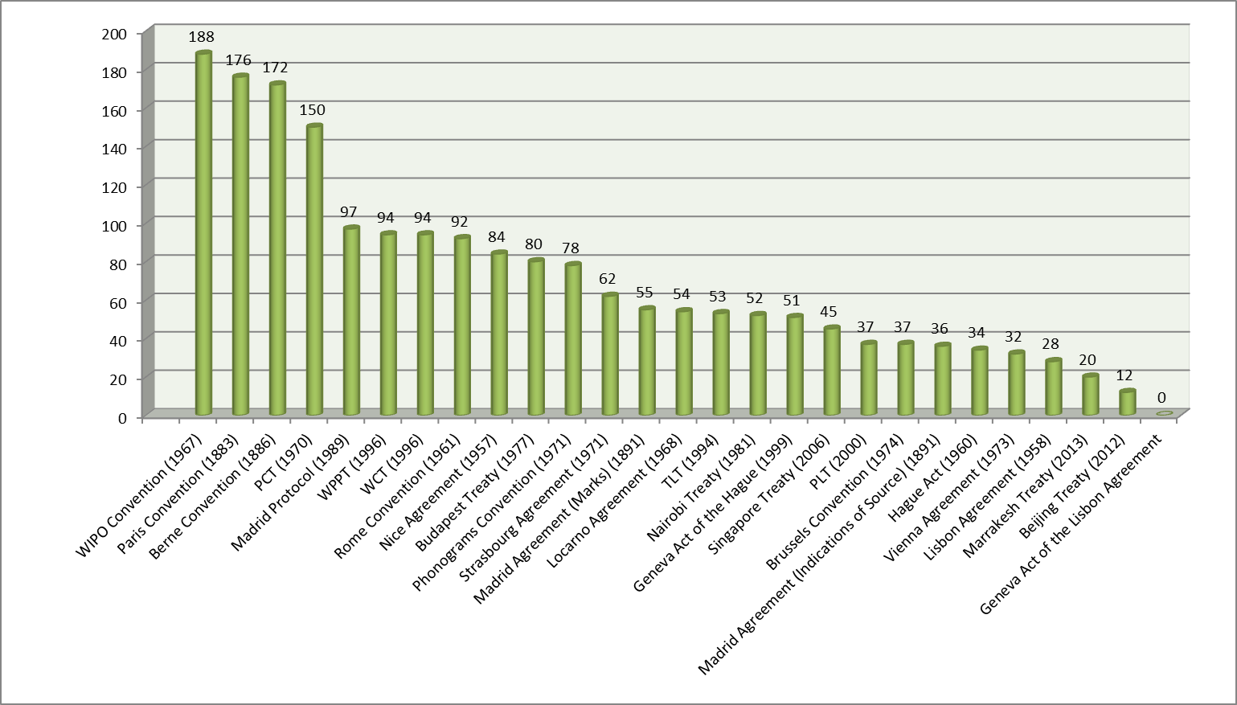

1. Since the treaties adopted by the Organization represent the collective policy expression of the Member States, Member States should be encouraged to address the possibility of adhering to them. This would have the advantage of creating a more harmonious and even legal international framework for intellectual property.
2. Turning to the current agenda, it may be noted that three new international agreements were adopted over the current period, namely, the Beijing Treaty on Audiovisual Performances (the Beijing Treaty), the Marrakesh Treaty to Facilitate Access to Published Works for Persons Who Are Blind, Visually Impaired or Otherwise Print Disabled (the Marrakesh Treaty) and the Geneva Act of the Lisbon Agreement on Appellations of Origin and Geographical Indications (the Geneva Act of the Lisbon Agreement). In the current period, only the Marrakesh Treaty has entered into force.
3. There are a number of projects under discussion between the Member States where agreement has been elusive. These include the proposed design law treaty; broadcasting; traditional knowledge (TK), traditional cultural expressions (TCEs) and intellectual property issues related to genetic resources (GRs); and exceptions and limitations in the field of copyright. It is clear that, as intellectual property assumes a more important position in the economy and in society as the knowledge economy evolves, as technology permeates the productive sector and as the production, distribution and consumption of creative works changes mode, multilateral agreement will continue to be difficult to achieve. It is not, however, helpful for the image of the Organization for issues to remain on the agenda without resolution for extended periods of time. Discussions on broadcasting, for example, commenced in the 1990s, while discussions on an international instrument or instruments in the field of GRs, TK and TCEs began at the turn of the current century. In part because of the difficulty of achieving multilateral consensus, an increasing number of instances of international rule-making in the area of intellectual property are occurring in bilateral, plurilateral and regional arrangements. The challenges for multilateral norm-making are thus considerable and will require active engagement and preparedness to compromise on the part of Member States, if they are to be successfully addressed.
4. Since the current agenda is a mature or long-standing one, and on the assumption that the items that comprise it may be brought to successful or agreed closure, it will be important that the Organization consider, over the next period, the nature of future normative exercises in which it wishes to engage. One area where views amongst Member States are least divided is the procedural functioning of the intellectual property system. This area may provide an opportunity for action on the part of the Member States.
5. The future agenda will require the careful identification of the areas in which multilateral action is either needed or can add value in the increasingly complex landscape of international norm-making. It may also require reflection on the part of the Organization as to the modalities by which normative issues are identified and carried forward. The current system of committees is considered by some to involve inefficiencies and it will be for the Member States to decide whether it should be the subject of evaluation, discussion or revision in order to improve its performance.

**STRATEGIES**

1. Six strategies will be followed in respect of Strategic Goal I over the next period:
2. The process of encouraging Member States to ratify approved constitutional reforms, such as the unitary contribution system and term limitations for the office of Director General will be pursued, with a view to bringing the formal implementation of the policies adopted by Member States into alignment with the practices of the Organization.
3. Member States will be encouraged to ratify or to accede to the three new international instruments concluded over the current period, with a view to enlarging the membership of the Marrakesh Treaty and to bringing into force the Beijing Treaty and the Geneva Act of the Lisbon Agreement (while pointing out, in the case of the last-mentioned treaty, the option of providing protection for geographical indications through the trademark system). Technical and legal assistance will be provided to Member States to assist in the process of ratification.
4. The Organization will seek to encourage accessions to the treaties administered by WIPO and technical and legal assistance will be provided to Member States in this regard. The objective will be to bring 12 of the treaties administered by WIPO to a membership of over 100 Contracting Parties by the end of the next period.
5. The Organization will seek to bring to a successful or agreed conclusion over the next period the outstanding normative processes in the areas of the proposed design law treaty; broadcasting; intellectual property relating to GRs, TK and TCEs; exceptions and limitations in the area of libraries and archives, disabilities other than visual impairment and educational institutions.
6. The Secretariat will seek to facilitate discussion amongst Member States on the identification of new issues beyond the existing agenda where the Member States consider that multilateral action is needed or would add value.
7. The Secretariat will encourage and seek to facilitate a discussion amongst the Member States about the procedures and bodies through which new normative issues where multilateral action is considered desirable may be identified and addressed.

# STRATEGIC GOAL II: Provision of Premier Global IP Services

**CONTEXT**

1. The Organization manages five global intellectual property systems that provide services to users of the IP system worldwide:

* The Patent Cooperation Treaty (PCT);
* The Madrid System for the international registration of marks (the Madrid System);
* The Hague System for the international registration of designs (the Hague System);
* The Lisbon System for the international registration of appellations of origin and geographical indications (the Lisbon System);
* The WIPO Arbitration and Mediation Center.

1. The Global IP Systems of the Organization are very good examples of successful international cooperation. They rely on cooperation between the Member States, between the Member States and the International Bureau, and between the Member States, the International Bureau and users of intellectual property. In general, the systems have experienced, since their establishment, consistent growth in participation by Member States and consistent growth in use by individuals, institutions and enterprises. They have, over the period of their respective life-times, been constantly modernized, either through treaty revision or the revision of the regulations and other subordinate legislative instruments, or throughthe development and deployment ofinformation technology systems and environments.
2. The Global IP Systems form the financial basis of the Organization, accounting for 94 per cent of the revenue of the Organization, thus enabling the functioning of the Organization and its various programs. The sound financial condition of the Organization results from the expansion of the systems and increasing demand. In general, the systems have out-performed the global economy in growth, a measure of the expanding role of knowledge in economic production and distribution and of globalization, which has seen enterprises seek IP protection across a broader range of markets.

**Graph 2: Growth in demand for services under the PCT, Madrid and the Hague Systems**

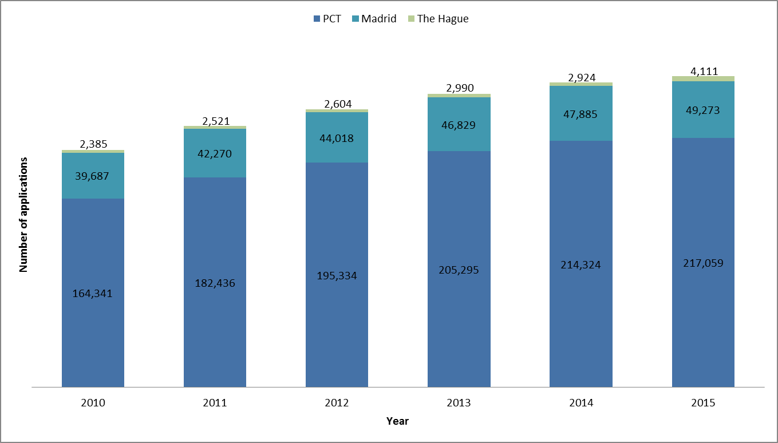

1. The reasons behind the growth in use of the Global IP Systems should remain valid over the period of the new MTSP. However, expectations in this regard should be tempered by two considerations. First, the state of the world economy remains fragile and unpredictable. Secondly, the various systems have different levels of contribution to the revenue of the Organization and different levels of maturity. The PCT generates 76 per cent of the revenue of the Organization, but, with 150 Member States, has reached a level of considerable maturity. Growth in the PCT will come mainly from growth in science and technology and their deployment within the productive sector, rather than from new participants in the PCT System. The Madrid System generates 16 per cent of the revenue of the Organization. Its membership of 97 Contracting Parties covers 113 countries. It might be expected that growth will come in the Madrid System not only from increased economic activity, but also from the growing attractiveness of the system as its expands its geographical reach. The Hague System generates 1 per cent of the revenue of the Organization. It is the least mature of the systems, with 59 Contracting Parties to the latest, Geneva Act of the Hague Agreement. In line with the impact of the recent accessions of Japan, the Republic of Korea and the United States of America, it may be expected that the growth rates in the Hague System will be considerable over the next period, but the financial impact of those growth rates will, because of the size of the overall contribution of the Hague System to the revenue of the Organization, be somewhat limited. The growth in the Hague System should, however, enable the financial profile of the Hague System to become balanced and not be in deficit. The Lisbon System, the smallest of the systems, with a current membership of 28 Contracting Parties, might be expected to grow, with the recent conclusion of the new Geneva Act, but the financial impact of the growth will be minimal because of the inherent limitation imposed by geography on the number of potential registrations. The WIPO Arbitration and Mediation Center has experienced strong growth in the use of its services, which might be expected to continue, especially in the area of non-domain name specific procedures, as the Center becomes increasingly well-known and trusted by the potential user base worldwide.
2. The success of the Global IP Systems has resulted from the continuous engagement of the Member States in renewal of the systems and the development of state-of-the-art IT systems, which have enabled productivity to be improved and cost to be curtailed.

**Graph 3: Evolution of Productivity of Examination – PCT and Madrid**

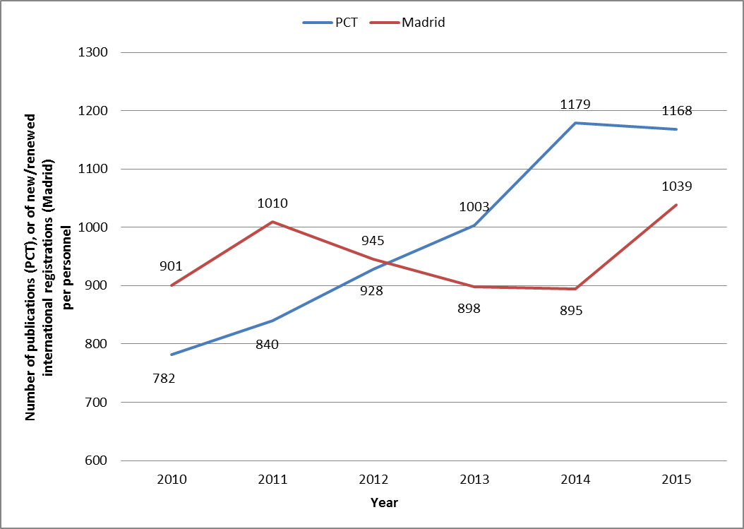

1. Both of these conditions are essential to the continued success of the systems over the next period. The latter will require further investment in the development of new and improved IT infrastructure, including the immediate environment for the operations of the systems, as well as security and resilience.

**STRATEGIES**

1. Four strategies will be pursued to maintain and to develop further the quality and competitiveness of the Global IP Systems.
2. The International Bureau will continue to pursue the aim of transforming the systems into **truly global systems** by encouraging States not party to the systems to consider the benefits of the systems and by supporting interested States in preparations for participation in the systems. The objective for the PCT will be to bring any large economies not yet party to the PCT into the PCT System. For the Madrid System, the objective will be to expand the current membership of 97 Contracting Parties towards a target of 150 Contracting Parties. For the Hague System, the objective will be to bring the number of Contracting Parties to the Geneva Act towards a target of 100 Contracting Parties. In the case of the Lisbon System, the objective will be to bring the Geneva Act into force and to expand the membership of the system while respecting the right of Member States to choose to provide protection for geographical indications by trademark or other forms of legal protection.
3. The process of **modernizing and**, where possible**, simplifying the regulatory framework** through the Working Groups established under the PCT, Madrid System and the Hague System will continue. In the case of the PCT, in addition to the adaptation of the PCT to new developments and new possibilities introduced by IT, the exploration of possible simplifications in the financial flows between Receiving Offices, international authorities, designated Offices and the International Bureau will be pursued with a view to evaluating reductions in cost and currency exchange vulnerabilities. In the case of the Madrid System, some difficult structural questions remain on the agenda of the Working Group relating to the basic mark and the difficulties presented by this requirement for countries using non Roman script languages. In addition, the question of languages of filing will most likely need to be examined as the Madrid System continues its expansion and the composition of the main filing countries evolves. In the case of the Hague System, the rapid expansion of the system and the experience of examining countries will need to be monitored and consequential adjustments made, where necessary. For the Lisbon System, the question of financial sustainability will need to be settled.
4. The continuing development of the IT environment for the Global IP Systems will remain a priority in order to improve productivity, to enhance the level of service provided to users, to contain costs and to maintain the competitiveness of the systems. For the PCT, the deployment of the new look and feel for ePCT, the further development of ePCT, the encouragement of greater use by Offices and users of the possibilities offered by ePCT will be pursued. The Madrid System will require considerable investment in IT to improve the productivity of the internal processing system and to create an environment for Offices and users that resembles, with appropriate differences acknowledging the different legal and regulatory system and the different user needs, the environment of ePCT. For the Hague System, a strategy and plan to develop a comprehensive IT environment needs to be developed and implemented. The IT needs of the Lisbon System are relatively modest, but some investment will be required to ensure efficiency and a seamless user experience. A review will be undertaken of the IT system that lies at the basis of both domain name dispute administration and the administration of conventional mediations and arbitrations. The current IT system dates from the pioneering days of domain name disputes and the online administration of mediations and arbitrations. A plan for the further development of the system will be developed and implemented in the next period. In addition, the work that has commenced on exploring synergies between the various IT systems for the Global IP Systems will continue. The aim is to create a common user experience through the adoption, where possible of similar architecture and look and feel and to achieve efficiencies through the provision of common functionalities in areas such as identity management, security and financial administration.
5. The alignment of skill profiles of staff in keeping with the growing sophistication of administrative tasks through the continuing development of the IT systems and with the changing geographical and linguistic composition of the user base of the Global IP Systems will continue to be pursued.

# STRATEGIC GOAL III: Facilitating the Use of IP for Development

**CONTEXT**

1. While Strategic Goal III is specifically devoted to development, and while there is a dedicated Development Sector within the Organization, all Programs of the Organization are delivered with the development dimension in mind and all Sectors of the Secretariat are cognizant of this imperative. Facilitating the use of IP for development is a horizontal objective and is horizontally embedded across the Organization.
2. The first role of the Development Sector in addressing Strategic Goal III is, thus, coordination of the various inputs of the Organization into coherent plans and projects that are delivered in a coherent manner.
3. The main orientations of the Organization’s programs that are specifically aimed at developing, transition and least developed countries (LDCs) are:

* assistance in the development of national IP strategies and plans, which seek to ensure that IP is used strategically to promote national economic plans and strategies and to address the specific level of development and the economic circumstances of the countries concerned;
* in coordination with other Sectors, providing advice and assistance, upon request, in relation to the legal and regulatory framework for IP;
* in coordination with the Global Infrastructure Sector, providing technical infrastructure for the effective administration of IP and use of IP in the economic sector;
* human capacity building, especially through the WIPO Academy;
* the implementation of the Development Agenda.

1. There are several challenges that arise in this area, most notably the constant and rising demand for development cooperation, the diversity of circumstances of the countries that fall within the footprint of the Organization’s dedicated development cooperation program and the competition for public policy attention in countries afflicted by low-income levels and civil unrest, instability or conflict.

1. In the current period, the Organization made significant headway in progressively mainstreaming all 45 Recommendations of the Development Agenda into the regular activities of the Organization. Guided by the Recommendations under Cluster A, these activities are delivered in a manner that is demand-driven, tailored to the specific development needs and targets of each Member State, and results-based. In addition to the mainstreaming of development priorities into each programmatic area, WIPO has also delivered 31 specific projects to advance the implementation of the Development Agenda
2. In line with the Recommendations of the Development Agenda, special emphasis has been placed on technical assistance to LDCs, guided by the seven WIPO Deliverables contained in the Istanbul Program of Action for LDCs 2010–2020, adopted at the Fourth United Nations Conference on the Least Developed Countries in 2011. A core focus of this work has been building capacity relating to the use of appropriate technologies to address specific development challenges.

**STRATEGIES**

1. Seven strategies will be followed in the next period:
2. Continued focus on coordination of the horizontal inputs of the Secretariat for the achievement of coherent delivery of effective, demand-driven technical assistance and development cooperation.
3. Consolidation and advancement of the progress achieved in the implementation of the Development Agenda, with particular attention to the findings of the review of the implementation of the Development Agenda that will be presented to the Committee on Development and Intellectual Property (CDIP) at the end of the current year.
4. Strengthening the quality of services delivered by the Secretariat by mapping the areas in the innovation process and the creative industries in which IP has a role and ensuring that those areas are covered systematically in the delivery of activities to countries.
5. Special focus on the specific needs of the LDCs and, in particular, projects for the utilization of appropriate technology in areas of social and economic importance identified by beneficiary countries.
6. The further development of the Academy as a center of excellence for capacity building and continued focus on distance learning, cooperation with universities and national authorities in the joint conduct of masters’ programs, summer schools and establishment of IP training academies in Member States.
7. Support for the implementation of the SDGs and 2030 Agenda for Sustainable Development within the mandate of the Organization and, in particular, in relation to innovation in SDG 9.
8. In line with the Guidelines adopted by Member States for External Offices, coordination with External Offices in the delivery of development cooperation programs.

# STRATEGIC GOAL IV: Coordination and Development of Global IP Infrastructure

**CONTEXT**

1. The databases, platforms, systems and services that constitute the global infrastructure program of the Organization provide rich opportunities for international cooperation for the purpose of delivering a range of results and benefits:

* The **efficiency of the operation of the intellectual property system worldwide** is improved through platforms such as the Digital Access Service (DAS), which reduces transaction costs for both Offices and applicants; the adoption of standards that facilitate interoperability, exchange of data and the availability of data; and the continued development of classification systems that facilitate the administration, search and retrieval of applications;
* The **capacity of IP Offices and collective management organizations in developing, transition and least developed countries** is enhanced through the Intellectual Property Automation System (IPAS) suite of IT modules, supporting business processes of IP Offices, from administration of applications and registrations of IP rights, to fully online publication, online filing and online transactions, which is deployed in approximately 80 IP Offices around the world, and WIPO Copyright Connect (WCC), which is in the process of being rolled-out;
* The **quality of information available to Offices** to take decisions is enhanced through platforms such as WIPO CASE (Central Access to Search and Examination) and the Global Databases (PATENTSCOPE, the Global Brands Database, the Global Designs Database and WIPO Lex);
* A free and rich **source of economic and business intelligence** is available to governments and economic agents through the Global Databases;
* The **capacity of developing, transition and LDCs** **to have access** to a wealth of scientific and technological information and to use this source for innovation and technology transfer is enhanced through the establishment of Technology Innovation Support Centers (TISCs) and the public-private partnerships of Access to Research for Development and Innovation (ARDI) and Access to Specialized Patent Information (ASPI), which provide free-of-charge or low-cost access to an extremely rich range of scientific and technological journals and technology databases;

1. Over the current period enormous progress has been made in developing the databases, platforms, systems and services of the Global Infrastructure Program. Notably, PATENTSCOPE has been developed to give access to over 50 million patent records and to enhance ease of access through multilingual search and computer-assisted translation tools. New global databases have been established and developed (the Global Brands Database, the Global Designs Database and WIPO Lex). Both the DAS and WIPO CASE platforms have been adopted by an expanding range of countries and their features have been constantly improved. The range of services and modules of IPAS has been augmented and an expanding number of countries have adopted IPAS as their basic IT administrative and processing system. WCC has been developed and is being deployed in the course of the current year. The revision rhythm of the international classifications has been accelerated, new publication platforms have been adopted for them and their coverage has been expanded. The Committee on WIPO Standards was unable to proceed with its work during an extended period as a result of a disagreement between Member States, but agreement was reached earlier this year, which enabled the Committee’s work to proceed, resulting in the adoption of two new and four revised standards. The TISC program has enjoyed widespread support, with 50 TISCs and an eTISC network, aimed to improving cooperation between TISCs, as well as technical support, having been established.
2. There are several challenges that arise in the development and maintenance of the Global Infrastructure Program. In the first place, the majority of the platforms and systems depend upon the active engagement of the Member States, which are the main contributors of needed data, the main developers of revised classifications and standards and the main users of the various databases, platforms and systems. Without that engagement, it would be impossible for the global databases, classification systems, standards and platforms to function and to thrive. The maintenance of this engagement is essential to the viability and success of the program. In addition, the program is based on IT. Resilience and appropriate security, in order to ensure the constant availability of the various databases, platforms and systems, which are used by millions throughout the world on a daily basis, as well as to ensure data integrity, are essential risk-mitigation measures for the program.

**STRATEGIES**

1. There are five strategies that will be pursued over the next period:
2. The Global Databases will be further developed to expand their collections to ensure a geographical coverage that is as wide as possible. The inclusion of non-patent literature in PATENTSCOPE will be explored and, where possible, collections of non-patent literature will be included to ensure that PATENTSCOPE is as useful as possible to patent applicants, IP Offices and the general public. The computer assisted translation tools will be further refined in line with the policy of multilingualism and the availability and utility of the databases to the widest possible international audience. The integration of publication under the Madrid and Hague Systems into the Global Brands Database will be fully achieved.
3. Several strands will be followed in the strategy for the classification systems. The international patent classification (IPC) remains the unifying system of patent classification worldwide. The common classification system adopted by certain members of the IP5 provides a more granular and advanced classification system that builds upon the IPC. The objective will be to ensure that the linkage between the two systems continues to be maintained in order to ensure the maximum coherence internationally for patent classification. In the case of the Nice Classification, the relationship between it and the Madrid Goods and Services Database will be explored in order to align, as much as possible, the two instruments. The Locarno Classification for designs is becoming more important as the Hague System expands. The Locarno Classification needs to be enhanced and to take into account, in particular, the experience of examining offices.
4. TISCs will continue to be established, where requested by Member States, on the basis that they should become sustainable. The networking of TISCs will continue to be encouraged through electronic means and opportunities will be sought for the sharing of good practices and for leveraging the position of TISCs as service‑providers to innovators so as to link with other IP services, such as dispute‑resolution and licensing, which can be of service to innovators. Developing, transition and least developed countries will be encouraged to take advantage of ARDI and ASPI to improve access to technology and knowledge.
5. The IPAS suite of applications will continue to be developed to ensure that it meets the needs of IP Offices at different levels of maturity in developing, transition and least developed countries. The focus will be on improving data quality, digitization of paper records, redesign of office workflows, improving management of IP registration processes and linking national IP systems into the global IP Systems (PCT and Madrid) and the regional IP Systems (ARIPO, EPO, OAPI), to enable fully online transactions with those systems.

1. WCC will be deployed across a broader range of developing, transition and least developed countries, according to demand from those countries. It will also be expanded beyond the management of musical works to audiovisual and published works.

# STRATEGIC GOAL V: World Reference Source for IP Information and Analysis

**CONTEXT**

1. The Organization serves as a reference resource for intellectual property activity globally, providing a number of information and analytical products that are widely used by IP Offices, policy makers, organizations, enterprises and the general public. These products comprise principally:

* the Global Databases that have been discussed in Strategic Goal IV (Global IP Infrastructure);
* a series of statistical reports, including the flagship World Intellectual Property Indicators (WIPI); the Statistics Data Center, accessible through the WIPO website, from which a variety of reports can be developed by users, including country profiles; and IP Facts and Figures, one of the most frequently downloaded publications on the website;
* Annual Reviews of the operations of the PCT, the Madrid System and the Hague System;
* the biennial World Intellectual Property Report, which provides an economic analysis of specific themes in the field of intellectual property;
* the annual Global Innovation Index (GII), published in partnership with INSEAD and the Cornell University Business School, together with a number of knowledge partners;
* at the request of individual Member States and within the scope of the Development Agenda, specific studies, usually on the use of intellectual property or the development of IP policies or strategies in various countries;
* surveys of activity in the creative industries and in the operation of the copyright system, including national studies on assessing the economic contribution of the copyright-based industries of which 49 have been produced in accordance with WIPO methodology, and international surveys on private copying and on text and image copyright levies.

1. During the current period, great progress was made in this area, with new products, such as the GII, WIPI, the World Intellectual Property Reports and country studies under the Development Agenda, being established, and existing products, such as the Annual Reviews of the Global IP Systems, being significantly improved.
2. The principal challenge facing the Organization in this area is the excess of demand over supply. The Organization’s resources are limited and the demand from Member States for studies, particularly those related to national situations, is strong. The judicious use of external resources assists the Secretariat in managing this challenge, but external resources also require quality control and administration and are, thus, also resource-intensive.
3. A second challenge is to ensure that the Organization’s work is adding value in a context in which intellectual property is the subject of increasing attention from public and academic institutions, think tanks and non-governmental organizations. Parts of the Organization’s work, such as statistics, are primary resources and fully complementary to the activities of other institutions and agencies. The WIPO Statistics Data Center, for example, is widely relied upon by a range of external institutions and organizations for the preparation of their own studies, facilitated by the open data policy of the Organization. Other parts of the Organization’s work, such as the GII and WIPI, have established leading positions and equivalent products do not really exist.

**STRATEGIES**

1. The products of the Organization’s program in this area are widely appreciated. The basic thrust of the Program to address Strategic Goal V will thus remain the same, with the following five strategies being pursued:
2. The effort to increase the number of countries covered by WIPI will continue, in cooperation with the Development Sector, and technical assistance will be provided where requested to improve the capacity of developing, transition and least developed countries to establish or develop statistical facilities. Work will continue, in consultation with Member States, on the development or refinement of indicators that are useful for policy analysis. The extension of the Organization’s statistical report into the area of copyright will be explored.
3. The GII will continue to be published and ideas for improving it, such as the examination of the capacity and performance of cities or clusters, in addition to countries, will be explored. In addition, the desirability and feasibility of an index in the area of creative industries and cultural products will be examined.
4. The World Intellectual Property Reports will continue to be published on a biennial basis, with the emphasis remaining on in-depth and quality reports.
5. The economic studies in the copyright area will be reviewed, with the aim of ensuring that the Organization’s contributions in this area are fresh and add value. It is planned to strengthen the internal capacity for the economic analysis of copyright-based industries.
6. The Annual Reviews of the Global IP Systems will be continued with the aim of ensuring that they provide Member States and other stakeholders useful assessments of the performance of the systems and of intellectual property activity worldwide.

# STRATEGIC GOAL VI: International Cooperation on Building Respect for IP

**CONTEXT**

1. As IP has grown in importance in the context of the knowledge economy, the protection of IP has faced a growing number of challenges and new vulnerabilities. These challenges and vulnerabilities come from a variety of sources. Developments in technology, particularly in the digital economy and in the life sciences, have made copies equal in quality to originals and have reduced the cost of reproduction, in some cases to zero marginal cost. Globalization has increased both the opportunity for counterfeiting and piracy and the vulnerability of individuals and communities, including indigenous peoples and traditional communities, to the misappropriation of intellectual assets. In all parts of the world, the growth in value of intangible assets has occurred more quickly than the corresponding rise in consciousness of that growth in value. The ease of reproduction often belies the difficulty, complexity and cost of original production, as in the case, for example, of a film.
2. The Strategic Objective of building respect for IP seeks to address these challenges and vulnerabilities. It is a vast objective and the resources available to the Organization to address it are necessarily limited. In the current period, the Member States have set three main orientations for the work of the Organization: (i) facilitating information exchanges among Member States; (ii) providing legislative and capacity building assistance; and (iii) cooperating on joint activities with other international actors.
3. Information exchange activities are conducted primarily through the Advisory Committee on Enforcement (ACE), and include sharing of national experiences in relation to awareness-raising campaigns, institutional arrangements concerning IP enforcement, and IP dispute resolution mechanisms, across the diverse national contexts of Member States.
4. The assistance programs take a number of forms. At the request of Member States, the International Bureau provides legislative advice on draft or current laws, as well as assistance in creating new regulatory solutions, tailored to each country. At the same time, the Organization’s capacity-building activities support institutions such as national IP Offices, the judiciary, and police and customs authorities in improving their ability to conduct both prevention and enforcement activities. Finally, guidance is provided on the development of education and awareness initiatives.
5. Given the vastness of the task of building respect for IP in the context of a globalizing economy in which knowledge and technology are playing an increasingly important role in production, distribution and consumption, the Organization’s program needs to be associated with other efforts being undertaken in the same direction, particularly those of other international stakeholders. The International Bureau seeks to achieve cohesion and to maximize the impact of its work by coordinating work with intergovernmental and non-governmental organizations, industry associations and academic institutions, where appropriate.

**STRATEGIES**

1. Three strategies will be followed in support of this strategic goal:
2. Building respect, compliance and enforcement are principally concerned with the implementation of norms. In the current period, the Member States have demonstrated little appetite for multilateral normative activates within the area of this Strategic Goal. Unless the Member States decide otherwise, therefore, the focus of the Organization’s work will remain on information exchange, legislative assistance and capacity building, and international cooperation activities.
3. The Organization’s work will continue to be guided by Recommendation 45 of the WIPO Development Agenda, which calls for the enforcement of IP to be understood in the context of societal interests and development-oriented concerns. This approach requires taking a broad, holistic view of building respect for IP. Accordingly, work will continue to extend beyond legal and regulatory frameworks to include prevention activities that account for the complex socio-economic dynamics underlying issues of counterfeiting and piracy. Further, while counterfeiting and piracy are problems faced by all countries, WIPO’s Member States face diverse challenges at differentiated development levels. The Organization’s technical assistance will take into account the societal interests and priorities of each Member State.
4. Given that building respect for IP touches all areas of IP, this Strategic Goal calls for horizontal attention across the Organization. Many different areas of the Organization support the efforts of Member States to work towards this goal. Thus, a strategy will be followed of ensuring effective coordination between all relevant Sectors in order to maximize the impact of the deployment of limited resources and to ensure the avoidance of duplication.

# STRATEGIC GOAL VII: Addressing IP in Relation to Global Policy Issues

**CONTEXT**

1. The increasingly important role of technology in the economy and society has brought intellectual property into prominence in a wide diversity of public policy issues. The objective of the program that addresses Strategic Goal VII is to ensure that the Organization, within its mandate, contributes positively to global efforts to address major policy issues, such as climate change, health and food security. The Organization does so in several ways:

* several public-private partnerships (PPPs) seek to encourage multistakeholder engagement and resources in support of agreed policy orientations of the Member States. There are three main PPPs relevant to this area. The first is WIPO Re:Search, which seeks to improve innovation capacity in the area of neglected tropical diseases, malaria and tuberculosis through the sharing of IP and unpublished scientific data between enterprises, universities and research institutions and through capacity building. The second is the Accessible Books Consortium (ABC), which seeks to assist in the implementation of the Marrakesh Treaty. The third is WIPO Green, which seeks to provide a platform for the exchange of green technologies in support of the goals of the Paris Climate Agreement and cognate international processes for managing the challenges of climate change and the preservation of the environment;
* the Secretariat participates in United Nations processes, at the request or invitation of the lead agencies of those processes, in order to provide factual information and clarifications of any perceived impacts of intellectual property;
* the Secretariat cooperates with the World Health Organization (WHO) and the World Trade Organization (WTO) through annual meetings on topics of health policy and in the production of reports in order to bring better understanding of, and greater coherence in, the intersection of health, trade and innovation policy in health issues;
* the Organization seeks to play a supportive and engaged role in the implementation of the SDGs.

1. In the current period, significant progress has been achieved in addressing this Strategic Goal, which, by its nature, requires steady engagement and is unlikely to produce over-night solutions. Three PPPs were established. WIPO Re:Search now counts 106 members from the public and private sectors of all parts of the world, developed, transition, developing and least developed. It has facilitated 96 international collaborations and organized capacity building for researchers and scientists in developing and least developed countries through placements and scholarships. Its objectives and activities are directly supportive of the innovation goal of SDG 9. The ABC Consortium has made enormous progress, with the engagement of all actors in the value chain of the production and distribution of works in accessible format – authors, publishers, rights-owners and rights-management organizations, libraries and the World Blind Union. WIPO Green has also made progress in attracting an increasing number of participants, which have made available technologies through WIPO Green’s platform.
2. The Trilateral Cooperation between WHO, WIPO and WTO was also established over the current period and successful technical workshops have been held. The joint report, *Promoting Access to Medical Technologies and Innovation*, was produced and has been widely welcomed.

**STRATEGIES**

1. Four strategies will be followed in support of Strategic Goal VII in the next period:
2. The existing PPPs of WIPO Re:Search, the ABC Consortium and WIPO Green will be strengthened by expanding the participation and the collaboration under the partnerships. Institutional arrangements for attracting extra-budgetary funding will be strengthened, as it is unlikely that the regular budget alone would be able to support the full potential for development of each partnership. The ABC Consortium, for example, could become the main resource worldwide for the international exchange of books in accessible formats, with significant volumes of exchanges. At the same time, the sustainability and success of each PPP will be examined to ensure that it is adding real value in a sustainable way.
3. The potential for any further PPPs will be cautiously explored, bearing in mind the mandate of the Organization, the limitation of resources and the need to contribute only where additional value would be created that does not exist elsewhere. Any such additional PPP would seek to be supportive of the SGDs and, in particular, the objective of innovation in SDG 9, the most relevant to WIPO.
4. The Trilateral Cooperation with WHO and WTO will be continued in order to provide the opportunity for discussion in relation to the intersection of health, intellectual property and trade policy in various topical health issues.
5. The Organization will continue to provide factual, technical assistance to other UN processes upon invitation or request, respecting the exclusive role of Member States to formulate policy positions where they do not already exist. In particular, the Organization will support the implementation of the SDGs within its mandate, particularly the innovation goal of SDG 9.

# STRATEGIC GOAL VIII: A Responsive Communications Interface between WIPO its Member States and all Stakeholders

**CONTEXT**

1. The objective of Strategic Goal VIII is to communicate to a global audience both the mission of the Organization to promote innovation and creativity through a balanced and effective intellectual property system and the services and products developed by the Organization in support of that mission.
2. A series of communication instruments are used for this purpose:

* The WIPO website is the main vehicle for worldwide communication. It averages three million page views per month. The website is multilingual, with most content being available in all six official languages, as well as elements of content available in German, Japanese, Korean and Portuguese. The design of the website is responsive, enabling the presentation of content to be adjusted automatically to the parameters of different devices that users may utilize in order to have access to the website.
* Use of social media has increased significantly, with a Twitter account now attracting 34,000 followers and active presences on Facebook, You Tube and other social media.
* The WIPO Magazine is published on a monthly basis and seeks to publicize programs and activities of the Organization, as well as to provide accessible accounts of the practical use of IP in the economy and society. WIPO Wire was introduced as a supplementary publication that is published every two weeks and contains short accounts of major developments. In the first year since its introduction, WIPO Wire has attracted more than 11,000 subscribers.

1. The major challenge arising in the area of communications is the abstract nature of IP. This challenge is to some extent off-set by focusing attention on the purposes for which IP exists, namely, innovation and creativity, and by producing material on practical stories illustrating the benefits of IP in producing socially and economically beneficial innovation and enriching cultural products.
2. In the current period, considerable progress has been made in rejuvenating the communications interface of the Organization. In particular:

* a new logo of the Organization was introduced, which presents a more contemporary and recognizable image;
* the design and presentation of the website was completely renewed and the content was re-organized in a more accessible way;
* WIPO Wire was introduced and has been widely welcomed;
* the Organization has successfully engaged with, and established a vibrant presence on, social media;
* a major focus has been placed on customer relations and service orientation, with a view to supporting the delivery of the various services and products of the Organization. A centralized customer service center has been established, which coordinates service orientation in the Global IP Systems, the External Offices and other Programs.

**STRATEGIES**

1. Five strategies will, in particular, be followed in the next period:
2. Efforts will be continued to increase the geographical availability and penetration of the Organization’s communications across all media and in all official languages. Particular attention will be paid to under-served audiences, such as school children, youth, small and medium-sized enterprises and those in countries without developed Internet access.
3. The renovation of the WIPO website will be continued, with the aim of increasing its usability and focus. The development of apps as alternative instruments for the communication of content will be pursued, with close attention to the empirical results achieved in the deployment of any apps.
4. The move towards digital publications will continue, with an open access policy governing as much published content as possible.
5. The service orientation of the Organization will be further developed, with the aim of standardizing, where appropriate, the customer experience across the Global IP Systems and other platforms and services. The work on consolidating the many client lists used for the Organization’s different services and mailings will be completed with the establishment of a single client database.
6. The External Offices will be actively engaged in promotion and communications within the footprint of their operations.

# STRATEGIC GOAL IX: An Efficient Administrative and Financial Support Structure to Enable WIPO to Deliver its Programs

**CONTEXT**

1. This Strategic Goal is, with Strategic Goal VIII (Communications), one of two enabling goals of the Organization. It deals with the administrative, financial and management structures that underlie and support the delivery and performance of all the Organization’s Programs. These support structures are key to ensuring the delivery of secure, high-quality, efficient, and cost-effective services under each of the Strategic Goals and, more broadly, to realizing the Organization’s mission of promoting a balanced and effective international intellectual property system.
2. There are three principal challenges facing the Organization in the provision of efficient administrative and financial support services.
3. The first of those challenges is the speed of change in the external environment and the capacity of the Organization to respond in a timely manner to changes. This challenge affects all the operations of the Organization. For example, the very rapid change in the geographical composition of demand for the Global IP Systems challenges the capacity of the Organization to adapt skill sets, particularly linguistic profiles, in order to be able to service the new demand. More generally, with the increased deployment of IT environments for the Global IP Systems, the skill profiles required of those working in these areas change from those that may have been more appropriate under the former, more paper-based procedures and practices. The Organization’s capacity to respond to the rapidity of these changes is affected by the regulatory environment for the International Civil Service, which is set in New York for the many and diverse activities and locations of the United Nations System.
4. A second challenge is organizational resilience. The Organization derives 94 per cent of its revenue from the services delivered under the Global IP Systems and these are almost all delivered through IT platforms. There are other risks inherent in a globalized world in a relatively fragile state. The risk environment calls for robust resilience and business continuity measures.
5. The third challenge is related to, but also separate from, the second and concerns security, both physical security and cyber security. Here, again, the risk environment requires robust measures to ensure that the best level of security is assured for the employees, contractors, delegates, visitors, systems, platforms and buildings of the Organization.
6. In the current period, enormous progress has been made in developing the administrative, financial and management structures. This has included:

* the implementation of a comprehensive and ambitious reform program: the Strategic Realignment Program (SRP). The SRP encompassed 19 initiatives, which all contributed to strengthening WIPO’s Core Values of service orientation; working as one; accountability for results; and environmental, social and governance responsibility. These initiatives resulted in concrete positive improvements by the end of their implementation in 2013, in areas from improving customer experience, to strengthening communication; planning for business continuity; improving the ICT framework; implementing an Enterprise Resource Planning (ERP) system; enhancing cooperation across Sectors within the Organization; strengthening results-based, performance, risk, and financial management processes; the establishment of an ethics framework; and reducing WIPO’s adverse impact on the environment. While the SRP was time bound, various elements have been taken forward with the general aim of continuous improvement.
* the establishment of an organizational resilience and business continuity strategy and the continuing implementation of that strategy.
* the commencement of the implementation of a new investment policy to accommodate the transition away from the former policy in which reserves were held on deposit with the Swiss federal authorities, a facility that will not be available in the future.
* the successful, on-time construction and commissioning of a new administrative building and a new conference hall.
* the development of a comprehensive security strategy and its continuing implementation.
* the establishment of two new External Offices, in Beijing and Moscow, and the   
  re-organization and renovation of the program and activities of the five External Offices (WIPO Brazil Office, WIPO China Office, WIPO Japan Office, WIPO Russia Office and WIPO Singapore Office), as well as the establishment of a seamless IT architecture linking headquarters and External Offices and enabling staff in External Offices to use the same administrative and management systems and tools that are available to staff working in Geneva.
* the development of increased tools for computer-assisted translation within the language services.
* the development of a Human Resource Strategy, the adoption of a Policy on Gender Equality, contract reform, improvements in the culture and management of staff performance, the revision of the Staff Rules and Regulations and the introduction of a rewards and recognition program.

**STRATEGIES**

1. Multiple strategies will be followed in this vast and complex area in the next period, notably:
2. *Results Based Management*

The Organization will continue to consolidate and refine its Results Based Management (RBM) practices and underlying support systems and tools, building on the progress made in the past six years in strengthening accountability for results. The RBM framework has now become fully embedded in the management approach of the Organization, which also integrates strengthened risk management, and is fully supported by the Enterprise Performance Management (EPM) system developed under the ERP portfolio of projects.

1. *Finance*

The transition to the Organization’s new investment regime will be fully implemented. The Secretariat will focus on implementing the two new policies for Operating and Core Cash, and for Strategic Cash, in accordance with the decision taken by its Member States. In addition, work will commence on the development of a new IT platform for financial operations that is better integrated with the Organization’s business operations that produce financial transactions and results. Such a platform will support the effective delivery of financial services to WIPO’s stakeholders, including to users of the Global IP Systems. This project will require significant investment of time and resources, as well as greater coordination between the business sectors and finance, but should result in significant gains in efficiency and quality of the services delivered to IP Offices and users.

1. *Human Resources*

The process of aligning skill profiles of staff to evolving circumstances and needs will continue. The pursuit of equitable geographical representation in the Organization will remain a priority, as will the attainment of gender equality and diversity at all levels of the staff.

1. *Information Technology*

The Organization will further develop its Enterprise Architecture to shape the Organization’s IT capacities to the delivery of its business strategy, and thus bridge the gap between business needs and operational activities. The deployment of a strengthened Enterprise Architecture has the potential to improve the quality, consistency, efficiency, and relevance of ICT solutions for the Organization’s business functions. It will also contribute to achieving better returns on ICT investments by utilizing economies of scale and allowing sharing of services across the Organization. The Organization will also implement a new identity management system to enable the centralized storage of customer data and business transactions. This will eliminate potential silos of information that may exist about the same customers in different areas of the Organization’s operations, and in doing so improve service delivery and strengthen client relationships.

1. *Physical and Information Security*

The Organization will continue investing in the strengthening of its information security posture through the execution of a long term Information Assurance Strategy. This Strategy will include measures to ensure acceptable security behavior by users, combat known and sophisticated threats, ensure resilience of WIPO’s ICT and physical security systems to cyber threats, effectively manage information risks, and demonstrate reasonable assurance of internal control to Member States and other stakeholders.

The Organization will also invest in the implementation of a long-term Security and Safety Strategy, in order to optimize existing investments in physical security and safety systems and to build new capabilities. The Strategy will have a renewed focus on prevention, preparedness and resilience, rather than reaction and compliance, in order to manage both predictable and unpredictable security risks. The Strategy will be aligned with the mandatory requirements of the UN Security Management System, and consistent with commercial security standards.

1. *Business Continuity*

The Organization’s systems will see greater evolution in the measures being developed under the enhanced resilience framework that has been implemented in the current period, for example, enhanced measures to preserve the integrity of the data generated and stored by the Global IP Systems, and the training of personnel in order to mainstream resilience approaches into daily operations.

1. *Conferences and Language Services*

The Organization will move to a more integrated Electronic Content Management (ECM) system, which will include records, archives, and transactions of the Organization. It will build upon the progress made during the last MTSP period in implementing the Records Management and Archiving Policy of 2012/13, which included the successful upgrade of the software used for records management and archiving to achieve better solutions for the archiving of documents of different Sectors, improved system compatibilities, and meeting business continuity requirements. The Organization will also work toward better, and more integrated, recording and archiving of meetings, including digital recordings, audio captioning, and print records.

The Organization will continue to promote and to implement a policy of multilingualism. It will build upon progress made in this regard in the current period. It will also continue to invest in new IT tools and systems supporting language services, such as cross-lingual searches and terminology databases, translation memories and other automatic translation tools, which improve productivity and enhance the quality of service available to Member States, users of Global IP Systems and to members of the general public.

1. *Buildings*

The Organization will continue its policy of openness to use of its facilities by Member States and partner Organizations. In accordance with the Organization’s capital master plan, WIPO’s buildings will be maintained in a condition that will reduce the possibility of requiring major investment in reactive and emergency repairs in future.

1. *External offices*

The Organization expects to see the implementation of the decision made by the Member States at the 55th Assemblies in 2015, to open up to three new WIPO External Offices in each of the 2016/17 and 2018/19 biennia, subject to approval by the WIPO Assemblies.

At the same time, the Organization will pursue the continuous enhancement of the External Office network to harness its potential to expand the reach of WIPO’s communications and outreach and to achieve benefits in terms of efficiencies in cost and program implementation. The Guiding Principles Regarding WIPO External Offices, adopted by Member States, reinforce the objective that the Organization develop a sustainable, adequately sized network of External Offices that add clear value, efficiency and effectiveness to program delivery in accordance with the organizational results framework, in a coordinated and complementary way with WIPO Headquarters and in a way that may otherwise not be achieved through operations at WIPO Headquarters. Pursuant to the Guiding Principles, the size and performance of the entire External Office network will be evaluated every five years, with due regard to the different mandates and functions performed by the External Offices.

[End of document]

1. Dominican Republic, Nigeria and Syrian Arab Republic
2. Lebanon, Madagascar and New Zealand