|  |  |  |
| --- | --- | --- |
|  | WIPO-E | **E** |
| WO/PBC/25/17 | | |
| ORIGINAL: ENGLISH | | |
| DATE: JULY 14, 2016 | | |

**Program and Budget Committee**

**Twenty-Fifth Session**

**Geneva, August 29 to September 2, 2016**

REVIEW OF MEDIUM-TERM STRATEGIC PLAN 2010-2015

*Document prepared by the Secretariat*

1. The present document contains the Review of the Medium-Term Strategic   
   Plan 2010-2015.
2. The Review is a self-assessment by the Secretariat of progress made towards achieving the Strategic Goals. The assessment highlights key achievements during the period under review.
3. The following decision paragraph is proposed.
4. *The Program and Budget Committee (PBC), having reviewed document WO/PBC/25/17, and recognizing its nature as a self‑assessment of the Secretariat, recommended that the Assemblies of the Member States of WIPO acknowledge Programs’ contribution made in 2010-2015 towards the achievement of the nine Strategic Goals of the Organization.*

[Review of the Medium-Term Strategic Plan 2010-2015 follows]

CONTENTS

I. INTRODUCTION 4

II. METHODOLOGY 5

III. OVERVIEW OF PRIORITIES OF THE MTSP 2010–2015 5

IV. WIPO ACHIEVEMENTS BY STRATEGIC GOAL 6

A. THE SUBSTANTIVE GOALS 6

Strategic Goal I: Balanced Evolution of the International Normative Framework for Intellectual Property 6

Strategic Goal II: Provision of Premier Global IP Services 10

Strategic Goal III: Facilitating the Use of IP for Development 17

Strategic Goal IV: Coordination and Development of Global IP Infrastructure 23

Strategic Goal V: World Reference Source for IP Information and Analysis 31

Strategic Goal VI: International Cooperation on Building Respect for IP 33

Strategic Goal VII: Addressing IP in Relation to Global Policy Issues 37

B. THE ENABLING GOALS 42

Strategic Goal VIII: A responsive communication interface between WIPO, its Member States and all Stakeholders 42

Strategic Goal IX: An Efficient Administrative and Financial Support Structure to Enable WIPO to Deliver its Programs 48

[ANNEX I: OVERVIEW OF STRATEGIC OUTCOMES AND OUTCOME INDICATORS OF   
 THE MTSP 2010-2015 60](#_Toc456346336)

ANNEX II: LIST OF TABLES AND FIGURES 61

# Introduction

1. The Medium Term Strategic Plan (MTSP)[1] covering the period 2010-2015 provided a high level strategic framework, which guided the preparation of the Program and Budget documents for the 2012/13 and 2014/15 biennia.[2]
2. The Assemblies of the Member States of WIPO, at the forty-eighth series of meetings, took note of the contents of document A/48/3, and also noted the comments of Member States on the document, and their submissions contained in Annex I of the Report (document A/48/26[3]).
3. The MTSP 2010-2015 was structured along nine Strategic Goals, which had been adopted by Member States in the Revised Program and Budget for 2008/09, that together established a jointly agreed frame of reference to measure organizational performance during the MTPS program period. Figure 1 below provides an overview of the nine Strategic Goals.

Figure : Overview of the WIPO MTSP Results Framework



1. The first seven Strategic Goals deal with the substantive work of the Organization. Strategic Goals VIII and IX are enabling goals, aimed at providing sound management, governance and effective two-way communication to support the achievement of the substantive goals, and ensure accountability to Member States.
2. The 45 Recommendations of the WIPO Development Agenda were incorporated in WIPO’s work conducted under all nine of the Goals. An in-depth independent review of the progress made on the implementation of the Development Agenda and the DA Recommendations, as mandated by the Committee on Development and Intellectual Property (CDIP), was underway at the end of 2015. The review will be presented to the CDIP in November 2016 and will constitute an integral part of the Review of the MTSP 2010-2015. As such, this report only contains a summary overview of progress made in this area.

# METHODOLOGY

1. The Review of the MTSP 2010-2015 is a self-assessment by the Secretariat of progress made towards achieving the Strategic Goals as measured by the Strategic Outcomes (SOs) and Outcome Indicators (See Annex I), based on the linkages with WIPO’s results frameworks approved in the Program and Budget documents[4] during the three biennia[5] of the six-year MTSP period. The assessment highlights key achievements during the period under review.
2. The assessment was based on the following methodology:

* a comprehensive review of the data[6] reported in the Program and Performance Reports (PPRs) for the three biennia,[7] the PPR being WIPO’s principal accountability tool for reporting on organizational performance to WIPO’s Member States and an integral part of WIPO’s RBM framework; and
* a desk review of other relevant documents, such as, *inter alia*, the Final Report on the Implementation of the WIPO Strategic Realignment Program (WO/GA/43/20), the Yearly Reviews of WIPO’s international registration systems, validations of the PPRs by the Internal Oversight Division (IOD) and independent evaluations conducted during the period under review.

# Overview of priorities of the MTSP 2010 – 2015

1. In the Revised Program and Budget for 2008/09, Member States adopted nine new strategic goals for WIPO. These Strategic Goals provided the starting point and the approved strategic framework for elaboration of the MTSP.
2. The actual MTSP was subsequently developed through an intensive consultative process that involved the Secretariat and the Member States.
3. The approved MTSP guided the preparation of the Program and Budgets for the 2012/13 and 2014/15 biennia, ensuring that they fully followed the strategic direction of the MTSP that had been agreed with Member States. In the case of the 2010/11 Program and Budget overlapped with the MTSP drafting process, which meant that that program did not fully reflect the specific structure of the MTSP.

# WIPO Achievements by Strategic Goal

## The Substantive Goals

### Strategic Goal I: Balanced Evolution of the International Normative Framework for Intellectual Property

#### **Strategic Outcome: Full engagement of Member States to reach agreements on legislative and practical measures in areas of common interest to adjust the existing international IP framework**

1. During the period 2010-2015, WIPO’s Member States made important advances in the balanced evolution of the international normative framework for intellectual property (IP), albeit with some variations across the different major normative areas. With the adoption of the Beijing Treaty on Audiovisual Performances (Beijing Treaty) in 2012, the Marrakesh Treaty to Facilitate Access to Published Works by Persons Who Are Blind, Visually Impaired, or Otherwise Print Disabled (Marrakesh VIP Treaty) in 2013 and the Geneva Act of the Lisbon Agreement on Appellations of Origin and Geographical Indications in 2015, WIPO was successful in adopting two new and one revised agreement in international IP law. In addition, the Organization helped to advance the multilateral discussions on three other key IP topics: (i) the protection of broadcasting organizations with the aim of adapting to the new and emergent challenges posed by the rise of the Internet and other new technologies; (ii) the simplification of international formalities for obtaining protection for industrial designs; and (iii) the protection of traditional cultural expressions (TCEs) and traditional knowledge (TK) and addressing the interface between intellectual property and genetic resources (GRs). The period also saw increased membership in existing IP agreements for patents, trademarks and copyrights, industrial designs and geographical indications. Finally, WIPO facilitated the consolidation of national IP legal and regulatory frameworks in Member States through needs-based technical, legal and policy-related assistance in all major areas of international IP law in response to upward of 190 requests for such support.

##### Outcome Indicator I.1: 1. Agreements reached by Member States within each major area of the international normative IP framework

1. In the area of copyright and related rights**,** the adoption of the Beijing Treatyin 2012 with 48 initial signatures made this agreement the first treaty on substantive IP law concluded since 1996. Upon entering into force, this new instrument will provide a clearer legal basis for the international use of audiovisual productions, with a focus on the rights of performers in those productions. By the end of 2015, 10 countries[8] had ratified or acceded to the treaty, out of the 30 required for its entry into force. Equally significant was the adoption of the Marrakesh VIP Treaty in 2013. It was intended to help address the “book famine” that led to only five per cent of published books being available in formats accessible to persons who are visually impaired or print disabled. The Marrakesh VIP Treaty obtained a total of 80 initial signatures upon its conclusion. Thirteen Member States[9] had ratified or acceded to the treaty by the end of 2015, out of the 20 required for its entry into force.
2. In the deliberations on updates to the protection of broadcasting[10], Member States successfully agreed on a new work plan in 2011 and were able to move discussion forward on some key basic principles in 2015. However, the Standing Committee on Copyright and Related Rights (SCCR) has not yet agreed on a road map towards a diplomatic conference on this issue. Work also progressed on limitations and exceptions to copyright for libraries, archives and educational materials. Although some progress was made in discussions in 2014/15, more work remains to be done in the next MTSP period.
3. Negotiations for a Design Law Treaty (DLT) by the Standing Committee on the Law of Trademarks (SCT), aimed at harmonizing international industrial design registration formalities, progressed to produce a well-developed draft document and draft regulations comprising 32 articles and 17 rules of which only a few remained the subject of alternative proposals. The General Assembly in 2015 agreed to convene a diplomatic conference for the adoption of a Design Law Treaty at the end of the first half of 2017, provided that the discussions on technical assistance and disclosure were completed during the thirty-fourth and thirty-fifth sessions of the SCT.[11] This not being the case, the matter will revert to the General Assembly for further consideration.
4. With regard to international law on patents, the Standing Committee on the Law of Patents (SCP) agreed in 2010[12] to examine five issues during its future sessions: (i) exceptions and limitations to patent rights; (ii) quality of patents, including opposition systems; (iii) patents and health; (iv) confidentiality of communication between clients and their patent advisors; and (v) transfer of technology. The SCP continued deliberations on these five issues throughout the period of the MTSP and identified different modalities to conduct its work. This included, for example, (i) the elaboration of background materials to facilitate the better understanding of different aspects of the agenda; (ii) the compilation of national laws and practices; (iii) the implementation of feasibility studies; (iv) the organization of seminars with external experts and (v) work sessions for Member States to share their practical experiences and discuss common challenges. Those various modalities have proven very useful in identifying similarities and differences in the practice of IP offices. The progress in the above-mentioned areas notwithstanding, the SCP sessions in 2014 and 2015[13] witnessed an increasing difficulty in the identification of priorities for the future work of the SCP. This highlighted the importance of continued efforts of WIPO and its Member States to identify a way forward for the SCP in the next programming period.
5. In the areas of TK, TCEs and GRs, the beginning of the six year period covered by the MTSP coincided with the adoption, in 2009, by the WIPO General Assembly, of a robust mandate for the Intergovernmental Committee on Intellectual Property and Genetic Resources, Traditional Knowledge and Folklore (IGC). The General Assembly subsequently renewed the mandate of the Committee throughout the MTSP period, tasking the IGC to follow an intense work program, save for 2015, when no agreement was reached on a schedule of IGC sessions at the General Assembly. The work of the IGC in the period 2010‑2015 consisted of consolidation and streamlining of texts under negotiation, thus resulting in work that remains to be completed by the IGC under the next MTSP.
6. The existing body of international IP law administered by WIPO saw a steady increase in contracting parties between 2010 and 2015, thus intensifying the engagement of WIPO Member States in the normative aspects of the IP system and broadening the overall scope of the systems. Three new Contracting Parties joined the Paris Convention of 1883 as the broadest and oldest international agreement on IP, bringing the total membership of the instrument to 176 by the end of 2015. By more than doubling the number of Contracting Parties, the Singapore Treaty on the Law of Trademarks saw the largest increase in membership between 2010 and 2015. The evolution of the number of contracting parties to all treaties during the period under review can be found in Table 1 and Figure 2 below.

**Table 1: Growth in number of Contracting Parties of WIPO-administered IP treaties (in alphabetical order)**

| **Treaty / Instrument** | **Purpose of Agreement** | **# of Contracting parties (2009)** | **# of Contracting parties (2015)** | **Percentage change** |
| --- | --- | --- | --- | --- |
| **IP Protection** | | | | |
| **Berne Convention (1886)** | Deals with protection of works and the rights of their creators, providing them with the means to control how their works are used, by whom, and on what terms. | 164 | 168 | **+2.4%** |
| **Brussels Convention (1974)** | Obligates each Contracting State to prevent the unauthorized distribution on or from its territory of any program-carrying signal transmitted by satellite. | 34 | 37 | **+8.8%** |
| **Budapest Treaty (1977)** | Regulates the International Recognition of the Deposit of Microorganisms for the Purposes of Patent Procedure. | 72 | 79 | **+10%** |
| **Madrid Agreement (Indications of Source) (1891)** | Regulates sanctions on products with false or deceptive indications of source. | 35 | 36 | **+2.9%** |
| **Nairobi Treaty (1981)** | Creates the obligation to protect the Olympic symbol against use for commercial purposes without authorization of the International Olympic Committee. | 47 | 51 | **+8.5%** |
| **Paris Convention (1883)** | Applies to industrial property in the widest sense; covering all major IP areas.[14] | 173 | 176 | **+2%** |
| **Patent Law Treaty (2000)** | Harmonization and streamlining of formal procedures with respect to national and regional patent applications and patents and making such procedures more user friendly. | 22 | 36 | **+64%** |
| **Phonograms Convention (1971)** | Obligates each Contracting State to protect a producer of phonograms who is a national of another Contracting State against the making of duplicates without consent. | 77 | 78 | **+1.3%** |
| **Rome Convention (1961)** | Secures protection in performances for performers, in phonograms for producers of phonograms and in broadcasts for broadcasting organizations. | 91 | 92 | **+1.1%** |
| **Singapore Treaty on the Law of Trademarks (2006)** | Create a modern and dynamic international framework for the harmonization of administrative trademark registration procedures. | 16 | 38 | **+138%** |
| **Trademark Law Treaty (1994)** | Standardizes and streamlines national and regional trademark registration procedures. | 45 | 53 | **+17.8%** |
| **WIPO Copyright Treaty (WCT) (1996)** | Special agreement under the Berne Convention that deals with the protection of works and the rights of their authors in the digital environment. | 71 | 94[15] | **+32.4%** |
| **WIPO Performances and Phonograms Treaty (1996)** | Deals with the rights of two kinds of beneficiaries, particularly in the digital environment: (i) performers; and (ii) producers of phonograms. | 69 | 94[16] | **+36.2%** |
| **Classification** | | | | |
| **Locarno Agreement (1968)** | Establishes a classification for industrial designs (the Locarno Classification). | 51 | 54 | **5.9%** |
| **Nice Agreement (1957)** | Establishes a classification of goods and services for the purposes of registering trademarks and service marks (the Nice Classification). | 83 | 84 | **1.2%** |
| **Strasbourg Agreement (1971)** | Establishes the International Patent Classification (IPC) which divides technology into eight sections with approximately 70,000 subdivisions. | 59 | 62 | **5.1%** |
| **Vienna Agreement (1973)** | Establishes a classification (the Vienna Classification) for marks that consist of, or contain, figurative elements. | 27 | 32 | **18.5%** |

**Figure 2: Growth in the number of Contracting Parties of WIPO-administered IP treaties, 2009-2015**

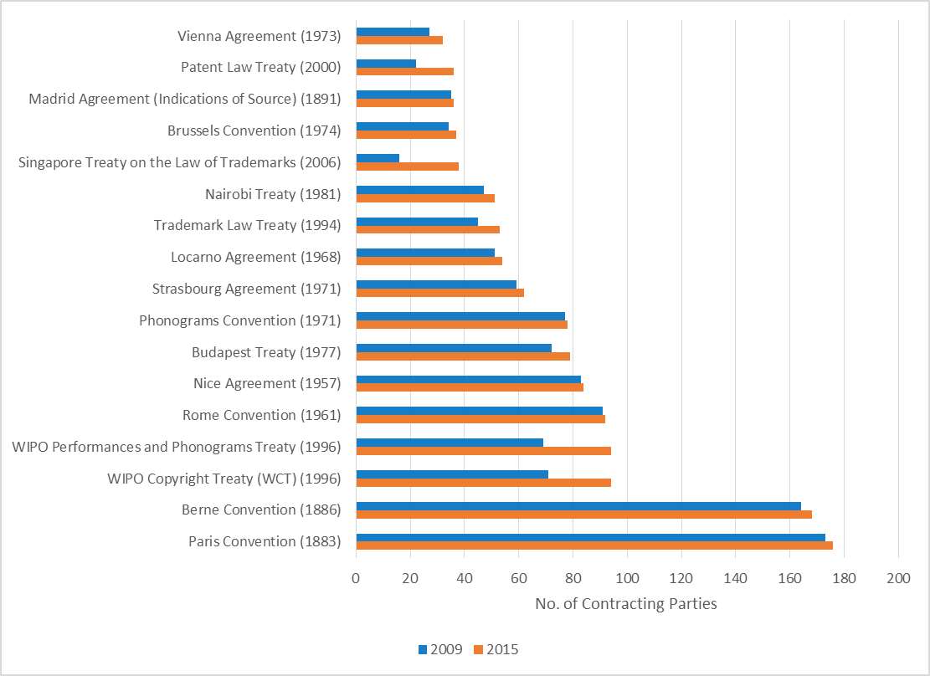

1. Throughout the six-year period, the Secretariat administered Article 6*ter* Paris Convention governing the protection of flags and emblems of states, as well as the names and emblems of international intergovernmental organizations (IGOs) against unauthorized registration and use as trademarks. The development of an electronic database for the management of flags and emblems early in the MTSP period allowed WIPO to efficiently manage a total of 284 requests for communication under Article *6ter*. By the end of 2015, the new database contained a total of 3,157 signs.
2. Indicating the active engagement of national stakeholders in the strengthening of national normative frameworks for IP, the Secretariat received and responded to upward of 190[17] requests for policy and legislative assistance. Satisfaction among Member States with the support received was high, ranging from approximately 86 to 93 per cent for advice on patents; from 91 to 95 per cent for advice on TK, TCEs and GRs; and reaching 100 per cent for support on trademarks, industrial designs and geographical indications.

### Strategic Goal II: Provision of Premier Global IP Services

***Strategic Outcome 1: A comprehensive range of WIPO global IP products and services which are the first choice for users***

1. WIPO’s global IP registration systems attracted growing interest amongst Member States during the period under review. The membership of the Hague System saw the strongest growth (39 per cent) followed by the Madrid System (19 per cent).
2. The demand from users for WIPO’s IP-related services witnessed strong growth since 2009. Increases in filings or registrations under the PCT, the Madrid, the Hague and the Lisbon Systems from 2010 to 2015 ranged from 13 per cent to over 70 per cent, with a slightly increased share of applications originating from developing countries. Interest in alternative dispute resolution (ADR) services for IP, offered through the WIPO Arbitration and Mediation Center (WIPO Center), saw considerable growth.
3. WIPO also successfully increased access to electronic services under its IP systems. The rapid uptake of these new opportunities by Member States shows how important progress in this area is for ensuring and increasing the satisfaction of users with WIPO’s IP services.

##### Outcome Indicator II.1: Increased and effective use of WIPO's global products and services in Member States including developing and least developed countries

1. The number of Contracting Parties having joined the key IP systems administered by WIPO rose over the six-year MTSP period. Among those, the Hague Systemfor the International Registration of Industrial Designs saw the strongest growth, with 14 additional Member States having acceded to the Geneva Act (1999) of the Hague Agreement, representing a 39 per cent increase in membership since 2009. Of particular note, as a result of Tunisia’s accession to the Geneva Act in 2013, no Contracting State remained bound only by the 1934 Act, allowing WIPO to take an important step towards establishing the 1999 Act as the predominant instrument in the system.[18]
2. The Madrid International Trademark System saw its membership grow by 20 per cent, from 81 Contracting Parties at the end of 2009 to 97 by the end of 2015. The accession of the *Organisation Africaine de la Propriété Intellectuelle* (OAPI)*,* a 17-country intergovernmental organization, increased the number of countries where users can centrally protect and manage their trademarks through the Madrid System to 113 by the end of 2015. This significantly advanced the transformation of the System into a truly global structure. A notable development was the accession of Algeria – which had been party only to the Madrid Agreement – to the Madrid Protocol in 2015. Algeria was the last country that was party only to the Madrid Agreement. In consequence of its accession to the Madrid Protocol, the Madrid System will be able to operate as a single treaty system.
3. The PCT System experienced the comparatively slowest growth in membership, with six new Contracting Parties, a four per cent increase, albeit from an already large membership base of 142 Contracting Parties at the end of 2009.
4. The number of members of the Lisbon Agreement grew by eight per cent over the six-year period, with two new Contracting Parties. In 2009, the Assembly of the Lisbon Union engaged in a full review of the Lisbon System aimed at making the System more attractive for users and prospective new Members, while preserving its principles. The revision of the Lisbon Agreement was concluded in May 2015 with the adoption of the Geneva Act of the Lisbon Agreement on Appellations of Origin and Geographical Indications (Geneva Act). By the end of 2015, 14 States had signed the Geneva Act, which will enter into force three months after the ratification of or accession by five States or intergovernmental organizations.

**Table 2: Evolution in the number of Contracting Parties to WIPO’s International Registration Systems, 2010–2015.**

|  |  |  |  |  |  |
| --- | --- | --- | --- | --- | --- |
| IP Service Area | Purpose of Agreement | | No. of Contracting parties (2009) | No. of Contracting parties (2015) | Percentage change |
| PCT System | | Assists applicants in seeking patent protection internationally for their inventions, helps patent Offices with their patent granting decisions, and facilitates public access to a wealth of technical information relating to those inventions. | 142 | 148 | **+4%** |
| Madrid International Trademark System | | Creates a “one-stop solution” for registering and managing marks worldwide. | 81 | 97 | **+20%** |
| The Hague System (Geneva Act of the Hague Agreement (1999)) | | Governs the international registrations of industrial designs | 36 | 50 | **+39%** |
| Lisbon Agreement (International Registration of Appellations of Origin) | | Offers a means of obtaining protection for an appellation of origin (AO) in the Contracting Parties to the Lisbon Agreement through a single registration. | 26 | 28 | **+8%** |

**Figure 3: Evolution in the number of Contracting Parties to WIPO’s International Registration Systems,  
2009–2015.**

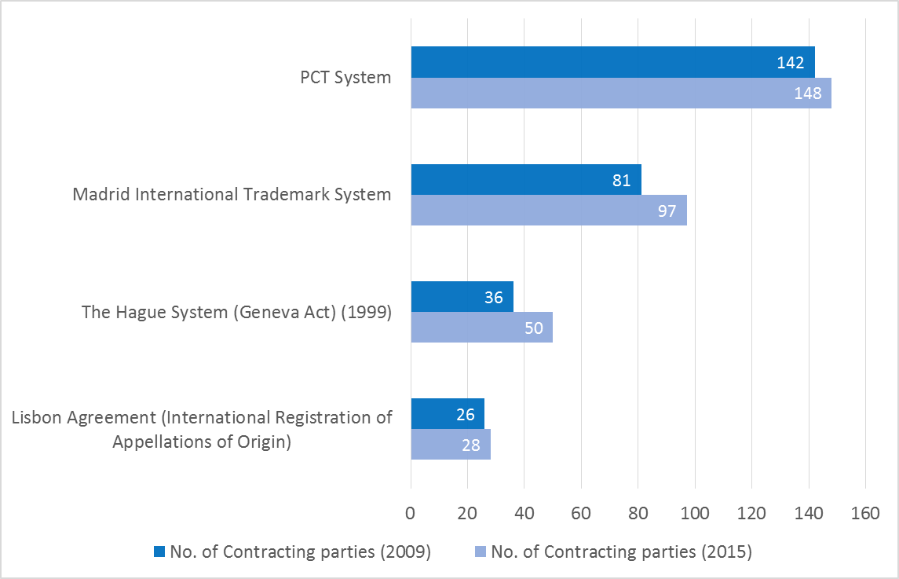

1. Over the course of the MTSP period, interest in alternative dispute resolution (ADR) services for IP, offered through the WIPO Center, grew considerably. This is well illustrated by the increasing number of disputes and requests for good office / “bon office” services[19] submitted to WIPO since 2009. While the WIPO Center had received a cumulative 254 such submissions by the end of 2009, this number had grown to 623 by the end of 2014/15 (see Figure 4).
2. The growing interest in ADR has also translated into greater numbers of participants in events organized by or involving representation by the WIPO Center. In comparison to the approximately 3,200 individuals who attended such events in 2010/11, participation more than tripled in 2014/15 to close to 10,000 people, as shown in Figure 5 below.

Figure 4: No. of disputes and bon office requests received by WIPO Arbitration and Mediation Center (by biennium and cumulative): 2008/09–2014/15

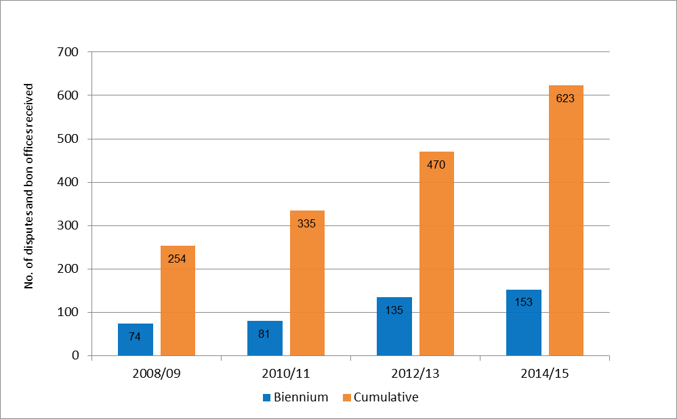

Figure : No. of participants at events organized by or involving representation by WIPO Arbitration and Mediation Center, 2010/11‑2014/15

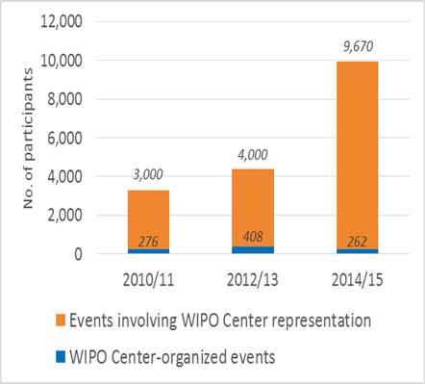

1. WIPO’s increased role in ADR is also evidenced by the growing number of dispute resolution cases the WIPO Center administered under the WIPO-initiated Uniform Domain Name Dispute Resolution Policy (the UDRP Policy) adopted by the Internet Corporation for Assigned Names and Numbers (ICANN),*[20]* both for generic top‑level Domains (gTLDs),[21] and furthermore applying to those country code top-level Domains (ccTLDs) that have opted for the UDRP. The cumulative number of gTLD cases administered by the WIPO Center grew during the three biennia from just over 20,000 in 2010/11 to close to 30,000 by the end of 2014/15. For ccTLDs, the cumulative caseload increased from approximately 2,100 to just over 3,500 in the same time period; the number of ccTLD registries for which WIPO provided dispute resolution services rose from 62 to 71.

Figure : No. of gTLD UDRP cases and ccTLD UDRP‑based cases administered by WIPO Arbitration and Mediation Center, 2010/1 –2014/15.

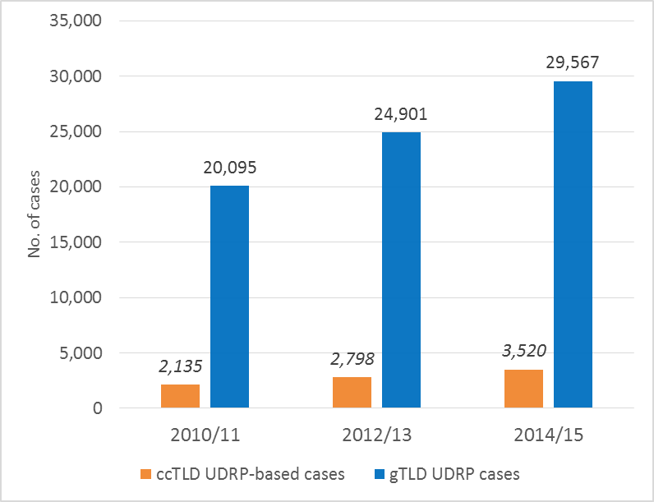

##### Outcome Indicator II.2: Enhanced demand for WIPO's global services and products contributing to the financial sustainability of the Organization

1. Demand for WIPO’s global services and products under the international protection systems rose significantly between 2009 and 2015, exemplified by a strong growth of 40 per cent in annual PCT filings[22] between 2009 and 2015. Overall, the PCT System received a total of 1.34 million filings throughout the MTSP period. Respectively, filings from China (143 per cent), the Republic of Korea (52 per cent), Japan (37 per cent), and United States of America (27 per cent) saw significant growth from 2010 to 2015. The combined share of applications from the top 10 largest users[23] of the PCT System[24] increased slightly from 85 per cent in 2010 to 87 per cent in 2015. In 2015, 94 per cent of all filings under the PCT System were submitted electronically, up from a 73 per cent share at the end of 2009.[25]

Table : PCT System: Total filings and filings per year

|  |  |  |  |
| --- | --- | --- | --- |
| Year | Total no. of filings/year* | Change in no. of annual filings | % change (annual filings) |
| 2009 | 155,402 | 0 |  |
| 2010 | 164,341 | +8,939 | 6% |
| 2011 | 182,436 | +18,095 | 11% |
| 2012 | 195,334 | +12,898 | 7% |
| 2013 | 205,292 | +9,958 | 5% |
| 2014 | 214,314 | +9,022 | 4% |
| 2015 | 218,000 | +3,686 | 2% |
| Total | **1,335,119** |  | **40%** |
| * Based on the year of filing. Data for 2015 are WIPO estimates | | | |

1. Following a significant decrease in the demand for trademark-related services under the Madrid system (16 per cent decrease in 2009 compared with 2008) as a result of the global financial crisis, the demand recoveredin 2010 and subsequent years. WIPO received 39,687 trademark applications in 2010 and registered an overall increase in applications of 24 per cent between 2010 and 2015.[26] The share of filings from developing countries under the Madrid System grew slightly between 2009 and 2013,[27] with a net increase of approximately 1.2 percentage points[28].

Figure : Trend in applications to Hague System,   
2010-2015

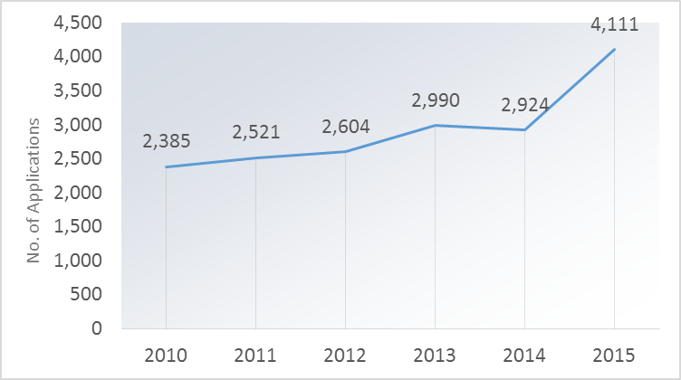

1. Interest in the Hague System rose significantly during the period under review. The number of annual applications to the System had increased steadily between 2010 and 2015, at an average rate of 12.4 per cent (see Figure 7). In 2015, the number of applications grew by over 40 per cent, with over 4,000 applications during that year alone. The number of designs contained in applications to the Hague System increased by 42.3[29] per cent over the six-year period, while the number of renewals per year grew by 14.4 per cent.[30]
2. Growth in the demand for registrations of appellations of origin under the Lisbon System also remained strong. By the end of 2015, a total of 931 international registrations were in force, an overall increase of approximately 14 per cent compared to the end of 2009. The share of registrations of appellations of origin held by parties in developing countries rose from 6.7 per cent at the end of 2009 to 10.2 per cent in 2015.

##### Outcome Indicator II.3: Higher satisfaction among users of WIPO's global IP products and services

1. To continue ensuring satisfaction among its customers, WIPO made important operational improvements to its IP systems, mainly geared towards enhanced electronic access to IP information and services and the streamlining of work processes.
2. The PCT Working Group endorsed several recommendations in 2010 for the more effective processing of patent applications under the PCT System and for the improved dissemination of technical information, technology transfer and technical assistance to developing countries. In response, the ePCT, a system to support the electronic processing of patent applications and other patent-related work processes, was introduced in 2013 and made it possible for any patent Office to offer electronic filing and processing services to their local applicants without the cost and difficulty of maintaining the relevant infrastructure themselves. This had previously been a major barrier especially for smaller Offices, but also represented an opportunity for simultaneously improving services and reducing costs, which was taken up by larger Offices as well.
3. The community of users of the ePCT system grew quickly following its introduction. In 2013, WIPO processed a total of 17,705 transactions through the ePCT, the greatest share (45 per cent) from public applicants using public services (a limited set of services offered using a simple username and password login), followed by applicants using private services (28 per cent, a more complete set of services requiring two factor authentication for greater security), Offices and third parties.. By the end of 2015, only approximately two years after its launch, transactions had grown nearly three-fold to 52,583. Moreover, 29 receiving Offices were accepting applications filed via ePCT, including Offices from developing countries such as Algeria, Azerbaijan, Brazil, Chile, Colombia, India, Malaysia, Mexico, Saudi Arabia and South Africa, none of which had previously offered online filing of international patent applications. In addition, 34 receiving Offices and eight International Authorities had authorized the submission of post-filing documents via ePCT by the end of 2015, and several other countries were in various stages of testing the new system.

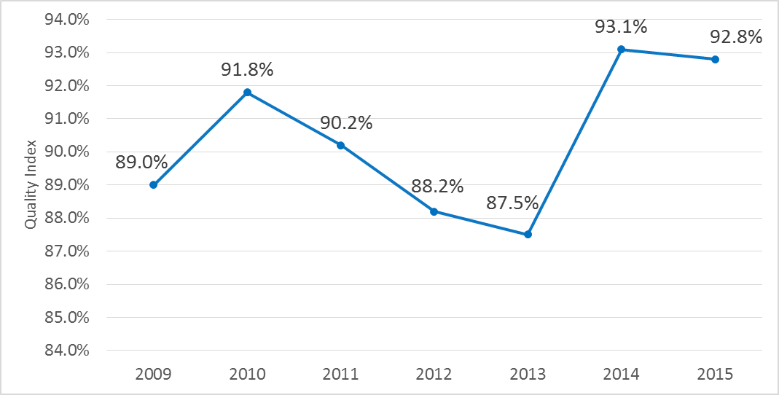

Figure : PCT Quality Index of Formalities Examination, 2009‑2014

1. Since 2012, the IB has made significant progress in the automation of certain processes relating to formalities examination of PCT international applications. The applications filed electronically in XML and PDF format, as well as the International Search Reports (ISRs) and Written Opinions, received from China, Japan, the Republic of Korea, and the European Patent Office, were increasingly processed automatically. This remarkably improved the productivity and the quality of the formalities examination of PCT international applications in the past years, which enabled the IB to absorb the continued workload increase with fewer staff, while maintaining a high quality of service. Productivity, measured by the number of PCT publications divided by the number of staff, increased significantly by 22 per cent in the 2014/2015 biennium compared to 2012/2013. The aggregate quality index for formalities examination[31] (see Figure 8) shows an overall improvement, albeit with some fluctuations between 2010 and 2013, and between 2014 and 2015. However, over the six-year period, the index rose from 89 per cent in 2009 to 92.8 per cent in 2015, mainly due to improved timeliness in performing formalities examination as well as reduced delays in republishing patent applications with the ISR.
2. The satisfaction among national/regional IP Offices with PCT cooperative activities remained high throughout the MTSP period. Based on the surveys conducted during the MTSP period,[32] 95 per cent of survey respondents expressed satisfaction with the PCT cooperative activities in which they had participated.

Table : Increases in electronic exchanges in the Madrid System

|  |  |  |  |  |
| --- | --- | --- | --- | --- |
| Year | % of documents received electronically | No. of email notifications | No. of MPM Clients | No. of Offices sending XML |
| 2010 | 46% | n/a | n/a | n/a |
| 2011 | 60% | 23,800 | 0 | 5 |
| 2012 | 65% | 50,000 | 400 | 10 |
| 2013 | 67% | 158,717 | 714 | 16 |
| 2014 | 70% | 220,000 | 1,800 | 17 |
| 2015 | 79% | 325,000 | 2,752 | 27 |

1. IT enhancements to both the Madrid and the Hague Systems allowed WIPO to significantly increase the share of electronic communication and improve other processes related to the two service areas. For the Madrid System, the percentage of documents that were received electronically rose from 46 per cent in 2010 to 79 per cent in 2015. The number of e-mail notifications grew more than thirteen-fold from 2010 to 2015, from 23,800 to 325,000 respectively. The client base for the Madrid Portfolio Manager (MPM) also expanded to a total of 2,752 users following its introduction in 2011 and as compared to 400 users at the end of 2012, i.e. its first year of usage. After a complete overhaul of the electronic-filing interface under the Hague System in 2013 and specific agreements with Offices of indirect filing, the percentage of international applications filed electronically under the Hague System increased from 66 per cent in 2010 to 90 per cent in 2015. Furthermore, an electronic renewal interface was made available in 2011 and, for the year 2015, accounted for 90 per cent of the renewals made under the Hague System.
2. In 2014, WIPO launched a program to improve the efficiency and quality of its Madrid services. Progress made in 2014 on workload and resource planning, improvement in customer services, and staff training was consolidated and yielded tangible results in 2015. The Madrid unit cost (i.e. the cost to process and maintain an international registration) dropped significantly, and a marked improvement in examination productivity was observed in that year (see Figure 9).[33] In addition, the pendency rate in all but one of the transaction categories fell below the average of the last five years.

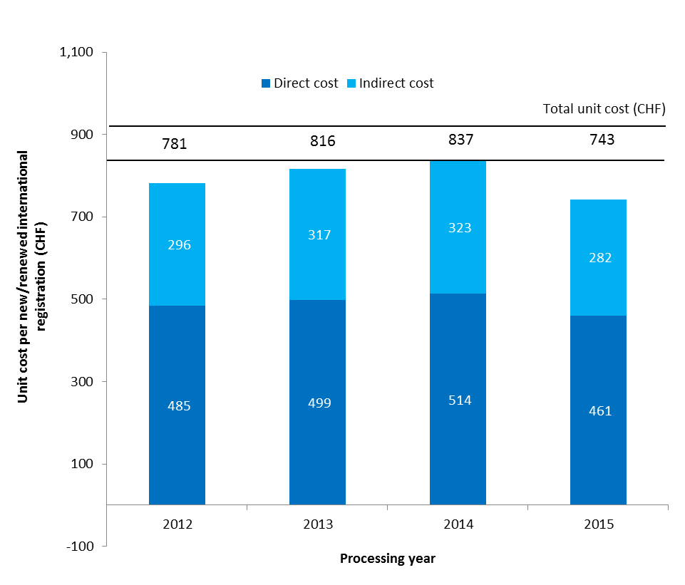

Figure : Unit Cost per new/renewed international registration Madrid System, 2012-2015

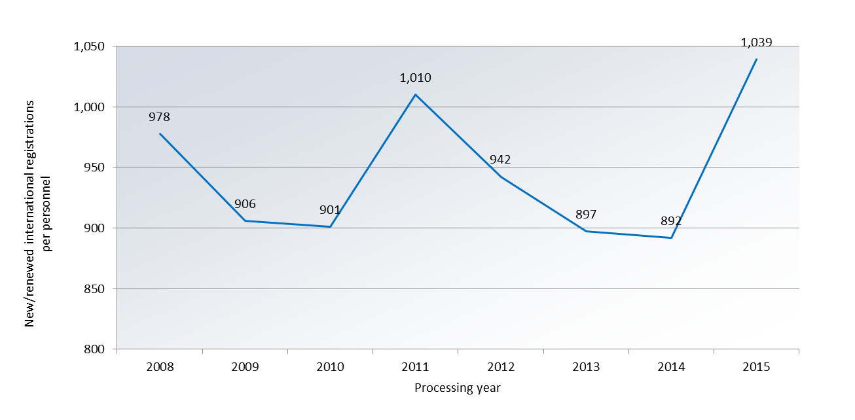

Figure : Productivity of examination of new/renewed international registrations, 2008-2015

1. WIPO progressed with the refinement of the electronic International Register of the Lisbon System. By the end of six-year period, 26 competent authorities had given their consent to the use of electronic means for communications under the procedures of the Lisbon System, as compared to 14 in 2010. In 2014, the Secretariat also completed and deployed an electronic interface linking the International Register and the Lisbon Express database on the WIPO website, improving user-friendly access to information on the Lisbon System.

### Strategic Goal III: Facilitating the Use of IP for Development

#### **Strategic Outcome III.1: Greater use of IP for Development**

1. The goal of facilitating the use of IP for social, cultural and economic development drives WIPO’s development-oriented activities delivered through programs across the Organization. As such, Strategic Goal III is both a vertical and a horizontal goal cutting across many of the other Strategic Goals. Progress in facilitating the use of IP for development is therefore reported on in a mainstreamed way, including in particular under Strategic Goal I (Balanced national IP legislative frameworks) and Strategic Goal IV (Strengthened IP institutions).
2. WIPO successfully anchored development cooperation in its overall programming during the period under review. In particular, all Development Agenda (DA) Recommendations were mainstreamed throughout WIPO’s work. A total of 31 DA projects were implemented over the course of the MTSP period, covering among other topics, the strengthening of IP-related institutional capacities, access to IP information and knowledge, economics of IP, Enhancement of the WIPO RBM framework, IP and the public domain, IP and competition policy and technology transfer. Throughout this period, a growing share of developing countries, LDCs and countries with economies in transition benefitted from assistance from WIPO to enhance the use of IP for social, cultural and economic development through the adoption and implementation of national IP strategies and IP-related development plans. Increased knowledge and understanding of IP-related issues among individual stakeholders from developing countries, LDCs and countries with economies in transition and among IP-professionals and relevant government stakeholders also helped to strengthen the connection between the governance of IP rights and the promotion of sustainable economic development.

##### Outcome Indicator III.1: A strong focus on development throughout the Organization, with effective mainstreaming of the DA principles and recommendations in the work of all relevant Programs

1. Over the period of the MTSP, WIPO made significant progress in mainstreaming development throughout its nine Strategic Goals. The Secretariat had already taken an important step forward in 2009 by issuing a set of internal instructions to apply the DA principles and recommendations throughout its work. One important step in that direction was the incorporation of the 45 DA Recommendations and the principles contained therein into the MTSP itself, providing the basis for their operationalization and implementation in the subsequent biennial budgets and annual work plans and for regular annual and biennial reporting on progress on the implementation of the WIPO Development Agenda.[34] An important milestone was the adoption by the WIPO Assembly in September 2010 of the integration of the planning and budgeting of DA projects into the budgetary processes of the Organization.[35] The period under review also saw the introduction of a robust monitoring and evaluation system to monitor and assess the implementation of DA projects.
2. Over the course of the period under review, the 45 DA Recommendations were progressively mainstreamed into the work of WIPO’s Programs. Whereas in 2009, only 19 of the DA recommendations were being addressed by the Organization through projects, activities or studies, by the end of 2013, the Secretariat had effectively mainstreamed the 45 DA Recommendations throughout the regular work of the relevant Programs. This was facilitated by the integration of DA Recommendations into the RBM frameworks of the Organization in both the biennial and the annual work plans.
3. In addition to mainstreaming the DA Recommendations into its work, WIPO advanced the implementation of the Development Agenda through the implementation of 31 projects over the course of the MTSP, with a total budget of over 28 million Swiss francs. By the end of 2015, a total of 25 DA projects had been completed and independently evaluated. A more in-depth review of the progress made on the implementation of the Development Agenda and the DA Recommendations, as mandated by the Committee on Development and Intellectual Property (CDIP), was underway at the end of 2015 and will be presented to the CDIP in November 2016.
4. The period under review saw a marked improvement in the delivery of development ‑oriented activities to developing countries, LDCs and countries with economies in transition, taking into account the diversity of the growing needs of beneficiary countries. This was facilitated through the development and use of various tools such as, *inter alia*, needs assessments, programming missions and the publishing of the *Manual on the Delivery of WIPO Technical Assistance[36]* in all six official UN languages in 2014.
5. Benefits also continued to be garnered from the ongoing deployment and improvement of specialized databases, in particular the IP Technical Assistance Database (IP-TAD), IP Development Matchmaking (IP-DMD) and the Roster of Consultants (IP-ROC). In addition, new tailor-made databases were developed and implemented to support the mainstreaming of DA Recommendations in WIPO’s technical assistance program. This included a database to capture baseline data used in national processes for the formulation of national IP strategies (NIPS-D) and an interface for South-South activities. The IP Advantage database, presenting case studies with practical illustrations of how IP works and how new IP rights contribute to promoting innovation both in developed and developing countries, also continued to be expanded. IP Advantage contained a total of 210 case studies and at the end of 2015, the homepage had been visited 199,700 times in 2014/15.
6. The focus on facilitating enhanced South-South cooperation on IP and development among developing countries and LDCs was also strengthened through the establishment of a dedicated focal point within the Development Sector, the development of a South-South webpage[37] and a virtual network on South-South cooperation.

##### Outcome Indicator III.2: Increased number of developing countries, LDCs and transition economies with balanced policy / legislative frameworks

1. Progress in the implementation of WIPO’s Development Agenda was mirrored by progress among Member States in developing a balanced policy and legislative framework for the governance of IP. In 2009, only a limited number of Member States from developing countries, LDCs and countries with economies in transition had adopted and/or were implementing a national IP strategy or an IP-related development plan. During the MTSP period, some 76 countries[38] in total, of which 24 LDCs, had begun and/or were in the process of formulating/adopting national IP strategies and/or development plans with the assistance of the regional Bureaus. By the end of 2015, a total of 64 countries, of which 19 LDCs, had successfully adopted and/or were implementing national IP strategies/development plans. In particular, by the end of the six-year period, some 26 countries in Africa had either adopted and/or were implementing such policies or plans, 17 countries in 2014/15 alone (see Figure 11).

Figure : Adoption and/or implementation of national IP strategies or IP development plans 2010-2015 (cumulative)

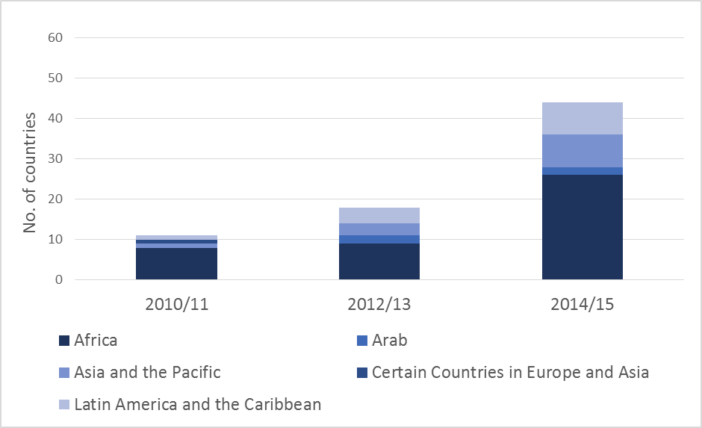

1. The formulation of national IP strategies and/or development plans was facilitated through the development of a standardized, yet flexible, methodology and a set of practical benchmarking tools with a view to assisting officials involved in the development of national IP strategies in assessing the status of their national IP system, defining strategic targets and assessing specific IP needs, as well as to ensure coherent and effective coordination in the framework of WIPO technical assistance to developing countries, LDCs and countries in transition. These tools were tested, refined and consolidated on the basis of feedback received from six pilot countries, which applied the proposed methodology in the development of their respective national IP strategies.
2. Progress made on establishing balanced national legal environments is reported under Strategic Goal II.

##### Outcome Indicator III.3: Increased number of developing countries, LDCs and transition economies with strong and responsive IP and IP-related institutions

1. The seven WIPO Deliverables in the Istanbul Program of Action for LDCs 2010-2020, adopted in 2011 on the occasion of the Fourth United Nations Conference on the Least Developed Countries (UN - LDC IV), instilled greater cohesion and focus in the delivery of technical assistance to LDCs throughout the period under review. In support of its implementation, WIPO worked closely with the United Nations Office of the High Representative for Least Developed Countries, Landlocked Developing Countries and Small Island Developing States. In addition, several interregional partnership programs were established in cooperation with the International Telecommunication Union (ITU), the United Nations Capital Development Fund (UNCDF), the United Nations Industrial Development Organization (UNIDO), the United Nations Economic Commission for Asia and the Pacific (UN ESCAP) and the United Nations Economic Commission for Africa (UNECA).
2. Capacity-building for LDCs in the use of appropriate technologies for identified development challenges received specific attention during the period under review. As part of a pilot project comprising three LDCs, namely Bangladesh, Nepal and Zambia, relevant technological solutions to identified problem areas were identified and business plans prepared for each of the need areas. The pilot project was subsequently expanded to additional countries.
3. Throughout the MTSP period, WIPO continued to build on the success of its University Initiative Program. Overall, 74 universities and R&D institutions in WIPO Member States received assistance under this initiative with establishing their IP management units and/or developing IP policies. Of particular impact was the adoption by the Government of Poland of a Law on Higher Education, which made it compulsory for all higher educational institutions (132 public and 302 non-public) to have in place an up‑to-date institutional IP policy by March 31, 2015. As a result, by the end of 2015, a total of 434 Universities/higher education institutions in Poland had developed new IP policies. The WIPO University Initiative Program was reviewed in 2014 to seek greater customization to the changing needs of universities and R&D institutions in WIPO Member States.
4. Please refer to Strategic Goal IV for progress related to IPAS, TISCs and TTOs.

##### Outcome Indicator III.4: A critical mass of human resources with relevant skills in an increased number of developing countries, LDCs and transition economies

1. WIPO invested a significant amount of resources into training and building human resource capacities in Member States, focusing in particular on developing countries, LDCs and countries with economies in transition. During the period under review, specialized training, focused awareness raising, capacity building and skills development programs provided opportunities for access to new information and knowledge touching a broad and diverse audience comprising policy-makers, administrators and officials, IP professionals and managers, inventors, researchers and academics, entrepreneurs and industrialists. These activities led to an increased number of IP specialists serving as knowledge resources in the regions, representing a broad range of institutions such as academia, business promotion centers and incubators, research and development institutions, innovation agencies, IP offices, judiciary and law enforcement officers.
2. WIPO reached its widest audience through its Distance Learning Program, providing training between 2010 and 2015 in ultimately 15 languages to over 243,000 individuals with interest in IP, and covering a wide range of IP-related topics. To ensure their continued relevance and topical interest, several DL courses were reviewed and updated during the period under review and new courses were developed including on Collective Management of Copyright and Related Rights; IP and Traditional Knowledge and Traditional Cultural Expressions; IP and Access to Medical Technologies; and IP Management. In addition, DA recommendations continued to be integrated in the DL courses through, for example, the addition of instructional modules to the advanced courses on flexibilities, exceptions and limitations and issues relating to the and public domain.
3. In collaboration with regular partner institutions from developed and developing countries, the Professional Development Program trained a total of 1,342 government officials from developing countries, LDCs and countries with economies in transition in several specialized IP-areas, such as patent search and examination in the fields of biotechnology and pharmaceuticals, trademarks, copyright and related rights, collective management of copyright and related rights, and transfer of technology and licensing. A Training Needs Assessment, conducted in 2015, resulted in a revision of the catalogue of courses, which included, *inter alia*, the addition of new topics (management of IP Offices, IP management and commercialization, and IP and branding) and the incorporation of two new courses targeting specific regional needs - one for LDCs and one for the Caribbean countries.
4. WIPO Summer Schools trained a total of over 1,900 senior and graduate students and young professionals across many IP-relevant fields and disciplines. Approximately 70 business managers, senior executives and corporate strategists benefitted from WIPO’s Executive Education Program (see Table 1).

Table : Number of participants in WIPO education and training programs, 2010-2015

|  |  |  |  |  |  |  |
| --- | --- | --- | --- | --- | --- | --- |
| **Year** | **No. of participants in WIPO education and training programs**  **(across types of participants and degrees)** | | | | | |
| **Professional Development Program** | **Distance Learning** | **Academic Institutions Program (Masters)** | **Executive Education Program** | **WIPO Summer School Program** | **Total** |
| **2010/11** | 396 | 83,800 | 249 | 23 | 640 | **85,108** |
| **2012/13** | 484 | 81,484 | 332 | 48 | 630 | **82,978** |
| **2014/15** | 462 | 78,551 | 340 |  | 689 | **80,042** |
| **Total** | **1,342** | **243,835** | **921** | **71** | **1,959** | **248,128** |

1. In order to address a relative shortage of academically trained IP professionals, WIPO used its Academic Institutions Program to offer Joint Master’s Programs on Intellectual Property in cooperation with partner universities and institutions in Africa;[39] Asia and the Pacific;[40] Europe;[41] and Latin America and the Caribbean.[42] Between 2010 and 2015, some 921 fellows from developing countries, LDCs and countries with economies in transition completed these programs, thus strengthening the IP-related human resource base in developing countries. WIPO also continued strengthening the capacity of teachers and government officials on IP in cooperation with the WTO through the jointly organized Colloquia for Teachers of IP and the WIPO-WTO Advanced Course on IP for Government Officials.
2. The multiplier effect of training and capacity building activities was strengthened through the Start-up Academies Project, which was mainstreamed into the Academy’s regular program in 2014. As a result, six national IP training institutions were established, awarding over 20,000 certificates in IP training by the end of the MTSP period. Seven new agreements for the establishment of new national training institutions were signed by the end of 2015.
3. WIPO also worked to increase the knowledge and understanding of IP-related issues among small and medium-sized enterprises (SMEs) in developing countries, LDCs and countries with economies in transition. The Secretariat’s SME Newsletter attracted an increased number of subscribers in 2014, compared to 2010 (see Figure 13). In 2015, the criteria to subscribe were modified, requiring existing SME Newsletter subscribers to re‑subscribe, ultimately resulting in a smaller but more focused user base. Interest in WIPO’s SME website was strong throughout the MTSP programming period, in spite of the fact that the number of downloads experienced a temporary decrease in 2014, compared to the previous years (see Figure 13).

Figure : No. of subscribers to the WIPO SME Newsletter, 2010-2015

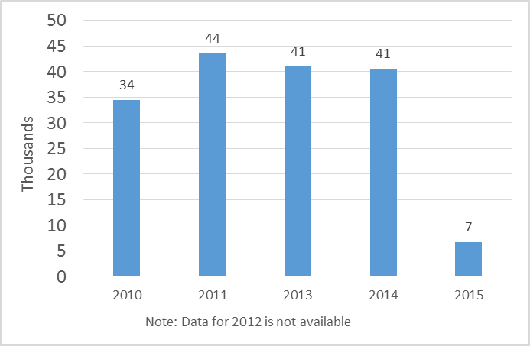

Figure : No. of page views of the WIPO SME web page, 2010-2015

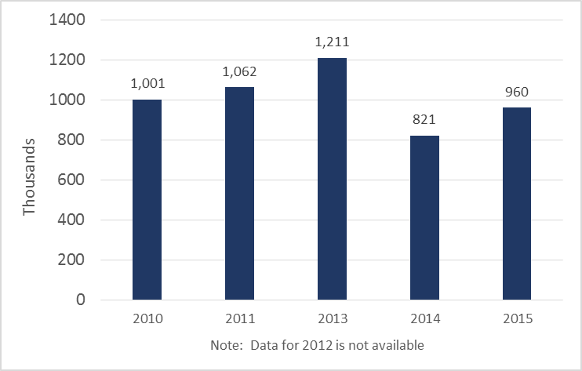

1. In addition, WIPO targeted representatives from SMEs and from SME support institutions with targeted trainings on the importance of IP for supporting innovation. Over 2,400 trainees benefited from these opportunities between 2012 and 2015[43], with satisfaction rates between 90 per cent and 100 per cent among participants.[44]
2. Increased reach to SMEs and SMEs support institutions was achieved through the development of awareness raising and capacity building materials. The IP PANORAMATM multimedia toolkit, developed over a three-year period by WIPO, jointly with the Korean Intellectual Property Office (KIPO) and the Korea Invention Promotion Association (KIPA), was increasingly used as an interactive e-learning tool in the field of IP asset management by a wide variety of SME stakeholders, including universities, business consultants, researchers and SMEs worldwide. In total, during the period under review, more than 3,000 students completed the online international certificate course on IP asset management for business success based on IP PANORAMATM.  To maximize its outreach, local language versions of IP PANORAMA were developed.

### Strategic Goal IV: Coordination and Development of Global IP Infrastructure

#### **Strategic Outcome IV.1: A more efficient IP system characterized by effective access to and better use of IP information and knowledge**

1. Over the past six years, WIPO contributed significantly to improving the efficiency of the IP system and access to and use of IP information and knowledge. During this period, technical assistance and support helped Member States to adopt WIPO’s IP-related Office Business Systems as an effective solution for managing the demand for IP rights and delivering quality services to their stakeholders. Furthermore, by ensuring the continuous and flexible update of international IP classification systems, such as the International Patent Classification (IPC) and the Nice Classification, WIPO ensured that access to IP-related information and knowledge continued to be facilitated by a modern typology of ‘prior art’ and existing protection that reflected the fast-paced changes in the creative and innovative sectors. Interest in the information and data made available by WIPO on IP classifications and standards has grown dramatically over the last six years, which is illustrated by the over five million users who accessed related information on WIPO’s websites in 2015 alone.
2. Beyond that, WIPO’s investments in global IP databases and other knowledge platforms have made an expanding body of IP-related data and information available to a growing global audience. Both PATENTSCOPE and the Global Brand Database covered a far wider range of overall records, including national IP-related document collections in 2015, than they did at the beginning of the MTSP period. A growing catalogue of languages for searches has made these tools accessible to a broader and larger global user base. WIPO also greatly improved access to specialized third party commercial IP-related information, and scientific and technical literature in the framework of two public private partnerships namely, the Access to Specialized Patent Information (ASPI) and Access to Research for Development and Innovation (ARDI) programs concluded by WIPO with the commercial database vendors and the scientific and technical publishers, respectively.
3. WIPO also helped intensify direct technical cooperation between IP Offices in Member States through WIPO CASE and WIPO DAS, two ICT platforms and services that enable the direct sharing of IP-related information among IP Offices.

##### Outcome Indicator IV.1.1: Increased efficiency of IP Office operations as indicated in reduced pendency times and reduced backlogs

1. IP Offices, particularly in least-developed, developing and transition countries, face challenges in providing high-quality and efficient services to applicants for IP rights, the public and other stakeholders. WIPO therefore made significant investments in this area over the last six years, supporting (i) the deployment of the WIPO Industrial Property Administration System (IPAS), (ii) the development of the new Electronic Data Management System (EDMS) module, and (iii) the completion of WIPO’s digitization software, WIPOScan. In addition WIPO provided direct support to IP Offices for the digitization of their IP records, improving the quality of IP data, and training and knowledge transfer on the use of WIPO solutions. Figure 14 illustrates how this work has led to the steady increase in usage of the WIPO IP Office systems over the past six years. By the end of 2015,77 IP Offices were using WIPO IP Office Systems, an increase of more than 100 per cent since 2010.[45]

Figure : Increase in the usage of WIPO IP Office Business Systems across regions (2010–2015)

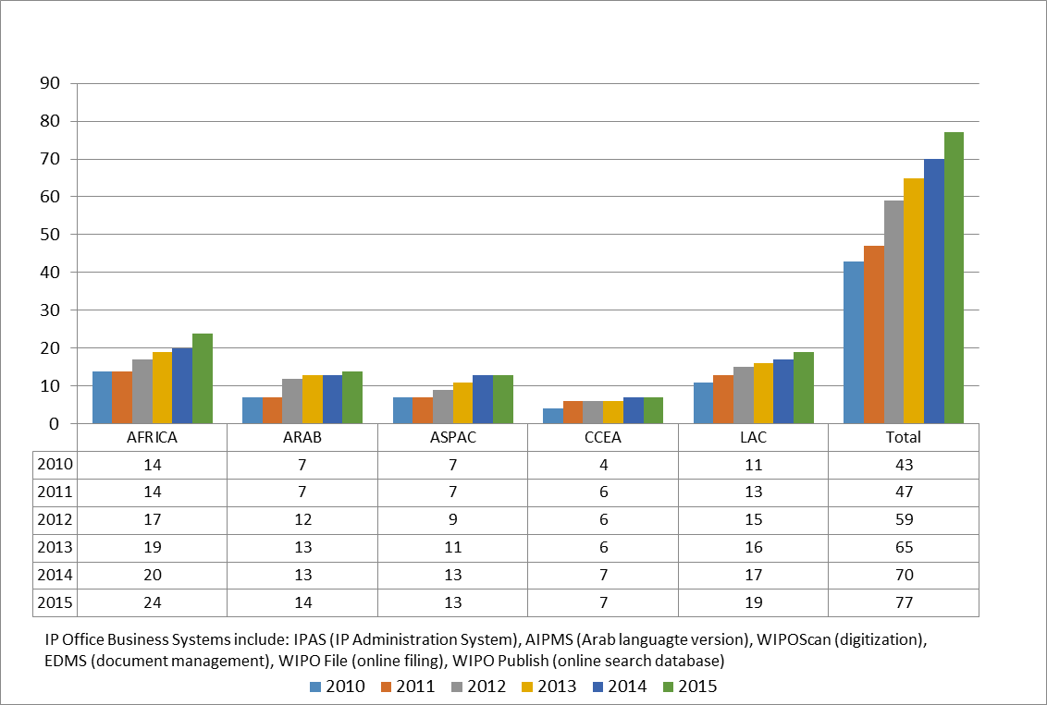

1. WIPO continued to improve the systems deployed in Member States by developing new features that allow for fully paperless operations within IP Offices and for multi-lingual operations, particularly for those Offices operating in the Arabic language. Two new modules were developed to provide the option for IP Offices to move towards fully online services – WIPO File, an online filing solution for small to medium-sized IP Offices, and WIPO Publish, an online system for publication, search and dissemination of IP data and documents. Support services were improved by providing increased training and knowledge transfer and by establishing a dedicated “helpdesk” function within the program.
2. Specifically, in relation to supporting the more efficient management of copyright, the period under review witnessed an increase in the number of Collective Management Organizations (CMOs) and Copyright Offices using WIPO’s software for collective management of copyright and neighboring rights, WIPOCOS, and the *Gestion del Derecho de Autor* (GDA) system. In the case of WIPOCOS, the number of CMOs equipped with the System grew from 10 in 2008/09 to 20 in 2010/11 and 26 at the end of 2013. The number of Copyright Offices using the GDA system grew from eight to 18 between 2011 and 2013 (see Figure 15).

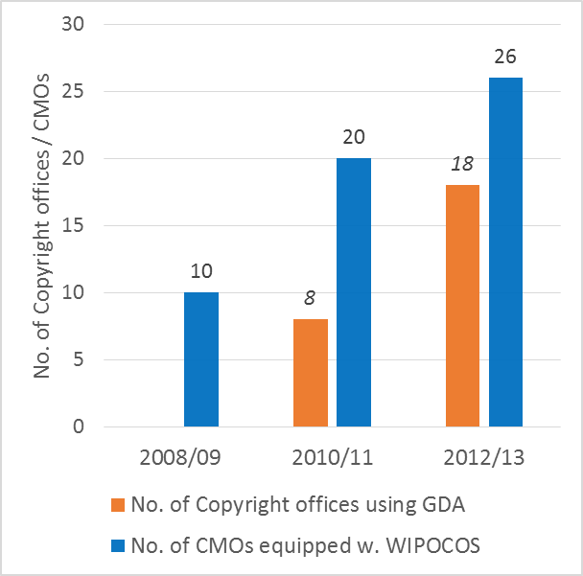

Figure : Improvements in copyright-related IP infrastructure

1. GDA was phased out in 2015 by transferring WIPO resources to all Copyright Offices using GDA. WIPOCOS entered into a transitional upgrading phase in 2014 by launching the development of the successor system for WIPOCOS, WIPO Copyright Connection (WCC). WCC should be able to offer an interconnected system for the management of author and neighboring rights to CMOs in Member States. An external contractor, engaged at the end of 2014, delivered a technical Proof of Concept in mid-2015. The system was in its final development phase at the end of 2015, and deployment to CMOs in developing countries and LDCs was foreseen to start in 2016.[46]
2. WIPO’s work in this area met with considerable satisfaction on the part of Members States, as between 70 to 80 per cent of governments reported improvements in the effectiveness of the administration and governance of IP Offices and other national institutions.

##### Outcome Indicator IV.1.2: Increase in the number and diversity of users of information and knowledge generated by the IP system

1. Access to and use of information contained in the international IP system hinges on WIPO’s ability to maintain a globally accepted system of international classifications for protected goods and services, as well as clear and up-to-date IP standards to guide the practices of the global IP community. Classifications are indispensable, among other things, in the search for "prior art" by patent-issuing authorities, potential inventors, research and development entities and others concerned with the application or development of technology.
2. 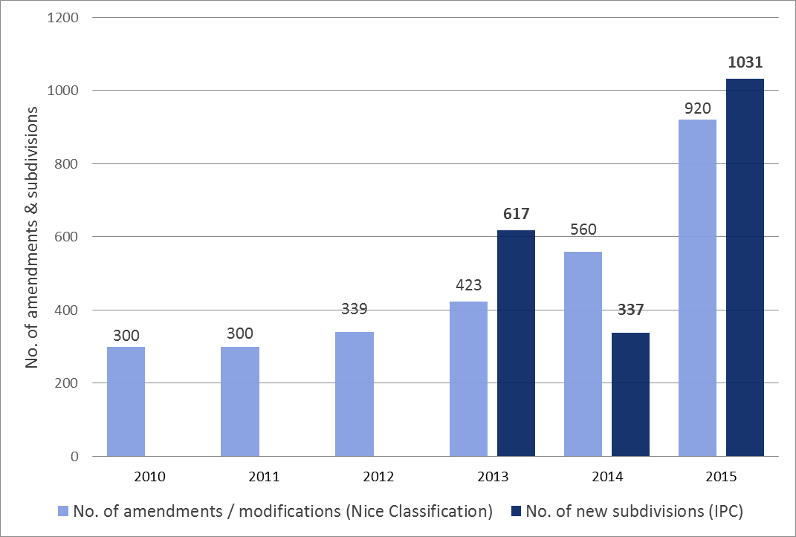Over the last six years, WIPO regularly updated all classifications and further streamlined and improved the procedures and platforms for revising the classifications to ensure that the latest technological advances were captured. A simplified structure for the International Patent Classification System (IPC) entered into force in 2011. In the same year, an agreement between the United States Patent and Trademark Office (USPTO) and the European Patent Office (EPO) to integrate their separate classifications under the Cooperative Patent Classification System (CPC), which is based on the IPC, represented a major breakthrough for the wider acceptance and more effective use of international classifications. Continuous updates of the IPC were facilitated by the introduction of improved classification platforms that were released in 2012 and 2014.[47] A temporary slowdown in updates of the IPC in 2014 was more than offset by the high number of new subdivisions that were introduced into the System in 2015 (See Figure 16).

Figure : Trends in updates of the IPC and the Nice Classifications, 201 -2015

1. A reform of the Nice Classification during the MTSP period made it possible for Nice amendments to be published annually from 2013 onwards. This improvement, supported by a new publication platform that was introduced at the same time, represented a major step to ensuring the continuous adaptation of the Nice Classification to new developments.[48] A total of 1,480 new amendments were introduced in 2014/15, representing a 94 per cent increase over 2012/13. In addition 25 new information files were introduced and 43 existing information files were revised (see Figure 16) during the 2014/15 biennium.
2. WIPO’s success in managing the different IP classification systems can be gauged by the increased number of users that have been accessing WIPO’s internet publications on international classifications and standards (see Figure 17). Overall, more than 5.1 million users visited WIPO web pages and publications relating to standards and classifications in 2015, up from less than 780,000 at the end of 2009. This represents more than a five-fold increase in traffic directed at these WIPO resources. WIPO publications on the IPC and the Nice Classification system generated the greatest interest by far: nearly 1.4 million users accessed the IPC publication website; nearly twice as many, 2.7 million users, accessed the publication site for the Nice Classification system in 2015. Close to half of these visits (44.8 per cent) originated from developing countries in 2015, representing a total of over 1.8 million users.

Figure : Users accessing WIPO Internet Publications on International Classifications and Standards

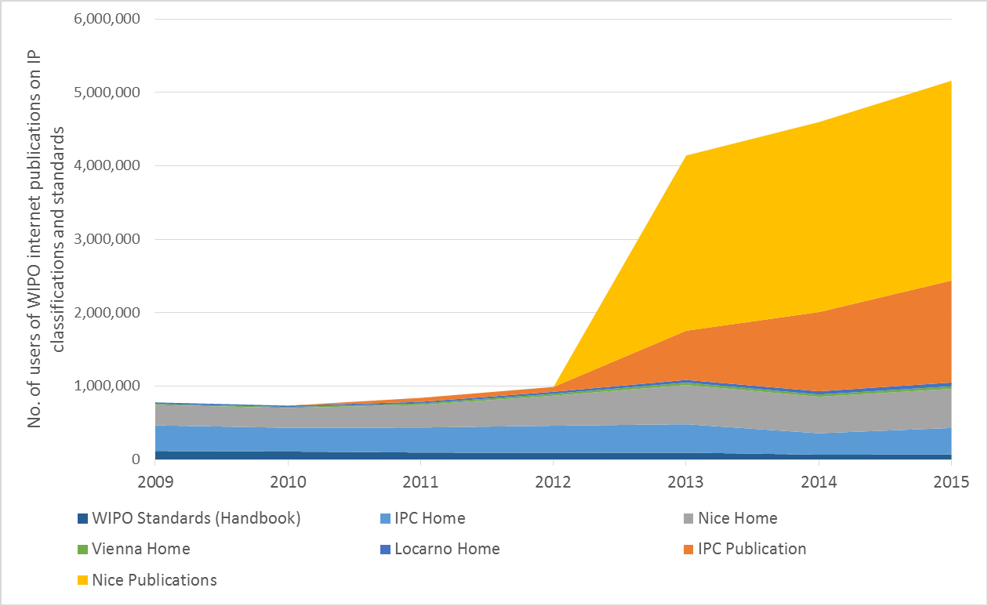

1. WIPO’s work on international classifications and standards was complemented by its investments in its global IP databases over the last six years, including in particular PATENTSCOPE and the WIPO Global Brand Database.
2. Between 2010 and 2015, the Secretariat significantly increased the variety and amount of content that can be accessed through these two platforms. The number of records available in PATENTSCOPE grew by 400 per cent, from 10 million in 2010 to 50 million in 2015. The size of the Global Brand Database grew more than thirty-fold (i.e. by 3,400 per cent) from an initial 700,000 number of records in 2010 to a total number of 24.5 million records at the end of the six-year period (see Figure 18).
3. Growth in the number of records in WIPO databases was mirrored by the broadened global coverage of the platforms. Both PATENTSCOPE and the Global Brand Database significantly increased the number of regional and national collections accessible through them. In the case of PATENTSCOPE, the number of collections grew by nearly 440 per cent, i.e. from eight in 2009 to 43 by the end of 2015[49]. The Global Brand Database had 26 collections available at the end of the MTSP period (see Figure 19). Users could also use a growing catalogue of languages to access this information: 14 languages were available for cross-lingual searches in 2015[50], and machine translations for searches could be used for seven language pairs[51] (see Figure 20).

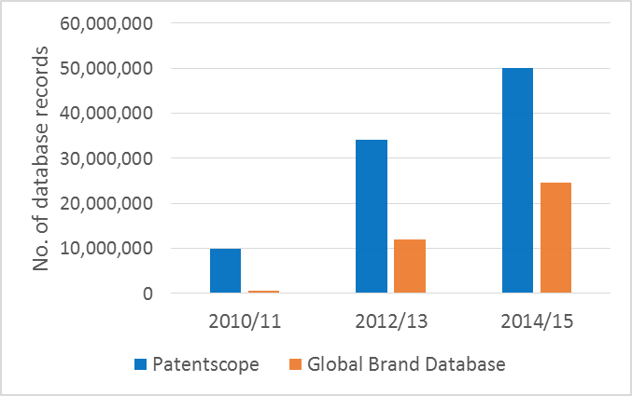

Figure : Growth in records available in PATENTSCOPE, Global Brand Database, 2010-2015

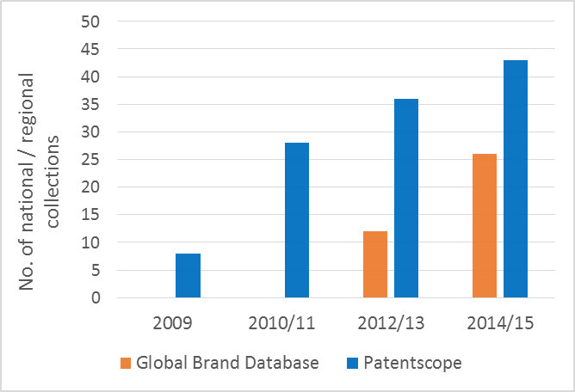

Figure : National and regional coverage of PATENTSCOPE and Global Brand Database

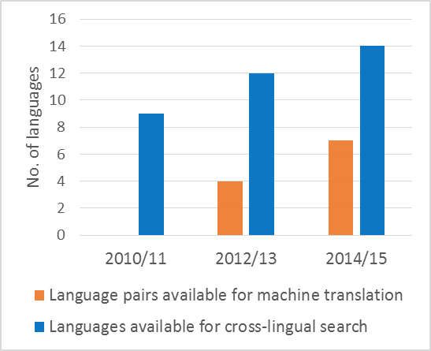

Figure : Availability of languages and language tools in WIPO Global Databases

1. The Secretariat also moved PATENTSCOPE to an entirely new high-performance system in late 2011, thereby enhancing search functions and user experience. This step and the other above-mentioned improvements resulted in the overall increase in the number of visitors to WIPO global IP databases. PATENTSCOPE registered an overall growth of 42 per cent in its user-base between 2010 and 2015. In the case of the Global Brand database, the number of users increased from only 9,000 in 2011 to 80,000 in 2015 (see Figure 21).

Figure : Growth in users of PATENTSCOPE and the Global Brand Database, 2010-2015

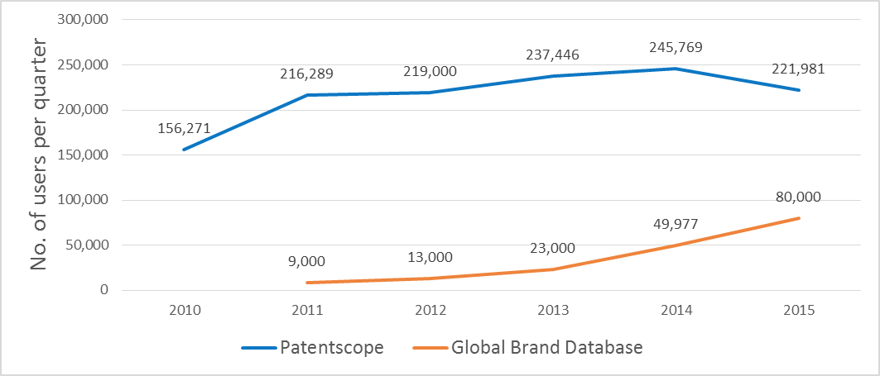

1. A new service, the Global Design Database for industrial designs was launched in January 2015. By the end of its first year, the Global Design Database had already reached an impressive 14,000 unique visitors per quarter. In addition, the number of national collections had reached five and contained more than 1.5 million design documents.

Figure : Increase in the number of WIPO Lex users, 2010-2015

1. 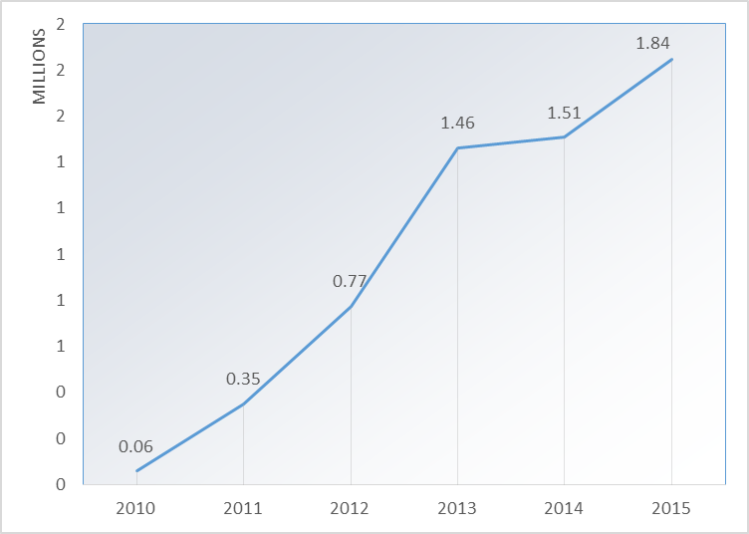In September 2010, WIPO introduced a new online database of IP-related laws and treaties, WIPO Lex, to replace its previous e‑portal for IP-related legal documents , the Collection of Laws for Electronic Access (CLEA). Since its launch, the number of users of the new system has grown significantly from 58,000 in 2010 to 350,000 in 2011. In 2012, its second full year of operation, WIPO Lex registered 770,000 annual users. Since then, its number has more than doubled to over 1.8 million in 2015, covering legal content in all six UN languages (see Figure 22).
2. Through the Technology Innovation Support Centers (TISCs), WIPO was also able to provide innovators in developing countries, LDCs and countries with economies in transition with greater access to high quality technology information and related IP services, helping them to exploit their creative potential and to manage their intellectual property rights. After receiving the mandate to pursue the creation of TISCs as a pilot initiative under the WIPO Development Agenda, WIPO had established TISC networks in 18 countries by the end of 2011. By the end of 2015, this number had grown to 50 countries in which over 400 TISCs had been established. On average, each of the centers, served between 874 and 2,631 users per quarter in 2015. Some 25 TISC networks were considered to be sustainable by the end of 2015. Certain national networks are also beginning to share their experiences and best practices through the establishment of formal regional TISC networks such as that formed among the ASEAN Member States and that of the CATI-CARD network, which comprises Central American countries and the Dominican Republic. A virtual online TISC network has also been set up through an e-TISC knowledge sharing platform, which included nearly 1,500 members and 25,000 page views in 2015, and which offers news, events, discussion blogs, as well as the possibility of discussing various aspects of IP rights with renowned experts in their respective fields. More recently, the e-TISC platform, as well as the TISC homepage found on the WIPO website, offered an ever-increasing range of e-learning possibilities, including various webinars and an interactive e-Tutorial on Using and Exploiting Patent Information.
3. WIPO also greatly improved access to specialized third party and commercial IP‑related information over the last six years. In 2010, the Secretariat launched the project ASPI program, leveraging experiences from a similar project the ARDI program, which had started a year before. In partnerships with commercial database vendors and other UN agencies, both programs made a number of commercial databases accessible for free, or at a preferential rate, in developing countries and LDCs. Shortly after its launch, ARDI dramatically increased access to journals by joining the Research4Life (R4L) partnership, which then offered access to over 8,000 peer-reviewed journals in the WHO’s Health Inter-Network Access to Research Initiative (HINARI) program (biomedical and health journals), FAO’s Access to Global Online Research in Agriculture (AGORA) program (agriculture based journals), and UNEP’s Online Access to Research in the Environment program (environmental issues). By 2015, ARDI provided its users access to 21,243 journals, 48,988  e-books and 169 reference works. The number of institutional users that are actively taking advantage of these resources has grown steadily for both ARDI and ASPI, albeit at a comparatively slower pace in the case of the ASPI (see Figure 23).

Figure : Growth in active institutional users of ARDI and ASPI, 2010–2015

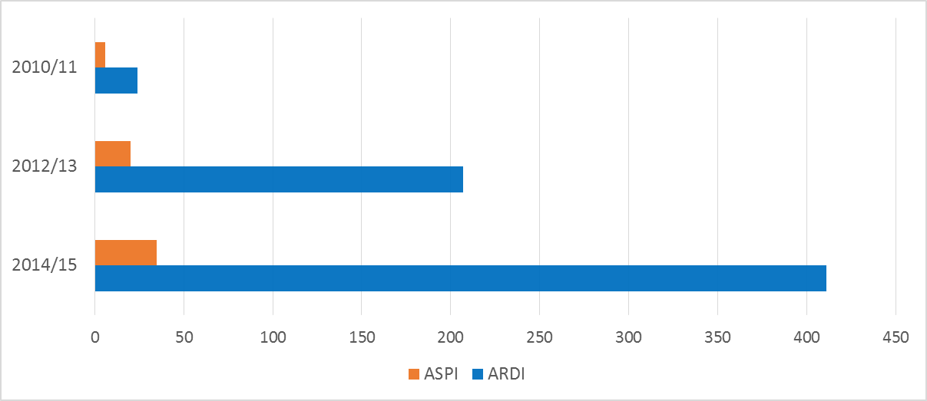

1. TISCs are also beginning to offer patent analytical services to follow-up on the patent landscape reports (PLRs) drafted on specific technologies to date, particularly in the areas of public health, food and agriculture and the environment. By 2015, 12 such PLRs had been drafted in cooperation with IGOs and Member State partners. Moreover, Guidelines on Preparing PLRs and a Manual on Open Source and Free of Charge Tools for Preparing PLRs were drafted in 2014 and 2015, respectively, and will form the basis of training for TISCs to be able to effectively offer these services.

##### Outcome Indicator IV.1.3: Additional platforms are created between IP Offices for enhanced voluntary, technical international cooperation

1. Work under this Strategic Goal also resulted in the intensification of direct technical cooperation between IP Offices and other related institutions in WIPO Member States. This trend was driven in particular by the development and extension of two ICT platforms and services that enable the direct sharing of information; i.e., the WIPO Centralized Access to Search and Examination (CASE) platform, enabling participating Offices to share information relating to patent search and examination processes, and the WIPO Digital Access Service for Priority Documents (DAS). WIPO made substantial progress in expanding both services to new institutional users. A total of 21 Offices registered to use WIPO CASE over the six-year period of the MTSP, of which 10 agreed to provide their dossier information to others. The number of Offices participating in the WIPO DAS service stood at 11 at the end of 2015.
2. In addition, investments in IP infrastructure also helped to facilitate improved access to published works on the part of the visually impaired. Policy dialogue among 42 countries in 2010/11 initiated by WIPO led to the creation of the Trusted Intermediary Global Accessible Resources (TIGAR) Service, a platform to promote the exchange of copyright protected books by enabling publishers to make their titles easily available to a group of Trusted Intermediaries (TIs) who share them amongst each other and with specialized libraries in formats accessible to visually impaired readers. The sharing of books commenced in October 2011 among a group of four TIs and three rights holders. By the end of 2014, about 2,500 audio books from a total of 45 rights holders had been downloaded by TIs, whose number had grown to 25. Some 16,000 persons with print disabilities also benefitted from this service. TIGAR was integrated into the Accessible Books Consortium (ABC) International Book Exchange, an international database of some 286,000 accessible titles in 55 languages, at the end of 2014.
3. In 2010/11, WIPO also launched a new Project for assisting Member States in the establishment of Technology Transfer Offices (TTOs) in countries of the Arab Region, with the intention of replicating the intervention in other regions if it proved to be successful.  The country specific phase of this project was launched during the 2012/13 biennium, resulting ultimately in strengthening four TTOs in Tunisia to be operationally independent and sustainable in 2014. In that context, implementation of the Tunisia Action Plan started focusing on legal institutional framework of beneficiary institutions in Tunisia. Throughout 2015, progress continued to be made towards strengthening the TTOs in Tunisia by providing training on IP valuation and licensing for the Centre Technique de la Chimie (CTC); the Techno-Park El Gazhala; Packtec Technical Center for Packaging and the Techno-Park of Sidi Thabet.

### Strategic Goal V: World Reference Source for IP Information and Analysis

#### **Strategic Outcome V.1: WIPO recognized as the source of IP-related economic and legal intelligence for policymakers, users of the IP system and other stakeholders**

1. Between 2010 and 2015, WIPO further established itself as a key source for economic, statistical and legal knowledge and information in the global IP community. WIPO was able to significantly broaden its catalogue of IP-related publications between 2010 and 2015, e.g. by adding to its portfolio a report series focused on economic analysis, country-specific statistical information and by co-publishing the annual *Global Innovation Index (GII)*. This wide range of information on IP issues has been received by WIPO’s Member States and other stakeholders with growing interest, as indicated by the growing circle of users who are accessing, citing and otherwise utilizing WIPO’s IP publications.

##### Outcome Indicator V.1.1: Increased availability of accurate and up-to-date IP content in the fields of technology, brands, laws and treaties and economic statistics and analysis responsive to the needs of stakeholders

1. Over the last six years, the Secretariat has continued to conduct comprehensive annual surveys of national IP Offices, as a basis for its various publications on IP issues and data. Global coverage of these surveys has increased substantially over this time period, reaching a total number of 127 responses from national and regional IP Offices in 2014/15.
2. While continuing to use this and other IP-related data to publish its well-established annual reports on IP[52], the Secretariat significantly broadened the catalogue of IP-related publications between 2010 and 2015 by launching five annual and biennial new publication series. In 2011 the *World Intellectual Property Report (WIPR),* a biennial economics-focused analytical report was launched, with its first issue dedicated to exploring the role of IP at the nexus of innovation and economic growth.[53] In addition, the IP-related Statistical Country Profiles, the *IP Facts and Figures*, and the yearly reviews for trends in the Madrid and the Hague systems (see Table 5) began to be compiled and published annually.
3. In addition, WIPO assumed the role, firstly as knowledge partner, and then as co-publisher of the *GII*, in collaboration with INSEAD and Cornell University. This enabled WIPO to make a contribution in the field of innovation measurement and to foster a high quality discourse on innovation policy. Finally, in the 2012/13 biennium, WIPO also established its IP Statistics Data Center, aiming at providing more customized access to all available statistics.

**Table 5: Overview of newly developed IP publications, 2010-2015**

| **Publication** | **Published since…** | **Thematic Coverage** |
| --- | --- | --- |
| IP Statistical Country Profiles | 2010 (annual) | Provide information on patents, utility models, trademarks and industrial designs, covering different dimensions of intellectual property (IP) activity, including incoming and outgoing filings, the share of filings in different technological fields, total patents in force, and the use of international IP systems by applicants. |
| IP Facts and Figures | 2011 (annual) | Provides an overview of intellectual property activity based on the latest available year of complete statistics. |
| World Intellectual Property Report | 2011 (biennial) | Focuses on specific economic trends in an area of IP. The three issues published during the MTSP period have explored the relationship of breakthrough innovation and economic growth (2015), the role of brands in the global marketplace (2013) and the changing face of innovation (2011). |
| Madrid Yearly Review | 2012 (annual) | Provides an overview of international applications, registrations under the Madrid System, as well as the geographical origin and coverage of goods and services of the system. |
| Hague Yearly Review | 2012 (annual) | Provides an overview of the international registrations and renewals of Industrial Designs, including their geographical origin and coverage of goods. |

##### Outcome Indicator V.1.2: Increased use of IP content for the more effective achievement of the underlying policy goals of intellectual property in the international context

1. WIPO’s work of increasing the availability of IP-related content between 2010 and 2015 met with significant interest from the global IP community. Releases of IP-reports in the last six years have generated a large number of news reports and interest from policymakers and academia. Key publications such as the *WIPR* and the *GII* are regularly used as established reference sources by national governments, international organizations – including UN organizations – and other stakeholders in the innovation system, evidenced by citations, data inquiries and requests for advisory services.
2. In addition, specific studies such as the study on the likely effects on users and IP Offices of the proposed Design Law Treaty supported Member States’ discussions in the SCT. Similarly, evidence generated as part of three DA projects, on IP and socioeconomic development, IP and the informal economy, and IP and brain drain, informed Member States’ discussions on the development dimension of IP. These projects, along with the long-standing seminar series and engagement within the network of IP Office economists, helped strengthen WIPO’s role in fostering and facilitating empirical and scientifically rigorous economic research on IP.
3. Driven both by the diversification of the WIPO publication catalogue and by the growing interest of Member States in IP-related information, the total number of downloads of publications on IP increased by nearly 400 per cent over the last six years. While in 2009, the two main WIPO publications combined, i.e. the *World Intellectual Property Indicators (WIPI)* and the quarterly, monthly and yearly PCT reports, were downloaded about 47,000 times, WIPO’s broadened publication catalogue generated over 215,000 downloads in 2015. In addition, the two most recent versions of the collaboratively published *GII* from 2014 and 2015 were downloaded nearly 140,000 times.[54]
4. WIPO’s newly established IP Statistics Data Center has created additional opportunities for increased access and use of knowledge and information for international IP-related policy and practice. The Data Center was only established in May 2015 and had already attracted upward of 50,000 users in the 2014/15 biennium who had viewed over 600,000 related pages.[55]

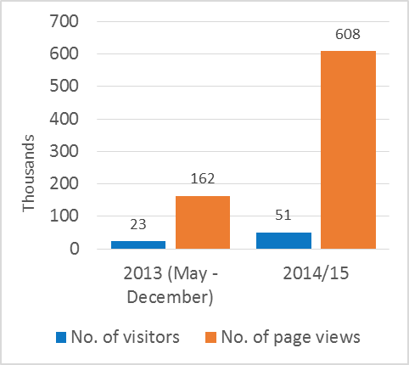

Figure : No. of visitors and page views of WIPO IP Statistics Data Center

### Strategic Goal VI: International Cooperation on Building Respect for IP

#### **Strategic Outcome VI.1: Shared understanding and cooperation among Member States to build respect for IP**

1. Between 2010 and 2015, WIPO successfully engaged a wide range of partners to further build respect for IP rights, holding joint events with participation from governments, the inter-governmental sector, industry and civil society. These engagements increased the commitment among participants to further address building respect for IP jointly and cooperatively. This work was complemented by the strong commitment of members of the WIPO Advisory Committee on Enforcement (ACE) to continue their dialogue: (i) on respect for and enforcement of IP, (ii) analyzing and discussing IP infringements in all their complexities, and (iii) providing opportunities to explore practices of alternative dispute resolution systems and preventive actions, measures or successful experiences to complement IP enforcement. At the national level, WIPO significantly increased its assistance to Member States, as evidenced by the growing number of countries that had adopted or amended their relevant policy and legal frameworks for IP enforcement over the last six years, or that were in the process of doing so. In addition, WIPO offered strategic support for the incorporation of respect for IP in national IP strategies. The WIPO Award Program presented additional opportunities to positively engage with an even wider selection of stakeholders, and showcased the importance and potential of IP protection among inventors, designers, schoolchildren and enterprises.

Outcome Indicator VI.1.1: Increased international cooperation with Member States, NGOs, IGOs and the private sector

1. Over the last six years, WIPO further intensified its engagement and cooperation with Member States, NGOs, IGOs and the private sector in building respect for IP. The events and activities dedicated to this result nearly doubled since 2009. In the 2014/15 biennium alone, WIPO organized and carried out 55 joint activities in this area (see Figure 25).

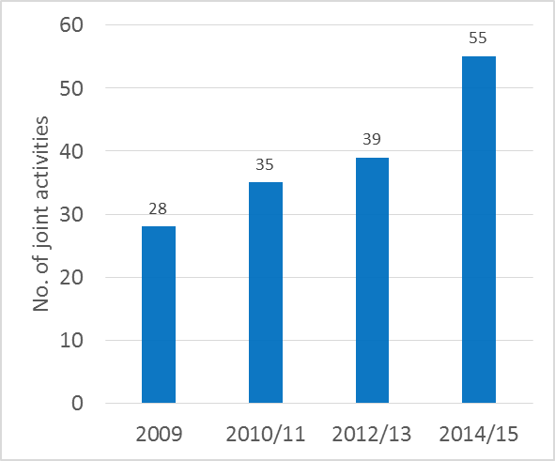

Figure : Trends in international cooperation on building respect for IP and enforcement

1. The activities covered a wide range of topics and issues aimed at increasing respect for IP and engaging a large variety of actors from government, the inter-governmental sector, industry and civil society.
2. Table 6 presents a few examples of these activities, such as the Global Congress on Combatting Counterfeiting and Piracy, co-organized with INTERPOL and the World Customs Organization (WCO), among others. These examples demonstrate how WIPO was able to bring together different types of stakeholders around a particular common IP-related issue or interest and to initiate a dialogue. In some cases, the debate spawned a series of follow-up events, such as the Counterfeit Medicines Roundtable, or informed publications on the issue in question, as illustrated by WIPO activities in relation to IP and private international law. A 2014 evaluation of Strategic Goal VI confirmed that WIPO’s international cooperation activities around the issue of respect for IP rights had indeed allowed the Secretariat to continuously strengthen its relationship with international stakeholders.

**Table 6: Illustrative examples of activities aimed at building respect for intellectual property**

| **Event Title** | **Year** | **Purpose** | **Outcome** |
| --- | --- | --- | --- |
| 6th session of the Global Congress on Combating Counterfeiting and Piracy | 2011 | Addressing overlapping social, economic and political dimensions of counterfeiting and piracy, and the need for targeted, integrated responses from a variety of actors (IGOs, governments, enforcement agencies, private sector). | * Under the banner of respect for IP, the discussions took a refreshed look at counterfeiting and piracy, taking due account of socio-economic and development-oriented concerns. * Improved understanding of the main drivers of trade in counterfeit and pirated goods and identification of innovative, effective and sustainable solutions to address this practice. |
| Counterfeit Medicines Roundtable | 2011, 2012 | Initiated in response to concerns over counterfeit medicines and corresponding requests from Member States for legal and technical assistance. Participating organizations were inter-governmental organizations[56], industry[57] and civil society[58]. | * Agreement on enhanced cooperation on the issue. * Follow-up round tables held in 2014 (hosted by WCO) and 2015 (hosted by WTO). |
| Seminar (and other events) on IP and Private International Law | 2015 | Respond to requests for capacity building activities on interface between private international law and IP (jurisdiction, application law, recognition of foreign judgments). | * Publication “Private International Law Issues in Online Intellectual Property Infringement Disputes with Cross-Border Elements – An Analysis of National Approaches” (published in September 2015) |

1. The WIPO Awards Program further increased the reach of the Secretariat for positively engaging with a wide variety of stakeholders. Presented to inventors, authors, designers, performers and producers, enterprises, schoolchildren and users of WIPO’s IP services, the awards have been used to recognize exemplary behavior and practices in the IP field, thus helping to accentuate the positive role that respect for IP rights plays in fostering innovation and creativity. Participation in the Awards Program rose steadily throughout the period of the MTSP, reaching a high of 43 participating countries in 2015. A particular highlight was the strong participation from developing countries, which consistently accounted for approximately 50 to 60 per cent of all participants of the Program, and included awardees from Africa, the Arab region, Asia and the Pacific, and Latin America and the Caribbean (see Figure 26).

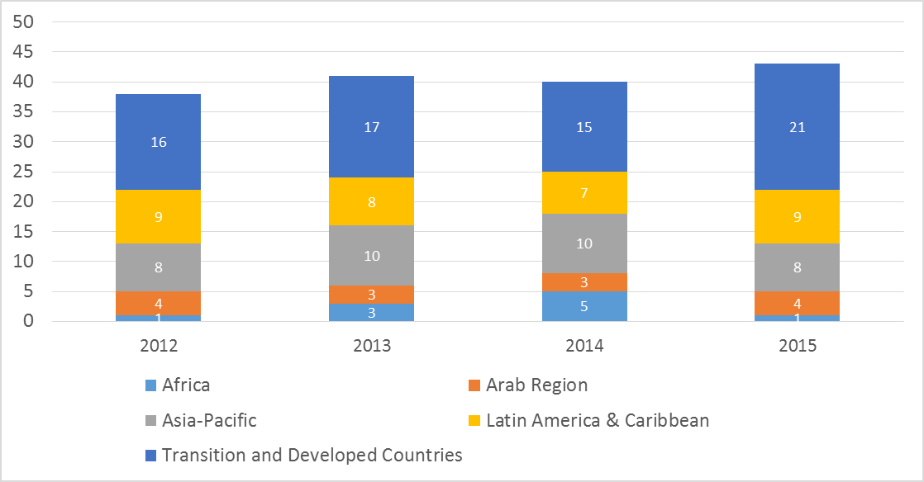

Figure : Participation in WIPO Awards Program

##### Outcome Indicator VI.1.2: Balanced policy dialogue within the auspices of the WIPO Advisory Committee on Enforcement (ACE), taking into account development-oriented concerns

1. The consistently thorough preparation by the Secretariat of the annual sessions of the WIPO ACE helped ensure that members were able to maintain their continued agreement on the substantive work of the Committee throughout the period under review and to use these sessions for balanced policy dialogue on building respect for IP. The Secretariat prepared and provided Member State input in the form of technical papers for the five sessions of the Committee that fell into the current MTSP period[59]. The work programs agreed by ACE members covered issues related to analysis of IP infringements in all their complexities; practices and operation of alternative dispute resolution systems in IP areas; and preventive actions, measures or successful experiences to complement ongoing enforcement, such as awareness raising and educational tools for young people, new business models, supply chain security, voluntary mechanisms, and national coordination to build respect for IP. Feedback from interviewed participants and an analysis of meeting documents on a sampling basis confirmed the diligent preparation of the meetings by the Secretariat.[60]

Outcome Indicator VI.1.3: Enhanced capacity among Member States for addressing piracy and counterfeiting

1. The six years of the MTSP have seen a significant growth in the number of countries which received assistance for the development of a new or updated legislative framework for IP enforcement. In 2009, only four countries were recipients of this type of support. For the 2014/15 biennium, this number rose considerably, with 12 countries that had adopted or amended their relevant policy and legal frameworks for IP enforcement or were in the process of doing so. This brought the number of national recipients of this type of support to 25 between 2010 and 2015.[61]

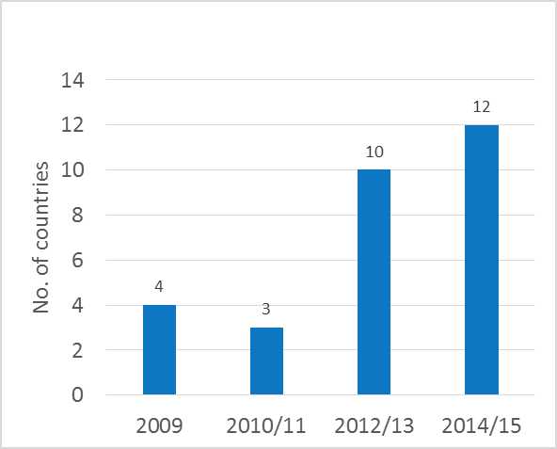

Figure : Progress in strengthening of national legislative frameworks for IP enforcement

1. Capacity building on building respect for IP was received positively by the participants throughout the MTSP period. For the years for which data is available, ratings regarding usefulness and satisfaction with the trainings were consistently 85 per cent or higher (see Figure 28).

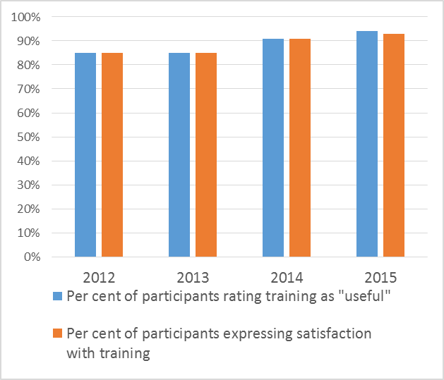

Figure : Participant ratings of WIPO building respect for IP and enforcement capacity building workshops.

### Strategic Goal VII: Addressing IP in Relation to Global Policy Issues

#### **Strategic Outcome VII: International discussions on global public policy issues are fully informed about the role of IP as a policy tool for promoting innovation and technology transfer**

1. The implementation of WIPO’s first MTSP coincided with the Secretariat’s first six years of work on the nexus between IP and key global challenges, namely global health, climate change and food security. Under Strategic Goal VII, WIPO provides empirically well-founded, useful support to policy dialogue between governments, international organizations, civil society actors and the private sector on these, and potentially other emerging global issues in their relationship to IP. The strategies set out in the MTSP 2010-2015 guided WIPO to provide support to relevant public policy processes, develop pertinent information tools, develop partnerships and collaborations, and facilitate voluntary innovation structures.
2. The achievements under this Strategic Goal have demonstrated the value of WIPO’s engagement in key global policy challenges from an IP-informed perspective. The Program has provided technical support to policy processes as requested by the responsible organizations. Most notably, two multi‑stakeholder platforms, WIPO Re:Search and WIPO GREEN, were established to foster cooperation between developed and developing countries to address global health and climate change challenges from the IP perspective. A number of publications contributed to technical information. Cooperation with partner IGOs, such as WHO, WTO and UNFCCC (Framework Convention on Climate Change) was strengthened. Under the trilateral cooperation between WHO, WIPO and WTO, a series of meetings on issues around global health, intellectual property and trade were organized, and the first joint comprehensive study in this field by the three agencies was published.

##### Outcome Indicator VII.1.1: WIPO recognized as the leading UN forum for addressing the interface between IP and global public policy issues

1. WIPO increased its outreach to relevant stakeholders in the international policy dialogue on the targeted global challenges. This was achieved through a number of events organized by WIPO, such as the WIPO Conference on Innovation and Climate Change in July 2011, and events co‑organized with IGO partners, such as the five joint WHO, WIPO, WTO Symposia on global health, IP and trade between 2010 and 2015. WIPO also continued to provide technical expertise to the then ongoing WHO process of developing a Pandemic Influenza Preparedness (PIP) Framework. Upon request of WHO, WIPO delivered a WIPO Patent Search Report on Pandemic Influenza Preparedness (PIP)-related Patents and Patent Applications in 2011 as a technical input to, and IP-related basis for, WHO Member State discussions on the PIP Framework, which was adopted by the sixty-fourth World Health Assembly (WHA) in 2011. UNITAID, in preparation of the establishment of the Medicines Patent Pool Foundation, requested WIPO to provide IP expertise to the deliberations and to organize a specific training on IP and licensing issues. In the area of climate change, WIPO reached out to stakeholders through collaboratively organized side events at UNFCCC meetings in partnership with the Technology Executive Committee as well as the Climate Technology Centre and Network (CTCN). In the area of food security, WIPO began to explore options for a work program through stakeholder consultations in expert meetings in Geneva and Tanzania. Priority was, however, given to the establishment of the two multi‑stakeholder platforms WIPO Re:Search and WIPO GREEN.
2. The interest in the establishment of the WIPO Global Challenges Program as well as WIPO Re:Search and WIPO GREEN was clearly reflected in the surge of internet traffic directed at the dedicated websites (launched in 2012) related to global health, climate change and the Global Challenges Division on the one hand, and the WIPO Re:Search and WIPO GREEN websites on the other hand. While data is not available for the beginning of the reporting period, the sites registered 6,476 page views for Global Challenges, 60,712 page views for WIPO Re:Search and 73,648 page view for WIPO GREEN in the 2012/13 biennium. During the 2014/15 biennium, the sites registered 39,445 page views for Global Challenges, Global Health and IP and Climate Change and IP; 62,118 page views for WIPO Re:Search; and 207,716 page views for WIPO GREEN. The number of pdf downloads increased from 3,773 downloads during the 2012/13 biennium to 45,253 during the 2014/15 biennium (see Figure 29). This serves as an indication of the WIPO potential for establishing itself as a leading resource partner at the interface of IP and global public policy issues.

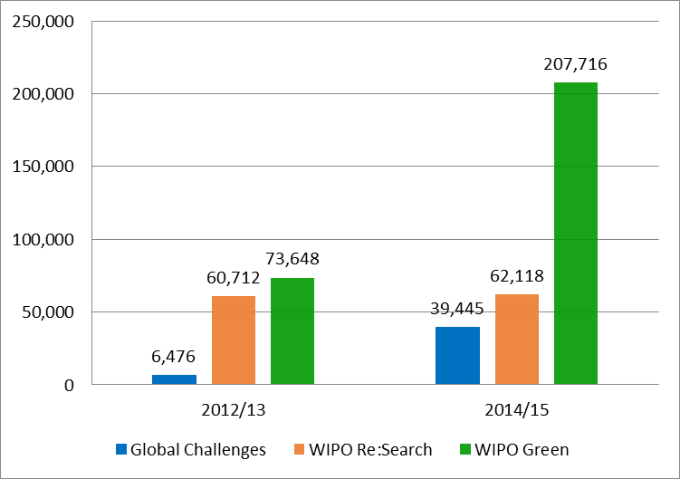

Figure : Access to Global Challenges websites between 2012 and 2015

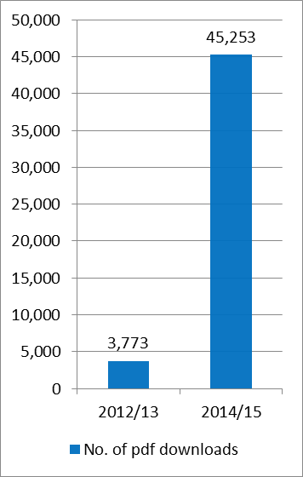

##### Outcome Indicator VII.1.2: WIPO's input is increasingly reflected in international discussions on global public policy issues

1. WIPO established and consolidated its position as a credible source of support, collaboration and reference for information on issues related to public policy and IP. This was evidenced through continued positive feedback from a wide range of stakeholders on WIPO’s work on IP and global challenges and through references to WIPO Re:Search and WIPO GREEN in discussions in other international fora, such as the WHA, the WTO TRIPS Council and a number of meetings in the UNFCCC process. To further enhance WIPO’s presence in IP‑related public policy processes, a series of Global Challenges Seminars were held that dealt with topical issues in the global challenges focus areas of: global health, climate change and food security. In addition, two types of global challenges publications were developed: a series of published Global Challenges Briefs (short and concise information overviews) and Global Challenges Reports (in‑depth analysis and discussion of issues) that informed policy debates on topical issues in the focus areas. Several articles were also published in specialized literature to reach a targeted and specific audience for the multi-stakeholder platforms.
2. Establishing WIPO Re:Search as a platform to support scientific collaboration between developed and developing country researchers and WIPO GREEN as a platform to connect technology providers and seekers solidified the WIPO reputation as the leading UN forum at the nexus of IP and global public policy issues.
3. As regards IP and competition policy, the Secretariat has steadily widened the circle of stakeholders that are engaged with WIPO. While in 2011, contacts between WIPO and other stakeholders were limited to five national competition authorities from three Member States and three additional inter-governmental organizations, this circle had grown considerably by 2014. WIPO had successfully engaged with 26 additional national authorities in that year alone, bringing the total cumulative number of national engagement partners to 69. In addition, WIPO had established contacts and held discussions with five relevant inter-governmental organizations between 2013 and 2015, in particular with the Common market for Eastern and Southern Africa (COMESA), International Competition Network (ICN), OECD, UNCTAD and the WTO (see Figure 30).

Figure : Growth in the number of stakeholders engaged in policy dialogue with WIPO on competition policy

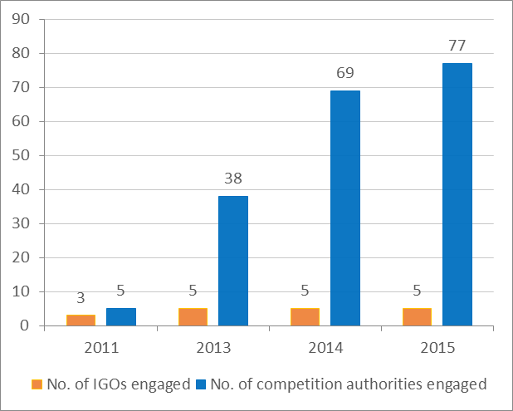

1. WIPO also received requests from Member States for specifically focused bilateral discussions. While in 2010, only two Member States had made such inquiries, their number had grown to six in 2013.[62] In 2014, a total of 16 countries asked WIPO for consultations with the aim of enhancing their understanding of the interface between IP and competition policy, among them Brazil, India, Italy, Singapore and South Africa. These included new requests and follow-up requests.

##### Outcome Indicator VII.1.3: IP‑based mechanisms are established to address global public policy issues

1. Defining achievements in these first years were the establishment of two multi‑stakeholder platforms: (i) WIPO Re:Search - Sharing Innovation in the Fight against Neglected Tropical Diseases, launched in October 2011 to help bring together a broad range of private and public sector institutions from developed and developing countries to stimulate new R&D for neglected tropical diseases, tuberculosis, and malaria; and (ii) WIPO GREEN ‑ The Marketplace for Sustainable Technology, started in 2011 as a pilot initiative and eventually launched as a fully operational platform in November 2013 to provide an online marketplace for sustainable technology.
2. The value for WIPO of the commitment to the multi‑stakeholder platforms policy is demonstrated by the overall growth in membership and database entries. Membership in WIPO Re:Search more than tripled from, initially, 31 to 100 Members by the end of 2015. Encouragingly, WIPO Re:Search membership included 15 Members from 10 African countries in 2013 and a total of 27 Members from developing countries in 2015. Similarly, the number of entries in the WIPO Re:Search database, to which WIPO Re:Search Members contribute assets, such as pharmaceutical compounds, technologies, know-how and data for research, product development and production, has grown. In 2011, the Re:Search database contained 80 entries and by the end of 2015, this number had increased to 193. The development was not without challenges. The number of database entries had been even higher in 2013 (247). The decrease was caused by the withdrawal of two Members from WIPO Re:Search and required efforts to engage with new corporate Members. Three new corporate Members joined in 2014 and 2015. While the withdrawal of the WIPO Re:Search Members led to a 27 per cent reduction in database entries in 2014, this was offset partially by the seven per cent increase of database entries in 2015.

Figure : WIPO Re:Search – Collaboration Map

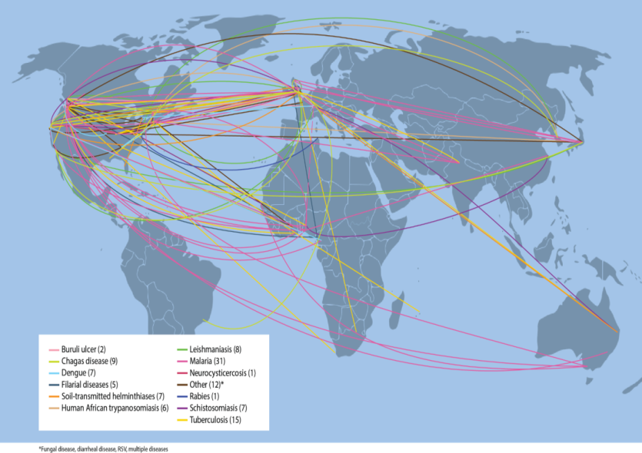

1. Given that the primary objective of WIPO Re:Search is to catalyze research collaborations, the platform registered a growing number of successful research collaborations across the globe (see Figure 31). Cumulatively, through the WIPO Re:Search Partnership Hub Administrator, BIO Ventures for Global Health (BVGH), 96 such collaborations were facilitated by the end of 2015. In addition, the Platform’s potential for technology transfer from developed to developing countries of IP assets, including know-how and expertise, was further demonstrated by the continued facilitation of research sabbaticals for six African scientists in overseas research institutions.
2. WIPO GREEN witnessed a similar growth in participants (both partners and users). Overall, participation grew from 35 partners to 65 partners across the globe by the end of 2015[63] (see Figure 32) and from 14 users to 490 users[64] by the end of 2015.
3. In comparison to WIPO Re:Search, WIPO GREEN has taken more time to develop. This is due to the fact that WIPO GREEN does not currently have a “partnership hub” or service provider to actively undertake the matching of needs with offers. Before its launch in November 2013, WIPO GREEN had concluded two agreements with external partners for data integration during 2012 and 2013.[65] For 2014/15, WIPO had intended to increase the number of successfully completed transactions to 250. However, ultimately, only seven data integration agreements could be facilitated by the end of 2015. Work in 2015 focused on helping seekers in refining needs and facilitating connections. To that end, more detailed guidelines for seekers were, therefore, introduced in 2015, resulting in an improvement in the quality of needs description.

Figure : WIPO GREEN Partners

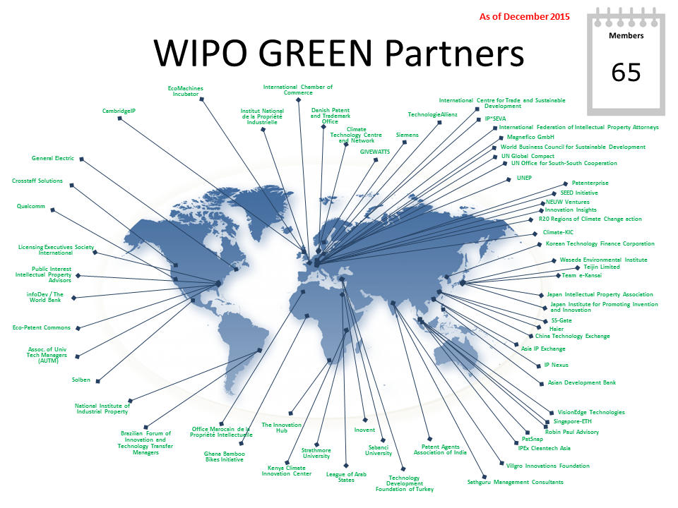

## The Enabling Goals

### Strategic Goal VIII: A responsive communication interface between WIPO, its Member States and all Stakeholders

#### **Strategic Outcome VIII.1: WIPO recognized as the primary trusted provider of international IP expertise, information and services in support of innovation and creativity**

1. During the last six years, WIPO successfully raised general public awareness and interest in IP. The Secretariat’s investment in social media presence attracted a diverse audience to IP-related content across different types of media and platforms, including YouTube, Facebook and Twitter. The enhanced online profile of the Organization also helped to provide a greater forum for sharing information and for achieving higher visibility for key events such as World IP Day or the annual launch of the Global Innovation Index (GII).
2. The Secretariat’s work during this MTSP period also further established WIPO as a global leader for discourse and information sharing on IP. Both the Secretariat in Geneva as well as the WIPO External Offices played key roles in this regard.

Outcome Indicator VIII.1.1: Enhanced awareness and understanding of the role of IP in encouraging creativity and innovation

1. In its MTSP, WIPO recognized that enhancing awareness and understanding of the role of IP in encouraging creativity and innovation would hinge at least in part on WIPO’s ability to reach a wider, differentiated audience with its IP awareness campaigns and information. Tapping the potential of the internet and social media for this purpose was one important element of this approach.
2. In keeping with this plan, WIPO significantly strengthened its social media presence over the last six years, using a host of platforms and media types. Producing and publishing IP‑related video content has been one effective avenue WIPO pursued. It garnered the interest and attention of a growing audience since 2008/09. As shown in Figure 33 below, the number of viewers of WIPO’s YouTube Channel increased from under 100,000 views in 2008/09 to over five million unique views in 2014/15, an increase of over 6,500 per cent.

1. Viewing figures soared in particular following the addition of the “Pororo” animations during the 2012/13 biennium, a series of educational videos intended to familiarize young children with the basic elements of IP. During the 2012/13 biennium alone, this part of the WIPO YouTube Channel attracted over 3.8 million views.

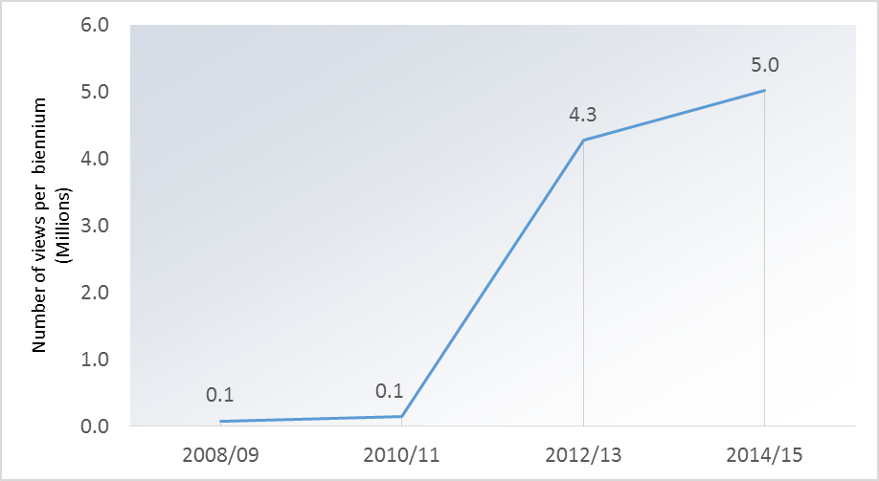

Figure : Interest in WIPO YouTube Channel, 2008/09–2014/15

1. WIPO’s official presences on other social media sites, such as Twitter, Flickr (photo sharing) and Scribd (publication sharing), were first launched in March 2012. Since their launch, WIPO’s social media influence has overtaken many comparable national and international institutions with much longer-established social media presences.[66]

Figure : Average no. of retweets of WIPO Twitter posts, 2013-2015

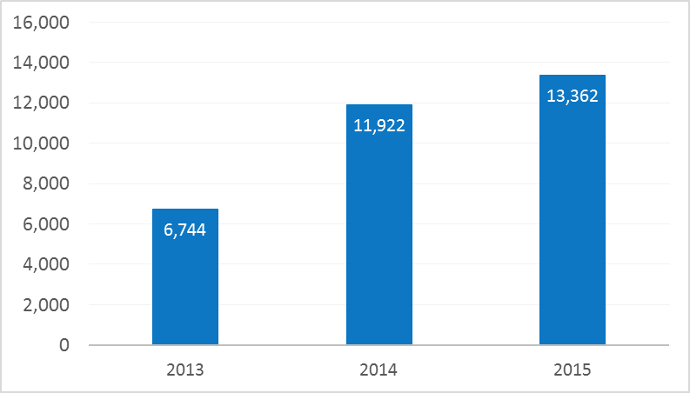

1. WIPO’s presence on Twitter also attracted a growing number of followers in its first three years of operation. The number of “retweets” of WIPO posts on the site, i.e. of reposted or forwarded WIPO messages, nearly doubled between 2013 and 2015, from approximately 6,700 to nearly 13,400 retweets (see Figure 34).
2. WIPO has generated increasing interest in the importance of IP via its presence on Facebook. This is illustrated by the increasing number of people around the world who accessed WIPO content on the World IP Day Facebook page.[67] In 2011, that page attracted approximately 180,000 Facebook views. In 2015, this number had grown to nearly 460,000. Although lower than the record number of people who accessed material on the World IP Day in 2014 (i.e. over 560,000), the overall growth of views by over 150 per cent between 2011 and 2015 was significant (see Figure 35).

Figure : Participation in annual World IP Day events via Facebook, 2011-2015

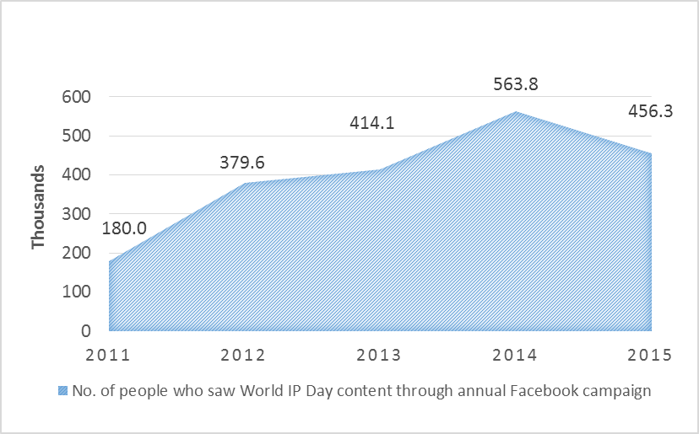

1. WIPO also attracted a greater viewership for its flagship IP-related publications. As illustrated in Figure 36, the number of unique views of the website for the WIPO Magazine, a bi-monthly publication exploring IP, creativity and innovation and related topics across the world, grew by 21 per cent between 2010/11 and 2014/15, resulting in over one million unique views of Magazine content online over the latest biennium of the MTSP period.

Figure : Increased Interest in WIPO Magazine, 2010/11 and 2014/15

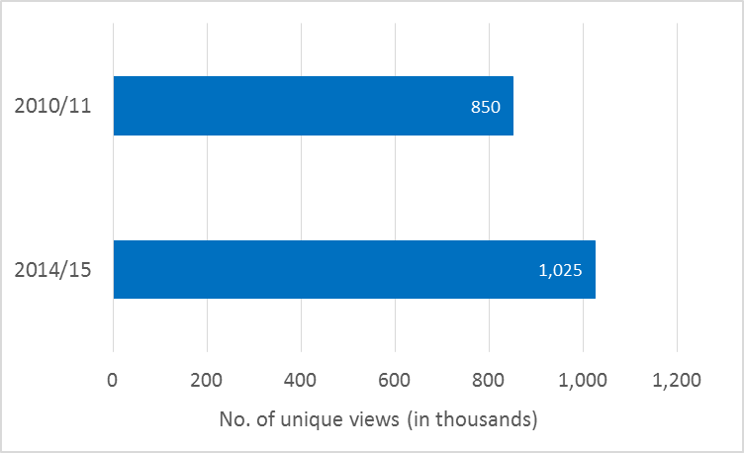

1. Promotion of key events and products, such as the annual Global Innovation Index (GII)[68] also attracted growing interest from the global IP community, with increasing numbers of people accessing GII-related web content in the weeks following the launches. In 2013, about 46,000 users viewed webpages, press releases or infographics or videos within the first 11 weeks of the official release of the report. By 2015, this number had grown by over 200 per cent. Over 140,000 people accessed webpages, press releases or infographics on the GII launch and just over 10,000 users viewed GII-related videos in the first 11 weeks after the GII publication that year (see Figure 37).

Figure : Public Interest in the annual launch of Global Innovation Index, 2013–2015

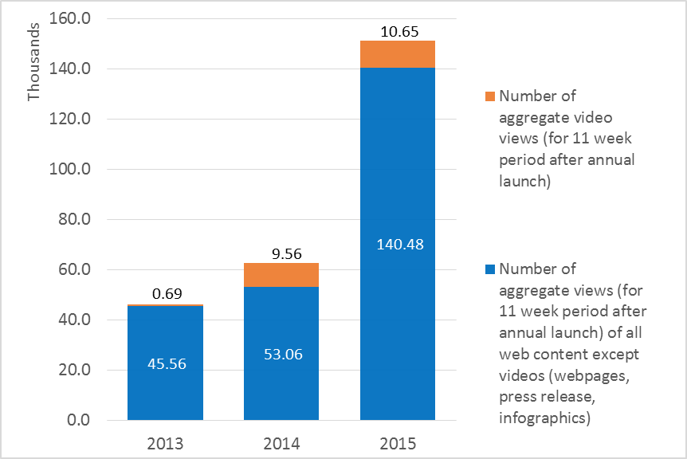

Outcome Indicator VIII.1.2: Enhanced recognition of WIPO's corporate identity in line with its mission, mandate and values

Figure : WIPO’s public perception of WIPO, 2012-2014

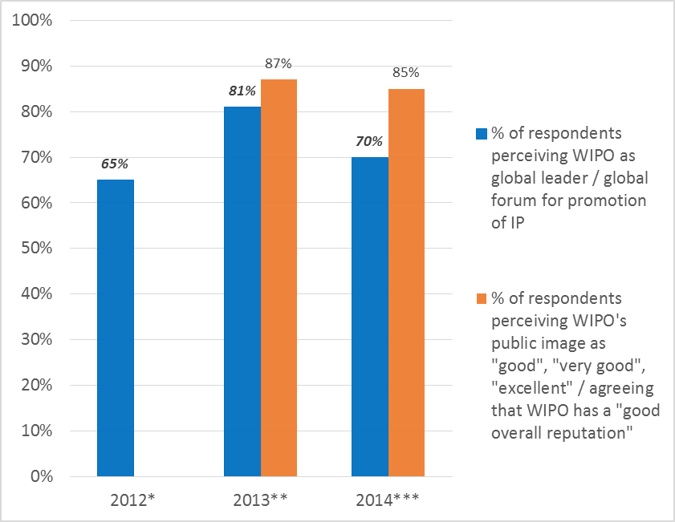

* WIPO Stakeholders Perceptions Survey, January 2012

** WIPO Service Orientation Survey results, August 2013

*** WIPO Stakeholders Perceptions Survey, June 2014

1. Over the past six years, WIPO continued to successfully establish itself as a global leader in IP. This is illustrated by many of the measures presented and discussed in this review, and, in spite of some fluctuations over the years, is confirmed by the direct feedback from WIPO clients and other stakeholders and partners. In 2014,[69] 70 per cent of respondents to the WIPO Stakeholder Perceptions Survey indicated that they saw WIPO as a global leader and a global forum for the promotion of IP rights. This share represents a five per cent increase if compared to the 2012 survey, but about a 10 per cent decrease in comparison to the 2013 survey (see Figure 38). Between 85 per cent (2014) and 87 per cent (2013) of respondents considered WIPO’s public image to be “good”, “very good” or “excellent”.

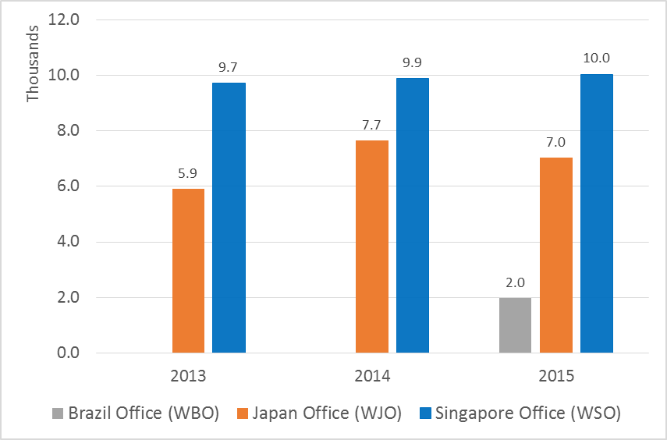

*Note: The website for WIPO’s External Office in Brazil was created in 2015.*

Figure : Site views of WIPO External Office websites, 2013 2015

1. The increased standing and name recognition of WIPO was also illustrated by higher volumes of internet traffic directed to the websites of its External Offices. The sites for the WIPO Brazil Office (WBO), the WIPO Japan Office (WJO) and the WIPO Singapore Office (WSO) together generated over 50,000 unique site views between 2013 and 2015. On average, the WSO attracted approximately 10,000 views per year; the WJO saw slightly less unique views on average, i.e. approximately 7,000 (see Figure 39).

#### **Strategic Outcome VIII.2: Service-oriented culture established throughout the Organization**

1. WIPO made great strides in establishing service-orientation as a guiding organizational principle between 2010 and 2015. Timeliness, responsiveness and client orientation improved with regard to the Secretariat’s interactions with representatives from Member States, in relation to its relationship to partner organizations in the global IP community and with respect to the clients for its IP-related services, such as those offered under the Madrid, PCT and the Hague Systems.

Outcome Indicator VIII.2.1: Higher satisfaction of Member States, other stakeholders, users and the interested public with WIPO's service provision

1. Throughout the MTSP period, WIPO invested in establishing itself as the global forum for IP services, policy, information and cooperation, ensuring the delivery of IP-related information and services to its Member States based on transparent working methods, effective consultation processes and responsiveness to the concerns and information needs of its Member States. The Director General conducted regular briefings for Ambassadors and held meetings with Member States, as a means for receiving feedback and advice to enhance progress on many issues. During the past six years, the Secretariat took care to make responsiveness to communications from Member States a key priority. As a result, 80 per cent of letters to the Director General from Member States received responses within two weeks.[70]
2. The Secretariat also took note of the requests of Member States for timely and inclusive preparation of sessions of the WIPO General Assembly and Committee meetings. WIPO was able to ensure that by 2015, 97 per cent of Committee meetings held by the Organization were preceded by preparatory pre-committee meetings. This is an improvement of nearly 20 per cent from the 80 per cent of committee meetings that were combined with pre-meetings in 2011 (see Figure 40).

|  |  |
| --- | --- |
| Figure : Percentage of Committee Meetings for which pre-Committee information meetings for Member States were held | Figure : Percentage of documents published at least two months in advance of the WIPO Assemblies |

1. The preparatory documents for nearly all WIPO Assemblies (99.5 per cent) were published at least two months in advance, a clear improvement over the 90 per cent of documents that were published in this timely fashion in preparation for the 2011 WIPO Assembly (see Figure 41).
2. The satisfaction of Member States with the preparation and functioning of the WIPO Assemblies as one of the main policy and decision making bodies of WIPO[71] consistently remained at a high level, and even grew between 2012 and 2015. In 2015, 90 per cent of Member States were satisfied with these aspects of the WIPO Assemblies.

Figure : Percentage of Members States satisfied with the preparation and functioning of the WIPO Assemblies,   
2012 2015.

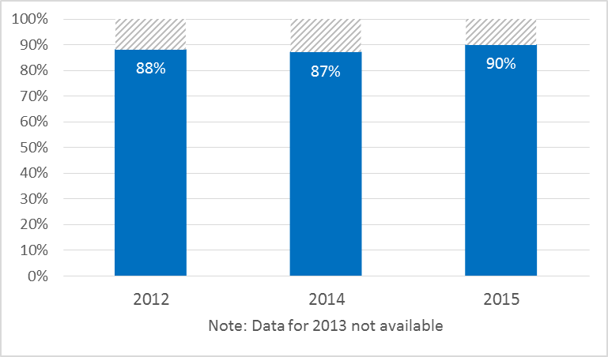

1. As an important element of its service orientation, the Secretariat also improved the timeliness of its responses to information requests from stakeholders other than Member States. By the end of the MTSP period, 93 per cent of requests for contributions from other UN agencies, Intergovernmental Organizations or other global IP partners were processed within five working days. In 2011, one year into the MTSP, this had only been the case for 80 per cent of these types of requests (see Figure 43). The Secretariat thus considerably improved its responsiveness in this area. In addition, WIPO’s Secretariat also increased its presence and visibility in major UN and IGO processes, such as the Agenda 2030 for Sustainable Development and the Paris Agreement on Climate Change, both of which were concluded in 2015.

Figure : Timeliness of WIPO responses to requests for contributions from UN, IGOs, 2011-2015

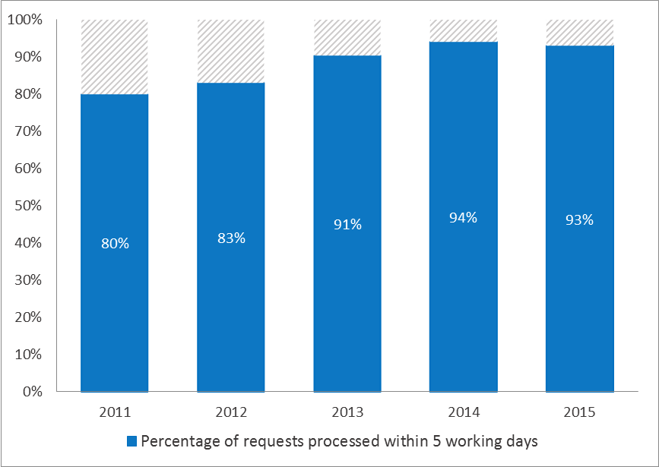

1. WIPO’s External Offices established a high standard for timely responses to information requests, as well. In 2015, the WIPO Japan Office and the WIPO Singapore Office responded to information inquiries within three days in 99 per cent and 95 per cent of the cases, respectively. Both Offices also saw improvements in the timeliness of their responses from the prior year[72]   
   (see Figure 44).

Figure : Timeliness of responses to information inquiries from WIPO External Offices; 2014-2015

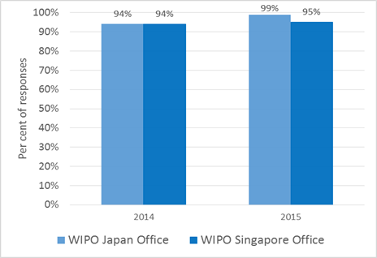

1. Client satisfaction for some of the main WIPO IP services (i.e. services related to the Madrid, the Hague and PCT Systems) remained high throughout the MTSP period. For the Madrid System, approximately 80 per cent of clients were satisfied with the services WIPO had provided in the years 2013, 2014 and 2015. Satisfaction for services delivered by the PCT and the Hague systems were equally high, or even higher, at 88 per cent for the Hague System in 2013,[73] and 89 per cent for the PCT in 2015.[74]

Figure : WIPO client satisfaction for Madrid, the Haque and PCT services

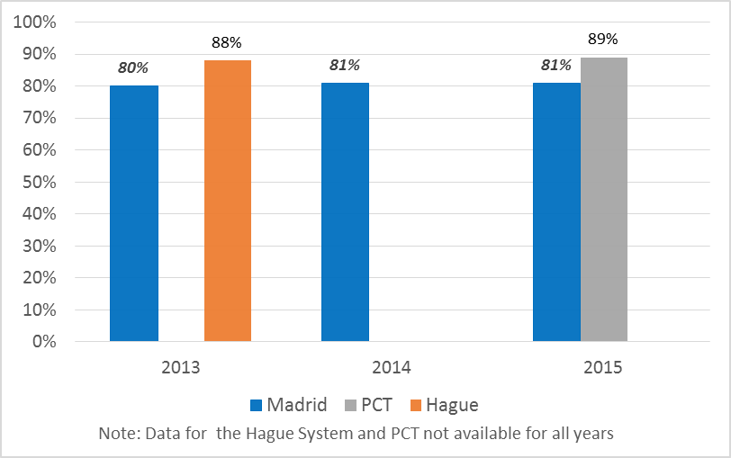

### Strategic Goal IX: An Efficient Administrative and Financial Support Structure to Enable WIPO to Deliver its Programs

#### **Strategic Outcome IX.1: A delivery-oriented, resource-effective and integrated administration that enables WIPO to deliver on its mandate, and is responsive to the changing needs of the Organization and its stakeholders**

1. WIPO made great strides during the six-year MTSP period with regard to building an agile and smooth functioning Secretariat with an appropriately skilled workforce centered around its four core values of service orientation, working as one, accountability for results and environmental, social and governance responsibility. Furthered by the launch and implementation of the Strategic Realignment Program (SRP), WIPO significantly strengthened its management and administrative infrastructure, including human resource management and recruitment processes, developing into a service-oriented, resource-efficient administration that can effectively support the delivery of internal and external services in line with its mandate and in response to the evolving needs of its stakeholders. The overall advancements made in developing an up-to-date, enabling management and administrative infrastructure represents important prerequisites for continued progress in the next MTSP period. Important milestones during the six-year MTSP period included: (i) strengthening of result-based management (RBM); (ii) contract reform; (iii) reform of the internal justice system; (iv) streamlining of the administrative, operational and financial regulatory framework; (v) significantly increasing access of staff to secure, modern and integrated information and communications technologies (ICT); and (vi) improving and expanding the physical infrastructure on WIPO’s Geneva campus with the completion of the New Building and the new WIPO Conference Hall. These were achieved while maintaining the share of administration and management costs in relation to the Organization’s overall expenditure.

Outcome Indicator IX.1.1: A well-managed, geographically diversified and appropriately skilled professional workforce

1. As part of the SRP, WIPO pursued efforts to continually assess staffing against future workforce needs. A 2012 organizational design review informed the 2014/15 Program and Budget planning process, and workforce planning was integrated into the annual work planning cycles. Enhancements to the Enterprise Performance Management (EPM) system allowed for the more accurate linkage of personnel resources to the work of the Organization and improved reporting on the use of the Organization’s human resources. In 2015, the Secretariat also completed an organization-wide exercise to ensure that all job descriptions were up-to-date and in line with business needs and priorities.
2. During the period under review, WIPO embarked on important reforms of its human resource management policies and processes, aimed at improved gender balance in professional and leadership positions and a more inclusive geographical representation of its Member States in the Secretariat’s workforce. In 2012, as part of the contract reform, the Staff Regulations and Rules (SRRs) were amended introducing two new appointment types, namely, temporary appointments and continuing appointments, in line with the contractual framework recommended by the International Civil Service Commission (ICSC). Since November 2012, 195 short-term contracts (including consultancies, Special Labor Contracts (SLCs) and temporary translator contracts) have been converted to temporary appointments, giving contract holders the status of “staff” and providing enhanced benefits. In addition, in line with the commitment made by the Director General and endorsed by Member States in 2010,[75] the regularization of long-serving temporary employees (LSTEs) was completed in 2014 resulting in a total of 84 regularizations.

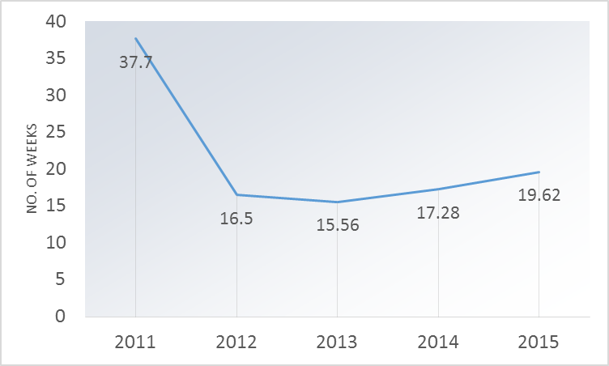

Figure : Recruitment lead times

1. The revision of the SRRs on recruitment, including the changes made to the composition of Appointment Boards, and the overall streamlining of recruitment processes, contributed to greater agility of recruitments with a significant reduction in recruitment lead times, from an average of 37.7 weeks at the end of 2011 to an average of just over 17 weeks in 2012 to 2015 (see Figure 46).
2. A review of the internal justice system in 2012/13, which included a comprehensive study by an external expert and intensive consultations with various stakeholders, resulted in amendments to the SRR, which entered into force on January 1, 2014.  The improved internal justice system provides for streamlined formal mechanisms and new and transparent procedures for the handling of grievances.  A key aspect of this reform was the recognition of the importance of conflict prevention, resulting in a strengthening of the Office of the Ombudsperson on January 1, 2014.

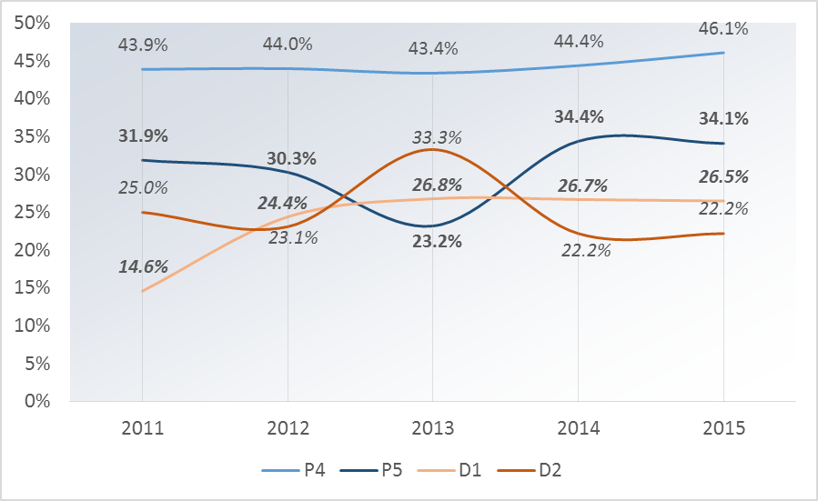

Figure : Percentage of professional and higher category female staff, 2011-2015

1. In 2014, WIPO issued its first Gender Equality Policy, with the twin objectives of mainstreaming the gender perspective in WIPO activities, and a time-specific goal for achieving gender balance at all staffing levels. Accordingly, a network of gender focal points covering all WIPO Programs was established, and recruitment efforts were intensified to redress the gender gap in staffing. The share of women at the D-1 level nearly doubled from 2011 until 2015, from 14.6 per cent of all staff to 26.5 per cent respectively. The percentage of women in P-5 and P-4 levels fluctuated moderately during the same time period, with the share of female staff at the P5 level increasing from 31.9 per cent in 2011 to 34.1 per cent in 2015, and at the P4 level, from 43.9 per cent to 46.1 per cent. The share of women at the D-2 level, however, saw an overall decrease between 2011 and 2015, from 25 per cent to 22.2 per cent (see Figure 47).

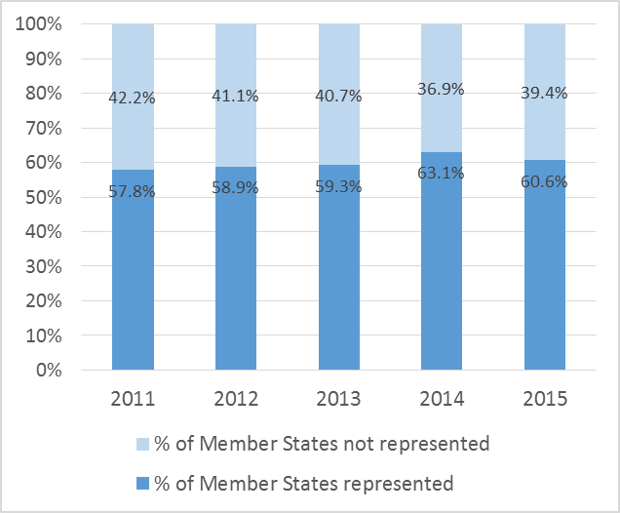

Figure : Percentage of Member States represented in WIPO staff,   
2011-2015

1. In spite of low staff turnover in WIPO, the Secretariat improved the geographical balance of WIPO’s workforce over the last six years. The share of Member States who were represented among the staff of the Secretariat increased during the period under review from 57.8 per cent in 2011 to 60.6 per cent in 2015[76] (see Figure 48). In 2015, the share of staff members from Western European countries dropped below 50 per cent, driven by the increased representation of Member States from other regions (seeFigure 49). Countries from Eastern and Central Europe and Central Asia constituted approximately seven per cent of the Secretariat’s workforce, representing an increase of one percentage point compared to 2013. The shares of staff from Asia and the Pacific and from North America also increased slightly, by 0.6 and 0.8 percentage points, respectively.

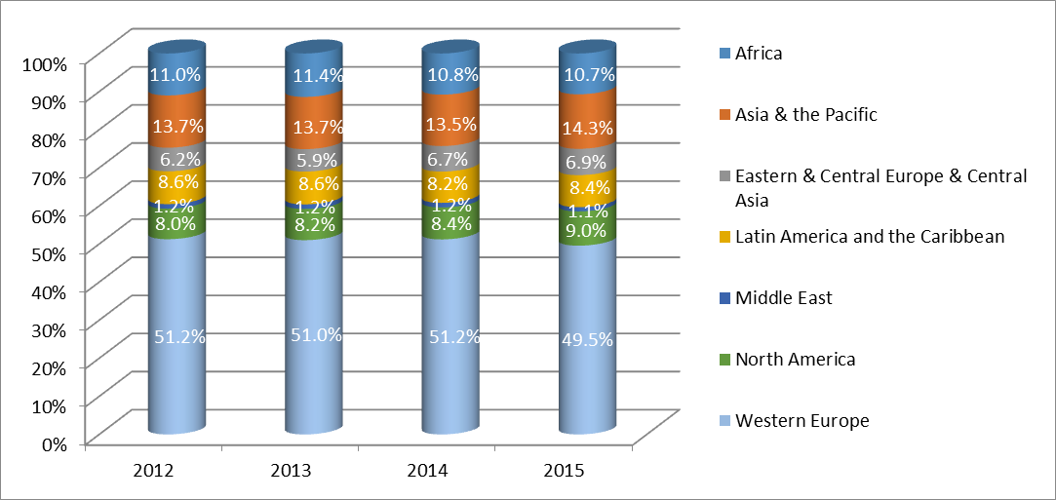

Figure : Percentage of Professional and Higher Category Staff by Region 2012-2015

1. Advances in implementing the Performance Management and Staff Development System(PMSDS) facilitated closer alignment of staff with the strategic goals of WIPO, supported systematic and proactive staff development, and helped facilitate continuous dialog between supervisors and employees. Over the six-year period, the PMSDS became operational across all WIPO Sectors and matured in scope, acceptance and application, supported by the implementation of a comprehensive training program. Compliance with the system increased early on in the period and remained high in the subsequent years. (see Figure 50).[77]

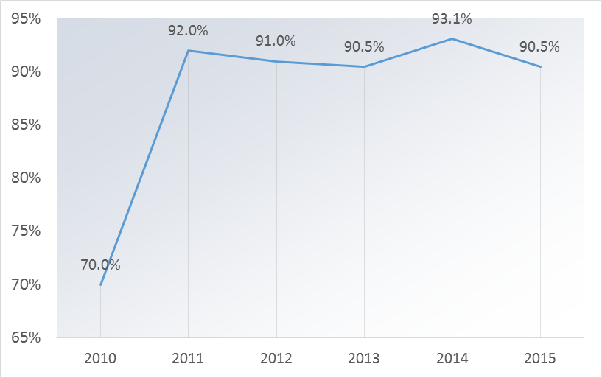

Figure : Percentage of staff whose performance is evaluated against their individual objectives and competencies

1. To facilitate learning and staff development and to close skills gaps, the Secretariat launched new Learning and Development Policy and Training Guidelines in 2013. In addition to regular training activities, new initiatives on conflict resolution, stress management, quality management, project management and accreditation of prior learning were launched in order to increase managerial capacity.

Outcome Indicator IX.1.2: An up-to-date and enabling management and administrative infrastructure

1. WIPO made important strides to solidify its administrative, operational and financial regulatory frameworks (see Box 1). Considerable progress was made, in particular, with regard to the financial management of WIPO. The establishment of new investment and reserves policies, both approved by Member States in 2015, and a review of WIPO’s treasury management provided the basis for strengthening financial management during the period under review. In addition to providing robust fee management support to the international registration systems,[78] which grew at a steady pace, the exploration of hedging and netting strategies to manage foreign exchange risks, identified within the context of the treasury review, was completed in 2015. Since 2010, the Secretariat developed and updated a range of its Financial Regulations and Rules (FRRs) and relevant Office Instructions (OIs) on core topics such as risk management, procurement and the management of voluntary contributions.

* **Financial Management** 
  + International Public Sector Accounting Standards (IPSAS) compliance
  + Investments
  + Reserves
  + Management of Voluntary Contributions
  + Cash Management and Financial Guidelines for External Offices
  + Prevention and deterrence of corruption, fraud, collusion, coercion, money laundering and the financing of terrorism
* **Procurement and travel**
  + Management of supplier relationships
  + Official travel and related expenses
  + Individual Contractual Services
* **Property Management**
* **Risk Management and Controls**

Box : Areas with significantly strengthened regulatory frameworks and policies 2010-2015

1. This foundation of clarified and consistent policies, rules and regulations enabled the Secretariat to focus its efforts on improving its overall service orientation and delivery, both internally and externally. The Secretariat’s performance in key areas such as legal advice, procurement and information and communication technology (ICT) either improved, or remained strong during the period under review. In the case of legal support, the Secretariat saw significant growth in the number and diversity of requests, in particular during the 2012/13 biennium, which received prompt and reliable responses in the last two biennia.[79]
2. Through a series of measures with a view to optimizing the cost of WIPO procured goods and services and streamlining its processes, the period under review saw strong results, culminating in significant cost savings for the Organization by the end of 2015.[80] Of particular note, the implementation of the On Line Booking Tool (OBT) in 2015 resulted in reduced fares and fees, as well as direct access for travelers to market fares. The satisfaction of internal

WIPO clients with the Secretariat’s procurement services increased between 2011 and 2015. While in 2011 only 75 per cent of staff were satisfied, this share had grown to nearly 90 per cent by the end of 2015.

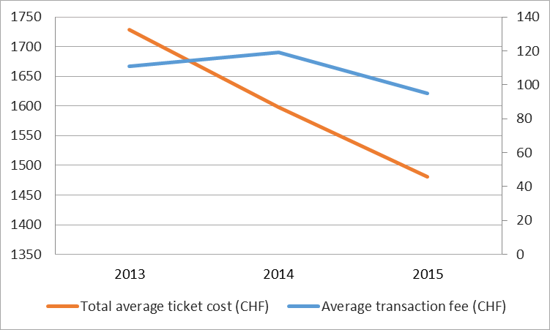

Figure : Evolution of travel costs,   
2013 2015

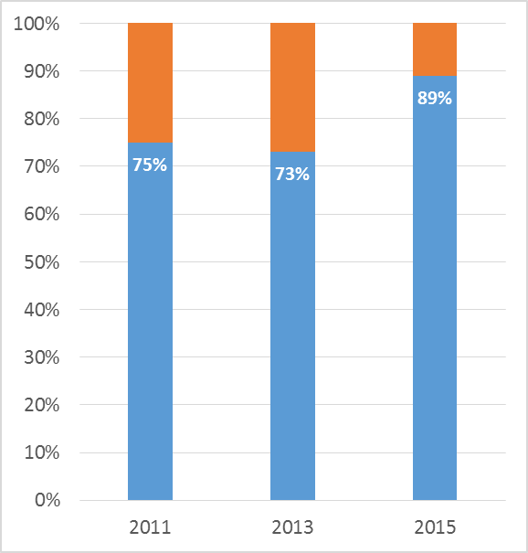

Figure : Internal client satisfaction with procurement services, 2011-2015

1. WIPO also made advances in improving the access of its internal clients to secure, modern and integrated information and communications technologies (ICT), starting with the organization-wide deployment of a new internal data network architecture that was completed in 2012. The new network provided reinforced network security, allowed for the effective handling of multimedia (voice, video and data) traffic, and reduced operational costs while enabling new services such as integrated video and telephony services for the desktop computer environment. The upgrade of office productivity systems to industry-standard platforms further facilitated the Secretariat’s work with external entities. In the 2014/15 biennium, a new Global Office Architecture (GOA) solution for WIPO’s External Offices securely connected all WIPO External Offices to the administrative IT systems hosted at headquarters, which extended the reach of these centralized and consistent IT services. Finally, an advanced fax system was introduced to seamlessly integrate with computer systems for Madrid and internal administrative systems, resulted in greater efficiency and significantly reduced error rates.
2. As ICT lies at the core of the delivery of WIPO’s services, an ICT Strategy,[81] was developed in 2013 in order to ensure the provision of cost-efficient, secure, state-of-the-art services to a broad range of stakeholders.
3. WIPO’s first organization-wide Information Risk Assessment[82] helped the Secretariat to guide its efforts to consolidate information security across its business areas. In the 2012/13 biennium, WIPO achieved certification against the ISO 27001 standard for information security management related to the PCT applications and data handling processes and systems. The certification was expanded in 2015 to include both the Madrid and the Hague operations. Additionally, technical security controls were deployed allowing for greater visibility on potential security events to the WIPO network, and enabling rapid and effective incident response. Recognizing the constantly evolving cyber and security threats to its business operations, a strategic organizational restructuring was undertaken in 2014/15, allowing for a better integration between physical and information security, as reflected in the comprehensive Security and Information Assurance Strategy.
4. A Knowledge Management Strategy[83] was developed in 2015 with a view to fostering a knowledge management culture within WIPO and to ensure the alignment and integration of knowledge management with WIPO’s Organizational Resilience Strategy.
5. Significant safety and security enhancements were made during the 2010-2015 period, leading to the completion of the Headquarters Minimum Operating Security Standards (H‑MOSS) project in 2015, notably the opening of the new WIPO Access Center (AB reception) and the Security Coordination Operations Center (SCOC), in time to successfully support the twenty-second session of the PBC and the WIPO Assemblies in 2014 as well as over 200 conferences and events in 2015 attended by staff, delegates, visitors, and the public. Additionally, safety and security assessment audits were completed for all five External Offices in 2014/15 with over 90 per cent of the audit recommendations closed by the end of the biennium.
6. The WIPO campus underwent significant transformation during the period under review with the addition of the New Building and the new WIPO Conference Hall. The New Building, whose worksite had started in spring 2008, was completed in 2011 and inaugurated on the first day of the WIPO Assemblies in September 2011. It permitted the regrouping of staff in the main WIPO Campus and the vacating of a large rented office building. The worksite for the New Conference Hall Project opened in mid-August 2011. The project was completed and delivered in accordance with quality requirements, on time for the first official meeting in the Hall taking place in September 2014.[84] The new facility was officially inaugurated on the first day of the 2014 WIPO Assemblies of Member States. The design of the new WIPO Conference Hall, and that of other improvements on the WIPO campus, also provided for the development of several physical accessibility measures.
7. Complementary to the completion of the WIPO Conference Hall, the Secretariat also put in place other requisites for effective conference and language services. Chief among these was the development and implementation of the new WIPO Language Policy, which was approved by the 2010 and 2011 Assemblies. The policy initially provided for the extension of full six-language coverage of three Committees: (i) the Intergovernmental Committee on Intellectual Property and Genetic Resources, Traditional Knowledge and Folklore (IGC); (ii) the Standing Committee on Copyright and Related Rights (SCCR); and (iii) the Standing Committee on Trademarks, Industrial Designs and Geographical Indications (SCT). By the end of the MTSP period, this six-language coverage extended to all of WIPO’s Committees and Main Bodies, as well as to four Working Groups.[85]
8. In order to improve the quality of translation services, especially with more reliance on outsourcing, the concept of “quality at source” was gradually introduced and continually strengthened. In 2014/15, this meant in particular that the Secretariat reviewed its contractual relationship with external translators, retaining only those who conformed to set standards. Additionally, the Secretariat linked payments to the quality and timely delivery of outsourced translations. As a result, the proportion of translation volume being subjected to quality control rose from less than 10 per cent before the implementation of the Language Policy (end of 2011) to around 39 per cent in 2014 and to 60 per cent by the end of the biennium. With these and other measures, the Secretariat achieved the dual goal of cost-effectiveness and quality-consciousness set out by Member States when adopting the new Language Policy.

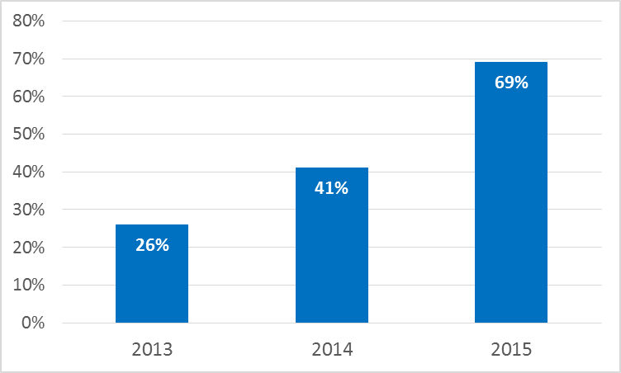

Figure : Percentage of documents published two months before relevant meeting

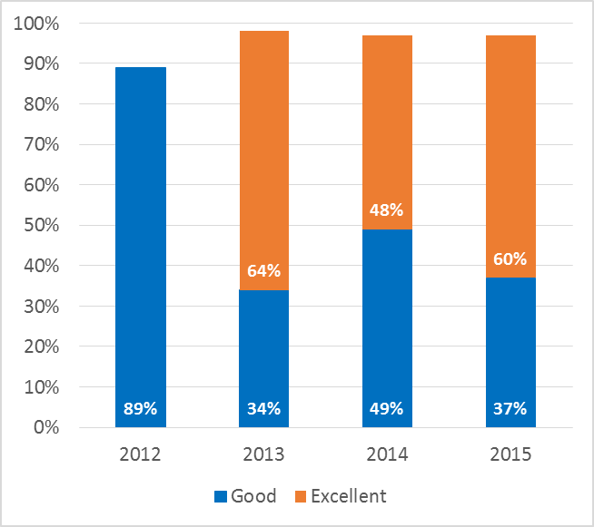

Figure : Percentage of internal and external participants satisfied with WIPO Conference Services

1. Efforts to improve conference services also translated into the more timely preparation of documents as evidenced by a 40 percentage point increase, between 2013 and 2015, in the share of conference and meeting documents published two months ahead of the meetings (see Figure 53), despite an overall increase in the number of meetings. This contributed to a high level of satisfaction of internal and external clients with WIPO’s conference services (see Figure 54).

Outcome Indicator IX.1.3: Reduced share of administration and management costs in overall expenditure

1. WIPO lowered the relative cost of administration and management compared to overall organizational expenditures over the course of the period under review (see Figure 55). Although absolute administrative costs rose by 7.8 per cent between 2010/11 and 2014/15, their relative share of the Secretariat’s total costs decreased by 0.4 percentage points, from 34.8 per cent for the 2010/11 biennium to 34.4 per cent for the 2014/15 biennium.

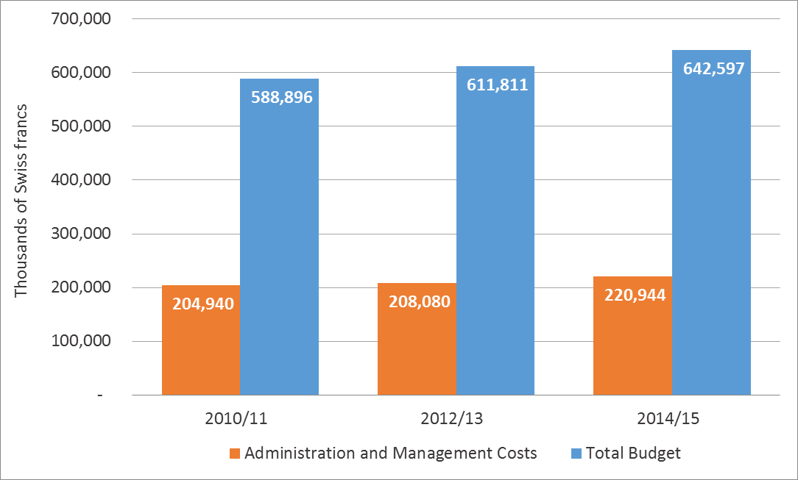

Figure : Comparison of expenditure for administration and management costs as compared to the total budget, 2010/1 –2014/15

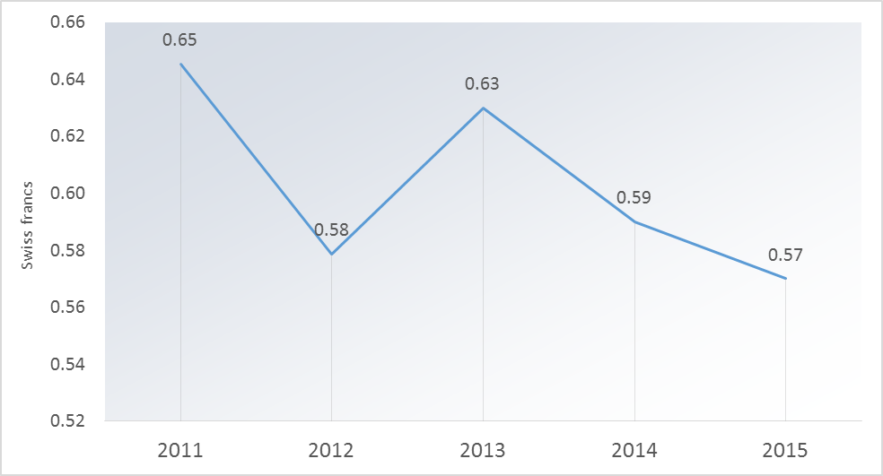

Figure : Cost per word of translation, 2011-2015

1. This was achieved, *inter alia*, through conscious cost-efficiency measures in relation to the procurement of goods and services, travel (see section above), as well as energy, electricity and water consumption. In addition, the price of translation (per word) decreased by almost 12 per cent between 2011 and 2015, from approximately 0.65 Swiss francs in 2011 to approximately 0.57 Swiss francs in 2015 (see Figure 56). Printing costs decreased by 25 per cent in only three years, from 0.20 Swiss francs per printed page at the end of 2012 to 0.15 Swiss francs in 2015. WIPO was also able to reduce mailing costs through tariff negotiations with external providers and by introducing a system of grouping addresses. The number of items sent in 2015 (1,314,048) was slightly lower than that of 2014 (1,372,099), resulting in an overall decrease in mailing costs of 7.2 per cent in 2015 for a total of 1,516,614 Swiss francs, as compared to 1,634,319 Swiss francs in 2014.

***Strategic Outcome IX.2: An environmentally and socially responsible Organization with a strong focus on performance, achievement of results, accountability and learning, transparency, ethics and integrity***

1. Over the six-year MTSP period, WIPO was able to further develop its credentials as an environmentally and socially responsible, results-oriented organization vis-à-vis its internal and external clients and stakeholders. Practices and culture related to results-based management (RBM) were firmly established throughout the Organization. Strengthened oversight and accountability structures helped WIPO to become a more transparent Organization with clearly communicated principles of operation and clear safeguards for its various stakeholders to register possible concerns about day-to-day operations of the Secretariat. Steps taken since 2010 to reduce the adverse impact of WIPO on the environment allowed WIPO to become carbon neutral for the next MTSP programming period.

Outcome Indicator IX.2.1: Enhanced results-based management at WIPO

1. A concerted effort was made during the MTSP period to embed the core value Accountability for Results in the organizational culture. This resulted in one of the most impactful management-related changes over the last six years.
2. Notable achievements during the period pertained to the continual refinement of WIPO’s results framework and the strengthening of all phases of the performance cycle, including through a better alignment of programmatic content and resources and the integration of risk management as a key component of the cycle. At the start of the MTSP period, WIPO’s expected results were embedded within individual programs with a large degree of duplication, as well as limited visibility into their cross-cutting nature. The work done in 2010/11 established a sound framework for the preparation of the Program and Budget 2012/13, which laid the foundation for the ensuing advances made during the period under review.

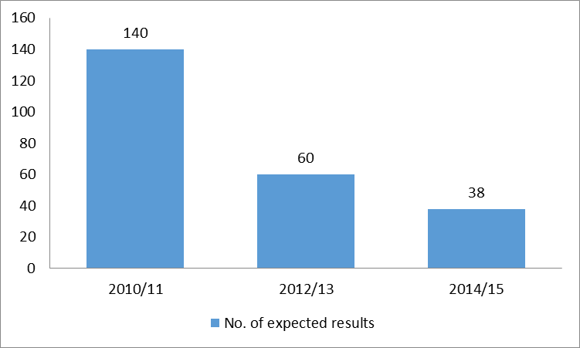

Figure : Refinement of WIPO’s expected results framework 2010/11‑2014/15

1. The Program and Budget for 2012/13 included several key enhancements, including: (i) a strategic organizational results framework (consolidation of Expected Results under the nine Strategic Goals);[86] (ii) for the first time, a results-based budget; (iii) strengthened measurement frameworks, including through better indicators and the systematic introduction of baselines and targets; (iv) an indication of the development share of resources for each result (in line with the Organization’s focused efforts to improve its planning, tracking and reporting on development expenditure); (v) mainstreaming of development in all substantive Strategic Goals; (vi) integration of DA projects in line with the Budgetary Process for DA projects approved by the WIPO Assemblies in 2010; and (vii) integration of Funds-in-Trust.
2. Further embedding a results-based culture and strengthening WIPO’s performance management cycle were carried through to the biennial planning and annual workplanning exercises, supported by first, second and third generation planning tools delivered by the Enterprise Resource Planning (ERP) Enterprise Performance Management (EPM) project. The evolution of the ERP EPM planning system was integral to the strengthening of RBM throughout the MTSP Period. The year 2014 saw the launch of two new key modules to support WIPO’s performance cycle, namely the ‘Implementation and Monitoring’ and the ‘Performance Assessment’ modules. These enabled cross-organizational analyses of workplans on several dimensions, such as results and countries, contributing to better coordination among implementing entities and coherence in the delivery of WIPO’s services. Increased transparency and accuracy was also achieved with regard to personnel resource allocation and utilization as well as tracking of performance data. The integration of EPM with the financial system AIMS enabled managers to track, for the first time, actual expenditure against their workplan during implementation. An Enterprise Risk Management (ERM) tool was implemented in the second half of 2014 and used to support the 2015 workplanning process as well as the 2016/17 Program and Budget process. The evolution of WIPO’s ERP system is illustrated in Figure 58.

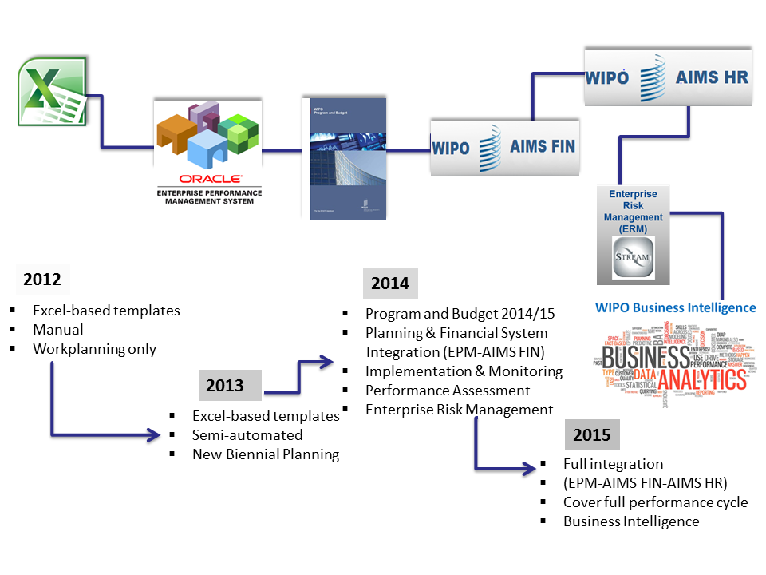

Figure : Evolution of WIPO’s ERP System 2012-2015

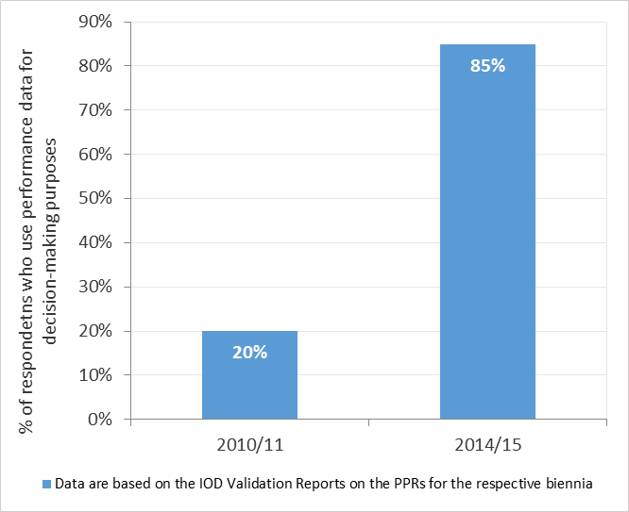

Figure : Percentage of programs using performance data to manage program performance

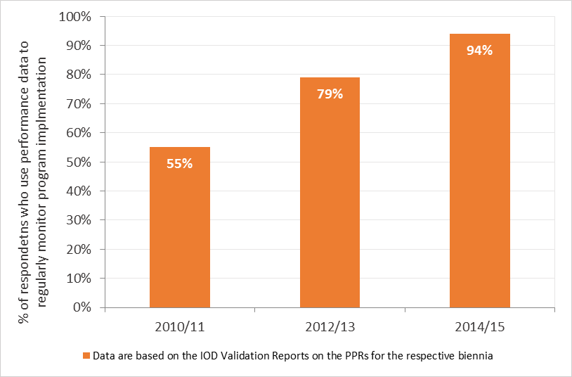

1. A marked increase in the use of performance data to inform the management of WIPO Programs can be observed during the period under review. In 2010/11, only 20 per cent of Programs reported using performance data for decision-making purposes. By 2015, this share had increased to 85 per cent. Likewise, whereas only 55 per cent of Programs reported using performance data to regularly monitor implementation of their workplans in 2010/11, this share had increased by 24 percentage points to 79 per cent in 2012/13, ultimately reaching 94 per cent in 2014/15 (see Figure 59).

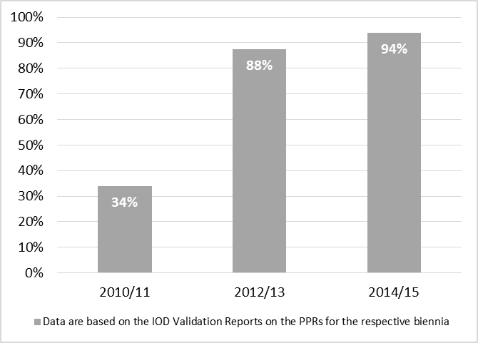

Figure : Percentage of WIPO Staff who perceive that WIPO is accountable for its results

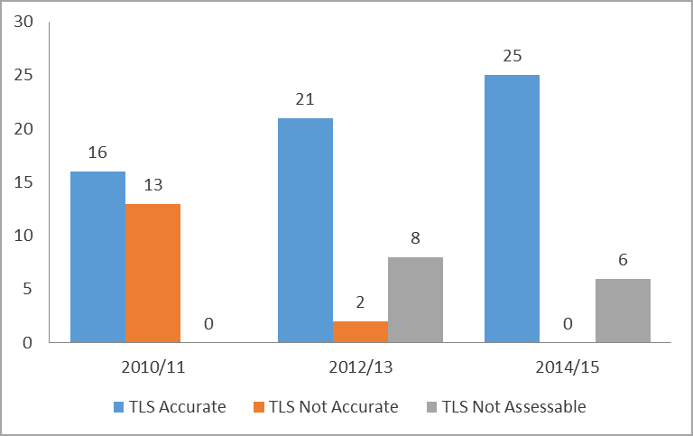

Figure : Accuracy of WIPO’s TLS ratings in the PPRs 2010/11-2014/15results

1. With a greater usage of performance data for managing implementation and reporting purposes, a marked improvement was seen in the accuracy of Programs’ self-assessments of the performance indicators against the targets reported in the Program Performance Reports (see Figure 61). In 2010/11, only 55 per cent of Programs had reported the traffic light system (TLS) accurately compared with 68 per cent of Programs in 2012/13 and 81 per cent of Programs in 2014/15.[87] The strengthened results-based culture also influenced WIPO staff’s perception of the Organization’s ‘accountability for results’. In 2011, only 34 per cent thought that the results-based approach had effectively changed the *modus operandi* of the Organization and had made “results accountability” an important guiding principle for WIPO. This number had grown to 88 per cent by 2013, ultimately reaching 94 per cent in 2015 (See Figure 60).

Outcome Indicator IX.2.2: Strengthened internal control and ethics system

1. Implementation of the SRP allowed the Secretariat to continue strengthening WIPO’s risk management and internal control systems. Risk management was integrated into the annual work planning cycle, and the 2014/15 Program and Budget identified, for the first time, risks and risk mitigation measures for the biennium. The Secretariat appointed risk management focal points for all Sectors and established risk registers to list and track events that may have adverse effects on the achievement of WIPO’s expected results and Strategic Goals. In the 2014/15 biennium, the Secretariat further developed a formalized and coherent risk management and internal controls framework, in accordance with WIPO’s Risk Management Roadmap, consisting of an Accountability Framework, a Risk Appetite Statement, the establishment of the Risk Management Group (RMG), a new Risk Management Policy, and the development of a Risk Management and Internal Controls Manual. Finally, processes for monitoring, risk reporting and internal controls were also strengthened by introducing semi-annual risk reviews and reports, by firmly integrating risk management in the program performance management processes, and by developing an internal control framework that utilizes ERM to record WIPO’s identified and assessed controls.
2. Internal oversight, accountability and learning were mainstreamed into the operations of WIPO as important principles over the course of the six years. The oversight functions helped to build up and maintain a culture of learning and a commitment to accountability at all levels, while contributing to the fostering of improved organizational processes and operations. An internal satisfaction survey on oversight work was launched in 2013 reflecting an 84 per cent average satisfaction rate. The survey served as a basis for better understanding stakeholders’ expectations regarding internal oversight services and to identify areas of improvement. The oversight-related working processes were also enhanced during the period under review through the introduction and use of an electronic working paper management software for recording oversight planning, fieldwork, review and reporting.
3. Oversight activities resulted in a significant number of recommendations for possible improvements of organizational processes, structures and practices. By the end of 2014/15, a total of 186 oversight recommendations, including from external auditors, had been closed. Specifically for the 2014/15 biennium, 95 per cent of oversight recommendations had been accepted. This represented an increase of five percentage points compared to the previous biennium.

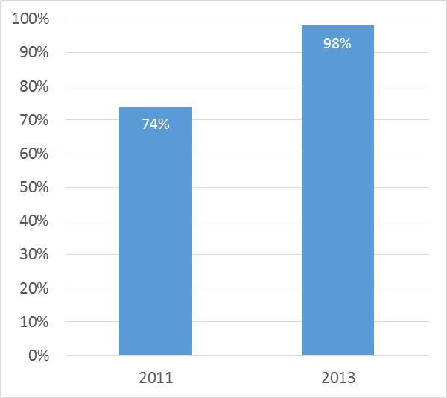

Figure : Awareness of WIPO ethics principles and policies

1. With regard to financial oversight and audit, WIPO received unqualified audits for each of the three biennia of the MTSP period.
2. The appointment of WIPO’s first Chief Ethics Officer in June 2010, the development of a WIPO Code of Ethics and the WIPO Whistleblower Protection Policy led to a comprehensive integrity system based on best practices. Subsequent efforts to enhance staff awareness of WIPO ethics principles and policies helped to more firmly embed these principles into WIPO’s organizational fabric. The percentage of staff cognizant of WIPO ethics principles and policies increased from 74 per cent in 2011 to 98 per cent in 2013 (see Figure 62).

Outcome Indicator IX.2.3: Reduced adverse impact of WIPO on the environment

1. After the launch of WIPO’s Carbon Neutrality Project in 2009, significant initiatives were started during the period under review, including mobility days to raise awareness on alternative means of commuting to work (public transport, car-sharing, biking); the introduction of environmental clauses in tender documents for office supplies and other goods; recycling of products; and the first draft of a sustainable travel policy. Additional premises-related efforts included the upgrading of technical installations to more ecological solutions; upgrading of electrical installations; upgrades to cooling installations; extensive use of wood from locally grown forests for the structure of the new WIPO Conference Hall; and the introduction of a new environmentally friendly scheme with a new electricity provider that was selected in January 2015. Finally, worth noting are the numerous additions to the biodiversity on the WIPO Campus, through the planting of new trees and other vegetation, including two roof tops representing over 1,500 square meters of meadows.
2. In line with WIPO’s commitment to off-setting carbon emissions, the 2015 International Annual Meeting on Language Arrangements, Documentation and Publications (IAMLADP) was held in June 2015 on the WIPO Campus and was declared a “green” meeting by UNEP in line with UN references. In addition, WIPO purchased compensation certificates via the UNFCCC from 2014 until 2020. As a consequence, WIPO was in a position to declare that it had, for the first time, compensated its carbon emissions until 2020.

[Annexes follow]

# ANNEX I: OVERVIEW OF STRATEGIC OUTCOMES AND OUTCOME INDICATORS OF THE MTSP 2010-2015

|  |  |  |
| --- | --- | --- |
| SG | Strategic Outcomes | Outcome Indicators |
| I | I.1: Full engagement of Member States to reach agreements on legislative and practical measures in areas of common interest to adjust existing international IP framework | I.1.1: Agreements reached by Member States within each major area of the international normative IP framework |
| II | II.1: A comprehensive range of WIPO global IP products and services which are the first choice for users | II.1.1: Increased and effective use of WIPO's global products and services in Member States including developing and least developed countries |
| II.1.2: Enhanced demand for WIPO's global services and products contributing to the financial sustainability of the Organization |
| II.1.3: Higher satisfaction among users of WIPO's global IP products and services |
| III | III.1: Greater use of IP for Development | III.1.1: A strong focus on development throughout the Organization, with effective mainstreaming of DA principles and recommendations in work of all relevant Programs |
| III.1.2: Increased number of developing countries, LDCs and transition economies with balanced policy / legislative frameworks |
| III.1.3: Increased number of developing countries, LDCs and transition economies with strong and responsive IP and IP-related institutions |
| III.1.4: A critical mass of human resources with relevant skills in an increased number of developing countries, LDCs and transition economies |
| IV | IV.1: A more efficient IP system characterized by effective access to and better use of IP information and knowledge | IV.1.1: Increased efficiency of IP Office operations as indicated in reduced pendency times and reduced backlogs |
| IV.1.2: Increase in the number and diversity of users of information and knowledge generated by the IP system |
| IV.1.3: Additional platforms are created between IP Offices for enhanced voluntary, technical international cooperation |
| V | V.1: WIPO recognized as the source of IP-related economic and legal intelligence for policymakers, users of the IP system and other stakeholders | V.1.1: Increased availability of accurate and up-to-date IP content in the fields of technology, brands, laws and treaties and economic statistics and analysis responsive to the needs of stakeholders |
| V.1.2: Increased use of IP content for the more effective achievement of the underlying policy goals of intellectual property in the international context |
| VI | VI.1: Shared understanding and cooperation among Member States to build respect for IP | VI.1.1: Increased international cooperation with Member States, NGOs, IGOs and the private sector |
| VI.1.2: Balanced policy dialogue within the auspices of the WIPO Advisory Committee on Enforcement (ACE), taking into account development-oriented concerns |
| VI.1.3: Enhanced capacity among Member States for addressing piracy and counterfeiting |
| VII | VII.1: International discussions on global public policy issues fully informed about role of IP as policy tool for promoting innovation and technology transfer | VII.1.1: WIPO recognized as the leading UN forum for addressing the interface between IP and global public policy issues |
| VII.1.2: WIPO's input increasingly reflected in international discussions on global public policy issues |
| VII.1.3: IP-based mechanisms established to address global public policy issues |
| VIII | VIII.1: WIPO recognized as primary trusted provider of international IP expertise, information and services in support of innovation and creativity | VIII.1.1: Enhanced awareness and understanding of role of IP in encouraging creativity and innovation |
| VIII.1.2: Enhanced recognition of WIPO's corporate identity in line with its mission, mandate and values |
| VIII.2: Service-oriented culture established throughout the Organization | VIII.2.1: Higher satisfaction of Member States, other stakeholders, users and the interested public with WIPO's service provision |
| IX | IX.1: A delivery-oriented, resource-effective and integrated administration that enables WIPO to deliver on its mandate, and is responsive to the changing needs of the Organization and its stakeholders | IX.1.1: A well-managed, geographically diversified and appropriately skilled professional workforce |
| IX.1.2: An up-to-date and enabling management and administrative infrastructure |
| IX.1.3: Reduced share of administration and management costs in overall expenditure |
| IX.2: An environmentally and socially responsible Organization with a strong focus on performance, achievement of results, accountability and learning, transparency, ethics and integrity | IX.2.1: Enhanced results-based management at WIPO |
| IX.2.2: Strengthened internal control and ethics system |
| IX.2.3: Reduced adverse impact of WIPO on the environment |

# ANNEX II: LIST OF TABLES AND FIGURES

List of Tables

[Table 1: Growth in number of Contracting Parties of WIPO-administered IP treaties   
(in alphabetical order) 8](#_Toc456261076)

Table 2: Evolution in the number of Contracting Parties to WIPO’s International Registration Systems, 2010–2015. 11

Table 3: PCT System: Total filings and filings per year 13

Table 4: Increases in electronic exchanges in the Madrid System 16

Table 5: Number of participants in WIPO education and training programs, 2010-2015 21

Table 6: Illustrative examples of activities aimed at building respect for intellectual property 34

List of Figures

Figure 1: Overview of the WIPO MTSP Results Framework 4

[Figure 2: Growth in the number of Contracting Parties of WIPO-administered IP treaties,   
2009-2015 9](#_Toc456344457)

Figure 3: Evolution in the number of Contracting Parties to WIPO’s International Registration Systems, 2009–2015. 12

Figure 4: No. of disputes and bon office requests received by WIPO Arbitration and Mediation Center (by biennium and cumulative): 2008/09–2014/15 12

Figure 5: No. of participants at events organized by or involving representation by WIPO Arbitration and Mediation Center, 2010/11‑2014/15 12

Figure 6: No. of gTLD UDRP cases and ccTLD UDRP‑based cases administered by WIPO Arbitration and Mediation Center, 2010/1 –2014/15. 13

Figure 7: Trend in applications to Hague System, 2010-2015 14

Figure 8: PCT Quality Index of Formalities Examination, 2009‑2014 15

Figure 9: Unit Cost per new/renewed international registration Madrid System, 2012-2015 16

Figure 10: Productivity of examination of new/renewed international registrations, 2008-2015 17

[Figure 11: Adoption and/or implementation of national IP strategies or IP development   
plans 2010-2015 (cumulative) 19](file:///N:\ORGOIOP\2007\WO%20PBC%2025%20(Sept%202016)\03%20DOCUMENTS\PBC%2025_17%20mtsp%20review\PBC%2025%20_%2017%20MTSP-review_11Jul2016%20with%20cover.docx#_Toc456344466)

Figure 13: No. of subscribers to the WIPO SME Newsletter, 2010-2015 22

Figure 13: No. of page views of the WIPO SME web page, 2010-2015 22

Figure 14: Increase in the usage of WIPO IP Office Business Systems across regions (2010–2015) 24

Figure 15: Improvements in copyright-related IP infrastructure 24

Figure 16: Trends in updates of the IPC and the Nice Classifications, 201 -2015 25

Figure 17: Users accessing WIPO Internet Publications on International Classifications and Standards 26

Figure 18: Growth in records available in PATENTSCOPE, Global Brand Database, 2010-2015 27

Figure 19: National and regional coverage of PATENTSCOPE and Global Brand Database 27

Figure 20: Availability of languages and language tools in WIPO Global Databases 27

Figure 21: Growth in users of PATENTSCOPE and the Global Brand Database, 2010-2015 28

Figure 22: Increase in the number of WIPO Lex users, 2010-2015 28

Figure 23: Growth in active institutional users of ARDI and ASPI, 2010–2015 29

Figure 24: No. of visitors and page views of WIPO IP Statistics Data Center 33

Figure 25: Trends in international cooperation on building respect for IP and enforcement 34

Figure 26: Participation in WIPO Awards Program 35

Figure 27: Progress in strengthening of national legislative frameworks for IP enforcement 36

Figure 28: Participant ratings of WIPO building respect for IP and enforcement capacity building workshops. 36

Figure 29: Access to Global Challenges websites between 2012 and 2015 38

Figure 30: Growth in the number of stakeholders engaged in policy dialogue with WIPO on competition policy 39

Figure 31: WIPO Re:Search – Collaboration Map 40

Figure 32: WIPO GREEN Partners 41

Figure 33: Interest in WIPO YouTube Channel, 2008/09–2014/15 42

Figure 34: Average no. of retweets of WIPO Twitter posts, 2013-2015 43

Figure 35: Participation in annual World IP Day events via Facebook, 2011-2015 43

Figure 36: Increased Interest in WIPO Magazine, 2010/11 and 2014/15 43

Figure 37: Public Interest in the annual launch of Global Innovation Index, 2013–2015 44

Figure 38: WIPO’s public perception of WIPO, 2012-2014 44

Figure 39: Site views of WIPO External Office websites, 2013 2015 44

Figure 40: Percentage of Committee Meetings for which pre-Committee information meetings for Member States were held 46

Figure 41: Percentage of documents published at least two months in advance of the WIPO Assemblies 46

[Figure 42: Percentage of Members States satisfied with the preparation and functioning of the   
WIPO Assemblies, 2012 2015. 46](file:///N:\ORGOIOP\2007\WO%20PBC%2025%20(Sept%202016)\03%20DOCUMENTS\PBC%2025_17%20mtsp%20review\PBC%2025%20_%2017%20MTSP-review_11Jul2016%20with%20cover.docx#_Toc456344497)

Figure 43: Timeliness of WIPO responses to requests for contributions from UN, IGOs, 2011-2015 46

Figure 44: Timeliness of responses to information inquiries from WIPO External Offices; 2014-2015 47

Figure 45: WIPO client satisfaction for Madrid, the Haque and PCT services 47

Figure 46: Recruitment lead times 49

Figure 47: Percentage of professional and higher category female staff, 2011-2015 49

Figure 48: Percentage of Member States represented in WIPO staff, 2011-2015 49

Figure 49: Percentage of Professional and Higher Category Staff by Region 2012-2015 50

Figure 50: Percentage of staff whose performance is evaluated against their individual objectives and competencies 50

Figure 51: Evolution of travel costs, 2013 2015 52

Figure 52: Internal client satisfaction with procurement services, 2011-2015 52

Figure 53: Percentage of documents published two months before relevant meeting 54

[Figure 54: Percentage of internal and external participants satisfied with WIPO   
Conference Services 54](file:///N:\ORGOIOP\2007\WO%20PBC%2025%20(Sept%202016)\03%20DOCUMENTS\PBC%2025_17%20mtsp%20review\PBC%2025%20_%2017%20MTSP-review_11Jul2016%20with%20cover.docx#_Toc456344509)

[Figure 55: Comparison of expenditure for administration and management costs as compared to   
the total budget, 2010/1 –2014/15 54](file:///N:\ORGOIOP\2007\WO%20PBC%2025%20(Sept%202016)\03%20DOCUMENTS\PBC%2025_17%20mtsp%20review\PBC%2025%20_%2017%20MTSP-review_11Jul2016%20with%20cover.docx#_Toc456344510)

Figure 56: Cost per word of translation, 2011-2015 54

Figure 57: Refinement of WIPO’s expected results framework 2010/11‑2014/15 55

Figure 58: Evolution of WIPO’s ERP System 2012-2015 56

Figure 59: Percentage of programs using performance data to manage program performance 56

Figure 60: Percentage of WIPO Staff who perceive that WIPO is accountable for its results 57

Figure 61: Accuracy of WIPO’s TLS ratings in the PPRs 2010/11-2014/15results 57

Figure 62: Awareness of WIPO ethics principles and policies 58

[End of Annex II and of document]

1. [A/48/3](http://www.wipo.int/meetings/en/doc_details.jsp?doc_id=142378)
2. The Program and Budget 2010/11 was already approved at the time of the drafting of the MTSP 2010-2015.
3. [A/48/26](http://www.wipo.int/meetings/en/doc_details.jsp?doc_id=147899)
4. The Program and Budget documents for the three biennia can be found on WIPO’s Results, Budget and Performance homepage: http://www.wipo.int/about-wipo/en/budget/
5. 2010/11, 2012/13, 2014/15
6. The data presented in the report reflect the most accurate data available at the time of preparation of the report. Due to the evolution of WIPO’s results frameworks across the biennia, as well as a more rigorous approach to data validation in the preparation of the PPRs, it should be noted that discrepancies with data reported across the various PPRs for a given year and/or biennium are possible.
7. Links to the PPRs: [A/49/4](http://www.wipo.int/meetings/en/doc_details.jsp?doc_id=174187) (2010), [A/50/4](http://www.wipo.int/meetings/en/doc_details.jsp?doc_id=211282) (2010/11); [A/51/5](http://www.wipo.int/meetings/en/doc_details.jsp?doc_id=244945) (2012); [A/54/6 REV.2](http://www.wipo.int/meetings/en/doc_details.jsp?doc_id=286998) (2012/13); [A/55/6](http://www.wipo.int/meetings/en/doc_details.jsp?doc_id=310016) (2014); [WO/PBC/25/7](http://www.wipo.int/meetings/en/doc_details.jsp?doc_id=342217) (2014/15)
8. Botswana, Chile, China, Japan, Qatar, Republic of Moldova, Russian Federation, Slovakia, Syrian Arab Republic, United Arab Emirates.
9. Argentina, Australia, Brazil, El Salvador, India, Mali, Mexico, Mongolia, Paraguay, Republic of Korea, Singapore, United Arab Emirates and Uruguay.
10. Broadcasting is the major area covered by the Berne and Rome Conventions that has not yet been updated to better respond to the challenges arising from the proliferation of new technologies, such as the advent of the internet.
11. Report of the Forty-Seventh (22nd Ordinary) Session of the WIPO General Assembly, Geneva, October 5 to 14, 2015.
12. Fifteenth Session of the Standing Committee on the Law of Patents, Geneva, October 11 to 15, 2010.
13. In 2014, during the twentieth session (Geneva, January 27 to 31, 2014) and in 2015, during the twenty-second session of the SCP (Geneva, July 27 to 31, 2015).
14. Including patents, trademarks, industrial designs, utility models, service marks, trade names, geographical indications and the repression of unfair competition.
15. Seventeen out of the 23 countries ratified the treaty in December 2009, with entry into force in 2010.
16. Seventeen out of the 25 countries ratified the treaty in December 2009, with entry into force in 2010.
17. This is a conservative estimate based on the number of Member States who have submitted requests for legislative and policy assistance as reported in the biennial Program Performance Reports (PPRs).
18. Still, by the end of 2014, two consents were still required for the termination of the 1934 Act. Four Contracting Parties outside the EU and OAPI remained bound by the 1960 Act.
19. Facilitating discussion by parties over the possibility of submitting an existing dispute to WIPO procedures.
20. The WIPO Center is one of a number of ICANN-accredited dispute resolution service providers under the UDRP policy and corresponding UDRP rules.
21. Such as .biz, .com, .info, .mobi, .name, .net and.org.
22. Based on the year of filing, as opposed to the date of receipt at the IB
23. By country of origin
24. China, France, Germany, Japan, Netherlands, Republic of Korea, Sweden, Switzerland, United Kingdom, and United States of America (in alphabetical order).
25. The earliest year for which this information is available.
26. In 2015, WIPO received a total of 49,273 applications for the registration of trademarks under the Madrid System.
27. The last year for which data for this indicator was available.
28. In 2013, 6.8 per cent of Madrid applications originated from applicants in developing countries, compared to 5.6 per cent in 2009.
29. From 11,551 in 2010 to 16,435 in 2015.
30. From 2,793 in 2010 to 3,194 in 2015.
31. The Quality Index of Formalities Examination is calculated as the average of four lead quality indicators. Three of these indicators are based on the timeliness of key transactions: acknowledgement of receipt of the PCT application, publication, and republication. The fourth indicator reflects errors made during the processing of PCT applications.
32. Surveys were conducted in: 2012 to cover 2011, 2013 to cover 2012 and 2016 to cover 2014/15.
33. During the MTSP period, the methodology for computing unit costs changed as reflected in the 2014/15 Program Performance Report (PPR). For more detailed information, please refer to the ‘Program 6 Annex: Indicators of Madrid Operations’ of the 2014/15 PPR.
34. Prior to reporting in the PPR 2014, the standard format contained separate sections for reporting on the implementation of the DA Recommendations. The PPRs for 2014 and for 2014/15 had integrated the reporting on the implementation of the DA Recommendations and DA projects under the main narrative sections for the Programs.
35. http://www.wipo.int/edocs/mdocs/govbody/en/a_48/a_48_5_rev.pdf
36. http://www.wipo.int/export/sites/www/cooperation/en/pdf/ta_manual.pdf
37. http://www.wipo.int/cooperation/en/south_south/
38. Africa (24); Arab (6); Asia and the Pacific (17); Certain Countries in Europe and Asia (14); Latin America and the Caribbean (15)
39. Africa University (AU) and ARIPO (Zimbabwe), the University of Yaoundé II and OAPI (Cameroon)
40. Queensland University of Technology (QUT) (Australia), Seoul National University (SNU) and the Korean Intellectual Property Office (KIPO) (Republic of Korea)
41. University of Turin and the International Training Centre of the International Labour Organization (ITC-ILO), Italy, and Haifa University, Israel
42. the Austral University and the National Industrial Property Institute of Argentina (INPI) (Argentina)
43. Figures for 2010/11 are not available.
44. For the years 2013 to 2015. Data for satisfaction rates in previous years are not available.
45. Comprising IPAS, the WIPO Arab Industrial Property Management System (AIPMS), EDMS, WIPOScan and the WIPO Madrid Module.
46. WIPO is committed to maintain the current WIPOCOS while the enhanced system is still being developed.
47. The modification of the platform in April 2014 included a new search tool, and the International Patent Classification / Cooperative Patent Classification/ File Index (IPC/CPC/FI) parallel viewer to help users display the differences and relationship between these classification schemes.
48. New editions of the Nice Classification are still published every five years.
49. This included the significant addition of collections from the China, Japan and the United States of America.
50. Languages added included English, French, German, Spanish, Portuguese, Japanese, Russian, Chinese and Korean (2010/11) Dutch, Italian and Swedish (2012/13); Danish and Polish (2014/15).
51. Including English – French, English – Chinese (2010/11), English – German, English – Japanese (2012/13); English- Korean, English – Russian, English – Spanish and English – Chinese (expanded to include descriptions and claims) (2014/15).
52. Including the *World Intellectual Property Indicators* (offering summary data and statistical analysis on patents, trademarks, industrial designs, and utility models) and the *PCT Yearly Review*.
53. *World IP Report 2011 - The Changing Face of Innovation*
54. With 123,161 downloads from the WIPO GII web page, and an additional 13,943 downloads from GII-dedicated website outside of the WIPO system.
55. Data for the period from June 2014 to the end of December 2014 had to be extrapolated from usage statistics for the first half of 2014, as data for these months was not available due to technical reasons. In 2015, the WIPO IP Statistics Data Center attracted 27,200 visitors with 250,000 page views.
56. World Health Organization, World Customs Organization, INTERPOL, World Trade Organization, South Centre.
57. International Federation of Pharmaceutical Manufacturers & Associations, European Generic and Biosimilar Medicines Association (EGA).
58. Third World Network.
59. The sixth session (December 1 to December 2, 2010); seventh session (November 30 to December 1, 2011); eighth session (December 19 to December 20, 2012); ninth session (March 3 to March 5, 2014); tenth session (November 23 to November 25, 2015).
60. Evaluation Report – Strategic Goal VI: International Cooperation on Building Respect for Intellectual Property; 2014 (EVAL 2014-01).
61. Excluding the four countries that had received assistance in this area in 2009.
62. In 2013, WIPO received six requests for bilateral discussions (Chile, Brazil, Ecuador, India, the Dominican Republic, the Republic of Moldova) and one request for legislative assistance (Bhutan).
63. WIPO GREEN users contribute to the WIPO GREEN database (by uploading a technology or an announcement of need) or provide services. Certain WIPO services, (for example arbitration and mediation) are accessible to Users at a discounted rate.
64. WIPO GREEN partners provide advice, facilitate technology diffusion, involve WIPO GREEN in specific activities or act as a local focal point.
65. With the Association of University Technology Managers (AUTM) and East Africa Climate Innovation Network (EACIN).
66. As measured by the “Klout Score”, a measure of a user’s social influence assessed on the basis of the size of the user’s social media network and the interaction of other users with that content. WIPO’s Klout score, a measure between one and 100, had risen to 66 by the end of 2015; a score higher than many comparable IGOs. It should be noted that the use of the Klout Score was discontinued by WIPO in 2015 due to changes in the methodology used to generate the score.
67. https://www.facebook.com/worldipday/
68. See more information on the GII in the Section on Strategic Goal V in this report.
69. No survey was conducted in 2015.
70. Data available for 2011, 2013, 2014, 2015.
71. Next to the Coordination Committee of WIPO.
72. The data tracking systems were still under development for the other External Offices.
73. Hague customers’ satisfaction was not evaluated in 2014/15.
74. The year 2015 was the first customer service satisfaction survey conducted for the PCT.
75. WO/CC/63/5
76. Data for the 2011, 2012 and 2013 are based on the Strategic Realignment Program Results Framework, whereas data for 2014 and 2015 are based on the Annual Report on Human Resources, (WO/CC/70/1 and WO/CC/71/2 REV.).
77. Refinements of the PMSDS were undertaken in 2011, 2013 and 2014 to ensure that the system continued to develop in line with the evolving needs of the Organization, to allow the Secretariat to proactively improve the performance of all of its staff, and to align the system with the existing the SRRs, taking advantage of the experience gained through the application of the system in the prior years.
78. This resulted in no increase to the headcount
79. In 2012/13, 98 per cent of legal queries received ‘prompt and reliable responses’ from the OLC; in 2014/15, this was the case for 95 per cent of these requests.
80. Please refer to the PPR 2014/15 Report on the Implementation of Cost Efficiency Measures in the 2014/15 Biennium for more detailed information.
81. http://www.wipo.int/meetings/en/doc_details.jsp?doc_id=277504
82. Conducted in the 2010/11 biennium
83. http://www.wipo.int/edocs/mdocs/govbody/en/a_55/a_55_inf_5.pdf
84. The first meeting held in the new WIPO Conference Hall in 2014 was the Program and Budget Committee from September 1 to 5, 2014.
85. The PCT Working Group; the Working Group on the Legal Development of the Hague System for the International Registration of Industrial Designs; the Working Group on the Legal Development of the Madrid System for the International Registration of Marks; and the IPC Revision Working Group.
86. Whereas in 2010/11, there were some 140 expected results with no linkages to the higher-level Strategic Goals, in 2012/13, the results framework had been consolidated to 60 organizational expected results with clear linkages to the nine Strategic Goals. The framework was further refined in 2014/15 to 38 expected results.
87. Source: IOD Validation Reports of the Program Performance Report for 2010/11, 2012/13 and 2014/15.