E
WO/PBC/25/14
ORIGINAL: ENGLISH
DATE: JUNE 20, 2016

Program and Budget Committee

Twenty-Fifth Session
Geneva, August 29 to September 2, 2016

PROGRESS REPORT ON THE IMPLEMENTATION OF A COMPREHENSIVE INTEGRATED ENTERPRISE RESOURCE PLANNING (ERP) SYSTEM

prepared by the Secretariat

I. INTRODUCTION

- The forty-eighth session of the Assemblies of the Member States of WIPO in September 2010 approved the Secretariat’s proposal for the Implementation of a Comprehensive Integrated ERP System (documents WO/PBC/15/17 and A/48/14), with a view to: (i) modernize WIPO’s core administrative, management and customer-service functions; (ii) improve efficiency and productivity of WIPO’s administrative and management processes; and (iii) enhance the capability to provide better information to Member States, stakeholders and management.
- This report complements previous progress reports submitted to the Program and Budget Committee (PBC), providing Member States with a view of progress made, milestones reached and budget utilized under the ERP Portfolio of Projects during the period June 2015 to May 2016. The report also provides a summary of the updated portfolio plan and related budget adjustments within the overall portfolio budget as approved by the Member States.

iI. OBJECTIVES, Scope AND APPROACH – BACKGRound

- The ERP system is being implemented through a portfolio of inter-related projects, gradually evolving the Administrative Integrated Management System (AIMS Evolution).
- The first stream of projects is aimed at providing WIPO with a comprehensive set of tools to strengthen Human Resource Management (HR), comprising position management, benefits and entitlements, payroll, recruitment, staff performance, learning and development.
- The second stream of projects has provided WIPO with a set of tools, Enterprise Performance Management (EPM) and Business Intelligence (BI), to strengthen and support the implementation of Results-Based Management (RBM), comprising biennial planning, annual work-planning, implementation monitoring and performance assessment, reporting and analytics. Enterprise Risk Management (ERM), a critical function for achieving the Organization’s strategic goals and expected results, performed as an integral part of the Organization’s RBM cycle, has also been strengthened as part of this stream.
- The third stream of projects has enhanced the existing PeopleSoft finance, procurement (FSCM) and travel systems through configuration changes and upgrades which will enable the introduction of new functionality, modules and improvements to business processes.
- The fourth stream will enable WIPO to gain experience of Customer Relationship Management (CRM) concepts and practices by supporting business led projects, such as mailing list tools, contact databases, access management, customer analytics and replacing some of the customer focused systems. WIPO has established a customer service board, which is separate and outside the scope of the ERP portfolio, that is addressing the vision, governance and overall roadmap which would then potentially lead to the identification and implementation of a more global CRM solution.
- WIPO’s implementation approach is based on the phased implementation of projects which help the ERP capabilities to evolve progressively in a coherent and measured manner. The approach is also driven by business needs and priorities and takes into account the capacity of concerned organizational units to absorb and integrate changes.
- Quality, accuracy and completion within the approved budget are the main drivers for the implementation of the ERP portfolio. A revised timeline was presented in the 2015 progress report based on these criteria and the capacity of the organizational units to absorb and embed the changes being deployed. A plan showing the timelines for the remaining projects, still within the revised timeline of completion in 2017, is provided later in this report.

III. PORTFOLIO ACHIEVEMENTS

- Overall, the portfolio is well on track to deliver the objectives of modernizing and improving the quality, efficiency and productivity of WIPO’s management, administrative and customer service functions, improving the Organization’s capacity to provide better information to Member States, stakeholders and management. Diagram 1 shows the evolution and the plans up to the end of the portfolio’s implementation.

Diagram 1 – Evolution of AIMS
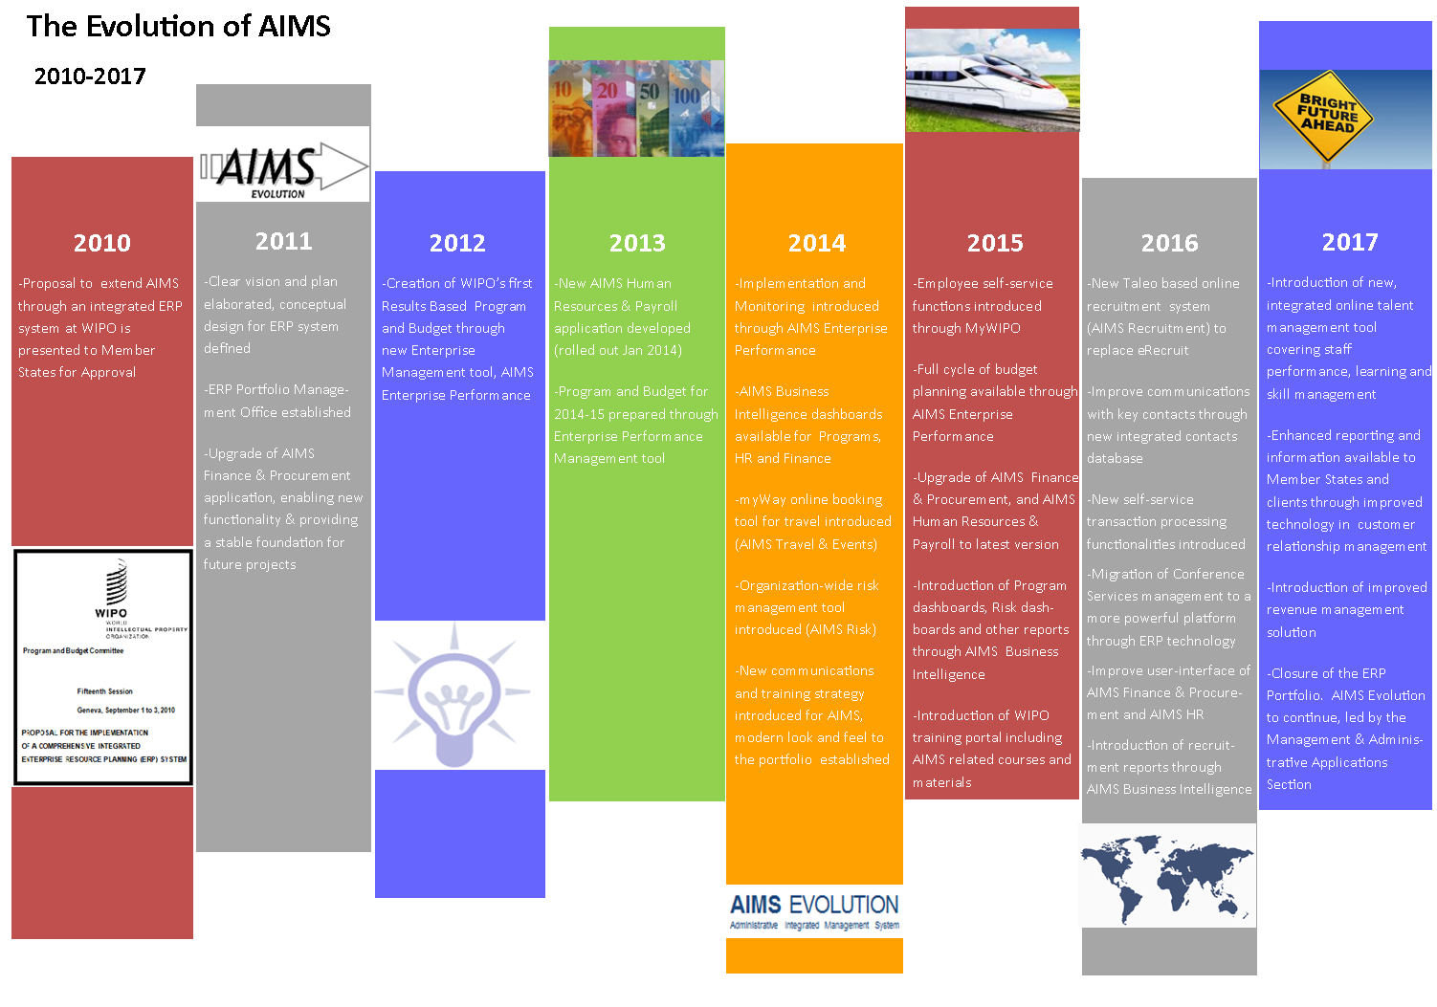

- Section X provides a detailed view of the progress within each of the portfolio streams.
IV. Independent Verification and Validation (IV&V)
- An initial IV&V was undertaken in 2013 and the recommendations were fully implemented. During 2016 a second IV&V review is planned to be performed by an independent external provider. This review will focus, among other aspects, on the business benefits and will provide WIPO Management with insights and recommendations which will help ensure that WIPO realizes the full potential of the systems deployed by the ERP Portfolio of projects beyond the closure of the Portfolio in 2017.
V. EXTERNAL IMPLEMENTATION PARTNER PEFORMANCE EVALUATION
- The performance of ERP implementation partners is continuously monitored during the delivery of each project. Contracts with partners typically consist of a series of deliverables, linked to milestones, against which a payment schedule is agreed. The deliverables must be accepted by WIPO in order for a milestone payment to be made. This helps to enforce the required level of control over quality and costs. However, this can impact the implementation timeline, as deliverables may need to be reworked before WIPO is able to accept them.
- Diagram 2 provides a representation of the performance of external implementation partners with the perfect partner profile represented by the outer green diamond. The actual performance of the two key ERP implementation partners used in the reporting period are represented by the inner red and blue profiles, i.e. the larger the profile the greater the number of criteria the partner has met.
Diagram 2 – External Implementation Partner Performance
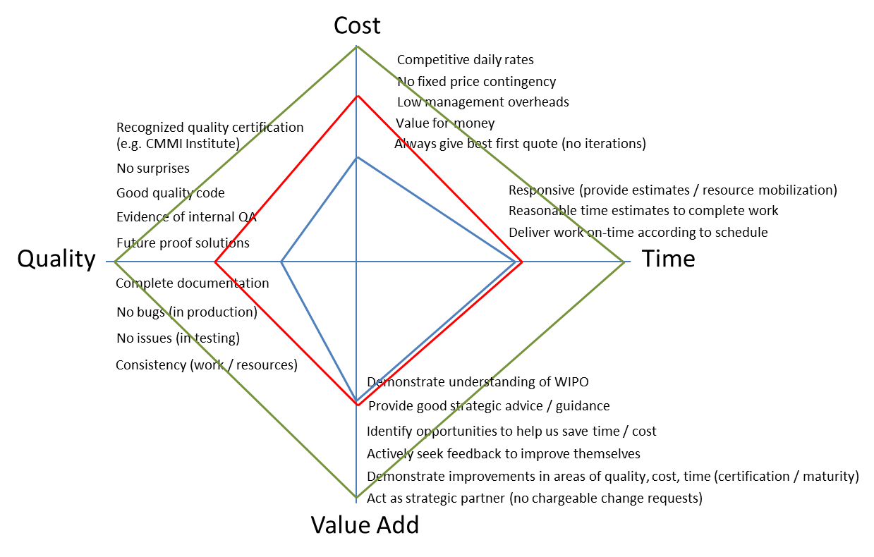
- The above diagram illustrates that both of the key ERP implementation partners have their strengths and weaknesses. During the reporting period both of the partners have improved their performance over the previous reporting period. This has been primarily due to:
- Including key performance indicators in contracts with regular measurement and corrective actions;
- Ensuring all work is competitively tendered for, including smaller pieces of work that could be awarded directly within the framework of an existing umbrella agreement;
- Improved gatekeeping, to ensure an acceptable level of quality is achieved before moving to the next stage of a project;
- Including penalties within contracts for poor performance.
- As an ongoing continuous improvement process, WIPO will continue to work with the key ERP implementation partners to close the gaps between their current and ideal performance levels.

VI. Communications

- The Information and Communication Technology Department (ICTD) are in the process of delivering a project to introduce an enterprise wide content management (ECM) solution. Recommendation 6 from the 2014 performance audit of the ERP conducted by the External Auditors requested WIPO to strengthen its document management system so that project related documents are maintained in one place. WIPO accepted this and proposed the ERP could be one of the early adopters of the ECM. However, as the ECM is being delivered in phases it is unlikely to be fully ready in time to benefit the ERP portfolio, which will close in 2017. Therefore, the portfolio continues to make the best use of the existing knowledge sharing tools (Intranet, Wiki, shared folders and email) to distribute information and to keep stakeholders up-to-date on the evolution of projects and the portfolio as a whole. Based on this, recommendation 6 of the External Auditor is expected to be closed.
- The EPMO continues to communicate with staff at all levels. Some of the major initiatives in 2015 included a “What’s New @ WIPO” session in November, which drew large interest from staff. Summer and Winter 2015 editions of the ERP Newsletter were also published and distributed in order to keep staff informed of new product and service releases across the various projects.
- The portfolio also delivered a number of communication and training activities for the PeopleSoft Upgrade project as well as the Recruitment project, both of which touch a large user base. Some of these activities included drop-in sessions, training videos, email communication and the upcoming Summer 2016 Newsletter.
- Lastly, an AIMS User Survey was conducted in 2015 to gather feedback from staff on the usability of AIMS. The results of this survey identified a number of potential improvements and many of these have already been, or are in the process of being, implemented. The survey will be performed again, later in 2016, to measure if the changes introduced have helped to improve the usability of AIMS and to also identify further improvement opportunities.

VII. ERP Project Budget Utilization

- The overall estimated cost for the implementation of the ERP portfolio of projects amounts to approximately 25 million Swiss francs over a five-year time frame. The estimated costs include application hosting, software acquisition, project personnel, user back-filling resources, external implementation partner fees, training and communication as well as other project-related costs. As the systems are deployed and become operational, the recurring costs of maintenance and system operation are included in successive Program and Budgets. A judicious mix of external and internal project personnel resources, including the use of low cost off-shore resources and fixed price contracts, has resulted in the delivery of planned functionality within a tightly managed project budget to date.
- A summary of budget utilization to date by major functional area and cost element and estimated budget utilization by the end of 2016, is presented in the tables below.
ERP Portfolio of Projects Budget Utilization (by Major Functional Area)
(In Swiss francs, as at May 31, 2016)

Major Functional Area | Original Project Budget | Updated Budget¹ | Actuals to Date² | Actual Utilization³ | Progress | Estimated budget utilization by end 2016⁴
Program and Change Management | 3,830,200 | 4,187,968 | 2,722,200 | 65% | 73% | 3,328,648
Human Resource Management and Development | 8,945,755 | 8,351,724 | 4,951,345 | 59% | 68% | 6,390,958
Enterprise Performance Management | 6,017,982 | 6,073,898 | 5,833,658 | 96% | 100% | 5,875,898
Customer Relationship Management | 1,955,690 | 1,365,433 | 108,925 | 8% | 4% | 551,565
AIMS Enhancements | 4,591,840 | 3,981,440 | 3,221,615 | 81% | 73% | 3,447,940
Accrued Contingency⁵ | - | 1,381,004 | - | - | - | -
Total | 25,341,467 | 25,341,467 | 16,837,743 | 66% | 73% | 19,595,009

¹ The updated budget is based on actual expenditure as at May 31, 2016 and the estimated budget for planned future projects. The latter includes a 10 per cent contingency, in line with the original planning assumption in document WO/PBC/15/17.
² Actuals to date include actual expenditure as at May 31, 2016.
³ Actual utilization reflects actual expenditure as at May 31, 2016 compared to the updated budget.
⁴ Estimated budget utilization by end 2016 reflects actual expenditure as at May 31, 2016 and expected expenditure until the end of 2016, based on current spending assumptions.
⁵ Accrued contingency refers to unused funds from contingency that was planned for projects already delivered. The overall contingency used will only be known at the end of the Portfolio.

ERP Portfolio of Projects Budget Utilization (by Cost Element)
(In Swiss francs, as at May 31, 2016)

Cost Element | Original Project Budget | Updated Budget¹ | Actuals to Date² | Estimated budget utilization by end 2016³
Application Hosting | 1,383,360 | 390,243 | 191,182 | 234,566
Software Acquisition | 3,989,738 | 2,652,050 | 2,312,062 | 2,527,112
Project Personnel | 5,564,680 | 6,939,876 | 5,987,149 | 6,319,476
User back-filling resources | 2,703,800 | 1,572,128 | 1,179,428 | 1,390,628
External Implementation Partner | 9,896,109 | 10,594,701 | 6,480,414 | 8,108,602
Training | 1,253,780 | 475,447 | 175,587 | 360,607
Communications and other | 550,000 | 1,336,017 | 511,921 | 654,017
Accrued Contingency⁴ | - | 1,381,004 | - | -
Total | 25,341,467 | 25,341,467 | 16,801,192 | 19,595,009

¹ The updated budget is based on actual expenditure as at May 31, 2016 and the estimated budget for planned future projects. The latter includes a 10 per cent contingency, in line with the original planning assumption in document WO/PBC/15/17.
² Actuals to date include actual expenditure as at May 31, 2016.
³ Estimated budget utilization by end 2016 reflects actual expenditure as at May 31, 2016 and expected expenditure until the end of 2016, based on current spending assumptions.
⁴ Accrued contingency refers to unused funds from projects already delivered.

- Overall, the portfolio budget remains on track, and the scope related to major functional areas are expected to all be delivered within the original approved budget.

- In the 2015 report it was forecast that the final expenditures under the Enterprise Performance Management area would be slightly (3.5 per cent) above the original budget as estimated in 2010. Within the reporting period these additional expenditures have been carefully managed and controlled and the current estimate is that the final expenditures for this area will now be less than 1 per cent above the original budget estimate.

- The final expenditures for the Program and Change Management area are currently forecast to be 9 per cent higher than the original budget as estimated in 2010. This is mainly due to the additional management capacity needed to deliver and mainstream the solutions into the operations of the Organization in a manner that ensures sustainability and continued benefits realization after the portfolio closes.

- Human Resource Management and Development (HRMD) area updated budget is higher than the updated budget reported in the 2015 progress report. The increase in the reporting period is due to two factors. First, the recruitment project which recently went live took 10 months longer to complete and whilst the implementation partner costs were fixed, the other internal costs, such as project resources, backfills, etc. increased proportionally to the time increase. It is to be noted that this project was WIPO’s first ever cloud-based implementation and required considerable planning and careful assessment of the risks and mitigation factors of the new approach. Second, the budget estimate received from the implementation partner for the Talent Management project, which is currently being planned, is higher than the original budget estimated in 2010. However, the projects under the HRMD area are forecast to be within the original budget as estimated in 2010, due to the savings made on previously delivered projects.

- The External Implementation Partner costs are currently estimated to be 7 per cent above the original budget estimated in 2010. This is due to the Talent Management project, as mentioned in the preceding paragraph. To help control this potential cost increase a competitive tender process has been launched which should reduce the forecast cost down to a level closer to the original budget estimated in 2010. It should be noted that the tender process is taking additional unplanned time and this may have a subsequent impact on the overall timeline.

- In 2015 it was reported that Project Personnel costs were expected to be higher than the original budget estimated in 2010. This was primarily due to the relatively higher use of skilled and qualified temporary staff resources, engaged by WIPO through competitions, as opposed to relying on more expensive implementation partner consultants that include the commercial entity’s overheads. Within the reporting period these additional personnel expenditures have been carefully managed and the current estimate is lower than the 2015 estimate, although still 25 per cent above the original budget estimated in 2010.

- The other cost element forecast to be above the original budget estimated in 2010 is Communications and Other. This is due to a need to increase the stabilization budget, included in this cost element, to ensure the skills to support new technologies are sufficiently embedded into the operational support team. The need to ensure there was sufficient stabilization budget was a lesson learned by the operations team from projects recently completed.

- The accrued contingency represents funds initially allocated to projects which have not been used for their completion for multiple reasons, including savings made through contract negotiations, fixed pricing and careful resource planning and management. During the lifespan of the portfolio the Organization’s needs have naturally evolved and will continue to evolve with new business requirements and priorities emerging, and others dropping. The accrued contingency allows the portfolio to remain flexible and able to adapt to unforeseen or emerging business requirements whilst ensuring completion within the original approved budget. At the end of the portfolio any remaining accrued contingency will be returned to the reserves.

- In 2015 it was reported that a working group had been formed by HRMD to review the policies and rules regarding flexible working arrangements. It was also reported that the recommendations of this working group may require the existing flexi-time system to be updated and that the available contingency may be considered as a means to fund the project. At the time of producing this report the recommendations from the working group have not yet been made and therefore this project, if one is required, would now be subject to the criteria specified in paragraph 34 of this report.

- Overall, the ERP Portfolio of Projects is expected to be delivered within the original approved budget.

vIII. Portfolio schedule

- The portfolio schedule, originally presented to the Member States in 2010 as a five-year project, has been impacted by a number of delays and subsequently revised, as reported to the Member States in the annual progress reports.
- In the 2015 report the revised AIMS Portfolio Future Plan was presented, showing the remaining projects to be delivered in 2016 and 2017. The AIMS Portfolio Board therefore only approves commencement of any new project if:
  - the objectives are aligned with those originally defined for the portfolio;
  - it has a strong enough business case, based on a detailed cost / benefit analysis;
  - the scope can be realistically delivered by mid-2017;
  - resources are available to execute it in parallel and without detriment to other regular activities, existing ERP projects and initiatives outside of the portfolio; and
  - the portfolio has sufficient budget to fund the project through to completion.
- Diagram 3 provides an overview of projects in progress (recruitment, self-service and contact database shown in color). The other projects still pending approval by the AIMS Portfolio Board at the time of preparing this report are shown in gray. The Travel / Event Redevelopment project is shown in white as this is not part of the portfolio, but is included due to the dependence of two portfolio projects (OBT Integration and DSS Transition) on its delivery. ICTD are also delivering projects relating to collaboration and ECM which are not shown, but some of the portfolio projects are dependent on certain phases of these being implemented.
Diagram 3 – AIMS Portfolio Future Plan

AIMS Portfolio Future Plan
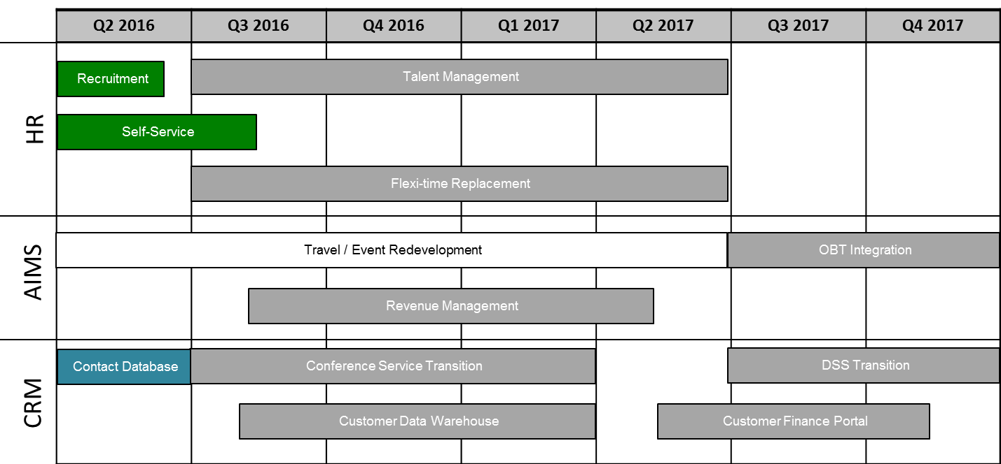

- The projects outside the portfolio are being closely monitored and, where possible, encouraged to complete as early as possible, as this may allow dependent projects to be executed as part of the portfolio, assuming they meet the criteria specified in paragraph 34.

- The projects planned for 2016 and 2017 will be within the originally approved budget. As projects are completed, the internal project resources will gradually stop being required and charged to the portfolio. Once all of the projects have been completed, a small team will perform the formal portfolio closure procedures during the latter part of 2017, such as ensuring that post project benefits are delivered, final reports produced, all the necessary documentation archived, accounts are reconciled and closed, etc. The resources to perform these closure activities have been included in the ERP project budget.

IX. PORTFOLIO Risks

- The ERP portfolio of projects continues to comprehensively identify, monitor and manage risks through the implementation of mitigation strategies. The table below highlights some of the key risks identified for the portfolio of projects as a whole.

Risk | Description | Risk Mitigation
Completion of the portfolio scope within the revised time-frame | The remaining scope of the portfolio still shows a large number of projects that need to be initiated and completed within a relatively short time-frame. The capacity of the Organization to absorb this additional work and to gain the knowledge of the technologies is a concern | Portfolio timeline extended to mid-2017. Drop projects that do not meet the criteria for inclusion in the portfolio. Re-use existing technologies and capabilities to minimize the introduction of new technologies and the time to gain the associated knowledge.
Inability to extract the maximum value from the ERP whilst the portfolio is still present | The portfolio is successfully delivering projects, but the full value of the ERP will only be obtained through changes to processes, behaviors, etc which are not achieved by technology delivery projects | Embed a continuous improvement process into the Organization, through the portfolio, to ensure the maximum value is extracted during the portfolio and in the future. Perform an IV&V with a focus on benefits to help identify opportunities for the portfolio to deliver the maximum value possible.
Loss of resources before the portfolio completes | As the portfolio is starting to close resources will start to look for other opportunities and they may leave before their work on the portfolio is complete | Engage resources on short term contracts, e.g. individual contractual service (ICS) roles, which are deliverable based.
Scope creep due to increased expectations | Following the successful delivery of many projects the maturity of the user base is increasing resulting in requests for more complex functionality. These requests could increase the scope of the remaining projects and the portfolio beyond what can be delivered in the time remaining | Ensure future projects have a solid business case, which considers the scope, costs, time and benefits and only proceed with projects that can be justified. Ensure existing projects have strong governance processes so that scope is not increased without the appropriate analysis / approval.

X. Key Achievements BY STREAM

HUMAN RESOURCE MANAGEMENT (HR)

- During the reporting period a new recruitment solution, Taleo, was introduced into the Organization. This provided WIPO with a modern, efficient solution for the recruitment of staff as well as attracting individuals for other opportunities such as fellowships, internships and individual contractual service (ICS) roles. As part of the introduction of the new tool WIPO updated the public career pages to help attract more candidates from all over the world.
- Following the completion of the PeopleSoft HR upgrade, reported in more detail in paragraph 53, the self-service capabilities, introduced in January 2015, have continued to be extended to cover other transactions. The self-service project will continue to deliver additional functionality during 2016.
- Integration between HR and other systems has been extended with more HR data available within BI, helping to improve the HR dashboards. Additionally HR data has been included in the data quality control dashboards within BI, helping to ensure the data in the source systems is accurate, up-to-date and consistent across the ERP solutions.
- During the reporting period a review for a legal case management system, planned to be delivered in 2016, was performed by HRMD. This review concluded that the existing solution was adequate and therefore the new legal case management project was dropped from the scope of the portfolio.

- The benefits achieved and expected in the future are listed in the table below.
Benefits Delivered 2014 | Benefits Delivered 2015 | Benefits Delivered / Expected 2016 | Expected Benefits 2017
Core HR / Payroll  Functionality supported:  Master Data Management  - Integration between HR and EPM for monitoring;  HR Management  - New interface to UNJSPF;  - New tool for processing of education grant claims;  - Additional reports and data control alerts.  Payroll Processing  - Standardized payroll processing across all staff including external offices.  Reporting  - Additional capabilities for HR Dashboard / analytical tools. | Self-Service  Functionality supported:  - Online access to key personal and payroll information for staff. | Recruitment  Functionality supported:  - Online recruitment of applicants, both internal and external;  - Preparation and publication of job vacancies and service opportunities;  - Evaluation and selection of applicants;  - Analysis of recruiting actions.  Self-Service  Functionality supported:  - New transactions for requesting and approving leave and absences;  - New transactions for staff to request specific benefits;  - New tool for managers to manage job descriptions. | Staff Performance  Functionality supported:  - Management of staff performance annual cycle;  - Track individual objectives;  - Ability to support advanced performance evaluations (peer-to-peer, 360, etc);  - Record performance;  - Monitoring and analysis of overall organizational staff performance.  Learning Management  Functionality supported:  - Capture training opportunities (from performance evaluations);  - Manage planned training activities;  - Record training outcomes;  - Monitoring and analysis of overall organizational staff training needs.
Users: HRMD, Payroll, PPBD, Safety and Security Coordination Service, Premises Infrastructure Division, Switchboard  Technology: PeopleSoft | Users: All staff  Technology: PeopleSoft | Users: HRMD, PTD, All staff, Internal and External Candidates (recruitment) and All staff (self-service)  Technology: Taleo (recruitment) and PeopleSoft (self-service) | Users: All staff  Technology: PeopleSoft

Results-Based Management (through the implementation of epm tools)
- The EPM application strengthens and reinforces WIPO’s core RBM philosophy, enhances the principles enabling consistent results-based planning, monitoring and resource management and enables Program Managers to develop biennial and annual plans and to monitor their annual workplans in an integrated, centralized system. The system provides the Organization with a sound audit trail and ensures that all activities are linked to WIPO’s expected results, with the associated human and financial resources.
- During the reporting period the EPM stream closed following the successful delivery of a number of tools. As part of the closure the ongoing maintenance and enhancement of the tools transitioned to the Management and Administrative Applications Section (MAAS).
- To ensure a smooth transition a number of resources were provided and funded by the portfolio to enable MAAS to maintain and continue to deliver enhancements to EPM, such as:
  - a new annual work planning (AWP) application to support the 2016/17 biennium.
  - major improvements to the integration between EPM, FSCM and HR, to enable increased sharing of information and to simplify some of the processes, such as the process to carry over regular positions from one biennium to the next and providing budget and actuals data at a position level.
- The benefits associated with annual work planning (AWP) are summarized below.
Benefits Delivered 2012 | Benefits Delivered 2013 | Benefits Delivered 2014 | Benefits Delivered 2015
AWP 2012/13  Functionality supported:  - Planning and update of activities linked to expected results;  - Allocation and adjustments of non-personnel and personnel resources at program activity level;  - Analysis of several dimensions of workplan information, i.e. results and implementing entity;  - Generation of reports directly from Essbase (e.g. staffing authorization tables, actuals versus workplan budget, etc.);  - Capability to generate budget journals for upload into FSCM;  - Feedback of actual expenditure by FSCM activity to managers in quarterly reports. | AWP 2014/15  Functionality supported:  AWP for 2012/13 with additional functionality:  - Planning / tracking status of workplan activities in 2014/15 linked to performance indicators and expected results;  - Position level planning;  - (Re)assigning positions to program activities;  - First phase integration with PeopleSoft HR and FSCM;  - Generating a large number of reports from EPM for both end-users and central teams. | AWP 2014/15  Functionality supported:  AWP functionality for 2014/15 with additional fine-tuning based on user feedback;  - Full integration with HR and FSCM:  - Actual expenditure from FSCM;  - Budget journals sent to FSCM;  - New Program Activities sent to FSCM;  - Position data received from PeopleSoft HR.  User authentication to corporate active directory  Generating advanced reports for both end-users and central teams. | AWP 2016/17  Functionality supported:  AWP functionality for 2016/17 with additional fine-tuning based on user feedback;  Improved integration with HR and FSCM;  Tracking of actual personnel expenditure at position level.
Users: Central Budget and Program Management and Performance Sections  Technology: Essbase with Excel supported interface | Users: End-users  Technology: Essbase, Hyperion Planning | Users: End-users  Technology: Essbase, Hyperion Planning | Users: End-users  Technology: Essbase. Hyperion Planning, BI

- During the reporting period, the updated version of the Biennial Planning application, delivered during the last reporting period, was used to support the 2016/17 biennium. This included the creation of multiple scenarios to support the outcome of the PBC. The project benefits in respect of biennial planning are summarized below.
Benefits Delivered 2012 / 2013 | Benefits Delivered 2014 / 2015
Biennial planning 2014/15  Functionality supported:  - Planning of high-level biennial program activities linked to expected results and performance indicators;  - Budgeting of resources (personnel and non-personnel) for high level activities;  - Estimation of development share of the budget;  - Estimation of results-based budget and budget by cost category; and  - Analysis of planning dimensions (expected result, cost category, Development Agenda etc.) by Program, Sector and/or Unit.  Users: End-users  Technology: Essbase, Hyperion Planning | Biennial planning 2016/17  Functionality supported:  Biennial planning ready for 2016/17 with additional functionality to support the refinement of assignment of personnel resources to expected results.  Users: End-users  Technology: Essbase, Hyperion Planning

- During the reporting period the ERM project was closed following the successful completion of the scope, including completing the user training, making the ERM based controls and actions data available to BI and integrating risk management into the biennial as well as the annual planning processes, thus capturing risks from the entire Organization in the tool.
- The benefits in respect of enterprise risk management are summarized below.
Benefits Delivered 2014 / 2015
Enterprise Risk Management

Functionality supported:

- Cost effective management and monitoring of risks
- Effective audits
- Unlocking the potential of the risk data
- Improved integrity of risk data
- More informed planning
- Information Security ISO27001:2013 certification achieved
- Conformity with recommendations to put in place robust risk management system
- Controls are linked to risks within the tool
- Support for Business Continuity Management and Organizational Resilience Management

Users: Risk and action owners
Technology: Acuity STREAM

STRENGTHENED ENTERPRISE REPORTING AND BUSINESS INTELLIGENCE

- During the reporting period the BI project was closed following the successful delivery of the defined scope, including expanding the data feeds to include controls and actions data from ERM, as mentioned earlier. As part of the closure the ongoing maintenance and enhancement of BI was successfully transitioned to MAAS, with a number of resources provided and funded by the portfolio during the BI stabilization period.
- The following table highlights the benefits of Business Intelligence.
Benefits Delivered 2012 / 2013 | Benefits Delivered 2014 / 2015
Functionality supported:  - Technology infrastructure established;  - Data feeds from FSCM established;  - Oracle Business Intelligence Applications for Finance and Procurement Departments;  - Prototype customized dashboards for Senior Management;  - User authentication to corporate active directory enabled.  Users: Specific key users  Technology: Oracle Business Intelligence | Functionality supported:  - Data feeds from HR, EPM, ERM (risks, controls and actions) and selected non-ERP systems established;  - Customized dashboards for Senior Management enhanced with further information;  - Oracle Business Intelligence Applications for HRMD;  - Customized dashboards for HRMD, Program Performance, Procurement and Finance.  Users: Extended stakeholders  Technology: Oracle Business Intelligence

ENHANCEMENTS TO the EXISTING AIMS SYSTEMS

- During the period under review the PeopleSoft 9.2 Upgrade project, initiated in late 2014 to update the existing FSCM and HR systems, concluded. Whilst primarily a technology driven project, introducing a new version, it targeted to reduce the number of customizations and non-standard bug fixes in use. The project achieved a reduction in customizations of 20.7 per cent (FSCM) and 7.3 per cent (HR) and non-standard bug fixes of 20 per cent (FSCM) and 10 per cent (HR).
- With the new 9.2 version of PeopleSoft, WIPO now has the opportunity to selectively adopt updates, thereby allowing future updates to be applied to individual parts of the FSCM and HR applications, delivering incremental new functionality to the business as part of the regular MAAS operational support activities.
- The 2015 status report highlighted a Regular Budget funded project being led by MAAS, outside of the portfolio, to replace the existing Metastorm Travel and Event solution. Originally this was a technology driven project as Metastorm support was due to stop in the near future. During the reporting period the Metastorm provider extended the support period and the project took this opportunity to pause to allow time to consider how the processes could be optimized, rather than just reproducing the existing process in a new technology. Also, based on the optimized process the project will consider the technology choice, potentially using standard event management functionality offered in a customer relationship management tool, rather than building a fully customized solution in PeopleSoft.
- The above delay to the Travel and Event project creates a risk to the ERP portfolio projects that are dependent on these capabilities, i.e. the Online Booking Tool (OBT) Integration and Development Sector System (DSS) Transition projects. This situation is being closely monitored and the dependent projects will only be undertaken if the conditions mentioned in paragraph 34 are met.
- A tender process has recently been launched to engage external expertise to ensure WIPO has a finance payment architecture that is able to support the rationalization, standardization and overall customer experience improvement. The output from this engagement will include a roadmap showing how WIPO can transition from the current to the future state in manageable phases. The initial phase(s) will then be implemented by the Revenue Management project as part of the ERP portfolio.

CUSTOMER RELATIONSHIP MANAGEMENT

- During the reporting period the Contact Database project gathered and confirmed the requirements and evaluated a number of potential solutions against these. Microsoft Dynamics has been identified as the tool that best meets the needs at the most reasonable cost. The implementation of this tool will commence once the commercial arrangements have been finalized.
- The introduction of Microsoft Dynamics provides some interesting functional opportunities that could benefit other projects. For example, the tool contains some standard event management functionality that could potentially be used to satisfy the event needs of the Travel and Event project, as mentioned in paragraph 55.
- The Conference Service Transition project, to replace the MDCS and IRCS databases, was presented to the AIMS Portfolio Board and is currently following the necessary approval process with a target start date in June 2016. This project may also utilize the functionality provided by the Microsoft Dynamics CRM tool for events and contacts.
- The DSS Transition project, to replace the IP_TAD and IP_ROC databases, has been put on hold as it has dependencies on the ECM and collaboration projects, being run by ICTD, and on the Travel and Event project. Once all of these pre-requisite projects have reached a satisfactory level of progress, and assuming the criteria in paragraph 34 are met, then this project can commence.
- The Customer Data Warehouse project has been put on hold as the introduction of Microsoft Dynamics provides the opportunity to have the customer data stored within this tool, rather than within BI, as previously planned. Once the Microsoft Dynamics tool is sufficiently established this project will be re-evaluated / re-scoped as needed, and assuming the criteria in paragraph 34 are met, then this project can commence.
- The following decision paragraph is proposed.
- The Program and Budget Committee (PBC) took note of the Progress Report on the Implementation of a Comprehensive Integrated Enterprise Resource Planning (ERP) System (document WO/PBC/25/14).

[End of document]

