|  |  |  |
| --- | --- | --- |
|  | WIPO-E | **E** |
| wo/pbc/23/INF.1 | | |
| ORIGINAL: ENGLISH | | |
| DATE: APRIL 28, 2015 | | |

**Program and Budget Committee**

**Twenty-Third Session**

**Geneva, July 13 to 17, 2015**

FINANCIAL SITUATION AS OF END 2014: PRELIMINARY RESULTS

*Document prepared by the Secretariat*

1. The current document provides the preliminary end of 2014 figures, which are subject to audit and will be reported on formally at the September 2015 session of the Program and Budget Committee (PBC) as audited financial statements for 2014.
2. The document is intended to provide Member States with background information in relation to the Draft Proposed Program and Budget for the 2016/17 Biennium.
3. It is recalled that, since 2010, WIPO’s financial statements have been prepared in accordance with International Public Sector Accounting Standards (IPSAS) whilst the Organization’s budget has continued to be prepared on a modified accrual basis (“budgetary basis”), in accordance with the Organization’s Financial Regulations and Rules. Tables presented below show both income and expenditure[1] on a modified accrual basis, together with their corresponding IPSAS adjustments, where indicated.
4. Table 1 provides an overview of WIPO’s preliminary results and financial parameters for the year ended December 31, 2014. The table also presents figures on the levels of registration activities undertaken under the PCT, Madrid and Hague systems. Charts 1 and 2 provide a breakdown of WIPO income and expenditure respectively, on a budgetary basis.
5. At the time of the preparation of the present document, the results pertaining to the first quarter of 2015 were not yet available. However, as *per* current practice, the results of the first quarter will be available on the WIPO Observatory on the internet.

Table 1 provides preliminary results and financial parameters as of end 2014.



1. Chart 1 provides information on the breakdown of WIPO’s income in 2014 (budgetary income not including FITs and IPSAS adjustments).

Chart 1: 2014 Income by Type

*(in millions of Swiss francs)*

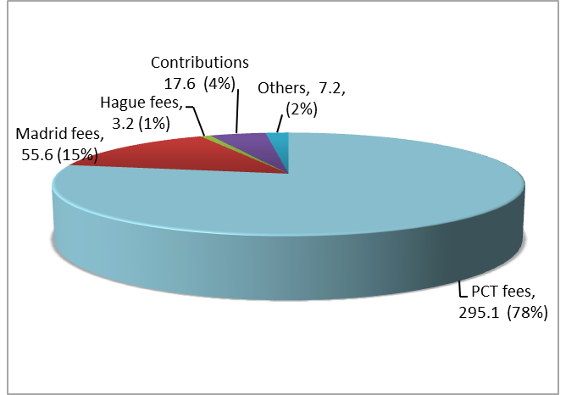

1. Chart 2 provides information on the breakdown of expenditure by type in 2014 (not including reserves, FITs and IPSAS adjustment).

Chart 2: 2014 Expenditure by Type

*(in millions of Swiss francs)*

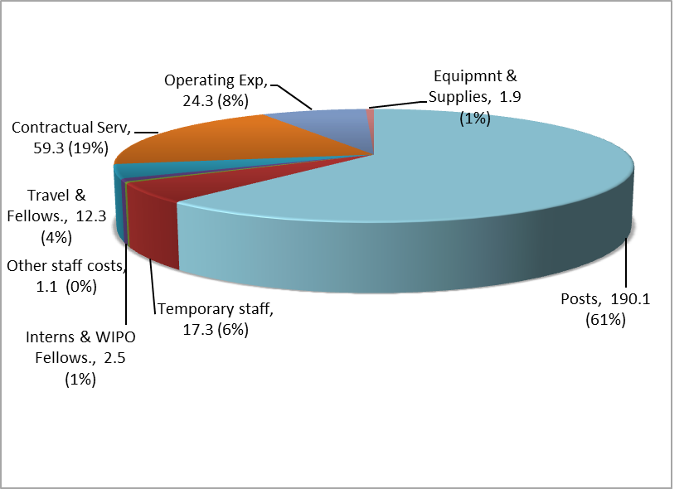

1. Chart 3 provides information on the total assets, total liabilities and net assets (reserves) of the Organization at the end of 2014.



1. Table 2 presents budget utilization figures by Program for 2014.



1. Table 3 provides the 2014 preliminary results by Unions (Contribution-financed Union, PCT Union, Hague Union and Lisbon Union).



1. Table 4 provides an outlook for the 2014/15 biennium taking into account the financial results for the year ended December 31, 2014.



[End of document]

1. Figures exclude Funds-in-Trust.