 |  | E
WO/PBC/21/INF.1
ORIGINAL: ENGLISH
DATE: july 31, 2013

Program and Budget Committee

Twenty-First Session
Geneva, September 9 to 13, 2013

Strategy for WIPO External Offices

Document prepared by the Secretariat

TABLE OF CONTENTS

INTRODUCTION 3
Existing EOs and Previous EOs 3
How and When was each Existing Office established? 4
WSO 4
WJO 4
WBO 4
Mandate, Objectives, Functions, Details of Placements, Activities of Each EO 5
General 5
WSO 6
WJO 9
WBO 12
Enhancement of Existing EOS since their Establishment 16
Improvements 16
Resources and Cost Efficiency 19
Demand for New EOs 21
Requests or Applications 21
Informal Consultations Held 21
The role of EOs in WIPO 22
Needs and Justification 22
Strategy 24
Small 24
Limited 24
Strategically positioned 25
Geographically representative 27
Geographic representation of other similar UN specialized agencies and of IP institutions 30
ILO 31
ITU 31
WHO 32
WMO 32
IP Institutions 33
Other Geographically Representative Factors 33
Monitoring of strategic objectives 34
Criteria 34
Analysis of the five proposed EOs 36
China 37
Russian Federation 38
United States of America 39
Africa 40
Cost, Financial Details and the Proposed Budget 41
Legal Issues and Procedures for creating new EOs 42
Beyond the Proposed Five 43
List of Documents in Annex 44

INTRODUCTION
1 The Program and Budget Committee (“the Committee” or “PBC”), at its 20th session, agreed to request the Secretariat to prepare an information paper and an in-depth study as follows:

“The PBC further requested the Secretariat to prepare the following documents regarding the matter of external offices, emphasizing the Member-driven nature of this process:

an information paper, including background documentation, to be circulated prior to the next session of the PBC, in response to questions and requests for further information made by delegations at the present session; and

an in-depth study to address, in a comprehensive manner, all the issues related to this matter including those that were raised by delegations at the present session.”

(see document WO/PBC/20/7; Summary of Decisions and Recommendations adopted by the Committee)

2 The draft Program and Budget for the 2014/15 biennium contains a proposal to establish five new External Offices (EOs) in China, Russian Federation, United States of America and two in Africa. In accordance with the above-mentioned agreement, the present document sets out the strategy for EOs with additional information requested by the Committee, and constitutes a combined and complete paper containing both the information paper and the in-depth study. Information contained in a white paper that was circulated during the last session of the Committee has been incorporated in this document, bearing in mind approaches to the issue suggested by the Committee.

3 The term “External Office” (EO) refers to a WIPO Office which is located outside of Geneva. The term “regional office”, which was used in the documents in previous years to refer to WIPO offices in certain regions, such as those referred to in WO/CC/62/4, has been replaced by the new term “WIPO External Office.” The new term is broader and more neutral, without prejudice to its mandate and functions. It also depends on the understanding that each WIPO EO has different mixes of functions in response to local priorities and specificities, and that each Office primarily focuses on activities to serve stakeholders and users in the host country and, where needed, its neighboring countries as a target zone of the Office. Most of the EOs do not have a predetermined region to cover, although certain Offices have acquired and established a zone of influence over the years of their activities and links to target countries. It is to be noted that WIPO has a liaison bureau in New York, the mandate of which is to liaise between WIPO and the United Nations (UN) Headquarter (HQ); thus, for the purpose of this paper, the WIPO liaison bureau in New York is not considered to be a WIPO External Office.

Existing EOs and Previous EOs

4 At present, the EOs are the WSO in Singapore, the WIPO Japan Office (WJO) in Tokyo, and WIPO Brazil Office (WBO) in Rio de Janeiro (in chronological order of establishment).

5 Prior to those EOs, two EOs were opened in Brussels in Belgium and in Washington D.C. in the United States of America. They were proposed in the draft Program and Budget for the biennium 2002/03, in order “to promote both understanding of WIPO and intellectual property issues through the WIPO offices in New York, Washington D.C. and Brussels” in Sub-Program 09.2 Media and Public Affairs. In September 2001, the WIPO Assemblies approved their establishment (see Annex I).

6 The preparations for establishing the WIPO Coordination Office in Brussels in Belgium led to a proposed agreement between the host country Belgium and WIPO which was submitted to the Coordination Committee at its Fifty-Second session in 2004 and was approved (see
Annex II). The Office was located in the building of UNDP. The Office was closed in 2008, as
a result of an evaluation and in a process of rationalization of EOs.

7 Approval of the WIPO Coordination Office in Washington D.C. was given in the Assemblies meetings in 2002 through the adoption of the Program and Budget for the biennium 2002/03 (see Annex I). As the United States of America did not require the HQ agreement, however, no document was submitted to the Coordination Committee. Like the Brussels Office, the Office was closed in 2008.

How and When was each Existing Office established?

WSO

8 WIPO Member States endorsed the establishment of the WSO during the fortieth series of Meetings of the Assemblies in September 2004 (see Annex III). The Government of Singapore and WIPO then signed an agreement establishing the Office in February 2005 and the agreement was submitted to the Coordination Committee at its Fifty-Third session in 2005 for approval. The Coordination Committee approved the Agreement between WIPO and the Government of Singapore (see Annex IV).

WJO

9 The Delegation of Japan made a formal offer at the General Assembly in September 2005 to host a WIPO office in Tokyo as an IP research center in cooperation with the United Nations University (UNU) in Tokyo on the condition that “no additional financial burden will be placed on WIPO”. The then Director General welcomed the offer and took note of no additional financial burden (see Annex V).

10 As it was too late to include the WJO in the Program and Budget for the biennium 2006/07, it was a draft Program and Budget for the biennium 2008/09 that included the WJO along with other Coordination Offices. The Program and Budget document defined the strategy that “the external relations Program at WIPO HQ, together with the WIPO Coordination Offices (Brussels, New York, Singapore, Tokyo and Washington), will continue to develop and manage networks of relationships with the external community” (see Annex VI).

11 WIPO and Japan confirmed the extension of the 1947 Convention on the Privileges and Immunities of the Specialized Agencies to the WJO in July 2006. As Japan did not require any HQ agreement, however, no document was submitted to the Coordination Committee.

WBO

12 In December 2008, the Program and Budget Committee at its 13th session discussed and approved the revised Program and Budget for the biennium 2008/09. It included, in
Program 20, EOs and Relations, a proposal of creating a new WIPO Office in Brazil as follows:
“A process of rationalization of WIPO's External Offices has begun, and in line with a refocusing of these offices, it is proposed that, following an invitation received from the Government of Brazil in October 2008 (accompanied by an offer to provide premises and infrastructure support at no cost to WIPO), a new office will be opened in Brazil in 2009” (see Annex X). This revised Program and Budget for the 2008/09 biennium was adopted by the Assemblies (see Annex VII).

13 Following the approval of the Program and Budget, WIPO and the Government of Brazil prepared an agreement aimed at determining the legal status of a WIPO Brazil Office (WBO), which was submitted to the Coordination Committee in 2009 for approval.

14 The Coordination Committee approved the Cooperation Agreement between WIPO and Brazil, as set out in the Annex to document WO/CC/62/3, with the amendment to delete the third preambular paragraph reading as follows: “recognizing that, a dedicated office serving the region of Latin America and the Caribbean (LAC) shall also serve as a visible symbol of WIPO’s strong commitment to the region, lending weight to any project or initiative promulgated by WIPO” (see Annex VIII and Annex IX).

Mandate, Objectives, Functions, Details of Placements, Activities of
Each EO

General

15 Over the last several years, the mandate and functions of the existing EOs have been updated and approved each time that the Program and Budget has been discussed and approved. The rationalization process of the existing EOs began at the end of 2008. The mandate and objectives of EOs before the process of rationalization were: “External Offices will continue to engage with other organizations of the UN system on intellectual property and on system-wide issues, as well as coordinating WIPO’s engagement with Civil Society and industry groups” to achieve the objective of “enhanced and more effective engagement of WIPO with the external community” (see Annex X).

16 During the rationalization process for EOs, the EOs and their objectives were also subject to the Strategic Realignment Program (SRP). The mandate and objectives of EOs became more integrated into the nine strategic goals of WIPO which were established in 2009. The objectives were shifted from the mere external coordination and better understanding of WIPO and IP issues to more advanced and profound ones to respond to the enhancement of the visibility and appreciation of WIPO and IP issues by Member States. The existing EOs are now engaged in supporting multiple strategic goals of the Organization. The Program and Budget of the 2012/13 biennium, which was approved in September 2011, included EOs in Program 20 and described the strategy of EOs as follows: “each of WIPO’s EOs will, within its respective host country and in the surrounding region, operating in a similar time zone, provide services in support of WIPO’s Global IP Services (Strategic Goal II), as well as capacity-building services in coordination with the respective regional bureau (Strategic Goal III).”

17 While reflecting the SRP in the rationalization of existing EOs and essentially maintaining the supportive roles of EOs to WIPO HQ, the proposed Program and Budget for the next biennium further extends the role of EOs to “contribute to the achievement of all Strategic Goals (emphasis added by the Secretariat for this document) in coordination with WIPO HQ” (see Program 20, Implementation Strategies). It aims at the complete integration of EOs into WIPO Strategic Goals. The proposed objective of EOs for the next biennium is to contribute to the achievement of WIPO strategic goals within the respective host countries and in the surrounding region and to support the delivery of the strategic objectives of the Organization. With the shared strategy and the above-mentioned general objectives, each EO can have more specific objectives and expected results which focus on local needs in the host country and the surrounding region.

18 The mandate of EOs is to take the responsibility for undertaking activities in accordance with the proposed results framework in the Program and Budget for the next biennium. The governance of WIPO will continue to apply, such as the reporting lines to facilitate the coordination between HQ and each EO, the preparation of work plans to implement activities and evaluation using the performance indicators as proposed in Program 20. The next section will discuss further details of each existing EO.

WSO
19 The WSO facilities are located in the campus of the National University of Singapore (NUS), next to most other intergovernmental organizations based in Singapore: the Asia-Pacific Economic Cooperation (APEC), the Asia-Europe Foundation and the UNDP Global Center for Public Service Excellence. The office location provides opportunities to collaborate. The WIPO Arbitration and Mediation Center (AMC) in Singapore is located in the Maxwell Chambers along with other arbitration institutions such as the Singapore International Arbitration Center, the ICC and AAA.
20 The Government of Singapore provides the premises for both offices and pays the rental costs, as well as some utility charges and maintenance costs. It also provided basic outfitting costs related to the set-up of the WSO, which included furniture and equipment necessary for the installation and operation of the office (Paragraphs 3 and 4 of the WIPO-Singapore Agreement of 2005). The WSO has a function room with capacity for around 40 delegates, as well as a formal boardroom that can accommodate meetings of up to 18 participants. The WSO also houses a large collection of WIPO publications and brochures which are regularly consulted by visitors.
21 The WSO regularly permits other UN agencies or the IP Offices of Member States to use its meeting rooms to conduct meetings or job interviews of candidates based in Singapore or the region. It also lends its premises to various institutions for events related to IP, for example, the Sorbonne University (Singapore) recently utilized WSO premises to host a reception for delegates attending an executive program entitled “Legal Aspects of Luxury Business”, which provided the WSO with the opportunity to provide a presentation on the role of WIPO, and to promote WIPO’s global services.
22 Through a series of Agreements, Memorandum of Understanding (MOUs) and exchange of Notes verbales, signed in 2006, 2009 and 2010, the scope of cooperation between WIPO and the Government of Singapore has been expanded to provide joint activities to promote IP awareness and to build IP capabilities in developing countries and least developed countries in the region, to establish the WIPO AMC in Singapore and to enumerate the privileges and immunities of both offices and staff. By an exchange of Notes verbales in December 2010, the WIPO Office Agreement was extended for six years, i.e. until February 1, 2017. Each year the IP Office of Singapore and the WSO agree on a new Joint Program of activities designed to assist Member States in the region, with a particular focus on the States of the Association of South East Asian Nations (ASEAN).
23 The WSO’s objectives are to:

- promote WIPO’s treaties and global services such as the PCT, Madrid and Hague systems;
- support and promote the WIPO AMC in Singapore (see Annex 3 for a summary of the Center’s services);
- assist the ASEAN Member States in the implementation of the ASEAN IP Rights Action Plan 2011-2015, particularly the areas for cooperation with WIPO requested by the ASEAN Working Group on Intellectual Property Cooperation (AWGIPC);
- work with stakeholders to establish and strengthen collective management organizations in the region;
- perform on-site ICT assessments of IP offices in the region, including analysis of: business and legislative procedures, IP data volumes, current backlog, office resources, ICT infrastructure and automation status;
- manage and implement the Memorandum of Understanding between WIPO and the Government of Singapore which consists of joint activities; and
- support WIPO’s Round-the-Clock service during the allotted time frame.

24 In accordance with Annex A of the 2005 Agreement between WIPO and Singapore, the Singapore Government shall bear the rental costs for office space as well as the costs for the maintenance of common areas and facilities, mechanical and electrical services and utilities, up to 50,000 SGD (1SGD=0.74 CHF). Every year WSO submits reimbursable claims to the Ministry of Law for 10,000 SGD on the understanding that under the 50,000 SGD per annum provision for maintenance, mechanical and electrical services and utilities under the WIPO-Singapore Agreement, approximately 40,000 SGD are paid by the Ministry of Law to United Premas Limited for maintenance of common areas and facilities.

25 The WSO will soon be equipped with Internet Protocol phones in order to reduce its communications expenses particularly with WIPO HQ. In addition, studies are currently being conducted with HQ in order to introduce more flexibility in the WIPO Travel Policy, allowing WSO and AMC to directly purchase air tickets from Singapore based agents rather than those in Geneva. This would allow the possibility to book online flights with low-cost companies for travel in the region. The availability of two meeting rooms at WSO is a significant motivating factor in the decision to organize meetings in Singapore. On average, the administrative cost of a meeting organized by WSO in its premises is around 2,000 CHF for a two-day meeting. This compares very favorably with commercial rates of hotels and other venues. It is to be noted that no translation or interpretation costs are usually borne for meetings organized in WSO. Moreover, the conference rooms are equipped for remote participation of speakers from WIPO HQ or from other parts of the world who are able, through online tools, to participate in meetings held in WSO.

26 The WSO forms an important component of the service network offered by WIPO in its Round-the-Clock service. Calls made to WIPO when the Geneva office is closed are re-directed to Singapore during certain windows.
Table 1: Calls and E-Mails received by WSO
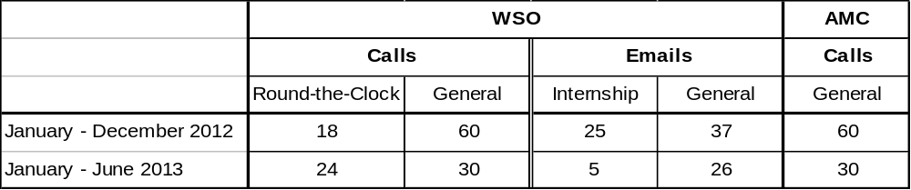

27 As regards communications and outreach activities, the chart demonstrates a trend of increasing usage of the WSO web site (www.wipo.int/singapore).
Figure 1: Pageviews of WSO’s web site
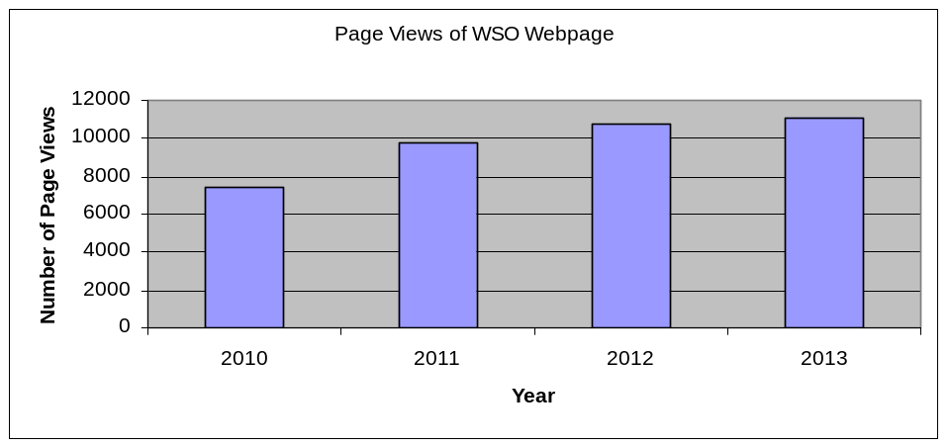

Note: 2013 figure has been extrapolated based on data at the halfway point in the year
28 Since data was first recorded in 2010 with Google Analytics, the site has experienced an increase of 50 per cent based on 2013 traffic levels. This finding is indicative of the increasing importance of the ASEAN region in the IP world and the work of the WSO.
29 Furthermore, work was completed earlier in 2013 that improved both the structure and content of the WSO website. In addition, new tools were added to improve access to valuable WIPO web content such as the country profiles (which are now displayed on the WSO homepage) and the ASEAN IP Quickfind which allows customers to access different aspects of each Member State IP regime from one central portal. The WSO is active in seeking out opportunities to promote WIPO’s global services through participation in events and proactively building relationships with associations and stakeholder groups. Apart from the workshops and missions facilitated by WSO staff, WSO and the AMC participated in 90 engagements, meetings and promotional events from June 2012 to July 2013. In addition the WSO identifies branding opportunities to increase WIPO brand awareness as well as ensuring that the WIPO logo is used in accordance with the Logo Policy and Guidelines.
30 Up until March 2013, when the UNDP Center for Public Service Excellence was opened in Singapore, WIPO was the only UN Organization represented in Singapore. The UNDP Center for Public Service Excellence is dedicated to policy research and the global exchange of knowledge and information on public service policies, strategies and institutions. Although, WSO keeps in close contact with the Center, there is no common field of work on IP. The WSO was invited to the release of the UNDP Human Development Report in Singapore on April 2013 and to present its activities to the Deputy Secretary General of the United Nations, Mr. Jan Eliasson, who visited the UNDP Center in May 2013.
31 In order to create better lines of communication and stronger relationships with other IP Technical Assistance (IPTA) providers in the region so that WSO is more informed of the work taking place and able to provide a more complete picture of IP activities in the region to HQ, WSO has initiated in March 2013 an informal roundtable meeting with the IP Attachés in embassies and those organizations who provide IP technical assistance in the ASEAN region (IP Attachés from the USA, France and the UK based in Singapore and representatives from IP Australia, AANZFTA/ASEAN Secretariat, the EU, ECAP (executed by the Office for Harmonization in the Internal Market (OHIM)), Japan and Republic of Korea based in the region).
32 The WSO has facilitated a range of events and study visits that have had both a regional and sub-regional focus, spanning the wide range of IP subject matter. Some figures below show the outcomes and achievements of 2012 and 2013:
- Number of events facilitated by the WSO or the AMC Office in Singapore in the previous 18 months = 12, (attracting a combined total of more than 266 delegates from across the region);
- Number of national or sub-regional events WSO or AMC participated in the previous 12 months = 52;
- Study visit programs arranged/received = two; and
- Including other engagements, meetings and promotional events attended by the WSO or the AMC = 98.

WJO

33 The relocation of the WJO from the UNU building to Kasumigaseki in January 2012 was strategic in order to reinforce the functions of the Office to serve users of WIPO’s services and also to strengthen cooperation with government authorities of the host country and with Japanese industry. WJO is located in a commercially-rented building with robust security. The administrative office space is approximately 100 square meters. The annual rent is approximately 120,000 CHF, and in compliance with the offer made by the host government in 2005, with respect to no additional financial burden on WIPO, the rent of the office space has been financed by the government of Japan since then.

34 The WJO is now focusing on support for Global IP Systems, particularly with respect to the PCT, the Madrid System and Japan’s examination of the Hague System; participation in the global customer response network; and capacity-building activities, largely funded by generous contributions from the Government of Japan. Excellent results are being obtained through the vigorous engagement with Japanese enterprises. PCT applications from Japan rose in 2012 by more than 10 per cent well in excess of the world average (on a volume that constitutes over 20 per cent of the worldwide PCT filings) and Madrid applications have risen by over 30 per cent in the same period.

35 The WJO currently has the following specific objectives and priorities:
- promote WIPO’s global services such as the PCT and Madrid systems, and coordinate with the host government to prepare for Japan’s accession to the Hague Agreement in the coming years.
- provide efficient and timely services to users and applicants of the PCT, Madrid systems, global databases such as PATENTSCOPE, as well as the WIPO Arbitration and Mediation Center services;
- collaborate with Japan’s industry to develop and promote WIPO’s global partnership projects such as WIPO GREEN and WIPO RE:SEARCH;
- coordinate with the host country and donor country of Funds-in-Trust (FITs) of Japan on industrial property and copyright, and assist the HQ in undertaking activities financed by FITs/JP, including the development of the WIPO knowledge database “IP Advantage” at http://www.wipo.int/ipadvantage/en/;
- cooperate with the United Nations agencies present in Japan to organize outreach program activities as part of inter-agency cooperation;
- assist the HQ in coordinating with IP experts and policy makers from Japan in order to share Japan’s experience in the use of IP systems for innovation through the participation of such experts in meetings;
- support WIPO’s Round-the-Clock service during the allotted time frame.
36 The WJO undertook the following activities in 2012:

- The Office organized nine meetings (under FIT/JP, in cooperation with the JPO, WIPO HQ as well as a local national authority (Thailand)), three workshops in Tokyo (IP Policy, Madrid, IT), one workshop in Bangkok, Thailand (PCT), and five training courses in Tokyo.
- The Office participated in 94 meetings (workshops, seminars etc.) to represent WIPO (30 meetings were attended both by WIPO HQ officials and WJO officials, and some 60 meetings were attended by WJO officials alone);
- The Office organized a total of 44 meetings for the promotion of the PCT and the Madrid system, the WJO organized and participated in all of them;
- The Office joined other EOs to launch the Round-the-Clock services;
- The WJO updated and added 34 cases to WIPO IP Advantage database which now has more than 170 cases, which is well regarded as an important resources of case studies regarding the use of IP for enhancing the competitiveness of enterprises in developing countries; and
- The WJO’s web site (bilingual in English and Japanese) has been updated to reach out to users of WIPO services in Japan (at http://www.wipo.int/about-wipo/ja/offices/japan/).

37 The statistics of calls and e-mails received by WJO are as follows;

Figure 2: calls and emails received by WJO in 2012
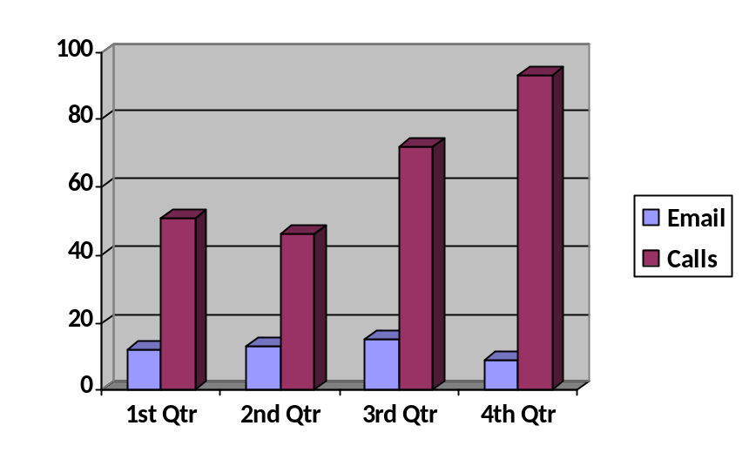
38 The WJO functions as a local support service provider for WIPO’s Global IP Systems, as a support provider for WIPO’s general customer response network and a supporter of capacity building. From 2012, the WJO has been deeply involved in service provision for WIPO’s Global IP Systems. In its first year under this new initiative, the office focused increasingly on PCT and Madrid systems and undertook intensive promotion of WIPO’s services. The WJO actively performed promotion activities that were executed at 44 venues all over Japan. Participants ranged from patent attorneys through private companies to academia and numbered almost 6,200. Among the 44 events, 34 were covered solely by the WJO, which significantly contributed to cost reduction for HQ and increased efficiency.

39 Information in the local language (Japanese) facilitates Japanese stakeholders’ understanding of WIPO’s IP systems and activities. As mentioned above, the WJO administers its bilingual website and provides information in Japanese. In 2012, the WJO posted more than 60 articles on the website for Japanese readers. In addition to that, the WJO produced Japanese translations of PATENTSCOPE’s User Guide. These activities contributed to better communication with Japan’s stakeholders and add value to the organization as a whole.

40 As for capacity building, the WJO has also played a significant role in cooperation with the Japan Patent Office (JPO) and HQ through effective and successful workshops and training. Participants at these workshops and training sessions were from all over the world such as the Asia and Pacific Region, Africa, and Latin America. Sessions covered a wide range of agendas, from Patent Examination Practices and Enforcement to IP Management and Information Technology Infrastructure.

41 The WJO represented WIPO in events outside Japan in countries such as Thailand and India, where the WJO contributed a speaker as well as a moderator on IP issues such as the Madrid Protocol, WIPO’s ICT tools, and PCT.

42 One approach adopted by the WJO for the promotion of PCT and the Madrid System which has proven to be most effective is collaboration with the JPO. The organization of meetings was a joint effort for planning, delivery and evaluation. Individual visits to a number of actual and potential users of the PCT and the Madrid System were also strategically planned and organized jointly by the WJO and the JPO in coordination with WIPO HQ. Follow-up inquiries by participants were also effectively addressed by the WJO in collaboration with JPO. These joint efforts with a strategically planned promotion campaign resulted in a significant increase in PCT and Madrid applications in 2012.

43 As regards the coordination with the host government, the WJO has excellent communications and collaboration in organizing joint meetings for users and other stakeholders in Japan. For instance, industry, university and patent attorneys are three of the most relevant stakeholders in the IP field and this resulted in the initiative WIPO GREEN, taken by the Japan Intellectual Property Association (a group of two thousand Japanese companies on IP matters) in 2011 and 2012.

44 As regards cooperation with UN agencies located in Tokyo, the experience of the WJO was that cooperation with other UN agencies remained at the level of general awareness building of IP among the UN circles in Tokyo and did not make a valuable contribution to WIPO strategic goals, mainly because IP is such a specialized area that other UN agencies have little idea of how inter-agency collaboration on IP issues could be undertaken. The WJO made efforts to sensitize officials of UN agencies in Tokyo as an initial step. Examples of cooperation are as follows:

- UN day (annually, usually in October: UN organizations hold events under a specific theme. In 2012, the theme was “Post ‘Rio+20’: Achieving the Future We Want”, and the WJO’s materials included those related to the environment. In addition, the WJO created a flyer for the event that highlights sustainable innovation case studies from IP Advantage.);

- Global Festa (October); this may not be an perfect example, but in this event which is co-sponsored by Japanese governmental agencies including the Ministry of Foreign Affairs, many International organizations including UN agencies participate in the event. The WJO joined in 2012 where it presented and distributed material of WIPO’s activities to raise awareness of IP.

45 The UN agencies represented in Tokyo are IAEA, ILO, UNAFEI, UNDP, UNFPA, UNHCR, UNIC, UNICEF, UNIDO, UNU, UNV, WFP and WIPO.

46 In 2012, the WJO responded to requests from other Member States to share IP knowledge from Japan with stakeholders in those countries. The WJO gave a presentation at meetings in Thailand and India in 2012. The presentation covered WIPO’s ICT tools, the promotion of the Madrid system in Japan, and the strategic use of patents by Japanese industry. Since these Asian countries are much closer to Japan than Geneva, it contributed to more efficient implementation of activities.

WBO

47 The WBO moved to a safe and commercial area which is increasingly attracting businesses, companies and organizations such as the World Bank Regional Office. The area also offers easy access to public transportation and hotel facilities. The office uses commercially rented building space and the annual rent (including electricity, internet connection, telephone and maintenance) is approximately 140,000 CHF, which is charged to WIPO budget.

48 The WBO negotiated with the Brazilian Government the establishment of FITs; the first focusing on promoting the use of the IP system and the development of competencies on IP protection and commercialization, and a second dedicated to promote collaborative activities based on South-South cooperation. Both Agreements are an outcome of WBO’s capacity to foster additional financial support for WIPO activities and the two Funds are managed from the WBO.

49 The WBO has the following specific objectives and priorities and activities:
- to assist the HQ in missions and activities taking place in Brazil;
- to assist the HQ in missions and activities taking place in the LAC region, as well as in other regions;
- to plan, implement and administer the work to be carried out under the two FITs/BR, as defined in line with objectives set by the Brazilian Government and with WIPO Strategic Goals;
- to promote new sources of income for the Organization. Two concrete examples were:
  - the signature of the new FITs/BR;
  - the signature between WIPO and the Government of Brazil of the MOU for the creation of the Center for the Defense of Intellectual Property (CDPI) (Mediation Center), which was inaugurated in March 2013;
- to be part of WIPO's Round-the-Clock service;
- to promote WIPO’s treaties and global services, such as the PCT, Madrid and Hague systems;
- to assist HQ with promotion and implementation of WIPO projects, such as WIPO Green, Economic Studies on IP and development, IPAS etc.;
- to administer mediation and arbitration services in cooperation with the Arbitration and Mediation Center.

50 The WBO is now focusing on support for the Global IP Systems, particularly with respect to Brazil’s examination of the Madrid System and the Hague System; participation in the global customer response network; support for the many IT and infrastructure projects with IP Offices in the Latin American region; and South-South cooperation. The work to promote the use of the IP system has been reflected in, for example, the increase by 17 per cent of PCT filings by Brazilian residents from 2010 to 2011.

51 In 2012, two new MOUs were signed with the Brazilian Government, with funding provided by Brazil. Under one MOU, the WIPO AMC cooperates with the Brazilian IP Office (INPI) to support the structuring of the INPI Center for the Defense of Industrial Property, as well as to administer mediations and arbitration for trademark and patent oppositions and disputes. Under the second MOU, as indicated before, Brazil funds a series of South-South activities and projects.

52 As regards inquiries by telephones and the Round-the-Clock services, the statistics are as follows:
Table 2: Calls received by WBO in 2012

Means | Calls |  | Emails
Period/Services | Round-the-Clock | General | Round-the-Clock | General
September to December 2012 | 108 | n/a | 83 | n/a
January to December 2012 | n/a | 1200 | n/a | 120

53 At the national level, the WBO attended approximately 130 meetings in 2012 with partners such as the FIOCRUZ Institute, the National Confederation of Industries (CNI), the Federation of Industries of the State of Rio de Janeiro (FIRJAN), the Federation of Industries of the State of São Paulo (FIESP), the Brazilian Innovation Agency (FINEP), the National Development Bank (BNDES), the National Institute of Industrial Property (INPI) of Brazil, the Ministry of External Relations (MRE), the Ministry of Culture (MINC), the Ministry of Development, Industry and Trade (MDIC), the Ministry of Science, Technology and Innovation (MCTI), the Innovation Agency of the Catholic University of Rio de Janeiro (PUC-Rio), the National Forum of Technology Managers (FORTEC), the Technology Network of Rio de Janeiro (REDETEC), the National Association for Research and Development of Innovative Companies (ANPEI), and the Brazilian Cooperation Agency (ABC) of the Ministry of External Relations.

54 In addition, the WBO has facilitated a wide range of events and study visits at the national, regional and inter-regional focus, covering a wide range of IP matters. In February 2102, as a result of a partnership established with ANPEI and INPI, WBO organized a one week study visit of fifteen representatives of industry and government to WIPO HQ. This initiative was inspired by four successful previous experiences organized for Members of Parliament, High Court Judges and Federal Attorneys.

55 The list of the main activities carried out by the WBO in 2012 includes (non-exhaustive):

- Organization of International and Inter-Regional Conferences and Meetings such as (a) the Inter-Regional Meeting to Discuss IP Governance; GRTKF and Copyright and Related Rights (Brasília, Brazil), (b) International Conference on the Strategic Use of Intellectual Property by the Sports Industry (Rio de Janeiro, Brazil), (c) Inter-Regional Meeting on IP Office Automation (Rio de Janeiro, Brazil), and (d) International Symposium on Geographical Indications (Fortaleza, Ceará);
- Organization of Regional Meetings such as Regional Roundtable on IP and Competition (Rio de Janeiro, Brazil);
- Support for the organization of regional meetings such as three meetings of the Technical and the Directive Committees of the Regional Collaborative System PROSUR (Rio de Janeiro, Brazil; Lima, Peru; and Santiago, Chile)
- Organization of training programs such as (a) two sessions of the series “IP and Emerging Topics”, (b) two editions of “Training programs on IP Mediation – basic and intermediate”, and (c) Lectures at the Master Course on IP, Innovation and Development of INPI-Brazil.
- Participation in technical meetings and committees such as (a) member of the working group for the establishment of a Lusophone Trademark System, (b) member of the Steering Committee of the IP Network of Rio de Janeiro, and (c) invited guest at the IP Committee of National Association for Research and Development of Innovative Companies (ANPEI) of Brazil.
- Participation in several meetings organized by the National Confederation of industries (CNI) and State Federation of Industries to promote the use of the IP system, with special focus on the accession to the Madrid System and on the challenges and opportunities for the export sector.

56 The following several examples explain certain activities undertaken in 2012, most of them funded from FIT/BR 1 and 2. In addition to the fact that FIT/BR 1 and 2 funded those activities, there was a considerable cost saving on the part of WIPO, as many activities were implemented in the field. The non-exhaustive list which follows indicates the magnitude of cost saving by the WBO as a result of representing WIPO HQ in the field.

57 The WBO also visited representatives of the National Congress in order to further promote the relevance of a future accession of the country to the Madrid Protocol. Expense WBO:
2,531 CHF, thus saving about 8,000 CHF for each mission, which would have been carried out by a WIPO official based in Geneva. Several meetings and video conferences among the WBO, WIPO’s AMC and INPI took place between April and June, 2012, which discussed matters about the implementation process for the establishment of INPI’s Mediation and Arbitration Center. These meetings enabled WIPO to save at least 4 missions of WIPO staff based in Geneva, which corresponds to approximately 32,000 CHF.

58 On May 8, 2012 the WBO, INPI and the Brazilian Cooperation Agency met in Rio de Janeiro to discuss the main terms of the agreement which was submitted later by the Government of Brazil to WIPO. The mentioned cooperation agreement had, as its main objective, the promotion of South-South collaborative activities. This new Funds-in-Trust was signed during the First WIPO Interregional Meeting on South-South Cooperation on IP that took place in Brasilia from August 8 to 10, 2012. This initiative saved one mission of a WIPO Official based in Geneva, amounting to approximately 10,000 CHF.

59 The VI National Meeting of the Forum of Managers of Innovation and Technology (FORTEC), that took place in Belem, Pará, in the Amazon Region, from May 17 to 19, 2012, brought together 233 participants from Technological Innovation Centers (the same as Technology Transfer Offices - NITs) of universities, and research centers as well as representatives of State and Federal Governments, and of enterprises. FIT/BR funded the mission of an international expert from Israel amounting to 4,159 CHF. The WBO funded one staff mission amounting to 1,468 CHF. This activity saved one mission of a WIPO official based in Geneva amounting to approximately 8,000 CHF.

60 On meetings with the Government of the Sultanate of Oman, participants agreed in recommending that the following activities take part in a future South-South Cooperation Project: (1) a study visit of an Omani delegation to Brazil to institutions that integrate the Brazilian innovation system; (2) Training Programs on protection and commercialization of IP; (3) The Organization of a series of Seminars to promote IP and Innovation among policy makers and potential users. WBO financed one Staff mission amounting to 14,376 CHF.

61 From June 4 to 6, 2012, professionals from the ICT area of 15 countries from Latin America and Africa (One participant from the IP Office of the following countries attended the event: Angola, Chile, Cape Verde, Costa Rica, Cuba, Ecuador, El Salvador, Honduras, Dominican Republic, Mexico, Mozambique, Paraguay, and Uruguay) gathered for the first time in Brazil at INPI to discuss solutions and existing systems for IP administration, with a specific focus on the IPAS project. During the meeting, participants discussed the following topics: challenges of IP Office automation, moving from paper-centric work processes to fully-automated processes, data governance, expanding the accessibility of the IP system provision of online services to applicants and the general public and regional collaboration. Two professionals attended from the HQ to advise on possible solutions for the establishment of a better and adequate IP infrastructure for the LAC Region as well as for lusophone countries. This activity was funded by FIT/BR to the sum of 32,929 CHF

62 A meeting of the Steering Committee of PROSUR (the project of operational cooperation system in IP in South America) was held in Santiago, Chile. Heads of the following IP Offices attended the event financed by FIT/BR and organized by the WBO: Argentina, Brazil, Chile, Colombia, Ecuador, Paraguay, Peru, Surinam and Uruguay. During the meeting, the Heads of the said IP Offices signed the Agreement which formalized the institutionalization of PROSUR. In addition, during the event in Chile, the Technical and Steering Committees of PROSUR approved the use of the Collaborative Platform of Electronic Examination (e-PEC). E-PEC aims at the reduction of the patent backlog in order to allow better quality and higher degree in efficiency in patent examination. FIT/BR funded the participation of a total of 16 participants in the event held in Santiago, Chile.

63 A Program for South-South cooperation was structured in the context of the Development Agenda. In this connection, Member States approved the organization of the Inter-Regional Meeting to Discuss IP Governance; GRTKF and Copyright and Related Rights, which took place in Brasília, from August 8 to 10, 2012. Representatives from twenty-six developing countries from Latin America, Africa, the Middle East and Asia discussed actions that could foster the use of IP as a tool for economic and social progress. The mentioned meeting focused on: fostering the exchange, among developing countries and least-developed countries (LDCs), of national experiences on issues related to IP Governance; GRTKF; and Copyright and Related Rights. FIT/BR financed four international speakers amounting to 32,148 CHF. WBO financed one staff mission amounting to 1,478 CHF. This initiative saved about 8,000 CHF, corresponding to one mission of a WIPO official based in Geneva.

64 On September 12 and 13, 2012 the International Conference on the Strategic Use of Intellectual Property by the Sports Industry took place in Rio de Janeiro. This major conference discussed the protection of IP with special focus on the use of patents, trademarks and broadcasting as tools for boosting innovation in the national sports industry. The discussion gained more attention as Brazil will host major sports events such as the 2014 FIFA World Cup and the 2016 Olympic Games. Speakers pointed out the opportunities countries may create when they receive sports events and what are the elements that should be considered in order to achieve economic and social gains out of sport activities. More than 200 participants attended the Conference. Other seminars are planned to be organized in cities that will host games of the 2014 FIFA World Cup. Following the Opening Ceremony, a MOU between WIPO and the INPI for the Provision of Alternative Dispute Resolution Services to Parties involved in Cases submitted with INPI-Brazil was signed. In addition, the Director General also signed the Executive Agreement between WIPO and the Government of Brazil for the promotion of South-South Cooperation for a better use of the IP system by developing countries. FIT/BR financed four participants from Argentina, Chile, Colombia and Uruguay and 5 speakers from Australia, United Kingdom, Switzerland, Portugal and Spain, amounting to 45,756 CHF. The WBO financed the conference room, amounting to 12,323 CHF.

65 The horizontal (South-South) cooperation in the training activities organized by the WBO or with the WBO’s assistance included officials from several Latin American, African, Middle Eastern and Asian countries.

66 Funds in Trust for the “Dissemination of the Intellectual Property Culture and the Incorporation of the Best Practices” (FIT 1): total project value (approximately 3,231,000 CHF)

- Amounts received by WIPO:
On December 20, 2011: 359,493 CHF
On November 7, 2012: 370,543 CHF
On February 8, 2013: 292,906 CHF

- FIT 1 expenses in 2012: 287,456 CHF
FIT 1 expenses until March 2013: 403,204 CHF
Funds available: 616,394 CHF

- FIT/BR to Promote South-South Cooperation (FIT 2): total project value (approximately 1,050,000 CHF)

- Amounts received by WIPO:
On February 19, 2013: 96,110 CHF
On July 10, 2013: 85,495 CHF
Funds available in July 2013: 181,605 CHF

67 In Rio de Janeiro, besides the WBO, there are many UN representative offices such as UN-HABITAT, IFC, International Finance Corporation – PANAFTOSA, Pan American Foot-and-Mouth Disease Center, OCHA, UNISDR, UNICEF, UNIC, UNESCO, UNRWA and UNDSS. The WBO cooperates with these agencies in security matters and for the recently re-launched process for the establishment of an UN House in Rio de Janeiro.

68 In summary, WBO's activities in 2012 are described in terms of a total number of participants in over 130 meetings organized, supported and/or attended by the WBO. The events organized by the WBO or with the WBO’s assistance, including training activities, gathered an audience of nearly 5,000 participants. Approximately 300,000 CHF were saved in 2012 alone with activities organized by the WBO or with the WBO’s assistance, once they counted with the participation of WIPO staff based in Rio de Janeiro, in addition to the amount spent (funded by FIT1 and FIT2) in the implementation of the activities listed above. These savings added to the amount invested by FIT 1 and FIT 2 in 2012 represented an approximate figure of 750,000 CHF.

Enhancement of Existing EOS since their Establishment

69 As apparent in the activities undertaken by the existing EOs, there has been considerable improvement in the services provided by, and enhancement of the role of, the existing EOs. These improvements have resulted from efforts in several different areas.

Improvements

70 The first area of focus has been to clarify the role and functions of each EO, bearing in mind WIPO Strategic Goals and results framework of the Program and Budget with respect to EOs in general. This resulted in the following evolving results:

- The WBO and WSO started to play a role with respect to support for Global IP Systems, technical assistance for the implementation of infrastructure projects, capacity building, South-South cooperation and, in the case of the Brazil Office, also the administration of activities under the Brazil FIT;

- The WJO initially ceased its functions with respect to research in collaboration with the UNU and subsequently started to focus on support for Global IP Systems, capacity building and the administration of activities under Japan FIT.

71 The second area of focus was on the relocation of the existing Offices to locations that are more suitable for the redefined missions of the Offices. This does not affect the WSO, which is situated in an optimal location adjacent to the campus of the NUS. In the case of the WBO, however, following the overall transfer of the INPI, new premises were rented in an area in which infrastructure needs were fully met. In January 2012, The WJO moved to new premises near the JPO and the center of business activities with respect to intellectual property.

72 The third area of focus has been to define more consistently which areas within the sphere of capacity-building should be devolved to the EOs. This is work-in-progress but some achievements were made as explained below. The final area of focus has been ensuring that the skill profiles of staff in the existing EOs correspond to the role and functions attributed to the respective Offices. This is again a work-in-progress, being undertaken within existing resource constraints and also within the context of the initiative on Organizational Design within the SRP.

73 The fourth area where the Secretariat enhanced the EOs relates to the services provided by the existing EOs and the use thereof to perform services that cannot be provided at HQ. A system was put in place for the Round-the-Clock services or 24-hour servicing of WIPO’s switchboard. After 6 pm Geneva time, calls to WIPO’s number are automatically referred to the WIPO liaison bureau in New York or the WBO (depending on whether the language of communication is English, Spanish or Portuguese). Following closure of business in the Americas, calls to WIPO’s number are automatically referred to the Japan and Singapore Offices (depending on whether the language of communication is Chinese, English or Japanese). Following closure of business in Asia, calls revert to HQ.

74 The Round-the-Clock service was launched in September 2012 and as statistics included in each section describing each EO above, the number of calls have grown steadily since the commencement of the service. Based on statistics in 2012, the HQ received about 8,200 calls per month. It is to be noted that the service was intended to respond to general inquiries from the public and for this purpose particular telephone numbers were indicated in a dedicated web site of “Contact Us”. There were other telephone calls made by, say, users of WIPO Global IP systems such as PCT and the Madrid, who usually dial particular direct numbers which connect to officers in charge (in the case of the PCT and the Madrid System infolines (direct service query lines)).

75 The public has become more familiar with the Internet and inquiries are also made by
e-mails. The HQ received some 1,100 emails per month to “Contact Us” e-mail addresses. The number of e-mails received by EOs has steadily increased, as indicated in the respective section with regard to activities of the existing EOs.

76 The WJO and WSO created their own web sites partly mirroring WIPO HQ web sites with local content. The WSO web site attracted a growing number of visitors, as a graph in the section on WSO shows. The WJO website is bilingual in English and Japanese, and the Japanese edition shows greater attraction of users in Japan.

Table 3: EOs Web Sites (unique pageviews) in 2012

Page | English | Japanese | TOTALS
WBO | no website | n/a | n/a
WJO | 4,510 | 48,190 | 52,700
Singapore office | 8,032 | n/a | 8,032
WIPO HQ | All UN languages | n/a | 31,430,269

77 The fifth area concerns WIPO’s ICT infrastructure for the delivery of services in the Global IP Systems and, increasingly, in other areas such as outreach activities. WIPO has developed its ICT infrastructure and enhanced the network connectivity for the improved delivery of services (such as the ePCT system) and for assistance for developing countries in business modernization (IPAS, or Industrial Property Automation System, and WIPOCOS, or the WIPO-provided IT system for collective administration of creative works).

78 The digital delivery of services and communications with stakeholders give strategic implications to the consideration of EOs. First, ICT and WIPO online tools can enhance services from the HQ to the world but also pose challenges and risk. WIPO ICT systems are not likely to replace the necessity of new EOs but should create synergy and added value that the collaboration between the HQ and EOs could create.

79 As discussed later in more detail, a slow response time (latency) of WIPO web sites such as PATENTSCOPE for users in Asia cannot be resolved by WIPO HQ alone, as servers of PATENTSCOPE are located only in Geneva. EOs can present a possible solution to this problem by providing mirror functions for services previously provided only by servers at WIPO HQ.

80 In response to a shift in WIPO’s means for service delivery from conventional communications means such as telephone calls, e-mails and web sites to computer-to- computer data transactions using the state-of-the-art ICT in the Global IP Systems and other areas, needs for enhancing ICT systems at EOs arose with a need to integrate the systems to provide a WIPO global office network. Global connectivity of the HQ and EOs inevitably gives rise to issues with security of ICT systems and designs of networks of EOs with the HQ which are essential for effective communications and coordination for the global delivery of services. The reinforcement of the ICT infrastructure of EOs for global digital delivery of services has made progress, following the best practices in the industry.

81 The objectives of each EO are different but some common objectives exist. The objectives, priorities and expected results of each EO are linked to WIPO Strategic Goals and the relation is described in the proposed Results Framework of the draft Program and Budget 2014/15. The following table shows the link and for further details. For further details, see the Results Framework of Program 20.

Table 4: The links between Objectives of the Existing Offices and WIPO Strategic Goals

Strategic Goals | WSO | WJO | WBO
II Provision of Premier Global IP Services | x | x | x
III Facilitating the Use of IP for Development | x | x | x
IV Coordination and Development of Global IP Infrastructure | x | x | x
VII Addressing IP in Relation to Global Policy Issues | x | x | x
VIII A Responsive Communications Interface between WIPO, its Member States and All Stakeholders | x | x | x

82 It is generally agreed that EOs should not duplicate work performed at HQ, but should perform work that cannot be performed at HQ or that can be performed more efficiently or effectively in the EO than at HQ. As activities are undertaken, and achievements made, by the existing EOs indicate in the respective activity report in the above sections, the added value of the existing EOs can be summarized as follows:

- a strong communications interface with the local stakeholders and the host government cannot be created by occasional missions and visits, EOs contributed to cooperation with Member States to meet demands from users of WIPO services;
- numerous missions were saved by having EOs participate in meetings in the host country and its neighboring countries which supplemented activities by WIPO HQ;
- EOs were able to increase the number of activities such as seminars and workshops in the host country in which otherwise delegations from WIPO HQ might have been unable to participate due to the limited human and financial resources, thus strengthening capacity-building and provision of technical assistance;
- WIPO’s geographical coverage became global (a global customer network or the Round-the-Clock service) in providing WIPO’s services which WIPO HQ alone cannot achieve; and
- EOs constitute an integral part of a WIPO global office network as a means of providing timely and efficient services to stakeholders over the world.

Resources and Cost Efficiency

83 One of benefits was the financial or in-kind contribution made by the host country to the existing Offices. The provision of the premises that the existing EOs can use removes WIPO's long-term liability as far as premises are concerned.

Table 5: Contributions by the host government

Contribution | WSO | WJO | WBO
Privileges and immunities extended to the Office | x | x | x
Provision of the premises | x | x
Joint organization of meetings | x | x | x
FIT |  | x | x

84 Resources allocated to the existing EOs are indicated in the following table which shows the resource breakdown for the existing EOs budgeted under Program 20 (it shows also resources to New York liaison bureau for comparison):

Table 6; Approved/Proposed Budgets for External Offices
(in thousands of Swiss francs)
 | Revised | Approved | Approved | Proposed
 | Budget | Budget | Budget | Budget
 | 2008/09 | 2010/11 | 2012/13 | 2014/15
New York
Personnel | 1,441 | 1,284 | 1,051 | 895
Non-Personnel | 906 | 884 | 880 | 792
Total | 2,347 | 2,168 | 1,931 | 1,687
Brazil
Personnel | n/a | 593 | 1,145 | 1,742
Non-Personnel | n/a | 85 | 510 | 519
Total | n/a | 678 | 1,655 | 2,261
Tokyo
Personnel | 637 | 334 | 401 | 834
Non-Personnel | 22 | 21 | 200 | 204
Total | 659 | 355 | 601 | 1,038
Singapore
Personnel | 375 | 1,534 | 1,848 | 1,781
Non-Personnel | 154 | 176 | 548 | 493
Total | 529 | 1,710 | 2,396 | 2,274
Total, Existing Offices | 3,535 | 4,911 | 6,583 | 7,260

85 The expenditure of the WSO, WJO and WBO in 2012 were respectively about
215,000 CHF, 92,000 CHF, and 287,000 CHF (all non-personnel costs), and excluding the expenditure of FITs.

86 WIPO’s cost efficiencies achieved in 2012/13 have been fully taken into account in the baselines used for the draft Program and Budget 2014/15. The Secretariat’s continued efforts to achieve further efficiencies has made it possible to accommodate a number of upward pressures on costs for specific initiatives, including the establishment of the new EOs. Accordingly, no additional funds are foreseen to be used to this purpose beyond what has been clearly set out for consideration and approval of Member States as part of the draft Program and Budget for the next biennium 2014/15.

87 As regards human resources, since 2008, WIPO has kept the total headcount of the Organization unchanged and, within these constraints, WIPO has managed to staff the existing EOs. This means that there has been, so far, no additional long-term liability of human resources for the existing offices. Furthermore, as a recent procurement of administrative service shows, local services are less expensive in Brazil (less than half when compared to Geneva rate), or give higher quality services of bilingual staff (English and Japanese) in Tokyo and trilingual staff (English, Spanish and Portuguese) in Brazil, in comparison with equivalent services available in Geneva at the same rate.

88 The human resources of the WSO are as follows: one D, one P5, one P4 and one short-term employee. IP Office Business Solutions Division (Program 15) employed a fixed-term expert (non-staff contract) at the WSO in order to assist the delivery of technical assistance to the region. The WIPO AMC also deployed two short-term employees at the AMC Office in Singapore which is located in another building in the city.

89 The human resources of the WJO are as follows: one P5 and one P4 are financed by WIPO budget and two short-term employees are financed by FIT/Japan. One half-time administrative support is provided by man-power company and financed by WIPO budget.

90 The human resources of the WBO are as follows: one D2, one P5, two short-term employees financed by WIPO budget.

Demand for New EOs

Requests or Applications

91 The demand for new EOs has continued to increase during the process of consultations (see below) and, as of July 2013, the Director General has received a number of official requests for the Organization to establish new EOs in their respective territories. As of July 2013, those requests amounted to a total of 23 countries as follows. Some requests were made in writing, while others were made orally by senior level officials of the country.

Algeria, Bangladesh, Cameroon, Chile, China, Egypt, Ethiopia, India, Jordan, Mexico, Morocco, Nigeria, Panama, Peru, Tunisia, Turkey, Senegal, South Africa, Republic of Korea, Romania, Russian Federation, United States of America, and Zimbabwe
(in alphabetical order).

Informal Consultations Held

92 The Director General received the above-mentioned official requests more particularly after a decision of the WIPO General Assembly in September 2010 (see Annex XI and
Annex XII). The Assembly agreed to the commencement of a process of informal consultations amongst the Member States to develop a policy on the establishment of new EOs.

93 A first open informal consultation was held on December 13, 2010. The invitation was sent to Permanent Representatives of all Permanent Missions in Geneva. A second such consultation was held on June 16, 2011. The invitation was also sent to all Permanent Missions. The Director General presented an informal information note (see Annex XIII) for the first consultation and a second information note (see Annex XIV) for the second informal consultation. Two documents were made available in English, French and Spanish and were posted on a special web site accessible by Permanent Missions.

94 During the two informal consultations, it was generally agreed that:

- EOs should add value and undertake activities that can be performed more efficiently or effectively than at HQ;
- EOs could have different mixes of functions in response to regional priorities and specificities;
- A new EO should only be established if it is financially feasible for the Organization to do so; and
- A phased and prudent approach should be adopted towards the establishment of functions and corresponding resourcing in the EOs.

95 At the PBC, at its 19th Session held in September 2012, in response to interventions made by two delegations, the Secretariat outlined issues in relation to the creation of new EOs and recognized a need for extensive consultations. Since then, the Director General has had opportunities to consult with the interested Member States individually or at informal meetings of some Member States.

96 Consultations in the first half of 2013 did not result in concrete proposals from the interested Member States with regard to the policy or criteria of selection of countries in the region where interested countries were located. There was no objection to the principles which were included in the information notes distributed at the two informal consultations in 2010 and 2011. The Director General has indicated on a number of occasions that consultations should be driven by Member States and such consultations should be a continuing process rather than distinct events. While some countries were engaged in the continuing process of consultation, essentially among countries in certain regions, other countries willing to host new EOs wished to accelerate the process and urged the Director General to include a concrete proposal for formal discussions at the Program and Budget Committee. Based on inputs from interested countries and reflection on principles suggested to Member States, the Director General believed that the inclusion of a proposal in the draft Program and Budget should facilitate the consultation process for moving on to a next stage.

97 The Secretariat provided a white paper for discussions at the PBC held in July 2013 to consider the proposal of the five new EOs (see Annex XV). The white paper was intended to facilitate a Member States-driven process. The paper responded to several key questions that had been raised during the preparatory consultations prior to the Committee.

The role of EOs in WIPO

Needs and Justification

98 One measure of the need to create new EOs is the request by more than 20 countries to establish EOs in their respective territories. It is a question for the Member States to decide how to respond appropriately to such strong demand from so many countries.

99 The Secretariat sees the following needs with respect to EOs:

- A need to respond to a geographical shift of the locus of technology production and IP activities confirmed by many indicators;
- A need to respond to the rise of the importance of innovation and creativity and the role to be played by IP in a knowledge-based economy in an increasing number of developing countries and countries in transition where WIPO’s presence is non-existent or weak, as compared with the networks of external offices or regional centers of similar UN agencies;
- A need to reflect the evaluation of the existing EOs into the planning of the Program and Budget cycle and extend EOs to other geographical areas with no WIPO presence, in order to bring WIPO closer to more regions;
- A need to adjust the current model of service delivery to a modernized and dynamic model corresponding to the present century in creating networks of ICT infrastructure for the operation of WIPO Global IP protection systems; and
- A need to ensure that the dependence of the Organization on ICT systems for the administration of its revenue-generating services is properly insured against risk.

100 The need mentioned above in paragraph 99(v) requires some further explanation. The starting point of the explanation is that 95 per cent of the revenue of the Organization is received from services rendered in the Global IP Systems administered by WIPO, namely, in order of magnitude of income, the PCT, the Madrid System, the Hague System and the WIPO AMC. The dominant (almost exclusive) route for use of these systems and for service delivery under them is ICT, specifically web-based ICT applications.

101 Four challenges or risks arise in relation to these ICT systems:

- security from infiltration, attack and loss of confidential data;
- the assurance of business continuity or the capacity to continue operations in the event of a disruption, which may be caused by a malicious attack, a system failure on another threat such as a localized or regional pandemic;
- the assurance of the capacity to recover from a disaster and to ensure that critical systems have not been destroyed or valuable data lost; and
- the assurance of an even quality of service to users, regardless of their location in the world (service response times differs for several reasons, most notably the routing channels for traffic on the Internet).

Collectively, these four challenges or risks are referred to in the following paragraphs as “redundancy capacity”.

102 The Secretariat, like any other responsible institution or enterprise with essential ICT systems or assets, has, with the aid of external consultants, developed (and continues to develop) a strategy to deal with the foregoing challenges and risks. The strategy constitutes a set of instructions for any badly intentioned person to break into WIPO systems and to damage, disrupt or destroy them. Naturally, therefore, details of the strategy cannot be published in a way that compromises the strategy and the Organization’s ICT systems and assets and, thus, its revenue and its reputation. The normal principle with respect to such matters is restriction of disclosure only to those with a demonstrable need to know. With this in mind, details necessary for the purposes of the consideration by Member States of the question of EOs are set out in the following paragraphs.

103 A broad distinction is made between, on the one hand, non-critical systems and public data and, on the other hand, critical systems and confidential data.

104 An example of a non-critical system is a web-based application for a request for information or a registration in a conference. An example of public data is PATENTSCOPE, which consists of published patent applications.

105 An example of a critical system is the PCT or Madrid electronic dossiers. An example of confidential data is unpublished international patent applications under the PCT.

106 In the case of non-critical systems and public data, the Secretariat is developing redundancy capacity in a variety of ways that include cloud-based services and hosting arrangements in the patent offices of Member States (since no conflict of interest is involved).

107 In the case of critical systems and confidential data, the strategy involves the development of a capacity to continue business operations in the event of a cessation of operations or impossibility to continue operations in Geneva in two EOs, namely, in China and the United States of America. The former will provide the requisite capacity for the Madrid and Hague Systems and the latter will provide the requisite capacity for the PCT. In each case, a processing team capacity will be established in the corresponding EOs.

108 The budget considerations for the establishment of the technical capacities has been included in the Program and Budget (Program 25) dealing with ICT. The budget considerations for the establishment of the processing team capacities are included in Programs 5, 6 and 31 dealing with the PCT System, the Madrid System and the Hague System. As and when the processing team capacities are established, appropriate clarity in the allocation of resources for these purposes within the relevant programs will be provided.

109 The Secretariat is of the view that all the above-mentioned needs can be met through the creation of a limited number of additional EOs in accordance with the strategy outlined below.
It is also recalled in this respect that:

- While the existing three EOs contribute to meeting the needs mentioned above, they are not enough to satisfy demands and optimize WIPO program activities if all the needs are to be met;
- EOs have been created and rationalized over the last three biennia and WIPO has firmly established solid governance and management of EOs with minimal risk in terms of control; and
- The proposed approach of no additional headcounts and receipt of an expected offer of the premises by the host government in most instances is cost-neutral or low cost and prudent enough to keep the integrity of the Program and Budget and WIPO’s long-term liability acceptably low.

Strategy

110 For the sake of clarity, it should be stated that WIPO EOs, whether existing or new, are not intended to be means of delocalization or off-shoring.

111 The demand for the establishment of new EOs is coming from Member States. It is a question of finding an appropriate expression to give to that demand that can meet the approval of all Member States as a shared understanding of the place of EOs. It is suggested, in this regard, that the shared understanding be that the Organization has a small, limited, strategically positioned and geographically representative network of EOs that can add value by providing political and logistical support for the delivery of the strategic objectives of the Organization in a way that cannot be achieved through operations at WIPO HQ alone. The next section will elaborate on the meaning of the words used in this strategy by subject.

Small

112 Both EOs and the network of EOs would remain small in size in terms of human and financial resources (the two redundancy capacities would constitute minor exceptions to this rule, but they would still remain small). As stated above, the network of EOs is not intended to be a means of delocalizing activities, but a means of supplementing HQ’s operations through local delivery of program objectives.

Limited

113 The total number of EOs cannot be determined a priori, as the process is driven by Member States. However, it is the view of the Secretariat that the number of additional EOs should be limited to establish a prudent and appropriate balance between the HQ and EOs.

Strategically positioned

114 As mentioned in a section discussing the approval of the previous Program and Budget, WIPO’s strategy for EOs, initially focused on the external coordination for better understanding of WIPO and IP issues. WIPO’s response to recent changes is reflected in the SRP and one of the core values is service orientation to increase WIPO’s responsiveness to global stakeholders and to satisfy WIPO’s customers with WIPO Global IP systems and services. This is based on the fact that WIPO derives around 95 per cent of its revenue from fees for services rendered under WIPO's Global IP Systems. As for the existing EOs in 2012, the local support includes the organization of seminars and workshops for training purposes and the provision of local support services for WIPO’s Global IP Systems.

115 Demand for WIPO’s Global IP Systems comes from around the world. In the PCT, which accounts for 75 per cent of the Organization’s revenue, around 30 per cent of the demand comes from the Americas and over 39 per cent from Asia. In other words, over two-thirds of the demand comes from applicants operating in time zones where the working hours occur mainly outside business hours Geneva time.

116 An essential part of the services that WIPO provides in respect of its Global IP Systems consists of information and assistance services to users of the systems. For the PCT, around 38.4 per cent of telephone calls for advice on PCT come from the Americas and around
27 per cent of the calls come from Asia. EOs can perform an indispensable service in supporting the Organization’s Global IP Systems in the relevant time zones and in the locally applicable language.

117 To explain the strategic impact from on-line delivery of services, it may be useful to use the WIPO web site as an example. WIPO has a number of popular web pages and the total unique pageviews in 2012 amounted to more than 130 million. The number of users of WIPO’s on-line services or web information and the distribution are shown below to better understand the strategic implications for WIPO.

Table 7: Top 10 WIPO web sites pageviews in 2012

PATENTSCOPE | 98,728,090
ROMARIN | 14,255,516
WIPO Portal | 3,937,523
Madrid | 4,873,650
WIPO Lex | 2,880,905
PCT | 2,683,011
AMC | 1,939,070
Global Brand Database | 1,909,276
Treaties | 1,708,202
Patents | 1,467,486

118 PATENTSCOPE attracts particular users seeking technological information contained in patents (PCT and national patent collections). The users regularly access PATENTSCOPE web site in Geneva from the areas given below. This shows about half of users come from the opposite side of the globe to Geneva. The speed of access to PATENTSCOPE from those areas is slow compared to the speed available for users from Europe (the latency problem). WIPO also experiences technical issues for PATENTSCOPE occurring during the peak time of usage from Asia or the west coast of America, outside HQ working hours.

Figure 3: Access to PATENTSCOPE by users/visitors

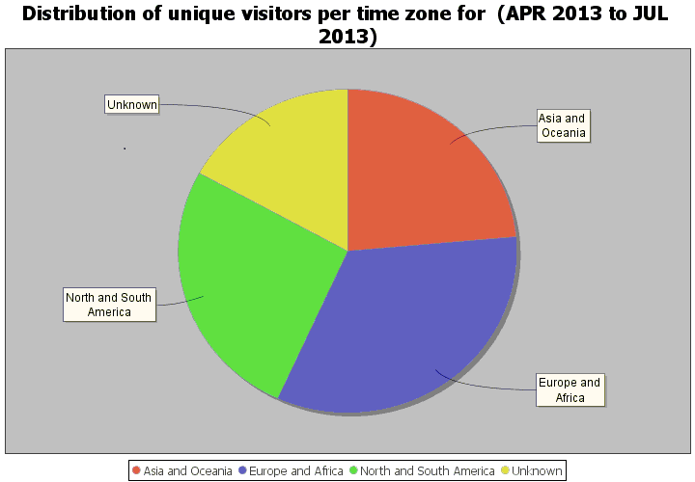

119 Users of other WIPO web sites show a similar geographical distribution as shown below (in the atlas, the thicker the color is, the higher the number of visitors to WIPO web sites).

Figure 4: WIPO Web site visitors
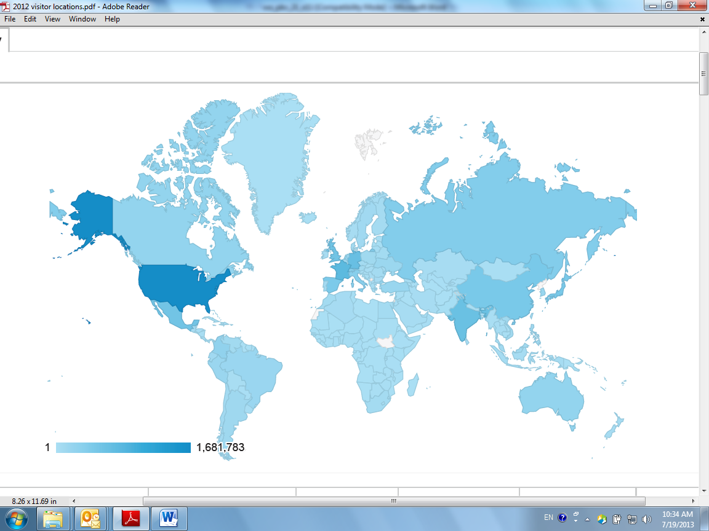

Table 8: Visitors to WIPO web site by country
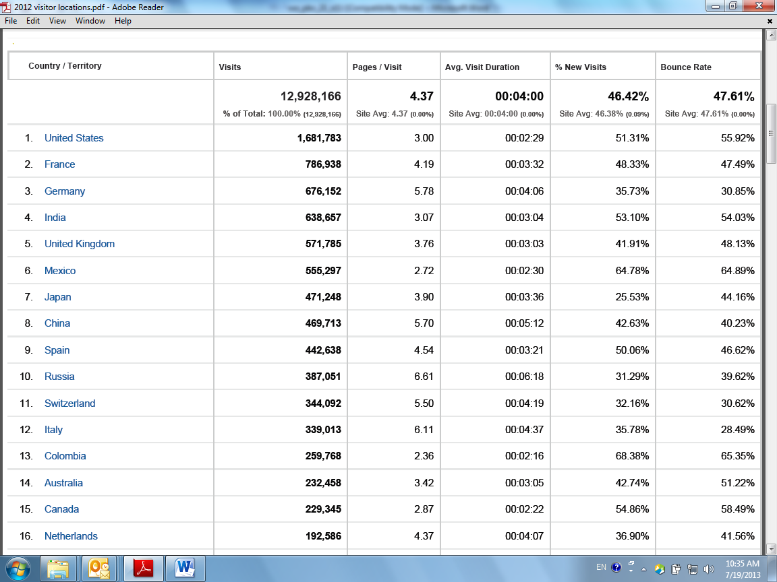

120 The geographical distribution of users of WIPO web services clearly indicates the need to create a global networked model of ICT infrastructure for effective delivery of WIPO services and information. The Secretariat’s internal and external expert studies confirmed an urgent need for adjustment of the current ICT architecture of WIPO to a modernized model pertinent to this century, which should, on the one hand, optimize the cost efficiency and added value in use of digital-networked delivery systems, and, on the other hand, mitigate any risks arising from the vulnerability of the model centered on a single place.

121 PATENTSCOPE and other WIPO websites contain published and non-confidential information. However, certain on-line services WIPO started recently, such as ePCT, contain highly confidential unpublished information of patent applications. It is crucial for the Organization to ensure the security of the Organization’s ICT platforms and systems, the capacity to provide business continuity in respect of them, the capacity to recover from a disaster and the capacity to provide consistent response times to users around the globe. These functions will be greatly enhanced by the strategic establishment of a limited number of mirror sites that can be administered or supervised through EOs.

Geographically representative

122 The locations of EOs need to be geographically representative. This does not mean that EOs should be offices representing the particular region, as explained above.

123 As described in the section on existing EOs, activities undertaken to assist the HQ in strengthening WIPO’s program activities for the provision of technical assistance and capacity building in a number of countries that were covered by those EOs proved to be cost effective, timely delivered, tailor-made to specific local needs, valuable, and supplementary to activities of WIPO HQ.

124 However, the existing EOs coverage is limited and there are many other Member States which could benefit from collaboration between WIPO HQ and EOs by creating new EOs in areas where there is extensive need for technical assistance and capacity building. The proposed Program and Budget addressed these needs by proposing two EOs in Africa where no EO has yet been established. Following a holistic approach to the issue of criteria and strategy for EOs, geographical distribution is particularly important to the delivery of WIPO’s services for technical assistance and capacity building.

125 As proposed in the Program and Budget 2014/15 (Program 15, Business Solutions for IP Offices), challenges facing the Secretariat include a shift from an initial deployment by the Secretariat of software packages and ICT systems for IP Office operation towards a more sustainable model in which IP Offices will take over the support and operation and acquire knowledge for further adaptation of the system. The initial intervention by the Secretariat for the deployment of the system requires a number of missions (for instance, more than 100 missions to 54 countries were undertaken in 2012 to deliver technical assistance to deploy and support IPAS and other business solutions applications, at a total cost of 635,000 CHF). In the service provider model, more resources would be devoted to providing software support using the Geneva-based development team, and delivery to IP offices would be handled, to the extent possible, by regionally-based staff. Overall coordination and direction would remain with the headquarters staff in Geneva. There would be a focus on knowledge transfer and promoting autonomy in the operation and support of systems within and between IP offices.

126 As many businesses have discovered, the importance of a local presence cannot be over-estimated. A regional expert, based in an EO (the WSO), is closer to the IP offices that need support, in the same time zone, often speaking the same language and sharing the same culture. These factors have intangible benefits that make the local support much more effective than remote support from Geneva.

127 The Secretariat will continue to intervene on-site whenever necessary, since there are always cases where remote intervention is not effective, especially in the area of knowledge transfer. New EOs are expected to be used as nodal points where technical experts are pooled and stationed for rapid delivery of services and on-site interventions. The presence of locally recruited experts should also contribute to effective transfer of knowledge, and enhancement of mutual support through creation of regional networks.

128 Experience of having technical experts on non-staff contracts has proved to be successful and demonstrated the potential of saving considerable resources. For instance, in 2012, WIPO had six locally recruited experts in the field (Africa, Latin America, Asia) and they supplemented technical assistance delivered by the HQ in a cost effective way. For comparison, a mission of one week by a local expert to a country in the same region typically costs around 2,500 CHF whereas the equivalent mission by Geneva-based staff would cost 7,000 CHF. The figures are similar for Africa, Asia and Latin America, and cost savings are less for the Arab and Eastern European regions. This means that significant cost savings are realized by having experts based in the regions, although the total cost saving depends on the extent to which local experts can substitute Geneva-based staff. In 2012, only one of the local experts was based in an EO (the WSO). The EOs provides office infrastructure such as robust secured network connectivity between WIPO HQ and EOs, administrative support, administrative supervision, and improves communications and coordination with Member States in the respective region through nodal points.

129 Many Member States IPOs have also established capability in IP operation, and partnerships with IPOs in those countries is strategically wise. Geographically representative presence of new EOs will address the future needs arising from countries which have proactively used IP for development. If IP statistics are not very helpful to measure the future potential, it may be useful to consider a list of countries which have started to develop IP technical infrastructure through the deployment of IPAS. The following list of countries which use IPAS may be a good indicator to discuss where nodal points for technical assistance could be effectively made and what countries could be better partners for the provision of technical assistance.

Table 9: Use of WIPO IP Office software packages; breakdown by country and by region (2012)
 | AIPMS | IPAS |  |  | WIPOScan
 |  | ID | P | TM
AFRICA (totals) |  |  | 8 | 15 | 7
ARIPO |  |  |  |  | 1
Botswana |  |  | 1 | 1 | 1
Ethiopia |  |  | 1 | 1
Gambia |  |  |  | 1
Ghana |  |  |  | 1
Kenya |  |  | 1 | 1 | 1
Madagascar |  |  | 1 | 1
Malawi |  |  |  | 1
Mauritius |  |  |  | 1
Mozambique |  |  | 1 | 1
Namibia |  |  |  | 1 | 1
South Africa |  |  |  |  | 1
Uganda |  |  |  | 1
United Republic of Tanzania |  |  | 1 | 1
Zambia |  |  | 1 | 1 | 1
Zanzibar (Tanzania) |  |  | 1 | 1
Zimbabwe |  |  |  | 1 | 1
ARAB (totals) | 10 |  | 1 | 3 | 3
Algeria | 1 |  |  | 1
Bahrain | 1
Egypt | 1 |  |  |  | 1
Jordan | 1
Kuwait | 1
Lebanon | 1
Morocco |  |  | 1 |  | 1
Oman | 1
Qatar | 1
Sudan | 1
Syria | 1
Tunisia |  |  |  | 1
United Arab Emirates |  |  |  | 1 | 1
ASPAC (totals) |  | 3 | 7 | 9 | 2
Bhutan |  |  | 1 | 1

Cambodia |  |  |  | 1
Indonesia |  | 1 | 1 | 1
Lao People's Democratic Republic |  |  |  | 1 | 1
Nepal |  |  | 1 | 1
Pakistan |  |  | 1 | 1
Papua New Guinea |  | 1 | 1 | 1 | 1
Philippines |  | 1 | 1 | 1
Sri Lanka |  |  | 1 | 1
CCEA (totals) |  | 1 | 4 | 6 | 1
Albania |  |  | 1 | 1
Azerbaijan |  |  |  |  | 1
Belarus |  |  | 1 | 1
Kosovo |  |  |  | 1
Macedonia |  |  | 1 | 1
San Marino |  | 1 |  | 1
Serbia |  |  | 1 | 1
LAC (totals) |  |  | 8 | 12 | 3
Argentina |  |  |  |  | 1
Bahamas |  |  |  | 1
Barbados |  |  |  | 1
Belize |  |  | 1 | 1
Brazil |  |  |  | 1
Chile |  |  | 1 | 1
Costa Rica |  |  |  | 1
Cuba |  |  | 1 | 1
Dominican Republic |  |  | 1 | 1 | 1
Jamaica |  |  | 1 | 1
Panama |  |  |  |  | 1
Saint Lucia |  |  | 1 | 1
Trinidad and Tobago |  |  | 1 | 1
Uruguay |  |  | 1 | 1
GRAND TOTALS | 10 | 4 | 28 | 45 | 16

NOTE: AIPMS; Arab IP Management System
IPAS ID; IP Office Administration System for Industrial Design
IPAS P; IPAS for Patents
IPAS TM; IPAS for Trademarks

Geographic representation of other similar UN specialized agencies and of IP institutions

130 The geographic representation of the offices of other similar UN specialized agencies reflects the strategic and organizational objectives of each individual agency. For comparison, the main regional, or other, offices of ITU, ILO, WHO and WMO are listed below with brief statements on the strategic function these offices hold within the structure of each agency. All information is taken from the agencies’ websites.

ILO

131 “ILO action in the field bring (sic) together regular budget and extra-budgetary activities, in full consultation with the tripartite constituents at the regional, sub-regional and country levels, to provide services in the areas of standards and fundamental principles and rights at work, employment, social protection and social dialogue. The network of field offices and technical specialists underpins the ILO’s work in promoting the Decent Work Agenda as an integral part of national development policies”.

- Ethiopia; ILO Regional Office for Africa - Addis Ababa
- Lebanon; ILO Regional Office for Arab States - Beirut
- Peru; ILO Regional Office for Latin America and the Carribean - Lima
- Thailand; ILO Regional Office for Asia and the Pacific - Bangkok

ITU

132 “ITUʼs policy on regional presence is designed to enable the Union to work as closely as possible with its members and to tailor ITU activities to meet the ever-increasing and diverse needs of the world's developing and least developed countries. ITU currently manages a network of thirteen field offices”. These are:

- Barbados; Bridgetown ITU Area Office
- Brazil; Brasilia ITU Regional Office
- Cameroon ; Bureau de zone de lÚIT Yaoundé
- Chile; Santiago ITU Area Office
- Egypt; Arab Regional Office
- Ethiopia; Regional Office - Addis Ababa
- Honduras; Oficina de Area de Tegucigalpa
- Indonesia; Jakarta ITU Area Office
- Russian Federation; Area Office (CIS) - Moscow
- Senegal; Area Office - Dakar
- Thailand; Regional Office for Asia and the Pacific - Bangkok
- United States of America; Liasion Office to the United Nations - New York
- Zimbabwe; Harare ITU Area Office

133 ITU field offices provide support for all Union activities, helping implement its strategic and policy objectives through direct, sustained contact with national authorities, regional telecommunication organizations and other relevant bodies. They also assist developing and least developed countries to meet their development goals. In addition to providing technical and logistical support to development activities, field offices fulfill the basic functions of the development sector as a specialized and executing agency, resource mobilizer and information center.

134 ITU’s regional presence serves also to assist the ITU General Secretariat, the Radiocommunication Bureau and the Telecommunication Standardization Bureau in fulfilling their missions by:
- promoting their work, representing them at regional and national events
- assisting them in organizing events of a regional character in their respective domain of activities or in joint activities with BDT
- representing ITU’s elected officials at regional events
- expressing the visions and the needs of the countries in the different domains of activities and proposing actions for responding to their needs.

WHO

135 “Each region of the world is served by a Regional Office with a responsibility to support the Member States in the generation and the use of appropriate health information to support decision making, health care delivery and management of health services, at the national and sub-national levels”.

- Congo; Regional Office for Africa - Brazzaville
- Denmark; Regional Office for Europe - Copenhagen
- Egypt; Regional Office for the Eastern Mediterranean - Cairo
- India; Regional Office for South-East Asia - New Dehli
- Philippines; Regional Office for the Western Pacific - Manila
- United States of America; Regional Office for the Americas - Washington

- Belgium; WHO Office at the European Union – Brussels
- France; International Agency for Research on Cancer (IARC) – Lyon
- Japan; WHO Centre for Health Development – Kobe
- Tunisia; WHO Mediterranean Centre for Health Risk Reduction - Tunis
- United States of America; WHO Office at the United Nations – New York, and WHO Office at the World Bank and the International Monetary Fund (Washington)

WMO
136 “The overall objective of the Regional Programme (RP) is to ensure the efficient and effective functioning of the six Regional Associations of the Organization in coordinating meteorological, hydrological, climatological and related activities of their Members. The RP provides a framework for regional cooperation in the implementation of the WMO strategies, policies and programmes taking into account regional requirements, capacities and priorities”.

“The Mission of the Regional Offices:

- Assist Members in their respective Regions to develop their national Meteorological or Hydrometeorological and Hydrological Services (NMHSs) to enable them to play their full role in the economic and social development of their countries as well as in any high priority areas of the Organization;
- Contribute to the development and implementation of the WMO Regional Programme and to assist the relevant Departments of the WMO Secretariat in discharging their responsibilities related to regional activities;
- Promote and advise Members on any new high-priority activities of the Organization such as those emanating from the follow-up to UNCED and other relevant global and regional Conferences;
- Liaise with bodies and agencies of the UN system located within the respective Regions and with regional inter-governmental bodies.”
137 The existing offices are:
- Bahrain; WMO Office for West Asia - Manama
- Costa Rica; WMO Office for North America, Central America & the Caribbean - San Jose
- Kenya; WMO Office for Eastern and Southern Africa - Nairobi
- Nigeria; WMO Office for North, Central and West Africa - Abuja
- Paraguay; Regional Office for the Americas (RAM) - Asuncion
- Paraguay; WMO Office for South America – Asuncion
- Samoa; WMO Office for South-West Pacific - Apia
- Switzerland; Regional Office for Africa (RAF) – WMO, Geneva
- Switzerland; Regional Office for Asia and the South-West Pacific (RAP) – WMO, Geneva
- Switzerland; Regional Office for Europe (ROE) – WMO, Geneva

IP Institutions

138 IP Institutions such as national IP Offices and regional IP Organizations have geographic representation in certain regions in order to execute projects in collaboration with the host country, advocate best IP rights management practices in the region and reach out to and foster relations with users of IP registration services rendered by the IP institutions. For instance, the Trade Marks and Designs Registration Office of the European Union (OHIM) has a representation in China, Mexico and Thailand. The United States Patent and Trademark Office instituted its Overseas Intellectual Property Rights Attaché program and it has a geographic representation in Brazil, China, Egypt, India, Mexico, Russian Federation, Switzerland and Thailand. Similarly, the United Kingdom IP Office has a representation in the ASEAN region, Brazil, China and India. In the region of ASEAN, there are several IP Attachés established by IP institutions (see paragraph 31 above). These Institutions apparently believe that it is beneficial to an IP Institution to establish and maintain representation in these regions.

Other Geographically Representative Factors
139 To show the remoteness of locations from Geneva, the following table may be useful. According to the current policy of WIPO, flights shorter than 9 hours are in economy class, and this is reflected in the following travel cost estimate.

Table 10: Distance and travel cost to various locations
Countries |  | Travel time in hours | Travel cost in CHF
Africa | Algeria | 2.00 | 745
Africa | Cameroon | 9.50 | 4,090
Africa | Egypt | 4.00 | 633
Africa | Ethiopia | 9.40 | 3,106
Africa | Morocco | 2.55 | 533
Africa | Nigeria | 8.50 | 1,133
Africa | Senegal | 7.35 | 1,320
Africa | South Africa | 12.15 | 4,221
Africa | Tunisia | 1.55 | 480
Africa | Zimbabwe | 13.05 | 3,955
Asia and the Pacific | Bangladesh | 13.15 | 3,498
Asia and the Pacific | China | 10.30 | 3,479
Asia and the Pacific | India | 9.20 | 3,047
Asia and the Pacific | Jordan | 5.50 | 940
Asia and the Pacific | Republic of Korea | 12.00 | 3,431
Asia and the Pacific | Turkey | 3.00 | 739
Countries in transition | Romania | 4.00 | 674
Countries in transition | Russia Federation | 3.30 | 576
Latin America and the Caribbean | Chile | 19.05 | 5,016
Latin America and the Caribbean | Mexico | 13.55 | 3,940
Latin America and the Caribbean | Panama | 14.45 | 4,252
Latin America and the Caribbean | Peru | 15.40 | 3,998
America | USA (West coast) | 14.35 | 5,185
140 In order for EOs to function as a nodal point to provide services to the host country and the zone of influence, it is necessary for an EO to be located in the country which has a good hub airport with effective travel connectivity.

141 In conclusion of this section, if a proposal of WIPO’s global, small, strategically positioned and geographically representative network of EOs is supported by Member States, this will facilitate further consideration of the criteria of EOs. Before discussing the criteria, it may be useful to make it clear that WIPO’s strategic objectives would continue to apply to new external offices within the results framework and the governance of the Program and Budget.

Monitoring of strategic objectives

142 The Existing EOs are an integral part of WIPO’s results-based management framework. Like any other organizational unit at WIPO, the work of the existing EOs is governed by a comprehensive results framework comprising of expected results, indicators, baselines and targets (see pages 144-146 in the draft Program and Budget 2014/15 (English version) ). The strategic goals and expected results to which a particular external office contributes will depend on its defined functions.

143 The biennial results frameworks form the basis for annual workplans for each existing EO which are reviewed for organizational consistency and coherence and approved by the Director General.

144 The results frameworks also form the basis for monitoring and assessing organizational performance, both internally on a continuous basis within the Secretariat and through the performance dialogue with Member States on the annual and biennial Program Performance Reports. Satisfactory or unsatisfactory performance by EOs based on the performance criteria supports decision-making regarding renewal of the mandate of the EOs, eventual corrective measures and, in the extreme case, closure.

145 The performance of new EOs would be subject to the development of similar comprehensive results framework to those for existing EOs in the draft proposed Program and Budget for the biennium 2014/15. Such frameworks will be developed as soon as new EOs are approved by the WIPO Assemblies and will be reported on in subsequent PPRs.

Criteria

146 Analysis of needs, strategic objectives and the requirements for implementing a proposed strategy leads to elements which may be considered as indicators of criteria for selecting new EOs. Some data are given below, bearing in mind a proposed strategy, that is, to use EOs to contribute to the achievement of strategic goals through a global, small, limited, strategically- positioned, geographically representative network of EOs with a view to add value by providing political and logistical support for the delivery of the strategic objectives of the Organization in a way that cannot be achieved through operations at HQ alone.

147 Apart from general information about the host country, such as the size of the country and population, other UN agencies (generally humanitarian aid agencies) appear to have considered such elements as financial structure (measured by salary levels), infrastructure (ICT connectivity), people’s skills and ability (human development index) and environment (political stability, flight availability, etc.). In addition to these generic UN factors, it is useful to examine other factors particularly relevant to WIPO’s mission. Recalling that WIPO encourages and promotes innovation and creativity through the IP system, the host country is expected to share the common goal. In this regard, the degree of innovation and creativity recently measured by the Global Innovation Index 2013 may be a good reference.

148 In the case where Strategic Goal II, Provision of Premier Global IP Services is relevant to the host country concerned, the intensity of IP activities and the concentration of users of WIPO Global IP Services are relevant elements and the most authoritative and representative indicator may be the number of PCT applications.

149 In the case where Strategic Goal III, Facilitating the Use of IP for Development is relevant to the host country concerned, certain elements concerning the delivery of technical assistance and capacity building are important to consider. In this regard, the minimum technical infrastructure (such as Internet connectivity and stable supply of electricity) for this assistance, as measured by the Infrastructure index included in the Global Innovation Index could be useful. A list of IPAS system users indicated above may be also relevant.

150 WIPO will continue to work with other UN specialized agencies, as described in the proposed Program and the Budget (see Program 20). The presence of other UN organizations, in particular, those with which WIPO has strengthened collaboration, may facilitate the continued partnerships also through EOs. In this regard, the location of other UN agencies such as ITU and WHO, as listed in the previous section could be relevant. Based on the recent experience gained by the existing EOs, however, collaboration with other UN EOs in the field did not yield noteworthy results, mainly because the expertise required for technical assistance and capacity building in the field of IP could not be found except in WIPO itself.

151 To summarize, the following indicators may be useful to discuss criteria:

- Global Innovation Index;
- PCT applications;
- Infrastructure index;
- Travel connectivity (represented by ranking of hub airports);
- Institutional Considerations.

152 Without prejudice to the adoption of these indicators as criteria, the following table shows value of the indicators of each location by world rank.

Table 11: Locations and their positions in the respective world ranking

Countries |  | A | B | C | D | E | F | G | H | I
Africa | Algeria | 10 | 34 | 138 | 140 | 90 | 129 | - | 93 | 93
Africa | Cameroon | 51 | 54 | 125 | 110 | 91 | 102 | - | 150 | 126
Africa | Egypt | 29 | 16 | 108 | 114 | 51 | 125 | - | 112 | 66
Africa | Ethiopia | 28 | 13 | 129 | 117 | - | 137 | - | 173 | 113
Africa | Morocco | 54 | 39 | 92 | 107 | 52 | 95 | - | 130 | 87
Africa | Nigeria | 30 | 7 | 120 | 74 | 73 | 139 | - | 153 | 133
Africa | Senegal | 85 | 70 | 96 | 62 | 109 | 86 | - | 154 | 104
Africa | South Africa | 24 | 25 | 58 | 68 | 27 | 68 | 74 | 121 | 83
Africa | Tunisia | 91 | 79 | 70 | 33 | 84 | 81 | - | 94 | 68
Africa | Zimbabwe | 60 | 71 | 132 | 93 | 95 | 120 | - | 172 | 132
Asia and the Pacific | Bangladesh | 94 | 8 | 130 | 131 | - | 134 | - | 146 | 109
Asia and the Pacific | China | 2 | 1 | 35 | 96 | 4 | 106 | 2 | 101 | 44
Asia and the Pacific | India | 7 | 2 | 66 | 65 | 19 | 123 | 34 | 136 | 89
Asia and the Pacific | Jordan | 110 | 105 | 61 | 59 | 101 | 91 | - | 100 | 90
Asia and the Pacific | Rep. Korea | 105 | 26 | 18 | 54 | 5 | 56 | 33 | 12 | 4
Asia and the Pacific | Turkey | 36 | 18 | 68 | 69 | 25 | 117 | 30 | 90 | 73
Countries in transition | Romania | 80 | 55 | 48 | 80 | 59 | 63 | - | 56 | 35
Countries in transition | Russian Fed. | 1 | 9 | 62 | 101 | 21 | 113 | 54 | 55 | 49
Latin America and the Caribbean | Chile | 37 | 59 | 46 | 96 | 39 | 41 | - | 40 | 40
Latin America and the Caribbean | Mexico | 14 | 11 | 63 | 48 | 33 | 105 | 53 | 61 | 57
Latin America and the Caribbean | Panama | 116 | 129 | 86 | 45 | 64 | 76 | - | 59 | 62
Latin America and the Caribbean | Peru | 19 | 40 | 69 | 41 | 73 | 104 | - | 77 | 64
America | USA | 3 | 3 | 5 | 19 | 1 | 44 | 22 | 3 | 17
Existing EOs | Brazil | 5 | 5 | 64 | 72 | 24 | 71 | 96 | 85 | 51
Existing EOs | Japan | 61 | 10 | 22 | 63 | 2 | 21 | 5 | 10 | 9
Existing EOs | Singapore | 184 | 115 | 8 | 40 | 22 | 10 | 18 | 18 | 6
HQ | Switzerland | 131 | 95 | 1 | 2 | 8 | 6 | - | 9 | 8

A: World rank by surface area (World Bank data)
B: World rank by population (World Bank data)
C: World rank by Innovation Index (The Global Innovation Index 2013)
D: World rank by creative outputs (The Global Innovation Index 2013)
E: World rank by PCT applications in 2012 (WIPO Country Database, WIPO)
F: Political Stability Indicator (The Global Innovation Index 2013)
G: World rank of airports by Airports Council International (the airport located in the capital)
H: Human Development Index (UNDP 2013)
I: Infrastructure Index (The Global Innovation Index 2013)

Analysis of the five proposed EOs

153 The five proposed EOs will have general strategic objectives and specific priorities to respond to local needs. General objectives are to contribute to all strategic goals of the Organization. Without prejudice to the outcome of the consultation, strategic objectives of the five proposed offices may correspond to the following WIPO strategic goals.

Table 12: The links between Objectives of the Proposed EOs and WIPO Strategic Goals
Strategic Goals | Africa | China | Russian Federation | USA
II Provision of Premier Global IP Services |  | x | x | x
III Facilitating the Use of IP for Development | x | x | x
IV Coordination and Development of Global IP Infrastructure | x | x | x | x
VII Addressing IP in Relation to Global Policy Issues | x | x | x | x
VIII A Responsive Communications Interface between WIPO, its Member States and All Stakeholders | x | x | x | x

154 As summarized in paragraph 82, the existing EOs have added value and not duplicated work performed at HQ in five areas. It is expected that the proposed EOs will achieve similar results by caring out the following five functions and depending on the local priorities and objectives of each EO, some or all of the five functions are carried out. For instance, apart from the third function which is a new proposition, the existing offices perform all the other four functions. As regards the third function (the administration of mirror sites for the Organization’s ICT systems and the delivery of services in case of disruption of services at WIPO HQ in Geneva), it is expected that two EOs should be able to function as back-ups and additional capabilities of redundancy which should constitute a dynamic and resilient network of institutions in the world. In summary, five functions indicated below are cumulative and supplementary to the functions of WIPO HQ.

- local support services for WIPO’S Global IP Systems;
- to provide support for WIPO’s general customer response network;
- the administration of the requisite redundancy capacity and/or mirror sites for the Organization’s ICT systems, platforms and databases of the purposes of ICT security, business continuity, disaster recovery and load-sharing;
- the provision of technical support in relation to the various technical assistance programs administered in the Global Infrastructure Sector of the Organization; and
- general capacity building and other development cooperation activities.

China

155 China has a population of 1.3 billion people. Its national language is Mandarin, which is one of the official languages of WIPO and the UN. It has the largest trademark office in the world, the largest patent office, the largest designs office and one of the largest and most vibrant creative sectors.

156 Intellectual property activity in China is exploding. Over the past 15 years, the number of patent applications filed in China has risen from 18,699 to 526,412; the number of trademark applications from 172,146 to 1,057,480; and the number of industrial design applications from 17,688 to 521,468:

Figure 5: Patent, Trademark and Industrial Design Applications in China
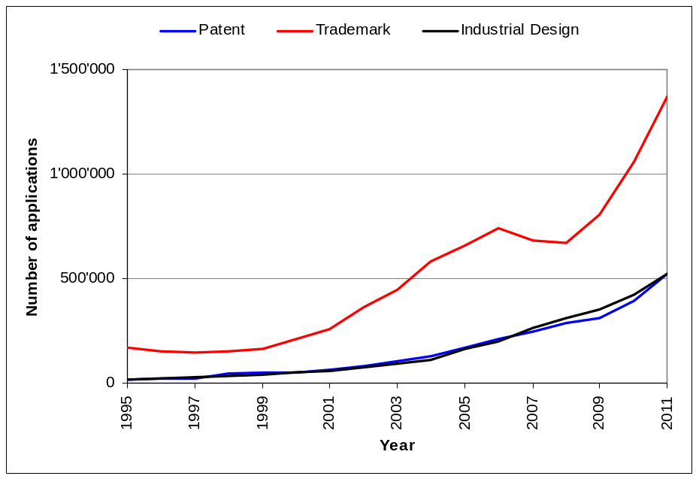
157 The number of domestic IP applications in China that are being internationalized through filings under WIPO’s Global IP Systems is growing at a very rapid pace. China files just over
10 per cent of PCT applications and is expected to pass Germany in 2013 to become the third largest filer of PCT applications after the United States of America and Japan. It is the eighth largest filer of Madrid applications (filing over 5 per cent of all Madrid applications) and the most designated country in the Madrid System (that is, the country that applicants around the world designate most frequently to obtain protection for their marks). It is actively examining accession to the Hague System.

158 The existing use by China of WIPO’s Global IP Systems is one of the most active in the world. When the level of domestic applications is considered, the potential for further growth in use of WIPO’s Systems is enormous. To achieve this, however, intense engagement with the enterprise sector in China, in the Chinese language, is required. Rare would be the Organization that relies on China for a substantial part of its revenue and that does not have a presence in China to service the Chinese market. It may also be expected that China will, in the future, play an increasingly important role in capacity-building activities.

Russian Federation

159 The Russian Federation is the ninth most populous country in the world, with a population of over 140 million people. Russian is one of the official languages of both the UN and WIPO and is also widely spoken throughout Central Asia and Eastern Europe.

160 The importance of intellectual property and innovation in the sustainable economic development of the Russian Federation has been emphasized by the country’s leadership. The scientific tradition in the country is extremely strong and the creative output in literature, film and music is rich. The use of intellectual property has been steadily increasing. Over the past 15 years, the number of patent applications filed in the Russian Federation has risen from 24,444 to 41,414; the number of trademark applications from 21,403 to 56,856; and the number of industrial design applications from 1,370 to 3,997:

Figure 6: Patent, Trademark and Industrial Design Applications in the Russian Federation
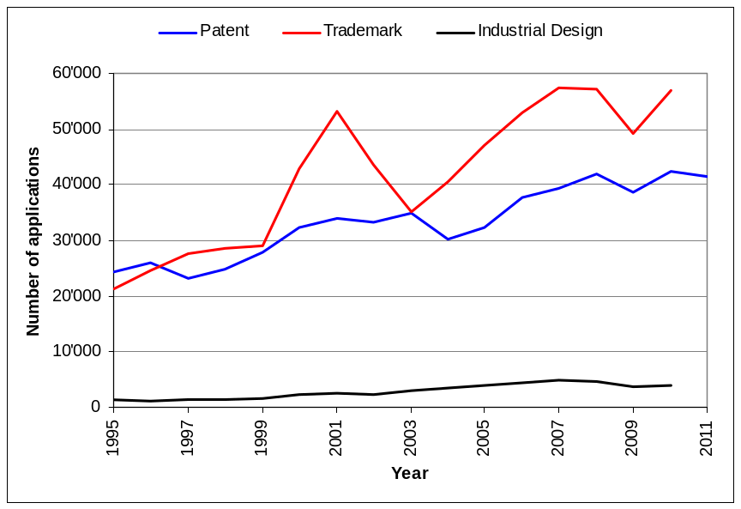
161 The use of WIPO’s Global IP Systems by the Russian Federation has also been rising. PCT applications filed by applicants in the Russian Federation have risen considerably over the past five years. The number of Madrid applications in 2012 rose by 19.7 per cent (having increased by 35.6 per cent in the preceding year), making the Russian Federation the ninth largest filer in the Madrid System. It was also the third most designated country in the Madrid System. The Russian Federation is actively considering accession to the Hague System.

162 An EO in the Russian Federation would offer considerable advantages in terms of strengthening the participation of the country in WIPO’s Global IP Systems, enabling the Organization to service more effectively a vast territory and its surrounding region, and would assist in building capacity for the use of IP in a region where most national economic strategies aim to use a rich resource base as a foundation for value addition in more knowledge-based industries.

United States of America

163 The USA is the largest economy in the world, with the third-largest population. It is the largest filer of PCT applications, filing around 27 per cent of all applications. It is the second largest filer of Madrid applications, filing 12.3 per cent of all applications, and is the third most designated country in the Madrid System. It is expected to accede to the Hague System in the near future. It also has the largest concentration of creative industries in the world. It is, in short, the largest producer of innovation and creative outputs in the world.

164 The State of California is the home of the much admired and much emulated Silicon Valley, a pioneer of the successful innovation ecosystem. Almost half of PCT applications filed from the United States of America and more than 10 per cent of total PCT filings have at least one applicant or inventor with an address in California. The University of California files more PCT applications than any other university in the world. According to figures from the United States Patent and Trademark Office (USPTO), the share of US patents granted to Californian applicants has steadily increased over the past years, reaching 25.4 per cent of all patents granted to US residents in 2010. California is also the home of Hollywood, the highest value film industry in the world.
165 Enormous opportunity exists to increase the use of WIPO’s Global IP Systems through a presence in Silicon Valley. Such a presence would also offer a more effective way of servicing the largest customer base of those Systems in the world.

Africa

166 Africa comprises 54 countries and a vast territorial area and is not represented in the existing EOs. The interest in both WIPO and IP has been growing steadily in the region, particularly now that growth rates have stabilized and that Africa is, overall, the fastest growing region of the world economy. The need for capacity-building activities in order to increase the region’s use of, and participation in, the intellectual property system is huge.

167 The proposed EOs in Africa would focus essentially on capacity building, as described in the outline of the functions of EOs given above. Locations within Africa for the two proposed offices have not been specified, as this is the subject of a continuing discussion with and within the African Group.

Map of External Offices (Existing, Proposed and Requested)

168 The following map illustrates locations of the existing EOs and all locations of capitals or cities from countries which have filed requests before July 2013 with the Director General to host new EOs.

Figure 7: Locations of external offices (including those requested by certain Member States)
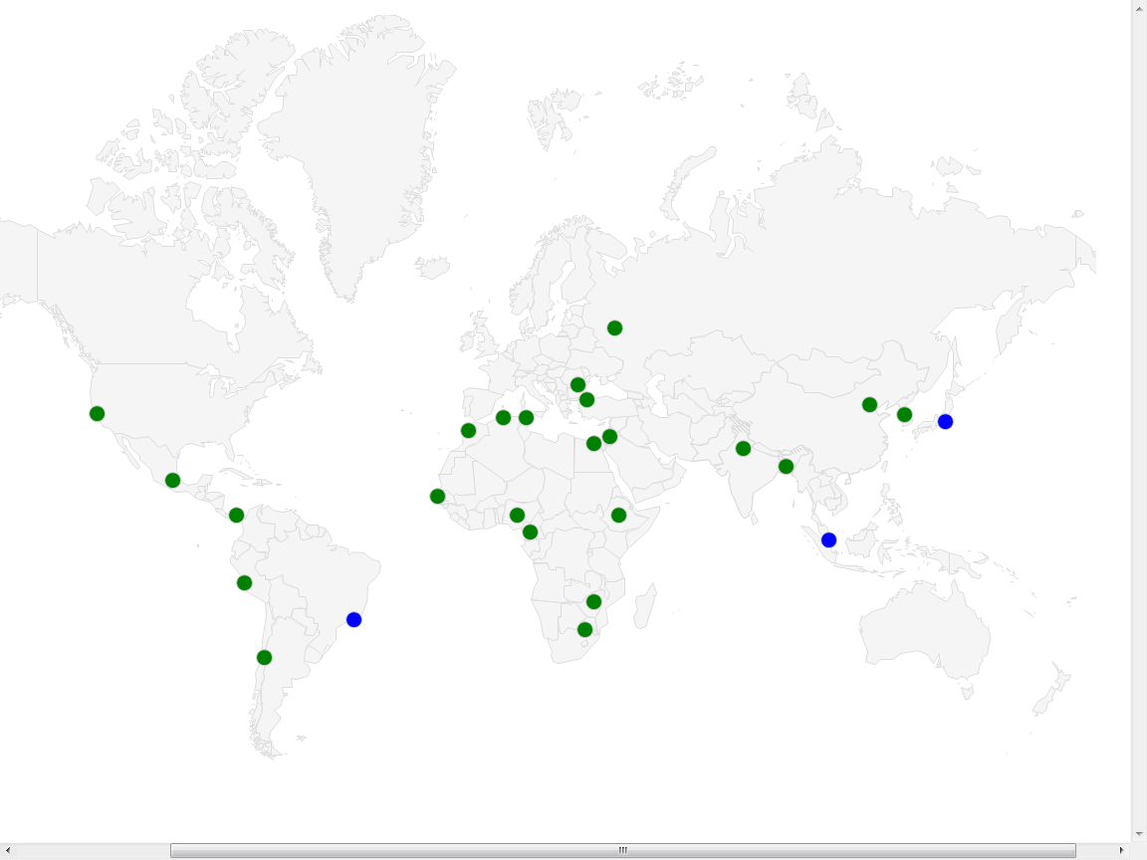

Cost, Financial Details and the Proposed Budget

169 The resources proposed for new EOs allocation is based on a standard model of a new EO, which is similar to existing offices, in which the following staff will gradually be deployed:

- One Director of the Office;
- One or two Professional grade staff for the management and implementation of program activities;
- One general-service staff (most likely recruited locally as a short-term employee at an initial stage).

170 The cost estimate of each EO for human resources also depends on the local job markets. To give an idea of the estimated cost in countries which requested WIPO EOs, without prejudice to the selection of new EOs, the following table shows the post adjustment of professional staff in locations of the current 23 applications, alongside with existing EOs and WIPO HQ for comparison. It is to be noted that the lower post adjustment in some of the duty stations listed may in part or in total be offset by higher costs of assignment grant and other benefits related to field duty stations. The amounts depend also the mobility status of the job holder and on the hardship classification of the duty station.

Table 13: Post Adjustment index in different locations

Countries |  | Post adjustment index (ICSC data as of July 15, 2013)
Africa | Algeria | 143.2
Africa | Cameroon | 150.6
Africa | Egypt | 134.3
Africa | Ethiopia | 141.9
Africa | Morocco | 136.3
Africa | Nigeria | 174.1
Africa | Senegal | 156.4
Africa | South Africa | 128.4
Africa | Tunisia | 125.1
Africa | Zimbabwe | 151.5
Asia and the Pacific | Bangladesh | 143.9
Asia and the Pacific | China | 170.1
Asia and the Pacific | India | 136.1
Asia and the Pacific | Jordan | 147.4
Asia and the Pacific | Republic of Korea | 166.7
Asia and the Pacific | Turkey | 144.6
Countries in transition | Romania | 122.8
Countries in transition | Russian Federation | 180.4
Latin America and the Caribbean | Chile | 138.7
Latin America and the Caribbean | Mexico | 151.6
Latin America and the Caribbean | Panama | 136.7
Latin America and the Caribbean | Peru | 147.9
America | USA | 159.1
Existing EOs | Brazil | 171.6
Existing EOs | Japan | 198.3
Existing EOs | Singapore | 193.2
HQ | Switzerland | 195.9

171 Lastly, it is expected that the premises will usually be provided by the host government. Any additional contribution and in-kind support such as personnel resources will also have to be factored in.

172 The draft Program and Budget has been prepared on the assumption that the five proposed EOs will gradually be staffed by using existing posts without increasing the headcount of the Organization. WIPO’s HR Strategy does not make specific reference to EOs but states in a general way that new activities have to be funded by redeployment of existing resources. The phased implementation of the EOs has been factored in the estimate of personnel resources required for external EOs. The Secretariat introduced in the revised SRR the category of National Professional Officers (NPO) who are recruited locally at a duty station outside of Geneva. Salary scales for the NPO category are established on a local basis by comparison with best prevailing conditions of service in the duty station. NPOs are also entitled to the same allowances and benefits as General Service staff except for overtime compensation. It is also to be noted that the post adjustment applies only to internationally-recruited staff and that NPOs do not get post adjustment. The availability of local corporations providing administrative support will be considered.

173 Taking all the above factors into consideration, the estimated costs in the biennium 2014/15 for the existing EOs and the five proposed EOs are included in the table below.

Table 14: Estimated Resources of the five proposed EOs in 2014/15
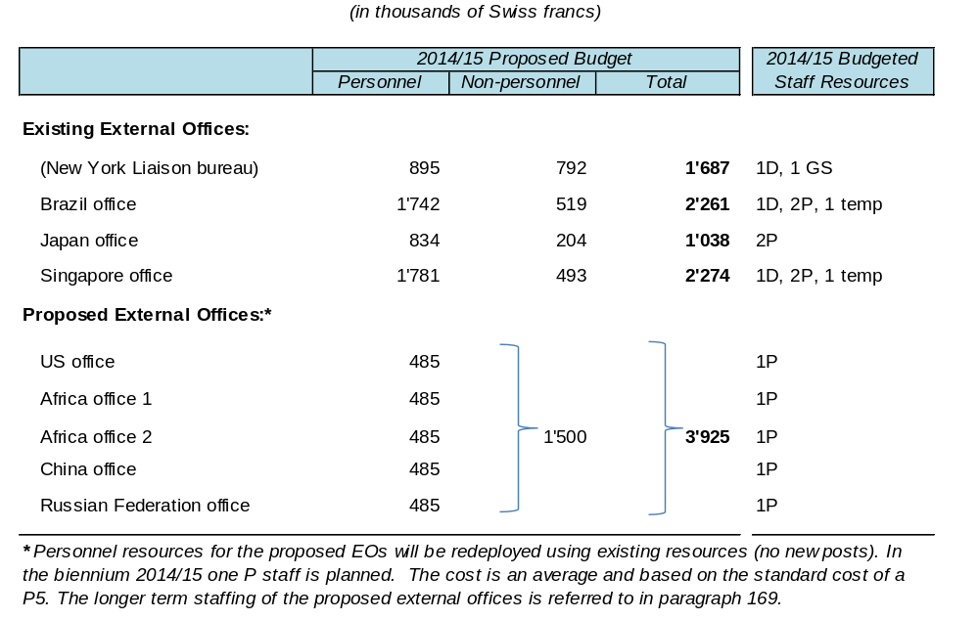

174 As part of WIPO’s business continuity and disaster recovery plan which will involve certain EOs, resources requirements for the two mirror sites to create the desired redundancy capability will be met by other relevant Programs in order to gradually develop processing team capacities, one for the PCT, and the other for the Madrid/Hague operation.

Legal Issues and Procedures for creating new EOs

175 The decision to establish a new EO is taken by the Assemblies in the adoption of the Program and Budget and upon the advice and recommendation of the PBC. A separate question from the decision to establish an EO is the terms and conditions under which the EO will operate in a host country. These terms and conditions, including the application of privileges and immunities, are defined in an agreement which is submitted to the Coordination Committee for approval. This agreement does not constitute the agreement to establish an EO, but constitutes the agreement of the terms and conditions under which an EO will operate. As described above, the existing EOs were included in the Program and Budget for approval by the Assemblies meetings.

176 As regards a question raised by some delegations at the July session of the PBC in connection with the procedures and legal questions on agreements with Russian Federation and China, the Legal Counsel clarified this matter. The Secretariat signed the agreements and included express provisions in both agreements that they were subject to confirmation by the Coordination Committee. This has been the practice each time an agreement is submitted to the Coordination Committee for its approval. If the Member States so wish, the practice can be changed such that, in future, agreements will only be signed after they have been approved by the Coordination Committee. They do contain the necessary provision: Article 8(3) of the agreement with the People’s Republic of China, and Article 7(3) of the agreement with the Russian Federation both state that they “shall enter into force on the date of the last notification where either Party notifies the other in writing of the completion of the respective internal procedures required for the entry into force” of the agreements. Only the Coordination Committee gives its approval under WIPO’s internal procedures.

Beyond the Proposed Five

177 It is considered that the establishment of EOs is a process, rather than a single event. Five new offices within a Biennium represent what is considered to be optimal in order to ensure a smooth deployment of a geographically representative and strategically important sample. However, there are strong demands for additional offices. The Group of Latin America and the Caribbean (GRULAC) has called for the establishment of a second office in the region, notably one that might be located in a Spanish-speaking country. The countries of GRULAC consider that the proposal in the draft Program and Budget should be expanded to six EOs, including a second office in Latin America as the sixth. India, the second most populous country in the world and the tenth largest economy in the world, has also requested to host an EO. It is understood that the patience being demonstrated by India for the coming Biennium, does not lessen the strength of its conviction that an EO should be established in India. The list could be further extended. These other demands will need to be discussed and decided upon.

178 As agreed at the PBC in July 2013, further informal consultations are planned on the basis of this document, and a member-driven process will determine what process should be established to decide whether and what additional EOs should be created in the next biennium and beyond.

List of Documents in Annex

179 At the request of several delegations, this document reproduces the previously published relevant documents as annexes, as follows:

Annex I Paragraph 144 of document WO/PBC/4/2
Annex II Annex IV of document WO/CC/52/1
Annex III Paragraphs 67 and 142 of document A/40/7
Annex IV Annex I of document WO/CC/53/2
Annex V Paragraphs 38 and 141 of document A/41/17
Annex VI Document WO/PBC/12/3 (Program 02 External Coordination)
Annex VII Paragraph 39 of document A/46/12
Annex VIII Document WO/CC/62/3
Annex IX Document WO/CC/62/4
Annex X Page 122 of document WO/PBC/13/4
Annex XI Document A/48/12 Rev.
Annex XII Paragraph 262 of document A/48/26
Annex XIII Information note distributed at the first informal consultation in 2010
Annex XIV Information note distributed at the second informal consultation in 2011
Annex XV White Paper distributed at the Program and Budget Committee in July

[Annexes follow]

