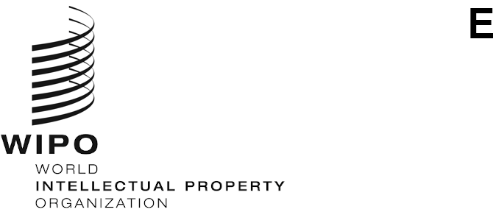
WO/GA/54/1
ORIGINAL: english
DATE: august 3, 2021

WIPO General Assembly

Fifty-Fourth (25th Ordinary) Session
Geneva, October 4 to 8, 2021

composition of the program and budget committee
Document prepared by the Secretariat
The members of the WIPO Program and Budget Committee (PBC) are elected for a period of two years.
At its meeting in October 2019, the WIPO General Assembly unanimously elected the following States as members of the PBC for the period from October 2019 to October 2021: Algeria, Angola, Azerbaijan, Bangladesh (2020-2021), Belarus, Brazil, Canada, Chile, China, Czech Republic, Dominican Republic, Egypt, El Salvador, France, Gabon, Germany, Greece, Guatemala, Hungary, India (2019-2020), Indonesia, Iran (Islamic Republic of) (2020-2021), Italy, Japan, Kazakhstan, Kenya, Latvia, Malaysia (2020-2021), Mexico, Morocco, Nepal, Nigeria, Oman (2019-2020), Pakistan, Panama, Peru, Philippines (2019-2020), Republic of Korea (2019-2020), Republic of Moldova, Romania, Russian Federation, Senegal, Serbia, Singapore (2019-2020), Slovakia, South Africa, Spain, Sweden, Switzerland (ex officio), Tajikistan, Thailand (2020-2021), Tunisia, Turkey, United Arab Emirates (2020-2021), United Kingdom, United States of America, Uruguay, Viet Nam (53).

As the mandate of the current members of the PBC expires in October 2021, new members must be elected by the WIPO General Assembly for the period from October 2021 to October 2023.
The WIPO General Assembly is invited to decide on the membership and composition of the Program and Budget Committee for the period from October 2021 to October 2023.
[End of document]

