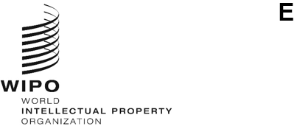
WO/CC/82/inf/2
ORIGINAL: English
DATE: may 31, 2023
WIPO Coordination Committee
Eighty-Second (54th Ordinary) Session
Geneva, July 6 to 14, 2023
ANNUAL REPORT BY THE ETHICS OFFICE
prepared by the Secretariat

Introduction
- This report is submitted to the WIPO General Assembly, through the Director General, in accordance with Office Instruction No. 16/2020 entitled “WIPO Ethics Office.” It describes the key activities undertaken by the Ethics Office in 2022.
- The Ethics Office was established in 2010 to support the Director General in ensuring that all WIPO personnel maintain the highest standards of ethics and integrity as required by the WIPO Convention, the Standards of Conduct for the International Civil Service, the Staff Regulations and Rules, the WIPO Code of Ethics, and relevant policies and procedures.
- The objective of the Ethics Office is to promote an organizational culture of ethics based on shared values of independence, loyalty, impartiality, integrity, accountability and respect for human rights. The Ethics Office fulfills this mission by providing services to WIPO’s international workforce, including senior management, in the following broad areas of responsibility:
  - Confidential advice and guidance;
  - Ethics training, awareness raising and outreach;
  - Standard setting and policy advocacy;
  - Administration of the protection against retaliation policy; and
  - Administration of the financial disclosure and declaration of interest (FDDI) policy.
- The Office is headed by a Chief Ethics Officer, who is functionally and operationally independent from WIPO management. In 2022, the Office staff also included an intern and temporary consultative and administrative support.

II. REPORT ON 2022 ACTIVITIES
- In 2022, the Ethics Office saw a noticeable increase in requests for its services. Despite challenges in managing the workload, the Office operated effectively and delivered record results.
- The Chief Ethics Officer met regularly with the Director General to discuss issues of general concern. The Chief Ethics Officer also kept the Director General and the Independent Audit and Oversight Committee (IAOC) apprised of the performance of the ethics function.

A. CONFIDENTIAL ADVICE AND GUIDANCE
- The Ethics Office plays a key role in supporting WIPO’s ethical values by providing confidential ethics advice to all WIPO personnel. This includes managing potential conflicts of interest and advising on complex ethical issues before they escalate, thereby avoiding operational and reputational damage. In this way, the Ethics Office also plays a fundamental role in risk management, promoting awareness of and compliance with applicable rules, policies and standards of conduct. Serving as a trusted consultative resource for all personnel, the Ethics Office also provides a confidential space to raise concerns and seek guidance.
- In 2022, the Ethics Office responded to 155 individual requests for ethics advice, through in-person and virtual meetings or in writing. Figure 1 summarizes the requests from 2018 to 2022.
- A comparison of the number of requests received in 2022 to those received in 2021 shows a considerable increase, above 300 per cent. This reflects strengthened staff and management engagement with the Ethics Office, and indicates a high level of trust in the Ethics Office as a resource for advice and a “safe space” for practical guidance and support. The higher number is also attributable to the Ethics Office’s proactive approach to outreach and training activities. The Ethics Office received a very high number of requests from the Human Resources Management Division (HRMD) to assess potential conflicts of interest related to the engagement of personnel in outside activities and employment, and this significantly increased the workload.

Figure 1. Comparison of requests per reporting year, 2018 to 2022
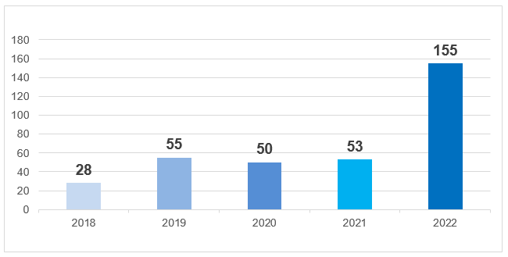
- Requests for advice and guidance covered a broad range of categories (see Figure 2). The majority concerned participation in outside activities and employment (66, or 42 per cent) such as speaking engagements, teaching assignments and publishing, often on the topic of intellectual property (IP). Most of these requests (53) did not come directly to the Ethics Office, but rather through the HRMD. In these cases, the Ethics Office provided advice to the Director, HRMD on potential conflicts of interest, although not having a dedicated role in the review of these cases under the current policy on outside activities. In other situations (13), individuals asked the Ethics Office whether an activity was appropriate (serving on a board of directors, providing third-party services, using WIPO information in written and research assignments, etc.), and the Ethics Office directly advised the individuals concerned.
- The other major categories of requests related to other conflicts of interest (32, or 21 per cent), standards of conduct (19, or 12 per cent) and other ethics advice (14, or 9 per cent) related to the fair and transparent application of policies and procedures, the reporting of misconduct including harassment and sexual harassment, and other workplace concerns.
- The Ethics Office also recorded requests in the following categories: gifts (12, or 8 per cent), financial disclosure (4, or 3 per cent), and retaliation (8, or 5 per cent) (see Section D).
Figure 2. Breakdown of advice by category
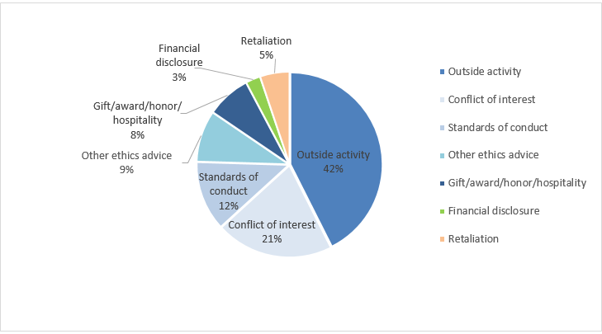
- As shown in Figure 3, the majority of requests were made by WIPO personnel (91). Within this category, 84 came from staff members, seven from non-staff personnel. The Ethics Office also received departmental requests from HRMD on outside activities (53), and “Management” requests, meaning queries from WIPO personnel in the performance of their official managerial function (10). There was one request from a former member of WIPO personnel.
Figure 3. Origin of requests
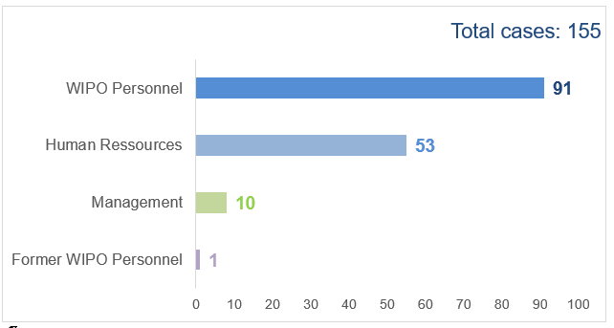

- A total of 149 requests (95 per cent) out of 155 were substantively handled solely by the Ethics Office. In a small number of cases (8, or 5 per cent), the Ethics Office directed staff and non-staff personnel to seek external support for matters related to grievances, dispute settlements and for reporting alleged wrongdoing. Referrals were made to HRMD, the Office of the Ombudsperson (OMB), the Internal Oversight Division (IOD), and the Office of the Legal Counsel (OLC) (see Figure 4).
Figure 4. External referrals
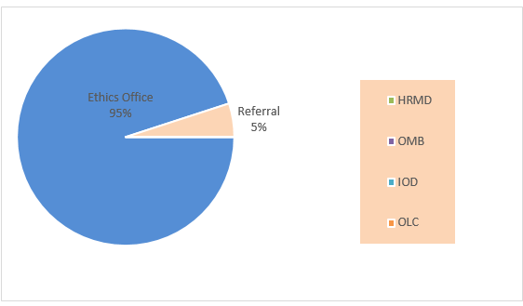

B. AWARENESS RAISING AND TRAINING
- The awareness-raising and training activities of the Ethics Office aim to reinforce the core values and principles of WIPO, increase knowledge of and compliance with ethics-related policies, and encourage personnel and management to maintain high ethical standards.
- In 2022, the Ethics Office reached a new milestone in the number of personnel in training and awareness-raising activities, with 891 personnel, compared to 112 in 2021.
- The Chief Ethics Officer delivered a presentation to approximately 750 personnel in a Town Hall meeting in January. The presentation included detailed information about the Office’s mandate and was aimed at increasing knowledge of and compliance with ethics-related policies, and inspiring personnel and management to maintain the highest ethical standards.
- The Chief Ethics Officer delivered two induction training sessions on ethics at WIPO in March and July, reaching 66 newly recruited personnel, including managers and staff at senior levels.
- Nineteen participants in the FDDI program attended two FDDI information sessions delivered jointly by the Chief Ethics Officer and the external reviewer, KPMG, contracted by WIPO to support the FDDI program.
- The Ethics Office created and delivered five bespoke workshops and awareness-raising sessions, reaching 56 members of personnel, including managers. These sessions were given to smaller groups and teams, and focused on diverse ethical issues such as gifts, outside activities, ethical supplier relationships for contract managers and procurement officers, and other ethics challenges faced in external offices.

Figure 5. Outreach initiatives by the Ethics Office
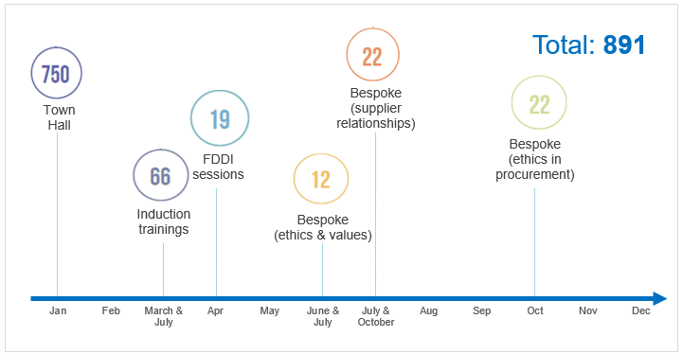

Mandatory Ethics Training
- A significant undertaking by the Ethics Office in 2022 was the revision and launch of the new “Ethics and Integrity at WIPO” e-learning course in November 2022 with the support of the WIPO Academy. The Ethics Office adapted the legacy training script to new ethical challenges presented by WIPO’s current operating realities. The training gives an overview of ethics resources available, and includes a message from the Director General on the importance of ethics at WIPO and a closing quiz. The Office also developed infographics, interactive exercises and videos to convey important ethical concepts in an engaging way, such as what ethics means at WIPO, ethical risks personnel may face, the expectation for managers and supervisors to act as ethical role models, the role of the Ethics Office, and protection against retaliation.
- The training launched on November 15 and required all personnel working in WIPO on that date to complete all the modules and obtain a pass in the mandatory quiz. All new recruits since then have also been required to complete the training. In total, for 2022, 1,470 out of 1,520 participants successfully completed the e-learning course, with a 97 per cent completion rate compared to the 25 per cent completion rate of the previous mandatory ethics training (before November 15, 2022). The training pass remains valid for three years and new recruits are required to complete it within 30 days of joining WIPO.

Ethics Survey
- Taking advantage of the launch of the mandatory ethics training, the Ethics Office embedded two anonymous pulse surveys within the training (“pre-training survey” and “post-training survey”) to assess the ethical maturity of WIPO personnel.
- The pre-training survey data shows that most respondents (88 per cent) were aware of the existence of the Ethics Office and its role. Almost half of the respondents (45 per cent) said they had not faced an ethical dilemma in their workplace, while 21 per cent responded affirmatively, meaning that they were able to identify an ethical dilemma. One-third (34 per cent) responded “I’m not sure,” which means either that they were not able to identify an ethical dilemma or that they have not faced one. Regarding the notion of “ethical role models”, 58 per cent of respondents said they had an ethical role model in the workplace, while almost half (42 per cent) said they did not. However, for most respondents (80 per cent), it is important to have an ethical role model in the workplace, while 18 per cent have no opinion and a minority (2 per cent) do not attach any importance to it.
Figure 6. Ethics and integrity training results: pre-training survey
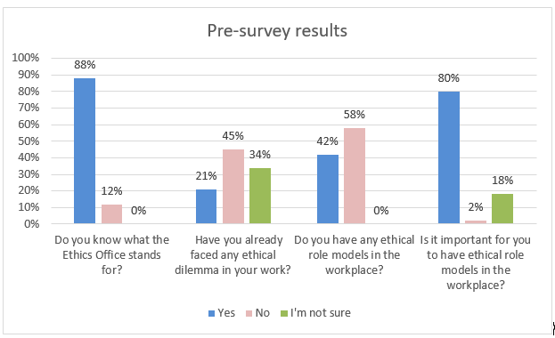
- The post-training survey shows that WIPO personnel’s knowledge of ethics had increased significantly after completing the e-learning course. Indeed, at the end of the training, 94 per cent responded that their knowledge of WIPO’s values and principles had improved, and 88 per cent felt better equipped to identify and deal with ethical dilemmas. A large majority of respondents (81 per cent) answered correctly regarding the steps to take when faced with an ethical dilemma.

Figure 7. Ethics and integrity training results: post-training survey
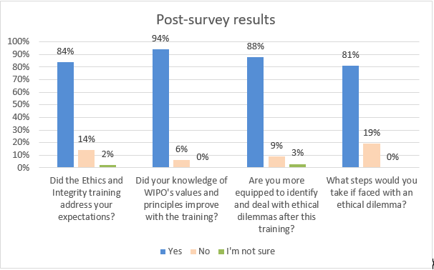

Ethics Office Intranet and Internet Pages
- The Ethics Office launched a revised Intranet page in February 2022 with the assistance of the Information and Digital Outreach Division, to provide an easy-to-navigate site for everything related to ethics in WIPO. This new site contains guidelines and policies, ethics-related forms, relevant contacts, and links to events and publications. It enables visitors to gain a quick understanding of the Ethics Office’s mandate, as compared to other offices dealing with dispute resolution within WIPO. The site received 1,830 unique page views in its first year.
- The Ethics Office also updated its external-facing Internet page to describe in more detail its areas of responsibility and to provide easy access to its publications, including its annual reports to the WIPO Coordination Committee.

C. STANDARD SETTING AND POLICY ADVOCACY
- The Ethics Office is mandated to provide standard-setting and policy support for the development and interpretation of ethics-related policies, and input to management to ensure that policies, procedures and practices reflect, reinforce and promote ethical standards and integrity within WIPO.
- In 2022, the Ethics Office contributed to the WIPO response and follow-up to the Joint Inspection Unit (JIU) reports on the Accountability Framework and on the current state of the ethics function in the United Nations (UN) system. The Office was also invited to provide input on WIPO’s Action Plan on Sexual Exploitation and Abuse, the 2021 Chief Executives Board (CEB) Annual Survey on Reporting of Sexual Harassment and the CEB Questionnaire in the context of the revision of the current Standards of Conduct for the International Civil Service.
- Finally, the Office provided clarifications requested by Member States, for example, on WIPO’s protection against retaliation policy.

D. protection against retaliation policy
- The Ethics Office is charged with administering the protection against retaliation policy, which sets out the prohibition against retaliation, the procedures for lodging a complaint and the steps WIPO may take to address retaliation. Upon receipt of a formal complaint, the Ethics Office undertakes a preliminary review of the request, and if a prima facie case of retaliation is established, the matter is referred to the IOD for investigation. Following completion of the investigation, the Ethics Office reviews the IOD’s report, seeks clarification as needed and then determines whether retaliation occurred.

Requests for Protection Against Retaliation
- In 2022, the Ethics Office received four formal requests for protection against retaliation. Figure 8 shows the number of requests each year since 2018.
Figure 8. Number of requests for protection against retaliation received from 2018 to 2022

- Of the four formal complaints received, one case was closed as no prima facie case was established. In this case, following a preliminary assessment, the Ethics Office determined that the allegations by the complainant did not support a case of retaliation.
- The other three complaints arose in the context of alleged misconduct (harassment and abuse of authority). In all three cases, the Chief Ethics Officer found that a prima facie case of retaliation was established and these matters were referred to the IOD for investigation. The Ethics Office has not yet received the related investigation reports, so the outcome is unknown. Figure 9 shows how the four requests received in 2022 were addressed.
Figure 9. Resolution of four requests for protection against retaliation in 2022

Advice
- The Ethics Office responded to three separate retaliation-related inquiries, where colleagues sought advice or reassurance about protection either before going on to report misconduct or when feeling exposed, having engaged in a protected activity. These inquiries did not escalate into formal requests.

Prevention Action
- WIPO’s policy on protection against retaliation provides that the IOD will inform the Ethics Office of any report of wrongdoing received that the IOD identifies as posing a retaliation risk. The Ethics Office then consults with the individual concerned about possible preventive action. Through this provision, the Ethics Office can be proactive in offering advice to a complainant rather than waiting to see if retaliation will materialize.
- In 2022, following referral from the IOD, the Ethics Office assisted one individual in a case of preventive action. After providing advice to the individual and monitoring their situation over a short period, the Chief Ethics Officer determined that their circumstances did not warrant interim protection measures. The case did not evolve into a request for protection against retaliation.

Policy Review
- In its 2021 report, the Ethics Office anticipated that the revision of the protection against retaliation policy would be completed in 2022. This was to reflect audit recommendations, the replacement of the United Nations Office for Project Services (UNOPS) with the United Nations Ethics Office (UNEO) as the second-level reviewer of non-prima facie cases of retaliation, and changes based on best practices. However, while the revision has been initiated, it is not yet finalized. This is because the Chief Ethics Officer’s workload has been impacted by the increase in requests for advice, and as the sole technical resource within the Ethics Office, only they can do this work. The document is currently undergoing internal consultations; following WIPO’s clearance process, it will be issued in 2023.

D. financial disclosure and declaration of interests

FDDI
- The FDDI program administered by the Ethics Office helps to promote transparency and accountability, thus enhancing public trust in the integrity of WIPO and its staff. The program is primarily a tool for identifying and assessing conflict-of-interest risks arising from the financial investments and outside activities of staff and their immediate family.
- In 2022, a total of 106 staff members – at the level of D1 and above, as well as other staff working in specifically designated categories – participated in the annual FDDI program, which covered the 2021 calendar year.
- KPMG, as the external reviewer contracted by WIPO, examined the FDDI declarations. During the review, KPMG brought two disclosure forms forward for discussion with the Chief Ethics Officer. One matter was closed with “No Action Required,” and the other was categorized as “Action Agreed Upon,” and the participant was given guidance on the required remedial action. There were otherwise no actual conflicts of interest identified during the review. Figure 10 shows the number of participants and the number of disclosures flagged from 2018 to 2022.
Figure 10. FDDI participants, 2018 to 2022
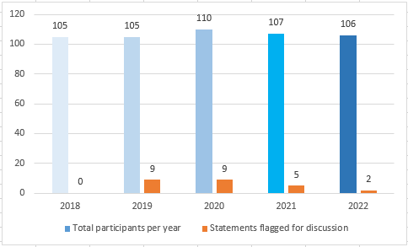
- KPMG also sought advice from the Ethics Office on the outside activity engagements disclosed by 14 participants. The Ethics Office reviewed these and confirmed that four of the 14 participants had valid formal authorization, and therefore no remedial action was necessary. These forms were closed as “Review Complete – No Action Required.” Five other participants did not require formal authorization based on the types of outside interests disclosed, and these forms were closed as “No Reportable Observations.” The remaining five participants disclosed outside activities for which the HRMD confirmed that they did not have updated approval records. Following advice by the Chief Ethics Officer, these five members of staff took corrective actions to mitigate the risks presented by the outside activities in which they had engaged.
- Following the closure of the exercise, approximately 5 per cent (6) of the participants were randomly selected to participate in the verification process prescribed by the rules. This verification process allows the Ethics Office to ensure that staff are completing their financial disclosure statements diligently and accurately. All participants selected were compliant and provided the necessary third-party documentation or confirmation, resulting in no reportable observations. At the end of the process, KPMG provided an anonymized report to the Director General. The program closed successfully with 100 per cent compliance.

International Public Sector Accounting Standards (IPSAS) disclosure
- Consistent with its mandate, the Ethics Office administered and managed the annual IPSAS disclosure exercise for 2022. All staff members at the D2 level and above were required to disclose transactions with close family members. All participants responded to the request on time and the exercise closed successfully with 100 per cent compliance.

Policy Review
- Before the launch of the annual FDDI program in April 2022, the Ethics Office revised and updated the FDDI guide to reflect recommendations made by KPMG to clarify some definitions and provide more details on reportable items, for example cryptocurrency. The revised guide was shared with all staff concerned and published on the Office’s Intranet.
- The Ethics Office also initiated the revision of the FDDI policy to reflect changes being made to the FDDI program, including the future use of in-house FDDI software to manage the program. The policy is now being finalized for publication ahead of the launch of the next FDDI exercise (see paragraphs 47 and 55).

III. OTHER ACTIVITIES OF THE ETHICS OFFICE
- Throughout 2022, the Ethics Office continued to engage with the IAOC and submitted timely updates and reports, in particular on the implementation of the Office’s workplan. The committee members engaged in constructive discussions with, and provided useful guidance to, the Chief Ethics Officer, drawing on their extensive and varied organizational experience.
- The Ethics Office, as with all program units within the organization, also contributed to WIPO’s annual and biennial planning and risk-management processes.

IV. COLLABORATION ON ETHICS-RELATED ISSUES WITHIN THE UN SYSTEM

JIU Recommendations
- In March 2022, the independent external oversight body of the UN system – the JIU – issued a report entitled Review of the ethics function in the United Nations system, in which four recommendations were made to all UN Ethics Offices.
- At the time of publication, two of the four recommendations were already in place within WIPO.
- Recommendation 1: “The executive heads of United Nations system organizations who have not yet done so should with immediate effect ensure that the contracts of newly appointed heads of Ethics Offices are issued for a full term.” Within WIPO, newly appointed Chief Ethics Officers are issued with a full-term contract, following a one-year probation period.

- Recommendation 2: “The legislative organs and governing bodies of the United Nations system organizations that have not yet done so should request that organizations update the terms of reference of their respective audit and oversight committees by the end of 2023 to include, where necessary, provisions for ethics, and ethics as a desirable area of expertise for new committee members.” Within WIPO, members of the IAOC are required to possess relevant qualifications and relevant and recent professional experience at the senior level; for example in auditing, evaluation, finance, accounting, risk management, investigations, legal affairs, information technology, ethics or human resources management and administration. They must also possess relevant personal qualities such as independence, objectivity, impartiality, integrity and strong ethical values. As part of their mandate, members of the IAOC are responsible for providing oversight to the Ethics Office.

- In 2022, the Ethics Office worked to close the remaining two recommendations.
- With regard to the implementation of Recommendation 3, requiring that “periodic refresher courses in ethics are introduced as mandatory for all staff and non-staff,” the Ethics Office has developed and successfully launched new ethics training for all staff and non-staff personnel. This training is valid for three years, after which time colleagues will be invited to repeat it or take refresher training as provided from time to time by the Ethics Office.

- Regarding the implementation of Recommendation 4, requiring organizations to evaluate “the effectiveness and efficiency, including ‘value for money,’ of their financial disclosure and declaration of interest programs and, on the basis of the findings, propose changes to the relevant policies where appropriate,” the Ethics Office conducted a benchmarking exercise to identify best practices and make proposals to management on ways to improve the efficiency and effectiveness of the FDDI program. Following a recommendation from the Chief Ethics Officer, the Secretariat decided that, starting in 2023, the FDDI program would run differently. WIPO would develop and start using its own proprietary FDDI software rather than licensing it from an external provider. Using an existing UN contract (“piggy-backing”), WIPO would also hire an external reviewer to benefit from their expertise. These actions should significantly reduce costs, to around 20 per cent of the previous annual figure. The software is currently in development and will be rolled out in 2023 following the launch of the next annual FDDI program. The Ethics Office is also revising the relevant policies and guides to reflect changes to the program.

Ethics Network of Multilateral Organizations (ENMO)
- The Ethics Office continued its active engagement with the ENMO, which serves as a broad forum of ethics functions from UN system entities, affiliated international organizations and international financial institutions, and aims to promote system-wide collaboration on ethics-related issues for participating bodies.
- In May 2022, for the first time since the pandemic, the Chief Ethics Officer brought together the heads of ethics of the ENMO in Geneva to revive this informal network. The group has since met three times and continues to exchange regularly on matters of common concern.
- The Chief Ethics Officer also attended the ENMO annual meeting and participated in training delivered by the European Business Ethics Forum (EBEF/EBI) professional international ethics network.

V. OBSERVATIONS AND Looking Forward
- The three-fold uptick in advisory cases is an area the Office will continue to monitor carefully into 2023. The Office has already improved its case-tracking and reporting capabilities, but still plans to move to an automated case-tracking and data-recording system that will further help with monitoring cases and analytics to better inform its strategy and help it report more efficiently and consistently on ethical maturity within WIPO.

- Based on the large number and the nature of requests received in the category of outside activities and employment, the Ethics Office considers that it would be in the best interests of WIPO to enhance the existing regulatory frameworks for the engagement of personnel in outside activities, particularly related to IP. It would also be helpful to include clearer guidance for personnel on the approval process and the role of the Ethics Office in the review of cases.
- Considering the results of the mandatory ethics and integrity training, the Ethics Office is confident that a strong foundation has been laid to increase trust among WIPO staff and managers, and in the Organization itself. It has also promoted accountability in decision-making and strengthened ethical leadership at all levels of the Organization. As the Ethics Office, and other concerned stakeholders, continue to reinforce the expectation for personnel to align their conduct with UN values, and WIPO in particular, they will in turn naturally expect procedural fairness from the Organization. Therefore, it is important that policies and guidelines are not only explicitly aligned with those values, with clear roles and responsibilities, but also clearly communicated to personnel, and implemented with integrity and fairness.
- The Ethics Office’s mandate includes supporting management in the review of policies that contain implicit or explicit ethical considerations. The Office encourages management to draw on its expertise in future discussions regarding WIPO’s policies, particularly concerning the ongoing culture change initiative in order to make sure that ethical considerations and considerations related to the Standards of Conduct for the International Civil Service are always incorporated into organizational policies and guidelines, as appropriate.

- In April 2023, the contract with KPMG as an external reviewer of the FDDI process came to an end. The Chief Ethics Officer has proposed that WIPO should have its own FDDI software and that KPMG should be replaced as the external reviewer, and management has approved these recommendations. This new approach should make the process more effective and efficient, yielding significant annual savings for WIPO. The Ethics Office is leading the project with the support of the Information and Communication Technology Department and the Information Security Section to develop a secure and dependable system that the Office will manage confidentially. Delivery is due in 2023, ahead of the launch of the next FDDI program.

- Finally, the Ethics Office appreciates the support received from management and other offices for the implementation of its mandate. The Chief Ethics Officer plans to increase the frequency of briefings to WIPO Senior Leadership, as this is an opportunity to raise awareness of ethical issues while respecting the Office’s independence and obligations of confidentiality. In addition, the Office appreciates the availability of temporary staffing and voluntary administrative support from within WIPO, which has helped its delivery capacity in 2022. With more sustained and durable resources, the Ethics Office looks forward to more significantly impacting the workforce and carry out new and strategic initiatives.

vI. CONCLUSION
- In 2022, the Ethics Office made significant efforts to provide consistent expert ethics advice, high-quality training and meaningful outreach to strengthen capacity and further increase awareness, understanding and compliance with WIPO’s guiding principles and standards of conduct. The Office is encouraged by its increased interactions with personnel on ethics issues and looks forward to continuing this work in the next year.
- This year, for the first time, the Ethics Office will issue an illustrated summary report to all WIPO personnel. This report will provide an overview of the work of the Office. A one-page snapshot of this report is available in the Annex.
[Annex follows]
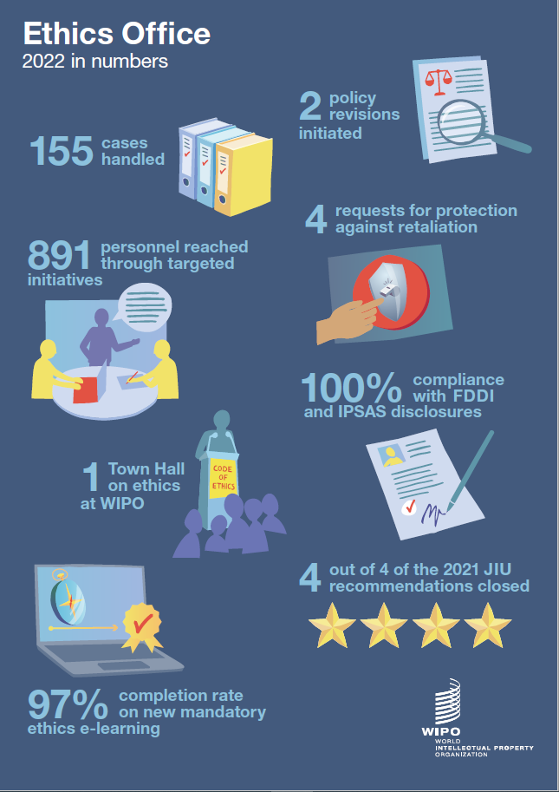
[End of Annex and of document]

This includes all WIPO staff and non-staff personnel based in WIPO headquarters and outside Geneva. The Ethics Office also provides services to staff of the International Union for the Protection of New Varieties of Plants (UPOV).
The Office relied on the support of a consultant (17 days), an intern (8 months) and part-time (50 to 80 per cent) administrative support (4 months).
The Ethics Office counts as a request any individual request for confidential advice and guidance by one member of staff or non-staff personnel, in relation to a set of facts. One request may require multiple communications by email and/or conversations, or it may require only a single exchange.
Outside activities. This category covers questions concerning external employment, occupations and other outside activities that might interfere with the ability of WIPO personnel to serve the Organization.
Currently, WIPO’s Policy on Outside Activity does not provide for the advisory role of the Ethics Office in each request to engage in an outside activity. The Office agreed to support the HRMD, consistent with best practice in the UN system, to screen requests for outside activities to prevent any potential conflict of interest. Pursuant to Office Instruction No. 16/2020 on the WIPO Ethics Office, “[p]roviding confidential advice and guidance to staff and other personnel on ethical issues” falls within its main responsibilities. Conflicts of interest are, by their very nature, an ethical issue.
Conflict of interest. This category covers questions about independence and impartiality, such as personal financial conflicts of interest, use of WIPO’s assets, and post-employment restrictions.
Standards of conduct. This category covers questions related to the Standards of Conduct for the International Civil Service and allegations or queries about workplace conduct, including possible misconduct, fraud and corruption, harassment, abuse of authority, discrimination and fair application of policies.
Other ethics matters include employment-related inquiries related to ethics, and questions from personnel about how to speak up and the fair application of WIPO policies and practices.
Gifts, awards, honors and hospitality. This category includes advice given to WIPO personnel on how to conduct themselves when offered gifts, favors, remuneration, honors, awards or hospitality by external sources in the course of their official duties or in relation to their WIPO status, while also clarifying if the gift was under the CHF 200 threshold, as indicated in WIPO’s Gifts and Honors Policy.
This category includes agency workers, individual contractors and other external providers.
Due to the Coronavirus outbreak, most of the Ethics Office’s outreach initiatives were online. However, bespoke sessions were carried out in person. While online sessions are useful for reaching all personnel – regardless of their location – the Ethics Office encourages in-person sessions to facilitate greater interaction.
See the HRMD publication on the WIPO Workforce 2022.
The timeline for completion of the previous mandatory ethics training was one year, and there was no timeline set for the training validity.
One-hundred and eight staff members were invited to participate at the start of the program. The files of two participants were administratively closed following an assessment by the Chief Ethics Officer bringing the total number of participants to 106.
WIPO Financial Regulations and Rules, Annex III, accessible here: https://www.wipo.int/export/sites/www/about-wipo/en/pdf/wipo_financial_regulations.pdf. Specifically, with regard to the Ethics Office, the IAOC has responsibility: (i) To review, at its last session of the previous year, and advise on the proposed workplan of the Ethics Office; (ii) To review the implementation of the work plan of the Ethics Office and advise on the quality, effectiveness and efficiency of the ethics function; (iii) To advise the Chief Ethics Officer in cases of significant impairment to their independence and objectivity, including conflicts of interest; (iv) To review and advise on proposed ethics policies; (v) To advise the Director General on the appointment and dismissal, if any, of the Chief Ethics Officer, including by reviewing the proposed vacancy announcement and the list of pre-screened candidates; (vi) To provide input to the Director General into the performance appraisal of the Chief Ethics Officer.

