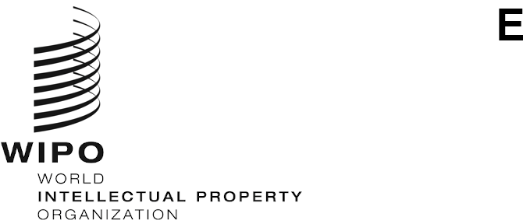
WO/CC/80/4
ORIGINAL: English
DATE: August 23, 2021

WIPO Coordination Committee

Eightieth (52nd Ordinary) Session
Geneva, October 4 to 8, 2021

WIPO Staff Pension Committee (WSPC)
Document prepared by the Secretariat
- At its ordinary session in 1977, the WIPO Coordination Committee decided that the WIPO Staff Pension Committee (WSPC) would consist of three members and three alternate members, with one member and one alternate to be elected by the WIPO Coordination Committee. The members proposed by the Director General for election by the WIPO Coordination Committee normally serve a four-year term of office. However, in order to establish a process that would facilitate a broader-based call for, and consideration of, the candidates presented by Member States for the eventual election of the member and the alternate member of the WSPC by the WIPO Coordination Committee, it is proposed that the terms of office for this election are reduced, exceptionally, to one and two years respectively. New elections will take place at the ordinary sessions of the WIPO Coordination Committee in 2022 and 2023. In the interim, the Secretariat will establish a process that invites Member States to propose candidates representing the required competencies and skills, and a diverse talent pool, for consideration by the Director General prior to their nomination for election by the WIPO Coordination Committee.

Member of the WSPC

- At its 59th session in 2008, the WIPO Coordination Committee elected Mr. Vladimir Yossifov as alternate member of the WSPC until the ordinary session of the WIPO Coordination Committee in 2011. Thereafter, however, as the term of office of one member expired in 2009, it was proposed that Mr. Yossifov be elected as the new member of the WSPC for a four-year term, until 2013. The WIPO Coordination Committee elected Mr. Yossifov until 2013, and re-elected him in 2013 for two subsequent terms until 2021.

- The Director General received from the Permanent Mission of Bulgaria the proposal that Mr. Yossifov be re-elected by the WIPO Coordination Committee as member of the WSPC to represent the Member States until the ordinary session in 2022 of the WIPO Coordination Committee.

- Mr. Yossifov, a national of Bulgaria born on February 7, 1946, holds an advanced degree in civil engineering from the High Institute for Mining and Geology in Sofia (1968), followed by a degree in patent engineering from the High Institute for Mechanical and Electrical Engineering in Sofia (1974). In 1979, he obtained a degree in international economy at the All Union Academy of Foreign Trade in Moscow.

- Mr. Yossifov is a member of the Bulgarian group of the Association for the Protection of Intellectual Property (AIPPI) and the Licensing Executives Society, and was employed by a State Foreign Trade enterprise in Bulgaria until he joined the Bulgarian Ministry of International Trade in August 1979.

- In November 1981, Mr. Yossifov was recruited by WIPO and held various positions, including at the senior level, within different sectors of the International Bureau until he retired from WIPO in February 2007 from the post of Director of the Division for Certain Countries in Europe and Asia.

- During his employment with WIPO, Mr. Yossifov also occupied functions in the Staff Council and was member of the WSPC representing the participants. He was elected Chairman of the United Nations Joint Staff Pension Board (UNJSPB) for the sessions in 2006, 2010, and again in 2016. He is currently Member of the UNJSPB Audit Committee, Chair of the UNJSPB Standing Committee and is also chairing the UNJSPB Budget Working Group.

Alternate Member of the WSPC

- At its 76th session in 2019, the WIPO Coordination Committee elected Mr. Philippe Favatier as alternate member of the WSPC until the ordinary session of the WIPO Coordination Committee in 2023. Mr. Favatier has recently expressed his intention to end his mandate.

- The Director General received from the Permanent Mission of France the proposal that Mr. Jean-Luc Perrin be elected by the WIPO Coordination Committee as alternate member of the WSPC to replace Mr. Favatier and represent the Member States until the ordinary session in 2023 of the WIPO Coordination Committee.

- Mr. Perrin, a national of France born on May 23, 1952, holds a degree in applied mathematics from École Polytechnique Fédérale de Lausanne (Switzerland).

- Mr. Perrin started his career in 1980 as Statistician at the United Nations Economic and Social Commission for Western Asia in Beirut (Lebanon) and Baghdad (Iraq). He subsequently joined the United Nations Joint Staff Pension Fund (UNJSPF) in Geneva in 1985, in charge of developing IT services and connections with its headquarters in New York, as well as with all bank-related pension payment issues.

- Mr. Perrin was transferred to WIPO in 1987 as Head of the Pension and Insurances Section. In that capacity, he served as Secretary to the WSPC of the UNJSPF and the WIPO (closed) Pension Fund Board (WPFB). In 1993, as he was appointed Director of the WIPO Personnel Division, he became member of the WPFB and Chair in 2010. He represented WIPO at the UNJSPB and the Administrative Coordination Committee (ACC). He also participated in meetings of the International Civil Service Commission (ICSC) as well as of the Advisory Committee on Post Adjustment Questions (ACPAQ).

- In 1997, he was appointed Director of the PCT Administrative Department in charge of all PCT administrative and financial questions. In 2002, under the direct supervision of the Director General, he acted as Coordinator for WIPO internal policies. In 2003, he was transferred, as Director of the International Registrations Division in charge of Trademarks, Industrial Designs and Geographical Indications. In 2007, he joined the Cabinet of the Assistant Director General for Trademarks, Industrial Designs and Geographical Indications as Senior Counselor in charge of administrative, financial and personnel issues. He has now retired in Geneva.

- The WIPO Coordination Committee is invited to elect:

(i) Mr. Vladimir Yossifov as member of the WIPO Staff Pension Committee for the period up to the end of the ordinary session of the WIPO Coordination Committee in 2022.

(ii) Mr. Jean-Luc Perrin as alternate member of the WIPO Staff Pension Committee for the period up to the end of the ordinary session of the WIPO Coordination Committee in 2023.

[End of document]

