E
A/59/inf/3
ORIGINAL: ENGLISH
DATE: september 12, 2019

Assemblies of the Member States of WIPO
Fifty-Ninth Series of Meetings
Geneva, September 30 to October 9, 2019
Information requested by the Program and Budget Committee as referred in document WO/PBC/30/15 under agenda item 11(iv)
Information document prepared by the Secretariat
Background

- The Program and Budget Committee (PBC), at its 30th session in July 2019, having completed its comprehensive review of the Proposed Program and Budget for the 2020/21 Biennium, as contained in document WO/PBC/30/10 and WO/PBC/30/10 Corr., agreed to revert to the issue reflected in WO/PBC/30/10 Corr. in the context of the adoption of the Program and Budget for the 2020/21 biennium at its 59th Series of Meetings of the WIPO Assemblies.
- In that context, the PBC requested the Secretariat to present for the consideration of the WIPO Assemblies a working document on the exact amount, details of calculations, sources and modalities of funding needed in connection with Judgment No. 4138 of the ILO Administrative Tribunal (ILOAT).

Estimated Personnel Costs for the Biennium 2020/21

- The personnel costs in the 2020/21 biennium are estimated at 475,918,900 Swiss francs. This results from a reduction of 1,655,800 Swiss francs for the WIPO Rewards and Recognition Program from the 477,574,700 Swiss francs referred to in document WO/PBC/30/10 Corr.

- The methodology for calculating the personnel costs for the 2020/21 biennium and the underlying planning assumption are outlined in the sections below.

Methodology
- The personnel costs for the 2020/21 biennium continues to be derived on the basis of actual costs supplemented by a set of planning assumptions.
- The 2020/21 personnel cost calculations incorporates changes related to the introduction of the unified salary scale on January 1, 2017 and the new common system compensation package for the professional and higher categories, as established by the International Civil Service Commission (ICSC) and amendments to the Staff Regulations and Rules.
- While costs for occupied positions are based on the latest available UN salary and pensionable remuneration scales, as well as the applicable policies for benefits and entitlements, the cost for vacant positions is based on average standard costs.

Planning Assumptions

  - For occupied positions, costing of salaries for 2020/21 takes into account the applicable ICSC scales (for general services category) and/or the salary scale and within-grade step increments effective January 1, 2018 (for professional and higher categories), prorated for 2020/21. For vacant positions, standard costs are calculated based on grade step I and an assumption of a dependent spouse and a child;
  - Following the ILOAT Judgment No. 4138, the exchange rate and post adjustment multiplier (PAM) are applied as of January 2018;
  - The USD/CHF exchange rate is applied at a 1:1 ratio for pensionable remunerations. The applicable ICSC scale for professional and higher categories is as of February 2019; for the general service category the April 2011 scale has been applied for occupied positions and the September 2017 scale for vacant positions;
  - All applicable benefits and entitlements for occupied positions, including education grant and home leave, are estimated at position level, taking into account the latest payroll information. An average cost has been estimated for vacant positions;
  - Provisions for education grant take into account the revised education grant system based on a global sliding scale of reimbursement of a streamlined list of education-related expenses;
  - Four new flexibility posts have been created in 2020/21 following the application of the Madrid Union Budget Flexibility Formula, bringing the total number of posts to 1209. An overall vacancy rate assumption of 4 per cent has been applied to the overall costing of posts to take into account recruitment delays;
  - In order to increase the funding for long term Employee Benefits which include the After Service Health Insurance (ASHI) liability, the ASHI provision charge has been increased from 6 to 8 per cent; a 2 per cent charge for separation has been applied for temporary positions;
  - Other Staff Costs include biennial provisions for Professional Accident Insurance (PAI) (900,000 Swiss francs), the Closed Pension Fund (700,000 Swiss francs), litigation costs (400,000 Swiss francs) and the WIPO Rewards and Recognition Program, (1,152,000 Swiss francs);
  - The provision for reclassifications amounts to 4 million Swiss francs in “Unallocated (Personnel)” for the implementation of the results of reclassification committee decisions;
  - Regularizations are expected to be completed in the 2018/19 biennium, and therefore no amount has been provisioned in 2020/21 for regularizations. In order to enable the Secretariat to better manage and control overtime expenses, the estimated overtime costs continue to be budgeted in a separate provision in “Unallocated (Personnel)”. The provision has been increased to 3 million Swiss francs in view of the introduction of flexible working arrangements. These costs will continue to be closely monitored in coordination with Program 23 (Human Resources Management and Development) and concerned Program areas.

- Based on the above planning assumptions, the increase in personnel costs for 2020/21 amounts to 15.9 million Swiss francs, or 3.5 per cent, compared to the 2018/19 Approved Budget. The share of budgeted personnel costs compared to the total budget has decreased from 62.4 per cent in 2018/19 to 61.9 per cent in 2020/21.

Sources and Modalities of Funding

- The Organization’s expenditure budget is estimated at 768,401,034 Swiss francs for the 2020/21 biennium and is funded by overall income, which is projected at 882.8 million Swiss francs for the 2020/21 biennium . Chart 1 below provides an overview of 2020/21 Income Share by Source.

Chart 1: 2020/21 Income Share by Source
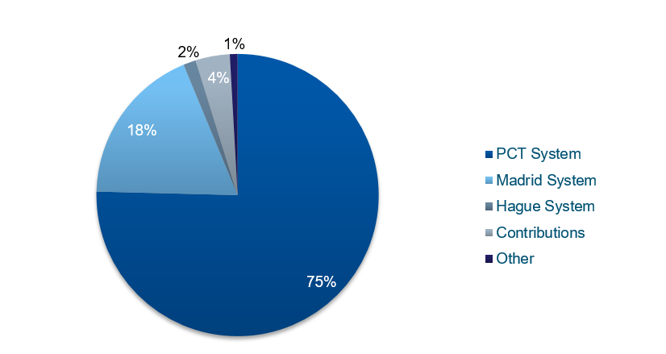
[End of document]

See document A/59/8 paragraphs 25-28.
Salary scale applied for Professional and higher categories as of January 1, 2019 and pensionable remuneration scale effective February 1, 2019. Salary scale and pensionable remuneration applied for occupied positions in the general service category as of April 1, 2011 and for vacant positions as of 1 September 2017.
The ICSC issued new PAMs in August 2019, which due to timing issues could not be applied for the personnel costing for 2020/21. The difference between the PAM and exchange rate as of January 2018 and those of August 2019 does not materially impact the estimation of personnel cost for the 2020/21 biennium.
See document A/59/8, paragraphs 5-8 for further details.

