E
WIPO/IP/ITAI/GE/18/4
ORIGINAL: English
DATE: March 14, 2018

MEETING OF INTELLECTUAL PROPERTY OFFICES (IPOs) ON ICT STRATEGIES AND ARTIFICIAL INTELLIGENCE (AI) FOR IP ADMINISTRATION

Geneva, May 23 to 25, 2018

WIPO IPAS Office Suite

Document prepared by the International Bureau of WIPO

INTRODUCTION

This document is intended to provide the most updated information of WIPO Industrial Property Administration System (IPAS) Office Suite.

The WIPO IP Office Suite is a group of software applications that IP Offices can use to support the processing of applications for IP rights by establishing an e-registry, controlling workflow processes and business rules, and providing online services to local and international users. The overall objective is to deliver operational efficiencies and improve quality of service.

The WIPO IP Office Suite, or parts of it, is currently in operation in more than 80 IP offices in all regions of the world. For more than 15 years, WIPO has been offering this service to IP offices of developing countries as part of the technical assistance program.

The suite is made up of three complementary systems: WIPO File, WIPO IPAS and WIPO Publish, supported by a Central Services component that provides for efficient and reliable data exchange to interconnect IP offices with WIPO Global IP systems and data.

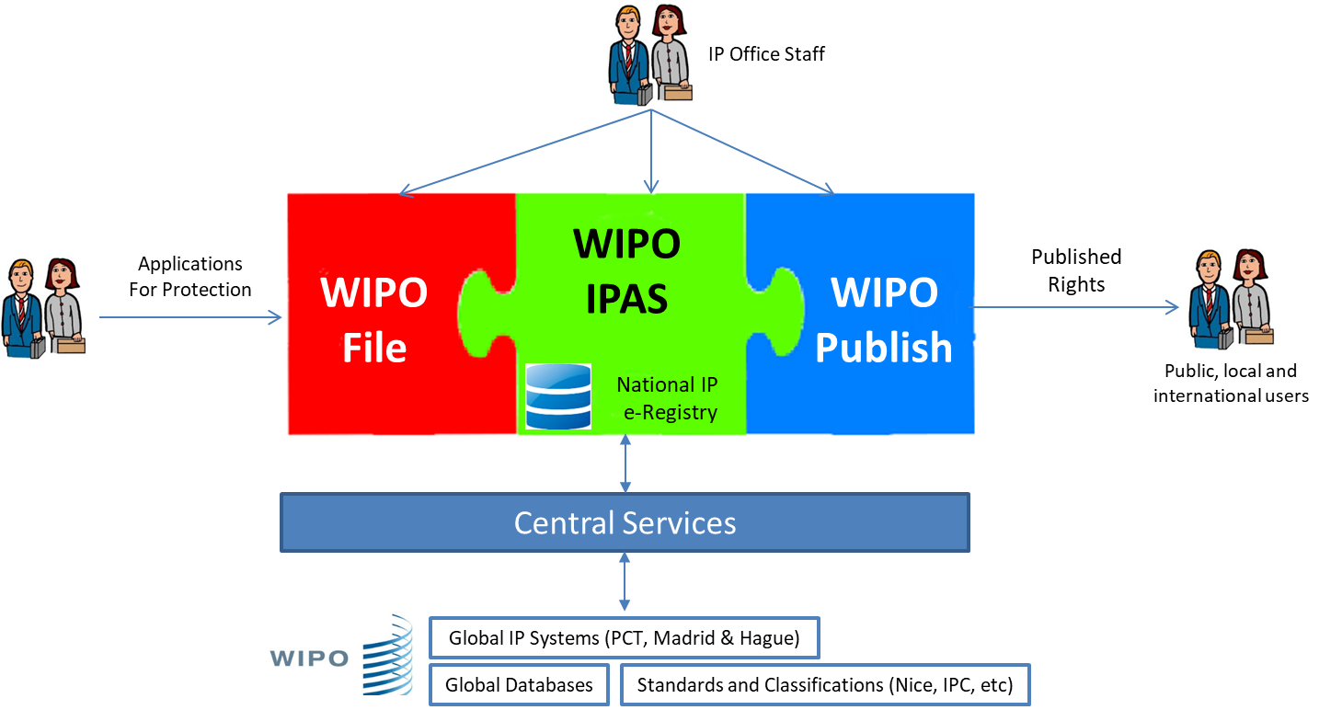

WIPO IPAS

The WIPO IPAS is the core of the WIPO Suite. It supports the processing of patents, trademarks and industrial designs from filing through to the grant of rights and post-grant processes. IPAS is a workflow-based system which is fully customizable to the requirements and legal framework of each IP office.

Main features include:

- Customizable workflows to automate the legal and administrative processes of the IP office.
- Configurable to support all incoming requests for services (new application, subsequent documents, renewal, assignment, amendment, etc.) and all outgoing notifications and certificates.
- Publication management functions for controlling and formatting official Gazette/Journal.
- Flexible and powerful search tools including phonetic, text and classification-based searches (using Nice, IPC, Vienna or Locarno classification systems).
- Integrated with WIPO Global IP systems for the reception and processing of notifications or national phase entries.
- Support for fully electronic records management, or paper-based file tracking.
- Support for multiple languages and language scripts (including right-to-left scripts) for both data storage and display.
- Security model to control access to functions or actions by user role.
- Fully document application programming interface so that local software developers can implement their own modules or interface with local systems for payment, online services, etc.

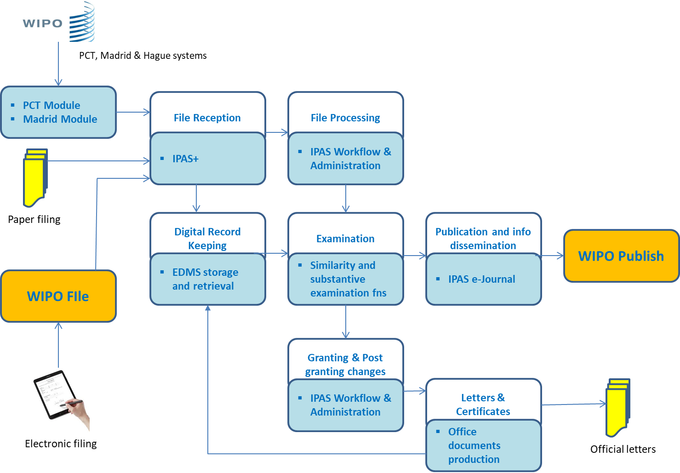

WIPO File

WIPO File is the software application that enables IP offices to offer full online services to applicants and agents. It supports the filing of new applications for patents, trademarks and industrial designs as well as submission of subsequent transactions such as renewals, amendments, assignments, etc.

The system speeds up the process of filing applications and subsequent transactions for both the applicants and the IP office. It can eliminate manual reception processes and improve quality by capturing IP data once only at the source.

The main features include:

- Filing of new applications for patents, trademarks and industrial designs.
- Configurable fee calculation module.
- Optional payment gateway interface. The payment gateway must be implemented for each IP office according to the local banking and payment systems.
- Optional manual validation process at the IP office to check submissions before formal reception.
- Portfolio management functions to allow applicants to see their portfolio of IP files at the office, receive notifications online, and view file status information.
- Fully configurable for legal and administrative requirements (e.g. mandatory data, rules checking).
- Secure architecture and options for secure configuration.
- Support for multiple languages and language scripts (including right-to-left scripts) for both data storage and display.
WIPO File is constantly being enhanced and will be extended to include enhanced drafting features, improvements to the portfolio management functions, ability to retrieve historical actions and documents and direct interaction with WIPO Global IP systems.

WIPO Publish

WIPO Publish is the software application that enables IP offices to disseminate official publication information and related IP information online to users and to WIPO Global IP databases and platforms. The system connects to WIPO IPAS or another IP administration system and extracts and formats IP data according to WIPO standards. The data is then made available for online search, for online official publication, and for exchange with WIPO Global IP Databases.

Using WIPO Publish, IP offices can easily provide powerful online search services for their published IP rights, including information about legal status and access to documents (if permitted by the legal framework).

IP offices can also move from paper-based publication to fully electronic publication that meets the requirements of the local legal framework. WIPO Publish also facilitates data sharing and integrations with WIPO Global IP databases and platforms such as Patentscope, Global Brand Database and WIPO CASE.

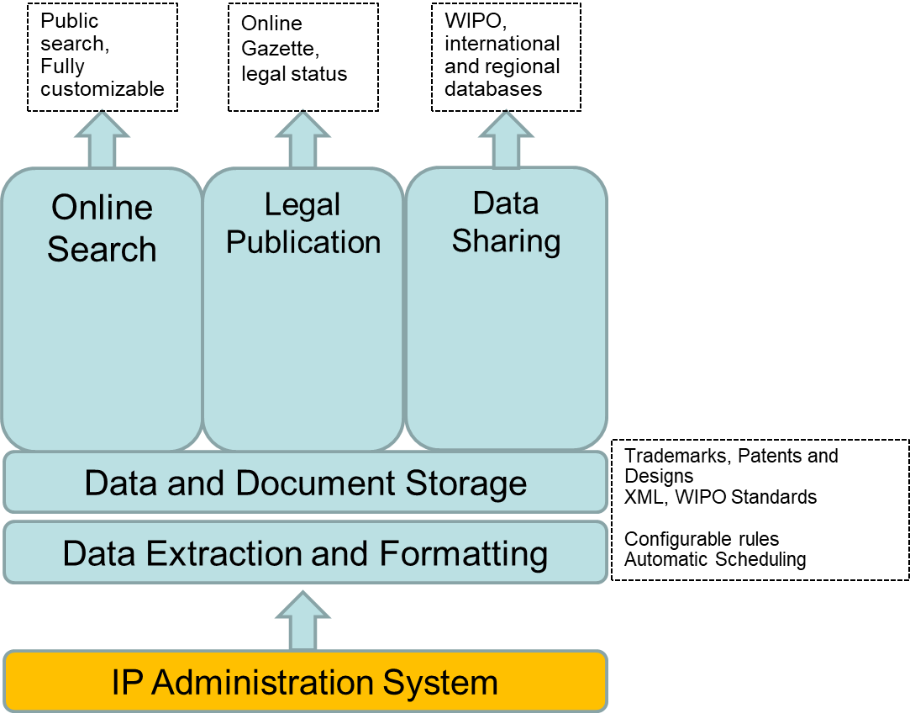

The main features include:

- Powerful search engine for field-based or full-text search on all published IP records.
- Publication function to enable fully online publication of official Gazette/Journal.
- Fully customizable according to the local language, terminology and branding (office names, logos, color preferences, etc.).
- Option to configure as a regional database by aggregating national IP databases into a single regional service.
- Extraction, formatting and storage of IP data according to WIPO standards.
- Simplified data exchange for regional and/or international IP databases such as WIPO Patentscope, Global Brand Database.
WIPO Publish is not dependent on WIPO IPAS. It can be installed and connected to any existing IP administration system at an IP office and used to provide online services to users or to integrate with WIPO Global databases and platforms.

The system will be further extended to take advantage of the WIPO Central Services component, for example to integrate patent family data into patent searches, image search for trademarks and links to other WIPO services.

WIPO Central Services

The Central Services component is a new system which is designed to provide efficient and reliable communications between IP offices and WIPO Global IP systems.

The system currently supports a small number of data exchanges:

- Classification services, to provide automated updates of Nice, Vienna, IPC and Locarno classification schemas.
- Reception (by the IP office) of notifications and data for Madrid and PCT designations.
- Transmittal (by the IP office) of notifications for Madrid designations.
The system will be progressively updated to support more transactions and services including, inter alia, data exchange for WIPO Global databases and statistics, access to centralized data resources such as patent family data, support for PCT receiving office and Madrid office of origin transactions, etc.

Cooperation Framework

The WIPO IP Office Suite is developed and owned by WIPO and is offered to IP offices of WIPO Member States free of charge as part of WIPO’s technical assistance services. Before starting a project, WIPO and the IP Office (or responsible Ministry) sign a cooperation agreement that sets out the shared responsibility for implementation, terms and conditions for the use of WIPO software systems, confidentiality and other provisions.

Projects are organized according to a shared responsibility model, with the aim of assisting IP offices to increase their capacities as much as possible using WIPO software solutions and to create projects with long-term sustainability.

Projects are initiated based on a request by the IP office concerned. This is followed by an assessment of the needs, capabilities and suitability of WIPO software solutions for the IP offices. If both parties agree to initiate the project, a project plan is created to clarify the roles and responsibilities, resource requirements and expected outcomes. The assessment process covers the critical pre-requisites for the project to succeed, as described below.

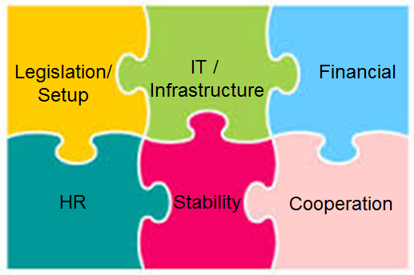

- Financial: availability of capital and operating budget to start and maintain the project. Capital investment may be required up front for IT infrastructure and equipment while operating expenses are typically required for upgrades, spare parts, etc.
- Legislation: IP laws and regulations should be in place and minimum functioning IPO organization with respective staff should be present. For online services, an appropriate legislative framework needs to be in place (electronic communications law, or similar).
- Information Technologies: depending on the project and systems to be deployed, the appropriate hardware, networking, security and physical infrastructure need to be in place. The need for good internet connectivity has become now a priority so that offices can provide online services and engage in remote support and training activities.
- Human Resources: local IT personnel for the day-to-day support of systems and infrastructure. WIPO has a profile of skills needed for local administrators who should basically have knowledge of IT and network administration activities.
- Stability: stable management and low turn-over of staff and local IT resources are important for project continuity.
- Cooperation with WIPO: the conclusion of the cooperation agreement prior to commencing the project.
WIPO provides resources for the development, maintenance and support of the software solutions. WIPO also has a network of experts based in Geneva and in all regions of the world to provide on-site assistance, advice and project management services to offices.

WIPO transfers knowledge to the IP office to the extent possible, through on-site training of users and technical staff and through regional workshops that are organized according to demand and available resources.

Advantages of WIPO Solutions

IP offices have a choice when implementing business solutions for the automation of internal processes and provision of online services. There are a small number of private companies offering software that is explicitly designed for IP operations (only two vendors have successfully marketed solutions to more than one IP office). IP offices may also use their own IT resources and/or local IT providers to develop their own solutions. These options have advantages and disadvantages compared to the WIPO solution, as described below.

Deployment Time and Features

WIPO brings more than 15 years of cumulative experiences working on projects with more than 80 IP offices. Offices will find most of the functionality they require for administering IP registration process in the WIPO solutions and with the considerable customization options available, the system will be ready for operational use in a relatively short time (subject to its readiness as outlined above).

Software developed in house typically requires substantial time and effort to build from scratch or using and customizing commercial platforms.

Flexibility

Thanks to its graphical process design, the software is fully customizable to cope with various needs of Member States ranging from small offices with simple process to medium sized offices with much complex procedures. Changes to legislation or administrative processes can be quickly introduced to the systems with little effort and often no programming. This brings greater flexibility of the WIPO software compared to the in-house or commercial alternatives which tend to address the smaller number of IP offices they target and generally will require service provider intervention for changes on the software to address functional or procedural need. Such flexibility will further enable Member States to have more control over the solution and eventually take ownership of the system with less and less dependencies on WIPO or on service providers for their administration.

Risk

As the WIPO software is offered under the mandate of the organization and its technical assistance program approved by the Member States themselves, the risk of discontinuity of the software and/or its support to offices is minimal. In comparison, in-house developed or commercial alternatives largely depend on the availability of development resources and/or availability of funds to renew or amend the contract with suppliers for changes and support.

Cost

WIPO software is offered free of charge to Member States, although there are costs associated with purchasing IT infrastructure and engaging resources to implement parts of the project. The commercial alternatives typically imply substantial cost to the client while those developed in house will require cost to cover development resources whether done by local or external resources.

Support

Support from WIPO is limited by available resources which must be shared by all IP offices using the solutions. Response times and service level agreements are provided on a “best efforts” basis, without guarantees. Support staff is Geneva-based and providing support resources on-site is difficult.

Commercial providers and local IT companies will usually provide a service level agreement in which levels of support and response times are guaranteed, in return for a regular payment. For some offices, this option may be more attractive as it reduces risk in the event of a system failure.

Future Plans

WIPO will continue to develop the WIPO IP Office Suite to keep up with the demands of IP offices and with modern technologies. Some planned improvements include:

- Better integration with WIPO Global IP systems to allow automated and online exchange of data and notifications.
- Improved support for substantive examination of patents, trademarks and designs by incorporating new technologies such as advanced search techniques and image recognition.
- More open and more configurable design, to allow IP offices to more easily implement their own functionality or interface with other systems.
- Improvements to support and maintenance processes, to incorporate new features more quickly and to provide better service levels to IP offices.
- Options for cloud hosting, especially for offices with limited local IT infrastructure.

[End of document]

