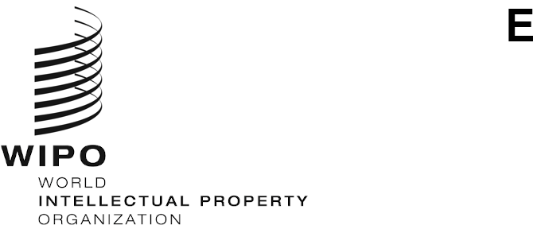
CWs/9/8
ORIGINAL: english
DATE: October 5, 2021

Committee on WIPO Standards (CWS)

Ninth Session

Geneva, November 1 to 5, 2021

Report on the Blockchain Whitepaper for IP ecosystem
prepared by the International Bureau

INTRODUCTION
At its sixth session held in 2018, the Committee on WIPO Standards (CWS) considered two proposals regarding blockchain technology and noted that several IPOs had experiments on the use of blockchain technology for IP business and some delegations had ongoing projects exploring the use of blockchain for IP purposes. The CWS created Task No. 59 to prepare a proposal for a new WIPO standard applying blockchain technology to IP ecosystems and established the Blockchain Task Force. (See paragraphs 28 to 31 of document CWS/6/34.)
In 2019, the International Bureau organized a workshop on Blockchain and IP. The participants from the workshop sought leadership from WIPO in supporting blockchain-enabled applications for IP ecosystem. (See document CWS/7/6.)
In order to study the implications of blockchain to IP systems and also support the Blockchain Task Force, the International Bureau of WIPO launched the Blockchain whitepaper project in May 2020. It is aimed to explore potential applications and opportunities presented by blockchain to the existing IP ecosystems. It also intends to identify the challenges and issues that should be addressed to determine the feasibility and cost-efficiency of introducing such technologies in IP ecosystems.
At its eighth session held in 2020, the CWS noted that the International Bureau was preparing a Blockchain whitepaper for IP ecosystem and the WIPO webinar on blockchain for IP was organized by the International Bureau on June 25, 2020. The webinar was to explain the objectives and scope of the whitepaper project and to discuss the output of early stage activities, including potential use cases of blockchain technology in IP space. (See paragraphs 8 to 11 of document CWS/8/15.)

blockchain whitepaper
In order to prepare this whitepaper, the three following activities were carried out:
- Desk research, including publications, bibliographic references, projects and ideas related to blockchain, IP ecosystems, and blockchain applications used within IP ecosystems. The findings of this research were analyzed and the identified projects and initiatives were categorized by their perceived level of interest for IP ecosystems;
- An online survey sent out to potential participants playing a role in the blockchain industry and the IP industry; 139 responses were considered in the whitepaper; and
- Interviews with 10 organizations and entities in IP and blockchain industries, which have experience in implementation blockchain technologies for IP businesses.
Draft versions of the whitepaper were reviewed and commented by the Blockchain Task Force Offices and various work areas in the International Bureau. Taking into account all the inputs received, the final draft whitepaper was prepared, which consists of six components, an executive summary, a main body and four Annexes, including Annex IV – the mock-up of decentralized identifiers or DIDs. The International Bureau intends to publish the whitepaper on WIPO website in November 2021 after editing and designing it.
In addition, the International Bureau organized a webinar toward the launch of the Blockchain whitepaper for IP ecosystem on September 28, 2021, where the final draft was introduced, and further information on the webinar, the recorded video and the documentation used at the event are available on WIPO website at: https://www.wipo.int/meetings/en/details.jsp?meeting_id=66030.
Meanwhile, upon requests by CWS members and observers, the International Bureau submits the final draft to this session of CWS for factual information checking as the Annex to this document. Since the whitepaper is not a document to form any agreement on issues, but rather a fact-based document, CWS members and observers are invited to check information included in the final draft to make sure of its accuracy and provide feedback to the International Bureau at: blockchain@wipo.int by October 22, 2021. The International Bureau will consider the received feedback and orally report to the CWS at this session.

The CWS is invited to note the content of the present document and the Annex to the present document as indicated in paragraph 8 above.

[Annex I follows]

