E
cws/5/8 Rev.1
ORIGINAL: English
DATE: May 02, 2017

Committee on WIPO Standards (CWS)

Fifth Session
Geneva, May 29 to June 2, 2017

NEW WIPO STANDARD FOR THE EXCHANGE OF PATENT LEGAL STATUS DATA BY INDUSTRIAL PROPERTY OFFICES

Document prepared by the Secretariat

INTRODUCTION
At its third session held in April 2013, the Committee on WIPO Standards (CWS) agreed to create Task No. 47: “Prepare a proposal to establish a new WIPO standard for the exchange of patent legal status data by industrial property offices. Once this task is completed, the corresponding proposal should be extended to trademarks and industrial designs.” The CWS also established the Legal Status Task Force (LSTF) to accomplish this Task and designated the International Bureau as the Task Leader. The CWS also agreed that the other Task Forces dealing with extensible markup language (XML) should be invited to implement and operationalize the outcome of the LSTF in XML. (See paragraphs 50 to 54 of document CWS/3/14.)
Since its establishment, the LSTF met numerous times in person and via online conferences to complete the Task. In an effort to complete the Task, the Task Leader organized four physical meetings and 13 online conferences. More than 80 experts from 27 industrial property offices (IPOs) and user groups participated in the discussions of LSTF and contributed to the development of the proposal for the new standard.
To date, the primary focus of the Task Force has been on preparing a proposal to establish a new WIPO standard on patent legal status data. Discussions regarding the development of the standard were organized into three phases. Phase 1 focused on defining the objective and scope of the new standard and discussions occurred in one round. Phase 2 determined what legal status data on applications and industrial property (IP) rights should be exchanged and was organized into eight rounds of discussion. Phase 3 determined how the legal status data should be structured and exchanged, and was organized into five rounds, including several rounds of the mapping exercise that LSTF members mapped their national or regional patent legal status events to the events defined in the draft standard.
Eight draft versions of the standard were prepared by the International Bureau, as Task Leader, on the basis of the inputs received from the Task Force members. Each of the eight drafts had multiple iterations and the Task Force members were invited to comment on each draft. The subsequent version of the draft incorporated Task Force members’ comments in the previous round.

proposed New WIPO standard
Within the framework of Task No. 47, the LSTF prepared a draft recommendation for the exchange of patent legal status data for consideration and adoption by the CWS as a new WIPO standard. The proposed name of the new standard is “WIPO Standard ST.27 – Recommendation for the Exchange of Patent Legal Status Data”. The proposed new WIPO standard which consists of the main body and Annexes I to IV, is reproduced in the Annex to the present document.

Objective
The availability of up-to-date, reliable, and understandable legal status information on IP rights is necessary if individuals are to be able to avoid IP right infringement. IPOs currently provide this information in various formats and languages, inconsistently, and in an untimely manner due to the difference of national and regional patent laws and practices. The proposed standard is intended to promote the efficient exchange of patent legal status data in a harmonized manner between IPOs in order to facilitate access to that data by IPOs, IP information users, IP data providers, the general public and other interested parties. This standard aims at improving worldwide availability, reliability and comparability of patent legal status data in a timely manner.

Scope
Taking the diversity of IP laws and practices among various jurisdictions into consideration, the proposed standard is not aimed at harmonizing procedural or substantive requirements under national/regional patent laws and regulations.
The proposed standard defines legal status events that may take place during the lifecycle of a patent or Supplementary Protection Certificate (SPC) on the basis of the agreed Overall Patent/SPC Prosecution Model. The definitions of the events are broad so as to cover the various practices of different IPOs. The proposed standard provides codes which can be used to straightforwardly identify the legal status of a patent or SPC.
The proposed standard also provides the data structure to be used to exchange the legal status data in electronic form between IPOs, the data associated with the defined events, and guidelines for IPOs to map their national/regional events to the events in the proposed standard.

Overall Patent/SPC Prosecution Model
As the diversity in patent and SPC prosecution laws among IPOs is significant, the proposed standard uses a general prosecution model to broadly describe the patent and SPC prosecution practices among IPOs worldwide. The model does not describe the unique prosecution practices of all IPOs, nor does it cover every eventuality that may occur during the prosecution of an application or IP right. Nonetheless, the prosecution model intends to provide an overview of the general steps involved in the prosecution of a patent or SPC at IPOs worldwide.
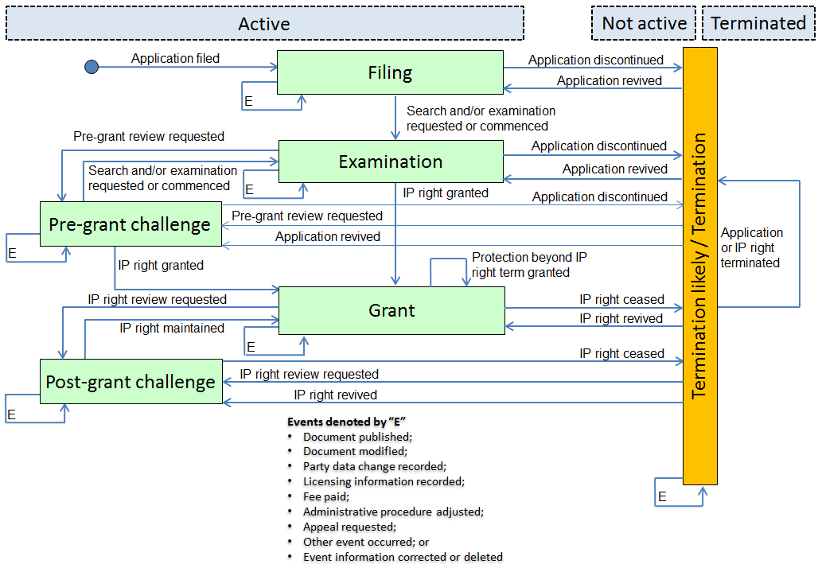

States, Stages and Events
The Overall Patent/SPC Prosecution Model illustrated above incorporates states (dashed rectangular boxes), stages (solid rectangular boxes) and events (arrows) to describe the prosecution of patents and SPCs. Not all of relevant events are indicated but only key events are indicated in the Prosecution Model for the sake of brevity.
The ‘state’ of the application or IP right refers to whether it is ‘active’, ‘not active’ or ‘terminated’ after an event occurred according to the applicable law of the IPO. It should be noted that not all IPOs can specify the terminated state under their national/regional law.
The ‘stage’ refers to a phase in the prosecution of an application or IP right, which encompasses the happening of events. According to the applicable law of the IPO, the application or IP right can be in one of the following six stages: filing, examination, pre-grant challenge, grant, post-grant challenge, or termination likely/termination stage. It should be noted that the first five stages mentioned above encompass ‘active’ applications or IP rights while the termination likely/termination stage encompasses applications or IP rights in either ‘not active’ or ‘terminated’ state. The application or IP right in the termination likely/termination stage may move back to an ‘active’ state or proceed to a ‘terminated’ state depending on the applicable laws.
An ‘event’ refers to an action during the prosecution of an application or IP right caused by the applicant, IP right owner, IPO or third party according to applicable law, which may cause a change in the state and/or stage of the application or IP right. The proposed standard recommends a list of generically-termed events with general descriptions on the basis of the terminology used by IPOs worldwide to broadly cover national/regional events. The proposed standard thereby assists users in interpreting national/regional events without requiring in-depth knowledge of the specific practices of the prosecuting IPO.

List of Categories, Key Events and Detailed Events
The proposed standard provides the list of categories and events that should be used to exchange legal status data between IPOs. The events are grouped into an event category, which provides a high-level cluster of related events. A single key event and several detailed events are defined in a category. Each category, key event and detailed event has a defined code. Furthermore, the proposed standard recommends providing national/regional events in coded form mapped to the relevant category and/or event(s) defined in the standard.
The proposed standard defines 21 categories, 21 key events and 145 provisional detailed events. It should be noted that the detailed events defined in the proposed new standard are provisional and should be reviewed and assessed by IPOs for finalization in due course. The categories describe a group of events which are of particular importance to the prosecution of a patent or SPC and share a common theme. The category description defines the theme of events included in that category. A key event is an important event related to the category. Key events are meant to enable IPOs to map national/regional events to a generic, universally-termed event that is understandable by a user. The detailed events are events in a category, which are more specific than a key event. They may describe a practice specific to only a few IPOs, or they may describe a practice that is nearly universal but that is of a specific nature.

Data Structure and Format for Exchange
The proposed standard recommends, for the purpose of facilitating the exchange of legal status data, a data structure in coded form which consists of the ST.3 two-letter office code, the creation date of data file, the identification of application or IP right and event data; the event data comprises the following components: the status event code, the calendar dates linked to the event, and supplementary data associated with the event.

Implementation
Implementing the proposed standard will require that IPOs map their national/regional events to the events defined in the proposed standard or at the very least a category. It is recommended that when implementing the proposed standard, an announcement be made and the International Bureau be informed by providing a mapping table of national/regional events to the events in the proposed standard in accordance with the template provided in Annex IV to the proposed standard. The proposed standard suggests that the frequency of exchange of legal status data should occur at one month intervals at a minimum, ideally at weekly intervals.
The International Bureau plans to publish, on the website of WIPO, the mapping tables of IPOs once they have been provided.

Further development
The LSTF noted that the following several pending works should be carried out after adoption of the proposed standard.

Assessment and finalization of detailed events
Once the proposed standard has been adopted, it is proposed that IPOs start assessing their business practices and IT systems to determine how to best produce and exchange legal status data on patents following the recommendations made in the new standard, including the provisional detailed events.
As the detailed events listed in Annex I of the proposed new standard are provisional, the LSTF proposes that IPOs review them and carry out a mapping exercise to determine whether the said detailed events describe their prosecution practices. It should be noted that the provisional detailed events are not necessary to cover all national and regional practices for all IPOs; rather they reflect the common practices of some IPOs and that major events in the prosecution lifecycle are covered for the majority of IPOs for data exchange and for the interest of users. On the basis of inputs by IPOs, the LSTF plans to finalize the list of detailed events and submit it for consideration and approval at the next session of the CWS.
In light of the aforementioned, and on the condition that the new standard is adopted at the present (fifth) session of the CWS, the Task Force proposes including the following Editorial Note at the front of new standard:
Editorial Note by the International Bureau
The detailed events included in this Standard are provisional and will be reviewed and assessed by industrial property offices (IPOs) for one year. On the basis of the outcome of the review and assessment reported by IPOs, a final proposal for the inclusion of detailed events in this Standard will be submitted for approval at the sixth session of the CWS. For the time being, IPOs may choose to exchange legal status data on the basis of categories and key events only, if they so desire.
The Committee on WIPO Standards (CWS) adopted the present standard at [its fifth session on June 2, 2017].

Finalization of Guidance Document
The proposed standard requires an IPO to map their national/regional events to a standard event, so that a receiving party may understand the legal status of an application or IP right without in-depth knowledge of the specific national or regional prosecution practices of that IPO. In order to assist IPOs to conduct the mapping, the proposed standard includes comprehensive descriptions of categories and events with several examples. However the LSTF noted that IPOs, in particular the IPOs which did not participate in the Task Force’s discussions, need more information to carry out the mapping in a harmonized way. Therefore the Task Force started preparing a guidance document that provides examples of various practices of IPOs and explanatory remarks and direction on how specific national/regional events could be mapped to the standard events.
Due to a lack of time to complete the document and a need for more examples of IPOs, the LSTF decided not to include it in the proposed draft standard and continue working on it with more examples and experiences from IPOs and present a final proposal for the guidance document as a new Annex to the proposed standard for consideration and approval at the next session of the CWS.

Development of XML for Legal Status Data Exchange
In order to facilitate the exchange of patent legal status data among IPOs, the proposed standard will likely have to be operationalized in XML. However, the proposed standard does not discuss the operationalization of the exchange of legal status data in XML format, which should be discussed and developed by other CWS Task Force(s) which deal with XML, in accordance of the decision by the CWS.
Following the agreement made at the third session of CWS, the LSTF requests the CWS to invite the XML4IP Task Force to develop XML schema components to facilitate the exchange of patent legal status data based on the proposed new standard. Once a draft XML schema has been prepared, it should be reported to the CWS for its consideration and decision on whether the XML schema should be integrated into the new WIPO standard or into WIPO Standard ST.96.

Trademarks and Industrial Designs
To date the Task Force has focused on preparing a proposal for a standard on the legal status of patents and has not considered trademarks and industrial designs. Following the decision by the CWS at its third session, once the proposed standard has been adopted, the LSTF should prepare recommendations for the exchange of legal status data on trademarks and industrial designs.

Proposed New Task No. 47
If the proposed new standard is adopted, the International Bureau proposes modifying Task No. 47 to focus on the remaining part. The proposed wording for the description of Task No. 47 is: “Prepare a final proposal for the detailed events and a guidance document with regard to patent legal status data; prepare a recommendation for the exchange of legal status data on trademarks and industrial designs by industrial property offices”. The International Bureau also proposes that the Legal Status Task Force continues working on the revised Task No. 47.
The CWS is invited to:
(a) note the results of the work of the Legal Status Task Force, as set out in this document;
(b) consider and decide on the name of the proposed standard “WIPO Standard ST.27 – Recommendation for the exchange of patent legal status data”;
(c) consider and decide on the adoption of the proposed new WIPO Standard ST.27, as reproduced in the Annex to the present document;
(d) request the Secretariat to issue a circular to invite IPOs to assess their business practices and IT systems and review the provisional detailed events, as referred to in paragraphs 21 and 22 above;
(e) consider and decide on the Editorial Note to be included in the proposed WIPO standard, as referred to in paragraph 23;
(f) request the Legal Status Task Force to finalize the list of detailed events and the guidance document for patent legal status data, as referred to in paragraphs 22 to 25, above, and present them for consideration and approval at its sixth session;

(g) request the XML4IP Task Force to develop relevant XML schema components, as referred to in paragraphs 26 and 27 above, and report the outcome of the Task Force work for consideration at its sixth session;
(h) request the Legal Status Task Force to prepare a recommendation for the exchange of legal status data on trademarks and industrial designs , as referred to in paragraph 28 above, and present a progress report on it for consideration at its sixth session; and
(i) decide on the modification of Task No. 47 and the assignment of modified Task No. 47 to the Legal Status Task Force as proposed in paragraph 29 above.

[Annex follows]

