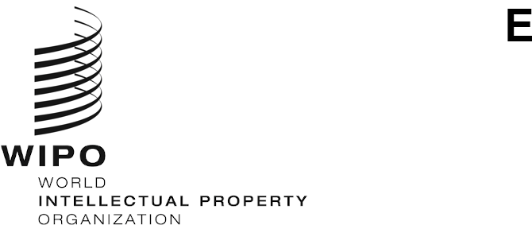
CWs/10/4
ORIGINAL: english
DATE: september 7, 2022

Committee on WIPO Standards (CWS)

Tenth Session

Geneva, November 21 to 25, 2022
Revision of WIPO Standard ST.3

Document prepared by the International Bureau

BACKGROUND
- At its seventh session in 2019, the Committee on WIPO Standards (CWS) approved a proposal for streamlined procedures for the revision of WIPO Standard ST.3. The CWS also approved changing the source of short names in ST.3 from ISO-3166 to the UN Terminology Database (UNTERM) and adding footnote 14 on usage of two-letter codes “EM”, “EP”, “EU” and “QZ” in WIPO Standard ST.3. (See paragraphs 14 to 18 of document CWS/7/29.)

REVISIONS
- In June 2022, the Secretariat issued circular C.CWS 161 informing Intellectual Property Offices (IPOs) of a change of name in ST.3 by the Republic of Türkiye (formerly Republic of Turkey), following an official letter to the United Nations and an update to UNTERM. The updated ST.3 was published on the WIPO website.
- Following the decision by CWS at its ninth session to change “industrial property” to “intellectual property” in the WIPO Handbook, the Secretariat prepared a proposed revision to ST.3 reflecting the decision. In addition to changing “industrial” to “intellectual”, the update adds two-letter codes for two IPOs that practice intellectual property but not industrial property (i.e. copyright) within the scope of coverage of ST.3: Marshall Islands and Niue. Furthermore, based on input from the Hague and Madrid Systems, the text of footnote 4 on use of codes “IB” and “WO” was updated to clarify their intended usage within those Systems.

- The CWS is invited to:
  - note the content of the present document; and
  - consider and decide on the proposed revisions to WIPO Standard ST.3 as shown in the Annex to the present document and indicated in paragraph 3 above.

[Annex follows]

