E
CWS/10/14
ORIGINAL: English
DATE: september 6, 2022

Committee on WIPO Standards (CWS)

Tenth Session
Geneva, November 21 to 25, 2022

WIPO Sequence Suite development and support

Document prepared by the International Bureau

Summary
WIPO Sequence Suite was improved during the WIPO Sequence Minimum Viable Product (MVP) project to produce version 2.1.0 which went live in production on the WIPO ST.26 implementation date of July 1, 2022. It is recommended that users always upgrade to the latest version of WIPO Sequence to ensure that users has access to any bug resolutions provided. Training was hosted by the International Bureau on WIPO Sequence in all ten PCT languages with the support of Patent Offices. Updates to the WIPO Sequence Suite are now made under a maintenance contract and support is provided to users under a threetier support model explained below.

Background
The WIPO Sequence Suite is the collective term for WIPO Sequence, a desktop tool published by WIPO and used by applicants to generate WIPO Standard ST.26 compliant sequence listings, and the WIPO Sequence Validator, which is a web service used by Patent Offices to determine compliance of a filed sequence listing according to WIPO ST.26. Both of these software tools were developed by the International Bureau after a request from Member States. The Sequence Listings Task Force was assigned the task of supporting the International Bureau in providing user requirements and feedback on beta versions during development (see paragraphs 42 and 45 of document CWS/5/22).
At the sixth, seventh, eighth and ninth sessions of the CWS, updates were provided by the International Bureau describing the status of development of the WIPO Sequence Suite. The first stable version of both components of the WIPO Sequence Suite, version 1.0.0, was published on the WIPO website in November 2020. Two subsequent stable versions, version 1.1.0 and version 2.0.0 were made available to the public in October 2021 and May 2022 respectively. At the same time, user documentation was provided to support use of these tools.
As the CWS was informed at the ninth session held in November 2021, WIPO Sequence Suite training was presented in English by the International Bureau. This included webinar trainings for both WIPO Sequence and the WIPO Sequence Validator in April and May 2021. There were 259 participants for WIPO Sequence sessions and 161 for the WIPO Sequence Validator session.

WIPO Sequence MVP Project
In October 2021, the International Bureau commenced an improvement project aimed to ensure that the WIPO Sequence Suite that went live on the WIPO ST.26 implementation date met the MVP requirements. The specification which described what comprised the MVP was provided by the Sequence Listings Task Force.
The project plan for the WIPO Sequence MVP project indicated two distinct phases: a development phase of two and a half2.5 months and a warranty phase of three months. The aim of the project was to provide this improved MVP version of WIPO Sequence Suite at least two months in advance of the WIPO ST.26 implementation date. However, as development continued into 2022 and thorough testing was only conducted during the warranty period, a large number of bugs were reported at this time. In order to ensure that the tool components were of a high quality, the warranty period was extended until the end of June, just prior to the WIPO ST.26 implementation date.
The main improvements implemented since version 1.1.0, impacting both WIPO Sequence and WIPO Sequence Validator, were the following:
- Bulk adding or editing mol_type qualifier values for DNA/RNA sequences;
- Disabling import of multisequence FASTA files;
- Improvement to how CDS features are managed by the tool. By default, a translation qualifier and/or protein ID will be generated by the tool;
- Additional verification rules to ensure the appropriate anticodon value is provided as the qualifier value for the transl_except qualifier;
- Verification rules to validate skipped sequences; and
- Additional verification rules to ensure appropriate feature location format for a CDS feature.
As a result of this development project, the International Bureau published two stable versions: version 2.0.0 and version 2.1.0. The only difference between these two versions is that version 2.1.0 addressed many of the minor bugs reported during testing of version 2.0.0. Version 2.1.0 went live into production on July 1, 2022.

Maintenance phase
The WIPO Sequence MVP project was formally closed on July 5, 2022. After this time, WIPO Sequence development is managed through a maintenance contract. According to this contract, any reported bugs must be resolved by the development team within an estimated timeframe and small improvements are possible. The current maintenance contract period will conclude on December 31, 2022 but the International Bureau is committed to continuous support for the WIPO Sequence Suite until the end of its lifecycle.

TRAININGS and Support
At the same time as development was undertaken for the MVP project, the International Bureau hosted trainings in collaboration with speakers provided by Patent Offices on WIPO Sequence in the remaining nine PCT publication languages (Arabic, Chinese, French, German, Japanese, Korean, Portuguese, Russian and Spanish). A WIPO Sequence Validator training was also provided in Spanish in response to a request from the Dominican Republic Intellectual Property Office (ONAPI). Additional training will be provided by the International Bureau on request, if resourcing is available.
The International Bureau, in collaboration with IP Offices, developed a knowledge base, the WIPO Sequence and ST.26 knowledge base, which contains questions posed by users of WIPO ST.26 and WIPO Sequence, and the answers provided. By publishing these question-answer pairs, it is hoped that users can find their own answers as quickly as possible, without the need to contact the International Bureau or relevant filing Office.
The International Bureau has established a WIPO Sequence mailing through which important announcements are made to users of the tool. This is considered to be the main mode of communication with users of WIPO Sequence and is an "opt-in" service.
In consultation with the Sequence Listings Task Force, the International Bureau has established a three-tier support model to manage requests for support, which is well described using the following diagram, and further detailed below:
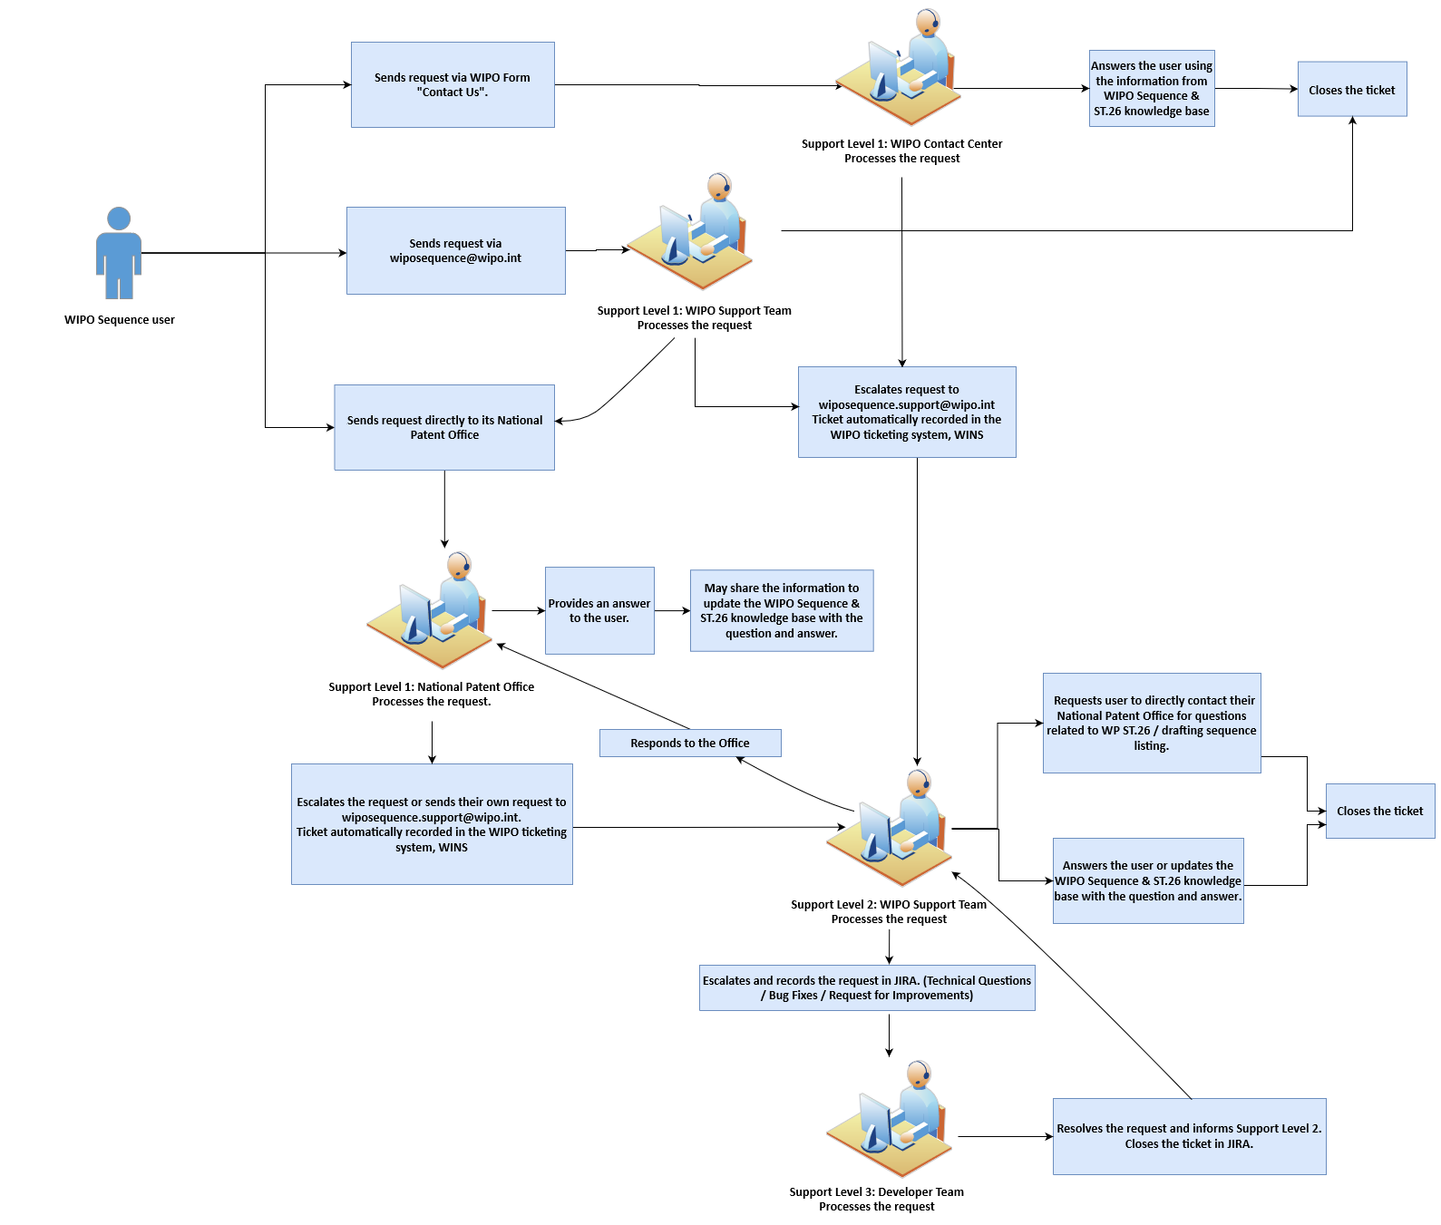
- Support level one: Any basic queries that are the first interaction with a user by the relevant Offices, including national or regional Offices;
- Support level two: Any level one queries that require further expertise from the WIPO Sequence Support team; and
- Support level three: Any queries that require technical support from the WIPO development team.

Reported Bugs
After WIPO Sequence went live into production on July 1, 2022, several critical bugs were reported by users. A full summary of known issues reported to the International Bureau can be found on the WIPO Sequence and ST.26 knowledge base. The following critical bugs were reported by users during July 2022:
- qID values assigned by the tool are not unique;
- sporadically sequences are being generated by the tool without a feature table;
- non-Latin characters are not allowed within the non-English qualifier value; and
- selecting 'yes' after noting the auto-update pop-up does not initiate the download of WIPO Sequence software.
Two patched versions were provided by the International Bureau to resolve these critical bugs: versions 2.1.1 and 2.1.2. Information regarding these releases was provided to WIPO Sequence users via the mailing list referenced above.

NeXT STABLE release Plan
The International Bureau is committed to providing new patches of WIPO Sequence Suite in response to critical bugs as required and plans to release a new stable version in 2022 addressing minor reported bugs and some improvements.

The CWS is invited to:
- note the contents of the present document;
- encourage applicants to subscribe to the WIPO Sequence mailing list and refer to the WIPO Sequence and ST.26 knowledge base as described in paragraphs 11 and 12 of this document; and
- encourage IP offices to report any new bugs sent by their applicants through the 3-tier support model as described in paragraph 13 of this document.

[End of document]

Note that this list is non-exhaustive. A number of non-critical bugs were also reported by users and will be addressed in future versions.

