E
ORIGINAL: English
DATE: June 25, 2015

Information Session on Broadcasting

Geneva, June 29, 2015

Biographies of Speakers

Mr. George Twumasi
Deputy Chairman and CEO ABN Holdings Limited (ABN)

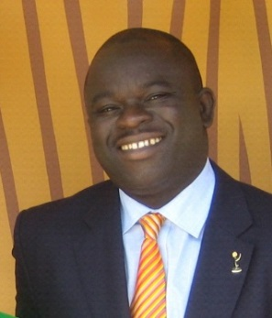
The goal of ABN is to create a viable content monetisation platform straddling multiple distribution platforms. ABN’s plan comprises a commercially viable, turnkey digital content production and distribution ecosystem – Made for Africans by Africans.

ABN is currently working towards the development of a viable cloud solution based commercial framework that will drive the re-aggregation and monetisation of content, initially spanning eighteen African countries.

ABN is committed to building an inspiring commercial vehicle via which a unique cultural content generation and an innovative DTH/DTT/OTT content distribution model can be achieved.

The intent is to establish a compelling business case and defensible revenue model based on, which a rich media African content hub is established.

ABN’s cloud vision straddles the fusion of sub-Saharan Africa’s emerging industrial television and digital broadband computing complexes, which is underpinned by the generation of quality culturally inspiring content “Made by Africans for Africans”.

George has extensive knowledge of the broadcasting and advertising landscape in Africa and has established a global network of industry contacts. He is a regular speaker at television media and content related events and business roundtables.

Ms. Shida Bolai
Chief Executive Officer, Caribbean Communications Network Limited

Ms. Shida Bolai has a career that spans over 30 years in the media industry, at both operational and executive levels across all media platforms, including press, television, radio and the internet. She possesses a proven track record of success and has played a pivotal role in the development and growth of the organization. Under her stewardship, CCN TV6 has been able to maintain its market dominance for the last 14 years and the Express newspapers has achieved over fifty percent of the newspaper readership market.

Other key positions held at the CCN Group were, General Manager - Trinidad Express Newspapers, Group Sales Manager - CCN and Advertising Manager -Trinidad Express Newspapers.

At present, she sits on the Board of Directors of One Caribbean Media Limited, Caribbean Communications Network Ltd, Grenada Broadcasting Network, and Tobago News. She currently holds the position of President of the Caribbean Broadcasting Union and also sits on the Board of The Little Carib Theatre.
Mrs. Bolai has had extensive training in media management and is the winner of a Fellowship Program sponsored by the Commonwealth Press Union which took her to places such as England, South Africa and Lesotho.

Ms. Anelise Rebello de Sá
Legal Manager, International Business and Contracts Compliance, TV Globo

May 1998 – present date: Globo Comunicação e Participações S.A. (TV Globo), Legal Manager, international business and contracts, compliance.

Currently coordinating a team of lawyers and interns, representing and advising TV Globo’s Sports department (mainly rights acquisitions, such as the FIFA World Cup and the Olympic Games), Films’ acquisition department (mainly license agreements with the majors and independent studios), the International business division (licensing of TV Globo’s programming and international channels outside Brazil, anti-piracy) and compliance department; Previous experience at Globo includes M&A and debt restructuring.

Oct 2005 – January 2006, Debevoise & Plimpton LLP, New York, NY, Foreign Associate, working in M&A deals and telecom restructuring.

Mr. Avnindra Mohan
President, Zee Network

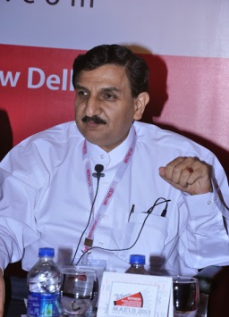
He is handling all the legal & regulatory affairs of the Group, which inter-alia include Broadcasting ( various Zee Channels), Direct - to- Home (DTH) Services – Dish TV, Cable Distribution -Siti Cable Network Limited etc.

In a career spanning over 32 years, he has served with various reputed companies and multi-national organizations, the last being M/s. Reliance Infocomm Ltd. where he worked as Head – Commercial & Legal.
Mr. Mohan is an expert in Broadcasting, Cable & Taxation Laws. He is a Chartered Accountant, Law Graduate, PGDBM & Chartered Financial Analyst. He is actively interacting with various Trade bodies, Associations such as FICCI, ASSOCHAM, etc., Regulatory Authorities (TRAI) & Ministries viz. Ministry of Information & Broadcasting, Ministry of Finance and Ministry of HRD on various industry-related issues such as Content Piracy, Treaties, IPRs, Copyrights, Content Code for Broadcasters, International Taxation, etc.

He has been representing Indian Broadcasting Federation (IBF) in the discussions relating to WIPO & WTO treaties for Broadcasting Sector (including the treaty under discussion-“Protection of Broadcasting organization”) with Ministry of HRD and Ministry of Information & Broadcasting. He has been a member of various task force and committees constituted by Ministry of Information & Broadcasting, Govt. of India for implementation of Digital Addressable Systems (DAS), Broadcasting Bill, Content Code etc.

He has been regularly contributing articles in various periodicals/magazines, and also delivering lectures and deliberating sector-specific issues in different seminars & meetings.

Mr. Tejveer Bhatia
Singh & Singh Advocates, New Delhi

In the Year 2011, Mr. Bhatia joined Singh and Singh Law Firm LLP as a partner and continued to represent various stake holder in the Broadcasting Sector including, TV Broadcaster, Radio Broadcaster, Cable TV Distributors, DTH Operators, etc.

[End of document]

