E
CWS/6/17
ORIGINAL: English
DATE: September 20, 2018

Committee on WIPO Standards (CWS)

Sixth Session
Geneva, October 15 to 19, 2018

WIPO ST.26 Software tool

Document prepared by the International Bureau

INTRODUCTION
At its reconvened fourth session held from March 21 to 24, 2016, the Committee on WIPO Standards (CWS) adopted WIPO Standard ST.26, entitled “Recommended standard for the presentation of nucleotide and amino acid sequence listings using XML (eXtensible Markup Language)” (see paragraphs 52 and 53 of document CWS/4Bis/16).
At its fifth session held from May 29 to June 2, 2017, the CWS discussed the transition provisions from WIPO Standard ST.25 to ST.26. The CWS agreed on the “big bang” scenario as the option for the transition, which requires all intellectual property offices (IPOs) to transit ST.26 from ST.25 at the same time; the international filing date as the reference date; and January 2022 as the transition date. The CWS requested the Sequence Listings Task Force to support the International Bureau by providing users’ requirements and feedback on the ST.26 software tool. (See paragraphs 42 and 45 of document CWS/5/22.)
The International Bureau informed the CWS that it would develop a new common software tool to enable applicants to prepare sequence listings and verify that such sequence listings are in compliance with WIPO Standard ST.26. The CWS noted that the International Bureau planned to complete the development project of the software tool by the end of 2018 and distribute it to applicants and IPOs around the globe. The CWS also noted the draft high-level roadmap for the transition from WIPO Standard ST.25 to ST.26 proposed by the International Bureau. (See paragraphs 46 and 48 of document CWS/5/22.)

WIPO ST.26 SOFTWARE TOOLS DEVELOPMENT
As the CWS was informed at its fifth session, the International Bureau has been developing the ST.26 Software Tools to assist the implementation of WIPO Standard ST.26 around the globe; the development project consists of four phases as follows:
- Phase 1: Business analysis
- Phase 2: Architecture and Proof of concept
- Phase 3: Development of application
- Phase 4: Delivery of acceptance and production
Phases 1 and 2 were completed in 2017 and the project is currently in Phase 3. The project is planned to be finalized in 2019 and the Tools will be deployed in the second half of 2019.
The ST.26 Software Tools are composed of three components: Authoring and Validation Tool for applicants (Applicant Tool), Validation tool for IPOs (IPO Tool) and Update and Release Applications (WIPO Tool). The relationship between the three tools is illustrated in the following conceptual network diagram:

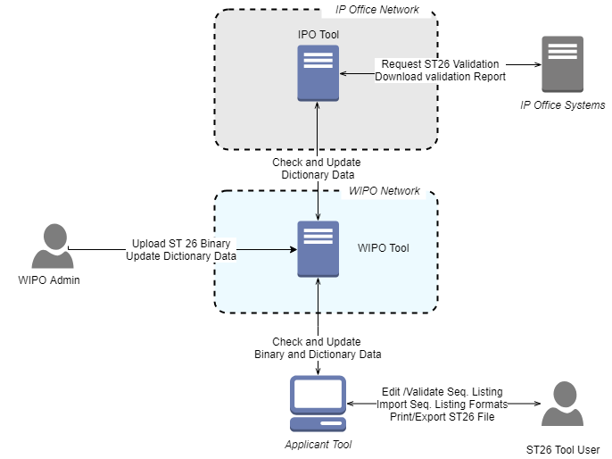
- Applicant Tool is a standalone application, which should be installed locally on a desktop or laptop and used by applicants. The Applicant Tool will automatically access the WIPO Tool deployed in the WIPO network to check the new release of the Tool when it is connected to the Internet;
- IPO Tool will be deployed as a standalone service in the IPO’s network, which will communicate with other business solution applications used by the IPO, in order to provide the validation service of the sequence listing data that the applicant submitted. The IPO Tool will access the WIPO Tool to check the new release of the tool; and
- WIPO Tool will be deployed in the WIPO network and provide a new release of Applicant Tool and/or the IPO Tool.

Main features of Applicant Tool
The Applicant Tool enables the user to generate a sequence listing file in ST.26 format. The three main functions of the system are:
- Acquire data from the user and create a sequence listing file in ST.26 XML format.
- Verify a sequence listing project for compliance with the WIPO ST.26 requirements.
- Import data from external files in various formats such as ST.25, ST.26, and other industry formats and acquire further input from the user as necessary, in order to generate a ST.26 XML sequence listing.
The generic interaction between the user and the Applicant Tool is shown below:
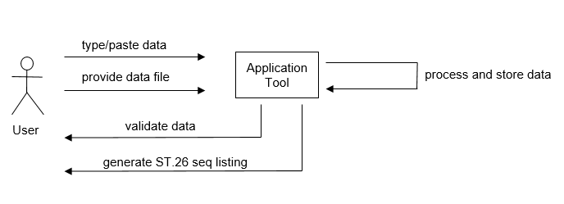

Main features of IPO Tool
The IPO Tool enables IPOs to verify whether the submitted sequence listings are compliant with the requirements defined in WIPO Standard ST.26. The validation function of the IPO Tool is the same as in the Applicant Tool. The difference between the two is the software architecture: the IPO Tool will be deployed as a Microservice on a server environment while the Applicant Tool is a standalone system.
As illustrated in the following diagram, there are four steps for verification, steps 1 and 2 are related to a simple XML validation and step 3 is related to a full verification according to ST.26 requirements. The simple XML validation can be used by the IPO’s online filing system.

1

11
Simple XML validation

Valid?

Parse XML (and store data in Database)

Full verification according to ST.26 requirements

Generate Validation Report

Yes
No

3
2

3
4

4

SYSTEM REQUIREMENTS OF APPLICANT AND IPO TOOLS
The minimum system requirements are suggested for a satisfactory execution of the tools, which is reproduced as the Annex to the present document. The system requirements have been decided based on the fact that the tool will go live in 2022 and some of the current versions of operating systems will lose official support by then.

COLLABORATION WITH IPOS AND APPLICANTS
The Sequence Listings Task Force supported the International Bureau by providing users’ requirements and feedback on the ST.26 software tool. In particular, the Task Force provided the functional specification for the tool, which guides the development of the tool. The Task Force also reviewed the graphical user interface (GUI) of the tool considering the GUI recommendations for a common look and feel on all WIPO software applications.
To facilitate discussion on the development of the Tool among IPOs, the International Bureau established a dedicated Wiki for the project (https://www3.wipo.int/confluence/display/ST26software), which is restricted to the Task Force members and development team.
Furthermore, in collaboration with the Task Force member IPOs, the International Bureau will invite several applicants, who will be the actual end users, to participate in testing the tool.
As a follow-up to the discussion on the roadmap for the transition from WIPO Standard ST.25 to ST.26 at the fifth session of the Committee, the International Bureau asked the Sequence Listing Task Force Offices to share their implementation plan of Standard ST.26 taking into account the potential modification of their regulations and the upgrade of their IT systems. The Japan Patent Office (JPO) and the Korean Intellectual Property Office (KIPO) posted their implementation plan of WIPO Standard ST.26 on the Project Wiki at: https://www3.wipo.int/confluence/display/ST26software/ST.26+Implementation+Plan.
For the convenience of testing the Tools by IPOs and applicants, the International Bureau set up the testing environment on the WIPO Cloud. Thanks to the technologies used in the Tools, most of the Tools’ functions are working on the online environment even though the final product of the Tools should be installed locally.
The CWS is invited to:
(a) note the contents of this present document; and
(b) encourage IPOs to share their implementation plan as referred to in paragraph 15 above.

[Annex follows]

