E
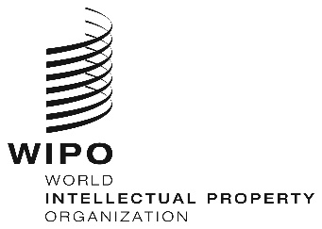
WEBINARS
ORIGINAL: eNGLISH
DATE: June 26, 2020
REGIONAL BUREAU FOR AFRICA CAPACITY BUILDING FOR SMEs, JULY 2020

organized by
the World Intellectual Property Organization (WIPO)

PROVISIONAL PROGRAM

prepared by the International Bureau of WIPO

Wednesday, July 22, 2020
14.30 – 15.30 | Topic 2 | IP Audits, Due Diligence and Valuation  - IP Audits  - IP in Due Diligence  - Valuation: IP and Funding  - Case Study
Speaker: Ms. Rose Mboya;
International Consultant and P Expert; Kenya
Industrial Research and Development Institute
(KIRDI); Kenya

 |  | Discussions
 |  | [End of Webinar]

