E
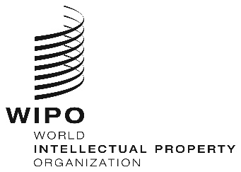
WEBINARS
ORIGINAL: eNGLISH
DATE: June 26, 2020
REGIONAL BUREAU FOR AFRICA CAPACITY BUILDING FOR SMEs, JULY 2020

organized by
the World Intellectual Property Organization (WIPO)

PROVISIONAL PROGRAM

prepared by the International Bureau of WIPO

Wednesday, July 22, 2020
10.30 – 11.30 | Topic 1 | Fundamentals of Intellectual Property and Relevance in Business  - Global shifts in value from tangibles to intangibles  - What is intellectual property  - Key concepts in respect of each IP type  - Examples of companies in Africa
Speaker: Prof. Caroline Ncube
Department of Commercial Law;
University of Cape Town; South Africa

 |  | Discussions
 |  | [End of Webinar]

