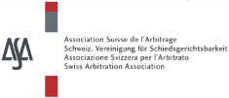 |  | 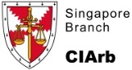
 |  |  | 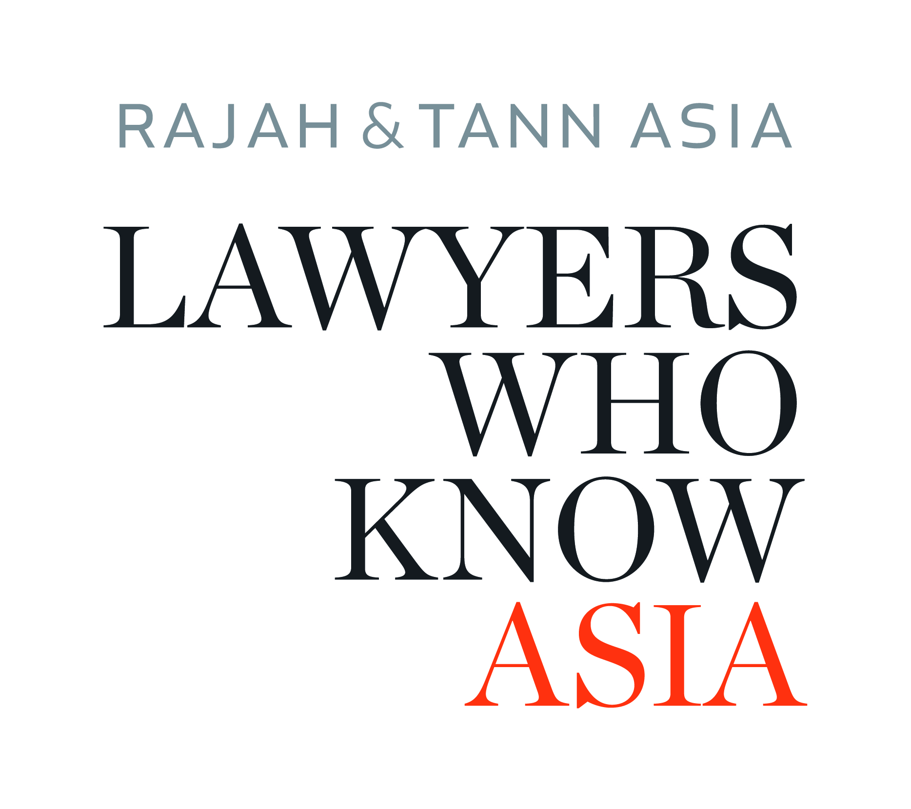

In-House Counsel Seminar
Alternative Dispute Resolution for IP and Technology Disputes
Recent Developments

Maxwell Chambers, 32 Maxwell Road, 069115 Singapore
Wednesday, February 8, 2017

Co-organized by:

Allen & Overy
Baker & McKenzie
Bird & Bird
Rajah & Tann
Schellenberg Wittmer
WIPO Arbitration and Mediation Center

Supporting Organizations:

Association of Corporate Counsel (ACC)
CIArb Singapore
Singapore Corporate Counsel Association (SCCA)
Swiss Arbitration Association (ASA)

PROGRAM OUTLINE

14:00 – 14:15 | Welcome and Introduction  Francis Xavier, CIArb Singapore  Ignacio de Castro, WIPO Arbitration and Mediation Center  Olivier Marquais, WIPO Arbitration and Mediation Center
14:15 – 14:45 | ADR Escalation Clauses  Andy Leck, Baker & McKenzie  Article 4 Mediation, Clause Generator and Escalation clauses  Philipp Groz, Schellenberg Wittmer
14:45 – 15:00 | Questions & Answers
15:00 – 15:30 | Submission of IP Disputes to Mediation and Arbitration  Vandita Chandrani, Procter & Gamble  Joachim Feldges, Allen & Overy
15:30 – 15:45 | Questions & Answers
15:45 – 16:15 | WIPO Film and Media Rules, and WIPO Experience  Richard Tan  Moderator  Olivier Marquais  Introduction to WIPO Film and Media Rules  Lau Kok Keng, Rajah & Tann  Film and Media Disputes
16:15 – 16:30 | Questions & Answers
16:30 – 16:45 | Coffee Break
16:45 – 17:15 | Life Sciences  Christopher Boog, Schellenberg Wittmer
17:15 – 17:45 | Information and Communications Technology Mediation and Arbitration,  and WIPO Experience  Ignacio de Castro  Jonathan Choo, Bird & Bird
17:45 – 18:00 | Questions & Answers
18:00 | Closing, followed by Drinks Reception
Registration Form

In-House Counsel Seminar
Alternative Dispute Resolution for IP and Technology Disputes
Recent Developments

Maxwell Chambers, 32 Maxwell Road, 069115 Singapore
Wednesday, February 8, 2017

Please complete the registration form and return by February 1, 2017 to:
WIPO Arbitration and Mediation Center, World Intellectual Property Organization (WIPO)
Singapore Office, Maxwell Chambers, 32 Maxwell Road #02-02, Singapore 069115
T +65 6225 2129 – F +65 6225 3568 - E arbiter.meetings@wipo.int

Participant information:

Title:  (Mr./Dr./Mrs./etc.) | Last name: |  | First name:
Position:
Organization/Company:
Address:
City/state: |  | Zip/post code:
Country:
Phone: |  | Fax:
E-mail:

This seminar is free of charge.
Please note that the number of seats in the seminar room is limited.
We recommend that you register as soon as possible.

