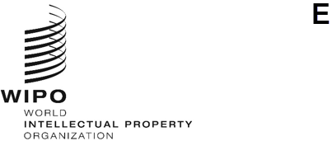

INFORMATION NOTICE No. 8/2023
Geneva Act of the Lisbon Agreement on Appellations of Origin and Geographical Indications
Change in the amount of the individual fee: Samoa
- In accordance with Rule 8(2)(d) of the Common Regulations under the Lisbon Agreement for the Protection of Appellations of Origin and their International Registration and the Geneva Act of the Lisbon Agreement on Appellations of Origin and Geographical Indications, the Director General of the World Intellectual Property Organization (WIPO) has established the following new amount, in Swiss francs, of the individual fee that is payable to Samoa:
ITEM |  | Current Amount  (in Swiss francs) | New Amount  (in Swiss francs)
Individual fee | for each international registration | 187 | 162

- This change will take effect on October 1, 2023.

August 21, 2023

