E
WIPO/GEO/BEI/07/5
ORIGINAL: English
DATE: June 11, 2007
 | 
STATE ADMINISTRATION FOR INDUSTRY AND COMMERCE | WORLD INTELLECTUAL PROPERTY ORGANIZATION
INTERNATIONAL SYMPOSIUM ON GEOGRAPHICAL INDICATIONS
jointly organized by
the World Intellectual Property Organization (WIPO)
and
the State Administration for Industry and Commerce (SAIC)
of the People’s Republic of China
Beijing, June 26 to 28, 2007
GEOGRAPHICAL INDICATIONS: CREATING VALUE THROUGH CONNECTING PRODUCTS WITH GEOGRAPHICAL ORIGIN
Presentation by Mr. Patrick J. Kole, Vice President, Legal Affairs,
Idaho Potato Commission, Eagle, Idaho, United States of America

INTRODUCTION

Geographic Indications, like trademarks, create value when consumers are willing to pay a premium price for products associated with a particular place. This presentation is a case study of how Idaho® potatoes became a famous and well known “brand” that has provided demonstrated economic returns to those who grow, ship, process and market potatoes and to the overall economy of the state of Idaho.

IDAHO POTATO COMMISSION

Mission Statement

To contribute to the economic welfare of the State of Idaho, its potato growers and other potato-related businesses:

- by leading, through facilitation, the various Idaho potato organizations in achieving mutually beneficial goals, including conducting strategic analysis of markets and marketing opportunities, maximizing research and education funds in improving quality, yield and variety expansion, and working with State and Federal government organizations to best leverage support;

- by promoting and advertising Idaho’s famous brand and certification marks with consumers, retailers, foodservice operators/distributors, and expanding both domestically and internationally all forms of Idaho potatoes;

- and by protecting Idaho potato certification and trademarks through approval and monitoring procedures which ensure compliance and aggressively challenging any improper usage.

To facilitate its mission, the IPC approves all packaging, sets grade standards, reviews brands, and requires the identity of Idaho® potatoes be preserved as close as possible to the end consumer.

GEOGRAPHICAL DESIGNATIONS OF PRODUCTION AREAS & BOUNDARIES ESTABLISHED

The Boundary of the State of Idaho



The entire state is designated as the geographic region where Idaho® potatoes are grown. Commercial potato production is centered in the southern part of the state.

IPC was established under state statute. The expressly provides that ownership of certification marks and trademarks are vested in IPC/state of Idaho.

Symbols, registered marks and trademarks are only as valuable as the generic advertising, promotional and public affairs dollars put behind them, the willingness to protect them from counterfeiters and the consumers perception that the product is worthy of purchase at a premium price.

During the 70 years of the IPC’s existence, over $170 million has been spent promoting the Idaho brand.

IDAHO POTATO COMMISSION

- Brief History: IPC created in 1937
- Tax Structure: Supported by an assessment on potatoes used for consumption of up to 15¢ per hundredweight. Grower pays 60%; remaining 40% paid by shipper or processor.
- IPC’s Budget: IPC currently spends approximately $11 million annually. This will increase to $13.5 million in 2007-2008.
- Research: IPC spends over $500 thousand per year for potato related research.
- Regulatory Functions: IPC regulates the way potatoes can be promoted as Idaho® Potatoes.

BENEFIT TO IDAHO ECONOMY & EMPLOYMENT

- Potatoes are Idaho’s third largest source of crop revenue.

- Over 3% of Idaho’s employment is related to potato production.

- Potato tax revenues support the $10 million budget of the IPC.

ECONOMIC BENEFIT TO GROWERS

- Greater recognition leads to more effective marketing.

- Effective marketing means greater return to grower.

- IPC uses a combination of TV advertising, retail and food service promotions, field staff, consumer outreach, internet and print campaigns and public relations events.

STATISTICS

Year | Planted  Acreage | Production  (cwt) | Value of  Production | Cash Receipts  (from ERS)
2002 | 375,000 | 133,385,000 | $666,925,000 | $701,503,000
2003 | 360,000 | 123,180,000 | $541,992,000 | $542,036,000
2004 | 355,000 | 131,970,000 | $560,873,000 | $503,034,000
2005 | 325,000 | 118,288,000 | $674,242,000 | $522,629,000
2006 | 330,000 | 121,820,000 | $712,647,000

- Potato shipping and processing has over a $5.4 Billion in net impact on Idaho’s economy.
- The economic return to growers has increased each of the last two years.
- Comparative Retail Sales Values: Idaho® Potatoes Command a .35¢ to .50¢ Premium at Retail Over All Other Potatoes

EARLY EXAMPLES OF GENERIC ADVERTISING

- Spud Commercial
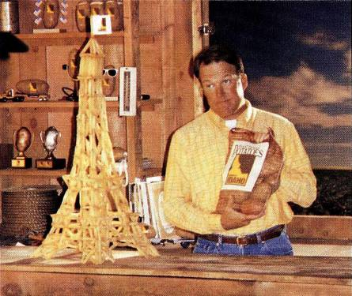

- Eiffel Tower Commercial

- Andrus Commercial

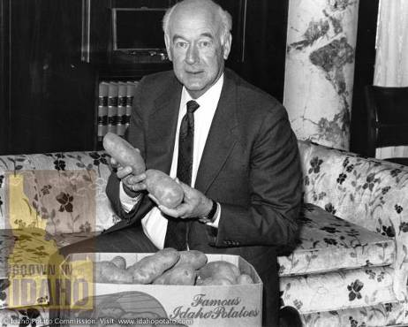

EXAMPLES OF CELEBRITY TIE-INS
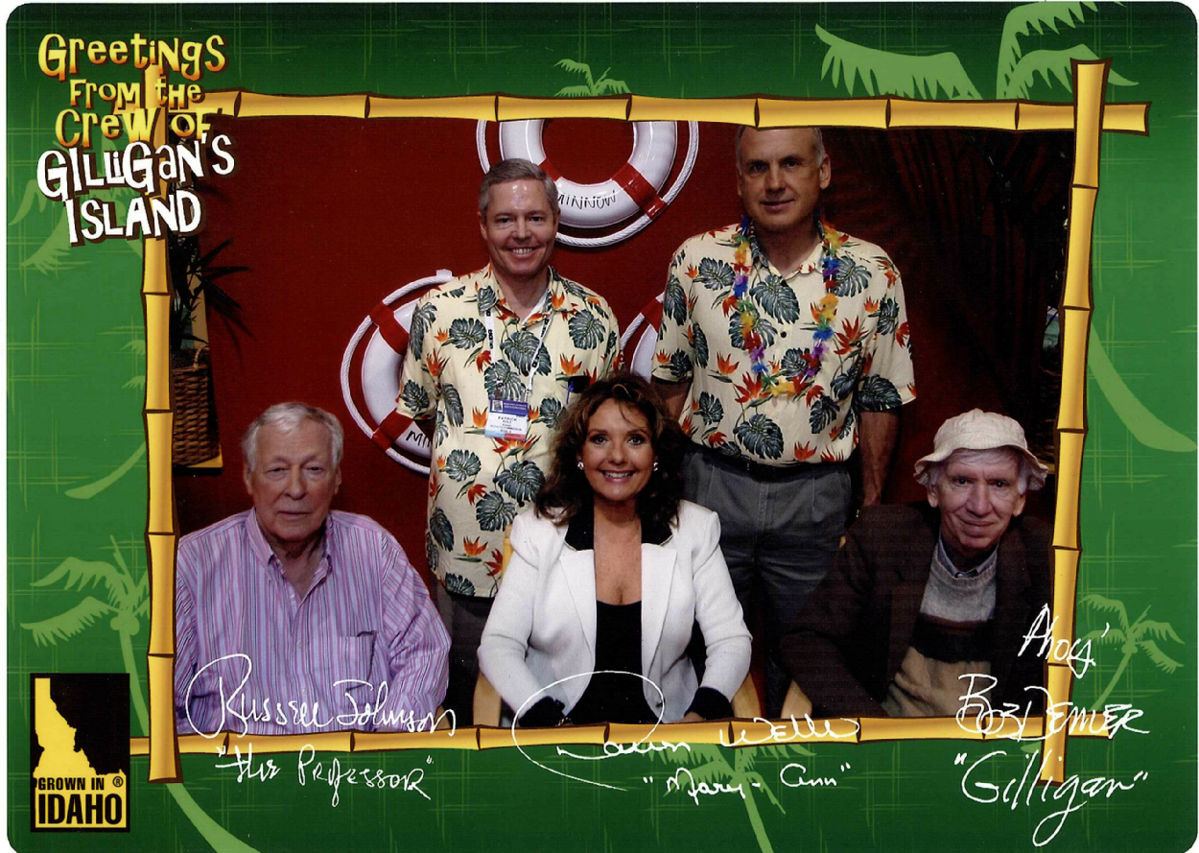



WE PUT “FAMOUS POTATOES” ON EVERY KIND OF PLATE

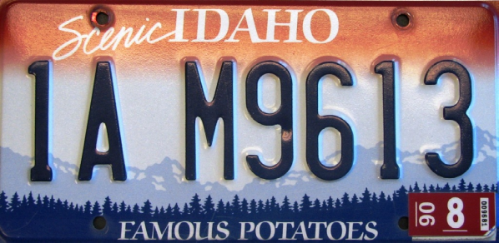

NAMA AWARDS

- TV Ad Campaign: 1st place
- Retail Trade Ads: 1st place
- Foodservice Trade Ads: merit award
- Producer or Company-Funded Advertising Campaigns: 1st place
- Events: merit award
- Company & Association Newsletters: 1st place

BRAND INFLUENCE ON MENU SELECTION

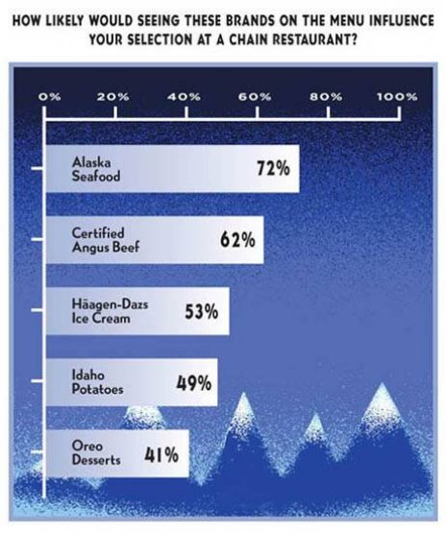

IDAHO’S BRAND STRENGTH

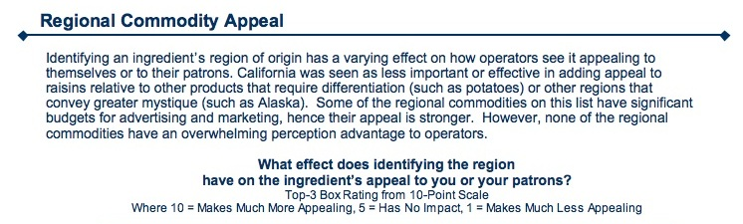

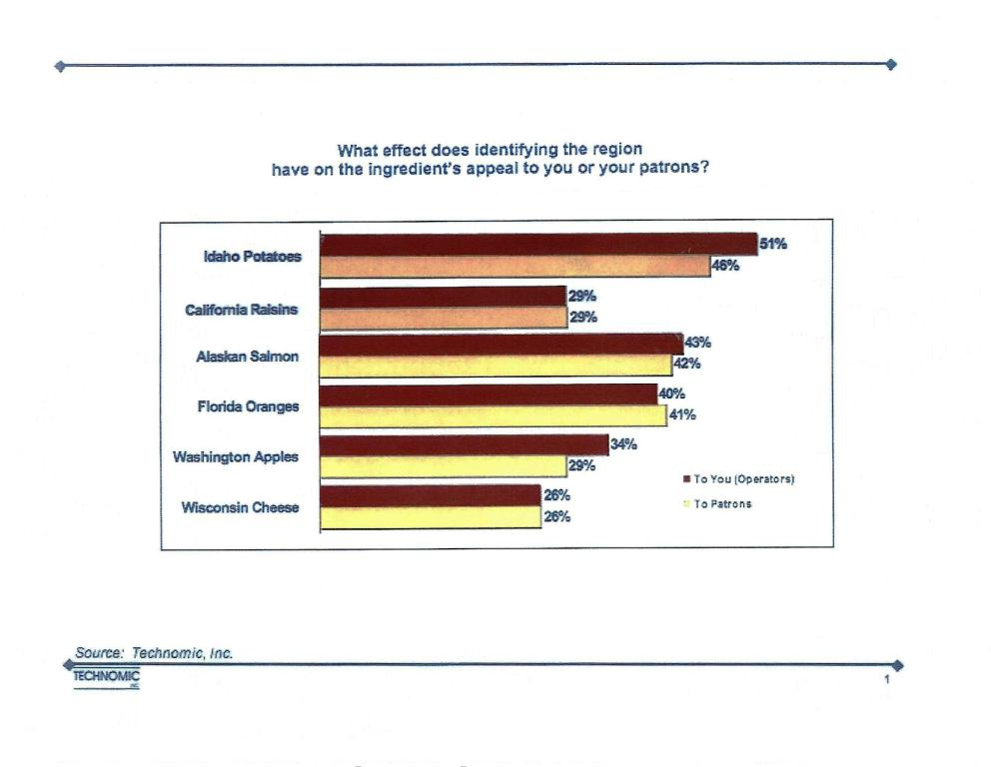
ATTITUDE AND USE STUDY PROVES EFFECTIVENESS OF IPC PROGRAMS
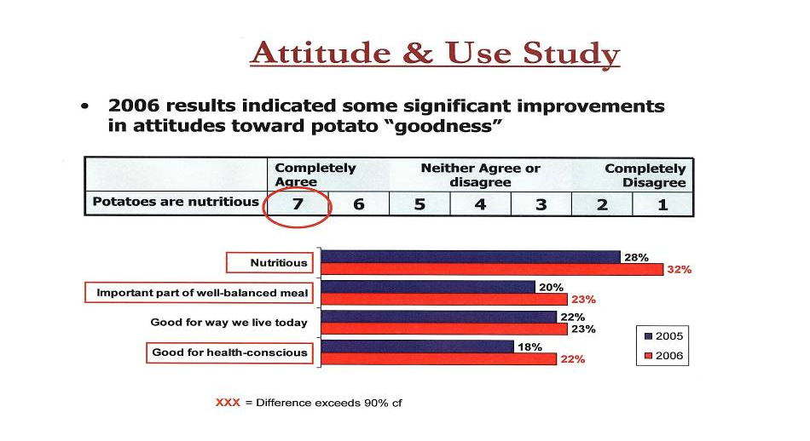

STUDY FROM IDAHOAN SHOWS IDAHO® POTATOES A FACTOR
IN DEHY MASHED POTATOES
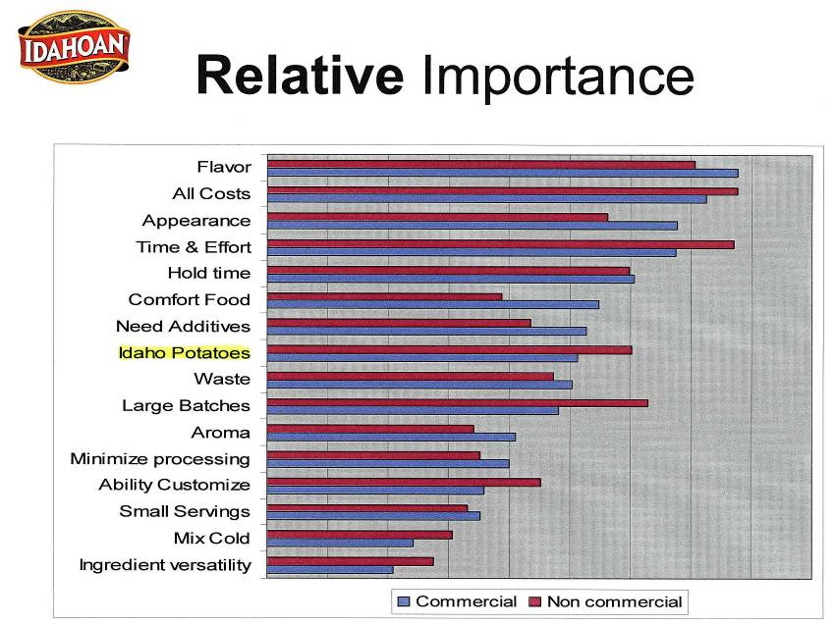

BRAND VALUE ASSESSMENT

- Results of a New Nationwide Consumer Research Study on the Power of Brands in Foodservice

BCG FINDINGS

Values of consumer branding

- Increased sales, e.g., “Steak sales have increased by as much as 75% thanks to the A.1. promotion.”

- Premium pricing, e.g., “Brand X costs the operator 4¢ more but they can sell it for 20¢ more.”

- Differentiation, e.g., “We’re the only one around that has (Brand X).”

- Quality “halo” effect, e.g., “When customers see the same brands they buy at home, they perceive quality.”

HIGHEST RANKING BRANDS

- Heinz Ketchup
- A.1. Steak Sauce
- Grey Poupon Dijon Mustard
- Smucker’s Jams/Jellies
- Land O’Lakes Butter/Cheese
- Hershey’s Chocolate
- Lipton Tea
- Idaho® Potatoes
- Tropicana Orange Juice
- Hellmann’s/Best Foods Mayonnaise
- Folger’s Coffee
- Lea & Perrins Worcestershire Sauce
- Oscar Mayer Bacon
- Kellogg’s Cereals
- Thomas’ English Muffins
- Equal Sweetener
- Campbell’s Soup
- Jimmy Dean Sausage

- Ritz Crackers
- French’s Mustard
- Oreo Cookies
- Maxwell House Coffee
- Wisconsin Cheese
- Sara Lee Baked Goods
- Uncle Ben’s Rice
- Tyson Chicken
- Kikkoman Soy Sauce
- Sweet N’ Low
- Perrier Bottled Water
- Quaker Oats
- Mott’s Apple Juice/ Apple Sauce
- Perdue Chicken
- Cheerios
- Florida Citrus
- Pace Picante Sauce
- Gulden’s Mustard
- Hunt’s Tomato Sauce
- Stouffer’s Lasagna
- McIlhenny Tabasco Sauce

TOP BRAND SCORES
0%
20%
40%
60%
80%
Idaho
Hershey’s
Lipton
Smucker’s
Land O’Lakes
Grey Poupon
A.1.
Heinz

POTATO PLACES: Top mentions of growing areas associated with potatoes

United States 94%
Idaho 86%
Maine 6%
New York 3%
Michigan 3%
Wisconsin 3%
Washington 3%

TV ADVERTISING IMPACT

Results of Study by Four Agricultural Economists:

- “Commodity advertising is unreasonably effective and unreasonably difficult to maintain.”

- “Each dollar spent on advertising agriculture products yields $3-6 in additional revenue.”

- Examples: Milk, Beef, Eggs, Almonds

Source: “The Economics of Commodity Promotion Programs 2005.”
CASE STUDIES: But there are examples where promotion campaigns have not worked:
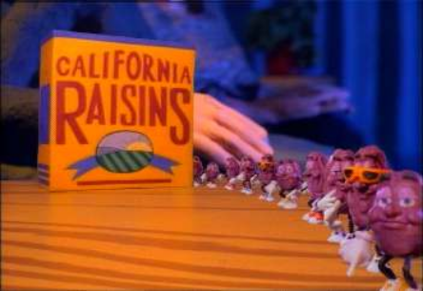
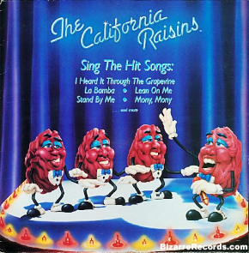

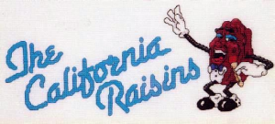

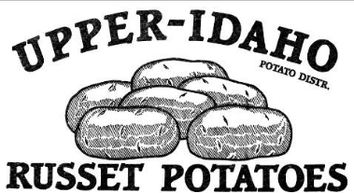
CASE STUDIES: COUNTERFEITING
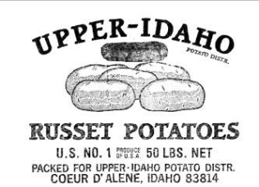

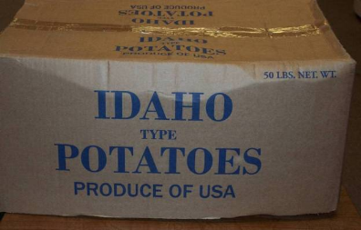
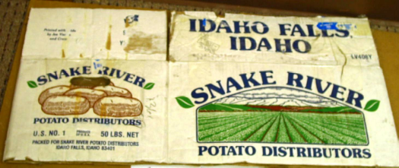

LAST YEAR PUBLICITY PROGRAMS

23.09 million impressions from publicity alone… a new record by more than double.

DENISE AUSTIN VIDEO
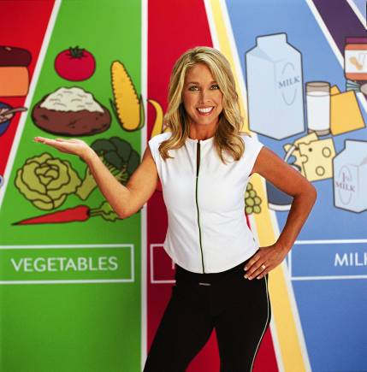

[End of Document]

