 |  | E
SCCR/41/6
ORIGINAL: French
DATE: JUNE 1, 2021

Standing Committee on Copyright and Related Rights

Forty-first Session

Geneva, June 28 to July 1, 2021
STUDY ON THE DIGITAL MUSIC MARKET IN WEST AFRICA
by M. El H. Mansour Jacques Sagna (digital culture expert)

OUR THANKS TO

- Mr. Paul Serge Abdoulaye Maboma, Leader and Bassist of the Cameroonian group Macase, President of the Urban Live Association and Promoter of Bastos Music Laboratory

- Mr. Walid Bara, Director General of the Burkinabe Copyright Office (BBDA)

- Mr. Aly Bathily, Director General of the Senegalese Copyright and Related Rights Office (SODAV)

- Ms. Melle Bathilde Hyvernat Imbert, Marketing Director at Sony Music Côte d’Ivoire

- Mr. Abdoulaye Noma Hassane, General Manager of Djobala Production in Niger

- Mr. Ibrahima Kane (Singer-songwriter), Senior Country Manager at Digital Virgo in Senegal

- Ms. Diallo Aïda Koné, Director General of the Malian Copyright Office (BUMDA)

- Ms. Ngoné Ndour, General Manager of the Prince Arts Label in Senegal

- Mr. Pa Manjai Sey, Manager of AfriRadio in Gambia

- Mr. Nabolle Marou, alias Oumsey, Producer and Publisher at the SYA Music label in Burkina Faso

SUMMARY

Since the advent of mobile Internet, digital media, social networks and DTT, music in French-speaking Africa has aroused a lot of passion and commitment from stakeholders in the sector. There has been euphoric distribution of content over networks in Africa, without there being any real knowledge about communication tools or business models in digital technology.

However, it should be noted that the rapid growth in music labels is a continuation of both the self-entrepreneurship of artists and the theoretical market, which has been marked by the absence of a well-controlled value chain and a business model adapted to its own environment of local consumption. Thus, since the crisis in analog media sales everywhere on the African continent and the slowdown of a socio-economic model based on the consumption of music on physical media, the repercussions of piracy and counterfeiting have augured a new revival driven by Internet access.

However, the search for a model structured around digital technology that would be profitable to all stakeholders in the music production economy has lost some steam since mid-2010. Indeed, in Africa, cultural economists are more interested in new opportunities in sectors such as audiovisual subscriptions on streaming platforms (online video-on-demand services) and digital terrestrial television and are leaving music to find other solutions based more on changes in music-listening habits in a context of very intense local digital transformation.

As a result, with the process of digitalization on the continent, African music is becoming an essential element in local creative economies. For the moment, it should be noted that, in addition to the lack of confidence in digital technology, the lack of interest in content distribution is undoubtedly due to the low incomes of music sector stakeholders and the restrictive value chain imposed by telecom operators. These operators are indispensable for network access and mobile payment means. Indeed, given the low rate of banking, music downloading and/or streaming services are purchased via postpaid telephone credit or mobile money. In this value chain involving telecom operators, costs are over 63 per cent more than the copyright royalties, and the balance goes to platforms and producers. It should also be noted that Internet coverage and access were relatively limited in West Africa, at least until the arrival of 4G mobile Internet, social networks and access to low-cost smartphones. What is more, mobile telecom operators use music as leverage to attract more users to their mobile data packages.

Another factor in music’s delayed transition to information and communications technology (ICT) can be considered to be the sectoral slowdown that characterizes the African creative economy in general when faced with social changes or the appearance of new groups and new forms of cultural sociability specific to each country.

The purpose of this study is, therefore, to analyze the digital music market in selected Sub-Saharan African countries based on the difficulties, opportunities and prospects it faces.

Indeed, music monetization, which is blooming in African countries thanks to downloading, streaming and/or the ring-back tone (RBT), is a significant growth factor for a creative economy in the States. It is also a great opportunity to reorganize and formalize the role of stakeholders and the value chain and thereby add value to local musical content creation for the benefit everyone.

INTRODUCTION

The arrival of African local streaming platforms has modestly stabilized traditional socio-economic models, but these platforms are struggling to carve out a comfortable market share. Even though artists and producers are eagerly anticipating their participation in the rebirth of a local music industry economy, it should be noted that they barely benefit from this rebirth because of their low exposure and audience ratings on local platforms; yet, at the same time, “local music users, through mobile penetration and data usage, have shown sufficient commitment to local African music and artists.” This is one of the motivations of the international label, Universal Music Group (UMG), which has opened a subsidiary, Universal Music Africa (UMA), in Côte d'Ivoire. The African subsidiary does not disclose its turnover but indicates that live music and brand partnerships now account for 60 per cent of its overall revenue.

It should be noted that Africa has more than one billion inhabitants and, according to GSMA, only 26 per cent of these people had access to the Internet at the end of 2019. The following figures illustrate the significant growth of Audiomack which, with 9.4 million active users, has surpassed the competition in some key African markets since 2017:

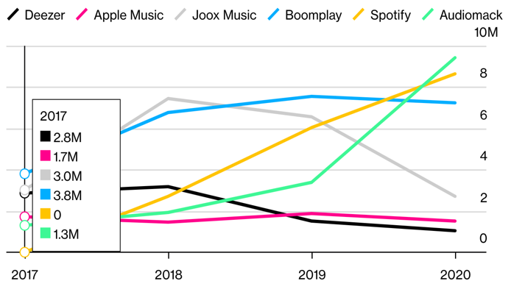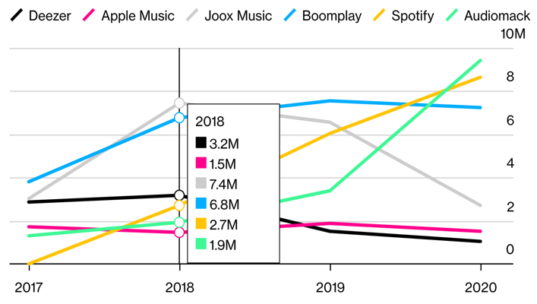

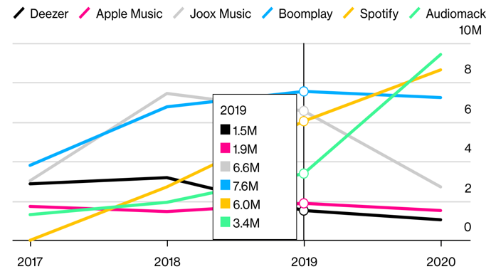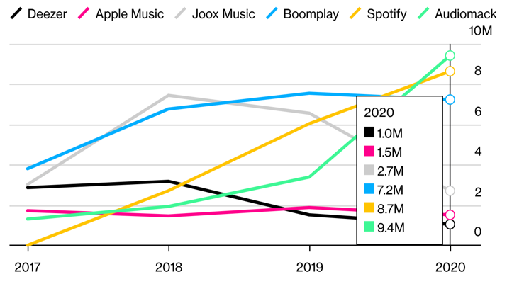

Remark: Data for active users in Kenya, South Africa and Nigeria

Consequently, as part of this study on digital music in Africa, many interviews were conducted with stakeholders in digital music content production and several proposals were made that explain this contrast by reflecting on music consumption in the digital age. What is more, it should be highlighted that the listeners interviewed emphasized the lack of interest that international platforms show for the specificities of African music.

CONTEXT

New technologies in West Africa are the main focus of a large portion of this new generation of young musicians whose playful and artistic productions testify to a huge expansion in African musical works through public distribution on all information technology and communications media.

Some of the significant issues raised by this new generation of artists relate mainly to the contrast in digital music distribution between the growing consumption on Internet and/or telecommunications networks and the lack of viable economic opportunities for music.

What must be emphasized is that digital music exploitation in Africa lags behind other creative industries, such as the audiovisual or video game industries, which are constantly expanding on the continent and are facing problems related to the legal framework and the lack of human capital. In particular, entertainment companies and music labels are struggling to carve out a market share due to the intrusion of multinationals (e.g., telecom operators) in the sector. The latter influence music consumers through their marketing approaches because music tends to become just a medium for promoting a product or animation around agribusiness products and services. There is also a lack of special attention in state cultural policies to supervising, legislating and promoting guarantees for private investment in the music industry.

Of course, the new uses and advantages that digital technology brings to the music industry are real, but the problem remains that music exploitation does not benefit the stakeholders enough in its implementation. The stakeholders, in turn, accuse either the State or the collective management organization (CMO) of being responsible for their lost profits. Moreover, collective management in West African countries is an indicator that can provide information about digital music exploitation on several levels, including artists’ live-streaming video performances. Also, because of the COVID-19 pandemic, digital technology has been repositioned as a second chance for the music industry.

In addition, digital music in Sub-Saharan Africa can be divided into listening to music via mobile phones on social networks with user-generated content (UGC) and via traditional thematic mass media, such as DTT. Today, DTT offers users interactive content without a subscription (freemium), whereas broadcasters in French-speaking Africa are increasingly monetizing their content on UGC platforms. This is the case for artists’ concerts in television studios or concert recordings that are subsequently monetized on YouTube channels and television stations, without the artist's prior authorization and without regular payment of royalties to the CMO.

LEGAL FRAMEWORK

In the case of Africa, the bulk of cultural content on the Internet is copyrighted works. This content confers, with good cause, a right of property on its author for a limited period. This is to ensure that authors may benefit from their work and that the link between authors and their work is preserved. It is, therefore, important to guarantee the author control over his or her work as a creator and this will, as a result, encourage local creation. This is necessary for the sustainable development of music in Africa.

In addition to a legal framework which is not sufficiently harmonized and up to date to contend with new digital consumer services in West African states, other problems are often of a political nature, as politicians struggle to define and/or apply regulations specific to the digital creative economy sector. It follows that this legal vacuum on reforms creates a situation that benefits the illegal exploitation of protected works more than collective management and music industry stakeholders. In the context of local digital music in Africa, the interests of authors are, therefore, facing new difficulties that deserve our full attention in this study.

Indeed, artists and music companies have, in general, been greatly affected by piracy and counterfeiting since the advent of physical media (cassette tapes, CDs, etc.). Moreover, it is for this reason that Senegal strengthened the ecosystem of protected works by adopting the law of January 25, 2008, which created the Senegalese Copyright and Related Rights Office (SODAV), a civil body, and thereby launched a new era of collective management and protection of related rights. As a result, stakeholders manage their works themselves and drive a common vision of their own professional environment.

According to Mr. Aly Bathily, Director General of SODAV: “For collective management, the opportunity that the development of digital technology can bring lies in the fact that this new exploitation paradigm can become an immense source of wealth. With the proliferation of international digital platforms accessible to the local consumer, the dynamism of digital music consumption has become the greatest challenge for collective management in Senegal, hence the awareness initiatives to encourage all digital music users to formalize the situation and sign the general representation contract with SODAV.”

For producers, working in compliance with collective management guarantees the security of their investment. We have the example with Djobala Production in Niger. Its manager, Abdoulaye Noma Hassane, explains that: “A few months ago, Niger reformed the statutes and legal framework of the Niger Copyright Office (BNDA), which manages and distributes intellectual property rights. The aim of this reform was to adapt the BNDA to the cultural policy of Niger so that the two are complementary...”

For some Central African countries, particularly Cameroon, a vision of cultural policy and collective management remains a very urgent problem that must be solved.

Furthermore, as Mr. Paul Serge Abdoulaye Maboma, Leader and Bassist of the Cameroonian group Macase, President of the Urban Live Association and Promoter of Bastos Music Laboratory, points out: “Personally, I have no relationship with the copyright society at this time. For almost two decades, there has been great disarray in copyright management in our country. Copyright societies have been created one after the other without ever bringing any serenity to copyright. As for cultural policy, it simply does not exist, or it is not known to us. Initiatives are generally taken by individuals based on their desires, their vision and their ambition for music in our country. We continue to hope that, one day, this long-awaited cultural policy will be available.”

As far as the digital music market on the continent is concerned, innovations in local online music distribution are developing everywhere. At first, these innovations develop outside the control of CMOs, which generally do not have technical monitoring means and find themselves too overwhelmed by the rapid evolution of music consumption modes to provide contractual management responses, or on the basis of uncertain expectations about business models and relevant local market rules.

They largely escape the copyright rules in most West African countries, which have, until now, been the measurable focal point for music distribution based on traditional royalty collection information.

Consequently, the uncontrolled distribution of digital content on the Internet, influenced by trends and hype, has given rise, in return, to protest from local music industry stakeholders. These stakeholders protest the detrimental effects of digital distribution on their business, which comes on top of the activity of broadcasters and telecom operators. Moreover, these telecom operators are an essential link in the value chain because of their mobile payment means, mobile users and, in particular, mobile Internet access. This situation has accelerated the search for new regulations to correct these externalities.

DIGITAL MUSIC IN AFRICA

While local music in Africa is struggling to keep up with the demands of the consumer, who is increasingly impacted by mass digital transformation, digital music distribution is aspiring to be more effective but needs a viable environment in which to set up and develop commercial activities.

Ms. Ngoné NDOUR, General Manager of the Prince Arts Label (Senegal), also talks about the difficulties encountered: “Firstly, the ecosystem is not very profitable at the moment because the populations’ Internet access is limited in many regions and those who have the option deplore the high cost. Other problems are the unbridled piracy of our works on Internet, the lack of stakeholder training in digital economy management, the unfair competition from audiovisual multinationals, and the failure to pay copyright and related rights by GAFA. As a result, the challenges we face are Internet for All, training, the fight against Internet piracy and payment by GAFA for the rights in the works exploited.”

Digital music products and services must, therefore, be developed further on the African continent in order to promote the creativity of musical art. To achieve this, the exploitation of digital music must be based on adequate copyright legislation and a less onerous tax regime for authors and production companies.

What is more, the license issued by the CMO must be enforced in order to add value to phonograms because artists, producers and publishers are powerless to act individually. Indeed, it is very difficult for them to manage exploitation requests from multiple music distribution channels on their own. As a result, CMOs must be able to manage very extensive repertoires and allow a more balanced negotiation of remuneration from digital exploitation.

In Mali, Ms. Diallo Aïda Koné, Director General of the Malian Copyright Office (BUMDA) says: “Thanks to habits and customs, we have always maintained a good relationship with operators and producers. As far as platforms are concerned, there has not been enough consultation between us yet. But this does not mean that our relationship is bad. By capitalizing on the understanding we share with rightholders, producers and users and on the support of the administrative authorities, we have been able to establish and consolidate a very good relationship. However, like any management system, there is still a long way to go because not all users are looking in the same direction.”

Digital technology has given collective management a new growth driver because local digital transformation has not spared the music sector, forcing musicians to adapt to new modes of exploitation of their works. Indeed, with the multiplication of content distribution channels (RBT, video streaming, audio streaming and Internet radios), copyright CMOs have had to adapt their royalty collection systems to telecom operators and digital broadcasters (DTT, DTR, Internet Radio and Internet TV).

For Côte d’Ivoire, the Marketing Director at Sony Music Côte d’Ivoire, Ms. Bathilde Hyvernat Imbert, says: “I think the opportunities are great due to the rapid penetration of smartphones. However, for development to be more effective, the regulatory bodies need to monitor the sector. With all these elements in hand, the challenge would be to professionalize the sector so that artists can finally make a living from their art thanks to digital technology.”

OVERVIEW OF MUSIC MARKET TRENDS

In Africa, music was the first of the local cultural industries to pay the price for its lack of adaptation to the digital shift in the early 2000s. According to Internet World Stats (2020), “the Internet penetration rate is now 39.2 per cent in Africa, while the world average is 58.8 per cent and 62.9 per cent for the rest of the world.”

Local music is a powerful vector that unites people around a common interest, and this gave rise to community music markets. But, with the advent of broadband Internet, new types of consumption are now the standard in Sub-Saharan Africa. Downloading and streaming are still modest segments among music users because of telecom operators’ data pricing, which is still not very accessible to millennials.

Moreover, the global coronavirus pandemic has allowed us to measure the strengths and weaknesses of each market in West African countries. Apart from musicians’ involvement in raising awareness among populations as part of the fight against Covid-19, the use of digital technologies to distribute music to the public has proven to be both an asset and a threat to business models and has sparked a lively debate in the African artistic community.

With regard to this analysis and current trends, Abdoulaye Noma Hassane from Djobala Production observes that: “Niger is a young country in terms of its population (more than 60 per cent). Young people love music very much, especially urban music, and we are in the same geographical basin as Nigeria and not so far from Côte d'Ivoire, two giants in African music. The digital market is still very small, but the potential is there. The difficulty may lie with Internet access. In Niger, the Internet connection is not yet at its best, and it is difficult to read, watch or buy music online.”

The history of the African music industry, which is known for its commitment to technological, social and cultural evolution as well as to transforming consumer habits, is punctuated by recurrent crises, each of which has provided an opportunity to reform the ecosystem, remobilize the socio-economic actors and appropriate technological progress to reorganize the sector and trigger a new period of growth.

The rapid expansion and liberalization of radio and television on the continent are important consequences of consumption in Africa. This means that the music industry is not limited to phonogram production. Today, mass media have started producing music-related content (concerts in TV studios and/or concert halls) with producers and monetizing this content for their YouTube or Instagram channels. This is the case of the concert Le Grand Bal by the artist Youssour Ndour on TFM’s YouTube channel or the concert by Wally Ballago Seck (Senegal) on SenTV’s YouTube channel.

Furthermore, the activity of traditional mass media (radio and TV) in West African countries has gradually assumed great strategic importance in the music sector to become the focal point for the dual strategy of repositioning and reintegrating the media as part of the local phonographic industry.

The direct impact of this crisis is a decrease in physical sales that affects the entire music sector in Africa, which accounts for only 0.8 per cent of global collections. In particular, the royalties paid to CMOs are affected because mechanical reproduction has dropped by more than half. In Africa, the crisis has prompted stakeholders to initiate a number of local strategies within the music industry to focus on digital management of catalogs, editorial rights and phonographic rights and diversify associated music production activities as intermediate productions for other cultural sectors in order to generate more income and stimulate local investment.

For Mr. Nabolle Marou, alias Oumsey, Producer and Publisher at the SYA Music label in Burkina Faso, the local music industry is undergoing profound economic and technological changes. His analysis is based on the following points:

- The rapid expansion of digital technology allows greater access for consumers and the Burkinabe public. A smartphone with an Internet connection allows you to listen to your favorite artists and discover new ones on all the streaming platforms. Attractive offers from local telecom operators contribute largely to this.
- Furthermore, the professionalization of music stakeholders has increased in Burkina Faso.
- From an economic point of view, one of the biggest challenges is the (re)structuring of the CMOs. Indeed, better optimization in the collection and redistribution of copyright and related rights would allow rightholders to develop in a sustainable way.

African local music platforms and stakeholders also have to contend with UGCs and international industry giants, which pick up the majority of the works that constitute most of local digital music traffic. Video music content is then selected based on the “like trade” and online advertising, and the international platforms generate significant profits from people listening to and viewing music videos.

Even though the trends in digital music are not to the advantage of local platforms, most stakeholders want an environment that fits a business model in line with their expectations, especially with regard to payments, which benefit telecom operators more due to the value chain activities of transportation, billing and interconnection with local third-party platforms.

In Côte d'Ivoire, according to Ms. Bathilde Hyvernat Imbert, Marketing Director at Sony Music Côte d'Ivoire, a global vision of digital music must be adapted more to the local context: “Indeed, music is changing rapidly worldwide and, with the crisis we are all going through, it is imperative to reinvent ourselves and capitalize on what is, today, the future of music. Between the development of Internet and increasingly sophisticated devices, digital music will be the primary means of consumption by the public.”

NEW BUSINESS MODELS

It is imperative to transition to digital transformation through digital music platforms created by Africans for Africans. Indeed, while UGC platforms, YouTube, Facebook, Instagram and WhatsApp are global technologies whose uses can be adapted to the local context, the local platforms mentioned in this study are solutions that are suited to a (fee-based) premium subscription for local music and are, above all, different from international services and those on popular traditional social networks.

Mr. Walid Bara, Director General of the Burkinabe Copyright Office (BBDA) explains the difficulties relating to the presence of international platforms: “Burkina Faso is unable to make these large platforms pay copyright royalties. This is a common reality in Africa and a solution is being studied. Indeed, these platforms exploit countless works but do not pay any financial compensation known as copyright royalties. Yet, the offense of counterfeiting does exist in our law when a work is exploited by anyone without respecting the creator's rights.”

The value gap in Africa
The value gap is the difference between the revenue that (UGC) platforms, streaming services with and/or without advertising and telecom operators get from music and what they pay to authors and other music stakeholders. The music community in Africa still does not realize the damaging effects that the value gap has on the local digital market. Indeed, some content-sharing platforms are very quiet about fair payment of artists and exploit their works for their own profit.

As an example, Deedo, present all over West Africa, is currently one of the streaming platforms that allows artists not only to distribute their music directly to the local market and reach the diaspora but also to offer exclusive content on the continent.

In Senegal, the local platforms MusikBi, Ziksen and Jaaba Music distribute music online in a very special context. Mr. Ibrahima Kane (Singer-songwriter), Senior Country Manager at Digital Virgo, which is specialized in value-added services, and Publisher of the music platform Ziksen, explains: “In my field of work, digital music consumption is more than an economic stake because it demonstrates, via the content, the expertise of the mobile payment structure. As a result, it is possible to implement content monetization solutions, and their profitability also depends on digital marketing campaigns. Local production is becoming essential to attract end users and meet the needs of a local market. It also creates value for local artists (possibility of having their content exploited automatically or ordered as an exclusive production by local platforms).”

It is also worth noting a significant fact about music consumption. Indeed, local music in Africa today is profitable for a lot of people and companies who use the music audience for their own marketing, commercial or financial needs to promote their products or services, recruit new customers, sponsor music or organize free events directly or indirectly. However, this installs a culture of free music consumption in peoples’ minds.

- UGC in Africa
Today, UGC platforms are world leaders in online music consumption and play an essential role in this field in Africa.

Most of the revenue from local music is collected by UGC platforms and they redistribute only a small portion to rightholders. This is one of the reasons why African States and CMOs must urgently define a direct legislative framework to regulate these platforms and their actions, which impoverish African local music. Indeed, by distributing the content, the host (UGC platform) would have the function of publisher. Moreover, the European Union Directive 2019/790 of April 17, 2019, could inspire cultural policies in Africa to consider a direct solution with UGC platforms, considering that new services in digital music involve new licensing systems after collective management.

The publisher, unlike the host, is directly liable for the unlawful consumption of digital music because the role of (UGC) platforms in Africa is to provide music distribution on their networks. Platforms play a key role in digital music through their positioning on the (no-fee) freemium model and monetization via advertising. That is why they are not exempt from liability in the difficulties this creates for African music.

Another issue is the mining of data generated by UGC platforms when they provide digital music to end users. By distributing digital music, UGC platforms generate digital social data. This is a basis for considering the big data approach that puts the music consumer at the center of the data collected by digital technology.

Ms. Diallo Aïda Koné, Director General of the Malian Copyright Office (BUMDA), explains that the difficulties observed are present all over the continent and that, upon analysis, it can be seen that several sectors of socio-economic activities are in great turmoil: “Music is in crisis. The market value of music is greatly affected in the digital age. For example, in Mali, music recorded on a CD used to be sold for between 1,000 and 2,000 West African CFA francs, compared to 50 to 100 West African CFA francs today. Although online sales, which are made possible by digital technology, are increasing significantly, they still do not make up the shortfall. African CMOs are having great difficulty controlling the chain of exploitation of musical works. The digital giants (YouTube, Google, etc.), which are platforms providing music and links for mass music consumption, are still not in complete compliance with the majority of African CMOs. In most cases, this situation has caused record companies to shut down. So, the real problem that CMOs are facing today is this lack of control over both music exploitation and the collection of royalties from the majority of large digital users.”

OPPORTUNITIES: THE GROWTH OF MOBILE INTERNET

The telecommunications sector has been growing rapidly in Sub-Saharan Africa over the past decade and has had a significant impact not only on consumer habits and models for online music exploitation but also on telecom operators, who are now focusing on content to stimulate growth.

In addition to the freemium model (subscription-free user access), music allows operators to deliver a free service at a low cost and potentially finance it, at least partially, with advertising. Freemium, therefore, offers the artist an income generated by advertising (for example, YouTube). While there is growth in (fee-based) premium subscriptions on local platforms, these are mostly subject to multiple constraints from telecom operators, and their dependency on Internet leads to an extra mobile data charge for consumers on top of their basic package. There is also growth in mobile payment methods, although their value chain constitutes a significant obstacle to the creation of a digital music market in West African countries.

“Over the next four years, West Africa is expected to experience an average subscriber growth of 6 per cent per year, one of the highest growth rates in the world, resulting in 45 million additional subscribers by 2020.”
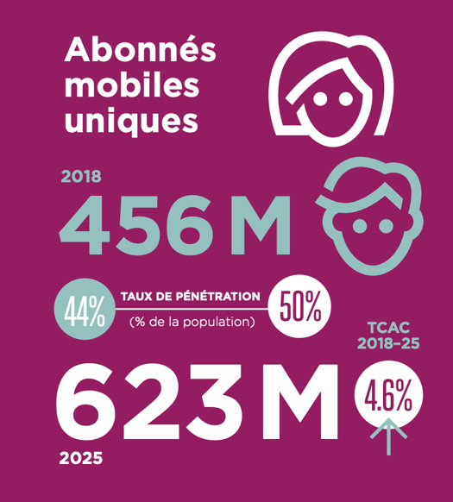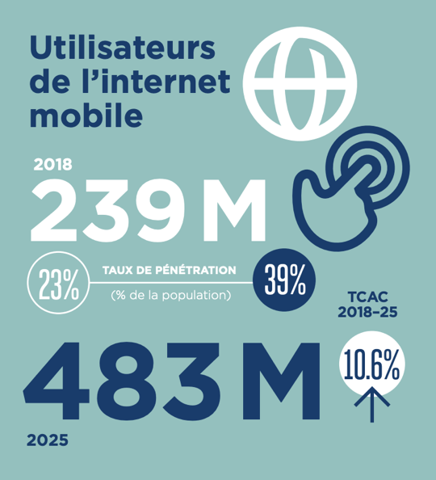
Single mobile subscribers Mobile Internet users
PENETRATION RATE PENETRATION RATE
(% of the population) (% of the population)

“Digital music consumption is being strongly driven by the affordability of low-cost smartphones and the deployment of 4G mobile Internet in almost all West African countries. This has also led to a steady drop in prices and the acceleration of mobile data consumption by users.”

SUB-SAHARAN AFRICA WILL HAVE OVER 600 MILLION SINGLE SUBSCRIBERS
BY 2025

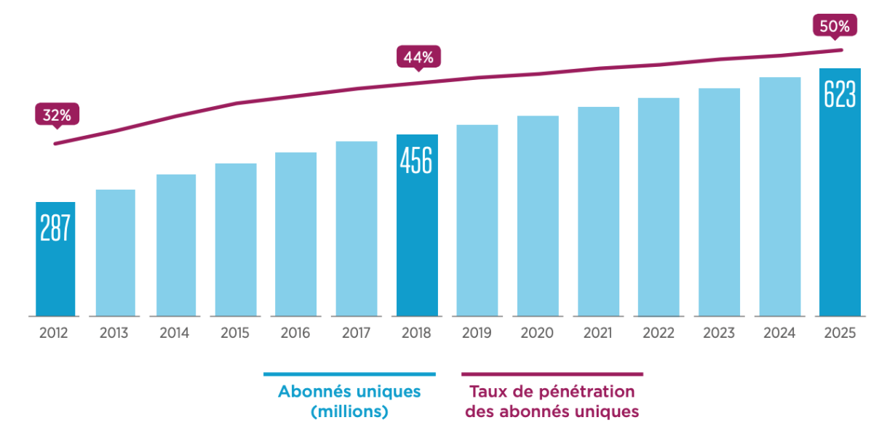
Single subscribers (million) Single-subscriber penetration rate

All of Sub-Saharan Africa will see a four-fold increase in mobile data usage by 2024.

“In 2018, mobile technology and services generated 52 billion dollars in economic value (8.7 per cent of GDP) in West Africa, a figure that will grow to nearly 70 billion dollars (9.5 per cent of GDP) by 2023. As a result, countries are benefiting more and more from the gains in productivity and efficiency brought about by the increased use of mobile services.”

DEMOGRAPHICS AND THE DIGITAL MUSIC MARKET

There is a great opportunity for music in the deployment of 4G in West African countries, which are admittedly lagging far behind the Eastern and Southern African subregions. This delay in the deployment of 4G is impacting market growth as well as music stakeholders in the distribution of their content over these large-scale telecommunications networks. Millennials in West Africa suggest that a very lucrative future is coming soon for digital music. According to recent United Nations projections, the continent's population is expected to double by 2050, from one billion inhabitants today to nearly 2.4 billion.

If we consider that half of the under-25 population in Africa constitutes the largest consumer of digital music on the continent, an urgent question arises as to the capacity of the creative economy in Africa to absorb the millions of new consumers that will expand its local market.

USER PAYMENT METHODS

The mobile money phenomenon is now having a fundamental impact on African society, redefining the way music producers and consumers interact through monetization of content in local digital channels offered by African fintech. According to Mr. Ibrahima Kane (Singer-songwriter), Senior Country Manager at Digital Virgo: “the challenges for the development of digital music will essentially revolve around the introduction of a business model specific to Africa. As far as payments are concerned, we will have to work on payment tools tailored to the local market in order to guarantee dynamic purchasing power for consumers.”

To that end, musicians in West Africa are resolutely committed to mobile connectivity as a cost-effective alternative and solution for promoting digital music to their target audience. The consumption of dematerialized cultural goods, especially music, is essential for reaching strategic objectives, which are key to a sustainable economic vision of creative industries in Africa.

It is, therefore, essential and urgent for local African music to engage more in digital transformation in order to stimulate expansion and capitalize on the exponential growth in the mobile phone sector, which is forecast to have “nearly 500 million users of mobile Internet in West Africa by 2030.”

Furthermore, the low rate of banking among the African population in general has a significant adverse effect on the supply of music to end users, but the main setback is also accessibility to the local market. Mr. Pa Manjai Sey, Manager of AfriRadio, explains that, in Gambia for example, like in many African countries: “Without PayPal, Visa or Master Card, you cannot access these platforms, and that is one of the biggest problems we face as an industry. With the right structures in place in Gambia, we can generate more music, more revenue, especially if consumers have easy access to music and payment means at their disposal. This will certainly increase revenue for creators in the music industry.”

CONSUMER EXPECTATIONS AND HABITS

Developments in musical art suggest that the younger generation is embracing the digital transformation in African society and that new forms of expression, associated with technology, are on the rise.

These new representations are distinctive in that they are very dynamic and target a younger audience, unlike traditional approaches to music, which were essentially oriented towards representation based on, inter alia, physical media and channels. These new representations of music are also driven by a new generation of Africans whose visions, practices and behaviors are strongly marked by consumer habits that are increasingly based on new technologies. It follows that music must rely on the African millennial generation for the digital music market, as the community characteristics of Internet users mirror those of African demographics, i.e., it is a predominantly young population.

This situation is especially beneficial to international platforms, which remain a source of admiration for many stakeholders in African music. Mr. Paul Serge Abdoulaye Maboma, Leader and Bassist of the Cameroonian group Macase, President of the Urban Live Association and Promoter of Bastos Music Laboratory, describes this situation in the following way: “We see and admire the results these platforms get in other countries on the continent. Unfortunately, for the reasons already mentioned, they are not yet part of the mechanisms that we can use collectively to distribute our works efficiently. Therefore, the answer to the question would be “no” because, for us, they are currently inaccessible. But, theoretically, platforms are the solution for breaking into the new economic Eldorado of the digital market. We just need to find a way for our populations to be able to pay without too many complications.”

This means that digital music consumption is of significant economic importance and thus influences local production in all West African countries. Furthermore, on this subject, Abdoulaye Noma Hassane from Djobala Production explains that: “Young Nigeriens consume a lot of music downloaded via YouTube, Audiomack, etc. and this inspires artists in their production. So, we can say that there are economic stakes in this field for everyone.”

CONCLUSION

In combination with the rise in digital exploitation, today’s local African music economy provides musicians with an increasingly global approach to their artistic projects and gives a fresh impetus to international careers for African artists.

In this study, our approach has looked, in particular, at the challenge of sharing the value generated by the consumption of copyrighted music on the Internet. This implies that all industry stakeholders in Africa must pay more attention to understanding the communication tools, the business model and the opportunity and risk analysis related to digital exploitation. It is also a question of finding suitable solutions to enable more balanced value-sharing between musicians on the one hand and the local and international platforms, which enable their works to be listened to and digitally shared, on the other.

It is, therefore, obvious that the professionalization of the music sector will require the introduction of specialized production and distribution chains to further expand local marketing possibilities for music and promote quality artistic activity for users.

For this reason, a professional music ecosystem will be beneficial to all the stakeholders in both the music and digital industries. In the same vein, there is urgent need of training for all music stakeholders because this will allow them to consolidate their professionalization and their involvement at several levels in the value chain, enabling a significant increase in their income. Training will also guarantee a better chance for a sustainable artistic career.

At the same time, the lack of digital expertise in the new business models, which are imposed by digital transformation and designed to develop the local music economy, can be addressed by bolstering cultural enterprises through a less onerous tax regime and the introduction of guarantee funds to stimulate investment in the music sector.

Finally, it is obvious that CMOs in Africa today are faced with a major hurdle, that of standing up to the Internet giants (Google, Facebook, etc.) in order to force them to pay royalties for the benefit of rightholders.

[End]

Digital Terrestrial Television
On-hold music on telecommunications networks
Apptopia
Coronavirus
Google, Amazon, Facebook and Apple
Consumer and market data generated on the Internet
CISAC, “Global Collections Report 2020”
GSMA Intelligence
Ibid.
Ibid.
Ericsson, GSMA Intelligence (GB per subscriber per month)
GSMA, “The Mobile Economy West Africa 2019”
https://www.un.org/fr/un75/shifting-demographics
GSMA Intelligence

