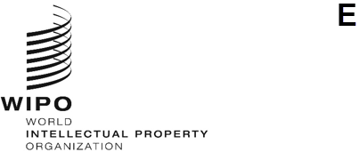

Information Notice No. 7/2021
Geneva Act of the Lisbon Agreement on Appellations of Origin and Geographical Indications
RATIFICATION BY HUNGARY
- On June 10, 2021, the Government of Hungary deposited with the Director General of the World Intellectual Property Organization (WIPO) its instrument of ratification to the Geneva Act of the Lisbon Agreement on Appellations of Origin and Geographical Indications (the “Geneva Act of the Lisbon Agreement”), adopted in Geneva on May 20, 2015.
- Pursuant to Rule 4(1) of the Common Regulations under the Lisbon Agreement for the Protection of Appellations of Origin and their International Registration and the Geneva Act of the Lisbon Agreement on Appellations of Origin and Geographical Indications (the “Common Regulations”), the Government of Hungary has notified the following name and address of its Competent Authority for the purposes of the procedures under the Geneva Act of the Lisbon Agreement:
European Commission
Directorate-General for Agriculture and Rural Development
Directorate B. Quality, Research & Innovation, Outreach
Rue de la Loi / Wetstraat 130
1040 Bruxelles / Brussel
Tel: +32 2 299 11 11
E-mail: Agri-b3@ec.europa.eu
Website: www.ec.europa.eu/agriculture/
- Otherwise, the name and address of the Competent Authority designated by the Government of Hungary for the purposes of the procedures under the Lisbon Agreement for the Protection of Appellations of Origin and their International Registration of October 31, 1958, remain unchanged, namely:
Hungarian Intellectual Property Office (HIPO)
PO Box 415
1438 Budapest
Hungary
Tel: +36 1 312 4400 / +36 1 474 5775
Fax: +36 1 474 5534 / 5936
E-mail: hipo@hipo.gov.hu
Website: http://www.hipo.gov.hu

- Pursuant to Rule 4(3) of the Common Regulations, the Competent Authority referred to in paragraph 2 above will make available information on the applicable procedures in its territory to challenge and enforce rights in appellations of origin and geographical indications. This information will be published at https://www.wipo.int/lisbon/en/applicable_procedures.htm.
- The Geneva Act of the Lisbon Agreement entered into force, with respect to Hungary, on September 10, 2021.
December 22, 2021

