Mr. Bai Guangqing
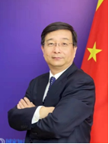
Director General, International Cooperation Department, China National Intellectual Property Association, China

Mr. Bai Guangqing is the Director General of International Cooperation Department of the China National Intellectual Property Administration (CNIPA). He has been working in the field of Intellectual Property for more than three decades since joining the CNIPA as a patent examiner in the area of Chemistry in 1989. He has worked for several years at the Patent Reexamination Board (PRB), CNIPA and was appointed as Deputy Director General of PRB in 2004. In 2006-2007, Mr. Bai served on secondment as Deputy Mayor of Huang Shi City, Hubei Province, with special responsibility for innovation, competitiveness and Industrial Property policy. He graduated from School of Medicine, Peking University. His postgraduate qualifications consist of a master degree in Law from Peking University, and an EMBA from School of Economics and Management, Tsinghua University. In 2002, he studied Intellectual Property Law at John Marshall Law School, United States as a visiting scholar.

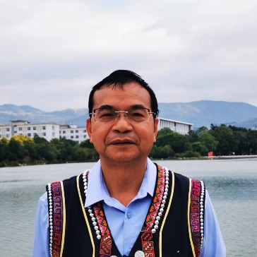
Mr. Huang Shaowen
Professor and Director of the Ethnic Cultural Heritage Research Centre of Honghe College, Yunnan Province, China

Mr. Huang Shaowen, of the Hani ethnic group, is a Professor and Director of the Ethnic Cultural Heritage Research Centre of Honghe College. He has published four personal monographs, including Research on Traditional Ecological Culture of the Hani Ethnic Group in Yunnan, and more than 40 academic papers. He has presided over two research projects of the National Social Science Foundation, and has been awarded one second prize and one third prize of the “Excellent Achievements in Philosophy and Social Science of Yunnan Provincial Government”.

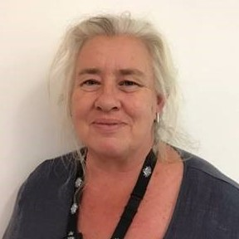
Ms. Edwina Lewis
Director of Policy and International Affairs, IP Australia, Australia

Edwina is a Director of Policy and International Affairs at IP Australia. She is responsible for leading IP Australia’s policy development for select issues such as Indigenous Knowledge. This includes IP Australia’s Indigenous Knowledge workplan, considering how the IP system can better support Australia’s First Nations Peoples benefit from their Indigenous knowledge and culture.

Ms. Xing Yue
Vice President, Alibaba Group

Before her current position, Ms. Xing Yue was Deputy General Manager of Tmall Global, responsible for business strategy and public affairs of Tmall Import & Export, and supported the final implementation of Alibaba Group’s globalization strategy in retail business. She also previously served as Director of Public Affairs for Cainiao Network (Alibaba's logistics arm) before joining Tmall Global. She was a senior executive of Hong Kong Dragon Airlines Limited before joining Alibaba Group. Many years of experience working in traditional industry combined with her experience at Alibaba Group has enabled her to have a thorough understanding of the integrated development of the Internet and traditional industries, as well as the transformation and upgrading of traditional industries. Xing Yue holds a Master degree in management from Tongji University.

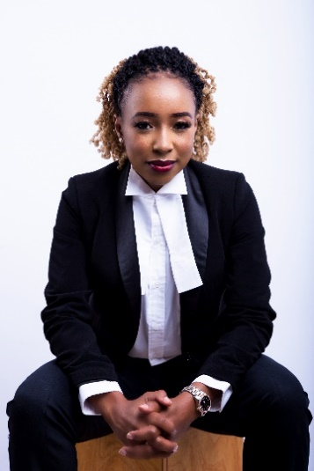
Ms. Liz Lenjo
Managing Consultant, MYIP Legal Studio, Kenya

Ms. Liz Lenjo is the Founder and Managing Consultant of MyIP Legal Studio. She specializes in Intellectual Property, Entertainment, Media, and Fashion Law. Liz has been appointed as the current Chairperson of the Copyright Tribunal. She is an adjunct faculty member at the Strathmore University Law School where she teaches Media and Entertainment Law, and Business Law. Liz is also a tutor with CopyrightX by HarvardX- Kenya, which the GoDown Arts Center runs. She is a volunteer with the Kenya Bureau of Standards as the Chairperson of the Intellectual Property Committee and the Kenya Fashion Council as the Head of Intellectual Property & Policy in the Legal Committee. Liz holds a Master of Laws (LL.M) in Intellectual Property Law from the University of Turin (Italy) and World Intellectual Property Organization (WIPO), a Bachelor of Laws (LL.B) from the Catholic University of Eastern Africa (CUEA), and a Postgraduate Diploma Kenya School of Law. She also holds a Certificate in Fashion Law from Fashion Law Institute - Fordham University Law School (New York).

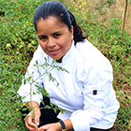
Ms. Fanny Vergara Ibarra
Vargas Torres, Ecuador

Agricultora, recolectora de frutos silvestres, promotora cultural, cocinera de comida ancestral y tradicional. Promueve el turismo gastronómico de la Provincia de Manabí a través de experiencias gastronómicas, para estudiantes de gastronomía, chefs, cocineros nacionales y extranjeros. Ha cocinado para importantes chefs reconocidos a nivel mundial, como el actual Chef campeón del mundo David Tissof, ganador del Bocuse d’ oro de Francia, quien recién nos visitó en nuestro restaurante de comida local y tradicional. Promueve el turismo rural comunitario a través de las tradiciones gastronómico en la que destaca el Horno de leña, sus técnicas y conocimientos heredados de sus ancestros a través de la oralidad de generación en generación. Investiga y promociona sus orígenes para la innovación de recetas y productos con base en la tradición, como el tomatillo silvestre con el cual ha ganado un concurso para la comunidad denominado “Relatos cortos de la OMPI”.

Her Excellency Ambassador Sofia Boza
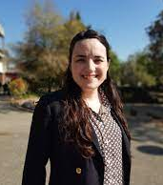
Permanent Representative of Chile to the World Trade Organization

Sofía Boza was appointed by President Gabriel Boric to be the Ambassador of Chile to the World Trade Organization starting in July of 2022. She has also taken over the co-coordination of the Structured Discussions on Investment Facilitation for Development. Prior to this position, Sofia Boza was an associate professor and head of the Department of Rural Management and Innovation at the University of Chile, a professor at the Institute of International Studies at the same university, as well as an external evaluator of public policies for the Budget Office of the Chilean Ministry of Finance. She has a PhD in Economics from the Autonomous University of Madrid, a master's in Economic Development and Public Policies from the same university, a professional title in Commercial Engineering from the University of Chile, and a bachelor’s degree in Economics (Honors) from the University of Seville. She has published more than 50 academic articles, book chapters and reports on agricultural policy and governance, rural development, food markets, and international trade. She has been a visiting fellow at the World Trade Institute at the University of Bern, as well as an expert instructor at the Institute of Food Laws and Regulations at Michigan State University. She has been a member of the board of the Chilean Association of Agricultural Economists and of the Ibero-American Network for Development Studies. Within the University of Chile, she participated in the creation and coordination of the Studies in Agricultural Policy and Development Group (NEPAD), the Sustainable Agrifood Systems Laboratory (SASLab), and the Chair of Family Farming and Food.

Mr. Johan Axhamn
Special Advisor, Ministry of Justice, Division for Intellectual Property Law and Transport Law, Sweden

Mr. Johan Axhamn is a Special Advisor, Ministry of Justice, Division for Intellectual Property Law and Transport Law, Sweden. Mr Axhamn has represented the Swedish government in the WIPO IGC since 2009, in addition to representing the Swedish government in other negotiations, for example within the EU. In addition to his work for the Swedish government, Mr. Axhamn is a senior lecturer and researcher in intellectual property law at Lund University. Mr. Axhamn obtained a doctoral degree (LL.D.) from Stockholm University in 2017.

Mr. Zhao Fuwei
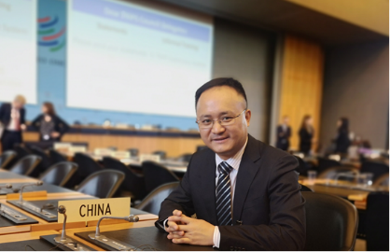
Associate Professor, Nanjing Institute of Environmental Sciences, Ministry of Ecology and Environment of China, China

Dr. Zhao has been engaging in policy research on genetic resources and traditional knowledge protection for many years. He is a member of the expert group for the national ABS legislation and member of the informal advisory group on capacity building of the Nagoya Protocol. As Chief Technical Advisor from 2019 to 2021, he carried out a UNDP - GEF project on the development and implementation of a national framework for access and benefit sharing arising from the use of genetic resources and traditional knowledge, which offered technical advice to the development and implementation of ABS regulations at the local level. He also lead the project on intellectual property strategy for genetic resources and traditional knowledge protection in 2017 and proposed legislative recommendations on disclosure requirements of genetic resources and traditional knowledge for the amendment of Patent Law and the Rules of Implementation of Patent Law.

Ms. Ann Ruth Reyes
Division Chief, Agricultural and Biotechnology Examining Division of the Bureau of Patents, Philippines

Ms. Ann Ruth Reyes is the Officer-in-Charge of the Agricultural and Biotechnology Examining Division, Bureau of Patents of the Intellectual Property Office of the Philippines. She is a highly trained Patent Examiner with more than 26 years of experience. She supervises and trains patent examiners of the Agricultural Biotech Examining Division as well as new examiners of the Bureau of Patents, renders decisions on applications with conflicting subject matters in the division, assists the Director/Asst. Director of the Bureau of Patents on issues relating to IP and is involved in the crafting and formulation of the guidelines in Biotechnology related applications and pharmaceutical applications as well as the International Preliminary Examination guidelines as IPOPHL has been appointed as an International Searching and International Preliminary Examination Authority.

Mr. Benson Mpalo
Deputy Registrar- IP, Patents and Companies Registration Agency, Zambia

Mr. Benson Mpalo has worked at the Zambian Patent and Companies Registration Authority since 2015. He has a Master of Laws (LLM) from the Munich Intellectual Property Law Center.

Mr. Axel Braun
President, Axel Braun Consulting

Dr. Axel Braun is President of Axel Braun Consulting advising clients on CBD-related policy matters. He was formerly responsible for global IP policy at F. Hoffmann-La Roche Ltd. (Roche) in Basle and represented Roche in this function in the IP working groups of various industry associations, incl. the International Federation of Pharmaceutical Manufacturers & Associations (IFPMA), in which he also chaired the CBD working group for many years. In this function he followed over many years the negotiation process in the IGC at WIPO. In addition, he followed the negotiations of the Nagoya Protocol as a member of the ICC business delegation and as technical adviser of the Swiss Delegation. After approval of the Protocol, he followed its implementation into national law in the EU and Switzerland. He was also a member of the ABS Consultation Forum established under the EU Regulation No 511/2014 and participated in the working group to support the establishment of further guidance for the interpretation of said Regulation. He practiced as a European Patent Attorney over many years and holds a Ph.D. in Biochemistry from the University of Munich, Germany (Max-Planck Institute of Psychiatry), a diploma degree in chemistry, also from the University of Munich (Max-Planck Institute of Biochemistry) and a bachelor degree of philosophy from the University of Heidelberg, Germany.

____________

