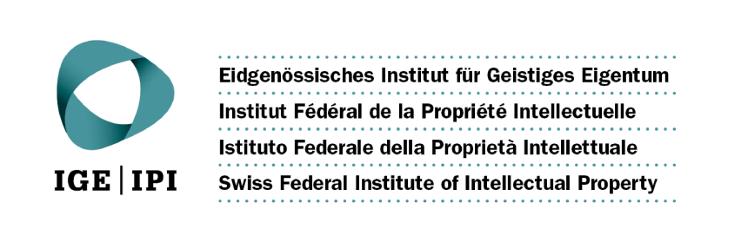

CALL FOR EXPRESSIONS OF INTEREST

FUNDING OF INDIGENOUS AND LOCAL COMMUNITIES REPRESENTATIVES’ PARTICIPATION

IN A SEMINAR ON INTELLECTUAL PROPERTY AND GENETIC RESOURCES, TRADITIONAL KNOWLEDGE AND TRADITIONAL CULTURAL EXPRESSIONS:

REGIONAL AND INTERNATIONAL DIMENSIONS

June 23 to 25, 2015

WIPO Headquarters, Geneva

The Background

The World Intellectual Property Organization (WIPO) is organizing a Seminar on Intellectual Property and Genetic Resources, Traditional Knowledge and Traditional Cultural Expressions: Regional and International Dimensions, which will be held at its headquarters in Geneva, from June 23 to 25, 2015, commencing at 2 p.m. on June 23, for WIPO Member States and accredited Observers. “Accredited Observers” refers to organizations and other entities that have either Permanent Observer status at WIPO or are already specially accredited to the WIPO Intergovernmental Committee on Intellectual Property and Genetic Resources, Traditional Knowledge and Folklore.

WIPO is pleased to announce that the Swiss Federal Institute of Intellectual Property has provided a generous financial contribution for the funding of indigenous and local community representatives which is intended to facilitate their participation and attendance in the Seminar.

The funding will cover air travel in economy class from the domicile of the funded representative to Geneva in accordance with WIPO’s travel rules, a daily subsistence allowance of Sfr 250 and terminal expenses.

The Seminar will focus on intellectual property (IP) and genetic resources (GRs), traditional knowledge (TK) and traditional cultural expressions (TCEs). The objective is to share practices, experiences and case studies regarding IP and GRs/TK/TCEs.

The working languages of the Seminar will be English, French and Spanish with simultaneous interpretation being provided in those languages. The Program will be available on the WIPO website at: http://www.wipo.int/meetings/en/details.jsp?meeting_id=36502.
/...

Participation of accredited Observers that represent indigenous and local communities is strongly encouraged. The Seminar will provide the indigenous and local community representatives with a valuable opportunity to acquire and exchange information on existing regional, national and local practices, case studies and policy issues regarding IP and GRs, TK and TCEs.

The Requirements: What qualifications are needed to apply?

Applicants for funding need to:

- be natural persons who belong to a WIPO accredited Observer which represents indigenous or local communities;
- be able to participate actively and effectively and contribute to the Seminar, such as through expressing experience in the field and the concerns of indigenous and local communities;
- depend on the funding in order to be able to participate in the above-mentioned seminar; and
- be able to understand and speak English, Spanish or French.

Furthermore, due consideration will be given to geographical and gender balance.

Expressions of interest: how to apply for funding?

Expressions of interest, accompanied, either in English, Spanish or French, by a full curriculum vitae (resumé) and a brief statement by the candidate addressing each of the requirements set out above, including the name of the accredited Observer the applicant is a member of, should be sent to:

Traditional Knowledge Division
World Intellectual Property Organization
34 chemin des Colombettes,
1211 Geneva 20,
Switzerland

or by email (grtkf@wipo.int)

or by fax (+41 22 338 8120)

before May 25, 2015

Please note that the expressions of interest should NOT include any other attachments or enclosures (such as copies of publications and other materials).

