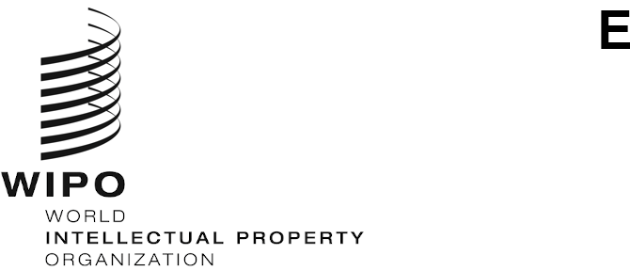
WIPO/GRTKF/IC/46/11
ORIGINAL: English
DATE: January 27, 2023

Intergovernmental Committee on Intellectual Property and Genetic Resources, Traditional Knowledge and Folklore

Forty-Sixth Session

Geneva, February 27 to March 3, 2023
JOINT RECOMMENDATION ON GENETIC RESOURCES AND ASSOCIATED TRADITIONAL KNOWLEDGE

Document submitted by the Delegations of Japan, the Republic of Korea and the United States of America

- On January 27, 2023, the International Bureau of the World Intellectual Property Organization (WIPO) received a request from the Permanent Mission of the United States of America to International Organizations in Geneva, on behalf of the Delegations of Japan, the Republic of Korea and the United States of America, to resubmit the “Joint Recommendation on Genetic Resources and Associated Traditional Knowledge”, as contained in document WIPO/GRTKF/IC/45/10, for discussion by the Forty-Sixth Session of the Intergovernmental Committee on Intellectual Property and Genetic Resources, Traditional Knowledge and Folklore (IGC).

- Pursuant to the request above, the Annex to this document contains the proposal
referred to.

- The Committee is invited to take note of and consider the proposal in the Annex to this document.
[Annex follows]
JOINT RECOMMENDATION ON GENETIC RESOURCES AND ASSOCIATED TRADITIONAL KNOWLEDGE

The Intergovernmental Committee on Intellectual Property and Genetic Resources, Traditional Knowledge and Folklore and the General Assembly of the World Intellectual Property Organization,

Considering the decision of the 55th Session of the WIPO General Assembly to convene a Diplomatic Conference to conclude an International Legal Instrument Relating to Intellectual Property, Genetic Resources and Traditional Knowledge Associated with Genetic Resources, to be based on document WIPO/GRTKF/IC/43/5 in addition to any other contributions by Member States;

Reaffirming their belief that genetic resources and traditional knowledge associated with genetic resources have important economic, scientific and commercial value to a wide range of stakeholders;

Recognizing the role of the intellectual property system in promoting innovation and the transfer and dissemination of technology to the mutual advantage of holders and users of genetic resources and traditional knowledge associated with genetic resources in a manner conducive to social and economic welfare;

Stressing the need to prevent patents from being granted erroneously for inventions or creations that are not novel or inventive with regard to genetic resources and traditional knowledge associated with genetic resources, and acknowledging the existent, inherent capacity of the patent system to achieve that end;

Further stressing the need for patent offices to have available and consider the appropriate prior art on genetic resources and traditional knowledge associated with genetic resources needed to make proper and informed decisions on patent grant, and further stressing the importance of transparency in the process of granting patents;

Recommend that each Member State may consider the use of this Recommendation adopted by the Intergovernmental Committee on Intellectual Property and Genetic Resources, Traditional Knowledge and Folklore as guidelines for the protection of genetic resources and associated traditional knowledge.

Recommendations follow:

1. DEFINITIONS

For the purposes of these Recommendations:

“Genetic material” means material of plant, animal, microbial or other origin containing functional units of heredity.

“Genetic resource” means any genetic material of actual or potential value.

“Member State” means a Member State of the World Intellectual Property Organization.

“Patent office” means the authority of a Member State entrusted with the granting of patents.

“Traditional knowledge associated with genetic resources” means substantive knowledge of the properties and uses of genetic resources held by indigenous peoples or local communities and which directly leads to a claimed invention.

2. OBJECTIVES AND PRINCIPLES

Member States, in protecting genetic resources and traditional knowledge associated with genetic resources, should aim to:

(a) Prevent patents from being granted erroneously for inventions that are not novel or inventive with regard to genetic resources and traditional knowledge associated with genetic resources.

(b) Protect indigenous peoples and local communities from the limitations of the traditional use of genetic resources and their traditional knowledge associated with genetic resources that might result from the erroneous patenting thereof.

(c) Ensure that patent offices have the appropriate available information on genetic resources and traditional knowledge associated with genetic resources needed to make informed decisions in granting patents.

(d) Maintain the incentives for innovation provided by the patent system.

3. PREVENTION OF THE ERRONEOUS GRANT OF PATENTS

Member States should provide legal, policy or administrative measures, as appropriate and in accordance with national law, to prevent patents from being granted erroneously with regard to claimed inventions that include genetic resources and traditional knowledge associated with genetic resources where, under national law, those genetic resources and traditional knowledge associated with genetic resources:

(a) Anticipate a claimed invention (no novelty); or

(b) Obviate a claimed invention (obvious or no inventive step).

4. OPPOSITION MEASURES

Member States should provide legal, policy or administrative measures, as appropriate and in accordance with national law, to allow third parties to dispute the validity of a patent, by submitting prior art, with regard to inventions that include genetic resources and traditional knowledge associated with genetic resources.

5. SUPPORTING MEASURES

1. Member States should encourage, as appropriate, the development and use of voluntary codes of conduct and guidelines regarding the protection of the use of genetic resources and traditional knowledge associated with genetic resources.

2. Member States should facilitate, as appropriate, the creation, exchange and dissemination of, and access to, databases of and/or regarding genetic resources and traditional knowledge associated with genetic resources, with a view to supporting the measures mentioned in Paragraphs 3 and 4.

3. The information contained in the databases mentioned in Subparagraph 2 should be used by Member States in determining novelty and non-obviousness with regard to patent applications that include genetic resources and traditional knowledge associated with genetic resources.

6. APPLICATION

Member States should provide adequate and effective legal, policy or administrative measures, as appropriate and in accordance with national law, to facilitate the application of these Recommendations.

[End of Annex and of document]

