WIPO |  | E  SCT/16/2  ORIGINAL: English  DATE: September 1, 2006
WORLD INTELLECTUAL PROPERTY ORGANIZATION
GENEVA

standing committee on the law of trademarks, industrial designs and geographical indications
Sixteenth Session
Geneva, November 13 to 17, 2006
NEW TYPES OF MARKS
Document prepared by the Secretariat

CONTENTS

Page

I. INTRODUCTION 2

II. SUBJECT MATTER OF PROTECTION 2

(a) Visible signs 2
- Three-dimensional marks 2
- Color marks 3
- Holograms 5
- Slogans 6
- Titles of films and books 6
- Motion or multimedia signs 7
- Position marks 8
- Gesture marks 8

(b) Non-visible signs 8
(i) Sound marks 8
(ii) Olfactory marks 9
(iii) Taste marks 10
(iv) Texture or feel marks 11

III. CROSS-CUTTING ISSUES 11

(a) Evolution of new types of trademarks in the marketplace 11
(b) Need to keep certain signs available 12
(c) Application of trademark principles 13
(d) Overlap with industrial design and copyright protection 14
(e) Approaches to graphical representation 14

IV. SUMMARY 14

ANNEX

EXAMPLES OF NEW TYPES OF MARKS

I. INTRODUCTION

1 At the fifteenth session of the Standing Committee on the Law of Trademarks, Industrial Designs and Geographical Indications (SCT), held in Geneva from November 28 to December 2, 2005, the SCT asked the International Bureau to prepare an issues paper on new types of marks (see document SCT/15/4, paragraph 8). Accordingly, the Secretariat has prepared the present document, which describes various new types of marks and discusses particular issues related to such types of marks.

2 The document is largely based on information provided in returns to the WIPO Questionnaire on Trademark Law and Practice, as presented in WIPO document WIPO/STrad/INF1 (hereinafter referred to as “the Questionnaire”) and on ad hoc contributions of individual SCT Members. The Annex to the document contains examples of types of marks that are discussed in chapter II. Those examples are of a merely illustrative nature and should not be considered as being representative of particular SCT Members trademark laws or practice.

II. SUBJECT MATTER OF PROTECTION

3 The types of signs that are nowadays considered as being capable of constituting a trademark have expanded beyond words or figurative devices. Moreover, visually perceptible signs are being used in trade together with signs, which may not, in themselves be visually perceptible, but have a potential for distinguishing goods and services. Other signs may be visible and yet differ from the traditional notion of signs constituting trademarks by one or more of their features. In an attempt to categorize various signs that may constitute a trademark, this document groups signs according to whether they are visually perceptible or whether they may be perceived by senses other than the sense of sight.

(a) Visible signs

(i) Three-dimensional marks

4 Product shape and product packaging and wrapping are signs that may constitute trademarks in the legislation and practice of several Member States. 62 out of 73 Offices responding to the Questionnaire, said that they accepted the shape of a product for registration as a three-dimensional mark and 70 said they accepted product packaging. Most replies indicated that, in any event, the mark had to be distinctive and capable of being represented graphically.

5 A number of limitations have been identified in national and regional trademark laws as regards the protection of three-dimensional marks. It is generally established that product shapes cannot be registered as trademarks if they result exclusively from the nature of the goods themselves.

6 It is also generally provided that product shapes cannot be registered as trademarks if they consist exclusively of a shape that is necessary to obtain a technical result, the principle often referred to as “functionality”. It has been noted that the purpose of this limitation is to preclude the registration of shapes whose essential characteristics perform a technical function with the result that the exclusivity inherent in the trademark right would limit the possibility of competitors supplying a product incorporating such a function or at least limit the freedom of choice in respect of the technical solution they desire to adopt in order to incorporate such a function in their product.

7 According to some laws, product shapes cannot be registered if they solely serve the purpose of giving substantial value to the goods. There may be other reasons for excluding the protection of shapes. 38 out of 62 Offices responding to the Questionnaire considered, among others, shapes found to be contrary to morality or public order, shapes not capable of distinguishing and the common or usual shape of a product or packaging.

8 With regard to product packaging and containers, it has been noted that the shape of the packaging for substances which have no inherent shape of their own, such as liquids and powders, should be assimilated to the shape of the goods and thus be subject to the same tests (functionality, distinctiveness and descriptiveness). Hence, where the particular combination of elements give a container a particular appearance, which, taking into account the overall aesthetic result, enables the public to distinguish the goods covered by the application from those of a different commercial origin, the combination of elements of presentation would distinguish that particular shape from other shapes on the market for the same goods.

9 Some replies to the Questionnaire provided information concerning proof of distinctive character of shapes acquired through use. Evidence would include: invoices, delivery slips, order slips, bills, receipts, account books, pamphlets, printed matter (newspaper clippings, magazines, catalogues, leaflets), publicity, photographs showing use of a trademark, a certificate issued by an advertising agency, a broadcasting agency, a publisher or printer, a certificate issued by a trade association or fellow traders, a certificate issued by a customer of goods or services or an agent, a certificate issued by a consumer and a certificate issued by a public organization (government authorities, local public bodies, a foreign embassy, a chamber of commerce and industry).

Representation of three-dimensional marks

10 In most registration systems, applicants are required to provide a representation of the mark in the form of perceptive or isometric drawings or photographs that clearly show all features of the mark. In some countries, these should be accompanied by a written description of the trademark and in others, an indication that the mark is a three-dimensional sign should be included in the application.

(ii) Color marks

11 Companies are increasingly making deliberate and consistent use of colors and color combinations, not only for their products and their packaging, but also in advertising (e.g. information material, printed and TV advertisements, letterheads, etc.) and even in their sales outlets (i.e. furnishings and decoration, signs, display units and the like). In modern commercial dealings colors are becoming an important means of identification from the point of view of consumers and this may explain the rising numbers of trademark applications concerning color marks.
12 According to the Questionnaire, 45 out of 75 Offices responding said that they accepted for registration a mark consisting of a single color, and 71 out of 76 accepted a combination of colors, while 72 out of 75 Offices accepted a single color or a combination of colors associated with other signs.

13 Applications for color and color combinations have given rise to some debate and already a number of judicial decisions. By way of example, reference can be made to some court decisions that address this issue. A recent decision, for instance, has held that a color per se cannot be presumed a priori to constitute a sign, although it may be so in relation to a product or a service. According to that decision, colors possess little inherent ability for communicating specific information, but the possibility that a color per se may in some circumstances serve as a badge of origin may not be ruled out. Since the average consumer is capable of distinguishing only a limited number of colors, a small number of trademark registrations could exhaust the entire range of colors available. The possibility of registering a color mark should therefore be limited for reasons relating to the public interest. Given the lack of inherent capacity of color per se to distinguish the goods of a particular undertaking, evidence of acquired distinctiveness will almost always be required.

14 Another court has identified four circumstances where color applied to goods would be inherently adapted to distinguish. These are: (a) the color does not serve an ornamental function by conveying a recognized meaning, such as red for danger; (b) the color does not serve a utilitarian function by physically or chemically providing an effect such as light reflection or color absorption; (c) the color does not serve an economic function –that is, the color is not the natural occurring result of the manufacturing process, such as terracotta roof tiles or pots; and (d) the color is not sought to be registered where there is a proven competitive need for the use of color, and in a market where having regard to the chosen color and the goods, other properly motivated traders might naturally think of the color and wish to use it in a similar manner for their goods.

15 In yet another decision, it was determined that a single color can be registered as a trademark if it is not de jure functional and if it has acquired distinctiveness. A color is de jure functional if it is essential to the use or purpose of the article or if it affects the cost or quality of the article. The critical inquiry is whether the exclusive use of the color would put competitors at a significant disadvantage. Factors to be considered in determining whether a color is functional include: whether the color serves a non-trademark purpose; whether that purpose is important to consumers; whether the color is the best, or at least one of the few superior colors available for that purpose; whether competitors are using the color for that purpose; and whether there are alternative colors available for similar use by others.

16 In most jurisdictions, applicants are required to provide evidence to demonstrate that the public has been educated to recognize the mark as being distinctive of the applicant’s goods. Applications to register a particular color should then be accompanied by strong evidence to show that the public would expect goods sold under that particular color to be the goods of one trader.
Representation of color marks

17 Replies to the Questionnaire on this point, indicated that national or regional trademark offices normally require, in the context of registration procedures, that the color be identified either by a deposited sample or by reference to a recognized color code (for example PANTONE®). A description in words could also be provided.

18 Concerning the representation of color, one court held that “graphic” representation of color must be “clear, precise, self contained, easily accessible, durable and objective”. Therefore, a mere sample of a color is insufficient, as a sample could deteriorate with time. However, a description in words of the color or a designation of the color using an internationally recognized identification code may be acceptable. Such codes were deemed to be precise and stable. In a later decision, the same court said that combinations of colors in the abstract, without contours must also include “a systematic arrangement associating the colors in a predetermined and uniform way”.

19 One trademark office amended its practice, so that trademarks consisting of a single color will be considered to be graphically represented if they are filed in the form of a written description of the color(s) and are accompanied by the relevant code(s) from an internationally recognized color identification system, e.g. PANTONE®, RAL, Focoltone®, etc. This is not an exhaustive list and the choice of the system rests with the applicant. Representations that are precise but impossible to interpret without costly specialized equipment or services, place too high a burden on third parties and are likely to be rejected because they are not “easily accessible”.

20 Another trademark office held that color is a sign capable of being represented graphically and has accepted, in addition to a sample of the color mark, a description that said the color applied by any process, as the predominant color to the wrapping, packaging or promotional material used on or in association with the goods. The applicant was required to amend his description of the mark by including the appropriate PANTONE® color code.

21 Requirements concerning the representation of a color mark may include a specification to the effect that the trademark is a color mark, a written description of the mark and reproductions of the mark in color. However, there might not be a requirement for the color mark to be limited to a shape or form, or to conform to any recognized system or shade classification.

(iii) Holograms

22 According to the Questionnaire, 32 out of 70 offices said that they accepted holograms for registration as trademarks. Since holograms may optically store and retrieve an image in three-dimensions, it may be difficult to capture the image in paper form, since depending on the angle that one looks at the image, the picture will change, and a paper print will not show the movement of the images.
23 One trademark office has accepted holograms for registration as trademarks and published them as figurative marks in the trademark gazette on paper.

Representation of holograms

24 One possible approach to the representation of marks consisting of holograms is to describe the hologram in as much detail as possible, providing visual views of the holograms in various frames with descriptions of angle and appearance. Use of high-resolution frames avoiding fading or picture overlapping may be an option, as descriptions of the visual effects alone might not be allowed.

25 Some replies to the Questionnaire stated that a selection of pictures revealing the whole of the holographic effect was required in addition to an explanation of the effect in plain words. It was also explained that taking a photocopy of a hologram would reveal the selection of pictures contained in the sign.

(iv) Slogans

26 Slogans are now more generally accepted for registration as trademarks (67 out of 72 Offices responding to the Questionnaire said that they accepted these signs). In most systems, slogans may be registrable as trade marks if they have the capacity to individualize the goods or services of one undertaking because they are not made up of signs or indications which directly describe the goods or services or their essential characteristics, are not laudatory and are not devoid of distinctive character for another reason.

27 Slogans may also acquire distinctiveness through use, whether they are used with or without another trademark, or as part of it. To acquire distinctive character, the mark may have to be used in such a manner that the relevant class of persons identifies the product or service as originating from a given undertaking. Such identification may result from using the mark as part of a registered trademark or as a component thereof, or by its use in conjunction with a registered trademark.

28 The question has been raised as to whether in assessing this type of mark, stricter criteria should be applied or whether a slogan has to comply with additional requirements of imagination or originality to be acceptable. In that particular instance, the answer has been that these requirements should not form part of the assessment of a slogan’s capacity to distinguish goods of one undertaking from those of another.

(v) Titles of films and books

29 According to the Questionnaire, 65 out of 76 Offices responding, said that they accepted film or book titles for registration as trademarks. It is generally admitted that serial titles and periodical or newspaper titles may fulfill a trademark function by identifying and distinguishing the successive issues of one publisher from those of other publishers or printers. In this case, the successive issues would be considered products (i.e. printed matter) emanating from a single commercial origin.
30 The situation is however different for single titles, which may not normally qualify for trademark protection, as this is the case of a single work and not one that is intended to be followed by others in a series. It has been considered that in this case, the public may associate, for example, a single book title with, at most, an author or a subject, but not with the source of the book, that is a publisher or printer.

31 Book titles may often be descriptive of book contents, but even where they are arbitrary and unrelated to the book contents, trademark protection may not be granted on single book titles, because of the interplay between copyright and trademark law. Specifically, while trademarks remain valid as long as the mark is used, copyrights eventually expire. A trademark in the title to a single book could compromise the policy of unrestricted use after expiration of the copyright (see document SCT/16/5, chapter IV(e) and (f)).

32 It should be noted that in certain jurisdictions, titles may be protected under sui generis systems. Such systems require that even where titles are basically understood as separate identifiers of works, they must, just like trademarks, be distinctive and not descriptive in respect of the work identified.

33 As to special requirements concerning this type of mark, replies to the Questionnaire indicated that registration was generally allowed if an authorization to register, granted by the owner of the rights over the title, was presented. It was also indicated that the titles of films or books should not be contrary to public order or morality.

(vi) Motion or multimedia signs

34 There are no general rules concerning these signs. In some offices, they do not constitute a separate category of mark. The sign consists of the movement of a certain object (i.e., a visually perceivable combination of the object and the movement). The moving image can be a film-clip, video, moving logo for TV-shows, etc.. It would seem that the decision as to whether a mark of this kind is registrable could only be made on a case-by-case basis. It should be noted that 21 out of 72 Offices responding to the Questionnaire said that they accepted motion or multimedia signs for registration as trademarks.

Representation of motion or multimedia signs

35 Some replies to the Questionnaire specified that all the stills that made up the multimedia effect, or a selection of samples sufficient to fully represent or reveal the distinctiveness of the multimedia effect, and an additional explanation of the effect in plain words must be submitted. It was generally required that an applicant file a sample of the full motion effect/multimedia sign on a digital data carrier in a data format chosen/accepted by the office, typically on a CD-ROM or a DVD.

36 It has been pointed out that with the Internet, it has become technically possible to display moving logos and that such signs are becoming more and more common. The choice of acceptable means to represent such marks would have to be made by offices and could include a series of still pictures, the moving image represented electronically, a description of the mark in words or a combination of those elements.
(vii) Position marks

37 These marks are specified by the position in which they appear or are fixed on a particular product. Offices responding to the Questionnaire did not provide separate information about these trademarks. It would seem that any assessment of distinctive character, either inherent or acquired through use would have to be made on a case-by-case basis. Graphic representation could include a picture or drawing showing the special position of the mark with regard to the product, as well as a description in words.

(viii) Gesture marks

38 A gesture has been mentioned as another kind of non-traditional mark. More experience may still be necessary to clarify whether these marks are just another form of motion mark or figurative mark, or if it is a different sort of mark. Even though the registration of this type of sign remains exceptional, it would seem that graphic representation could be achieved through a drawing or picture and a description. It may be more difficult to prove that the gesture is distinctive for the type of goods and/or services that it is intended to cover. There is no information on this type of mark in the replies to the Questionnaire.

(b) Non-visible signs

(i) Sound marks

39 Sounds may be both musical and non-musical. Musical sounds may be either purposely created (i.e. specially commissioned) or taken from the range of existing musical scores. Non-musical sounds may also be created or simply reproduce sounds found in nature (e.g., thunder or a lion’s roar). According to the questionnaire, 38 out of 76 offices responding said that they accepted musical sounds and 28 out of 73 offices responding said that they accepted non-musical sounds for registration as trademarks.

40 Some laws specifically contemplate that sound signs may be protected as trademarks. Others, while not providing for such protection, could be interpreted as not excluding it. This may be the case where the list of signs contained in the relevant legislation is not considered to be exhaustive and may accommodate other signs, as long as they fulfill predetermined criteria. For example, if such a list would mention signs which are in themselves capable of being perceived visually, while not excluding other signs, like sounds which do not have that inherent capacity.

41 Although it may not be ruled out that sounds can be inherently distinctive in respect of goods and services, it may be more common for them to become distinctive through use and to be used in conjunction with other types of trademarks, such as word or device marks. In such case, both types of signs should have the potential to function as trademarks.

Representation of sounds

42 The majority of replies to the Questionnaire stated that a sound had to be represented graphically, through musical notation or a description in words. Cassettes and CDs could also be provided. In one reply the “moo of a cow” and the “sound of an automobile horn” were
mentioned, provided that these sounds had distinctive features. In that case, the application had to include the characteristics of the sound or the diagram of frequencies, with the soundtrack registered on an audiocassette.

43 There does not seem to be a preferred approach to the graphical representation of sound signs and different national systems apply a variety of means, sometimes used in combination. In one Member State, for example, graphical representation of sounds may be achieved by a verbal description of the sounds, musical notation or the name of the specific piece of music if additional information is supplied to identify the particular rendition claimed in the trademark, as demonstrated in the recording accompanying the application. The IP office of another Member State requires applicants to describe sound marks using musical notation, where possible. It usually requests that applicants file two CD recordings of the sound for the registry’s retention.

44 Reference can be made to one court decision that dealt with the question of whether a sign, which is not in itself capable of being perceived visually, may be represented graphically, and what are the acceptable means for the graphic representation of such signs. In this specific decision, it was held that graphic representation could be achieved “particularly by means of images, lines or characters” as long as that representation was “clear, precise, self contained, easily accessible, intelligible, durable and objective”.

45 Moreover, that particular court has noted that in the case of a sound sign, those requirements are not satisfied when the sign is represented graphically by means of a description using the written language, such as an indication that the sign consists of the notes going to make up a musical work, or the indication that it is the cry of an animal, or by means of a simple onomatopoeia, without more, or by means of a sequence of musical notes, without more. On the other hand, those requirements are satisfied where the sign is represented by a stave divided into measures and showing, in particular, a clef, musical notes and rests whose form indicates the relative value and, where necessary, accidentals.

(ii) Olfactory marks

46 It is possible to register olfactory (odor, scent or smell) marks in some countries. According to the questionnaire, 20 out of 72 Offices replied that they accepted for registration this type of mark. Like any other type of mark, olfactory marks need to pass the test of registrability and it has been found that there is no reason to bar the registration of a scent if it functions as a trademark for the applicant’s goods.

47 For example, the competent administration of one Member State found that the test to be applied in this case should be whether: (a) the applicant is the only person marketing the goods concerned; (b) the fragrance is not an inherent attribute or natural characteristic of the goods but a feature supplied by the applicant; (c) the applicant emphasized and promoted the scent mark in advertising, and (d) the applicant demonstrated that customers dealers and distributors of its products had come to recognize the applicant as the source of these goods. Similar criteria have been established for assessing olfactory marks in another Member State, where some scent marks have been accepted for registration.

48 According to the trademark office practice of one Member State, the capability of a scent to distinguish an applicant’s goods or services is assessed under the same criteria as for any other trademark, namely whether other traders would want or need to use the scent in the ordinary course of their business without improper motive. However, some scents were specifically identified as not adapted to distinguish. These would include: (a) the natural scent of a product, including perfumes and essential oils; (b) masking scents, which would be seen as having a functional purpose and would therefore be considered incapable of distinguishing, and (c) scents that are functional or common to the trade, for example,
lemon-scented washing products, which are used to make the product more pleasant or attractive.

Representation of olfactory marks

49 National and regional trademark laws may greatly differ as to the means considered to be acceptable for the graphic representation of olfactory marks. Most systems require some form of graphic representation of scent signs. However, it has proven difficult to ascertain whether a description in words would fulfill that requirement. For example, according to the office practice of one Member State administration, applicants are not required to submit a drawing of the mark if the mark consists solely of a non-visual mark such as a scent or sound. Instead, applicants should submit a detailed written description which clearly describes the non-visual mark.

50 In another particular case, the question was considered whether the requirements of graphic representation of a smell mark were satisfied where an odor was reproduced: (a) by a chemical formula; (b) by a description (to be published); (c) by means of a deposit; or (d) by a combination of the above mentioned surrogate reproductions.

51 In that case, the competent court ruled that as regards a chemical formula, few people would recognize that such a formula would relate to the odor in question. As a chemical formula did not represent the odor of a substance, but the substance as such, it was not a sufficiently clear and precise representation of the trademark. The actual description of the odor, moreover, was not sufficiently clear, precise and objective. The deposit of an odor sample did not constitute a graphic representation and, moreover, was not sufficiently stable and durable.

52 It followed that, in the case of smells, graphic representation was not satisfied by a chemical formula, by a description in written words, or by the deposit of an odor sample, or even a combination of those elements. More recently, it was pointed out that, at present, there was no generally accepted international classification of smells which would make it possible, as with international color codes or musical notation, to identify an olfactory sign objectively and precisely through the attribution of a name or a precise code specific to each smell.

(iii) Taste marks

53 Some jurisdictions have accepted taste marks for registration. In one particular instance, the graphic representation requirement was satisfied by using a written description of the taste and an indication that it concerns a taste mark. In assessing the registrability of this type of sign, principles similar to those concerning odors may apply and it could be argued that taste marks may only be applied to goods and not to services.
54 In one recent court decision, it was held that the flavor for which registration was sought was not constant and would be subject to modification owing to the type of fruit considered or the ripeness of the fruit. Therefore, the indication “artificial flavor” was not sufficient to create consistency, as several strawberry flavors existed and could be synthesized. Accordingly, the court held that the mark applied for was devoid of any objective character and did not allow its registration.

(iv) Texture or feel marks

55 With this type of mark, it is the surface of the product that might lead to recognition, for instance because the surface touched has a specific recognizable structure or texture. According to the Questionnaire, at least in one jurisdiction, it was possible to register a texture mark. The graphic representation of the sign was achieved in embossed printing (Braille). In one Member State, a mark has been registered for the texture or surface of a bottle. The applicant indicated the type of mark in the application and provided a very detailed description of the mark and a Braille-like sample of the surface, as reproduction of the sign.

III. CROSS-CUTTING ISSUES

56 On the basis of the overview of new types of trademarks presented in the preceding chapter, selected horizontal issues will be brought into focus in the present chapter. As a starting point, section (a) describes the evolution of new types marks in the marketplace as a consequence of changing marketing and advertising strategies. Subsequently, attention will be devoted to the need to keep certain signs available for use by all traders (section (b)), the application of general trademark principles in the field of new types of marks (section (c)), possible areas of overlap with other fields of intellectual property protection (section (d)) and ways of representing new types of marks in the context of the registration procedure
(section (e)).

(a) Evolution of new types of trademarks

57 The diversity of signs which enterprises seek to develop as trademarks and to use in the marketplace (see preceding chapter II.) shows that trademark law is subject to a dynamic process from which new types of marks may constantly evolve. The idea of the potentially open-ended nature of signs that may constitute trademarks is expressed in Article 15(1) of the Agreement on Trade-Related Aspects of Intellectual Property Rights (hereinafter referred to as “TRIPS Agreement”), which starts with the words: “Any sign (emphasis added) or combinations of signs, capable of distinguishing the goods or services of one undertaking from those of other undertakings, shall be capable of constituting a trademark.” Article 15(1) of the TRIPS Agreement also states clearly that only signs that are capable of distinguishing the goods or services of one undertaking from those of other undertakings function as trademarks. In doing so, it inherently refers to one of the core functions of trademarks, namely to identify the commercial source of goods and services offered in the market. It follows that virtually any sign that is able to distinguish goods or services may be considered a trademark. This is of course without prejudice to the fourth sentence of Article 15(1) of the TRIPS Agreement, under which Members may require, as a condition of registration that signs be visually perceptible.
58 The choice of specific signs for use on goods or services depends on the individual marketing and advertising strategy of enterprises. However, acceptance of a chosen sign in the marketplace will eventually depend on consumer perceptions. Substantial advertising and promotion efforts in respect of new and non traditional signs may attract attention and incline consumers to establish a line between the new sign and the enterprise using it in commerce.

59 Once consumers associate a given sign with a specific enterprise, denial of trademark protection implies a certain risk of consumer confusion. In the absence of adequate protection, competitors of the original producer or service provider may use identical or confusingly similar signs, thereby misleading consumers as to the commercial origin of goods or services. Competitors may also attempt to free-ride on the reputation which the original producer or service provider has established through investments in product quality and promotion. In this context, competent authorities may need to consider whether the protection of new types of signs can be achieved through the application of established principles of trademark law, or whether new approaches or principles may be required.

(b) Need to keep certain signs available

60 The recognition of new types of trademarks enlarges the reservoir of signs eligible for trademark protection, which commercial operators may use to distinguish their goods or services. Hence more types of signs are considered for use and protection as trademarks. This, in turn, means that a broader range of signs may become subject to individual exclusive trademark rights. The acquisition of trademark rights does not generally exclude the sign from use. By definition, the scope of trademark rights is restricted to the exclusive use in commerce of individually protected signs. Moreover, the right to prevent third parties from using the protected trademark is subject to the principle of specialty. The right can only be invoked in relation to use of the mark for goods and services in respect of which the trademark is protected.

61 Under trademark law, the trademark owner enjoys the exclusive right to use the protected trademark, as expressed by the right to exclude third parties from such use. This exclusive right, in general, must be balanced against the interest of other market participants to keep certain signs free and available for use. Indications that describe certain characteristics of goods or services, for instance, must necessarily be kept available for use by all market operators offering such goods or services. This principle is expressed clearly in Article 6quinquies(B)(2) of the Paris Convention for the Protection of Industrial Property (hereinafter referred to as “Paris Convention”), which lists as grounds of refusal for trademark registrations indications as to “the kind, quality, quantity, intended purpose, value, place of origin, of the goods, or time of production”.

62 The need to keep certain signs or indications available for use by all market participants is thus a general issue of trademark protection. As such, it also concerns the recognition of new types of trademarks. Not surprisingly, in the context of granting protection to new types of marks, courts have considered factors such as the need for the use of a specific sign, a bona fide need for other traders to use a sign, or a need of other traders to use a given sign in the ordinary course of their business (see II (a)(ii) and II (b)(ii) above).

63 In the case of new types of marks, the response to the need to keep signs available does not differ from the standard applied with regard to traditional trademarks. This issue will usually be dealt with as one of the factors for determining the capability of a given sign to distinguish the source of the goods or services on which it is used. Arguably, this might be a lesser problem in connection with complex signs, such as product packaging combining a three-dimensional shape with several colors and figurative elements, a hologram constituted by pictures combining individual colors and drawings, a video clip or a musical piece requiring specific instrumentation.

64 However, the claim to trademark protection for more basic signs, such as simple containers using unmodified basic geometrical forms, a single color or a smell, brings forth the need to keep certain signs available for all business operators in a specific sector. In addition, the question may be asked to what extent consumers are capable of distinguishing within a potentially wide diversity of signs of a specific type. In theory, for instance, the diversity of color shades can hardly ever be exhausted. In practice, however, consumers may not be able to distinguish fine nuances of colors.

(c) Application of trademark law principles

65 Besides the question of a balance between trademark protection and a need to keep signs available, the application of other principles of trademark protection must also be considered with regard to new types of marks. Absolute grounds for refusal, for instance, concern signs that are devoid of any distinctive character, consist exclusively of descriptive indications or have become generic. Signs may also be refused on the grounds that they are contrary to morality or public order, or of such a nature as to deceive the public.
Article 6quinquies(B)(2) and (3) of the Paris Convention reflects these criteria in the context of exceptions to the principle of “telle quelle” protection established in Article 6quinquies(A)(1).

66 It may be asked, for instance, whether the use of an olfactory sign on perfume should be deemed descriptive even if the perfume and the olfactory sign under which it is marketed differ substantially. A further example may be the use of a sound mark on musical scores or compact discs. In these cases, the decision may be guided by criteria, such as whether the olfactory or sound mark forms an inherent attribute or natural characteristic of the goods on which it is used (see II (b)(ii) above).

67 In the context of new types of marks, particular attention may also be devoted to the principle that distinctiveness may be acquired through use, as reflected, for instance, in Article 15(1) of the TRIPS Agreement. As the overview of visible and non-visible signs in the preceding chapter has shown, certain new types of marks, such as single colors, have a
limited inherent capacity for distinguishing goods or services. Protection may thus depend on a showing that distinctiveness has been acquired through use (see, for instance, II (a)(ii), (vii) and (viii) above).
(d) Overlap with industrial design and copyright protection

68 The recognition of new types of trademarks may lead to the application, in trademark law, of principles originating in other fields of intellectual property protection. In the preceding chapter, reference was made, for instance, to the principle of functionality which serves to preclude the registration of shapes, the essential characteristics of which perform a technical function (see II (a)(i) above). This principle is also relevant in the protection of industrial design (see document SCT/9/6).

69 A further area of overlap may arise between trademark and copyright law. Certain subject matter may be susceptible to protection by both copyright and trademark law. Examples include traditional types of trademarks, such as logotypes, paintings, figures and drawings. The recognition of new types of marks enlarges the range of subject matter that may enjoy double protection under the copyright and trademark regimes (see document SCT/16/5 for a more detailed analysis).

(e) Approaches to the representation of new types of marks

70 With regard to registration procedures, new types of marks give rise to the practical question of graphic or other type of representation, which is a requirement under many trademark laws. As the overview in the preceding chapter has shown, a number of criteria, such as the clearness, preciseness, accessibility, intelligibility, durability and objectivity of a graphic representation, may be considered in order to ensure that the trademark register adequately reflects protected signs. In respect of the practical means of representation, new types of marks frequently offer different possibilities ranging, for instance, from a written description to digital reproductions (see II (a)(ii) and (vi), II (b)(i) and (ii)).

71 Rule 3(4), (5) and (6) of the Regulations Under the Singapore Treaty on the Law of Trademarks contemplates reproductions of visible signs and representations of non-visible signs as part of the application procedure. Indications as to the nature of the reproduction or representation are only given in the case of three-dimensional marks. In this respect, Rule 3(4)(a) clarifies that “the reproduction of the mark shall consist of a two-dimensional graphic or photographic reproduction”. Further clarification and, where appropriate, the development of a common approach to the representation new types of marks in administrative trademark office procedures remains an outstanding issue.

IV. SUMMARY

72 The use and registration of new types of marks raises a number of important issues that may require further study. Such issues include:

  - the constant emergence of new types of marks as a consequence of steadily evolving means of communication and marketing techniques (see III (a): “Evolution of new types of trademarks in the marketplace”);

  - a balance between the possible protection of new types of trademarks and the need to keep certain signs available for use by all traders (see III (b): “Need to keep certain signs available”);

  - appropriate ways of applying established trademark principles, such as the requirement of distinctiveness, the exclusion of descriptive signs, the acquisition of distinctiveness through use, in respect of new types of marks (see III (c): “Application of trademark principles”);

  - a need to develop complementary approaches and principles in trademark law in order to deal with the emergence of new types of signs and to ensure coherence with other fields of intellectual property protection (see III (d): “Overlap with industrial design and copyright protection”);

  - appropriate ways of representing new types of trademarks for the purpose of their registration (see III (e): “Approaches to the representation of new types of marks”).

[Annex follows]

EXAMPLES OF NEW TYPES OF MARKS

This annex contains examples of new types of marks that the Secretariat has received from some SCT members on an ad hoc basis. They are reproduced merely for illustrating various ways of representing particular types of new marks, and are not necessarily representative of the trademark law and practice of the individual SCT member concerned.

Examples of registered three-dimensional marks:

Switzerland (Reg. Nr. 541 393), class 29:

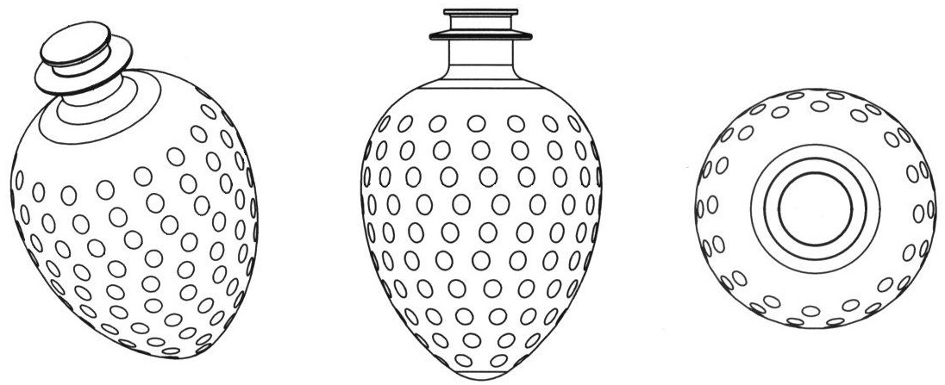

Madagascar (no Reg. No. given), Japan (Reg. No. 4153602), class 43:
classes 32 and 33:

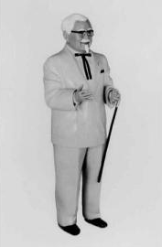
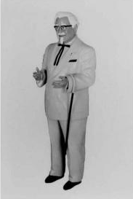
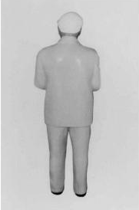
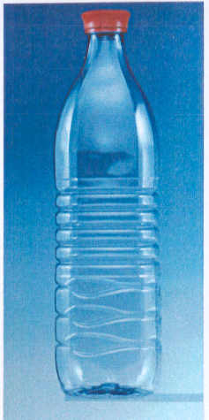

Singapore (Reg. No. T00/12240B), Norway (Reg. No. IR 785438),
class 16: class 5:

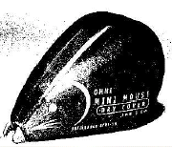
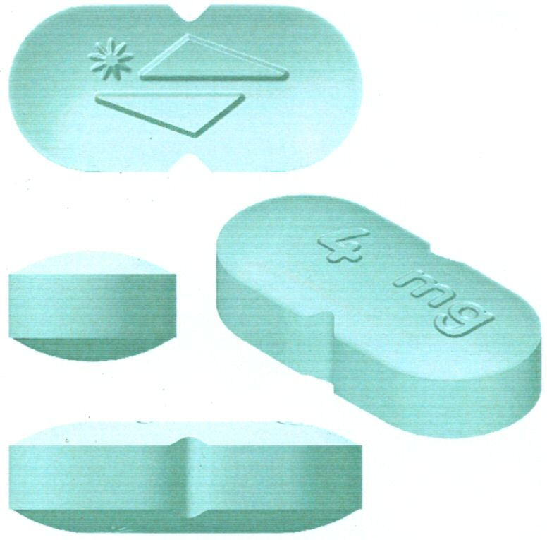

Examples of registered color marks:

Madagascar (no Reg. No. given), class 4:



Norway (Reg. No. 226920), class 34:



Turkey (Reg. No. 2004/40402), Turkey (Reg. No. 2004/40403),
classes 18 and 25: classes 18 and 25:



Switzerland (Reg. No. 499 949), class 16:

“green”

- Declaration (type of mark): color mark
- Specification: PANTONE 347 MC
- Acquired distinctiveness in accordance with consumer survey

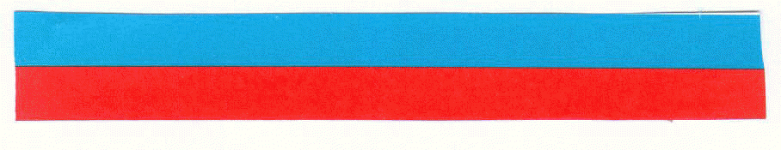
United Kingdom (No Reg. No. given), classes 6, 11, 19 and 20:

Description: The distribution and ratio of the colours to each other is 50-50, whereby the colour blue runs horizontally above the colour red, forming a striped whole.

Indication of colour: Blue RAL5015, Red RAL 2002

United Kingdom (Reg. No. 2360815A), class 33:


Mark Description: The mark consists of vodka coloured black, in the colour “PANTONE black”.
Mark Claim/Limit: The applicant claims the colour black (“PANTONE black”) as an element of the mark.

Examples of registered hologram marks:

Switzerland (Reg. No. IR 683 249), classes 9, 16, 36 and 38:


Examples of registered slogan marks:

Singapore (Reg. No. T03/04435F), class 3:

“NEVER SAY DRY”

United States of America (Reg. No. 2,793,39), for various telecommunication
services in class 39:

“PROUD TO BE THE NEXT BEST WAY TO SAY HELLO”

Madagascar (No Reg. No. given), class 36:

“VIVRE ET ENTREPRENDRE AVEC SÉRÉNITÉ”

Switzerland (Reg. No. 357 711), class 31:

“LES CHATS ACHÈTERAIENT WHISKAS”

Examples of registered film/book title marks:

Switzerland (Reg. No. 486 730), classes 9 and 41: “HARRY POTTER”

United States of America (Reg. No. 3,106,202), for a series of pocket-sized
fiction books with western theme: “SILVER KANE”

Examples of registered motion or multimedia signs:

European Community (Reg. No. 3429909), Classes 9, 28, 38, 41:

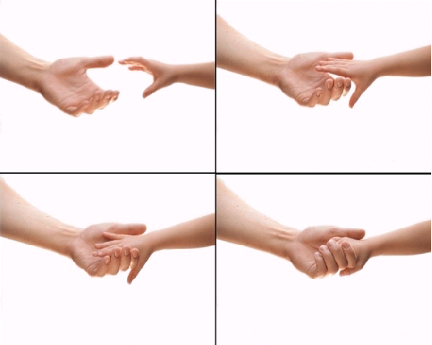

Switzerland (Reg. No. 495 047), class 5:



Trademark registered with the following indication: “the color changes, from red to green, in a continuous manner in the waves from the bottom left in the direction of the upper right, in a lapse of time of eight seconds”.

Finland (Reg. No. 229446), classes 9, 25, 28, 38 and 41:
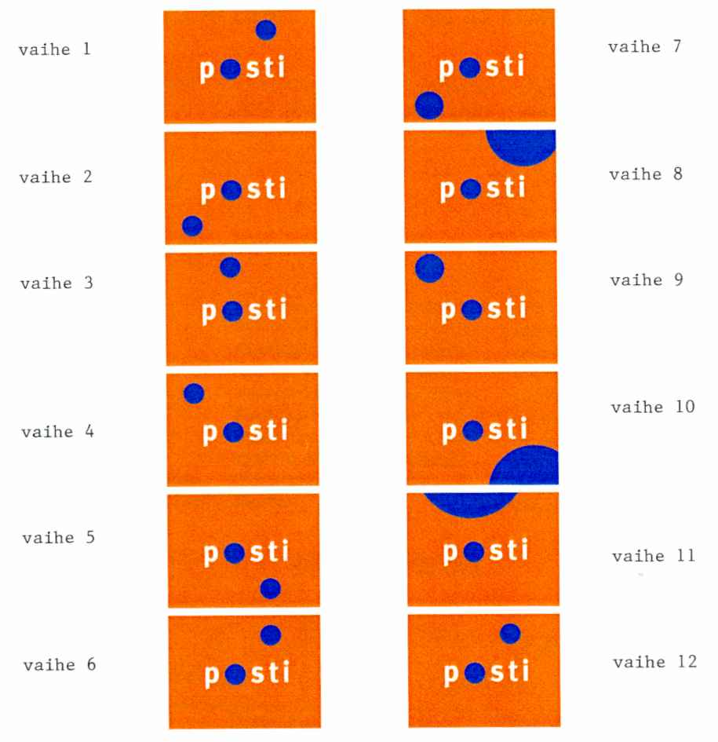
Trademark registered with the following indication: “The mark is a moving image in which the word POSTI remains in the same position, and around which a loose blue circle is shown in changing sizes and positions. The position in which the circle appears as well as the size of the circle of part of it are shown in the pictures”.
Examples of registered position marks:

Switzerland (Reg. No. 465 214), class 25:

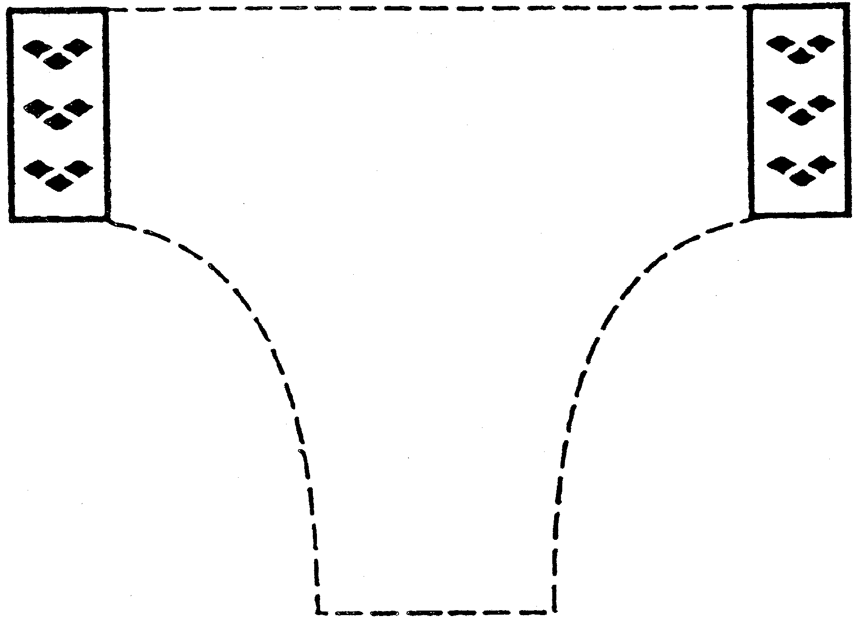

Mark registered with the following indication: “The registration of the mark does not cover the design of the bathing trunk”.

Examples OF registered sound marks:

Norway (Registration Number 226092), classes 29, 30 and 35:

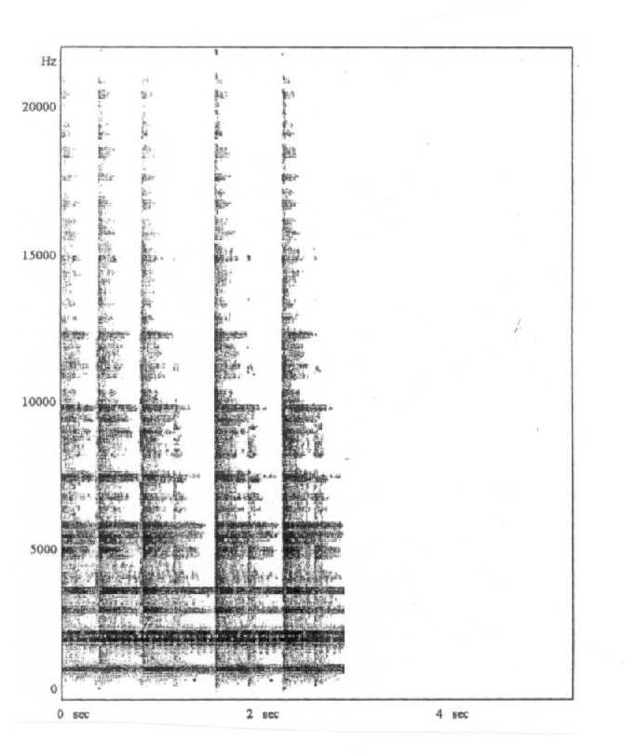

Switzerland (Registration No. 525027 = IR 838231), classes 5 and 30:

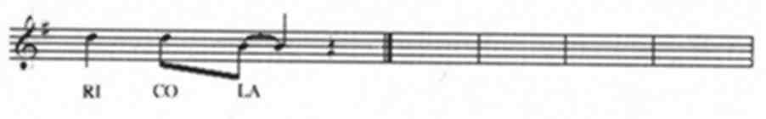

United States of America (Reg. No. 2,827,972)

“The mark consists of a series of five chirps similar to the chirping sound of a cricket”.

EXAMPLE OF REGISTERED OLFACTORY MARK

United States of America (Reg. Nr. 2,560,618), for oil-based metal cutting fluid and oil-based metal removing fluid for industrial metal working in class 4:

“The scent of bubble gum”.

[End of Annex and of document]

See, for example: European Directive on marks (Article 2), European Regulation on the Community Trade Mark (Article 4), Andean Community Decision No. 486 (Article 134.f)), OAPI Agreement (Annex III, Article 2.1), etc.
See “Summary of Replies to the Questionnaire on Trademark Law and Practice (SCT/11/6)”, document WIPO/Strad/INF/1, pp.17 and 18, at <http://www.wipo.int/sct/en/meetings>.
63 out of 72 Offices responding to the Questionnaire considered the shape which results from the nature of the goods themselves to constitute an absolute ground for refusal of the application. Ibid., p. 21.
53 out of 67 Offices responding to the Questionnaire considered the shape, which is necessary to obtain a technical result an absolute ground for refusal of the application. Ibid., p. 22.
ECKHARTT, Klaus “The Razor’s Edge” in Trademark World No. 171, October 2004, p. 40.
For example, in Hong Kong. See BARRACLOUGH, Emma “Tips on non-traditional marks in Asia”, Managing Intellectual Property, November 2005, p. 39 and European Regulation on the Community Trade Mark, Article 7(1)(e).
See Henkel KgaA v OHIM, Case T-393/02 [2005] E.T.M.R. 6, as reported by SIMON, Ilanah in “ECJ decisions reveal tension over registrability”, Managing Intellectual Property, Vol. 2005, No. 149, p. 58.
See Nestlé Waters France v OHIM, Case T-305/02 [2004] E.T.M.R. 41, as reported by Peter Turner-Kerr in “EU Intellectual Property Law: Recent Case Developments”, IP Quarterly, 2004, No. 4, pp. 476 and 477.
However, 50 out of 67 Offices responding said that, where the mark was refused, the holder could not prove that his/her sign had acquired distinctive character through use. See Questionnaire, op.cit., p. 22.
See Questionnaire, op. cit., p. 22.
See the practice in Australia, Japan and Singapore, BARRACLOUGH, op cit., pp. 37, 41 and 3.
See Questionnaire, op. cit., p. 26.
See European Court of Justice in Libertel Groep v Benelux-Merkenbureau Case C-104/01[2003] E.T.M.R 41.
See Federal Court of Australia in Philmac Pty Ltd v the Registrar of Trademarks (2002) 56 IPR 452 and BP Plc v Woolworths Limited (2004) 62 IPR 545, See BARRACLOUGH, op.cit., p. 37.
See Qualitex Co. v. Jacobson Products Co., Inc., 514 US. 159, 34 USPQ.2d 1161.
See United States of America, 7. Color, Trademark Reporter, INTA, 13th Annual International Review of Trademark Jurisprudence. March-April 2006, Vol. 96, No. 2, p. 235.
For example, in the “blue bottle trademark” case, the Registrar of Trademarks in the United Kingdom held that the applicant should have provided such evidence. Ty Nant Spring Water Ltd’s Trade Mark Application [2000] R.P.C. 55.
The criteria established by the ECJ in Ralf Sieckmann v Deutsches Patent-und Markenamt, Case C-273/00 [2002] E.C.R. I-11737, paragraph 55.
See Libertel, op.cit., paragraphs 28 to 38.
See Heidelberger Bauchemie GmbH Case 49/02 [2004] E.T.M.R. 99, paragraph 33.
Information provided by the UK Patent Office, June 2006.
The color purple for “block chocolate, chocolate in bar or tablet form”. Cadbury Ltd v JH Whittaker & Sons Ltd, Case No. T26/2004, the Assistant Commissioner of Trademarks of New Zealand (IPONZ), November 14, 2004, See Trademark Reporter, INTA, op.cit., pp. 488 and 489.
See India, color marks, BARRACLOUGH, op.cit., pp. 40 and 41.
See RØNNING, Debbie, “Taste, smell and sound – Future Trademarks? at <http://www.patentstyret.no/templates/Page_429.aspx>.
See SIECKMANN, Ralf “Holograms: the next generation of trademarks?”, CPA’s IP Review, Winter 2005/06, Issue 13, page 26.
See Questionnaire, op. cit., p. 30.
See Questionnaire, op. cit., p. 28.
See Société des Produits Nestlé v Mars UK Ltd., Case C-353/03 E.T.M.R., paragraph 23.
See OHIM v Erpo Möbelwerk GmbH, Case C-64/02 P (Das Prinzip der Bequemlichkeit) [2004] E.T.M.R., paragraph 35.
See Questionnaire, op. cit., p. 31.
See PASSA, Jérôme, “Titres et slogans: entre marque et droit d’auteur”, Propriétés intellectuelles, January 2005, No. 14, pp. 35-36.
See for example US Court of Appeals for the Federal Circuit in Herbko International, Inc. vs. Kappa Books Inc., (308 F. 3rd 1156), September 3, 2002.
For example, in Germany’s §5(1), (3) and §15 of the 1994 Trade Marks Act. According to §5(3) titles are “names or special designations of printed publications, cinematographic works, musical works, dramatic works or other comparable works”. See KLINK, Jan, “Titles in Europe: Trade Names, Copyright Works or Title Marks?”, European Intellectual Property Review, Vol. 7, No. 7, August 2004, pp. 297-300.
See RØNNING, op. cit., “Moving image mark”.
See Questionnaire, op. cit., p. 33.
See VÖLKER, Stephan, “Registering new forms under the Community Trademark”, Trademark World No. 152, November 2002, p. 32.
The classical examples being those that take the form of a fabric tag or decorative top stitching on the back pocket of jeans.
Mars BV has a registration in the Benelux Trademark Register for a gesture of two cutting fingers for its TWIX chocolate (BX No. 520574). In the UK, there is a registration for services in the field of mortage and investments (UK No. 2012603), which shows a person tapping his/her nose. See RØNNING, op. cit., “Gesture Marks”.
See, for example Article L.711-1,b of the French Code la propriété intellectuelle and Article 134(c) of Andean Community Decision 486 “Common Provisions on Industrial Property”.
The ECJ made this interpretation in Shield Mark BV v Kist, Case C-283/01 [2004], paragraph 35.
In Australia, for example, the “Mr. Whippy” tune has been registered despite the strong word mark “Mr. Whippy” for ice cream and the “Dolmio” Sicilian waltz will clearly be played in advertisements incorporating the product’s well-known trade name “Dolmio” for its pasta sauce. See McCUTCHEON, Jani “The Registration of Sounds and Scents as Trade Marks under Australian Law”, Intellectual Property Quarterly, Issue 2, 2004, pp. 167 and 168.
See Questionnaire, op. cit., p. 27.
See Australia, sound marks, BARRACLOUGH, op.cit., pp. 37 and 38.
Ibid, Singapore, sound marks, at p. 43.
In Shield Mark BV v Kist, the ECJ cited its previous ruling and recalled the “Sieckmann criteria” for the graphic representation of trademarks. See Ralf Sieckmann v Deutsches Patent-und Markenamt, op.cit., paragraph 55.
See Shield Mark BV v Kist, op.cit., Ruling, paragraph 2.
See Questionnaire, op. cit., pp. 28 and 29.
See Re Celia Clarke, DBA Clarke’s Osewez, U.S.P.Q. 2d 1238 (1990) (TTAB). The mark was described as “a high impact, fresh, floral fragrance reminiscent of Plumeria blossoms” for use with sewing thread and embroidery yarn.
See Trade Marks Registry Work Manual, Chapter 6.2.2 “Examination” at <http://www.patent.gov.uk/tm/reference/workman/index.htm>. See also: Trademark 2001416 “the trademark is a floral fragrance/smell reminiscent of roses as applied to tyres” and Trademark 2000234 “the mark comprises the strong smell of bitter beer applied to flights of darts”. See UK Patent Office <http://webd4.patent.gov.uk/tm/number/>.
See Australia, smell marks, BARRACLOUGH, op.cit., p. 37.
USPTO Trademark Manual of Examining Procedure (2002) WLTMEP3rd 807.11 (WL).
See Ralf Sieckmann v Deutsches Patent-und Markenamt, op.cit. paragraph 19(2). The applicant sought to register the pure chemical substance methyl cinnamate. He provided a chemical formula and described the odor as “balsamically fruity with a slight hint of cinnamon” in respect of various services in Classes 35, 41 and 42 of the International Nice Classification. See paragraphs 10 to 13.
Ibid, paragraphs 69 to 73. After the Sieckmann ruling, the ECJ has applied the same criteria for the graphic representation of other non-traditional signs, such as color in the Libertel case, and sound in the Shield Mark case. See supra notes 13 and 39.
See Ralf Sieckmann v Deutsches Patent-und Markenamt, op.cit. final ruling.
Eden SARL v OHIM, Case T-305/04, October 27, 2005 concerning the “smell of ripe strawberries” for a wide variety of household goods, leather goods and paper goods.
For example, in the Benelux Office the following mark has been registered (DE SMAAK VON DROP BX No. 625971). “The trademark consists of the taste of liquorice applied to goods in class 16 (taste mark)”. See RØNNING, op. cit., “Taste marks”.
Eli Lilly and Co. v INPI, Court of Appeal of Paris, 4th Chamber, October 3, 2003, Recueil Dalloz, Vol. 184 (2004), No. 33, p 2433. The application concerned a taste mark constituting “the artificial taste of strawberry” for pharmaceutical, veterinary and hygiene products and diet substances for medical use.
It has been mentioned that the glass bottle of Coca-Cola was designed in 1915 to also be recognized in the dark. See RØNNING, op. cit., “Feel marks (tactile marks)”.
See Questionnaire, op. cit., p. 33.
Application No. 140058, of December 17, 2003, and registration granted though title No. 29597 of April 28, 2004 “Textura Superficie Old Parr” for alcoholic beverages, Instituto Ecuatoriano de la Propiedad Intelectual (IEPI).
See Questionnaire, op. cit., pp. 56-59.
See Questionnaire, op. cit., pp. 60-61.
Article 6quinquies(A)(1) of the Paris Convention reads as follows: “Every trademark duly registered in the country of origin shall be accepted for filing and protected as is in the other countries of the [Paris] Union…”.
See Questionnaire, op. cit., pp. 6-7.

