PCT/WG/17/7
ORIGINAL: English
DATE: January 18, 2024
Patent Cooperation Treaty (PCT) Working Group
Seventeenth Session
Geneva, February 19 to 21, 2024
Further amendment to Rule 26.3ter ─ Invitation to Correct Defects under Article 3(4)(i)
Document submitted by Japan

Summary
- Japan would like to propose a further amendment to Rule 26.3ter (a)(i), with the aim of bringing clarity and legal consistency to the operations of the receiving Office.
- The purpose of this proposed revision is to close a loophole in Rule 26.3ter that does not allow the receiving Office to issue invitations for corrections.

Background
- During the sixteenth session of the Working Group in February 2023, the Delegation of Japan commented that it intended to bring a proposal concerning further amendment to Rule 26.3ter(a) (see paragraph 17 of the Summary by the Chair of the session, document PCT/WG/16/9). The current rule does not allow the receiving Office to invite the applicant to submit the translation of the text matter of the drawings and the abstract into the publication language in the following case:
  - The description and claims are filed in Arabic, Chinese, French, German, Japanese, Korean, Portuguese, Russian or Spanish (any of the languages of publication under Rule 48.3(a) except English),
  - The abstract and the text matter of the drawings are filed in English, and
  - The translation under Rule 12.3 is submitted in English.
- As a result, neither the abstract nor the text matter of the drawings would be in the language in which the international application is to be published (Rule 48.3(a)), as illustrated in the following figures [CASE 2].
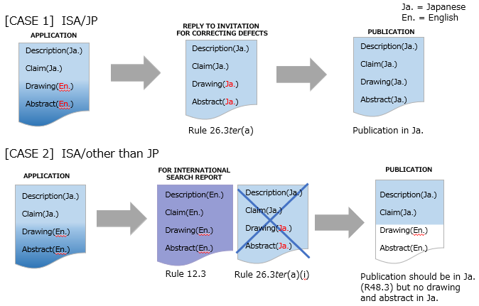
- The PCT Assembly adopted Rule 12.3 at its twenty-fourth session in 1997 when introducing measures that make it possible to file international applications in a language different from those accepted by the competent International Searching Authority and amended Rule 26.3ter(a) to take account of the new provision (see paragraph 14 and Annex I of document PCT/A/XXIV/6 and paragraph 16 and Annex III of the Report of the session, document PCT/A/XXIV/10). The proposed amendments to Rule 26.3ter(a) provided the following explanation (see Annex I of document PCT/A/XXIV/6):
“[COMMENT: Where the abstract is in a different language from that of the description and claims, a translation of the abstract will, in general, be required under paragraph (a). Such translation will have to be into the language in which the international application is to be published. However, no translation of the abstract would be required if a translation of the international application is required under Rule 12.3(a), since the abstract would need to be included in the translation furnished under that Rule. Nor would a translation of the abstract be required if it is already in the language in which the international application is to be published, even if the description and claims are filed in another language. The position in relation to translations of any text matter in the drawings is the same as that just explained in relation to the abstract.
EXAMPLE 1: Description and claims filed in German with the German Patent Office; abstract filed in French. The European Patent Office is the competent International Searching Authority; the international application will be published in German. A translation of the abstract into German is required.
EXAMPLE 2: Description and claims filed in Italian with the Italian Patent and Trademark Office; text matter in drawings is in French. The European Patent Office is the competent International Searching Authority. Under Rule 12.3(a), a translation of the (entire) international application, including the text matter in the drawings, is required for the purposes of international search and international publication (that translation may be into English, French or German). A translation of that text matter into Italian is not required.]”
- The case shown in paragraph 3 above, where the translation to be provided under Rule 12.3 is not in the language in which the international application is to be published, seems not to have been considered at the twenty-fourth session of the PCT Assembly.
- In light of the above, the Japan Patent Office (JPO) consulted with the International Bureau and initiated a discussion on this issue by proposing the amendment to Rule 26.3ter(a) included in Annex I of this document in the electronic forum of the PCT Working Group (wiki) in September 2023. The proposed amendment to the text of Rule 26.3ter(a) that will enter into force on July 1, 2024 would limit the exception from the requirement of the receiving Office to invite the applicant to furnish a translation of the abstract or text matter of the drawings into the language of international publication when the applicant is required to provide a translation for the purposes of international search to situations where the translation provided for the purposes of international search is also the language to be used for international publication. According to comments submitted on the proposal, ensuring that the entire application is published in one single language would be useful, while some Offices would be concerned about the burden on the receiving Office by this amendment.

Proposal
- Based on the wiki feedback, the JPO has concluded that this amendment is meaningful since the PCT System has become more multilingual. At present, there is a total of 10 publication languages.
- Publishing all the elements of the international application in one language is consistent with Article 3(4)(i) and Rule 48.3(a). In addition, from third parties’ point of view, their convenience would be served by having all the elements written in one language.
- Some Offices would also recognize that in certain technical fields, there is no need to translate the text matter of the drawings, which can be published as is, even though the language of the text matter of the drawings and the abstract are different from those of the description and the claims. Therefore, it is suggested to modify the Receiving Office Guidelines so that the applicant can reply to the invitation from the receiving Office by explaining that there is no need to translate the text matter of the drawings, since this is obvious within the technical field.
- The draft Receiving Office Guidelines included in Annex II are intended to address such concerns that Offices might have, while reaffirming their clear role as the Receiving Office after the implementation of the amendment to the Regulations. Annex II is included only for sharing information and receiving further feedback that the International Bureau could consider further if the Assembly adopts the amendments to the Regulations proposed in this document.
- The Working Group is invited:
(i) to consider the proposed amendments to the Regulations in Annex I to this document; and
(ii) to provide preliminary comments on the draft modifications to the Receiving Office Guidelines in Annex II to this document.
[Annexes follow]
Proposed AMENDMENTS TO THE PCT Regulations

TABLE OF CONTENTS

Rule 26 Checking by, and Correcting before, the Receiving Office of Certain Elements of the International Application 2
26.1 to 26.3bis [No change] 2
26.3ter Invitation to Correct Defects under Article 3(4)(i) 2

Rule 26
Checking by, and Correcting before, the Receiving Office of Certain Elements of the International Application

26.1 to 26.3bis [No change]
26.3ter Invitation to Correct Defects under Article 3(4)(i)
(a) Where the abstract or any text matter of the drawings is filed in a language which is different from the language, subject to Rules 12.1bis and 26.3ter(e), of the description and the claims, the receiving Office shall, unless
(i) a translation of the international application is required under Rule 12.3(a) into a language in which the international application is to be published, or
(ii) the abstract or the text matter of the drawings is in the language in which the international application is to be published,
invite the applicant to furnish a translation of the abstract or the text matter of the drawings into the language in which the international application is to be published. Rules 26.1, 26.2, 26.3, 26.3bis, 26.5 and 29.1 shall apply mutatis mutandis.
(b) to (e) [No change]
[Annex II follows]
DRAFT MODIFICATIONS TO THE RECEIVING OFFICE GUIDELINES
REGARDING RULE 26.3ter(a)

Language of Abstract and Text Matter of the Drawings

63. Correction of Defects Where the language in which the abstract and/or any text matter of the drawings, or any part thereof, is filed is different from the language of the description and claims, the receiving Office invites (Form PCT/RO/106) the applicant to furnish, within the time limit referred to in Rule 26.2 (Rule 26.3ter(a)), a translation of the abstract and/or any text matter of the drawings into the language in which the international application is to be published under Rule 48.3(a) or (b), unless:
- a translation of the (entire) international application is required under Rule 12.3(a) into the language in which the international application is to be published, or 12.4(a) (paragraphs 67 or 67A), or
- the abstract and any text matter of the drawings are (already) in the language in which the international application is to be published.

64. [No change] In the invitation, the receiving Office indicates the language into which the abstract and/or any text matter of the drawings is to be translated, so as to comply with the requirements of Rule 26.3ter(a). Rules 26.3 and 26.3bis concerning physical requirements (paragraphs 132 to 146) apply mutatis mutandis to any translation furnished by the applicant under Rule 26.3ter(a).

65. Failure to Correct Where the receiving Office has sent to the applicant an invitation under Rule 26.3ter and the applicant has not, within the applicable time limit, furnished the required translation, it proceeds as provided for in Rules 26.5 and 29.1, which apply mutatis mutandis (Rule 26.3ter(a)). For the procedure applicable in such case, see paragraph 159. If the applicant’s response demonstrates that a translation of the text matter of the drawings is not required within a particular technical field, the receiving Office may consider the defect corrected.

[End of Annex II and of document]

A third example was provided in the explanation relating to a provision that is no longer applicable (Rule 48.3(b) in force in 1997 was deleted by the PCT Assembly in 2002 with effect from January 1, 2003. The present Rule 48.3(b) was numbered Rule 48.3(a-bis) before 2003 (see footnote 7 in Annex IV to document PCT/A/31/10).
See PCT Notification No. 224 at https://www.wipo.int/treaties/en/notifications/pct/treaty_pct_224-annex1.html.
Proposed additions and deletions are indicated, respectively, by underlining and striking through the text concerned.

